CHAPTER 1 – RESEARCH METHODS:
RESEARCH METHODS I:
Scientific Method:
- 7 steps; collecting/analyzing data while minimizing bias or conflicts.
- Theory – a general set of ideas about how the world works.
- Hypothesis – a testable statement guided by theories that make predictions between two variables in the theory.
- Research Method – how the hypothesis is tested.
- Collect Data – taking measurements of the outcomes of the test.
- Analyze Data – discovering trends/relationships between the variables.
- Report Findings – publishing articles in scholarly journals.
- Revise Theories – including new information and revisions to theories (usually due to a paradigm shift).
- Paradigm Shift – a dramatic change in the way we think.

Hypothesis In-Depth:
- Anecdotal Evidence – evidence gathered from others or self-experience.
- Problems with Anecdotal Evidence:
  - Single experience might not properly represent the theory.
  - Personal experience might not represent others.
  - Cannot be sure about one factor affecting the results.
- Experiment – scientific tool used to measure the effect of one variable on another.
- Independent Variable – manipulated by the scientist.
- Dependent Variable – observed by the scientist.
- Experimenter usually controls the level of the independent variable; also measures this effect on the chosen measure of the independent variable.

Control Groups:
- Helps to further manipulate the independent variable while measuring the effects on the dependent variable.
- Experimental Group – receives a manipulation of the independent variable.
  - Control group does not receive a manipulation.
  - Allows for one to compare the dependent variable for both groups.
- Both groups should be as similar as possible in order to minimize difference; as a result, if a difference is found, then it is likely that the manipulation of the independent variable was the cause.

Experimental Designs:
Within-Subjects Design:
- Manipulating the independent variable within each participant to minimize the effect of external variables on the dependent variable.
- Minimizes the effect of subject differences on the dependent measure.
- Can be time consuming and costly; practice effect may become an issue.
  - Practice Effect – improved performance over the course of an experiment due to becoming more experienced.
Between-Subjects Design:
- One group receives experimental manipulation, while the other is the control group.
- Confounding Variable – a variable other than the independent variable that has an effect on the results.

Sampling:
- Results from specific group(s) of participants cannot be generalized to other groups.
- Population – the people one is trying to learn about.
- Sample – members of the population that data is collected from.
- The best sample is a random sample.

1st Step – Random Sample:
- Choosing a sample at random from the entire population.
- Reduces bias towards a specific group; hard to achieve.

2nd Step – Random Assignment:
- Assigning subjects to either the experimental or control group at random to avoid any biases that may cause differences between the groups of subjects.
- Also avoids bias.

Conducting an Experiment:
- Placebo Effect – effect that occurs when an individual exhibits a response to a treatment that has no related therapeutic effect; influences a range of independent variables.
  - Also a form of subject bias which influences the results of the experiment.
- Participant Bias – when a participant’s actions in an experiment influence the results outside of the manipulations of the experimenter.
- Blinding – when participants do not know whether they belong to the experimental or control group, or which treatment they are receiving.
- Experimenter Bias – actions made by the experimenter to promote the result they hope to achieve.
- Bias can be reduced…
  - If the experimenter does not know whether each participant belongs to the experimental/control group.
  - Double-blind experiments – experiments in which neither the experimenter nor the participants know which group each participant belongs to.

RESEARCH METHODS II:
Working with Raw Data:
- Statistics allow one to summarize, interpret, and present the data we have collected.
- Descriptive Statistics – presents information that gives an overall idea of the results of the experiment; mean, median, mode.

Histograms:
- Visual summarizations of data (pie chart, bar graph…); type of graph used to report the number of times groups of values appear in a data set.
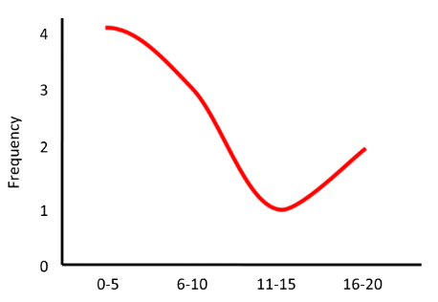
  - X-Axis = Bins
- Frequency Distribution – type of graph illustrating the distribution of how frequently values appear in the data set.
  - Shows data given every possible outcome of an event.
  - In most cases, higher values are more frequent in the experimental group.
- Normal Distribution – a distribution with a characteristic smooth, symmetrical, bell-shaped curve containing a single peak.
  - Shows data for a given measure.

Measures of Central Tendency:
Mean:
- Tells us where a data set is centered; average value of a data set.
- Calculated by adding together all of the points in a data set and dividing by the number of items in the set.
- Influenced by outliers; extreme points, distant from others in a data set.

Mode:
- The value that appears most frequently in the set.
- Tells us one of the most typical responses when looking at a data set; can be used for non-numerical data.

Median:
- Centre value in a data set when the set is arranged numerically.
- Says where the middle of the data set is, but is not influenced by an outlier.

- All of these measures only focus on the centre/typical value, not others around that point.

Measures of Variability:
- Reviews the spread and distribution of a data set.
- Standard Deviation – a measure of the average distance of each point from the mean.
  - Smaller Spread = Smaller SD Larger Spread = Larger SD
- Some variability in results is due to chance.

Inferential Statistics:
- Allow us to use results from samples to make inferences about overall populations.
- Scores without any manipulation follow a symmetrical distribution.
- T-test – can be used to compare the difference between the data from the control and experimental groups.
  - Considers each data point from both groups to calculate the probability that two samples were drawn from the same population.
- P-value – expresses the probability calculated by the t-test.
  - Usually best if there is a <5% chance (0.05 p-value) that an observed difference happened due to chance.
  - If the p-value is <0.05, then then results are statistically significant.

- Statistical Significance – when the difference between two groups is due to some true difference between the properties of the 3 groups and not simply due to random variation.

Observational Research:
- Observes the effect of variables one is interested in without performing any explicit manipulation; follows the scientific method.
- Correlation – measure of the strength of the relationship between 2 variables; not always meaningful.
- Correlation Coefficient (r):
  - +1 = perfect positive correlation.
  - -1 = perfect negative correlation
  - 0 = no relationship between the 2 variables.
- Even if two variables are strongly correlated, the result doesn’t definitely state that this relationship is causing this effect.
- Correlation and causation are not the same.

TEXTBOOK:
Operational Definitions:
- Something that can be objectively measured.
- In psychological research:
- Operational definitions are essential.
- They are always open to argument.
- A key step in critically evaluating any research.

Asking Questions & Methods of Analysis:
- Choices made by psychologists are guided by the level of analysis that is applied to the problem.
- Examples – learning, cognition, social, development, evolution, neuroscience…
- Each researcher operates in different paradigms, and get different answers.

- Scientific Method – formal way of asking question about human nature; allows for the most accurate and objective conclusions to be reached.
- Levels of Analysis – important to consider multiple levels of analysis in order to get the most accurate theories.
- Unbiased Research – helps to avoid letting our own opinions get in the way of one’s current research.
4 Basic Principles of Scientific Inquiry:
- Foundational for any scientific practice; must be used in order to establish trustworthy theories.
- Parsimony:
- Choosing the simplest theory with the most explanatory power.
- Simple = lower amount of assumptions.
- Applied to competing explanations that are similar in terms of how they deliver facts.
- Eg. “Penalty shootout” – if one team clearly wins, it isn’t required.

- Natural Order:
- Attributing the same effects to the same causes.
- Eg. A behaviour is a reflection of the same underlying mechanism in people worldwide.

- Generalizability:
- The same causes that produce effects in a specific situation also produce those effects in everyday life.

- Conservatism:
- Scientists tend to support the current explanation of something until new fact prove it otherwise.

Empiricism and Objectivity:
- Empiricism – knowledge should be based on actual observation, and not solely reason.

Inductive and Deductive Reasoning:
- Inductive Reasoning – allows us to build theories based on various incidents of observed phenomena converging on a hypothesis; facts theory.
- Deductive Reasoning – allows us to make predictions about certain phenomena based on the claims of a theory; tests theory.
- Scientific Theory – generates testable predictions.

Scientific Method:
- Generate a Theory – through studying existing information or building upon a theory.
- Make a Hypothesis – testable predictions generated by a theory using deductive reasoning.
- Choose a Research Method
- Collect Data
  - Statistically Significant – information that supports a hypothesis.
- Analyze Data
- Report Findings
- Revise Theories

Testing a Hypothesis:
- Must be both reliable and valid.
- Reliability – a consistent output when the same input is entered.
- Construct Validity – the ability of a test to measure what we intend to measure.

Case Studies:
- Detailed examination of one particular individual.
- Involve the long term study of an individual/group, but are not exactly generalizable to populations.
- Important starting points for research and establishing formulated theories.

Correlational Studies:
- Simple Correlation – measure of the direction and strength of the relationship between two variables.
- Positive Correlation – as the value of one variable increases, the value of the other also increases.
- Negative Correlation – increasing values on one variable are associated with decreasing values on the other.
- Zero Correlation – no relationship.
- Typically described using a correlation coefficient; usually range from -1 to +1.
  - Sign refers to the direction of the relationship, not the strength.
  - Strength refers to how far the number is from zero in either direction.
- No matter how strong a relationship we observe, a correlation does not allow us to tell a “cause and effect” story.
- Two variables may be strongly related but other unknown variables may actually be contributing to the observed relation.

Experiments:
- Procedure of choice used to systematically study a problem in psychology.

Independent/Dependent Variables:
- Binary Variables – have two possible values.
- Constant – one possible value.

- Independent Variable – researcher explicitly manipulates this variable.
  - Important to distinguish between the levels of IV.
- Dependent Variable – measured by the researcher to see if their manipulation of the IV had any effect.
- Confounding Variables (Extraneous Variables (EV)) – variables that the researcher did not manipulate, but can still affect the outcome of the experiment.

Experimental and Control Groups:
- Control Group – receives a zero level of the IV.
- Experimental Group – IV is manipulated in some way.

Advantages/Disadvantages of Experimental Research:
- Advantages:
  - The ability to say why something happened.
- Disadvantages:
  - Little resemblance in lab conditions vs. the real world.

Key Research Methods:
Case Study:
- Advantages: lots of in-depth information; can be helpful to provide direct evidence of a theory.
- Disadvantages: not applicable to the general population.

Direct Observation:
- Advantages: allows for longer data collection periods rather than a shorter period; useful when little is known about the phenomenon of interest.
- Disadvantages: observers might be noticed; observers may be biased.

Experiment:
- Advantages: researcher has control over manipulation of variables and setting.
- Disadvantages: results may not translate to the real world.

Interviews:
- Advantages: 1-1 allows for further investigation; can observe more specific behaviours.
- Disadvantages: interviewee may be dishonest due to social desirability.

Questionnaire:
- Advantages: can see behaviours that might be hard to see otherwise; simple to collect data from larger samples.
- Disadvantages: answers might not be truthful; if not correctly done, data is inadmissible.

Coming to Conclusions:
Samples and Populations:
- Sample – a group of individuals selected for scientific study; used as a representation of the larger population to which they belong.
- Important to be a research participant because…:
  - Allows for one to see the kind of research that occurs at the institution.
  - Data must be collected in order to conduct research.
- Ex. group of students = sample human race = population.
- A randomly selected sample is the best group to get more representative data from.
- If a sample is to be truly random, every member of the population must have an equal chance of being selected for the sample.
- Random assignment is important; systematic designation does not give representative results.
- For the most generalizable results: participants must be randomly selected and assigned to control and experimental groups.
Descriptive Statistics:
- Organize and describe sample data.

Measures of Central Tendency:
Mean:
- Adding all the values and dividing by the number of values; most understandable way to summarize data.
- Outliers may render the mean useless; therefore, might not be a useful way to summarize the data.
- First choice: allows more options for future statistical analysis.
Median:
- Reduces the influence of outliers in a set of data.
- Uses rank ordering (arranges the data in numerical order), and then uses the value in the middle of the set.
Mode:
- Most commonly occurring value in the data set.

Inferential Statistics and Variability:
- Employs multiple methods to answer questions about why the data are how they are; tests if differences between groups are due to significant causes and effects.

Variability:
- Describes how much the population strays from the mean; allows us to explore whether groups are significantly different, or different due to chance.
- Spread-out data is usually represented graphically as a frequency distribution.
  - Height of curve = number of occurrences of a specific value.
  - Width of curve = range of values obtained.
  - Range – difference between the lowest and highest values obtained.
- Standard Deviation – average difference from the mean of all the points in the data set.
- Normal Distribution – have a characteristically smooth, symmetrical bell-shaped curve around a single peak.
- The less overlap, the smaller the variability, the stronger the differences between groups, and the more likely differences are not due to chance.

Looking for Flaws and Evaluating Research:
- Peer reviewing a study helps to reduce the amount of errors present.

Type I/II Errors:
- In both cases: if the experiment is repeated with a different sample and does not show the same results, there is a problem.
Type I Error:
- When someone claims that the IV had an effect, when realistically, any difference is due to sampling errors.
Type II Error:
- When one concludes that the IV had no effect, even though it actually did.

Distortions in Self- Report Data:
- Social Desirability Bias – answering questions in order to appeal to society’s standards.
- Response Sets – a tendency to respond to questions in a certain way, regardless of the content.

Experimenter Bias:
- Personal expectations about the outcome of the study, which can influence the results.
- Can be avoided using a double-blind study.

CHAPTER 2 – CLASSICAL CONDITIONING:
MODULE:
- Reflexive learning is vital to the survival of a species.

- Classical Conditioning – allows us to associate two events.
- Instrumental Conditioning – allows us to associate actions and consequences.

- Pavlov – interested in stages of digestion; began with salivation in the mouth as food was first ingested.

- Conditional Reflex – conditional upon training.
- Contingent Relationship – presentation of one stimulus reliably leads to the presentation of another.
  - When an organism learns the association with a signal and an event.
- Classical Conditioning – the learning of a contingency between a particular signal and a later event that are paired in time/space.

Components of Classical Conditioning:
- Unconditional Stimulus (US) – any stimulus or event; occurs naturally, prior to learning; does not need training.
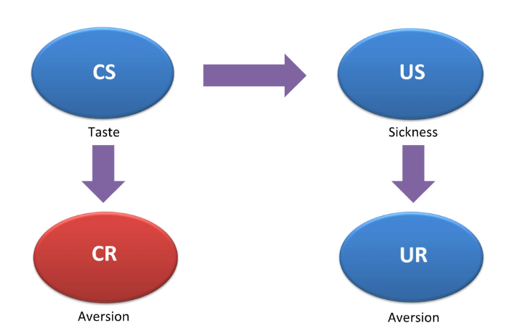
- Unconditional Response (UR) – response that occurs after the US; occurs naturally, prior to learning.
  - Often a biologically-programmed reflex.

- Conditional Stimulus (CS) – paired with the unconditioned stimulus to produce a learned contingency; eventually triggers a response of its own.
- Conditioned Response (CR) – occurs once the contingency between the CS and the US has been learned, since the CS does not initially elicit a response.

- Acquisition – process by which a contingency between a CS and a US is learned.
  - Follows a negatively-accelerating curve.
  - Learning in earlier trials > learning in later trials.

Extinction:
- If conditions change, such that the conditional stimulus is no longer a reliable cue, the conditional response will fade.
- The loss of the CR when the CS no longer predicts the US.
  - Repeatedly presenting the CS in the absence of the US.
- Spontaneous Recovery – sudden recovery of a CR following a rest period after extinction.
- Suggests that extinction leads to learning an inhibitory response.
- Extinction promotes a learned inhibitory response that competes with the original learned contingency.

Generalization & Discrimination:
- Stimulus Generalization – process by which stimuli similar to the CS will also elicit a CR.

Generalization Gradient:
- Normal distribution; exists for any kind of CS.
- Adds flexibility/efficiency to classical conditioning, since one may generalize their learning to avoid similar stimuli.
- Extinction allows for the generalization gradient to “flatten”; shows a decrease in fear responses elicited by stimuli.

Stimulus Discrimination:
- Restricts the range of CS that can elicit a response.
  - Fear response elicited by the rest of the stimuli across the gradient (that don’t have discrimination training) are intact.
- Alternating between fear-eliciting and discrimination-training trials give the best results.

- CS+ - predicts the presence of an US.
- CS- - predicts the absence of an US.
- If both are presented at the same time: subject shows immediate fear response.

- Generalization/discrimination of stimuli are necessary for learned adaptations.

Treating Phobias:
Implosive Therapy:
- Person is encouraged to confront the CS that evokes fear.
- CS is presented in the absence of the US.

Systematic Desensitization:
- Gradual exposure to a feared stimulus.
  - Paper shreds mud dirt.
- More accessible to most patients.

Homeostasis:
- Made more efficient through classical conditioning.

Drugs:
- Over many drug-taking trials, conditional stimuli in the environment become paired with the drug effects; therefore, a contingency is learned (withdrawal symptoms).

LECTURE:
Learning and Drug Effects:
- Learning – relatively enduring change in behaviour due to experience.
- Behaviourism – we learn from experience.
- Pavlov – reflexive responses associated with cues.
- Watson – prediction/control of behaviour.
- Skinner – prediction/control of behaviour.

Types of Learning:
Non-Associative Learning:
- Information about one external stimulus.
  - Habituation – decrease in behavioural responding to a repeated stimulus.
  - Sensitization – increase in behavioural responding to a repeated stimulus.

Associative Learning:
- How two or more pieces of information are related.
- Classical Conditioning – learn that 2 stimuli go together.
- Operant Conditioning – learn that a behaviour leads to a particular outcome.

- Brain changes during learning.
- Long-term potentiation – strengthening of synaptic connections between neurons.
- Learning allows for homeostasis.

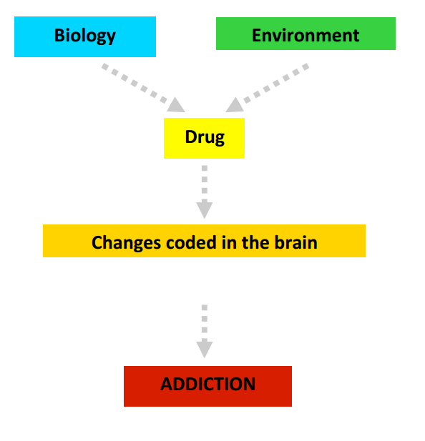
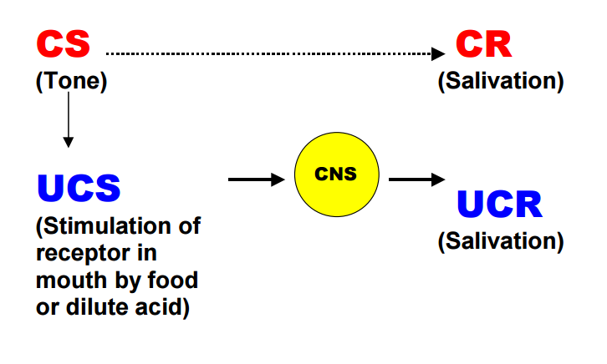
^^^an acquired reflex Learning and Drug Effects

- Functional changes in the addicted brain affects future choice of behaviours.
- Brains of addicts response to taking the drug, but also to drug-associated cues.
  - Increased activity at anterior angulate cortex.
- Drug effects decrease with repeated administration, leading to tolerance.

TEXTBOOK:
Learning:
- Relatively enduring change in the mechanisms of behaviour that occurs due to experience.
- Three concepts:

Mechanisms of Behaviour:
- Motivational factors can alter behaviour.
- Learning may occur, yet not be immediately reflected, in performance (latent learning).

Learning Involves Change that is Relatively Enduring:
- Learning should occur over time whether or not it is being continually expressed in behaviour.

Learning is a Process Based on Experience:
- Maturation – behaviours that develop/change as one matures, often independent of experience.

Orienting Responses, Habituation, and Sensitization:
- Orienting Response – an automatic shift o attention toward a stimulus or event.
  - Important for focussing attention on unfamiliar stimuli, which may signal sudden danger or unexpected opportunity.
- Habituation – a decrease in response to a stimulus or event as it is repeatedly presented without any consequence.
  - Allows one to ignore irrelevant stimuli that may otherwise be distracting and divert your limited attentional resources.
- Dishabituation – an increase in responding that follows a change in the stimulus to which habituation has occurred.
- Sensitization – an increase in responding; focusses attention to stimuli that do have relevance.
  - Plays a role in many drug psychological processes.

- Habituation and sensitization are considered non-associative learning, because they modify an existing stimulus-response relationship, rather than create a new one.
- Reflex – takes place independently of the conscious experience of the subject.

- Associative learning allows organisms to learn relationships between stimuli and events.
Classical Conditioning:
- Unconditional Response (UR) - biologically determined reflex that can be elicited in the absence of any prior learning.
- Unconditional Stimulus (US) – elicits the UR.
- In both cases, the existing relationship between the US and UR is not conditional upon any prior learning, meaning that it happens independently of previous experience, hence why it is unconditional.

- Conditional Response (CR) – only emerges after some learning has taken place (experience).

- Conditional Stimulus (CS) – elicits the CR; becomes associated with the US if they are repeatedly presented together; come together after multiple conditioning trials.

- To test if the CS elicits the CR, a test trial must take place, with the CS by itself.
- US vs. CS – evidence of learning occurs when the CS elicits the CR, the same as the UR, without presentation of the US.

Acquisition of the CR:
- Conditioning is gradual; strength of the CR slowly grows over the course of conditioning trials; eventually reaches a point where further conditioning trials do not result in any further increases in CR strength.
- Dependent on stimulus contiguity; the extent to which the two stimuli occur together in time and space.
- Contiguity:
  - Important to acquisition is the presentation of the US and CS together in time and space continuously in order for learning the association between the two to occur.

Extinction of the CR:
- Extinction is not the same as forgetting.
- Reacquisition – occurs faster than acquisition.
- Spontaneous Recovery
- Renewal

Inhibitory Conditioning:
- Excitatory Condition – what is learned is that the CS signals the presence of the US.
- The complexity of extinction suggests it may also be a form of learning, through inhibitory-learning based on the anticipation of the absence of a biological event.
- Individuals learn a new acquisition on top of the old excitatory condition, but the original learning is not forgotten.

Higher-Order Conditioning:
- The established CS is now paired with a new stimulus, allowing the new stimulus to become another CS capable of eliciting a CR.
- Weaker, and more vulnerable to extinction compared to the original CR.

Generalization and Discrimination:
Generalization:
- Stimulus Generalization – the process of applying what has been learned with a particular set of stimuli to a wider range of similar stimuli is referred to as stimulus generalization.
- Stimulus Discrimination – an organism fine-tuning its responding, such that a CR occurs to one stimulus but not the other, similar, stimuli.
- CS+ - signals the onset of the US; excitatory association.
- CS- - acquires an inhibitory association with the US.

Temporal Arrangement of the CS/US:
- How the stimuli are related in terms of time.
- Short-Delay Conditioning – the onset of the CS occurs first, followed by the onset of the US; both stop at the same time; most effective.

Physiological Regulation:
- Homeostasis – the study of homeostatic regulation is classical conditioning; compensatory responses maintain homeostasis.

UNIT 3 – INSTRUMENTAL CONDITIONING
LECTURE:
- We learn effects of behaviour through operant (instrumental) conditioning.
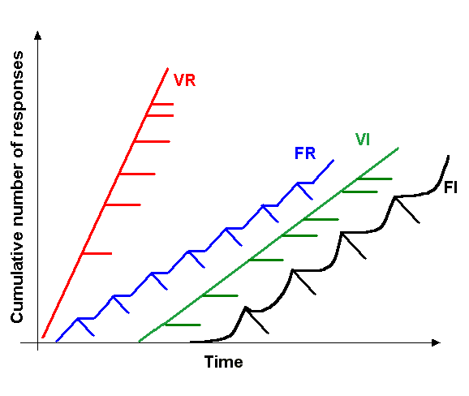
- The learning between voluntary behaviour and its consequences.
- Can create superstitious behaviours.
- SD/Sẟ are signals.
- Shaping – rewarding bits until behaviour is achieved.
- Chaining – keeping previous behaviours intact.
- Primary reinforcers – satisfy biological need.
- Secondary reinforcers – established through conditioning; use secondary to get primary.
- Temporal Proximity – how close the behaviour and the consequence are in time.

MODULE:
- Explicit training between voluntary behaviours and their consequences.
- The learning of a contingency between behaviour and consequence.
- Classical – involuntary; operant – voluntary.

Thorndike:
- Studied cats in a puzzle box (food outside box for motivation); main focus on overt behaviour rather than mental elements.
- Predicted that it would take less time to escape in later trials.
- Actually found: the frequency of random behaviours gradually decreased over time.
- Favourable behaviours are “stamped in”; unvfavourable behaviours are stamped out.

Law of Effect:
- Behaviours with positive consequences are stamped in.
- Behaviours with negative consequences are stamped out.

- Reinforcer – stimulus that, when presented after a response, leads to a change in t hat rate of response.

- 4 types of I.C.: presenting/removing a positive reinforcer; presenting/removing a negative reinforcer.

Reward Training:
- Presentation of a positive reinforcer; increases the frequency of a behaviour.
- Presentation of Positive Reinforcer Reward

Punishment Training:
- Presentation of a negative reinforcer; decreases the frequency of a behaviour.
- Presentation of Negative Behaviour Punishment.
- Authority figure may become a trigger for distress/pain.

Omission Training:
- Removal of a positive reinforcer; decrease in the behaviour being reinforced.
- Time out procedure – removes positive reinforcers, and often stops the unwanted response.
- Removal of a positive reinforcer does not equal presentation of a negative reinforcer.

Escape Training:
- Removal of a negative reinforcer; increase in the response behaviour.

- All types of instrumental conditioning proceed best when the consequence immediately follows the response.
- Learning is most effective when the time between desirable behaviour and reward is minimized.

Acquisition & Shaping:
- Acquisition leads to learning the contingency between a response and its consequence.
  - Rate of responding to the new behaviour.

Graphing Responses:
- Visualized with a cumulative recorder.
- Pen draws a line on a long piece of paper; each response causes it to move up a notch; leads to a characteristic pattern of acquisition.
- Autoshaping – behaviours that can be learned without guidance by a higher power.
  - Some instrumental responses are too complex for a subject to discover on their own.
  - Rewards a behaviour that the animal might do spontaneously.
- Shaping – can be organized into smaller steps which gradually build up to the full response we hope to condition.
  - Successive approximation to train someone to partake in a complex task.

Generalization & Discrimination:
- Contingencies are not always valid.

Discriminative Stimulus (SD):
- Signals when a contingency between a response and a reinforcement is “on”.
- S- (Sẟ)- cue which indicates when the contingent relationship is not valid.
- Range of response can be captured on a SD generalization gradient.

- Training with an SD/Sẟ can lead to better discrimination that can be measured by testing several stimuli along an SD generalization gradient.
- Extinction can still occur; behaviour with reward training can be weakened if the behaviour no longer yields reward under conditions that previously signalled that the contingency was valid.
CS in C.C. vs. SD in I.C.:
- CS – automatically elicits a response; paired with US; CS itself elicits a conditioned response.
- SD – sets the occasion for a response; paired with response-reinforcer outcome; voluntary; indicates a contingency is valid.

Schedules of Reinforcement:
- Continuous Reinforcement – a response leads to a reinforcer on every single trial.

Partial Reinforcement:
- Ratio Schedule – based on the number of responses; determines when reinforcement is given.
- Interval Schedule – based on the time since the last response that was reinforced.
- Fixed Schedule – conditions that are held constant across trials.
- Variable Schedule – provided following a variable amount of work/length of time.

Four Basic Schedules of Reinforcement:
Fixed Ratio (FR #):
- Must do something a certain amount of times to receive an award.
- Too stingy – leads to ratio strain, and subject stops responding.
- Pause and run pattern – following reinforcement following reinforcement, a subject will pause with inactivity before beginning the next run of responding.
- A lack of motivation leads to procrastinating.
Variable Ratio (VR #):
- Reinforcement delivered after some random number of responses around a characteristic mean.
- Variable ratio schedules can support a high response rate of behaviour.
- Slope of cumulative record – reflects the average number of responses required before reinforcement is delivered.
- VR schedules that deliver more frequent reinforcement will support higher response rates.

Fixed Interval (FI #):
- Reinforcement is delivered following the first response after a set interval or time.
- Produce a cumulative record with a characteristic scallop.
- Following reinforcement: lull period in which responding drops, slowly starts picking up again; peaks just before the next reinforcement is scheduled to be delivered following a response.

Variable Interval (VI #):
- Reinforcement received at any time; you have an idea of how often reinforcement is likely to come up.
- Responds at a steady rate; ensures that an opportunity for reinforcement is not missed.
- Schedule that gives more frequent reinforcement will support higher response rates.
- Learning is more robust on a partial rather than a continuous reinforcement schedule.
  - Best to train using PRF rather than CRF.

TEXTBOOK:
- Instrumental Conditioning – forming new voluntary behaviours that direct goal-centered actions.

Thorndike’s Law of Effect:
- Target responses stamped in; irrelevant responses stamped out.
- A response followed by an satisfying effect is strengthened and likely to occur again in the situation; a response followed by an unsatisfying effect is weakened, and less likely to occur again in that situation.
  - Proportional to consequences.
- Problem-solving behaviours – change in the probabilities of the various possible responses.

- Operant – coined by Skinner; voluntary actions operate on the environment to produce change, leading to a specific consequence.
- Reinforcer – reward/satisfying effect; no assumptions about judgments being made in the mind of the individual responding.
  - Anything that increases the probability of response being emitted again in the future.
- Primary reinforcers – intrinsic value (essentials).
- Secondary reinforcers – reinforcing through previous learning; lead to primary reinforcers.
- Operant Chamber – consisted of a mechanism which an animal could respond to produce a reinforce.
  - Allows for shorter trials, no constraints on responding, repeated responses…

Generalization & Discrimination:
- Discriminative Stimuli (SD) – signal to the organism when a given response-reinforcer relationship is valid.
  - S- - when a response should not occur; response-reinforcer is not valid.
  - S+ - when a response should occur.
- CS+ / CS- - inform you of what will/will not happen.

Reinforcement & Punishment:
- Positive Reinforcement – arrival of a stimulus following a response increases the probability that the response will occur again.
  - Used in reward training.
- Appetitive Stimulus – something that produces satisfaction when received.
- Negative Reinforcement –when the removal of an aversive stimulus (something unpleasant) follows a response; leads to an increase in the probability that response will occur again; escape training.
- Both positive/negative increase responding, but by different means.

- Punishment – outcome that decreases the probability that the response will happen again.
- Positive Punishment – arrival of an aversive stimulus follows a response; decreases the likelihood of that response occurring again.
- Negative Punishment – when a response leads to the removal of an appetitive stimulus; decreases the probability of that response occurring again (omission training).

Immediate & Delayed Consequences:
- Most effective way to ensure associations are formed between behaviours and consequences is to present consequences immediately after the behaviour.

Shaping & Chaining:
- Shaping by Successive Approximations – used to train a complex response.
- Chaining – a response is reinforced with the opportunity to perform the next response.
  - Can be built leading to a final sequence of behaviours that is complex.

Complex Nature of Reinforcement:
- Contrast Effects – changes in the value of a reward lead to shifts in response rate.
- Negative Contrast – switching from a high to a low reward leads to a slower response rate.
- Positive Contract – switching from a low to a high reward leads to a faster response rate.
- Power of a reinforcer depends on: absolute value, relative value compared to past reinforcers.
- Overjustification Effect – displays how changes in reinforcement, ie. presentation of rewards for behaviours already naturally performed, alter the perception of behaviour.

Schedules of Reinforcement:
- Continuous Reinforcement Schedule – reinforcer follows every correct response made by the individual.
- Partial Reinforcement – reinforcer follows only some of the responses.
  - More resistant to extinction.

- Ratio and Interval
- Fixed and Variable

4 Types of Partial Reinforcement:
- Fixed Ratio
- Variable Ratio
- Fixed Interval
- Variable Interval

Observational Learning:
- Associative learning involves direct experience, and often leads to imitation or avoidance behaviours when appropriate, especially in unfamiliar situations.
- Understanding learning in such ways has application for behavioural issues as well as understanding the neurological basis of imitation.

CHAPTER 4 – PROBLEM SOLVING AND INTELLIGENCE:
JOURNAL:
- Fluid intelligence – reflects how well you handle a new task rather than what facts you have.
  - Studies have found that it is heritable; however, intelligence can be honed.
- Working memory (Short-term memory) – keeps vital information at the ready so that other parts of the brain can use it to solve problems; key component of fluid intelligence.
- As training progresses, working memory becomes better at tuning out distractions, and the brain regions that work with short-term memory become more efficient.
- Prefrontal cortex – executive function; regulates attention, modulates impulses, coordinates information from other brain regions.
- N-back test – participants asked to keep track of something that appeared n positions back in a series.

- After N-back training…:
  - Found that those who practiced the task learned to resist the impulse to respond automatically to a stimulus.
- Scanned the brain while doing the tests:
  - Before: greatest activation in parts of the prefrontal and parietal cortex.
  - After: less activation in those regions.
- Working memory training leads to more efficient brain activation.
- Parts of the brain that become more efficient through training are better prepared for the task (more blood flow).

MODULE:
- Intelligence – cognitive ability of an individual to learn from experience, reason well, remember important, information, and cope with the demands of daily living.

Problem Solving:
- Problem solving ability is a relative indicator of intelligence.
- Deductive Reasoning – ideas/general information specific conclusions.
- Inductive Reasoning – specific facts broad generalizations.
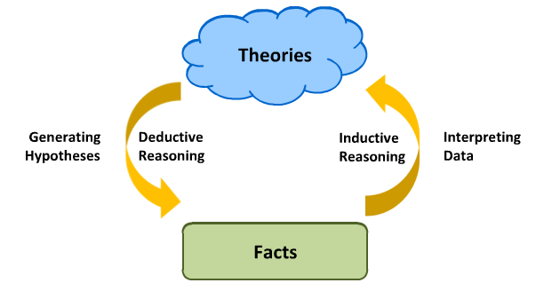
Arch of Knowledge:

- Insight Problem – designed to test your ability to think outside the box.
- Functional Fixedness – our difficulty seeing alternative uses for common objects.

History of Intelligence Testing:
- Reliability Test Quality Validity
- Reliability – a reliable test produces the same result if one person takes it multiple times.
- Validity – a valid test measures the trait it’s supposed to be measuring.

Galton’s Study:
- Increased reaction time = higher intelligence; reaction to sensorimotor tasks.

Binet’s Intelligence Scale:
- Had 30 simple tasks that could adapt to each age group.
- Later called the Standford-Binet Intelligence test.

Spearman & Generalized Intelligence:
- Called it “g”; intelligence is reflected in overall performance.
Gardner’s Types of Intelligence:
- 8 different types of intelligence, independent from one another.
- Lack of evidence; ignores Spearman’s findings on “g”.

Human Intelligence:
Weschler Scales of Intelligence:
- Originally modelled on Binet’s scale, but has been changed since.

IQ Scores:
- Standardized relative to the population scores.
- IQ scores surrounding mean are assigned around a perfect normal distribution with a standard deviation of 15.
  - Your IQ score is relative to the whole population.

- “Do the individual difference sin human IQ result more from genetic or environmental differences?”
Twins:
- Correlation between IQs of identical twins: +0.8 (strong correlation between scores).
- Correlation between IQs of fraternal twins: +0.6
- Shows that both genes/environment can influence intelligence.

The Flynn Effect:
- Observation that raw IQ scores have been rising since 1932.
- Population’s IQ is always 100; raw score that contributes to the 100 is rising.
- Increased quality of life is the best way to explain the Flynn Effect.

Piaget and Intelligence Development:
- Schema – mental framework for interpreting the world.
- Assimilation – incorporating new information into existing schemas.
- Accommodation – modifying existing schemas to fit in compatible information.

Piaget’s 4 Stages of Cognitive Development:
- Sensorimotor Pre-operational Concrete Operational Formal Operational
- Must be followed in that order; one can go faster or slower, but cannot skip a step.

Sensorimotor (0-2 years):
- One can affect change on their environment.
- Object Permanence – realization that objects continue to exist when no longer visible.

Pre-operational (2-7 years):
- Mastered object permanence; still needs to master egocentrism, seriation, reversible relationships, and conservation.
- More egocentric; does not fully understand the world from another perspective (mainly one’s own); shown through the “three mountain tasks” experiment.
- Also struggle with seriation (the ability to logically order a series of objects).
- Have difficulty with reversible relationships.
- Struggle with conservation tasks.

Piaget’s Three Mountain Tasks:
- 3 pictures; child asked to choose which one would be from another person’s perspective; usually are incorrect.

Concrete Operational (7-12 years):
- Can perform all the tasks from preoperational stage.
- Unable to think in abstract terms, or reason based on hypothesis.

Formal Operational (12+ years):
- Can think abstractly, and can do everything within the range of adult cognitive abilities.

Flaws of Piaget’s Theories:
- Décalage – some children go through these stages in a random order.
- Tasks that formed the stages relied too much on a child’s language abilities.

Biases and Heuristic:
- Confirmation Bias – tendency to seek out information that supports our hypothesis.
- Testing a hypothesis involves seeking data that could both confirm and refute it.
- Confirmation bias is lessened in more contextual scenarios.

- Availability Heuristic – tendency to make decisions based on the information that is most quickly and readily available to us.
- Representativeness Heuristic – tendency to assume that what we see is representative of the larger category we have in mind.
  - Ex. gamblers and winning history boards.

LECTURE:
- Functional Fixedness – bias limiting views to how an object is traditionally used.
- Intelligence – cognitive ability of one to learn from experience, reason well, remember important information, and cope with daily living; theoretical construct.
- Bounded Rationality – cognitive limitations prevent humans from being fully rational.

- System 1 – Fast thinking; uses bias, heuristics…
- System 2 – Slow, thoughtful…; useful for studying.

- Anchoring – the bias to be affected by an initial anchor, even if it’s arbitrary.
- Sets a ceiling for the highest price you will pay.

- Framing – bias to be systematically affected by the way in which information is presented.
CHAPTER 5 – LANGUAGE:
TEXTBOOK:
Components of Language:
Arbitrary Associations:
- Words used to represent concepts in language are made up and arbitrary.
- Same concept can be represented by different words in other languages.
- Onomatopoeia is an exception to this component, since the word represents an actual sound.

Productive:
- With the limited set of sound combinations and words in a language, a potentially infinite number of expressions can be made, including completely novel expressions.

Rule-Governed:
- Rules about what makes sense exist between languages, despite language’s productive nature.

Structure of Language:
- Linguists – scientists who study language.

Morphemes – The Symbols of Language:
- Symbols of language used to transmit information.
- Analysing the morphemic structure of language can reveal information about its origins and development.

Phonemes – The Building Blocks of Symbols:
- Morpheme that is broken up into its constituent sounds.
- Languages typically use a set of around 30 - 50 phonemes.

Grammar – The Rules for Constructing Sentences:
- Rules that govern how we put words together to form a sentence.
- Commonly understood, difficult to describe.

Semantics – The Meaning:
- The meaning that is produced through the use and/or combination of certain words and morphemes.

Language Development:
Age | Language-Related Skill
0 – 4 months | Turns head towards sound source; makes noise when spoken to; cooing; pragmatics.
6 – 12 months | Tries to imitate sounds; babbles.
12 – 17 months | Answers simple questions non-verbally; points; follows simple directions with gestures; 1 – 3 word sentences; holophrastic phase.
18 – 23 months | Follows simple verbal directions; asks for familiar items by name; combines words; imitates animal sounds; naming explosion; telegraphic speech.
24 months | Uses ~ 50 – 250 words.
2 – 3 years | Speaks in 2 – 3 word phrases; answers simple questions; begins to use plurals and past tense.  Vocabulary > 850 words
5 years | Understands >2000 words; uses longer sentences.
6 years | Understands >10 000 words; continues to develop sentence structure; fast mapping.

Universal Phonemic Sensitivity:
- The ability to discriminate between virtually all phonemes even before an infant learns language.
- Conditioned Head-Turn Procedure Examples:
  - A familiar phoneme is presented (repeatedly) – the infant loses interest The infant has habituated to the sound of the phoneme.
  - A novel phoneme is presented (following a familiar phoneme) – the infant shows no interest The infant is unable to discriminate between the phonemes.
  - A novel phoneme is presented (following a familiar phoneme) – the infant turns their head The infant can discriminate between the phonemes.
- Perceptual Narrowing – the loss of universal phoneme sensitivity; occurs when individuals begin to specialize in a language; suggests that this phenomenon us somewhat inherent, but shaped by early experiences.
  - Losing the ability to distinguish between contrasts in sounds not used in native language.
  - Our perceptual abilities are influenced by the stimuli to which we are exposed.
- Infant-Directed Speech – when people talk to infants, they tend to speak in a higher pitch, and exaggerate changes in pitch and use of rhythm.
  - The exaggerated changes in pitch helps infants discriminate between vowel sounds, aiding in t he learning of vowel sound categories.

Early Language Skills:
- Still-Face Procedure – adult looks at an infant while maintain a neutral facial expression.
  - 2 – 3-month-old infants will become distressed; shows that they have some sort of expectation about how face-to-face interactions should go.
- Cooing – pre-linguistic behaviour; parents can practice “conversational skills” by cooing back, or vocally responding to them.
- Pragmatics – the skills that allow children to communicate effectively in a social situation.
  - Develop throughout childhood and adolescence.
  - Holophrastic Phase – occurs at ~1 year; a single word is used to indicate the meaning of an entire sentence.
- Naming Explosion (Word Spurt) – when vocabulary expansion hits a rapid increase (~18 – 24 months).
- Fast Mapping – children learn the meaning of a word following 1 – 2 encounters with it (~6 years).

Receptive & Expressive Vocabulary:
- Expressive – the words that children use to speak.
- Receptive – the words that children understand, but do not necessarily use yet.

Further Characteristics of Language Development:
- Overextensions – using a specific word for a broader set of related items; include both semantic and syntax errors.
- Underextensions – a general term is used for a particular thing.
- Overextensions in production persist longer than overextensions in comprehension/
- Telegraphic Speech – short phrases that only contain crucial information that they are trying to communicate (like a telegram).
- Over-Regularizations – syntactic errors which involve using a grammatical rule too broadly.

Theories of Language Development:
- Social Learning Theory.
- Innate Mechanism Theory (Language Acquisition Device).

Interactionist Theories of Language Development:
- Combined role of nature and nurture.
- Children are biologically prepared for language, but also require extensive experience with language in the environment for adequate development.
- Three influences on language: biological maturation of the brain, social interaction, and cognitive preparedness.

MODULE:
- Language is: regular, arbitrary, productive.
  - Regular – regulated by the rules of grammar.
  - Arbitrary – sounds assigned to concepts are random; words arbitrarily represent meaning.
  - Productive – can be combined in many ways.

Whorf-Sapir Hypothesis:
- Language influences our perception of the world, alongside how we think.
  - Ex. Piraha tribe’s simplistic numbering system.
  - Counter-evidence – relative labels in different countries.

Structure of Language:
- Morpheme – smallest unit of sound that contains some sort of information; can be a single word, or a multiple morpheme word.
  - Each provides a chink of information about a word.
  - Ex. Ta ble, table cloth, table s .
- Phoneme – smallest units of sound in a word; the broken-down sounds of a morpheme; ck-, ai-, kn-, oo- …
- Syntax – rules that dictate how sentences should be composed; grammar.
- Semantics – the meaning of a word (noun, verb, etc…).

Language Development in Infants:
- 12 weeks – “cooing” sounds.
- 16 weeks – responds to outside voices.
- 6 months – imitates sounds.
- 1 year – “babbles”.
- 2 years – 50 -250 words; 2-word phrases.
- 2.5 years - >850 words.

Babbling:
- Drawn-out sounds made up of repetitive vowels/consonants in combination.
- Inflection/rhythm makes it seem like a question/response.
- Combinations eventually become real words.

Language Explosion:
- 1 ½ - 6 years: major increase in vocabulary, mastery of various aspects of language; syntax complexity improves.

Segmentation Problem:
- Someone speaking another language can sound like it’s being spoken quickly.
- Infants who have good speech segmentation skills have larger expressive vocabularies as children.
- Can lead to screening tests to predict future language development issues.

Universal Phonetic Sensitivity:
- Ability of infants to discriminate between various sounds that they might encounter in a test; includes “foreign” sounds.
- Infants can distinguish more phonemes than adults.
- Children develop phonemic sensitivity based on the language they grew up with.

- Head-Turn Procedure – measures perception of phonemes.
- Infants perform equally as well as native speakers when distinguishing between foreign phonemes.
  - Disappears by the end of their 1st year living.
- Adults need more practice than infants to find phonemes in a new language.

Theories of Language Development:
Social Learning Theory:
- Children learn language through imitation/operant conditioning; “nurture” component of language.
- Lack of early social interaction leads to a less-developed set of language skills.
  - Counter-argument – children learn language too quickly to be solely influenced by social interaction.

Overextensions & Underextensions:
- Overextensions – rule applied too broadly; improper grammar, using a specific label for too general a group.
- Underextensions – rule applied too specifically; meaning only applies to one object/thing.

Innate Mechanism Theory:
- Also known as a Language Acquisition Device (LAD) – innate mechanism that helps for language to develop based upon universal rules; only humans.
- All languages follow fundamental, underlying, rules; ex. sign language.
- Infants’ brains are wired to listen to speech, even if they don’t understand language.

Animal Communication:
The Waggle Dance – Bees:
- Communicates the location of food for other bees.
- Waggle Phase – distance of waggle = distance of food; angle of waggle = direction of food.
- Return Phase – returns either to left or right, forming a figure-8 pattern.

Bird Song – mate attraction and competition.

Washoe:
- Demonstrates differences in animal vs. human communication.
- Could use signs to communicate, but not systematic grammar.

Sarah:
- Taught to use symbols to communicate, and answer simple questions.
- Could not combine phonemes, or form sentences.

Kanzi:
- Used lexigrams to communicate.
- Used full immersion (learning by observation) instead of classical conditioning.
- Could communicate some novel requests, but had limited grammar.
- Language is a defining characteristic of human cognition.
LECTURE:
- Language – complex system; allows us to share details/emotions with others.
- Rules of Making a Language:
  - Grammar (clear rules) – syntax/morphology.
  - Lexicon – meaningful descriptions.

Neuroscience of Swearing:
- Activates right hemisphere (area associated with negative emotion).
  - Basal Ganglia – where swears are produced.
  - Amygdala – where we “hear” them.

4 Categories of Swearing:
- Supernatural – religious; emotions of awe/fear.
- Body Effluvia/Organs – emotions of disgust.
- Disease/Death/Sickness – emotions of dread.
- Sexuality – negative emotions; exploitation, incest, jealousy…

QUIZTERM CONTENT – THE SCIENCE OF LEARNING:
JOURNAL:
- Cramming, rereading, highlighting; considered ineffective strategies.
- Curricula are more focused on providing content – not showing students how to effectively learn it.
  - Emphasis on what needs to be learned, not on how one should learn the content.
- Current textbooks do not cover effective learning strategies.
  - Strategies taught to professors have little benefit in any event.

Learning Strategies Addressed:
- Practice Testing – self-testing/ taking practice tests on material that will be learned.
- Distributed Practice – making a study schedule that spreads content out over time.
- Interleaved Practice – a practice schedule that mixes different kinds of problems or content reviewed in a study session.
- Elaborative Interrogation – creating an explanation for why a fact is true.
- Self-Explanation – explaining how information relates to each other, or the steps of problem solving.
- Rereading – restudying text material at least once more after an initial read.
- Highlighting & Underlining – marking important parts of content when reading through it.
- Summarization – creating summaries of the content.
- Keyword Mnemonic – keywords/mental images associated with the content.
- Imagery for Text – forming mental images of text materials while reading.

Most Effective Strategies:
- Practice testing and distributed practice.
- Help students regardless of age; enhance learning/comprehension of a large range of materials, boost student achievement.
Practice Testing:
- Boosts long-term memory; unlike simply reading a text, when students correctly retrieve an answer from memory, the correct retrieval can have a direct effect on memory.
- Practice tests can help students make better decisions about what needs further practice, and what does not.
- Helps students make better decisions about what needs further practice, and what does not.
- Students benefit most from tests that require recall from memory, not tests that ask them to recognize an answer.
- If retrieving information from memory, does not require creating a bank of test questions to serve as practice tests.
- Students should be encouraged to take notes in a manner that will foster practice tests.
- As the material becomes more complex, teachers should encourage students to write down the answers when they are testing themselves.
- Students should continue to test themselves until they correctly recall each concept at least once from memory.
- The more closely the practice questions tap the same information that will be tested on the in-class examination, the better students will do.

Distributed Practice:
- Massed Practice – practicing something multiple times in succession, and then moving on to something else while repeating the same process.
- Students will retain knowledge and skills for a longer period of time when they distribute their practice, compared to when they mass it, even if they use the same amount of time massing and distributing their practice.
- Learning feels more difficult when using distributed practice, but it is essential for keeping knowledge over longer periods of time.
- D.P. used in real life through various situations, yet many do not use it to work towards mastering the course content.
- Each study block will be smaller than an all-night cram session, and would involve studying (and using practice tests) for material that was recently introduced in class, and for material studied in previous sessions.
- Repeating key points in a lecture emphasizes the most important content, along with giving students distributed practice.

Strategies with Much Promise:
- Might be effective, but more research is needed to fully clarify.

Interleaved Practice:
- Distributing practice across a study session, while varying the order of the content you study.
- Improves student achievement, specifically in problem solving.
- Those who interleaved did 3x better on an exam than those who mass practiced.
- Slows learning, but leads to greater retention.
- Require distributing practice, which is proven to benefit one’s studying.
- Also forces students to identify and evaluate problems, while massed practice allows one to pass over that aspect.
- Interleaved practice does not seem to help in areas surrounding language and grammar.

Elaborative Interrogation & Self-Explanation:
- Elaborative Interrogation – explaining why a certain piece of content is true, even if the explanations are not entirely correct.
- Self-Explanation – relating new information to knowledge that one already knows; explaining to yourself why you made a particular decision.
- Success rate of solving problems did not change for those self-explaining compared to those who don’t; though it did change for the better when approaching a new problem.
- Both methods encourage students to actively process the content they are studying, and compare it to prior knowledge.
- Majority of research conducted on elaborative interrogation has been conducted on isolated facts instead of bunches of content.
- To take full advantage of self-explanation: you need to self-explain and not paraphrase what they are learning.
- Issues:
  - Those who have no idea about this new content could find it difficult to use elaborative interrogation.
  - As a result, not as useful for younger students who may not have as broad of an academic career as someone who is older.

Less Useful Strategies (Most Used by Students):
Rereading and Highlighting:
- 84% of students studied by rereading their notes/textbooks.
- Any benefits of rereading may not be long-lasting, nor may it enhance one’s understanding of the content.
- Highlighting - by focusing on individual concepts while highlighting, students may have spent less time thinking about connections across concepts.

Summarization:
- Paraphrasing the most important ideas within a text.
- Shows some success in helping undergrads learn, but needs extensive training in order to work effectively.

Keyword Mnemonic & Imagery for Text:
- Imagery – developing internal images that help to elaborate on what one is studying.
- Increases retention of the material being studied, especially when being tested shortly after; however, only lasts a short time, and cannot be widely applied.

Tips for Using Effective Learning Strategies:
- Give a low-stakes quiz at the beginning of each class, and focus on the most important material.
- Give a cumulative examination, which should encourage students to restudy the most important material in a distributed fashion.
- Encourage students to develop a “study planner”, so they can distribute their study throughout a class, and rely less on cramming.
- Encourage students to use practice retrieval when studying instead of passively rereading their books and notes.
- Encourage students to use practice retrieval when studying instead of passively rereading their notes.
- Encourage students to elaborate on what they are reading, such as by asking “why” questions.
- Mix problems from earlier content with new ones (if applicable), so that students can practice identifying problems and their subsequent solutions.
- Tell students that highlighting is fine, but only the beginning of the learning journey.

MODULE:
- Cognitive Psychology – field that studies learning and memory scientifically.

Where to Study:
- Multi-Tasking – simultaneous completion of two or more tasks.
- Brains are not wired to multi-task; we switch between multiple tasks, and perceive it as being more efficient, even though it decreases overall efficiency.
- “Impairments associated with using a cell phone while driving can be as profound as those associated with driving with a blood-alcohol level of 0.08%.”
- To counter distraction:
  - Find a quiet location with little to no distraction.
  - Keep snacks nearby so you don’t need to get them.
  - Keep devices away from your work area.
  - Use special software to keep you on track if you use electronics.
  - If you take a break, focus on that; if you’re working, focus on that.

Pomodoro Technique:
- 25 minutes of focussed working, without distraction, with 5 minutes of break after each “session”.
- After 4 cycles of this, take a 30-minute break.
- Goal is to go long periods of time without task switching, while preventing burnout.

When to Study:
- Spacing Effect – by distributing learning over time, one can learn content in less total study time; founded to Hermann Ebbinghaus.
- Distributed approach to practicing harnesses the spacing effect; allows more learning per unit time.
How to Study:
- Sleep strengthens memories and promotes problem-solving.
- Repeated Exposure – rereading, highlighting… 81% of students use this strategy.
  - Leads to rapid learning in the short-term; helpful if cramming the night before an assessment, and if said assessment involves low memorization.
  - Intuitive way to study, and makes us feel like we’re learning.

- Retrieval Practice Effect – describes how studying some information, attempting to retrieve it from memory, and then re-studying it, leads to better long-term memory than the equivalent amount of time simply studying.
  - Active Memory Search – using retrieval practice strengthens the connections between the new bits of knowledge and the correct answer; creates a more coherent network in memory that is less vulnerable to being forgotten.
- Tips:
  - Cover up your notes while retrieving.
  - Space out your retrieval practice.
  - 3x3 rule of thumb – studying until you can retrieve the information three separate times within the same study session; then retrieving the information three times over multiple study sessions.
    - Has a good balance between spending the least amount of time studying, and retaining the information on a long-term scale.
  - Mixed Practice – mixing up topics while studying enhances learning.

- Desirable Difficulties – slow down learning at first, but ultimately improve understanding and long-term memory.

CHAPTER 6 – CATEGORIES:
MODULE:
- Attention – helps to focus a limited amount of mental resources on important parts of an active scene.
- Memory – helps to recall specific thoughts/behaviours which tailor to your current situation.
- Without the cognitive ability to categorize, every sensory experience would be completely unique.

Functions of Categorization:
- Classification – groups different objects into the same category.
- Understanding – identifying the intentions of a situation.
- Predicting – uses past experiences to know what to expect.
- Communication – uses specific words to describe ideas efficiently.

- Illusion of the Expert – the feeling that a task must be simple for everyone because it is simple for oneself.

Rules:
- Humans have an internal representation of categories that is independent of the rules we try to define.
- People are not able to define simple rules for more complex categories.
- The number of people who can identify rules for categories decreases as the complexity of the category rises.

Prototype Theory:
- We categorize objects by comparing them to an internal “best” representation of a given category; average of your experiences.
- New objects compared to the average representation in prototype theory.
- Category members that are closer to the prototype are categorized quicker and easier than atypical category members.
- Cannot explain why internal representations change over time.
- Single case is blended into the averaged prototype; has little to no effect.
- Explains simple categorization better than exemplar theory.

Exemplar Theory:
- We categorize objects by comparing them to every previously-stored experience (exemplar) in a given category; store a lifetime worth of experiences.
- Any increase to the number of relevant exemplars would improve categorization performance.

Development of Categorization:
- Children as young as 3 are able to understand general categories.
- Category Membership – members of the same categories share similar characteristics.
- Children can understand hypothetical categorization as well.
  - Also have an understanding of the innate properties of a category.

Animal Categorization:
- Baboons can be taught to classify objects with high accuracy, and how to classify using more abstract rules (same vs. different).
- Animal categorization may not necessarily demonstrate language ability.

Dermatologists Study:
- Showed that diagnostic accuracy was highest for conditions that the dermatologist had seen and diagnosed recently, supporting the exemplar theory.

ARTICLES:
Don’t Know Much of Biology:
- Showed a group of college students a long list of words in order to see how quickly and accurately the volunteers used movement and naturalness to classify these things as living or non-living.
- Had trouble classifying plants, and moving things in a general sense; both college students and professors with specializations in Biology has this issue.
- Children have an urge to see the world as designed and simple, and to be the centre of it all.
- We tend to associate motion with life, although they are not always paired.

Are Our Brains Wired for Categorization?
- The visual cortex’s organization around processing animate and inanimate objects is similar in sighted and blind people.
- The wiring system that connects different areas of the visual cortex with appropriate regions in the rest of the brain is innate; does not have to form gradually based on visual inputs.
- The organization of the brain has to be understood in terms of our evolutionary history.

LECTURE:
- Ability to form concepts/categories allows efficient navigation through the world.
- 3 Levels of Category Distinction:
  - Basic – most common; most abstract level that objects have similar shapes; about the same reaction time for an expert and a novice.
  - Superordinate – more general; high accuracy, low predictive power.
  - Subordinate – more specific; low accuracy, high predictive power.
- Expertise determines speed of category verification.

- A new exemplar is classified by its similarity to the prototype.
- Typicality infleunces verification times.
- Prototypes can be directly formed through instruction, or indirectly through inductive learning.

CHAPTER 7 – ATTENTION:
TEXTBOOK:
- Flashbulb Memories – vivid experiences; have a “live” quality feeling.
- We remember what we pay attention to, and our attention is shaped by what we remember.
- Psychologists are studying how attentional processes are guided by:
  - Focussing limited mental resources on the immediate task.
  - Monitoring ongoing stimuli to evaluate their potential significance and shifting the allocation of mental resources when necessary.

Tools to Measure Attention:
- Cocktail Party Effect – despite competing background noises, a listener can focus on a single channel, and still pick out relevant salient information from the background.
- Dichotic Listening Paradigm – headphones worn; different messages played to each ear.
  - Participant has to shadow (repeat) what is said in the attended ear.

Bottom-Up and Top-Down Processing:
- Bottom-Up Processing – stimulus-driven mechanism in which attention is captured by salient change in the environment; automatically-captured attention; automatic nature.
- Top-Down Processing – purposefully capturing attention; one can strategically direct their attention to match their expectations from experience through memory; controlled nature.

Orienting and Spatial Cueing Paradigm:
- Orienting – the act by which attention moves across a scene.
- Spatial Cueing Paradigm – allows the experimenter to measure shifts in attention in the absence of eye movements.
- Overt Attending – where you are attending is also where you are looking.
- Covert Attending – where you are attending is not where you are looking; invisible shifts of attention.
  - Measured in the efficiency with which targets are detected at cued locations.
- Inhibition of Return (IOR) – occurs when you try to redirect your attention to a previously attended location, where a target was not found.
  - If the time between the cue onset and the target is greater than 300 ms, you are slower to detect the target at cued locations than uncued locations.
  - Prevents your gaze from revisiting areas that are irrelevant to your attention.

Visual Search Paradigm:
- Models how we search for items in our environment.
- Pop-Out Effect – bottom-up capture of attention due to the salience of the physical attributes of the target.
  - Time it takes to respond is independent of set size; processing of items happens in parallel.
- Conjunctive Search – trying to find a target based upon multiple features.
  - Response time increases with set size.
- Contextual Cueing:
  - Schemas – a representation depicting the range of plausible objects and likely configuration of those objects within particular scenes.
  - Suggests an implicit memory mechanism, since your memory for the global spatial configuration of the display from your memory provides context in finding your target.

Unattended Items:
- Some participants who took part in the dichotic listening paradigm reported no explicit memory for unattended message content.
- Word meaning may be processed pre-attentively (before attention is committed).

Inattentional Blindness:
- Our limited attentional processes can be susceptible to missing out on important/salient information.
- We are faster at detecting the change if we know which part of the image is changing.
- Change Blindness Paradigm – illustrates the important role of attention in perceiving change.

The Stroop Task:
- The automatic process of word reading interferes with the ability to name the coloured ink when the word and ink colour are incongruent.
- No all complex processes require attention; numerous experiences/practice with tasks allow us to perform them almost automatically.

Models of Attention:
- Spotlight Model of Spatial Attention.

Filter:
- Early-Selection Theory: Broadbent’s Model:
  - Physical characteristics of sensory information are briefly stored/analyzed.
  - Incoming information goes through a bottleneck which selects a limited amount of the information to pass on for further processing.
- Attenuation Theory: Treisman’s Model:
  - Unattended information is “turned down”; all information passes through, but with different “weights” depending on whether the information is physically similar to the target or not.
- Late-Selection Model:
  - Filter placed after all of the incoming information has been analyzed for physical/semantic content.
  - Only selected information is maintained, so the unselected information fades.
- Last 2 models may be able to account for the cocktail party effect.

MODULE:
- Phenomenon Model Hypothesis

William James’ Definition:
- “… taking possession by the mind in clear form, of one out of what seem several simultaneously possible objects or trains of thought.”
- “… withdrawal from some things in order to deal effectively with others.”

- Selection – act of attending to an object to select it apart from the unattended objects; ex. light flashing in periphery.
- Attention (alternate definition) – one’s conscious ability to attend to the information that is relevant to our goals.
- Irrelevant information acts as “noise” that makes it difficult to attend to the important information.
- When irrelevant information overwhelms us, we get distracted.

Automatic and Controlled Attention:
- Automatic Processes – involuntarily capturing attention through being triggered by external events; fast, efficient, obligatory.
- Controlled Processes – voluntary, conscious attention to objects of interest; slow, effortful (due to more cognitive effort); ex. driving (changing lanes, stations, etc…).
- Our attentional resources are limited, and must be controlled carefully.

- Salient Information – found in automatic processes; information that captures our attention automatically, intentionally or not.
- Consciously effortful tasks can be come automatic through practice.

The Spotlight Model (Michael Posner):
- Attentional “spotlight” focusses on one part of the environment at a time.
- Can be consciously directed across a visual scene; can also be taken over by unconscious processes that quickly grab your attention.
- Objects within the spotlight = faster reaction time, higher accuracy.
Cuing Paradigms:
- Cuing to target can ease the fluency of processing at that location.
- Test the automatic processes of attention.
- Participant determines whether a star appears in the left or right box on a screen.
  - Box that flashes may not contain the star.
- Flashing box automatically attracts the attentional spotlight to the cued location.
  - If target is in cued location: attention will amplify the perceptual processing of the target (detected quickly).
  - If target is in uncued location: target detected slower, since attentional spotlight is directed elsewhere.
- Attention does not immediately rely on sight; attentional spotlight can still miss important information.

Filter Models:
- Audio cues are used to filter target sounds from background noise.
- Cocktail Party Effect – the ability to separate target sounds from background noise is based on physical characteristics (gender, pitch, speech speed…).
- Filters suppress noise; spotlights enhance stimuli.
  - Information Filter Further Processing.
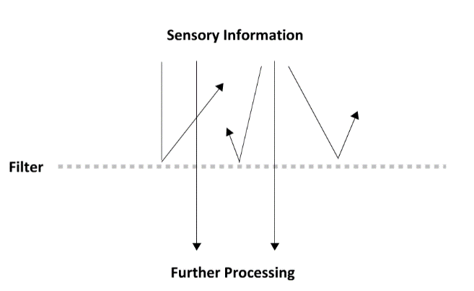
Single Filter Model (Donald Broadbent):
- Attentional filter selects important information based on physical characteristics; allows the information to continue on for further processing.
- Information that does not pass through the early physical filter is deemed “unimportant”.
- Accepts less information than dual filter model.

Dichotic Listening Paradigm:
- Different messages in each ear; attended ear message must be shadowed back to the experimenter.
- Subjects remember nothing about unattended information.
- Information going through attended ear goes to deeper processing.

Von Wright et al.:
- Some information can still be processed, even when unattended to.
- Conducted an experiment to test this theory:
  - 1st Part: classical conditioning paradigm – shock whenever a particular word is said.
  - 2nd Part: dichotic listening paradigm – words said in both ears.
    - Participants reacted to these words in both the attended and unattended ears.
- Some unattended information can pass through the filter; disputes Broadbent’s prediction.
Dual Filter Model (Treisman):
- Two filters: one physical, one semantic.
  - Physical – information processed based on physical cues; weighs importance of incoming stimuli against physical cues.
  - Semantic – information processed based on meaning; accounts for:
    - Weights assigned by the physical filter, deeper meaning, relevance of stimuli.
    - Then chooses which information should be attended to.
  - Explains Broadbent’s findings from D.L. Paradigm, alongside how breakthrough and Von Wright’s findings apply.
- Semantic filter can override the physical filter’s decisions, through considering the meaning of information.
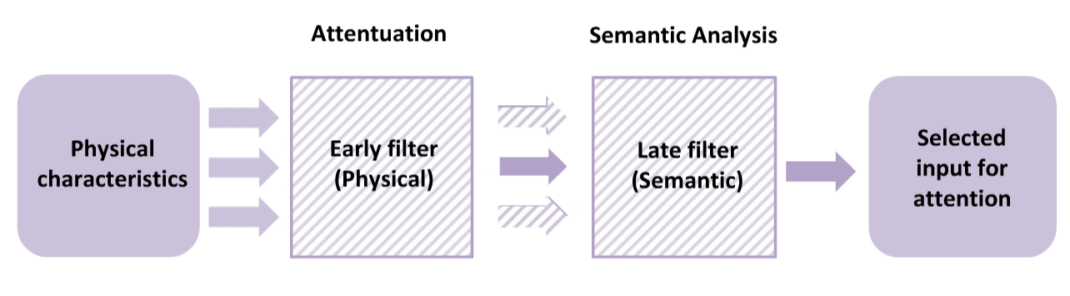

- Breakthrough Effect – participants remember unattended information, especially when it is highly relevant (ex. name).

- Cocktail Party – can be explained by both single and dual filter models.

- Both Filters – decreased processing of irrelevant information.

The Stroop Task:
- Requires you to focus your attention on ink-colour (relevant to task), while ignoring the word itself (irrelevant task).
- Congruent Items – contain matching word/colour dimensions; “red” written in red.
- Incongruent Items – contain mismatching word/colour dimensions; “blue” written in green.
- Congruent elicits a faster response than incongruent.
- Attention is facilitated by stimulus relevance.
  - Congruent Trials – facilitates colour naming performance.
  - Incongruent Trials – interferes with colour naming performance.

- Proportion Congruent Manipulation – change the ratio of congruent:incongruent trials.
  - Ex. 75% congruent, 25% incongruent increased Stroop effect.
- High congruency tests bias attention to task-irrelevant information.
  - If a strategy develops for congruency trials, it would cause one’s results to suffer on incongruent trials; larger Stroop effect.
- Low congruency tests bias attention to task-relevant information; ex. actively ignoring the words since most will not match the colour low Stroop effect.
- Automatic Evidence – word reading influences performance, even when the word is ignored.
- Controlled Evidence – adopting consciously-controlled word reading strategies can change the Stroop effect.
- Word Reading = Automatic Process (fast).

Visual Search Tests:
- Test how we use everyday attention; looking for a specific target within multiple distractions.
- Set Size – the number of items to search through.
- Set Size Effect – increase in difficulty as set size increases.

- Single-Feature Search Task – looking for only one particular feature to identify the target.

- Pop-Out Effect – single feature; object of a visual search is easily found, regardless of size; ex. colour.
- Conjunctive Search Task – identifying a target defined by 2+ features.
- Contextual Cuing – helps to search more efficiently; gained through knowledge of our environment.
LECTURE:
- Vigilance – ability to maintain attention.
- Change Blindness – even with directed focus, attention limits lead us to miss information.
- Attention is a dialogue between bottom-up and top-down processing.
  - Bottom-Up – external environment; facts, surroundings…
  - Top-Down – internal thoughts; bias, ideas…
- Hemispatial Neglect – paying attention to only half the world; affects reality, memories…
  - Damage to the right parietal lobe.
  - Left hemisphere attends to right side; right hemisphere attends to both sides.
  - If left parietal lobe damaged: right still accounts for attention of both sides.

CHAPTER 8 – MEMORY:
MODULE:
Problems with Memory Metaphors:
Data:
- Stored data is identical to inputted information.
- Retrieved data is identical to inputted information.

Memory:
- Stored memory includes personal details and interpretations.
- Retrieved memory may be altered or lost.

- Forgetting – stored memories are frequently lost as time passes.
- Data does not equal memory.
  - Several people watching the same event will usually remember it differently.
  - Memories can change, and be forgotten over time.

The Basics of Memory:
- Psychologists study how memory is acquired, encoded, stored, and retrieved.
  - Acquisition & Encoding Storage Retrieval
- Cue-Response Mechanism – one memory acts as a cue to trigger another memory.

Herman Ebbinghaus:
- Memory is a serial learning task.
- Each word connects the word before and after it; like pearls in a necklace.
- Our ability to recall recently encoded information decreases rapidly over time.
  - Ability to recall words was highest immediately following learning.
- Forgetting Curve – total forgetting always increases; rate of forgetting decreases over time.

- Models – describe/organize data; make specific hypotheses that are studied through controlled experiments in the lab.
- Basic Memory Task:
  - Encoding Phase – subject learns a list of items, words, or pictures.
  - Retrieval Phase – subjects are tested for their memory of the items presented during the encoding phase.
    - Recall Test – generate as many items as one can remember; not given any external cues.
    - Recognition Test – several items shown; asked to mark whether each item is new or old.

Multi-Store Model:
- Proposed by Atkinson & Shiffrin.
- Memory is composed of short and long term storage systems.
- Short-Term Memory Buffer – available for a short period of time; not stored permanently; information can be transferred to long term memory through rehearsal.
- If LTM and STM represent separate stores of memory that interact dynamically, changes caused by manipulating specific variables can be isolated.

George Miller:
- Short Term Memory Capacity – 7 ± 2 items.
- Organizing items into meaningful chunks expands the capacity of short-term memory.

The Serial Position Curve:
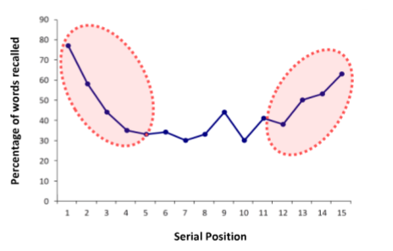
- Memory is strongest for items at the beginning and end of a list.
- Primacy Effect – occurs when there is increased rehearsal of early items over later ones.
  - Items at the beginning of the list enter STM first, and have the most opportunity to be rehearsed.
  - Greater change of being transferred into LTM.
- Middle of the list have less opportunity for rehearsal/LTM transfer than those at the start.
- Recency Effect – least opportunity for rehearsal/LTM transfer, but recall is high.
  - The more recent items replace the previous items to occupy short-term memory.

Improving Primacy:
- Primacy effect is enhanced when using a longer time interval, relative to a shorter time interval between presented items.
- Increasing time between item presentations increases:
  - Amount of times each item can be repeated.
  - Probability of item being stored in long-term memory.
  - Performance recalling first couple of items.

Diminishing Recency:
- A manipulation that causes the most recent contents of the STM to be replaced/disrupted neutralizes the Recency Effect.
- Disrupting the short-term memory buffer affects the Recency Effect.
- Performing a distracting task diminishes the Recency Effect.
  - Distractions require STM resources; causes the most recent items to be disrupted from the STM buffer.

Levels of Processing Principle:
- Memory performance depends on the level at which items are encoded; improves for increasingly deeper levels of processing.
- The more we try to organize and understand the material, the better we remember it; paying attention to surface details leads to poorer recall.

Shallow Level:
- Encode physical characteristics.
- Encoding requires little effort.
- Poor memory performance.

Deeper Level:
- Encode semantic characteristics.
- Encoding requires significant effort.
- Better memory performance.

- When processing was manipulated during encoding…:
  - Shallow / Physical – is the word in capital letters?
  - Moderate / Acoustic – does the word rhyme?
  - Deep / Semantic – does the word fit in a sentence?

Encoding Specificity:
- Memory encodes all aspects of an experience; the context that we learn information in is encoded along with the information itself.
- Environmental cues are encoded together with memories for items and events.
- Preserving encoding context improves subsequent recall of a memory.

Memory Illusions and Fluency:
- Loftus – our susceptibility to false memories indicate that memory is a reconstructive process.
- Repeated imagination of any event can lead to the event being falsely remembered; can confuse false events with actual events.
- Memory is reconstructive; open to re-interpretation.

- (Processing) Fluency – the ease with which an experience is processed; some experiences are more fluent than others.
- Familiar experiences processed more fluently than novel (new) experiences.
- Attribution – judgment tying together causes with effects; used to make sense of fluency.
- The time between exposure and recall affects our attributions to fluency.

- Memories exist by reconstructing them when we need to remember them.
- Bartlett – memory is building blocks that are made up of perception and experience.

TEXTBOOK:
3 Processes of Memory:
- Encoding – how information initially enters into memory; highly dependent on attention.
- Storage – how the record of memory is maintained over time; can be modified.
- Retrieval – recovering stored information; dependent on retrieval cues (information that triggers memory).
- Cues integrated during memory encoding.

Sensory Memory:
- Transient maintenance of perceptual and physical information from the recent past; not limited by attention.
- Iconic Memory – visual information; represented by the visual system.
- Echoic Memory – auditory information; represented by the auditory system.
- Sensory memory decays at an extremely fast rate.
Short-Term (Working) Memory:
- Unrehearsed selected information stays in STM for ~20 s; rehearsed (repeated) information stays for longer.
- Chunking – information is organized into sets of familiar groups of items; increases STM.

Working Memory:
- Upgrade to the original conceptualization of STM; has three stores:
  - Phonological Loop – maintains information that can be rehearsed verbally.
  - Visuospatial Sketchpad – temporarily represents/manipulates visual information.
  - Episodic Buffer – draws on the other buffers alongside other stored LTM.
- Central Exclusive – coordinates and manipulates information that is maintained in the buffers; allows for working memory to be more flexible than short-term memory.

Long-Term Memory:
- Once information is transferred from STM into LTM, new information is organized according to prior knowledge.
- Concepts that are more closely related are more directly connected.
- Information transferred both ways; ex. remembering the past (LTM to STM).
- Past memories largely linked to attention (top-down control).
- Schemas – mental frameworks for interpreting the world around us based upon prior experiences.

Long-Term Memory Systems:
- Declarative Memories – memory from factual information.
- Semantic Memories – information not tied to a specific place or time.
- Episodic Memories – tied to a particular place and time.
- Non-Declarative Memories – learned actions and procedures, skills, implicit memories…; difficult to explain.

- Hippocampus is vital for STM memory and trace formation, but LTM processes are apparent throughout the cortex.
  - Hippocampus still important for the coordination of memories for activation in consciousness.

Effect of Rehearsal:
- Free-Recall Paradigm:
  - Participants study a list of words presented one at a time; each word represents a specific spot in the list.
  - Greater recall of words at the beginning and end of the list.
- Primacy Effect – reflect retrieval of words from LTM.
- Recency Effect – retrieval of words from STM.
- STM relies on rehearsal; LTM does not.
- Sensory memory perceives sensory information which is selectively held online by STM and with rehearsal through STM components may be transferred and stored in LTM.
Levels of Processing:
- Memory not divided into separate stores; more like a continuum.
- Items encoded at a deeper level last longer in memory than at a shallower level.
- Vague model; does not go in-depth about what a “deeper” level is.

Enriched Encoding:
- Mnemonic Strategy – information encoded with yourself in mind is better remembered than if you had someone else in mind; also known as the self-referent effect.
- Reflects the deepest level of processing.

Encoding Specificity:
- The effectiveness of the context as a cue is largely dependent on the specificity of its relations to the item.
- Memory is better for items encoded and retrieved in the same environment.

Transfer-Appropriate Processing:
- Memory is aided when similar processes are engaged at encoding and retrieval.
- Words processed in semantic sentences are better remembered than those in rhyming sentences.

Forgetting:
- Reduces the potential interference from out-of-date memories; allows for more efficient remembering of current information.
- Memory Savings – difference in the time it takes to memorize a list at test vs retest (Ebbinghaus).
- Decay Theory – memories fade with time; explains STM loss, but not LTM loss.
- Interference – a cue that was once associated with one memory is now associated with another, making it more difficult to retrieve the original memory.

Proactive Interference:
- Old info interferes with retrieval of new info; ex. old memory from French interfering with the retrieval of one’s newer memory for Spanish words.
- Experimental group reads lists A and B; control group reads B.
  - Proactive interference in play if the experimental group remembers fewer words than the control group.

Retroactive Interference:
- New information interferes with the retrieval of old information.
- Experimental group studies lists A and B; control group studies list A and is distracted.
  - Both groups recall words from list A; retroactive interference occurs if the experimental group remembers fewer words than the control group.

Temporary Forgetting:
- Tip-of-Tongue State – often occurs for people’s names and common words.
- Words that induce this state in the past will do so in the future; word is more associated with error-prone process each time it’s in this state.

Repression:
- Freud – horrific memories can be repressed as a defence mechanism.

Memory Errors:
- Misinformation Effect – creation of false memories by incorporating new erroneous information with an old memory.

Source Confusion:
- Source Monitoring – process by which we make attributions about the origins of memories.
- Source Monitoring Error – failing to recall exactly where you learned this information.
- False Fame Effect – incorrectly judging a name as being famous because it seems familiar (fluently processed).
- Reality Monitoring – ability to discriminate real memories from those that are imagined.

LECTURE:
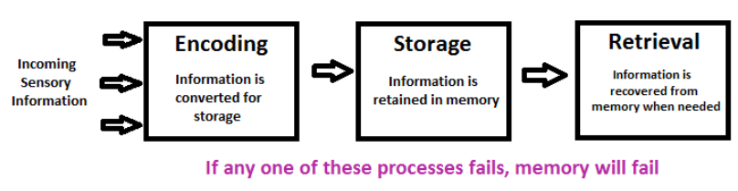

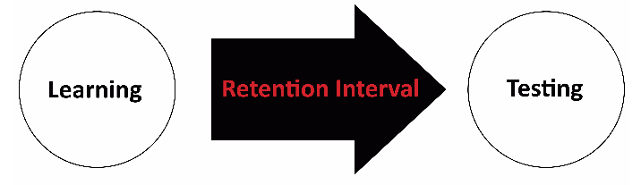
- Lineup – non-suspects should fit the eyewitness’ description of the suspect.

CHAPTER 9 – FORMING IMPRESSIONS:
- Conscious/unconscious judgments you make lead to social perceptions.

Attribution Theories:
Correspondence Inference Theory:
- Uses the variables listed below in order to infer about a situation.
  - Degree of Choice, Expectation, Intended Consequences.

Expectation:
- Whether a behaviour is common or atypical.
- Uncommon behaviour gives one more information than common; more information available to infer a cause to said behaviour.

Degree of Choice:
- Considering to what degree a person had a choice in the way they act.
- Ex. being assigned to a certain topic in a debate, vs. genuinely believing in that stance.
- Strong degree of choice = unassigned; choice of the person.

Intended Consequences:
- Intentions and motives behind a certain behaviour.

Covariation Theory:
- Personal or situational circumstances that can be attributed to one’s behaviour; determined through three variables.
  - Consistency, Distinctiveness, Consensus.

Consistency:
- Does one usually behave like this in this particular situation?

Distinctiveness:
- Does one’s behaviour vary depending on the situation?
- If Yes Situational; if No Dispositional.
  - Situational – driven by the situation.
  - Dispositional – driven by the individual (inherent qualities of said person).

Consensus:
- Do others behave in a similar manner when presented with this situation?
- If Yes Situational; if No Dispositional.
  - Situational – this situation similarly influences everyone.
  - Dispositional – due to each individual’s disposition.

Fundamental Attribution Error:
- The tendency to over-value dispositional factors for the observed behaviours of others while under-valuing situational factors.
- Rely more on dispositional factors than situational factors for interpreting behaviour.
- Usually used when determining the cause of someone else’s behaviour rather than your own.
- FAE – behaviour of others are due to dispositional factors.
- Actor Observer Effect - considering the situational factors of your own behaviour; assume the individual’s behaviour is typical.
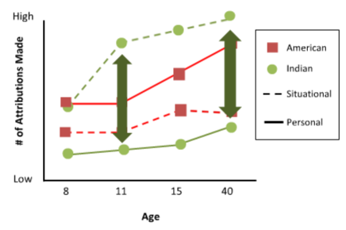
Cultural Differences:
- American 8 & 11 year olds – attributed behaviour to personal/situational causes in the same ratio.
- American Adults – attributed behaviours to personal factors more often than situational.
- Indian 11 Year Olds & Adults – more situational than personal attributions.

- FAE diminished in collectivist societies; less focus on individual behaviour, more on relationships/roles in society.

Self-Serving Bias:
- Tendency to perceive yourself favourably.
- Above-Average Effect – dispositional causes for your successes; situational causes for your errors.
  - Ex. card game – if you win: attribute it to personal strategy; if you lose: attribute it to poor dealing.
- Positive Events – “actors” select dispositional explanations; observers select situational explanations.
- Negative Events – “actors” select situational explanations; observers select dispositional explanations.
- We are biased in believing we are above average on things that matter to us.

Cognitive Heuristics:
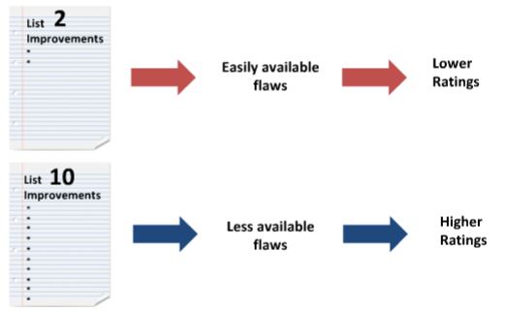
- Accelerate the processing of social situations; helps to make quick decisions about information from the environment.
- Representativeness Heuristic – how one’s behaviour fits with a certain prototype.
- Probability is often discounted in favour of a representative prototype.
- Availability Heuristic – considers the experiences most readily available in memory.
- Availability of flaws in memory influences our perception of an experience.

Relationships:
- Attractiveness – has a positive impression on you; increases your desire to share their company.
- Four factors: Proximity, Familiarity, Physical Attractiveness, Others’ Opinions.

Proximity:
- Functional distance – how often do individuals get to interact?
- More likely to become attracted to those you live/work closely with.
- Anticipated Interaction Higher Ratings.
- Physical Proximity – physically close to someone.
- Functional Proximity – interacting with someone.

Familiarity:
- More positive towards familiar than unfamiliar stimuli.
- Mere Exposure Effect – tendency to be more positive toward things that are familiar, even if only seen a few times in the past.
- More familiar faces = more attractive; mirror image.
- High Frequency More Positive.

Physical Attractiveness:
- How physically attractive he/she is.
- Used as an indicator of personal characteristics; ex. attractive children are rated more intelligent than unattractive children.

Others’ Opinions:
- We are attracted to those who like us back, especially when we have low self-esteem.
- Also influenced by how a person has previously thought of you.

Aronson and Linder – Evaluations:
- Positive Negative – 4th (least liked)
- Negative Positive – 1st (most liked)
- Negative Negative – 3rd
- Positive Positive – 2nd
- When opposite to the initial impression, the new impressions is strongly influential.

TEXTBOOK:
- Harlow – effect of isolation on monkeys.
  - Suffered emotional disturbances; rarely moved; those who eventually became mothers abused their infants.

Fundamental Attribution Error:
- Situational Attribution – depends on the situation; ex. being late for a meeting because you did not want to be rude and leave a conversation.
- Dispositional Attribution – depends on the traits of the person; ex. being late for a meeting because you are typically disorganized.
- Fundamental Attribution Error – over-estimating dispositional attributes, and under-estimating situational attributes.
- More likely to make the FAE for others than for ourselves.

Self-Serving Bias:
- We are biased to a good evaluation of ourselves.
- Successes = true abilities (dispositional attribution); failures = fluke of circumstances (situational attribution).

Actor-Observer Effect:
- Making/keeping assumptions based on what other people do, even if they no control over their position.

Cognitive Heuristics:
Representative Heuristics:
- Judging an outcome to occur if it is similar to the population from which it was selected.
- Allows us to disregard the more ideal option in favour of our own impressions of something.
- Those with more knowledge in a certain field were still just as likely to let the representativeness heuristic influence their impressions.

Availability Heuristics:
- Probability estimates are affected by how easy it is to think of examples.
- Slovic et al. – asked participants if two different events were more likely to result in death.
  - Stroke vs. Accidents – people voted accidents to be more likely, even though the risk of stroke is much higher.
    - Accidents – more coverage on media; most readily available to an individual.

The False Consensus Effect:
- Your thoughts are similar to others; makes us overestimate how much others agree with us.
- Believe that more people share our views than they do, even if it is a “minor” belief.

Stereotypes:
- Illusory Correlation – occurs when individuals believe that two variables are related, even if there is no relationship.

Implicit Association Test (IAT):
- Categorization task where individuals categorize stimuli into four different categories using two response keys; two categories require one response key, in two different instances.
  - Participant views two categories requiring the response as related: IAT is fast and accurate.
  - Two categories require different responses – IAT performance is slow with more errors.
- Greenwald et al. – were faster at categorizing words in the compatible pairing (positive – white, negative – black), than in the incompatible pairing (positive – black, negative – white).

LECTURE:
- Stereotypes (Cognition) – beliefs about attributes that are thought to be characteristic of members of particular groups.
- Prejudice (Affect) – a negative attitude or affective response toward a certain group and its individual members.
- Discrimination (Behaviour) – negative behaviour towards members of a particular group based on their membership in that group.

- Type I thinking – allows for appropriate behaviour in various scenarios.
- Type II thinking (slow, thoughtful) better for making impressions.

- In-Group – positive attitudes; heterogeneity.
- Out-Group – negatives attitudes; homogeneity.

- Representativeness – what prototype does this person fit?
- Availability – what recent or salient exemplar does this person match?

- Implicit Processes (automatic)– occur outside of your awareness, without conscious control.
  - Implicit Association Task – reveals natural associations in the participants.
  - Implicit association toward race = increased amygdala activity.
- Explicit Processes (controlled) – occur with conscious direction and deliberate thought.

- William’s Syndrome – amygdala less reactive to social fear associated with reduced racial, but not gender bias.

Solution to Unconscious Bias:
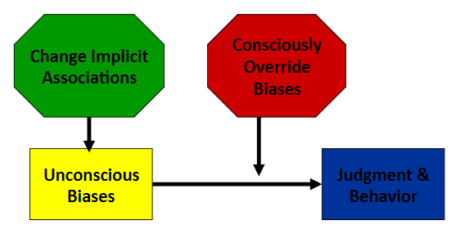

CHAPTER 10 – INFLUENCE OF OTHERS:
MODULE 1:
- Common sense does not always equal research findings.

Presence of Others:
- Norman Triplett – first formal study of social psychology.
- Observed that cyclists raced faster when competing against each other in a group vs. against a clock.
- Co-Actor – another individual performing the same task.
- Audience – a group of people watching an individual perform a task.
- Social Facilitation – increased performance that occurs in the presence of co-actors or an audience.

Zajonc’s (zye-ontz) Resolution:
- Presence of others increases arousal to improve performance on well-practiced tasks.
- Simple tasks which you have mastered, with plentiful practice – performance is enhanced.
- Complex tasks that are foreign to you, with little practice – performance is hindered.

Social Learning Theory:
- Popularized by Albert Bandura; suggests that we learn appropriate behaviours by modeling and imitating the behaviour of others.
- Different from basic conditioning because you do not require explicit reinforcement to imitate said behaviours.

Bobo Doll Experiment:
- Children were asked to play with toys, with an adult in the room modelling passive or aggressive behaviour towards a Bobo Doll.
- Those who viewed an aggressive play model were more likely to subsequently display aggressive behaviour to the doll, with no explicit reinforcement.
- Children mimic observed behaviours, even when afflicting harm to other people.

Conformity:
Autokinetic Effect Experiment:
- Conducted by Muzafer Sherif; had a perceptual illusion where one had to track where a dot moved.
- Trick is: did not actually move; eyes mistake the movement of the image on your retina as actual motion of the light.
- If in a group over several days: results converged with what the other group members thought, even if the “starting points” differed; example of norm formation.
- Norm Formation – leads to convergence in behaviour, even in the presence of outliers.
  - Ex. laugh tracks in shows – hearing the laughter may convince you that the dialogue is funnier than it is.

Asch’s Stimuli:
- Individuals had to identify which of the 3 comparison lines matched the standard line given.
- One subject, surrounded by six other confederates; they answer before the subject does.
- 75% of subjects conformed to an incorrect answer for at least one trial; 37% of the average responses conformed to an incorrect answer.
- Subjects doubt their own perceptions when it conflicts with that of others.

- Normative Function – the role of others in setting standards for our conduct based on a fear of rejection.
- Comparative Function – the role of others in providing information about an ambiguous situation.

Group Dynamics:
- James Stoner – risky shift effect.
  - Groups made riskier decisions than individuals before the group discussion part of the experiment.
  - Sometimes it is opposite, where the individual makes “risker” decisions than the group.
- Group Polarization – group decision-making strengthens the original inclinations of the individual group members; leads to more extreme views.
- The group consensus is pushed to the extreme of the individual members’ decisions.
- Groupthink – a group decision-making environment that occurs when group cohesiveness becomes so strong, it overrides realistic appraisals of reality and alternative opinions.
  - Coined by Irving Janis; “mob mentality”; groups overestimate their might and right.
  - Groups think they are unquestionably right and all other groups are wrong.
  - Rationalized group decisions; high pressure to conform.

Preventing Groupthink:
- Be impartial – group leader should remain neutral.
- Critical evaluation – allow group members to disagree; playing “devil’s advocate”.
- Subdivide the group – make separate decisions, then come together to discuss the differences between them.
- Give a second chance – in order to reveal any further doubts/issues.

The Bystander Effect:
- Kitty Genovese – was murdered in NYC; ~30 witnesses that did nothing to help her out.
- Two Decisions to Action:
  - One must decide whether the situation is an emergency.
  - If it is an emergency, should I be the one to respond?
- The more people present, the less likely a single person takes to realize an emergency.
- Latane and Darley – released smoke into a room of individuals to see how long it would take for them to report it.
  - Took longer for individuals in groups to report it than solely individuals.
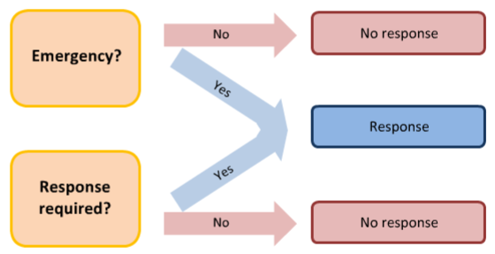
- Collective Ignorance – when everyone in a group see nobody responding in a situation, they conclude that the situation is not an emergency; basing their decision on the behaviour of others around them.
- To test the 2nd decision – subject was placed in a room, talking over an intercom.
  - A planted individual started saying that they were having seizures.
  - Most rapid responses came from subjects that thought that no one else was available to take action.
  - As the number of participants increased, the probability for taking action decreased.
- Diffusion of Responsibility – in deciding whether we have to act, we determine that someone else in the group is more qualified.
- To avoid The Bystander Effect: be direct about asking for help.
- Seeing someone else helping increases the probability that you will help in a later situation; helpful behaviour is contagious.

- Social Loafing – individuals seem to be less motivated when working in a group than when working alone; special case of diffusion of responsibility.
- Ingham – had blindfolded subjects play tug of war “with other people” (even though they played alone); found that subjects pulled 18% less when they thought they were pulling in a group vs. alone.
- Latane, Williams, & Harkins – blindfolded subjects put on headphones and were told to clap/shout as loud as they could.
  - Subjects made less noise as group size increased; subjects reported that they did not change their sound.
- Responsibility is diffused for both emergency situations and collective efforts.

MODULE 2:
Obedience:
Milgram’s Experiment:
- Teachers administered “electrical shocks” to a Learner whenever they got a set of words wrong.
  - The Learner was an actor, and the shock was not actually administered; however, the Teacher did not know that.
- The more answers the Learner responds incorrectly to, the more intense the shock is.
- The Teacher is told to continue giving shocks, even when the Learner is clearly “in pain”.
- 65% of subjects continued to the end of the experiment.

- People display strong obedience, even to minimally powerful figures of authority.
- You are not always an accurate judge of how you would behave in a given situation.
- The prestige of an institution influences the level of obedience in subjects.
- The proximity between Teacher and Learner influences obedience levels in subjects.
  - Closer to Learner = less obedient.
- Proximity to the experimenter influences the Teacher’s obedience to shock Learners.
  - Closer to experimenter = more obedient. ‘

Obedience in the Real World:
- Nurse’ Obedience to a Prohibited Request:
  - Asked to give an overly large dose to a patient, even though medication orders should never be taken on the phone, along with the fact that the person over the phone might not have been a doctor.
  - 5% said they would obey; 95% actually obeyed.

Cognitive Dissonance:
Festinger & Carlsmith:
- Told participants that an experiment will be exciting; turns out it was not, but then they asked the participants to tell the next one that it WAS exciting.
  - Paid the person $1 or $20.
  - Those who were paid less had greater dissonance between attitude and behaviour.
  - Those who were paid more told themselves that the money was the motivation for their behaviour.
- The subjects paid $20 in the Festinger & Carlsmith study had an easier time telling the next subject how fun the experiment was compared to those paid $1.

- Dissonance – inconsistency between attitudes and behaviour that produces an uncomfortable feeling.
  - Must be insufficient justification for a behaviour in conflict with the attitude.
- To reduce dissonance: adjust your behaviour or your attitude.
- Attitudes are less likely to change when external motivations over-justify the behaviour.

Stanford Prison Experiment:
- Participants were either set up as guards or prisoners; the prisoners were mock arrested, and sent to a mock prison.
- Study only lasted 6 days out of 2 weeks due to the sadistic behaviour of the guards, and the emotional trauma of the prisoners rapidly increasing.

- Deindividualization – in a group situation, the loss of a sense of personal responsibility and restraint; ex. covering one’s face makes it easier to perform anti-normative behaviours.

Persuasion:
- The most persuasive communicators have high credibility, are attractive, and are relatable to their audience.
- Speech style influences perceived trustworthiness; a straightforward and concise speech style can make you sound more persuasive.

Goethals & Nelson:
- Similarity – more persuasive for personal lifestyle choices.
- Credibility – more persuasive for objective fact.

- One-Sided Argument – most effective with an audience that initially agrees with your standpoint.
- Two-Sided Argument – most effective with an audience that initially disagrees with your standpoint.
  - Two-Sided = acknowledging both your and the opposing opinions, and then presenting arguments as to why your position is better.

- Central Appeal – well reasoned, factual, two-sided arguments; effective for academic audiences.
- Peripheral Appeal – well presented, easy to understand messages; effective for non-academic audiences.

Techniques in Persuasion:
- Foot in the Door Effect – a gradual escalation of demands increases obedience.
  - Asking for a small request made subjects agree to a larger, typically denied request.
  - Every request is considered in relation to the previous request, rather than the first.
- Low Ball Technique – an escalation of the terms of an agreement after someone has already agreed to comply.
  - Agreeing to an experiment makes subjects more likely to attend them.

TEXTBOOK:
Self-Perception Theory:
- We do not necessarily have a special insight into ourselves.
- Strack, Martin, & Stepper – had subjects hold a pen in-between their teeth (smile), or their lips (frown).
  - Those who had the pen in-between their teeth found that a cartoon was more amusing.

Cognitive Dissonance:
- If an obvious reason for doing something does not present itself, we will make up a justification for it.

Persuasion:
The Communicator:
- The source of persuasion; trustworthiness can trump expertise in some cases.
- As reputation dissipates, so does communicator effectiveness.

The Message:
- One-Sided Argument – effective when the audience initially agrees; preaching to the choir.
- Two-Sided Argument – more effective when the audience initially disagrees.
- Messages are usually more effective when associated with a good feeling.
- Fear can also persuade, but only in “moderate” doses.
- Little fear = no impact; too much fear = doubt in the credibility of the communicator.

The Audience:
- Academic – well-reasoned, factual, 2-sided argument.
- Non-Academic – well-presented, easy-to-understand argument.

Techniques in Persuasion:
- Foot in the Door – getting your target to agree to something up front; committed = more likely to follow through.
- Low Ball – getting your target to agree to something small, then later escalating the terms.
- Door in the Face – asking for something completely unreasonable, then greatly scaling back your request.
- Using “buzzwords” to label a product as trending.
- Advertising luxury products towards our desire of prestige.

Obedience:
- Humans have a tendency towards obedience to authority.
- Decreases with reduced prestige and perceived experimenter power.

Conformity:
- Norm Function – founded by Sherif; having your own opinion be swayed by that of others in a group.
- Conform – adjust our behaviour/thinking to coincide with a group standard.
- Normative Social Influences – we want to be approved by the people we associate with.
- Informational Social Influences – open to learning/gaining information from a group.
- Conformity levels decrease with reduced group size, and when dissention occurs within a group.

The Influence of Groups:
- Norms depend on culture, or on the social roles one hold.

Roles:
- Individuals internalize roles given to them, and take on their respective attitudes.

Crowds:
- Deindividualization – losing sight of one’s individuality, and acting as part of a crowd.
- Large groups provide a sense of anonymity; you may be more inclined to partake in malicious behaviours if you feel as though no one is watching you.

Acting in a Group:
- Zajonc – the presence of other people increase arousal.
  - Simple task arousal = improved performance; complex task arousal = decreased performance.

Social Loafing:
- We expend less effort when we believe our contribution will be averaged among others.
- Individuals do less work in groups than by themselves.

Group Dynamics:
- Group Polarization – groups tend to strengthen original inclinations.

Group Conflict:
- Robber’s Cave Study findings:
  - Within a group, children settled into their roles, and became a cohesive unit.
  - When another group was introduced: there was hostility between the two due to the emergence of competition.
  - When working together towards a common goal: the hostility disappeared.

Groupthink:
- Occurs when:
  - The group is highly cohesive, and shut off from non-group members.
  - The leader is directive and subordinates are not encouraged to challenge the leadership.
  - When the group is under pressure to make a decision.

Helping Others:
- Altruism – unselfish regard for the welfare of others; willingness to risk your life to help others.
- Norm of Reciprocity – we are expected to reciprocate when someone else treats us well; returning the favour.
- Norm of Social Responsibility – as a member of society, we are expected to contribute to its welfare in a responsible way.
- Empathy-Altruism Hypothesis – altruism results from empathy.
- Negative State Relief Model – we help because we would feel distressed and guilty if we didn’t.
Bystander Effects:
- More people = less individual responsibility, more anonymity, loss of individual identity.
- Taking action in front of a group makes one self-conscious, so they wait for someone else to do it.
- We wait for the expert to step in.
- People consider a cost-benefit ratio.
- Eagle & Crowley – female bystanders are equally as likely to help male/female individuals; male bystanders are more likely to help female individuals.
- We are more willing to help those who are in need due to problems beyond their control than those whose need arose from their own doing.

Zimbardo & The Heroic Imagination Project:
- Teaching individuals the various mechanisms surrounding bystander effects will prevent them from making those mistakes in emergency situations.
- Heroes – socially centered (interact in a positive way with others on a daily basis).
- Key of this project: to get people to think of themselves as capable of being a hero.

Harming Others:
- Aggression – behaviour that is intended to harm someone else; is not socially justifiable.

Learning to be Aggressive:
- Witnesses violence de-sensitizes us to it.

Aggression and Gender:
- Relational Aggression – personal interactions; done to make others dislike someone.
- Hostile Aggression – directly confrontational; ex. hitting someone.
- Males tend to display hostile aggression, while women show relational aggression.

LECTURE:
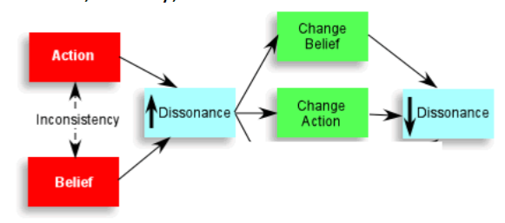

- Sunk Cost Trap – unrecoverable investments of resources leading to further investment; ex. staying in a terrible movie because you paid for it; don’t want to lose out.
- Ben Franklin Effect – ask a person who has negative feelings toward you for a favour.
- Top-down processing cannot be switched off.

