KEY QUESTIONS 20, 21, 22, 23
20a&b)
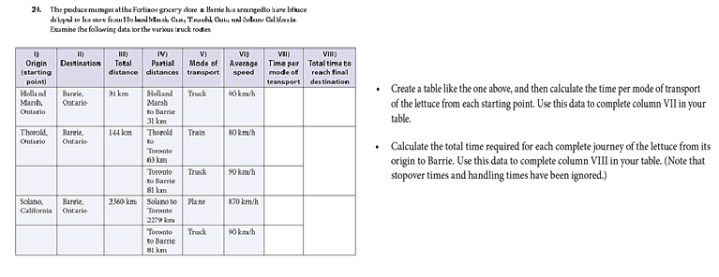
I)  Origin (starting point) | II)  Destination | III)  Total Distance | IV)  Partial Distances | V)  Mode of transport | VI)  Average speed | VII)  Time per mode of transport | VIII)  Total time to reach final destination
Holland Marsh, Ontario | Barrie, Ontario | 31 km | Holland Marsh to Barrie  31 km | Truck | 90 km/h | t = d/s  31km/90km/h  = 0.34h or 0.3 hour | 0.3 hour since destination is to Barrie
Thorold, Ontario | Barrie, Ontario | 144 km | Thorold to Toronto  63 km | Train | 80 km/h | t = d/s  63km/80km/h  = 0.79h or 0.8 hour | Add 0.8hour and 0.9hour for total time  0.8+0.9=1.7hour
Toronto, Ontario | Barrie, Ontario |  | Toronto to Barrie  81 km | Truck | 90 km/h | t = d/s  81km/90km/h  = 0.9hour
 |  | 2360 km | Solano to Toronto 2279 km | Plane | 870 km/h | t = d/s  2279km/870km/h  = 2.6hour | 2.6 hour + 0.9 hour = 3.5hour
Toronto, Ontario | Barrie, Ontario |  | Toronto to Barrie  81 km | Truck | 90 km/h | t = d/s  81km/90km/h  = 0.9hour

20c)
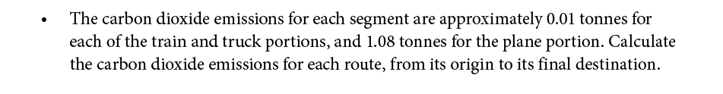
Carbon dioxide emissions from Holland, Ontario to Barrie, Ontario:
0.01 ton X 1 = 0.01 ton
Carbon dioxide emissions from Thorold, Ontario to Barrie, Ontario:
0.01 X 2 = 0.02 tonnes
Carbon dioxide emissions from Solano, California to Barrie, Ontario:
(0.01 tonnes X 1 ) + (1.08 X1) = 1.09 tonnes

20d)
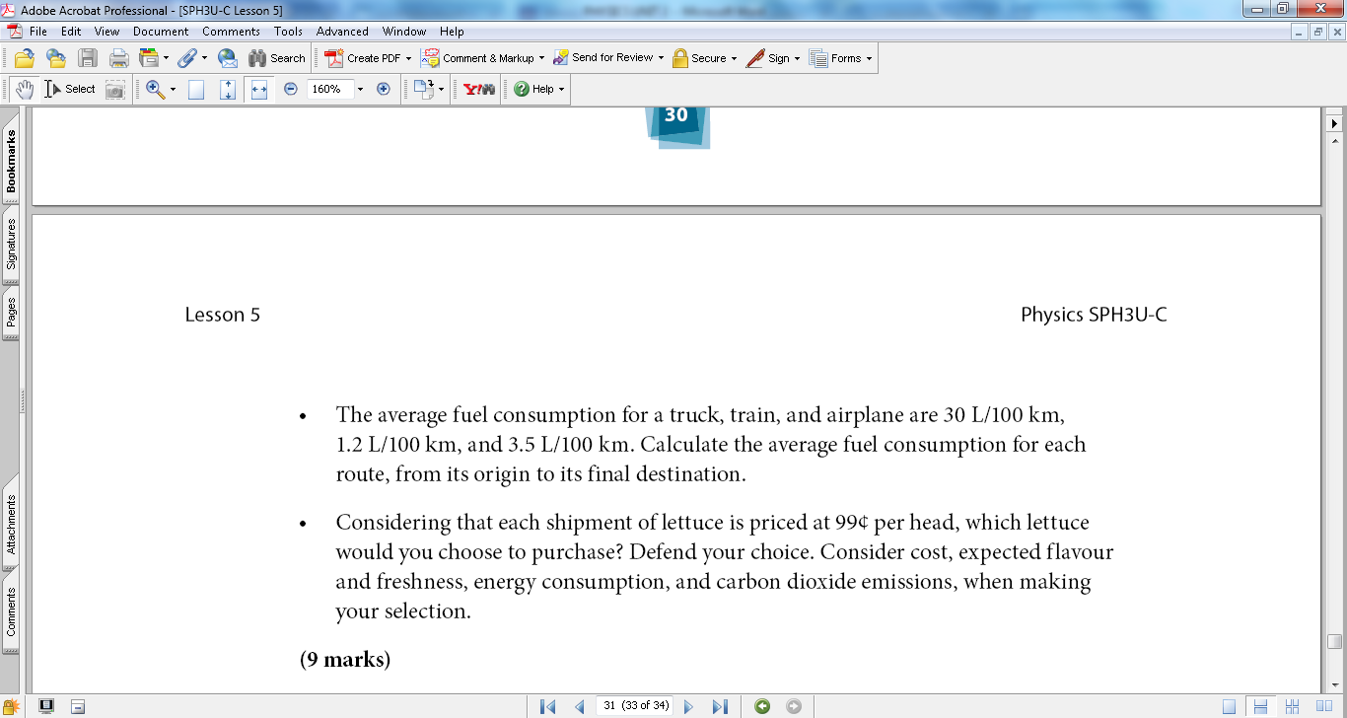
Partial Route 1: Fuel consumption for Holland, Ontario to Barrie, Ontario:
Truck: 30 L in 100 km
? L in 1 km
Cross Multiply: (30L*1km)/100km = 0.3 L in 1 km
Multiply fuel consumption of 0.3L in 1km by the distance.
0.3L/km * 31 km = 9.3 L or litres
Partial Route 2: Fuel consumption for Thorold, Ontario to Toronto, Ontario:
Train: 1.2 L in 100 km
? L in 1 km
(1.2L*1km)/100km = 0.012 L in 1 km or 0.012L/1km
0.012L/1km * 63 km = 0.756 L
Partial Route 3: Fuel consumption for Toronto to Barrie, Ontario:
Truck: 30 L in 100 km
? L in 1 km
(30L*1km)/100km = 0.3 L in 1 km
0.3 L/km * 81 km = 24.3 L
Partial Route 4: Fuel consumption for Solano to Toronto, Ontario:
Plane: 3.5 L in 100 km
? L in 1 km
(3.5L*1km)/100km = 0.035L/km
0.035 L/km * 2279 km = 79.765 L or 79.8 L
Partial Route 5: Fuel consumption for Toronto, Ontario to Barrie, Ontario:
Truck: 30 L in 100 km
? L in 1 km
(30L*1km)/100km = 0.3 L in 1 km
0.3 L/1km * 81 km = 24.3 L
Route 1 from origin to destination:
Average fuel consumption = 30L/100km * 31km = 9.3 L
Route 2 from origin to destination:
63 km× (1.2 L)/(100 km) = 0.756 L
81 km× (30 L )/(100 km) = 24.3 L
Average fuel consumption = (0.756 L + 24.3 L) = 25.0 L
Route 3 from origin to destination:
2279 km× (3.5 L)/(100 km) = 79.8 L
81 km× (30 L)/(100 km) = 24.3 L
Average fuel consumption = (79.8 L + 24.3 L) = 104 L

20e)
Considering that each shipment of lettuce is priced at 99 cents per head, I would choose the lettuce travelled from Holland to Barrie, Ontario. This is not only because the time and distance travelled was less, but the fuel consumed and the carbon dioxide emissions were of the least amount. Compared to the other routes, this was the most time saving, environment friendly and cost efficient route. The quality of the lettuce would also be very fresh physically and would taste much better unlike the routes travelled by train and plane. This is because it would come in a shorter time since the distance travelled was less. The longer the distance the more time consumed resulting in rotten or not as fresh lettuce. As the mode of transportation was a truck, it saved a lot of money since the larger the mode of transportation, the more energy would be consumed and more carbon dioxide emitted. Therefore, It is evident that lettuce from Holland would be cost effective, fresh, better quality and would produce less carbon dioxide emissions and consume less fuel.
21) I have used Desmos and Photoshop (to draw tangents) for this question.

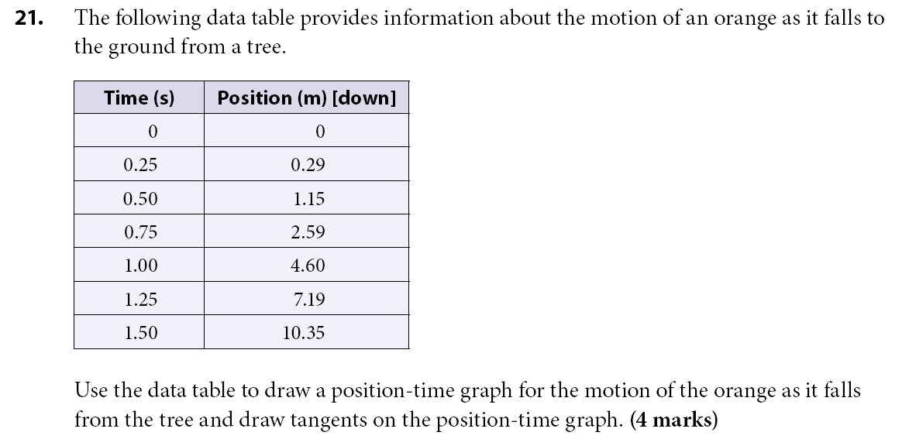

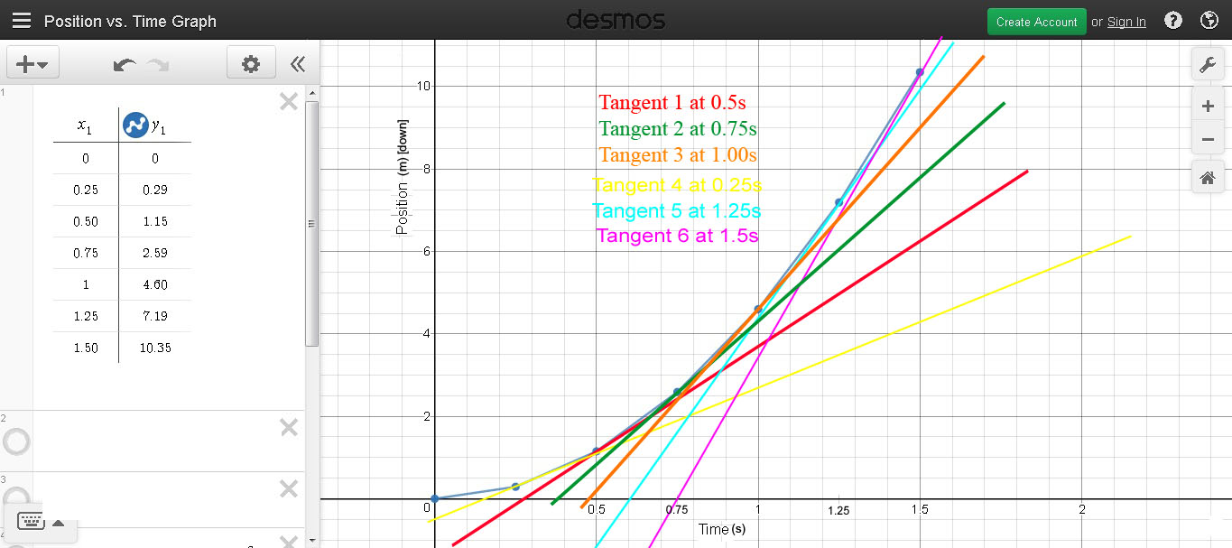

22) 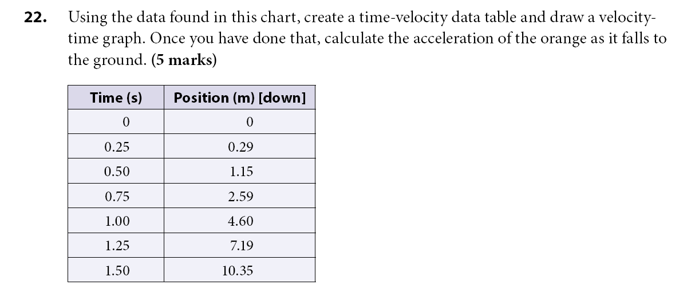
Desmos and Paint (to add velocity and time) were used.
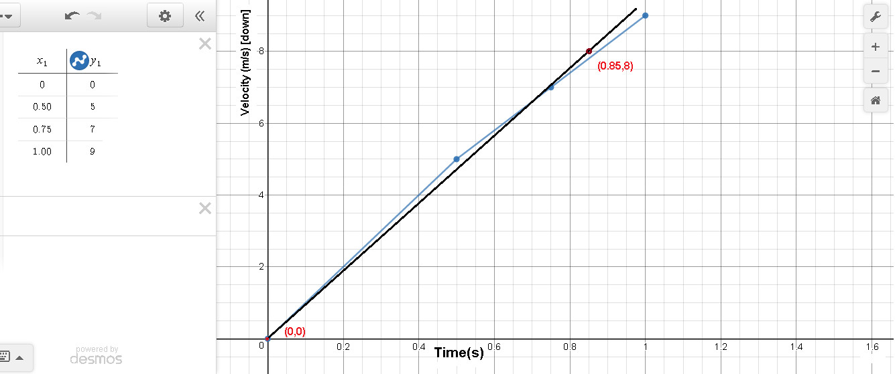
Time (s) | Velocity (m) [down]
Graph of this table is above.
0.50 | (0.3, 0.2) and (1, 3.7) = 5 m/s  $\vec{v}=\frac{\vec{d_{2}}- \vec{d_{1}}}{\vec{t_{2}}-\vec{t_{1}}}=\frac{3.7-0.2}{1-0.3}=5 m/s$ [down]
0.75 | (0.6, 1.5) and (1.10, 5) = 7 m/s  $$\vec{v}=\frac{\vec{d_{2}}- \vec{d_{1}}}{\vec{t_{2}}-\vec{t_{1}}}=\frac{5-1.5}{1.10-0.6}=7\frac{m}{s}\left[down\right]$$
1.00 | (0.71, 2) and (1.10, 5.5) = 9 m/s  $$\vec{v}=\frac{\vec{d_{2}}- \vec{d_{1}}}{\vec{t_{2}}-\vec{t_{1}}}=\frac{5.5-2}{1.10-0.71}=9 m/s [down]$$

Acceleration is found by finding the slope of the line of best fit on the velocity-time graph.
$\vec{a}=\frac{\vec{v_{2}}-\vec{v_{1}}}{\vec{t_{2}}-\vec{t_{1}}}$ = $\frac{8 – 0}{0.85 – 0}$ = 9.41m/s²
This was a different method I followed to find acceleration.
I used the formula below for slope to calculate velocity then divided that by time and since it was all constant differing by 0.25 seconds I just divided by that without subtracting from the previous.
$\vec{v}=\frac{\left({\vec{d}}_{2}-{\vec{d}}_{1}\right)}{t_{2}-t_{1}}$ $\vec{v}=\frac{\left({\vec{d}}_{2}-{\vec{d}}_{1}\right)}{t}$
The numbers highlighted in purple are all the initial table values in the question.
Time (s) | Velocity (m) [down]
0 | 0
0.25 | 0.29(m)[down] – 0(m)[down] =  0.29(m)[down]  0.29(m)[down]/0.25s = 1.16m/s [down]
0.50 | 1.15(m)[down] - 0.29(m)[down] =  0.86(m)[down]  0.86m[down]/0.25s = 3.44 m/s [down]
0.75 | 2.59(m)[down] - 1.15(m)[down] =  1.44 (m)[down]  1.44m[down]/0.25s = 5.76 m/s [down]
1.00 | 4.60(m)[down] - 2.59(m)[down]  = 2.01 (m)[down]  2.01(m)[down]/0.25s = 8.04 m/s [down]
1.25 | 7.19(m)[down] – 4.60(m)[down]  = 2.59 (m)[down]  2.59(m)[down]/0.25s = 10.36 m/s [down]
1.50 | 10.35(m)[down] – 7.19(m)[down]  = 3.16(m)[down]  3.16(m)[down]/0.25s = 12.64 m/s [down]
Using the final velocity calculated from the slope formula I chose the velocities and times below to find acceleration to be 9.12m/s².
$$\vec{a}=\frac{\vec{v_{2}}-\vec{v_{1}}}{\vec{t_{2}}-\vec{t_{1}}}= \frac{3.44(\frac{m}{s^{2}}) – 1.16(\frac{m}{s^{2}})}{0.50s – 0.25s} = 9.12\frac{m}{s^{2}}$$

23a)
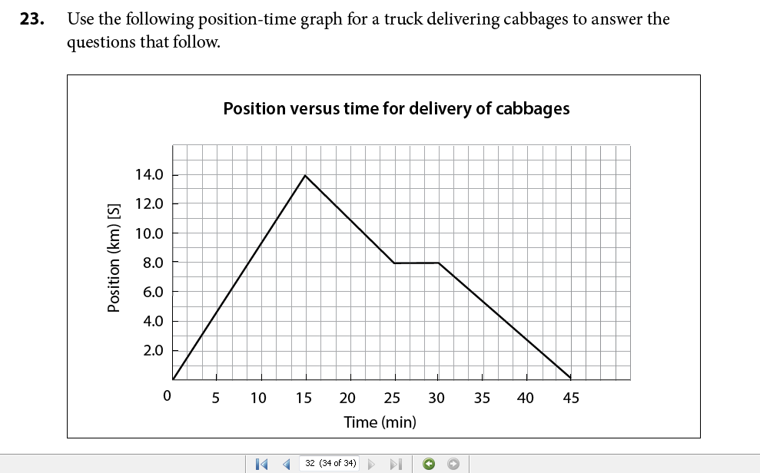
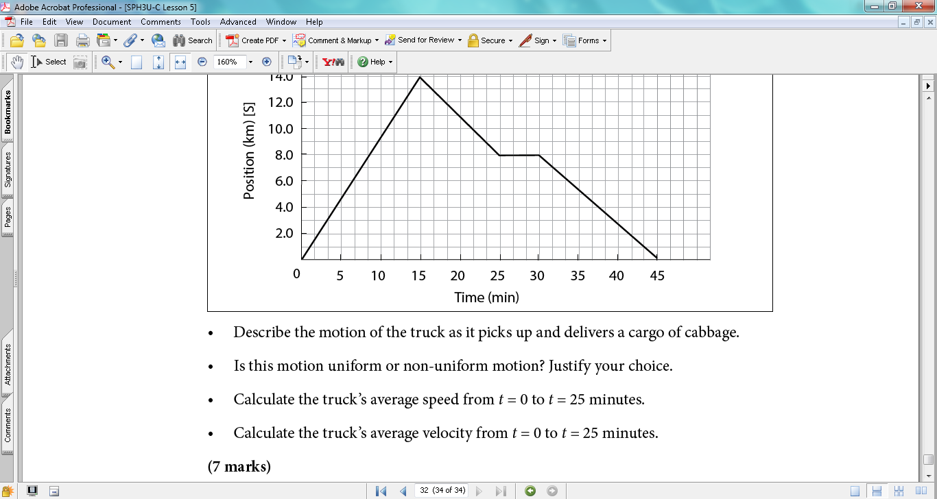
The truck drives 14 km [S] at a rate of 16 m/s for 15 minutes, then changes direction to go 6 km [N] at a slower rate of 10 m/s over a time of 10 minutes. It then stayed at that location for 5 minutes. The truck continued heading north for 8 km of the journey at a constant speed of 11 m/s towards its destination for another 15 minutes.
23b)
The motion of the truck as it picks up and delivers cabbage represents non-uniform motion. This is because although there are places where the truck drove in a uniform motion, it also has to stop at traffic signals and stop signs etc. Change of speed is also apparent as when the signal becomes green again the truck will speed up. Therefore, this is an example of non-uniform motion since change in velocity and direction cannot be constant when driving on roads and highways because the truck will face many changes, turns, and stops throughout the journey till destination.
23c)
$$v_{av} = total distance/total time$$However, since this question is asking only the distance took till the 25 minute mark not the total time which was 45 minute.
Therefore, convert 25 minute to seconds as both velocity and time are in m/s or meters per second using unit calculation.
$$25\min{ *\frac{60seconds}{1min}=1500s or 1500 seconds}$$
Total distance in 25 mins:
From 0 to 15 mins the truck went 14 km. Then from 15mins to 25 mins the truck went down 6km.
The total distance the truck covered in 25 minutes: 14km + 6km = 20km.
$$20km *\frac{1000m}{1km}= 20,000m$$v_{av} = total distance/total time
v_{av} = 20,000m / 1500s
v_{av} = 13.333…m/s or 13.3m/s [S]
OR $v_{av} =20km/25\min{=0.8km/\min{ [S]}}$

23d)
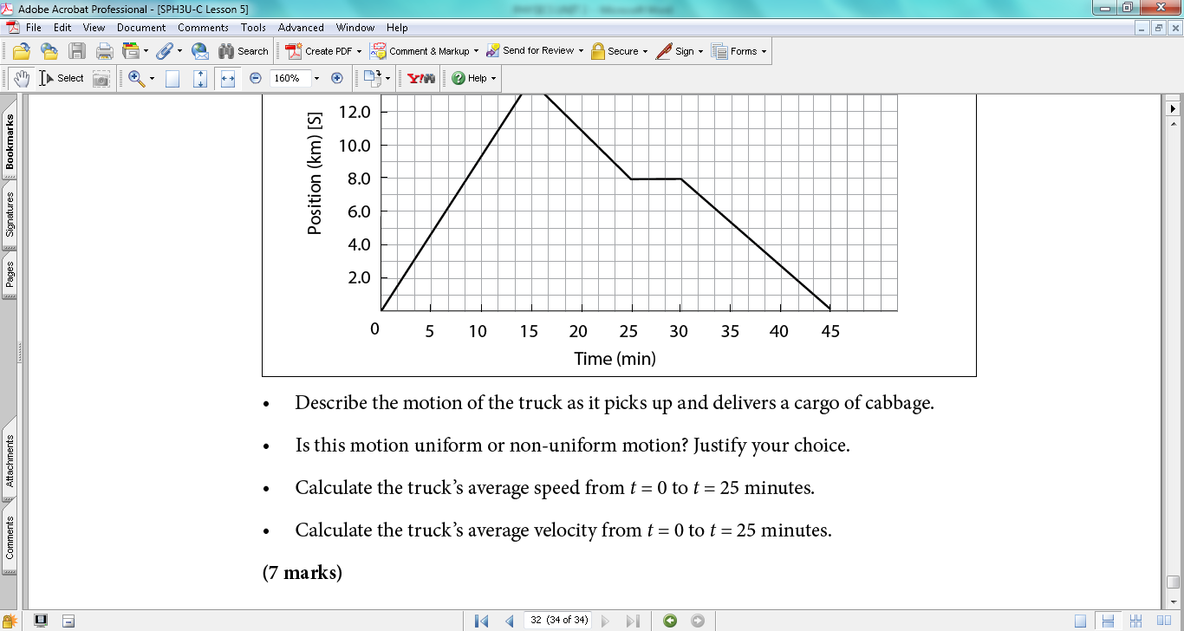
$\vec{v_{av}} = total displacement/total time$
Finding the slope or path length from (0,0) and (25,8) would give you velocity.
$\vec{v}=\frac{d_{2}-d_{1}}{t_{2}-t_{1}}$
Truck started at (0,0) at t = 0 and at t = 25, truck was at (25,8)
$$\vec{v}=\frac{8-0}{25-0} \\ \vec{v}=\frac{8}{25}$$$\vec{v}=0.32$ km/min
Or convert 0.32km/min to m/s
$$\frac{0.32km}{min}*\frac{1000m}{1km}=320m/min$$
$\frac{320m}{min}*\frac{1min}{60s}=\frac{5.333m}{s}or 5.3 meters per seconds$

KEY QUESTIONS 24, 25, 26, 27
24)
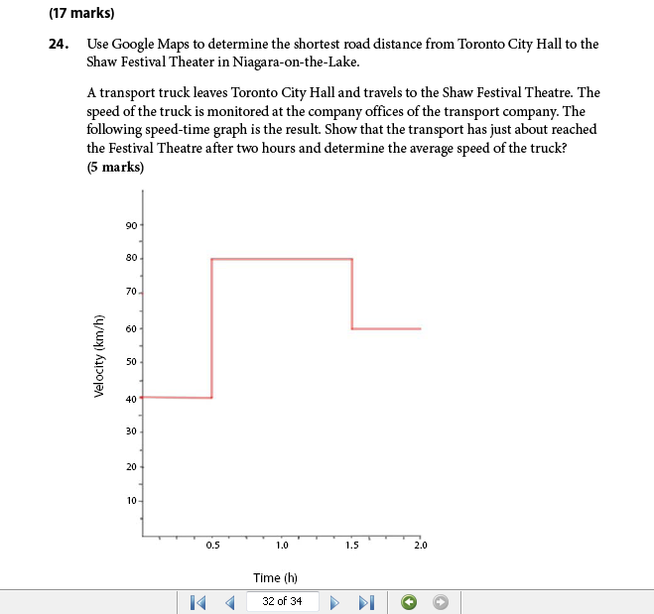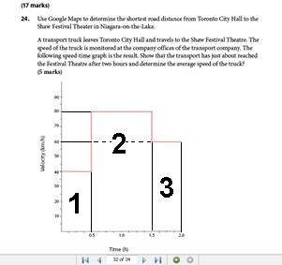
Since velocity is positive the average velocity will equal to average speed.
Calculations:
As no direction is given here this is a scalar quantity, thus, no vector arrows are shown.
$$Δd or total distance=A_{1strectangle + }A_{2ndrectangle +} A_{3rdrectangle } \\ total distance or Δd_{total} = Δd_{1}+ Δd_{2}+ Δd_{3}$$
From using google maps, 131 km is the distance from Toronto City Hall to Shaw Festival Theater which is close to my answer. 1 h 42 minutes is the fastest time to reach the destination at no traffic but, does not account for weather or construction.
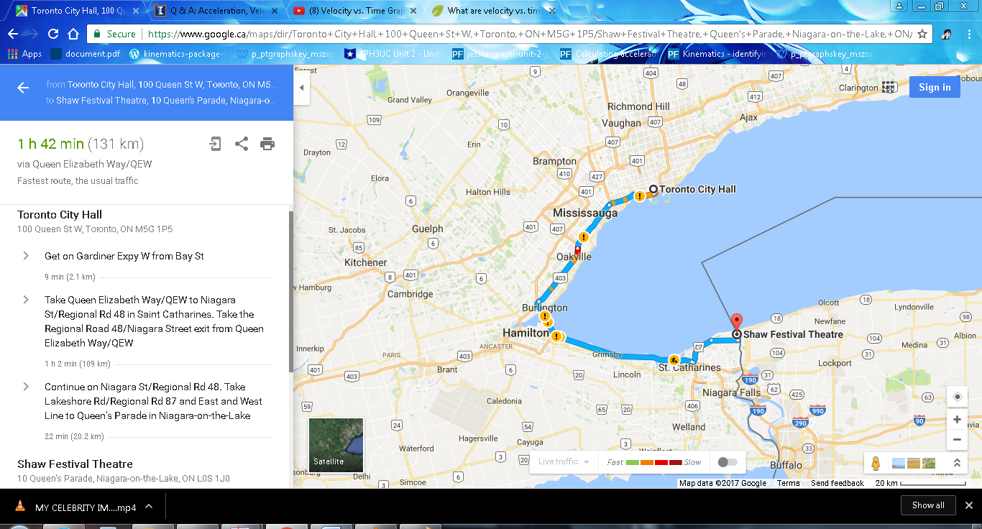
$$Area of rectangle 1: Δd_{1}= v Δt \\ Δd_{1}=\frac{40km}{h}*\left(0.5h-0h\right) =\frac{40km}{h}* 0.5h=20km$$
$$Δd_{2}=\frac{80km}{h}*\left(1.5h-0.5h\right) =\frac{80km}{h}* 1h=80km$$
$$Δd_{3}= \frac{60km}{h}*\left(2.0h-1.5h\right) =\frac{60km}{h}* 0.5h=30km \\ Δd_{total} = Δd_{1}+ Δd_{2}+ Δd_{3}$$
$$Δd_{total}=20km+80km+30km=130km \\ During the 2.0 hours$$
$$v_{av} =(total distance)/(total time)$$
$$v_{av} =\frac{130km}{2.0h}=\frac{65km}{h}was the average speed of the truck$$
From my calculations the distance was 130 km in 2.0 hours which is about the same from the one below. However, the extra 1 mile shown in the picture above could account for traffic, construction, weather etc.

25)
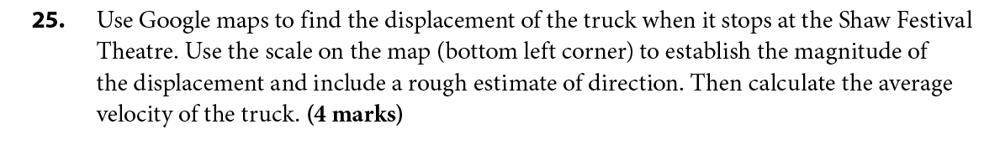
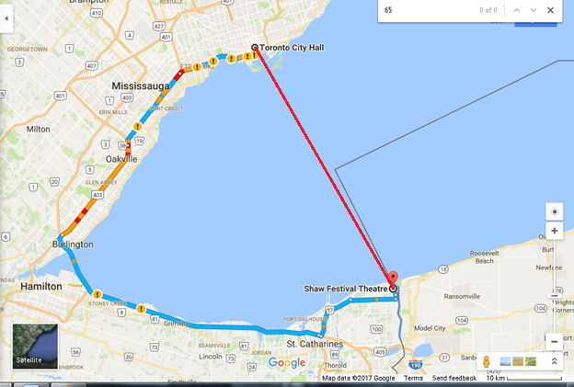
According to google maps with a scale of 10km in 2cm and not the picture above I measured a displacement of 10.5cm from Toronto City Hall to Shaw Festival Theatre.
10 km in 2 cm
? km in 10.5 cm
Cross multiply to find out how many kilometres:
(10km*10.5cm)/2 cm
= 52.5 km [South East]
= 52.5 km in 10.5 cm
Average velocity = total displacement/total time
Convert 1 hour 42 min to minutes to hour:
1 hour = 60 minutes + (42 minutes) = 102 minutes/60minutes = 1.7 hour
$v_{av} =\left[\frac{52.5 km}{1.7hour}\right]= 30.9 km/hr$
26a)
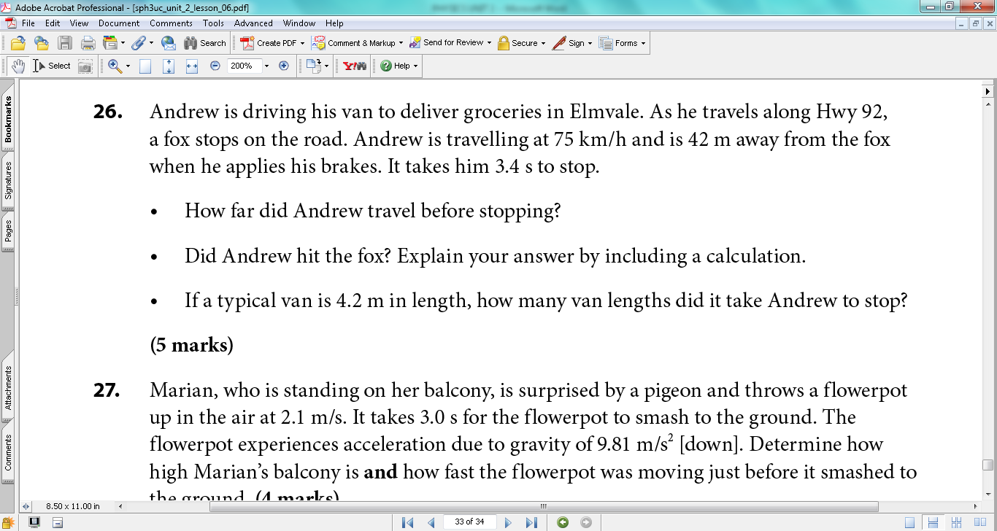
Convert 75km/h to m/s
$$75\frac{km}{h}*\frac{1000m}{1km}*\frac{1hr}{3600s}=21m/s$$
$$∆\vec{d}=\frac{1}{2}\left({\vec{v}}_{1}+ {\vec{v}}_{2}\right)∆t \\ ∆\vec{d}=\frac{1}{2}\left(21m/s\right)*3.4s=36 meters$$
Andrew travelled 36 meters before stopping.
26b)
No, Andrew did not hit the fox because the fox was 42 m away.
26c)
35.4m/4.2m = 8.4 van lengths because to check our answer to find distance Andrew travelled before stopping we take 8.4 van lengths and multiply by 4.2 m (length of van), we get 71 meters.
$$Van lengths =\frac{∆d}{lengthofvan}=\frac{35.4m}{4.2m}=8.4 van lengths$$
27)
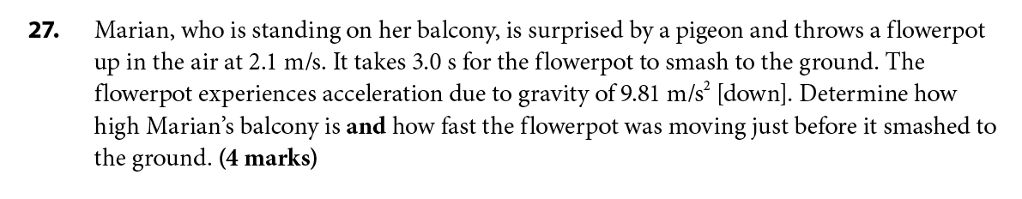
Height of Marian’s balcony from ground level:
$$∆\vec{d}= \vec{v_{1}}∆t+\left(\frac{1}{2}\right)\vec{a}∆t^{2} \\ ∆\vec{d}=2.1\left(\frac{m}{s}\right)\left[up\right]\left(3.0s\right)+\frac{\left\{-9.81 \left(\frac{m}{s^{2}}\right)\left[up\right]{\left(3.0s\right)}^{2}\right\}}{2}$$
$$∆\vec{d}=2.1 \left(\frac{m}{s}\right)\left[up\right]\left(3.0s\right)+\{-44.145m \left[up\right]\}$$
$$∆\vec{d}=6.30 m \left[up\right]-44.145 m \left[up\right]= -37.845m\left[up\right] rounded to-38 m\left[up\right] or 38 m\left[down\right] since 2 sig digs$$Marian’s balcony to ground level is 38 meters [down].
To find velocity of how fast the flowerpot was moving just before it reached the ground.
$${\vec{v}}_{2}= {\vec{v}}_{1}+\vec{a}∆t \\ {\vec{v}}_{2}=2.1\frac{m}{s}[up]+(-\frac{9.81m}{s^{2}}[up])(3.0s)$$
$${\vec{v}}_{2}=\frac{2.1m}{s}\left[up\right]+(-29.43\frac{m}{s}\left[up\right])$$
$${\vec{v}}_{2}=\frac{27.33m}{s}\left[down\right] rounded to two sig digs 27\frac{m}{s}\left[down\right]$$
The flowerpot was moving at 27 m/s [down] just before it smashed to the ground.

KEY QUESTIONS 28, 29, 30

28) Scale: 1 cm = 2km
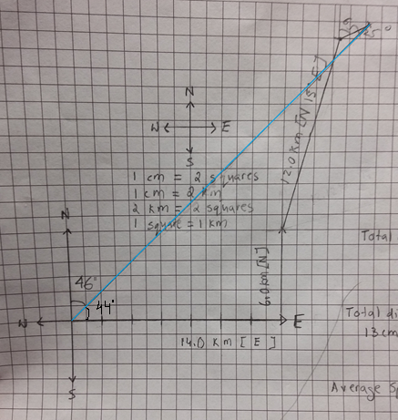
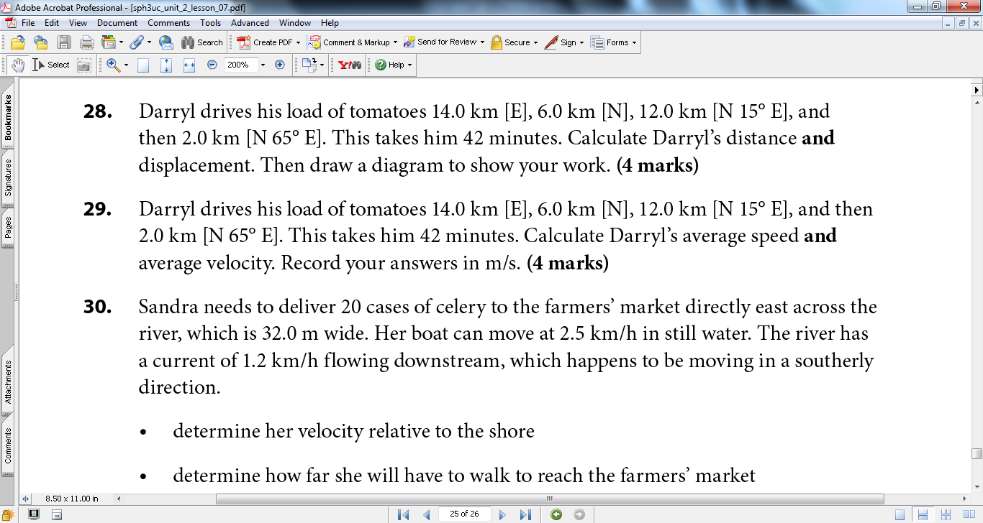
Total distance:
14.0km + 6.0km + 12.0km + 2.0km
= 34.0km
In centimeters using scale: 34.0 km * (1.0 cm/2.0 km) = 17.0cm
Total displacement: Highlighted in blue in picture above.
Ruler measured 13.0 cm
13.0 cm in km = 13.0 cm * (2.0km/1.0cm) = 26.0km [N 46° E] or 26.0km [E 44° N]

29)
Average speed:
$$v_{av}=\frac{∆d}{∆t}or total distance over total time$$
$∆t$ = 42 minutes
42 min * (1 hr)/(60 min) = 0.7 hour
$$v_{av}=\frac{34.0km}{0.7hr}=\frac{49.0km}{hr}or\frac{34.0km}{42min}=0.81km/min$$
$$\left(\frac{49.0km}{hr}\right)*\frac{1000m}{1km}*\frac{1hr}{3600s}=13.6 m/s$$
Average velocity = total displacement/total time
$${\vec{v}}_{av}=\frac{∆\vec{d}}{∆t}=\frac{26.0km}{0.7hr}=\frac{37.1km}{hr}or\frac{26.0km}{42min}=0.62km/min$$
$$\left(\frac{37.0km}{hr}\right)*\frac{1000m}{1km}*\frac{1hr}{3600s}=10.3\frac{m}{s}\left[N 46° E\right] or 10.3m/s [E 44° N]$$

30a)
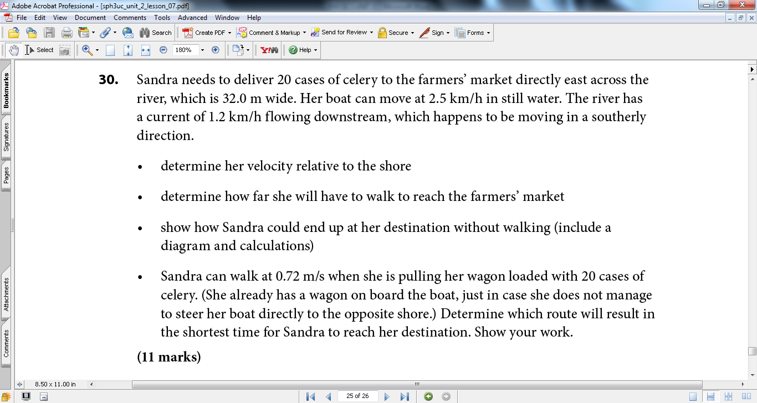
Convert 2.5 km/h and 1.2 km/h into m/s
$$\frac{2.5 km}{h}*\frac{1000 m}{1 km}*\frac{1 hour}{3600s}=0.69 m/s$$
$$\frac{1.2 km}{h}*\frac{1000 m}{1 km}*\frac{1 hour}{3600s}=0.33 m/s$$
$$b v_{w}=0.69\frac{m}{s}\left[east\right] velocity of boat with respect to the water$$
$$w v_{s}=0.33\frac{m}{s}\left[south\right] velocity of water with respect to the shore$$
$$b {\vec{v}}_{w}+w {\vec{v}}_{s}=b {\vec{v}}_{s} velocity of boat with respect to the shore$$
c² = a² + b²
$$\left|b {\vec{v}}_{s}\right| = \sqrt{{\left(\frac{0.69m}{s}\right)}^{2}+{\left(\frac{0.33m}{s}\right)}^{2}}$$
$$\left|b {\vec{v}}_{s}\right| =\sqrt{0.585} =0.76 m/s$$
$$tanθ=\frac{opposite}{adjacent}= \frac{0.33\frac{m}{s}}{0.69\frac{m}{s}}$$
$$tanθ=0.478…$$
$$θ=\tan^{-1} \left(0.478…\right)=25.559…rounded to 26°$$
$$b {\vec{v}}_{s}=0.76\frac{m}{s}[east 26° south]$$
Sandra’s velocity is 0.76 m/s south of east relative to shore.
I have done the diagram below all on Photoshop. I copied the boat, compass, and both sides of shore from the example in the lesson.
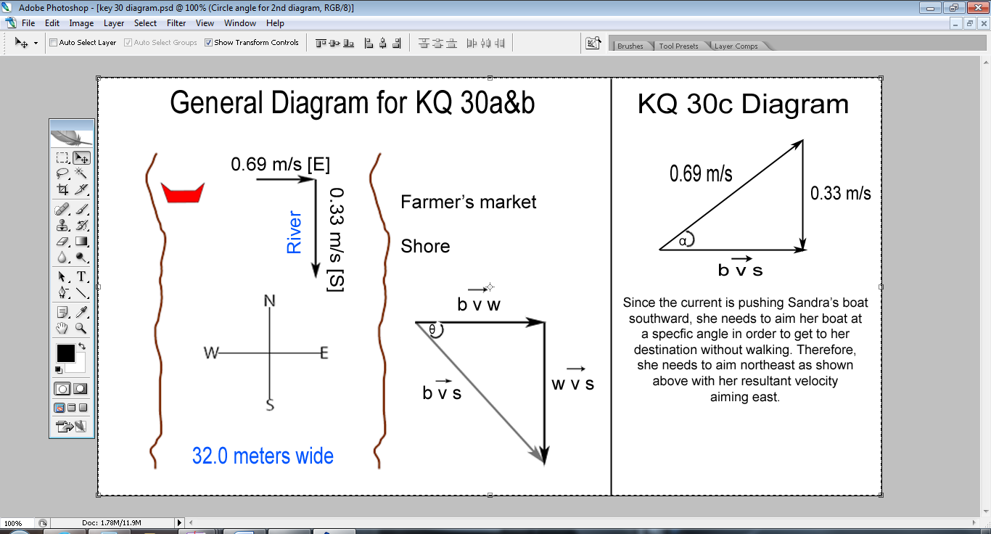
30b)
$$tanθ=\frac{opposite}{adjacent} \\ tan26°=\frac{\left|∆{\vec{d}}_{2}\right|}{32.0m}$$
$$\left|∆{\vec{d}}_{2}\right|=15.607… rounded to 16m$$
Sandra will have to walk 16 meters north since she landed south to reach the farmer’s market.
30c)
Direction of angle that Sandra needs to aim for:
$$sinα=\frac{opposite}{hypotenuse}$$
$$α= \sin^{-1}=\frac{\frac{0.33m}{s}}{\frac{0.69m}{s}}$$
$$α=28.571…rounded to 29°$$

Magnitude of $b {\vec{v}}_{s} :$
$$tanα=\frac{opposite}{adjacent}$$
$$adjacent=\left(\frac{opposite}{tanα}\right)=\frac{0.33\frac{m}{s}}{tan29°}$$
$$adjacent =0.595…rounded to 0.60 m/s$$

Resultant velocity of Sandra is 0.60 m/s [east]
The time it takes for Sandra to travel straight across.
$$∆t=\frac{∆d}{\vec{v}}=\frac{\left\{32.0 m \left[east\right]\right\}}{\frac{0.60m}{s}[east]}$$
$$∆t=53.333…rounded to 53 seconds$$Therefore, the time it takes for Sandra to travel directly across to reach the Farmer’s Market is 53 seconds.
30d)
The shortest time Sandra takes if she heads directly east, allowing the downstream to push 16m south of where she wanted to end up is as below.
$$∆t=\frac{∆d}{\vec{v}}=\frac{32\left[E\right]}{0.76m/s[east 26° south]}=42seconds$$
$$∆t=\frac{∆d}{\vec{v}}=\frac{16\left[N\right]}{0.72m/s[North]}=22seconds$$
Total time = 42 seconds + 22 seconds = 64 seconds
Therefore, this route will be longer and take more time so if Sandra aims her boat 29 degrees northeast then she will reach her destination the fastest with the shortest time possible.

KEY QUESTIONS 31, 32, 33
31)
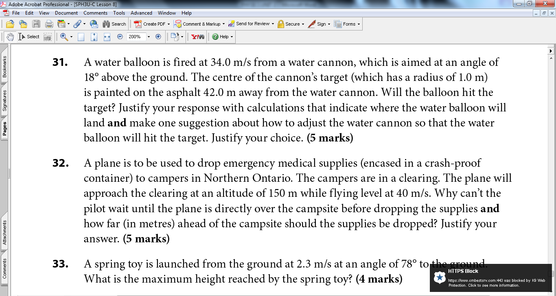
$${∆d}_{h}={(v^{2}}_{1}sin2θ)/(\frac{9.8m}{s^{2}})$$
$${∆d}_{h}={\{\left(\frac{34.0m}{s}\left[up\right]\right)}^{2}sin2(18°)\}/(9.8m/s^{2})$$
$${∆d}_{h}=\frac{679m}{s}/(\frac{9.8m}{s^{2}})$$
$${∆d}_{h}=69.3m$$
The water balloon went 69.3 meters so it went past 42.0m and therefore, did not hit the target.
Increasing the angle from 18 degrees to 79.5 degrees will decrease the horizontal distance from 69.3 meters to around 42.0 meters significantly and hit the target. For example, it can be observed from the calculation below that when the launch angle was increased above 45 degrees the horizontal displacement decreases.
$${∆d}_{h}={\{\left(\frac{34.0m}{s}\left[up\right]\right)}^{2}sin2(79.5°)\}/(9.8m/s^{2})$$
$${∆d}_{h}=\frac{414m}{s}/(\frac{9.8m}{s^{2}})$$
$${∆d}_{h}=\frac{42.3m}{s}$$
Therefore, the water balloon will hit the target if the launch angle was 79.5 degrees.
32)
The pilot can’t wait until the plane is directly over the campsite to drop the supplies since it could end up somewhere else than planned. As the plane is moving and not at rest, the supplies are also moving with the same velocity due to the plane’s motion going forward. Therefore, it will drop beyond the actual intended place if it was dropped over the campsite. Therefore, the package must be dropped 221m ahead(before) of the location. This is considering that gravity and air friction/resistance are ignored.
$$∆{\vec{d}}_{v}=\frac{1}{2}\vec{a}∆t^{2}$$Acceleration is not negative here because time is positive thus, the negative is disregarded.
$$150m\left[down\right]=\frac{1}{2}*\left(\frac{9.81m}{s}\left[down\right]\right)∆t^{2}$$
$$∆t=5.5 s$$
$${\vec{d}}_{h}= {\vec{v}}_{h}∆t$$
${\vec{d}}_{h}=\left(\frac{40m}{s}\left[forward\right]\right)*5.5s=221 m$
33)
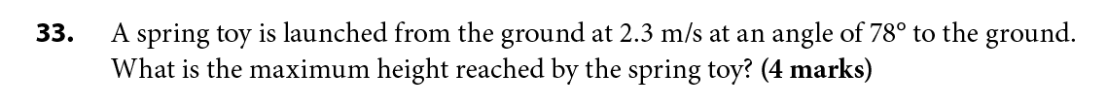
$$Maximum Height=\frac{\left[\left(initial velocity^{2}\right){\left(sine of launch angle\right)}^{2}\right]}{2\left(acceleration due to gravity\right)}$$
$$H=[\frac{\left(v_{1)}^{2}sin^{2}θ\right]}{2a}$$
$$H={[\left(\frac{2.3m}{s}\left[up\right]\right)}^{2}*{(sin78°)}^{2}]/2*9.8m/s^{2}[up]$$
$H=0.26 m$
Well done Zainab 100%

