Gross Anatomy of Skeletal Muscles
- recall that muscle fiber is the name of a single muscle tissue cell
- several different levels of CT wrapping
- endomysium fine layer of CT that surrounds each muscle fiber (cell)
- perimysium sheath around a fascicle
- epimysium dense, fibrous CT that surrounds & holds together a group of fascicles = outside layer of a single muscle
- deep fascia still coarser layer of dense CT that binds muscles into functional groups »» eg hamstrings vs quadriceps
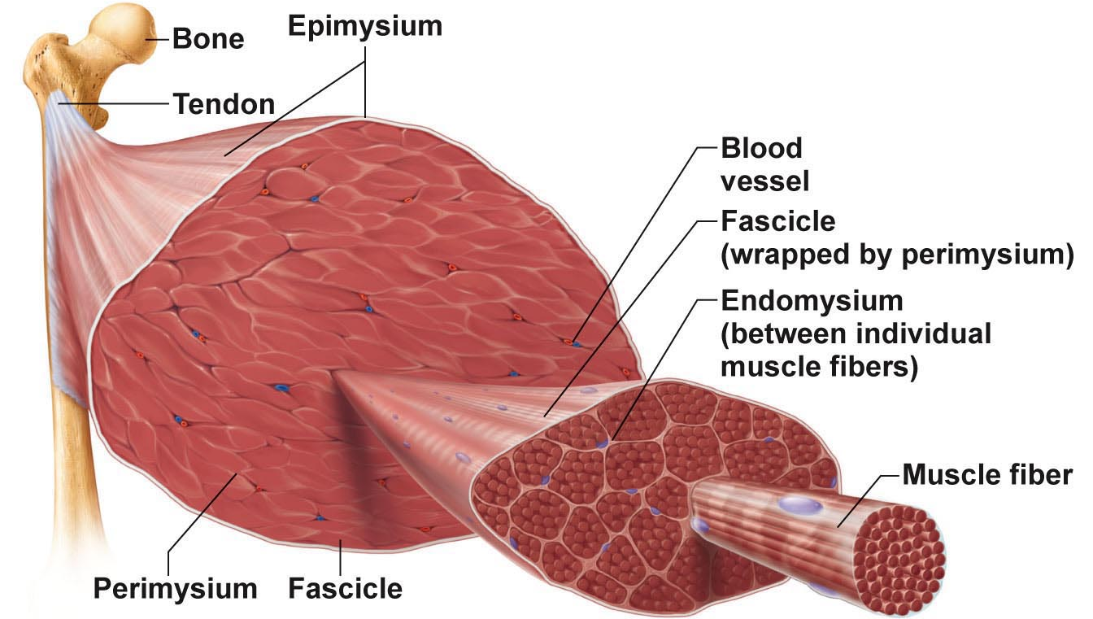
- most muscles span joints
- Most attachments are indirect attachments involving either a tendon or an aponeurosis

10.1 For any movement, muscles can act in one of three ways
- muscles can only pull; they never push. Generally, as a muscle shortens, its insertion (attachment on the movable bone) moves toward its origin (its fixed or immovable point of attachment).
- Muscles can be classified into three functional groups
- A muscle that has the major responsibility for producing a specific movement is a prime mover, or agonist
- Muscles that oppose, or reverse, a particular movement are antagonists. When a prime mover is active, the antagonist muscles may stretch or remain relaxed. A prime mover and its antagonist are located on opposite sides of the joint across which they act. Antagonists can also be prime movers in their own right The latissimus dorsi is the prime mover of extension of the arm.
- most movements involve the action of one or more synergists. Help prime movers by adding a little extra force to the same movement or by reducing undesirable or unnecessary movements.
- When a muscle crosses two or more joints, its contraction causes movement at all of the spanned joints unless other muscles act as joint stabilizers.
- the finger flexor muscles cross both the wrist and the interphalangeal joints, but you can make a fist without bending your wrist because synergistic muscles stabilize the wrist
- When synergists immobilize a bone, or a muscle’s origin so that the prime mover has a stable base on which to act, they are called fixators
- muscles that help maintain upright posture are fixators.

10.2 How are skeletal muscles named?
- Skeletal muscles are named according to
- Muscle action. When muscles are named for the movement they produce, action words such as flexor, extensor, or adductor appear in the muscle’s name.
- Location of the attachments. Some muscles are named according to their points of origin and insertion. The origin is always named first.
- Number of origins. When biceps, triceps, or quadriceps forms part of a muscle’s name, you can assume that the muscle has two, three, or four heads, respectively, each attached to a different origin.
- Direction of muscle fibers. The names of some muscles reveal the direction in which their fibers (and fascicles) run in reference to some imaginary line, usually the midline of the body or the longitudinal axis of a limb bone. In muscles with the term rectus (straight) in their names, the fibers run parallel to that imaginary line (axis). Transversus indicates that the muscle fibers run at right angles to that line, and oblique indicates that the fibers run obliquely to it.
- Muscle size. Terms such as maximus (largest), minimus (smallest), longus (long), and brevis (short) are often used in muscle names.
- Muscle shape. Some muscles are named for their distinctive shapes.
- Muscle location. Some muscle names indicate the bone or body region with which the muscle is associated.

10.3 Fascicle arrangements help determine muscle shape and force
- All skeletal muscles consist of fascicles (bundles of fibers), but fascicle arrangements vary
- most common patterns of fascicle arrangement are circular, convergent, parallel, and pennate
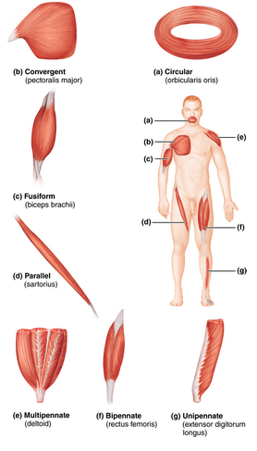
Circular
- The fascicular pattern is circular when the fascicles are arranged in concentric rings
- surround external body openings, which they close by contracting. A general term for such muscles is sphincters
Convergent
- A convergent muscle has a broad origin, and its fascicles converge toward a single tendon of insertion. Such a muscle is triangular or fan shaped like the pectoralis major muscle of the anterior thorax
Parallel
- In a parallel arrangement, the length of the fascicles runs parallel to the long axis of the muscle. Such muscles are either straplike like the sartorius muscle of the thigh or spindle shaped with an expanded belly (midsection), like the biceps brachii muscle of the arm
- However, some anatomists classify spindle-shaped muscles into a separate class as fusiform muscles.
Pennate
- In a pennate pattern, the fascicles (and muscle fibers) are short and they attach obliquely to a central tendon that runs the length of the muscle. Pennate muscles come in three forms
  - Unipennate, in which the fascicles insert into only one side of the tendon, as in the extensor digitorum longus muscle of the leg
  - Bipennate, in which the fascicles insert into the tendon from opposite sides so the muscle looks like a feather
  - Multipennate, which looks like many feathers side by side, with all their quills inserted into one large tendon.
- Because skeletal muscle fibers may shorten to about 70% of their resting length when they contract, the longer and the more nearly parallel the muscle fibers are to a muscle’s long axis, the more the muscle can shorten. Muscles with parallel fascicle arrangements shorten the most, but are not usually very powerful. Muscle power depends more on the total number of muscle fibers in the muscle
- The stocky bipennate and multipennate muscles, which pack in the most fibers, shorten very little but tend to be very powerful.
*Swallowing begins when the tongue and buccinator muscles of the cheeks squeeze the food back along the roof of the mouth toward the pharynx. A rapid series of sequential muscular movements in the posterior mouth and pharynx complete the process The suprahyoid muscles pull the hyoid bone superiorly and anteriorly toward the mandible, which widens the pharynx to receive the food (Figure 10.9c). The larynx is also pulled superiorly and anteriorly under the cover of the flaplike epiglottis, a maneuver that closes off the respiratory passageway (larynx) so that food is not inhaled into the lungs. Small muscles that elevate the soft palate close off the nasal passages to prevent food from entering the superior nasal cavity. (These muscles, the tensor and levator veli palatini, are not described in the table but are illustrated in Figure 10.9c.) The pharyngeal constrictor muscles in the wall of the pharynx propel food inferiorly into the esophagus. The infrahyoid muscles pull the hyoid bone and larynx to their more inferior positions as swallowing ends.
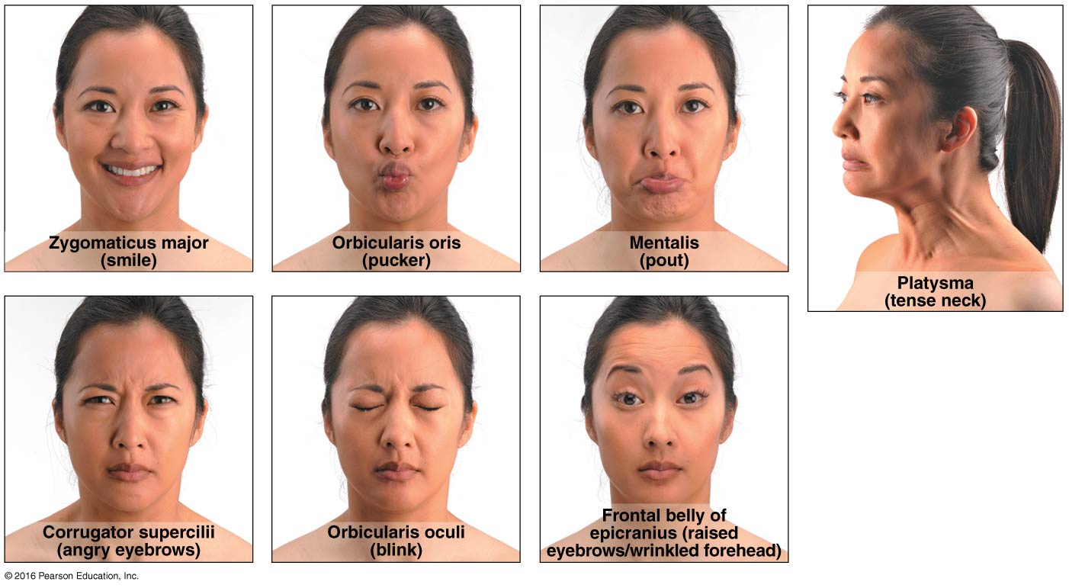
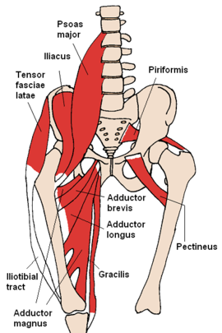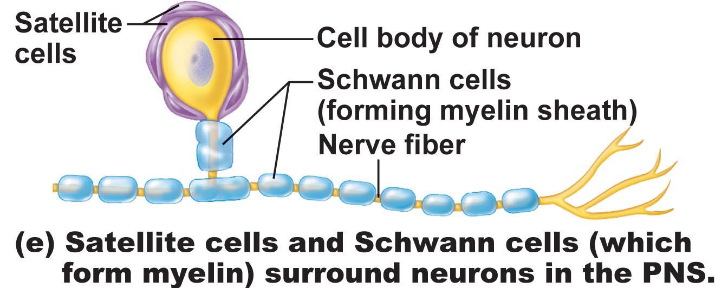

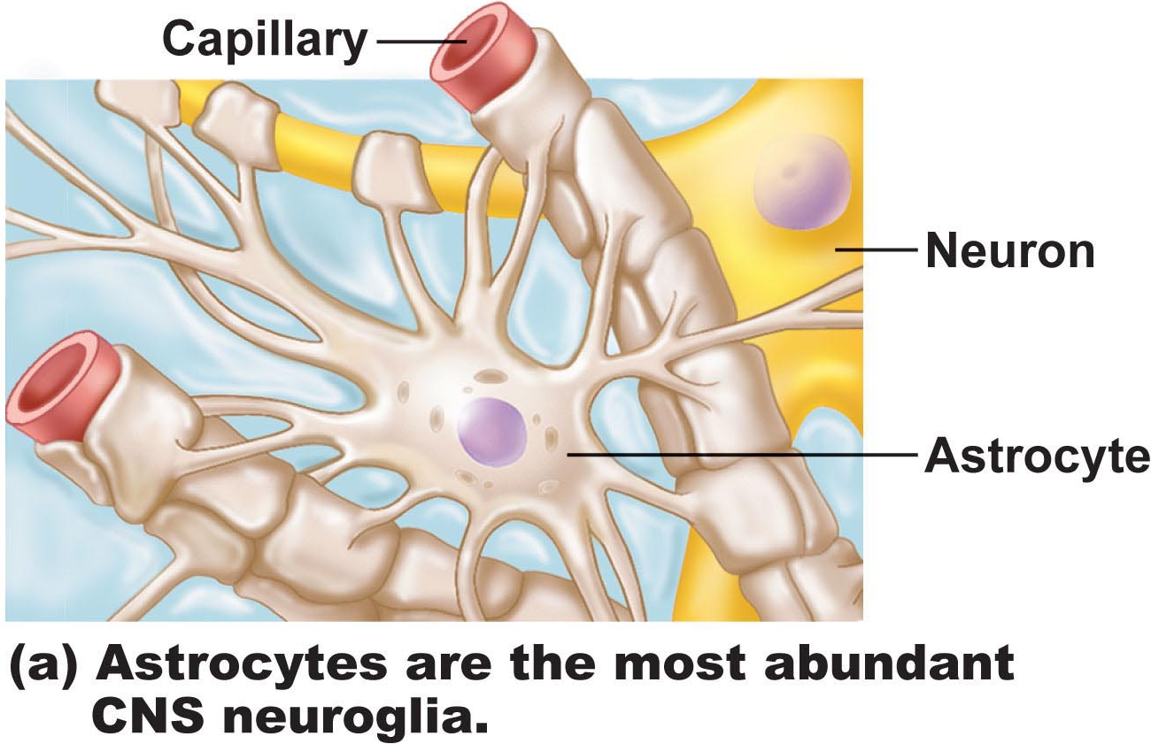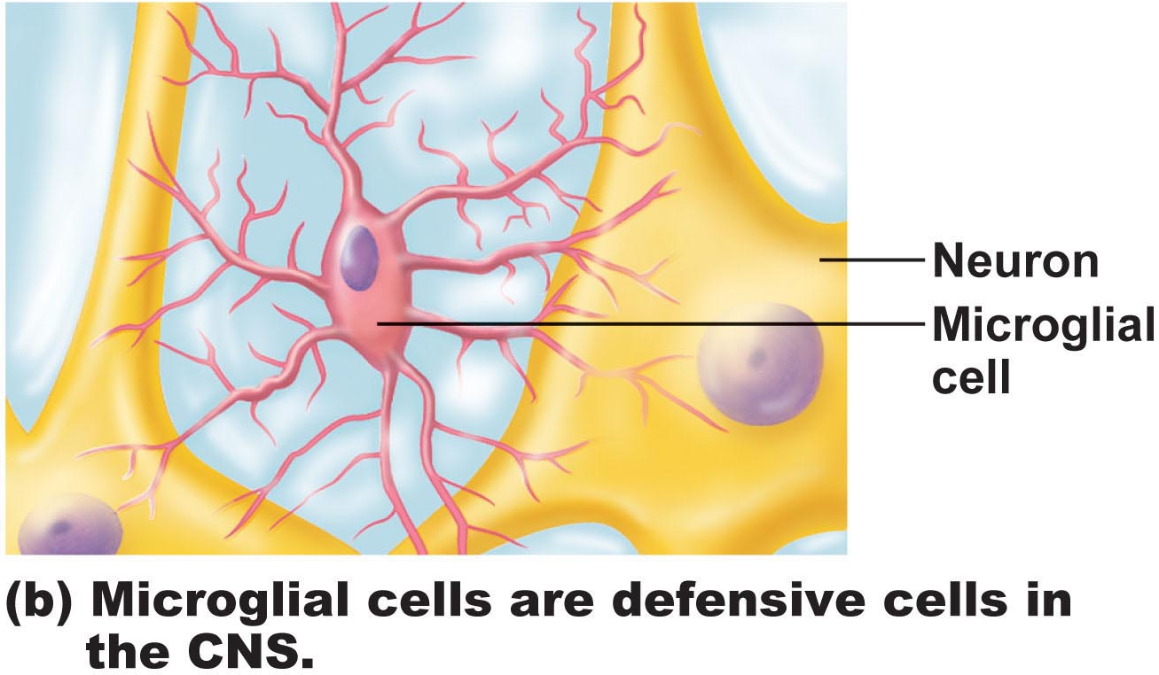
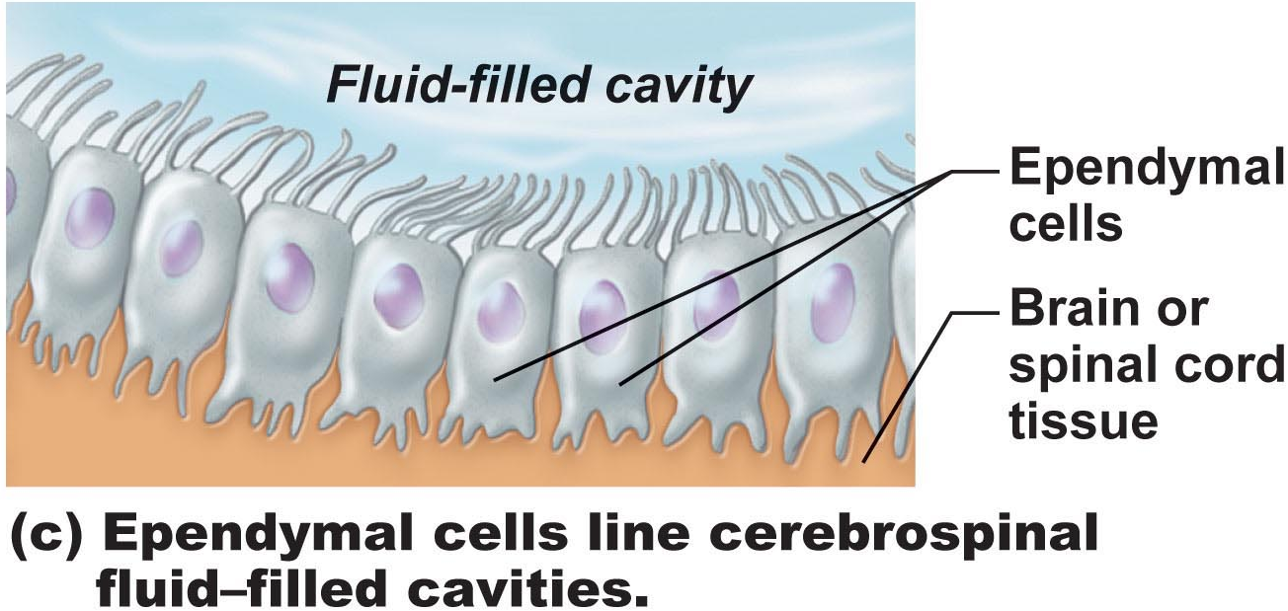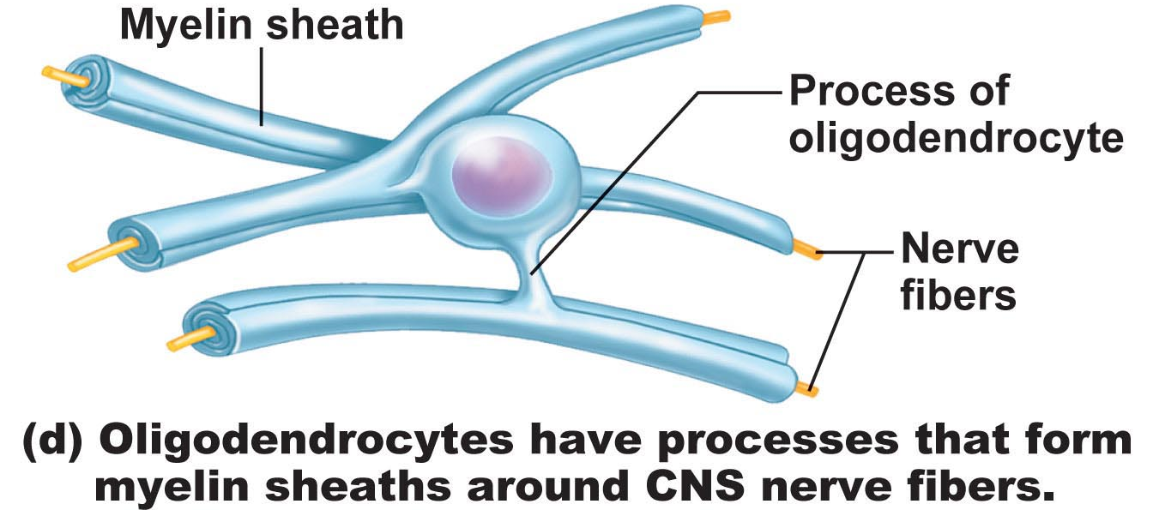
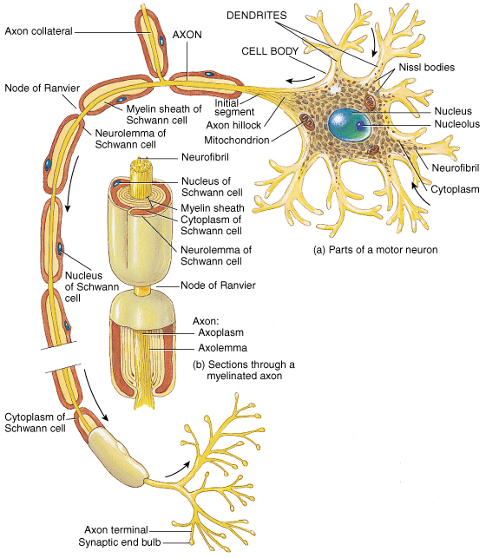
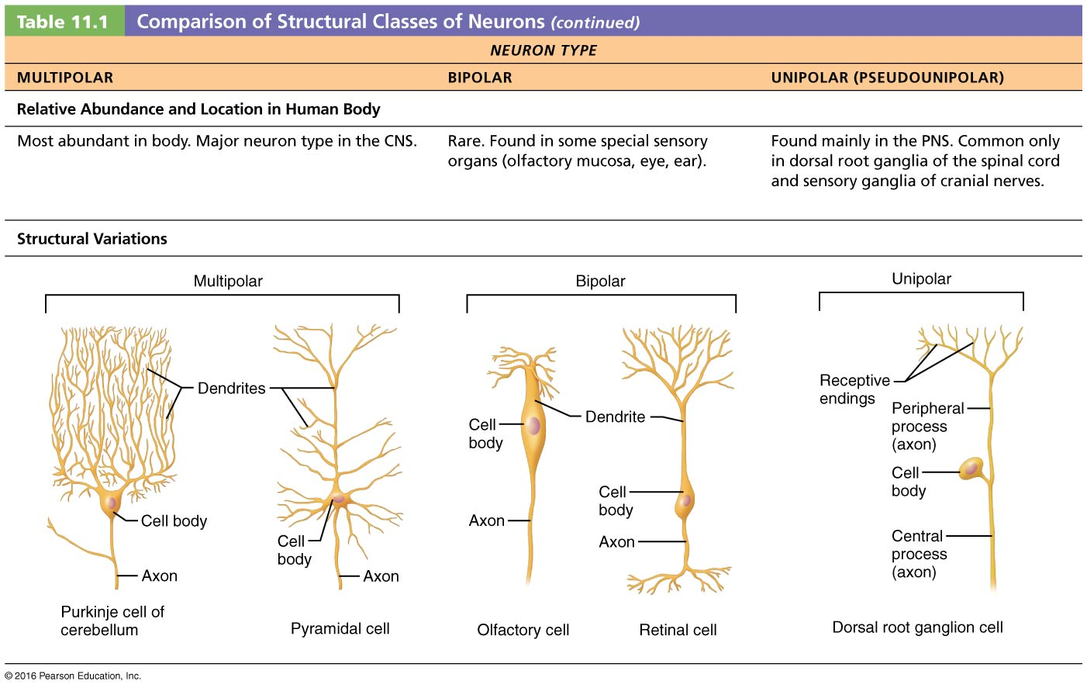

11.1 The nervous system receives, integrates, and responds to information
  - Sensory input. The nervous system uses its millions of sensory receptors to monitor changes occurring both inside and outside the body. The gathered information is called sensory input.
  - Integration. The nervous system processes and interprets sensory input and decides what should be done at each moment—a process called integration.
  - Motor output. The nervous system activates effector organs—the muscles and glands—to cause a response, called motor output.
- The central nervous system (CNS) consists of the brain and spinal cord, which occupy the dorsal body cavity. The CNS is the integrating and control center of the nervous system. It interprets sensory input and dictates motor output based on reflexes, current conditions, and past experience
- The peripheral nervous system (PNS) is the part of the nervous system outside the CNS. The PNS consists mainly of nerves (bundles of axons) that extend from the brain and spinal cord, and ganglia (collections of neuron cell bodies). Spinal nerves carry impulses to and from the spinal cord, and cranial nerves carry impulses to and from the brain. These peripheral nerves serve as communication lines that link all parts of the body to the CNS.
- The sensory, or afferent, division (af′er-ent; carrying toward) consists of nerve fibers (axons) that convey impulses to the central nervous system from sensory receptors located throughout the body.
- The motor, or efferent, division (ef′er-ent; carrying away) of the PNS transmits impulses from the CNS to effector organs, which are the muscles and glands. These impulses activate muscles to contract and glands to secrete. In other words, they effect (bring about) a motor response.
- Somatic sensory fibers convey impulses from the skin, skeletal muscles, and joints (soma = body)
- Visceral sensory fibers transmit impulses from the visceral organs (organs within the ventral body cavity)
- The motor division also has two main parts
  - The somatic nervous system is composed of somatic motor nerve fibers that conduct impulses from the CNS to skeletal muscles. It is often referred to as the voluntary nervous system because it allows us to consciously control our skeletal muscles.
  - The autonomic nervous system (ANS) consists of visceral motor nerve fibers that regulate the activity of smooth muscles, cardiac muscles, and glands. Autonomic means a law unto itself, and because we generally cannot control such activities as the pumping of our heart or the movement of food through our digestive tract, the ANS is also called the involuntary nervous system
- the ANS has two functional subdivisions, the sympathetic division and the parasympathetic division
- The nervous system consists mostly of nervous tissue, which is highly cellular. For example, less than 20% of the CNS is extracellular space, which means that the cells are densely packed and tightly intertwined
- nervous tissue is made up of just two principal types of cells
  - Supporting cells called neuroglia, small cells that surround and wrap the more delicate neurons
  - Neurons, nerve cells that are excitable (responsive to stimuli) and transmit electrical signals

11.2 Neuroglia support and maintain neurons
- Neurons have an exceptionally high metabolic rate and require continuous and abundant supplies of oxygen and glucose. They cannot survive for more than a few minutes without oxygen.
- Neurons have extreme longevity. Given good nutrition, they can function optimally for a lifetime. Neurons are amitotic. As neurons assume their roles as communicating links of the nervous system, they lose their ability to divide.
- There are exceptions to this rule. For example, olfactory epithelium and some hippocampal regions of the brain contain stem cells that can produce new neurons throughout life.
- There are six types of neuroglia—four in the CNS and two in the PNS
- outnumber neurons in the CNS by about 10 to 1, and make up about half the mass of the brain.
- Like neurons, most neuroglia have branching processes (extensions) and a central cell body
Neuroglia in CNS
- Neuroglia in the CNS include astrocytes, microglial cells, ependymal cells, and oligodendrocytes
- Astrocytes
- Astrocytes play a role in making exchanges between capillaries and neurons, helping determine capillary permeability. They guide the migration of young neurons and formation of synapses (junctions) between neurons. Astrocytes also control the chemical environment around neurons, where their most important job is mopping up leaked potassium ions and recapturing and recycling released neurotransmitters. Furthermore, astrocytes have been shown to respond to nearby nerve impulses and released neurotransmitters
- Their numerous radiating processes cling to neurons and their synaptic endings, and cover nearby capillaries.
- Connected by gap junctions, astrocytes signal each other with slow-paced intracellular calcium pulses (calcium waves), and by releasing extracellular chemical messengers
- Oligodendrocytes
  - much smaller size and their darker-staining nuclei.
  - Oligodendrocytes line up along the thicker nerve fibers in the CNS and wrap their processes tightly around the fibers, producing an insulating covering called a myelin sheath
  - have fewer processes than astrocytes
- Ependymal Cells
  - line the central cavities of the brain and the spinal cord, where they form a fairly permeable barrier between the cerebrospinal fluid that fills those cavities and the tissue fluid bathing the cells of the CNS. The beating of their cilia helps to circulate the cerebrospinal fluid that cushions the brain and spinal cord.
  - range in shape from squamous to columnar, and many are ciliated
- Microglial Cells
  - Their processes touch nearby neurons, monitoring their health, and when they sense that certain neurons are injured or in other trouble, the microglial cells migrate toward them. Where invading microorganisms or dead neurons are present, the microglial cells transform into a special type of macrophage that phagocytizes the microorganisms or neuronal debris. This protective role is important because cells of the immune system have limited access to the CNS.
Neuroglia in the PNS
- Schwann cells (also called neurolemmocytes) surround all nerve fibers in the PNS and form myelin sheaths around the thicker nerve fibers
- Schwann cells are vital to regeneration of damaged peripheral nerve fibers. functionally similar to oligodendrocytes
- Satellite cells surround neuron cell bodies located in the peripheral nervous system, and are thought to have many of the same functions in the PNS as astrocytes do in the CNS.

11.3 Neurons are the structural units of the nervous system
Neuron Cell Body
- The neuron cell body consists of a spherical nucleus with a conspicuous nucleolus surrounded by cytoplasm. Also called the perikaryon (peri = around, kary = nucleus) or soma, the cell body ranges in diameter from 5 to 140 μm
- major biosynthetic center of a neuron
- Most neuron cell bodies are located in the CNS, where they are protected by the bones of the skull and vertebral column. Clusters of cell bodies in the CNS are called nuclei, whereas those that lie along the nerves in the PNS are called ganglia
- the plasma membrane of the cell body acts as part of the receptive region that receives information from other neurons.
- The cell body of some neurons also contains pigment inclusions. For example, some contain a black melanin, a red iron-containing pigment, or a golden-brown pigment called lipofuscin
- Lipofuscin, a harmless by-product of lysosomal activity, is sometimes called the aging pigment because it accumulates in neurons of elderly individuals.
- Microtubules and neurofibrils, which are bundles of intermediate filaments (neurofilaments), are important in maintaining cell shape and integrity. They form a network throughout the cell body
- This rough ER, also called the chromatophilic substance (chromatophilic = color loving) or Nissl bodies (nis′l), stains darkly with basic dyes. The Golgi apparatus is also well developed and forms an arc or a complete circle around the nucleus.
Neuron Processes
- all have a cell body and one or more slender processes
- two types of neuron processes, dendrites and axons
- The brain and spinal cord (CNS) contain both neuron cell bodies and their processes. The PNS consists chiefly of neuron pro-cesses. Bundles of neuron processes are called tracts in the CNS and nerves in the PNS.
The Axon Structure
- Each neuron has only one axon, but axons may have occasional branches along their length. These branches, called axon collaterals, extend from the axon at more or less right angles.
- Any long axon is called a nerve fiber.
- The initial region of the axon arises from a cone-shaped area of the cell body called the axon hillock
Dendrites
- Dendrites convey incoming messages toward the cell body. These electrical signals are usually not action potentials (nerve impulses) but are short-distance signals called graded potentials
- They bristle with dendritic spines—thorny appendages with bulbous or spiky ends—which represent points of close contact (synapses) with other neurons
- Dendrites, the main receptive or input regions, provide an enormous surface area for receiving signals from other neurons
- Virtually all organelles present in the cell body also occur in dendrites.
- Dendrites of motor neurons are short, tapering, diffusely branching extensions
The Axon Functional Characteristics
- conducting region of the neuron
- lacks rough endoplasmic reticulum and a Golgi apparatus
- axon contains the same organelles found in the dendrites and cell body
- When the impulse reaches the axon terminals, it causes neurotransmitters—signaling chemicals—to be released into the extracellular space.
- the nerve impulse is generated at the junction of the axon hillock and axon (the trigger zone) and conducted along the axon to the axon terminals, which are the secretory region of the neuron.
- It generates nerve impulses and transmits them, typically away from the cell body, along the plasma membrane, or axolemma
- An axon usually branches profusely at its end, 10,000 or more terminal branches (also called terminal arborizations) per neuron is not unusual. The knoblike distal endings of the terminal branches are called axon terminals.
Axonal Transport
- Certain viruses and bacterial toxins that damage neural tissues use retrograde axonal transport to reach the cell body. This transport mechanism has been demonstrated for polio, rabies, and herpes simplex viruses and for tetanus toxin. Researchers are investigating using retrograde transport to treat genetic diseases by introducing viruses containing corrected genes or microRNA to suppress defective genes.
- uses different ATP-dependent motor proteins (kinesin or dynein), depending on the direction of transport
- cell body to be advised of conditions at the axon terminals and delivers to the cell body vesicles containing signal molecules (such as nerve growth factor, which activates certain nuclear genes promoting growth).
- Substances transported through the axon in the retrograde direction are mostly organelles returning to the cell body to be degraded or recycled. Retrograde transport is also an important means of intracellular communication
- Substances moved in the anterograde direction include mitochondria, cytoskeletal elements, membrane components used to renew the axon plasma membrane, and enzymes needed to synthesize certain neurotransmitters
- Movement away from the cell body is anterograde movement, and that in the opposite direction is retrograde movement.
- motor proteins and cytoskeletal elements (microtubules and actin filaments), substances travel continuously
- Consequently, an axon depends (1) on its cell body to renew the necessary proteins and membrane components, and (2) on efficient transport mechanisms to distribute them. Axons quickly decay if cut or severely damaged.
Myelin Sheath
- Adjacent Schwann cells do not touch one another, so there are gaps in the sheath. These myelin sheath gaps, or nodes of Ranvier, occur at regular intervals (about 1 mm apart) along a myelinated axon. Axon collaterals can emerge at these gaps.
- presence of specific protein molecules that interlock to form a sort of molecular Velcro between adjacent myelin membranes.
- Channel and carrier proteins are notably absent, making myelin sheaths exceptionally good electrical insulators
- The nucleus and most of the cytoplasm of the Schwann cell end up as a bulge just external to the myelin sheath. This portion is called the outer collar of perinuclear cytoplasm (formerly known as the neurilemma)
- This tight coil of wrapped membranes is the myelin sheath, and its thickness depends on the number of spirals.
- Initially the wrapping is loose, but the Schwann cell cytoplasm is gradually squeezed from between the membrane layers.
- Myelin sheaths in the PNS are formed by Schwann cells
Myelination in the PNS
- Myelinated fibers (axons bearing a myelin sheath) conduct nerve impulses rapidly, whereas nonmyelinated fibers conduct impulses more slowly. Note that myelin sheaths are associated only with axons. Dendrites are always nonmyelinated.
- Many nerve fibers, particularly those that are long or large in diameter, are covered with a whitish, fatty (protein-lipoid), segmented myelin sheath
- Sometimes Schwann cells surround peripheral nerve fibers but the coiling process does not occur
- Nerve fibers associated with Schwann cells in this manner are said to be nonmyelinated and are typically thin fibers.
Myelination in the CNS
- Regions of the brain and spinal cord containing dense collections of myelinated fibers are referred to as white matter and are primarily fiber tracts. Gray matter contains mostly neuron cell bodies and nonmyelinated fibers.
- As in the PNS, the smallest-diameter axons are nonmyelin-ated. These nonmyelinated axons are covered by the long extensions of adjacent glial cells.
- an oligodendrocyte has multiple flat processes that can coil around as many as 60 axons at the same time. As in the PNS, myelin sheath gaps separate adjacent sections of an axon’s myelin sheath. However, CNS myelin sheaths lack an outer collar of perinuclear cytoplasm because cell extensions do the coiling and the squeezed-out cytoplasm is forced back toward the centrally located nucleus instead of peripherally.
- The central nervous system contains both myelinated and nonmyelinated axons. However, in the CNS, it is the oligodendrocytes that form myelin sheaths
Classification of Neurons
- Structural Classification
  - Multipolar neurons (polar = end, pole) have three or more processes—one axon and the rest dendrites. They are the most common neuron type in humans, with more than 99% of neurons in this class. Multipolar neurons are the major neuron type in the CNS.
  - Bipolar neurons have two processes—an axon and a dendrite—that extend from opposite sides of the cell body. These rare neurons are found in some of the special sense organs such as in the retina of the eye and in the olfactory mucosa.
  - Unipolar neurons have a single short process that emerges from the cell body and divides T-like into proximal and distal branches. The more distal peripheral process is often associated with a sensory receptor. The central process enters the CNS. Unipolar neurons are more accurately called pseudounipolar neurons (pseudo = false) because they originate as bipolar neurons. During early embryonic development, the two processes converge and partially fuse to form the short single process that issues from the cell body. Unipolar neurons are found chiefly in ganglia in the PNS, where they function as sensory neurons.
  - We have chosen to emphasize the newer definition of an axon as generating and transmitting an impulse. For unipolar neurons, we will refer to the combined length of the peripheral and central process as an axon. In place of dendrites, unipolar neurons have receptive endings (sensory terminals) at the end of the peripheral process.
Functional Classification
- groups neurons according to the direction in which the nerve impulse travels relative to the central nervous system
- Interneurons, or association neurons, lie between motor and sensory neurons in neural pathways and shuttle signals through CNS pathways where integration occurs. Most interneurons are confined within the CNS. They make up over 99% of the neurons of the body, including most of those in the CNS. Almost all interneurons are multipolar, but there is considerable diversity in size and fiber-branching patterns
- Motor, or efferent, neurons carry impulses away from the CNS to the effector organs (muscles and glands) of the body. Motor neurons are multipolar. Except for some neurons of the autonomic nervous system, their cell bodies are located in the CNS.
- Sensory, or afferent, neurons transmit impulses from sensory receptors in the skin or internal organs toward or into the central nervous system. Except for certain neurons found in some special sense organs, virtually all sensory neurons are unipolar, and their cell bodies are located in sensory ganglia outside the CNS. Only the most distal parts of these unipolar neurons act as impulse receptor sites, and the peripheral processes are often very long
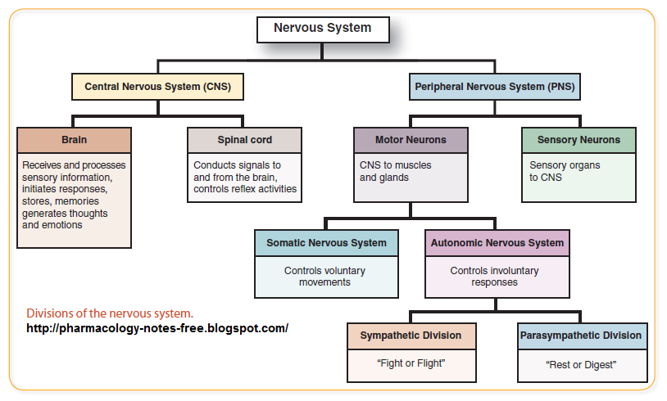
Chapter 12 The Central Nervous System
- The average adult human brain has a mass of about 1500 g (3.3 lb).
- During the course of animal evolution, cephalization) has occurred. That is, there has been an elaboration of the rostral (toward the snout), or anterior, portion of the CNS, along with an increase in the number of neurons in the head.

  - Folding during development determines the complex structure of the adult brain
- The forebrain divides into the telencephalon (endbrain) and diencephalon (interbrain), and the hindbrain constricts, forming the metencephalon (afterbrain) and myelencephalon (spinal brain). The midbrain remains undivided.
- The remaining caudal (toward the tail), or posterior, portion of the neural tube becomes the spinal cord
- The diencephalon specializes to form the hypothalamus, thalamus, epithalamus, and retina of the eye.
Ventricles
- The brain ventricles are continuous with one another and with the central canal of the spinal cord
- Each lateral ventricle communicates with the narrow third ventricle in the diencephalon via a channel called an interventricular foramen.
- Anteriorly, the lateral ventricles lie close together, separated only by a thin median membrane called the septum pellucidum
- The hollow ventricular chambers are filled with cerebrospinal fluid and lined by ependymal cells, a type of neuroglia
- Three openings mark the walls of the fourth ventricle the paired lateral apertures in its side walls and the median aperture in its roof. These apertures connect the ventricles to the subarachnoid space, a fluid-filled space surrounding the brain.
- The third ventricle is continuous with the fourth ventricle via the canal-like cerebral aqueduct that runs through the midbrain. The fourth ventricle lies in the hindbrain dorsal to the pons and superior medulla

Brain Regions and Organization
- Gray and white matter have a unique distribution in the brain. The gray matter of the CNS consists of short, nonmyelinated neurons and neuron cell bodies. The white matter is composed of myelinated and nonmyelinated axons. The basic pattern of the CNS is a central cavity surrounded by gray matter, external to which is white matter
- The spinal cord exhibits this basic pattern. This pattern changes with ascent into the brain stem.
- The brain stem has additional gray matter nuclei scattered within the white matter.
- The cerebral hemispheres and the cerebellum have an outer layer or bark of gray matter called a cortex
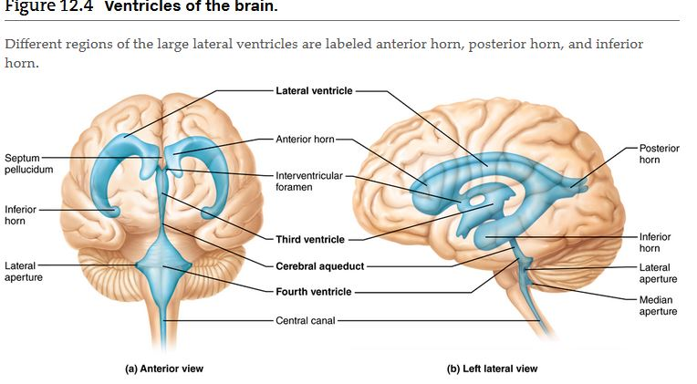

12.2 The cerebral hemispheres consist of cortex, white matter, and the basal nuclei
- cerebral hemispheres form the superior part of the brain
- 83% of total brain mass
- Deeper grooves, called fissures, separate large regions of the brain
- Elevated ridges of tissue called gyri —separated by shallow grooves called sulci
- Sulci divide it into five lobes:
- The deep lateral sulcus outlines the flaplike temporal lobe and separates it from the parietal and frontal lobes. A fifth lobe of the cerebral hemisphere, the insula, is buried deep within the lateral sulcus and forms part of its floor
- The central sulcus, which lies in the frontal plane, separates the frontal lobe from the parietal lobe. Bordering the central sulcus are the precentral gyrus anteriorly and the postcentral gyrus posteriorly. The parieto-occipital sulcus, located more posteriorly on the medial surface of the hemisphere, separates the occipital lobe from the parietal lobe.
- Another large fissure, the transverse cerebral fissure, separates the cerebral hemispheres from the cerebellum below
- The median longitudinal fissure separates the cerebral hemispheres
- The frontal lobes lie in the anterior cranial fossa, and the anterior parts of the temporal lobes fill the middle cranial fossa
- The posterior cranial fossa, however, houses the brain stem and cerebellum. The occipital lobes are located well superior to that cranial fossa.
- Each of the cerebral hemispheres has three basic regions:
  - A superficial cerebral cortex of gray matter, which looks gray in fresh brain tissue
  - Internal white matter
  - Basal nuclei, islands of gray matter situated deep within the white matter
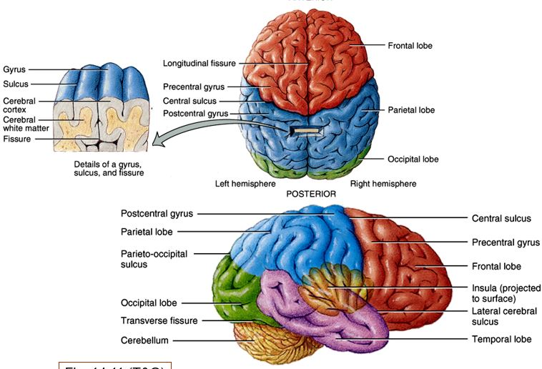
Cerebral Cortex
- The cerebral cortex contains three kinds of functional areas motor areas, sensory areas, and association areas. As you read about these areas, do not confuse the sensory and motor areas of the cortex with sensory and motor neurons. All neurons in the cortex are interneurons. Each hemisphere is chiefly concerned with the sensory and motor functions of the contralateral (opposite) side of the body. Although largely symmetrical in structure, the two hemispheres are not entirely equal in function. Instead, there is lateralization (specialization) of cortical functions.
- The cerebral cortex is composed of gray matter neuron cell bodies, dendrites, associated glia and blood vessels, but no fiber tracts. It contains billions of neurons arranged in six layers.
- PET scans show maximal metabolic activity in the brain
- functional MRI scans reveal blood flow
- 40% of total brain mass. Its many convolutions effectively triple its surface area.
Motor Areas
- motor areas of the cortex, which control voluntary movement, lie in the posterior part of the frontal lobes primary motor cortex, premotor cortex, Broca’s area, and the frontal eye field
- They show that specific motor and sensory functions are localized in discrete cortical areas called domains. However, many higher mental functions, such as memory and language, appear to be spread over large areas of the cortex in overlapping domains
Primary Motor Cortex
- The primary (somatic) motor cortex is located in the precentral gyrus of the frontal lobe of each hemisphere
- Large neurons, called pyramidal cells, in these gyri allow us to consciously control the precise or skilled voluntary movements of our skeletal muscles. Their long axons, which project to the spinal cord, form the massive voluntary motor tracts called pyramidal tracts or corticospinal tracts
- The motor homunculus view of the primary motor cortex (Figure 12.8) implies a one-to-one correspondence between cortical neurons and the muscles they control, but this is somewhat misleading.
- mapping of the body in CNS structures is called somatotopy
- For example, reaching forward with one arm involves some muscles acting at the shoulder and some acting at the elbow
Premotor Cortex
- Just anterior to the precentral gyrus in the frontal lobe is the premotor cortex
- The premotor cortex helps plan movements. This region selects and sequences basic motor movements into more complex tasks, such as playing a musical instrument or typing. Using highly processed sensory information received from other cortical areas, it can control voluntary actions that depend on sensory feedback, such as feeling for a light switch in a dark room.
- the premotor cortex also influences motor activity more directly by supplying about 15% of pyramidal tract fibers.
- All other descending motor tracts issue from brain stem nuclei and consist of chains of two or more neurons.
Broca’s Area
- Broca’s area lies anterior to the inferior region of the premotor area
- Broca’s area also becomes active as we prepare to speak and even as we think about (plan) many voluntary motor activities other than speech.
- It has long been considered to be (1) present in one hemisphere only (usually the left) and (2) a special motor speech area that directs the muscles involved in speech production.
Frontal Eye Field
- The frontal eye field is located partially in and anterior to the premotor cortex and superior to Broca’s area (Figure 12.7a). This cortical region controls voluntary movement of the eyes.
- Damage to localized areas of the primary motor cortex (as from a stroke) paralyzes the body muscles controlled by those areas
- Destruction of the premotor cortex, or part of it, results in loss of the motor skill(s) programmed by that region, but does not impair muscle strength and the ability to perform the discrete individual movements
Sensory Areas
- Areas concerned with conscious awareness of sensation, the sensory areas of the cortex, occur in the parietal, insular, temporal, and occipital lobes
- Only voluntary control is lost, however, as the muscles can still contract reflexively.
Primary Somatosensory Cortex
- The primary somatosensory cortex resides in the postcentral gyrus of the parietal lobe, just posterior to the primary motor cortex. Neurons in this gyrus receive information from the general (somatic) sensory receptors in the skin and from proprioceptors (position sense receptors) in skeletal muscles, joints, and tendons. The neurons then identify the body region being stimulated, an ability called spatial discrimination
- The amount of sensory cortex devoted to a particular body region is related to that region’s sensitivity (that is, to how many receptors it has), not its size.
- largest parts of the somatosensory homunculus
- the face (especially the lips) and fingertips are the most sensitive body areas
Somatosensory Association Cortex
- The somatosensory association cortex lies just posterior to the primary somatosensory cortex
- major function of this area is to integrate sensory inputs (temperature, pressure, and so forth) relayed to it via the primary somatosensory cortex to produce an understanding of an object being felt its size, texture, and the relationship of its parts
- Someone with damage to this area could not recognize these objects without looking at them.
Visual Areas
- The primary visual (striate) cortex is seen on the extreme posterior tip of the occipital lobe, but most of it is buried deep in the calcarine sulcus in the medial aspect of the occipital lobe
- The largest cortical sensory area, the primary visual cortex receives visual information that originates on the retina of the eye. There is a contralateral map of visual space on the primary visual cortex, analogous to the body map on the somatosensory cortex.
- The visual association area surrounds the primary visual cortex and covers much of the occipital lobe
- We do our seeing with these cortical neurons. However, complex visual processing involves the entire posterior half of the cerebral hemispheres
- visual association area uses past visual experiences to interpret visual stimuli (color, form, and movement)
Auditory Areas
- Each primary auditory cortex is located in the superior margin of the temporal lobe next to the lateral sulcus.
- Sound energy exciting the hearing receptors of the inner ear causes impulses to be transmitted to the primary auditory cortex, where they are interpreted as pitch, loudness, and location
- The more posterior auditory association area then permits the perception of the sound stimulus, which we hear as speech, a scream, music, thunder,
- Memories of sounds heard in the past appear to be stored here for reference
Vestibular (Equilibrium) Cortex
- the part of the cortex responsible for conscious awareness of balance (the position of the head in space) is located in the posterior part of the insula and adjacent parietal cortex.
Gustatory Cortex
- The gustatory (taste) cortex, a region involved in perceiving taste stimuli, is located in the insula just deep to the temporal lobe
Olfactory Cortex
- The primary olfactory (smell) cortex lies on the medial aspect of the temporal lobe in a small region called the piriform lobe which is dominated by the hooklike uncus
- Afferent fibers from smell receptors in the superior nasal cavity send impulses along the olfactory tracts that are ultimately relayed to the olfactory cortices.
- The olfactory cortex is part of the primitive rhinencephalon, which includes all parts of the cerebrum that receive olfactory signals—the orbitofrontal cortex, uncus, and associated regions located on or in the medial aspects of the temporal lobes, and the protruding olfactory tracts and bulbs that extend to the nose.
- It has become part of the newer emotional brain, called the limbic system
- The only portions of the human rhinencephalon still devoted to smell are the olfactory bulbs and tracts and the greatly reduced olfactory cortices
Visceral Sensory Area
- The cortex of the insula just posterior to the gustatory cortex is involved in conscious perception of visceral sensations. These include upset stomach, full bladder, and the feeling that your lungs will burst when you hold your breath too long.
- Damage to the primary visual cortex (Figure 12.7) results in functional blindness. By contrast, individuals with a damaged visual association area can see, but they do not comprehend what they are looking at.
Multimodal Association Areas
- Most of the cortex, though, consists of complexly connected multimodal association areas that receive inputs from multiple senses and send outputs to multiple areas.
- The multimodal association cortex seems to be where sensations, thoughts, and emotions become conscious.
- The multimodal association areas can be broadly divided into three parts the anterior association, posterior association, and limbic association areas.
Posterior Association Area
- The posterior association area is a large region encompassing parts of the temporal, parietal, and occipital lobes. This area plays a role in recognizing patterns and faces, localizing us and our surroundings in space, and binding different sensory inputs into a coherent whole.
- Many parts of the posterior association area (including Wernicke’s area) are also involved in understanding written and spoken language.
- Different problems arise for individuals with lesions in the part of the posterior association area that provides awareness of self in space. They may refuse to wash or dress the side of their body opposite to the lesion because that doesn’t belong to me.
- Tumors or other lesions of the anterior association area may cause mental and personality disorders including loss of judgment, attentiveness, and inhibitions
Anterior Association Area
- The anterior association area in the frontal lobe, also called the prefrontal cortex, is the most complicated cortical region of all
- It is involved with intellect, complex learning abilities (called cognition), recall, and personality. It contains working memory, which is necessary for abstract ideas, judgment, reasoning, persistence, and planning. These abilities develop slowly in children, which implies that the prefrontal cortex matures slowly and depends heavily on feedback from our social environment
Limbic Association Area
- The limbic association area includes the cingulate gyrus, parahippocampal gyrus, and hippocampus
- The hippocampus establishes memories that allow us to remember this incident.
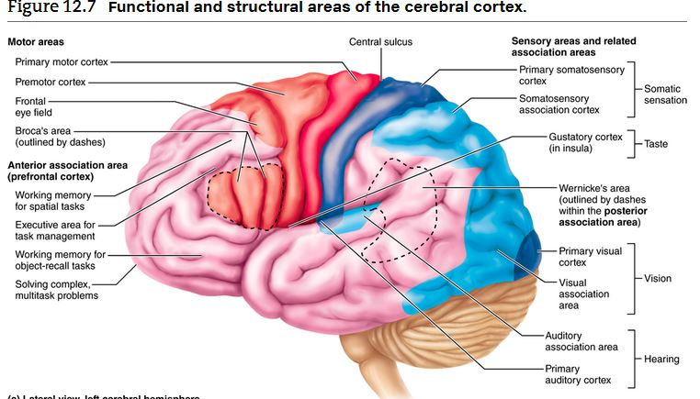
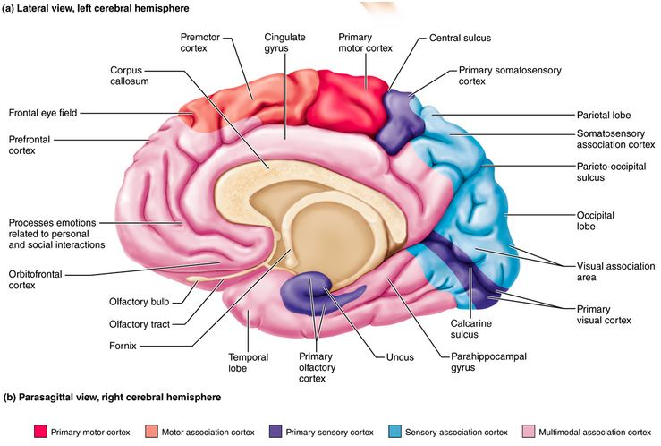
Lateralization of Cortical Functioning
- there is a division of labor, and each hemisphere has abilities not completely shared by its partner. This phenomenon is called lateralization
- the term cerebral dominance designates the hemisphere that is dominant for language
- In most people (about 90%), the left hemisphere has greater control over language abilities, math, and logic.
- The other hemisphere (usually the right) is more free-spirited, more involved in visual-spatial skills, intuition, emotion, and artistic and musical skills.
- Most individuals with left cerebral dominance are right-handed. In the remaining 10% of people, the roles of the hemispheres are reversed or the hemispheres share their functions equally
- Some lefties who have a cerebral cortex that functions bilaterally are ambidextrous.
- The two cerebral hemispheres have almost instantaneous communication with each other via connecting fiber tracts, as well as complete functional integration.
Cerebral White Matter
- The second of the three basic regions of each cerebral hemisphere is the internal cerebral white matter
- The white matter deep to the cortical gray matter is responsible for communication between cerebral areas and between the cerebral cortex and lower CNS centers.
- White matter consists largely of myelinated fibers bundled into large tracts. These fibers and tracts are classified according to the direction in which they run as association, commissural, or projection
  - Projection fibers either enter the cerebral cortex from lower brain or cord centers or descend from the cortex to lower areas. Sensory information reaches the cerebral cortex and motor output leaves it through these projection fibers. They tie the cortex to the rest of the nervous system and to the body’s receptors and effectors. In contrast to commissural and association fibers, which run horizontally, projection fibers run vertically
  - Commissural fibers connect corresponding gray areas of the two hemispheres. These commissures allow the two hemispheres to function as a coordinated whole. The largest commissure is the corpus callosum, which lies superior to the lateral ventricles, deep within the longitudinal fissure. Less prominent examples are the anterior and posterior commissures
  - Association fibers connect different parts of the same hemisphere. Short association fibers connect adjacent gyri. Long association fibers are bundled into tracts and connect different cortical lobes
- At the top of the brain stem, the projection fibers on each side form a compact band, the internal capsule, that passes between the thalamus and some of the basal nuclei. Superior to that point, the fibers radiate fanlike through the cerebral white matter to the cortex. This distinctive arrangement is called the corona radiata
- * Because a nucleus is a collection of neuron cell bodies within the CNS, the term basal nuclei is technically correct. The more frequently used but misleading historical term basal ganglia is a misnomer and should be abandoned, because ganglia are PNS structures.
Deep Basal Nuclei
- within the cerebral white matter is the third basic region of each hemisphere, a group of subcortical nuclei called the basal nuclei or basal ganglia.
- each hemisphere’s basal nuclei include the caudate nucleus, putamen, and globus pallidus
- The comma-shaped caudate nucleus arches superiorly over the diencephalon. Together with the putamen, it forms the striatum, so called because the fibers of the internal capsule passing through them create a striped appearance. Although the putamen (pod) and globus pallidus (pale globe) together form a lens-shaped mass, sometimes called the lentiform nucleus, these two nuclei are functionally separate.
- The basal nuclei are functionally associated with the subthalamic nuclei (located in the lateral floor of the diencephalon) and the substantia nigra of the midbrain
- The basal nuclei receive input from the entire cerebral cortex, as well as from other subcortical nuclei and each other. Via relays through the thalamus, the output nucleus of the basal nuclei (globus pallidus) and the substantia nigra project to the premotor and prefrontal cortices and so influence muscle movements directed by the primary motor cortex. The basal nuclei have no direct access to motor pathways.
- the basal nuclei play a role in cognition and emotion. In all of these cases, the basal nuclei seem to filter out incorrect or inappropriate responses, passing only the best response on to the cortex.
- Additionally, they inhibit antagonistic or unnecessary movements. Disorders of the basal nuclei include Huntington’s disease and Parkinson’s disease.
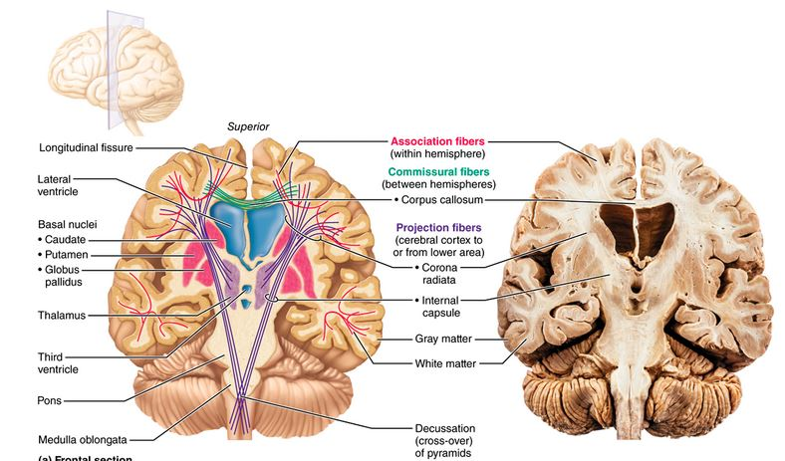

12.3 The diencephalon includes the thalamus, hypothalamus, and epithalamus
- Forming the central core of the forebrain and surrounded by the cerebral hemispheres, the diencephalon consists
- the thalamus, hypothalamus, and epithalamus. These gray matter areas enclose the third ventricle
Thalamus
- The thalamus consists of bilateral egg-shaped nuclei, which form the superolateral walls of the third ventricle
- In most people, an interthalamic adhesion (intermediate mass) connects the nuclei
- The thalamus is the relay station for information coming into the cerebral cortex
- the ventral posterolateral nuclei receive impulses from the general somatic sensory receptors (touch, pressure, pain, etc.), and the lateral and medial geniculate bodies are important visual and auditory relay centers, respectively.
- Impulses having to do with similar functions are relayed as a group via the internal capsule to the appropriate area of the sensory cortex and to specific cortical association areas. However, specific stimulus localization and discrimination occur in the cerebral cortex.
- In addition to sensory inputs, virtually all other inputs ascending to the cerebral cortex funnel through thalamic nuclei. These include:
  - Inputs that help regulate emotion and visceral function from the hypothalamus (via the anterior nuclei)
  - Instructions that help direct the activity of the motor cortices from the cerebellum and basal nuclei (via the ventral lateral and ventral anterior nuclei, respectively)
  - Inputs for memory or sensory integration that are projected to specific association cortices (via pulvinar, lateral dorsal, and lateral posterior nuclei)

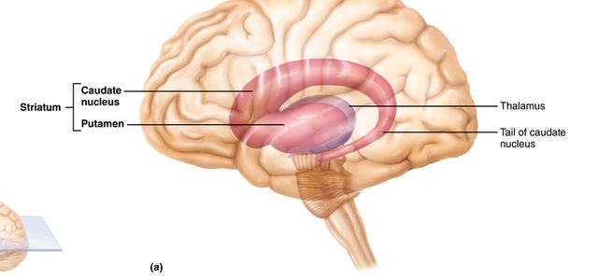

Hypothalamus
- Named for its position below (hypo) the thalamus, the hypo-thalamus caps the brain stem and forms the inferolateral walls of the third ventricle
- extends from the optic chiasma (crossover point of the optic nerves) to the posterior margin of the mammillary bodies
- The mammillary bodies, paired pealike nuclei that bulge ventrally from the hypothalamus, are relay stations in the olfactory pathways. Between the optic chiasma and mammillary bodies is the infundibulum, a stalk of hypothalamic tissue that connects the pituitary gland to the base of the hypothalamus
- Its chief homeostatic roles are to
  - Control the autonomic nervous system. Recall that the autonomic nervous system (ANS) is a system of peripheral nerves that regulates cardiac and smooth muscle and secretion by the glands. The hypothalamus regulates ANS activity by controlling the activity of centers in the brain stem and spinal cord. In this role, the hypothalamus influences blood pressure, rate and force of heartbeat, digestive tract motility, eye pupil size, and many other visceral activities.
  - Initiate physical responses to emotions. The hypothalamus lies at the heart of the limbic system (the emotional part of the brain). It contains nuclei involved in perceiving pleasure, fear, and rage, as well as those involved in biological rhythms and drives (such as the sex drive). The hypothalamus acts through ANS pathways to initiate most physical expressions of emotion. For example, a fearful person has a pounding heart, high blood pressure, pallor, sweating, and a dry mouth.
  - Regulate body temperature. The body’s thermostat is in the hypothalamus. Hypothalamic neurons monitor blood temperature and receive input from other thermoreceptors in the brain and body periphery. Accordingly, the hypothalamus initiates cooling (sweating) or heat-generating actions (shivering) as needed to maintain a relatively constant body temperature (see Figure 24.28).
  - Regulate food intake. In response to changing blood levels of certain nutrients (glucose and amino acids) or hormones (cholecystokinin, ghrelin, and others), the hypothalamus regulates feelings of hunger and satiety.
  - Regulate water balance and thirst. When body fluids become too concentrated, hypothalamic neurons called osmoreceptors are activated. Osmoreceptors excite hypothalamic nuclei that trigger the release of antidiuretic hormone (ADH) from the posterior pituitary. ADH causes the kidneys to retain water. The same conditions also stimulate hypothalamic neurons in the thirst center, causing us to feel thirsty and drink more fluids.
  - Regulate sleep-wake cycles. Acting with other brain regions, the hypothalamus helps regulate sleep. Its suprachiasmatic nucleus (our biological clock) sets the timing of the sleep cycle in response to daylight-darkness cues received from the visual pathways.
  - Control endocrine system function. The hypothalamus acts as the helmsman of the endocrine system in two important ways. First, its releasing and inhibiting hormones control the secretion of hormones by the anterior pituitary gland. Second, its supraoptic and paraventricular nuclei produce the hormones ADH and oxytocin.
- the hypothalamus is implicated in failure to thrive, a condition characterized by delay in growth or development that occurs when a child is deprived of a warm, nurturing relationship.
Epithalamus
- The most dorsal portion of the diencephalon, the epithalamus forms the roof of the third ventricle. Extending from its posterior border and visible externally is the pineal gland or body which secretes the hormone melatonin (a sleep-inducing signal and antioxidant
- The posterior commissure forms the caudal border of the epithalamus.

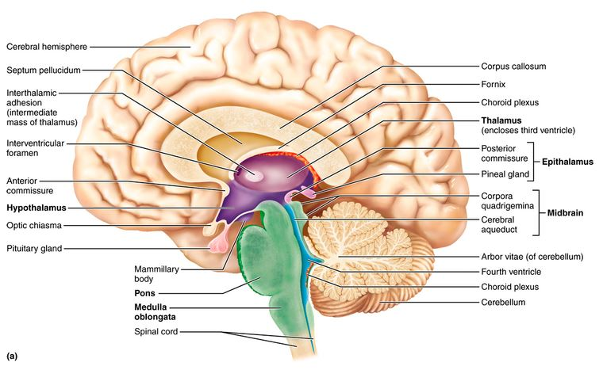
12.4 The brain stem consists of the midbrain, pons, and medulla oblongata
- From superior to inferior, the brain stem regions are midbrain, pons, and medulla oblongata
- However, the brain stem has nuclei of gray matter embedded in the white matter, a feature not found in the spinal cord.
- account for only 2.5% of total brain mass
- positioned between the cerebrum and the spinal cord, the brain stem also provides a pathway for fiber tracts running between higher and lower neural centers
- associated with 10 of the 12 pairs of cranial nerves, so it is heavily involved with innervating the head
Midbrain
- The midbrain is located between the diencephalon and pons
- On its ventral aspect two bulging cerebral peduncles form vertical pillars that seem to hold up the cerebrum
- The crus cerebri (leg of the cerebrum) of each peduncle contains a large pyramidal (corticospinal) motor tract descending toward the spinal cord. The superior cerebellar peduncles, also fiber tracts, connect the midbrain to the cerebellum dorsally
- Running through the midbrain is the hollow cerebral aqueduct, which connects the third and fourth ventricles
- the tectum, the midbrain’s roof. Surrounding the aqueduct is the periaqueductal gray matter, which is involved in pain suppression and links the fear-perceiving amygdaloid body and ANS pathways that control the fight-or-flight response
- periaqueductal gray matter also includes nuclei that control two cranial nerves, the oculomotor and the trochlear nuclei
- The corpora quadrigemina the largest midbrain nuclei, raise four domelike protrusions on the dorsal midbrain surface
- The superior pair, the superior colliculi, are visual reflex centers that coordinate head and eye movements when we visually follow a moving object
- The inferior colliculi are part of the auditory relay from the hearing receptors of the ear to the sensory cortex
- Also embedded in each side of the midbrain white matter are two pigmented nuclei, the substantia nigra and red nucleus
- Its dark color reflects a high content of melanin pigment, a precursor of the neurotransmitter (dopamine) released by these neurons.
- its axons project to the putamen
- Degeneration of the dopamine-releasing neurons of the substantia nigra is the ultimate cause of Parkinson’s disease.
- Its reddish hue is due to its rich blood supply and to the presence of iron pigment in its neurons. The red nuclei are relay nuclei in some descending motor pathways that cause limb flexion, and they are embedded in the reticular formation, a system of small nuclei scattered through the core of the brain stem.
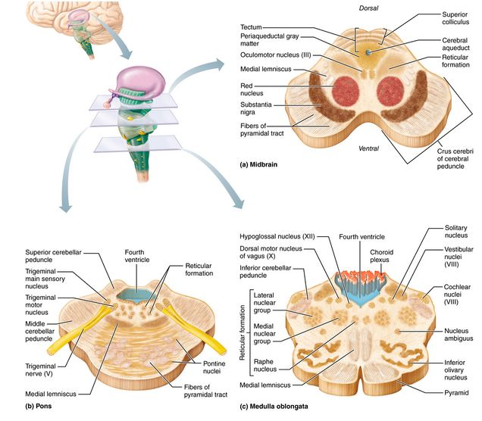
Pons
- Dorsally, the fourth ventricle separates it from the cerebellum
- the pons is chiefly composed of conduction tracts. They are oriented in two different directions:
  - The more superficial ventral fibers are oriented transversely and dorsally. They form the middle cerebellar peduncles and connect the pons bilaterally with the two sides of the cerebellum dorsally. These fibers issue from numerous pontine nuclei, which relay conversations between the motor cortex and cerebellum.
  - The deep projection fibers run longitudinally as part of the pathway between higher brain centers and the spinal cord
- Several cranial nerve pairs issue from pontine nuclei. They include the trigeminal, abducens, and facial nerves
Medulla Oblongata
- most inferior part of the brain stem. It blends imperceptibly into the spinal cord at the level of the foramen magnum of the skull
- Together, the medulla and the pons form the ventral wall of the fourth ventricle. [The dorsal ventricular wall is formed by a thin capillary-rich membrane called a choroid plexus which is next to the cerebellum dorsally
Structures of the Medulla Oblongata
- Flanking the midline on the medulla’s ventral aspect are two longitudinal ridges called pyramids, formed by the large pyramidal (corticospinal) tracts descending from the motor cortex
- This crossover point is called the decussation of the pyramids
- The inferior cerebellar peduncles are fiber tracts that connect the medulla to the cerebellum dorsally. Situated lateral to the pyramids, the olives are oval swellings
- caused mainly by the wavy folds of gray matter of the underlying inferior olivary nuclei
- The rootlets of the hypoglossal nerves emerge from the groove between the pyramid and olive on each side of the brain stem. Other cranial nerves associated with the medulla are the glossopharyngeal nerves and vagus nerves. Additionally, the fibers of the vestibulocochlear nerves synapse with the cochlear nuclei (auditory relays), and with numerous vestibular nuclei in both the pons and medulla. The vestibular nuclei mediate responses that maintain equilibrium
- The most prominent are the dorsally located nucleus gracilis and nucleus cuneatus, associated with a tract called the medial lemniscus (Figure 12.15c). These serve as relay nuclei in a pathway by which general somatic sensory information ascends from the spinal cord to the somatosensory cortex.
Functions of the Medulla Oblongata.
- The medulla contains these important functional groups of visceral motor nuclei:
  - Cardiovascular center. This includes the cardiac center, which adjusts the force and rate of heart contraction to meet the body’s needs, and the vasomotor center, which changes blood vessel diameter to regulate blood pressure.
  - Respiratory centers. These generate the respiratory rhythm and (in concert with pontine centers) control the rate and depth of breathing. Various other centers.
  - Additional centers regulate such activities as vomiting, hiccuping, swallowing, coughing, and sneezing.
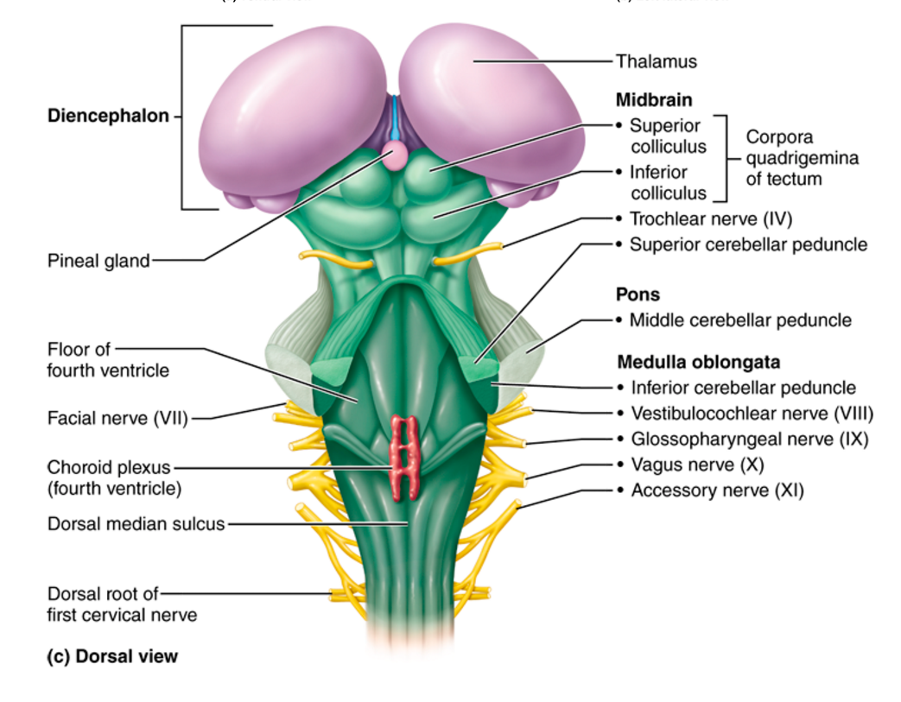

12.5 The cerebellum adjusts motor output, ensuring coordination and balance
- 11% of total brain mass. The cerebellum is located dorsal to the pons and medulla (and to the intervening fourth ventricle). It protrudes under the occipital lobes of the cerebral hemispheres, from which it is separated by the transverse cerebral fissure
- The cerebellum provides the precise timing and appropriate patterns of skeletal muscle contraction for smooth, coordinated movements and agility needed for our daily living—driving, typing
Cerebellar Anatomy
- The cerebellum is bilaterally symmetrical. The wormlike vermis connects its two apple-sized cerebellar hemispheres medially
- Transversely oriented pleatlike gyri known as folia
- Deep fissures subdivide each hemisphere into anterior, posterior, and flocculonodular lobes
- paired masses of gray matter, the most familiar of which are the dentate nuclei. Several types of neurons populate the cerebellar cortex, including Purkinje cells
- These large cells, with their extensively branched dendrites, are the only cortical neurons that send axons through the white matter to synapse with the central nuclei of the cerebellum, a pattern fancifully called the arbor vitae
- The anterior and posterior lobes of the cerebellum, which coordinate body movements, have three sensory maps of the entire body
- The medial portions influence the motor activities of the trunk and girdle muscles. The intermediate parts of each hemisphere influence the distal parts of the limbs and skilled movements. The lateral most parts of each hemisphere integrate information from the association areas of the cerebral cortex and appear to play a role in planning movements rather than executing them. The flocculonodular lobes receive inputs from the equilibrium apparatus of the inner ears, and adjust posture to maintain balance.
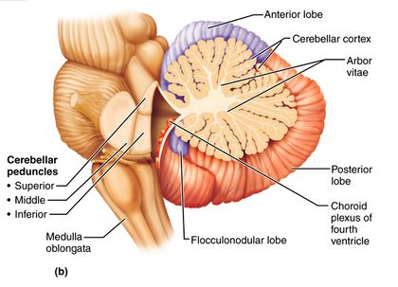
Cerebellar Peduncles
- three paired fiber tracts—the cerebellar peduncles—connect the cerebellum to the brain stem
- all fibers entering and leaving the cerebellum are ipsilateral (ipsi = same)—from and to the same side of the body.
  - The superior cerebellar peduncles connecting cerebellum and midbrain carry instructions from neurons in the deep cerebellar nuclei to the cerebral motor cortex via thalamic relays. Like the basal nuclei, the cerebellum has no direct connections to the cerebral cortex.
  - The middle cerebellar peduncles carry one-way communications from the pons to the cerebellum, advising the cerebellum of voluntary motor activities initiated by the motor cortex (via relays in the pontine nuclei).
  - The inferior cerebellar peduncles connect medulla and cerebellum. These peduncles convey sensory information to the cerebellum from (1) muscle proprioceptors throughout the body, and (2) the vestibular nuclei of the brain stem, which are concerned with equilibrium and balance.
Cerebellar Processing
- The motor areas of the cerebral cortex, via relay nuclei in the brain stem, notify the cerebellum of their intent to initiate voluntary muscle contractions. At the same time, the cerebellum receives information from proprioceptors throughout the body (regarding tension in the muscles and tendons, and joint position) and from visual and equilibrium pathways. This information enables the cerebellum to evaluate body position and momentum—where the body is and where it is going. The cerebellar cortex calculates the best way to coordinate the force, direction, and extent of muscle contraction to prevent overshoot, maintain posture, and ensure smooth, coordinated movements. Then, via the superior peduncles, the cerebellum dispatches to the cerebral motor cortex its blueprint for coordinating movement. Cerebellar fibers also send information to brain stem nuclei, which in turn influence motor neurons of the spinal cord.
- cerebellum also plays a role in thinking, language, and emotion. As in the motor system, the cerebellum may compare the actual output of these systems with the expected output and adjust accordingly

12.6 Functional brain systems span multiple brain structures
- Functional brain systems are networks of neurons that work together but span relatively large distances in the brain, so they cannot be localized to specific regions. The limbic system and the reticular formation
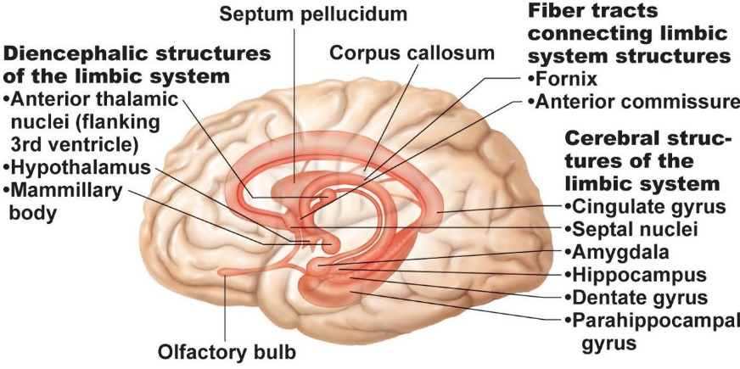
The Limbic System
- The limbic system includes the amygdaloid body, an almond-shaped nucleus that sits on the tail of the caudate nucleus, and other parts of the rhinencephalon (cingulate gyrus, septal nuclei, the C-shaped hippocampus, dentate gyrus, and parahippocampal gyrus). In the diencephalon, the main limbic structures are the hypothalamus and the anterior thalamic nuclei. The fornix (arch) and other fiber tracts link these limbic system regions together
- The amygdaloid body is critical for responding to perceived threats (such as angry or fearful facial expressions) with fear or aggression. The cingulate gyrus plays a role in expressing our emotions through gestures and in resolving mental conflicts when we are frustrated.
- These responses reflect the origin of much of the limbic system in the primitive smell brain (rhinencephalon)
- Most limbic system output is relayed through the hypothalamus.
- Disorders with physical symptoms that originate from emotional causes are known as psychosomatic illnesses.
- Because the limbic system interacts with the prefrontal lobes we (1) react emotionally to things we consciously understand to be happening, and (2) are consciously aware of the emotional richness of our lives
- Communication between the cerebral cortex and limbic system explains why emotions sometimes override logic and, conversely, why reason can stop us from expressing our emotions inappropriately. Particular limbic system structures—the hippocampus and amygdaloid body—also play a role in memory.
The Reticular Formation
- The reticular formation extends through the central core of the medulla oblongata, pons, and midbrain
- composed of loosely clustered neurons in what is otherwise white matter
- the midline raphe nuclei, which are flanked laterally by (2) the medial (large cell) group of nuclei and (3) the lateral (small cell) group of nuclei.
- Individual reticular neurons project to the hypothalamus, thalamus, cerebral cortex, cerebellum, and spinal cord, making reticular neurons ideal for governing the arousal of the brain as a whole.
- unless inhibited by other brain areas, the neurons of the part of the reticular formation known as the reticular activating system (RAS) send a continuous stream of impulses to the cerebral cortex, keeping the cortex alert
- The RAS also filters this flood of sensory inputs
- Between them, the RAS and the cerebral cortex disregard perhaps 99% of all sensory stimuli as unimportant.
- The RAS is inhibited by sleep centers located in the hypothalamus and other neural regions, and is depressed by alcohol, sleep-inducing drugs, and tranquilizers
- Severe injury to this system results in permanent unconsciousness (irreversible coma)
- The reticular formation also has a motor arm. Some of its motor nuclei project to motor neurons in the spinal cord via the reticulospinal tracts, and help control skeletal muscles during coarse limb movements. Other reticular motor nuclei, such as the vasomotor, cardiac, and respiratory centers of the medulla, are autonomic centers that regulate visceral motor functions.

12.8 The brain is protected by bone, meninges, cerebrospinal fluid, and the blood brain barrier
Meninges
- The meninges are three connective tissue membranes that lie just external to the CNS organs
  - Cover and protect the CNS
  - Protect blood vessels and enclose venous sinuses
  - Contain cerebrospinal fluid
  - Form partitions in the skull
- From external to internal, the meninges (singular: meninx) are the dura mater, arachnoid mater, and pia mater
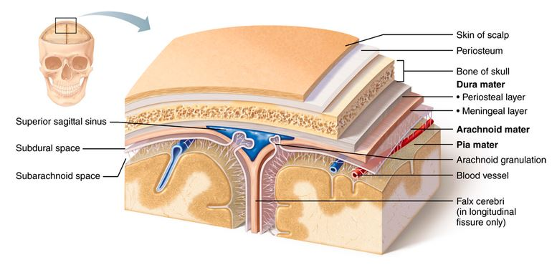
Dura Mater
- it is a two-layered sheet of fibrous connective tissue. The more superficial periosteal layer attaches to the inner surface of the skull (the periosteum). (There is no dural periosteal layer surrounding the spinal cord.) The deeper meningeal layer forms the true external covering of the brain and continues caudally in the vertebral canal as the spinal dura mater. The brain’s two dural layers are fused together except in certain areas, where they separate to enclose dural venous sinuses that collect venous blood from the brain and direct it into the internal jugular veins of the neck
- In several places, the meningeal dura mater extends inward to form flat partitions that subdivide the cranial cavity. These dural septa, which limit excessive movement of the brain within the cranium, include the following
  - Falx cerebri. A large sickle-shaped fold that dips into the longitudinal fissure between the cerebral hemispheres. Anteriorly, it attaches to the crista galli of the ethmoid bone.
  - Falx cerebelli. Continuing inferiorly from the posterior falx cerebri, this small midline partition runs along the vermis of the cerebellum.
  - Tentorium cerebelli. Resembling a tent over the cerebellum, this nearly horizontal dural fold extends into the transverse fissure between the cerebral hemispheres (which it helps to support) and the cerebellum.
Arachnoid Mater
- The middle meninx, the arachnoid mater forms a loose brain covering, never dipping into the sulci at the cerebral surface. It is separated from the dura mater by a narrow serous cavity, the subdural space, which contains a film of fluid. Beneath the arachnoid membrane is the wide subarachnoid space. Spider web-like extensions span this space and secure the arachnoid mater to the underlying pia mater
- The subarachnoid space is filled with cerebrospinal fluid and also contains the largest blood vessels serving the brain
- Knoblike projections of the arachnoid mater called arachnoid granulations protrude superiorly through the dura mater and into the superior sagittal sinus. These granulations absorb cerebrospinal fluid into the venous blood of the sinus.
Pia Mater
- composed of delicate connective tissue and richly invested with tiny blood vessels. It is the only meninx that clings tightly to the brain like plastic wrap, following its every convolution.
- Meningitis, inflammation of the meninges, is a serious threat to the brain because a bacterial or viral meningitis may spread to the CNS. Brain inflammation is called encephalitis. Meningitis is usually diagnosed by obtaining a sample of cerebrospinal fluid via a lumbar tap
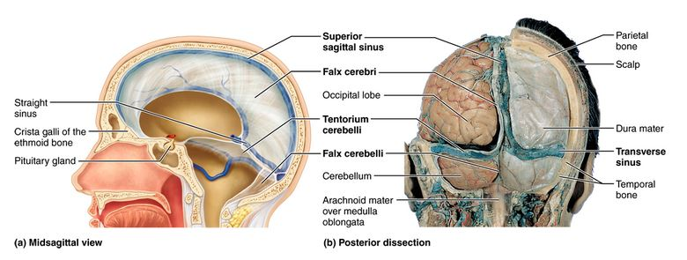
Cerebrospinal Fluid (CSF)
- found in and around the brain and spinal cord, forms a liquid cushion that gives buoyancy to CNS structures
- reduces brain weight by 97% and prevents the delicate brain from crushing under its own weight
- similar in composition to blood plasma, from which it is formed. However, it contains less protein than plasma and its ion concentrations are different. For example, CSF contains more Na+, Cl−, and H+ than does blood plasma, and less Ca2+ and K+.
- The choroid plexuses that hang from the roof of each ventricle form CSF. These plexuses are frond-shaped clusters of broad, thin-walled capillaries (plex = interwoven) enclosed first by pia mater and then by a layer of ependymal cells lining the ventricles
- However, the choroid plexus ependymal cells are joined by tight junctions, and they have ion pumps that allow them to modify this filtrate by actively transporting only certain ions across their membranes into the CSF pool.
- Ion pumping also sets up ionic gradients that cause water to diffuse into the ventricles.
- The choroid plexuses also help cleanse the CSF by removing waste products and unnecessary solutes.
- CSF enters the subarachnoid space via the lateral and median apertures in the walls of the 4th ventricle
- The long cilia of the ependymal cells lining the ventricles help keep the CSF in constant motion. In the subarachnoid space, CSF bathes the outer surfaces of the brain and spinal cord and then returns to the blood in the dural sinuses via the arachnoid granulations.
- CSF is produced and drained at a constant rate. However, if something (such as a tumor) obstructs its circulation or drainage, CSF accumulates and exerts pressure on the brain. This condition is called hydrocephalus
- In a newborn baby with hydrocephalus, the head enlarges because the skull bones have not yet fused. In adults, however, the skull is rigid and hard, and hydrocephalus is likely to damage the brain because accumulating fluid compresses blood vessels and crushes the soft nervous tissue. Hydrocephalus is treated by inserting a shunt into the ventricles to drain excess fluid into the abdominal cavity.
Blood Brain Barrier
- If the brain were exposed to such chemical variations, its neurons would fire uncontrollably, because some hormones and amino acids serve as neurotransmitters and certain ions (particularly K+) modify the threshold for neuronal firing.
- The blood brain barrier is the protective mechanism that helps maintain the brain’s stable environment. Exceptionally impermeable tight junctions between capillary endothelial cells are its major component.
- Bloodborne substances in the brain’s capillaries must pass through three layers before they reach the neurons: (1) the endothelium of the capillary wall, (2) a relatively thick basal lamina surrounding the external face of each capillary, and (3) the bulbous feet of the astrocytes clinging to the capillaries.
- The astrocyte feet are not themselves the barrier, but play a role in its regulation: They supply required signals to the endothelial cells, causing them to make tight junctions. These tight junctions seamlessly join together the endothelial cells, making these the least permeable capillaries in the body.
- Nutrients such as glucose, essential amino acids, and some electrolytes move passively by facilitated diffusion through the endothelial cell membranes. Bloodborne metabolic wastes, proteins, certain toxins, and most drugs are denied entry. Small nonessential amino acids and potassium ions not only are prevented from entering the brain, but also are actively pumped from the brain across the capillary endothelium.
- The barrier is ineffective against fats, fatty acids, oxygen, carbon dioxide, and other fat-soluble molecules that diffuse easily through all plasma membranes.
- In some brain areas surrounding the third and fourth ventricles, the barrier is entirely absent and the capillary endothelium is quite permeable, allowing bloodborne molecules easy access to the neural tissue. One such region is the vomiting center of the brain stem, which monitors the blood for poisonous substances. Another is in the hypothalamus, which regulates water balance, body temperature, and many other metabolic activities. Lack of a blood brain barrier here is essential to allow the hypothalamus to sample the chemical composition of the blood

12.10 The spinal cord is a reflex center and conduction pathway
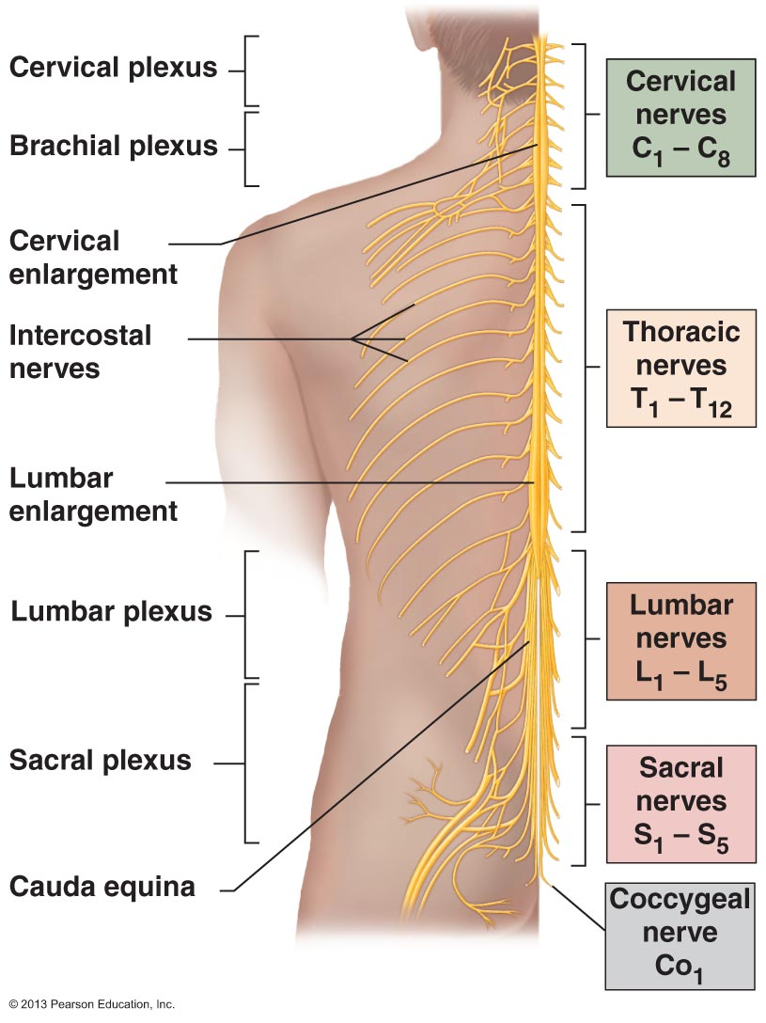
Gross Anatomy and Protection
- The spinal cord, enclosed in the vertebral column, extends from the foramen magnum of the skull to the first or second lumbar vertebra, just inferior to the ribs
- provides a two-way conduction pathway to and from the brain. It is a major reflex center: Spinal reflexes are initiated and completed at the spinal cord level.
- The single-layered spinal dura mater (Figure 12.27c) is not attached to the bony walls of the vertebral column. Between the bony vertebrae and the spinal dura mater is an epidural space filled with a soft padding of fat and a network of veins (see Figure 12.29a). Cerebrospinal fluid fills the subarachnoid space between the arachnoid and pia mater meninges
- Inferiorly, the dural and arachnoid membranes extend to the level of S2, well beyond the end of the spinal cord. The spinal cord typically ends between L1 and L2
- For this reason, the subarachnoid space within the meningeal sac inferior to that point provides an ideal spot for removing cerebrospinal fluid for testing, a procedure called a lumbar puncture
- Inferiorly, the spinal cord terminates in a tapering cone-shaped structure called the conus medullaris. The filum terminale a fibrous extension of the conus covered by pia mater, extends inferiorly from the conus medullaris to the coccyx, where it anchors the spinal cord so it is not jostled by body movements (Figure 12.27a, d). Furthermore, saw-toothed shelves of pia mater called denticulate ligaments (den-tik′u-lāt; toothed) secure the spinal cord to the tough dura mater meninx throughout its length.
- The spinal cord is about the width of a thumb for most of its length, but it has obvious enlargements where the nerves serving the upper and lower limbs arise
- the spinal cord is, in fact, continuous throughout its length and its internal structure changes gradually. Each nerve exits from the vertebral column by passing superior to its corresponding vertebra via the intervertebral foramen, and travels to the body region it serves.
- Because the cord does not reach the end of the vertebral column, the spinal cord segments are located superior to where their corresponding spinal nerves emerge through the intervertebral foramina. The lumbar and sacral spinal nerve roots angle sharply downward and travel inferiorly through the vertebral canal for some distance before reaching their intervertebral foramina. The collection of nerve roots at the inferior end of the vertebral canal is named the cauda equina
Spinal Cord Cross-Sectional Anatomy
- The spinal cord is somewhat flattened from front to back and two grooves mark its surface: the wide ventral (anterior) median fissure and the narrower dorsal (posterior) median sulcus
- The gray matter of the cord is located in its core, the white matter outside. The cerebrospinal fluid-filled central canal runs the length of the spinal cord.
Gray Matter and Spinal Roots
- the gray commissure, that encloses the central canal. The two dorsal projections of the gray matter are the dorsal (posterior) horns, and the ventral pair are the ventral (anterior) horns.
- The thoracic and superior lumbar segments of the cord have an additional pair of gray matter columns, the small lateral horns.
- All neurons whose cell bodies are in the spinal cord gray matter are multipolar. The dorsal horns consist entirely of interneurons. The ventral horns have some interneurons but mainly house cell bodies of somatic motor neurons. These motor neurons send their axons out to the skeletal muscles (their effector organs) via the ventral rootlets that fuse together to become the ventral roots of the spinal cord
- The amount of ventral gray matter present at a given level of the spinal cord reflects the amount of skeletal muscle innervated at that level
- The lateral horns consist mostly of the cell bodies of autonomic (sympathetic division) motor neurons that serve visceral organs. Their axons leave the cord via the ventral root along with those of the somatic motor neurons. Because the ventral roots contain both somatic and autonomic efferent fibers, they serve both motor divisions of the peripheral nervous system
- Afferent fibers carrying impulses from peripheral sensory receptors form the dorsal roots of the spinal cord that fan out as the dorsal rootlets before they enter the spinal cord (Figure 12.29). The cell bodies of the associated sensory neurons are found in an enlarged region of the dorsal root called the dorsal root ganglion or spinal ganglion.
- The dorsal and ventral roots are very short and fuse laterally to form the spinal nerves
- Spinal gray matter has the following four zones (Figure 12.30): somatic sensory (SS), visceral sensory (VS), visceral (autonomic) motor (VM), somatic motor (SM).
White Matter
- The white matter of the spinal cord is composed of myelinated and nonmyelinated nerve fibers that allow communication between different parts of the spinal cord and between the cord and brain. These fibers run in three directions:
  - Ascending—up to higher centers (sensory inputs)
  - Descending—down to the cord from the brain or within the cord to lower levels (motor outputs)
  - Transverse—across from one side of the cord to the other (commissural fibers)
- The white matter on each side of the cord is divided into three white columns, or funiculi, named according to their position as dorsal (posterior), lateral, and ventral (anterior) funiculi (Figure 12.29b). Each funiculus contains several fiber tracts, and each tract is made up of axons with similar destinations and functions.
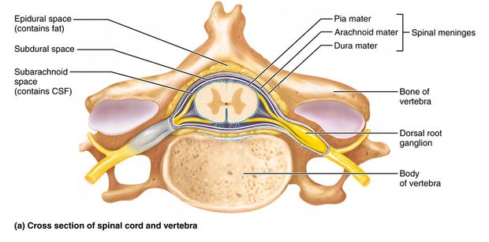
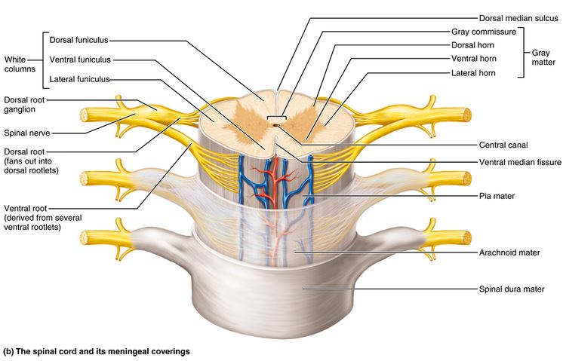
Spinal Cord Trauma
- Damage to the dorsal roots or sensory tracts results in either loss of sensation or paresthesias
- Damage to ventral roots or ventral horn cells results in paralysis
  - Flaccid paralysis of the skeletal muscles occurs when the spinal cord or ventral roots are injured. Nerve impulses do not reach the affected muscles, which consequently cannot move either voluntarily or involuntarily. Without stimulation, the muscles atrophy.
  - Spastic paralysis occurs if only the upper motor neurons of the primary motor cortex (or their axons in the spinal cord) are damaged. In this case, the spinal motor neurons remain intact and spinal reflex activity continues to stimulate the muscles irregularly. As a result, the muscles remain healthy longer, but their movements are no longer subject to voluntary control. In many cases, the muscles shorten permanently.
- Transection (cross sectioning) of the spinal cord at any level results in total motor and sensory loss in body regions inferior to the site of damage. If the transection occurs between T1 and L1, both lower limbs are affected, resulting in paraplegia (par″ah-ple′je-ah; para = beside, plegia = a blow). If the injury occurs in the cervical region, all four limbs are affected and the result is quadriplegia
- Hemiplegia, paralysis of one side of the body, usually reflects brain injury rather than spinal cord injury
- Anyone with a spinal cord injury must be watched for symptoms of spinal shock, a transient period of functional loss that follows the injury. Spinal shock immediately depresses all reflex activity caudal to the lesion site. Bowel and bladder reflexes stop, blood pressure falls, and all muscles (somatic and visceral alike) below the injury are paralyzed and insensitive. Neural function usually returns within a few hours following injury. If function does not resume within 48 hours, paralysis is permanent in most cases.
Poliomyelitis
- results from the poliovirus, which typically enters the body in feces-contaminated water and destroys ventral horn motor neurons. Early symptoms include fever, headache, muscle pain and weakness, and loss of certain somatic reflexes. Later, paralysis develops and the muscles served atrophy. The victim may die from paralyzed respiratory muscles.
- However, many survivors of the great polio epidemic of the late 1940s and 1950s have begun to experience extreme lethargy, sharp burning pains in their muscles, and progressive muscle weakness and atrophy. These disturbing symptoms are referred to as postpolio syndrome. The cause of postpolio syndrome is not known, but a likely explanation is that its victims, like the rest of us, continue to lose neurons throughout life. While a healthy nervous system can recruit nearby neurons to compensate, polio survivors have already drawn on that pool and have few neurons left to take over.
Amyotrophic Lateral Sclerosis (ALS)
- also called Lou Gehrig’s disease, is a devastating neuromuscular condition that progressively destroys ventral horn motor neurons and fibers of the pyramidal tracts (a major motor pathway). As the disease progresses, the sufferer loses the ability to speak, swallow, and breathe. Death typically occurs within five years.
- In 10% of cases mutations are inherited; spontaneous mutations are probably involved in the rest. Recently, the mutations have been localized to genes that are involved in RNA processing
- excess extracellular glutamate suggests that excitotoxic cell death is involved. Riluzole, a drug that interferes with glutamate signaling, is the only available life-prolonging treatment.

  - Neuronal pathways carry sensory and motor information to and from the brain
- All major spinal tracts are part of multineuron pathways that connect the brain to the body periphery
- There are four key points in regard to spinal tracts and pathways:
    - Decussation. Most pathways cross from one side of the CNS to the other (decussate) at some point along their journey.
    - Relay. Most pathways consist of a chain of two or three neurons (a relay) that contribute to successive tracts of the pathway.
    - Somatotopy. Most pathways exhibit somatotopy, a precise spatial relationship among the tract fibers that reflects the orderly mapping of the body. For example, fibers transmitting pain and temperature information from sensory receptors in superior body regions lie medial to those from inferior body regions within the same tract.
    - Symmetry. All pathways and tracts are paired symmetrically (right and left), with a member of the pair present on each side of the spinal cord or brain.
Ascending Pathways to the Brain
- The ascending pathways conduct sensory impulses upward, typically through chains of three successive neurons (first-, second-, and third-order neurons) to various areas of the brain.
    - First-order neurons, whose cell bodies reside in a ganglion (dorsal root or cranial), conduct impulses from the cutaneous receptors of the skin and from proprioceptors to the spinal cord or brain stem, where they synapse with second-order neurons. Impulses from the facial area are transmitted by cranial nerves, and spinal nerves conduct somatic sensory impulses from the rest of the body to the CNS. First-order neurons entering the spinal cord are shown at the bottom of Figure 12.32.
    - The cell bodies of second-order neurons (Figure 12.32) reside in the dorsal horn of the spinal cord or in medullary nuclei. They transmit impulses to the thalamus or to the cerebellum where they synapse.
    - Third-order neurons have cell bodies in the thalamus (Figure 12.32). They relay impulses to the somatosensory cortex of the cerebrum. (There are no third-order neurons in the cerebellum.)
- Two of these pathways (the dorsal column–medial lemniscal and spinothalamic pathways) transmit impulses via the thalamus to the sensory cortex for conscious interpretation. Collectively the inputs of these sister tracts provide discriminative touch and conscious proprioception. Both pathways decussate—the first in the medulla and the second in the spinal cord
    - The third pathway, the spinocerebellar pathway, terminates in the cerebellum, and does not contribute to sensory perception. Let’s examine these pathways more closely.
    - Dorsal column–medial lemniscal pathways. The dorsal column–medial lemniscal pathways (lem-nis′kul; ribbon) mediate precise, straight-through transmission of inputs from a single type (or a few related types) of sensory receptor that can be localized precisely on the body surface, such as discriminative touch and vibrations. These pathways are formed by the paired tracts of the dorsal white column of the spinal cord—fasciculus cuneatus and fasciculus gracilis—and the medial lemniscus. The medial lemniscus arises in the medulla and terminates in the thalamus (Figure 12.32a and Table 12.2). From the thalamus, impulses are forwarded to specific areas of the somatosensory cortex.
    - Spinothalamic pathways. The spinothalamic pathways receive input from many different types of sensory receptors and make multiple synapses in the brain stem. These pathways consist of the lateral and ventral (anterior) spinothalamic tracts (see Figure 12.32b and Table 12.2). Their fibers cross over in the spinal cord. The fibers in these pathways primarily transmit impulses for pain and temperature, but also for coarse touch and pressure. All are sensations that we are aware of but have difficulty localizing precisely on the body surface.
    - Spinocerebellar pathways. The third ascending pathway consists of the ventral and dorsal spinocerebellar tracts. They convey information about muscle or tendon stretch to the cerebellum, which uses this information to coordinate skeletal muscle activity (see Figure 12.32a and Table 12.2). As noted earlier, these pathways do not contribute to conscious sensation. The fibers of the spinocerebellar pathways either do not decussate or else cross over twice (thus undoing the decussation).
Descending Pathways and Tracts
- The descending pathways that deliver efferent impulses from the brain to the spinal cord are divided into two groups: (1) the direct pathways, which are the pyramidal tracts, and (2) the indirect pathways, essentially all others
    - Upper motor neurons are the pyramidal cells of the motor cortex and the neurons of subcortical motor nuclei.
    - Lower motor neurons are the ventral horn motor neurons. These directly innervate the skeletal muscles (their effectors).
Direct (Pyramidal) Pathways
- The direct pathways originate mainly with the pyramidal cells located in the precentral gyri. These neurons send impulses through the brain stem via the large pyramidal (corticospinal) tracts (Figure 12.33a). The direct pathways are so called because their axons descend without synapsing from the pyramidal cells to the spinal cord. There they synapse either with interneurons or with ventral horn motor neurons.
- Stimulation of the ventral horn neurons activates the skeletal muscles with which they are associated
Indirect Pathways
- The indirect pathways include brain stem motor nuclei and all motor pathways except the pyramidal pathways.
- Indirect motor pathways are complex and multisynaptic. They are most involved in regulating:
  - Axial muscles that maintain balance and posture
  - Muscles controlling coarse limb movements
  - Head, neck, and eye movements that follow objects in the visual field
- Overall, the reticulospinal and vestibulospinal tracts maintain balance by varying the tone of postural muscles (Table 12.3). The rubrospinal tracts control flexor muscles, whereas the tectospinal tracts and the superior colliculi mediate head movements in response to visual stimuli.
- In the spinothalamic pathway, the cell bodies of first-order sensory neurons are outside the spinal cord in a ganglion, cell bodies of second-order sensory neurons are in the dorsal horn of the spinal cord, and cell bodies of third-order sensory neurons are in the thalamus.
A nerve is a bundle of axons in the PNS, whereas a tract is a bundle of axons in the CNS. A nucleus is a collection of neuron cell bodies in the CNS, whereas a ganglion is a collection of neuron cell bodies in the PNS

PART 2 TRANSMISSION LINES: NERVES AND THEIR STRUCTURE AND REPAIR - 13.3 Nerves are cordlike bundles of axons that conduct sensory and motor impulses
- A nerve is a cordlike organ that is part of the peripheral nervous system. Nerves are classified as cranial or spinal depending on whether they arise from the brain or spinal cord. Nerves vary in size, but every nerve consists of parallel bundles of peripheral axons (some myelinated and some not) enclosed by successive wrappings of connective tissue
  - Each axon (or nerve fiber) is surrounded by endoneurium, a delicate layer of loose connective tissue that also encloses the fiber’s associated Schwann cells.
  - A coarser connective tissue wrapping, the perineurium, binds groups of axons into bundles called fascicles.
  - A tough fibrous sheath, the epineurium, encloses all the fascicles to form the nerve.
- myelin, the protective connective tissue wrappings, blood vessels, and lymphatic vessels.
- Recall that the PNS is divided into sensory (afferent) and motor (efferent) divisions. Nerves are also classified according to the direction in which they transmit impulses: Mixed nerves contain both sensory and motor fibers and transmit impulses both to and from the central nervous system. Sensory (afferent) nerves carry impulses only toward the CNS. Motor (efferent) nerves carry impulses only away from the CNS.
- Because mixed nerves often carry both somatic and autonomic (visceral) nervous system fibers, the fibers in them may be classified according to the region they innervate as somatic afferent, somatic efferent, visceral afferent, and visceral efferent.
- Ganglia associated with afferent nerve fibers contain cell bodies of sensory neurons. (These are the dorsal root ganglia described in Chapter 12
- Ganglia associated with efferent nerve fibers mostly contain cell bodies of autonomic motor neurons

Regeneration of Nerve Axons
- Damage to nervous tissue is serious because, as a rule, mature neurons do not divide. If the damage is severe or close to the cell body, the entire neuron may die, and other neurons that are normally stimulated by its axon may die as well. However, if the cell body remains intact, axons of peripheral nerves can regenerate but axons in the CNS cannot
- Permanent paralysis and sensory deficits are the usual result. The inability to regenerate seems to have less to do with the neurons themselves than with the company they keep. As we will see shortly, Schwann cells actively help peripheral axons regenerate. Oligodendrocytes, the supporting cells of the CNS, on the other hand, actively suppress CNS axon regeneration.
- Oligodendrocytes are studded with growth-inhibiting proteins. Consequently, the growing end of the damaged axon collapses and the axon fails to regrow. Moreover, astrocytes at the site of injury form scar tissue that blocks axon regrowth.

13.4 There are 12 pairs of cranial nerves
- Twelve pairs of cranial nerves are associated with the brain (Figure 13.6). The first two pairs attach to the forebrain, and the rest are associated with the brain stem. Other than the vagus nerves, which extend into the abdomen, cranial nerves serve only head and neck structures.
- Two cranial nerves (I and II) have sensory function only, no motor function. Four nerves (III, VII, IX, and X) carry parasympathetic fibers that serve visceral muscles and glands. All cranial nerves that innervate muscles also carry afferent fibers from proprioceptors in the muscles served
- Several of the mixed cranial nerves contain both somatic and autonomic motor fibers and hence serve both skeletal muscles and visceral organs. Except for some autonomic motor neurons located in ganglia, the cell bodies of motor neurons contributing to the cranial nerves are located in the ventral gray matter regions (nuclei) of the brain stem.
Composition of Cranial Nerves
- Most cranial nerves are mixed nerves, as shown in Figure 13.6b. However, two nerve pairs (the olfactory and optic) associated with special sense organs are generally considered purely sensory. The cell bodies of the sensory neurons in the olfactory and optic nerves are located within their respective special sense organs. For other sensory neurons contributing to cranial nerves (V, VII, IX, and X), the cell bodies are located in cranial sensory ganglia just outside the brain. Some cranial nerves have a single sensory ganglion, others have several, and still others have none.
- Most cranial nerves are mixed nerves, as shown in Figure 13.6b. However, two nerve pairs (the olfactory and optic) associated with special sense organs are generally considered purely sensory. The cell bodies of the sensory neurons in the olfactory and optic nerves are located within their respective special sense organs. For other sensory neurons contributing to cranial nerves (V, VII, IX, and X), the cell bodies are located in cranial sensory ganglia just outside the brain. Some cranial nerves have a single sensory ganglion, others have several, and still others have none.

13.5 31 pairs of spinal nerves innervate the body
- All are mixed nerves.
- The spinal nerves include:
  - 8 pairs of cervical nerves (C1–C8) 12 pairs of thoracic nerves (T1–T12)
  - 5 pairs of lumbar nerves (L1–L5)
  - 5 pairs of sacral nerves (S1–S5)
  - 1 pair of tiny coccygeal nerves (Co1)
- The first seven pairs exit the vertebral canal superior to the vertebrae for which they are named, but C8 emerges inferior to the seventh cervical vertebra (between C7 and T1). Below the cervical level, each spinal nerve leaves the vertebral column inferior to the same-numbered vertebra.
- Dorsal roots contain sensory (afferent) fibers that arise from sensory neurons in the dorsal root ganglia and conduct impulses from peripheral receptors to the spinal cord.
- Ventral roots contain motor (efferent) fibers that arise from ventral horn motor neurons and extend to and innervate the skeletal muscles.
- In the cervical region, the roots are short and run horizontally, but the roots of the lumbar and sacral nerves extend inferiorly for some distance through the lower vertebral canal as the cauda equina before exiting the vertebral column
- A spinal nerve is quite short (only 1–2 cm). Almost immediately after emerging from its foramen, it divides into a small dorsal ramus, a larger ventral ramus, and a tiny meningeal branch that reenters the vertebral canal to innervate the meninges and blood vessels within. Each ramus, like the spinal nerve itself, is mixed.
- Special rami called rami communicantes, which contain autonomic (visceral) nerve fibers, attach to the base of the ventral rami of the thoracic spinal nerves
- The dorsal rami supply the posterior body trunk. The thicker ventral rami supply the rest of the trunk and the limbs.
- Let’s review the difference between roots and rami:
  - Roots lie medial to and form the spinal nerves. Each root is strictly sensory or motor.
  - Rami lie distal to and are lateral branches of the spinal nerves. Like spinal nerves, rami carry both sensory and motor fibers.
- Except for T2–T12, all ventral rami branch and join one another lateral to the vertebral column, forming complicated interlacing nerve networks called nerve plexuses
- Within a plexus, fibers from the various ventral rami crisscross one another and become redistributed so that (1) each resulting branch of the plexus contains fibers from several spinal nerves and (2) fibers from each ventral ramus travel to the body periphery via several routes
- An advantage of this rearrangement is that damage to one spinal segment or root cannot completely paralyze any limb muscle.
- Irritation of the phrenic nerve causes spasms of the diaphragm, or hiccups. If both phrenic nerves are severed, or if the C3–C5 region of the spinal cord is crushed or destroyed, the diaphragm is paralyzed and respiratory arrest occurs.

Innervation of Skin: Dermatomes
- A dermatome is an area of skin innervated by the cutaneous branches of a single spinal nerve. Every spinal nerve except C1 innervates dermatomes.
- The skin of the upper limbs is supplied by ventral rami of C5–T1 (or T2). The lumbar nerves supply most of the anterior surfaces of the thighs and legs, and the sacral nerves serve most of the posterior surfaces of the lower limbs.
- On the trunk, neighboring dermatomes overlap considerably (about 50%). As a result, destruction of a single spinal nerve will not cause complete numbness anywhere. In the limbs, the overlap is less complete and some skin regions are innervated by just one spinal nerve.
- Hilton’s law: Any nerve serving a muscle that produces movement at a joint also innervates the joint and the skin over the joint.

