Process Analysis II
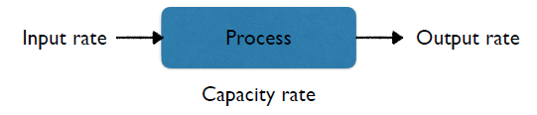
July. 6, 2017

Capacity Rate (maximum possible output rate) vs
Throughput Rate (actual output rate)
- Throughput rate depends on both the capacity of the process and the input rate
- It is the lower of the two rates (capacity rate and input rate)

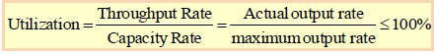
Utilization

- This can be computed for each individual resource in a process

- Turnaround time plays a key role in profitability
  - Ex. Airlines – the more time the plane sits on the ground the lesser the utilization

Demand and Supply Mismatch
- In reality, the demand or the input rates will vary over time
- Managing and matching the supply (capacity) and the demand is a key operational challenge
- When there is a mismatch between demand and supply over time, “inventory” builds up (inventory build-up has to do with excess demand)

Short Run vs Long Run Averages
- The long run average input rate must be less than the long run capacity of your process
- In the short run, average input rate may be greater than the capacity rate
- It may be needlessly expensive to have excess capacity in order to meet short-run spikes in demand ie. input rate

Implied Utilization
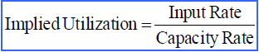
- Another measure of utilization = implied utilization, captures that there may be excess demand in the short run

- Implied Utilization (also called short term utilization) = the excess demand that the system has to meet (Ex. Met by working overtime)
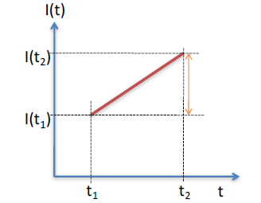
Continuous Inventory Buildup

- Input Rate at time t is R_{i}(t)
- Output Rate is R_{o}(t)
- Instantaneous Inventory Buildup => R_{i}(t) - R_{o}(t)

- Suppose the instantaneous inventory build-up between two time points t₁ and t₂ is R
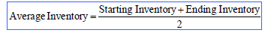
- Then I(t₂) = I(t₁) + R * (t₂ – t₁)
- Average inventory is also the area under the curve of an inventory vs. time graph then divided by the entire amount of time

Little’s Law: establishes a relationship between average inventory, average throughput rate and average flow rate

- Inventory – the number of units within the process boundaries (ex. Number of customers waiting in line)
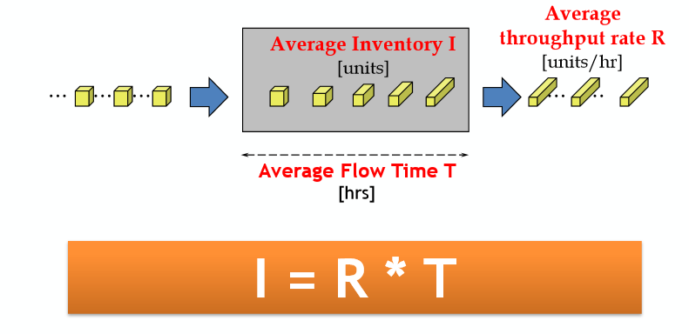

- Key application of Little’s Law is you can estimate the third parameter by knowing the other two
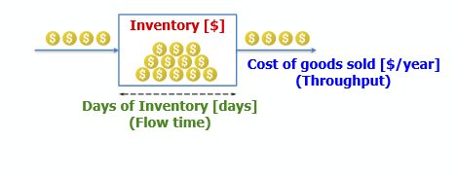
- Inventory Turns – you want to keep inventory on the shelves for as little time as possible



