Chapter 1: Intro to law

Why Study Law?

• Law affects all areas of business
• Business decisions can have negative and positive legal
consequences
• Negative: eg dumping pollutants into environment
• Positive: eg binding contractual party to promise
• Legal consequences affect profits and losses
• Some decisions impose liability, others create opportunities.

Risk Management
• What is “Risk Management”?
• “the process of identifying, evaluating and responding to the
possibility of harmful events.
• Knowing and understanding the law assists the decision maker in:
Making informed decisions that avoid future problems
Recognizing when they need to obtain legal advice
Taking steps to mitigate and reduce the risk associated with a particular kind of situation
When need to obtain insurance
What business structure to choose
• Risk can never be eliminated – but it can be managed

Risk Management Example
Stephanie has decided to start her own business making specialty cakes. She is concerned with the potential risks associated with baking and selling cakes. For example, what if she mistakenly includes an ingredient in a cake that causes a customer to have an allergic reaction and go into anaphylactic shock?
Could she face legal liability if that happens?
Would incorporating her business reduce her liability?
Should she require her clients to sign a written contract?
What should she include in the contract to manage this risk?
Should she get insurance?

The Nature of Law
•What is “Law”? A law is a rule that can be enforced by a court
• Rules vs. laws : All laws are rules but not all rules are laws • Ex.:
• Rule – you must not speak on your phone during class
• Law – You must not steal your classmate’s textbook
6

Ethics vs the Law
• Ethical / moral wrongs are informally sanctioned
• Ex.:damagedfriendshipsorreputation
VS • Legal wrongs are formally sanctioned
• Ex.: paying money or imprisonment
• Ethical Reasoning VS Legal Reasoning
• Ethical reasoning – is about weighing values and principles
• 4 principles of ethical reasoning:
Consequences – we should promote good consequences and avoid bad ones
Fairness – good and bad consequences should be divided fairly
Rights & Duties –we should protect rights and perform our duties
Character / virtue – what kind of people do we want to be? Setting examples for others
7
The Drowning Canoeist
• Textbook – p. 7 – Ethical Perspective 1.1
• While fishing from a lakeshore, Dan saw a canoeist tip his boat and fall into the water. Although he screamed for help for more than 20 minutes, Dan did nothing to help him. The canoeist eventually drowned.
• Do you think Dan should have rescued the canoeist? - Why / why not?
8
Ethical reasoning
• Would your answer change if Dan had a motorboat nearby and could have rescued him without risking his own life?
• Would your answer change if you knew that Dan was a poor swimmer and there was no motorboat?

Legal Reasoning
• Is there a legal duty to rescue? – Would Dan be legally liable to the Canoeist family for not rescuing him?
• Answer: The law says that there is no legal duty to rescue, absent a special relationship (e.g., parent-child) or a special professional duty (e.g., if Dan was a lifeguard on shift that day)

The Canadian Legal System
Civil Law and Common Law
• Canada has two distinct legal systems (set of laws) that apply within particular jurisdictions
• A jurisdiction is a geographical area that applies the same legal system (or set of laws)
- Civil law system:
• Originated in ancient Rome
• - Jurisdictions -
• eg France and most of Europe, Louisiana, and
• In Canada – only in the Province of Quebec
- Common law system:
• Originated in England
• Jurisdictions - All of Canada - with the exception of Quebec
• Judge-made laws (dispute base)

• Some laws are the same across Canada (Federal laws)
• eg criminal laws and constitutional laws
Public Law vs Private Law
Two types of Law – Public law and Private law
- Public law concerns the rules that apply between the government and everyone else
Ex.: constitutional law, criminal law and tax law Basically – it is when the government tells us how to behave
- Private law concerns the rules that apply to private matters
Ex.:
tort law: rules governing wrongs against persons (involuntary)
contract law: rules governing creation and enforcement of agreements (voluntary)
property law: rules governing acquisition, use, and disposition of property

The Constitution
• Provides basic rules for society, including our legal and political systems
• Highest source of law –
• “the Supreme Law of the Land”
• All other laws must not be inconsistent with the Constitution
• Difficult to amend:
• requires consent of both Parliament and two- thirds of all provinces with at least 50% of population

Constitution Charter of Rights & Freedoms
• Canada has two levels of government: federal and provincial
- At any given moment, we are governed by two levels of government - with the authority to make laws
• How do we ensure that those laws do not conflict with each other?
• Ex. – driving on the right side or left side of the road? The Constitution is the answer
The Constitution divides legislative authority – determines what level of government has the power/authority to create laws governing particular issues
Division of Powers
Federal Powers
• Section 91 – lists the areas of law that federal government had powers to legislate in
• Examples:
• Criminal law
• Bankruptcy laws
• Copyright laws
• Money (currency)
• Interprovincial / international trade
• Tax law
• Federal government companies and employees
20
Provincial Powers
• Section 92 – Lists the area of law that Provincial governments have the power to legislate
• Examples:
• Property and civil rights (i.e., contract law, tort law, property law, employment law etc.)
• Provincial tax
• Municipalities
21
• When a government legislates outside its authority, the law is considered ultra vires (beyond the power of) that government
• Ex:
• A law passed by the Ontario government regarding Bankruptcy may be ultra vires (beyond the Power of) the Ontario government
22
• Section 52 of the Constitution:
“The Constitution of Canada is the supreme law of Canada, and any law that is inconsistent with the provisions of the Constitution is, to the extent of the inconsistency, of no force or effect.”
• If a law is found to be “ultra vires”, a court will declare it to have “no force or effect” - This essentially means that the law will not be enforced by any Canadian Court

Charter of Rights and Freedoms
• Part of Constitution since 1982 • Its purpose is to protect the fundamental rights and
freedoms of everyone in Canada • Rights and freedoms commonly affecting business:
• freedom of religion
• freedom of expression
• freedom of mobility
• right to equality: prohibition against discriminating on the basis of various grounds, including race, sex and religion, but not poverty
-Charter only applies to government action
• not (directly) applicable against private businesses
-Charter may apply in favour of private business
• some provisions limited to “individuals”
No economic rights (no positive charter right to make money!)
-Charter rights subject to “reasonable limitations within a free and democratic society” (sec. 1)
• A court will balance individual rights with community interest
• Irwin Toy v. Quebec – (Textbook p. 14 – Case Brief 1.2)
• Child Pornography case

-Charter subject to “notwithstanding clause”
government can override some rights and freedoms
Rarely invoked by government (except for Quebec)
Ex.: Quebec’s Language laws (sandwich au fromage fondu anyone?)

What if a law violates the Charter?
• section 52 of Constitution: ... a law that is inconsistent with Charter is “of no force or effect”
Chapter 2 : THE CANADIAN COURT SYSTEM
28
Court Hierarchy and Precedent
Canada’s court system is based on jurisdictional hierarchies (i.e., different levels of courts within each jurisdiction)
All hierarchies end with Supreme Court of Canada
Hierarchy determines appeal route
Also determines what decisions are binding on courts
The Principle of the Rule of Law - to solve disputes based on law, not opinion
• Doctrine of Precedent
• Judge must follow similar decisions from courts higher in same hierarchy
• Other court decisions may be persuasive but not binding
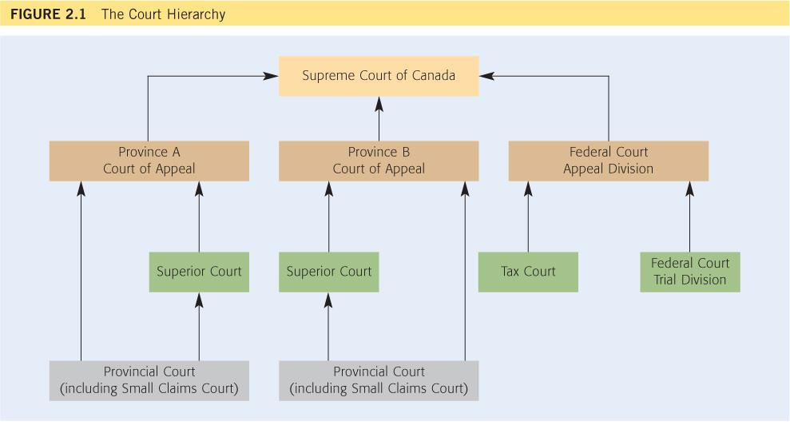
Canada’s Court System

How to solve a legal question?
1.Read the case carefully and identify the material (important) facts.
2. Identify the relevant legal issues:
• Ask yourself: what do I need to find out? / what legal problem needs to be analyzed?
• Ex.:
• Is the person liable for the tort of negligence?
• Is the contract enforceable?
• Sometimes you need to address several issues:
• Important - deal with one issue at a time
State the law / legal test
3.Provide an analysis - apply the law to the facts
4.Provide a conclusion, that flows from and can be supported by your analysis

Sample Question
In an effort to homogenize and secularize the public sector, the Ontario Government passed legislation called the Secular Work Act. The Secular Work Act prohibits all Ontario government employees from wearing religious artifacts or symbols, such as Muslim hijabs, Jewish Yarmulkes (skullcaps) and Christian crosses, while they are at work. The legislation states that government employees that come to work wearing religious symbols may be fired. A group of government employees has gotten together to form the Multi-Faith Coalition. The Multi- Faith Coalition wants to challenge the Secular Work Act in court.

• Can the Multi-Faith Coalition challenge the Secular Work Act in Court and if so, on what legal basis (bases)? Explain your answer

Step1: The legal issue
• This is a constitutional law issue
• More specifically, it is a Charter of Rights
and Freedoms issue
• So the legal issue is: Does the Secular Work Act violate the Charter of Rights and freedom.

Step2: What is the law?
•The Charter forms part of the Constitution
•The Constitution is the Supreme Law of the Land.
•All legislation must be consistent with the Constitution, otherwise it may be declared of “no force and effect”
•The charter guarantees the fundamental rights and freedoms of all persons in Canada. Some of those freedoms include:
-Freedom of Religion (sec. 2)
-Freedom of Expression (sec. 2)
-The Right to Equality, which prohibits discrimination on the basis of religion (sec. 2)

Step3: Analysis - application of the Law to the Facts

The Secular Work Act violates the Charter because:
A. It infringes upon (violates) the employees’ freedom of religion
B. It infringes upon (violates) the employees’ freedom of expression
C. It violate the equality rights of the employees because it discriminates against certain employees on religious grounds

Because the SWA violates the Charter, it may be declared by a court to be of “no force and effect

Step4: Conclusion
•The Multi-Faith Coalition may successfully challenge the SWA on constitutional grounds

Chapter 3: Torts

What is Tort Law?
• A Tort is a failure to fulfill a private obligation imposed by law
• Tort Law: includes almost every sort of private law wrong outside of breach of contract
• Tortfeaser – a person who commits a tort

The Purpose of Tort Law : Tort law discourages people from committing private wrongs by requiring them to compensate the wronged party.
• 2 UNDERLYING PRINCIPLES:

Compensation – to compensate the victim of the tort
Deterrence – to incentivize people against injuring / harming others

Three Types of Torts
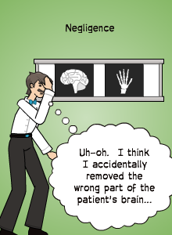
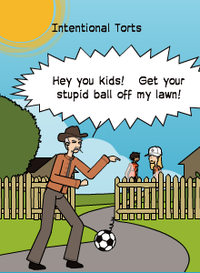
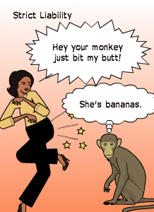

1. Intentional Torts – Chap. 4 & 5
•A tort occurs when a person intentionally acts in a wrongful way
•Meaning of “intention” differs depending on the tort:
• Intent to Harm the Plaintiff
• Intent to perform a certain act regardless of its outcome
• “Intention” does not necessary require knowledge of all of the circumstances
• Ex.: Trespass to land you do not have to know that the land belongs to the Plaintiff
•assult
•Battary
•False improsenment
•Trespass to land
•Intererence with chattels
•Conspiracy
•Intemedation
•Interference with contratual relations
•Unlawful interference with economic relations
•decit
2.Negligence Torts (Chapter 6)
• Basically – it is the law of accidents.
• A tort occurs when a person acts
carelessly
• Ex:
•negligence,
•product liability,
•professional negligence,
•occupier’s liability,
•nuisance

3. Strict Liability Torts for Extraordinarily Dangerous Activity
• A tort occurs when the defendant is responsible for an especially dangerous activity that causes harm
• Only in the following rare cases:
• Transportation / dealing in dangerous products
• Keeping of Dangerous animals

Strict Liability vs Intentional Torts / Negligence
What is the difference?
•Intentional torts / negligence – The Defendant must have done a wrongful act (intentionally or carelessly)
•Strict Liability- The Defendant did not have to do anything wrong - liability is imposed because the defendant’s activity is inherently dangerous

Risk Mitigation - What should you do if you are engaged in an inherently dangerous activity

1. Intentional Torts – Chap. 4 & 5

A.The Tort of Battery :The defendant intends to cause offensive bodily contact with the plaintiff that causes harm
•Test for the tort of battery (what you have to prove to win the case if you are the plaintiff):
1. The defendant intends to Cause
2. Offensive
3. Bodily contact
4. Resulting in Harm
• Important→there is no requirement to intend to cause harm→only to intend to cause offensive bodily contact
• There is no need to prove actual physical injury to the plaintuff

Bettel v. Yim case (1978)
Defendant (Ki Yim) owns a variety store in Toronto. One day, the Plaintiff (Bettel) & 6 other boys enter the store, play on the pinball machine and start playing with toy guns, football and other store items. Yim asks them to leave. The boys go outside and start throwing lit matches into the store. Yim goes outside, grabs one of the boys (Bettel) and starts shaking him, trying to get him to confess. While shaking him, Yim ends up hitting Bettel in the nose. Yim says it was an accident.
Is Yim liable for a tort?
1. What is the legal issue? (i.e. what is the tort?)
Answer: Is Yim Liable for the Tort of Battery?
2. What is the law?
Answer: The defendant has intentionally caused offensive, physical contact with the plaintiff
3. Analysis
Break it down by the elements:
Intendedtocause–Yimpurposefully shook Bettel–he intended to do the act of shaking
Offensive – shaking is an offensive act
Bodily contact – shaking a person’s body is bodily contact
Resulting in harm – the shaking resulted in a broken nose
4. Conclusion – Yim is liable for the tort of battery

B.Intentional Tort: Trespass to Land :Intentional interference with someone else’s land
Examples: defendant physically goes on, over, or under; builds/grows/puts something on, over or under; takes something from on, over, or under another person’s property.

The defendant did not have to know he / she were on the plaintiff’s land

Legal Test for Trespass :
1. Intentional act
2. Causing person or object
3. to interfere with the plaintiff’s

Examples
 Your neighbor builds a fence 1 foot onto your property, because he thought it was on the property line. Did he commit the tort of trespass?
Answer: Yes, because he intended to build a fence, whether or not he knew it was on your land
 You take your dog for a walk and it ‘does its business’ on someone’s front lawn. Did you commit the tort of trespass?
 Answer: Yes – you intentionally allowed your dog to go on the property of another

DEFENCES TO TRESPASS TO LAND :

1. Legal authority – Some individuals have legal authority to enter a property (ex. firemen when there is a fire alarm; municipal by-law officers etc.)
2. Consent - If plaintiff consented to the trespass – no liability

• In retail context / public spaces – there is an implied consent to customers. However - Consent can be revoked at the owner’s / occupiers discretion

Case Study
• Ch. 4 Question # 6 p. 103
• Indira, an employee of Speedit Delivery Service, mistakenly left a package at the front door of 57 Rollingwood Dr. In fact, she was supposed to deliver the package to 75 Rollingwood Dr. Late that night, when Anton arrived home at 57 Rollingwood Dr., he tripped on the box and suffered serious injuries.
Is Anton entitled to sue for an intentional tort ?

Specific Approach: Trespass to Land
Issue: Is Indira liable for the tort of trespass to land?
Legal Test :
Did the Indira intend to go over / under / above Anton’s land?
Do any of the Defences Apply?
Did Anton get Consent :
Did Indira have Legal Authority?
Analysis:
Indira intended to walk on Anton’s land – she committed the tort of trespass
Anton did not give consent to Indira (because of the mistake in the address)
Conclusion: Indira is liable for trespass to land
Remedies for Trespass to Land
• Damages – order to pay money 3 Types:
1. Compensatory Damages – most common
• Purpose – to compensate victim for harm / loss
• How do we compensate financially for trespass?
2. Nominal Damages – small amount (ex. $100) that sends a message (symbolic)
3. Punitive Damages – Rare
• Purpose – to punish the trespasser
• Only when act is “harsh, vindictive, reprehensible and malicious behavior”

• Injunction: orders someone to do something or not to do something
• For trespass –
• Preventing ongoing trespass
• Ex.: dog walker
• Requirement to remove trespassing structure / person
• Ex.: fence

REMOVING TRESPASSERS
• Removal of Trespassers – the law says you must use reasonable force
• Arrest of trespassers –
• Should be last resort (R. v Asante- Mensah (2003 SCC)
• Must use reasonable force in arrest

RETAILER CONTEXT
There is implied consent for the public to enter retail stores during business hours
Can a retailer exclude a person from its store for no reason?
• Answer: Yes, but not on discriminatory grounds (Human Rights Code)
What if customer refuses to leave?
• Answer: Can use REASONABLE FORCE to remove and only as last resort - otherwise may be sued for Battery
What if customer steals goods - Can retailer “arrest” customer?
• Answer: Yes, but only as “last resort” and must use REASONABLE FORCE – otherwise may be sued for Battery / False Imprisonment /defamination.

DEFENCES TO INTENTIONAL TORTS
TWO KINDS OF DEFENCES
1. COMPLETE DEFENCES: If defendant can prove them, he / she can avoid liability
2. PARTIAL DEFENCES: If Defendant can prove them, may still be liable but his / her liability is REDUCED (i.e., amount of damages is less)

A. Self-Defence & Third Party Defence
• Complete Defences
• Self-Defence: Right to protect oneself from actual or threatened violence
• Applies to torts of assault and battery
• Available only if person at immediate risk of harm
• Reasonable force requirement→Cannot use more force than necessary in circumstances
Ex.: If someone pushes you – you cannot take out a gun and shoot him
• Third-Party Defence: the right to protect a third-party from actual or threatened harm
• eg parent protecting child

B. Defence of Property
• Must use reasonable measures to protect property
• Principle - the law values human life and well- being over property
• If only threat is to property, it may never be reasonable to deliberately cause death or serious injury
• Recall from last class - in Retail context, when removing / arresting trespassers / thieves – must use reasonable force and be of last resort

C. Defence of Necessity
• Definition: Defendant’s actions are justified by an emergency
• Test for necessity:
Immediate action must be required
in order to avoid calamity
• Ex.:
• doctor giving urgent medical care to unconscious patient
• tearing down house to prevent spread of fire

2. PARTIAL DEFENCES to Intentional Torts
• Allows court to reduce damages on basis of plaintiff’s own responsibility for injury
• Applies to intentional and negligent torts
• Includes:
• Provocation
• Contributory negligence

A. Provocation : Words or actions that would cause a reasonable person to lose self-control
• Typically, defendant “snaps”after being taunted or insulted
• Usually a defence to torts of assault or battery
• Defendant liable for attack, but plaintiff’s damages are reduced because tort was provoked by plaintiff

B. Contributory Negligence
• Most common defence to torts
• Canadian jurisdictions divided:
• Some apply it only to the tort of negligence
• Others (Ontario included) – to all torts (including intentional torts)
• Occurs when plaintiff partially responsible for
his / her own injury
• Damages reduced to reflect plaintiff’s contribution to harm

Business Torts

Tort of Nuisance : Defendant unreasonably interferes with the plaintiff’s use and enjoyment of his or her land.
• Nuisance typically occurs when the defendant is not physically on the plaintiff’s land – the activity that the defendant is doing is causing the interference (for example: noise, smell, vibrations, ect..)
EX.
• ABC Inc. has a factory that omits noxious smells onto plaintiff’s neighboring property
• David’s construction workers make noise that keeps the neighbors awake at night
• While the defendant was drilling into the ground on its property, the plaintiff’s house’s , foundation vibrates and cracks

Nuisance vs. Trespass
• Trespass – requires the defendant to physically be on / under /above plaintiff land; or to physically put something onto / over/ under plaintiff’s land
VS .
• Nuisance- the defendant is not physically on / under / above the Plaintiff’s land but rather is causing some disturbance that is interfering with plaintiff’s enjoyment of his / her land.

Deceit : The Defendant makes a false statement, which he /she knows to be untrue, with which he /she intend to mislead the plaintiff and which causes the plaintiff to suffer a loss

Legal Test
To prove the tort of Deceit, the Plaintiff must prove the following ELEMENTS:
1. Defendant made a false statement
• Includes half truths; failure to update info; and silence when have duty to disclose
2.Defendant knew the statement was false (when s/he made it) or was reckless in determining the truth
3.Defendant intended to mislead the plaintiff
4.Plaintiff suffered loss as a result of reasonably relying upon statements

Ex
• Dan is interested in buying Stella’s car. Dan asks if the car was involved in an accident. Stella says “no”. In fact, the car was involved in an accident 1 year prior. Dan buys the car. Dan would not have bought the car had he known of the accident.

• Louis wants to buy a printing business from Sal. During the negotiations, Sal prepares a statement of the business’ income over the past 5 years, averaging $500,000 / year. In fact, the business had only made an average of $100,000 / year and Sal knew that when he prepared the statement. After reviewing the statement, Louis buys the business

Tort of Defamation : Defendant makes a false statement that could lead a reasonable person to have a lower opinion of plaintiff

Legal Test of Defamation : The Plaintiff must prove:
1.The statement refers to plaintiff
• irrelevant that defendant did not intend reference
• plaintiff must be living person but can also be corporation
• group statement must refer to plaintiff personally (Taxi driver case)
2.The Statement is defamatory - meaning that it would lower the person’s reputation in the minds of a reasonable person
3.The statement was published to third party → meaning that someone other than the plaintiff has read / heard / viewed it

Simple examples:
• Dan yells in class: “Aaron is an idiot!”
• Mary tells her friends that Lily is a
cheat and cannot be trusted.
• Linda writes on her Facebook page: “My brother is a criminal.” (Linda has only one brother.)

• Includes any form of communication (spoken, written, gestures, videos etc.)
• ANYONE in the chain of publication may be liable for defamation. Ex.:
• Publisher of newspaper / book
• Distributor of leaflets / marketing materials
• Owner of billboard
• Website host
• Risk management:
• Business faces special risk when trying to enhance own reputation by disparaging competitors

Online Defamation :
• People are less careful about what they say online than in person
• You can be liable for defamation online in the same way as in any other media
•Online anonymity is a fallacy – the Courts allow a plaintiff to discover their defamers online (through special court orders)
•Employer: special risks:
• Vicarious liability for employees’ defamation
• Employees can be fired for disparaging their employers /bosses online and
• Employers can be liable as publisher of defamatory material – if published on the employer’s website or social media site

Defences to Defamation :
• Once Plaintiff proves the 3 elements of Defamation, the Defendant may raise any one or more of the following defences and must PROVE them:
1. Justification(truth):
• Defendant must prove that the statement is true
• honest and reasonable belief in truth insufficient
2. Privilege: 2 kinds -
• Absolute privilege
• Qualified privilege
3. Fair comment

Absolute Privilege
• Complete immunity from liability
• No liability even if statement made in bad faith (maliciously)
• Limited to statements made:
• during parliamentary proceedings
• between high government officials dealing with government business
• by a judge, lawyer, litigant, or witness in legal proceedings
• between spouse

Qualified Privilege : Applies when the defendant has a legal, moral or social obligation to make a statement to someone with a similar duty or interest in receiving it
• There must be PUBLIC INTEREST in making the statement
• BUT – Defendant will be liable if the statement was made in bad faith or motivated by malicious (other bad) purpose

Public Interest Responsible Journalism Defence:

• Important application of this Qualified Privilege defence
• Applies to members of the media only
• Test: Defendant must prove that he / she:
1.Is a member of the media (journalist)
2.Investigated the statement to determine if it was true prior to publishing it;
3.Used reasonable and proper methods of investigation;
4.Had given the plaintiff a reasonable opportunity to respond prior to publishing the statement; and
5.Tried to to publish both sides of the story
• Defense not available if the defendant had malicious (other improper) intentions

Defence: Fair Comment
• Expression of an opinion on a matter of public interest:
• Opinion must be informed – made with an honest and reasonable belief in the truth of the statement cannot do so carelessly
• Opinion must relate to issue of public interest
• Defense applies as long as the opinion in question could honestly be held by a reasonable person
• But → defendant will be liable if the statement was made with a malicious purpose in mind

Remedies for Defamation:
•Usually compensatory damages to repair losses→ reflect what the court considers the plaintiff’s damaged reputation to be worth
•Sometimes damages for personal distress (for individuals only)
• Sometimes punitive damages for outrageous conduct
• Injunctions: a. Apologies / retractions b. Removal of defamation c. Prevention of deamination

Practice Question
• David is a car dealer. After he had a dispute with MIDA car manufacturer, MIDA decides to stop doing business with David. David then starts a website called www.midacarsuck.com. On the website he writes that “MIDA cars are dangerous because they have a faulty break system and that MIDA has known about it and has been covering it up.” This statement is false.
David then emails a link to that website to the media and to all of his contacts. MIDA is barraged with emails and calls from customers and the public asking about their faulty cars.
• Can MIDA sue David for defamation? Explain your answer
• Can David raise any defences ?
ANSWER
• ISSUE: Whether David is liable for the defamation?
• TEST:
Did the statement refer to MIDA?
Would the statement cause a reasonable person to think less of MIDA?
Was the statement published?
ANALYSIS
Yes, the statement referred to MIDA.
The statement implies that MIDA makes faulty dangerous cars and that it lied about that fact
The statement was published on the website AND to the recipients of the emails.
• CONCLUSION: MIDA can sue David for defamation.

• Defences:
1.Justification? – not available because statement is false

2.Absolute Privilege? – not available because not member of one of the protected classes

3.Qualified Privilege – It can be argued that David had a legal or moral duty to disclose the information and the media and clients had an interest in finding out about it + it is a matter of public interest
BUT – David had malicious intent – so will likely not succeed on defence

4. Fair Comment – not likely to succeed
• it was not a statement of opinion but of fact
• Was made with malicious intent

Interference with Contractual Relations :Intentional disruption of contract between plaintiff and another person / entity
• Risk management in business
• luring away competitor’s customers
• luring away competitor’s workers
• 2 KINDS of interference with contractual relations
• direct inducement to breach of contract
• indirect inducement to breach of contract

Direct Inducement to Breach Contract:
• Directly cause third-party to breach contract with plaintiff • e.g., convince customer to break agreement, or employee
to quit job
• ASK YOURSELVES: did Defendant encourage another person to commit a breach of contract?
• ELEMENTS OF TEST (Plaintiff must prove):
1) defendant knew about contract
2) defendant intended to cause breach of contract
3) defendant actually caused breach of contract
4) plaintiffsufferedloss
• NOTE: the defendant’s actions do not have to be unlawful offering someone a job)
• Ex.: offering a job to competitor’s employees

Indirect Inducement to Breach Contract
• Indirectly cause breach with plaintiff
• eg prevent employees from going to work, or steal worker’s tools to prevent performance
• Plaintiff must prove
• same factors as direct inducement
• plus defendants actions were themselves unlawful
• NOTE: this tort is NOT committed if a union calls a LEGAL strike, which causes the employer to lose business

Practice:
Best Ride is a taxi dispatch company in Toronto. It provides taxicab owners with dispatch services, which includes answering calls from customers and dispatching taxis to pick up customers. The legal relationship between the taxicab owners and Best Ride is of independent contractors. ABC Inc. is a company that makes advertising signs to be placed on top of taxicabs. ABC has entered into contracts with five of Best Ride’s taxicab owners to place its ads on their taxis. Best Ride does not want any taxicabs associated with it to have rooftop advertisements, because it thinks it makes the taxis look ugly. When Norman, Best Ride’s general manager, found out about the contracts between the taxicab owners and ABC, he was furious. Norman told the taxicab owners that, if they go ahead with the ABC contracts, Best Ride will not dispatch any customer calls to them. Because the taxicab owners did not want to risk losing dispatch calls (and therefore lose customers), they cancelled their contracts with ABC. In other words, they breached their contracts with ABC. As a result, ABC lost $80,000 in potential revenue.
• Can ABC sue Best Ride for a tort? Explain

VICARIOUS LIABILITY
• Employer risk in tort law
• Test: Employer is responsible for a wrongful act done by an employee when it is done in the course of employment.

Effects of Vicarious Liability:
Company will be held liable even though they didn’t do anything wrong
Victim can sue both employee and employer for their torts:
• Employees are directly liable for their own tort
• Employer may also be directly liable if it committed a separate and independent tort – e.g. careless training of careless employee
•Vicarious Liability is not a separate tort
• Employers maybe vicariously liable for employees tort

Test for Vicarious Liability
• Employer Vicariously Liable for:
a. Acts the company authorized an employee to do; or
b. A tortious act closely connected to employment relationship

• Employer Not Vicariously Liable If:
a. the employer’s relationship with the tortfeasor is that of independent contractor (non-employees) – this would depend on the nature of the relationship, not the words used to describe it
b. Employee tort’s occurred completely outside the employment relationship

CASE STUDY
John Pasta is a professional Rugby Player for the Rugby League. John has a very short temper. On the way home from a game when he played particular badly and his team lost an important match, John was approached by a fan of the team that swore at John and called him the worst Rugby player to ever play the game. Furious, John punches the fan and knocks him unconscious. The fan then sues John and the Rugby League for his injuries.

Should the League be liable for John’s battery? - Explain your answer

Would your answer change if the punch happened during a game?
What defences can the League raise?

Negligence Definition: The careless causing of harm Basically, it is the law of accidents...
• The tort of negligence balances the interests of Plaintiffs and Defendant
It tries to compensate plaintiff for harm caused by actions conducted carelessly; while allowing the defendants to take some risks.

Test for Negligence
1. Duty of Care:
• Is there a duty of care to the Plaintiff? (Why should the defendant care about the Plaintiff?)
2. Standard of Care:
• What is the standard of care and did the Defendant breach it? (How should the defendant take care?)
3. Causation :
• Did the defendant’s careless conduct cause the Plaintiff’s harm / injury?

1. Duty of Care:
• Analyzes the relationship between the Plaintiff and the Defendant to determine if the Defendant owed a duty to the Plaintiff (or someone like the Plaintiff) to avoid causing the Plaintiff harm
• Two-Part Test:
I). Have previous cases decided that there is a duty of care between someone like the Defendant and someone like the Plaintiff?
• Ex. Donoghue v. Stevenson (1932 HL) (Textbook p. 137 Casebrief 6.1)
• A manufacturer owes a duty of care to a consumer of its product (created the modern product liability cases)
• Ex.: Car accidents - between drivers and other users of the road etc.
2). If there are no precedents, the court will apply a 3-part test:
a) Was the harm to the plaintiff reasonably foreseeable by the defendant?
b) Is there a relationship of proximity between the Plaintiff & Defendant?
c) Is there a public policy reason to find for or against a duty of care?

a) reasonably foreseeable
Objective test: Would a reasonable person have anticipated that the PLAINTIFF would be harmed by the defendant’s carelessness?
• Ex.:
• Slip and fall on icy sidewalk in front of store→it is reasonably foressable that if you do not clear the ice, a pedestrian walking by will slip and fall
• But it is not reasonably forseeable that a person who is in a car on the road (not the sidewalk) would be harmed by the ice on the sidewalk
• Not Subjective→The opinion of either plaintiff or defendant does not matter
• Allows for assessment of risk and insurance coverage

Ex..: Textbook p. 138, Business Decision 6.1
→ BDC Ltd v Hofstrand Farms Ltd (1986)
• Defendant Courier company agrees to deliver package for Plaintiff by Dec. 31 for $10
• Plaintiff did not tell courier that, if package is delayed, it will suffer a loss of $1 million
• Courier delivers the package late – plaintiff sues courier for $1 million
• Was this reasonably foreseeable?
• What if Plaintiff told the courier about the potential loss?
• Ethically – do you think the court’s decision is fair? Why / why not?

b) Proximity:close and direct connection between the plaintiff and defendant
• Ex.:
• Social relationship (parent and child)
• Commercial relationship
• Bar and drunk driver
• Manufacturer and consumer
• Asks yourselves – given the type of relationship should there be a general duty of care?

c) public policy reason:
• What effect would a duty of care have on society and the legal system?
• Does our society wish to encourage or discourage a person like the defendant to owe a duty to a person like the plaintiffs?
Courts may consider:
• Would the decision open the floodgates for litigation?
• Would it Interfere with political decisions?
• Will it hurt a valuable type of relationship?
• Ethical Perspective 6.1 (textbook p. 137) - Mother and unborn child

2. Standard of Care:
• Two-part test:
1. What is the standard of care -
• How should the defendant have acted in this situation?
2. Was that standard breached by the Defendant -
• did the defendant act according to the standard of care?
• If the answer is Yes – no liability
• If the answer is no – this element of the test is met
What is the Standard of Care?
• Test: How should the defendant act? Reasonable person test
• How would a reasonable person act in this situation?
• Are there legal, moral or social requirements to act in
a certain way?
• Ex.: When driving, there is a legal requirement to stop at a red light; not to speed etc.
• It is an objective test
• Subjective conduct of defendant does not matter
• The standard of care is not perfect – only that of an average person in the same circumstances
• No hindsight

Standard of Care for Professionals
• Special standard of care for persons in professional roles
• Ex.: accountants; lawyers; doctors; stockbrokers; real estate agents; architects; etc.
• Standard is higher than of a lay person (non-professional)
• The professional must act as a reasonable professional in similar circumstances
• no allowance for inexperience
• no allowance for exaggerated credentials
• Standard may be higher still for specialist or expert
• must act as a reasonable expert would act

Case Study: Textbook p. 157 Question 2

Facts:
John Brokaw was interested in purchasing an apartment building. Concerned about the price, he contacted Lonnie Hauser, a property value appraiser. Brokaw explained in great detail that he needed to know, as precisely as possible, how much the apartments would generate in rent. The final report provided by Hauser stated the property was worth $1,400,000. The actual value of the property was $1,000,000. Hauser says he should not be responsible because he had reasonably assumed that the same rent would apply to every apartment.
• Can Brokaw sue Hauser for a tort? Explain your answer
Standard of Care for Products (product liability):
• Harm caused by manufactured products
• In Canada - manufacturer liable only for
careless defects.
• Examples:
• Defect in the manufacturing of the product (Ex. Snail in ginger beer)
• Defect in the design of the product (Ex. faulty steering wheels in cars)
• Failure to warn of known risks • Ex.: medication side effects
3. CAUSATION:
• Did the defendant’s conduct cause the harm?
If the harm to the plaintiff was caused by something or someone other than the defendant – this element is not met and the defendant is not liable for negligence
• The “But-For” test----Would the plaintiff have suffered harm “but for” the defendant’s careless conduct?
• In other words - What happens if you take the defendant “out of the picture”?
• If plaintiff still suffers harm----defendant did NOT cause loss
• If plaintiff does not suffer harm-----then the defendant is the cause of loss
EXAMPLE:
• Textbook p. 150 - Man goes to hospital complaining of stomach ache. Doctor fails to diagnose him with arsenic poisoning and sends him home untreated. Man goes home and later dies.
• What if evidence shows that, had doctor properly diagnosed and treated the man, he would have survived?
• What if the amount of arsenic in his body was so significant that, even if Doctor had properly diagnosed and treated him, he would have died?

Causation – Remoteness:
• There will be no liability if the HARM that the plaintiff has suffered is too “remote”
• Test: reasonable foreseeability of HARM
→whether the TYPE OF HARM that the plaintiff has suffered was reasonably foreseeable.
(Unlike Duty of care test - which is about the reasonable foreseeability of the PLAINTIFF)
Remoteness Example
• Was it reasonably foreseeable that –
by selling too hot coffee someone will put it in their pants and suffer a serious burn?
• Answer: probably yes - because a burn is a TYPE of injury that is reasonably foreseeable from coffee
that is too hot.
Exceptions to Remoteness:
1. Thin skull Doctrine:
• You take the Plaintiff “as she / he is”
• Applies it there is a pre-existing medical condition that causes the injury to be worse than what
a normal person would suffer
2. Thin wallet – you might get special treatment if you suffer a more serious loss because you are poor
3. Intervening Act – occurs when something happens after the defendant’s careless act that contributes
to the plaintiffs’ injuries
• Test: Did the initial bad conduct contribute to the subsequent injury?
• Ex.: P slips and falls due to Defendant’s carelessness and breaks a leg. While on crutches,P trips and breaks back
– D responsible for broken back as well
Defences to Negligence
A. Contributory negligence
B. Voluntary assumption of risk (“volenti”)
C. Illegality (see book)
A) Contributory Negligence:
• Loss is caused partly by defendant and partly by plaintiff’s own carelessness
• Same tort elements, looking at plaintiff’s conduct
• Proportional liability →damages reduced to reflect plaintiff’s
contribution
• Common examples:
• Drunk driver
• Distracted customer slips on wet floor

B) Voluntary Assumption of Risk
• Plaintiff freely accepted both physical and legal risk of injury (gave up right to sue)
• Two part test:
1.Physical risk – did the plaintiff knowingly engage in a risky activity (ex: skill hill); and
2.Legal risk – did the plaintiff legally waive his / her right to sue defendant for this type of risk
• complete defence (not proportional)
• courts interpret this narrowly because of harsh result
• Risk management→Disclaimers and waivers

Occupiers Liability Act
• Ontario Legislation
• Applies when Plaintiff is carelessly injured while on someone else’s property
• Replaces the common law test for standard of care – instead we apply the OLA standard of care
• The Defendant is the “occupier” of the property where the Plaintiff was injured
• “Occupier” - any person having possession of, or control over and responsibility for premises or activities
on premises;
   ▪Ex: owner of land; tenant in building; property management company responsible to caring for the
building; maintenance company; superintendent, etc.
   ▪There can be multiple “occupiers” for a single premises
28
OCCUPIERS’ DUTY OF CARE :
• An “occupier” owes a duty of care to anyone who is on his / her premises (and to the property that
such people may bring with them)
29
• Occupier must ensure that the premises is reasonably safe from harm to anyone who is on it
• This standard of care applies whether the danger is caused by the condition of the premises or by an
activity carried on the premises
DEFENCES TO OLA:
1. Voluntary Assumption of Risk:
• The occupier is not required to keep the property reasonably safe from harm from the following persons (but cannot deliberately intend to do harm to them):
 ➢People engaged in criminal activity while on premises
 ➢Trespassers
2. Contributory negligence
31
OLA – Independent Contractors:
• The occupier is not liable for the negligence of an independent contractor, provided the occupier acted reasonably in entrusting the work to the independent contractor
• Example: owner of parking lot and snow removal company
32

Case study
Belair shopping mall and its parking lot are owned by the Belair Corporation. Belair contracts out the maintenance of the shopping mall and of the parking lot to the Lennox Property Management Company.
Lisa has just completed a full day of shopping at Belair Shopping Mall, and is in a hurry to pick up her son from school. When she exists the shopping mall’s door, she notices that it is raining heavily (when Lisa started shopping that morning, it was hot and sunny). Lisa is wearing flip flops. While carrying 3 large shopping bags in each hand, she runs towards her car that is parked in the mall’s outdoor parking lot. Suddenly she trips and falls. Lisa looks down to where she fell and notices that there is a large crack in the crosswalk. Lisa thinks that she tripped when her toes hit the crack but cannot be sure. Lisa has been suffering for years from osteoarthritis. After several tests, her doctor concludes that Lisa had injured her hip during her fall and that this injury has aggravated her pre-existing condition to such an extent that she would require painful hip replacement surgery.
• Who can Lisa sue for a tort and on what legal basis? Explain your answer
• Are there any defences that the defendant(s) can raise? Explain your answer

CONTRACTS

• Answer: Legally enforceable agreement
• Contract law→Private law – governs the relationship between the parties to an agreement
• Contract law – enables you to force someone to keep his / her promises
• Why are contracts important to business?
1.Create predictability and certainly in commercial relationships / marketplace
• Ex. – I promise to mow your lawn; you promise to pay me for mowing your lawn – we both can reasonably predict our respective performances
2.Risk management – reduces risk of non performance
• Ex. – You promise to tutor me in math - I promise to pay you $50 for tutoring me. If I do not pay you – you can sue me in court to force me to pay you $50

Does a contract have to be in writing to be legally enforceable?
• Answer: NO – a contract can be written OR oral
• There are SOME exceptions to that rule – legislation that requires certain types of contracts to be in writing (e.g. - Statute of Frauds; Consumer Protection Act; Sales of Goods act)

To be a legally enforceable contract – a contract MUST have the following 3 elements:
1. intention to create legal relations
2.“meeting of the minds” - offer and acceptance
3. “consideration: - mutual exchange of value

1. intention to create legal relations
Parties must intend to enter into a legally enforceable agreement
• Objective test: Would a reasonable person believe that the parties intended to create a contract at the time the contract was formed?
• Not subjective (does not matter what parties say they intended)Why do you think that is?(general rule)

• General rules:
1.Presumption of intention in commercial dealings
Ex. – two businessmen negotiating a deal – presumed to negotiate with the intention to create a contract
2. Presumption against intent in social and family context
Ex. – Adult son living in parent’s basement – presumed not to intend to enter into a contract to rent the basement
BUT: Presumptions are rebuttable→
Ex. – The parents may be able to convince the court that son and parents did intend to enter into a lease in this particular case

• Textbook p. 165 (You be the judge 7.1)
Every year for 10 years, Cogan bought 8 season tickets in prime location for baseball games. Cogan then sold 4 of his season tickets to Fobasco Ltd. – company managed by David Fingold, Cogan’s friend. David used the tickets to get customers for his business. In 1986, Cogan decides to give the 4 tickets to his sons, rather than sell them to Fobasco. Fobasco sued Cogan - claiming that there was a contract to sell 4 season tickets to Fobasco every year indefinitely.
Was there a contract between Cogan and Fobasco? Explain your answer by arguing for or against the existence of a contract
Issue:
• Was there an intention to enter into a contract?
• Would a reasonable person believe that the parties intended to enter into a contract?
• Social relationship = presumption against intention
• Arguments for and against?

2.“meeting of the minds” - offer and acceptance
2 part test:
A. Was there an offer?
- AND -
B. Was there an acceptance of the offer?

A. Offer
Offer = a willingness to contract on stated terms
Offeror = person who makes the offer
Offeree = person who receives the offer
Offer must be communicated to the Offeree
Offer can communicated through:
• written document
• oral statement
• Conduct
• Ex.:silentlyhandingaproductandmoneytothecashieratastore
Rule: Once the offer is accepted – a contract is formed - the parties are legally bound by the contract
- No contract formed if offer not communicated to offeree

Managing Risk: Invitation to Treat
• Invitation to treat = willingness to receive offers:
• Your Kijiji ad is considered an invitation to receive offers for your desk
• People responding to your ad are the offerors – they are making an offer to buy your desk for $100
• You are the offeree – you can choose to accept whichever offer you choose
• “Invitation to Treat” is most common in retail context
Ex. product shelf display; advertisements; catalogues The Life of an Offer
• An offer is open for acceptance by the offeree unless it is terminated.
Offer may be terminated before acceptance That means the offer cannot be accepted and there will be no contract.
Offer can be terminated by:
• revocation
• lapse of time
• rejection
• counter offer
• death or insanity

Revocation of Offer: withdrawal of offer by offeror
• offeror normally free to revoke at any time
• Even a “firm offer” can be revoked
• “Firm offer” = gratuitous promise to not revoke the offer
• Ex.: I offer to sell you my desk for $50. You are not sure if you want to buy the desk and ask if you can think it over. I promise to keep the offer to sell you the desk for $50 open for 1 week
• General rule: firm offers are unenforceable
• Ex.: I can sell the desk to someone else before the week is over.
• Exception: firm offers are enforceable only if:
• Made under seal
•Offeror receives some value in return for a binding promise to keep the offer open for a specific period
• Ex.: You pay me $25 non-refundable deposit to hold the desk for me for 1 week

Dickinson v. Dodds (1876)
Textbook p 167 - Dickinson is one of several people interested in buying a piece of land from Dodds. On Wednesday, Dodds offers to sell the land to Dickinson and offers to hold that offer open for acceptance until Friday. On Thursday, Dickinson finds out that Dodds is negotiating selling the property to someone else. Dickinson tries to reach Dodds to accept his offer but unable to locate him. Dickinson leaves a letter of acceptance with Dodds’ mother-in-law. Dickinson locates Dodds on Friday morning and tells him he accepts his offer. By that time, however, Dodds already sold the land to someone else.
• Issue?
• Law?
Legal analysis? What could someone in Dickinson’s place do to avoid this result? Ethical analysis – do you think this is fair? Why / why not?

Lapse of time:offeror can set termination date
•Ex.: “This offer is open for acceptance until Friday at 5pm” – if you communicate acceptance on Friday at 5:01pm, there is no contract.
•if no termination date set, court will infer reasonable time

Rejection:
•Ex.: Offeree says - “I reject your offer”; “I do not accept your offer”
•offeree cannot subsequently revive offer

Counter offer:
• offeree responds to an offer but modifies the terms
• Result (Offeree becomes the offeror and creates new offer )

B. Was there an acceptance of the offer?
• Acceptance = agreeing to offer’s terms
• RESULT -- contract created immediately upon
acceptance
• Acceptance must be in response to offer
• 2 types:
1. Bilateral Contract (acceptance by promise)
• promise exchanged for a promise = both parties have future obligations (most common form of contract)
2.Unilateral Contract acceptance by performance
• Offeror makes an offer ( Offeree accepts the offer by performing his / her obligations )

A. Acceptance by Promise (bilateral contract)
Ex.: Contract to sell a car: “I will pay you $7500 and you will give me your car”
The Offeror is a the “master of the acceptance” – he/she can dictate the form of acceptance
Acceptance may occur in a number of ways:
• words (written or spoken)
• conduct may signify acceptance (e.g. handshake)
Silence - silence alone cannot be acceptance
• Ex.: Bookstore sends you a book by mail with a letter saying – “if you keep this book you agree to pay for it”→no acceptance = no contract – you do not have to pay for it.
Unsolicited goods: good or servises supplied to someone who has not asked for them.(you don’t have to pay for them but u get to keep them)
BUTsilence plus prior agreement may be acceptance
• Ex.: You join a bookclub and agree to pay for books they send you every month

B. Acceptance by Performance (unilateral contract)
• Ex.: I offer to pay you $50 if you mow my lawn. You do not respond and mow my lawn→ parties are bound by a contract and I am required to pay you $50
• However→Contract only formed and enforceable when performance is completed
• Ex.: You only mow half of my lawn = no contract→I am not legally required to pay you $50 (although equity / fairness may require me to pay you a reasonable amount for your services
Time and Place of Acceptance :Important because determines time and place of formation of contract
• Instantaneous acceptance (= no substantial delay):
• Ex.: face-to-face; by telephone;
• General Rule: Contract created when acceptance received, where received and only if received.
• Non-Instantaneous acceptance (= substantial delay):
• Ex.: by snail mail
• “Postal Rule”: acceptance is effective where and when the offeree sends it (even if not received).

• Practical advice: always avoid setting up a situation where the postal rule would apply! (i.e., do not send an acceptance by snail mail)

Practice Question
Realty Inc. is a developer and seller of condominiums. On October 1, Miranda signed an offer to purchase one of Realty’s condos for $350,000. Part of that document said “This offer is irrevocable by the Purchaser until one minute before midnight of October 15, after which time, if not accepted, this offer shall be null and void. Acceptance shall be made by signing and dating below this offer”. On October 12, Realty signs and dates the offer document and mails it back to Miranda. On October 13, prior to receiving Realty’s mailed document, Miranda sees another condo for sale that she loves even more than the Realty condo, and decides she wants to purchase it instead. She calls Realty’s sales office and tells them she wants to revoke her offer on the condo. The sales manager responds that she cannot revoke it and that she is bound by the contract to purchase the condo.

Is Miranda bound by an enforceable contract to purchase the condo from Realty? Explain your answer.
3. “consideration: - mutual exchange of value: Third element of an enforceable contract
• Consideration = mutual exchange of value • No consideration = no contract
• Ex.: A gift → not mutual exchange of value →no consideration→not an enforceable contract
• Exception – if contract made under seal = special mark on document
• Consideration = can be a benefit or a detriment to the parties
• Each party must either:
• promise to provide a benefit to someone; or
• promise to suffer detriment to self
• Ex.: I will pay you $5000 in exchange for you transferring your car to me
• Consideration (benefit) can be provided to someone who is not a party to the contract
• Ex.: I will pay $5000 to your brother in exchange for you transferring your car to my sister

Sufficient vs. Adequate Consideration
• Consideration must be sufficient
• Sufficient: any value from a legal perspective = money, goods, land, or services but not “love and affection”
Forbearance to sue (= give up right to pursue a lawsuit) is sufficient consideration if legal claim is valid
• Consideration need not be adequate
• Adequate: exchange of equal value
Courts will not save someone from a “foolish” bargain (“Peppercorn Theory”)
Ex.: I pay you $5 for your new computer
• Risk Mitigation - Always ensure that contract states some form of consideration (ex. $2)

Past Consideration : consideration given before contract contemplated No mutuality and therefore no consideration
• Rule: Past consideration is no consideration
Ex.: I gratuitously mow your lawn. After I am done, you are so glad that you promise to pay me $100.
• This is PAST consideration (I cannot legally force you to pay me $100)

Past Consideration – Ethical Issues
Textbook p. 187; Ethical Perspective 8.1
David is strolling down the beach when he sees Lucy drowning. David jumps into the water, pulls Lucy out of the water and performs CPR. When Lucy comes to, she is so delighted she offers to pay David $1 million for saving her life. (recall from first class: there is no legal duty to rescue)
Legally: Is there an enforceable contract? (can David sue Lucy to force her to pay him $1 million?)
• Ethically: Do you think Lucy should be required to pay David to fulfill her promise ?

Pre-Existing Same Party Obligation (Gilbert Steel Rule)
Promise to perform obligation already owed to the same party = not sufficient consideration (Gilbert Steel case)
Ex.: A and B have a contract for B to print 1000 business cards for A for $100. B prints 500 business cards and then runs out of ink to print more cards. B asks A to pay him an additional $50 so he can buy more ink to finish the printing.
B has not provided any new consideration → therefore, if A accepts this offer, it will not be an enforceable contract
Why does this legal rule exist?
Ethical reasoning: Do you think this result is fair?
What if B cannot get the money to print new business cards. How can A & B resolve the issue?
Answer: B should promise NEW consideration (ex.: deliver the cards earlier; offer better quality cards; offer a discount on next purchase ect.)
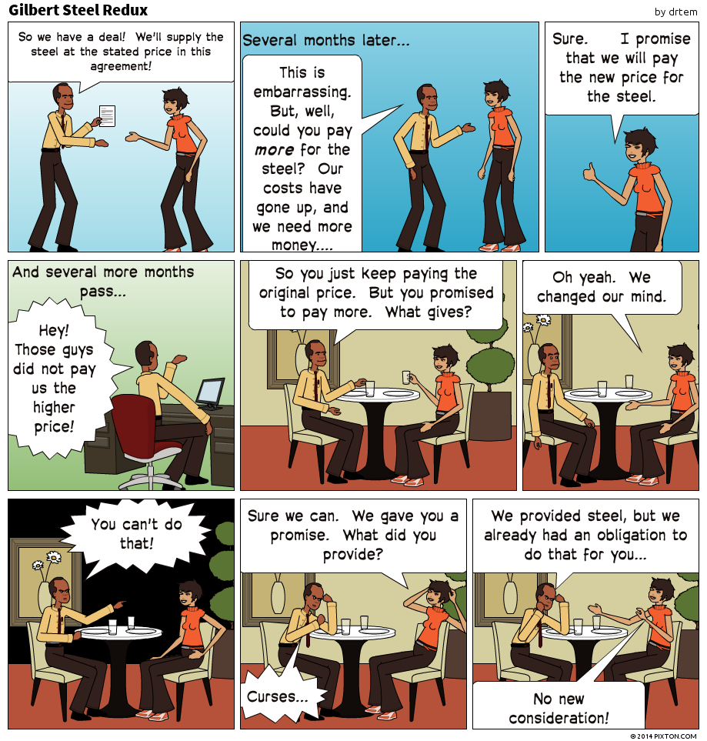

Exception - Pre-Existing Third Party Obligation
• Promise to perform duty owed to third party = sufficient consideration
• Old contract promise repeated for new contract
• Ex.: Jon enters into contract with Sal to mow Sal’s lawn for $50. Just before Jon begins the work, Sal realizes he is out of cash. Sal’s friend Jean then agrees to pay Jon the $50 for mowing Sal’s lawn (i.e., performing an already existing contract).
• Law says this is a new benefit for new party under new contract→Jean acquired the right to enforce Jon’s performance

Promise to Forgive Existing Debt :Promise to discharge debt upon part payment
• Ex.: You owe me $500. You do not have enough money to pay me. I agree that you can pay $200 and forget the rest
• This agreement is unenforceable because no new consideration (not a valid contract)
• Exceptions:
• Promise made under seal
• promise exchanged for new benefit (e.g. early payment)
• Legislation (including Ontario)→promise enforceable if part payment actually received

Privity of Contract
Privity is the relationship between parties to a contract
• Parties: persons who create contract (who have enforceable obligations promises)
Privity rule: only parties to a contract can sue or be sued under the contract
Stranger (or third party): someone without privity
• cannot sue or be sued for breach of contract
• irrelevant that stranger is beneficiary of contract
Ex.: A and B enter into a contract, whereby A agrees to pay C $5000, in exchange for B’s car”
Only B can sue A if A does not pay C→C cannot sue because he/ she is not a party to the contract

Exceptions to Privity of Contract
• Assignment: a process of transferring contractual rights to a third party.
• the assignor transfers her rights under the contract to the assignee; debtor now owes obligation to the assignee

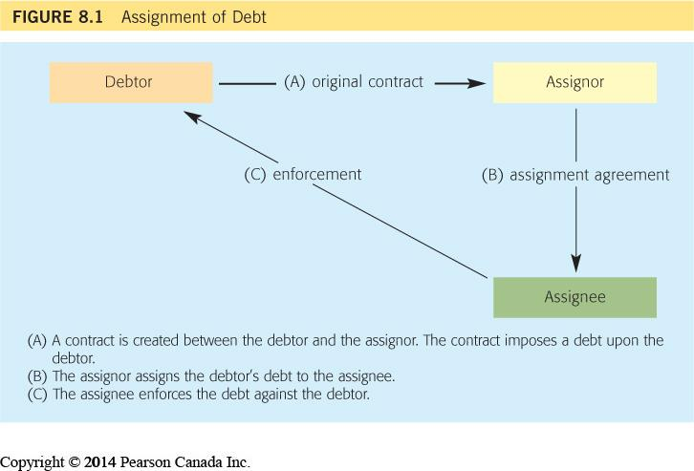

CONTRACTUAL TERMS

Pre contractual terms : Statements made during negotiations (pre-contract)
• Issue: Which statements form part of the contract?
• The answer would depend on the TYPE of statement:
1. Statements that do NOT form part of contract:
A. Mere “Puffs”: advertising / sales words
Ex.: “Juicyfruit – the taste is going to move you”
There are no legal consequences to “puffs”
B. Representations:statement of prior or existing fact (not opinion) made before a contract is formed
Ex.: “Our products are of superior quality to those of our competitors”
If representation induces a party to enter into the contract and is false→can lead to liability for the TORT of fraudulent / negligent misrepresentation

Contractual Terms
• Statements that form part of a contract
• Definition: statements of legally enforceable obligations
These statements are often made as part of an “offer” or “counter-offer” during negotiation
Ex. Printorama offers to print Louis’ 1000 business cards for $100. Louis accepts this offer→This is now a contract, which includes the following terms:
• “Printorama will print 1000 business cards”
• “Louis will pay Printorama $100”

Contracts may have two type of terms:
• Express terms
• Implied Terms

• Express term = a STATEMENT (oral or written) made by a party to the contract that a reasonable person would believe was intended to create an enforceable obligation
• Basically--the promises that the parties have expressly agreed to pereform
• What happens when a written term of a contract is ambiguous (i.e., unclear)?---parties may disagree on how they should perform their respective obligations (litigation )
• Ex: “A must pay B on the 30 day of each month”
• What happens in the month of February? – does A have to pay B anything, and if so, when is his payment due?

Express Term Interpretation Rules
• The courts have developed different approaches to interpreting contractual terms:

1.Literal approach: (“golden rule” = takes precedent over all other approaches)→words are given their plain and ordinary meaning
2.Contextual approach: what were the reasonable intentions of the parties? – the court will consider evidence of surrounding circumstances, including history of the relationship between the parties, industry practices, commercial principles etc.
3. Contra Proferentem Rule: The term will be interpreted AGAINST the party that drafted it
• Why? If you wanted it to be clear – you should have drafted it clearly!
• Recommendation: always use plain, ordinary language when drafting contracts no “jargon” please!

Case Study - Textbook p. 219 - Business Decision 9.2
There was a tuition fee freeze imposed by the B.C. government. Vancouver Business School was planning on raising its tuition once the freeze was lifted, since it needed significant funds to meet its basic costs. There was a provincial election and the party in power changed. The university was expecting the new government to lift the freeze at some point, but did not know when or if this will happen. In the fall, the following offer letters were sent to students, containing the following term:
“Tuition Fees: $7000* for the 15 month program (payable in four instalments of $1750).
*Student activity fees are also assessed. Fees for the year are subject to adjustment and the university reserves the right to change fees without notice. Please see attached information sheet and fees section of the university calendar”.
In March, the tuition freeze was lifted and the university immediately raised tuition from $7000 to $28,000. Students sued the university for breach of contract. The issue was whether the wording of this term gave the university the right to unilaterally raise tuition to $28,000.

Is the term ambiguous?
What interpretation approach should the university take?
What interpretation approach should the students take?

Implied Terms = an obligation that is not stated in the contract but that may arises by operation of law ---i.e., the law imposes this obligation on the parties to the contract
• Two ways in which a term may be implied:
1.By common law (implied by court)---if necessary to carry out the parties’ intentions; standard industry practices; etc.
• Ex.: the right to receive reasonable notice of termination by your employer
2.By legislation (implied by statute)---Ex.: Consumer Protection Act; Sale of Goods Act; Residential Tenancies act;

Standard Form Agreement Terms
Standard Form Agreement = Mass-produced documents
Inherently involves an imbalance of power---“take-it-or- leave-it” approach – no actual negotiation of the terms
examples:
Bank documents (account opening agreements; credit card agreements; mortgages
Utility agreements (cable company; electric company etc.)
Waivers of liability (exclusion clauses)

Advantages to using SFA?
Disadvantages / risks?
• General Rule: Signature of party is proof of party’s agreement to its terms
• signor bound by terms of agreement even if he / she did not read it
• signor bound by terms even if he/ she did not understand the terms
• Exception Signor not bound if he/she was not given a reasonable opportunity to read the agreement; or if asks for explanation and it is either not given or improperly explained.
• Ex. customer rushed

Exclusion Clauses (Waiver): term in an agreements that expressly excludes or limits the liability of a party
• Ex:
Exclusion clauses are a common way in which parties limit their liability
Parties can limit liability entirely or partially (Ex.: “we are not at all liable”; “our liability is limited to $100”)
Consequence of agreeing to exclusion clause→You sign away your right to sue for bad acts committed by other side
Ethical reasoning: Do you think this is fair? Why / why not?

4-part Test for Enforceability of Exclusion Clause:
1.Clause must be clear and unambiguous ambiguities interpreted against drafter -contra preferentem rule
2.Reasonable notice of the term must be given to affected party
• the clause must be properly brought to the party’s attention and the party must be allowed time to read the clause
heavier onus for unusual or harsh terms----In the words of a famous English judge: “some clauses ... would need to be printed in red ink on the face of the document with a red hand pointing to it before the notice could be held to be sufficient” (Lord Denning)
3.The affected party must have expressly agreed to the clause→ signature is best evidence of acceptance of clause
4.Clause may not be enforced if it is unconscionable or unfair (not important for this course)

Ticket Contracts
• A type of a Standard Form Agreement
• Terms often printed on the back or bottom of tickets or
receipts
• Ex.: Ski hill tickets - exclusion clause; retailers – return policies
• Enforcement depends upon Notice and Agreement:
1. Notice:
• reasonable notice must occur before contract is created
• heavier burden for unusual or harsh terms (exclusion clauses)
• perhaps no burden for obvious terms
2. Agreement:
signature is best evidence of acceptance
If customer buys ticket after being given reasonable notice – likely evidence of agreement (even if not read term)

Reading Contractual Terms
• Legal Purpose • Document Title; Document
Purpose; Recitals • Parties
• Terms And Conditions • Description of
• Terms and Conditions • Warranty
•Price • Effective Date; Expiration Item/Equipment Date
•Consideration •Disclosures
•Delivery & Risk of Loss • Applicable Laws
• Remedies • Confidentiality
• Force Majeure

Boilerplate Clauses
• Common contractul terms that are reproduced in most business contracts:
• Several types
• exclusion clauses
• force majeure clauses
• confidentiality clauses
• arbitration clauses
• jurisdiction clauses
• entire agreement clauses

Contractual defects
What are Contractual Defects?
External circumstances that render a contract unenforceable
If a party proves one of these defects → the court may not enforce the contract (the party will not have to perform his / her contractual promises
• Misrepresentation
• Incapacity to contract
• Unfairness during bargaining:
1. Duress
2.Undue Influence
3. Unconscionability
• Illegality

Misrepresentation: Misrepresentation is a false statement of a prior or existing fact that induces (causes) a person to enter into a contract
• LEGAL TEST:
1.A statement of a prior or existing fact;
2.That is false when made; and
3.The statement induced the person to enter into a contract

Statement must be FALSE when it is made 3 kinds of misreps:
• Innocent Misrepresentation - the person making the statement did not know it was false and could not reasonably have known it was false by investigating the facts
• Negligent Misrepresentation - the person making the statement should have known the statement was false but was negligent (careless) in investigating the facts---constitutes a tort
• Fraudulent misrepresentation (= tort of deceit) – the person making the statement knew the statement was false when he / she made it and intended to deceive the person to whom it was made

Statement INDUCES person to enter into the Contract
• The person must have reasonably relied on the statement when entering into the contract
• If the person could have found out the truth by doing his / her reasonable investigation, then he / she may be bound by the contract.

• Ex.: commercial contracts may have a “due diligence” condition - a clause that allows the parties time to conduct an investigation of the facts before finalizing the contract

Practice Question
Textbook p 210 - Business Decision 9.1 –
Mr. and Mrs. Perry decided to construct a shopping mall building. They determined that, in order to make a profit, they would need to construct it for less than $120,000. They hired an architect who “guesttimated” that he could design a building that could be constructed for less than $120,000. The Perrys agreed to his proposal and hired him to prepare the plans. He charged them $5000 for the plans. When the Perrys showed the building plans to a contractor, the contractor told them it will cost them much more than $120,000 to construct the building.

Is the Architect’s “guestimate” a misrepresentation? → why / why not?
Does it matter that the architect is an expert?
Would your answer change if the Perrys were sophisticated real estate developers who have developed similar shopping malls in the past? Why / Why not?

Remedies for Misrepresentation
1. Rescission = cancelling the contract and placing the parties back in the position as if the contract did not exist
• Not available if the complaining party has “affirmed” the contract - party performed his / her side of the bargain after discovering the misrepresentation or waited too long before complaining about it
2. Restitution - each side gives back what they gave and received
• Ex.: returning a product for the money
• Restitution may be denied if:
a.It is physically impossible (eg product is used)
b.Third party rights would be affected (ex. purchased mall already rented to tenants)
c.Contract is affirmed - misled party acted as if contract was good
• Damages (for negligent misrep / fraudulent misrep only)

Incapacity to contract
• Capacity = legal ability to give consent
• If a contract is entered into with an incapacitated party→that contract will be unenforceable
• Groups with “incapacity”:
1. Minors - in Ontario anyone below the age of 18 cannot legally consent to a contract
2. Mentally incompetent persons - with impaired / diminished mental capabilities (requires a medical opinion and court finding)
Ex.: someone with dementia / Alzheimer's
3. Intoxicated persons (alcohol / drugs)
• Intoxicated person must promptly elect to rescind the contract immediately after becoming sober. If waits too long, considered to have affirmed the contract

Unfairness during bargaining:
• Contract may be voidable (unenforceable) due to unfairness
• Three fairness grounds that may render a contract unenforceable:
1. Duress (thretining you)
2.Undue Influence (internal manupiltion)
3. Unconscionability

1. Duress (thretining you):illegitimate external pressure into entering into a contract
• contract voidable at victim’s option
3 Types of Duress:
a.Duress of person----threat of physical harm to party or loved one forcing someone to sign contract (ex: “sign this contract or I will shoot you”)
b.Duress of goods----threat to detain, damage, or destroy goods
• Ex.: a moving and storage company refuses to give you your furniture back unless you pay them $1000 above the agreed upon contract
c. Economic duress

Economic Duress threat of financial harm--does not always give rise to unenforceable contract
• Court will determine if the threat was illegitimate pressure or a commercial reality
• Factors to determine whether it is Economic Duress ---
1.threat made in bad faith
2.victim could not reasonably resist the threat
3.victim acted promptly once pressure removed
4.victim protested at time of threat (if practical)
5.victim did not have legal advice before succumbing to pressure
• Ex: Nanny being threatened by employer that she will lose her immigration status unless she agrees to work for no to little pay

2.Undue Influence (internal manupiltion)
• The abuse of imbalance of power to pressure someone into entering into a contract (no actual threats made)
• Depends on the relationship between the parties:
1. fiduciary relationship
2. no fiduciary relationship

Fiduciary Relationship occurs whena person is in a special relationship / position of power / trust over another
Ex.:
parent - child;
physician-patient
Lawyer – client
Undue influence presumedif fiduciary
• fiduciaryparty can rebut presumption by:
a. show transaction was fair ; or
b. weaker party received independent legal advice (ILA)

No Fiduciary Relationship
• Party alleging undue influence must prove it - there is no presumption of undue influence
• Partyneeds to show imbalance of power & actual pressure exerted over the weaker party to enter into the contract
• Opposing party can adduce evidence of equality
• show fairness of transaction
• show fairness of bargaining process
• Riskmanagement-if thereis imbalance of power between parties ---refrain from bullying tactics & recommended ILA

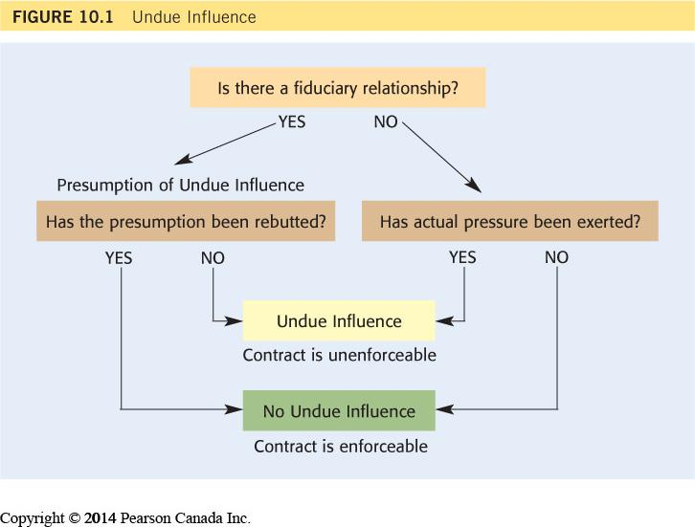

3. Unconscionability :An agreement that no fair-minded person would offer and no right-minded person would accept
• Basically - it has to be inherently unfair
• Test:
1. The contract was “improvident” = a bargain made without regard to the future
an unreasonable bargain - no one in their right mind would have entered into it;
AND
2. There was an inequality of bargaining power between the parties
• If these two elements are proved→there is a presumption that the contract was unconscionable and therefore unenforceable.
• Responding party can rebut the presumption by proving:
• bargaining process was fair, right and reasonable; OR
• other party received independent legal advice (ILA)

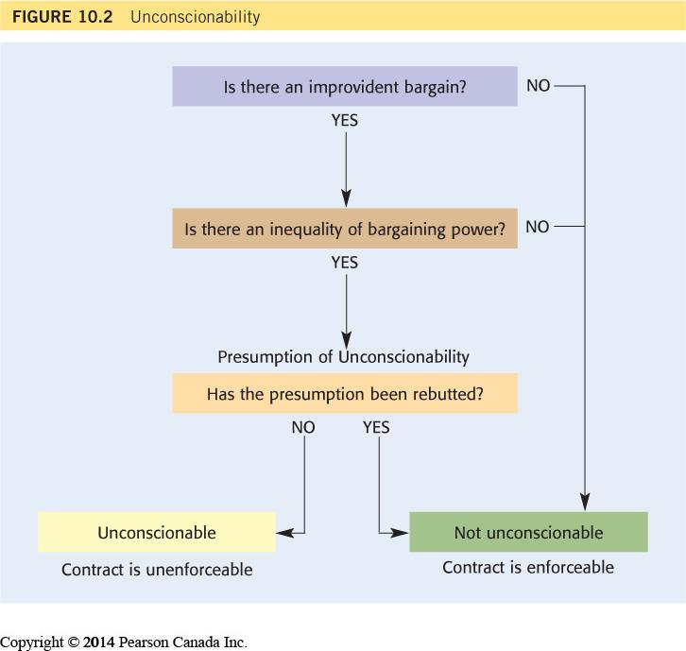
Practice Question
A low income apartment building suffers a fire during the winter months. The poor and disabled tenants have lost all of their personal belongings in the fire (food, clothing, medicine, furniture) and have no financial ability to purchase new items. The tenants are offered immediate compensation by the landlord and its insurance company. The offer is significantly lower than what thy would be entitled to (replacement value of the items they lost). The tenants accept the offer because they desperately need the money to buy food and clothes. The landlord and its insurer know that when they make the lowball offer. The tenants sign the contracts but later change their minds.
Can the tenants ask the court to void the contracts and, if so, on what legal basis or bases? ( Explain your answer)
What could the landlord and insurer do to avoid having this agreement set aside by a court?
Consumer Protection Legislation
• Consumer - business relationship = inherent imbalance of power
• Consumer protection legislation tries to address this by imposing requirements on certain types of consumer contracts
• Ontario examples:
• Consumer Protection Act (CPA)→applies to certain forms of consumer contracts, including:
• Personal service contracts (modelling; gyms / fitness; sports etc.)
• Mechanics
• Car leases Energy Consumer Protection Act → energy contracts (door to door
sales)
• New Home Warranties Plan Act and Condominium Act→contracts for new homes and condominiums

Consumer Protection Laws
• Impose specific requirements on contracts – which may invalidate contract if non-compliant
• Example of requirements:
1.disclosure requirements (ex.: must disclose rates)
2.cooling off periods (ex.: can change your mind within X days)
3.Cancellation rights (ex.: can cancel at any time with X days notice)
4.Prohibited use of unfair terms, such as exclusion clauses
5.broad discretion to the courts to render harsh or unconscionable contractsunenforceable

• Illegality
• Contract may be void because it has a term that is illegal
• The illegal term may not necessarily invalidate the entire contract.
Ex: A person who agreed to a loan that imposes a criminal rate of interest may have to pay back the loan, but not at that interest rate.
3 Common situations:
1. Contrary to Legislation or Regulations
Ex: contract violates criminal interest rate (60% / annually); food safety rules; building code
2. Contrary to the Common Law
Ex.: Agreement to commit a tort (battery; fraud; etc.)
3. Contrary to Public Policy:
• Unreasonable restraint on trade--public policy encourages economic competition--An agreement may be ineffective when it unreasonably restricts one party’s liberty to carry on a trade, business, or profession in a particular way
• Non-competition agreements:May be enforceable if they are reasonable in geography and time
Ex. Employment contract includes a non- compete term that states that, if the employment is terminated, the employee may not work for a competing company for 6 months in Toronto
Ex. Sale of business contract includes a term that states that the vendors may not set up a competing business in Canada in the next 5 years

Practice Question
Textbook p. 260, Question 12
In 1995, Oli was 88 years old. Oli’s mental capacity was failing – he had good and bad days. Turner was 47 years old. Oli owned a large piece of land that had a value of $167,000. Turner offered to lease the land with an option to purchase it for $100,000 payable over 20 years at $5000 per year (with an option to exercise the purchase sooner). Oli agreed. Turner prepared the document for Oli to sign and he had Oli come to his office to sign it. Oli did not consult with a lawyer before signing the contract. When he signed the agreement, Turner knew that Oli was old and his mental abilities were failing. By the year 2000, the value of the land increased to $418,000. Turner sought to exercise his option to purchase the land. Oli’s estate sought to have the agreement declared unenforceable.

Should the agreement to purchase the land be voided by the court, and, if so, on what legal basis?explain

Contractual Discharge

- Discharge = the contract has come to an end (a.k.a. terminated)
- When a contract is discharged, the parties no longer have to perform their contractual obligations
- Void / unenforceable contract VS discharged contract:
    - Void / unenforceable = contract never existed
    - Discharge = contract existed but is now at an end.
- Manners in which a contract can be discharged:
- Performance
- Agreement
- Breach
- Frustration

1.Performance

- A contract can be discharged through the performance of its terms (obligations)
- Rule: parties must perform exactly as contract requires
- Exceptions:
  - Late Performance is still performance
  - Substantial performance is still performance
Late preformance
- Time is usually “not of the essence” – party can perform reasonably late even if contract sets a specific date
  - Ex. Manufacturer promises to deliver 1000 products to Store by July 1, but due to delay in production is unable to do so until July 10. If a court finds that the delay was reasonable in the circumstances, Store is required to pay for the products, but may recover damages for any losses it incurred due to the lateness.
- Exceptions:
- If contract specifically states that “time is of the essence” – must deliver on time; OR
- If timing is an important aspect of performance
    - Ex.: delivery of perishable goods such as fresh meat by specified date
- If no time specified in the contract, must be performed within a reasonable time.

Substantial preformance
- Definition = Contract is mostly performed, but performance is defective is some minor way
- Rule: Substantial Performance is performance it does not relieve the other parties from carrying out their obligations
  - Ex.: You contract with builder to build ten houses. Builder builds ten houses and completes everything but the doorknobs - you would be required to pay builder for his services, but the price would be reduced by the amount you paid someone else to install the doorknobs
- Exception: “Entire Contract Clauses” - a term of the contract that states that no part of the price is payable unless all of the work is done
  - In the above example, if your contract with the builder had an Entire Contract Clause, you would not have to pay the builder anything unless he installs the doorknobs
2. Agreement
- Occurs when the parties to a contract agree to terminate it
- Common ways in which a contract is discharged by Agreement:
A.Contract contains an “Option to Terminate:
  - Ex.: The contract contains a clause that states that either party can terminate the contract by giving the other party 60 days notice. 1 year into the contract, one party gives the other such notice. 60 days later, the contract is discharged = no party is required to perform its obligations after that date.
B. Accord and Satisfaction (new consideration)
C. Release (under seal)

D.Also if there is option to terminate, giving other part notice (if agreed upon in contract)

B. Accord and Satisfaction : parties agree that one party will give the other some new consideration (benefit) to give up right to performance.
- Result - discharges the contract and creates a new contract
- Ex.: Lucy agrees to deliver 20 cartons of apples to Donald. Lucy’s apple crops experience a bad season and she can only deliver 10 cartons of apples. Lucy and Donald agree that Lucy can deliver 10 cartons of apples and 10 cartons of oranges instead.
* Reminder: Past Consideration / Same-Party Existing Obligation Rule

C. Release :an agreement made under seal whereby one party releases the other from performance, or the parties release each from performance of the contract (i.e., no new consideration provided).
- Ex.: Lucy and Donald sign a release under seal, which states that Lucy need only deliver 10 cartons of apples.

3. Breach
- What is a breach of contract?
- Answer: When a party fails to perform precisely as promised.
- There are 4 manners a party can breach a contract:
- Defective Breach
- Deviation
- Anticipatory Breach
- Self-Induced Impossibility

1. Defective performance (most common breach)
- Rule: A party breaches a contract when it fails to perform exactly the way it is required
- Exception: if the defect is truly trivial in nature.
Rule: A buyer of a product is entitled to reject it and sue for breach of contract if it is defective in any way (unless truly trivial)

2. Deviation:
- A subset of defective performance
- Applies to contracts for carriage of goods = deviating from the agreed upon route.
  - Ship, train or truck departs from the agreed route in a contract for the carriage of goods by land or sea The carrier in breach may lose benefit of limitation or exclusion clauses in contract
- Ex. Mark enters into a contract for the shipment of computers with LOL shipping company – the contract states that LOL must deliver the goods from Vancouver to Toronto by truck. Contract contains a waiver clause that excludes LOL’s liability for damage to the computers. LOL delivers the goods by train and goods arrive damaged. LOL may not be able to rely on exclusion clause because LOL breached the contract
3. Anticipatory breach:
- When a party lets the other party know that it intends to breach the contract in the future
- Rule - the innocent party does not have to wait until the other party breaches – it can elect to sue for breach of contract immediately and does not have to perform it obligations
  - Ex.: Manufacturer tells Store on June 1 that it will be delivering products on July 31 instead of July 1, and the contract contains a “time is of the essence clause”. Store does not have to wait until July 31 to sue. It can sue Manufacturer for breach of contract immediately.
4. Self-induced impossibility: Occurs when one party renders performance impossible
  - Ex.: You hire me to mow your lawn. Just before I arrive to mow your lawn, you place gravel over your lawn. By making my performance impossible, you breached the contract
Discharge by breach:
- “NOT ALL BREACHES ARE CREATED EQUAL….”
- Rule: Not all breaches of contract will result in discharge (i.e., discharging the innocent party from performing its side of the bargain)
- If the breach does not give rise to discharge, the innocent party must still perform its obligations, but may be entitled to sue for damages.
- Test for discharge by breach: What type of term was breached?:
- “condition” = gives rise to discharge
- “warranty” = does NOT give rise to discharge
- “intermediate” = may give rise to discharge – it depends on the circumstances

May or May not Discharge
- Court decision can go either way…
NO DISCHARGE
Innocent party:
- must perform its obligations; and
- Can sue for damages
DISCHARGE
Innocent party can choose:
- Discharge (not perform) and sue for damages; or
- Affirm (perform) and sue for damages
- Ex. #1: Linda signs a contract to buy a black Honda Civic 2014 vehicle from a dealership. The dealership does not provide her with any vehicle. Is this a breach of a condition / warranty / intermediate?
- Answer: condition – it substantially deprived Linda of the benefit of the contract for a car
- What are Linda’s options?
  - Discharge – not pay the purchase price and sue for damages (ex.: if she paid a deposit she can sue to get it back with interest); or
  - Affirm – pay the purchase price and sue for damages
- Ex. #2: dealership delivered a Honda Civic 2014 in grey instead of black
- Is it a condition / warranty / intermediate?
  - Answer: likely a warranty
  - Linda must still pay for a car but can sue for damages
- Ex. #3: dealership delivered a Honda Accord 2012. Is it a breach of condition / warranty / intermediate?
  - Answer: can be argued either way – likely an intermediate
  - Linda may be entitled to discharge and not pay purchase price

Issue:was the contract breached by condition or warranty?

Risk Management Suggestions:
- Use language in the contract that clearly states which term is a “condition” and which is a “warranty”
- When the other party breaches the contract, do not automatically assume you are discharged from performing your end of the bargain
- Consult with a lawyer when breach occurs

4.Frustration
- Rule: Contract is frustrated when a faultless event makes performance impossible, or radically undermines the purpose of the contract
- Example: After contract is signed to rent beach house, the house burns down by no fault of any party
- Frustration does not apply if performance more difficult or expensive
Ex.: beach house suffers flooding. Owner has to spend $$$ to clean it up – contract not frustrated
- Issue: Who should bear the loss of a frustrated contract?
  - Ex.: Contract for the sale of produce. There is a snow storm that delays its shipment to the grocery store. As a result, the produce is unmarketable. Who should bear the loss - the farmer who sold the produce or the grocery store that purchased it?
- Answer: depends on whether:
- There is a Force Majeure Clause in the contract – will state who bears the loss; or
- No Force Majeure clause - legislation (statutory rules)

Contractual remedies

Remedies for breach of contract
- General Rule: you are entitled to receive damages (money) not performance as remedy
- Exception to the rule: you can sometimes get performance (rare)
  - Equitable relief = specific performance and injunctions
Types of damages
- Expectation Damages
- Liquidated Damages
- Nominal Damages
- Punitive Damages
- Account of Profits:make profit out of breach
- Reliance Damages: putting you back like u never had a contract

1.Expectation Damages
- Most commonly awarded for breach of contract
- Plaintiff receives expected benefit of contract
- Plaintiff does not receive performance, but instead value of performance at time of agreed performance
- Ask yourselves – what position would the Plaintiff be in if the contract was performed as required?
How to Calculate Expectation Damages:
- Formula = the value of the defendant’s performance less the value of the plaintiff’s performance
(i.e., expected benefits minus expected costs of contract)

example:
- Maria contracts to buy a car from Jose for $5000. The contract says that Maria will pay the $5000 purchase price when the car is delivered. Jose does not deliver the car. The car’s market value is $7,500.

Issues for Expectation Damages:
- There are a number of challenges that can impact the amount of expectation damages
- Challenges:
1. Difficulty of calculation – when the value of the performance is difficult to calculate (ex. value of winning beauty contest)
  - Rule: damages should be awarded if they can be reasonably assessed (even if they are imprecise); but may not be awarded if they are totally speculative
2. Alternative performance: if contract allows the defendant to perform in different or alternative ways
- Rule: expectation damages calculated according to the least onerous option
- Test: What is the minimum acceptable performance? (Hamilton v Open Window Bakery (SCC 2004) – Textbook case brief 12.2))
- Applies when there is an “option to terminate” in contract
3.Intangible losses and emotional distress
Intangible loss = a loss that does not have an economic value (ex., stress and anxiety; anger; disappointment; depression etc.)
- Issue: how do you put a price on emotions?
- New Rule: damages are available if peace of mind was expected contractual benefit
- Emotional distress treated in same manner as other types of loss
- Ex.: firing an employee; causing the cancellation of someone’s wedding; killing someone’s pet etc.
4. Causation and Remoteness
- In order to recover losses, loss must be caused by breach AND loss must not be remote from breach
- What is the rationale behind the remoteness rule?
- Answer: The defendant should not be expected to pay for unforeseeable risks associated with non-performance.

- REMOTENESS TEST:
- Did the defendant actually know when entering into the contract that such a loss may result from the defendant’s breach?;
OR
2. Would a reasonable person in the defendant’s place have reasonably expected this loss to result from the breach?
- If the answer to any of these questions is YES = loss not remote and Plaintiff can recover damages for it
- If the answer to BOTH questions is NO = loss is remote and Plaintiff cannot recover damages from it.
- Test applied at time contract is created (no hindsight)
- Risk management suggestion: make other parties to the contract aware of any unusual losses you may suffer if they breach it

5. MITIGATION OF DAMAGES
- Mitigation = minimizing losses
- Plaintiff is legally encouraged to minimize losses
- Plaintiff need only take reasonable steps to mitigate
- Plaintiff entitled to expenses incurred in mitigation
- Effect of failure to mitigate - damages reduced to extent losses not reasonably mitigated
- Ex.: Late delivery of goods. If you could reasonably purchase the same goods right away from another supplier, you should do so. The cost of sourcing the goods from another supplier would be reflected in the calculation of your damages. If you choose not to purchase replacement goods, the calculation of your expectation damages may be reduced to reflect your failure to mitigate your losses.

Case Brief 12.4 –Textbook p. 294
Contract for Boiler Delivery by boiler maker and laundry owner. Boiler maker breached the contract by delivering the boiler 20 weeks late. Laundry owner suffered two types of losses as a result of the breach:
- 20 weeks income from operating laundromat; &
- Very lucrative government contract. Laundry owner did not tell boiler maker about the government contract when they entered into their contract
Question: Can Laundry owner recover expectation damages for these losses?
Issue: Are these losses too remote?
Test:
- Did the Boiler maker actually know about these losses? or
- Would a reasonable person in the boiler maker’s place have known that such losses would result from late delivery?
Analysis:

Nominal Damages
- Awarded when a breach of contract occurs but plaintiff suffers no loss.
- Symbolize wrongdoing without loss
- Limited to small amount (ex. $10)
- Risk management:
  - avoid suing for nominal damages. Judges do not like to waste time on trivial matters

Liquidated Damages:
- Definition: When parties predetermine the amount of damages in their contract.
- Effect of liquidated damages - recovery of agreed amount if breach
  - actual size of loss (larger or smaller) irrelevant
- What are the benefits of including a liquidated damages clause in a contract?
- What are the risks?

Punitive Damages:
- Intended to punish and discourage outrageous conduct
- Awarded in addition to expectation damages
- Not as common or large in Canada as in USA
- General requirements for punitive damages
  - acting in harsh, vindictive, reprehensible or malicious manner
  - commission of independently actionable wrong
    - eg different breach of contract, tort of negligence

Equitable Relief – Rare
1. SPECIFIC PERFOMANCE :
- Court order to perform contractual action
  - “Do what you promised to do!”
- Awarded only if:
- plaintiff has “clean hands” (has not done anything wrong)
- Damages inadequate to compensate plaintiff - usually because the loss is UNIQUE (ex. unique land, family heirloom, private shares)
- Mutuality rule: specific performance must be available for both parties (but cannot be awarded against (or to) child) (don’t worry)
- No Judicial supervision: once-and-for-all order (e. grocery store not forced to remain open)
- No personal services = prohibition against slavery (eg actress not required to appear in movie)
2. Injunction:
- Court order prohibiting defendant from doing something
  - “Don’t do what you promised not to do!”
  - Ex.: Employment contract prohibits employee from soliciting employer’s clients after employee leaves job - Injunction prohibiting employee from soliciting those clients
- More likely to be ordered than Specific Performance
  - specific performance: large limit on freedom
    - Cannot do anything other than required act
    - Ex: "You must only work for me” – means you cannot work for anyone else
  - injunction: small limit on freedom
    - can do anything other than prohibited act
    - Ex.: “You cannot work for competitors” – you can still work for non-competitors

Practice question :
LOL, a courier company, has entered into a 5 year long contract with Gary’s Auto Cleaning Co. (“Gary’s”) to clean its trucks. The contract contains the following pertinent term:
  - Gary’s must clean LOL’s trucks at Gary’s truck cleaning facility in Toronto every weekday morning
  - In the event Gary’s is unable to perform the cleaning services, Gary’s must give LOL at least 24 hours notice
  - Each party can terminate the contract for any reason by giving the other party 30 days written notice.
For the first 2 years, the business relationship between LOL and Gary’s went well. LOL paid Gary’s approximately $220,000 / year, and Gary’s incurred costs of approximately $100,000 / year.
On January 21 of the third year of the contract, there was a bad snow storm in Toronto and there was a power outage at Gary’s truck cleaning facility. When Gary’s workers arrived at the site that morning to clean LOL’s trucks, the water pipes and pump did not work. As a result, they could not clean LOL’s trucks. Gary’s workers called LOL to let them know that they could not clean their trucks that day. LOL’s manager tried to call Gary, Gary’s general manager, to discuss how they could address the problem. Gary was unreachable and was not returning any calls or emails (apparently, Gary was on vacation in Cuba). Desperate (LOL cannot deliver packages in dirty trucks), LOL entered into a contract with another company to clean its trucks. The water pipes and pump at Gary’s were fixed 3 days later but by then LOL was using the new company to clean its trucks and was no longer interested in using Gary’s. When Gary returned from vacation, he was told by LOL that it has decided to terminate (discharge) its contract with Gary’s, effective as of January 21. As LOL has been Gary’s only client for the past 10 years and is its only source of income, Gary’s goes out of business and is forced to fire its employees. Gary (who is the sole shareholder of Gary’s) is close to bankruptcy and is forced to live off unemployment insurance. Gary’s sues LOL for breach of contract claiming that LOL had no right to discharge the contract.
- Was LOL legally entitled to discharge (terminate) the contract with Gary’s as of January 21? Explain your answer
- If Gary’s is successful in a legal action against LOL for breach of contract, what remedy would the court order? Explain your answer
- Should LOL be ethically required to compensate Gary’s for losing its business? Why / why not

