Screw

Power transmission screws are used for transforming a rotation motion into translation motion(平移).
- Transfer power
- Effect a linear positioning

Regular contact
Ball screws

ACME regular 29° & trapezoidal ISO:
General purpose

ACME 29° wide:
High loads, or limited space justifying a less deep thread

ACME 60° wide:
Some special machine tool applications

Square and modified square:
Some precision applications

Circular thread, simple or complex:
For use with balls
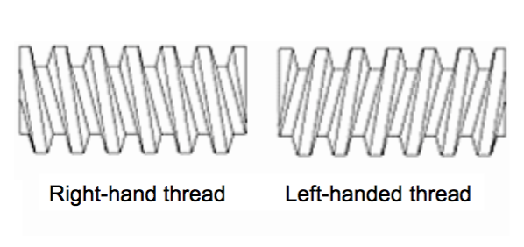
The loading to the screw should be axial co-linear, no lateral

Assembly screw:
How to ensure that the nut(螺帽) is held in place on a bolt(螺栓), i.e. the assembly resists vibrations?

- Use a second nut
- Nut with deformable ring, most of the time made of polymer: Lock nut
- Locker washer (垫锁圈)
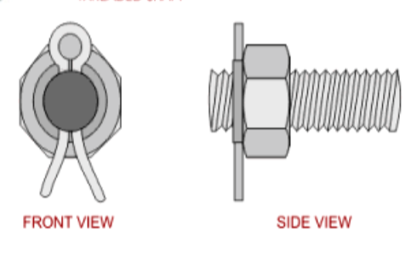
- Cotter pin

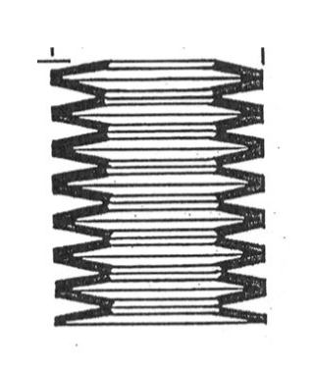
- Belleville(碟形) springs

- Adhesiv(粘合剂)

When a bolted assembly (bolt + nut) is loaded in tension
- Bolt(螺栓) can fail in tension, if engaged length of thread > radius at root(螺栓半径)
- Threads can fail in shear, if radius at root > engaged length of thread
Failure in bolt have maximum load that can be withstood

