Shaft

- Driven shaft: transmits torque from a motor to a machine or component of a machine
- Countershaft: supports components (gears, pulleys, sprockets) and transmits torque between these components.
- Axle(轮轴): stationary or rotating shaft that does not transmit torque; serves only to support/position components.

Mount gears on shafts

Transmit low torques:
1. Press fit 2.Thermal expansion 3.Set screw

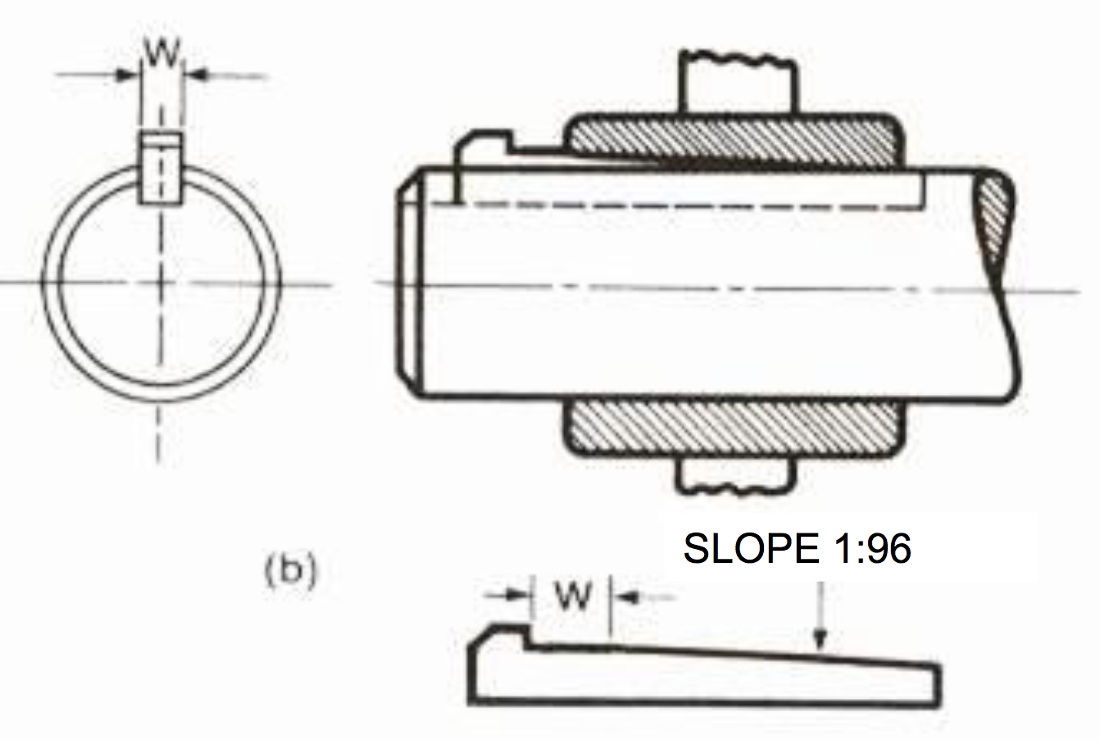
Transmit medium torques:
- Keys – parallel, square or rectangle

- Gib-head(勾头) keys and other tapered keys
- Key is better secured
- Machining of hub is more difficult
- Vibrations at higher ration speed
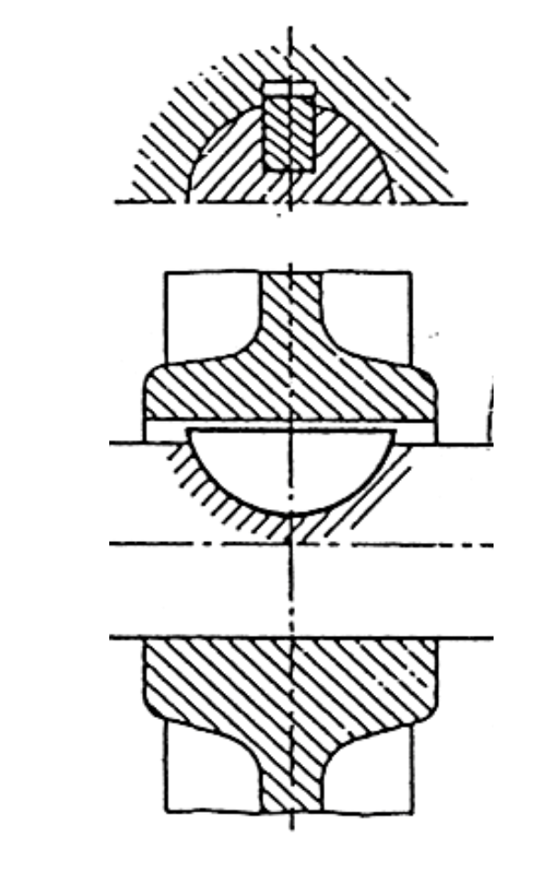
- Woodruff keys(半圆)
- Used for improving concentricity
- Best keys for high rotation speeds

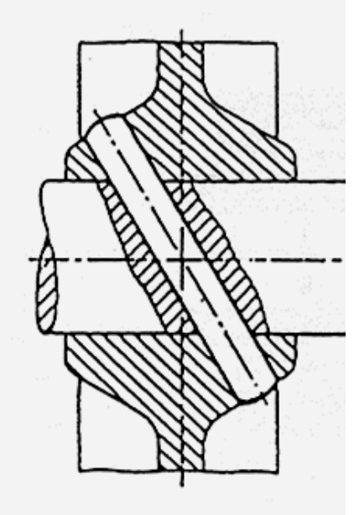
- Cotter pins, shear pins, conical pins

Best way of transmitting power
Splines: Suitable for transmitting high to very high torque, high to very high speeds, and anything below; but more expensive to make.
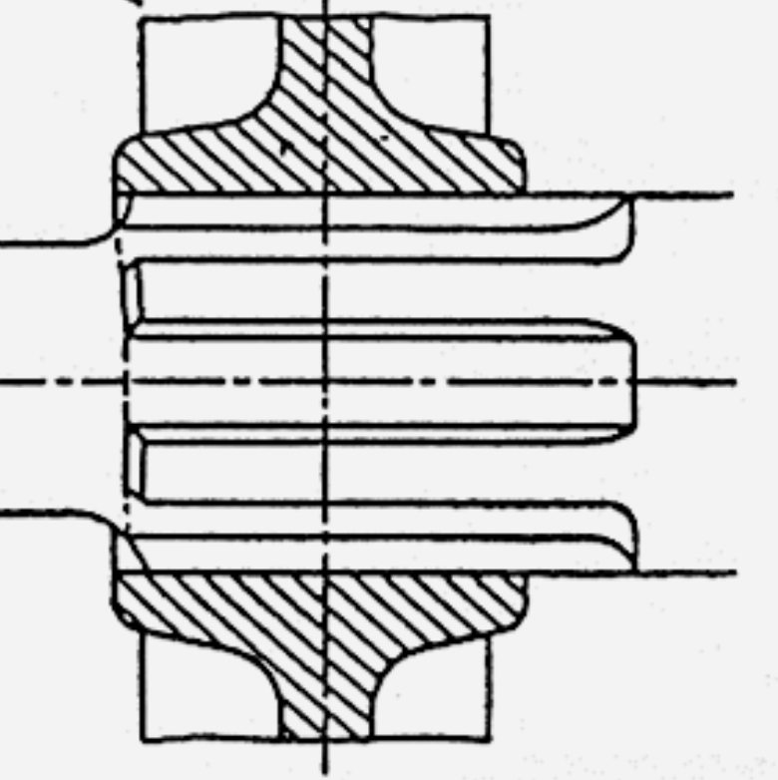
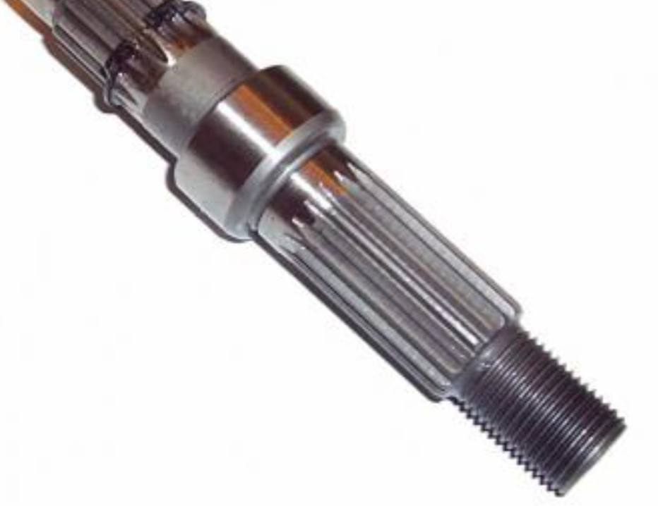

Disassemble gears: Gear extractors

Axially(横向) mount gears on shafts:
- Circlips internal and external
- Nuts also need along with changes in diameter
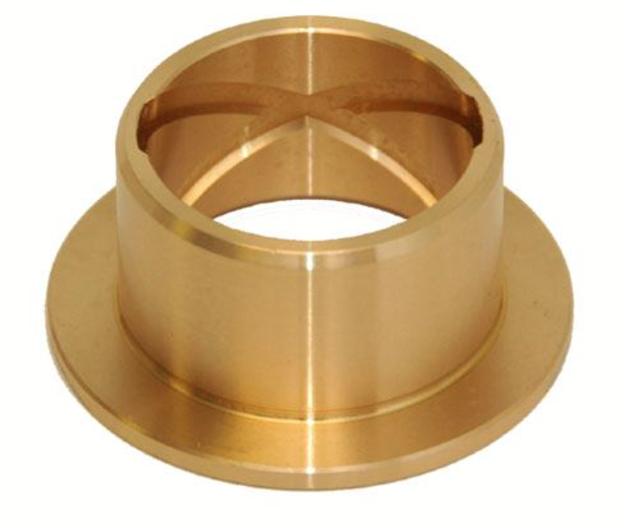
Support shafts:
- Bushings
- No mobile parts
- Used for large load, low speed
- Economical assemblies
- Bearing

Join two shafts – Coupling
- Chain coupling
- Double slider coupling
- Flexible coupling
- Universal joint


