Belt

Belts are flexible machine elements that enable the transmission of power from a driving shaft to a driven shaft that are at a relatively large distance.

- Simpler and more economical than gears
- Belt relative flexibility which can absorb vibrations, impacts
- Fairly good mechanical efficiency, low noise levels
- Fairly low linear speeds: 5 to 33m/s
- Speed ratio cannot exceed 10

Most belts are composite structures:
Rubber = high coefficient of friction
Fibers = high Young’s modulus, can carry high loads (tension)

Shaft alignment and relative positioning are far less critical with belts than they are with gears, especially through the use of belt tensioners.
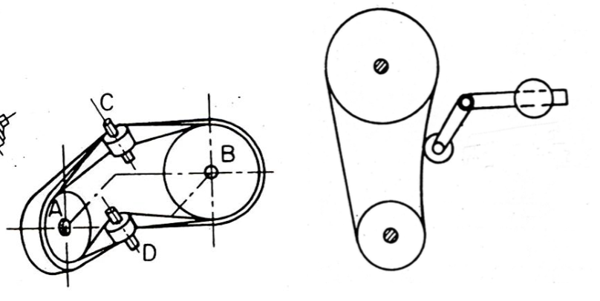
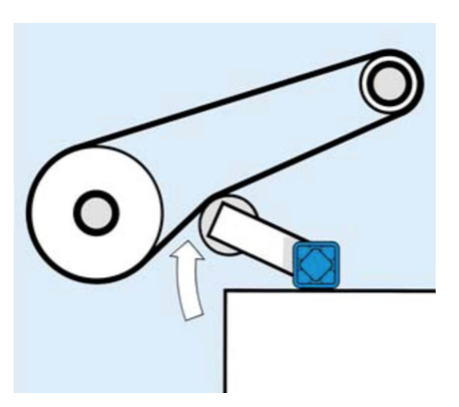

- Flat belt
- V-belts: Very resistant to tension and creep(蠕变), relatively high mechanical efficiency, good durability(耐久性)
Cogged belt(齿形带): easier to bend around small radii
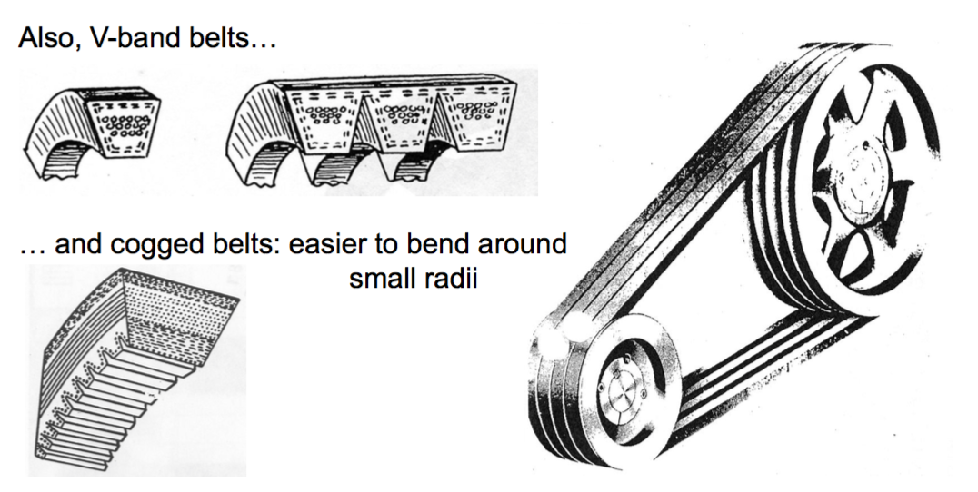
- Ribbed belts
Large contact area (shape of pulley corresponds to shape of belt), efficiency superior to that of V-belts
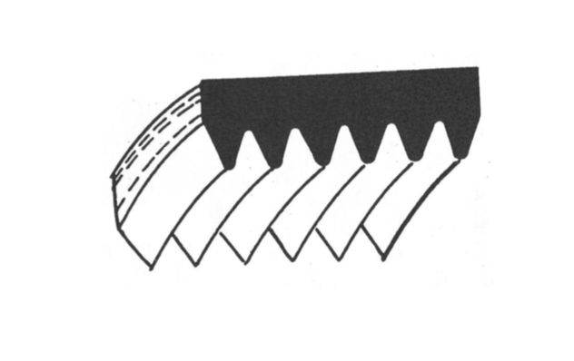

Belt with variable speed ratio
Specifically designed for use with variable(多变的) speed drives (cars, snowmobiles, but mostly many industrial applications) – require very specific pulleys(滑轮) with variable diameter and sometimes-adjustable distance between shafts.

Chain

Chains also are flexible machine components that enable the transmission of power from a driving shaft to a driven shaft, both shafts being relatively far one from another.

Advantages:
- Support more demanding conditions than belts
- Precise overall speed ratio
- High mechanical efficiency
- Long life
- Cheaper than gears

Disadvantages:
- More noisy than belts
- Limited impact/shock absorption
- Higher linear mass
- Lubrication needed, chains will only fulfill(满足) their stated specs if correctly maintained

- Roller chain
- Low noise chain


