Gears

Geared devices can change the speed, torque or direction of mechanical power.

A speed reducer of is an assembled unit featuring one or more stages of speed reduction, a set configuration, casing and lubrication (润滑)
Smallest of 2 meshing gears is the pinion(小齿轮); straight gear is a rack(齿条)

Spur gears(正齿轮)
Spur gears are used for transmitting rotary motion between parallel shafts.
- Teeth are straight
- Teeth are parallel to each other and axis of rotation
- Teeth are machined(加工) on cylindrical surface
- Torque is transmitted between two parallel axes

Characteristic:
- Noise is an issue with spur gear.
- There is a minimum number of teeth needed o the pinion(小齿轮), to avoid undercutting(砍口). There is also practical maximum numbers of teeth on gears.
- Spur gears are economical, but less teeth in contact compare to other types, and more sensible to alignment(校准) issue.

Axes are parallel; either shaft may be used as input and output, rotation speed being reduced in one case and increased in the other
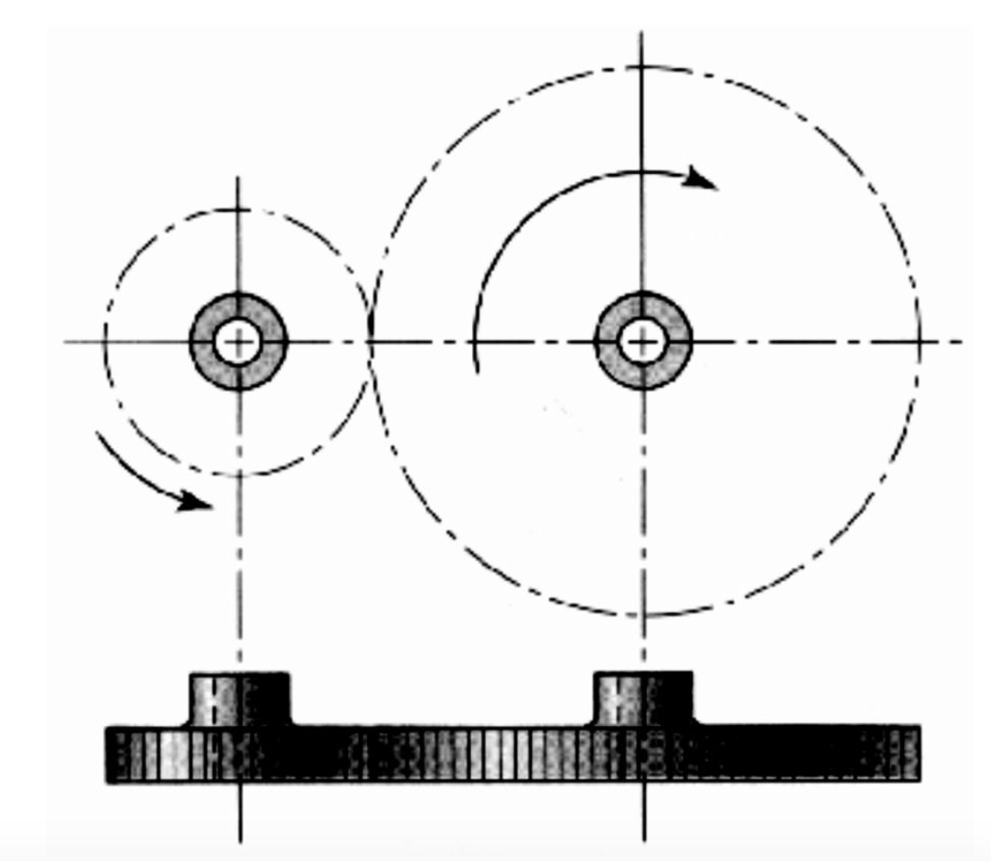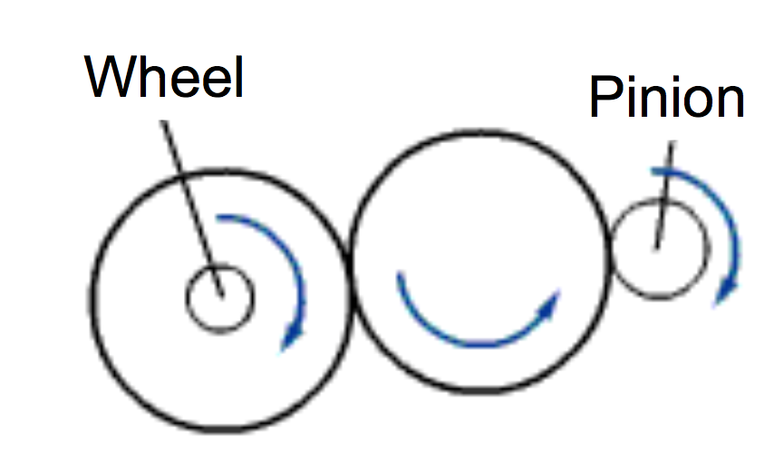
Two meshing(结合) external gears turn in opposite directions.
Configuration:
- External: Pinion
- Internal: only gear/wheel is internal
- Either pinion or wheel may be used as input / output. Turn in same direction.
- Rack(齿条): wheel with infinite radius
- Either pinion or wheel may be used as input / output
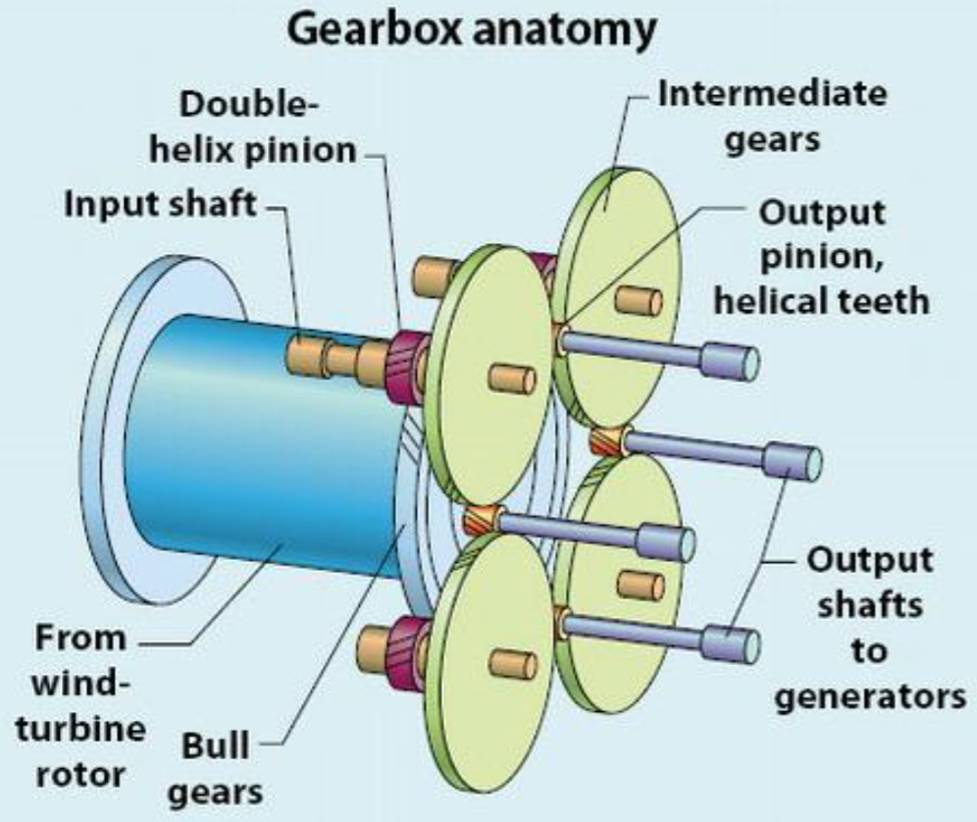
Application: Planetary or epicyclic gear train
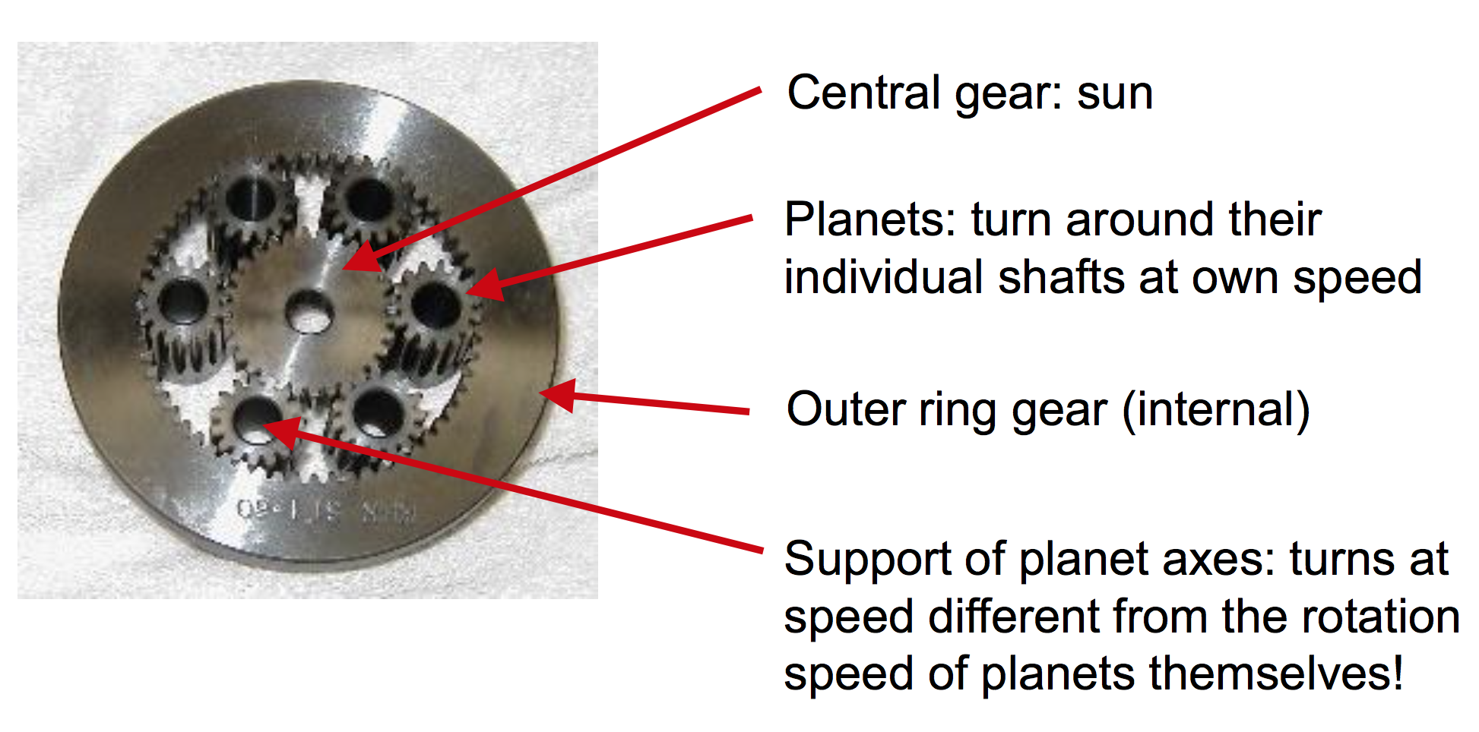
Enables:
- Different speed ratios depending on whether the sun, the planet support or the outer ring is blocked and kept from turning
- Very large sped reduction in a very compact(紧凑的) assembly

Electronic screwdriver:
Low speed & high torque needed from small electric motor
Helical Gears(斜齿轮)

Helical gears are used for transmitting rotary motion between shafts that are no necessarily parallel.
They are cylindrical, and the teeth are cut in a helix pattern, forming an angle with the axis(轴) of ration that is constant for a given gear; hence teeth are locally parallel

- Teeth are helical and locally parallel to each other -
- Teeth are at an angle to the axis of rotation
- Teeth are machined on cylindrical surface
- Torque is transmitted between two axes that are parallel or not

Characteristic:
- Contact between teeth is better, longer, and more progressive.
- Noise is less than spur gears; helical gears can transmit higher torque and higher speeds, with less vibration.
- There are no limits on the number of teeth.
- A clockwise pinion must mesh with a counter clockwise wheel.

You can invert rotation direction by adding an idle(闲置的) gear
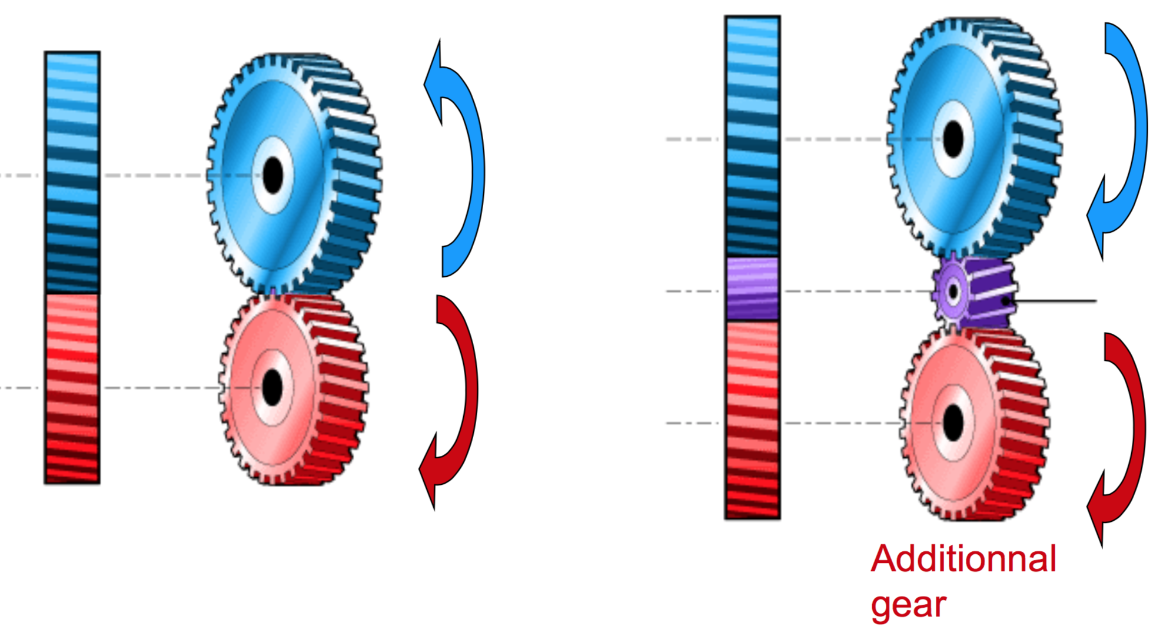

Configurations:
- External: Axes may not be parallel for case of 2 helical gears.
- Internal
- Rack: Either pinion or rack may be used as input

Application:
- Most automotive gearboxes
- Major inconvenience: Large opposite axial forces and bending moment
- Planetary or epicyclic gear train

Variation(变种): Herringbone(鱼骨型) or double helical gear
  - V teeth eliminate(消除) lateral(侧向) forces;
  - Very stable at high speeds
  - Mostly used for transmitting sizeable(相当大的) mechanical power
  - Very costly.
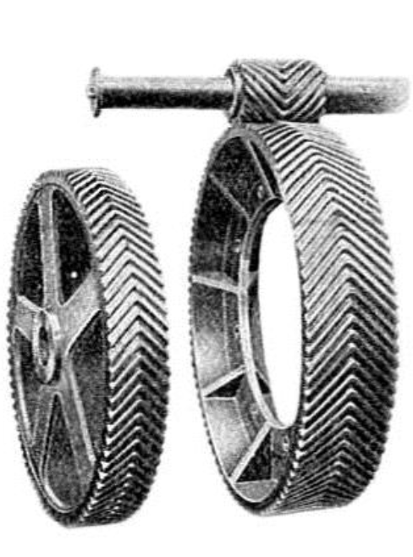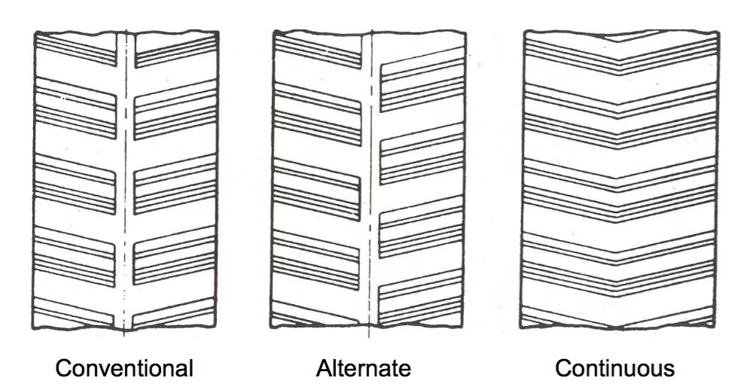

Bevel (conical) gears(扇形齿轮)
- Bevel gears are used for transmitting rotary motion between shafts that intersect(交叉), often at 90° but not always.
- Angles other than 90° are generally reserved for straight teeth; helical teeth offer a better contact, with associated advantages.
- They are conical(圆锥型) and teeth may be straight or helical / spiral.
- In the 1st case the profile lines project onto the rotation axis; in the 2nd case they wind towards it.

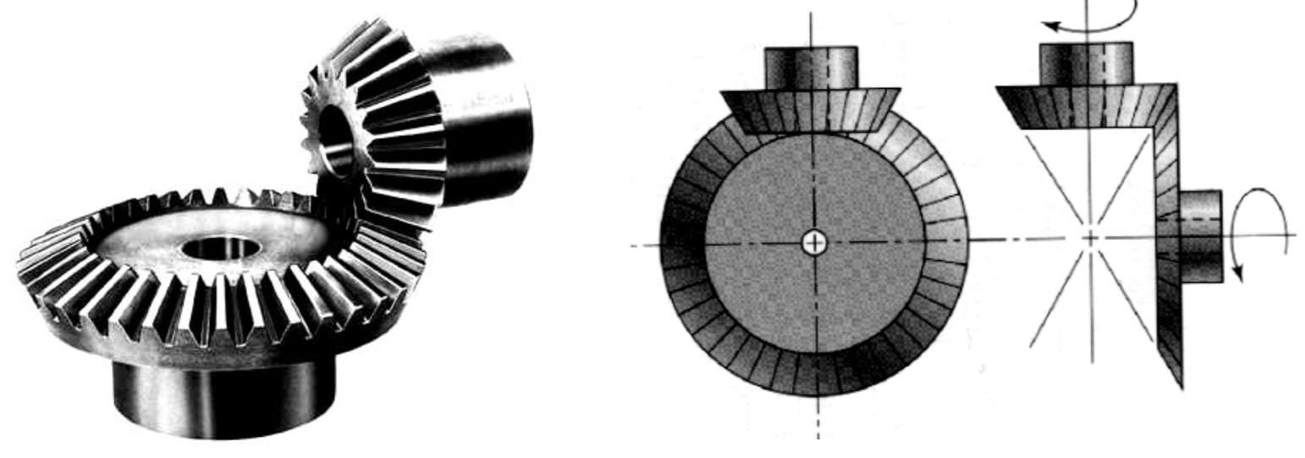

- Forces generated by meshing must be equilibrated through reducer /gearbox design.

Variation: Hypoid gear(双曲面齿轮)
- Used for non-parallel axes that do not intersect.
- Major advantage: no need to cut the shafts! Found in differentials of RWD cars and others.
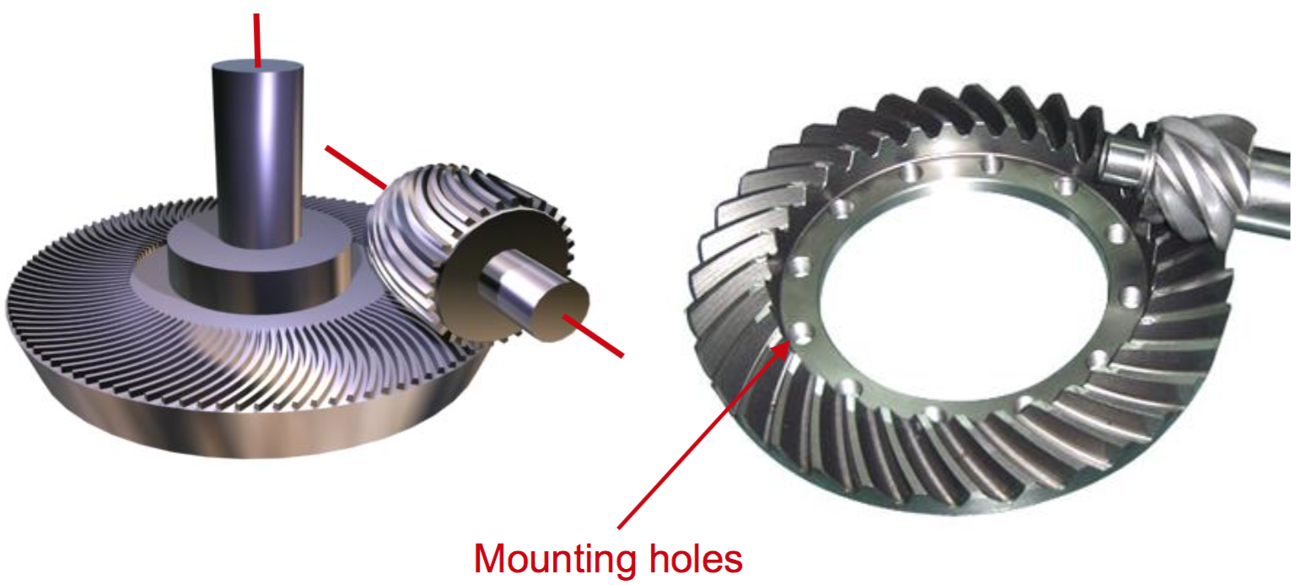

Worm gears(蜗轮)
- Worm gears are used for transmitting rotary motion between shafts that are perpendicular and do not intersect.
- Their main operational characteristic is that they enable very large speed ratios between the screw and helical gear.
- Normally the screw drives the wheel (speed reduction).
- Transmitting power from the wheel to the screw (increase in speed)
- Direction of rotation depends on the way the screw is machined: clockwise or counter clockwise.
- Forces generated by meshing must be equilibrated through reducer /gearbox design.


