Brakes
The role of brakes is most often to slow down a rotational motion
The primary function of a brake is to absorb energy
- Reduction of a relative motion through friction force
- Energy: 1) absorbed, 2) transformed into heat, and 3) evacuated to atmosphere
- Friction coefficient of materials in contact is important

Clutches(离合器)
The primary function of a clutches is to transmit energy
- Reduction of relative motion
- Engagement(接触) of clutch = two inertias(惯性) put in physical contact
- Before engagement, inertias have 2 different angular speeds ω1 & ω2
- Once the clutch is engaged, inertias reach the same angular speed ω after a certain time.
Hence, a certain amount of energy is dissipated during engagement, resulting in an increase in temperature.
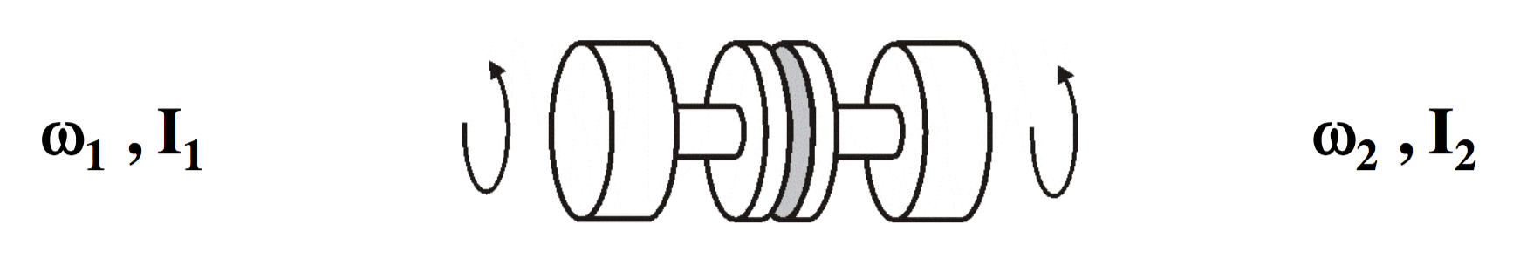

When designing a brake objectives:
1) Absorb a maximum amount of ‘mechanical’ energy into the brake
2) Dissipate this as thermal energy out of the brake and into the atmosphere, efficiently.
When designing a clutches objectives:
1) Transfer mechanical energy efficiently through the clutch
2) Lose a minimum of energy as heat into the atmosphere.

Radial brakes & clutch
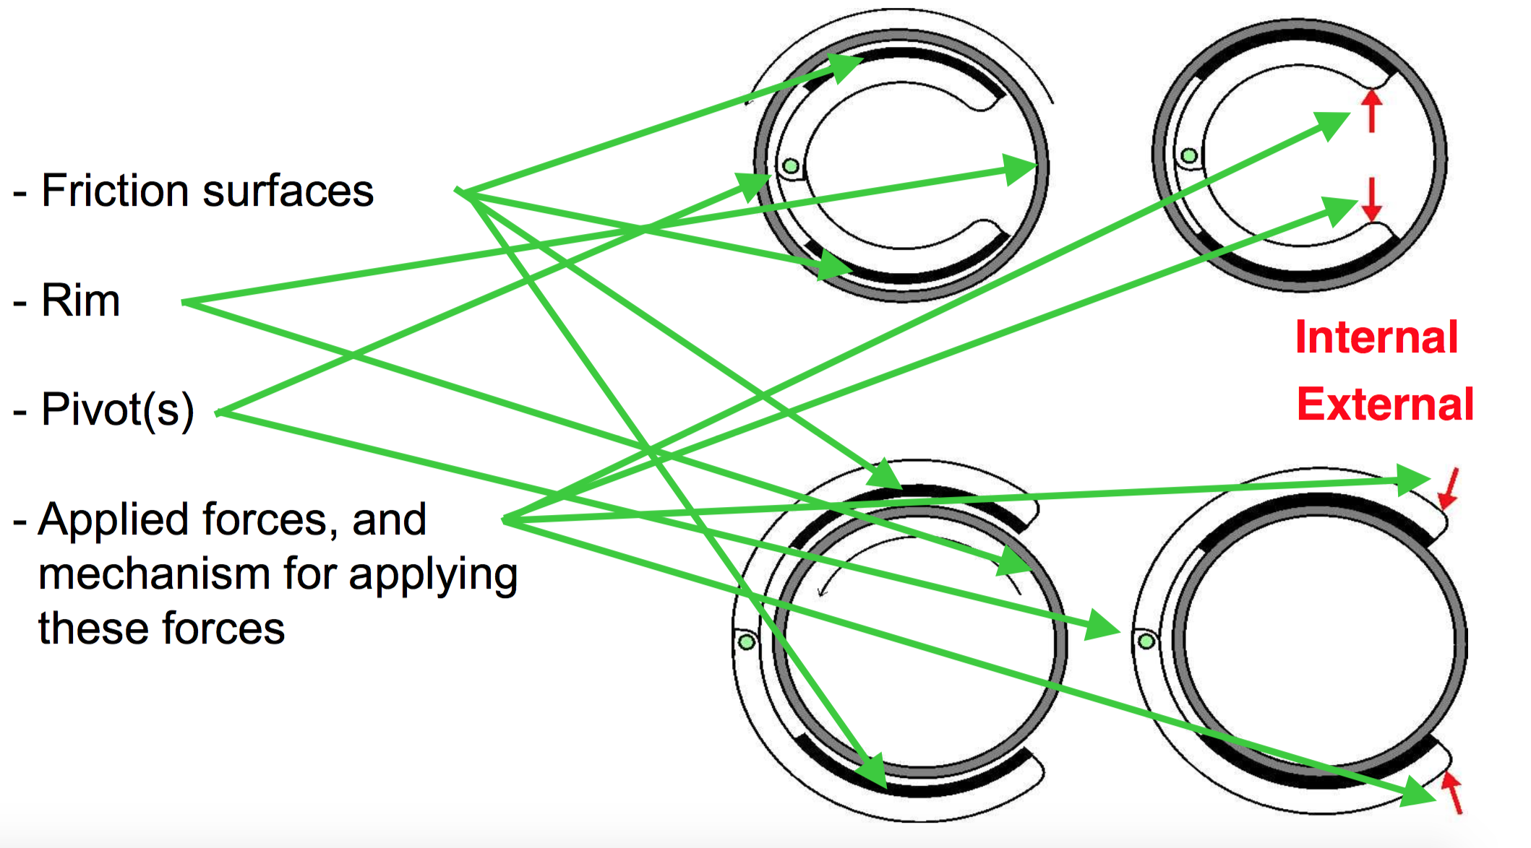

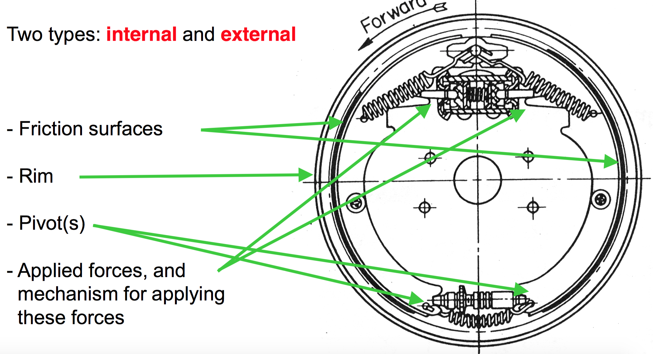
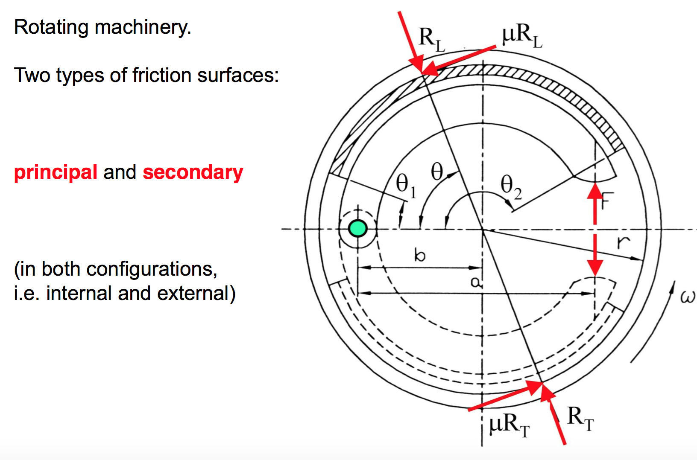

- For the upper arm, friction generates a counter clockwise moment around the pivot: the friction moment pushes the friction surface TOWARDS the rim
- For the lower arm, friction also generates a counter clockwise moment around the pivot: the friction moment pushes the friction surface AWAY from the rim.
Band brakes(带式刹车)
- One end of band is fixed, and some level of tension is applied at the other end; tension is always applied along rim’s rotation direction.
- Tension at the band’s static end (T1) is always greater than applied tension (T2) as a result of forces equilibrium. Tension is transmitted along the band; friction forces on the band progressively add to it.
- Friction forces applied by the rim on the band follow direction of rim rotation, and vice-versa.
- Pressure on the rim varies from one point to the next, but it is everywhere proportional to level of applied tension.
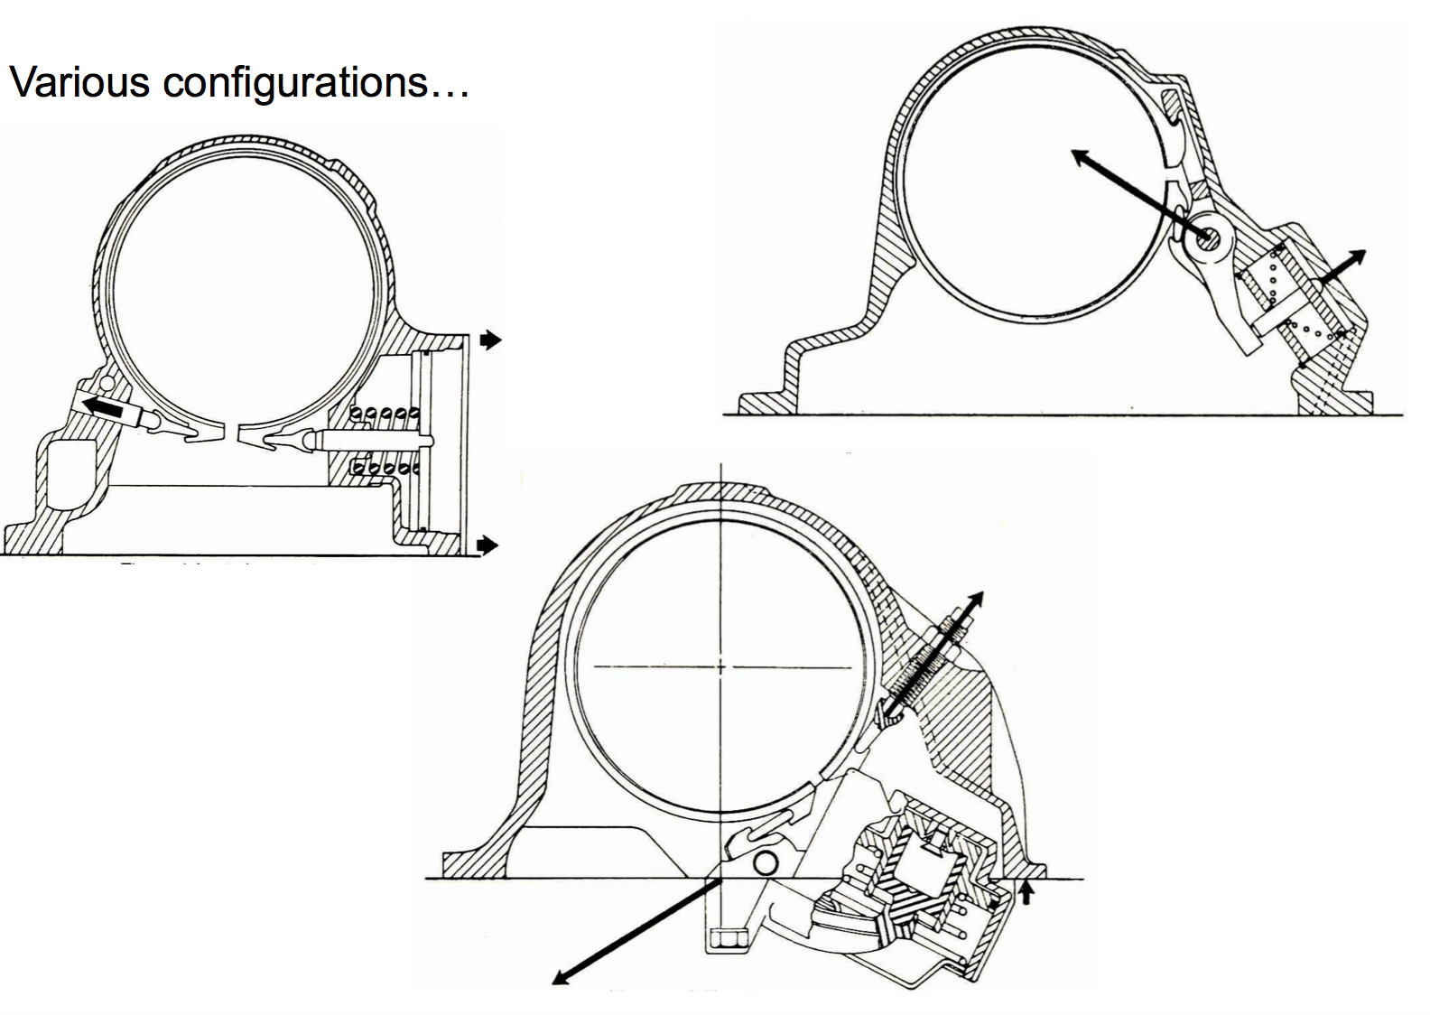
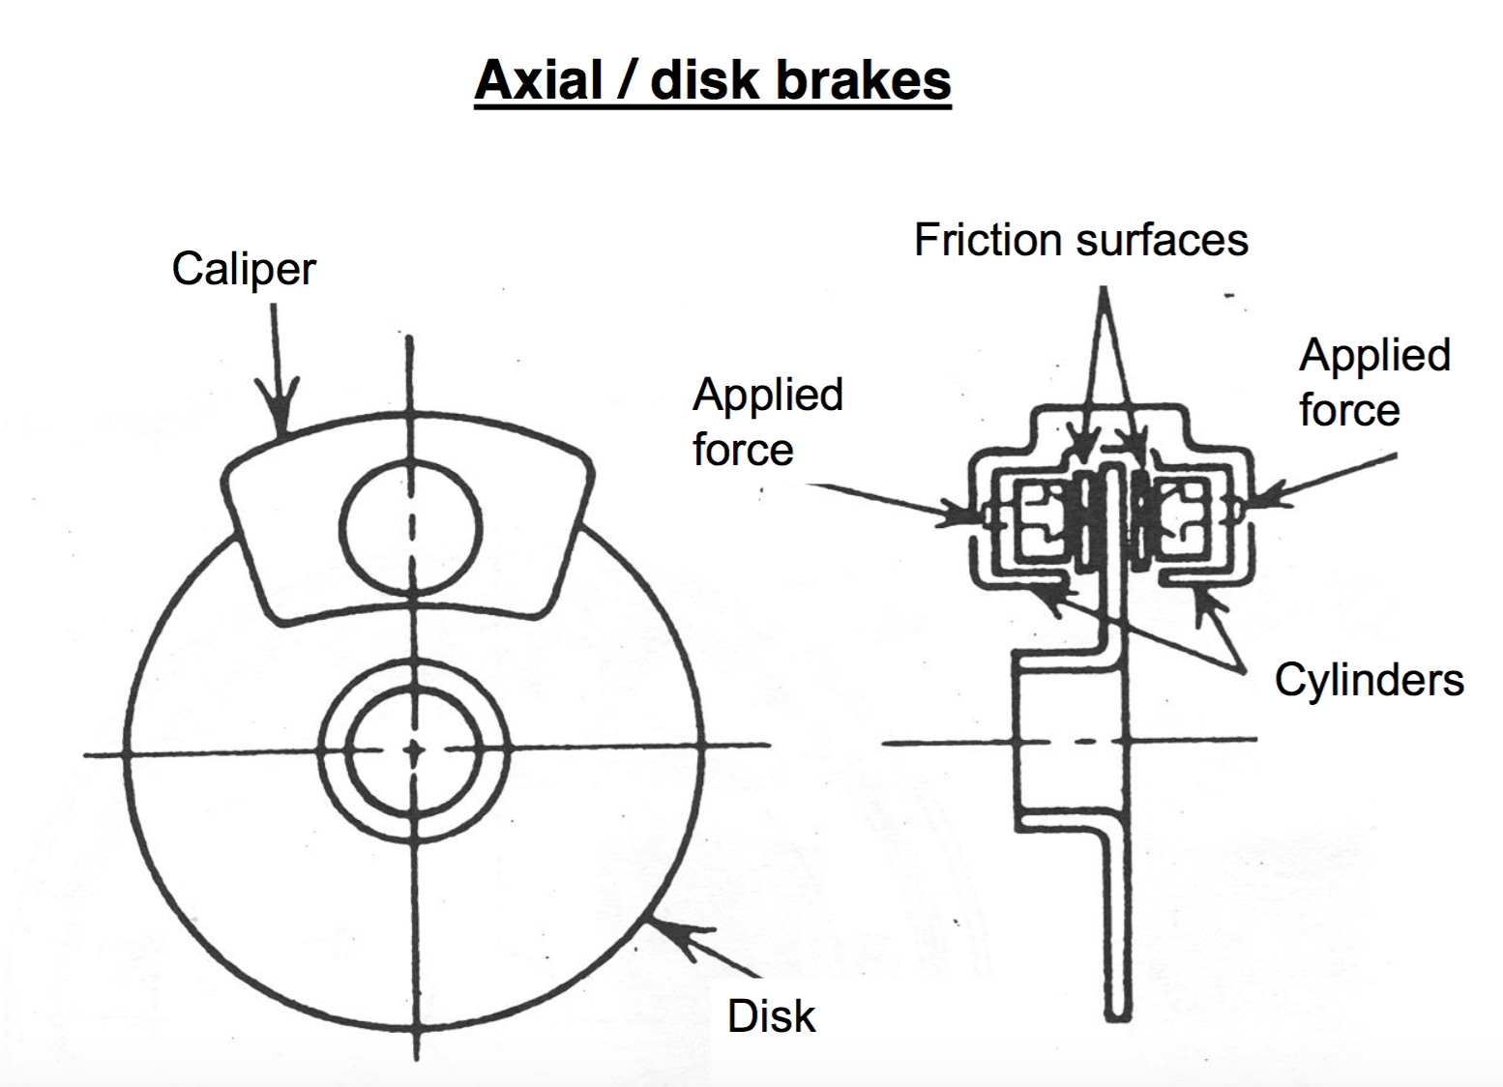
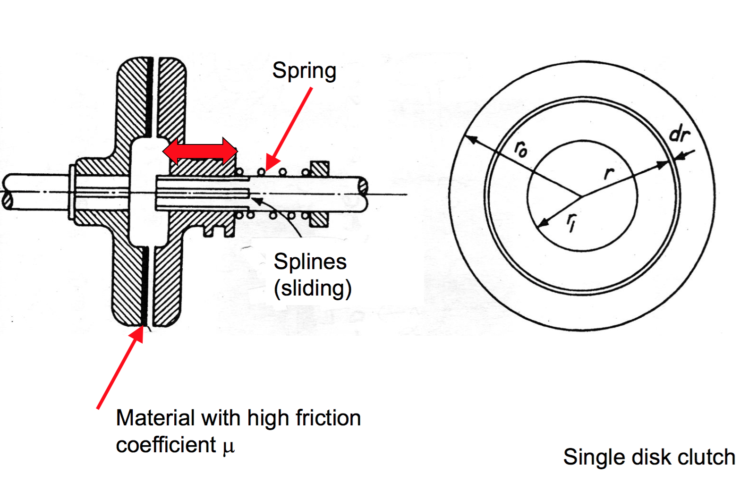
Axial / disk brakes & clutches

Conical(圆锥) brakes & clutches
Advantage: greater contact surface for same inside & outside diameters

Disadvantage: difficult to make, engagement much more sudden, much more sensitive to any alignment or manufacturing defects.

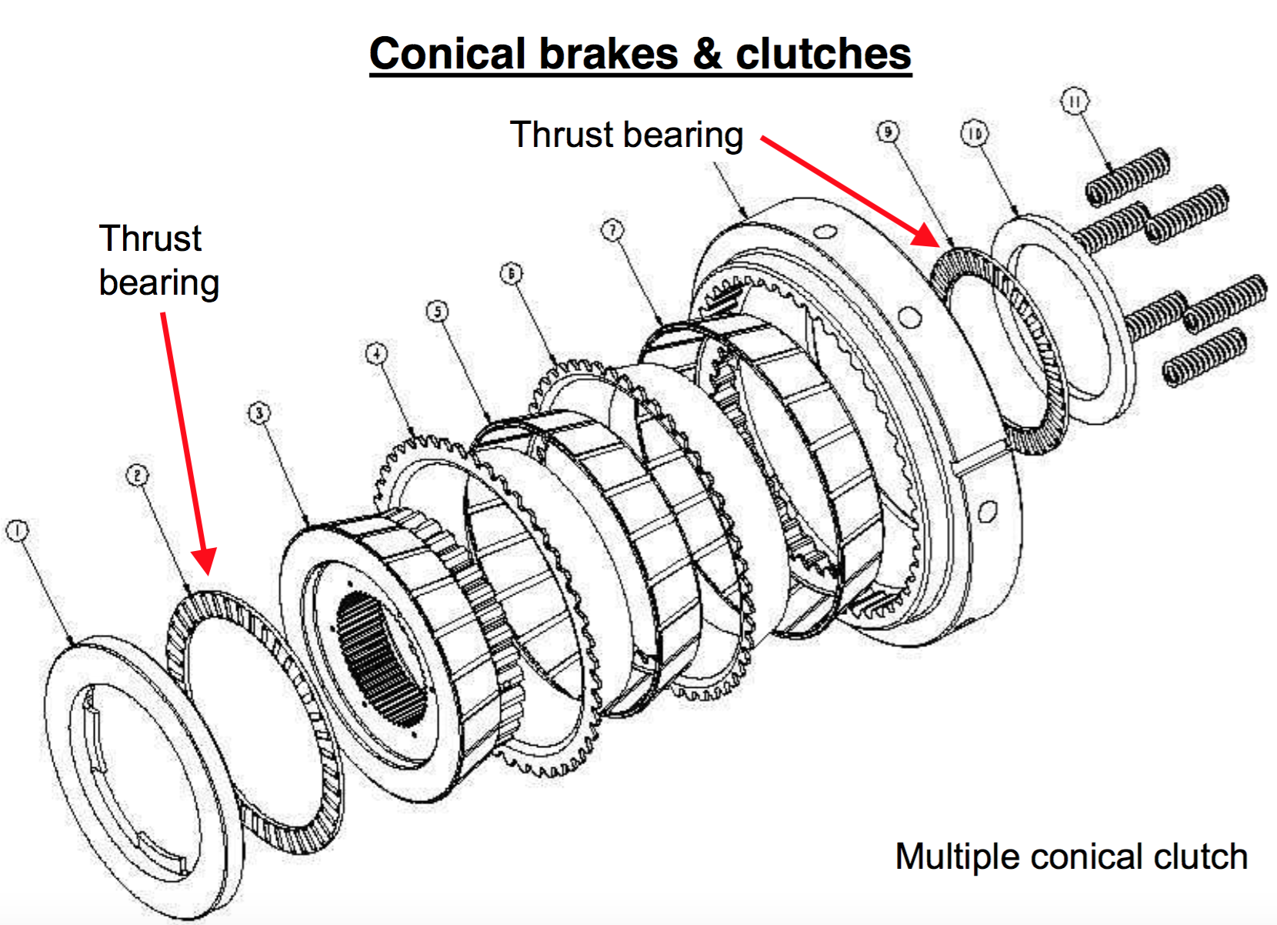

Brakes & clutches: materials
Managing temperature is the most critical aspect(方面), especially over repeated cycles.

Friction surfaces are the most critical component of a brake / clutch; material selection for the friction surfaces is critical.
- High and uniform coefficient of friction
- Stable properties that are independent of heat and humidity(湿气)
- Very good thermal conductivity
- Capability to support high pressures
- Capability to resist wear(磨损)

Dry regime: aramid fibers + phenolic resin + metal particles + + binder
Wet regime (oil): lower friction but pressures can be higher, because of far superior heat transfer.

