Bearing

Bearings are built so as to support different loadings cases:
- Radial loads (竖向负载)
- Axial loads (轴向负载)
- Both radial and axial load
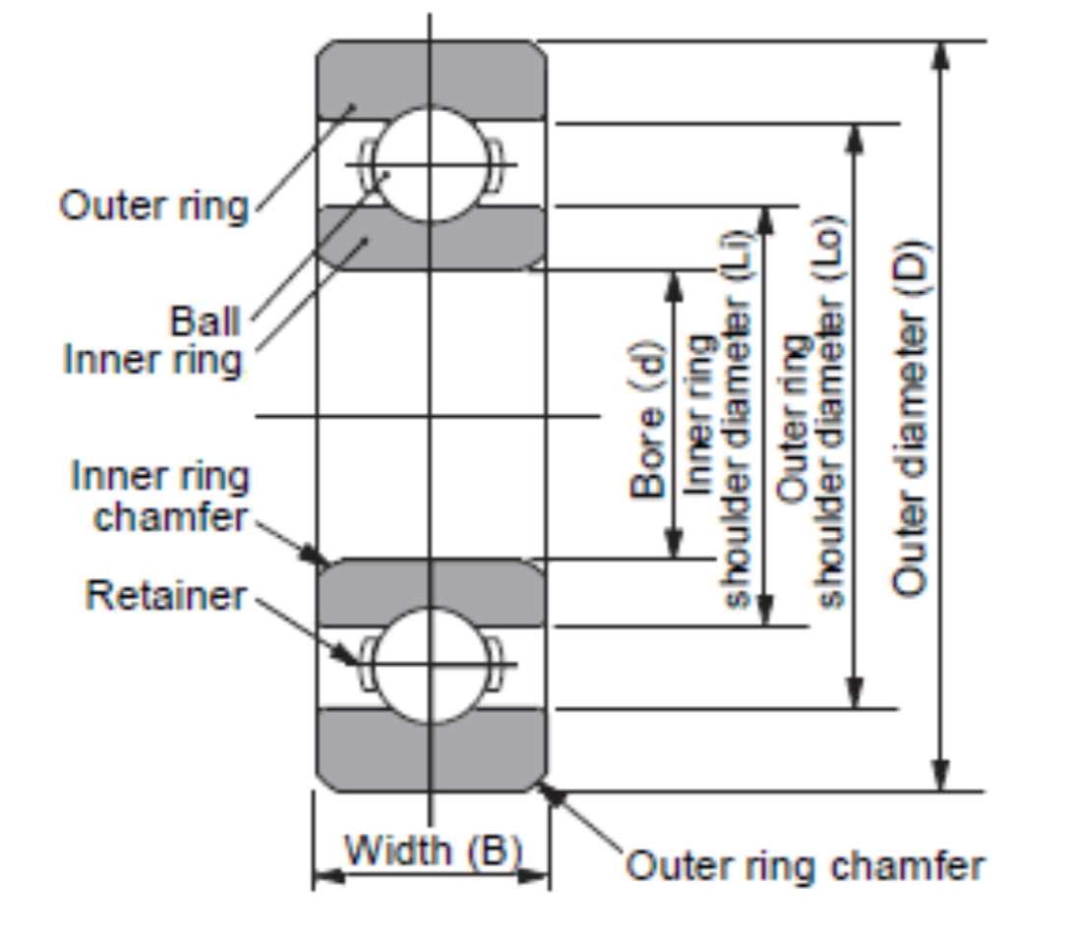

Ball bearings: Used for low & medium loads
Roller bearings: Used for high loads, large diameter shafts and reducing bearing volume

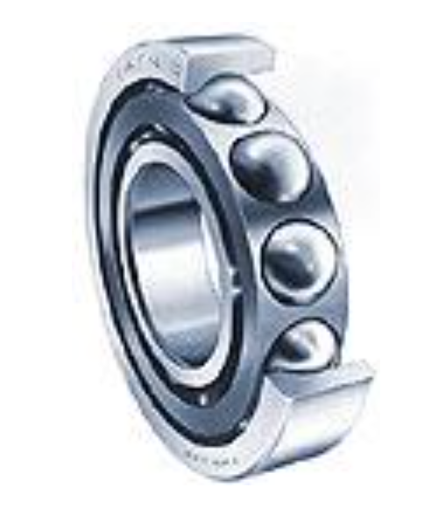
Ball Bearing

- Single row deep groove(凹槽) ball bearing
- Groove depth and conformity to ball diameter enables carrying of some axial loading in both axial directions.
- But not for very large amplitude along with the radial loads
- Double row ball bearing
- Much higher loads can be supported, for a relatively low increase in length
- Better packaging, but whole bearing to replace if fails
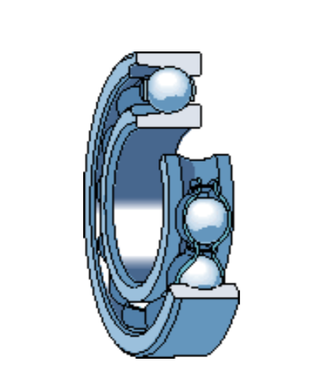
- single row Slot-fill(夹槽) ball bearing
Can support large radial loads, but cannot support axial loads a all

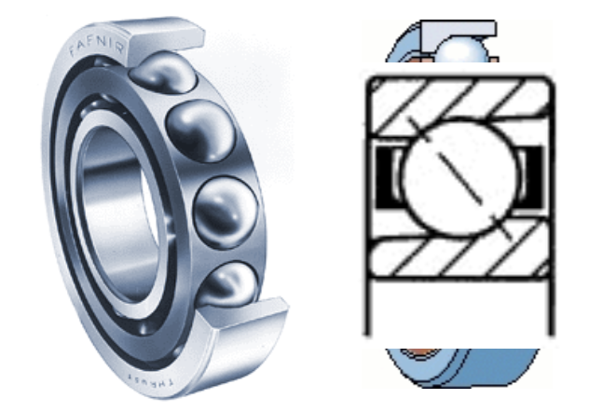
- Angular contact ball bearing
- Can support both radial and axial loads.
- Some cases axial loading may be two times the radial load

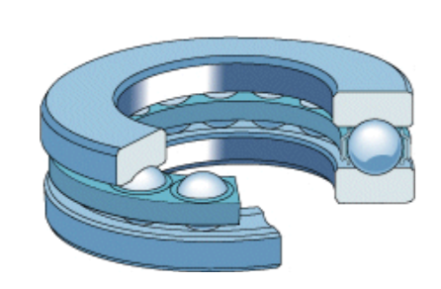
- Thrust(推力) ball bearing
- Can support large axial loads, but support no radial loads

- Self-aligning ball bearings
The rotation axis of the assembly made of the inner ring, balls and retainer can itself rotate relatively to the rotation axis of the outer ring; lending alignment freedom to rotation axis.

Roller bearing

- Single row cylindrical roller bearings
- Double and multiple row cylindrical roller bearings
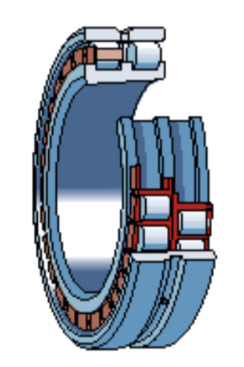
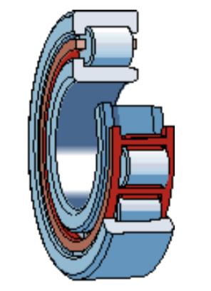

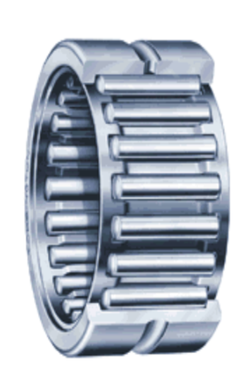
- Needle bearings

- Conical(圆锥) roller bearing
- Capable of carrying combined load if rollers are inclined
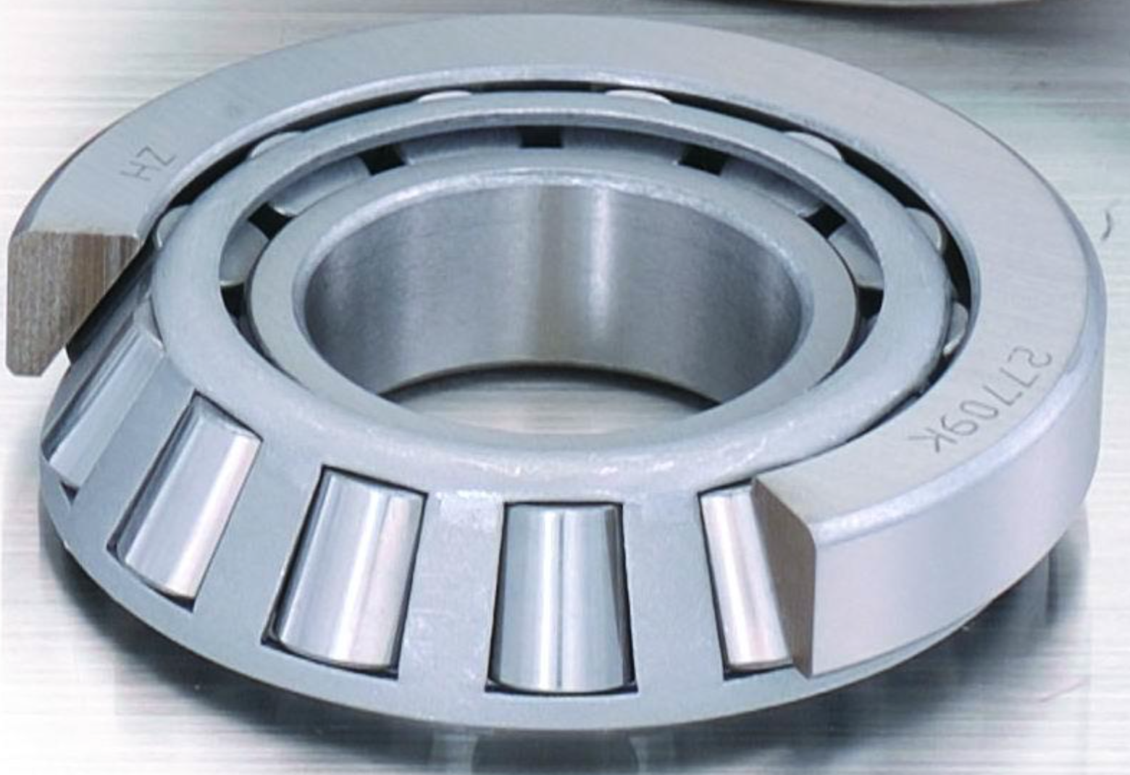

- Spherical(球面) roller bearings
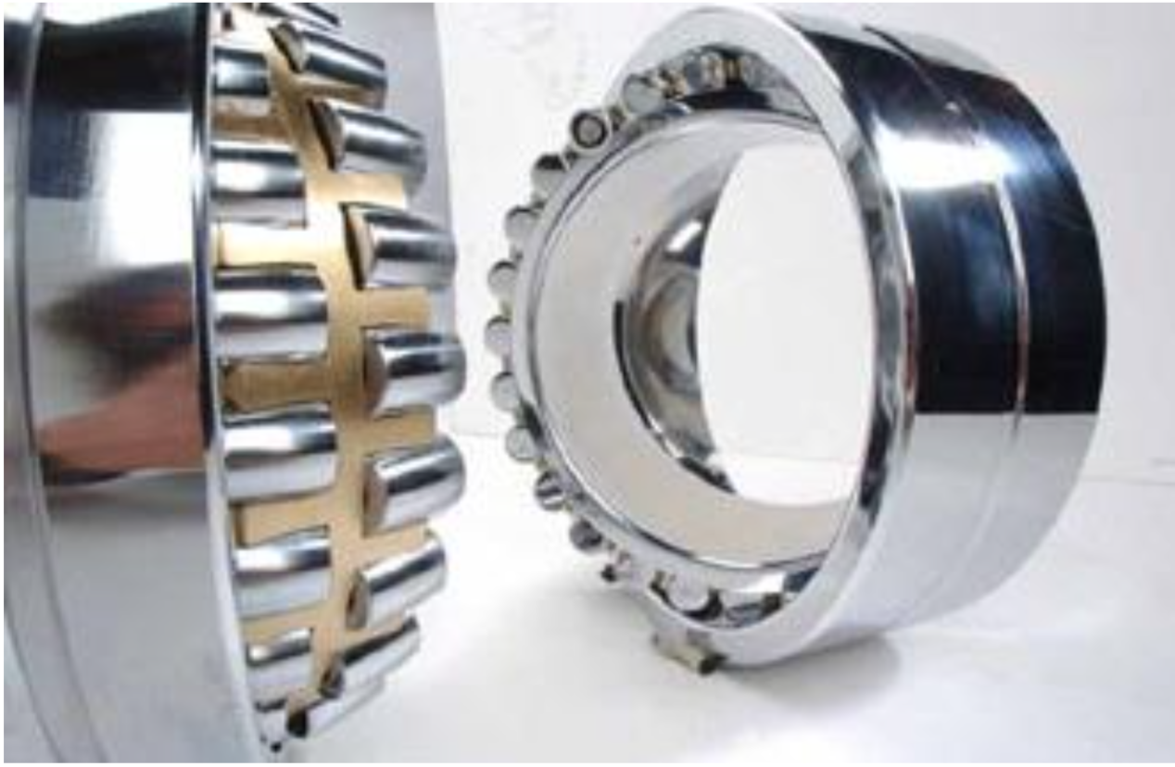

- Conical bearing with spherical rollers
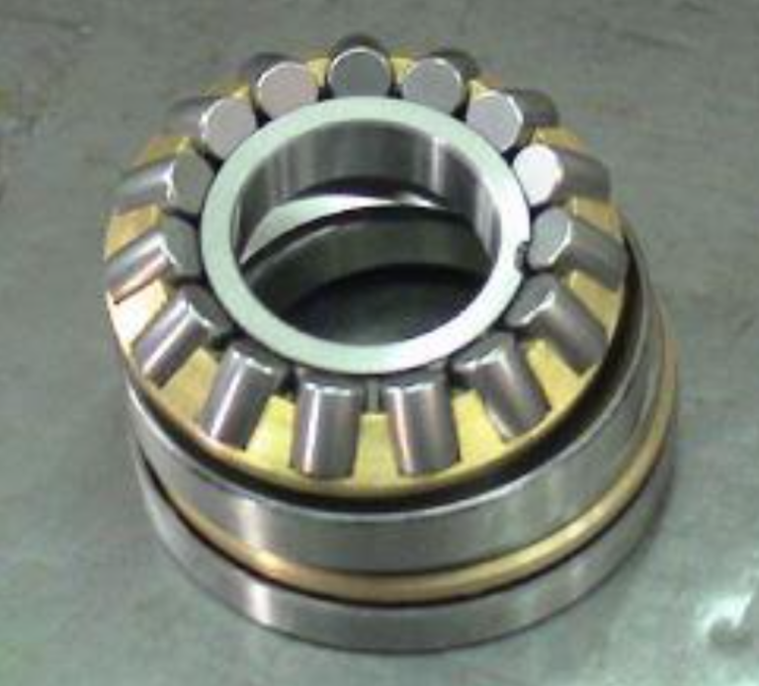
- Rod ends: Enables use of bearings in linkages

