Intermediate Microeconomics
Assignment 1
Chapter 2
Problem 9

To find the elasticity of demand we use the formula
E^{d} = (Q/P)(P/Q).
Given E^{d} = -50,000 x 2/50,000 = -2, the elasticity of demand at last year’s price is -2.

We can use the elasticity of demand to derive the linear demand curve
Q^{d}= A - BP
E^{d} = (Q/P)(P/Q) = (-B)(P/Q).

We can solve for A by using known values.
50,000 = A - 50,000 x 2
A = 150,000
Q^{d} = 150,000 - 50,000P

Total expenditure on jelly beans would have been largest when price elasticity of demand was equal to -1.
-1 = -50,000P/(150,000-(50,000P))
P = $1.50.
Total expenditure on jelly beans was largest at a price of $1.50.

Problem 12
Q^{d} = 430 - 10 P_{A} + 10 P_{C} - 10 P_{G}
Q^{d} = 430 - (10 x 20,000) + (10 x 20,000) - (10 x 3.00) = 400
Using this we can determine the Cross-price elasticity of demand for Honda Accords in comparison to the price of a Toyota.
E_{pc} = (∆Q/∆P) x (P/Q)
E_{pc} = 10 x (20,000/400)
E_{pc} = 500.00
We can also use Q^{d} to determine the cross-price elasticity of demand for Honda Accords in comparison to the price of gasoline.
E_{pg} = (∆Q/∆P) x (P/Q)
E_{pg} = -10 x (3/400)
E_{pg} = -0.075
The elasticity of demand for the Accord with respect to the price of a camry when both cars cost $20,000 and gas is $3/gallon is 500. The elasticity of demand with respect to the price of gas is -0.075.

Problem 13
In order to determine the values of A and B we first need to derive the linear demand curve. To do this, we first solve for -B using the values given for P and Q.
E^{d} = (∆Q/∆P) x (P/Q)
-1 = (∆Q/∆P) x (1.00/60)
-B = (∆Q/∆P), B = 60
Now we can solve for A using our value for B, Q^{d} and P.
Q^{d} = A - BP
60 = A- (60 x 1.00)
A = 120
Q^{d} = 120 - 60P
The values of A and B determined using the linear demand curve are 120 and 60 respectively.

Chapter 3
Problem 3
The most cost effective amount of time to hire your mechanic for would be the amount of hours where MC = MB because that would result in the greatest net benefit.
The greatest benefit will be achieved when 654H - 80H = 110H + 240H
574H = 350H
H = 1.7

Hours | Total Benefit  654H - 40H² | Total Cost  110H + 120H² | Net Benefit  Benefit - Cost
0 | 0 | 0 | 0
1.7 | 966.2 | 533.8 | 462.4
6 | 2484 | 4980 | -2496

The best choice would be the hire the mechanic for 1.7 hours because it results in the greatest net benefit.

Problem 5
The most cost effective amount of time to hire your mechanic for would be the amount of hours where MC = MB because that would result in the greatest net benefit. 200/H = 100
H = 4
Hours | Total Benefit  400H | Total Cost  100H | Net Benefit  Benefit - Cost
0 | 0 | 0 | 0
4 | 800 | 400 | 400
6 | 979.8 | 600 | 379.8

The best choice would be the hire the mechanic for 4 hours because it results in the greatest net benefit.

Problem 8
Your best choice in this case would be to foregoing the use of a mechanic in general because it costs you $0 whereas any use of the mechanic results in costing you money since the greatest benefit is less than the cost of parts. Regardless of the amount of hours the mechanic works the charge for parts is constant. That being said, 3.4 hours would still be the greatest net benefit without parts. With the cost of parts, your net benefit becomes $-575.20 meaning that the best choice in this scenario would be to have the mechanic work 0 hours. Using a mechanic will at the very most have a net benefit of -$575.20

Chapter 4
Problem 1
- John would choose to read two books and no movies because his marginal utility for reading books is always greater than his marginal utility for watching movies.
- His family of indifferences curves would be equal to Movies = Utility - 3 Books. This curve would be an upward sloping line that increases with the amount of books read.
- For John, movies and books are perfect substitutes because he is willing to substitute 3 movies with one book.
Problem 2
- Since Mia is a vegetarian, her indifference curve would be a straight horizontal line since she would never eat meat assuming that meat was on the x axis and bread was on the y axis.
- Because Taka is only concerned with calories and meat is much denser in calories than bread his indifference curve would be sloping downward as the quantity of meat increased assuming that meat was on the x axis and bread was on the y axis.
Problem 12
- Kate would be willing to give up 4 M&M’s in exchange for Antonio’s one Milk Dud. Antonio would need to be reimbursed with a minimum of 3 M&M’s in order to return to his original utility value. This trade would increase Antonio’s utility.
- The point at which there is no more opportunity for mutual gain will be the exchange of 4 M&M’s for a milk dud, the value of Kate’s utility, and Kate will have 0 M&M’s and 6 Milk Duds. At this point, Antonio will have 24 M&M’s and 6 Milk Duds.

Chapter 5
Problem 1
- If the price of bread is $.50 per pound and the price of butter is $0.25 per ounce and Channing spends all her income on 12 lbs of bread and 7 oz of butter her income is $7.75;
Income = P_{bread}X + P_{butter}Y
Income = ($0.50 x 12 lbs) + ($0.25 x 7 oz)
Income = $7.75
- If Rupert has an income of $15.00 which he uses to buy 6 pounds of bread at $0.75 and butter at $0.20 per ounce then he is buying 52.5 oz of butter.
Income = P_{bread}X + P_{butter}Y
$15.00 = ($0.75 x 6) + ($0.20 x Y)
4.5 = ($0.20 x Y)
Y = 52.5
- If Aaron’s income is $40 and he is buying 45 lbs of bread at $0.60/lbs and 26 oz of butter then butter costs $0.50 an ounce.
Income = P_{bread}X + P_{butter}Y
$40.00 = ($0.60 x 45) + P_{butter} 26
13$ = P_{butter}26
P_{butter} = $0.50

Problem 6
The price of a concert ticket is 8$ because she buys twice as many film tickets as she does film tickets which are 4$. Natasha’s utility function shows that the marginal utility for film ticket is the same as concert tickets.

Chapter 6
Problem 1
- Sam’s compensating variation for the proposed policy is $-1200.00 1.
- We can calculate this without knowing Sam’s preferences because all prices increase proportionally. A compensating variation is the amount of money needed to reach initial utility after a change in price. If all costs were to rise by 8% and Sam’s income also rises by 8% then his budget would not change and his optimal choices would not change since they are dependent on his budget. Therefore, if all prices rise by 8% and Sam’s income also rises;
30,000 x 0.08 = $2,400
Sam is compensated for the exact amount of the change in price. When Sam’s income is raised by 12%, $3,600, he benefits $1,200 because $3,600 - $2,400 = $1,200 because prices were raised by 8% and his income raised by 12%. Raising Sam’s income and prices is equivalent to paying Sam $1,200 therefore, his compensation value is $1,200.

Problem 4
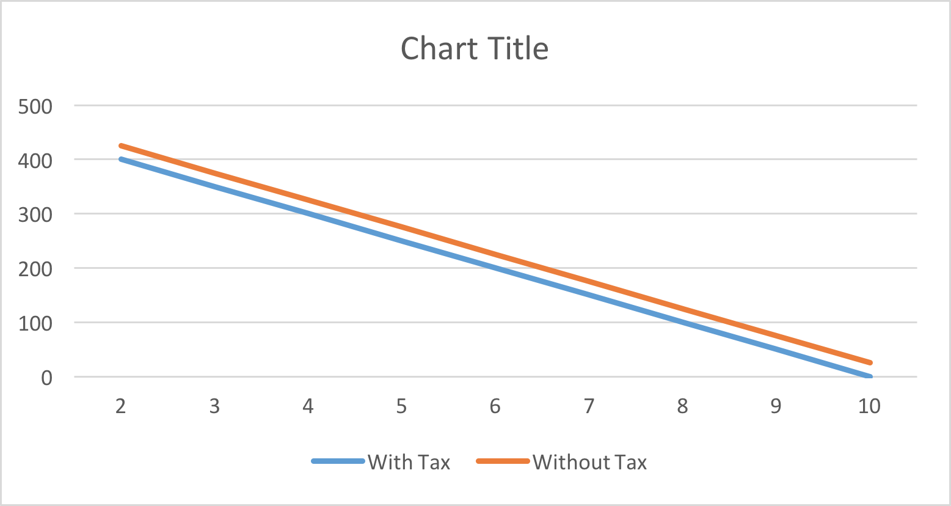
Beatriz’s Consumer Habits
- Beatriz’s change in consumer surplus is 25.
- The amount of revenue the government would raise by taxing Beatriz would be equal to the amount Beatriz would lose. Yes, the government would have enough to compensate Beatriz for her loss.

