Laboratory Class 5: Nucleic Acids

Laboratory of Introduction to Biochemistry
BCH2333
Section: 02
Team: 01
Demonstrator: Curtis Walton

July 24th, 2017

University of Ottawa

Purpose: The purpose of this lab was to develop knowledge on nucleic acids in a lab setting. For the first part of the experiment we were to extract DNA from calf liver. The second experiment was done in order to analyze the effect of salt on calf DNA structure using various solutions. The last 2 parts of the lab was don in order to allow students to develop techniques on plasmid mapping that is done using DNA electrophoresis on agarose.

R1.
Absorbance values:
$$A_{260}=0.656$$
$$A_{280}=0.415$$
$$A_{234}=0.543$$

$$\frac{A_{260}}{A_{280}}=\frac{0.656}{0.415}$$
$\frac{A_{260}}{A_{280}}=$ 1.58

$$\frac{A_{234}}{A_{260}}=\frac{0.543}{0.656}$$
$\frac{A_{234}}{A_{260}}=$0.83

The purpose of performing UV spectrophotometry is to see how pure a DNA sample truly is. The maximum UV absorption is shown at a wavelength of 260 nm and minimum UV absorption is shown at a wavelength of 234 nm. Absorbance at 280 can be used to measure DNA since there is usually a histone protein wrapped around the DNA strands. The pure DNA ratio is modeled by the ratio Absorption at 260 nm/Absorption at 280 nm. Most pure double stranded DNA would result in a ration between 1.8 and 1.9. If there is a ratio higher than 1.9 that would be an indication of RNA contamination. To check the purity of protein a ratio of Absorption at 234nm/Absorption at 260 nm should result in a number lower than 0.5.

R2.
Table 1. DNA melting results
In this experiment 500 mg of calf live tissue was used which was homogenized in 4mL of cold standard saline EDTA (0.15 M NaCl in 0.1 M ethylene-diamine tetra-acetate – EDTA, pH 8.0 with 100μg/mL RNAseA). 375 micrometers of 25% SDS was extracted using a pipette and added to the mixture which was mixed via inversion. The mixture was than incubated in 60 degrees Celsius for 10 minutes. 0.725 mL of 6.0 M NaClO4 was also added. In the fume hood 5 mL of chloroform was added to the solution. The waver was used to gently mix the solution and centrifuged at 12000 xg for 5 minutes each. 70% of the upper aqueous phase was carefully removed via a pipette & the remaining chloroform waste was discarded.10 mL of ethanol was added to form the top layer of the 70% extracted solution that was mixed to form a solution using a centrifuge. The decant supernatant was formed by adding 2mL of 70% EtOH and centrifuged at 3000g/min. The ETOH was extracted via a pipette and the remaining pellet was left to air dry. The pellet was resuspended in 2mL of 15 mM buffer and placed in the wavier for 5 minutes. 1 mL of the solution was centrifuged at 13,000 RPM for 1 minute. 50 microliters of DNA was added to a cuvette with 950 micrometers of 15mM citrate buffer and was mixed via inversion. The absorbance was collect at 234 nm, 260 nm and 280 nm using a UV-Spectrophotometer. A dilution of DNA sample was taken with a final volume of 1mL in 15 mM citrate buffer, pH 7.0 which created an absorbance reading for 260 nm, which was between 0.2 and 1. Calculations for how the values were obtained are shown below.

DNA Sample | Tm (°C) | ΔT (°C) | h (%) | h/ΔT (°C⁻¹)
a) Commercial | 95.02 | 15.95 | $$29.93$$ | 1.88
b) Commercial + 0.03M NaClO4 | 95.37 | 12.10 | 31.3 | 2.59
c) Commercial + 4.75M NaClO4 | 89.52 | 26.05 | 23.05 | 0.89
d) Extracted DNA (step 15) | 86.94 | 16 | 9 | 0.56

Figure 1. DNA melting results for the commercial DNA sample
To prepare the solution commercially purified calf DNA was diluted with a final volume of 1 mL using 15 mM of a citrate buffer, pH 7.0 which led to the absorbance values being between 0.2 and 1.0. The absorption was taken using a wavelength of 260 nm. The blue curve represents absorbance vs. temperature. As the double stranded DNA dissociates there is a hyper-chromic shift observed. The red curves represent temperature vs. 1st derivative. The first derivative represents dA/dT, which is the slope of the tangent to the curve. The first derivative measures the change in absorbance over time. TA provided data since data collected from my group did not produce accurate values that are due to systematic errors endured during the lab session.

Calculations (for the commercial solution)

$$∆T=T_{f}-T_{i}$$
$$∆T=95.02℃-79.07℃$$
$$∆T=15.95℃$$

$$∴the change in temperature for the commercial DNA sample is 15.95℃$$

$$h\%=\frac{A_{s}-A_{d}}{A_{d}}×100\%$$
$$h\%=\frac{0.521-0.401}{0.401}×100\%$$
$$h\%=29.93\%$$

$$∴the hyperchromicity percentage of the commercial DNA sample is 29.93\%$$

$$\frac{h}{∆T}=\frac{29.93}{15.95℃}$$
$$\frac{h}{∆T}=1.88℃^{-1}$$

$∴$ h/∆T ratio for the commercial DNA sample is 1.88℃⁻¹

Figure 2. DNA melting results for Commercial + 0.03M NaClO4
To prepare the solution commercially purified calf DNA was diluted with a final volume of 1 mL using 15 mM of a citrate buffer, pH 7.0 containing 0.03M NaClO4 which led to the absorbance values being between 0.2 and 1.0. The absorption was taken using a wavelength of 260 nm. This graph can be used to analyze the effect of salt at low concentrations on the DNA structure. The blue curve represents absorbance vs. temperature. As the double stranded DNA dissociates there is a hyper-chromic shift observed. The red curves represent temperature vs. 1st derivative. The first derivative represents dA/dT, which is the slope of the tangent to the curve. The first derivative measures the change in absorbance over time. TA provided data since data collected from my group did not produce accurate values that are due to systematic errors endured during the lab session.

Calculations (for Commercial + 0.03M NaClO4)

$$∆T=T_{f}-T_{i}$$
$$∆T=95.37℃-83.27 ℃$$
$$∆T=12.1℃$$

$$∴Change in temperature for Commercial+0.03M NaClO4 DNA sample is 12.1℃$$

$$h\%=\frac{A_{s}-A_{d}}{A_{d}}×100\%$$
$$h\%=\frac{0.495-0.377}{0.377}×100\%$$
$$h\%=31.30\%$$

$$∴the hyperchromicity percentage for Commercial+0.03M NaClO4 is 31.30\%$$

$$\frac{h}{∆T}=\frac{31.30}{12.10℃}$$
$$\frac{h}{∆T}=2.59℃^{-1}$$

$∴$ h/∆T ratio for $Commercial+0.03M NaClO4$is 2.59℃⁻¹

Figure 3. DNA melting results for Commercial + 4.75 M NaClO4
To prepare the solution commercially purified calf DNA was diluted with a final volume of 1 mL using 15 mM of a citrate buffer, pH 7.0 containing 4.75 M NaClO4 which led to the absorbance values being between 0.2 and 1.0. The absorption was taken using a wavelength of 260 nm. This graph can be used to analyze the effect of salt at high concentrations on the DNA structure. The blue curve represents absorbance vs. temperature. As the double stranded DNA dissociates there is a hyper-chromic shift observed. The red curves represent temperature vs. 1st derivative. The first derivative represents dA/dT, which is the slope of the tangent to the curve. The first derivative measures the change in absorbance over time. TA provided data since data collected from my group did not produce accurate values that are due to systematic errors endured during the lab session.

Calculations (for Commercial + 4.75 M NaClO4)

$$∆T=T_{f}-T_{i}$$
$$∆T=95.57℃-69.52℃$$
$$∆T=26.05℃$$

$$∴the change in temperature for Commercial+4.75 M NaClO4 DNA sample is 26.05℃$$

$$h\%=\frac{A_{s}-A_{d}}{A_{d}}×100\%$$
$$h\%=\frac{0.523-0.425}{0.425}×100\%$$
$$h\%=23.05\%$$

$$∴the hyperchromicity percentage for Commercial+4.75M NaClO4 is 23.05\%$$

$$\frac{h}{∆T}=\frac{23.05}{26.05℃}$$
$$\frac{h}{∆T}=0.89 ℃^{-1}$$

$∴$ h/∆T ratio for $Commercial+4.75 M NaClO4$is 0.89℃⁻¹

Figure 4. DNA melting results for the Extracted DNA sample
500 mg of calf live tissue was used which was homogenized in 4mL of cold standard saline EDTA (0.15 M NaCl in 0.1 M ethylene-diamine tetra-acetate – EDTA, pH 8.0 with 100μg/mL RNAseA). 375 micrometers of 25% SDS was extracted using a pipette and added to the mixture which was mixed via inversion. The mixture was than incubated in 60 degrees Celsius for 10 minutes. 0.725 mL of 6.0 M NaClO4 was also added. In the fume hood 5 mL of chloroform was added to the solution. The waver was used to gently mix the solution and centrifuged at 12000 xg for 5 minutes each. 70% of the upper aqueous phase was carefully removed via a pipette & the remaining chloroform waste was discarded.10 mL of ethanol was added to form the top layer of the 70% extracted solution that was mixed to form a solution using a centrifuge. The decant supernatant was formed by adding 2mL of 70% EtOH and centrifuged at 3000g/min. The ETOH was extracted via a pipette and the remaining pellet was left to air dry. The pellet was resuspended in 2mL of 15 mM buffer and placed in the wavier for 5 minutes. 1 mL of the solution was centrifuged at 13,000 RPM for 1 minute. 50 microliters of DNA was added to a cuvette with 950 micrometers of 15mM citrate buffer and was mixed via inversion. The absorbance was collect at 234 nm, 260 nm and 280 nm using a UV-Spectrophotometer. A dilution of DNA sample was taken with a final volume of 1mL in 15 mM citrate buffer, pH 7.0 which created an absorbance reading for 260 nm, which was between 0.2 and 1. The absorption was taken using a wavelength of 260 nm. The blue curve represents absorbance vs. temperature. As the double stranded DNA dissociates there is a hyper-chromic shift observed. The red curves represent temperature vs. 1st derivative. The first derivative represents dA/dT, which is the slope of the tangent to the curve. The first derivative measures the change in absorbance over time. TA provided data since data collected from my group did not produce accurate values that are due to systematic errors endured during the lab session.

Calculations (for gDNA)

$$∆T=T_{f}-T_{i}$$
$$∆T=95.02℃-79.02℃$$
$$∆T=16℃$$

$$∴the change in temperature for gDNA sample is 16℃$$

$$h\%=\frac{A_{s}-A_{d}}{A_{d}}×100\%$$
$$h\%=\frac{0.727-0.667}{0.667}×100\%$$
$$h\%=9\%$$

$$∴the hyperchromicity percentage for the gDNA sample is 9\%$$

$$\frac{h}{∆T}=\frac{9}{16℃}$$
$$\frac{h}{∆T}=0.56℃^{-1}$$

$∴$ h/∆T ratio for $the gDNA sample$is 0.56℃⁻¹

R3. The low salt concentration corresponded to 0.03M NaClO4 and high concentration was 4.75M od NaClO4. The melting temperature of the 0.03M NaClO4 was determined graphically and has a value of 95.37. In comparison to the commercial DNA sample there was an increase in both the Tm and h%. The 0.03M of NaClO4 due to it’s lower concentration will increase melting temperature and hyperchromicity values due to stabilization of the negative charge found on the DNA backbone. At the higher salt concentration that was 4.75 there was a decrease in the melting temperature.
At a higher salt concentration the hyperchromicity was 23.05% and the melting temperature was 89.52 degrees Celsius; compared to the commercial DNA which had hyperchromicity of 29.93% and the melting temperature of 95.02 degrees Celsius. At higher concentration salts the melting temperature tends to decrease due to anions breaking the hydrogen bonds between the complementary strands that leads to destabilization and therefore a decrease in the melting temperature. The 4.75M salt solutions contain a perchlorate anion that will cause destabilization within the DNA.

R4. A hyper chromic shift of less than 40% in a DNA sample translates to an impure DNA. The extracted DNA sampled has a hyper chromic shift of 9% and a melting temperature of 86.94 degrees Celsius. These values correspond to DNA being highly unsure and therefore did not maintain it’s structural integrity in comparison to the commercial DNA sample. Other explanations for this phenomenon include partial denaturation, shortened or contaminated with UV absorbing materials. Looking at Figure 4. DNA melting results for the Extracted DNA sample, the curve does not appear to be steep. When a DNA has partially undergone denaturation or has been shorten the hyperchromicity will occur over a wider temperature range hence a greater change in temperature (ΔT). There is a difference in temperature between the commercial DNA and the extracted DNA sample that should not be the case since there was no other high or low salt concentration solutions added to the mixture. This can be caused by contamination in the DNA or due to a loss of structural integrating which can be caused by systematic errors endured during the lab session.

R5.
Figure 5. Gel electrophoresis of unknown plasmid #30. Unknown plasmid #30 was used to be digesting using EcoRI and HindIII that are restriction enzymes. The reagents were added to 4 separate tubes. In order to bring the reagents to the bottom the tube was to be tapped using a finger than centrifuged for 15 seconds. The tubes were placed in incubation with a 37 degree Celsius environment for 1 hour. When the digestion has gone to completion, 2.2 microliters of 10X DNA-electrophoresis loading buffer was added to each sample and than mixed well. 100 mL of a 1% agarose solution was prepared using a TAE (40 mM tris-acetate, 1.0 mM EDTA) buffer. Prior to heating the cap had to be loose and this is done so to prevent pressure build up. Agarose was heated inside a microwave oven. After each minute the agarose suspension was mixed (3x 1min). The solution was left to cool until it reaches 50 to 55 degrees Celsius in order to avoid melting the gel-casting mold. After cooling, 10 μL of SyBr Safe DNA Stain was added.

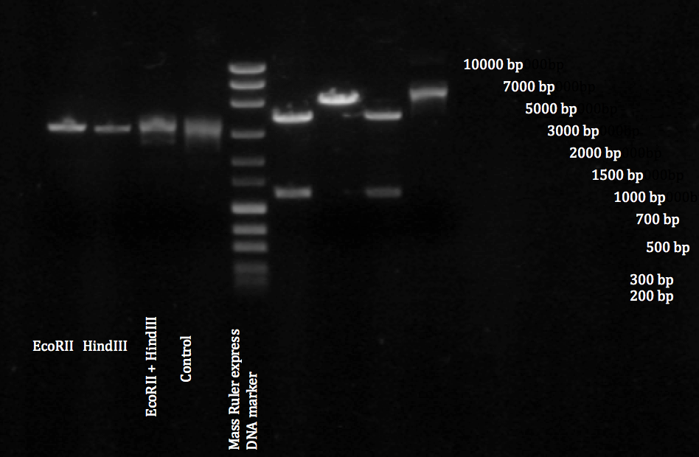

Figure 6. Graph of logMW (bp) of the MassRuler DNA ladder vs. the migration distance
Migration distances were determined by measuring from the center using a ruler. Log function was determined by finding the logs of each migration distance via excel. The graph is of the form y=mx+b where m is the slope and b is the y-intercept. The graph is modeled by the equation y = -0.3409x + 4.4848. For this equation y represents the length in BP and x represents the migration distance. The graph has a linear regression of R² = 0.99206.

Calculations for length (BP)

Band: EcoRI
Y = -0.3409x + 4.4848
x= 0.27 cm
Y= -0.3409*(0.27) + 4.4848=4.3928
Therefore length of 4393 BP

Band: HindIII
Y = -0.3409x + 4.4848
x= 0.29 cm
Y= -0.3409(0.29) + 4.4848=4.4848
Therefore length of 4484 BP

Band: Fragment A
Y = -0.3409x + 4.4848
x= 0.49 cm
Y= -0.3409(0.49) + 4.4848=4.4848
Therefore length of 4484 BP

Band: Fragment B
Y = -0.3409x + 4.4848
x= 0.41 cm
Y= -0.3409(0.41) + 4.4848=4.4848
Therefore length of 4484 BP

Band: Fragment C (Partial digest)
Y = -0.3409x + 4.4848
x= 0.33 cm
Y= -0.3409(0.33) + 4.4848=4.4848
Therefore length of 4484 BP

Band: Control
Y = -0.3409x + 4.4848
x= 0.34 cm
Y= -0.3409(0.34) + 4.4848=4.4848
Therefore length of 4484 BP

R6.

Figure 7. Plasmid DNA of unknown 30 A schematic of unknown plasmid 30 is shown with its features of EcoRI, HindRIII and 2 fragments denoted in red and blue. Unknown plasmid #30 was used to be digesting using EcoRI and HindIII that are restriction enzymes. The reagents were added to 4 separate tubes. In order to bring the reagents to the bottom the tube was to be tapped using a finger than centrifuged for 15 seconds. The tubes were placed in incubation with a 37 degree Celsius environment for 1 hour. When the digestion has gone to completion, 2.2 microliters of 10X DNA-electrophoresis loading buffer was added to each sample and than mixed well. 100 mL of a 1% agarose solution was prepared using a TAE (40 mM tris-acetate, 1.0 mM EDTA) buffer. Prior to heating the cap had to be loose and this is done so to prevent pressure build up. Agarose was heated inside a microwave oven. After each minute the agarose suspension was mixed (3x 1min). The solution was left to cool until it reaches 50 to 55 degrees Celsius in order to avoid melting the gel-casting mold. After cooling, 10 μL of SyBr Safe DNA Stain was added. EcoRI’s length was approximately 4393 BP and HindIII was calculated to be 4484 BP. The blue fragment using calculations was estimated to be 4484 bp and the red fragment was estimated to be 4484 BP in length.

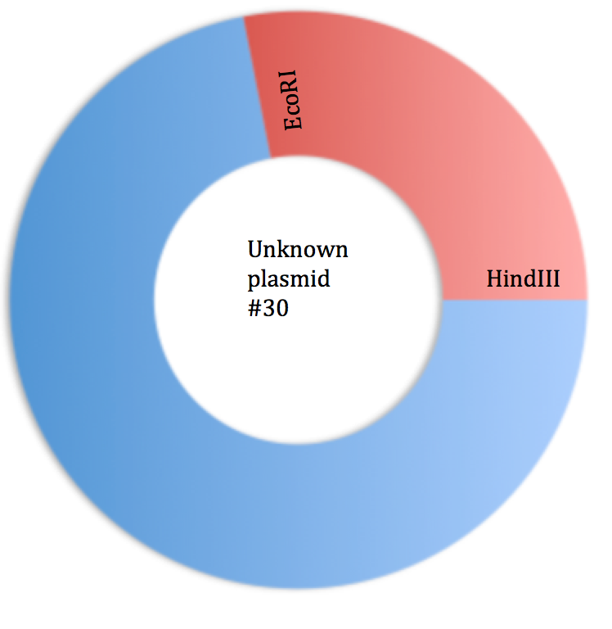

R7. The undigested plasmid is clearly visible at the 5th lane of the gel electrophoresis (as shown in figure 6). Since the lane appears to be smeared which means it was difficult to travel (due to steric hindrance) through out the gel therefore there was high signal, which meant that plasmids are in a supercoiled confirmation. The EcoRI lane is smeared indicating a high signal that translates to a completion in digestion. The EcoRI + HindIII and control lanes were also highly smeared which indicates complete digestion. There may however may also been an error when loading the sample into the well which caused the 2 lanes to become very smeared. The 3rd fragment in the last well corresponds to the partial digest that was similar in nature to the undigested fragment thus implying that this was a partial digest.

