Laboratory Class 4: Lipids & Membranes

Laboratory of Introduction to Biochemistry
BCH2333
Section: 02
Team: 01
Demonstrator: Graham

June 21st, 2017

University of Ottawa

Purpose: In this lab students were expected to examine membrane fractions that were extracted from calf liver tissues. There were 2 different fractions, one consisting of microsomal enriched extractions which was later to be examined using TLC plates and another fraction was mitochondrial enriched. In the second half of the experiment there was a protein and lipid assay to be done using appropriate dilution fractions of the mitochondria.
PI
PC
PE
CH
FA
PE
CH
CL
FA
PE
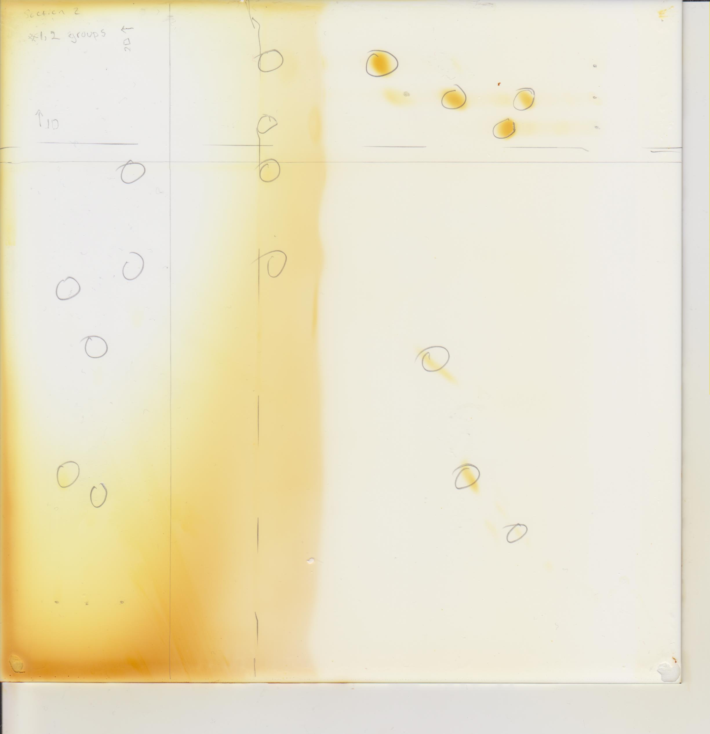
PC
PI
PC
PI

R1. Figure 1. Two-dimension TLC template using lipid standards
A 20 by 20cm silica gel plate was used in this part of the experiment where the template was drawn with pencil rather than pen because the chemicals of the pen can easily interact with the template. On the TLC plate 5 microliter of standards and 10 microliter of sample were placed via pipette. The standards used were fatty acid, phosphatidylcholine, phosphatidylinositol, phosphatidylethanolamine, cardiolipin and cholesterol. The plate was than placed in a tank consisting of CHCl3-MeOH-ammonia (65:35:5 v/v) where the TLC plate was underdevelopment until 1cm of the solvent was reached. The plate was late heated in order to speed up the drying process. The second plate was developed at a 90-degree angle in a tank under acidic conditions where the solvent was CHCl3-acetone-MeOH -acetic acid-H2O (10:4:2:2:1; v/v). Finally the TLC plate was placed in an iodine saturated tank and once removed was placed inside the fume-hood.

Table 1. Rf values of the lipid standards for each of the two solvent systems
Three standards were used on the 20x20 cm TLC plate. The first standard contained a mixture of FA (fatty acid) and PC (phosphatidylcholine), second had PI (phosphatidylinositol) and PE (phosphatidylethanolamine) and the third standard consisted of CL (cardiolipin) and CH (cholesterol). Column one lists all the standards used in this experiment, column 2 (Rf for first dimension) represents the basic solvent used which was CHCl3-MeOH-ammonia (65:35:5 v/v) and column 3 (Rf for second dimension) represents the acidic solvent conditions where CHCl3-acetone-MeOH -acetic acid-H2O (10:4:2:2:1; v/v) was placed in a tank.
Standard | Rf for first dimension | Rf for second dimension
FA (fatty acid) | 0.78 | 0.96
PC (phosphatidylcholine) | 0.45 | 0.50
PI (phosphatidylinositol) | 0.40 | 0.44
PE (phosphatidylethanolamine) | 0.63 | 0.72
CL (cardiolipin) | 0.85 | 0.95
CH (cholesterol) | 0.97 | 0.99

Sample RF calculation (for CH)
Basic conditions
Rf= Distance CH travelled/ Distance solvent travelled= 8.7/9= 0.97
Acidic conditions
Rf= Distance CH travelled/ Distance solvent travelled= 7.9/8= 0.99
The TLC plate is made up of silica gel which is polar and will bind polar compounds are more tightly bound to the silica gel than non-polar this means that the non-polar would be able to travel a further distance than the polar because the polar will be “pulled back” by the silica interactions. The more polar lipids would spend more time in the stationary phase than the non-polar. The separation is measured by the Rf value where the formula is Rf= distance travelled by lipid / distance solvent travelled. The Rf values for both solvents varied by small amounts due to one solvent system being basic and the other acidic. The basic and acidic conditions allow for the structures to alter via protonation or deprotonatation that will in turn affect the polarity of the overall structure and hence the migration distance will vary.

R2. Polarity of standards in basic solvent: polarity of CH > polarity of CL > polarity of FA > polarity of PE > polarity of PC > polarity of PI
Polarity of standards in acidic solvent: polarity of CH > polarity of FA > polarity of CL > polarity of PE > polarity of PC > polarity of PI
- FA (fatty acid) vs. PC (phosphatidylcholine)
Fatty acids have a polar tail that is made up of a carboxylic acid and a hydrocarbon chain that is non-polar. Phosphatidylcholine has a choline head group and contains glycerophosphoric acid; in addition to this there are fatty acid chains that have hydrocarbon tails that is the non-polar region. Under the acidic and basic conditions of the tank, the Fatty acid will travel the furthest on the TLC plate, as it is the fastest due to being more non-polar than the phosphatidylcholines.

Figure 2. Fatty Acid chain

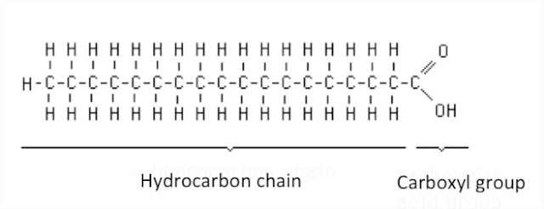
Figure 3. Phosphatidylcholine
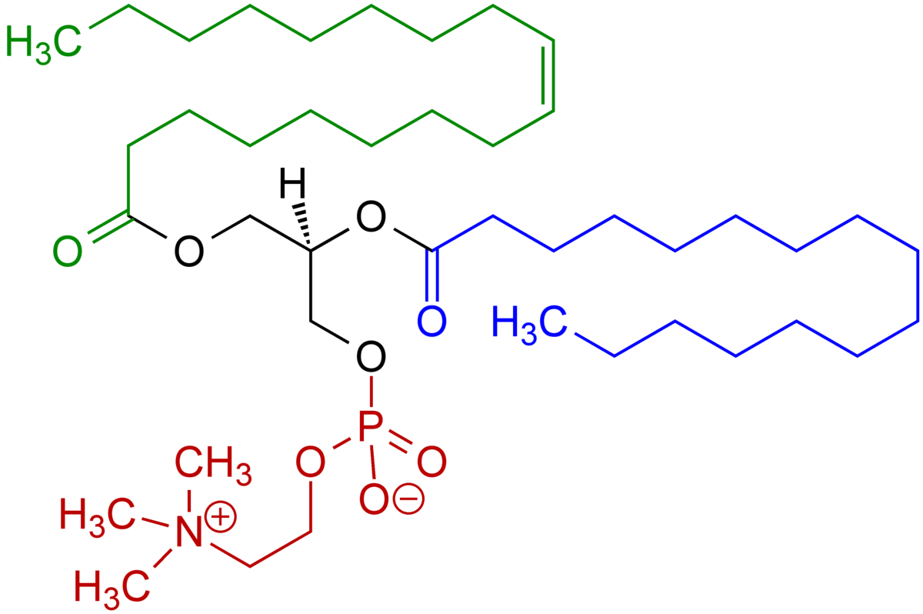

2) PI (phosphatidylinositol) vs. PE (phosphatidylethanolamine)
Phosphatidylinositol is amphiphilic as it consists of both non-polar and polar regions. It contains a glycerol backbone, 2 fatty acid tails that are nonpolar, phosphate group with an inositol polar head attached. Phosphatidylethanolamine contains glycerol, fatty acid chains, and phosphoric acid, ester and amine group. The polar region of this molecule is the amine and phosphate group and the non-polar regions are the hydrocarbon chain. In both acidic and basic solvents the more polar between the 2 lipids is phosphatidylinositol due to containing more polar groups than phosphatidylethanolamine.

Figure 4. Phosphatidylinositol

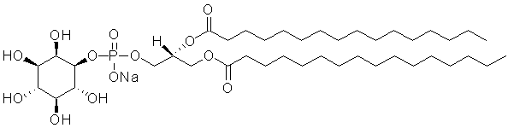

Figure 5. Phosphatidylethanolamine
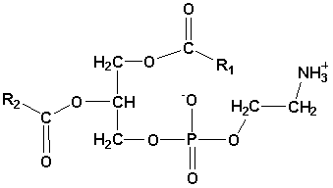

3) CL (cardiolipin) vs. CH (cholesterol)
Cardiolipin contains phosphate ions, carboxylic acid molecules and due to its symmetry it cannot be polar. The alcohol group attached to the benzene ring is what gives the cholesterol it’s polar properties and the rest of the structure is non-polar.

Figure 6. Cardiolipin
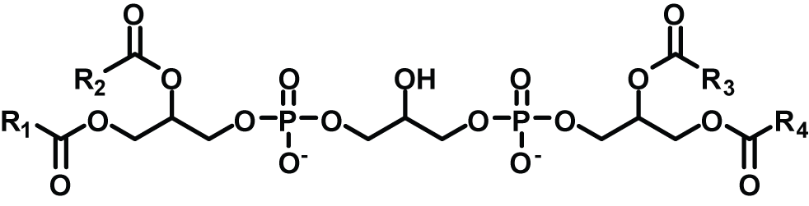

Figure 7. Cholesterol
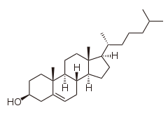

R3.
Table 2. Lipid Assay
The mitochondrial membrane was prepared by mincing 3g of calf liver and placing it in 10 mL of a buffer solution consisting of 0mM Tris, 0.25M sucrose, 1mM EDTA, 1 mM DTT, pH 7.5. The liver was homogenized than transferred to a cortex tube where it was centrifuged at 1,000xg for 10 minutes at 4°C. Five assay tubes were prepared where each sample corresponded to control, 1/200, 1/100, 1/40 and 1/25 dilutions. There was increase in the amount of mitochondrial membrane with a suspension in 2mL of 0.1 M concentration phosphate buffer of a pH of 11. The dye Brilliant Blue R was added where the test tubes were than vortexed in order to perfectly mix the solutions. The assay tubes were finally incubated for duration of 15 minutes at room temperature. The absorbance was taken at a wavelength of 559 nm.

Sample | Dilution fraction | Absorbance (A₅₅₉)
Control | 0 | 1.086
1/200 | 0.005 | 0.563
1/100 | 0.01 | 0.965
1/40 | 0.025 | 0.520
1/25 | 0.04 | 0.273

Figure 8. Graph of lipid assay
The graph has an equation of the form y=mx+b where m is the slope and b is the y-intercept. The equation for this figure is y = -16.941x + 0.9525 which shows there is a negative linear relation. This implies that there is a decrease in absorbance values as the dilution fractions increase.

Table 3. Protein Assay
The mitochondrial membrane was prepared by mincing 3g of calf liver and placing it in 10 mL of a buffer solution consisting of 0mM Tris, 0.25M sucrose, 1mM EDTA, 1 mM DTT, pH 7.5. The liver was homogenized than transferred to a cortex tube where it was centrifuged at 1,000xg for 10 minutes at 4°C. The remaining pellet was set aside for experiment 2 of the lab that was to be used during protein assay. For the protein assay there were 4 test tubes prepared each containing blank and dilutions of 1/5, 1/20and 1/100. Appropriate amounts of phosphate with a pH of 11 and concentration of 0.2M, water and membrane suspension were added to each corresponding dilution. Absorbance was collected at a wavelength of 280 nm.

Sample | Dilution fraction | Absorbance (A₂₈₀)
Blank | 0 | 0
1/100 | 0.01 | 0.394
1/20 | 0.05 | 0.954
1/5 | 0.2 | 1.635

Figure 9. Graph of protein assay
The graph has an equation of the form y=mx+b where m is the slope and b is the y-intercept. The equation for this figure is y = 7.1885x + 0.2785. There is a positive linear relationship that implies absorbance increases, as there is an increase in dilution fraction.

R4.
A=εCL
C=A/εL
Where
A is solved by subbing 1 into the x-value of the equation
Y = 7.1885(1) + 0.2785
Therefore A= 7.467
C= 7.467/(2.0 L g ⁻ ¹ cm ⁻ ¹)(1 cm)
= 3.7335 g/L

Therefore protein concentration from the membrane preparation is 3.7335 g/L

R5.
A1/C1= A2/C2
Where subbing 1 into the x-value of the equation & subtracting from control solves A2
y = -16.941x + 0.9525
y= -15.9885
A2= 1.086- (-15.9885)
A2= 17.0745
Rearranging A1/C1= A2/C2 & plugging in the appropriate values we get
C2= (17.0745) (1 microgram/ mL)/ 0.013
= 1313 µg/mL

Therefore concentration of lipids in the mitochondria-enriched fraction is 1313 µg/mL

R6.
Mass= concentration * volume
= 3.7335 g/L * 0.01 L
= 0.037335 g
= 37.335 milligrams

Yield= mass of protein/ mass of calf liver
= 37.335 mg/ 3g
= 12.445 mg/g

Therefore yield for mitochondria preparation of protein is 12.445 mg/g

