TOPIC: AGGREGATE OPERATIONS PLANNING (Ch. 13 & Supplements)

Q : An aircraft engine manufacturer wants to develop an aggregate production plan for the next four quarters. The forecasted demand and the other relevant cost data for each quarter are given:

Period | Demand Forecast | Inventory carrying cost = $15,000 per engine per quarter Regular production cost = $50 per unit  Hiring cost = $2,500 per worker Firing cost = $4,000 per worker
Q1 Q2 Q3 Q4 | 450 engines  380 engines  410 engines  360 engines
Each worker can manufacture 40 engines per year. The beginning inventory for quarter 1 and the ending inventory for quarter 4 are assumed to be both zero. There were three workers fired at the end of quarter 4 of the previous year, leaving 35 workers still employed by the company.

- Clearly define the decision variables involved in writing a Linear Programming (LP) formulation for the above aggregate planning problem.

Define the following decision variables:
Number of workers hired in quarter t, Number of workers fired in quarter t,
Number of units in inventory at the end of quarter t
Units produced in quarter t, Workforce size in quarter t

- Write the LP formulation for the above problem.

Subject to:

Demand Change Constraints: (Note that and

Production Constraints:

Workforce Change Constraints:

All variables should be non-negative

Q 2: A jewelry store makes necklaces and bracelets from gold and platinum. The store has developed the following linear programming model for determining the number of necklaces and bracelets (x1 and x2) to make in order to maximize profits.

Subject to
(Total Profit in $)

(Gold in ounces) (Platinum in ounces) (Demand for bracelets)

  - Solve this model graphically.
  - The maximum demand for bracelets if 4. If the store produces the optimal number of bracelets and necklaces; will the maximum demand for bracelets be met? If not, by how much will it be missed?

Solution:
The feasible region is shown below. The values of the optimal solution is x1 = 2 and x2 = 4. The optimal solution lies at the intersection of and . The optimal objective function value is
. The optimal number of bracelet is 4; hence the maximum demand is
met.

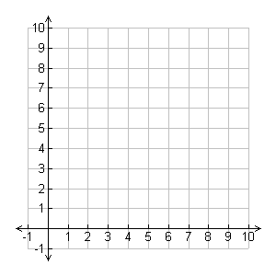

Q 3: The admission office at Tech wants to determine how many in-state and out-of state students to accept for next fall’s entering freshman class. Tuition for in-state student is $7,600 per year while out-of- state tuition is $22,500 per year. A total of 12,800 in-state and 8,100 out-of-state freshman have applied for next fall, and Tech does not want to accept more than 3,500 students. However, since Tech is a state institution, the state mandates that it can accept no more than 40% out-of-state students. From past experience, the admissions office knows that 12% of in-state students and 24% of out-of-state students will drop out during their first year. Tech wants to maximize total tuition while limiting the total attrition to 600 first-year students.
- Formulate a linear programming model for this problem.
- Solve this model using the graphical method in order to find the optimal number of in-state and out-of-state students admitted.

a) Let x1 = Number of in-state students admitted
Let x2 = Number of out-of-state students admitted

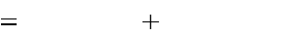
Maximize Z
$7,600x1 22,500x2

Subject to

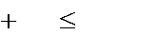
x1
x2 3,500
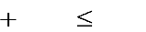
x2 / x1
x2 .40

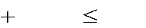
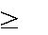
.12x1
x1, x2
.24x2 0
600

b)


