Notes BPS2110

MIDTERM 1

Biopharmaceutics: study of the properties of “therapeutic substances” and their dosages/bioactivity relationships.
Therapeutic substances:
A) prescription drugs
- small molecule: >500 molecular mass, goes to the brain, unlike big molecules (blood-brain barrier)
- peptides/proteins: have very short biological half-lives, the more often you have to take the drug
- vaccines (and conjugates)
B) Natural health products (NHPs): not regulated as much as typical pharmaceutical drugs, issues with cross-reactions with other pharmaceuticals. Anyone can create an NHP, bottle it and market it. NHPs are not touchable by the FDA.
- vitamins: vitamin C helps the immune system; Pauling (respected scientist) stated that, if you ingest a lot, 1000mg, it does not help. Studies proved that there’s no benefit.
- plant extracts
C) Diagnostics: wide range of products, ex: dye for x-rays, radio-isotopes

Pharmaceuticals sciences: a group of interdisciplinary areas of study involved with the design and synthesis, mode of action, delivery and “use” of drugs

Pharmaceutical industry:
- What’s their purpose: supplying materials and techniques that deliver (or promise to deliver) the things that people desire most, AKA good health. Pharma promises to deliver that
- What do they get out of it?: profit

Cure vs Prevention
- Average life span in the early 1900’s: 50 years
- Average life span in 2015: 80+ years
> The increase is due to a higher standart of living from:
- better food and food and water supply (pasteurized milk, prevents TB)
- work place infrastructure (workplace education) ex: benzene to wash hands
- vaccines (prevention), ex: smallpox was cleaned out by vaccination and then some cases come back, because they stopped vaccinated against it
- drugs (cures): Antibacterials, antihypetensives, bacterial resistance resurfaced. The pharma’s started to create new antibiotics to cure the resistant bacterias. In WW1, most common reason for death was bacterial infections
- Diagnostics and improved medical procedures: we can detect and treat serious conditions earlier (ex: cancer)

The irony is that health care spending by the government does NOT correlate well with the wellness of the population.

World-wide (global) pharmaceuticals industry
- the top 4 pharmaceutical giants in 2012
- Pfizer (USA): 70.7 billion $ of profit (only in 2012) - 137 000 employees
- Johnson&Johnson (USA): 63.7 billion $ (only in 2012) - 119 000 employees
- Hoffman - La Roche (Swiss): 43.9 billion $ (Only in 2012) - 78 600 employees
- Novartis (Swiss): 41.5 billion $ (only in 2012) - 98 200 employees
——— The others ———
- Glaxo Smith Kline : 40B$ - 103 000 employees
9. Merck-Frosst (USA): 24B - 74 300 employees
12. Boehringer Ingelheim (Germany) 17B - 43 000 employees
13, Takeda Pharma (Japan): 16B - 15 000 employees
> People spend lots of money to counteract the consequences of their lifestyle choices

The Most Prescribed Drugs (USA 2012)
- Hydrocodone (T3): synthetic opioid from codein, mixed with acetaminophen, effective pain killer - 131.2 million prescriptions
- Generic Zocor (simvastatin): hypolipidemic drug to lower cholesterol - 94 million prescriptions
- Lisinopril: ACE (angiotensin-converting-enzyme) inhibitor, lowers blood pressure (hypertension, can be caused by lots of salt and can be lowered with physical activity or change in the diet), do not come off these drugs because of the profit pharma's makes out of it - 87 million prescriptions
- Generic Synthraid: synthetic thyroid hormone (indentical to thyroxine T4), regulates the basal metabolic rate - 70 million prescriptions
- Generic Norvasc: next generation beta-blocker (keeps your heart-rate low, ex: athletes), used to treat hypertension (when ACE inhibitor is not enough) Norvasc is a calcium channel blocker that regulates blood pressure - 57 million prescriptions
- Generic Prilosec: treats GERD (gastroesophageal reflex disease) - 54 million prescriptions
- Azithromycin (Z-pak): from pfizer, antibiotic (for only 5 days) - 56.2 million prescriptions
> Most antibiotics used worldwide are for agriculture and fish farms
8. Amoxicillin: antibiotic - 52.3 million prescriptions
9. Generic Glucophage: first line of treatment for Type 2 diabetes, caused mostly by processed food - 48 million prescriptions
10. Hydrochlorothiazide: blood pressure control - 48 million prescriptions

Top selling drugs (USA 2010): doesn’t mean the most prescribed drug, but the ones that generate the most income
- Lipitor: cholesterol lowering drug - 7.2 billion $ (2010)
- Nexium: proton pump inhibitor in the stomach, it is a chiral molecule made ion to be more soluble in water. The company got a second patent with the enantiomere, but the active ingredient is actually dimeres of that molecule- 6.3 billion $ (2010)
- Plavix: blood thinner used to treat clots - 6.1 billion $ (2010)
- Advair: treats asthma, two different drugs combined (inflammatory agent that is steroid based with a fast acting agent) - 4.7 billion $ (2010)
- Abilify: antipsychotic drug, to treat bipolar disorders and schizophrenia - 4.6 billion $ (2010)

Compare the stats in 2012 for the top selling drug (USA 2010)
- Humira: anti-inflammatory, - 9.8 billion $ (2012)
- Enbrel: psoriasis, rhumatoid arthritis, autoimmune conditions - 8.4 billion $ (2012)
- Advair: asthma - 8.0 billion $ (2012)
- Remicade: chimeric MAB against ThF2? -
- Rituxan: chimeric MAB to treat B-cell diffusion, AKA transplant/tissue rejection -

> Change in order between two years: newer drugs are to treat complex autoimmune conditions (“Recent change “)

Top selling drugs in 2006
- Lipitor: 14.4 billion
- Advair: 6.1 billion
- Plavix: 6.1 billion
- Nexium: 5.2 billion
…..
50. Abilify: 1.9 billion
> From 2006 to 2010, the top list was stable, some of the patents expired

The Canadian pharmaceutical industry
- It represent 3% of the world pharmaceutical sales in 2010, but enters the top 10 list
- Canadian Pharma: research and development (R and D) companies (giants) make 78% of the total sale, while generic drug companies make 22% of sales
- R and D companies are usually multinationals to develop new drugs, requires lots of funds. On average, they spend 700 million $ over 15 years.
- The generic companies manufacture drugs after the patents expire (usually after 20 years)

Drug cost vs healthcare cost (Canada)
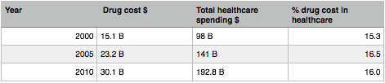

> We don’t have more drugs available to treat conditions, even though we spend more and more money on healthcare

Theories on the cost of healthcare and drugs increasing
- First world nations are much more wealthier and can just pay more for treatment
- Older and less healthy populations
- We utilize more and more healthcare each year

Drug development process: interdisciplinary and combined effort from key individuals, takes about 8-18 years

Key persons
- Biochemists
- Molecular biologists
- Physiologists
- Analytical chemists: quality control, formulations, metabolic studies
- Toxicologists
- Organic chemists: med chemists, process chemists bigger scales
- Pharmacologists
- Biostatisticians
- Chemical engineers: design plans to prevent exothermina
- Legal experts (patents, intellectual property aka. IP)

From the identification of a potential drug or substance to lead structures to approved for sales by FDA or Health Canada

Four phases
- Preclinical research and development (3-8 years)
- Understanding the nature of the disease or condition that you want to treat
- Where d you intervene in the process of the disease and what does the drug want to target exactly? ex: HIV; initial infection, replication process (HIV protease target, reverse transcriptase inhibitors), virus release (neuromidase inhibitor with Tamiflu)
- Have to identify a “lead” structure or a compound, where to look for it? 3 common strategies
- Rational design
- Accidental discovery (MAJOR), responsible for more drugs than any other (ex viagra)
- Nature

- Clinical trials (4-8 years)

- New Drug Application Review AKA NFDA or approval for sales (1-2 years)

- Post market surveillance (on going)

CLASS 5?
Difference between efficacy and efficiency
Efficacy: how much you need
Efficiency: scale in which you are working. If there is an overexpressend enzyme causing a certain disease, the drug intervention strategy might be to knock out the enzyme. Give a drug to clear the enzymes and so the body will produce more.
Define the difference between efficacy and efficiency such as the enzyme

How does Pharma “decide” what disease to treat?
- Filling a need: Have to have a disease/condition to treat that affects many people ton make money out of it. Business model form which you still have to make money, because of the cost of the production.
- ex: HIV, 1980-2000, scientists studied the disease since it affected so many (a lot of time can be spend researching and identifying the origin of the condition, like bacteria, etc.).
- Development of new drugs to treat the condition (nucleoside reverse transcriptase inhibitors, protease inhibitors).
- The current treatment is a cocktail of drugs, because treating with a nucleoside reverse transcriptase inhibitor wasn’t enough, they now take huge amounts of drugs. But this treatment has prolonged the life expectancy (can live until 60 y/o now, used to be 5 years after HIV positive)
- React to an opportunity: something happens, breakthrough or new understanding about a disease or condition. Unrelated discovery/ new developments that helps understanding a certain disease or condition. ex: cystic fibrosis
- Ex: cyclooxygenases (COX) and inflammation, there are two different COX enzyme and you only have to inhibit one of the two, you have no inflammation. When you inhibit both (1:1) (advil, etc.) you control inflammation but also can have stomach bleeding or ulcers. Naproxen is great for inflammation (2 tablets for major injury), but extremely hard on the gut, and you know the side effects since it’s been used for a long time. Some people seem to be immune from the selective issues and stomach problem (ex: estrogen alpha/beta receptors for breast cancer in women, a balance had to be maintained in the hitting the receptors to create a safe drug)
- How do we discover a drug candidate (lead compound, not the drug that will be marketed, compound 1 which you use and do the studies with to develop better molecules): a) design an artificial compound that looks like a natural substrate, but very hard, b) …..
  - Target identification: what you need to know before creating a drug that is effective (6 months to 2 years)
  - HTS: identifying the good compounds between thousands of screenings by colouring, radioactive, enzymes. (3 to 4 months)
  - Active to hit: something you have confidence in and can develop, whole range of efficiency (3 months)
  - Lead compound: decent structural profile, no or poor in toxicity issues (6-9 months)
  - Lead optimization projects: insurance policy, optimization to reduce or remove the undesired effects. Making of hundreds of compounds to find the best one (also varying the concentrations of the compounds), by modifying the length of carbon chains (example), knowing the limits of design for the “effective window” (2 to 5 years or more). *Trying to improve the pharmacokinetics: to get to a point where we can go forward spending lots of money to create the drug.
  - Candidate drug

Biological Mechanisms / Sales of Drug (2005)
- Enzyme inhibitors: blocks the work of the enzymes. 38%
- Receptor antagonists: blocks the response that the receptor usually fires. 24%
- Receptor Agonists: bind and causes the receptor to fires without being the natural substrate and usually has a higher affinity than natural substrate. 12%
- Ion Channel Modulators: open up or close ion channels, prevent the transport of ions through the channels. (Norvasc) 8%
> These 4 categories make up 80% of the drugs on the market

Bioassays
- Essential for the entire process to get a drug candidate and/or lead compound, we can make the enzyme we’re interested on inhibiting or whatever, the bioassay allows us to test the drugs on a real enzyme, determining the structures that are better or efficacy. Identify the key compound that binds to the molecule. The synthesis of molecules takes weeks for one.
- Computer programs are not the most useful, present the computer with active site or receptive site found out with the bioassays. A lot of powerful stuff can be done with molecular programs but there is a lot of problems. Ultimately, we can’t use the computer to find something to bind to the enzyme, they are not capable
- If you’re going to design a drug you need in vitro assay that you have controls for. Ex: looking for receptor or modulator, you have to have the receptor isolated ( dish or tray) and add molecules to it to see if it binds/reacts. How to have receptors: cloning or expression. Problem: folding of the proteins that often need chaperonins.
- Once you establish your target, you need to identify other compounds that interact. Most targets are enzymes, and they are easy to work with

- Types of bioassays
- Bioassays based upon either
  - Cells (whole): you have to make sure your drug can get inside the cells, since they are so selective about what they let in.
  - Isolated enzymes: removing the cell problem, you need a suitable way to express your enzyme and thus folding.
- A solution HTS (High throughput screening: in theory, you can take one dish or plate and put in a thousand compounds in one well saving a lot of time. This allows us to work with librairies or groups of compounds (100-10 000 compounds in once)

HTS (high-throughput screening): screening of thousands of molecules at the time. Industrial process, screen a series of compounds. 50-70% of drugs in last 10 years are from HTS. Why not test them separately in the first place? Because assay take about a week or more to complete, so not many compounds can be tested. After the HTS, all the compounds have to be separated to test the ones that look promising
High-throughput fluorimeter: relies only on fluorescence, very quick and on real time. Fancy plate reader, if there is an interection it will be visible. Used to do kinetic analysis, factor of time, 1000x better than cuvettes
Types of librairies
  - Combinatorial librairies: generate compounds using synthetic organic chemicals.
      - PROS: great amount of different compounds
        - CONS: structural diversity is limited. It’s not truly random. Librairies won’t identify the crazy structures that don’t have what they think is needed, but still would work. Separation of the compounds can be a problem
- EX: 2 component librairy R(1)-N(R2)-H (amines) + R3-C(=O)-OH (carboxilic acid) -(coupling agent-> R1-N(R2)-C(=O)-R3 + H2O. If we have 10 amines + 10 acids, we have 100 different amides. This increases if there was a third component to the librairy of 10 compounds, there would be 1000 different ones (librairies to 30 000 compounds)
  - Natural product based librairies: use the extracts that contain many different compounds. PROS: It is a high diverse librairy (structurally), very likely that the compounds are bioavailable (sub category of absorption, i.e. the amount of drugs that reaches the systemic circulation, through the liver first for filtration and thus lost of drugs), because they come from a living organism, something you can work with and we can absorb too.
        - CONS: it is a complex mixture and it is difficult to separate into individual components

        - Diversity in natural products library (more than 2 sources but those are the most common)
        - A) Plant sources: ex, morphine(1), Cocaine(2), THC(3), podophyllotoxin (anticancer) (4)
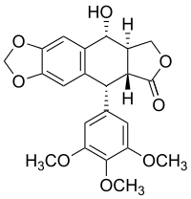
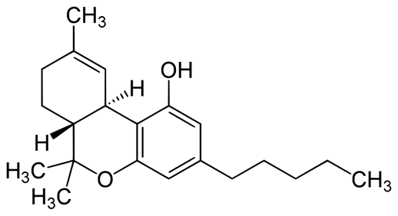
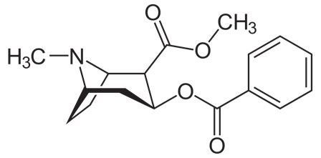

        - B) Microorganisms: ex, penicillin (1), Adriamycin (anticancer) (2)
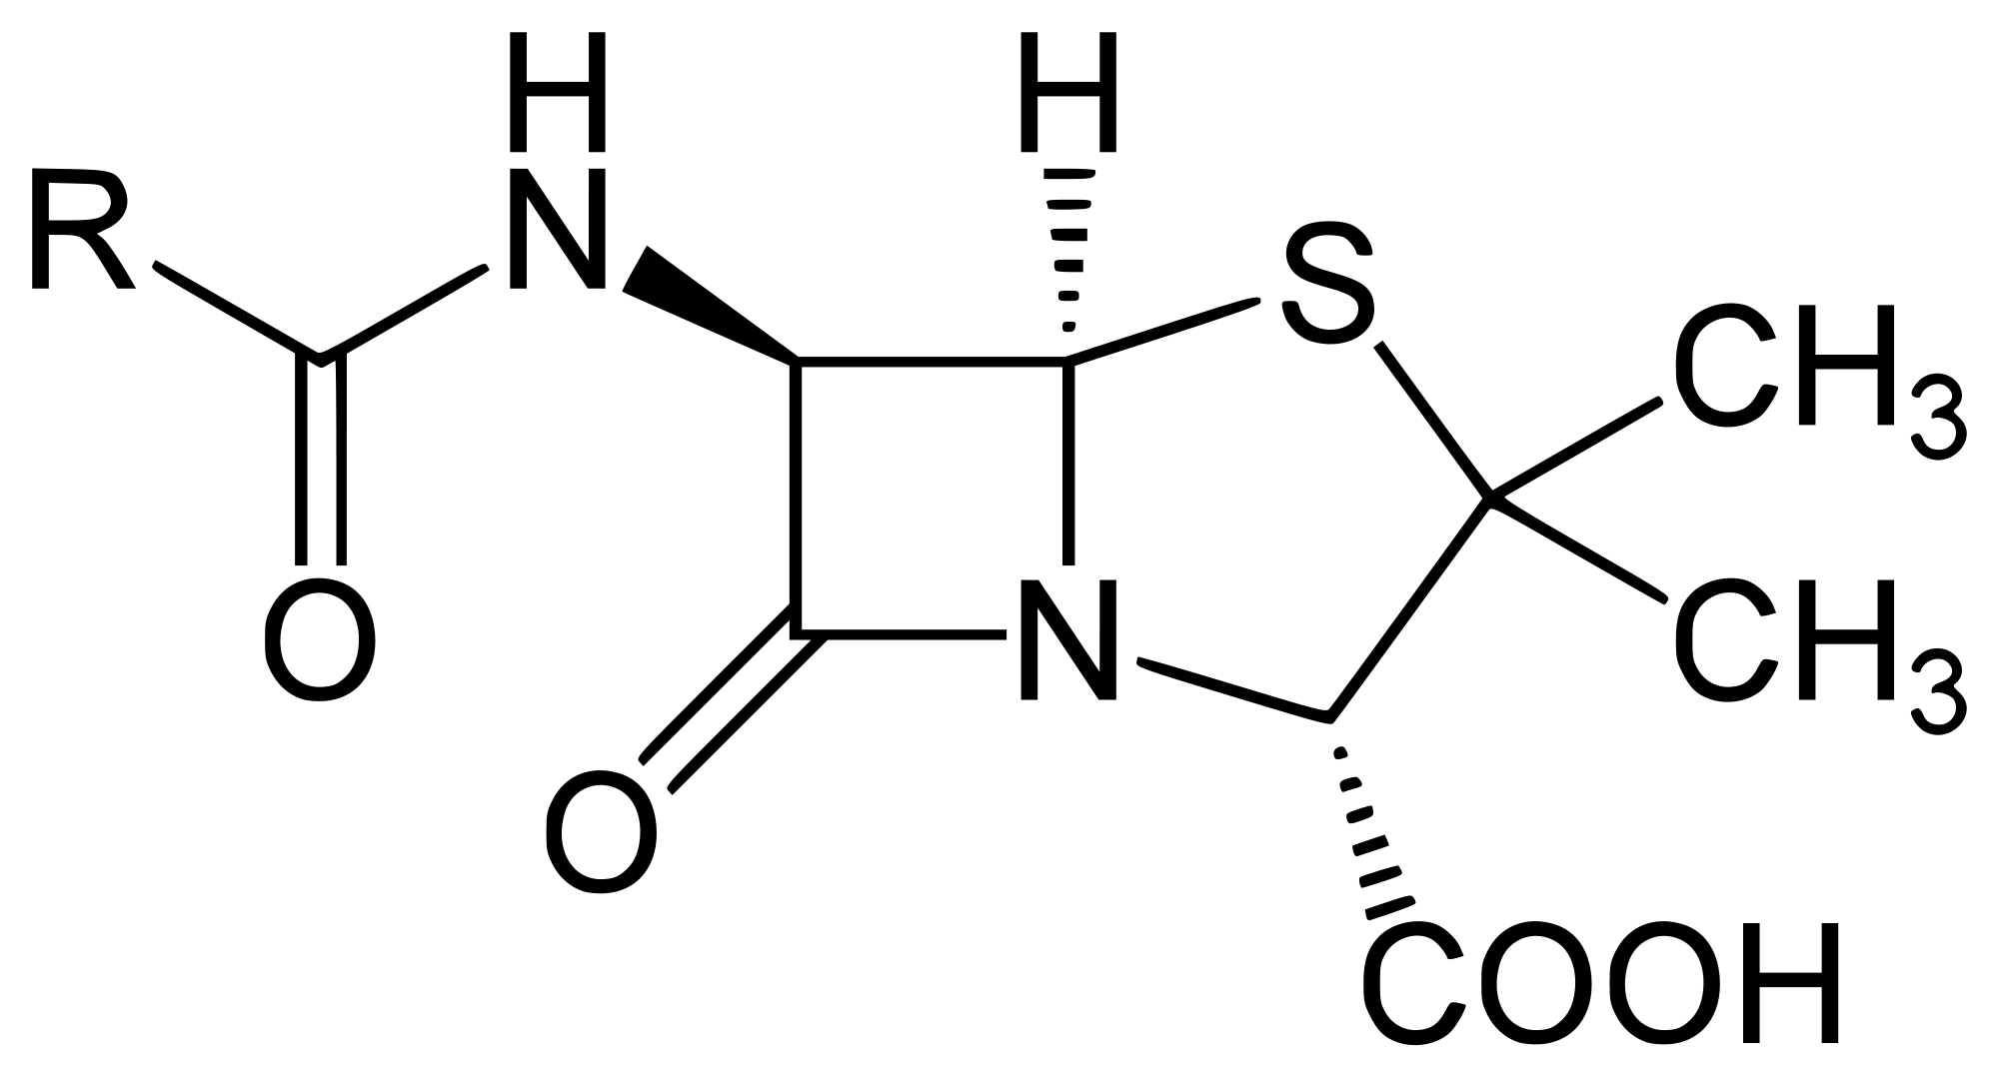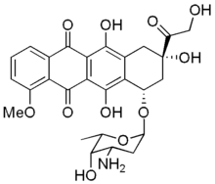
Lecture?? RECORDING

Ethnopharmacology: the study of the use of plant-derived materials in traditional societies for the purpose of maintaining and improving health.
- This includes Chinese traditional medicine
- 80% of the world population uses plant materials to treat health problems
- Combining random screening of natural product librairies and ethnopharmacology is a clever strategy, increases odds of finding a hit. Ex: 50% of new anticancer drugs come from natural products. Malaria treatment, early 1820’s, people knew Quinine (structure 1 shwon below) had an effect on the disease, comes from the Chincoma Tree, the very first antimalarial “drug”. The parasite that causes malaria developed resistance extremely quickly
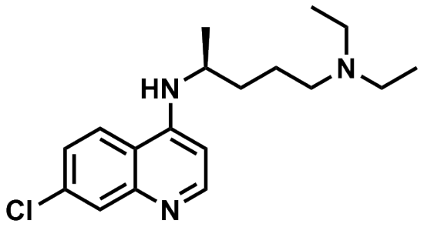
- 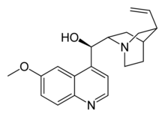
- Resistant parasite were then treated with Chloroquine (see structure 2) from 1934 to 1943, but again resistance was developed
- Mefloquine (see structure 3) was developed and used in the 1970’s, the CF3 group helps with solubility.
- The structures of these different molecules are actually very similar
- Malaria drug development is being pushed by what? (the disease isn’t a pandemic). The drugs were developed in the US during the Pacific WWII (Chloroquine) and the Mefloquine was created during the Vietnam War. The US were sending soldiers into Malaria infected parts of the world, do they developed these new drugs to protect their army. There is a correlation between drug development and “political vaccine”.
- Often, medical chemistry and drug development is bases upon political/war needs…

Today, to treat Malaria, we have Artimisinin (see structure 1 below). It comes from a bush called artemensia Annua (Chinese Traditional medicine).

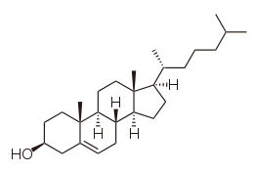
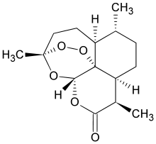

The Story of the Statin Drugs
- Excellent example of drug discovery process
- Based upon a complete understanding of cholesterol (see structure 2 above) biosynthesis
- Sources include: meats, butter, lard, etc. We don’t get it from plants/fruits/vegetable products. It is needed to survive
- Our body uses the cholesterol in cell membranes (particularly brain and spinal cord, myelin sheaths), it helps making the cell membranes more pliables. Also important because when cell age, the cholesterol replace some parts that are lost??
- Negative effects: arterial plagues, too much cholesterol makes the fat deposit on the arteries of veins, blocking them, causing strokes and heart attacks, issues with the lungs, etc.
- Some of these bad effects can be controlled by diet, ex: lowering cholesterol

Biosynthesis of Cholesterol
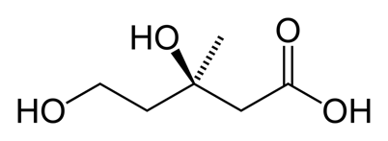
- Mevalonate is the KEY
- 3 acetate units (CH3C(O)O-
- HmG-CoA
- Mevalonate (structure beside)
The first steps:
Many enzymes involved, uses acetyl-CoA (shown below) 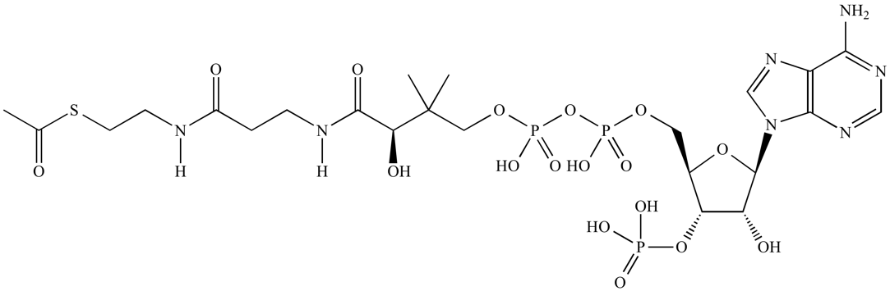
Molecule made from 1. ATP 2. Cysteine 3. Panthenoate (vitamin B5)
- Acetyl-CoA -> HmG-CoA (HmG-CoA reductase, the enzyme) –(rate determining step)-> Mevalonate
So, series of phosphorylation with decarbolyzation and lost of water, to (A) Isopentenyl pyrophosphate (IPP) to (B) Dimethylallylpyrophosphate (DmAP)
- A and B are key building blocks for cholesterol
- Mechanism (3-methyl-but-2-ene + double link of DmAP) to infinity
- Becomes Geranyl Phosphate (C10) then Farnesyl Phosphate (C15) then Squalene (C30H50) to Cholesterol (C27H46O)
So the big question is: Knowing all of this biochem and biosynthesis (pathways and intermediates), how do you inhibit HmG-CoA Reductase (Key enzyme)and ultimately reduce or shut down the cholesterol biosynthesis and lower the blood cholesterol level (not completely knock it out)
- Answer: find a substrate that “looks like” HmG-CoA and binds to the active site of HmG-CoA Reductase. You need to design something to fit the inside shape of the enzyme but that isn’t released as easy.
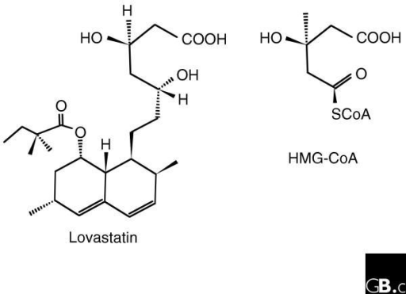
- Mevalstatin (see below): isolated from a penicillium mold by a Japanese biochemist (Akiro Endo in the 1970’s). How does the mevalstatin inhibit the HmG-CoA Reductase? If you open the lactone ring (cyclic esther) and keep everything else the same, , there is a carboxylic acid in 3C and attach H to the O’s.

Comparison: HmG-CoA (2nd compound on 2nd), There is a real structure similarity between mevalonate and mevalstatin.
- But mevalstatin was not developed into a drug because of toxicity issues.
- Merck-Frost tried to develop a drug based upon a secondary metaolite from the oyster mushrooms. If you take the toxic structure and make changes in it, trying to take out the structures that causes toxicity, bad idea. It was very risky.

Other naturally occurring HmG-CoA reductase inhibitors: mevastatin, lovastatin (oyster mushroom Mevacor), pravastatin, simvastatin (Zocor)
- Very similar structures, the essential part of the molecules are the O-ring (see figure 1 above), the stereochemistry is important and the arrangement too.
- Initial approach was to keep the molecule very simple, to adjust the polarity (hydrophobic, hydrophilic)
- Issues with aromatic rings: flat, not like the enzyme, stereochemistry is also important.
- Results of synthetic statins (the lactone ring is opened under condition, stomach makes the stomach open it): Lipitor, Baycol, Crestor.
Structure relationship: - They all have a phenyl with Fluor substituent (very hydrophobic and the enzyme has a deep hydrophobic pocket), the lactone ring, and Ns
- Lipitor: best selling drug in history: since 1996, >125B$, the patent ended in 2011, but they reduced the cost of the drug dramatically (almost generic).
- Other statin include: Mevacor, Crestor, Zocor, Pravachol, Baycol
- Zocor (clinical trial): about 4500 patients with high cholesterol and heart disease, after 5 years, 35% lowering of cholesterol, 42% decrease in deaths due to heart attacks.
- Side effects or statins: Kidney failure, skeletal muscle wasting, death 1/25 000 (Baycol 1/2500 kidney failure)
  - Good side effect: 50% reduction of colorectal cancer
  - Bad side effect: increase risk of type II diabetes

Aspirin– building a better aspirin
ASA (Acetyl Salicylic Acid)

- Positive effects: relieves pain (analgesic), reduces fever (antipyretic), relieves inflammation and reduces blood clothing
- Negative effects: causes gastric lesions
- Canadian consume about 120 ASA tablets per year at 325mg/tablet (1 320 tons)
Mechanism of action of ASA
- Inhibits the formation of prostaglandins (mediate inflammation) from the arachidonic acid (poly-unsaturated fatty acid)

Cyclooxygenase (COX)
- ASA inhibits COX (ibuprofen, ketoprofen, naproxen), major side effect are gastric lesions?
- Two COX enxymes, they both inhibit prostaglandin formation, one is involved with inflammation (COX2) and the other is involved with stomach lining (COX1).
- COX1 inhibiting drugs mess with the stomach lining regeneration
- DuP697 is a molecule made by Dupont and is a selective COX2 inhibitor, didn’t bind well with COX1.
- The discovery started a race between Pfizer (US) and Merck-Frosst (MTL)
- Celebrex and Vioxx: very quick approval, excellent treatment for inflammation and very little chances to cause stomach lesions, helps with arthritis and sports/accident injuries
  - Merck-Frosst announced the withdrawal of Vioxx because of the use of it for the prevention of colon cancers, long term leads to the risk of heart attack and stroke of 2.
  - Celebrex was never pulled because no study proved correlation to anything, > unlike Vioxx.
- COX2 might do more than simply mediate inflammation, it is present in heart tissue, involved in the production of prostacyclin, vasodilator that also inhibit platelet aggregation

Natural products (secondary metabolites) as a source of new Drugs
- Terrestrial plants and sea organisms (lesser extent)
- 60% of all new antibiotics have a natural product origin
- 50% of all new anti-cancer drugs are derived from natural products
- Most CNS drugs have a synthetic chemistry origin but are based on the naturally occurring alkaloids with CNs activity

Plant secondary metabolites
- Perform key functions necessary for survival of the organism, ex: animal hormones
- Ensure propagation ex: pollination and dispersal of seeds
- Protection and defence against insects and herbivores
- Phytochemical redundancy and plant defence (no resistance)

Bio-assay guided isolation: finding products that might have chemicals that can be transformed or synthetized into drugs by consultation
Natural products are more likely to be bioactive, because it was found in an organism, so it has an activity. More bio-available too, already has a balance between hydrophilic/phobic, it evolved to be bioavailable. Produced as single isomers (no enantiomers), the stereocenters are important (ex: adrenaline R/S, the R is 20x more active)
- Avoid racemic drugs, because the two enantiomers have very different properties. One can be biologically active, the other one can not be, or be toxic, etc.
- Ex: Thalidomide, racemic drug, one of the isomer caused terogenicity, because the body racemized the drug (congenital defects in the prenatal development, shut angiogenesis (growth of blood vessels)). The body racemize the drug even if only the active enantiomere is given. Now used to treat leprosy
- Ex1: Ibuprofen, sold as racemic, has only one active isomer (S), but the body is able to convert the R isomer into the S by the action of a particular enzyme. No need for the separation process, so it’s way cheaper

NHPs and bio-assays
- Taxol: originally obtained from the bark of yew trees, it is used as an anti-cancer drug, but primarily lungs, ovarian and small cell lung cancer. It has been discovered by creening for cytotoxic properties
- Podophyllotoxin: treats small cell lung cancer, it is islated from the roots of the North American May Apple and is used by natives to remove warts
- Adriamycin: discovered by screening for cytotoxic activity, used since the 1960 to treat variety of cancers like leukemia, hidkins lymphoma, bladder, breast and stomach cancer
- ??????
- The penicillins: antibiotics formed with 6-amino-penicillanic acid (4 member lactam ring)
- Penicillin V: from pericillium mold, attacks gram positive, poor oral activity
- G: produced via fermentation, attacks gram positive, good oral activity
- Amoxycillin: broader spectrum activity, attacks gram positive and gram negative bacterias, orally active and produced semi-synthetically

Natural CNS active alkaloids: all have basic nitrogen atom joined to an aromatic ring via a saturated two carbon units (benzene, indole ring benzene+4cycle with one double link and 1 N:)Neurotransmitters
- Adrenaline/epinephrine:
- Mescaline: peyote cactus (tea)
- Morphine
- Lysergic acid: ergot fungus growing on rye (not toxic),
- Psilocybin: sacred mushroom
- Harmaline: hallucinogen drinks from the Amazone Ayahusca
- Amphetamine: stimulant
- MDMA/ecstasy: a cycle of 5 with 2 O has been added to the benzene ring of amphetamine
- Dopamine, serotonine: neurotransmitters contribution to feeling well
- Designer drug: the chemist modified a drug by adding a CH3 at the end of ecstasy, different structure than ecstasy so they can market them and have the same effects. Not catalogued as illicit substances, so they can’t arrest them. The chemist induced parkinson’s in his clients because he fucked up, irreversible. From that drug you can induce parkinson’s to an animal model

Metabolism
- Mainly liver enzymes belonging to the cytochrome P-450 family
- Almost a dozen variations have been identified in humans:
- CYP3A4 most important enzyme is involved in the metabolism of approximately half the drugs that are used today. Handles oxidation, promiscuous (takes almost any substrate), generally substrates are hydrophobic and need to be oxidized, converting C-H into O-H. Unique enzyme with irons. Mechanism with a radical stabilized on C to build OH
- CYP2C19:
- Having drugs with such short half lives, only little drug gets out of the liver. Given that we’re adding an O across a C-C bond on an aromatic, increasing electron density of the ring, better nucleophile reacts with electrophile faster or opposite. Good technique to increase or decrease metabolism, decrease halflives of drugs is to add aromatic rings
- How long does the drug last in our body
- therapeutic index or TI: ratio of therapeutic dosage for 50% of the patients.
- Toxic dosage (TD) or Therapeutic dosage (ED): Large number is better. Generally if its less than a ratio of 5 it’s a problem (digoxin, coronary heart disease, dangerous drug, only given by injection by doctors and nurses), acetaminophen has a rather large TI, safe drug
- Anticancer drugs have low TI, very low selectivity in chemotherapy (more in tumors) but reaches tumors
- Avoiding liver enzye metabolism (first pass metabolism), when drugs are orally ingested, they get metabolized in the liver soon. To avoid it, send it directly in the blood stream before metabolization

Methods of administration
- Oral: pills
- Intraveinous:
- Intramuscular: vaccines, etc.
- Sublingual: angia drug, nitoglycerin
- Inhalation: asthma drugs, salmutamol puffer
- Transdermal: hormones, nicotines
- Rectal suppositories: aspirin, best way to deliver drug beause lower intestine is high in vascular vessels

Anticancer drugs (3 classes of drug discovery)
- Vincristine (Vinblastine): childhood leukemia, accidental discovery from Madagascar periwinkle, the plant contains 70 different alkaloids, many are biologically active. Increased 5-year survival
- Etoposide for small lung cancer the North American May apple,
- Taxol: from the Pacific Yew tree, identified as cytotoxic in cancer screen, 1200kg of bark results in 28g of crude and eventually 10g of pure drug. Treats ovarian cancer. Taxol violates 2 Lipinski rules (weight and H-bonds acceptors). Taxol can’t be synthetic, because too many steps, too many trees were cut, comes from more than one taxol source now. How to convert the Taxus Canadiensus shrub needles? Compound isolated is baccetin III. Acylation reaction from an alcohol plus activated acid derivatives gives an ester. In real life is it very difficult. Beta lactam chemistry from lactam and open it with an alcohol in acidic or basic condition, licensed it to Bristol Myers (pays to use patent) and generated 351 M$
  - Biggest problem of taxol is extremely insoluble in everything (including water), mixed with ethanol and cremophor, but side effects are bad, can only be given through IV
  - Bristol myers company solved the supply problem with Bristol, which became Taxol. Sales hit 1.6B in 2000 where it applies to lung, ovarian, breast, head and neck cancers.
  - Taxotere solved the solubility problem with the top phenyl with an ester isobutyl group, can be administered orally, highly bioavailable, no side effects due to formulation, but still toxic anti-cancer, somewhat better than taxol in clinical trials
- Gleevec: orphan disease drug (chronic myelogenous leukemia or CML) is relatively rare but fatal where white blood cells grow unchecked, diagnosed under 40 has a 25% survival rate after a year in the 1980s?
  - Rationnal design of a drug based on the study of the origin, target tyrosine kinases that, in the disease, keep being active
- All compounds are super complex, but have kinda the same core structure, extended flat hydrophobic rings. No stereochemistry to control, five years survival rates is higher than 90% when interferon is about 50% and conventional chemical treatment lower than 30%
- Resistance arose from gleevex, the enzymes had mutated and no longer off when gleevex was in the body, so Gleevec (Novartis) – Sprycel (Bristol myers) – Tasigna (Novartis)
  - Sprycel vs Gleevec: 77% vs 66% of gone cancer cells in bone marrow

GUEST SPEAKER GENERIC VS ORIGINAL

Musende part
Office hour Friday 12-1 and 6-8 145 seraphin marion 104 by appointment only
- amusend2@uttowa.ca

5 multiple choice, 6 filling the blanks, no measuring of the gap, 3 calculations HENDERSON HASSELBACH, 3 short answers
HENDERSON HASSELBACH CONCEPT:
Slide 30 not on exam
FICKS LAW IMPORTANT
How did we go from the last equation slide 14 lecture 14 to eqution 1 slide 15
Key principle of dissolution!!! Lec 13
No need to know specific for food stuff , food can just affect

Most drugs behave like weak acids or bases
- Means strong acids tend to ionize
- However weak acid and bases only dissociated partially ionized aqueous ?
- Absorbing from intestine to circulatory system
- Passive diffusion: only the physicochemical nature of compound allows it to cross membrane, important because of key players in drug absorption located on the membrane, which is lypophillic
- Ka tells the force of the acid, higher the value the stronger the acid, Ka=([H+][A-])/HA. Acid ionizes so the higher the Ka the more ionization have been done.
- Why is the ionized form unable to cross the membrane? Two main reasons: 1. charges on the cell membranes, positive and negative, can attach or be repelled, hydrophilic, 2. bonds more strongly with the water molecules, creating much larger complex molecule making them difficult to cross the membranes, because it is easier dissolved into water when the membrane is hydrophobic
- Tablets are easier to make but more difficult to predict their behavior in the human body
- Injections are easier to predict, but soon or later its going to hit the liver, metabolism in the liver is called first pass metabolism (misleading because orally taken drugs the first one is in the intestine by its enzymes)
- Bioavailability is the rate and extend on the site of action
- Solubility: important
- Solubility vs pH: as the pH of the solution increases, the quantity of drug in solution increases, because the concentration of ions is decreasing and thus the drug can pass better through the membrane, pH increasing gives more ionized form, more ionized form means the solution becomes saturated.
- Surface active agents: ability to remove particles in the surface of any impurities or undesired compounds
PPT

- The challenge with enantiomers is to separate both isomers, most drugs are marketed as racemate when only one enantiomer is active

Drug absorption and transport
- CYP3A4 attacks lipophilic drugs, so the lower log P, the slower the metabolism of the drug by the CYP3A4 enzymes
- Enterohepatic circulatory effect (EXAM QUESTION): enterohepatic loop, loop where the drug will go to the stomach, then the intestine and the liver back to the intestine. Leading the liver going back to the intestine is not passive diffusion, its been pumped out of the liver by some component of the liver cell membranes. !!!!!! Not explain, scenario that involves enterohepatic loop!!!!!! all this lead to understand that simple diffusion happens, facilitated and active transport. Passive diffusion doesn’t explain everything.
- The transport protein on top of the cell are to allowed selective passage of compounds inside the cells and pumping outside of cell, like waste.
- Semi-permeable membranes allows the passage of molecule towards the lowest concentration to equalize the concentration, aka the concentration gradient.
- Sources of energy of active transport: light, oxidation reaction, ATP hydrolysis, cotransport of other solutes
- Drug transporters are defined according to direction
- Efflux/iflux EXAM QEUSTION
- Efflux transporters are bad against drugs that try to kill cells, ex: chemo, because they can’t necessarily target the specific cell or the drug gets out by transporters
- Channels allow molecules to be transported across the lipid bilayer without dissolving it, the configuration relates to its function
- BCRP: breast cancer resistant protein
- P-gp: P-glycoprotein, a multidrug resistance transporter
- ATP binding site means active transport
- Know MRP1, Pgp MDRi, BCRP, MXR, ABCP, tissue distribution and functions
- IC50 goes higher if the transporter proteins are upregulated, since ic50 is inhibitor concentration minimum to give 50% effect
- To remember in slc family, hpepT1
- Take drug A then drug B, means the drug A helps the drug B ex: Verapamil, Nifedimine, Taxotere inhibit P-gp
- Generally to increase solubility is to use the ionic form of the drug
- Ppt 8 lecture 14; the schema, transporters are size related so adding to the structure might not go well, the catalytic cleavage has to leave the drug intact. Is it really effective? What is the ratio of transforming? How effective will it be? What is the nature of the linker? Toxicity?, it must be well characterized. We need to know about the catalytic cleavage, the linker, the substrate and the toxicity. The effects of the cleavage, its success and effectiveness. What happens to the substrate and linker, how does it affect the drug or the cell
- Ppt11: the donor compartment is cd, sink condition: on the exam, in the bloodstream, opening the water, net result is that the concentration of drug is diluted to approximately zero (Cr), so the drug will always go in the blood stream, C1 is the wall on the lumen side and C2 on the sink side
- Ppt 15: mathematical expression for the sink condition Cd>>>Cr
- Surface area of the drug and the absorbing surface
- A drug has to be dissolved to be absorbed
- Mother dilemma of drug formulation (drug has to be dissolved to be absorbed) is that the hydrophilic drug will have to pass through the hydrophobic membrane, how?
- We can use co-solvant to make sure a drug dissolves
- Drugs are tested at 37°C
- Everything in the drug has to be active, even the colorant. There are medicinal and non-medicinal compounds
- If companies are differenciating particle size, the effects can be different because of the rate of dissolution, absorption and acting
- Small intestine is the primary site of drug absorption
- Coated so it can dissolve only in the intestine when taken through the mouth, polymer film protect against the acidity of the stomach acid. The acid may deactivate the drug, the film dissolves in pH of around 7, intestine. Aspirin is a popular enteric coated drug
- For example, the newborns have no fully developed organs so the number of absorptive cell is not optimal, SIMILARITY
- Preformulation work: carry out physicochemical and physiological status
- ADME: absorption, distribution, metabolism and excretion
- ADME is the journey of the drug in an organism, why the body metabolizes the drug?
- From the metabolism to the liver and intestine (starter of metabolism in orally taken drugs), first pass metabolism to the liver excretion to the urine, feces, etc.
- Distribution: not all the drug that enters the bloodstream directly play a role in action
- Being inactive, the drug can be shielded from metabolism and excretion when bound to blood proteins. Bondage of protein and drug, for them not to be involved in M&E, considered inactive but may serve as a reservoir. A reservoir, the drug is bound as such in such a way it won’t be metabolized, at a certain point, the bound drug will gradually separate, the drug then ends up acting longer in the body.
- The predictability and the ratio of how much will be leaving the bound state can not be predicted 100%. When the bound drug is entering the blood stream, the effect is prolonged.
- The sink concept happens when the drug enters the bloodstream, bound or unbound.
- Drug % bound: the effects of the drugs are from the lose drugs, not the bound. The theory behind the binding of the drug, you can predict for a particular drug, once it reaches 99% in the blood, the albumin is somewhat saturated for that type of drug. The bound is what you CANNOT predict?
- Unbound is into the fluid bating tissue
- Metabolism prepares the drug for excretion, so it is easier to carry in the bloodstream. Transformed and prepared to be excreted,
STOP EXAM SLIDE 14

FINAL
- During metabolism, the drug is transformed, metabolites can have 3 forms
- Most natural product are metabolized into an inactive form.
- Prodrug is when the actual drug is inactive but its metabolite is active
- Liver is key metabolism site, intestine, kidney,
- No need to need examples for reactions of metabolite, MULTIPLE CHOICE
- So many differencdes across species, ethnies, environments, age, diet,
- Metabolism is what will determine the future of the drug in the body, time time, the extend of effects, etc
- Phase 4, post market surveillance, relies on drug users to report the side effects, adverse reaction, everything experienced.
- Rate limiting step is the absorption of the drug
- Have tp be able to predict the concentration of drug at the site of absorption
- Compartmental model needed only, all assumptions grounding principles to use some mathematical model
- Why is the half like an indication of metabolism and excretion: because the time that it will take a drug to reduce concentration in half will say the rate of excretion and metabolism, gives an idea of the extent of it,
- If a prodrug, the half life is not an indication of metabolism because the drug was created to undergo metabolism
- Health Canada approves the drug when the benefits outweigths the risks
- Not clearance
- Bioavailability is the most important concept of drug formulation
- Highest concentration a drug can reach in the bloodstream, have to be known because it is the indicator of whether or not a drug can be toxic and lethal.
- Ecological footprint: cost of our lives in terms of the ressources we are using and the waste we are producing.
- Blood serum concentration curve is important to enlight the decisions to formulate drugs
- Parameters needed: peak concentration, important because you want to know if that peak concentration can be toxic. When in the time the peak happens. Area under the serum concentration time curve: total amount present un the blood after a certain period of time. Tell us if the orally taken drug about the bioavailability of the drug.
- At peak height, the rate of absorption and of elimination are equal with a slope of zero. That means that the amount of concentration in the blood is constant, the curve shows absorption of an orally taken drug, meaning also that if there was no peak concentration, the slope would never be zero, the absorption would continue. The curve from 2 hours down to 12 hours is an expression of elimination.
- Drug is formulated to be at maximum efficacy and efficiency but at the lowest cost, so it can make profit
- Graph with formulation A and B, minimum concentration to have an effect
- MEC: minimum effective concentration; if the drug, including the peak concentration, is below MEC, what is the point, it won’t even work. It will be in the blood but will not have any effects at the level we wish desirable.
- MTD: minimum toxic dose, without that information we can’t pronounce ourselves on the formulation A if it is toxic or not. It is eliminated quickly, so is it good? Depends on the purpose and the cost of the drug.
- Area under the curve is the reflection of absorption.
- Toxic dosage can be different in patients, the graph would be a normal distribution.
- Local means with respect to the site of administration, doesn’t have to enter the blood stream. It is systemic when it has to enter the blood stream to induce an action. Local ONLY if the site of action is right where administered
- Tablet is an oral solid dosage form
- Different dosage form result in different
- Physicochemical properties, physiological factors, pharmaceutical ingredients and dosage form characteristics
- If you add dose ingredients, it has to play an active role. All of the compounds are active, but there are medicinal and non-medicinal (most are non-medicinal). Even coloring is an active ingredient, because its activity is to colour the powder or the tablet
- Small dosage of the dose will make it to the site of action. Reflection of why oral dosing is much more challenging.
- Difference between amorphous and crystals: crystal have a defined structure unlike the amorphous form.
- Powder: intimate mixture homogenous, if the mixture is heterogenous, the concentration of drug in tablets might not be the same
- Solid materials, medicinal ingredients are also tested. Every ingredient going into the formulation are known about their morphology, purity, physicochemical properties
- There are serious challenges in getting the exact concentration in each tablet. The guide of pharmaceuticals give a margin that is acceptable, roughly 10%.
- Flowability: refers to how it is going to flow in a tablet press,
- 90% of materials are imported, the issue is changing suppliers, other countries, etc.
- if it’s a liquid you need to see if it will dissolve or not, suspended is not really dissolved. Huge implication, if its suspended, its not in solution, particles are on top, to shake a drug means to resuspend the particles before taking it. May not get the expected concentration otherwise
- Uniformity of distribution: in tablets, its important to have the same concentrations, there is a margin that is said to be acceptable about 10%, by the USP, pharmacopeia guidelines. The ingredients are blended or suspended
- Granules are powder that have been agglomerated, my agglomerating them, it gives properties that makes it easier for formulation
- Most capsules are filled with aqueous substances because alcohol or any other solvent can be toxic to human beings. That’s why sometimes suspension is better than having the solvent toxic and the drug being dissolved
- Lack of grittiness: has to be smooth, ranges of particle sizes that experiments have determined
- Granules are not powder, FLOWING properties, much more easily weighted, more stable, preferred for a product to be constituted in solution or suspension, easier to wet
- Powders, tends to move and flow in the air, the rooms in pharma have to be sequestered. High maintenance for powder production and more sensible to the environment.
- TYPES OF TABLETS ON EXAM
- Buccal is absorbed between the gums and the cheeks, the drug might not survive acidic environment, sublingual under the tongue and oral digested
- Don’t memorize tablet characteristics
- Non-medicinal ingredient do not memorize examples but know the roles
- Lucrbicant increases flowability
- No non-medicinal ingredient must affect the drug
- Difference with film-coated tablets and enteric-coated tablets: viscosity has to be exact before spraying evenly, why would they coat tablets if it costs so much and have higher risks of rejection? Enteric coated: drug sensitive to enzymes or acidic environment,
- Weigth variation vs content uniformity: +/- 15% is the error margin.
- Weigth variation test: purpose is to calculate the average
- Once tabelts are compressed, they’re packaged. From that point, it can undergo rough handling, so by the time it uses the end user, it has to be a tablet, and not in powder form
- Disintegration test: 37°C, the body temperature
- Difference between disintegration and dissolution: disentegration is breaking down the tablet as dissolution is solubility. For a drug particle to be absorbed, it must be in solution
- Tablets: most convenient and natural approach to drug administration
- One of the key thing is accurate dosage, tablets are easier than injections
- Dissolve much more slowly than liquid, disavandtage
- Extemporaneously: without planning???
- Tablets are lower cost: antiseptic environment, antimicrobial added for liquid formulation. Need to protect the liquid, cheaper than liquid formulation

FINAL EXAM CONCEPTS
- Fick’s law with cr, cd etc. observation more than calculations
- Drug linker scheme
- Protein binding

