Chapter 1 What is Marketing?
- Marketing: a set of business practices designed to plan for and present an organization’s products or services in ways that build effective customer relationships
- Simplified definition: a process by which companies create value for customer and build strong customer relationships to capture value from customers in return
- Good marketing is not a random activity; it requires thoughtful planning with an emphasis on the ethical implications of any of those decisions on consumers and society in general
- Marketing plan: a written document composed of an analysis of the current marketing situation, opportunities and threats for the firm, marketing objectives and strategy specified in terms of the four Ps, action programs, and projected or pro forma income (and other financial) statement
- How the product or service will be conceived or designed
- How much it should cost
- Where and how it will be promoted
- How it will get to the customer
- Core aspects of marketing
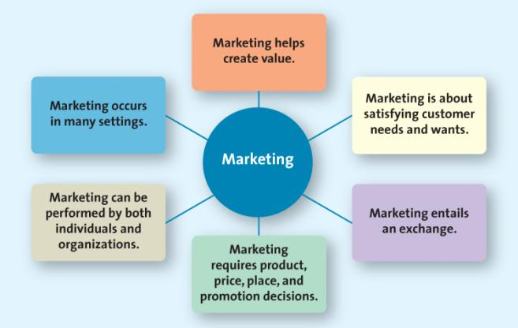

Marketing is About Satisfying Customer Needs and Wants*
- Need (basic necessities): when a person feels deprived of the basic necessities of life:
- Food
- Clothing
- Shelter
- Safety
- Want (how to fulfill that need): the particular way in which the person chooses to fulfill his or her need; shaped by a person’s:
- Knowledge
- Culture
- Personality
- A Market: the groups of people who need or want a company’s products or services and have the ability and willingness to buy them
- All the people (or businesses) that do buy or could buy a product (or service)
- To understand customer’s needs and wants
- Marketing costs company, good marketers carefully seek out potential customers who have both an interest in the product and an ability to buy it
- Target market: the customer segment or group to whom the firm is interested in selling its products and services (who are most likely to be interested in their offerings)

Marketing Entails and Exchange*
- Exchange: the trade of things of value between the buyer and the seller so that each is better off as a result
- Not only money for a good or service
Marketing Requires Marketing Mix Decisions*
- Marketing mix: product, price, place, and promotion—the controllable set of activities that a firm uses to respond to the wants of its target markets

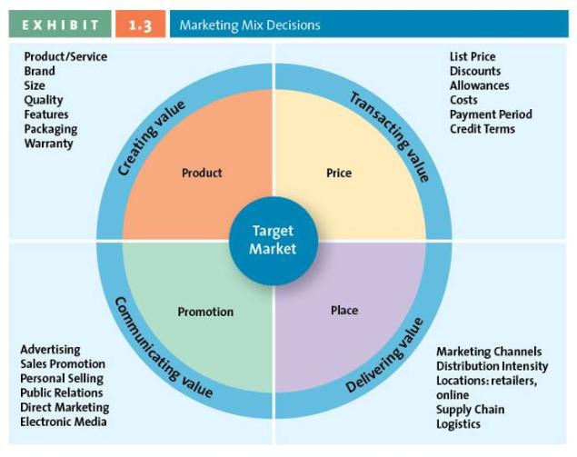
- Product: Creating Value
- The fundamental purpose of marketing is to create value by developing a variety of offerings
- Goods: items that can be physically touched
- Services: Intangible customer benefits that are produced by people or machines and cannot be separated from the producer
- Ideas: thoughts, opinions, philosophies, and intellectual concepts
- Price: Transacting Value
- The overall sacrifice a consumer is willing to make—money, time, energy—to acquire a specific product or service
- Everything the buyer gives up in exchange for the product
- Place: Delivering Value
- All the activities necessary to get the product from the manufacturer or producer to the right customer when that customer wants it
- Retailing and Marketing Channel/Supply chain management: the set of approaches and techniques that firms employ to efficiently and effectively integrate their suppliers, manufacturers, warehouses, stores, and other firms involved in the transaction into a seamless value chain
- In the right quantities, to the right locations, and at the right time
- Minimize system wide costs and satisfying the service levels required by the customer
- Promotion: Communicating Value
- Communication by a marketer that informs, persuades, and reminds potential buyers about a product or service to influence their opinions or elicit a response
- It can enhance a product or service’s value
- Used to inform, persuade and remind potential buyers
- Used to influence their opinions or elicit a response
Marketing Can Be Performed by Both Individuals and Organizations*
- Business-to-Consumer (B2C): the process in which businesses sell to consumers (retailors)
- Business-to-Business (B2B): the process of selling merchandise or services from one business to another
- Consumer-to-Consumer (C2C): the process in which consumers sell to other consumers
- Social Media: the use of digital tools to easily and quickly create and share content to foster dialogue, social relationships, and personal identities
- Organizing protesters(抗议者) and to report news of events in these countries to the rest of the world as the events unfolded in real time
Choosing a Value Proposition
- Value proposition: the set of benefits or values a company promises to deliver to customers to satisfy their needs
Making Impacts Many Stakeholders (non-profit sector)
- Communicating their messages to their constituents
- Hospitals
- Charities
- Museums
- Religious institutions
- Designed to benefit an entire industry/firms
Four Orientations of Marketing (Marketing Strategies):
- Product orientations (toothpaste)
- Focus on developing and distributing innovative products with little concern about whether the products best satisfy customers’ needs
- Consumers will buy the product if they believe it is the best
- Constant change to the product improves sales
- Start out by thinking about the product they want to build
- They try selling the product after it is developed rather than starting with an understanding of the customers’ needs and then developing a product to satisfy those needs
- Selling orientations
- View marketing as a selling function where companies try to sell as amny of their products as possible rather than focus on making products consumers really want
- Profits come from sales volume
- The product is fine as-is
- Advertising = Sales
- > Advertising > Sales
- Marketing Orientation (customer is the king)
- Focusing on what consumers want and need before they design, make, or attempt to sell their products and services
- They believe that customers have choice and make purchase decisions based on several factors
- Quality
- Convenience
- Price
- Focus is on consumer:
- Lifestyle
- Needs
- Wants
- Demands
- Goal: to develop a target market

- Value-based Orientation
- Value: the relationship of benefits to costs, or what the consumer gets for what he or she gives
- Firms must understand how each aspect of their product/service creates value for customers
- The goal is to find the most desirable balance between providing benefits to customers and minimizing costs
- Value CoCreation (价值共创): customers can act as collaborators to create the product or service
- The fundamental purpose of marketing is to create value for both the firm and customer; values is in essence what you get for what you give up
- To compete successfully, they focus on triple bottom line (provide with greater value than their competitors):
- People (consumer needs and wants)
- Profits (long-term profitable relationships with customers and suppliers)
- Planet (do all this in a way that is socially and environmentally responsible)
- Valuable benefits:
- Speed
- Convenience
- Size
- Accuracy
- Price
- Cost-savings
- User-friendliness
- Marketer’s Responsibility: Marketers must address the ethical implications of their actions on society in general

How do Firms Become More Value Driven? (Value-based marketing)
- Firms must constantly monitor the marketplace in order to create value
- Firms must offer customers something in excess of that being offered by the competitors
- Firms must understand how each aspect of their product/service creates value for customers
- Firms focus on four activities
- Sharing Information: in a value-based, market-oriented firm, marketers share information about customers and competitors that has been collected through customer relationship management, and integrate it across the firm’s various departments
- Balancing Benefits with Costs: use available customer data to find opportunities in which they can better satisfy their customers’ needs and in turn develop long-term loyalties
- Understand key benefits
- Focus on key benefits
- Eliminate cost of less strategic benefits
- Building Relationships with Customers (Customer relationship management)
- Relational orientation: a method of building a relationship with customers based on the philosophy that buyers and sellers should develop a long-term relationship
- Customer relationship management: increasingly used by marketers to ensure that data is transmitted throughout the firms
- Connecting with Customers Using Social and Mobile Media: connect better with customers, serve needs more effectively

Why is Marketing Important?
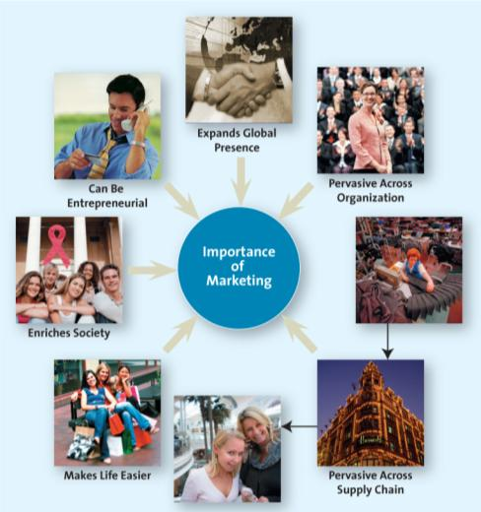
- Marketing Expands Firms’ Global Presence
- Good are available to consumers from many countries from the far reaches of the globe
- Must understand customers needs & wants
- Segment-by-segment, region-by-region
- Marketing is Pervasive Across marketing Channel Members
- Supply chain: the group of firms and set of techniques and approaches firms use to make and deliver a given set of goods and services
- All members in the chain must ultimately focus ton creating value for their customer and the end user consumer
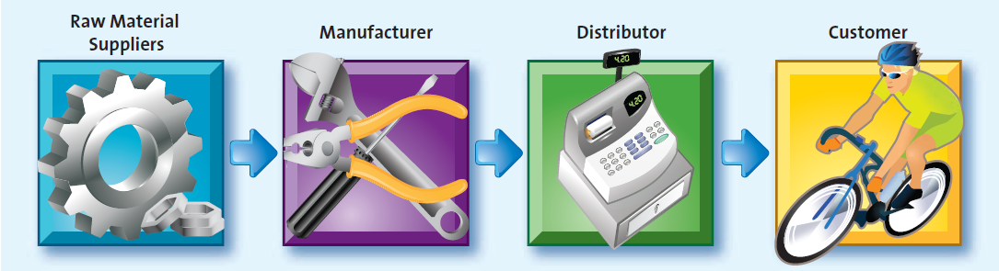
- Marketing Makes Life Easier and Provides Employment Opportunities
- Choices of products and services choices as well as information about those choices
- Employment in diverse fields such as research, sales, promotions, global marketing
- Marketing Enriches Society
- Investors view firms that operate with high levels of corporate responsibility and ethics as safe investments
- Good corporate citizenship through socially responsible actions should be a priority because it will help their bottom line in the long run
- Marketing Can be Entrepreneurial
- E,g. Tim Horton
- Great and distinguished entrepreneurs have a vision of how certain combinations of products and services can satisfy unfilled needs
- They find and understand a marketing opportunity
- Conduct a thorough examination of the market place
- Develop and communicate the value of their products and services to potential consumers

Chapter 2
What is a Marketing Strategy?
- Marketing Strategy identifies
- A firm’s target market
- A related marketing mix—the four Ps
- The bases upon which the firm plans to build a sustainable competitive advantage
- Competitive advantage: doing things better than competitors
- Sustainable competitive advantage: an advantage over the competition that is not easily copied and thus can be maintained over a long period of time
- Developing customer value & sustainable competitive advantage
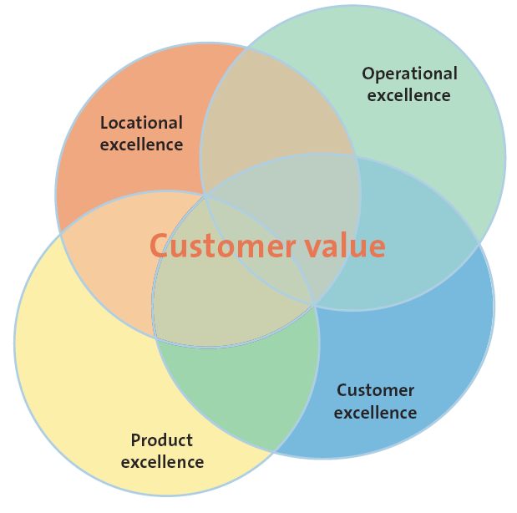

- Four overarching strategies that focus on aspects of the marketing mix to create and deliver value and to develop sustainable competitive advantages
- Customer Excellence: focuses on retaining loyal customers and excellent customer service
- Retaining Loyal Customers
- Having a strong brand
- Unique merchandise
- Superior customer service all help solidify a loyal customer base
- To create an emotional attachment through loyalty programs
- Customer Service
- Once a marketer has earned a good service reputation, it can sustain this advantage for a long time because a competitor is hard pressed to develop a comparable reputation
- Operational Excellence (Starbucks): achieved through efficient operations and excellent supply chain and human resource management
- Efficient operationsExcellent supply chain managementStrong supplier relationships
- They unsure good value to their customers
- Earn profitability for themselves
- Satisfy their customers’ needs
- Enable firms to provide their consumers with lower –priced merchandise
- Achieve efficiencies:
- Developing sophisticated distribution
- Information systems
- Strong relationships with vendors (gain exclusive rights)
- Sell merchandise in a particular region
- Obtain special terms of purchase that are not available to competitors
- Receive popular merchandise that may be in short supply
- Product Excellence: having products with high perceived value and effective branding and positioning
- Investing in their brand itself
- Positioning their product or service by using a clear, distinctive brand image
- Constantly reinforcing that image through their merchandise, service, and promotion
- Apple: understanding customer needs and satisfying those needs
- Locational Excellence: having a good physical location and Internet presence (it is not easy to duplicate)
- The three most important things in retaining are location

- Multiple sources of advantage: low prices or excellent service is not sufficient to build a sustainable competitive advance

The Marketing Plan
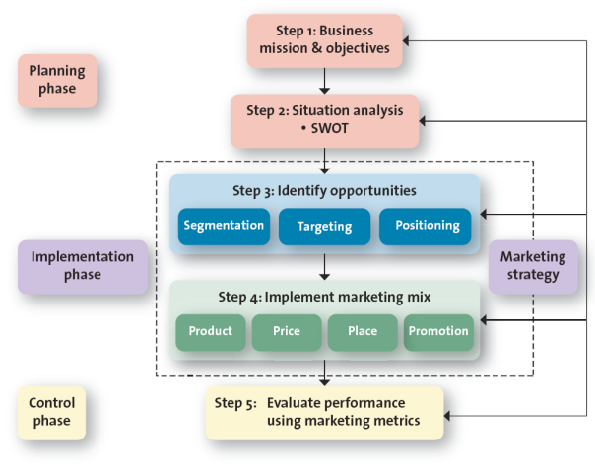
- Planning Phase: where marketing executives and other top managers define the mission and objectives of the business, and evaluate the situation by assessing how various players, both inside and outside the organization affect the firm’s potential for success
Step 1: Defining the Mission and Objectives
- Mission statement: a broad description of a firm’s objectives and the scope of activities it plans to undertake
- E.g. Starbucks; Petro; Google
- Importance of mission statement to marketing:
- Importance of marketing to mission statement:
- Marketing is a public face
Step 2: Conduct a Situation Analysis Using SWOT
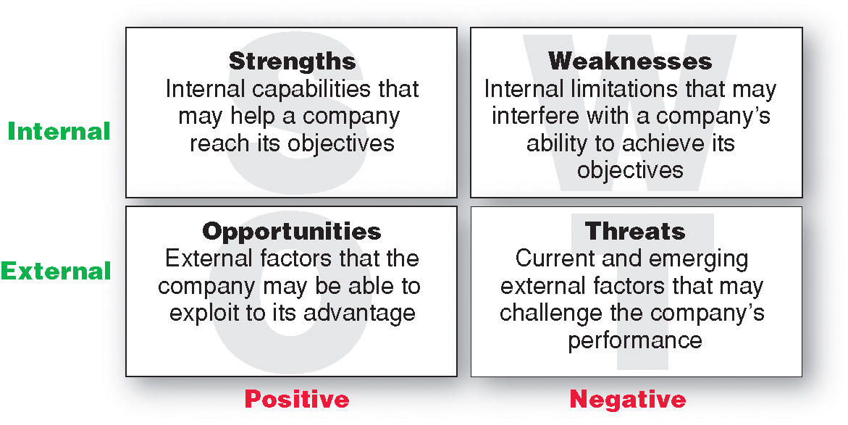
- Strengths & Weakness (Internal): the firm will be better positioned to address weaknesses and deal with threats arising from its eternal business environment
- Opportunities & Threats (External): the firm can decide only how it wants to respond
- SWOT: to help the firm determine areas in which it is strong and can compete effectively and areas where it is weak and vulnerable to competitive attacks
- Strengths: Positive internal attributes of the firm
- Weakness: negative attributes of the firm
- Opportunities: positive aspects of the external environment
- Threats: the negative aspects of the company’s external environment
- Also includes an examination of market trends, customer analysis, and competitive analysis
- The firms should assess the opportunities and uncertainties of the marketplace due to changes in CDSTEP
- Cultural
- Demographic
- Social
- Technological
- Economic
- Political forces
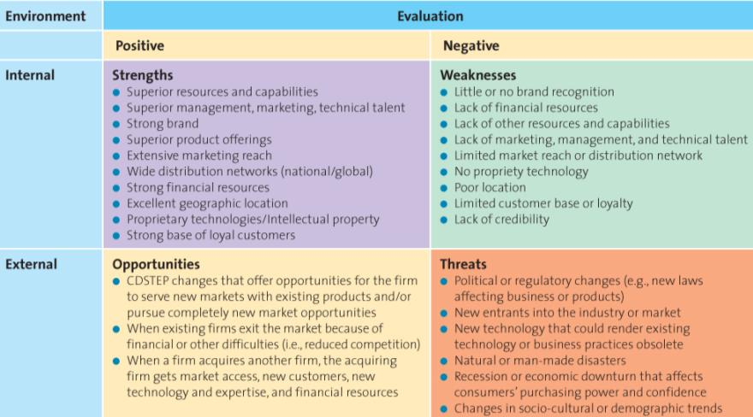
- Implementation Phase: where marketing managers identify and evaluate different opportunities by engaging in a process known as segmentation, targeting, and positioning. They then develop and implement the marketing mix by using the four Ps.
Step 3: Identify and Evaluating Opportunities Using STP
- The firm must first
- Understand customer needs and wants through market research,
- Divide the market or customers into distinct subgroups or segments,
- Determine which of those segments it should pursue or target,
- Finally decide how it should position its products and services to best meet needs of those chosen targets
- Segmentation: the process of dividing the market into distinct groups of customers, each group having similar needs, wants, or characteristics, who might appreciate products or services geared especially for them in similar ways
- Market segment: a group of consumers who respond similarly to a firm’s marketing efforts
- Targeting: evaluating the attractiveness of various segments and then deciding which to pursue as a market
- Positioning: how a firm wants to be positioned in those segments it has decided to pursue
- This involves defining the marketing mix variables (4Ps: product, price, place, promotion)

Step 4: Implement Marketing Mix (aka4Ps) and allocate Resources
- The real actions begin
- It makes important devisors about how it will allocate tis scarce resources to its various products and services
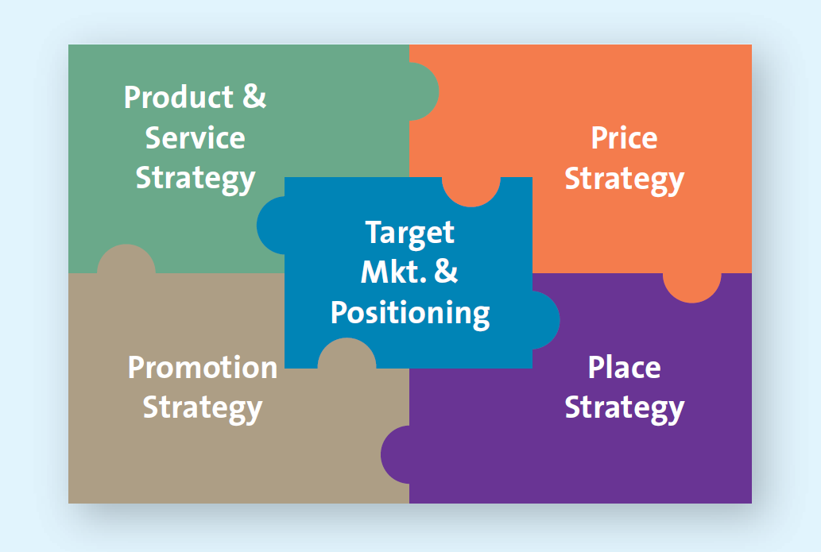

- Product and Value for Creation: the key to success of any marketing program is the creation of value, firms attempt to develop products and services that customers perceive as valuable enough to buy
- Price and Value for Money: price should be based on the value the customer perceives
- It is important for firms to have a clear focus in terms of what products to sell, where to buy them, and what methods to use in selling them
- Place and Value Delivery
- Product must be readily accessible
- Direct vs. Indirect
- ManufacturerConsumer
- ManufacturerRetailerConsumer
- ManufacturerWholesalesRetailerConsumer
- Intensity:
- Intensive (Kraft, Pepsi)
- Exclusive (Rolex)
- Selective (Seiko)
- Promotion and Value Communication
- Through variety of media
- Television
- Radio
- Magazines
- Sales force
- New Media
- Increasing number of companies are using the Internet and their own websites to advertise and communicate with their customers and build closer relationships
- In addition to developing the four Ps and allocation resources, karketing managers must develop schedules
- Timelines for each activity and the personnel responsible for the respective activity to avoid bottlenecks
- Ensure smooth and timely implementation of the marketing mix activities
- Marketers must design the organization that will be responsible for putting the plan into action
- In most established companies, the marketing organization already exists and marketing managers must simply assign responsibilities to various employees within the marketing department
- The marketing organization is usually responsible for the day-to-day operational decisions involved in executing the plan

- Control Phase: the part of the strategic marketing planning process when managers evaluate the performance of the marketing strategy and take any necessary corrective actions
The Strategic Marketing Planning Process
- Do not need to go through the entire process for every evaluation
Step 5: Evaluate Performance and Make Adjustments by Using Marketing Metrics
- A metric is a measuring system that quantifies a trend, dynamic, or characteristic; used to explain why things happened and to project the future
- Make it possible to compare results across regions, business unties, product lines, and time periods
- Determining why it achieved or did not achieve its performance goals
- Understanding the causes of the performance, regardless of whether that performance exceeded, met, or fell below the firm’s goals, enables firms to make appropriate adjustments
- Who is accountable for performance?
- Expense: affect both labor and capital expenses associated with operating a corporate headquarters
- Sales: associate productivity, and energy costs
- Performance evaluations are used to pinpoint problem areas
- Performance Objectives and Metrics
- To compare a firm’s performance over time or to competing firms, using common financial metrics such as sales and profits
- Assessing performance is to view the firm’s products or services as a portfolio
- Financial Performance Metrics
- Revenues
- Sales
- Profits
- Managers must understand how their actions affect multiple performance metrics
- A firm may wish to measure the relative level of sales and profits
- Depending on:
- The level of the organization at which the decision is made
- The resources the manager controls
- Social Responsibility Performance Metrics
- Their impact on the environment
- Their ability to diversify their workforce
- Their energy conservation initiatives
- Their policies on protecting the human rights of their employees and the employees of their suppliers
- Strategy Planning Is Not Sequential
- Portfolio Analysis (组合分析): management evaluates the firm’s various products and businesses—its “portfolio”—and allocates resources according to which products are expected to be the most profitable for the firm in the future
- Typically perform at Strategic business unit/product line
- SBU: a division of the company that can be managed somewhat independently from other divisions since it markets a specific set of products to a clearly defined group of customers
- Product line: a group of products that consumers may use together or perceive as similar in some way
- Relative market share: a measure of the product’s strength in a particular market, defined as the sales of the focal product divided by the sales achieved by the largest firm in the industry
- Market growth rate: the annual rate of growth of the specific market in which the product competes
- Stars: often require a heavy resource investment in things (promotions/new production facilities) to fuel their rapid growth
- Cash cows: these products have already received heavy investments to develop their high market share, they have excess resources that can be spun off to those products that need it
- Question marks: often the most managerially intensive products in that they require significant resources to maintain and potentially increase their market share
- Dogs: they may generate enough resources to sustain themselves, but are not destined for stardom and should be phased out unless they are needed to complement or boost the sales of another product or for competitive purposes
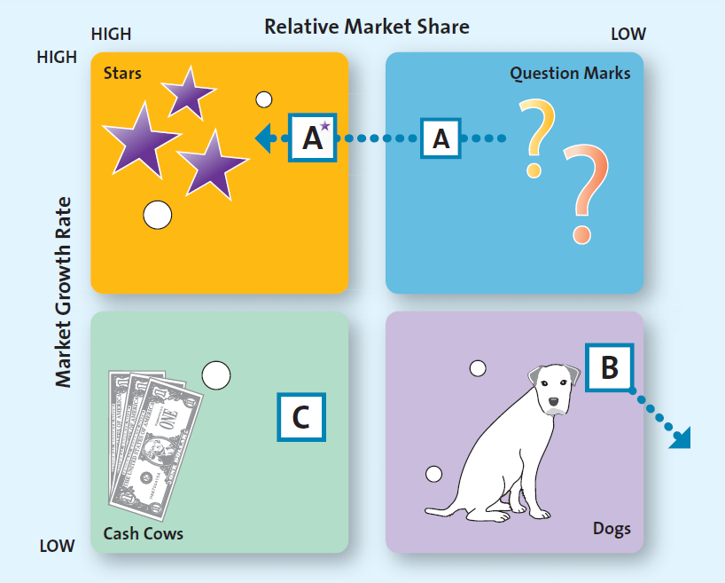

Growth Strategies
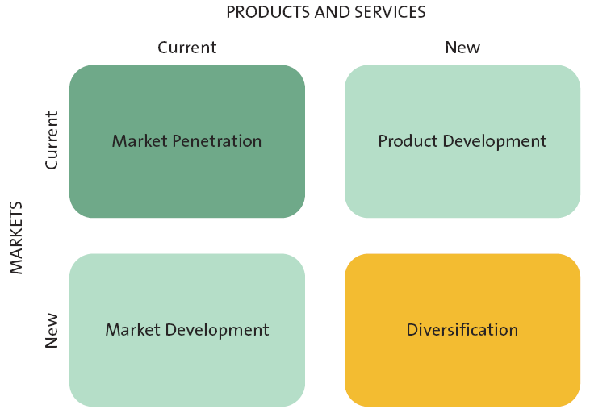

- Market Penetration: employs the existing marketing mix and focuses the firm’s efforts on existing customers
- Require greater marketing efforts (increased advertising, additional sales and promotions, or intensified distribution efforts in geographic areas in which the product or service is already sold)
- The easiest to implement since it focuses on promoting existing products to existing customers
- Market Development Strategy: employs the existing marketing offering to reach new market segments, whether domestic or international or segments not currently served by the firm
- Risker: differences in government regulations, culture traditions, supply chain considerations, and language
- Marketers have experience with one element and must learn the other element
- Product Development: offers a new product or service to a firm’s current target market
- Marketers have experience with one element and must learn the other element
- Diversification: a firm introduces a new product or service to a market segment that does not currently serve
- Related Diversity: the current target market and/or marketing mix shares something in common with the new opportunity
- Unrelated Diversity: do not capitalize on either core strengths associated with markets or with products; they would be viewed as very risky
- Requires marketers to go outside both their current products and markets, and the risks of making mistakes are substantially greater with this strategy
- Downsizing: exiting markets, reducing product portfolios, or closing certain businesses or store or plant locations
- They have entered new markets where they have little or no experience
- Diversified into markets or products that do no quite fit with current products, markets, or capabilities
- Developed products that offer very little value for customers
- Encountered declining demand for some products

Chapter 3
Analyzing the Marketing Environment
- At the heart of the marketing environment is the consumer
- Consumers are influenced by many things:
- Actions of the focal company
- Actions of company’s competition
- Actions of corporate partners in the supply chain
- Actions of the Company/ Competitors
- Pricing
- Advertising
- Ethics
- Social responsibility
- Depiction by the press
- Quality assurance
- Actions of Corporate Partners in the Supply Chain
- Quality
- Reliability
- Timeliness
- Conflict
- Ethics
- Social responsibility
- Relationship with other partners

Marketing Environment Analysis Framework
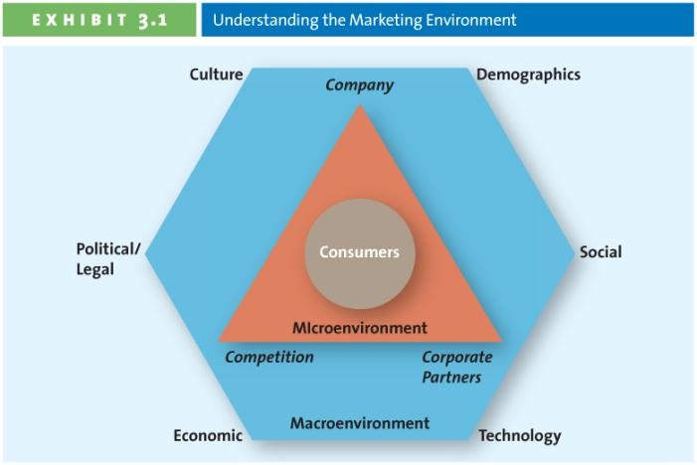

Microenvironment
- Experts and design; distribution
- Company Capabilities
- Core competency = Satisfy customer needs
- Existing knowledge, facilities, patents, etc. New markets, new products, etc.

Leverage Core competency: good at existing knowledge, facilities, patents; and apply to new markets, new products

What are the core competencies of Rolex?
- Manufacture: hand-made
- Huge brand name
- Distribution: control tied
- Promotion of their brand

- Competitors:
- Identify and analyze direct and indirect competitors
- Know strengths & weakness
- Greater competition more choices for consumers, which influences their buying decisions
- Competitive Intelligence (CI): used by firms to collect and synthesize information about their position with respect to their rivals: enables companies to anticipate changes in the marketplace rather than merely react to them
- Sending an employees to a competitive store to check merchandise prices, traffic
- Other more sophisticated methods
- Reviewing public materials, including websites, press release, industry journals, annual reports, subscription databases, permit applications, patent applications, and trade shows
- Interviewing customers, suppliers, partner, or former employees
- Analyzing a rival’s marketing tactics, distribution practices, pricing, and hiring needs
- Corporate Partners
- Firms are part of alliances
- Align with competitors, suppliers
- Just-in-time Delivery Systems (JIT)
- Inventory: contain huge costs
Macro-environmental Factors*
- Culture: the shared meanings, beliefs, morals, values, and customs of a group of people
- Country culture: easy-to-spot visible nuances that are particular to a country, such as dress, symbols, ceremonies, language, colors, and food preferences, and more subtle aspects, which are trickier to identify
- Regional culture: the region in which people live in a particular country affects the way they react to different cultural rituals, or even how they refer to a particular product category
- Shared meanings, beliefs, morals, values, and customs of a group of people
- Transmitted by words, literature, and institutions; passed down from generation to generation and learned over time
- A multiple dimension models of national culture (5)
- Power distance
- Uncertainty avoidance
- Individualism-collectivism
- Masculinity-femininity
- Long-term vs. Short-term orientation

USA vs. Japan
- A masculine society: aggressive, competitive, gender based roles (same for both)
USA vs. Singapore
- Low uncertainty avoidance: deviating from the norm is acceptable
National Culture Differences (meanings for marketing):
- Different marketing mix (product, price, place, promotion)
- Different marketing strategy
- Different timelines
- Different micro and macro-environmental factors

- Demographics: the characteristics of human populations and segments especially those used to identify consumer markets
- Provides an easily understood snapshot of the typical consumer in a specific target market
- Age: generation cohorts: a group of people of the same generation have similar purchase behaviors because they have shared experiences and are in the same stage of life
- Tweens: generational cohort of people who are not quite teenagers but are not young children either (9-12); they are in between
- Lighting speed; digital natives
- Food and drinks, electronics and clothing
- Generation Y/Millennials/”Echo boom”: generational cohort of people born between 1972 and 1992; the biggest cohort since the original postwar baby boom (27% of Canadian population)
- More media-intensive and brand-conscious era than their parents
- Internet and technology savvy and love digital electronics such as cellphones, digital music players, digital cameras, and video games
- Emphasis on balancing work
- Generation X: generational cohort of people born between 1966 and 1971 (8%)
- First generation of latchkey kids (those who grew up in homes in which both parents worked)
- Economic recessions
- Higher debt loads, travel the world, and move far away from their parents
- Less interest in shopping than their parents
- Less interested in status products than older generations (don’t see the points)
- Baby Boomers: generational cohort of people born after World War II until 1965 (30%, largest)
- Individualistic
- Leisure time is high priority for them
- Believe that they will always be able to take care of themselves, partly driven by their feeling or economic security, even though they are a little careless about the way they spend their money
- Having an obsession with maintaining their youth
- Always love rock ‘n’ roll
- Seniors: North America’s fastest-growing generational cohort, people aged 65 and older
- Travel
- Homes
- Luxury cars
- Electronic equipment
- Investments
- Home furnishings
- Clothing
- Income (purchasing power)
- Upper class: very affluent, and their spending patterns not influenced by economic conditions (48%)
- Middle class: they can afford a good life most of the time; tend to be careful about their spending and are often values conscious (38%)
- Working-class/low-income families: barely sufficient income to cover their basic needs
- Underclass
- Education (relate to income): high education lead to better jobs and higher incomes
- For some products, marketers can combine education level with other data such as occupation and income to obtain quite accurate predictions of purchase behavior
- Gender: affects the way many firms design and promote their products and services
- Ethnicity
- The growing number of ethic groups or visible minorities represents both a challenge and a marketing opportunity
- Challenge: to understand the culture, value, and spending patterns of the various groups and determine the best way to communicate and serve them
- Much of the growth will from ethnic markets
- Choosing ethnic-targeted media to advertise
- Celebrating ethnic holidays with events, promotions and seasonal products
- Offering ethic merchandise for sale and ensuring it is merchandised correctly
- Technological advances: impacted every aspect of marketing
- Technological changes that have contributed to the improvement of the value of both products and services in the past few decades
- Advanced technology make consumers increasingly dependent on the help they can provide, especially in terms of making decisions and communicating with others
- Mobile devices enhance the customers experience by making it easier to interact with the manufacturer or retailer or other customers, and they add a new channel of access which makes customers more loyal and more likely to spend more with a particular retailer
- Different technology adoption levels also matter to marketers when communicating a new product or using a new media type
- New products
- New forms of communication
- New retail channels
- Economic situation
- Economic changes that affect the way consumers buy merchandise and spend money; see inflation, foreign currency fluctuations, interested rates, and recessions
- Foreign currency fluctuations
- Combined with inflation and interest rates affect a firm’s ability to market goods and services
- Inflation: refers to the persistent increase in the prices of goods and services
- Foreign currency fluctuations: changes in the value of a country’s currency relative to the currency of another country; can influence consumer spending.
- Interest rate: represent the cot of borrowing money
- Recession: a period of economic downturn when the economic growth of the country is negative for at least two consecutive quarters
- Consumers alter their spending patterns by postponing big-ticket or discretionary items and look for the best deals for items they need
- Most marketers cut costs,
- Lower prices to keep their existing customers
- To attract new customers
- May even introduce slightly lower quality goods
- Reduce the level of services offered in order to manage costs
- Shifts these four factors make marketing easier for some and harder for others
- Inflation consumers probably don’t buy less food; but shift their expenditures form expensive steaks to less-expensive hamburgers
- Interest rate more consumers to borrow to finance purchases
- Political/Regulatory environment
- Comprises political parties, government organizations, and legislation and laws that promote or inhibit trade and marketing activities
- Competition Act
- Consumer Packaging and Labeling act
- Food and drugs act
- Access to information act
- Patent ActNorth American Free Trade Agreement (NAFTA)
- Legislation
- Regulations require manufacturers to abstain from false or misleading advertising practices that might mislead consumers
- Manufacturers are required to identify and remove any harmful or hazardous materials that might place a consumer at risk
- Organizations must adhere to fair and reasonable business practices when they communicate with consumers
- The government enacts laws focused on specific industries and on consumers
- Social Trends
- These trends tend to change over time in their popularity and importance, and savvy marketers work hard to identity emerging trends to understand whether they present an opportunity or pose a threat to their business
- Greener consumers: who appreciate the efforts of companies to supply them with environmentally friendly merchandise
- Many consumers, concerned about everything from the purity of air and water to the safety of beef and salmon, believe that each person can make a difference in the environment
- Marketing to children
- Privacy concerns
- Loss of privacy
- Identity theft
- Do not call
- Do not e-mail
- Time-poor society
- In the majority of families, most parents work
- Consumers have many more choices regarding leisure
- Many consumers multitask
- Health and Wellness Concerns
- Health concerns, especially those pertaining to children, are prevalent, critical, and widespread

Consumers’ demands

Chapter 16
The 4e framework for social media
- Excite
- Educate
- Experience
- Engage
- ActionLoyaltyPotential relationshipCommitment
Categories of Social Media*
- Social network sites: create excitement (purpose)
- Facebook
- LinkedIn
- Google+
- Media-sharing sites: enable users to share content they have generated
- YouTube
- Photo Sites
- Thought0sharing sites: sites that contain different types of blogs
- Corporate professional personal micro

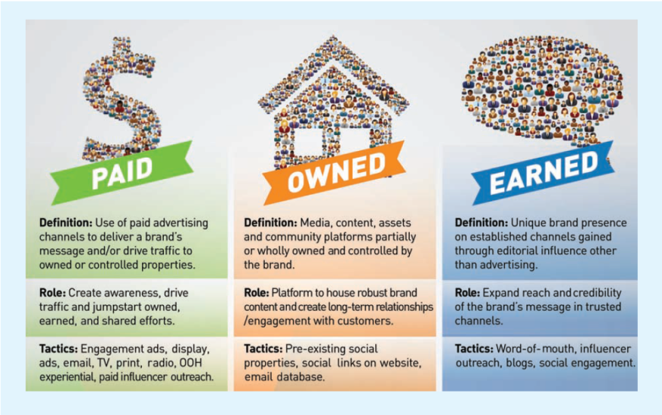
- Paid
- Owned
- Earned Media

Understanding mobile applications
- Create excitement for consumers at sale time
- Engaging customers using customers using social media
- Listen: listen to what your customers are saying & monitor it frequently
- Analyze
- Used
- Site traffic
- Who is visiting the site & what is important to them
- Keyword analysis
- Types
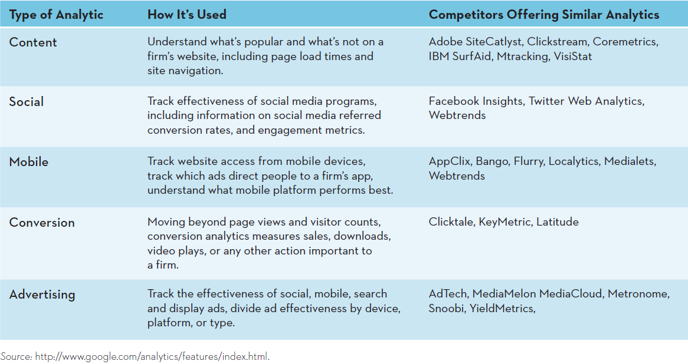
- Do: doing is implementing what has been learned from analyzing social & mobile media activity

Ethical considerations

Chapter 4
The Consumer Decision Process
- Step 1: Need Recognition: the beginning of the consumer decision process; occurs when consumers recognize they have an unsatisfied need and want to go from their needy state to a different, desired state
- Functional needs: pertain to the performance of a product or service
- Psychological needs: pertain to the personal gratification consumers associate with a product or service
- A key to success: determining the correct balance of functional and psychological needs that best appeals to the firm’s target markets
- Step 2: Information Search
- The length and intensity of the search are based on
- The degree of perceived risk associated with purchasing the product or service
- Importance of the product to the consumer
- Internal search for information: occurs when the buyer examines his or her own memory and knowledge about the product or service, gathered through past experiences
- External search for information: occurs when the buyer seeks in formation outside his or her personal knowledge base to help make the buying decision
- Friends, family
- Commercial media
- Magazines
- TV
- Internet
- Social media
- Factors affecting consumers’ search process
- Perceived benefits & Perceived Costs: is it worth the time and effort to search for information about a product or service?
- Internal locus of control: more search activities; refers to when consumers believe they have some control over the outcomes of their actions, in which case they generally engage in more search activities
- External locus of control: fate, external factors = why bother (cannot control); refers to when consumers believe that fate or other external factors control all outcomes
- Five types of risks:
- Performance risk: involves the perceived danger inherent in a poorly performing product or service
- Financial risk: risk associated with a monetary outlay; includes the initial cost of the purchase, as well as the costs of using the time or service
- What if it leaks?
- What if I somehow void the warranty?
- What if the component fail
- Social risk: the fears that consumers suffer when they worry others might not regard their purchases positively
- Physiological risk/safety risk: risk associated with the fear of an actual harm should the product not perform properly
- Psychological risk” associated with the way people will feel if the product odes not convey the right image
- Type of product or service
- Shopping goods/services
- Specialty goods/services
- Convenience goods/services
- Step 3: Alternative Evaluation
- Evaluative Criteria: consist of a set of salient, or important, attributes about a particular product that are used to compare alternative products
- How do consumers begin to evaluate different alternatives, and what important attributes and criteria do they use?
- Functional
- Decision heuristics: mental shortcuts that help consumers narrow down choices
- Price
- Product presentation
- Brand
- Determinant Attributes: product or service features that are important to the buyer and on which competing brands or store are perceived to differ (food and beverages marketed)
- Consumer decision rules: the set of criteria consumer use consciously or subconsciously to quickly and efficiently select from among several alternatives
- Compensatory decision rule: is at work when the consumer is evaluating alternatives and trades off one characteristic against another
- Non-compensatory decision rule: is at work when consumers choose a product or service on the basis of a subset of its characteristics, regardless of the values of its other attributes
- Step 4: Purchase Decision
- Ritual consumption: refers to a pattern of behaviors tied to life events that affect what and how people consume
- Post-purchase Evaluation: actual rather than potential customers
- Customer satisfaction
- Steps to ensure post purchase satisfaction
- Build realistic expectations
- Demonstrate correct product use
- Stand behind the product or service by providing money-back guarantees and warranties
- Encourage customer feedback, which cuts down on negative word-of-mouth and helps marketers adjust their offerings
- Periodically make contact with customers and thank them for their support
- Post purchase Dissonance: an internal conflict that arises from an inconsistency between two beliefs, or between beliefs, and behavior; buyer’s remorse
- Firm’s attempt to reduce dissonance by reinforcing the decision
- Thank you letters, congratulations letters, quality ratings.
- Customer Loyalty: develops over time with multiple repeat purchases of the product or brand from the same marketer
- Undesirable consumer behavior
- Negative word-of-mouth: occurs when consumers spread negative information about a product service, or store to others
Factors influencing the consumer decision process
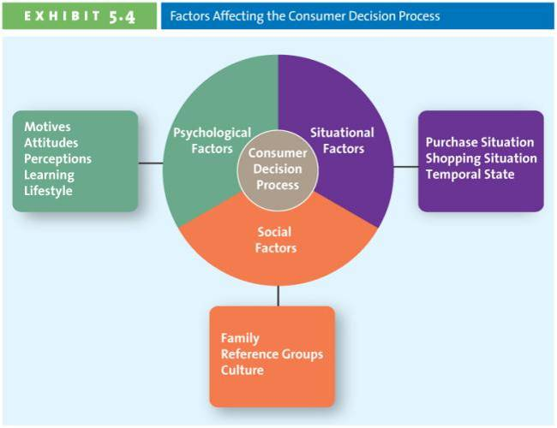
- Psychological Factors
- Motives: a need or want that is strong enough to cause the person to seek satisfaction
- Physiological (food, water): relate to the basic biological necessities of life
- Safety (secure employment, health): pertain to protection and physical well-being
- Love (friendship, family): relate to our interactions with others
- Esteem (confidence, respect): allow people to satisfy their inner desires
- Self-actualization (people engage in personal growth activities and attempt to meet their intellectual, aesthetic, creative, and other such needs): occurs when you feel completely satisfied with your life and how you live
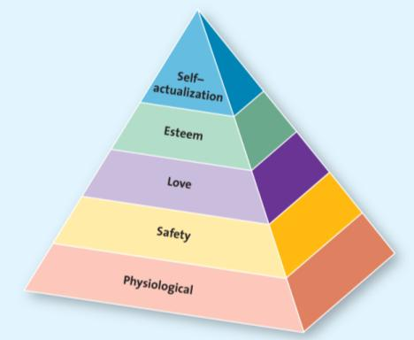
- Attitudes: a person’s enduring evaluation of his or her feelings about and behavioral tendencies toward an object or idea; consists of three components
- Cognitive: a component of attitude that reflects what a person believes to be future
- Affective: a component of attitude that reflects what a person feels about the issue at hand – his or her like or dislike of something
- Behavioral: a component of attitude that comprises the actions a person takes with regard to the issue at hand
- Perceptions: the process by which people select, organize, and interpret information to form a meaning full picture of the world
- Selective exposure
- Selective attention: consistent with their beliefs and not others
- Selective comprehension: when consumers interpret a marketing message in a way that is different from what the marketer intends
- Selective retention: consumers do not remember all the information they see, read, or hear
- Learning: refers to a change in a person’s thought process or behavior that arises from experience and takes place throughout the consumer decision process
- Lifestyle: refers to the way consumer spend their time and money
- Social Factors:
- Family
- Decision makers
- Influencers
- Reference groups: one or more persons an individual uses as a basis for comparison regarding beliefs, feelings, and behaviors
- Groups
- Family
- Friends
- Coworkers
- Famous people
- Reference groups affect buying decisions by
- Offering Information
- Providing rewards for specific purchasing behaviors
- Enhancing a consumer’s self-image
- Culture
- Situational Factors: factors affecting the consumer decision process; those that are specific to the purchase and shopping situation and temporal state that may override, or at least influence, psychological and social issues
- Purchase situation: customers predisposed to purchase certain products or services because of some underlying psychological trait or social factor (thriftiness)
- Shopping situation
- Store atmosphere
- Salesperson
- Crowding
- Promotions
- In-store demonstrations
- Packaging
- Temporal state: our state of mind at any particular time can alter our preconceived notions of what we are going to purchase
Involvement and Consumer Buying Decisions
- Involvement: the consumer’s degree of interest or concern in the product or service
- Extended problem-solving: a purchase decision process during which the consumer devotes considerable time and effort to analyzing alternative often occurs when the consumer perceives that the purchase decision entails a great deal of risk
- Limited problem-solving: occurs during a purchase decision that calls for, at most, a moderate amount of effort and time
- Impulse buying: a buying decision made by customers on the spot when they see the merchandise
- Habitual decision making: a purchase decision process in which consumers engage with little conscious effort

Chapter 5
- B2B Marketing: to other institution; the process of buying and selling goods or services to be used in the production of other goods and services, for consumption by the buying organization, or for resale by wholesalers and retailers
- Distinction (B2B & B2C): who is the end user
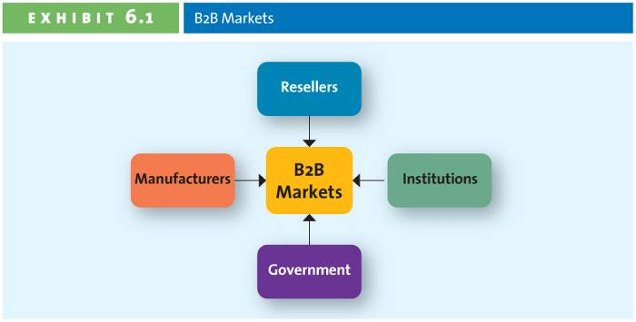

- Manufacturers or Producers (Airbus)
- Buy raw materials, components or parts
- Manufacture their own goods
- Resellers: marketing intermediaries that resell manufactured products without significantly altering their form
- Manufacturer
- Reseller
- Retailer
- Wholesalers
- Distributors
- Institutions
- Schools
- Museums
- Religious
- Organizations
- Government: one of the largest purchasers of goods and services
- Buying goods and services
- Takes a long time to support government
- Key challenges of reaching B2B clients
- To identify the right persons or decision makers within the organizations who can authorize or influence purchases
- Marketers must understand the buying process of each potential client
- To identify the factors that influence the buying process of potential clients
- Characteristics of Business Markets (difference between business and consumer markets)
- Market characteristics
- Derived demand: the linkage between consumers’ demand for a company’s output and its purchase of necessary inputs to manufacture or assemble that particular output
- Demand of business products is derived, fluctuates more, and more frequently
- Fewer customers, more geographically concentrated, and orders are larger
- Demand is more inelastic
- Product characteristics
- Products are technical in nature and purchased based on specifications
- Mainly raw and semifinished goods are purchased
- Heavy emphasis is placed delivery time, technical assistance, after-sale service, and financing assistance
- Price
- Delivery liability

- Buying process characteristics
- Buying decision is more complex
- Buying may involve competitive bidding, negotiated pricing, and complex financial arrangements
- Buying involves qualified, professional buyers who follow a more formalized buying process
- Buying criteria and objective are specified as are procedures for evaluating and selecting vendors and products
- Multiple people with varied interests participate in purchase decisions
- Reciprocal arrangements exist, and negotiations between buyers and sellers are common
- Marketing mix characteristics (4Ps)
- Direct selling is the primary form of selling and physical distribution is often essential
- Advertising is technical in nature and promotions emphasize personal selling
- Price is often negotiated, inelastic, frequently affected by trade and quantity discounts. Price usually include a service or maintenance component
B2B Buying Process
- Need recognition
- Can be generated internally or externally
- Source for recognizing new needs:
- Supplies
- Salespeople
- Competitors
- Product specifications
- Considers alternative solutions and comes up with potential specifications that suppliers might use to develop their proposals to supply the productcan be done collaboratively with suppliers
- Request for proposal (RFP)
- A process through which buying organizations invite alternative suppliers to bid on supplying their required components
- Allows supplier to understand specification;
- Proposal analysis, vendor negotiation and selection
- Evaluate all the proposals it receives in response to its RFP
- Often several vendors are negotiation against each other
- Considerations other than price play a role in final selection
- Order specification
- Places orders with preferred suppliers
- Include details of goods, prices, delivery dates, penalties if the order is not filled on time
- All terms are detailed including payment
- Vendor analysis
- Analyze their vendors’ performance so they can make decisions about their future purchases

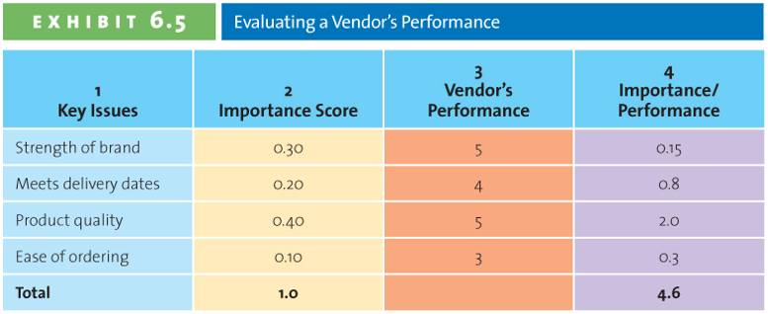

Factors affecting the buying process

- The Buying Center: the group of people typically responsible for the buying decisions in large organizations
- Initiator: the buying center participant who first suggests buying the particular product or service (your doctor)
- Influencer: the buying center participant whose views influence other members of the buying center in make the final decision (the medical device supplier, the pharmacy)
- Decider: the buying center participant who ultimately determines any part of or the entire buying decision – whether to buy, what to buy how to buy, or where to buy )the hospital)
- Buyer: the buying center participant who handles the paperwork of the actual purchase (the hospital’s materials manager)
- User: the person who consumers or uses the product or service purchased by the buying center (the patient)
- Gatekeeper: the buying center participant who controls information or access to decision makers and influencers (the purchasing department)
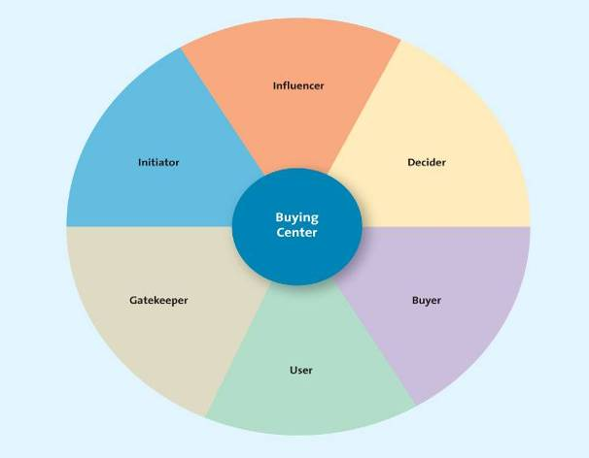

- Organizational Culture: reflects the set of values, traditions, and customs that guides a firm’s employees’ behavior (organizational buying culture)
- Autocratic buying centre: a buying centre in which one person makes the decision alone, though there may be multiple participants
- Democratic buying centre: the buying centre in which the majority rules in making decisions
- Consultative buying centre: a buying centre in which one person makes the decision, but he or she solicits input from others before doing so
- Consensus buying centre: a buying centre in which all members of the team must reach a collective agreement that they can support a particular purchase
- Common features:
- Distinction
- Identity
- Commitment
- Standard
- Diving force
- Buying Situations
- New buy: a purchase of a good or service for the first time; the buying decision is likely to be quite involved because the buyer or the buying organization does not have any experience wit the item
- Modified rebuy: refers to when the buyer has purchased a similar product in the past but has decided to change some specifications, such as the desired price, quality level, customer service level and options
- Straight rebuy: refers to when the buyer o buying organization simply buys additional units of products that had previously been purchased

Chapter 6
Segmentation Targeting and Positioning (STP)
- Process
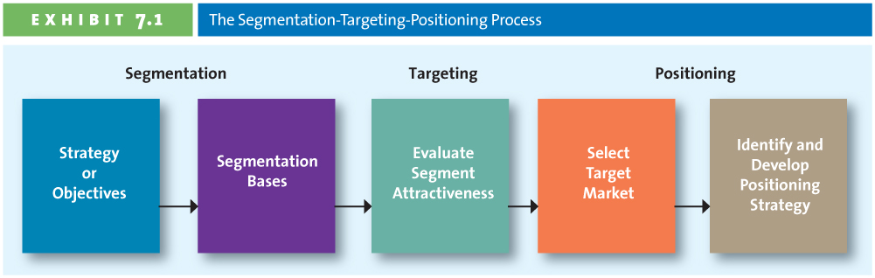

Step 1: Establish Overall Strategy or Objectives
- To articulate the mission and the objectives of the company’s marketing strategy clearly
Step2: Profile segments
- Geographic: the grouping of consumers on the basis of where they live
- Divide market into separate geographic units
- Countries, regions provinces, cities, neighborhoods, climate, etc.
- Develop appropriate marketing programs
- Demographic: the grouping of consumers according to easily measured, objective characteristics
- People who have the same demographic may have different lifestyle
- Most common method
- Divide market into groups based on:
- Gender
- Age
- Ethnic group
- Family lifecycle stage
- Household type
- Income
- Other, e.g. occupation, education, religion
- Psychographic: the segmentation base delves into how consumers describe themselves; allows people to describe themselves by using those characteristics that help them chose how they occupy their time (behavior) and what underlying psychological reasons determine those choices
- How consumers describe themselves
- Self-values: life goals that refer to overriding desires that drive how a person lives his/her life
- Cause people to develop self-images of how they want to be and then determine a way of life that will help them arrive at these ultimate goals
- Self-respect
- Self-fulfillment
- Sense of belonging
- Self-concept: the image people have of themselves
- Fun-loving
- Serious
- Studios
- Intelligent
- Academic
- Lifestyles: the ways we live (conjunction with other segmentations)
- Healthy
- Balanced to achieve our goals
- Behavioral: groups consumers based on the benefits they derive from products or services, their usage rate, their loyalty and the occasion
- User status
- Usage Rate
- Loyalty: strategy of investing in retention and loyalty initiatives to retain the firm’s most profitable customers
- Occasion segmentation: groups consumers based on when they purchase or consume a product or service
- Benefits Sought: groups consumers based on the benefits they derive from products or services
- Multiple Segmentation Methods
- Geodemographic segmentation: the grouping of consumers on the basis of a combination of geographic, demographics, and lifestyle characteristics
- PSYTE clusters: the grouping of all neighborhoods in Canada into 60 different lifestyles clusters

Step 3: Evaluation Segment Attractiveness
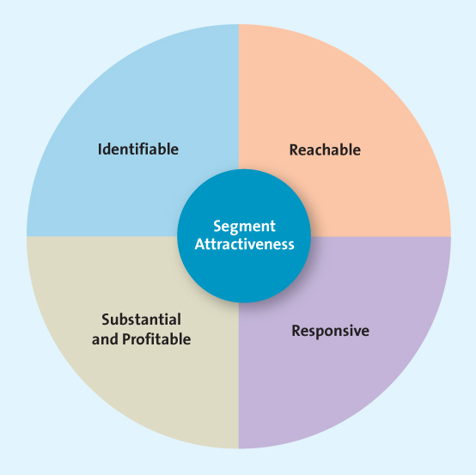
- Identifiable: firms must determine who is within their market to be able to design products or services to meet their needs; ensure the sements are distinct form one another
- Reachable
- Know the product exists
- Understand what it can do
- Recognize how to buy
- Responsive: customers in the segment must react similarly and positively to the firm’s offering
- Substantial and profitable: measure the size and growth potentials
Step 4: Selecting a Target market and a Segmentation Strategy
- Undifferentiated Targeting Strategy/Mass Marketing: a marketing strategy a firm can use if the product or service is perceived to provide the same benefits to everyone with no need to develop separate strategies for different groups
- Differentiated Targeting Strategy: a strategy through which a firm targets several market segments with a different offering for each
- E.g. La Senza: confident fashion forward 18-35 years old women
- La Senza Girl: younger girls
- La Senza Express: women looking for the ultimate destination for bras and panties fro everyday and trend-forward styles
- Concentrated/Niche Targeting Strategy: a marketing strategy of selecting a single, primary target market and focusing all energies on providing a product to fit that market’s needs
- Micromarketing/One-to-one Marketing: an extreme form of segmentation the tailors a product or service to suit an individual customer’s wants or needs
- Mass customization: the practice of interacting on a one-to-one basis with many people to create custom-made products or services; providing one0to0one marketing to the masses
Step 5: Identify and Develop Positioning Strategy
- Positioning: the mental picture that people have about a company and its products or services relative to competitors
- One of the most important but difficult and least understood
- It is not easy to shape consumers’ perceptions in the way marketers may want
- It is difficult because while marketers must keep their positioning fresh to keep abreast with the ever-changing marketplace, consumers’ perceptions are enduring and do not change easily
- Risky for marketers because if it is not done correctly, the brand may not succeed in the marketplace
- Effective positioning requires that markers not only shape their customers’ thinking and feelings, but also evolve these feelings as they reposition their products and brands to keep up with the dynamic marketplace
- Positioning statement: expresses how a company wants to be perceived by consumers
- Target market
- Offering name or brand
- Product/service category or concept
- Unique point of difference/benefits
- Positioning methods
- Value: the relationship of price to quality is among the most important considerations for consumers wen they make a purchase decision
- Low-price positioning
- High-price positioning
- Product Attributes: focus on product leadership, emphasizing dimensions such as innovation, quality, performance, design and reliability
- Benefits & Symbolism: emphasizes the benefits of the brand as well as the psychological meaning of the brand to consumers
- Competition: choose to position their products or services head-to-head against a specific competitor or an entire product/service classification on similar attributes within the target market
- Market Leadership: emphasize their leadership position within their industry
- Positioning by Using Perceptual Mapping
- Perceptual mapping: displays, in two or more dimensions, the position of products or brands in the consumer’s mind
- Ideal point: the position at which a particular market segment’s ideal product would lie on a perceptual map
- Determine consumers’ perceptions and evaluations of the firm’s product or service in relation to competitors
- E.g. What the person likes or dislikes about the brand in relation to competitors
- What might make that person choose one brand over another
- Identify the market’s ideal points and size
- Identify competitors’ positions
- Determine consumer preferences
- Select the position
- Monitor the positioning strategy (firms must always view the first three steps as ongoing, with adjustments made in step 4 as necessary)
- Repositioning
- Brand repositioning: a strategy in which marketers change a brand’s focus to target new markets or realign the brand’s core emphasis with changing market preferences
- Repositioning can change the quality image of the brand
- But has costs and risks

Chapter 7
- Marketing research: a set of techniques and principles for systematically collecting, recording, analyzing, and interpreting data that can aid decision makers involved in marketing goods, services, or ideas
The Marketing Research Process
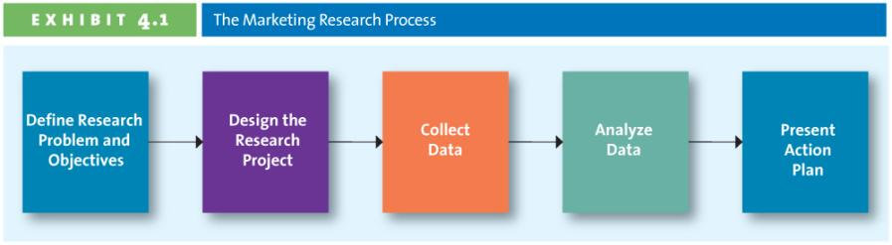
- Step 1: Defining the Objective and Research Needs
- What information is needed to answer specific research questions
- Poor design arises from three major sources:
- Basing research on irrelevant research questions
- Focusing on research questions that marketing research cannot answer
- Addressing research questions to which the answers are already known
- How should that information be obtained
- Dasani:
What competition/brand
What people like
Survey/research: consumers’ habits; preferences
- Step 2: Designing the Research Plan
- Identify type of data needed
- Determine type of research necessary to collect the data
- Project objectives drive the type of data needed
- Specific research approach:
- Observation
- Survey
- Experiment
- Contact method:
- Mail
- Telephone
- In person
- Online
- Sampling plans:
- Sampling unit
- Sampling size
- Sampling procedure
- Instrument to gather data
- Questionnaire
- Step 3: Data Collection Methods
- Secondary data: pieces of information that have been collected prior to the start of the focal project (can be internal or external)
- Primary data: data collected to address the specific research needs/questions currently under investigation. Some primary data collections methods include focus groups, in-depth interviews, and surveys
- Conclusive Research Methods
- Descriptive
- Experimental
- Survey Research
- Unstructured
- Structured
- Web Surveying
- Response rates are relatively high (why?)
- Respondents may lie less (why?)
- It is inexpensive
- Results are processed and received quickly
- Experimental Research
- Scanner Research
- Panel Research
- Step 4: Analyzing Data and Develop Insights
- Data: raw numbers or other factual information of limited value
- Information: data that has been organized, analyzed interpreted, and converted into a useful form for decision makers
- The purpose of converting data to information is to describe, explain, predict, and/or evaluate a particular situation and then use it to develop insights
- Step 5: Present Action plan
- Prepare the result
- Executive summary
- Body
- Conclusion
- Supplement
- Tables
- Figures
- Appendixes
- Present the results
- Short to the point
- Interesting and appropriate to style of audience
- No technical jargon
- Recommendations
Secondary Data
- Might come from free or very inexpensive to obtain
- External sources
- Census data, trade journals, books, articles, reports
- Can also be purchased from specialized research firms
- Downside: may not be specific or timely enough to solve the research needs
- Internal sources
- From the company/firm itself
- Invoices, customer lists, other reports created by the firm
- Firms use data mining techniques to decipher large amounts of data
- Downside: may not be the data you need or the right data
- Internal Secondary Data
- Data mining: the use of statistical analysis tools to search for patterns in data or relationships among variables
- External Secondary Data
- Syndicated data: data available for a fee from commercial research firms such as Symphony IRI Group, National Diary Panel, Nielsen, and Leger marketing
- Scanner data: a type of quantitative research that uses data obtained from scanner readings of UPC codes at checkout counters
- Panel data: a type of quantitative research that involve collecting information from a group of consumers (the panel) over time; data collected may be from a survey or a record of purchases
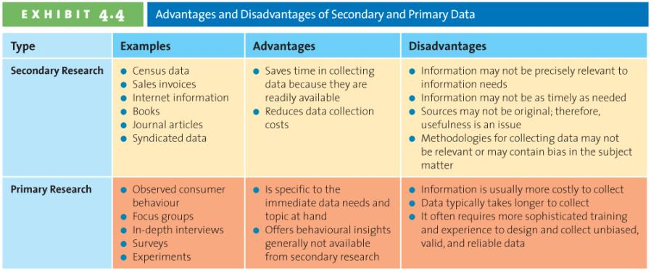

Primary Data Collection Techniques

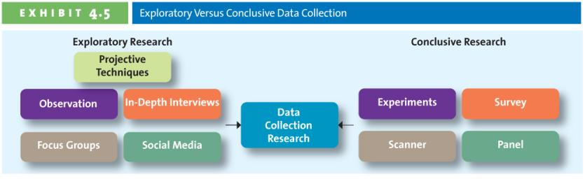
- Qualitative research: attempts to begin to understand the phenomenon of interest; also provides initial information when the problems lacks any clear definition
- Exploratory in nature and it is more informal than quantitative research methods
- Reliability: the extent to which the same result is achieved when a study is repeated under identical situations
- Validity: the extent to which a study measures what it is supposed to measure
- Sample: a segment or subset of the population that adequately represents the entire population of interest
- Qualitative research methods
- Observation: entails examining purchase and consumption behaviors though personal or video camera scrutiny
- Ethnography: an observational method that studies people in their daily lives and activities in their homes, work, and communities
- Observation may be the only way to determine how consumers might use a product, and therefore be useful for designing and marketing it
- Social Media
- It can provide valuable information that could aid their marketing research and strategy endeavors
- Blogs: valuable sources of marketing research insights’ online reviews about everything from restaurants to running shoes to recycling
- Companies build their own communities and encourage the online conversation
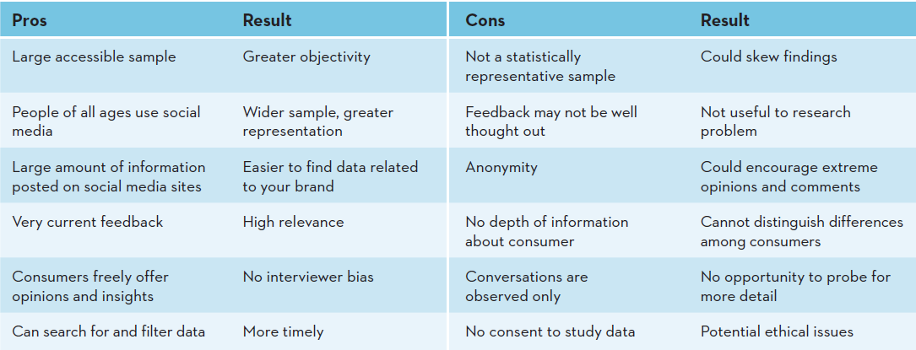
- In-depth interviews: a research technique in which trained researchers ask questions, listen to and record the answers, and then pose additional questions to clarify or expand on a particular issue
- Focus group interviews: a research technique in which a small group of persons (usually 8 to 12) comes together for an in-depth discussion about a particular topic, which the conversation guided by a trained moderator using an unstructured method of inquiry
- Projective technique: subjects are provided a scenario and asked to express their thoughts and feelings about it
- Deciding which one to use”
- Objective of the research
- The cost to undertake the research
- The time required to undertake the research
- How soon the results are needed
- Whether the marketer has the research expertise in-house
- Or Has to hire a market research firm to do the research
- Quantitative research: provides the information needed to confirm preliminary insights, which managers can use to pursue appropriate courses of action
- Hypothesis: a statement or proposition predicting a particular relationship among multiple variables that can be tested through research
- Quantitative research methods
- Survey Research: the most widely used method and is best for descriptive information – knowledge, attitudes, preferences, and buying behavior
- Questionnaire: a form that features a set of questions designed to gather information from respondents and thereby accomplish the researchers’ objectives’ questions can be either unstructured or structured
- Structured questionnaire: close-ended questions for which a discrete set of response alternatives, or specific answers, is provided for respondents to evaluate
- Unstructured questionnaire: open-ended questions that allow respondents to answer in their own words
- Panel Research
- Scanner research: uses data obtained from scanner readings of UPC codes at checkout counters
- Panel research: involves collecting information from a group of consumers (the panel) over time (e.g. survey, record of purchases)
- Experimental Research: systematically manipulates one or more variables to determine which variable has a causal effect on another variable (best for gathering causal information; cause-and-effect relationships)

Promotion is ____________ by a marketer that informs, persuades, and reminds potential buyers about a product or service to influence their opinions or elicit a response.
A) smoke-and-mirrors
B) coercion
C) teasing
D) communication

What must firms do to become value driven?
A) Share information, balance benefits and costs,
and build customer relationships.
B) Set low prices, put profit above service, and use
effective marketing strategies.
C) Make logistics a priority, expand globally, and
always offer new goods and services.
D) Keep a vigilant eye on the market-place,
undercut competitors, and provide competitive
salaries.
Which of the following would NOT be considered part of a supply chain?
A) consumer
B) retailer
C) manufacturer
D) customer service representative
What is sustainable competitive advantage?
A) A broad description of the firms objectives and scope of its activities.
B) Tool used to evaluate marketing performance.
C) Something the firm can consistently do better than its competitors.
D) Written document that discusses competitor strengths and weaknesses, and the firms advantages over them.
Customer excellence focuses on?
A) having products with high perceived value and effective branding and positioning.
B) retaining loyal customers and providing excellent customer service.
C) having a good physical location and Internet presence.
D) efficient operations and excellent supply chain and human resource management.
One of the keys in place and value delivery is to provide the consumer _______________.
A) a wide product selection
B) merchandise they want at the time they want it
C) a variety of media communication methods
D) accessible management personnel to handle complaints
Which of the following refers to a group of consumers who respond similarly to a firm’s marketing efforts?
A) Market segment
B) Target market
C) Targeting
D) Positioning
Which of the following is NOT considered a marketing growth strategy?
A) Market penetration
B) Diversification
C) Product development
D) Sequential planning
A diversification strategy introduces a new product or service to a market segment that _______________.
A) is currently not served
B) includes many ethnicities
C) already exists
D) does not traditionally respond to mixed media
Since the turn of the century, the government has enacted laws
that promote both fair trade and competition by prohibiting __________
that would damage a competitive marketplace.
A) the formation of foreign corporations
B) excessive foreign imports
C) price gouging
D) the formation of monopolies or alliances
Minorities now represent ________ of the population.
A) one-quarter
B) one-third
C) one-half
D) two-thirds

Which of the following are examples of typical demographics?
A) age, gender, race
B) behavior, dress, physical settings
C) temperature, topology, climate
D) conservative, liberal, independent

Decision heuristics are ________ that help a consumer narrow down his or her choices.
A) mental shortcuts
B) breathing exercises
C) logical steps
D) compensatory decision rules
Which of the following is a way in which reference groups might provide information to consumers?
A) Leading by example
B) Indirectly, through observation
C) Contacting the seller
D) Web research
B2B firms focus their efforts on serving _______________ to create value for those customers.
A) new markets
B) wholesalers and distributors
C) resellers
D) specific target markets
When dealing with RFPs, some firms have a policy that requires them to _______________, particularly if the product or service represents a critical component or aspect of the business.
A) negotiate with several suppliers
B) hold out for the lowest price
C) only work with a preferred vendor
D) follow a ten step plan
In most large organizations, who is typically responsible for buying decisions?
A) the CFO
B) the procurement manager
C) several people
D) the vice-president
In what type of buying situation is the decision likely to be the most involved?
A) modified rebuy
B) straight rebuy
C) Internet purchase
D) new buy
Geographic segmentation is most useful for companies whose products satisfy needs that vary by __________.
A) gender
B) region
C) age
D) nationality
Which of the following factors would be most useful in determining whether or not a product will be profitable?
A) the region where the consumer lives
B) the inflation rate
C) the purchase behaviour
D) the speed of the distribution factors
Which of the following products is most likely to use an undifferentiated segmentation strategy?
A) shoes
B) jewellery
C) cereal
D) flour
Positioning strategies generally focus on either how the product or service affects the consumer or how it is _______________.
A) better than the previous year’s product line
B) advertised on the Internet
C) better than competitors’ products and services
D) positioned relative to the company mission statement
When conducting research, why must researchers assure respondents that the information they provide will be treated as confidential?
A) It is the law
B) Customers will be more likely to make purchases
C) Customers will be more likely to provide
honest responses
D) It is a requirement of the Canadian Marketing Association
Data can be collected from many different sources, including both secondary and primary sources. All of the following about primary data sources is true EXCEPT:
A) It is data that has been collected prior to the start of the project.
B) It is data that addresses specific research needs.
C) It can be expensive to gather & time consuming.
D) It includes focus groups.
A type of quantitative research that uses data obtained from readings of UPC codes at checkout counters is referred to as:
A) Panel data
B) Syndicated data
C) Scanner data
D) Primary data
The following represents a key advantage of using social media in research :
A) Conversations are observed only
B) No consent to study data
C) One has access to a large potential sample
D) Anonymity
What is the typical response rate for online surveys?
A) 1 – 2 percent
B) 10 – 15 percent
C) 30 – 35 percent
D) 40 – 45 percent

Chapter 8
- Innovation: the process by which ideas are transformed into new products and services that will help firms grow
Why Do Firms Create New Products?
- Changing Customer needs: adding new products allows firms to create & deliver value by satisfying changing needs of current and new customers
- Sometimes firms take a well-known product, such as vacuum, and make it much more interesting
- Market saturation: the longer a product exists in the marketplace, the more likely the market will become saturated
- Saturated markets also offer opportunities
- Without new products or services, the value of the firm declines
- Managing risk through diversity: innovation allows firms to create a broader portfolio of products
- This leads to diversification of risk
- A portfolio of products is better than having just a single product
- “Don’t put all your eggs in one basket”
- Fashion Cycles: fashion industry relies on trends; experiences short product life cycle; most sales come from new products
- Improving Business relationships
- Innovation and value
- Pioneers/breakthroughs: new product introductions that establish a completely new market or radically change both the rules of competition and consumer preferences in a market
- First mover: product pioneers that are the first to create a market or product category, making them readily recognizable to consumers and thus establishing a commanding an early market share lead
- 95% new consumer goods products fail, because:
- They offer consumers too few benefits compared with existing products
- They are too complex or require substantial learning and effort before consumers can use them
- Bad timing – they are introduced at a time when consumers are not ready for such new products or services
Adoption of Innovation
- Diffusion of innovation: the process by which the use of an innovation, whether a product or a service, spreads throughout a market group over time and over various categories of adopters
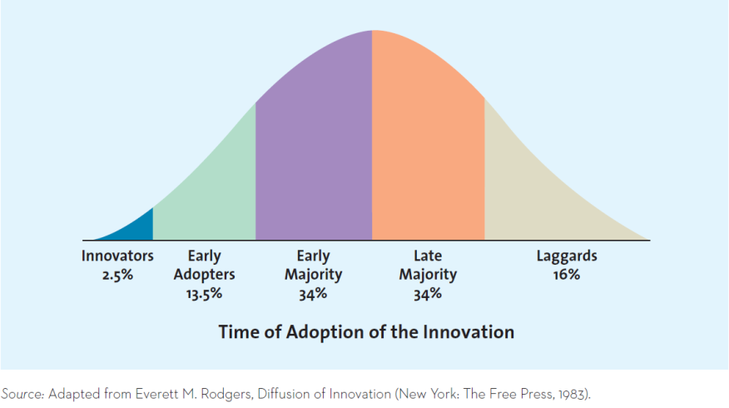
- Innovators: those buyers who want to be the first to have the new product or service
- Early adopters: generally don’t like to take as much risk as innovators
- Early majority: members don’t like to take much risk and therefore tend to wait until bugs are worked out
- Late majority: the last group of buyers to enter a new product market
- Laggards: consumers who like to avoid change and rely on traditional products until they are no longer available
- Using the adoption cycle

- Relative advantage: if a product is perceived to be better than substitutes, then the diffusion will be relatively quick
- E.g. CD player vs. MP3 player
- Compatibility: most business professionals and executives have to make decisions in a timely fashion and be able to communicate their decisions in a timely manner; they need real-time information to do this
- Were cell phones compatible with how we communicated before the were invented, what were we using
- Observability: when products are easily observed, their benefits or uses are easily communicate to others, which enhances the diffusion process
- Did you see people enjoying the benefits from a cellular phone or mp3 player before you bought one?
- Complexity and trialability: products that are relatively less complex are also relatively easy to try (diffuse more quickly than those that are not)
- Was it difficult to learn how to load music onto your MP3 player? Was it difficult to use?
- Were you able to try a mp3 player or cellular phone before buying it?

How Firms Develop New Products

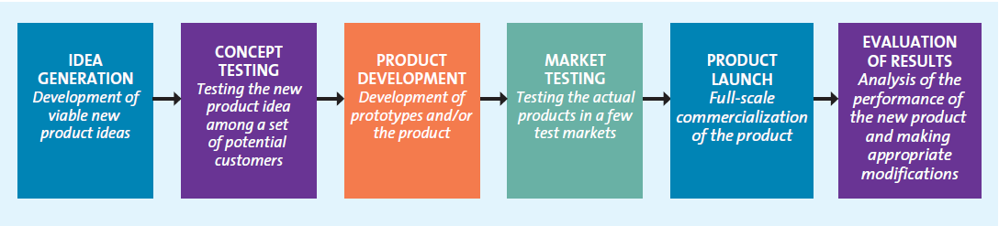

- Idea generation
- Internal search and development
- Internal source: company’s own formal research and development (R&D), management and staff, and entrepreneurial programs
- External source: the sources outside the company such as customers, competitors, distributors, suppliers and outside design firms
- Licensing
- Brainstorming
- Competitors’ products
- Reverse engineering: involves taking apart a competitor’s product, analyzing it, and creating an improved product that does not infringe on the competitor’s patents, if any exist
- Customer input: listening to the customer
- Lead users: innovative product users who modify existing products according to their own ideas to suit their specific needs
- Concept testing: the process in which a concept statement that describes a product or a service is presented to potential buyers or users to obtain their reactions
- Concepts: brief written descriptions of a product or service; its technology, working principles, and forms; and what customer needs it would satisfy
- Consumers’ reactions determine whether or not it goes forward
- Triggers the marketing research process
- Product development: entails a process of balancing various engineering, manufacturing, marketing, and economic considerations to develop a product
- Prototype: the first physical from or service description of a new product, still in rough or tentative form, that has the same properties as a new product but it produced through different manufacturing processes, sometimes even crafted individually
- Alpha testing: an attempt by the firm to determine whether a product will perform according to its design and whether it satisfies the need for which it was intended; occurs in the firm’s R&D department
- Beta testing: having potential consumers examine a product prototype in a real-use setting to determine its functionality, performance, potential problems, and other issues specific to its use
- Market testing: test the market for the new product with a trial batch of products
- Premarket testing: conducted before a product or service is brought to market to determine how many customers will try an d then continue to use it
- Customers exposed
- Customers surveyed
- Firm makes decision
- Test marketing: introduces a new product or service to a limited geographical area (usually a few cities) prior to a national launch
- Mini product launch
- More expensive than premarket tests
- Market demand is estimated
- Product launch
- Promotion: the test results help the firm determine an appropriate integrated marketing communications strategy
- Place: the firm must have an adequate quantity of product available for shipment and to keep in stock at relevant stores
- Price: the firms needs to ensure that it gets the price right
- Timing: the timing of the launch may be important, depending on the product
- Evaluation of results
- Satisfaction of technical requirements
- Customer acceptance
- Satisfaction of the firm’s financial requirements
The Product Life Cycle
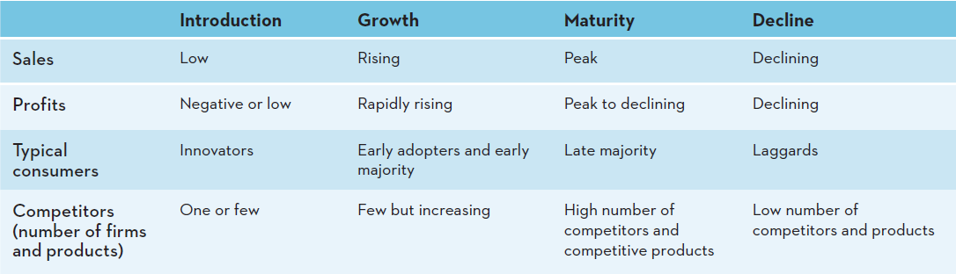
- Production life cycle (PLC): defines the stages that new products move through as they enter, get established in , and ultimately leave the marketplace and thereby offers marketers a starting point for their strategy planning
- Introduction stage: when innovators start buying the product
- Growth stage: when the product gains acceptance, demand and sales increase, and competitors emerge in the product category
- Firms attempt to reach new consumers by studying their preferences and producing different product variances, varied colors, styles, or features, which enables them to segment the market more precisely
- Goal: to ride the rising sales trend and firmly establish the firm’s brand, so as not to be outdone by competitors
- Maturity stage: when industry sales reach their peak, so firms try to rejuvenate their products by adding new features or repositioning them
- Strategies to increase customer base and/or defend their market share
- Entry into new markets or market segments
- Development of new products
- Develop new uses
- Modify product
- Increase frequency of use
- Reposition product
- Tweak marketing strategy
- Decline stage: when sale decline and the product eventually exits the market

Variations on the product life cycle curve
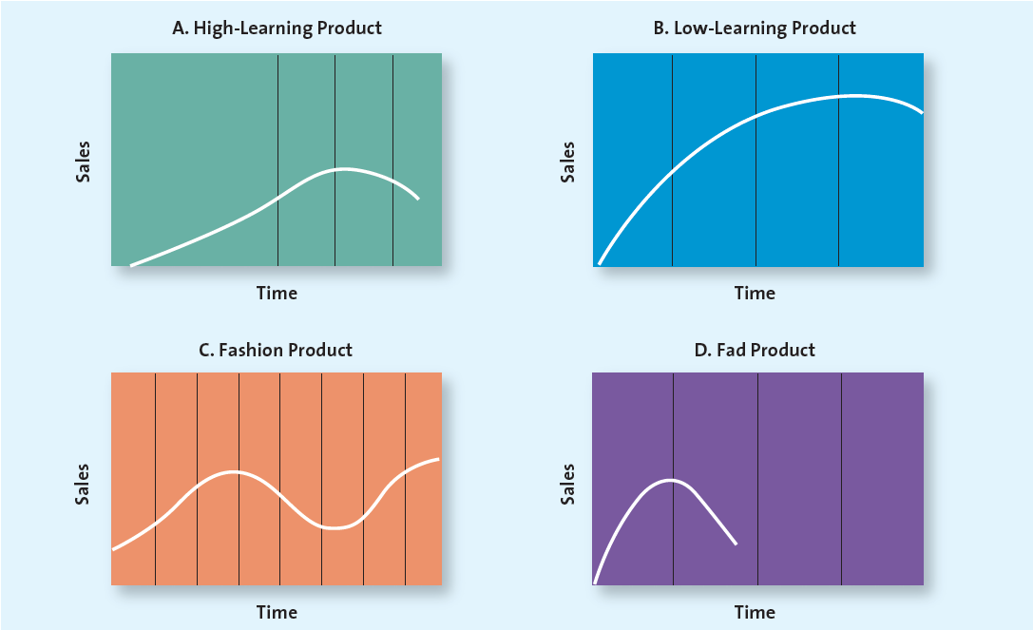

Chapter 9
Complexity of Products
- Core customer vale: the basic problem solving benefits that consumers are seeking
- Actual products: brand name; features/design; quality level and packaging are considered, though the importance of these attributes varies depending on the product
- Associated services/augmented product: the nonphysical attributes of the product, including product, warranties, financing, product support, and after-sale service
Types of Products
- Consumer products: products and service used by people for their personal use
- Specialty products/services: are consumer products and services with unique characteristics or brand identification for which a significant group of buyers is willing to make a special purchase effort
- Specialty goods/services: products or services toward which the customer shows a strong preference and for with he or she will expend considerable effort to search for the best suppliers
- Medical services
- Designer clothes
- Rolex watches
- Shopping products are consumer products and services that the customer compares carefully on suitability, quality, price, and style
- Shopping goods/services: products or services, such as apparel, fragrances, and appliances, for which consumers will spend time comparing alternatives
- Furniture
- Cars
- Appliances
- Convenience products are consumer products and services that the customer usually buys frequently, immediately, and with a minimum comparison and buying effort
- Convenience goods/services: products or services for which the consumer is not willing to spend any effort to evaluate prior to purchase
- Newspapers
- Candy
- Fast food
- Unsought products/services (非寻求的商品): consumer products that the consumer does not know about or knows about but does not normally think of buying
- Life insurance
- Funeral services
- Blood donations
Product Mix
- Product mix: the complete set of all products offered by a firm
- Product lines: groups of associated items, such as those that consumers use together or think of as part of a group of similar products
- Product category: an assortment of items that the customers sees as reasonable substitutes for one another
- Brands: the names, terms, designs, symbols, or any other features that identify one seller’s good or service as distinct from those of other sellers
- Product mix breadth: the number of product lines, or variety, offered by the firm
- Change product mix breadth
- Increase Breadth: firms often add new product lines to capture new or evolving markets, increases sales, and compete in new venues
- Decrease Breadth: sometimes it is necessary to delete entire product lines to address changing market conditions or meet internal strategic priorities
- Product line depth: the number of products within a product line
- Stock keeping units (SKUs): individual items within each product category; the smallest unit available for inventory control
- Change product line depth: firms occasionally either add to or delete from their product line depth
- Increase depth: firms may add new products within a line to address changing consumer preferences or preempt competitors while boosting sales
- Decrease depth: from time to time, it is necessary to delete product categories to realign resources
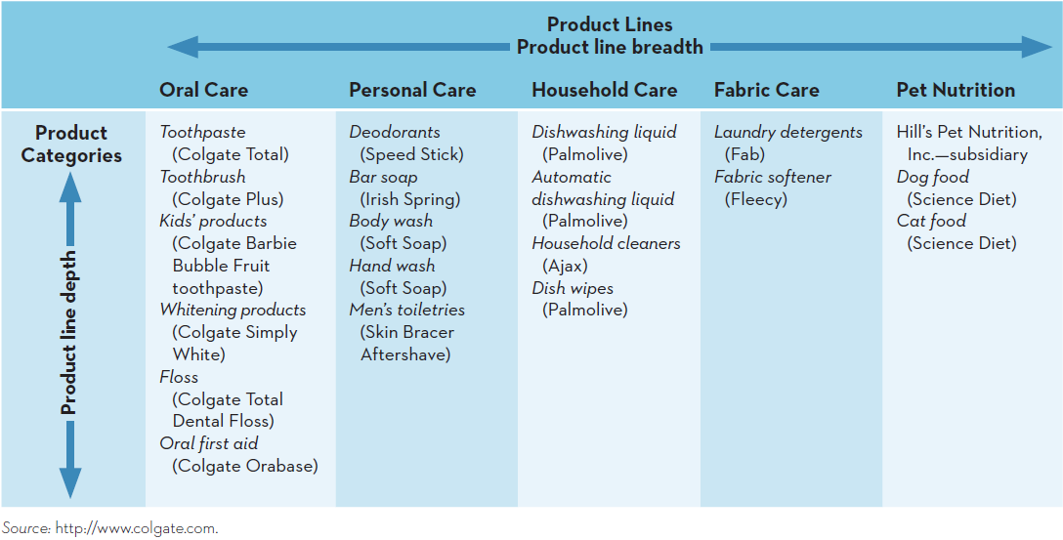

- Change number of SKUs: a very common and ongoing activity for many firms is the addition or deletion of KUs in existing categories to stimulate sales or react to consumer demand
- E.g. Different color or fabric
- Product line decisions for services

Branding
- The name, logos, symbols, characters, URLs, slogans, jingles, design, and distinctive packages – or a combination of these – that identifies the maker or seller of a product or service
- Provides a way for a firm to differentiate its product offerings from those of its competitors and can be used to mix, one product line or a single item
- Value of branding
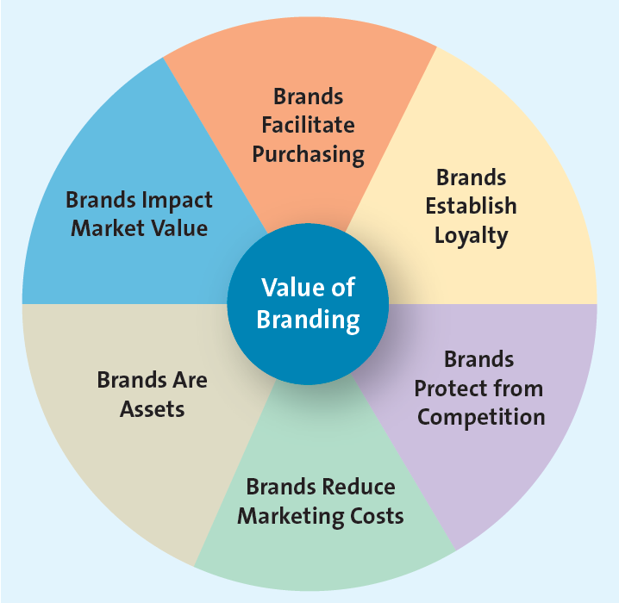
- Brand facilitate purchasing: brands are often easily recognized by consumers and because they signify a certain quality level and contain familiar attributes, brands help consumers make quick decisions
- Brands establish loyalty: over time and with continued use, consumers learn to trust certain brands
- Brands protect from competition and price competition: strong brands are somewhat protected from competition and price competition
- Brands reduce marketing costs: firms with well-known brands can spend relatively less on marketing costs than firms with little known brands because the brand sells itself
- Brands are assets: can be legally protected through trademarks and copyrights and thus constitute a unique ownership for the firm
- Brands impact market value: having well-known brands can have a direct impact on the company’s bottom line
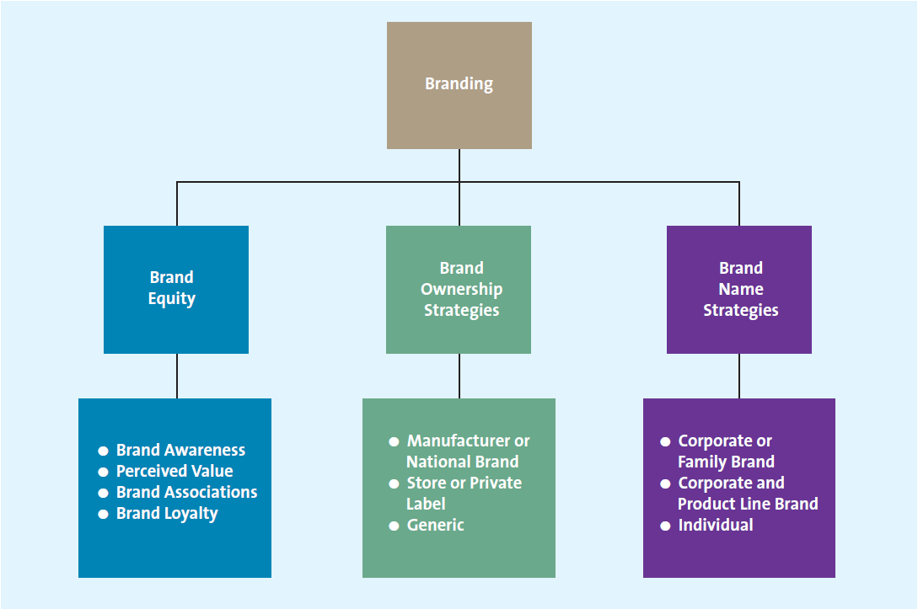
Brand Equity
- Brand awareness: measures how many consumers in a market are familiar with the brand and what it stands for; created through repeated exposures of the various brand elements (brand name, logo, symbol, character, packaging or slogan) in the firm’s communications to consumers
- Perceived Value: the relationship between a product or service’s benefits and its cost
- Brand associations: the mental links that consumers make between a brand and its key product attributes; can involve a logo, slogan or famous personality
- Brand personality: refers to a set of human characteristics associated with a brand that has symbolic or self-expressive meanings for consumers
- Male/female
- Old/young
- Fun loving/conservative
- Fresh/smooth/lean/floral
- Brand loyalty: occurs when a consumer buys the same brand’s product or service repeatedly over time rather than buying from multiple suppliers within the same category
- Consumers are often less sensitive to price
- Marketing costs are much lower
- Loyal customers praise the virtues of their favorite products
- High level of brand loyalty insulates the firm from competition
Brand Ownership Strategies
- Brand ownership: brands can be owned by any firm in the supply chain, whether manufacturers, wholesalers, or retailers
- Manufacturer brands: brands owned and managed by the manufacturer
- Private-label brands (store brands): brands developed and marketed by a retailer and available only from that retailer
- Generic: a product sold without a brand name, typically in commodities markets
- Naming brands and product lines
- Corporate brands: the use of a firm’s own corporate name to brand all of its product lines and products
- Family brands: the use of a combination of the company brand name and individual brand name to distinguish a firm’s products
- Individual brand: the use of individual brand names for each of a firm’s products
- Choosing a name
- The brand name should be descriptive and suggestive of benefits and qualities associated with the product
- Easy to pronounce, recognize, remember
- Register as a trademark & protect it legally
- Easy to translate
- Brand Extension: the use of the same brand name for new products being introduced to the same or new markets
- Brand dilution: occurs when a brand extension adversely affects consumer perceptions about the attributes the core brand is believed to hold
- Benefits of using of the same brand name for new products
- Well established name
- Perception of high quality carriers over
- Lower marketing costs
- Synergy among complementary
- Boost sales of the core brand
- Negative consequences
- Core brand & new extension may not ‘fit’ well together
- Brand associations between the two may not be similar
- Too many extensions results in brand dilution
- Ensure the brands can be distanced from one another if need be
- Cobranding: the practice of marketing two or more brands together, on the same package or promotion
- Brand licensing: a contractual arrangement between firms, whereby one firm allows another to use its brand name, logo, symbols, or characters in exchange for a negotiated fee

Packaging
- Packaging is an important brand element with ore tangible or physical benefits than the other brand elements because packages come in different types and offer a variety of benefits to consumers, a=manufacturers, and retailers
- Packaging attracts the consumer’s attention, enables products to stand out from their competitors, and offers a promotional tool
- Also allows the same product to appeal to different markets with different sizes
- Stand-up, recallable zipper pouches
- Aluminum beverage cans
- Aseptic packaging
- Child-resistant/senior-friendly packages
- Green and biodegradable packaging
Labeling
- Labels on products and packages provide information the consumer needs for his or her purchase decision and consumption of product

Chapter 10

- Service: Any intangible offering that cannot be physically possessed
- Customer service: specifically refers to human or mechanical activities firms undertake to help satisfy their customers needs and wants
- The service-product continuum
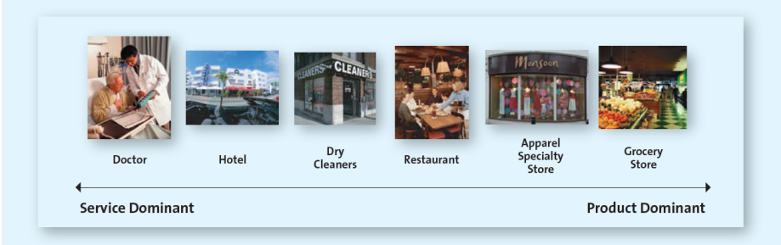
- Economic importance of service
- Generally less expensive for firms to manufacture their products in less-developed countries
- Household maintenance activities, which many people performed by themselves in the past have become quite specialized
- People place a high value on convenience and leisure
Service Marketing Differs From Product Marketing
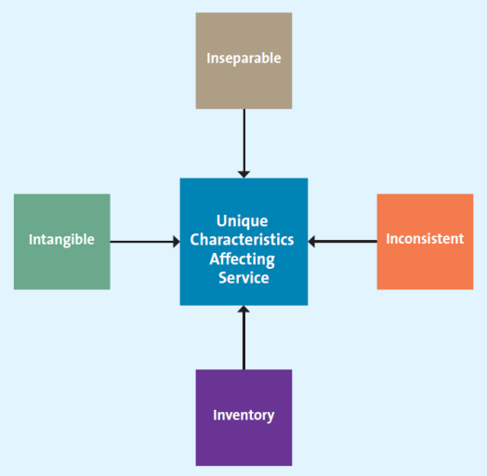
- Intangible: it cannot be touched, tasted, or seen like a pure product can
- Requires using cues to aid customers
- Atmosphere is important to convey value
- Images are used to convey benefit of value
- Inseparable production & consumption: it is produced and consumed at the same time – that is, service and consumption are inseparable
- Lower opportunity to test a service before use
- Lower risk by offering guarantees or warranties
- Inconsistent: its quality may vary because it is provided by humans
- To reduce service inconsistency through training and standardization
- As advantage: customized services to meet specific needs
- Bundle services in to one package and charge a single price
- Some service providers tackle the inconsistency issue by replacing people with machines
- Self-service technology
- Increasing use of self-checkout machines
- Consumers enjoy faster checkout
- Retailers save on labor and training costs
- The internet
- Inventory: it is perishable and cannot be stored of future use
- It is hard to march demand and supply of service closely

Providing Great Service: The Gaps Model
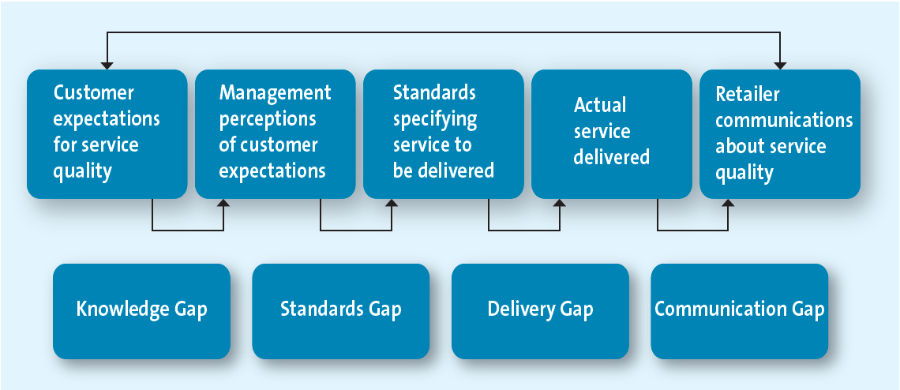
- The knowledge Gap: knowing what customers want/ reflects the difference between customers’ expectations and the firm;;s perception of those expectations
- Understanding customer expectations: customers’ expectations are based on their knowledge and experiences
- Expectations according to type of services
- Vary depending on the situation
- Evaluating service quality by using well-established marketing metrics
- Service quality: customers’ perceptions of how well a service meets or exceed their expectations
- Five distinct service dimensions to determine overall service quality
  - Reliability: the ability to perform the service dependably and accurately
  - Responsiveness: the willingness to help customers and provide prompt service
  - Assurance: the knowledge of and courtesy by employees and their ability to convey trust and confidence
  - Empathy: the caring, individualized attention provided to customers
  - Tangibles: the appearance of physical facilities, equipment, personnel, and communication materials
- Voice-of-customer: an ongoing marketing research system that collects customer insights and intelligence to influence and drive business decisions
- Zone of tolerance: the area between customers’ expectations regarding their desired service and the minimum level of acceptable service-that is, the difference between what the customer really wants and what he or she will accept before going elsewhere
- What is the desired and expected level of service for each dimension
- What are the customer’s perceptions of how well the focal service performs and how well a competitive service performs
- What is the importance of each service quality dimension
- A very straightforward and inexpensive method of collecting consumers’ perceptions of service quality is to gather them at the time of the sale
- Another excellent method for assessing customers’ expectations is making effective use of customer-complaint behavior
- Standards Gap: pertains to the difference between the firm’s perceptions of customers’ expectations and the service standards it sets
- Achieve service goals through training
- Commitment to service quality
- Delivery Gao: the difference between the firm’s service standards and the actual service it provides to customers (to reduce delivery gap)
- Empowering Service Providers
- Empowerment: means allowing employees to make decisions about how service is provided to customers
- It can be difficult and costly
- Empowerment becomes more important when price points edge higher and services are more individualized
- Providing Support and Incentives
- Managers and coworkers should provide emotional support to service providers by demonstrating a concern for their well-being and by standing behind their decisions
- Service providers require instrumental support – the systems and equipment to deliver the service properly
- The support that managers provide must be consistent and coherent through-out the organization
- Providing rewards to employees for excellent service
- Using Technology
- Internet enabled customers to buy more quickly, more easily and with more information than in the past
- Using technology to facilitate service delivery can provide many benefits, such as:
- Access to wider variety of services
- Greater degree of control by the customer over the services
- The ability to obtain information
- Communication Gap: refers to the differences between the actual service provided to customers and the service that the firms promotion program promises
- Poor communication between marketers and their customers can result in a mismatch between an ad campaign’s or a salesperson’s promises and the service the firm can actually offer
- Manage customer expectations
- Promise only what you can deliver
- Communicate service expectations
Service Recovery
- Occur when service providers fail to meet customer expectations
- Effective service recovery efforts can significantly increase customer satisfaction, purchase intentions, and positive word-of-mouth, tough customers’ post recovery satisfaction levels usually fall lower than their satisfaction level prior to the service failure
- Listening to the customer
- Firms often don’t find out about service failures until a customer complains
- When the company and the customer work together, the outcome is often better than either could achieve on their own
- Providing a fair solution
- Distributive fairness: pertains to a customer’s perception of the benefits he or she received compare with the costs (inconvenience or loss) than resulted from a service failure
- Procedural fairness: refers to the customer’s perception of the fairness of the process used to resolve complaints about service
- Resolving the problem quickly
- The longer it takes to resolve a service failure, the more irritated the customer will become and the more people he or she is likely to tell about the problem
- Companies should welcome complaints, make it easy for customer to provide feedback, and listen carefully to what customers have to say

Chapter 11
The Role of Price in the Marketing Mix
- Price is the only element in the marketing mix that generates revenue
- Price is a cue signaling to consumers the quality of a product or service
- Price is usually ranked as one of the most important factors in purchase decisions
The Five C’s of Pricing
- Company Objectives
- Profit Orientation: a company objective that can be implemented by focusing on
- Target profit pricing: when they have a particular profit goal as their overriding concern; firms use price to stimulate a certain level of sales at a certain profit per unit
- Maximizing profits: relies primarily on economic theory; if a firm can accurately specify a mathematical model that captures all the factors required to explain and predict sales and profits
- Target return pricing: a pricing strategy implemented by firms less concerned with the absolute level of profits and more interested in the rate at which the profits are generated relative to their investments; designed to a produce a specific return on investment usually expressed as a percentage of sales
- Sales Orientation: a company objective based on the belief that increasing sales will help the firm more than will increasing profits
- Competitor Orientation: a company objective based on the premise that the firm should measure itself primarily against its competitor
- Competitive parity: a firm’s strategy of setting prices that are similar to those of major competitors
- Customer Orientation: pricing orientation that explicitly invokes the concept of customer value and setting prices to match consumer expectations
- Customers (the most important C)
- It is all about understanding consumers reactions to different prices
- Consumers want value – price is half of the value equation
- Demand curve and pricing
- Demand Curve: shows how many units of a product or service consumers will demand during a specific period at different prices
- Prestige products and services: hose that consumers purchase for status rather than functionality
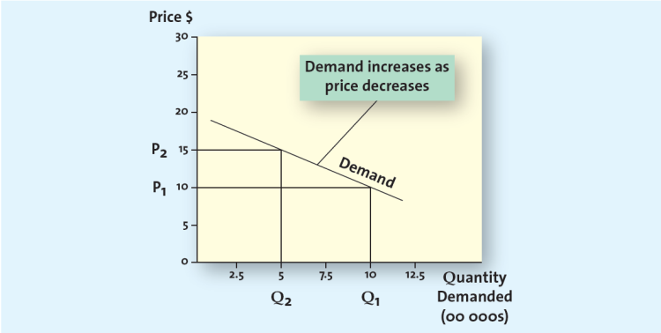
- Price Elasticity of Demand: measures how changes in a price affect the quantity of the product demanded; specifically, the ratio of the percentage change in quantity demanded to the percentage change in price
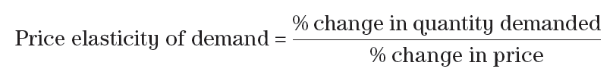
- Consumers are generally more sensitive to price increases than to price decreases
- Consumers are less sensitive to price increases for necessities
- Price sensitive (elastic): relatively small changes in price will generate fairly large changes in the quantity demanded
- Price insensitive (inelastic): relatively small changes in price will not generate large changes in the quantity demanded
- Factors influencing price elasticity of demand
- Income effect: increases income, tend to shift their demand from lower-priced product s to higher-priced alternatives
- Substitution effect: consumers’ abilities substitute other products for the focal brand, thus increasing the price elasticity of demand for the focal brand
- Cross-price elasticity: the percentage change in demand for Product A that occurs in response to a percentage change in price of Product B
- Complementary products whose demand curves are positively related, such that they rise or fall together; a percentage increase in demand for one results in a percentage increase in demand for the other
- Substitute products: products for which changes in demand are negatively related—that is, a percentage increase in the quantity demanded for Product A results in a percentage decrease in the quantity demanded for Product B
- Costs
- Variable costs: those costs primarily labor and materials, that vary with production volume
- Fixed costs: unaffected by production volume
- Total cost: sum of variable and fixed costs
- Break-even analysis and decision making: the point at which the number of units sold generates just enough revenue to equal the total costs; at this point, profits are zero
- Competition
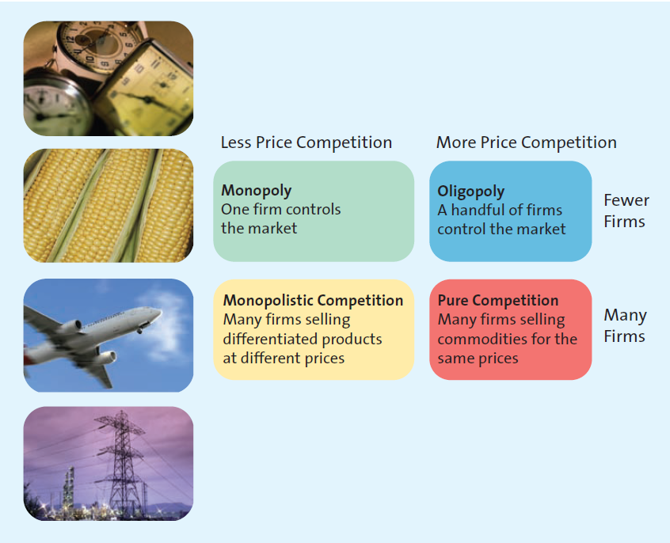
- Monopoly: occurs when only one firm provides the product or service a particular industry
- Oligopoly: occurs when only a few firms dominate a market
- Monopolistic competition: occurs when many firms sell closely related but not homogeneous products; these products may be viewed as substitutes but are not perfect substitutes
- Pure competition: occurs when different companies sell commodity products that consumers perceive as substitutable; price usually is set according to the laws of supply and demand
- Price war: occurs when two or more firms compete primarily by lowering their prices
- Channel members
- Manufacturers, wholesalers and retailers can have different perspectives on pricing strategies
- Manufactures must protect against grey market transactions
- Grey market: employs irregular but not necessarily illegal methods; generally, it legally circumvents authorized channels of distribution to sell goods at prices lower than those intended by the manufacturer
Other Influences on Pricing
- The internet
- Showrooming: occurs when consumers visit a physical store to get information about a product that then buy online from another relater that offers a lower price
- Increased price sensitivity
- Growth of online auctions
- Economic factors
- Cross-shopping: the pattern of buying both premium and low-priced merchandise or patronizing both expensive, status-oriented retailers and price-oriented retailers
- The growth of the global economy has changed the nature of competition around the world
- Competition, disposable income, and unemployment all may signal the need for different pricing strategies
Pricing Methods and Strategies
- Cost-based Methods: determines the final price to charge by starting with the cost, without recognizing the role that consumers or competitors’ prices play in their marketplace
- All costs calculated on a per unit basis
- Assumers costs don’t vary for different levels of production
- Competitor-based Methods: an approach that attempts to reflect how the firm wants consumers to interpret its products relative to the competitors’ offerings
- Value-based Methods: focuses on the overall value of the product offering as perceived by consumers, who determine value by comparing the benefits they expect the product to deliver with the sacrifice they will need to make to acquire the product
- Improvement value method: represents an estimate of how much more (or less) consumers are willing to pay for a product relative to other comparable products
- Cost of ownership method: a value-based method for setting prices that determine the total cost of owning the product over its useful life
New Product Pricing Strategies
- Price Skimming: a strategy of selling a new product or service at a high price that innovators and early adopter are willing to pay to obtain it; after the high-price market segment becomes saturated and sales begin to slow down, the firm generally lowers the price to capture (or skim) the next most price-sensitive segment
- Competitors cannot be able to enter the market easily; otherwise, price competition will likely force lower prices and undermine the whole strategy
- Potential drawback: relatively high unit costs often associated with producing small volumes of products
- Discontent for consumers
- Market penetration pricing: a pricing strategy of setting the initial price low for the introduction of the new product or service, with the objective of building sales, market share, and profits quickly
- Experience curve effect: refers to the drop in unit cost as the accumulated volume sold increases; as sales continue to grew, the costs continue to drop, allowing even further reductions in the price
Psychological Factors Affecting Value-based Pricing Strategies
- Consumers’ use of reference prices
- Reference price: the price against which buyers compare the actual selling price of the product and that facilitates their evaluation process
- Odd prices: prices that end in odd numbers, usually 9
- Everyday low pricing: a strategy companies use to emphasize the continuity of their retail prices at a level somewhere between the regular, non-sale price an the deep-discount sale prices their competitors may offer
- High/low pricing: a pricing strategy that relies on the promotion of sales, during which prices are temporarily reduced to encourage purchases
Pricing Tactics
- Pricing tactics: short-term methods, in contrast to long-term pricing strategies, used to focus on company objectives, customers, costs, competition, or channel members; can be responses to competitive threats (e.g. lowering price temporarily to meet a competitor’s price reduction) or broadly accepted methods of calculating a final price for the customer that is short term in nature
- Pricing Tactics Aimed at Consumers
- Price lining: consumer market pricing tactic of establishing a price floor and a price ceiling for an entire line of similar products and then setting a few other price points in between to represent distinct differences in quality
- Price bundling: consumer pricing tactic of selling more than one product for a single, lower price than the times would cost sold separately; can be used to sell slow-moving items, to encourage customers to stock up so they wont purchase competing brands, to encourage trial of a new product. Or to provide an incentive to purchase a less desirable product or service to obtain a more desirable one in the same bundle
- Leader pricing: consumer pricing tactic that attempts to build store traffic by aggressively pricing and advertising a regularly purchased item, often priced at or just above the store’s cost
- Consumer Price Reductions
- Markdowns: reductions retailers take on the initial selling price of the product or service
- Enable retailers to get rid of slow-moving or obsolete merchandise, sell seasonal items after the appropriate season, and match competitors’ prices on specific merchandise
- To promote merchandise and increase sales
- Quantity discounts for consumers
- Size discount: the most common implementation of a quantity discount at the consumer level, the larger the quantity bought, the less the cost per unit
- Coupons and rebates
- Coupon: provides a stated discount to consumers on the final selling price of a specific item; the retailer handles the discount
- Rebate: a consumer discount in which a portion of the purchase price is returned to the buyer in cash; the manufacturer, not the retailer, issues the refund
- Business-to-Business Pricing Tactics and Discounts
- Seasonal discounts: pricing tactic of offering an additional reduction as an incentive o retailers to order merchandise in advance of the normal buying season
- Cash discounts: tactic of offering a reduction in the invoice cost if the buyer pays the invoice prior to the end of the discount period
- Allowances: lowers the final cot in return for specific behavior
- Advertising allowance: tactic of offering a price reduction to channel members if thy agree to feature the manufacturer’s product in their advertising and promotional efforts
- Listing allowances: fees paid to retailers simply to get new products into stores or to gain more or better shelf space for their products
- Quantity discounts: pricing tactic of offering a reduced price according to the amount purchased; the more the buyer purchases the higher the discount and, of course, the greater the value.
- Cumulative quantity discount: pricing tactic that offers a discount based on the amount purchased over a specific period and usually involves several transactions
- Non-cumulative quantity discount: pricing tactic that offers a discount based on only the amount purchased in a single order
- Uniform delivered vs. geographic pricing
- Uniform delivered pricing: the shipper charges one rate, no matter where the buyer is located
- Geographic pricing: the setting of different prices depending on a geographical division of the delivery areas
Legal and Ethical Aspects of Pricing
- Deceptive or illegal price advertising
- Deceptive reference prices
- Loss leader pricing: loss leader pricing takes the tactic of leader pricing one step further by lowering the price below the store’s cost
- Bait and switch: a deceptive practice of luring customers into the store with a very low advertised price on an item (the bait), only to aggressively pressure them into purchasing a higher-priced item (the switch) by disparaging the low-priced item, comparing it unfavorably with the higher-priced model, or professing and inadequate supply of the lower priced item
- Predatory pricing: a firm’s practice of setting a very low price for one or more of its products with the intent of driving its competition out of business
- Price Discrimination: the practice of selling the same product to different resellers (wholesalers, distributors, or retailers) or to the ultimate consumer at different prices; some, but not all, forms of price discrimination are illegal
- Price fixing: the practice of colluding with other firms to control prices
- Horizontal price fixing: occurs when competitors that produce and sell competing products, collude, or work together, to control prices, effective taking price out of the decision process for consumers
- Vertical price fixing: occurs when parties at different levels of the same marketing channel (manufacturers, and retailers) collude to control the prices passed on to consumers

Chapter 12

The Importance of Distribution
- Distribution channels, supply chain, and logistics are related
- Distributed channel: the institutions that transfer the ownership of and move goods from the point of production to the point of consumers
- Supply chain management: refers to a set of approaches and techniques firms employ to efficiently and effectively integrate their suppliers, manufacturers, warehouses, stores, and transportation intermediaries into a seamless value chain in which merchandise is produced and distributed in the right quantities, to the right locations, and at the right time
- Wholesalers: those firms engaged in buying, taking title to , often storing, and physically handling goods in large quantities, and hen reselling the goods (usually in smaller quantities) to retailers or industrial or business users
- Retailers: sell products directly to consumers
- Logistics management: the integration of two or more activities for the purpose of planning, implementing, and controlling the efficient flow of raw materials, in-process inventory, and finished goods from the point of origin to the point of consumption
- Designing distribution channels
- Channel Structure
- Direct distribution
- Significance in B2B
- Some companies may be forced to distribute their goods directly because they are unable to secure shelf space in retail outlets or are unable to pay the high listing fees demanded by retailers for the shelf space
- Indirect distribution: one or more intermediaries work with manufacturers to provide goods an services to consumers
- Wholesalers are often used when a company does not buy in sufficient quantity to make it cost-effective for a manufacturer to deal directly with a retailer (common for low cost, low unit value items; candy)
- Multichannel distribution
- Sony
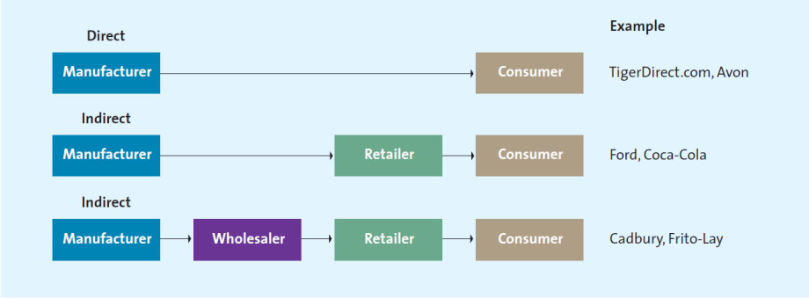
- Push Versus Pull distribution strategies
- Push marketing strategy: designed to increase demand by focusing on wholesalers, distributors, or salespeople, who push the product to consumers via distribution channels
- Pull marketing strategy: designed to get consumers to pull the product into the supply chain by demanding retailers carry it

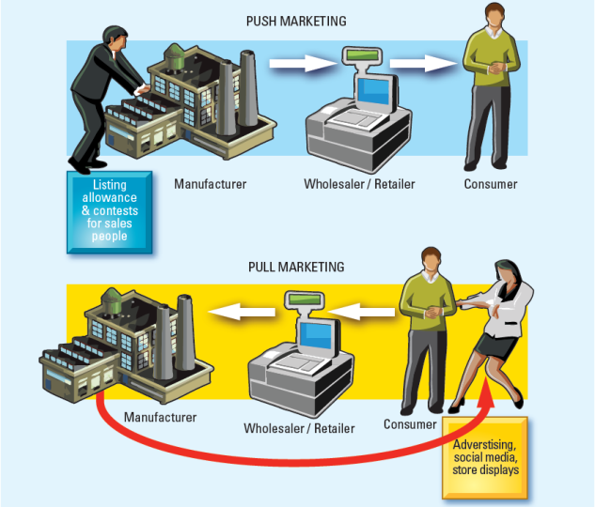

- Distribution Intensity
- Distribution intensity: the number of channel members to use at each level of the supply chain
- Intensive: a strategy designed to get products into as many outlets as possible
- PepsiCo: available everywhere
- P&G
- Selective: lies between the intensive and exclusive distribution strategies; uses a few selected customer sin territory

- Exclusive: strategy of granting exclusive rights to sell to one or very few retail customers so no other customers can sell a particular brand

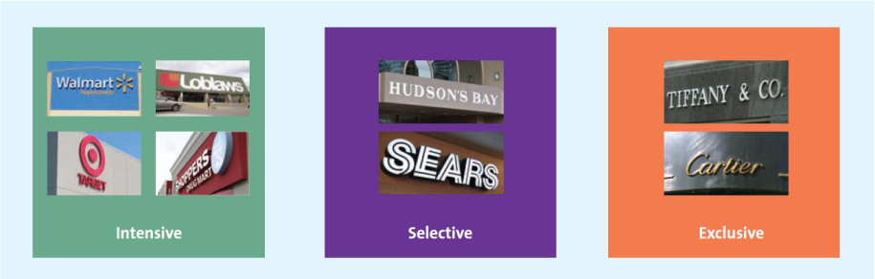

Distribution Channels Add Value
- Distribution centre: a facility for the receipt storage, and redistributing of goods to company stores or customers; may be operated by retailers, manufacturers, or distribution specialists
- Buying: wholesalers, retailers
- Selling: manufacturers. Wholesalers
- Helping exchange: transportation companies
- Functions performed by intermediaries
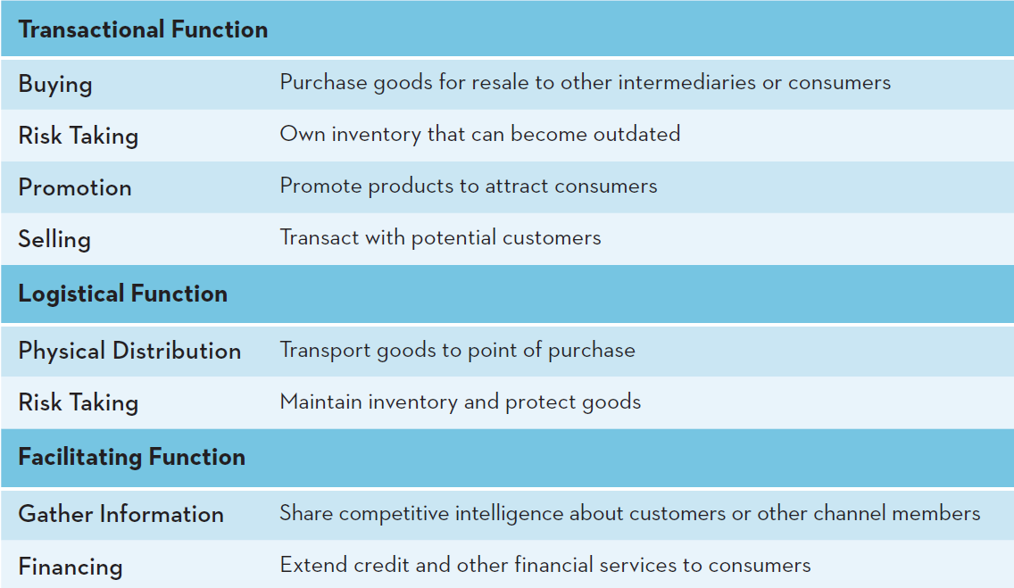
- Managing distribution channels
- Channel conflicts: results when supply chain members are not in agreement about their goals, roles, or rewards
- Managing distribution channels by developing strong relationships with supply chain partners
- Managing channels through vertical marketing system
- Independent distribution channel: each attempt to satisfy their own objectives and maximize their own profits, often at the expense of other members
- Vertical marketing system: a supply chain in which the members act as a unified system; there are tree types:
    - Administered vertical marketing system: a supply chain system in which there is no common ownership and no contractual relationships, but the dominant channel member controls the channel relationship
    - Contractual vertical marketing system: a system in which independent firms at different levels of the supply chain join together through contracts to obtain economies of scale and co-ordination and to reduce conflict
- Francizing (most common): a contractual agreement between a franchisor and a franchisee that allows the franchisee to operate a retail outlet. Using a name and format developed and supported b franchisor
    - Corporate vertical marketing system: a system which the parent company has compete control and can dictate the priorities and objectives of the supply; it may own facilities such as manufacturing plants, warehouse facilities, retail outlets, and design studios

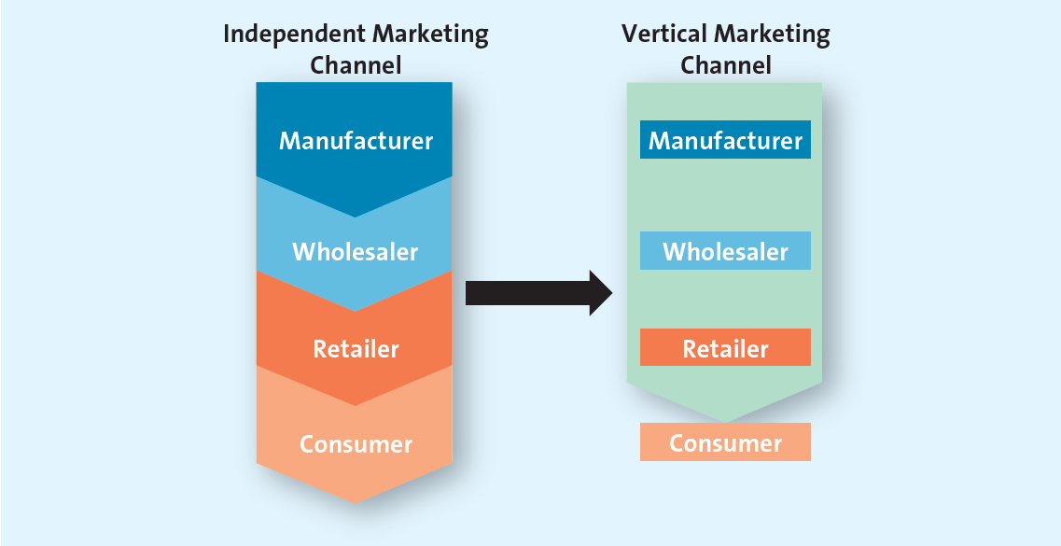

Logistics management: Making information Flow
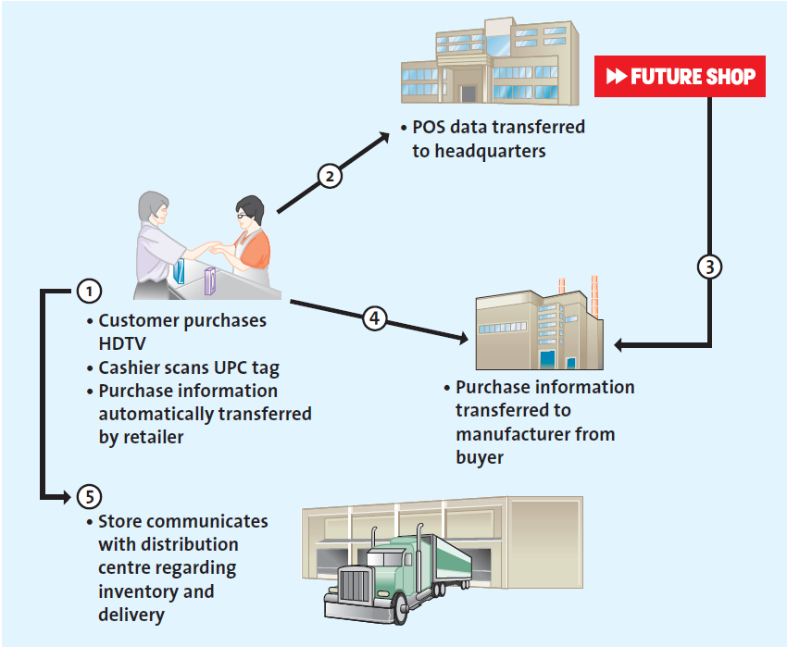

- Flow 1: CustomerStore
- The sales associate at Future Shop scans the universal product code tag on the HDTV packaging, and the customer receives a receipt
- UPC: the black and white bar code found on most merchandise
- Flow 2: StoreBuyer
- The point-of-sale terminal records the purchase information and electronically sends it to the buyer at Future Shop’s corporate office
- Flow 3: Buyer to manufacturer
- The purchase information from each Future Shop store is typically aggregated by the retailer as a whole, which creates an order for new merchandise and sends it to Sony
- Flow 4: Store to Manufacturer
- In some situations, the sales transaction data a re sent directly from the store to the manufacturer, and the manufacturer decides when to ship more merchandise to the distribution cenres and the stores
- Flow 5: StoreDistribution Centre
- Stores also communicate with the Future Shop distribution centre to co-ordinate deliveries and check inventory status
- Data Warehouse: the information stoed in the data warehouse is accessible on various dimensions and levels
- Electronic Data Interchange: the computer-to-computer exchange of business documents from a retailer to a vendor and back
- Advanced shipping notice: an electronic document that the supplier send the retailer in advance of a shipment to tell the retailer exactly what to expect in the shipment
- Three main benefits:
- EDI reduces the cycle time, or the time between the decision to place an order and the receipt of merchandise
- EDI improves the overall quality of communications through better record keeping
- The data transmitted by EDI are in a computer-readable format that can be easily analyzed and used for a variety of tasks, ranging form evaluating vendor delivery performance to automating reorder processes
- Managing supply chains through strategic relationships
- Strategic relationship (partnering relationship): a supply chain relationship that the members are committed to maintaining long term, investing in opportunities that are mutually beneficial; requires mutual trust, open communication, common goals, and credible commitments
- Successful strategic relationships require:
- Mutual trust: holds a strategic relationship together
- When vendors and buyers trust each other, they are more willing to share relevant ideas, clarify goals and problems, and communicate efficiently
- Open communication: to share information, develop sales forecasts together, and co-ordinate deliveries
- Common goals: shared goals give both members of the relationship an incentive to pool their strengths and abilities and exploit potential opportunities together
- Credible commitments: successful relationships develop because both parties make credible commitments to, or tangible investments in, the relationship
Logistic management: Making merchandise Flow
- Inbound Transportation
- Dispatcher: the person who co-ordinates deliveries to distribution centres
- Receiving and checking
- Radio Frequency identification tags: tiny computer chips that automatically transmit to a special scanner all the information about a container’s contents or individual products
- Storing and cross-docking
- Traditional distribution centres: a warehouse in which merchandise is unloaded from trucks and placed on racks or shelves for storage
- Cross-docking: vendors ship merchandise prepackaged in the quantity required for each store; the merchandise already contains price and theft detection tags
- Combinations: combine the two previous approaches; it is difficult for a firm to operate without some storage facilities even if merchandise is stored for only a few days
- Getting merchandise floor-ready
- Ticketing, marking,: refers to creating price and identification labels and placing them on the merchandise
- Placing garments on hangers
- Shipping merchandise to stores
- Inventory management through just-in-time systems
- JIT inventory systems/Quick response systems (in retailing): inventory management systems designed to deliver less merchandise on a more frequent basis than traditional inventory systems; the firm gets the merchandise “just in time” for it to be used in the manufacture of another product
- Lead time: the amount of time between the recognition that an order needs to be placed and the arrival of the needed merchandise at the seller’s store ready for sale

Chapter 14
Integrated Marketing Communications
- Integrated marketing communications (IMC): represents the promotion dimension of the four Ps; encompasses a variety of communication disciplines-general advertising, personal selling, sales promotion, public relations, direct marketing, and digital media-in combination to provide clarity, consistency, and maximum communicative impact.
- Communicating with consumers
- The communication process
- The sender: the firm from which an IMC message originates; the sender must be clearly identified to the intended audience
- Deceptive advertising: a representation, omission, act, or practice in an advertisement that is likely to mislead consumers acting reasonably under the circumstances
- The transmitter: an agent or intermediary with which the sender works to develop the marketing communications; for example, a firm’s creative department or an advertising agency
- Encoding: the process of converting the sender’s ideas into a message, which could be verbal, visual, or both
- The communication channel: the medium-print, broadcast; the internet-that carries the message
- The receiver: the person who reads, hears, or sees and processes the information contained in the message or advertisement
- Decoding: the process by which the receiver interprets the sender’s message

- Noise: any interference that stems from competing messages, a lack of clarity in the message, or a flaw in the medium; the problem after all communication channels
- Feedback loop: allows the receiver to communicate with the sender and thereby informs the sender whether the message was received and decoded properly
- How consumers perceive communication
- Receivers decode messages differently
- Senders adjust messages according to the medium and receivers’ traits
Steps in Planning an IMS Campaign
- Identify target audience
- Target audience may or may not be the same as current users of the product
- Campaign success depends on how well the advertiser can identify its target audience
- The audience may be
- Potential buyers/current users
- Those who make the buying decision/those who influence it
- Individuals groups, or publics
- Set objectives
- The yardstick against which success of failure is measured
- The objectives
- Can be short-term or long-term
- Short-term: generating inquiries; increasing awareness; promoting trial
- Long-term: increasing sales, market share, and customer loyalty
- May aim to inform, persuade or remind customers
- When setting objectives, marketers have to consider
- Distribution channel strategy: Push vs. Pull
- Pull strategy: the goal is to get consumers to pull the product into the supply chain by demanding retailers carry it; advertising consumers
- Push strategy: are designed to increase demand by focusing on wholesalers, distributors, or salespeople, who push the product to consumers via distribution channels
- Nature of the market (consumer vs. business)
- Nature of the product (simple vs. complex)
- Stage in the product life cycle
- Determine budget
- Considerations
- Role that advertising plays in meeting overall promotional objectives
- Expenditures vary over the course of the product life cycle, with considerably higher levels of spending during the introduction stage
- Nature of the market and the product influence the size of the budget
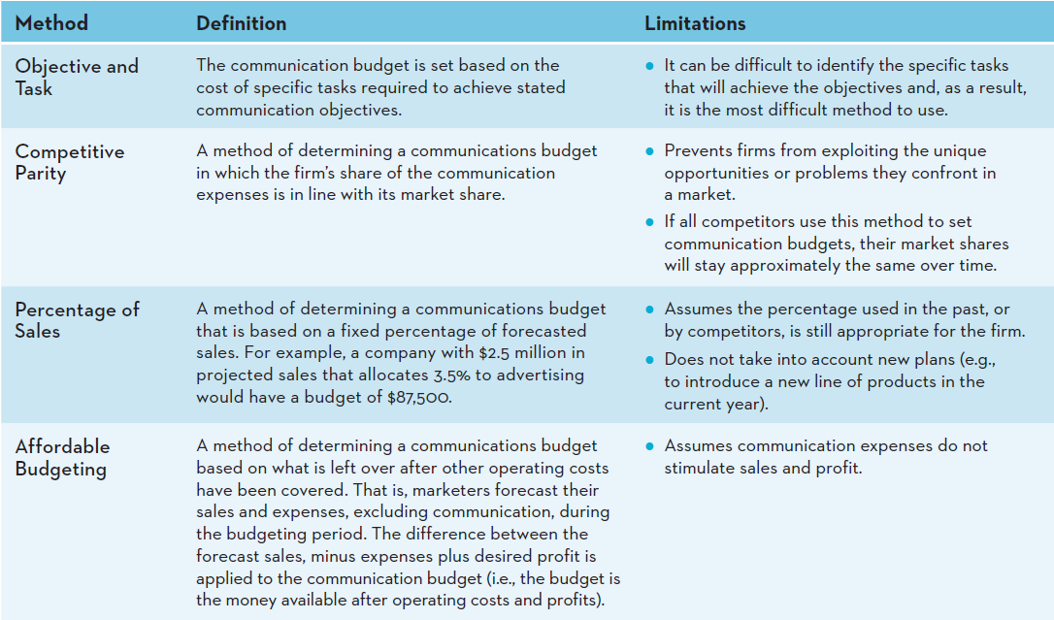
- Convey message
- The message: providing the target audience with reasons to respond (E.g. product’s benefits/attributes/problem solving abilities)
- Unique selling proposition: a strategy of differentiating a product by communicating its unique attributes; often becomes the common theme or slogan in the entire advertising campaign
- Appeal
- Rational appeal vs. emotional appeal
- Rational: helps consumers make purchase decisions by offering factual information and strong arguments build around relevant issues that encourage consumers to evaluate the brand favourably on the basis of the key benefits it provides
- Emotional appeals: aims to satisfy consumer’s emotional desires rather than their utilitarian needs

- Evaluate and select media
- Media planning: the process of evaluating and selecting the media mix that will deliver a clear, consistent, compelling message to the intended audience
- Media mix: the combination of the media used and the frequency of advertising in each medium
- Media buy: the purchase of airtime or print pages
- Mass and Niche Media
- Mass media: channels, such as national newspapers, magazines, radio, and television, that are ideal for reaching large numbers of anonymous audience members
- Niche media: channels that are focused and generally used to reach narrow segments, often with unique demographic characteristics or interests
- Choosing the right medium
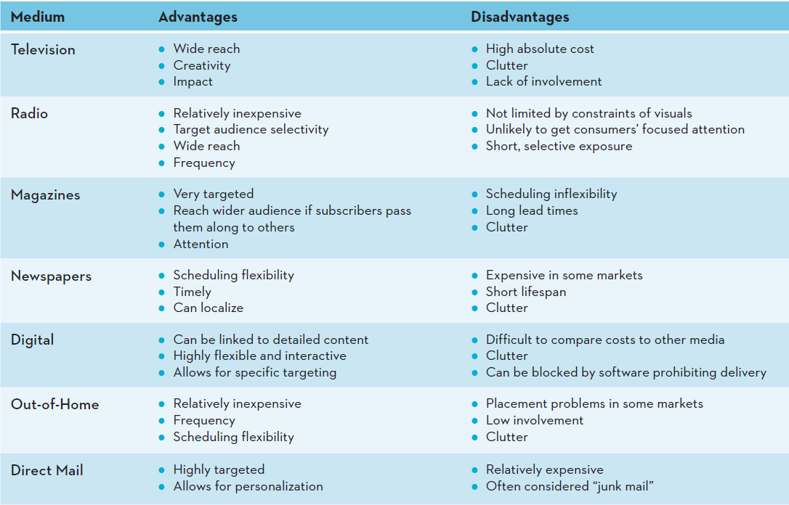
- Determining the advertising schedule
- Advertising schedule: specifies the timing and duration of advertising
- Continuous advertising schedule: runs steadily throughout the year and therefore is suited to products and services that are consumed continually at relatively steady rates and that require a steady level of persuasive or reminder advertising
- Fighting advertising schedule: implemented in spurts, with periods of heavy advertising followed by periods of no advertising
- Pulsing advertising schedule: combines the continuous and fighting schedules by maintaining a base level of advertising but increasing advertising intensity during certain periods
- Create communication
- The type of medium determines the execution style
- Creativity plays a major role in the execution stage
- Creativity should not overshadow the message
- The execution style must match the medium and objectives
- Assess impact
- Pretesting: assessments performed before and ad campaign is implemented to ensure that the various elements are working in an integrated fashion and doing what they are intended to do
- Tracking: includes monitoring key indicators, such as daily or weekly sales volume, while the advertisement is running to shed light on any problems with the message or the medium
- Post-testing: the evaluation of an IMC campaign’s impact after it has been implemented
- Traditional Media: when measuring IMS success, the firm should examine when and how often consumers have been exposed to various marketing communications
- Frequency: measure of how often the target audience is exposed to a communication within a specified period of time
- Reach: measure of consumers’ exposure to marketing communications; the percentage of the target population exposed to a specific marketing communication, such as an advertisement, at least once
- Gross rating points (GRP): measure used for various media advertising-print, radio, or television; GRP=reach x frequency
- Digital media
- Click-through tracking: measures how many times users click on banner advertising on websites
Integrated Marketing Communications Tools
- Advertising: a paid form of communication from an identifiable source, delivered through a communication channel, and designed to persuade the receiver to take some action, now or in the future
- Most visible element of IMC
- Extremely effective at creating awareness and generating interest
- Objective
- Informative advertising: creates and builds brand awareness
- Early in the PLC, firms use informative advertising to educate consumers about the product/service
- Persuasive advertising: firms use persuasive advertising to motivate consumers to take action
- Generally occurs in the growth and early maturity stages of the PLC when competition is most intense
- In the later stage of the PLC may be used to reposition an established brand
- Reminder advertising: it is communication used to remind or prompt repurchases
- After the products have gained market acceptance
- Top-of-mind-awareness: prominent place in people’s memories
- Personal selling: the two-way flow of communication between a buyer and a seller that is designed to influence the buyer’s purchase decision
- Sales promotion: special incentives or excitement-building programs that encourage the purchase of a product or service, such as coupons, rebates, contests, free samples, and point-of-purchase displays
- Direct marketing: marketing that communicates directly with target customers to generate a response or transaction
- Through the use of
- Direct mail/email: a targeted form of communication distributed to a prospective customer’s mailbox or inbox
- Catalogues: many companies use catalogues to strategically build their business; catalogues are particularly important for companies with no bricks-and-mortar locations
- Direct response TV (DRTV): TV commercials or infomercials with a strong call to action
- Kiosks: digital kiosks can be sued to facilitate the way services companies deliver their services to customers
- Characteristics: targeted, motivates an action, measurable, provides information
- Public relations (PR): the organizational function that manages the firm’s communications to achieve a variety of objectives, including building and maintaining a positive image, handling or heading off unfavorable stories or events, and maintaining positive relationships with the media
- Examples: Press releases, sponsorships, special events, Web pages
- Generate “free” media attention
- PR becoming more important as:
- Cost of other media has increased
- Consumers becoming more skeptical about marketing
- Cause-related marketing: commercial activity in which businesses and charities form a partnership to market an image, product or service for their mutual benefit; a type of promotional campaign
- Event sponsorship: a popular PR tool; occurs when corporations support various activities (financially or otherwise), usually in the culture or sports and entertainment sectors
- Digital Media: tools ranging from simple website content to far more interactive features such as corporate blogs, online games, text messaging, social media and mobile apps
- Websites
- Blogs (weblog or web log): a web page that contains periodic posts; corporate blogs are a new form of marketing communications
- Social media
- Mobile apps

