Chapter1

Information Systems Basics

- Information Systems (IS): any computer-based tool that people use to work with information and that supports the information and information-processing needs of an organization
- Most useful when they leverage the talents of people
- Information: about significant things (employees, items in stock, customers….) within the organization or its environment
- Tool: hardware, software, databases, data warehouses, networks, telecommunications…
- Information Technology: the acquisition, processing, storage, and dissemination of vocal, pictorial, textual, and numerical information by a microelectronics-based combination of computing and telecommunications
- Management Information Systems: the function that plans for, develops, implements, and maintains information systems hardware, software, and applications that people use to support the goals of an organization
- A business function just as marketing, finance, operations and human resources
- In organizations, this function is also referred to as: IS or IT
Data, Information, Business Intelligence, and Knowledge
- Data: raw facts representing events such as business transactions
- Information: data shaped into a form that is meaningful and useful to human beings
- Knowledge (Actionable Information): created by analyzing information; may lead to action
- Business Intelligence (BI): information collected from multiple sources (suppliers, customers, competitors, partners, and industries) that analyzes patterns, trends, and relationships for strategic decision making
- Converts data into useful info and through human analysis, into knowledge
- Knowledge Management (KM): organizational process for acquiring, organizing and dissemination knowledge (management the knowledge you’ve already have and help others to make decisions; to disseminated; distribute)

IS (Enable Innovation)
IS are no IT
- IS (information system): is not the same as IT (information technology)
- IS existed long before IT
- Before IT, using books and ledgers, hotels were able to
- Take reservations
- Check guests in and out
- Keep track of room status
- Manage inventory
- Before IT, banks already had sophisticated information systems
- IS supported the processes of the bank by doing the following
- Input, process, store, output (capture info, process info, store info, disseminate info)
- Input-processing-output
- Input: captures info from within the organization or from its external environment
- Processing: conversion manipulation, and analysis of input
- Output: distribution of processed info to people or to other IS
- Giving access for external environment (supplies, regulatory agencies, customers and partners)

Information system helps making decisions

Information Resources and Cultures
- Culture influences the way people use information (their information behavior) and reflects the importance that company leaders attribute to using information in achieving success or avoiding failure
- An organization’s information culture can directly affect its ability to compete in the global market
- Four common information-sharing cultures
- Information-functional: employees use information as a means of exercising influence or power over others
- Information-sharing: employees across departments trust each other to use information to improve performance
- Information-inquiring: employees across department search for information to better understand the future and align themselves with current trends and new directions
- Information-discover: employees across departments are open to new insights about crises and radical changes and seek ways to create competitive advantages
Roles and Responsibilities in Information Systems
- Chief Information Officer (CIO): an executive-level position that involves high-level strategic planning and management of information systems pertaining to the creation, storage, and use of information by a business
- Responsible for:
- Overseeing all uses of information systems
- Ensuring the strategic alignment of IS with business goals and objectives
- Key roles (roles can be differ in terms of how CIOs manage their time and the hurdles障碍):
- Manager: ensure the delivery of all IS projects, on time and within budget
- Leader: Ensure the strategic vision of IS is in line with the strategic vision of the organization
- Communicator: Advocate and communicate the IS strategy by building and maintaining strong executive relationships
- Chief Technology Officer (CTO): ensuring the throughput, speed, and accuracy. Availability, and reliability of an organization’s information technology
- Direct responsibility for ensuring the efficiency of IT resources used in information systems throughout the organization (report to CIO)
- Chief Security Officer (CSO): ensuring the security of information systems, and developing strategies and technical safeguards against attacks from hackers and viruses
- Chief Privacy Officer (CPO): ensuring the ethical and legal use of information within an organization
- Chief Knowledge Officer (CKO): collecting, maintaining, and distributing an organization’s knowledge
- Design processes and information systems that make it easy for people to reuse knowledge
- Can contribute directly to organization’s bottom line by reducing the learning curve for new employees or employees taking on new roles
The Skills Gap in Canada
- Skill profiles:
- With an understanding of business processes including an understanding of the specific context in which a business or organization operates
- With the technical skills that are important to another field (industry or sector)
Functional Areas in Organizations
- Functional areas are not isolated silos, they are interdependent
- An “order fulfillment” process involves sales, Accounting, & Production
- The organization needs to have something better than email to exchange information among different departments
- Email: different systems between two different departments
- ERP System (solution): runs across different departments
IS Support & Organizational Levels
- Operational-level: IS support operational managers in keeping track of elementary activities and transactions
- Management-level: IS help in monitoring, controlling, decision-making, and administrative activities of middle managers
- Strategic-level: IS help senior managers address strategic issues
Managers and IS
- Managers must
- Identify opportunities to use IS to heir organization’s advantage
- Make decisions about the use of IS in their organization
- Plan

Identifying Competitive Advantages
- Competitive Advantage: a product or service that an organizations customers put a greater value on than similar offerings from a competitor
- First-mover advantage: occurs when an organization can significantly impact its market share by being first to market with a competitive advantage
- Environmental scanning: the acquisition and analysis of events and trends in the environment external to an organization
- Three common tools to analyze and develop competitive advantages
- Five Forces Model
- Three generic strategies
- Value chain analysis

Porter’s Five Forces Model: Evaluating Business Segments
- Helps determine the attractiveness of an industry by looking at the 5 forces that organizations within the industry must deal with
- Buyer power: high when buyers have many choices of whom to buy from and low when their choices are few (lower is better for sellers)
- Two situations need to concern about buyer power
- In their relationships with customers
- In their relationships with suppliers
- Loyalty programs: reward customers based on the amount of business they do with an organization (frequent flyer programs)
- To reduce buyer power
- Some companies rely on switching costs to reduce buyer power – manipulating costs to make customers reluctant to switch to another product
- Supplier power: high when buyers have few choices to buy from and low when they have many choices (higher is better for sellers)
- Use IS to reduce supplier power by locating alternative supply sources through B2B marketplaces
- B2B marketplace: an Internet-based service that brings together buyers and sellers
- Private exchange: a B2B marketplace in which a single buyer posts its needs and then opens the bidding to any supplier who cares to bid
- Reverse auctions(反向拍卖): a format in which increasingly lower bids are solicited from organizations willing to supply the desired product or service at an increasingly lower price
- Internet-based reverse auctions are an excellent example of how information systems can reduce supplier power for an organization and create a competitive advantage
- Threat of new entrants: high when it is easy for new competitors to enter a market and low when there are significant entry barriers to entering a market
- Use IS to create an entry barrier; a product or service feature that customers have come to expect from organizations in a particular industry and must be offered by an entering organization to compete and survive
- Online banking for banks
- Online package tracking for shipping companies
- Substitute products or services: high when there are many alternatives to a product or service and low when there are few alternatives from which to choose (lower is better)
- Switching Cost: costs that can make customers reluctant to switch to another product or service; to create competitive advantages

- Rivalry among existing competitor: high when competition is fierce(凶猛的) in a market and low when competition is moderate
- Use IS to build effectiveness and efficiency into the supply chain
- Electronic links between Wal-Mart and its suppliers
- A firm can achieve competitive advantage over its competitors (threat 5) by enhancing its ability to deal with threats 1,2,3,4
- An industry can achieve strategic advantage by getting together to face threats 2,3 and 4
- Deal with suppliers as a group (2)
- Develop industry standards
- Raise entry barriers to discourage new entrants (3)
- Make product substitution harder (4)
- Internet’s impact on the 5 forces
- Customers have access to more info on products & pricing
- Suppliers have more options to sell their products
- The Internet reduces barriers to entry (physical presence)
- New substitutes emerge
- The Internet widens geographic markets, increasing the number of competitors
- IS-enabled competitive advantage: when you use IS to obtain and edge over competitors
- But sustainable IS-enabled competitive advantage is had to achieve – competitors can duplicate it
- Organizations need to continuously perform environmental scanning

Porter’s 3 Generic Strategies: Creating A Business Focus (P18)
- Broad cost strategy: low cost, large market segment
- Broad differentiation strategy: higher safety, large market segment
- Focused strategy: low cost, narrow market segment
- Relationship among strategy
- Cost Leadership Strategy
- Differentiation Strategy
- Market segmentation
- Broad Market
- Focused Market
Value Chain Analysis: Targeting Business Process (P19)
- Value Creation
- Business process: a standardized set of activities that accomplish a specific task (processing a customer’s order)
- Value Chain: views an organization as a series of processes, each of which adds value to the product or service for each customer
- To create a competitive advantage, the value chain must enable the organization to provide unique value to its customers
- Organizations can add value by offering lower prices or by competing in a distinctive way
- Organizations should attempt to use information systems to add value to both primary and support value activities
- Primary value activities: acquire raw materials and manufacture, deliver, market, sell, and provide after-sales services
- Support value activities: firm infrastructure, human resources management, technology development, and procurement(采购), support the primary value activities
- Value chain analysis is highly useful tool in that it provides hard-and-fast numbers for evaluating the activities that add value to products and services
- Offering high quality of customer servicesincreasing switching costdecreasing buyer power
- Analyzing and constructing its support value activitiesdecrease the threat of new entrants
- Analyzing and constructing its primary value activitiesdecrease the threat of substitute products or services
Business-Driven Information Systems and Business Strategy
- Porter’s Five Forces Model: a framework that helps companies evaluate the relative attractiveness of entering or operating within an industry; can be sued to assess the attractiveness of the industry in which a firm competes
- Three Generic strategies: brad competitive approaches that organizations fall under; help organization make informed decisions about how the company should compete with others
- Value Chain Analysis: a systematic approach organizations can use to assess and improve the value of their business change or improve those activities to help it become more competitive
- Business-driven information systems: are implemented to support a company’s competitive business strategy

Chapter 2

Making Business Decisions
- Managerial Decision-making Challenges
- Managers need to analyze large amounts of information
- Managers must make dicisions quickly
- Managers must apply sophisticated analysis techniques, such as Porter’s strategies or forecasting, to make strategy decisions
- Decision Making
- JIT goal: carry less inventory of parts & finished products
- Need: information in order to produce the right amount of products with the right spaces/features
- The more info you process, the better decisions you make
- But info can e overwhelming
- You need IS in order to:
- Make better decisions faster while leveraging large amounts of info
- Applying sophisticated analysis techniques, without security and privacy of the info
- Three Levels
- Operational: employees develop, control, and maintain core business activities required to run day-to-day operations
- Structured decisions: arise in situations where established processes offer potential solutions; affect short-term business strategies
- E.g. Reordering and creating employee staffing and weekly production schedules
- Managerial: employees are continuously evaluating company operations to hone the firm’s ability to identify, adapt to, and leverage change
- Covers short and medium range plans, schedules, and budgets, along with policies, procedures and business objectives for the firm.
- Semi-structured decisions: they occur in situations in which a few established processes help to evaluate potential solutions, but not enough to lead to a definite recommended decision
- E.g. decisions about producing new products or changing employee benefits range from unstructured to semi-structured
- Strategic: managers develop overall business strategies, goals, and objectives, as part of the company strategic plan
- Monitor the strategic performance of the organization and its overall direction in political, economic, and competitive business environment
- Unstructured decisions: occurring in situations in which no procedures or rules exist to guide decision makers towards the correct choice
- Infrequent, extremely important, and typically related to long-term business strategy
- E.g. Decisions to enter a new market or even a new industry over the next three years

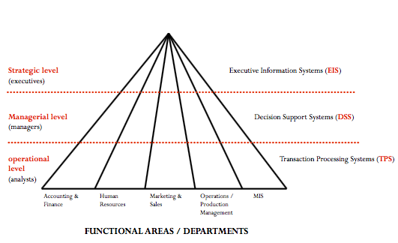

Measuring Decision Success
- Project: a temporary activity a company undertakes to create a unique product, service or result
- Metrics: measurements that evaluate results to determine whether a project is meeting its goals
- Critical success factors (CSFs): crucial steps companies perform to achieve their goals and objectives and implement their strategies
- Key performance indicators (KPIs): the quantifiable metrics a company uses to evaluate progress toward critical success factors (far more specify as CSFs)
- KPIs measure the progress of CSFs with quantifiable measurements
- One CSF can have several KPIs
- Market share: external KPI; the proportion of the market that a firm captures
- Return on investment (ROI): internal KPI; indicates the earning power of a project
- Challenging to measure
- Best practices: the most successful solutions or problem-solving methods that have been developed by a specific organization or industry
- Efficiency and Effectiveness Metrics
- Efficiency IS metrics: measure the performance of MIS itself
- Throughput, transaction speed, and system availability
- Focus on extent to which a firm is using its resources in an optimal way
- Getting the most from each resource
- Effectiveness IS metrics: measure the impact MIS has on business processes and activities
- Customer satisfaction
- Customer conversion rates
- Focuses on how well a firm is achieving its goals and objectives
- Setting the right goals and objectives and ensuring they are accomplished
- Increases in productivityincreases in effectivenessfocus on CSFs
- Interrelationship between efficiency and effectiveness MIS metrics
- Success in one area does not necessarily imply success in the other
- Benchmarks: a process of continuously measuring system results, comparing those results to optimal system performance (benchmark values), and identifying steps and procedures to improve system performance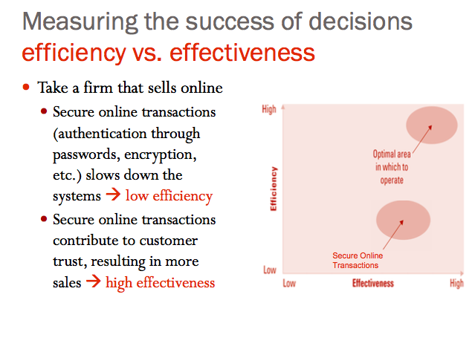
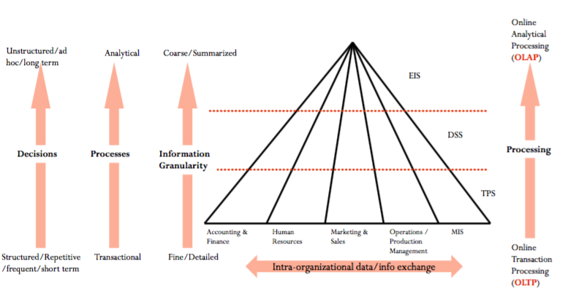
Types of Information
- Transactional data: raw materials within a single business process or department
- Supports daily operational tasks
- Examples: order size, manager’s salary, product price, stock price, shipping date
- Use when performing operational tasks and routine decisions
- Analytical information: encompasses all summarized or aggregated transactional data
- Support performing analysis tasks
- Example: market trends, forecasts, sales by region
Categories of IS In the Organization
- Transaction Processing Systems: support operational managers in keeping track of elementary activities and transactions (accurate)
- IS answers questions such as “what is the inventory level?” “where is my order?”
- Basic IS that serves the operational level in an organization (for clerks and analysts)
- Payroll system (Tracking hourly employees)
- Accounts Payable system
- Human Resources systems (tracking vacation, sick days)
- Course Registration system (university)
- System running an ATM (bank)
- Online reservation system (hotel)
- Online Transaction Processing: capturing of transaction and event data using information system (Operational)
- Process the data according to defined business rules
- Store the data
- Update existing data to reflect the new data entered
- Online Analytical Processing: the analysis of summarized or aggregated information sourced from transaction processing systems data, and sometimes external information from outside industry sources, to create business intelligence in support of analytical and strategic decision
- Business Intelligence: a broad, general term describing information that people use to support their analytical and strategic decision making efforts
- Consolidation: involves the aggregation of information and features simple rollups to complex groupings of interrelated information
- Drill-down: enables users to view details, and details of details, of information
- Digging into the numbers (revenues broken down into individual product revenues for each store)
- Slice-and-dice: the ability to look at information from different perspectives
- One slice of information could display all product sales during a given promotion
- Another slice could display a single product’s sales for all promotion
- Decision Support Systems (DSS): serve the monitoring, controlling, decision-making, and administrative activities of middle managers
- An IS that models data and information to support managers, analysts, and other professionals during the decision-making process
- Depending on the level of the analysis, a DSS is used on transactional data or analytical information
- IS answer questions such as: “Is the production running according to plan?”, “what happens if we double our production?”
- Three quantitative models
- What-if analysis: checks the impact of a change in variable on the outcome
- Sensitivity analysis: the study of the impact that changes in one (or more) part(s) of the model have on other parts of the model
- Interested in “what variables have the most effect on the outcome
- Goal-seeking analysis: finds the inputs necessary to achieve an outcome
- Sets a target value for a variable and then repeatedly changes other variables until the target value is achieved
- “How many customers are required to increase profits to $5 million”
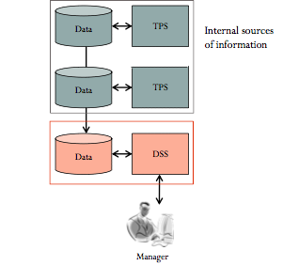
- Executive Information Systems (EIS): a specialized DSS that supports senior level executives
- Typically contains information from external sources as well as information from internal data sources, supports executive end-users exclusively, contains primarily very coarse information, and is used more often for strategic purpose
- EIS may use a digital dashboard – integrates information from multiple components and presents it in a unified display
- Visualization: use it to produce graphical displays of patterns and complex relationships in large amounts of data
- Digital dashboards: to support visualization, which tracks KPIs and CSFs by compiling information from multiple sources and tailoring it to meet user needs
- Market pulse: daily sales numbers, market share, and subscriber turnover
- Customer services: problems resolved on the first call, call center wit times, and on-time repair calls
- Cost drivers: number of repair trucks in the field, repair jobs completed per day, and call center productivity

 | TPS | DSS | EIS
Types of data or information typically found in the system | Transactional data | Transactional data or analytical information | Analytical information
Who typically makes the decisions using the system? | Clerk or analyst | Analyst or manager | Executive
Type of decision typically handled | Operational | Analytical or managerial | Strategic

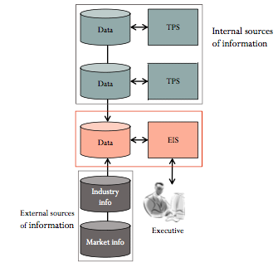
Artificial Intelligence
- Enables organizations to track the product offerings, pricing policies, and promotions of l=online competitors
- Simulates human thinking and behavior, such as the ability reason and learn
- Intelligent systems: various commercial applications of artificial intelligence
- Includes sensors, software and devices that emulate and enhance human capabilities
- Learn or understand from experience
- Make sense ambiguous or contradictory information
- Use reasoning to solve problems
- Make decisions effectively
- Expert Systems: computerized advisory programs that imitate the reasoning processes of experts in solving difficult problems
- Most common use of AI in the business because they fill the gap when human experts are difficult to find or retain, or are too expensive
- (Artificial) Neural networks: attempts to emulate the way the human brain works
- Learning and adjusting to new circumstances on their own
- Lending themselves to massive parallel processing
- Functioning without complete or well-structure information
- Coping with huge volumes of information with many dependent variables
- Analyzing nonlinear relationships (they have been called fancy regression analysis systems)
- Genetic algorithms: an artificial intelligence system that mimics the evolutionary, survival-of-the-fittest process to generate increasingly better solutions to a problem
- It finds the combination of inputs that gives the best outputs
- Best to make decisions when thousands, or perhaps millions, of solutions are possible
- Intelligent agents: a special-purpose knowledge-based information system that accomplishes specific tasks on behalf of its users
- Shopping bot: software that searches several retailer websites and provide a comparison of each retailer’s offerings, including price and availability
- Environmental scanning and competitive intelligence
- Multi-agent systems: groups of intelligent agents have the ability to work independently and interact
- Agent-based modeling: each of the intelligent agents follows a set of simple rules and can adapt to changing condition
- Model stock market fluctuations
- Predict the escape routes that people seek in a burning building
- Estimate the effects of interest rates on consumers with different types of debt
- Anticipate how changes in conditions will affect the supply chain
- Virtual reality: a computer-simulated environment that can be a simulation of the real world or an imaginary world
- Augmented reality: the viewing of the physical world with computer-generated layers of information added to it

Evaluating Business Processes
- Business process: a standardized set of activities that accomplish a specific task
- Manufacturing: “assembling a product”
- Sales & Marketing: “identifying customers”
- Finance & Accounting: “creating financial statements”
- HR: “hiring new employees”
- Categories:
- Customer facing processes: result in a product or service that is received by an organization’s external customer (customer service)
- Business facing processes: are invisible to the external customer but are essential to the effective management of the business (budget planning)
- Organization-wide processes: span 2 or more functional areas of an organization (order processing)
- Inter-organizational processes: span 2 or more organizations (supply chain process)
- Business patent: a patent that protects a specific set of procedures for conducting a particular business activity
- Core processes: business processes, such as manufacturing goods, selling products, and providing service, that make up the primary activities in a value chain
- Visualizing: discovering inefficiencies redundancies, bottlenecks, then improving it or reengineering it
Business Process Modeling
- The activity of creating a detailed flowchart, workflow diagram, use case diagram, or process map showing process inputs, tasks, and activities in a structured sequence
- Business process model: a graphic description of a process, showing the sequence of tasks that complete the process from a selected viewpoint
- Purpose:
- Expose process detail gradually and in a controlled manner
- Encourage conciseness and accuracy in describing the process model
- Focus attention the process model interfaces
- Provide a powerful process analysis and consistent design vocabulary
- As-is process models: represent current state of the operation that has been mapped without any specific improvements or changes to existing processes
- To-be process models: show the results of applying change improvement opportunities to the current (As-is) process model
- Modeling allows us to do a thorough analysis that takes into account all these decision points and variables
* (P54-60)
Business Process Improvement
- Attempts to understand and measure current processes and upgrade them
- All business process should be based on business strategies and goals
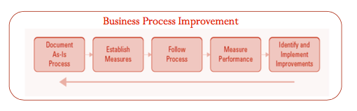
Business Process Re-engineering
- Business Process Re-engineering/re-design: the analysis and redesign of business processes
- The purpose of BPR is to make all business processes best-in-class
- Unlike “business process improvement”, BPR assumes the current process is broken and must be redesigned from scratch
- Unlike “business process improvement” which brings “slow and incremental improvements, BPR brings “rapid and dramatic improvements”

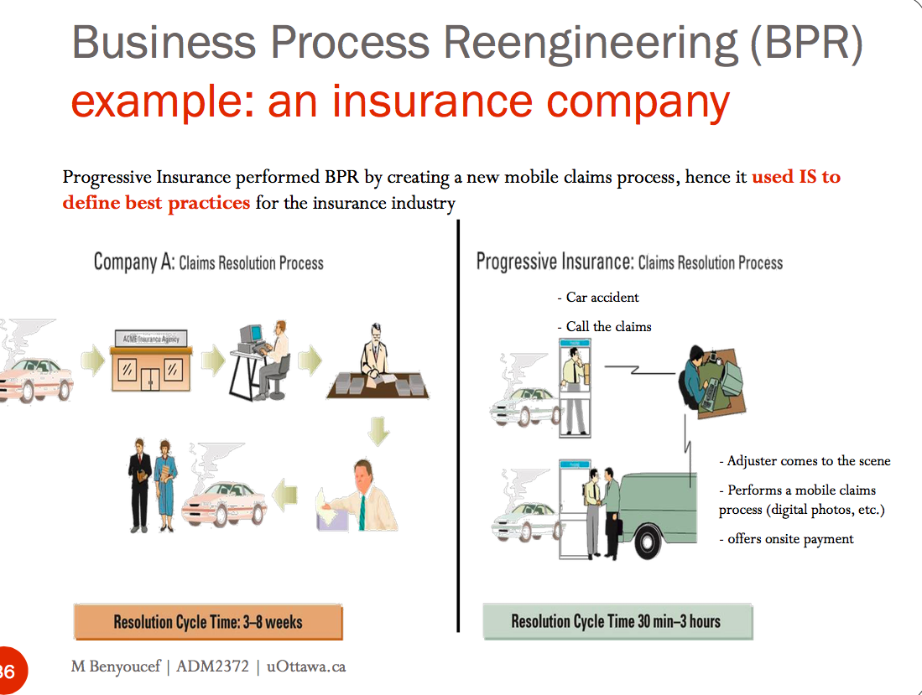

- Process change spectrum
- Automate: new IS to speed up performance of existing tasks
- Bank employee uses IS to access customer records
- Streamline: new IS to streamline processes
- Eliminate bottlenecks, make processes efficient
- BPR: new IS requires that processes be radically redesigned
- Combine steps, eliminate repetitive steps
- Strategic Re-engineering: new IS transforms the nature of the business
- Universities use IS to offer courses onlineteaching methodologies are altered
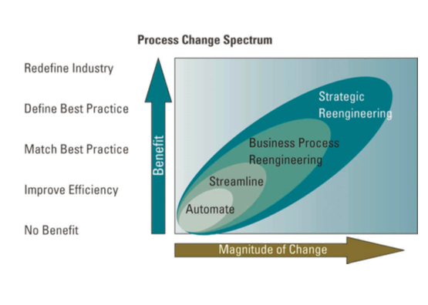
The Future: Business Process Management
- Business Process Management: integrates all of an organization’s business process to make individual processes more efficient
- Can be used to solve a single glitch or to create one unifying system to consolidate a myriad of processes

Self-check
Business travellers

Online

Chapter 3

- Data: raw facts representing events such as business transaction
- Information: data shaped into a form that is meaningful and useful to human beings
- Knowledge: created by analyzing information; may lead to action
Organizational Data and Information
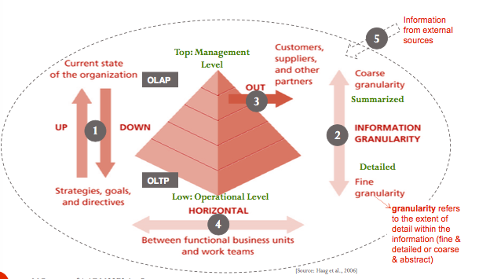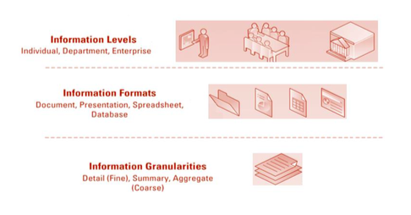
- Granularity: the extent of detail within the data and information (fine and detailed versus coarse and abstract)
- Information
- Transactional Data: encompasses all of the data contained within a single business process or unit of work, and its primary purpose is to support performing daily operational tasks
- E.g. Analyzing daily sales figures and production schedules to determine how much inventory to carry
- Analytical information: encompasses all organizational information, and its primary purpose support the performance of higher-level analysis tasks
- E.g. Whether the organization should build a new manufacturing plant or hire additional personnel
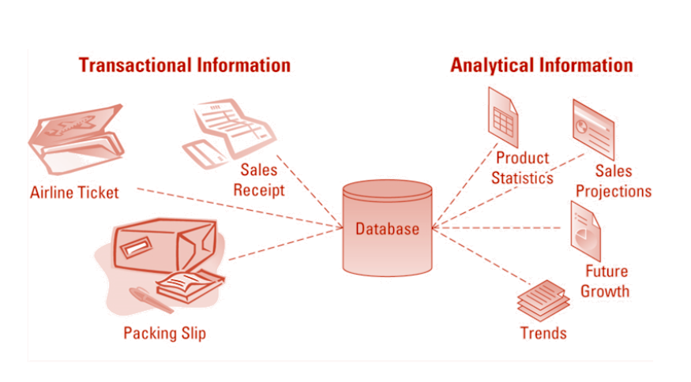
- Timely Data and Information: timeliness is an aspect of data and information that depends on the situation
- Some data or information that is a few days or weeks old can be relevant
- E.g. Insurance and contruction company
- Other data or information that is a few minutes old can be almost worthless
- E.g. 911 centers, stock traders, banks
- Real-time data: up-to-date data
- Real-time information: up-to-date information
- Real-time system: provides real-time transactional data and/or real-time analytical information in response to query requests
- High quality
- Accurate
- Is the name spelled correctly?
- Complete
- Is the address complete (street, city, province, postal code)?
- Consistent
- Does the total field equal the total of the individual fields
- Unique
- Are there any duplicate customers
- Timely
- Is information updated weekly, daily, or hourly?
- Low quality
- Sources:
- Online customers intentionally enter inaccurate info to their privacy
- Data or info from different systems have different entry standards and formats
- Call center operators enter abbreviated or erroneous in accident or to save time
- Third party and eternal info contains inconsistencies, inaccuracies and errors
- Cost of poor data and information:
- Inability to accurately track customers, which directly affects strategic initiatives such as customer relationship management (CRM) and supply chain management (SCM)
- Difficulty identifying the organization’s most valuable customers
- Inability to identify selling opportunities and wasted revenue from marketing to non-existent customers and non-deliverable mail
- Difficulty tracking revenue because of inaccurate invoices
- Inability to build strong relationships with customers, which increases their buyer power
- Benefit of good data and information:
- Ensure the basis of the decisions is accurate
- The success of the organization depends on appreciating and leveraging the true value of timely and quality data and information
- Data governance: refers to the overall management of the availability, usability, integrity, and security of company data
- 1) From Data to Knowledge
- Knowledge: actionable information
- Information becomes knowledge only when info can be acted upon
- To be knowledgeable, a person must understand the information, to make inferences between various tidbits of information, and be able to apply that knowledge into action
- A carpenter can put all the info he accumulated about woodworking into action by gilding something
- If I give a non-woodworking expert a book about woodworking, would it make him a carpenter?
- Not necessarily
- That person would be more “informed”, and would not be considered “knowledgeable” unless he puts the info he has “into action”
- You are only knowledgeable if you know how to apply the information in the real cases
- Helping employees access, share, and utilize information is perhaps the best way to convert information into knowledge
2) From Data to Wisdom
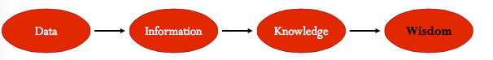
- Types of knowledge:
- Explicit knowledge: consist of anything that can be documented, achieved, and codified, often with the help of information systems
- E.g. Assets such as patents, trademarks, business plans, marketing research, and customer lists
- Tacit knowledge: the knowledge contained in people’s heads
- Challenges:
- Figuring out how to recognize, generate, share, and manage knowledge that resides in people’s heads
- The best way to sharing/transferring/recreating tacit knowledge inside an organization
- Shadowing: less experienced staff learn by observing more experienced
- Joint problem solving: novice and expert work together (note that shadowing is more passive)
- Wisdom: the collective and individual experience of applying knowledge to the solution of a problem
- Involves knowing when, where, and how to apply knowledge
- Knowledge Management (KM)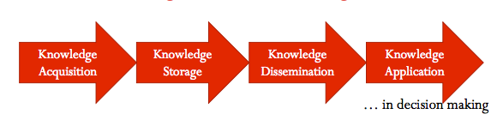
- Capturing, classifying, evaluating, retrieving, and sharing information assets in a way that provides context for effective decision and actions*
- A business discipline for managing the cultural conditions necessary to ensure the effective capture, transfer, and translation of knowledge from those who “know: to those who “need to know” in support of organizational goals, objectives and outcomes
- KM is systematic. Effective management and use of an organization’s information resources that contain or embody knowledge
- Sources: people, paper documents, electronic documents, presentations, and spreadsheets, and data warehouse solutions
- About how companies cultivate and promote practices (behaviors), and use information systems that help capture, store, organize, and make the best use of information within and across the enterprise to increase and leverage organizational knowledge and know-how
- Knowledge Management System (KMS)
- Companies are turning to IS to enable their employees to access, share and utilize information in an efficient and effective way
- Supports the capturing, organizing, and disseminating knowledge (i.e. know-how) throughout the organization)
- These IS are usually referred to as KMS
- E.g. an intranet, a corporate wiki, a corporate social network (Yammer), etc.
- Why wiki is KMS: it can gather, organize, manage and distribute knowledge
- Social Network: share, gather, and comment information/knowledge
- An effective KMS system should help do one or more of the following:
- Foster innovation by encouraging the free flow of ideas
- Improve customer service by streamlining response time
- Boost revenues by getting products and services to market faster
- Enhance employee retention rates by recognizing the value of employees’ knowledge
- Streamline operations and reduce costs by eliminating redundant or unnecessary processes
- Result in
- Improved in efficiency
- Higher productivity
- Increased revenue practically in any business function
- Difference between BI & EMS: BI gives the knowledge, KMS helps to manage the knowledge

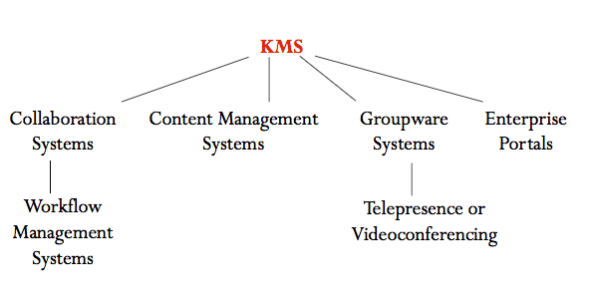
- Collaboration Systems: an IT based set of tools that supports the work of teams by facilitating the sharing and flow of information
- Ways business is using collaboration:
- Telecommunicating
- Remote projects
- Online meeting
- Deploying application
- Unstructured collaboration/information collaboration
- Includes document exchange
- Shared white boards
- Discussion forums
- E-mail
- Structured collaboration/process collaboration
- X does something, then Y does something
- Until the process is finishedworkflow management system
- Workflow: all the steps or business rules, from beginning to end, required for a business process
- Workflow management system: facilitates the automation and management of business processes and controls the movement of work through the business process
- Employees are notified when their action is required as part of the business process
- Message-based workflow systems: send work assignments through an email system
- Database-based workflow systems: store documents in a central location and automatically ask the team members to access the document when it is their turn to edit the document
- Core competency: its key strength, a business function that it does better than any other competence
- Core competency strategy: one in which an organization chooses to focus specifically on what it does best, and form partnerships and alliances with other specialist organizations to handle non-strategic business processes
- Information partnership: occurs when two or more organizations cooperate by integrating their information systems, thereby opportunity for IS-enabled business partnerships and alliances
- Content Management Systems: tools to manage creating, storing, editing, and publishing of information (documents) in a collaborative environment
- Document management system (DMS): supports the electronic capturing, storage, distribution, archiving, and accessing of documents. It optimizes the use of documents within an organization independently of any publishing medium
- Digital asset management system (DAM): though similar to document management, generally works with binary rather than text files
- Web content management system (WCM): adds a layer to document and digital asset management that enables publishing content both to intranets and to public websites
- Groupware Systems: an IT based tool that supports team interaction
- Videoconferencing/telepresence: interactive telecom technologies that allow 2 or more locations to interact via two-way video and audio
- Web Conferencing: blends audio, video and document sharing technologies to create virtual meeting rooms
- Advantages:
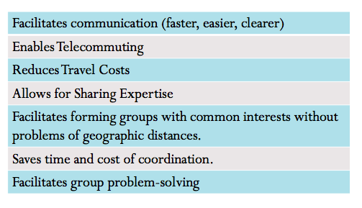

- Enterprise Portals: a portal (or web portal) is “ a website that functions as an entry point to the Internet, as by providing useful content and linking to various sites and features on the World Wide Web
- A single-point web browser interface used to promote the gathering, sharing and dissemination of info throughout an enterprise
- An enterprise portal typically has
- A taxonomy or classification of info categories
- A search engine
- Links to internal and external info sources
- Instant message: a type of communications service that enables someone to create a kind of private chat room with another individual in order to communicate in real time over the Internet
Business Intelligence and Big Data
- BI (just the definition in PDF): applications and technologies that are used to gather, provide access to, and analyze information to support decision-making.
BI’s Operational Value
- Latency: gap between a business event and action taken
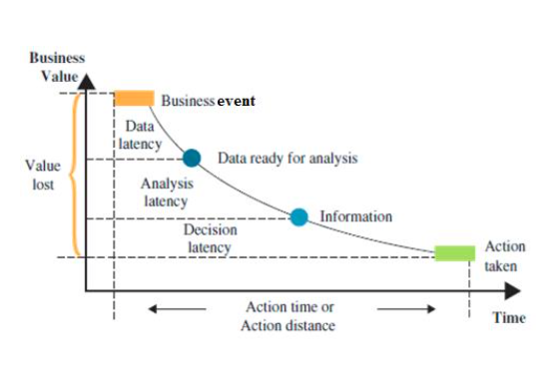
- Data Latency: time needed to make transaction data ready for analysis
- i.e. the time for extracting transforming , and cleansing the data
- Analysis Latency: time between accessing analytical information and when the analysis is complete
- Decision Latency: time it takes to take appropriate action

Chapter5

Web 1.0: Disruptive Technology
- Digital Darwinism: implies that organizations that cannot adapt to the new demands put on them for surviving in the information age are doomed to extinction
- Disruptive Vs. Sustaining Technology
- Disruptive technology: a new way of doing things that initially does not meet the needs of existing customers
- Opens new markets and destroys old ones (e.g. digital photography, digital music, e-books, etc)
- Sustaining technology: produces an improved product that customers are eager to buy (e.g. faster car, larger hard drive, cheaper mp3 player) in established markets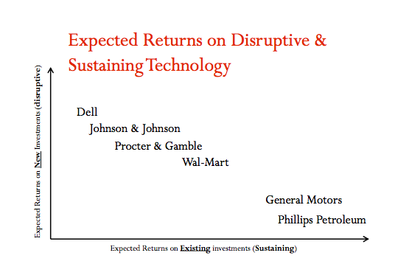
The Internet and World Wide Web: Business Disruptors
- Internet: a global public network of computer networks that pass information from one to another using common computer protocols
- Protocols: standards that specify the format of data as well as the rules to be followed during transmission
- The Internet has disrupted the way business operate employees communicate, and products are developed and sold:
- Travel sites
- Entertainment
- Education and Training
- U.S. Department of Defense (Beginning)ScientistsBusiness
- Evolution of the Internet
- Internet service provider (ISP): provides individuals and other companies access to the Internet
- Application service provider (ASP): offers access over the Internet to applications and related services that would otherwise have to be located in organizational computers
- World Wide Web (WWW): a global hypertext system that uses the Internet as its transport mechanism
- Hypertext transport protocol (HTTP): the Internet standard that supports the exchange of information on the WWW
- Other protocols:
- File transfer protocol (FTP)
- Telnet: a protocol for accessing a remote host computer
- Digital Divide: occurs when those with access to technology have great advantages over those without access to technology
E-Business Basics
- E-commerce: the buying and selling of goods and services over the Internet (online transactions)
- E-business: derived from e-commerce, is the conduct of business on the Internet, not only buying and selling, but also serving customers and collaborating with business partners
- Differences
- E-business: refers to online exchanges of information
- A manufacturer allowing its suppliers to monitor production schedules or a financial institution allowing its customers to review their banking, credit card, and mortgage accounts
- Advantages of E-business
- Expanding Reach: easy access to real-time information
- E-business expands information reach: the measure of the number of people a firm can communicate with all over the world
- Opening New Markets: perfect for increasing niche-product sales
- Mass customization: the ability of an organization to tailor its products or services to the customers; specifications
- Personalization: occurs when a company knows enough about a customer’s likes and dislikes that it can fashion offers more likely to appeal to that person
- Long-tail: refers to the tail of a sales curve
- Because online businesses are not limited by shelf space, they can offer a far wider selection of products that may suit only a few customers (i.e. niche products such as less popular movies)
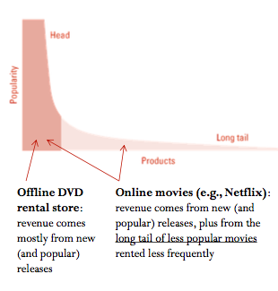
- Intermediaries: agents, software, or businesses that provide a trading infrastructure to bring buyers and sellers together
- The introduction of e-business about disintermediation: occurs when a business sells directly to the customer online and cuts out the intermediary
- Re-intermediation: steps are added to the value chain as new players find ways to add value to the business process
- DellWalmartCustomers
- Cybermediation: refers to the creation of new kinds of intermediaries that simply could not have existed before the advent of e-business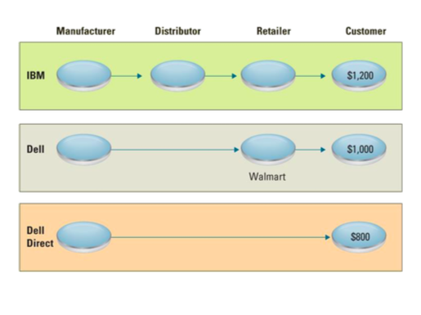
- Reducing Costs
- Improving Operations
- Improving Effectiveness
- Interactivity: measures advertising effectiveness by counting visitor interactions with the target ad, including;
- Time spent viewing the ad
- Number of pages viewed
- Number of repeat visits to the advertisement
- Click-through rate: number of banners clicked/ number of banners viewed
E-Business Models
- E-business model: an approach to conducting electronic business on the Internet
- Two types of business relationships
- B2B
- B2C
- Difference:
- The nature of customers
- B2B: applies to businesses buying from and selling to each other over the Internet
- E-marketplaces: comprises interactive business communities providing a central market where multiple buyers and sellers can engage in e-business activities
- B2C: applies to any business that sells its products or services to consumers over the Internet
- C2B: applies to any consumer that sells a product or service to a business over the Internet
- C2C: applies to sites primarily offering goods and services to assist consumers interacting with each other over the Internet (ebay)
Organizational Strategies for E-Business
- Primary business areas taking advantage of e-business include:
- Marketing/Sales: direct selling was the earliest type of e-business, and it has proven to be a stepping stone to more complex commerce operations
- Financial Services: are enjoying rapid growth, as they help consumers, businesses, and financial institution distribute information with greater convenience and richness than is available in other channels
- Procurement
- Maintenance, repair, and operations (MRO) materials/ indirect materials: materials necessary running an organization but do not relate to the company’s primary business activities
- Office supplies
- Equipment
- Furniture
- Computers
- Replacement parts
- E-procurement: the B2B purchase and sale of supplies and services over the Internet
- It reduces the need to check the timeliness and accuracy of supplier information
- Electronic catalogue: presents customers with information about goods and services offered for sale, bid, auction on the Internet
- Customer service: E-business enables customers to help themselves by combining the communications a capability of a traditional customer response system with the content richness only the Web can provide
- Intermediaries
E-Business Challenges
- Protecting consumers
- Against invasion of privacy, hackers, etc.
- Leveraging existing systems
- Integrating old systems with the new ones
- Increased liability
- Internet law is vaguely defined and differs from country to country
- Providing security
- To protect information while it travels on the network and while stored in database (e.g. encryption)
- Adhering to taxation rules
- The Internet remains mostly free from traditional from of taxation
E-Business Benefits
- Better accessibility
- Businesses can operate 24/7
- Increased customer loyalty
- Additional channels to contact, respond to, and access customers contribute to customer loyalty
- Improved information content
- Web pages present customers with updated information in real-time about goods, services, and prices
- Increased convenience
- E-business automates and improves many of the activities that make up a buying experience
- Increased global reach
- Businesses, large and small, can reach new markets
- Decreased cost
- The cost of conducting business on the Internet is substantially smaller than traditional forms of business communication
Web 2.0 and Beyond
- Web 2.0: a set of economic, social, and technology trends that collectively form the basis for the next generation of the Internet—a more mature, distinctive medium characterized by user participation, openness and network effects
- Mashups: a website or Web application that uses content form more than one source to create a complete new service
- Application programming interface (API): a set of routines, protocols, and tools for building software applications
The Future: Web 3.0
- Provides a way of describing relationships between web pages so that machines understand the meaning of hyperlinked
- Transforming the web into a database
- Emergence of a data-driven web where structured records can be reusable and queried remotely
- Allows unparalleled information sharing because communication forms and files have common formats
Accessing Internet Information
- Four common tools
- Intranets: an internalized portion of the Internet, protected from outside access, that allows an organization to provide access to information and application software to only its employees
- Secured behind a firewall—hardware/software that filter information and keeps outsiders from accessing your network
- Extranets: an intranet that is available to strategic allies (customers, suppliers, and partners)
- Portals: a website that offers a broad array of resources and services (email, online discussion groups, search engines, and online shopping malls)
- Kiosks: a publicly accessible computer set up to allow interactive information browsing
E-Government and M-Commerce
- E-government: uses strategies and technologies to transform government by improving the delivery of services and enhancing the quality of interaction with the citizen-consumer within all branches of government
- M-commerce: the ability purchase goods and services through a wireless Internet-enabled device
- Some technical challenges for M-commerce
- Size of display
- Awkward input capabilities
- Slow transfer
- Few websites offer content for wireless Internet
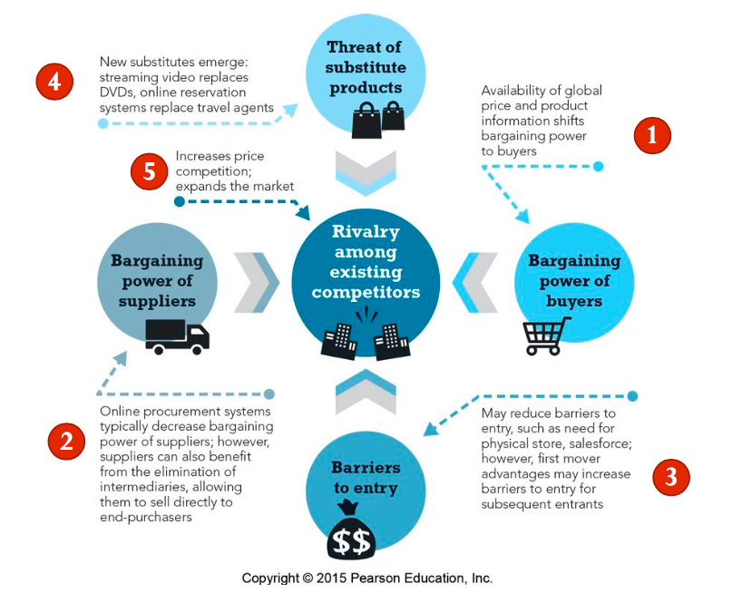
Chapter 7

Enterprise Computing Challenges
- Innovation: the introduction of new equipment or methods
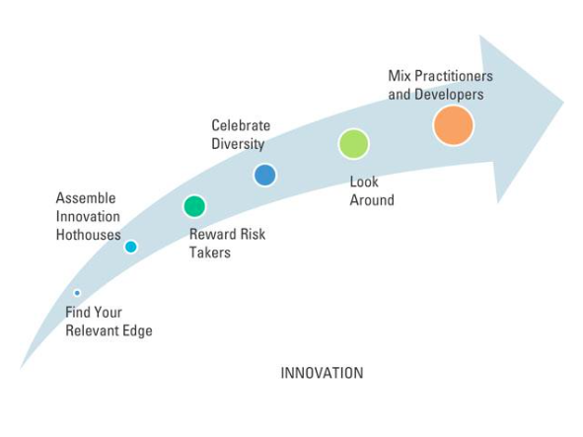

Chapter 8
Operations management Fundamentals
- Production management: activities managers do to help companies create goods
- Operations management (OM): management of systems or processes that convert resources into goods and services
- Responsible for managing the core processes used to manufacture goods and produce services
- Creating goods or services involves transforming or converting inputs into outputs
- Transformation process: the technical core, especially in manufacturing organizations, and is the actual conversion of inputs to outputs
- Value-added: used to describe the difference between the cost of inputs and the price value of outputs
- Greater value-addedgreater effectiveness of the operations
Operations Management in Business
- Forecasting: estimate demand for a product/service
- Capacity Planning: determine the amount of space, equipment, etc needed to achieve production targets
- Scheduling: determine when production will occur
- Managing inventory: ensure raw materials are available on time and in place; and finished goods have storage
- Assuring quality: ensuring standards are met through sampling inputs, in process work and outputs
- Motivating and training employees: appropriate pay, benefits, supervision
- Locating Facilities: determining where to put production facilities
Information Systems’ Role in Operation Management
- What: what resources and in what amounts?
- When: schedules for ordering, delivery, use, personnel deployment
- Where: delivery of supplies, production, final shipment of goods
- How: business process design, methods and equipment, resource allocation
- Who: manage and perform the work strategic partnerships and suppliers
Strategic Business System
- In developing an operations strategy, management needs to consider three factors:
- The level of technology that is or will be available
- The required skill levels of the workers
- The degree of vertical integration, in terms of the extent to which outside suppliers are used
- Strategic business units (SBUs): consist of several stand-alone businesses
(Hierarchy of Operational Planning*)
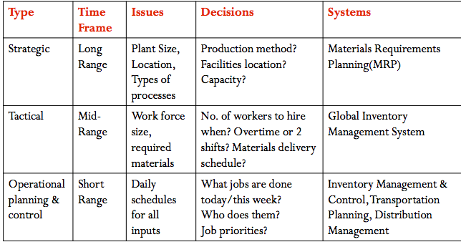
- MRP (Materials Requirements Planning): use sales forecasts to make sure that needed parts and materials are available at the right time and place in a specific company
- GIMS (Global Inventory Management System): provide the ability to locate, track, and predict the movement of every component or material anywhere upstream or downstream in the business process
- OP&C (Operational planning and control): deals with the day-to-day procedures for performing work, including scheduling inventory, and process management
- Transportation planning systems: track and analyze the movement of materials and products o ensure the delivery of material and finished goods at the right time, to the right place, and at the lowest cost
- Distribution management systems: coordinate the process of transporting materials from a manufacturer to distribution centers to the final customers
- Inventory Management and control system: provide control and visibility to the status of individual items maintained in inventory
- Current inventory and order status
- Cost accounting
- Sales forecasts and customer orders
- Manufacturing capacity
- New-product introduction
Competitive OM Strategy
- Five key competitive priorities translate directly into characteristics that are used to describe various processes by which company can add value to its OM decision
- Cost: consumer use cost as the primary determinant in making a purchasing decision
- Only one lowest-price producer, and that firm usually establishes the selling price in the market
- Quality
- Product quality: levels vary as to the particular market that is aims to serve
- Must set up proper level of product quality by focusing on the exact requirements of their customers
- Over-designedbeing prohibitively expensive
- Under-designedlose customers to products that cost a little more but are perceived by the customers as offering greater value
- Process quality: products without defects; produce error-free products
- Six sigma quality
- ISO 9000
- ISO 14000
- CMMI
- Delivery speed/reliability: consistent and fast delivery allows it to charge a premium price for its products/minimum variance in delivery times
- Flexibility
- The ability of a company to offer a wide variety of products to its customers
- A measure of how fast a company can convert its process from making an old line of products to making a new product line
- Service: high-quality customer service

OM and the Supply Chain
- Supply chain: set of business process that allow suppliers, manufacturers, distributors, and retailers to function as “one virtual organization” to deliver products to consumers
- Supply chain management (SCM): involves managing information flows between and among stages in a supply chain to maximize total supply chain effectiveness and profitability
- Supply chain strategy: the strategy for managing all the resources required to meet customer demand for all products and services
- Supply chain partners: the partners chosen to deliver finished products, raw materials, and services, including pricing, delivery and payment processes along with partner relationship monitoring metrics
- Supply chain operation: the schedule for production activities including testing, packaging, and preparation for delivery. Measurements for this component include productivity and quality
- Supply chain logistics the product delivery processes and elements, including orders, warehouses, carriers, defective product returns, and invoicing
- Effective and efficient supply chain management
- Decrease the power of its buyers
- Increase its own supplier power
- Increase switching costs to reduce the threat of substitute products or services
- Create entry barriers, thereby reducing the threat of new entrants
- Increase efficiencies while seeking a competitive advantage through cost leadership

Supply Chain Fundamentals
- Three main links of supply chain
- The flow of materials from suppliers and their upstream suppliers at all levels
- The transformation of materials into semi-finished and finished products – the organization’s own production processes
- The distribution of products to customers and their downstream customers at all levels
- Basic SCM Components
- Plan (strategic)
- Design a plan for managing the resources that o into making products
- Develop metrics to monitor SC efficiency & effectiveness
- Source (create contracts, info links)
- Choose suppliers that will deliver the goods and services required for making products
- Develop pricing, delivery, and payment processes with suppliers and develop metrics for monitoring and improving the relationships
- Make (manufacture; transform inputs into outputs)
- Schedule the activities necessary for production, testing, packaging, and preparing for delivery
- Develop metrics for measuring quality levels, production output and worker productivity
- Deliver
- Receive orders, fulfill orders via a network of warehouses, pick transportation companies to deliver the products and implement billing and involving system to facilitate payments
- Return
- Create a network for receiving defective and excess products and support customers who have problems with delivered products

Information Systems’ Role in the Supply Chain
- Advances in IS (in enterprise applications in general and SCM applications in particular) resulted in major changes:
- Visibility: the ability to view all areas up and down the supply chain
- The info shared between SC partners must be current & correct
- When incorrect “demand forecast” for a product is passed along the SC it can create a “Bullwhip Effect”
- Bullwhip effect: occurs when distorted product demand information passes from one entity t the next throughout the supply chain
- SC partners often carry a “safety stock” in case the forecast is not accurate
- As you move upstream, the “safety stock” get bigger, magnifying the issue, hence the “bullwhip effect”
- This results in inefficiencies for SC partners
- Consumer behavior: the behavior of customers has changed the way businesses compete
- Customers (online) expect perfect order fulfillment and personalized products when they want them
- Companies must respond to demanding customers through SC enhancements (demand planning softwaregenerate demand forecasts using statistical &forecasting techniques)
- Competition (following increase ability to compete)
- Supply chain planning systems (SCP)
- Use advanced mathematical algorithms to improve the flow and efficiency of the supply chain while reducing inventory
- Use algorithms to generate forecasts for a product; develop sourcing & manufacturing plans for a product
- Depends entirely on information for its accuracy
- Supply chain execution (SCE)
- To automate the different steps of the SC
- E.g. send orders electronically to suppliers
- To manage materials, warehousing, transportation, etc.
- Speed
- It is increased as Electronic Data Interchange and other Supply Chain Execution applications remove the need for paper flow and allow for continuous materials and product flow
- Increasing speed and capacity of servers and telecommunications ahs improved supply chain speed dramatically
Supply Chain Management Success Factors
- SCM Success Metrics
- It can help an organization understand how it’s operating over a given time period
- SCM metrics should cover all areas of the SC
- It is important that all SC partners need to use SCM metrics to monitor their performance
- Common SCM metrics
- Back order: an unfilled customer order. A back order is demand (immediate or past due) against an item whose current stock level is insufficient to satisfy demand
- Inventory replenishment cycle time: manufacturing cycle time plus time to deploy the product to the appropriate distribution channel
- SCM best practices
- Make the sale to suppliers: make sure suppliers are on board with the benefits that the SVM system will provide
- Wean (脱离) employees off traditional business practices: convince people using the software will be worth their time, or will decrease the chances of success for the SCM system
- Ensure the SCM system supports the organizational goals
- Deploy in incremental phases and measure and communicate success
- Be future-oriented: how flexible the systems will be when (not if) changes are required in the future
- What a firm needs to do
- Realignment: show commitment to the partnership by adjusting our processes
- Performance measurements: define responsibilities and goals in the partnership & establish performance measurements (clear and agreed upon metrics)
- Dispute resolution: clarify and document all aspects of the partnership to avoid conflicts
- Security: establish policies to ensure security and confidentiality of the data exchanged between the partners
Supply Chain Trends
- Instrumentation
- SCM will increasingly be machine-generated by means of RFID-enabled and GIS-enabled devices
- Interconnectedness
- The entire supply chain will be interconnected including vehicles, shipping containers and products (think Internet, Mobility, UPS codes, RFID, GIS)
- Intelligence
- Advanced analytics will help decision makers evaluate alternatives having highly complex and dynamic set of risks and constrains

Chapter 9
- Customer relationship management: a business and technology discipline for managing customer relationships to optimize revenue, profitability, customer satisfaction, and customer retention
- The sooner a company embraces CRM, the better off it will be, and the harder it will be for competitors to steal customers
- Allows an organization to gain insights into customers’ shopping and buying behaviors
- CRM systems: a set of integrated applications to address all aspects of the customer relationship including sales, marketing and service
- Capture and integrate customer data from all over the organization
- Consolidate and analyze the data
- Distribute results to various systems and customer touch points across the organization
- Touch point: a method of interaction with the customer such as phone, email, etc.
- CRM as a business strategy
- A process and business goal enhanced by using information technologies
- Helps an organization identify customers and design specific marketing campaigns tailored to each customer, thereby increasing customer spending
- Allows an organization to treat customers as individuals
- Gaining important insights into their buying preferences and behaviors
- Leading to increased sales, greater profitability
- Higher rates of customer loyalty
Improved call center efficiency |  | Better customer service
Simplification of marketing and sales processes |  | Ability to discover new customers
Ability of sales staff to close deals faster
Ability to cross-sell products more effectively
- Business Benefits of CRM

- Finding the most valuable customer
- R-Recency: how recently has a customer purchased items?
- F-Frequency: how frequently does a customer purchase items?
- M-Monetary: how much does a customer spend on each purchase occasion?
- RFM-Spells customer value: at one time the data from each component was added or multiplied together. Today more sophisticated algorithms are used to extract patterns of behavior hat indicate loyalty and profitability
- Sales
- Sales cycle decrease: faster
- Revenue per customer increase
- Average order size increase
- Revenue per sales rep increase
- Marketing
- Customer acquisition costs decrease (only target potential customers)
- Campaign response rates increase
- Marketing driven revenue
- Service
- Response times decreases (do not need to ask)
- Services costs decrease
- CSR productivity increases
- Customer retention increase
- Operating costs will decrease
- Customer profitability will increase
- The Evolution of CRM
- CRM reporting systems
- Identifying most valuable customers
- CRM analysis systems
- Ranking customers from best to worst
- Profiling, determining attributes of each customer segment
- CRM predicting systems
- Applying profiles to potential business opportunities
- Selecting customers with highest probability of profitability & retention
- Operational CRM: supports traditional transactional processing or day-to-day front-office operations or systems that deal directly with customers
- Analytical CRM: supports back-office operations and strategic analysis, and includes all systems tat do not deal directly with the customers (back office)
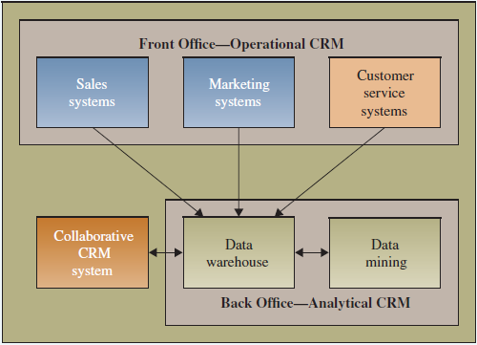
- Primary difference: the direct interaction between the organization and its customers
Using Information to Drive Operational CRM
- Marketing CRM: companies are trying to sell one customer as many products as possible instead of sell on product to as many customers as possible
- Marketing department can implement components of operational CRM systems to increase customer satisfaction
- List generators: compile customer data from a variety of sources and segment the data for different marketing campaigns
- Data sources: website visits, website questionnaires, online and offline surveys
- It provides marketing department with a solid understanding of the type of customer it needs to target for marketing campaigns
- Campaign management systems
- Guide users through marketing campaigns performing such tasks as campaign definition, planning, scheduling, segmentation, and success analysis
- Can provide quantified ROI and a de-brief including suggestions to improve future performance
- Cross-selling and upselling strategies
- Cross-selling: adds additional products and services to current purchases
- Upselling: increases the value of the sales by moving purchases to premium levels, increasing volume, adding additional uses etc.
- Sales CRM: first to begin developing CRM systems
- Two reasons to track customer sales data electronically:
- Sales representatives were struggling with the overwhelming amount of customer account data they were required to maintain and track
- Companies were struggling with the issue that much of their vital customer and sales data remained in the heads of their sales representatives
- Sales Force Automation: a system that automatically tracks all steps in the sales process (help to address issues above)
- Increasing customer satisfaction
- Building customer relationships
- Improving product sales by tracking all sales data
(Three components)
- Sales Management CRM System: automate each phase of the sales process, helping individual sales representative coordinate and organize all of their accounts
- Calendars to help plan customer meetings
- Alarm reminders signaling important tasks
- Customizable multimedia presentations
- Document generation
- Contact management CRM Systems: maintains customer contact information and identified prospective customers for future sales (deal with current customers)
- Includes features such as maintaining organizational charts, detailed customer notes, and supplemental sales information
- Opportunity Management CRM Systems: targets sales opportunities by finding new customers or companies for future sales (deal with new customers)
- Determines potential customers and competitors and defines the appropriate level of selling effort including budgets and schedules

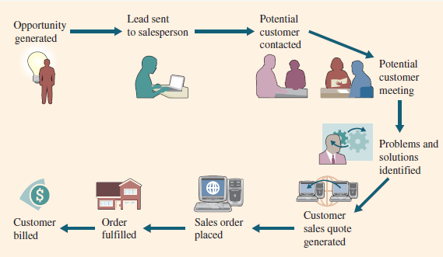

- Pointers for Gaining Prospective Customers
Get their attention | Make your appearance professional and do something positive to stand out.
Value their time | In exchange for your customers’ time, you need to provide them something of value.
Over-deliver | Do more than just keep your word.
Contract frequently | Send updates and provide value continuously.
Generate a trustworthy mailing list | Ensure mailing list names are genuine contacts with authority to deal.
Follow up | Send thank you notes for meetings…to everyone you contacted in the company.

- Customer Service CRM
- Call Centers: answer customer inquiries and respond to problems through a number of different customer touch points
- Knowledge-management system can support CSRs by providing suggested responses
- CSRs need training to use software effectively
- Best assets a customer-driven organization can have—maintaining a high level of customer support is critical to obtaining and retaining customers
- Track customer call history along with problem resolutions—this history is critical for providing a comprehensive customer view to the CSR
- Improve customer satisfaction and agent empowerment by increasing evaluator and agent confidence in an overall quality program at their call centers:
- A clearer and more holistic skill evaluation for accurately gauging improvements
- Establishment of a “coach and mentor” system
- Web-based Self-service Systems: allow customers to use the Web to find answers to their questions or solutions to their problems
- Live chat and email improve and personalize the service
- Call Scripting Systems: access organizational databases that track similar issues or questions and automatically generate the details for the CSR, who can then relay them to the customer
- Can provide diagnostic questions a CSR might ask
Using Information To Drive Analytical CRM
- Design to dig deep into a company’s historical customer data and expose patterns of behavior on which a company can capitalize
- Primarily used to enhance and support decision making, and works by identifying patterns in customer data collected from the various operational CRM systems
- Aggregates, analyzes, and disseminates customer information throughout an organization
- Relies heavily on data warehousing technologies and business intelligence
- Personalization: occurs when a website knows enough about a person’s likes and dislikes that it can fashion offers more likely to appeal to that person
- Analytical CRM can reveal information about which customers are worth investing in, which should be serviced at an average level, and which should not be invested in at all
- Enhances Employee Performance: it can also reveal information about employees
- Customer feedback forms are used to decide on training requirements for front-line personnel
- Take advantage of thousands (millions) of transactions stored in Data Warehouse
- Example:

Give customers more of what they want | Communications made more personal with personal solutions. CRM matches customer requests with new production & notifies customer.
Find new customers similar to your best customers | CRM matches the profiles of your best customers to select prospects out of a mass mailing list.
Find out what the organization does best | CRM can find the top performing segments and what your most popular offering is to them.
Beat competitors to the punch | Determine sales trends offering best customers deals ahead of the competition.
Reactivate inactive customers | Periodically select lapsed customer and send targeted promotions to bring them back.
Let customers know they matter | CRM lists best customers and makes suggestions for personalized rewards.

Implementing CRM
- Creating a CRM vision that provides a “Big Picture of what the customer-centric organization should look like
- Identify the customers with whom the organization wants a relationship, the importance and benefits of CRM to the company’s overall business strategy, and the nature of the customer experience that is desired
- Defining and weaving a CRM strategy that aligns with broader marketing and sales strategies, and informs operational and production strategies
- Understand and engaging the customer
- Accomplished by getting constant feedback from customers, and using that feed back to improve and fine-tune the CRM strategy and how it is operationalized
- Ensuring organizational collaboration between internal groups and external business partners
- Focusing on improving customer processes
- Achieving data integrity across the enterprise
- Leveraging information systems to implement CRM
- Defining, collecting and analyzing CRM metrics

Industry Best Practices for CRM Implementation

- Clearly communicate the CRM Strategy. Gartner Dataquest indicates that enterprises with CRM success had committed senior executives who set goals for CRM, match strategies with corporate objectives and tied measurement to goals and strategies.
- Define data needs and flows. Have a clear understanding of how data flows in and out of the organization because it tends to come in many different forms from many different touch points.
- Build an integrated view of the customer. Choose the correct CRM solution that can meet strategic goals and be successfully implemented including integration into current systems.
- Implement in manageable pieces, which makes it easier to manage, measure and track the design, building and deployment of the system. Allows an early warning of fatal flaws.
- Make the CRM system scalable, able to grow and contract as needed to be adaptable to current and future needs. Understand the organization and its growth strategies. Take time to answer tough questions up front to get the most out of the CRM system.
`
CRM Metrics
Marketing Metrics | Sales Metrics | Service Metrics
Number of marketing campaigns | Number of prospective customers | Cases closed same day
New customer retention rates | Number of new customers | Number of cases handled per agent
Number of responses by marketing campaign | Number of retained customers | Number of service calls
Number of purchases by marketing campaign | Number of open leads | Average number of service requests by type
Cost per interaction by marketing campaign | Number of sales calls per lead | Average number of service calls per day
Number of marketing campaigns | Number of prospective customers | Cases closed same day
New customer retention rates | Number of new customers | Number of cases handled per agent
Number of responses by marketing campaign | Number of retained customers | Number of service calls
Number of purchases by marketing campaign | Number of open leads | Average number of service requests by type
Cost per interaction by marketing campaign | Number of sales calls per lead | Average number of service calls per day
- An important source of CRM metrics comes from external communities such as social media. CRM analytics collect and determine quantity and quality of Facebook message, Tweets, blog comments among others
- Measurement of CSR satisfaction in the metrics they monitor (important to track)
- CSR unmotivated, rushed, slow respondcustomer dissatisfactiondecline in customer loyalty and retention
- Collect and analyze CRM metrics on customer experiences that span multiple customer interactions over different communication channels
- Complex and difficult to measure
- Limitation of CRM
- CRM is firm centric
- Only relies on transactional and behavioral data pertaining to the interaction of the customer with the firm
- Limited predictive ability
- Some events are unforeseeable and only the customer knows about their occurrence
CRM Applications and Vendors
- Managing Other Relationships
- Building healthy relationships with key stakeholders is healthy and profitable for companies
- Good relationship: when there is a reciprocal exchange of value between the two parties, and when both parties want to be part of that relationship and avidly work at keeping the relationship strong
- IS can be useful in improving relationships
- IS provide more efficient and effective communication between stakeholders and be beneficial in monitoring stakeholder activities and measuring stakeholder performance
- Supplier Relationship Management (SRM): focuses on keeping suppliers satisfied by evaluating and categorizing suppliers for different projects, which optimizes supplier selection
- Reasons:
- Organization can determine the best supplier to collaborate with at any time if know them well
- Organization can work better with its suppliers to streamline processes and deliver higher-quality products and parts than it could if such relationship did not exit
- SRM system: an application that supports SRM that analyzes vendors based on key variables such as strategy, business goals, prices and markets to find complementary partners
- It provides seamless communication channels where data can be share by all parties
- Benefits
- Single consolidated view of all suppliers
- Consistent, detail management information with multiple views
- Elimination of duplicate suppliers
- Partner Relationship Management
- Partners
- Alliance partners: competitor organizations who cooperate with one another because doing so allows them to compete more successfully
- E.g. Star Alliance
- Dealers: agents who sell products or services on behalf of a company or organization, particularly in the automobile industry
- E.g. Canadian Tire retail stores
- Retailers: stores or shops operating at the end of the supply chain that acquire goods or products from manufacturers or importers, and then sell smaller quantities of these goods or products to customers at higher prices to cover expenses and make a profit
- Resellers: companies or individuals who purchase goods and products in bulk with the intention of reselling them at a profit
- Partner Relationship Management (PRM): has a goal to select and foster relationships with effective partners
- PRM systems: facilitate communication with partners and monitor partner activities
- Employee Relationship Management: a management activity that focuses on managing an organization’s relationships with tis employees
- Unhappy employees may upset or anger customers leading to customer attrition
- ERM focuses on increasing employee morale, productivity communications and change readiness
- ERM systems: information systems applications that support ERM practice
- Subset of CRM systems
- Assist employees in dealing with customers by providing jut in time information on the company, policies, products, services etc.
Future CRM Trends
- Will integrate with RFID, wireless, SaaS and other information technological developments to improve in providing a 360-degree view of the customer
- Already support mobile sales and comminations by integrating wireless into CRM systems
- Greater incorporation of RFID (and other coding systems) to track sales, shipping product uptake, productivity and providing a richer source of CRM metrics

Chapter 4
(No 4.1)
Rational Database
- Basic
- Field: group of characters representing an attribute or characteristic
- Record (row)
- Table (relation)
- Database
- Relations
- Data stored in one table relates to data stored in another table when both tables share a common element
Data Warehouse (for decision making)
- Before
- DSS or EIS = database + model + interface
- After
- To separate reporting & analysis from transaction in order to maximize the performance of both
- Reason of having both database and data warehouse
- One database will slow down the operating process, since these is only one base to do both analysis and operate
- Data Warehouse: a logical collection of information – gathered from many different operational database – that supports business analysis activates and decision-making tasks
- The primary purpose of a data warehouse is to aggregate information throughout an organization into a single repository for decision-making purposes
- Difference between DB & DW
- DB
- Store the information necessary for day to day transactions (operational level)
- Designed (and optimized) to record (write, update)
- For OLTP (On-line transaction processing) where every transaction has to be recordedwrite optimize
- DB Query
- Show me the list price of “the hardware Bible”
- Update Mr. Rubin’s Salary
- DW
- Store information for analysis and decision making (management and strategic levels)
- Designed (and optimized) to respond to analysis questions
- For OLAP (On-line analytical processing), to facilitate querying and analysisread-optimize
- DW Query
- For bikes, show me the profit margin % for February
- Show me (visually) some salary trends
- Why separate DW from DB
- Performance: high demand for data analysis might slow down operational systems
- Imagine waiting at an ATM for 10 mins before it prompts you for input
- Data access: analysis requires data from different sources (a DW aggregates data from these sources)
- Data formats: need for summarized and time-based data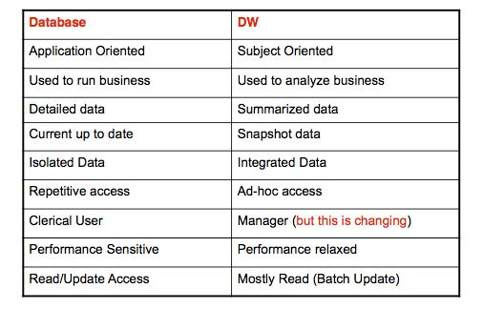
- Fundamentals
- DW is Subject-oriented
- A DB is application oriented: applications are designed around the business processes of the firm (ordering, hiring, etc.)
- Data in the DW is organized around major subjects, such as customer, sales, etc
- A DW provides a simple and concise view around a particular subject
- DW is integrated
- To get to the “single version of the truth”, a DW contains rules to integrate data from different applications
- Data is organized around a common identifier, consistent names, the same values throughout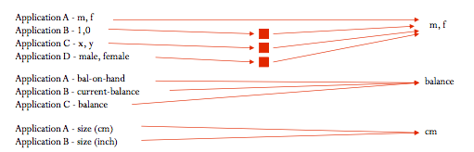

- DW is time-variant
- Data shows history, not current status
- DB (operational) data is accurate when users access it
- DW data is accurate only at the time it is loaded – not necessarily accurate “right now”
- Example:
- DB (Operational data): used to respond to a query about a customer tracking his order
- DW: used to identify sales trends hence a certain time lag does not affect the result
- DW is Non-volatile
- Data does not change over time
- DB (Operational): updates are done as changes occur
- DW: new data is added only at the regular time of loading
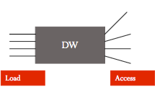
- Information cleansing/scrubbing: a process that weeds out and fixes or discards inconsistent, incorrect, or incomplete information
- Software tools use sophisticated algorithms to cleanse and scrub the info
- ETL (Extract, Transform & Load): a set of processes by which data is extracted from numerous sources, transformed as appropriate, and loaded into the DW
- More than half of all development work for DW projects is dedicated to the design and implementation of ETL processes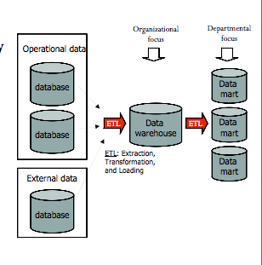
- Data mart (small version of DW): similar to a DW, but provides summary and historical data for a single department (or subject) rather than an entire organization
- More narrow scope than a DW (sales data mart)
- After an organization builds a DW and data marts it uses them to gain insight into tis operations, its customers’ behavior & buying habits, etc.
- For that it needs Business Intelligence (BI) tools such as:
- Multidimensional analysis: DB contain information in two-dimensional tables
- In a DW and data mart, information is multi-dimensional it contains layers of columns and rows
- Dimension: a particular characteristic of the information; an attribute (products, stores, region, data, etc.)
- Cube: common term for the representation of multi-dimensional information
- Data mining tools: designed to find what queries and reports do not reveal
- Uses algorithms to analyze data in a DW to find patterns and infer rules that can be used to guide decision making
- Example:
- Mining data about purchases in supermarket revealed that when potato chips are purchased, soda is purchased 65% of the time
- Data mining for fraud detection triggers an alarm when you (or someone who stole your credit card) make an unusual purchase or purchase in a place you don’t usually frequent
- Cluster analysis: technique used to divide info into mutually exclusive groups such that the members of each group are as close as possible to one another
- Define groups (segments) that go together
- Association detection: technique used to determine the likelihood of events occurring together at a particular time or following
- Statistical analysis: technique to perform such functions as information correlations, distributions, and variance analysis
- Forecasting: predicting future situations (e.g. “what Is the likelihood that a customer switches to a competitor?)

Case
- What three dimensions the company should use and why (Multi dimensional analysis)
- Customer
- Machines
- Property
- Time
- Revenue

- From three techniques, which one the company would use
- Association detection: total rewards helps employees determine which level of service to provide each customer;
- Statistical: predict based on how people
- Cluster: customers who don’t gamble a lot/frequently/for travelling
- Describe the effects on the company if it did not integrate the data that is located at each of its casinos
- Traditionally treat customers as though they belong to a single property,
- The company received a $100 million increase in revenue from customers who gambled at more than one casino
- What is the relationship between CRM and BI:
- Analytical CRManalyzeuse BI to function
- Operational CRM use: when swipe cards

Chapter 11 (first half)
Developing Information Systems
- The activities that go into producing an information system address an organizational problem or to take advantage of an opportunity
- Problem: customers leaving; Solution: CRM
- Opportunity: growth, solution e-business, SCM
- Challenges
- Time, cost
- Organizational changes associated with new IS
- Deciding where and how to use the new IS
- When the wrong business process is automated, it becomes efficient at doing what it shouldn’t do (become worse)
- New IS should help an organization become more productive, otherwise it may damage productivity
- It is hard to establish the information requirements of the organization
- New IS should evolve as the organization and its business evolve
- Success/failure
- The more an organization relies on IS, the higher the consequences of IS successes and failures
- Increase or decrease revenue
- Nike’s poorly designed SCM delayed orders, increased excess inventories, and caused earnings to fall 24% below expectations
- Prevent or incur liabilities
- FoxMeyer used SAP for $500 million for an ERP failure
- Increase or decrease productivity
- Defective software accounts for 45% of computer downtime and cost U.S. businesses &100 billion in 2003
- Repair or damage to brand reputation
- Imagine how you’d feel if your bank’s website goes down
System Development Lifecycle (SDLC)
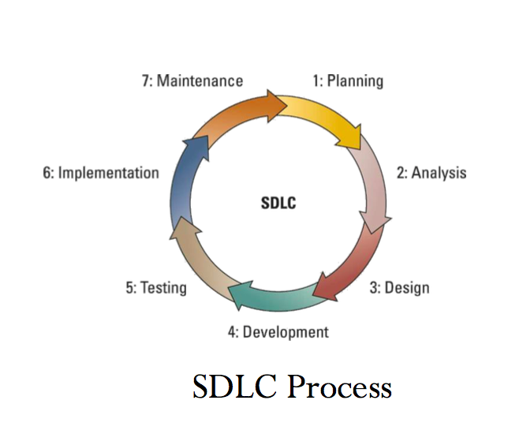
- The overall process for developing information systems
- The foundation for many systems development methodologies such as waterfall, RAD, etc.
- Planning phase: involves establishing a high-level plan of the intended project and determining project goals
- Primary planning activities:
- Identify and select the system for development
- Assess project feasibility
- Develop the project plan ( a guiding force behind on time delivery of a complete and successful system)
- Analysis phase: involves analyzing user requirements and refining project goals into defined functions of the intended system
- Primary analysis
- Gather business requirement
- This is typically one of the hardest tasks to perform on any IS development project, one reason being that requirements continually change
- Create process diagrams
- Process modeling: graphically representing the processes that capture, manipulate, store, and distribute information between a system and its environment
- Perform a buy vs. build analysis (make decision guidecost, unique process)
- Design phase: involves describing the desired features and operations of the system including screen layouts, business documentation
- At the end of this phase we have the blueprint of the system
- Development phase: involves taking all of the detailed design documents from the design phase and transforming them into the actual system (transfer blueprint into programs)
- IT specialists perform the majority of tasks associated with this phase
- Primary development activities
- Develop the IT infrastructure
- Develop the database and programs
- Testing phase: involves bringing all the project pieces together into a special testing environment to test for errors, bugs, and interoperability, in order to verify that the system meets all the business requirements defined in the analysis phase
- Implementation phase: involves placing the system into production so users can begin to perform actual business operations with the system
- Primary implementation activities:
- Write detailed user documentation
- Provide user training
- Determine implementation method
- Four main implementation methods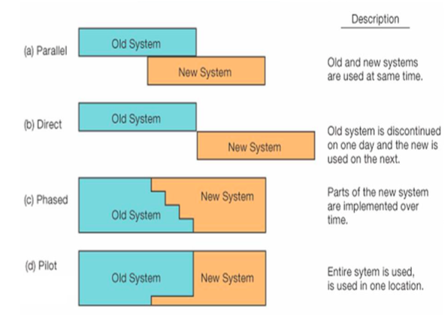
- Parallel
- Direct
- Phased
- Pilot (only for one department)
- Which one is better?
- Safe: parallel
- Maintenance phase: involves performing changes, corrections, additions, and upgrades to ensure the system continues to meet the business goals
- Types of maintenance
- Adaptive: making changes to requirements
- Corrective: repairs defective systems
- Perfective: making changes to enhance the system )e.g. processing performance)
- Preventive: making changes to reduce the chance of future system failures
- It is cheaper to find and fix an error during the early stages (i.e. analysis) than it is to find the same error during the maintenance phase
- Question: whyhard to make changes
System Development Methodologies
- Methodology: a set of policies, procedures, standards, processes, practices, tools, techniques, and tasks that people apply to technical and management challenges
- Waterfall methodology: sequential, activity-based process in which each phase in the SDLC is performed sequentially (don’t change once blueprint is done, don’t allow you to go back)
- Problems:
- Assumes users can specify all requirements in advance
- Assumes requirements do not change over time
- The success rate is just 10%
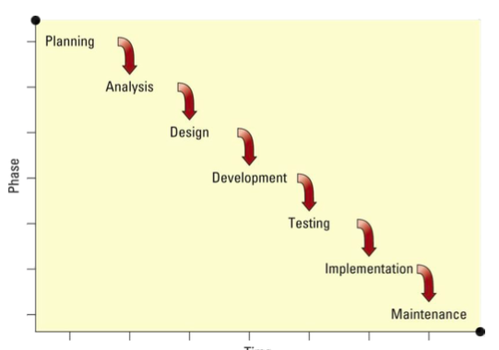

- Agile methodologies: focus on early & continuous delivery of system components that meet minimum requirements (make changes a lot)
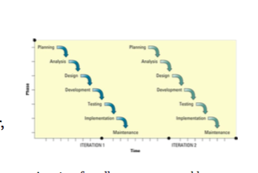
- Divide project into smaller, more manageable, shorter, more efficient, lower cost projects that achieve rapid feedback & acceptance
- Use an iterative approach
- Rapid application development (RAD): emphasizes extensive user involvement in the rapid and evolutionary construction of working prototypes
- Prototypes: a scaled down representation or a working model of the users’ requirements
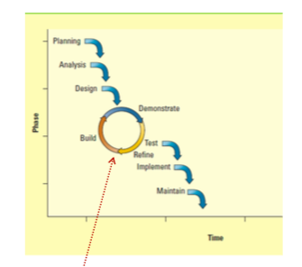
- Fundamentals of RAD
- Focus on creating a prototype that looks and acts like the desired system
- Actively involve users in the analysis, design, and development phases
- Collect the requirements through and interactive and iterative approach
- Participatory design (PD)
- Create opportunities for mutual learning between users and designers (each ahs knowledge that can benefit the other)
- Use design tools that are familiar to users (e.g. data-flow diagrams)
- Employ language that end0users know
- Understand how users currently conduct their activities
- Encourage users to envision future situations of working with the final system
- This will allow them to experience how the emerging design may affect their work
- Self-sourcing (end user design)
- Development is by people who use the system
- End users build and maintain the system without much support from IT
- Ranges from simple Excel worksheet templates to complex systems including prototypes
- Advantages:
- Meeting user requirements
- Sense of ownership by users
- Faster development
- Disadvantages
- Problems due to lack of development expertise
- Not consistent with organizational goals
- Lack documentation

5 Reasons project failure
- Project management skill & leadership
- Unclear goals & business alignment
- Scope changes & change management: stakeholders needs
- Staffing & inappropriate skills of team: be honest with weakness
- Executive support: understand expect, time

Chapter 10
- Spam: unsolicited email
- Job loss: competitive pressure caused by out unwillingness to pay higher prices is driving the reengineering process and outsourcing which leads to job loss
- Copyright
- Privacy
- Hackers
Information Ethics
- The ethical and moral issues arising from the development and use of information technologies as well as the creation, collection, duplication, distribution, and processing of information itself
- Ethics: attempts to understand the nature of morality; to distinguish “right” from “wrong”
- Examples:
- Individual copy, use, and distribute copyright digital content
- Individuals create and spread viruses
- Organizations collect info on customers without their knowledge or consent
- Employees search organizational databases for corporate or personal info
- Unethical vs. Illegal
- Some but not all unethical activities are illegal
- Sharing/selling customers’ info without their consent is illegal in Canada; also unethical
- Not all legal activities are ethical
- Making users agree to lengthy and complicated (and sometimes unfavorable) contracts before they are allowed to sign up for an online service
- Canada’s Anti=spam legislation (Bill C-28): compels businesses to obtain express consent from recipients and requires businesses o provide an opt out mechanism for people who do not want to receive further messages from them
- Canada’s Copyright Modernization Act (Bill C-11)
- Legalized format shifting (copying content from one formant to another)
- Legalized time shifting (recording TV programs for viewing at another time)
- Allowing back up copies of content to be made against loss or damage
- Requires ISPs to notify customers of copyright infringement & possible penalties
- In Workplace
- Employee abuse of Internet is hurting productivity
- Downloading music, reading online news, email, shopping, job hunting on company time
- Monitoring technologies
- Key logger: program that records keystrokes and mouse clicks
- Hardware key logger: device that captures keystrokes on their journey from the keyboard to the motherboard
- Cookie: file deposited on a hard drive by a website containing info about customers and their web activities
- Spyware: program hidden in free downloadable software which tracks online movements, mines the info stored on a computer, etc.
- Difference: file/program
- Some negative effects of employee monitoring
- Lower job satisfaction
- Rise in employee absenteeism
- The desire of employees to do something will likely increase fi they are told not to do it (psychological reactance)
- Lack of trust between employee and employer
- If the employer does not trust its employees, then perhaps it should find new ones
- But sometimes monitoring is required
- Organizations can be held responsible for their employees’ actions, may be liable for the risks their employees take
- In this case, organizations must communicate with employees regarding monitoring
Information Privacy
- Challenges
- Individuals release info about themselves
- Credit card purchases, video rental, magazine subscriptions
- Data storage costs are declining
- It is cheap to maintain databases on individuals
- Computing power doubles every 18 months
- Advances in data analysis techniques
- Advances in networking
- Information privacy: concerns the legal right or general expectation of individuals, groups, or institutions to determine for themselves when, and to what extent information about them is communicated to others
- Opt-in vs. Opt-out model
- Opt-in model: prohibits an organization form collecting personal info unless the user agrees to it
- The default is to assume consent is not given
- Canada
- Opt-out model: permits the collection of personal info until the consumer requests that it stops (organization prefer thisgive a chance to talk to customer and then make decisions)
- The default is to assume consent is given
- Personal Information Protection and Electronic Documents Act (PIPEDA) is a Federal act that applies to all organizations
- Examples of personal information
- Pension and employment insurance files
- Medical records
- Tax records
- Security loan applications
- Military records
- Exceptions to PIPEDA
- Information is for journalistic, artistic, or literacy purposes
- Information aids a legal investigation or an emergency where lives and safety are at stake
- Information disclosure facilities the conservation of historically important records
- Obtaining permission would infringe on the information’s accuracy
- PIPEDA principles
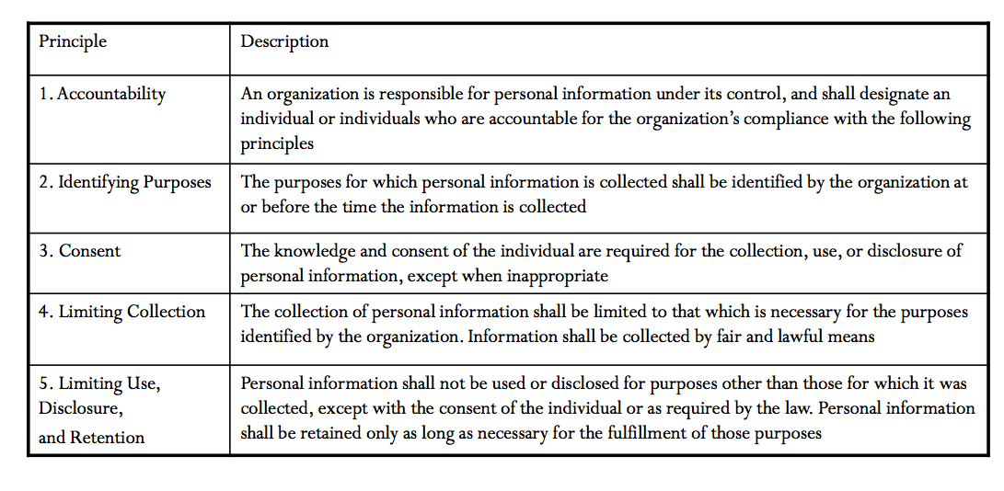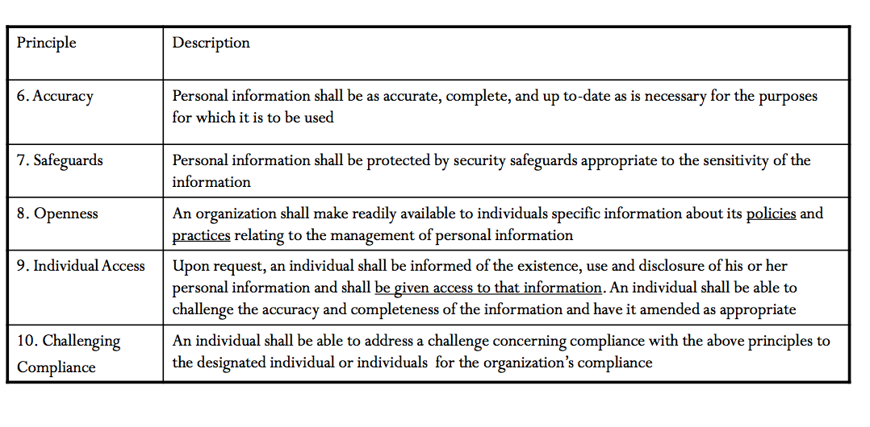
Information Security
- The protection of information from accidental or intentional misuse by persons inside or outside an organization
- Information must be protected to maintain a company’s competitive advantage
- Information must be protected to maintain customer privacy
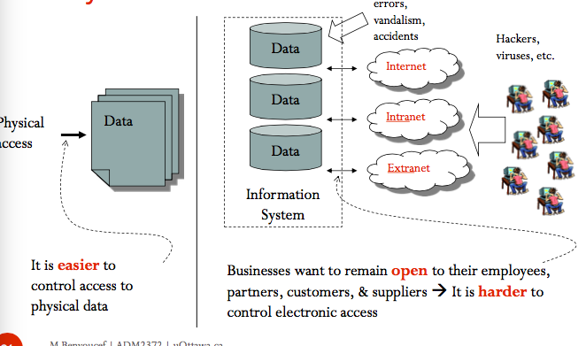
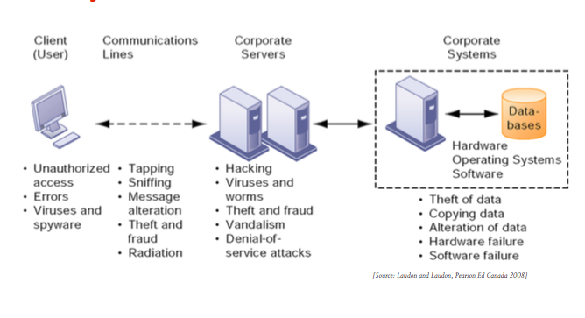
- Inside risk
- 38% of security incidents originate within the organization
- Employees have access to privileged info (passwords, magnetic cards, etc.)
- They may harm the integrity of systems/data intentionally or unintentionally
- They may share their password with other employees, friends & family members
- Hackers use social engineering to trick employees into revealing access credentials or other valuable information
- Use social ideas to get something
- Policies & plan
- The first line of defense an organization should follow is to develop information security policies an information security plan
- Information security policies: identify the rules required to maintain information security
- Requiring users to log off of their systems before leaving, never sharing passwords
- Information security plan: details how an organization will implement the information security policies
- What actions to take?
- Authentication: a method for confirming users’ identities
- The most secure type of authentication involves
- Something the users knows such as a user ID and password
- Something the user has such as a smart card
- Something that is part of the user such as a fingerprint or voice signature (biometrics) – (can be costly and intrusive)
- ID and password authentication is the most ineffective form of authentication
- Identity theft: the forging of someone’s identity for the purpose of fraud
- Phishing: a technique to gain personal information for the purpose of identity theft, usually by means of fraudulent e-mail
- Prevention and resistance: encryption, fire walls, content filtering such as using spam filters
- Encryption: the science of encrypting (scrambling) a message to ensure its privacy and integrity
- Useful in email, online banking transactions
- Single key encryption
- A single key known to Ann and Bill
- But exchanging the key represents a security risk
- Public Key Encryption (PKE)
- Uses 2 keys: a public key and a private key, which are mathematically related
- The public key is passed openly between the parties or published in a public repository, but the related private key remains private
- Data encrypted with the public key can be decrypted only using the private key and vice versa
- Only Bill can decrypt the message with his private key
- No need to exchange the public key
- Detection & response: detecting and responding to DoS and DDos attacks, anti-virus software
- Denial of service (DoS) attack (just one computer)
- Flood of messages sent to a server in order to crash it
- The intent is to deny access to legitimate users
- Distributed denial of service (DDos) attack (millions of computers)
- DoS attack comes from numerous sites
- It is harder to detect and protect against
- Detection and response to DoS attacks
- Use filters to identify messages with a common characteristic (e.g. coming from the same site)
- Place “choke points” in the system: a router can have a “limit” built into it that disallows the sudden flood of messages
- “Be prepared”: backup equipment, IT staff should prepare & rehearse for a DoS attack, etc.

Video 1
- Consent

Video 2
- Did not ask for consent
- Put password for wifi
Change into more privacy mode

Video 3
1)

]
Chapter 12
- MIS Infrastructure: includes hardware, software, and telecommunications equipment that when combined, provide the underlying foundation to support the organization’s goals
- MIS Infrastructure can be seen as
- A technology: focus on capacity & speed of the infrastructure
- Hardware
- Software
- Telecommunications equipment
- A set of services: focus on the business value of the infrastructure
- Moore’s Law
- Computing power doubles every 18 months
- The price of computing falls by half every 18 months
- This is due to the increase in the number of components (transistors) that can be included on a computer chip
- Future
- RFID (radio frequency identification) Tags will be on every consumer good
- Nanotechnology will use individual atoms and molecules to create computer chips
- Hardware Price decrease
- Hardware Sizes decrease
- Hardware Power increases
- Hardware Complexity increases
- Amount of digital information produced increase
- Cost of storing digital information decreases
- Cost of communications (sharing info) decreases
- Size of the Internet increases
- Acceptance of standards and protocols ( by business and consumers) increases
- Agile MIS Infrastructure
- Agile: flexible and quick to respond to changes (e.g. growth, high demand, etc.)
- Characteristics:
- Accessibility: varying levels allow system users to access, view, or perform operational functions
- Meets each person’s different system needs, requirements and authorization level
- Web accessibility: facilitates connection for people with physical, neurological and mental challenges
- Availability: the system is operational during different time frames
- High availability means the system is operational at all times
- But systems must be taken down for maintenance and upgrade
- Maintainability/flexibility: the system quickly transforms to support environmental changes
- How quickly (and how easily) can a system be transformed to support changes in the organization’s environment
- E.g. transform an e-business website to accept different currencies
- Portability: the system is available to operate on different devices or software platforms
- The ability of the system to operate on (or be accessed from) different devise (desktops, handheld devices, kiosks, etc.) or software platforms (PC, Mac, etc.)
- Portability increases the target market
- Reliability/Accuracy: the system functions correctly and provides accurate information
- Inaccurate or out-of-date information puts a company at risk of losing customers, costly overstocks or out-of-stock, and poor business decisions
- Vulnerability: a weakness in the system (e.g. weak password) that can be exploited by a threat
- Scalability: the system can “scale up” or adapt to the increased demands of growth
- Capacity: the maximum amount (of users, transactions, etc.) a system or system component can handle
- Capacity planning: determines the future capacity and performance of the system; a critical strategic decisions
- Usability: the system is easy to learn and efficient and satisfying to use
- Simplify user interface with one-touch operability & intuitive navigation
- Open Systems
- Open source: software whose source code is made available for use or modification
- Produced by a community of programmers
- Supposed to be superior in quality as thousands participate in developing and perfecting it
- Usually free
- Usually not restricted to a software/hardware platform
- Infrastructure trends
- Service-oriented architecture (SOA) is a business-driven IT architectural approach, based on web services
- Web service: is a self contained application that provides a computation upon request
- Is not merely a piece of software but a business taks that is part of a business process
- A web service is an application
- Available on the network (e.g. Internet)
- Runs when invoked
- Returns an answer
- HTMP (hypertext markup language): for humansdisplayed for humans to see
- XML (eXtensible markup language): for applicationsprocessed by applications
- Outline data source (e.g. statistics Canada)
HTML your computer browser
XMLSoftware applications
- Interoperability: a key characteristic of web services allowing them to be used across platforms and applications
- Loose coupling: applications are built from a number of web services that can be disconnected and replaced or reused elsewhere as needed
- New applications may be assembled rather than created from scratch
- Grid computing: connects remote computers to create a “virtual” super computer by combining the unused power of all computers on the grid
- Uses the Internet to connect computers to the grid
- Is used for applications that require heavy computing (modeling, simulations, forecasting…)
- Advantages: cost savings; high speed
- Grid software: controls & allocates resources on the grid; divides the program into smaller tasks

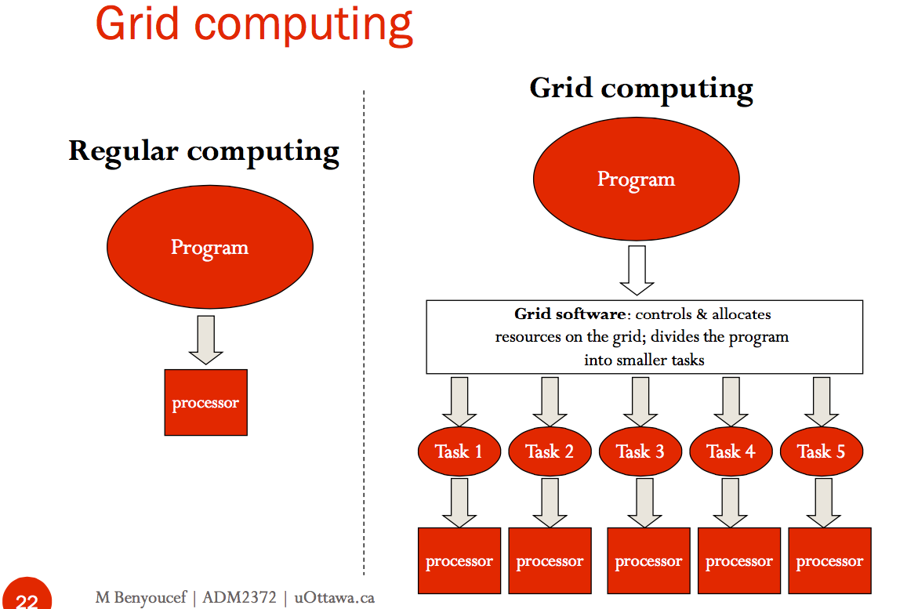

- Cloud Computing: computing resources (hardware, software) accessible through the internet (i.e. the cloud)
- You only need a browser that runs on a desktop, laptop, or a handheld device
- Computing resources are offered, managed, maintained by vendors
- Google docs
- www.Saleforce.com (CRM application)
- Amazon S3 (storage services)
- Benefits
- On-demand self-service: users can increase storage and processing power as needed
- Broad network access: all devices can access data and applications
- Multi-tenancy: customers share pooled computing resources
- Rapid elasticity: storage, network bandwidth and computing capacity can be increased or decreased immediately, allowing for optimal scalability
- Measured service: clients can monitor and measure transactions and use of resources
- Challenges:
- Quality
- Reliability
- Privacy
- Security
- Availability
- Cloud delivery models
- SaaS (software as a service) provides applications: complete business applications focused on end-user requirements
- Google Docs
- Facebook
- Sales force
- PaaS (Platform as a Service): operating system (OS) and development framework, no need to directly mange OS, database, etc.
- Google App Engine
- IaaS (Infrastructure as a Service): physical infrastructure (CPU, memory, disk, bandwidth
- No need to purchase or mange a data center
- E.g. Amazon EC2, Amazon Simple Storage Service (S3)
- Cloud Computing Environments
- Public cloud: for big industry-wide applications offered to the general public
- Amazon Web Services
- Windows Azure and Goggle Cloud Connect
- Private cloud: serves only one organization and can be located on the customer’s premises or off
- Bank or sensitive information
- Community cloud: fro a community with common business models, security requirements
- Mount Sinai Hospital health information community
- Non-profit organizations
- Hybrid cloud: combines private, public or community clouds
- Cloud bursting: use own infrastructure but access the cloud at peak capacity to ensure seamless service
- Keep sensitive info on a private cloud and public info on a public one

