ADM1100 FINAL EXAM NOTES
CHAPTER 7 – MANAGEMENT, LEADERSHIP THE INTERNAL ORGANIZATION
- Management: Process of achieving organizational goals through people and other (technical) resources
- Top management
- CEO, CFO, Premier, Mayor
- Develops long-range strategic plans
- Inspire execs and employees to achieve their vision for company’s future
- Decisions: new products, acquisitions, new geographical markets
- Middle management
- General managers, plant managers, regional manager, branch manager, division head, director, dean
- Focus on specific operations, products or customer groups within an organization
- Responsible for developing detailed plans and procedures to implement firm’s strategic plans (more detailed than top management)
- Supervisory (first-line) management
- Supervisor, department chairperson, program manager, team leader, store manager
- Implement plans developed by middle managers
- Responsible for non-manager and employees
- Motivate workers to accomplish daily, weekly and monthly goals
MANAGERIAL SKILLS
- Technical skills: manager’s ability to understand and use techniques, knowledge, tools and equipment of a specific department or area of study
- Human skills: interpersonal skills that enable a manager to work effectively with and through people
- Conceptual skills: ability to see organization as a unified whole and to understand how each part of the overall organization interacts with other parts

MANAGERIAL FUNCTIONS
- Planning: Process of looking forward to future events and conditions and deciding on the course of action for achieving organization’s goals
- Organizing: Blending human and material resources through a formal structure of tasks and authority
- Directing: Guiding and motivating employees to accomplish organizational goals
- Controlling: Function of assessing an organization’s performance against its goals. Four steps… setting performance standards, monitor actual performance, compare actual performance w/ standards, making corrections if needed.

- Vision: Ability to perceive marketplace needs and what an organization must do to satisfy them. Must be focused yet adaptable to changes in the business environment. (Target for firm’s action)
- Long-term success is also tied to the ethical standards that the top management team sets.
- High ethical standards encourage, motivate and inspire employees to achieve goals. Unethical behaviour leads to unethical action at all levels (example: accounting wrongdoings)

Importance of Planning
- Different types and levels of plans – organization should have comprehensive planning framework. Each step should fit into overall plan.
- Broad/long-range: mission statement, objectives and goals
- Narrow/short-range: functional plans for specific areas/employees
- Plans outline steps company will take to meet goals and objectives

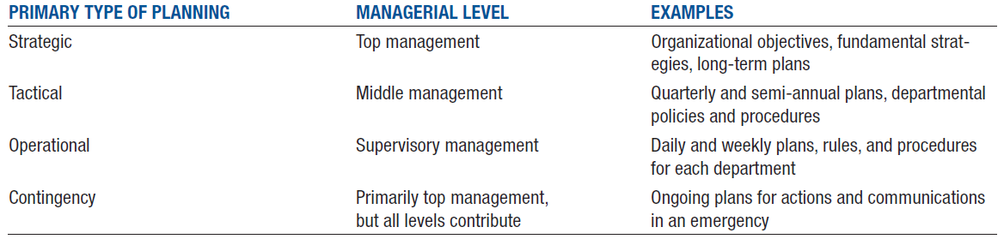
Planning at Different Management Levels
- Strategic planning is the process of deciding on the primary objectives of an organization and then taking action and setting aside resources to achieve those objectives.
- Tactical planning involves carrying out the activities set out in the strategic plans.
- Operational planning sets the detailed standards that help to carry out tactical plans.
- Contingency planning helps firms to resume operations as quickly and as smoothly as possible after a crisis.

Strategic Planning Process
- Determines over-reaching focus and objectives of entire organization.
- Define organization’s mission (mission statement – written description of organization’s overall business purpose and aim)
- Assign organization’s competitive position (examine factors that may help or hinder organization)
- Set objectives for organization (profitability, customer service, growth, employee satisfaction)
- Create strategies for competitive differentiation (strategies to compete w/ similar companies)
- Turn strategy into action (allocate resources)
- Evaluate results and refine the plan (analyzes success and failures using data; “retool” planning process based on results; monitoring is matching performance with expectation; adapting plans when performance fails)

SWOT Analysis
- Strengths, weaknesses, opportunities and threats. Helps firms develop best strategies to gain competitive advantage.
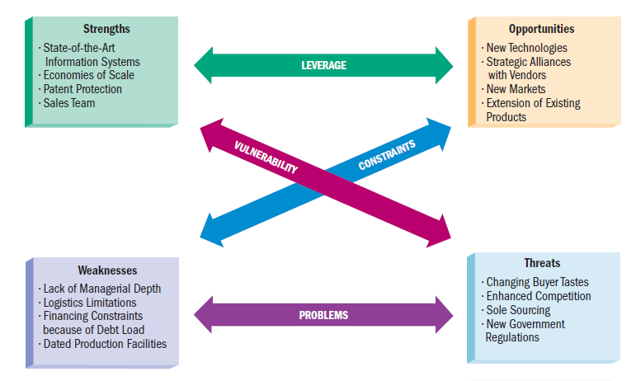
Managers as Decision Makers

- Decision making: Process of seeing a problem or opportunity, assessing possible solutions, selecting and carrying out the best-suited plan, and assessing the results
- Programmed decision involves simple, common and frequently-occurring problems that already have solutions (ordering supplies, creating a discount schedule or renewing a lease). Rules and policies that exist to help make these decisions.
- Non-programmed decision involves complex and unique problems or opportunities with important results for the organization. Entering a new market, acquiring a company and introducing a new products).
How managers make decisions…
- See a problem or opportunity
- Develop possible ways of taking action
- Evaluate options
- Select and carry out one option
- Assess outcome

- Outcome of managerial decisions depends on factors such as quality of information used and experience, creativity, wisdom.
- Decision-making also have legal and ethical effects.
Managers as Leaders
- Leadership: Ability to direct or inspire people to reach goals
- Involves use of influence or power to meet goals and objectives.
- Three common leadership traits: empathy, self-awareness and objectivity in dealing with others
- Autocratic leadership: leader-centred; make decisions on own without consulting employees
- Democratic leadership: involves employees in decisions, delegate assignments, and ask them for suggestions
- Free-rein leadership: involves minimal supervision; leave most decisions to employees
- Empowerment is important – giving employees shared authority, responsibility and decision-making w/ managers

Corporate Culture
- An organization’s collection of principles, beliefs and values
- Managers use symbols, rituals ceremonies and stories to reinforce corporate culture
- Strong culture is created when everyone supports the same principles, beliefs and values.

Organizational Structures
- Organization: Structured group of people working together to achieve common goals. Created with a formal structure through tasks and authority. Easy for individuals and departments to work together to achieve company goals.
- Bigger companies means a more complex structure with specialization and growing number of employees.
- Three key elements: human interaction, goal-directed activities, structure
- Decide on specific work activities needed to carry out plans and achieve objectives.
- Group all work activities into a pattern or structure that makes sense
- Assign activities to specific employees and give them the resources they need
- Coordinate activities of different groups and individuals.
- Evaluate results of the organizing process.

- Organizational charts are used to help employees understand how their work fits within the overall operation of the firm. Visual representation of firm’s structure.

Departmentalization
- Process of dividing work activities into units within the organization
- Product departmentalization: Organized based on goods and services that company offers
- Geographical departmentalization: Organized by geographical regions within a country or region
- Customer departmentalization: Organized by different types of customers the organization serves
- Functional departmentalization: Organized by business functions such as finance, marketing, human resources and production
- Process departmentalization: Organized by work processes necessary to complete production of goods or services.
- Companies combine different types of departmentalization to build their structure.

Delegating Work Assignments
- Delegation: Managerial process of assigning work to employees.
- Providing employees with the responsibility and necessary authority to complete tasks.
- Employees have accountability, responsibility for actions and decisions.
- Span of management: number of employees a supervisor manages.
- Centralization: decision-making process is retained at top management hierarchy
- Decentralization: decision-making is shifted to lower levels… many firms believe it enhances their flexibility and responsiveness to customer needs.

Types of Organizational Structures

- Lines organizations: oldest and simplest form; direct flow of authority from CEO to employees. Chain of command indicates who directs which activities and who reports to whom.
- Line-and-staff organizations: combines line departments and staff departments. Line departments participate directly in decisions that affect the core operations of the organizations; staff departments lend specialized technical support (accounting, HR)

Committee Organizations
- Authority and responsibility are in hands of a group of individuals.
- Often part of a line-and-staff structure.
- Often develop new products.
- Tend to act slowly and conservatively.
- Often make decisions by compromising conflicting interests rather than choosing the best alternative.
- Empowers all members rather than a single manager…
- Representatives from different parts of the organization (different skills and expertise)

Matrix Organizations
- Project management structure that links employees from different parts of the organization to work together on specific projects. Popular in technology, multinational corporations, hospitals and consulting firms.
- Employees report to both a line manager (vertical authority) and a project manager (horizontal authority)
- Effective when company leaders give project managers authority to use any available resources for project’s objectives.
- Projects need adequate staffing, reasonable workload and availability of other resources to project managers.
- Advantages: flexibility in adapting to changes; focus on major problems or products; outlet for employees’ creativity and initiative
- Disadvantages: Integrating skills of many specialists in one coordinated team; team members’ permanent functional managers must adjust the employees’ regular workloads.
CHAPTER 8 – HUMAN RESOURCE MANAGEMENT: FROM RECRUITMENT TO LABOUR RELATIONS
- Human Resource Management: Function of attracting, developing and retaining employees who can perform activities needed to meet organizational objectives
- Three main objectives:
- Providing qualified, well-trained employees for the organization
- Maximizing employee effectiveness in the organization
- Satisfying individual employee needs through monetary compensation, benefits, opportunities to advance, and job satisfaction.
- Core responsibilities of human resource management:
- Employee recruitment and selection
- Employee training and performance evaluation
- Employee compensation and benefits
- Employee separation
- Planning for staffing needs
Recruitment and Selection
- Recruiting techniques continue to evolve as technology advances. Internet recruiting is quick, efficient and inexpensive. Social networking sites, online job search sites, company’s websites.

Selecting and Hiring…
- Identify job requirements
- Choose sources of candidates (internet, schools, employee referrals, internal promotion, post-secondary)
- Review applications and resumes
- Interview candidates
- Conduct employment tests (mechanical, computer, language) and check references
- Conduct follow-up interviews
- Select candidate and negotiate offer (benefits, expectations, accessibility)
- Must follow legal requirements… or else bad publicity, poor employee morale, litigation.
- Cannot discriminate based on race, religion, colour, sex…
- During interviews, candidates cannot be asked about marital status, children, race, religion, age, criminal records, mental illness, medical history, alcohol/substance abuse.
- Ensuring employee has necessary skills to succeed.

Orientation, Training and Evaluation
- Newly hired employees complete orientation program (learn about policies, obtain annuals, benefits, training)
- Training includes on-the-job training (tasks under experienced employees), classroom (lectures, conferences, workshops, seminars) and computer-based (presentations, videos) training and management development (improve knowledge and skills of current or future managers)
- Build skills, keep long-term workers

Performance Appraisals
- Evaluation of and feedback on employee’s performance. Needed to make decisions on compensation, promotion, additional training needs, transfers or even termination.
- Effective performance reviews take place several times a year, linked to organizational goals, based on objective measures, are two-way conversations
- Peer reviews are also common
- 360-degree performance review: feedback from coworkers, supervisors, team members and even customers.

Compensation
- Compensation: Amount employees are paid in money and benefits
- Wage: Pay based on an hourly rate or amount of work accomplished
- Salary: Pay calculated on a periodic basis (weekly or monthly)
- Most firms base compensation decisions on five factors:
- What competing firms are paying
- Government regulation
- Cost of living
- Company profits
- Employee productivity
- Good compensation package but also keep costs reasonable
- Should attract workers, maintain satisfaction and inspire employees. Also be legal.
- Four forms of incentive compensation
- Profit sharing – bonus based on company profits
- Gain sharing – bonus based on productivity gains, cost savings or quality improvements
- Lump-sum bonus – one-time cash payment to buy shared of company stock based on performance
- Pay for knowledge – salary increase based on learning new job tasks
- Firms offer incentive compensation in addition to salaries or wages.

Employee Benefits
- Additional compensation: vacation time, retirement savings plan, profit-sharing, health insurance, gym membership, child and elder care, tuition reimbursement (could reach 30% of total employee compensation)
- Some benefits required by law: Canada Pension Plan, unemployment insurance, workers’ compensation programs.
- Flexible benefits: medical, dental, vision, life and disability insurance
- Flexible time off: freedom to use paid time off as liked (instead of a set number of holidays, vacation days, sick days)

Flexible Work
- Allows employees to adjust working hours and places of work to accommodate personal needs
- Flextime allows employees to set own work hours within certain constraints
- Compressed work week allows employees to work the regular number of weekly hours in fewer than the typical five days
- Job sharing program allows two or more employees to divide tasks of one job
- Home-based work program allows employees or telecommuters to perform jobs from home instead of their workplace… more than 70% of Gen Y employees are concerned w/ balancing career and personal lives
- Flexible work has reduced employee turnover and absenteeism, and boosted productivity and job satisfaction.

Employee Separation
- Voluntary turnover is when employees leave firms to start own business, take jobs with other firms or retire
- Exit interviews to ask about reason for resignation
- Involuntary turnover is when employees are terminated for poor job performance, unethical behaviour or downsizing
- Termination reasons must be documented properly; HR must abide by laws during this process

Downsizing
- Process of reducing number of employees by cutting jobs
- Negative effects: anxiety, health problems, lost productivity amongst remaining workers; expensive severance packages for laid-off workers; domino effect on the local economy

Outsourcing
- Using outside vendors to produce goods or fulfill services and functions that were completed in-house or in-country
- Usually cuts expenses when outsourcing non-core areas of business
- Used to remain competitive against domestic and international rivals

Employee Motivation
- Motivation starts with good employee morale (mental attitude of employees toward employer and jobs)
- High employee morale: workers feel valued, heard and empowered
- Poor morale results in absenteeism, voluntary turnover and lack of motivation

Maslow’s Hierarchy of Needs
- A satisfied need is not a motivator; only needs that remain unsatisfied can influence behaviour
- People’s needs are arranged in a hierarchy of importance; once they satisfied one need, at least partially, another remerges and demands satisfaction
- Employees must satisfy these needs
- People have five levels of needs:
- Physiological
- Safety
- Social (belongingness)
- Esteem
- Self-actualization
Herzberg’s Two-Factor Model of Motivation
- Hygiene factors: salary, job security, working conditions, status, interpersonal relations, technical supervision, company policies.
- Do not directly relate to a task but do relate to job environment
- Motivator factors can produce high levels of motivation… job responsibilities, achievement, recognition, growth.
- Absence of a condition did not cause employees to feel bad, although that factor could motivate employees…

Expectancy Theory
- Process people use to evaluate likelihood that efforts will lead to result they want and the degree to which they want those results… affects motivation.
- Three factors to determine how much effort to put forth: person’s subjective or personal prediction that a certain effort will lead to the desired result; value of the outcome (reward) to the person; the person’s assessment of how likely a successful performance will lead to a desirable reward

Equity Theory
- An individual’s perception of fair and equitable treatment
- Employees first consider effort then rewards.
- Next, employees compare results against results of coworkers.
- If they feel they are being rewarded less than coworkers, they will decrease effort to restore balance… if they feel over rewarded, they will feel guilty and put more effort into job to restore equity and reduce guilty

Goal-Setting Theory
- A goal is a target, objective or result that someone tries to accomplish.
- People will be motivated to the extent to which they accept specific, challenging goals and receive feedback that shows their progress toward goal achievement.
- Goal specificity: goals are clear and concrete
- Goal difficulty: how hard the goal is to reach… more motivation than an easier goal
- Goal acceptance: understanding and agreement of the goal… usually rejecting a goal that is too challenging
- Performance feedback: information about performance and how well the goal has been met
Management by objectives (MBO)
- Structured approach that helps managers focus on reachable goals and to achieve best results based on organization’s resources
- MBO helps motivate individuals by aligning their objectives with goals of organization, increased organization performance
- MBO principles:
- Series of related organizational goals and objectives
- Specific objectives for each person
- Participative decision-making
- Set time period to accomplish goals
- Perofmrance evaluation and feedback
Job Design and Motivation
- Job enlargement expands employee’s responsibilities by increasing number and variety of tasks
- Job enrichment expands employee’s job duties to empower an employee to make decisions and learn new skills leading toward career growth
- Job rotation involves systematically moving employees from one job to another, increase range of activities
- These strategies improve productivity and morale
Managers’ Attitudes and Motivation
- According to psychologist Douglas McGregos, managers make two assumptions make about employees affect management styles and employee motivation.
- Theory X assumes employees dislike work and try to avoid it whenever possible, so management must coerce them to do their jobs (money and job security are motivators)
- Theory Y assumes that the typical person actually likes work and will seek and accept greater responsibility (self-control and self-direction are motivators)
- Theory Z (professor William Ouchi) views worker involvement as key to increased productivity for the company and improved quality of work life for employees
Labour-Management Relations
- Labour union: group of workers who organize themselves to work toward common goals in the areas of wages, hours and working conditions
- Focus on fewer work hours, better working conditions and improved benefits
- Local, national and international levels
- 600,000 Canadian employees represented by Canada’s largest union, Canadian Union of Public Employees (CUPE)

Collective Bargaining Process
- Process of negotiation between management and union representatives
- Issues such as wages, work hours, benefits, union activities and responsibilities, grievance handling and arbitration, layoffs, employee rights and seniority

Settling Labour-Management Disputes
- Most labour-management negotiations result in signed agreements without work stoppages
- Mediation is the process of settling labour-management disputes through an impartial third party
- Arbitration adds a third party who renders a legally binding decision
- Complains to supervisor, middle-management, top-management, arbitration (levels if one doesn’t work)

Competitive Tactics of Unions and Management
Union tactics:
- Strike: temporary work stoppage by employees until a dispute has been settle or a contract is signed (disrupts business by calling attention to workers’ needs; damages local economy)
- Picketing: workers march in public protest against employer (protected under law as long as there is no violence or intimidation… may accompany a strike or may be a protest against unfair labour practices
- Boycott: organized attempt to keep public from purchasing goods and services of a firm
Management Tactics
- Lockout is a management “strike” to put pressure on union members by closing the firm. They either hire strike-breakers in highly visible fields or transfer supervisors and other non-union employees to continue operations during strikes

Future of Labour Unions
- Membership and influence are declining, caused by shift from manufacturing industries to information and service businesses
- Public sector unions include more than 70% of all employees
- Unions need to be more flexible and adapt to a global economy and diverse workforce
- Flexibility is key for continued effectiveness (responding to growing need for environmentally responsible business and manufacturing processes; setting up working relationships with HR and other managers
- Unions can recognize potential for prosperity for all – management and union workers included

CHAPTER 11: CUSTOMER DRIVEN MARKETING
- Marketing is an organizational function and set of processes for creating, communicating and delivering value to customers and for managing customer relationships in ways that benefit the organization and its stakeholders
- Discover unmet customer needs; research potential markets; produce a good/service capable of satisfying targeted customers; promote, price and distribute good/service
- Successful organizations focus on building customer relationships throughout the process
- Best marketers give consumers what they want and anticipate consumers’ needs before they surface
- Exchange process: an activity in which two or more parties trade something of value (such as goods, service or cash) that satisfied each other’s needs.

- Utility is the power of a good or service to satisfy a want or need
- Create time utility by making a good or service available when customers want to purchase it
- Create place utility by making a product available in a location convenient for customers
- Create ownership utility through an organized transfer of goods and services from the seller to the buyer
- Production function creates firm utility by converting raw materials, component parts and other inputs into finished goods and services.

- Today, there is more focus on relationships (customer satisfaction and building long-term business relationships) and marketing rather than simply sales and production.

- Marketing concept: company-wide consumer focus on promoting long-term success
- Firm starts with analysis of customers’ needs and works backward to offer products that fulfill them
- Marketplace success begins with the customer – strong competition to satisfy customers. Organizations must focus on long-term value of customers and their needs.
Not-for-profit and non-traditional marketing
- 20 million not-for-profits worldwide
- Apply marketing tools to reach audiences, secure funding and accomplish overall mission
- Operate in public and private sectors
- Sometimes partner with profit-seeking company to promote a message
- Compete for dollars (funding) and people (donors or volunteers)
Non-traditional marketing
- Cause marketing: promotes awareness of a cause or social issue or raises money for a cause or social issue such as drug abuse prevention or childhood hunger
- Place marketing: attract people to a particular area (city, region or country)
- Event marketing: marketing or sponsoring short-term events such as athletic competitions and cultural and charitable performances
- Person marketing: efforts designed to attract attention, interest and preference of a target market toward a person.
- Organization marketing: influences consumers to accept the goals of an organization, receive the services of an organization or contribute in some way to an organization
Developing a Marketing Strategy
- Study and analyze potential target markets and choose among them.
- Create a marketing mix to satisfy the chosen market.

- Marketing plan outlines firm’s marketing strategy. Key in firm’s overall business plan.
- Also includes information about target market, sales and revenue goals, marketing budget and timing for implementing elements of the marketing mix.
Selecting a Target Market
- Target market: group of people that an organization markets its goods, services or ideas toward, using a strategy designed to satisfy this group’s specific needs and preferences.
- Consumer (B2C) product: good or service that is purchased by end users
- Business (B2B) product: good or service purchased to be used either directly or indirectly in the production of other goods for resale
- Some products fit both classifications (computers and credit cards are used by both)
- Marketers study individuals and business decision-makers in its potential market to find a need.
- A market consists of people who have purchasing power, willingness to buy and authority to make purchasing decisions.
- Marketing mix: Blending of the four elements of marketing strategy to satisfy chosen customer segments. Communicates to the target market. Marketing success depends on the combination of four strategies.
- Product strategy involves the nature of the product and its package design, brand names, trade markets and product image
- Distribution strategy ensures customers receive purchases in proper quantities at right times and locations.
- Promotional strategy blends advertising, personal selling, sales promotion and public relations to achieve goals of informing, persuading and influencing purchase decisions.
- Pricing strategy sets profitable and justifiable prices for the firm’s product offerings, sometimes subject to government scrutiny.
Developing a Marketing Mix for International Markets
- Standardization means offering the same marketing mix in every market. Works best with business to business goods, which need little sensitivity to a nation’s culture.
- Adaptation means developing a unique marketing mix to fit each market’s local competitive conditions, consumer preferences and government regulations. Consumer products tend to be more culture-dependent than business products… food and restaurants.
- Mass customization allows a firm to mass-produce goods and services while adding unique features to individual or small groups of orders. Build adaptability into the designs of standardized goods and services for international and domestic markets.

Marketing Research
- Process of collecting and evaluating information to support marketing decision-making, creating an effective strategy and building a strong marketing mix
- Internal data is generated within the organization; includes financial records, inventory levels, sales and profitability
- External data comes from outside sources such as trade associations, advertising agencies, national marketing research firms
- Secondary data is previously published data. Low-cost and easy to obtain. Government publications provide data sources (census statistics)
- Primary data is collected through observation, surveys and other forms of observational duty.
- Focus groups gather 8 to 12 people in a room or online to discuss a specific topic. Can lead to new ideas, address consumer needs and point out flaws in existing products.
- Business intelligence is a field of research that uses activities and technologies for gathering, storing and analyzing data to make better competitive decisions
- Data mining is the use of computer searches of customer data to detect patterns and relationships. Use data warehouses, which are sophisticated customer databases that allow managers to combine data from several different organizational functions.

Market Segmentation
- Process of dividing a total market into several relatively similar groups based on marketing research results.
- Attempts to isolate traits that distinguish a certain group of customers from the overall market.
- Segment must be a measurable group… data collected on dollar amount and number of purchases by university students.
- Segment must be accessible for communication… more seniors are now online, so more of them can be reached through Internet channels.
- Segment must be large enough to offer profit potential… in a small community, a store carrying only large-size shoes might not be profitable. For similar reasons, a specialty retail chain may prefer to locate in a large market.

In Consumer (B2C) markets
- Geographical: region, population, diversity, postal code – dividing an overall market into similar groups on the basis of their locations
- Psychographic: lifestyles, attitudes, opinions, behaviour, patterns, values, personality, self-image
- AIO statements are people’s verbal descriptions of various attitudes, interests and opinions
- Demographic: age, gender, income, education, family size and occupation
- Product-related: comfort, safety, luxury, economy, convenience, durability, brand loyalty; groups based on benefits sought by buyers, usage rates and loyalty levels
In Business (B2B) markets
- Geographical: geographically concentrated industries
- Demographic/customer-based: designs good or service intended for a specific organizational market (health care institutions)
- End-use: marketing strategy that focuses on the precise way a B2B purchaser will use a product

Consumer Behaviour
- End consumers’ activities that are directly involved in obtaining, consuming and disposing of products, and the decision processes before and after these activities
- Personal factors: needs and motives, perceptions, attitudes, learned experiences, self-concept
- Interpersonal factors: cultural, social and family influences
- External factors: economic events
- Business buying behaviour often includes a variety of influences from multiple decision markets within the organization
Steps in Consumer Behaviour Process
- Recognition of problem or opportunity
- Search
- Evaluation of alternatives
- Purchase decision
- Purchase act
- Post-purchase evaluation (feedback)

- Interpersonal determinants: cultural influences, family influences and social influences
- Personal determinants: needs and motives, perceptions, attitudes, learning, self-concept
Relationship Marketing
- Developing and maintaining long-term, cost-effective exchange relationships with partners (individual customers, suppliers and employees)
- Consumers enter into relationships only if there is some benefit to them
- Seeks to achieve customer satisfaction as ultimate goal
- Better-informed consumers require a beneficial relationship when they make investments. They demand benefits from the companies that supply them.

Benefits of Relationship Marketing
- Lower costs, higher profits and protection against competitors for the business. Efficiently target best customers.
- Studying current customers’ buying habits and preferences can help marketers identify potential new customers and establish ongoing contact with them
- Attracting a new customer can cost five times as much as keeping an existing customer
- Lifetime value of a customer: revenues and intangible benefits (referrals and feedback) from a customer over the life of the relationship, minus the amount the company must spend to acquire and serve that customer
- Stronger relationships with business partners and opportunities to combine capabilities and resources to better accomplish goals
- Long-term customers reduce marketing costs and usually buy more, require less service, refer other customers and provide valuable feedback

Tools for Nurturing Customer Relationships
- Frequency marketing: marketing initiative that reward frequent purchases with cash, rebates, merchandise or other premiums. More personalized than in the past… airlines, hotels, restaurants, retailers use them.
- Affinity programs: Marketing effort sponsored by organization that targets people who share common interests and activities. Common in credit card industry.
- Comarketing: cooperative arrangement where two or more businesses jointly market each other’s products
- Cobranding is a cooperative arrangement where two or more businesses team up to closely link their names on a single product
- Comarketing and cobranding nurture complimentary relationships: Nike and Apple have marketed the Nike 1 iPod Sport Kit – strengthen relationship they have with their customers.
- 80/20 rule: 20% of firm’s customers account for 80% of sales and profits

One-to-one marketing
- Customizing products and marketing and rapidly delivering goods. Meet different needs.
- Customer relationship management (CRM) software helps companies gather, sort and interpret data about specific customers.
- Form of relationship marketing that depends on technology
- Customer relationship management uses technology to efficiently manage one-to-one relationships.
CHAPTER 12 -- PRODUCT AND DISTRIBUTION STRATEGIES
Product Strategy
- Product: A bundle of physical, service and symbolic characteristics designed to satisfy consumer wants. Includes decisions about package design, brand name, trademarks, warranties, product image, new product development and customer service.

Consumer product categories

- Convenience products: Items the consumer seeks to purchase frequently, immediately, and with little effort (tissues, milk, etc.)
- Shopping products: Typically purchased only after the buyer has compared competing products in competing stores (fridges, sofas, TV)
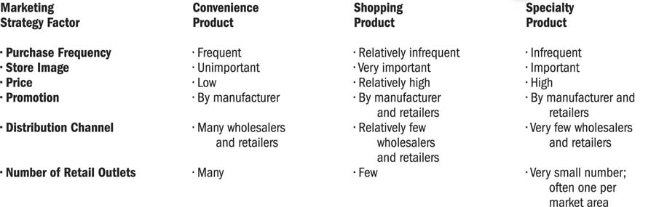
- Specialty products: Items a purchaser is willing to make a special effort to obtain (vehicle, jewelry)
- Classifying B2C and B2B consumers helps with the development of marketing strategy

Classifying Business Goods

- Capital (long-lived and expensive) versus expense items (less-costly and quickly consumed)
- Installations are major capital items such as new factories, heavy equipment and machinery, and custom-made equipment
- Accessory equipment includes less expensive and shorter-lived capital items than installations; involves fewer decision makers
- Component parts and materials become part of a final product
- Raw materials are farm and natural products used in producing other final products
- Supplies are expense items used in a firm’s daily operations that do not become part of the final product
- Consumer products are classified by how consumers but them; business products are classified by their basic characteristics and by how they are used
Classifying Services
- Different from goods: intangible, perishable (cannot stockpile in inventory), difficult to standardize (customized to each person’s needs), service provider is the service
- They do fall under the same categories as convenience, shopping and specialty
Marketing Strategy Implications
- In B2B, greater emphasis on personal selling for installations and many component parts, and a concentration on quality and customer service
- Producers of installations and component parts may involve customers in new-product development
- Advertising is more commonly used to sell supplies and accessory equipment
- Producers of supplies and accessory equipment place a greater emphasis on competitive pricing strategies
- Each group of products requires a different marketing strategy

- Product line: Group of related products that share physical similarities; shared toward a similar market
- Product mix: Assortment of product lines and individual goods and services that a firm offers to consumers and business users
- Need to ensure growth, satisfy changing consumer needs and wants, and adjust to competitors’ offerings. Can introduce new products and product lines.
- Example: Pepsi has soda products but also other drinks (juice, water, teas) and snacks (Lays)
Product Life Cycle
Four basic stages in the development of a successful product: introduction, growth, maturity and decline (PDAs)
- Sales and profits decline over time (peak at the growth stage)
- Introduction: Firms promote demand; inform the market; free samples for trial purchase; explains features, uses and benefits. Losses are common due to low sales and high costs of promotion, marketing and advertising.
- Growth: Sales climb as new customers enter; begins to earn profits on the new product. Other competitors enter the field with similar offerings.
- Maturity: Industry sales eventually reach a saturation level at which further expansion is difficult. Competition intensifies; availability of product increases. Trying to outsell competitors to increase appeal and keep market share.
- Decline stage: Sales fall and profits decline. Product innovation and shift in consumer preferences.
Marketing Strategy Implications of Product Life Cycle
- Marketer’s objective is to extend the life cycle as long as product is profitable
- Marketer’s goals: increasing customers’ frequency of use; adding new users; finding new uses for product; changing package sizes, labels and designs
- Developing new products, lowering prices, increasing distribution coverage, creating new promotional campaigns

Stages in New-Product Development
- Expensive, time-consuming and risky; but also has rewards
- Only one-third of new products are successful
- Each step requires a “go/no-go” decision
- Generate new product ideas (customer suggestions, suppliers, employees, competitive products… relate to customer needs)
- Screening. Eliminates ideas that do not contribute to overall objectives or cannot be developed within the resources.
- Concept development and business analysis. Potential sales, profits, growth rate and competitive strengths.
- Product development. Prototypes, descriptions – firm’s development staff and marketers..
- Test marketing. Completed marketing campaign to a city or TV coverage area to examine consumer responses and marketing effort.
- Commercialization. Made public – distribution, promotion and pricing strategies are put into effect.
Product Identification
- Brand: Name, term, sign, symbol, design or some combination that identifies products of one firm… shows difference from competitors
- Brand name: Part of the brand that is made up of words or letters. Used to identify products.
- Trademark: Brand that has been given legal protection
- Uses logos, slogan, packaging elements and product features such as colour and shape

Brand Categories
- Manufacturer’s (or national) brand is offered and promoted by manufacturer (Tide, Nike, Windex)
- Private (or store) brand is not linked to manufacturer but instead carries wholesaler’s or retailer’s label (Loblaw’s PC foods, Sears’ Craftsman tools)
- Family branding strategy uses a single brand name for several related products… Johnson & Johnson
- Individual branding strategy gives each product within a line a different name… Procter & Gamble produces Tide, Cheer and Dash

Brand Loyalty
- Brand recognition is when the consumer is aware of the brand but does not have a preference for it over other brands
- Brand preference: consumer chooses one firm’s brand over a competitor’s
- Brand insistence: consumer will seek out a preferred brand and accept no substitute (ultimate degree of brand loyalty)
- Consume loyalty increases a brand’s value… both business and consumer goods

- Brand equity: Added value that a respected and successful name gives to a product. Results from awareness, loyalty, perceived quality and feelings/images the customer associates with the brand.
- Brand awareness: product is the first one that comes to mind when a product category is mentioned
- Product managers look at a certain brand; category managers look at a group of products and have profit responsibility for the group
- Category advisors are major suppliers to deal with other suppliers for a special purchase and to present the entire package to entire business buyer
Packages and Labels
- Packaging affects durability, image and convenience of an item… responsible for one of the biggest costs in many consumer products
- Important in product identification and overall product strategy
- Especially important in international marketing (language, culture)
- Must meet legal requirements (languages, ingredients, government standards)
- Universal Product Code: bar code read by optical scanner; link UPC to product
- Environmental impacts!
- Packaging weight must be considered… shipping costs depend on weight.

Distribution Strategy
- Distribution channel: Path that products—and their legal ownership—follow from producer to consumers or business users
- Physical distribution: Actual movement of products from producer to consumers/business users
- Marketing channels are made up retailers/wholesalers that move product through channel to customer

Distribution Channels
- Marketers use different distribution channels for every product
- Can be a direct channel or indirect (with intermediaries such as wholesalers, retailers and agents/brokers)

Direct
- Direct contact between producer and consumer
- Most common in B2B markets
- Found in the marketing of relatively expensive, complex products that may require demonstrations
- Internet plays a vital role in direct distribution
Distribution using marketing intermediaries
- Distribute products through wholesalers and retailers
- Inexpensive products sold to thousands of consumers across the world
- Lower costs of goods to consumers by creating market utility
- Wholesalers add significant value to purchasing process… they do not add cost
- Instead of a manufacturers trying to reach different customers; each manufacturer reaches a marketing intermediary who reaches customers
- Reduces number of transactions; consolidates goods to one place

Wholesaling
- Wholesaler: distribution channel member that sells primarily to retailers, other wholesalers or business users. Owned by manufacturers, retailers or independent.

Manufacturer-owned wholesaling intermediaries
- Owned by the manufacturer of the goods or products to control distribution or customer service
- Sales branch stocks products and fills orders from inventories
- Sales office takes orders but does not stock product

- Independent wholesaling intermediary is a business that represents several different manufacturers and sells to retailers, manufacturers and other business accounts. Can be either merchant wholesalers or agents and brokers, depending on whether they take tile to (legal ownership of) the products they handle.

Retailing
- Retailers: Distribution channel members that sells goods and services to individuals for own uses; not for resale
- Final link of distribution channel; deal directly with customers
- Two types: store and non-store

Non-Store Retailing

- Direct-Response Retailing: sales through catalogues; telemarketing; newspaper; TV; order and delivery
- Internet Retailing: sales through virtual storefronts, web-based sellers; websites
- Direct Selling: direct manufacturer-to-consumer sales through party plans and direct contact
- Automatic Merchandising: sales of consumer products such as candy, soft drinks through vending machines

Types of Retail Stores
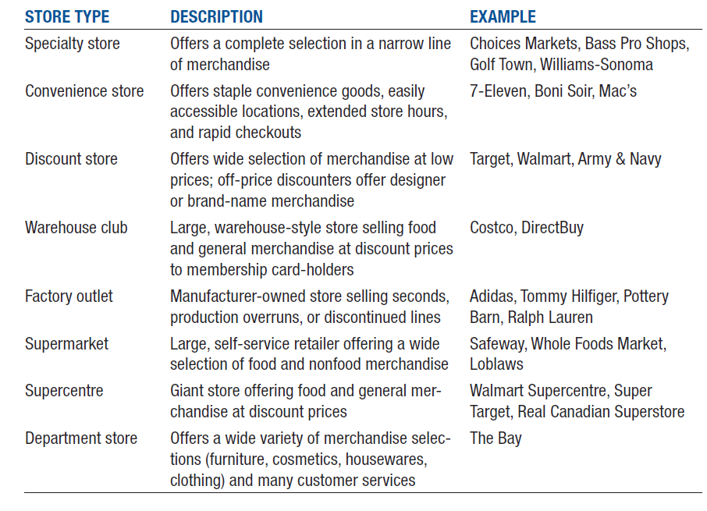

Wheel of Retailing
- Retailers go through constant change; new retailers enter the market by offering lower prices made possible through reductions in services.
How Retailers Compete
- Identify a target market (size and profit of potential market)
- Select product strategy (right mix of product categories and product lines)
- Select customer service strategy
- Selecting pricing strategy (based on costs of purchases)
- Choose location
- Build promotional strategy
- Create store atmosphere (physical characteristics)
Choosing a Location
- Planned shopping centre (group of retail stores planned, coordinated and marketed as a unit to shoppers in a geographical trade area)
- Shopping mall
- Regional mall
- Lifestyle mall
- Location selection has shifted to smaller centres with retailers that focus on specific shopper segments and product interests
Distribution Channel Decisions and Logistics
- What specific channel to use?
- Level of distribution intensity?
- Selecting distribution channels…
- Complex, expensive, custom-made products move through shorter distribution channels (no intermediaries)
- Standardized products with low unit values pass through long distribution channels
- Start-up companies use direct channels because they can’t persuade intermediaries to carry products (or because they want to extend sales reach)
Selecting Distribution Intensity
- Distribution intensity is the number of intermediaries or outlets through which a manufacturers distributes goods
- Intensive distribution involves a firm’s products in nearly every available outlet; requires cooperation of many intermediaries (goods for milk, soft drinks)
- Selective distribution is when manufacturers select a limited number of retailers to distribute its product lines
- Exclusive distribution limits market coverage in a specific geographical area to enhance product image; prestige products that may be expensive or customer wants to control customer experience
Logistics and Physical Distribution
- Supply Chain: Complete sequence of suppliers that help create a good or service and deliver to business users and final consumers
- Logistics: Process of coordinating flow of goods, services and information among members of the supply chain
- Physical distribution: Activities aimed at efficiently moving finished goods from production line to consumer or business buyer
- Choice of distribution channel creates final link in supply chain
- Supply chain begins with raw materials and ends with customers and the retail relationship.
- Must choose most appropriate method of transportation for product, channel and customer needs...

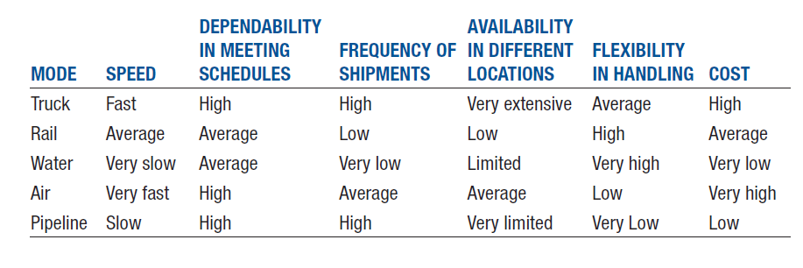
Customer Service
- Customer service standards measure quality of service firm provides for its customers
- Warranties are firm’s promises to repair a defective product, refund money paid or replace product if it proves unsatisfactory
- Internet retailers try to humanize customer interactions and deal with complaints more effectively
CHAPTER 13 – PROMOTION AND PRICING STRATEGIES
- Promotion: Function of informing, persuading and influencing a purchase decision

- Integrated marketing communications (IMC)
- Coordination of all promotional activities—media, advertising, direct mail, personal selling, sales promotion and public relations—to produce a unified, customer-focused promotional strategy
- Must take broad view and plan for all form of customer contact
- Create unified personality and message for the good, brand or service
- Elements include personal selling, advertising, sales promotion, publicity and public relations
- Not only broadcast and print media… today, it’s about packaging, store displays, sales promotions, sales presentations, online media

Promotional Mix
- Combination of personal and non-personal selling that marketers use to meet needs of a firm’s target customers and to effectively and efficiently communicate its message to them
- Personal selling: Most basic form of promotion – direct person-to-person promotional presentation to a potential buyer
- Non-personal selling: Forms of selling such as advertising, sales promotion, direct marketing and public relations
- B2B manufacturers spend more on personal selling than on advertising b/c it’s less costly.
- B2C may focus on advertising and sponsorships.
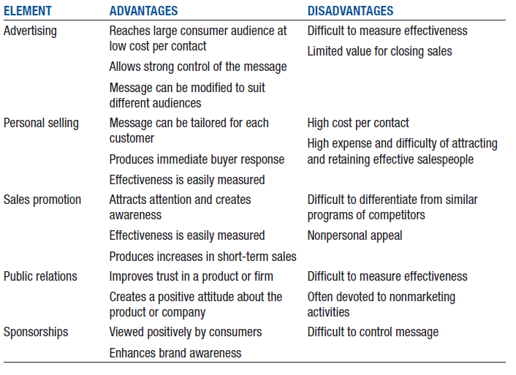

Objectives of Promotional Strategies
- Differentiate Product: Comparing two laundry detergents (positioning)
- Provide Information: Explaining features of a car
- Stabilize Sales: Holding contests during slow sales periods; according to season
- Increase Sales: End-of-aisle grocery displays
- Highlight Product Value: Warranty programs and guarantees that make product appealing

Promotional Planning
- Product placement: Form of promotion where marketers pay placement fees to have their products featured in various media, from newspapers and magazines to television and movies
- Guerrilla marketing: Innovative, low-cost marketing efforts designed to get consumers’ attention in unusual ways

Advertising
- Paid non-personal communication usually targeted at large numbers of potential buyers
- Expenditures are high… carmakers spend $20 billion on advertising every year
- Need for creativity and efficiency to grab attention
- Product advertising: Messages designed to sell a particular good or service
- Institutional advertising: Messages that promote concepts, ideas or philosophies. Can promote goodwill toward industries, companies, organizations or government entities (events like Walk for the Cure)
- Cause advertising: Form of institutional advertising that promotes a specific viewpoint on a public issue as a way to influence public opinion and political process
Advertising and the Product Life Cycle
- Informative advertising: Used to build initial demand in introductory phase
- Persuasive advertising: Improve competitive status of product, institution, concept; growth/maturity stages
- Comparative advertising: Compares products directly with competitors… by name or influence
- Reminder-oriented advertising: Maintains awareness of important and usefulness of product in late maturity or decline stages

Types of Advertising
- TV: reaches a large number of customers, most expensive
- Newspapers: local advertising, short life span
- Radio: commuters in car; internet radio gives new opportunities
- Magazines: consumer publications; customize for different geographical areas
- Direct Mail: higher per person cost; can be carefully targeted
- Outdoor Advertising: requires brief messages
- Online/interactive: links to home sites; viral ones can increase popularity; search engines and classified ads; social media advertising costs nothing
- Sponsorship: providing funds for a sporting or cultural event in exchange for a direct association with the event (exposure to target audience, association with image of the event)
- Infomercials: direct-marketing; 30-minute programs
- ATM commercials/receipts
- Directory advertising
- Ethical issues: consumers recruited as “brand ambassadors” for pay (not required to disclose status to other consumers)

Sales Promotion
- Forms of promotion such as coupons, product samples and rebates that support advertising and personal selling.
- Integral part of promotional mix
- Promotion accounts for more than half of marketing as many dollars spent on advertising… increasing in spending by retailers and manufacturers
- Short-term advantages of increased sales; improve customer relationships and brand equity

Consumer-Oriented Promotions
- Premiums, coupons, rebates, samples
- Free/reduced price premiums likely to get consumers thinking and caring about brand and product
- Coupons attract new customers but focus on price rather than brand loyalty
- Rebates increase purchase rates, promote multiple purchases and reward product users
- ¾ consumers try samples
Games, contests, sweepstakes
- Introduction of new products
- Offer cash, merchandise or travel as prizes to winners
- Legal restrictions
Specialty advertising
- Promotional items that prominently display a firm’s name, logo or business slogan
Trade-Oriented Promotions
- Sales promotion geared to marketing intermediaries, not to final consumers
- Encourage retailers to stock new products; to continue carrying existing ones; promote both new and existing products effectively
- Point-of-purchase (POP) advertising: displays that promote products where consumers buy them (retail stores)
- Trade shows (toward members of distribution channels)
- Trade promotions should include financial incentives. Should bring quick results and improve retail sales.
Personal Selling
- Person-to-person promotional presentation to a potential buyer
- Significant costs of hiring, training, benefits and salaries
- Long-term relationships with customers
- Many companies consider personal selling the key to marketing effectiveness
- Seller matches firm’s goods or services to the needs of a particular client or customer
- Businesses often spend 5 – 10 times as much on personal selling as on advertising
- Firms focus on personal selling under four conditions:
- Few geographically concentrated customers
- Product is technically complex, involves trade-ins or requires special handling
- Product carries a relatively high price
- Product moves through direct-distribution channels
Sales Tasks
- Order processing: Used at wholesale and retail levels; identifying customer needs, point out products that meet needs and completing orders
- Creative selling: Persuasive type of promotional presentation. Promotion when benefits are not readily apparent or purchasing decision requires close analysis of alternatives
- Missionary selling: Indirect; representative promotes goodwill for a company or provides technical or operational assistance to customer
- Telemarketing: Personal selling by telephone, which provides a firm’s marketers with high return on expenditures, an immediate response and opportunity to personalize two-way conversation

Sales Process
- Prospecting and qualifying: identify potential customer
- Approach: prepare for sales interview
- Presentation: tell product’s story
- Demonstration: involve customer in the presentation
- Handling objections: answer questions
- Closing: ask for the order
- Follow-up: thank you; begin maintaining mutually beneficial relationships that result in future sales
Good salesperson varies sales process based on needs and responses
- Prospecting: identifying potential customers
- Qualifying: identifying potential customers who have financial ability and buying authority
(through direct mail responses, personal visits from sales reps., e-mail, social media)
- Approaching: analyzing available data about a prospective customer’s product lines and other relevant info
- Presentation: salespeople communicate promotional messages… describe major features of products, highlight advantages and examples of satisfied customers
- Demonstration: reinforces the message that the salesperson has been communicating
- Objections: answer questions and explain how product will benefit customer
- Closing: critical point in sales process; asking customers to buy
*Even if sale is not made, salesperson should regard interaction as the beginning of a potential relationship
- Follow-up: important part of building long-lasting relationship… customer might make another purchase. Address any issues.

- Public Relations: Organization’s communications and relationships with various public audiences… efficient, indirect communications channel for promoting products. Publicize products and create positive image of company. Supports advertising, personal selling and sales promotion.
- Publicity: Non-personal stimulation of demand for a good, service, place, idea, event, person or organization by unpaid placement of information in print or broadcast media. Good publicity promotes image; negative publicity causes problems.
- Pushing strategy: Personal selling to market an item to wholesalers and retailers in a company’s distribution channels. Promoting product to members of marketing channel, not end users.
- Pulling strategy: Promote product by generating consumer demand for it (through advertising and sales promotion). Potential buyers will request that their suppliers—retailers or local distributors—carry the product, thereby pulling it through the distribution channel.
- Most marketing situations require combinations of push and pull strategies.
- Push for consumers; pull for business products.
- Cooperative advertising: allowances that marketers provide to share with channel partners the cost of local advertising of their firm’s product or product line
Pricing Objectives in the Marketing Mix
- Pricing decisions vary (high prices for high profits or low prices for high demand). Price is the exchange value of a good or service.
- Profitability objectives: Common goals that are included in the strategic plans of most firms. Maximize profits by reducing costs; maintain price while reducing package size.
- Volume objectives: Pricing decisions that are based on market share, the percentage of a market controlled by a certain company or product.
- Pricing to Meet Competition: meet competitors’ price; competitors cannot legally work together to set prices; competition results in price war.
- Prestige pricing: establishing a relatively high price to develop and maintain an image of quality and exclusiveness. Role of price is vital in communication overall image for firm and its products. Products that are limited in distribution or so popular that they become scarce.

Cost-based pricing
- Calculating total costs per unit and then adding markups to cover overhead costs and generate profits.
- Totals all costs associated with offering product (R&D, production, transportation and marketing)
- Markup is added to cover unexpected or overlooked expenses and provides a profit
- Typical markup for clothing is determined by doubling wholesale price (cost to merchant)
- Total is selling price
- Actual markup used varies by factors such as brand image and store type

Breakeven Analysis
- Pricing-related technique used to calculate minimum sales volume a product must generate at a certain price level to cover all costs
- Breakeven point (in units) = Total fixed costs/contribution to fixed costs per unit
- Contribution to fixed cost per unit is revenue per unit – variable cost per unit
- Breakeven point (in dollars): Total fixed costs/1-variable cost per unit/price
- Total cost is sum of total variable costs and total fixed costs.
- Variable costs change with level of production (labour, raw materials)
- Fixed costs are constant (utility rates, insurance premiums)
- Total revenue = price x number of units sold
- Sales beyond BE will generate profit; below will result in losses

Alternative Pricing Strategies

- Skimming pricing: Strategy that sets intentionally high price relative to prices of competing products. Distinguishes firm’s high-ended product from those of competitors. Often used when introducing a distinctive good or service that has little or no competition.
- Penetration pricing: Strategy that sets a low price as a major marketing tactic (new products)
- Everyday low pricing (EDLP): Strategy of maintaining continuous low prices instead of using short-term price-cutting tactics such as cents-off coupons, rebates and special sales
- Discount pricing is used to attract customers by dropping prices for a set period of time
- Competitive pricing: Strategy that tries to reduce emphasis on price competition by matching other firms’ prices and by focusing their own marketing efforts on the product, distribution and promotional elements of the marketing mix

Consumer Perceptions of Prices
- Price-quality relationships
- Consumers’ perceptions of quality closely tied to price
- High price = prestige and higher quality
- Low price = less prestige and lower quality
- Odd pricing: Uses uneven amounts to make prices appear to be less than they really are ($1.99; $9.95). Use it for markdowns – notifies a sale.
CHAPTER 15: UNDERSTANDING ACCOUNTING AND FINANCIAL STATEMENTS
- Accounting: Process of measuring, interpreting and communicating financial information to support internal and external business decision-making
- Internal and external individuals rely on accounting information to make business decisions
- Owners, stockholders, potential investors and creditors: evaluate operations of the firm to make investment decisions
- Management: to plan and control
- Employees, union officials: to use in contract negotiations
- Lenders, suppliers: to evaluate credit ratings
- Government agencies, economic planners, consumer groups: to evaluate tax liabilities; approve new issues of stocks and bonds

Open-book management
- Sharing sensitive financial information with employees and teaching them how to understand and use financial statements
- Helps understand how work contributes to company’s success
- Outsiders use it for investment opportunities
Business activities involving accounting
- Financing activities provide necessary funds to start a business and expand
- Investing activities provide valuable assets required to run a business
- Operating activities focus on selling goods and services but also consider expenses as important elements of sound financial management

Accounting Professionals
- Public accountant: Provides accounting services to other organizations… auditing, tax preparation, consulting. Provided to individuals or businesses for free (Chartered Accountant). Unbiased.
- Management accountants provide timely, relevant, accurate and concise information that executives can use to operate firms profitably and effectively (Chartered Management Accountant)
- Government and not-for-profit accountants. Similar to management accountants.

Foundation of Accounting System
- Generally accepted accounting principles (GAAP): Outline conventions, rules and procedures for deciding on acceptable accounting practices at a particular time
- Accounting Standards Board (AcSB): Organization that interprets GAAP in Canada for private and not-for-profits
- Canadian public companies are required to use International Financial Reporting Standards (IFRS). Allows financial statements to be more easily compared from country to country.
- Senior executives must personally certify that financial information reported by company is correct.
- Corruption of Foreign Public Officials Act: Federal law that prohibits Canadian citizens and companies from bribing foreign officials to win or continue business
The Accounting Cycle
- Set of activities involved in converting information and individuals transactions into financial statements
- Basic data…. Transactions (receipts, invoices)
- Processing:
- Record transactions
- Classify entries by different accounts
- Summarize w/ financial statements (balance sheet, income statement, statement of owner’s equity, statement of cash flows)

Accounting Equation
- Asset: anything with future benefit owned or controlled by a firm (land, building, supplies, cash, AR)
- Liability: claim against firm’s assets by creditors
- Accounting equation: Relationship that should reflect firm’s financial position. Assets = Liabilities + Owner’s Equity
- Double-entry bookkeeping: Process used to record accounting transactions; each individual transaction is always balanced by another transaction
Impact of Computers and the Internet on the Accounting Process
- Simplifies accounting process by automating data entry and calculations
- Available products are customized for business of different sizes
- Small businesses use Quickbooks or Sage 50; large firms use Oracle and SAP
- Some software for accounting information for different languages/currencies
- Financial statements provide managers with information for evaluating the organization’s ability to meet current obligations and needs through its profitability, financial health and liquidity position
- Balance Sheet: Statement of a firm’s financial position—what it owns and the claims against its assets—at a particular point in time. Assets, liabilities and owner’s equity.
- Income Statement: Financial record of a company’ revenues, expenses and profits over a specific period of time. Reports profit or loss. Focus on revenues and costs. Bottom line is key. Managers can look at costs closely. Used to calculate financial ratios for planning and controlling activities.
- Statement of Changes in Equity: Record of change in equity from one fiscal period to the next one. Begins with amount of equity shown on the balance sheet. Net income is added; cash dividends paid is subtracted. All additions and subtractions equal to change in equity; new OE is reported on balance sheet for current year. Uses BS and IS data.
- Statement of Cash Flows: Record of the sources and uses of cash (receipts and payments from operations, investments and financing) during a period of time. Keeps cash flow in check to avoid business failures.
- Accrual accounting: An accounting method that records revenue and expenses when they occur, not when cash actually changes hands.
Financial Ratio Analysis
- Tool for measuring firm’s liquidity, profitability and reliance on debt financing, and how effectively management uses the firm’s resources. Actual performance vs. expectations. Also used to compete with other firms.

LIQUIDITY RATIOS
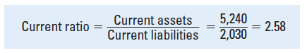
- Firm’s ability to meet short-term obligations.
- Current ratio compares current assets to current liabilities (higher the better)
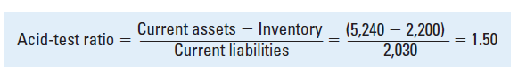
- Acid-test (or quick) ratio measures ability of a firm to meet its debt payments on short notice. (higher the better)

ACTIVITY RATIOS
- Measure how effectively management uses the firm’s resources
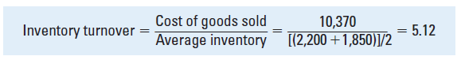
- Inventory turnover ratio indicates number of times merchandise moves through a business.

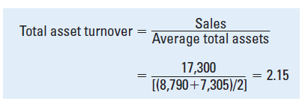
- Total asset turnover ratio indicates how much in sales each dollar invested in assets generates. Higher means efficiency.

PROFITABILITY RATIOS
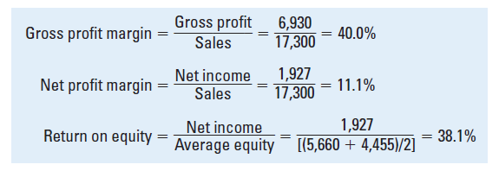
- Measure organization’s overall financial performance by evaluating its ability to generate revenues in excess of operating costs and other expenses

LEVERAGE RATIOS
- Measure how much a firm relies on debt financing
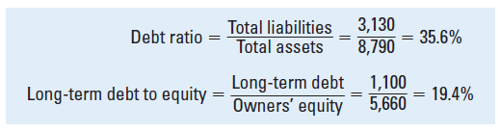
Total labilities to total assets ratio (debt ratio) greater than 50% indicates that a firm is relying more on borrow money rather than owner’s equity; problems may arise in meeting future interest payments and repaying outstanding loans.

Budgeting
- Budget: Organization’s plans for how it will raise and spend money during a specific period of time.
- Shows firm’s expected sales revenues, operating expenses, cash receipts and cash expenses.
- Financial blueprint that serves as a financial plan.
- Cash budget tracks cash inflows and outflows.
- Overall master budget is composed of many individual budgets for different units (production, advertising, sales, etc.)

International Accounting
- Accounting procedures and practices must be adapted to accommodate an international business environment
- Exchange rates are value of one country’s currency in terms of the currencies of other countries.
- Consolidated financial statements must reflect gains and losses due to exchange rates
- Can have a significant impact on financial statement

