Bones of the Head, Trunk, and Pelvis

Skull
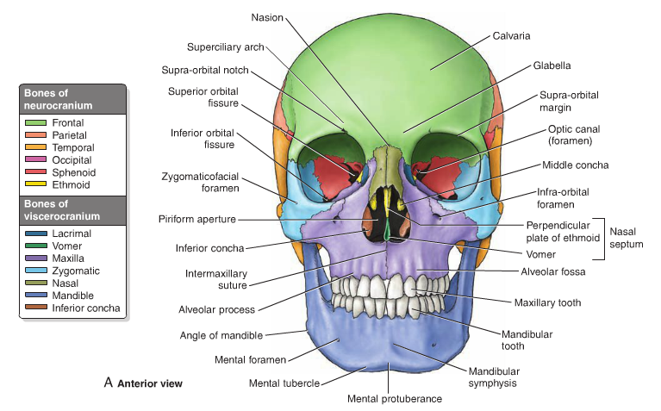
A Series of bones form the skull`s two parts
- Neurocranium - Formed by 8 bones
  - Frontal bone
  - Paired parietal bone
  - Paired temporal bone
  - Occipital bone
  - Sphenoid bone
  - Ethmoid bone
- Facial Skeleton - Formed by 14 irregular bones
  - Lacrimal bone (2)
  - Nasal bone (2)
  - Maxillae (2)
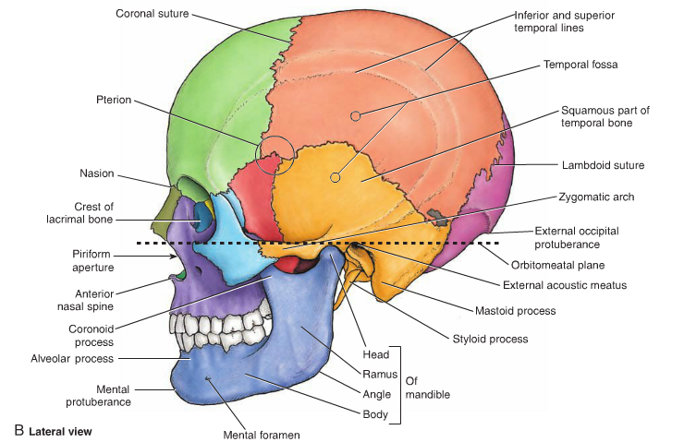
  - Zygomatic bone (2)
  - Palatine bones (2)
  - Inferior nasal conchae (2)
  - Mandible (1)
  - Vomer (1)

Main Features of the Skull
Anterior View of the Skull
- Frontal bone
- Zygomatic bone
- Orbits
- Nasal region
- Maxillae
- Mandible
Lateral Aspect of the Skull
- Temporal fossa
- The opening of the external acoustic meatus
- Mastoid process and styloid process of the temporal bone

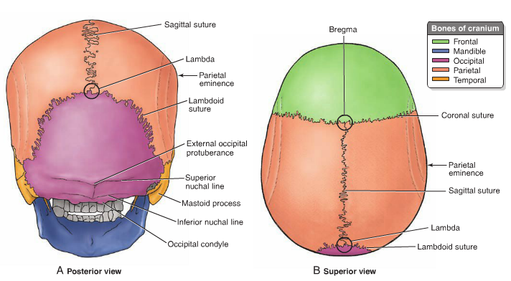
Posterior Aspect of the Skull
- External occipital protuberance

External Aspect of the Cranial Base
- Foramen magnum – brainstem passage
- Occipital condyles

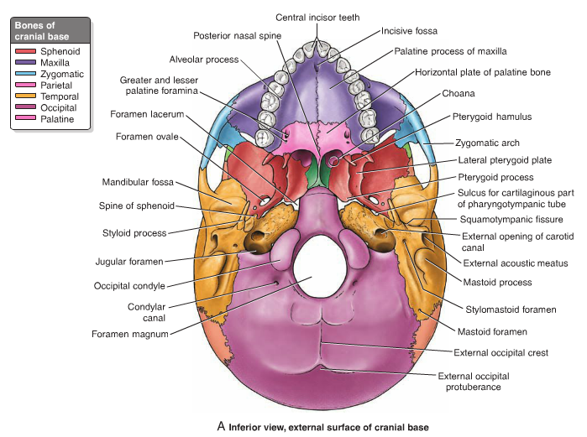

Vertebral Column
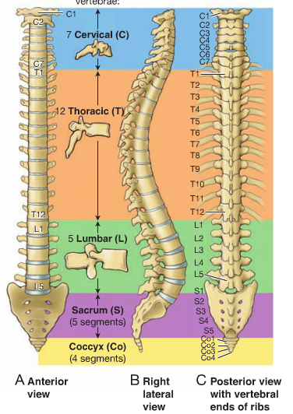
- Vertebral column extends from the skull to the apex of the coccyx
- Its function includes:
  - Forms the skeleton of the neck and back and is the man part of the axial skeleton
  - Protects the spinal cord
  - Supports the weight of the body
  - Provides a partly rigid and flexible axis for the body and a pivot for the head
  - Plays an important role in posture and locomotion
- Consists of 33 vertebrae
  - 7 in cervical region
  - 12 in thoracic region
  - 5 in lumbar region
  - 5 in sacral region
  - 4 in coccygeal region
- 24 vertebrae are moveable while 5 are fused to form the sacrum and 4 are fused together to form the coccyx
- Intervertebral disc
  - Approximately one-fourth of the spine
  - Separate and bind the vertebrae together
  - Cartilaginous

Curvatures of the Vertebral Column
- There are four curvatures
  - Cervical
  - Thoracic
  - Lumbar
  - Sacral
- The curvatures provide flexible support for the body

Abnormal Curvatures of the Vertebral Column
- Kyphosis - abnormal increase in the thoracic cavity
- Lordosis – an anterior rotation of the pelvis and can cause low back pain
- Scoliosis – an abnormal lateral curvature that is accompanied by rotation of the vertebrae
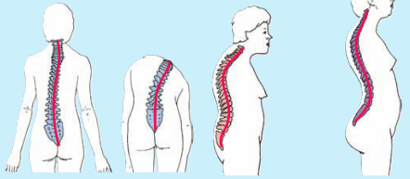

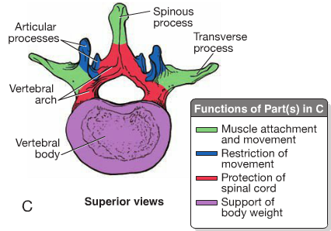
Structure and Function of Vertebrae
- A typical vertebra consist of
  - A vertebral Body
    - Gives strength to the vertebral column and supports body weight
  - A vertebral arch
    - Protects spinal cord
  - Seven Processes
    - A spinous process for muscle attachment and movement
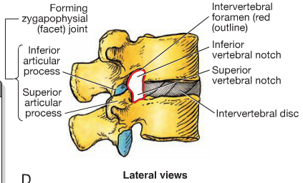
    - Two transverse processes for muscle attachment and movement
    - Four articular processes, two superior and two inferior, for restriction of movement in certain direction
  - Vertebral foramen is formed by the vertebral arch and the posterior surface of the vertebral body. The succession of vertebral foramen in the articulated column forms the vertebral canal
  - The superior and inferior vertebral notches of adjacent vertebrae contribute to the formation of IV foramina, which give a passage to spinal nerve roots and accompanying vessels

Regional Characteristics of Vertebrae
Cervical Vertebrae

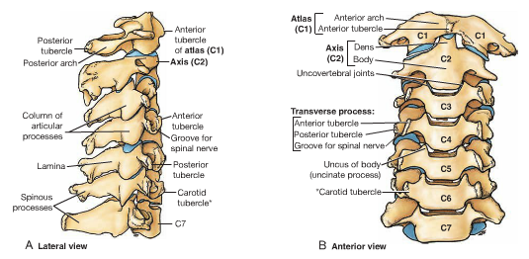
- Transverse foramen – for passing blood vessels and nerves (small or absent in C7)
- Body is small and wider
- Spinous process is short (C3-5) and bifid (C3-5).C7 has a long spinous process

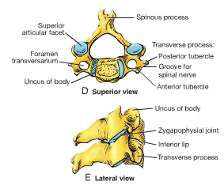
- Articular process
  - Superior facets: directed superoposteriorly
  - Inferior facets: directed inferoanteriorly
- C1 and C2 are atypical vertebrae
  - C1 – the atlas – has no spinous process or body, it consists of anterior and posterior arches. The superior articular surfaces of C1 receive the two occipital condyles at the sides of the foramen magnum
  - C2 – the axis – the strongest of the cervical vertebrae
    - Has two large, flat bearing surfaces, the superior articular facets, on which the atlas rotates
    - Has the blunt toothlike dens
  - Part of the body of C1 is transferred to the body of C2
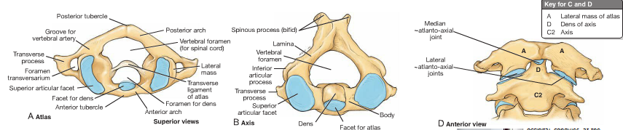
Thoracic Vertebrae
- Heart shaped body with costal facets for articulation with ribs(T1-10)
- The spinous processes are long and slopes posteroinferiorly
- Transverse processes are long, strong and extend posterolaterally
- Articular processes
  - Superior facets directed posteriorly and slightly laterally
  - Inferior facets directed anteriorly and slightly medially
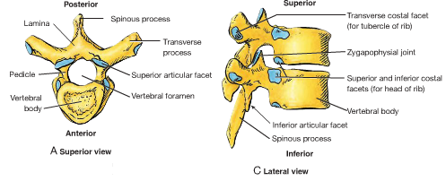

Lumbar Vertebrae
- Lumbar vertebrae are distinguished by their
  - Absence of costal facets
  - Massive kidney shaped bodies
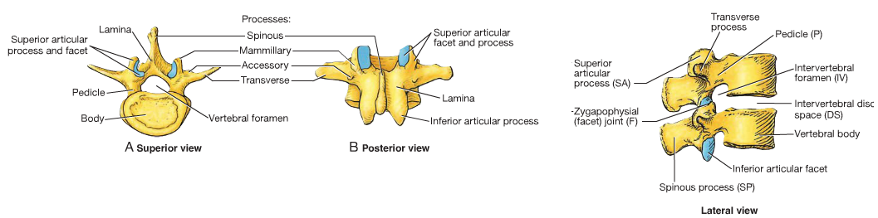
  - L5 is the largest of all movable vertebrae
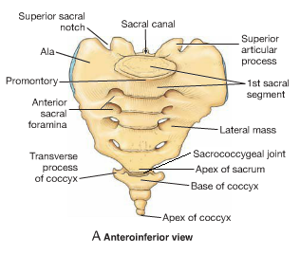
Sacrum
- Sacrum is usually composed of five fused sacral vertebrae in adults
- Forms the posterior part of the bony pelvic
- Articular facets for articulation with L5 and hip bones
Coccyx
- Coccyx is usually formed by four rudimentary vertebrae, but there may be one less or one more
- The first coccygeal vertebra may be separate
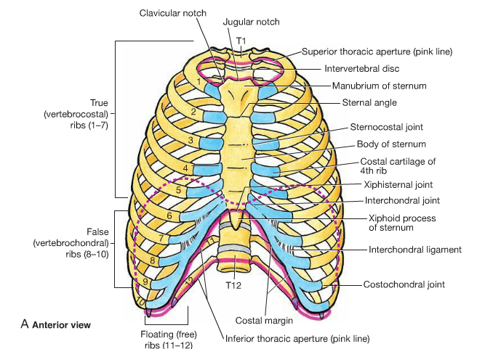
- The last three coccygeal vertebrae often fuse during middle life

Skeleton of Thoracic Wall

Thoracic Cage and Wall
- Thoracic Cage – formed by the 12 pairs of ribs, sternum, costal cartilages, and 12 thoracic vertebrae. Along with the skin and associated fascia and muscles, the thoracic cage forms the thoracic wall
- The role of the thoracic cage
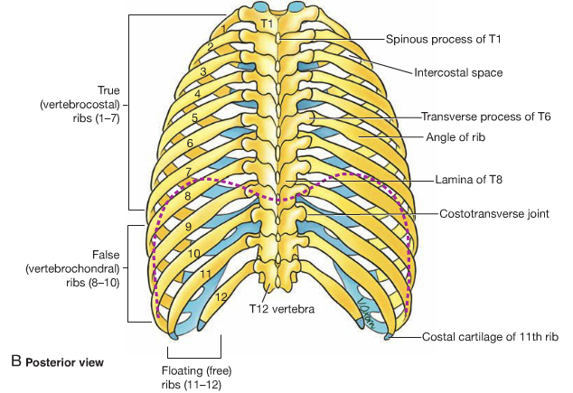
  - Lodges and protects the contents of the thoracic cavity
  - Provides attachments for muscles
  - Supports the pectoral girdle
- The thoracic wall provides mechanical function of breathing

Ribs
- Three types of ribs
  - True ribs (first 7 ribs) attach directly to the sternum through their own costal cartilages
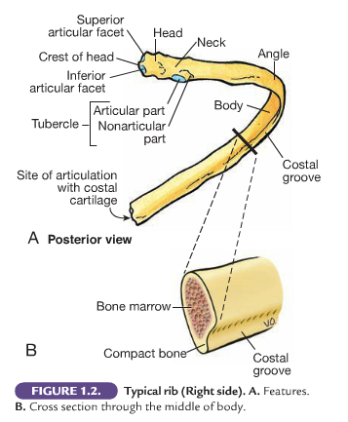
  - False ribs (8-10 ribs) their cartilages are joined to that of the rib immediately superior to them. Their connection with the sternum is indirect
  - Floating ribs (11 and 12) they do not connect with the sternum
- Typical ribs have
  - Head that has two facets for articulation with vertebrae
  - Neck
  - Tubercle that has one particular area for articulation with vertebra
  - Shaft

- Atypical Ribs
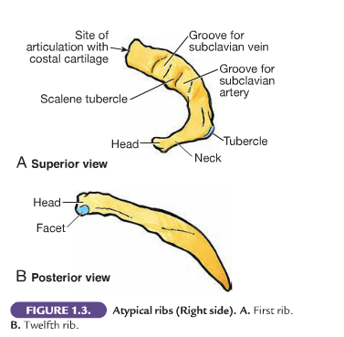
  - 1st – broad, short, sharply curved. Two grooves crossing its superior surface which are separated by the scalene tubercle
  - 2nd – thinner, less curved, longer than 1st. two facets to articulate with the body of T1 and T2
  - 10th-12th – only one facet on their head
  - 11th & 12th – no neck or tubercles

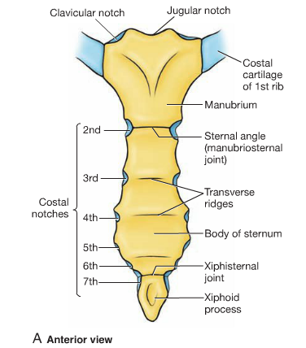
Sternum
- Consists of three parts, manubrium, body, and xiphoid process
- Lies at the level of the bodies of T3 and T10 vertebrae
- Articulates with clavicles and pairs of costal cartilages of 1-7 ribs
- The jugular notch, sternal angle, and xiphoid process are palpable and are the important landmarks

Bones of the Pelvis

Pelvic Skeleton
- In the mature adult the pelvic skeleton is formed by four bones
  - Hip bones, two large, irregular shaped bones, each of which develops from the fusion of three bones, ilium, ischium, and pubis
  - Sacrum – formed by the fusion of five originally separate sacral vertebrae
  - Coccyx – formed by the fusion of four coccygeal vertebrae
- In children, each hip bone consists of three separate bones, ilium, ischium, and pubs, which are united by cartilage at the acetabulum
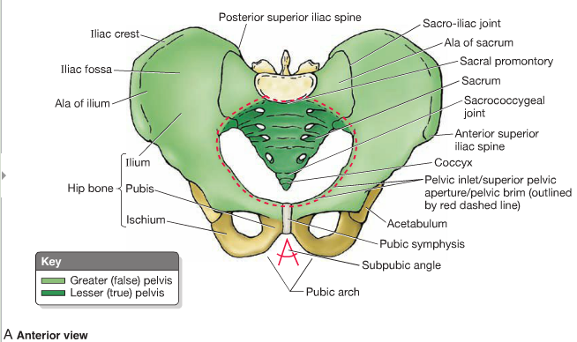

Hip Bone – Lateral Aspect
- The flattened, fan-shaped part of the bone
- In children, each hip bone consists of three separate bones, ilium, ischium, and pubis, which are united by cartilage at the acetabulum
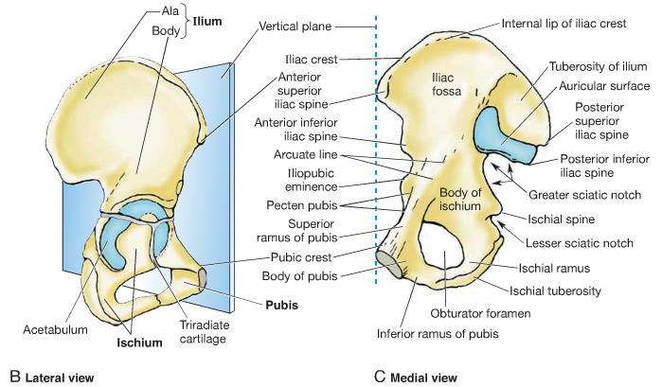
Ilium
- The flattened, fan-shaped part of the hip bone
- Important to know
  - Iliac Crest
  - Posterior superior iliac spine
  - Posterior inferior iliac spine
  - Anterior superior iliac spine
  - Anterior inferior iliac spine
  - Acetabular fossa
  - Iliac fossa
  - Articular surface (with the sacrum)
Ischium
- The ischium composes the posteroinferior part of the hip bone It has a body and ramus
- The body helps to form the acetabulum
- The ramus of the ischium helps to form the obtuator foramen
- Important to know
  - Ischial tuberosity

Pubis
- The pubis is an angulated bone and composes the anteromedial part of the hip bone
- The superior ramus of the pubis helps to form the acetabulum, and an inferior ramus helps to form the obturator foramen
- Medially, the symphyseal surface of the body of the pubis articulates with the corresponding surface of the body of the contralateral pubis by means of the pubic symphysis
Obturator Foramen & Acetabulum
- Obturator foramen is bounded by the pubis and ischium and their rami, which is a small passageway for the obturator nerve and vessels
- All three parts (ilium, ischium, pubis) of the hip bone join to form the acetabulum, which articulates with the head of the femur to form the hip joint

