CHAPTER 24 & 25
Options

HEDGING WITH OPTION CONTRACTS
An option contract is an agreement that gives the owner the right – but not the obligation – to buy or sell (depending on the option type) some asset at a specified price for a specified time.

Option Contract – An agreement that gives the owner the right, not the obligation, to buy or sell a specific asset at a specific price for a set period of time.

OPTION TERMINOLOGY
Options come in 2 flavors: puts & calls.

The owner of a call option has the right, but not the obligation, to buy an underlying asset at a fixed price called the strike price or exercise price for a specified time.

The owner of a put option has the right, but not the obligation, to sell an underlying asset at a fixed price for a specified time.

Call Option – An option that gives the owner the right, but not the obligation, to buy an asset.

Put Option – An option that gives the owner the right, but not the obligation, to sell an asset.

The act of buying or selling the underlying asset using the option contract is called exercising the option. Some options (American options) can be exercised anytime up to and including the expiration date (the last day); other options (European options) can only be exercised on the expiration date. Most options are American.

Because the buyer of a call option has the right to buy the underlying asset at the strike price, the seller of a call option is obligated to deliver the asset and accept the strike price if the option is exercised.

The buyer of the put option has the right to sell the underlying asset and receive the strike price. In this case, the seller of the put option has to accept the asset and pay the strike price.

OPTIONS VS FORWARDS
There are 2 key differences between an option contract and a forward contract.

- With a forward contract, both parties are obligated to transact; one party delivers the asset and the other party pays for it. With an option, the transaction occurs only if the owner of the option chooses to exercise it.

- No money changes hands when a forward contract is created; the buyer of an option contract gains a valuable right and must pay the seller for that right. The price of the option is frequently called the option premium.

OPTION PAYOFF PROFILES
The figure below shows the general payoff profile for a call option from the OWNER’S viewpoint.

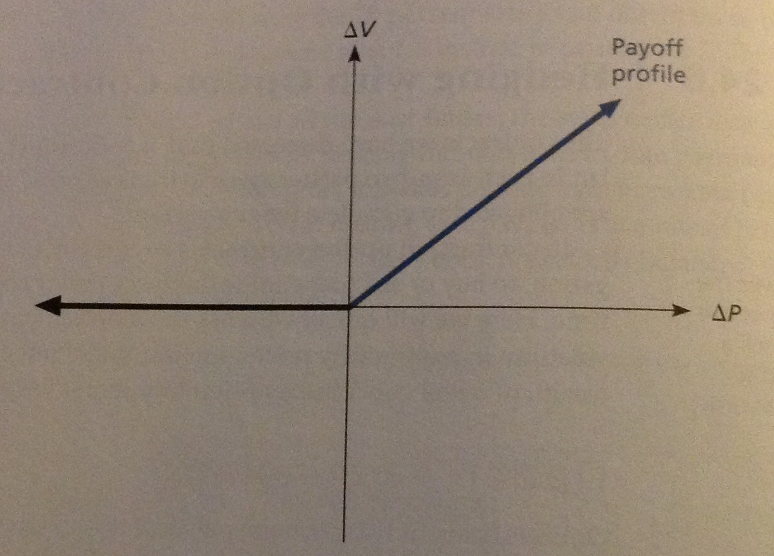

The horizontal axis shows the difference between the asset’s value and the strike price of the option.

As shown, if the price of the underlying asset rises above the strike price, then the owner of the option will exercise then option and enjoy a profit. If the value of the asset falls below the strike price, the owner of the option won’t exercise it.

Notice that this payoff profile doesn’t consider the premium that the buyer paid for the option.

The payoff profile that results from buying a called is repeated in Part A of the following figure. Part B shows the payoff profile on a call option from the seller’s side. A call option is a zero-sum game, so the seller’s payoff profile is exactly the opposite of the buyer’s.

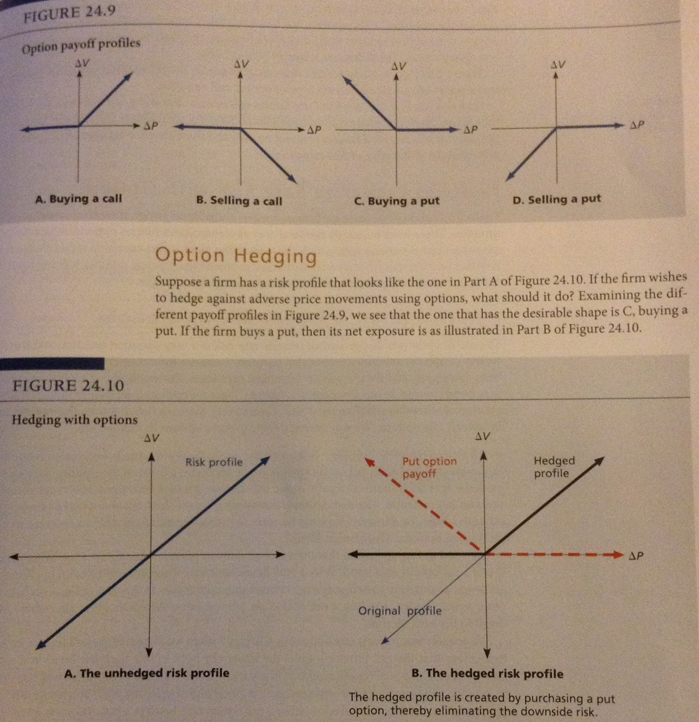

Part C of the figure shows the payoff profile for the buyer of a put option. In this case, if the asset’s value falls below the strike price, then the buyer profits because the seller of the put must pay the strike price.

Part D shows that the seller of the put option loses out when the price falls below the strike price.

OPTION HEDGING
Let’s say a firm has a risk profile that looks like the one in Part A in the figure below. If the firm wishes to hedge against adverse price movements using options, what should it do?

Looking at the different payoff profiles in the figure with Parts A, B, C & D, we see that the one that has the desirable shape is C, buying a put.

If the firm buys a put, then its net exposure is as illustrated in Part B of the figure above.

By buying a put option, the firm has eliminated the downside risk – the risk of an unfavorable price movement. But the firm has retained the upside potential; the put options acts as a kind of insurance policy. This desirable insurance isn’t always free, the firm pays for it when it buys the put option.

OPTIONS

We looked briefly at options and their use in risk management, but there’s much more to them. Options are valuable, but actually putting a dollar value on them isn’t easy.

Option – A contract that gives the owner the right to buy or sell some asset at a fixed price on or before a given date.

The most familiar options are stock options – these are options to buy and sell shares of common stock. Almost all corporate securities have implicit or explicit option features and the use of these features is expanding with the growth of financial engineering.

So, understanding securities that involved option features requires a general knowledge of the factors that determine an option’s value.

OPTIONS: THE BASICS
An option is a contract that gives the owner the right to buy or sell some asset at a fixed price on or before a given date.

Ex.:
An option on a building might give the holder of the option the right to buy the building for $1 million anytime on or before the Saturday before the third Wednesday in January 2016.

Options are a unique financial contract because they give the buyer the right, but not the obligation to do something. The buyer only uses the option if it’s profitable to do so.

There’s a special vocabulary associated with options – here are some important definitions:

- Exercising the Option: The act of buying or selling the underlying asset via the option contract

- Striking Price or Exercise Price: The fixed price in the option contract at which the holder can buy or sell the underlying asset.

- Expiration Date: The last day on which an option can be exercised.

- American Options: An option that can be exercised at any time until its expiration date

- European Options: An option that can only be exercised on the expiration date.

PUTS & CALLS
As we saw earlier, options come in 2 basic types: Puts & Calls.

A call option is more common; it gives the owner the right to buy an asset at a fixed price during a particular time period. It basically gives you the right to “call in” an asset.

An investor who sells a call option receives money up front and has the obligation to sell the asset at the exercise price if the option holder wants it.

A put option is the opposite of a call option – instead of the option to buy; it gives the holder the right to sell that asset for a fixed exercise price. If you buy a put option, you can force the seller to buy the asset from you for a fixed price and thereby “put it to him”.

An investor who sells a put option receives cash up front and is then obligated to buy the asset at the exercise price if the option holder demands it.

The asset involved in an option could be anything – the most common bought and sold are stock options; options to buy and sell shares of stock.

Many of the general principles we see with stock options apply to options involving any assets, not just shares of stock.

STOCK OPTION QUOTATIONS
In the 70s and 80s, trading options grew tremendously due to the increased volatility in financial markets. Exchange trading in options started in 1973 on the Chicago Board Options Exchange (CBOE) and is still the largest organized options market.

Option trading started in Canada in 1975 on the Montreal Exchange. Options are still traded on the Montreal Exchange and are cleared through the Canadian Derivatives Clearing Corp (CDCC). The CDCC stands between option buyers and option sellers, called writers.

Put and call options involving stock in well-known corporations are traded daily and almost all such options are American.

To start, we look at a Montreal Exchange option quotation for a CDCC option:

BNS – Bank of Nova Scotia (Call Option):
Last Price: 53.110
Month/Strike | Bid Price | Ask Price | Last Price | Impl. Vol. | Vol.
+12 JL 50.000 | 3.100 | 3.200 | 3.100 | 18.27 | 35
+13 JA 42.000 | 11.150 | 11.350 | 11.000 | 31.70 | 10

The first thing listed in the company identifier – BNS – this tells us these options involve the right to buy or sell shares of stock in Bank of Nova Scotia.

After the company identifier is the closing price of the stock – as of the close of business in Montreal, BNS was selling for $53.11 per share.
Inside the table are the expiration date and strike price for the first call option.

12 JL = The option expires in July 2012
All CDCC options expire after the close of trading on the 3rd Friday of the expiration month.

The first Bank of Nova Scotia option listed here has an exercise price of $50; the 2nd one has an exercise price of $42

The 1st option would be described as the “BNS $50 call” – the asking price for this option is $3.20 – so if you pay $3.20 you have the right between now and the 3rd Friday in July to buy one share of the BNS for $50.

Trading actually occurs in round lots (multiples of 100 shares), so one option contract costs $3.20 * 100 = $320

As another example, look at the options quote for Aurizon Mines Ltd:

ARZ – Aurizon Mines Ltd
Last updated: June 22, 2012
Last Price: 4.680
Month/Strike | Bid Price | Ask Price | Last Price | Impl. Vol. | Vol.
+12 JL 2.500 | 2.170 | 2.210 | 2.230 | 110.90 | 0
+12 JL 3.000 | 1.670 | 1.720 | 1.730 | 88.59 | 0
+12 JL 4.000 | 0.710 | 0.780 | 0.790 | 58.75 | 0
+12 JL 5.000 | 0.120 | 0.180 | 0.190 | 52.50 | 0
+12 JL 6.000 | 0.010 | 0.050 | 0.060 | 62.06 | 0
+12 JL 7.000 | 0.000 | 0.070 | 0.080 | N/A | 0
+12 JL 8.000 | 0.000 | 0.070 | 0.080 | N/A | 0
+12 AU 3.000 | 1.690 | 1.740 | 1.750 | 74.95 | 0
+12 AU 4.000 | 0.810 | 0.870 | 0.870 | 60.61 | 0
+12 AU 5.000 | 0.280 | 0.310 | 0.320 | 57.53 | 0
+12 AU 6.000 | 0.060 | 0.110 | 0.130 | 58.13 | 0
+12 AU 7.000 | 0.010 | 0.090 | 0.110 | 70.26 | 0

Suppose you wanted to buy 100 shares of Aurizon Mines Ltd for $5 any time between now and the 3rd Friday in August 2012. What should you order and much will it cost you?

Since you want the right to buy the stock for $5, you need to buy a call option with a $5 exercise price. Place an order for one ARZ 2012 August $5 call. Since the August $5 call is quoted at $0.31 asking price, you have to pay $0.31 per share or $31 in all (plus commissions).

OPTION PAYOFFS
Suppose you were to buy 50 BNS 2012 July $52 call contracts. The option is quoted at a $1.28 asking price so the contracts cost $128 each. You’d spend a total of 50 * 128$ = $6,400.

You wait a while until the expiration date rolls around – now what? You have the right to buy Bank of Nova Scotia stock for $52 per share. If BNS is selling for less than $52 a share, this option isn’t worth anything and you throw it away. In this case, we say the option has finished “out of the money” since the exercise price exceeds the stock price.

Suppose the BNS stock rises to $59 per share. Since you have the right to buy BNS at $52, you make a profit of $7 on each share on exercise. Each contract involves 100 shares, so you make $7 per share * 100 shares per contract = $700 per contract.

Finally, you own 50 contracts, so the value of your options is $35,000.
You invested $6,400 and your net profit if $28,600

Ending Stock Price | Option Value (50 Contracts) | Net Profit (Loss) | Stock Value (121 shares) | Net Profit (Loss)
$45 | $ --- | $(6,400) | $5,445 | $(955)
$50 | $ --- | $(6,400) | $6,050 | $(350)
$55 | $15,000 | $8,600 | $6,655 | $255
$60 | $40,000 | $33,600 | $7,260 | $860
$65 | $65,000 | $58,600 | $7,865 | $1,465
$70 | $90,000 | $83,600 | $8,470 | $2,070

As our example shows, the gains and losses from buying call options can be large.

Suppose you had simply purchased the stock with $6,400 at $53.11 each instead of buying call options. You’d now have about $6,400/53.11 = 120.50 shares (approximately 121 shares). We can now compare what you have when the options expire for different stock prices.

The option position magnifies the gains and losses on the stock by a substantial amount because the payoff on your 50 option contracts is based on 50 * 100 = 5000 shares of stock instead of just 121.

In the example, with the option, if our stock price changes by only a small amount, you lose all $6400. With the stock, you still have about what you started with.

Also, notice that the option can never be worth less than zero because can always just throw it away – so you can never lose more than your original investment ($6400 in our example).

Stock options are a zero-sum game – whatever the buyer of a stock option makes, the seller loses, and vice versa. You’d receive $6400 upfront and you’d be obligated to sell the stock for $52 if the buyer of the option wanted to exercise it.

In this situation, if the stock price ends up at or less than $52, you’d be $6400 ahead. If the stock price ends up more than $52, you have to sell something for less than it’s worth, so you’d lose the difference.

Ex.:
If the stock price were $61, you’d have to sell 50 * 100 = 5000 shares at $52 per share, so you’d be out $61 – 52 = $9 per share, or $45,000.

Because you received $6400 up front, your net loss is $38,600. Other possibilities are summarized below:

Ending Stock Price | Net Profit to Option Seller
$45 | $6,400
$50 | $6,400
$55 | $(8,600)
$60 | $(33,600)
$65 | $(58,600)
$70 | $(83,600)

Notice that the net profits to the option buyer (just calculated) are the opposites of these amounts.

PUT PAYOFFS
If you buy 10 Aurizon 2012 October $5 put contracts, how much does this cost (ignoring commissions)? Just before the option expires, Aurizon is selling for #3 per year. Is this good news or bad news? What’s your net profit?

The option is quoted at 0.79, so one contract costs 100 * 0.79 = $79
Your 10 contracts total $790
You now have the right to sell 1000 shares (10 * 100) of Aurizon for $5 [er share – this is most definitely good news.
You can buy 1000 shares at $3 and sell them for $5.
Your puts are therefore worth $2 * 1000 = $2000.
Since you paid $790, your net profit is $2000 - $790 = $1,210

LONG-TERM OPTIONS
Our listings also show listings for Long-Term Options – in the US, this is referred to as Long-Term Equity Anticipation Securities (LEAPS). These are long-term calls and puts that expire in January for terms of at least one year up to 2 2/3 years.

For example, the chart lists call long-term options for Bank of Nova Scotia expiring in January 2013 and 2013 = about 6 months and 1 ½ years respectively from the time of the price quotes.

FUNDAMENTALS OF OPTION VALUATION

Now that we’ve looked at the basics of puts and calls, we can discuss what determines their values. We focus on call options but the same type of analysis can be applied to put options.

VALUE OF A CALL OPTION AT EXPIRATION
We’ve already described payoffs from call options for different stock prices. To continue this, the following notation is useful:

$$S_{1}=Stock price at expiration \left(in one period\right)$$
$$S_{0}=Stock price today$$
$$C_{1}=Value of the call option on the expiration date \left(in one period\right)$$
$$C_{0}=Value of the call option today$$
$$E=Exercise price on the option$$

From the previous discussion, remember that if the stock price ($S_{1})$ isn’t more than the exercise price (E) on the expiration date, the call option ($C_{1})$ is worth ZERO, in other words:

$$C_{1}=0 if S_{1}≤E$$

Or, equivalently:

$$C_{1}=0 if \left(S_{1}-E\right)≤0$$

This is the case where the option is out of the money when it expires.

If the option finishes in the money, $S_{1}>E$, the value of the option at expiration is equal to the difference:

$$C_{1}=S_{1}-E if S_{1}>E$$

Or, equivalently:

$$C_{1}=S_{1}-E if \left(S_{1}-E\right)>0$$

Ex:
Suppose we have a call option with an exercise price of $10. The option is about to expire. If the stock is selling for $8, we have the right to pay $10 for something worth only $8.

Our option is thus worth exactly ZERO because the stock price is less than the exercise price on the option ($S_{1}≤E)$

