CHAPTER 14
Cost of Capital

You’re the president of a large company – the first decision you face is whether or not to go ahead with a plan to renovate the company’s warehouse distribution system.
This plan will cost the company $50 million and it’s expected to save $12 million per year after taxes over the next 6 years.

This is a capital budgeting problem – to address it, you’d determine the relevant cash flows, discount them and if the NPV is positive, you’d take on the project. What should you use as the discount rate?

From risk & return, you know the correct discount rate depends on the riskiness of the warehouse distribution system. The new project would only have a positive NPV is its returns exceed what the financial market offers of investments of similar risk – this is called minimum required return the cost of capital associated with the project.

So, as president, you have to look at the returns that investors expect to earn on the securities represented in the pool of funds that would finance the project. Then you’d use this information to come to an estimate of the project’s cost of capital.

We have to examine different concepts – the most important being the weighted average cost of capital (WACC) – this is the cost of capital for the firm as a whole and it can be interpreted as the required return on the overall firm.

In looking at WACC, we know that a firm can raise capital in many differ ways and that these different forms of raising capital can have different costs associated with them.

Taxes are also an important consideration in determining the required return on an investment – we always want to value the after-tax cash flows from projects.

THE COST OF CAPITAL: PRELIMINARIES

We looked at the SML line and how it related expected returns on securities and their systematic risk. We also concentrated on how the risky returns from buying securities looked from an investor’s/shareholder’s viewpoint – this helped us understand more about the alternatives available to an investor in the capital markets.

Now we look closer at the other side of the problem – how these returns and securities look from the companies viewpoint.

- The return that an investor in a security receives is the cost of that security to the company that issued it

REQUIRED RETURN VS COST OF CAPITAL
When we say the required return on an investment is 10%, we mean that the investment has a positive NPV only if its returns exceed 10%.

Another way to interpret the required return is to see that the firm has to earn 10% on the investment just to compensate their investors for using the capital that was needed to finance the project this is why we can also say that 10% is the cost of capital associated with the investment.

Ex.:
We’re evaluating a risk-free project. To determine the required rate, we have to look at the capital markets and observe the current rate offered by risk-free investments; we use this rate to discount the project’s cash flows.

So, the cost of capital for a risk-free investment is the risk-free rate.

If the project were risky, assuming all other information is unchanged; the required return will be higher. In other words:

The cost of capital for a risky project is greater than the risk-free rate and the appropriate discount rate would exceed the risk-free rate.

So these terms are used interchangeably:

Required Return = Appropriate Discount Rate = Cost of Capital

The important concept is the cost of capital associated with an investment depends on the risk of that investment.

“the cost of capital depends primarily on the use of the funds, not the source. The use of the funds refers to risk associated with the investment”

The cost of capital does not depend primarily on how & where the capital is raised.

FINANCIAL POLICY & COST OF CAPITAL
We know that a company’s capital structure – their choice of a mix of debt & equity – is a managerial variable. We now assume that a firm has a fixed debt/equity ratio that they maintain and this D/E ratio reflects the firm’s target capital structure.

We know that a firm’s overall cost of capital reflects the required return on the firm’s assets as a whole. A firm’s cost of capital reflects both its cost of debt capital and its cost of equity capital.

THE COST OF EQUITY

The most difficult question on the subject of cost of capital is what’s the firm’s overall cost of equity?

Cost of Equity – The return that equity investors require on their investment in the firm

This isn’t easy to answer because there’s no way of directly observing the return that the firm’s equity investors require on their investment – instead, we have to estimate it. There are 2 ways to determine the cost of equity:

- The dividend growth model approach
- The security market line (SML) approach

THE DIVIDEND GROWTH MODEL APPROACH
The dividend growth model is the easiest way to estimate the cost of equity. Remember that under the assumption that the firm’s dividend will grow at a constant rate, g, the price per share of the stock, $P_{O}$, can be written as:

Price Per Share of Stock

$$P_{0}=\frac{\left[D_{0}*\left(1+g\right)\right]}{\left[R_{E}-g\right]}=\frac{D_{1}}{\left[R_{E}-g\right]}$$

$D_{0}$= The dividend just paid
$D_{1}$= Next period’s projected dividend
$R_{E}$= The required return on the stock; E stands for equity

We can arrange this to solve to for $R_{E}$ as follows:

$$R_{E}=\frac{D_{1}}{P_{0}}+g$$

Since $R_{E}$ is the return that the shareholders require on the stock, it can be interpreted as the firm’s cost of equity capital.

IMPLEMENTING THE APPROACH – To estimate $R_{E}$ using the dividend growth model approach, we need 3 pieces of information:
- $P_{0}$
- $D_{0}$
- g

For a publicly traded, dividend-paying company, the first 2 ($P_{O} \&{ D}_{O})$ can be observed directly so they’re easily obtainable.

The third part, the expected growth rate in dividends, has to be estimated.

Ex.:
Provincial Power Company paid a dividend of $4 per share last year.
The stock currently sells for $60/share
You estimate the dividend will grow steadily at 6% per year into the indefinite future.
What’s the cost of equity capital for Provincial Power?

Using the dividend growth model, the expected dividend for the coming year, $D_{1}$ is:

$$D_{1}=D_{0}*\left(1+g\right)$$
=
$4 * (1.06)
=
$4.24

Given this, the cost of equity, $R_{E}$, is:

$$R_{E}=\frac{D_{1}}{P_{0}}+g$$
=
$$\frac{\$4.24}{\$60}+0.06$$
=
$13.07%

So the cost of equity is this 13.07%

ESTIMATING g – To use the dividend growth model, we have to come up with an estimate for g, the growth rate. There are 2 ways of doing this:

- Use historical growth rate
- Use analysts’ forecasts of future growth rates

Analysts’ forecasts are available from research departments of investment dealers. Different sources have different estimate, so one way might be to obtain multiple estimates and average them.

We can also look at dividends from previous years – let’s say five years – and calculate the compound growth rate.

Ex.:
We observe the following for the James Bay Company:

Year | Dividend
2008 | $1.10
2009 | $1.20
2010 | $1.35
2011 | $1.40
2012 | $1.55

The compound growth rate, g, is the rate at which $1.10 grew to $1.55 during 4 periods of growth.

$$\$1.10{\left(1+g\right)}^{4}=\$1.55$$
=
$${\left(1+g\right)}^{4}=\frac{\$1.55}{\$1.10}=1.4090$$
=
$$1+g={\left(1.4090\right)}^{0.25}=1.0895$$
=
$$g=0.0895=8.95\%$$

If historical growth has been volatile, the compound growth rate would be sensitive to our choice of beginning and ending years. In this case, it’s better to calculate the year-to-year growth rates and average them:

Year | Dividend | Dollar Change | Percentage Change
2008 | $1.10 | -- | --
2009 | $1.20 | $0.10 | 9.09%
2010 | $1.35 | $0.15 | 12.50%
2011 | $1.40 | $0.05 | 3.70%
2012 | $1.55 | $0.15 | 10.71%

We calculated the change in dividend in a dollar amount and by percentage. As an example, in 2009 the dividend rose from $1.10 to $1.20 which is an increase of $0.10 – this represents a $0.10/$1.10 = 9.09% increase

If we average the 4 growth rates, the result is (9.09 + 12.50 + 3.70 + 10.71)/4 = 9%, so we could use this as an estimate for the expected growth rate, g.

AN ALTERNATIVE APPROACH – Another way to find g starts with earnings retention. Consider a company whose earnings next year are expected to be the same as this year unless a net investment is made.

The net investment will be positive only is some earnings aren’t paid out as dividend – if the earnings are retained.

This leads to the following equation:
Earnings Next Year
=
[Earnings This Year] + [Retained Earnings This Year] * [Return on Retained Earnings]

This increase in earnings is a function of both the retained earnings and the return on retained earnings. So, we divide both sides of the equation by earnings this year yielding:

$$\frac{\left[Earnings Next Year\right]}{\left[Earnings This Year\right]}$$
=
$$\frac{\left[Earnings This Year\right]}{\left[Earnings This Year\right]}+\frac{\left[Retained Earnings This Year\right]}{\left[Earnings This Year\right]}*Return on Retained Earnings$$

The left side of the equation is just 1 + the growth rate in earnings, which we can write as [1 + g]. The ratio of retained earnings to earnings is called the retention ratio, which we can write as:

$$1+g=1+Retention Ratio*Return on Retained Earnings$$
Retention Ratio – Retained earnings divided by net income

$$\frac{\left[Retained Earnings\right]}{\left[Net Income\right]}$$

It’s not easy for a financial analyst to determine the expected return on currently retained earnings because details of forthcoming projects aren’t generally public information. But it’s usually assumed that project chosen in the current year have the same risk and therefore the same anticipated return as projects in other years.

Here, we can estimate the anticipated return on current retained earnings by historical return on equity (ROE). ROE is just the return on the firm’s entire equity, which is the return on the accumulation of all the firm’s past projects.

Return on Equity (ROE) – Net income after interest and taxes divided by average common shareholders’ equity

$$\frac{\left[Net Income after Taxes \& Interest\right]}{\left[Average Common Shareholders^{'}Equity\right]}$$

So now we have a way to estimate growth:

g = Retention Ratio * ROE

ADVANTAGES & DISADVANTAGES OF THIS APPROACH – Whichever way that we estimate g, the main advantage of the dividend growth model approach is that it’s simple. But there are problems & disadvantages with it.

- The dividend growth model is applicable to companies that pay dividends. For companies that don’t pay dividends, we can use the mode and estimate g from growth in earnings – this is the same as assuming that one day dividends will be paid.

The underlying assumption is that the dividend grows at a constant rate – but will this never be exactly the case. Generally, the model is really only applicable to cases where reasonably steady growth is likely.

- Another problem is that estimated cost of equity is very sensitive to the estimated growth rate. If g increases by just 1%, the estimated cost of equity will increase by a full percent. Since $D_{1}$ would probably be revised upwards as well, the increase would actually be somewhat larger than that.

- The approach doesn’t explicitly consider risk. There’s no direct adjustment for the riskiness of the investment.

For example, there’s no allowance for the degree of uncertainty surrounding the estimated growth rate in dividends. As a result, it’s hard to say whether or not the estimated return is proportionate to the level of risk.

THE SML APPROACH
Our main conclusion about the SML was that the required or expected return on a risky investment depends on 3 things:

- The risk-free rate, $R_{f}$
- The market risk premium, $E\left(R_{M}\right)-R_{f}$
- The systematic risk of the asset relative to average, called its beta coefficient, β

Using the SML, the expected return on the company’s equity, $E\left(R_{E}\right)$, can be written as:

$$E\left(R_{E}\right)=R_{f}+β_{E}*\left[E\left(R_{M}\right)-R_{f}\right]$$

$β_{E}$ is the estimate beta for the equity - for the SML approach to be consistent with the dividend growth model, we drop the expectation sign, E, and write the required return from the SML, $R_{E}$, as:

Required Return from the SML

$$R_{E}=R_{f}+β_{E}*\left[R_{M}-R_{f}\right]$$

IMPLEMENTING THE APPRAOCH – To use the SML approach, we need:
- A risk-free rate, $R_{f}$
- An estimate of the market risk premium, $R_{M}-R_{f}$
- An estimate of the relevant beta, β

We saw that one estimate of the market risk premium (based on large Canadian common stocks) is around 4.30%.

To reflect the long-term horizon over which we’ll apply the cost of equity, we measure the risk-free rate as the yield on 30-year Canadian bonds around 5%. Beta coefficients for publicly traded companies are widely available and we’ve already looked at how to calculate betas from historical returns.

We saw before that Investors Group has an estimated beta of 0.76; we could therefore estimate their cost of equity as:

$$R_{CU}=R_{f}+β*\left[R_{M}-R_{f}\right]$$
=
5.0% + 0.76 * (4.30%)
=
8.27%

So, using the SML approach, Investors Group’s cost of equity is about 8.27%

ADVANTAGES & DISADVANTAGES OF THE APPROACH – The SML approach has 2 primary advantages:

- It explicitly adjusts for risk
- It’s applicable to companies other than those with steady dividend growth

So it can be useful in a wider variety of circumstances. But there are drawbacks as well.

The SML approach requires that 2 things be estimated: the market risk premium and the beta coefficient. If our estimates are poor, the resulting cost of equity is inaccurate.

As an example, our estimate of the market risk premium, 4.30%, is based on about 50 years of returns on a particular portfolio of stocks. Using different time periods or different stocks could result in very different estimates.

Like with the dividend growth model, we basically rely on the past to predict the future when using the SML approach. Economic conditions can change quickly, so the past might not always be a good guide for the future.

The SML approach is considered to be the “best practice” and is most widely used.

The dividend valuation model can be used to check how reasonable our SML result is.

THE COST OF EQUITY IN RATE HEARINGS
Let’s say that Provincial Power has just applied for increases in the rates charged to some customers. One test that regulators apply is called the “fair rate of return” rule.

This means that they determine the fair rate of return on capital for the company and allow an increase in rates only if the company can show that revenues are insufficient to achieve this fair rate.

Ex.:
Suppose a company has capital in the form of equity of $100 and net income of $8 providing a return of 8%. If the fair rate of return were 9%, the company would be allowed a rate increase sufficient to generate one extra dollar of net income.

Regulatory authorities determine the fair rate of return after hearing presentation by the company and consumer groups. Consultants engaged by the company argue for a higher fair rate and consultants engaged by consumer groups argue for a lower fair rate.

Because the fair rate depends on market conditions, consultants use the dividend growth approach and the SML approach, along with other techniques.

If Provincial Power has presented regulators with cost equity of 11% and you’re a consultant for a consumer group, what flaws would you look for?

If you think cost equity is too high, you should challenge the assumed growth rate in dividends. Also, the market risk premium used in the SML may be too high.

Ex.: The Cost of Equity
Sun Life Financial is trading on the TSX at $22.34. They had a 120-month beta of 0.78, the market risk premium historically has been around 4.30% and our estimate of the risk-free rate in 2012 was 5.00%.

Sun Life’s last dividend was $1.44 and some analysts expect that the dividends grow at 8% indefinitely. What’s Sun Life’s cost of equity?

$$R_{i}=R_{f}+β_{E}*\left[R_{M}-R_{f}\right]$$
=
5.00% + 0.78 * 4.30%
=
8.35%

This suggests that 8.35% is Sun Life’s cost of equity. Next we use the dividend growth model as a check. The projected dividend is:

$$D_{0}*\left(1+g\right)=\$1.44*\left(1.08\right)=\$1.56$$

So the expected return using this approach is:

$$R_{i}=\frac{D_{1}}{P_{0}}+g$$
=
$$\frac{\$1.56}{\$22.34}+0.08$$
=
14.98%

Our 2 estimates differ significantly – so we’ll use the one we have more confidence in, the SML.

If the inputs are fairly reliable for the SML, it’s preferred over the growth model, which might not apply to all companies.

One main reason for the SML preference is that the SML considers risk (as measured by beta), while the growth model doesn’t.

Also, an 8% indefinite growth rate seems quite high, so the dividend growth model might be overestimating the cost of equity.

THE COSTS OF DEBT & PREFERRED STOCK

In addition to equity, firms use debt and preferred stock to finance their investments. Determining the costs of capital associated with these sources of financing is a lot easier than determining the cost of equity.

THE COST OF DEBT
The cost of debt is the return that the firm’s long-term creditors demand on new borrowing. We could determine the beta for the firm’s debt and then use the SML to estimate the required return on debt the same way we estimate the required return on equity – but this isn’t really necessary.

The Cost of Debt – The return that lenders require on the firm’s debt

Unlike a firm’s cost of equity, their cost of debt can usually be observed either directly or indirectly because the cost of debt is simply the interest rate the firm has to pay on new borrowing – we can observe interest rates in the financial market easily.

For example, if the firm already has bonds outstanding, then the yield to maturity on those bonds is the market-required rate on the firm’s debt.

So, there’s no need to actually estimate a beta for the debt since we can directly observe the rate we want to know.

BUT – be careful, the coupon rate on the firm’s outstanding debt is irrelevant here – all that tells us is what the firm’s cost of debt was back when the bonds were issued, not what the cost of debt is today. This is why we have to look at the yield on the debt in today’s marketplace.

We’ll use $R_{D}$ for the cost of debt

Ex.: The Cost of Debt
Encana Corporation has a bond outstanding with about 6 years to maturity (12 semi-annual coupons) and a coupon rate of 5.80%. The bond was currently selling for $112.22.

What’s Encana’s cost of debt?

To answer this, we need to solve the bond pricing formula for R, the yield to maturity:

$$\$112.22=\sum_{t=1}^{12}{\frac{\$2.9}{{\left(1+\frac{R}{2}\right)}^{t}}+\frac{100}{{\left(1+\frac{R}{2}\right)}^{12}}}$$

Using a financial calculator, we find that R is 3.52%. Encana’s cost of debt is thus 3.52%

THE COST OF PREFERRED STOCK
Preferred stock has a fixed dividend paid every period forever, so a share of preferred stock is essentially a perpetuity. The cost of preferred stock, $R_{P}$, is thus:

$$R_{P}=\frac{D}{P_{0}}$$

D = The fixed dividend
$P_{0}$= The current price per share of the preferred stock

Notice that the cost of preferred stock is simply equal to the dividend yield on the preferred stock.

Another way to do it as that preferred stock are rated pretty much the same way as bonds, so the cost of preferred stock can be estimated by observing the required returns on other, similarly rated share of preferred stock.

Ex.: Cost of Preferred Stock
On May 9th, 2012, Aimia Inc.’s preferred stock traded on the TSX with a dividend of $1.63 annually and a price of $26.00. What’s Aimia’s cost of preferred stock?

The cost of preferred stock is:

$$R_{P}=\frac{D}{P_{0}}=\frac{\$1.63}{\$26}=6.3\%$$

So Aimia’s cost of preferred stock is 6.3%

THE WEIGHTED AVERAGE COST OF CAPITAL

Now that we have the costs associated with the main sources of capital that the firm uses, we need to worry about the specific mix. We take this mix (the firm’s capital structure) as given for now.

One of the implications of using WACC for a project is that we’re assuming that money is raised in the optimal proportions.

For instance, if the optimal weight for debt is 25%, raising $100 million means that $25 million will come from new debt and $75 million from common and preferred shares.

In a practical sense, the firm wouldn’t raise these sums simultaneously by issuing both debt & equity. The firm might just use debt, or just equity – which, at that point, has the effect of upsetting the optimal debt ratio.

Issuing just one type of security and temporarily upsetting the optimal weights isn’t a problem as long as the subsequent issue takes the firm back to the optimal ratio.

The point is that the firm’s capital structure weights might fluctuate within some range in the short-term, but the target weights should always be used in computing the WACC.

Financial analysts usually focus on a firm’s total capitalization – the sum of their long-term debt and equity.

- This is particularly true in determining the cost of capital; short-term liabilities are usually ignored in the process. Short-term liabilities such as accounts payable rise automatically with sales increases and have already been incorporated into cash flow estimates – so we ignore them to avoid double counting.

Other current liabilities, like short-term bank borrowing, are excluded because they support seasonal needs and aren’t part of the permanent capital structure.
THE CAPITAL STUCTURE WEIGHTS
We use the symbol E (for equity) to stand for the market value of the firm’s equity. We calculate this as follows:

[Number of Outstanding Shares] * [Price Per Share]

We use the symbol $D_{m}$ (for debt) to stand for the market value of the firm’s debt. For long-term debt, we this as follows:

[Market Price of a Single Bond] * [Number of Bonds Outstanding]

For multiple bond issues, we repeat this calculation for each and then add the results.

If there’s debt that’s not publicly traded (because it was privately placed with a life insurance company, for example), we have to observe yields on similar, publicly traded debt and estimate the market value of the privately held debt using this yield as the discount rate.

We use the symbol V (for value) to stand for the combined market value of the debt and equity:
$$V=E+D_{m}$$

If we divide both sides by V, we can calculate the percentages of the total capital represented by the debt & equity:

100%
=
$$\frac{E}{V}+\frac{D_{m}}{V}$$

These percentages can be interpreted just like portfolio weights and they’re often called the capital structure weights.

Ex.:
If the total market value of a company’s stock was calculated as $200 million and the total market value of the company’s debt was calculated as $50 million, the combined value would be $250 million.

Of this total, E/V = $200/$250 = 80%, so 80% of the firm’s financing is equity and the remaining 20% is debt.
The correct way to proceed is to use the market values of the debt & equity. This is because market values measure management’s success in achieving its goal: maximizing shareholder wealth.

In certain circumstances, like a privately owned company, it might not be possible to get reliable estimates of these quantities. Even for publicly traded firms, market value weights may fluctuate significantly so that the weighted average cost of capital (WACC) is another number by the time a weekend is over.

Because practitioners encounter some of these problems in computing WACC using market value weights, book values are usually the better alternative when market values aren’t readily available.

TAXES & THE WEIGHTED AVERAGE COST OF CAPITAL
The preceding result that we got was the unadjusted WACC because we didn’t consider the taxes. We’re always concerned with after-tax cash flows.

If we’re determining the discount rate appropriate to those cash flows, the discount rate also needs to be expressed on an after-tax basis.

Remember Interest paid by a corporation is deductible for tax purposes.
Dividends to shareholders are not

This means that basically the government pays some of the interest provided the firm expects to have positive taxable income. So in determining an after-tax discount, we have to distinguish between the pre-tax and the after-tax cost of debt.

Ex.:
A firm borrows $1 million at 9% interest.
The corporate tax rate is 40%
What’s the after-tax interest rate on this loan?

The total interest bill would be $90,000 per year – this amount is tax deductible. So the $90,000 interest reduces our tax bill by 40% * $90,000 = $36,000

The after-tax interest bill is therefore $90,000 - $36,000 = $54,000

The after-tax interest rate is $54,000/$1 million = 5.4%

Generally, the after-tax interest rate is simply equal to the pre-tax rate multiplied by one minus the tax rate. For example, using the numbers above, we find that the after-tax interest rate is:
9% * (1 – 0.40) = 5.4%

We use the following symbols in our next equation:
$T_{C}$ = Corporate tax rate
$R_{D}*\left(1-T_{C}\right)$ = After-tax rate used in WACC calculation

So once we consider the effect of taxes, the WACC is:
After-Tax WACC

$$\left(\frac{E}{V}\right)*R_{E}+\left(\frac{P}{V}\right)*R_{P}+\left(\frac{D_{m}}{V}\right)*R_{D}*(1-T_{C})$$

So when we speak of the WACC from now on, this is the number we have in mind.

WACC interpretation – it’s:
- The overall return that the firm has to earn on its existing assets to maintain the value of its stock

- It’s also the required return on any investments by the firm that have essentially the same risks as existing operations – so, if we’re evaluating the cash flows from a proposed expansion of existing operations, this is the discount rate we’d use.

Ex.: Calculating the WACC
The BB Lean Company has 1.4 million share of stock outstanding.
The stock currently sells for $20 per share.
The firm’s debt is publicly traded and was recently quoted at 93% of face value.
It has a total face value of $5 million and it’s currently priced to yield 11%
The risk-free rate is 8% and the market risk premium is 3.4%
You’ve estimated that they have a beta of 0.74
If the corporate tax rate is 40%, what’s the WACC of Lean Co.?

We start be determining the cost of equity & the cost of debt.
From the SML, the cost of equity is 8% + 0.74 * 3.4% = 10.52%
The total value of the equity is 1.4 million * $20 = $28 million
The pre-tax cost of debt is the current yield to maturity on the outstanding debt, 11%.
The debt sells for 93% of its face value, so its current market value is 0.93 * $5 million = $4.635 million
The total market value of the equity and debt together is $28 + 4.65 = $32.65 million

From here, we can calculate the WACC easily.
The percentage of equity used to finance operations is $28/$32.65 = 85.76%
Because weights have to add up to 1, the percentage of debt is 1 – 0.8576 = 14.24%
So, the WACC is:
$$WACC=\left(\frac{E}{V}\right)*R_{E}+\left(\frac{D_{m}}{V}\right)*R_{D}*\left(1-T_{C}\right)$$
=
$$0.8576*10.52\%+0.1424*11\%*\left(1-0.40\right)$$
=
9.96%

BB Lean has an overall weighted average cost of capital of 9.96%

SOLVING WAREHOUSE PROBLEM & SIMILAR CAPITAL BUDGETING PROBLEMS

We can now solve the warehouse problem that we saw before - before rushing to discount the cash flows at the WACC to estimate NPV, we need to make sure we’re doing the right thing.

First we have to find an alternative in the financial markets that’s comparable to the warehouse renovation. To be comparable, an alternative must be of the same risk. Projects having the same risk are said to be in the same risk class.

The WACC for a firm reflects the risk & target capital structure of the firm’s existing assets as a whole – as a result, the firm’s WACC is the appropriate discount rate only if the proposed investment is a replica of the firm’s existing operating activities. So, we can only use the WACC to value the warehouse project if it’s in the same risk class as the firm.

Projects like the warehouse renovation that are intimately related to the firm’s existing operations are usually seen as being in the same risk class as the overall firm. We can now see what the President should do.

Suppose the firm has a target debt/equity ratio of 1/3 – in this case:

$$\frac{E}{V}=0.75$$
&
$$\frac{D_{m}}{V}=0.25$$

The cost of debt is 10% and the cost of equity is 20%. Assuming a 40% tax rate, the WACC is:

$WACC=\left(\frac{E}{V}\right)*R_{E}+\left(\frac{D_{m}}{V}\right)*\left(R_{D}*\left(1-T_{C}\right)\right)$ = 0.75 * 20% + 0.25 * 10% * (1 – 0.40) = 16.5%

Remember that the warehouse project had a cost of $50 million and expected after-tax cash flows (the cost savings) of $12 million per year for 6 years. The NPV is thus:

$$NPV=-\$50+\frac{\$12}{{\left(1+WACC\right)}^{1}}+…+\frac{\$12}{{\left(1+WACC\right)}^{6}}$$

Since the cash flows are in the form of an ordinary annuity, we can calculate this NPV using 16.5% (the WACC) as the discount rate as follows:

$$NPV=-\$50+\$12*\frac{\left[1-\left(\frac{1}{{\left(1+0.165\right)}^{6}}\right)\right]}{0.165}=-\$50+\$12*3.6365= -\$6.36$$

The project has a negative NPV using the firm’s WACC - this means the financial markets offer superior projects in the same risk class (namely, the firm itself). So the answer is clear: the project should be rejected.
Ex.: Using the WACC
A firm is considering a project that will result in initial cash savings of $5 million at the end of the first year and for an infinite period. These savings will grow at the rate of 5% per year.

The firm has a debt/equity ratio of 0.5, a cost of equity of 29.2% and a cost of debt of 10%.

The cost-saving proposal is closely related to the firm’s core business, so it’s viewed as having the same risks as the overall firm. Should the firm take on the project?

Assuming a 40% tax rate, the firm should take on this project if it costs less than $30.36 million.

To see this, first note that the PV is:
$$PV=\frac{\$5million}{\left[WACC-0.05\right]}$$

This is an example of a growing perpetuity. The WACC is:

$$WACC=\left(\frac{E}{V}\right)*R_{E}+\left(\frac{D_{m}}{V}\right)*R_{D}*\left(1-T_{C}\right)=\frac{2}{3}*29.2\%+\frac{1}{3}*10\%*\left(1-0.40\right)=21.47\%$$

The PV is thus:
$$PV=\$5\frac{million}{\left[0.2147-0.05\right]}=\$30.36 million$$

The NPV is positive only if the cost is less than $30.36 million.

SUMMARY OF CAPITAL COST CALCULATIONS
The Cost of Equity, $R_{E}$
- The SML approach:
$$R_{E}=R_{f}+\left(R_{M}-R_{f}\right)*β_{E}$$

Where $R_{f}$ is the risk-free rate, $R_{M}$ is the expected return on the overall market and $β_{E}$ is the systematic risk of the equity

- Dividend Growth Model Approach:
$$R_{E}=\frac{D_{1}}{P_{0}}+g$$

Where $D_{1}$ is the expected dividend in one period, g is the dividend growth rate and $P_{0}$ is the current stock price
The Cost of Debt, $R_{D}$
- For a firm with publicly held debt, the cost of debt can be measured as the yield to maturity on the outstanding debt. The coupon rate is irrelevant.

- If the firm has no publicly traded debt, the cost of debt can be measured as the yield to maturity on similarly rated bonds

The Weighted Average Cost of Capital, WACC
- The firm’s WACC is the overall required return on the firm as a whole. It’s the appropriate discount rate to use for cash flow, similar in risk to the overall firm.

- The WACC is calculated as:

$$WACC=\frac{E}{V}*R_{E}+\frac{D_{m}}{V}*R_{D}*\left(1-T_{C}\right)$$

Where:
$T_{C}$ = The corporate tax rate
E = The market value of the firm’s equity
$D_{m}$ = The market value of the firm’s debt
E/V = The percentage of the firm’s financing (in market value terms) that’s equity
$D_{m}/V$ = The percentage of the firm’s financing (in market value terms) that’s debt

Remember that:
$V=E+D_{m}$

PERFORMANCE EVALUATION: ANOTHER USE OF THE WACC
WACCs can also be use for performance evaluation; probably best know in this area is the economic value added (EVA) method

Economic Value Added (EVA) – Performance measure based on WACC

The details may differ, but the basic idea behind EVA and similar strategies is straightforward:

Suppose we have $100 million in capital (debt & equity) tied up in our firm and our overall WACC is 12%. If we multiply these 2 together, we get $12 million.

Remember – if our cash flow from assets is less than this, overall, we’re destroying value. If cash flow from assets exceeds $12 million, we’re creating value.

In practice though, these types of strategies suffer to an extent from problems with implementation. Even so, by focusing on value creation, WACC based evaluation procedures forces employees and management to pay attention to the real bottom line: increasing share prices.

DIVISIONAL & PROJECT COSTS OF CAPITAL

We’ve seen that using the WACC as the discount rate for future cash flows is only appropriate when the proposed investment is similar to the firm’s existing activities – this isn’t as restrictive as it sounds.

If we were in the pizza business and we’re thinking of opening a new location, the WACC is the discount rate to use - the same is true of a retailer thinking of opening a new store.

Despite the WACC being useful as a benchmark, there are situations where the cash flows under consideration have risks distinctly different from those of the overall firm.

THE SML & THE WACC
When we’re evaluating investments with risks substantially different from the overall firm, using the WACC can potentially lead to poor decisions. The following figure shows why.

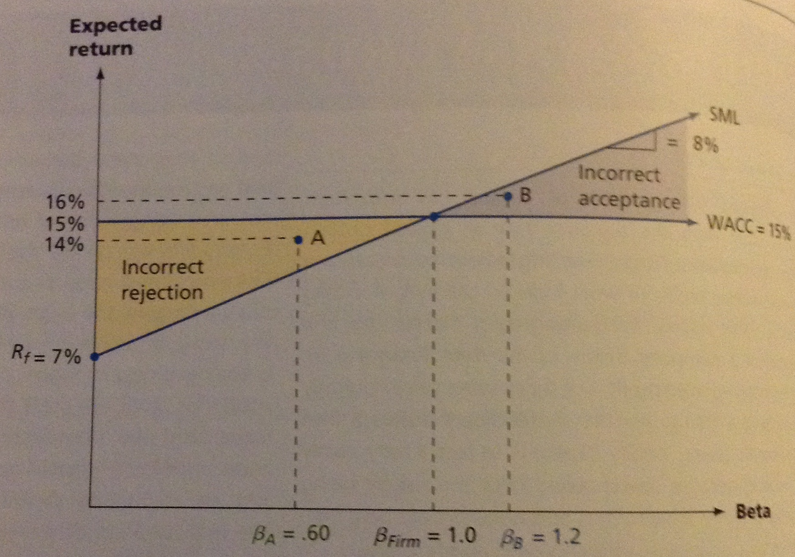

In the figure above, the SML is plotted corresponding to a risk-free rate of 7% and a market risk premium of 8%.

To keep things simple, we consider an all-equity company with a beta of 1.

As indicated, the WACC and the cost of equity are exactly equal to 15% for this company since there’s no debt.

Let’s say the firm uses its WACC to evaluate all investments – this means any investment with a return greater than 15% is accepted and any investment with a return less this is rejected.

We know from studying risk & return that a desirable investment is one that plots above the SML. As the figure above illustrates, using the WACC for all types of projects can result in the firm incorrectly accepting risky projects and incorrectly rejecting safe ones.

Ex.:
Consider point A.
This project has a beta of 0.6 compared the firm’s beta of 1.0
It has an expected return of 14%.
Is this a desirable investment? YES, because the required return is only:

$$Required Return=R_{f}+β*\left(R_{M}-R_{f}\right)=7\%+0.60*8\%=11.8\%$$

But if we use the WACC as a cutoff, this project would be rejected because its return is less than 15%. This example shows that a firm using its WACC as a cutoff tends to reject profitable projects with risks less than those of the overall firm.

Ex.:
At the other extreme, consider point B.
This project offers a 16% return, which excess the firm’s cost of capital.
But this isn’t a good investment because its return is inadequate given its level of systematic risk.
But if we use the WACC to evaluate it, it appears to be attractive.

So the second mistake comes if we use the WACC as a cutoff, we tend to make unprofitable investments with risks greater than the overall firm.

As a consequence, through time, a firm that uses its WACC to evaluate all projects has a tendency to both accept unprofitable investment and become increasingly risky.

DIVISIONAL COST OF CAPITAL
The same type of problem can come up in a corporation with more than one line of business.

Imagine a company with 2 divisions – a regulated phone company and a high tech communications company. The phone company has relatively low risk, the communications has high risk.

In this case, the firm’s overall cost of capital is a mixture of 2 different costs of capital, one for each division.
If the 2 divisions were competing for resources and the firm used a single WACC as a cutoff, which division would tend to be awarded greater funds for investment?

The answer:
The riskier division would tend to have greater returns (ignoring the greater risk) so it would usually be the winner. The less glamourous operation might have great profit potential that ends up being ignored.

This is a problem large corporations are aware of and they’re working to develop separate divisional costs of capital.

THE PURE PLAY APPROACH
We know that using the firm’s WACC inappropriately can lead to problems – how can we come up with an appropriate discount rate in these circumstances?

Because we can’t observe returns on these investments, there’s no direct way of coming with a beta. So instead we have to examine other investments outside the firm that are in the same risk class as the one we’re considering and use the market-required return on these investments as the discount rate.

- We determine what the cost of capital is for such investment by locating some similar investments in the marketplace

Ex.:
Going back our phone company division – we want to come up with a discount rate for that division. We can identify several other phone companies that have publicly traded securities.

We might find a typical phone company has a beta of 0.40, AA-rated debt and a capital structure that’s about 50% debt and 50% equity. Using this information, we could develop a WACC for a typical phone company and use this as our discount rate.

Ex.:
Alternatively, we’re thinking of entering a new line of business. We’d try to develop the appropriate cost of capital by looking at the market required return on companies already in that business.

A company that focuses on a single line of business is called a pure play. So what we try to do here is find companies that focus as exclusively as possible on the type of project we’re interested in. So our approach is called pure play approach to estimating the required return on an investment.

Pure Play Approach – Use of a WACC that’s unique to a particular project

The pure play approach is useful in finding the fair rate pf return for utility companies.
We’d use the pure play approach on Provincial Power if it wasn’t a publicly traded company – because many electric utilities in Canada are crown corporations, consultants use publicly traded Canadian & US utilities for comparison.

Finding similar companies for comparison comes with problems. The most obvious one is that we may not be able to find any suitable companies for comparison. In this case, determining a discount rate becomes challenging.

Alternatively, a comparable company might be found but the comparison is complicated by a different capital structure.

The important thing is to be aware of the issue so we at least reduce the possibility of the kinds of mistakes that can arise when the WACC is used as a cutoff on all investments.

THE SUBJECTIVE APPROACH
Because of the difficulties that exist in objectively finding discount rates for individual projects, firms often adopt an approach that involves making subjective adjustments to the overall WACC.

Let’s say that a firm has an overall WACC of 14%. It places all proposed projects into 4 categories:

Category | Examples | Adjustment Factor | Discount Rate
High Risk | New products | +6% | 20%
Moderate Risk | Cost savings, expansion of existing lines | +0% | 14%
Low Risk | Replacement of existing equipment | -4% | 10%
Mandatory | Pollution control equipment | N/A | N/A

All projects either fall into one of 3 risk classes or else they’re mandatory. In this last case, the cost of capital is irrelevant since the project has to be taken.

With the subjective approach, the firm’s WACC may change through time as economic conditions change. As this happens, the discount rates for the different types of projects also change.

Within each risk class, some projects have more risk than others and the danger of making incorrect decisions still exist. The figure below shows this.

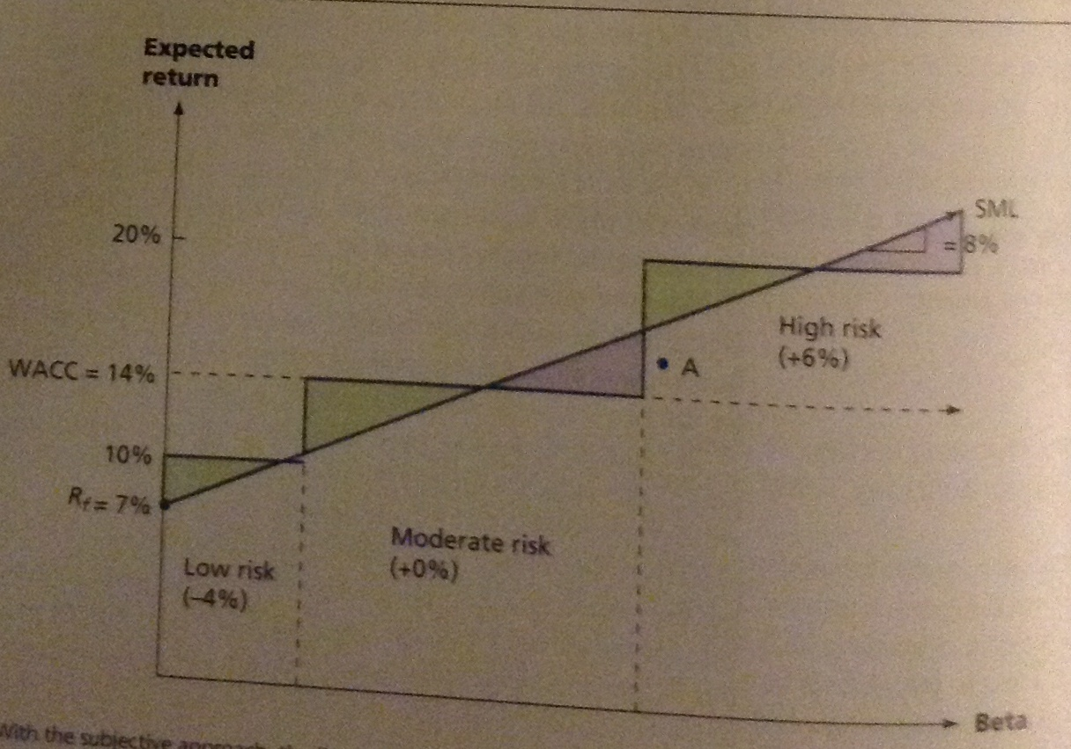
You can see between this figure and the last one that a similar problem still exists (of making incorrect choices), but the magnitude of the potential error is less with the subjective approach.

Ex.:
The project labelled A would be accepted if the WACC were used, but it’s rejected once it’s classified as a high risk investment. This shows that some risk adjustment is probably better than no risk adjustment.

It would be better to determine the required return objectively for each project separately. But practically, it might not be possible to go much beyond subjective adjustments because either the necessary information isn’t available or else the cost and effort required isn’t worthwhile.

CALCULATING WACC FOR LOBLAW

We show the practical application of the WACC by calculating it for Loblaws. Their revenue for the year ending in December 2011 was about $31.25 billion, with net earnings of $769 million.

As pointed out, WACC calculations depend on market values as observed on a particular date. In this example, market values for Loblaw were observed on May 10th, 2012 – other information comes from the annual statements at Loblaw’s year-end.

ESTIMATING FINANCING PROPORTIONS
The table below shows an abbreviated statement of financial position for Loblaw. Remember that when calculating the cost of capital, it’s common to ignore short-term financing such as payables & accruals. We also ignore short-term debt unless it’s a permanent source of financing.

As both current assets and current liabilities are ignored for our purposes, increases (or decreases) in current liabilities are netted against changes in current assets. Leases are included in long-term debt for the purposes of this analysis.

Assets |  | Liabilities & Equity
Current | $6,462 | Current | $4,718
 |  | Deferred taxes & other | $938
Long-term | $10,966 | Long-term debt | $5,765
 |  | Equity
 |  | Common equity | $6,007
Total | $17,428 | Total | $17,428

Ideally, we should calculate the market value of all sources of financing and determine the relative weights of each source. Sometimes, difficulty comes from finding the market value of non-traded bonds – this would require us to use the book values for debt.

This isn’t a problem for Loblaw – they don’t have any non-traded bonds.
It’s more important to use the market value for calculation of equity weights than for debt, as the market value of common equity differs from the book value.

MARKET VALUE WEIGHTS FOR LOBLAW
To find the market value weights of debt and common stock we find the total market value of each. The market values are calculated as the number of shares times the share price.

For Loblaw, as of December 2011, these figures were 281,385,318 common shares and 9,000,000 preferred shares outstanding. Multiplying each by its given price gives:

Security | Book Value  ($ millions) | Market Price | Market Value  ($ millions)
Interest-bearing debt | $5765 | -- | $4393.1
Preferred shares | $225 | $27.57 | $248.1
 | $6007 | $38.48 | $10,828

Proportions | Dollars | Market Value Weights
Debt | $4393.1 | 28.40%
Preferred Shares | $248.1 | 1.60%
Common Stock | $10,828 | 70.00%
 | $15,469.20 | 100.00%

As you can see from the market value weights, Loblaw capital structure contains common equity, debt and preferred stock.

COST OF DEBT
Loblaw has 18 relatively long-term bond issues that account for almost all of its long-term debt. To calculate the cost of debt, we combine these 18 issues and compute a weighted average.

We should note that finding the yield to maturity for all of a company’s outstanding bond issues on a single day is unusual. The bond market isn’t as liquid as the stock market and on many days individual bonds may not trade.

To find the book values of the bonds, we used Bloomberg Financial Services, the basic information is below:

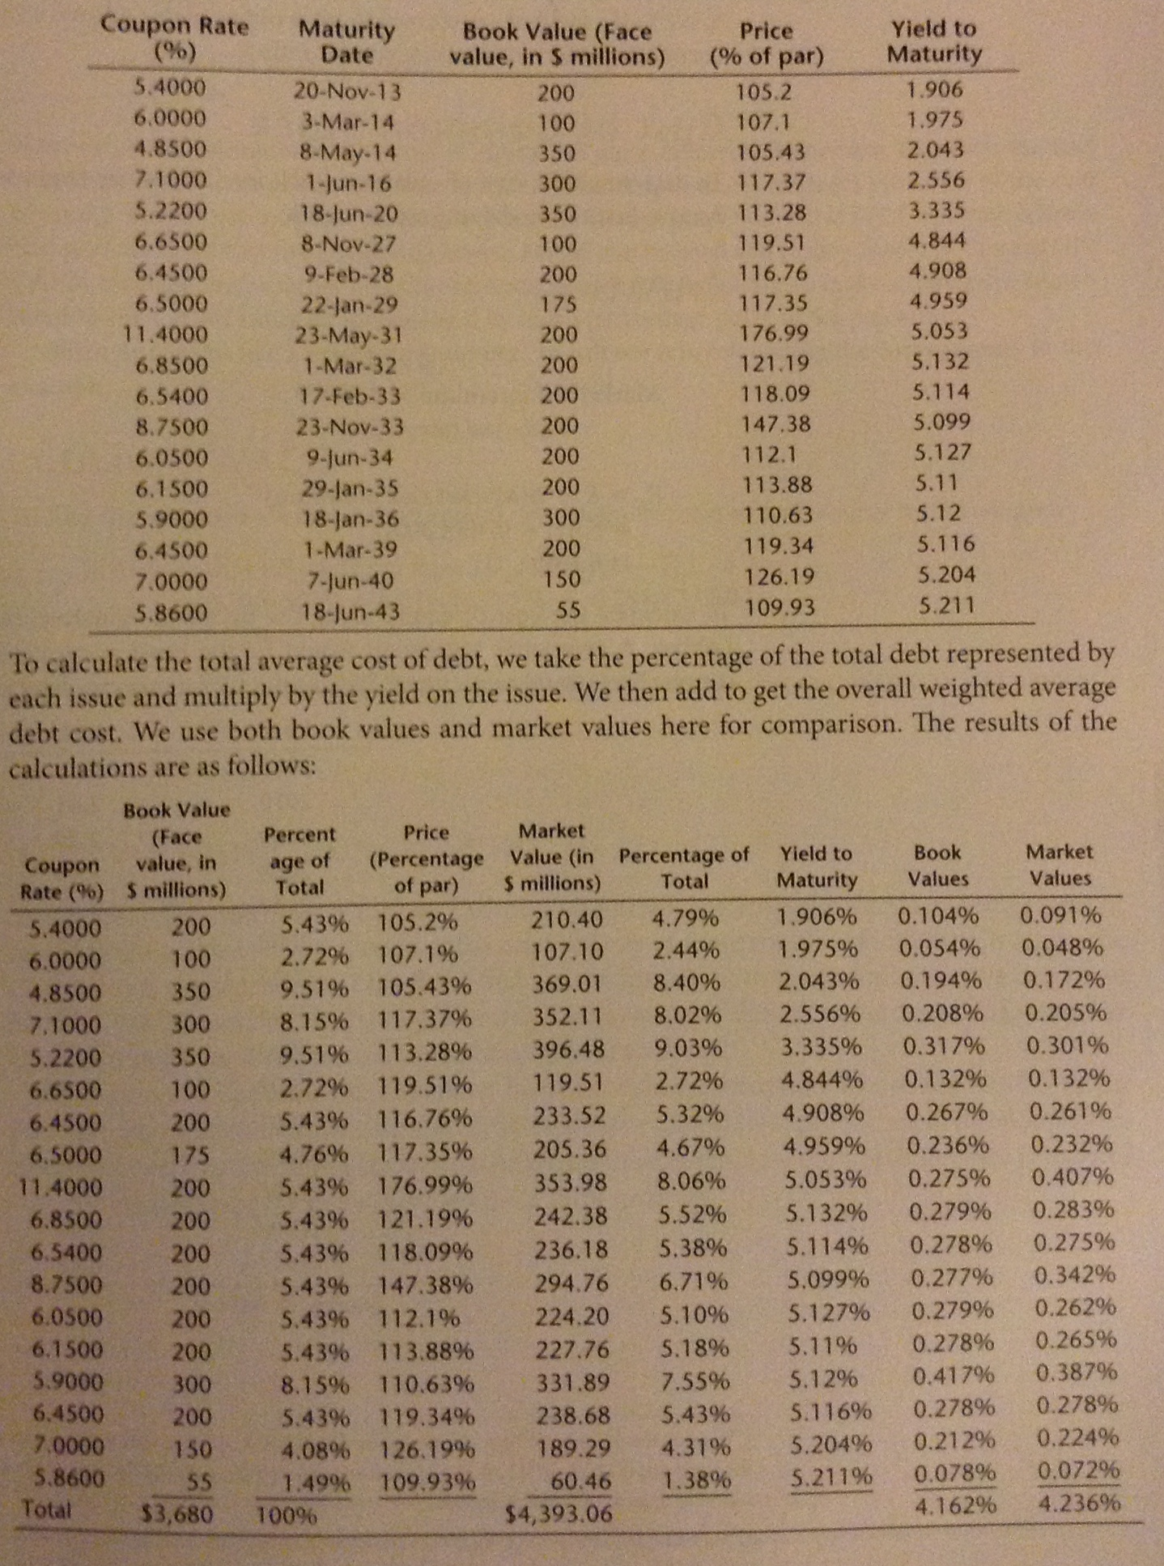
To calculate the total average cost of debt, we take the percentage of the total debt represented by each issue and multiply by the yield on the issue.

Then we add to get the overall weighted average debt cost. We use both book values and market values here for comparison. The results of the calculations are as follows:

As these calculations show, Loblaw’s cost of debt is 4.162% on a book value basis and 4.236% on a market value basis. They’re very similar.

So for Loblaw, whether the market value or book values are used makes only a small difference. The reason is only that the market & book values are similar. This will often be the case and explains why companies often use book values for debt in WACC calculations.

The last step is to convert the before-tax cost of debt to an after-tax cost. To do this, we use the average tax rate for Loblaw during 2011: 27.2%

$$R_{D}\left(1-T_{C}\right)=Cost of Debt \left(market value\right)*\left(1-T_{C}\right)=4.236\%\left(1-0.272\right)=3.08\%$$

COST OF PREFERRED SHARES
The cost of preferred shares is obtained from Bloomberg Financial Services and its value is 5.597%.

COST OF COMMON STOCK
To determine the cost of common stock for Loblaw, we start with the CAPM and use the dividend valuation model as a reality check.

CAPM
$$β=0.30$$
$$Market Risk Premium=4.30\%$$
$$RiskFree Rate=5\%$$
$$R_{E}=R_{f}+β(market risk premium)$$
=
$$5.0\%+0.30\left(4.30\%\right)$$
=
6.29%

To calculate the cost of equity using the dividend valuation model, we need a growth rate for Loblaw. A geometric regression would be the most accurate, but a geometric average is simpler and nearly as accurate.

We use the EPS figures to determine the growth rate for Loblaw:

Year | EPS
2011 | 2.73
2010 | 2.45
2009 | 2.39
2008 | 1.99
2007 | 1.20
2006 | -0.80
2005 | 2.72
2004 | 3.53
2003 | 3.07
2002 | 2.64
2001 | 2.04
2000 | 1.71
1999 | 1.37
1998 | 1.06
1997 | 0.88

DIVIDEND VALUATION MODEL GROWTH RATE

$${\left(1+g\right)}^{14}=\left(\frac{2.73}{0.88}\right)$$
=
$$g={\left(3.10\right)}^{\frac{1}{14}}-1$$
=
g = 8.42%

The geometric growth rate in EPS over the period 1997-2011 was 8.42%

$$Dividend Valuation Model=\frac{D_{1}}{P_{0}}+g$$

To get next year’s dividend, $D_{1}$, we adjust the current dividend of $0.84 for projected growth:

$$D_{1}=D_{0}\left(1+g\right)=\$0.84\left(1.0842\right)=\$0.9107$$

$$P_{0}=\$38.48$$

$$R_{E}=\frac{D_{1}}{P_{0}}+g=\frac{\$0.9107}{\$38.48}+0.0842=10.79\%$$

Notice that the estimates for the cost of equity are quite different. Remember that each way of estimating the cost of equity relies on different assumptions, so different estimates of the cost of equity shouldn’t surprise us.

Remember we said earlier that the CAPM estimate follows best practices and that the Dividend Growth Model can be used as a reality check. In this case, the CAPM estimate seems rather low. One reasonable approach would be to make a subjective adjustment to the CAPM estimate increasing it by half a percentage point to 6.8%

Since this seems like a reasonable number, we’ll use it in calculating the cost of equity in this example.

LOBLAW’S WACC
To find the weighted average cost of capital, we weight the cost of each source by the weights:

$$WACC=\left(\frac{E}{V}\right)R_{E}+\left(\frac{R}{V}\right)R_{P}+\left(\frac{D_{m}}{V}\right)R_{D}\left(1-T_{C}\right)$$
=
$$0.70\left(6.80\%\right)+0.0160\left(5.597\%\right)+0.2840(3.08\%=5.72\%$$

Our analysis shows that in May 2012 Loblaw’s weighted average cost of capital was 5.72%

