CHAPTER 13
Risk & Return II

Remember:
- There is reward for bearing risk – we call this reward a risk premium
- This risk premium is larger for riskier investments

We now look at the economic and managerial implications of this basic idea. We look at the risks associated with individual assets and we find 2 types of risks: SYSTEMATIC & UNSYSTEMATIC.

EXPECTED RETURNS & VARIANCES
Now we start looking at how to analyze returns and variances when the information we have concerns future possible returns and their possibilities.

EXPECTED RETURN
Consider a single period of time, one year. We have 2 stocks: L & U, with the following characteristics:

- Stock L: Expected to have a return of 25% in the coming year
- Stock U: Expected to have a return of 20% for the same period

Why would anyone want to hold Stock U? Why invest in one stock when the expectation is that another will do better? The answer must depend on the risk of the 2 investments – the return on Stock L, although expected to be 25%, could actually be lower or higher.

Suppose the economy booms – in this case, we think that Stock L would have a 70% return. If the economy enters a recession, we think the return would be -20%.

So we say that there are 2 states of the economy – meaning that these are the only 2 possible situations. This is oversimplified but it lets us illustrate key ideas without a lot of computation.

Let’s say there’s an equal (50-50) chance of there being a boom or a recession. The table below shows the basic information we’ve described.

States of the Economy & Stock Returns
 |  | Security Returns if State Occurs
State of the Economy | Probability of State of the Economy | L | U
Recession | 0.5 | -20% | 30%
Boom | 0.5 | 70% | 10%
 | 1.0

If you buy one of these stocks, let’s say Stock U, what you earn in a particular year depends on what the economy does during that year.
But let’s say that the probabilities stay the same through time. If you hold U for a number of years, you’ll earn 30% about half the time and 10% the other half. We say that your expected return on Stock U, $E(R_{U})$ is 20%:

$$E\left(R_{U}\right)=0.50*30\%+0.50*10\%=20\%$$

In other words, you should expect to earn, on average, 20% from this stock.

Expected Return – Return on a risky asset expected in the future.

For Stock L, the probabilities are the same, but the possible returns are different. Here we lose 20% half the time and we gain 70% the other half. The expected return on L, $E(R_{L})$, is 25%:

$$E\left(R_{L}\right)=0.30*-20\%+0.50*70\%=25\%$$

The following table shows these calculations:

Calculation of Expected Return
 |  | Stock L |  | Stock U
(1)  State of Economy | (2)  Probability of State of Economy | (3)  Rate of Return if State Occurs | (4)  Product  (2) * (3) | (5)  Rate of Return if State Occurs | (6)  Product  (2) * (5)
Recession | 0.5 | -0.20 | -0.10 | 0.30 | 0.15
Boom | 0.5 | 0.70 | 0.35 | 0.10 | 0.05
 | 1.0 |  | $$E\left(R_{L}\right)=25\%$$ |  | $$E\left(R_{U}\right)=20\%$$

We defined the risk premium as the difference between the return on a risky investment and a risk-free investment and we calculated the historical risk premiums on some different investments.

Using our projected returns, we can calculate the projected or expected risk premium as the difference between the expected return on a risky investment and the certain return on a risk-free investment.

Ex.:
Suppose that risk-free investments are currently offering 8%. We say that the risk-free rate (labeled as $R_{f}$) is 8%. Given this, what’s the projected risk premium on Stock U and on Stock L?

Since the expected return on Stock U, $E(R_{U})$ is 20%, the projected risk premium is:

Risk Premium = Expected Return – Risk-Free Rate
=
$$E\left(R_{U}\right)-R_{f}=20\%-8\%=12\%$$
Similarly, the risk premium on Stock L is 25% - 8% = 17%

In general, the expected return on a security or other asset is simply equal to the sum of the possible returns multiplied by their probabilities.

So if we have 100 possible returns, we’d multiply each one by its probability and add the results. The result would be the expected return. The risk premium would be the difference between this expected return and the risk-free rate.

Equation for Expected Return

$$E\left(R\right)=\sum_{j}{R_{j}*P_{j}}$$

$$R_{j}=value of the jth outcome$$
$$P_{j}=associated probability of occurence$$
$$\sum_{j}{=} the sum over all j$$
Ex.:
Looking back at our previous 2 tables.
Suppose you though that a boom would occur only 20% of the time instead of 50%. What are the expected returns on Stocks U and L in this case? If the risk-free rate is 10%, what are the risk premiums?

The first thing to notice is that a recession must occur 80% of the time (1 – 0.20 = 0.80) because there are only 2 possibilities. With this in mind, Stock U has a 30% return in 80% of the years and a 10% return in 20% of the years.

To calculate the expected return, we just multiply the possibilities by the probabilities and add up the results:
$$E\left(R_{U}\right)=0.80*30\%+0.20*10\%=26\%$$

The following table summarizes the calculations for both stocks.

 |  | Stock L |  | Stock U
(1)  State of Economy | (2)  Probability of State of Economy | (3)  Rate of Return if State Occurs | (4)  Product  (2) * (3) | (5)  Rate of Return if State Occurs | (6)  Product  (2) * (5)
Recession | 0.80 | -0.20 | -0.16 | 0.30 | 0.24
Boom | 0.20 | 0.70 | 0.14 | 0.10 | 0.02
 | 1.0 |  | $$E\left(R_{L}\right)=-2\%$$ |  | $$E\left(R_{U}\right)=26\%$$

Notice that the expected return on L is -2%.
The risk premium for Stock U is 26% - 10% = 16% in this case.
The risk premium for Stock L is negative: -2% - 10% = -12%
This is odd, but not impossible.

CALCULATING THE VARIANCE
To calculate the variance of the returns on our 2 stocks, we determine the squared deviations from the expected return. We then multiply each possible squared deviation by its probability. We add these, and the result is the variance.

The standard deviation, as always, is the square root of the variance. It’s important to note there’s an alternative way to calculate the variance using the correlation coefficient, but we’ll look at this later.

Generalized equations for variance and standard deviation are:

$$δ^{2}=\sum_{f}{{\left[R_{j}-E\left(R\right)\right]}^{2}*P_{j}}$$

$$δ=\sqrt{δ^{2}}$$

As an example, Stock U has an expected return of $E\left(R_{U}\right)=20\%$. In a given year, it could actually return either 30% or 10%. The possible deviations are thus 20% - 20% = 10% or 10% - 20% = -10%. In this case, the variance is:

$$Variance=δ^{2}=0.50*{\left(10\%\right)}^{2}+0.50*{\left(-10\%\right)}^{2}=0.01$$

The standard deviation is the square root of this = 0.10 = 10%

$$Standard Deviation=δ=\sqrt{0.01}=0.10=10\%$$

The table below summarizes these calculations for both stocks. Notice that Stock L has a much larger variance.

(1)  State of Economy | (2)  Probability of State of Economy | (3)  Return Deviation from Expected Return | (4)  Squared Return Deviation from Expected Return | (5)  Product  (2) * (4)
Stock L
Recession | 0.50 | -0.20 – 0.25 = -0.45 | (-0.45)^2 = 0.2025 | 0.10125
Boom | 0.50 | 0.70 – 0.25 = 0.45 | (0.45)^2 = 0.2025 | 0.10125
 |  |  |  | $$δ_{L}^{2}=0.2025$$
Stock U
Recession | 0.5 | 0.30 – 0.20 = 0.10 | (0.10)^2 = 0.01 | 0.005
Boom | 0.5 | 0.10 – 0.20 = -0.10 | (-0.10)^2 = 0.01 | 0.005
 |  |  |  | $$δ_{U}^{2}=0.010$$

When we put the expected return and variability information for our 2 stocks together:

 | Stock L | Stock U
Expected Return E(R) | 25% | 20%
Variance $δ^{2}$ | 0.2025 | 0.0100
Standard Deviation $δ$ | 45% | 10%
Stock L has a higher expected return, but U has less risk.
You could get a 70% return on your investment in L, but you could also lose 20%. Notice that investment U always pays at least 10%

Which of these stocks should you buy?
We can’t really say; this depends on your personal preferences.

The way we’ve calculated expected returns and variances is different from how we calculated it when we were looking at historical returns. That’s because we had estimated the average return and the variance based on some actual events.

Here, we’ve projected future returns and their associated probabilities, so this is the information with which we must work with.

Ex.:
Going back to our previous example, what are the variances on the 2 stocks once we have unequal probabilities? What are the standard deviations? We can summarize the needed calculations as follows:

(1)  State of Economy | (2)  Probability of State of Economy | (3)  Return Deviation from Expected Return | (4)  Squared Return Deviation from Expected Return | (5)  Product  (2) * (4)
Stock L
Recession | 0.80 | -0.20 – (-0.02) = -0.18 | 0.0324 | 0.02592
Boom | 0.20 | 0.70 = (-0.02) = 0.72 | 0.5184 | 0.10368
 |  |  |  | $$δ^{2}=0.12960$$
Stock U
Recession | 0.80 | 0.30 – 0.26 = 0.04 | 0.0016 | 0.00128
Boom | 0.20 | 0.10 – 0.26 = -0.16 | 0.0256 | 0.00512
 |  |  |  | $$δ^{2}=0.00640$$

Based on these calculations., the standard deviation for L is $δ_{L}=\sqrt{0.1296}=36\%.$ The standard deviation for U is much smaller, $δ_{U}=\sqrt{0.0064}=8\%$

PORTFOLIOS

Most investors usually hold a portfolio of assets – investors tend to own more than just a single stock, bond or other asset. Because of this, portfolio return and portfolio risk are relevant.

Portfolio – Group of assets such as stocks and bonds held by an investor.

PORTFOLIO WEIGHTS
There are many of the same ways to describe a portfolio – the most convenient approach is to list the percentages of the total portfolio’s value that’s invested in each portfolio asset – this is called the portfolio weights.

Portfolio Weights – Percentage of a portfolio’s total value in a particular asset.

Ex.:
If we have $50 in one asset and $150 in another, our total portfolio is worth $200. The percentage of our portfolio in the first asset is $50/$200 = 25% (0.25) and the percentage of our portfolio in the second asset is $150/$200 = 75% (0.75). Our portfolio weights are therefore 0.25 and 0.75.

Notice that the weights have to add up to 1.00 since all of our money is invested somewhere.

PORTFOLIO EXPECTED RETURNS
Let’s go back to Stocks L & U, you put half your money in each – the portfolio weights are obviously 0.50 and 0.50. What’s the pattern of returns on this portfolio and the expected return?

Let’s imagine the economy enters a recession. In this case, half your money (the half in L) loses 20%, the other half (in U) gains 30%. Your portfolio return, $R_{P}$, in a recession is thus:

$$R_{P}=0.50*\left(-20\%\right)+0.50*30\%=5\%$$

The table below summarizes the remaining calculations – notice that when a boom occurs, your portfolio would return 40%:

$$R_{P}=0.50*70\%+0.50*10\%=40\%$$

As indicated in the table below, your expected return on your portfolio, $E\left(R_{P}\right)$ is 22.5%

(1)  State of Economy | (2)  Probability of State of Economy | (3)  Portfolio Return is State Occurs | (4)  Product  (2) * (3)
Recession | 0.50 | ½ * (-20%) + ½ * (30%) = 5% | 2.5%
Boom | 0.50 | ½ * (70%) + ½ * (10%) = 40% | 20.0
 |  |  | $$E\left(R_{P}\right)=22.5\%$$

We can save time by calculating the expected return more directly. Given these portfolio weights, we reason that we expect half our money to earn 25% (the half in L) and half our money to earn 20% (the half in U). Our portfolio expected return is thus:

$$E\left(R_{P}\right)=0.50*E\left(R_{L}\right)+0.50*E\left(R_{U}\right)$$
=
0.50 * 25% + 0.50 * 20%
=
22.5%

This is the same portfolio expected return we had before.

This way of calculating the expected return on a portfolio works no matter how many assets are in the portfolio.

If we had n assets in our portfolio, where n is any number. If we let $x_{i}$ stand for the percentage of our money in asset I, the expected return is:

Expected Portfolio Return

$$E\left(R_{P}\right)=x_{i}*E\left(R_{1}\right)+x_{2}*E\left(R_{2}\right)+…+x_{n}*E\left(R_{n}\right)$$

This says that the expected return on a portfolio is a straightforward combination of the expected returns on the assets in that portfolio.

Ex.:
Suppose that we have the following projections on 3 stocks:

 |  | Returns
State of Economy | Probability of State | Stock A | Stock B | Stock C
Boom | 0.40 | 10% | 15% | 20%
Bust | 0.60 | 8% | 4% | 0%

What would be the expected return on a portfolio with equal amounts invested in each of the 3 stocks?

What would be the expected return if half the portfolio were in A, with the remainder equally divided between B and C?

From what we looked at earlier, the expected returns on the individual stocks are:
$$E\left(R_{A}\right)=8.8\%$$
$$E\left(R_{B}\right)=8.4\%$$
$$E\left(R_{C}\right)=8.0\%$$

If a portfolio has equal investments in each asset, the portfolio weights are all the same – this type of portfolio is said to be equally weighted.

Since there are 3 stocks, the weights are all equal to 1/3; the portfolio expected return is thus:

$$E\left(R_{P}\right)=\left(\frac{1}{3}\right)*8.8\%+\left(\frac{1}{3}\right)*8.4\%+\left(\frac{1}{3}\right)*8.0\%=8.4\%$$

In the second case, check that the portfolio expected return is 8.5%

PORTFOLIO VARIANCE
From our previous discussion, the expected return on a portfolio that contains equal investment in Stocks U & L is 22.5%. What’s the standard deviation of return on this portfolio?

The following table shows us the right way to calculate the portfolio’s standard deviation.

Variance on Equally Weighted Portfolio of Stock L & U
(1)  State of Economy | (2)  Probability of State of Economy | (3)  Portfolio Return if State Occurs | (4)  Squared Deviation from Expected Return | (5)  Product  (2) * (4)
Recession | 0.50 | 5% | (0.05 – 0.225)² = 0.030625 | 0.0153125
Boom | 0.50 | 40% | (0.40 – 0.225)² = 0.030625 | 0.0153125
 |  |  | $$δ_{P}=\sqrt{0.030625}=17.5\%$$ | $${δ^{2}}_{P}=0.030625$$

As we see, the portfolio’s variance is about 0.031 and its standard deviation is only 17.5% - what we’ve shown is that the variance on a portfolio isn’t generally a simple combination of the variances of the assets in the portfolio.

We can show this a bit better by looking at a slightly different set of weighted portfolios. Let’s say we put 2/11 (about 18%) in L and 9/11 (about 82%) in U. If a recession occurs, this portfolio would have a return of:

$$R_{P}=\left(\frac{2}{11}\right)*\left(-20\%\right)+\left(\frac{9}{11}\right)*\left(30\%\right)=20.91\%$$

If a boom occurs, this portfolio would have a return of:

$$R_{P}=\left(\frac{2}{11}\right)*70\%+\left(\frac{9}{11}\right)*\left(10\%\right)=20.91\%$$

The return is the same no matter what – no further calculations are needed. This portfolio has a zero variance.

Apparently, combining assets into portfolios can substantially alter the risks faced by the investor – this is a crucial observation.

Ex.:
Given the following 2 portfolios, what’s the standard deviation of the two portfolios?

 |  | Returns
State of Economy | Probability of State | Stock A | Stock B | Stock C
Boom | 0.40 | 10% | 15% | 20%
Bust | 0.60 | 8% | 4% | 0%

First we have to calculate the portfolio returns in the 2 states. We’ll work with the second portfolio, which has 50% in Stock A and 25% in each of Stocks B & C. The relevant calculations are shown below:

 |  | Returns
State of Economy | Probability of State | Stock A | Stock B | Stock C | Portfolio
Boom | 0.40 | 10% | 15% | 20% | 13.75%
Bust | 0.60 | 8% | 4% | 0% | 5.00%

The portfolio return when the economy booms is calculated as:

$$0.50*10\%+0.25*15\%+0.25*20\%=13.75\%$$

The return when the economy goes bust is calculated the same way. The expected return on the portfolio is 8.5%. The variance is therefore:

$$δ^{2}=0.40*{\left(0.1375-0.085\right)}^{2}+0.60*{\left(0.05-0.085\right)}^{2}=0.0018375$$

The standard deviation is thus about 4.3%.

PORTFOLIO STANDARD DEVIATION & DIVERSIFICATION
How diversification reduces portfolio risk as measured by the portfolio standard deviation is worth exploring in detail.

The key concept is correlation, which gives us a reading on the extent to which the return on 2 assets move together – if correlation is:

- POSITIVE = we say that Assets A & B are positively correlated
- NEGATIVE = we say that they’re negatively correlated
- ZERO = the 2 assets are uncorrelated

The following figure shows these 3 benchmark cases for 2 assets, A & B.

The graphs on the left side plot the separate returns on the 2 securities though time. Each point on the graphs on the right side represents the returns for both A & B over a particular time period.

The figure shows examples of different value for the correlation coefficient, CORR(Ra,Rb), that range from -1.0 to 1.0.

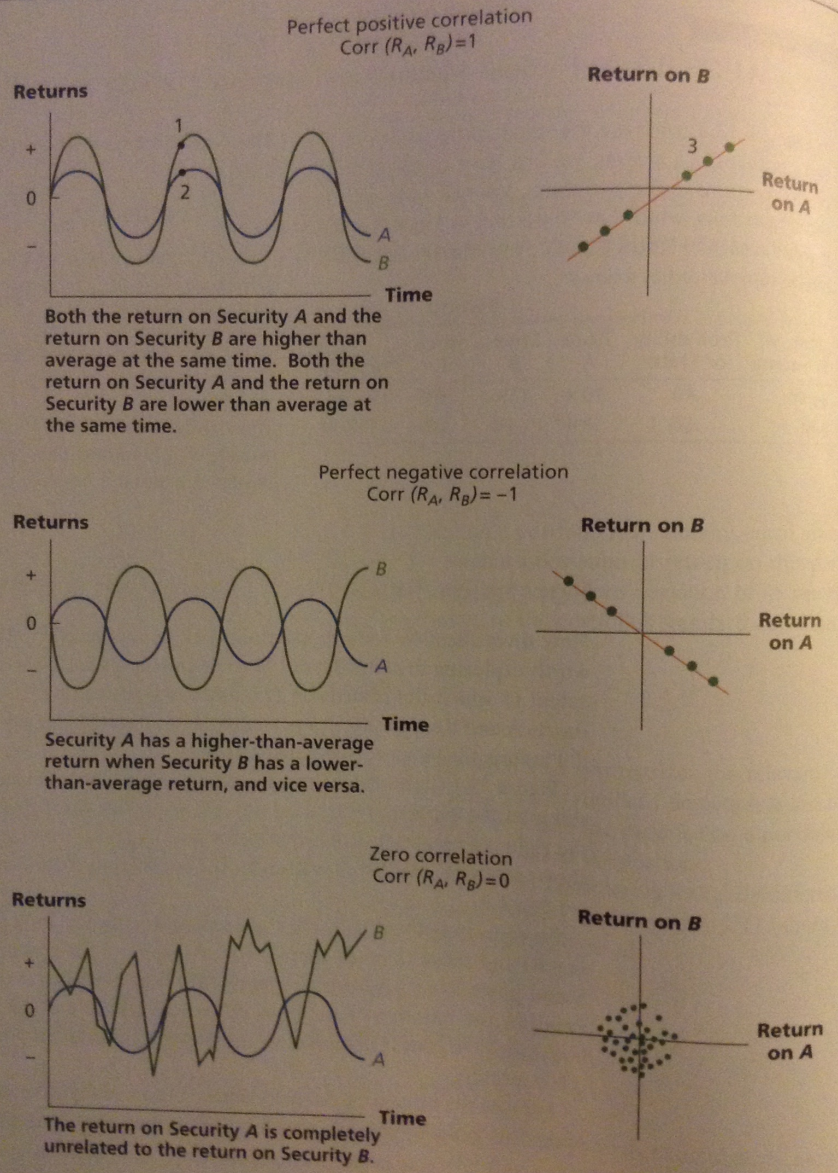
To show how the graphs are constructed, we need to look at points 1 & 2 (on the upper left graph) and relate them to point 3 (on the upper right graph).

Point 1 = A return on company B
Point 2 = A return on company A

They both occur at the same time period, let’s say June. Both returns are above average.

Point 3 = The returns on both stocks in June

The other dots in the upper right graph represent the returns on both stocks in other months.

Because the returns on Security B have bigger swings than on Security A, the slope of the line in the upper right graph is greater than 1. Perfect positive correlation doesn’t imply that the slope is one. It actually implies that all points lie exactly on the line.

Less-than-perfect positive correlation implies a positive slope, but the points don’t lie exactly on the line.

An example of less-than-perfect positive correlation is provided in the left side of the following figure:

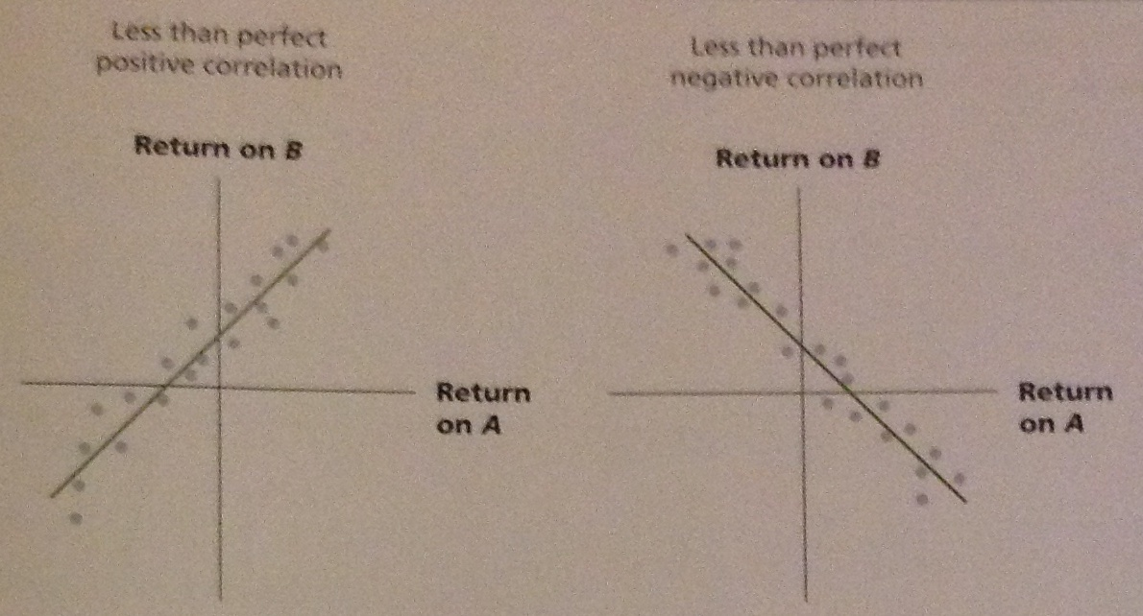

As before, each point in the graph represents the returns on both securities in the same month. In a graph like this, the closer the points lie to the line, the closer the correlation is to one.

In other words, a high correlation between the 2 returns implies that graph has a tight fit.

Less-than-perfect negative correlation implies a negative slope, but the points don’t lie exactly on the line, as shown on the right side of the figure above.

Ex.:
What’s the correlation between Stock L & U from our earlier example if we assume the 2 states of the economy are equally profitable?

The table below shows the returns on each stock in recession and boom states:

 | Stock L | Stock U
Recession | -0.20 | 0.30
Boom | 0.70 | 0.10

The figure below plots the line exactly the same way we plotted the graphs on the rights sides of our figures above (figure with 3 graphs).

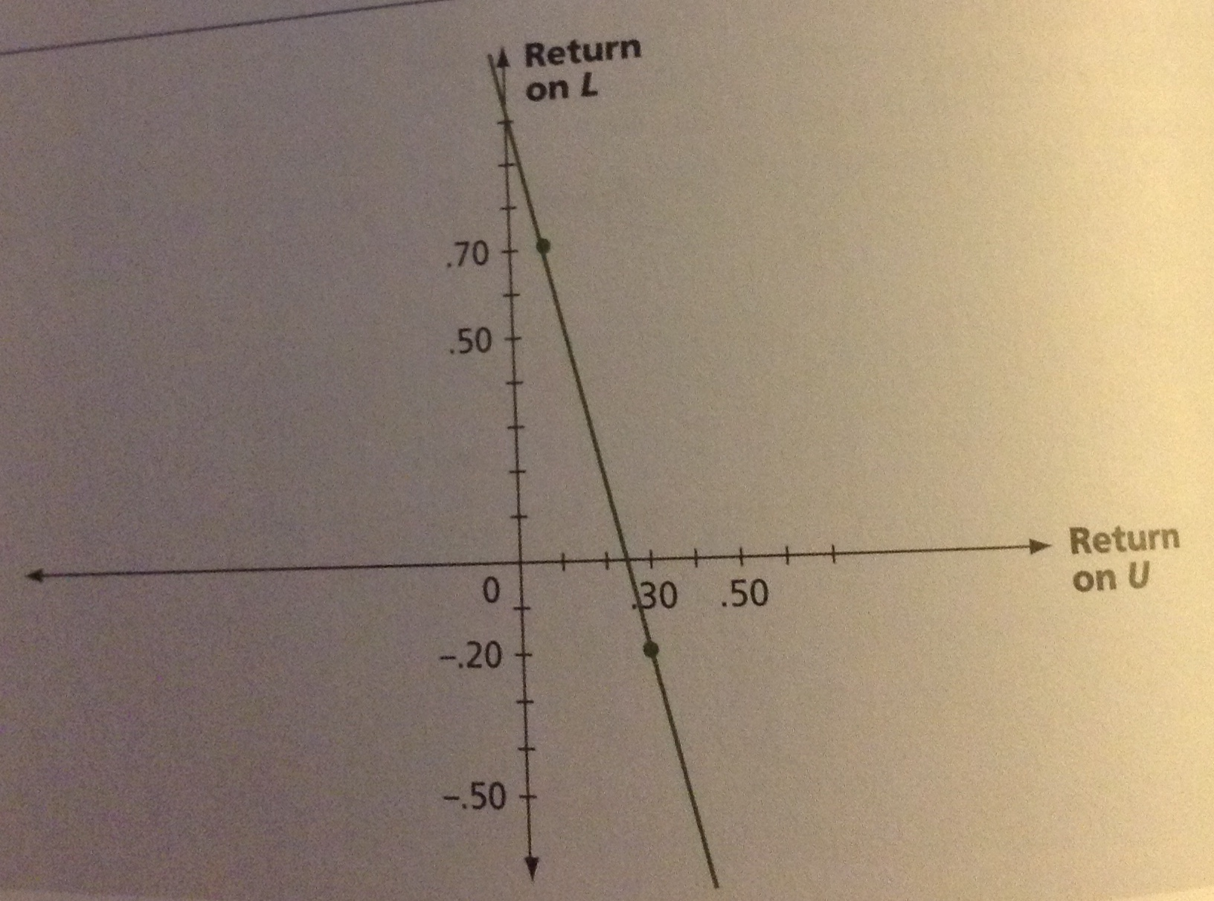

You can see from the figure that the line has a negative slope and all the points lie exactly on the line (since we only have 2 outcomes for each stock, the points must plot exactly on a straight line).

You can conclude that the correlation between Stocks U & L is equal to -1.0.

Our discussion of correlation gives us a key building block of a formula for portfolio standard variance and its square root, portfolio standard deviation.

$${δ^{2}}_{P}={x^{2}}_{L}{δ^{2}}_{L}+{x^{2}}_{U}{δ^{2}}_{U}+2x_{L}x_{U}{CORR}_{L,U}δ_{L}δ_{U}$$

$$δ_{P}=\sqrt{{δ^{2}}_{P}}$$

Remember that $x_{L}$ and $x_{U}$ are respectively, the portfolio weights for Stock U & L.
${CORR}_{L,U}$ is the correlation of the 2 stocks.

We can use the formula to check our previous calculation of portfolio standard deviation for a portfolio invested 50% in each stock.

$$={\left(0.5\right)}^{2}*{\left(0.45\right)}^{2}+{\left(0.5\right)}^{2}*{\left(0.10\right)}^{2}+\left(2\right)*\left(0.5\right)*\left(0.5\right)*\left(-1.0\right)*\left(0.45\right)*\left(0.10\right)$$
$$=0.030625$$
$$= \sqrt{0.030625}=17.5\%$$

These are the same results we got in our previous table.
Ex.: The Zero-Variance Portfolio

Can you find a portfolio of Stock U & L with zero variance?
Before we shows that investing 2/11 (about 18%) of the portfolio in L and the other 9/11 (about 82%) in U gives the same expected portfolio return in either a recession or a boom.

As a result, the portfolio variance and standard deviation should both be zero. We can chec this with the formula for portfolio variance:

$${δ^{2}}_{P}={\left(\frac{2}{11}\right)}^{2}*{\left(0.45\right)}^{2}+{\left(\frac{9}{11}\right)}^{2}*{\left(0.10\right)}^{2}+2-\left(\frac{2}{11}\right)*\left(\frac{9}{11}\right)*\left(-1.0\right)*\left(0.45\right)*\left(0.10\right)$$
=
0.006694 + 0.006694 – 0.013388 = 0

You can see the portfolio variance (and standard deviation) are zero because the eights were chosen to make the negative 3rd term exactly offset the first 2 positive terms. This 3rd term is called the covariance term because the product of the correlation times the 2 security standard deviations is the covariance of U and L.

To explore how the portfolio standard deviation depends on correlation, the following table recalculates the portfolio standard deviation, changing the correlation between U & L but keeping the portfolio weights and all other input data the same.

Portfolio Standard Deviation & Correlation
Stock L | $$x_{L}=\frac{2}{11}$$ | $$δ_{L}=45\%$$ | $$E\left(R_{L}\right)=25\%$$
Stock U | $$x_{U}=\frac{9}{11}$$ | $$δ_{U}=10\%$$ | $$E\left(R_{U}\right)=20\%$$
${CORR}_{L,U}$ Portfolio | Standard Deviation of Portfolio $s_{P}$
1. -1.0 | 0.0000%
2. 0.0 | 11.5708%
3. +1.0 | 16.3636%

When the correlation is perfectly negative,${CORR}_{U,L}=-1.0$, the portfolio standard deviation is 0 as we just calculated.

If the 2 stocks were uncorrelated (${CORR}_{L,U}=0)$, the portfolio standard deviation become 11.5708%

With a perfect positive correlation$({CORR}_{L,U}=+1.0)$, the portfolio standard deviation is 16.3636%

When the returns on the 2 assets are perfectly correlated, the portfolio standard deviation is simply the weighted average of the individual standard deviations. In this special case:

$$16.3636=\left(\frac{2}{11}\right)*45\%+\left(\frac{9}{11}\right)*10\%$$

With perfect correlation, all possible portfolios lie on a straight line between U & L in expected return/standard deviation space.

In this polar case, there’s no benefit from diversification. But, as soon as correlation is less than perfectly positive,${CORR}_{L,U}=+1.0$, diversification reduces risk.

As long as CORR is less than +1.0, the standard deviation of a portfolio of 2 securities is less than the weighted average of the standard deviations of the individual securities.

The figure below shows this important result by graphing all possible portfolios of U & L for the 3 cases for${ CORR}_{L,U}$.

The portfolios marked 1, 2, and 3 in the figure below all have an expected return of 20.91% as calculated in our table above.

Their standard deviations also come from the table above.

The other points on the respective line or curves are derived by varying the portfolio weights for each value of ${CORR}_{L,U}$.

Each curve or line represents all the possible portfolios of U & L for a given correlation. Each is called an opportunity set or feasible set. The lowest opportunity set representing ${CORR}_{L,U}=1.0$ always has the largest standard deviation for any return level. This again shows how diversification reduces risk as long as correlation is less than perfectly positive.

THE EFFICIENT SET
Let’s say that L & U have a correlation of about +0.70. The opportunity set is graphed in the following figure:

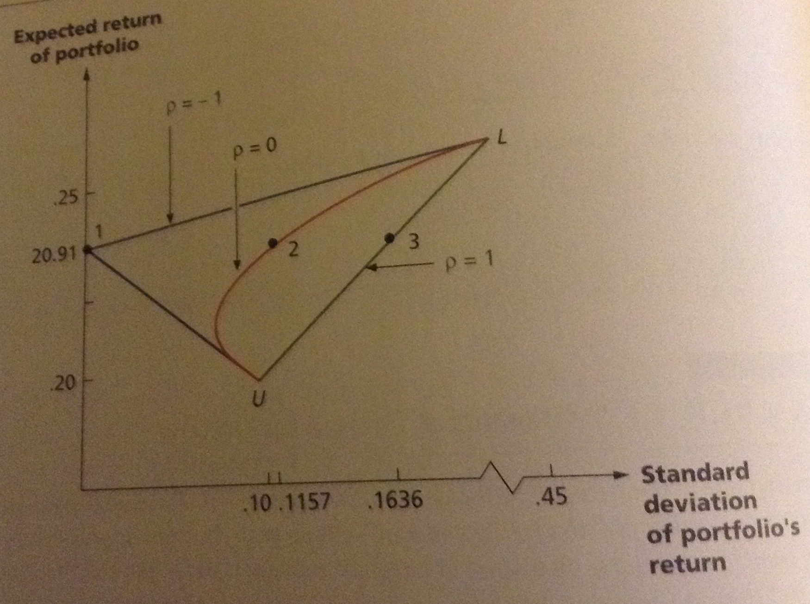

In this next figure, we have marked the minimum variance portfolio, MV.

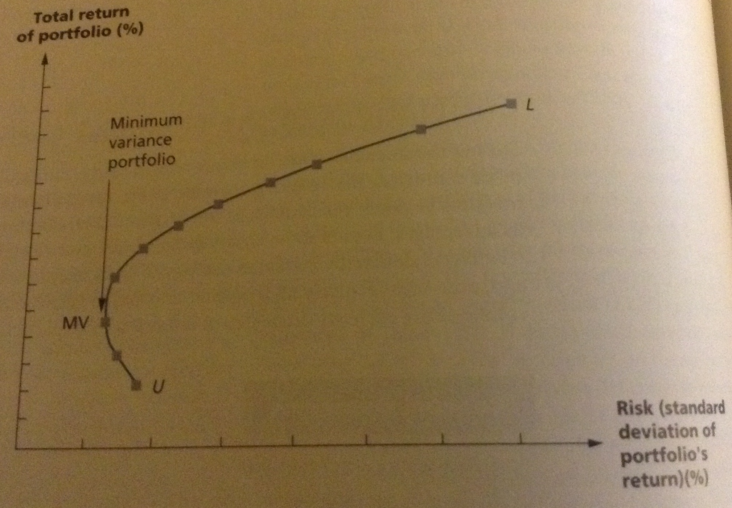

No risk-averse investor would invest 100% in Stock U because such a portfolio has lower expected return and higher standard deviation than the minimum variance portfolio.

We say that portfolios such as U are dominated by the minimum variance portfolio (since the standard deviation is the square root of variance, the minimum variance portfolios also have minimum standard deviations as shown in our 2 figures above).

Although the entire curve from U to L is called the feasible set, investors only consider the curve from MV to L. This part of the curve is called the efficient set.

ANNOUNCEMENTS, SURPRISES & EXPECTED RETURNS

Now that we can construct portfolios and evaluate their return, we start describing the risks and returns associated with individual securities.

We’ve measured volatility by looking at the difference between the actual returns on an asset or portfolio, R, and the expected return, E(R) – we now look closer at why these deviations exist.

EXPECTED & UNEXPECTED RETURNS
We consider the return on the stock of TransCanada Industries. What will determine this stock’s return in the coming year?

The return of any stock traded in a financial marker is composed of 2 parts:

- The normal or expected return from the stock is the part of the return that shareholders in the market predict or expect – these returns depend on the information shareholders have that affects the stock and it’s based on the market’s understanding today of the important factors that influence the stock in the coming year.

- This is the uncertain or risky part of the return on a stock. This is the portion that comes from unexpected information that’s revealed within the year. A few examples can includes:

  - News about TransCanada’s research
  - Government figures released on gross national product
  - The imminent bankruptcy of an important competitor
  - A sudden, unexpected drop in interest rate

Based on this discussion, one way to write the return on TransCanada’s stock in the coming year would be:

Total Return = Expected Return + Unexpected Return
=
R = E(R) + U

R = The actual total return for the year
E(R) = The expected part of the return
U = The unexpected part of the return

This says that the actual return, R, differs from the expected return, E(R), because of surprises that occur during the day.

ANNOUNCEMENTS & NEWS
We have to be careful when talking about the effect of news items on returns. As an example, suppose that TransCanada Industries’ business is such that the company prospers when GNP grows at a relatively high rate and suffers when GNP is relatively stagnant.

In deciding hat return to expect this year from owning TransCanada stock, shareholders either implicitly or explicitly think about what the GNP is likely to be for the year.

When the government actually announces GNP for the year, what will happen to the value of TransCanada’s stock?

The answer depends on what figure is released – but the impact depends on how much of that figure is new information.

At the start of the year, participants have some idea or forecast of what the yearly GNP will be. To the extent that shareholders had predicted the GNP the prediction is already factored into the expected part of the return on the stock, E(R).

On the other hand, if the announced GNP is a surprise, the effect is part of U, the unanticipated portion of the return.

Ex.:
Suppose shareholders had forecast that the GNP increases this year would be 0.5%. If the actual announcement this year is exactly 0.5%, the shareholders didn’t learn anything and the announcement isn’t new. There’d be no impact on the stock price as a result. This is like receiving confirmation of something you’ve known all along, it doesn’t reveal anything new.

When Steve Jobs died, Apple’s stock price dropped by only 0.2% - why? Because years of declining health and resignation from the post of CEO gave market participants time to re-price Apple shares without his leadership.

One way of saying an announcement isn’t news is to say that the market has “discounted” the announcement – this means it has less of an impact on the market because the market already knew much of it.

Ex.:
Suppose the government announced that the actual GNP increase during the year was 1.5%. Now shareholders of TransCanada have learned something – that the increase is 1% higher than they had forecast.

The difference between the actual result and the forecast, 1% in this case, is sometimes called the innovation or the surprise.

An announcement can then be broken into 2 parts – the anticipated or expected part and the surprise or innovation:

Announcement = Expected Part + Surprise

The expected part of any announcement is the part of the information that the market uses to form the expectation E(R), of the return on the stock.

The surprise is the news that influences the unanticipated return on the stock, U.

RISK: SYSTEMATIC & UNSYSTEMATIC

The unanticipated portion of the return resulting from surprises is the true risk of any investment.

If the investment is perfectly predictable, by definition, it’s risk-free. The risk of owning stock comes from surprises – unanticipated events.

There are important differences between different sources of risk. Some stories are directed specifically at a company, others are more general.

Which of the news items are of specific importance to TransCanada Industries?

Announcements about interest rates of GNP are important for all companies. News about TranCanada’s president, its research, or its sales are of specific interest to TransCanada Industries.

SYSTEMATIC & UNSYSTEMATIC RISK
The surprise that affects a large number of assets is known as a systematic risk. Systematic risks have market-wide effects, so they’re sometimes called market risks.

Unsystematic risks are risks that affect a single asset or a small group of assets. Because they’re unique to individual companies, they’re sometimes called unique or asset specific risks.

Systematic Risk – A risk that influences a large number of assets. Also known as a market risk.

Unsystematic Risk – A risk that affects at most a small number of assets. Also called a unique or asset-specific risk.

Uncertainties about general economic conditions, such as the GNP, interest rates or inflation or examples of systematic risks. These conditions can affect all companies to some degree.

An unanticipated increase in inflation can affect wages and the costs of the supplies that companies buy – it affects the value of assets that companies own and it can affect the prices at which companies sell their products. These forces, to which all companies are susceptible, are the essence of systematic risk.

In contrast, an announcement of an oil strike by a company mainly affects that company and maybe a few others (like primary competitors and suppliers). It’s not likely that it will have much of an effect on the world oil market or on the affairs of other companies not in the oil business.

SYSTEMATIC & UNSYSTEMATIC COMPONENTS OF RETURN
The distinction between the types of risk allows us to break down the surprise portion, U, of the return on TransCanada Industries stock into 2 parts. Like we did before, we break the actual return down into its expected and surprise components.

R = E(R) + U

Now we know that the total surprise portion, U, has a systematic and an unsystematic component, so:

R = E(R) + Systematic Portion (m) + Unsystematic Portion (ε)

R = E(R) + m + ε
The important thing about the way we’ve broken down the total surprise, U, is that the unsystematic portion, ε, is more or less unique to TransCanada Industries – its unrelated to the unsystematic portion of return on most other assets.

DIVERSIFICATION & PORTFOLIO RISK

Portfolio risks can be quite different from the risk of the assets that make up the portfolio – we’ve already seen this. Now we look closer at the riskiness of an individual asset VS the risk of the portfolio of many different assets.

Before we saw that the standard deviation of the annual return on a portfolio of several hundred large common stocks has historically been about 17% per year for both the TSX and the NYSE – this doesn’t mean the standard deviation of the annual return on a typical stock is about 17% - this is an important observation.

To look at the relationship between portfolio size and portfolio risk, the table below shows typical average annual standard deviations for equally weighted portfolios that contain different numbers of randomly selected NYSE securities.

(1)  Number of Stocks in Portfolio | (2)  Average Standard Deviation of Annual Portfolio Returns | (3)  Ratio of Portfolio Standard Deviation to Standard Deviation of a Single Stock
1 | 49.24% | 1.00
2 | 37.36% | 0.76
4 | 29.69% | 0.60
6 | 26.64% | 0.54
8 | 24.98% | 0.51
10 | 23.93% | 0.49
20 | 21.68% | 0.44
30 | 20.87% | 0.42
40 | 20.46% | 0.42
50 | 20.20% | 0.41
100 | 19.69% | 0.40
200 | 19.42% | 0.39
300 | 19.34% | 0.39
400 | 19.29% | 0.39
500 | 19.27% | 0.39
1000 | 19.21% | 0.39

In column 2, we see that the standard deviation for a “portfolio” of one security is about 49% - this means that if you randomly choose a single NYSE and put all your money in it, your standard deviation of return would typically have been a substantial 49% per year.

If you were to randomly select 2 stocks and invest half your money in each, your standard deviation would have been about 37% on average, and so on.

The important thing to notice in the table is that the standard deviation declines as the number of securities is increased. By the time we have 30 randomly chosen stocks, the portfolio’s standard deviation has declined about 60%, from 49% to about 20%.
THE PRINCIPLE OF DIVERSIFICATION
The figure below illustrates the point we’ve been discussing. We’ve plotted the standard deviation of return VS the number of stocks in the portfolio.

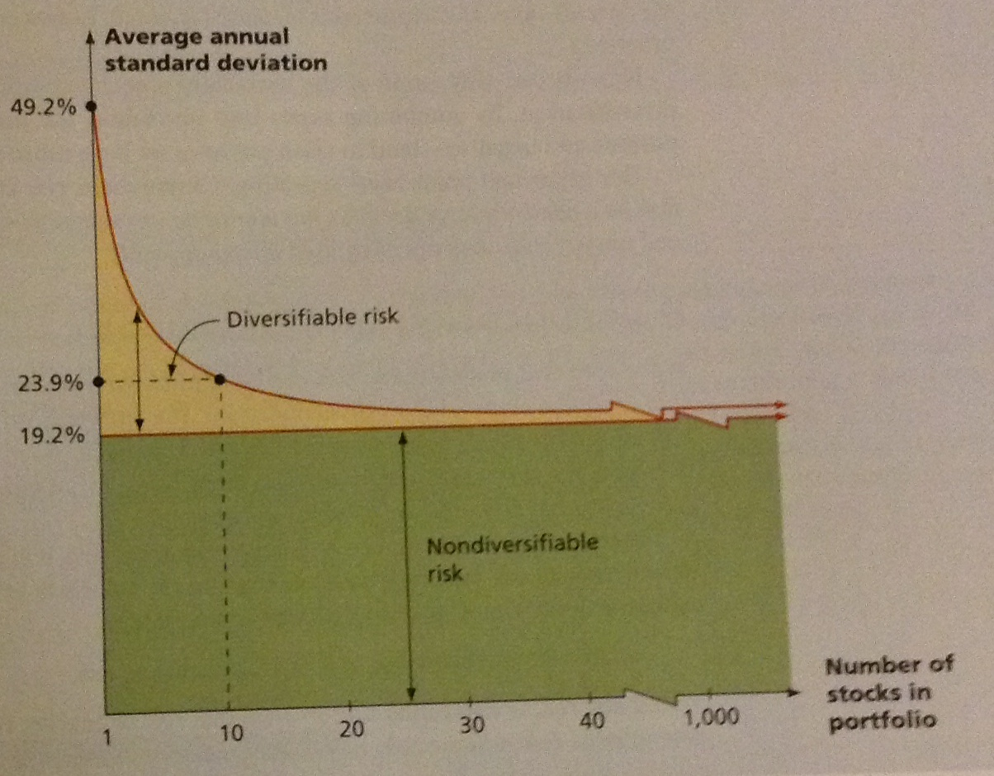

Notice in the figure that the benefit in risk reduction from adding securities drops as we add more and more. By the time we have 10 securities, the portfolio standard deviation has dropped from 49.2 to 23.9% - most of the effect is already realized and by the time we get to 30 or so, there’s little remaining benefit.

The figure illustrates 2 points:

- The principle of diversification tells us that spreading an investment across many assets eliminates some of the risk. The shaded area in the figure (labelled ‘diversifiable risk’), is the part that can be eliminated by diversification

- A minimum level of risk can’t be eliminated just by diversifying. This minimum level is labelled as ‘nondiversifiable risk’ in the figure.

Taken together, these 2 points are an important lesson from capital market history:

Diversification reduces risk, but only up to a point – some risk is diversifiable, and some isn’t

Principle of Diversification – Principle stating that spreading an investment across a number of assets eliminates some, but not all, of the risk.

DIVERSIFICATION & UNSYSTEMATIC RISK
Why is it that some of the risk associated with individual assets can be diversified away and some can’t? The answer hinges on the distinction we made between systematic and unsystematic risk.

By definition, an unsystematic risk is one that is particular to a single asset or, at most, to a small group. For example, if the asset under consideration is stock in a single company, the discovery of positive NPV projects tend to increase the value of the stock – unanticipated lawsuits, accidents, strikes and similar events tend to decrease future cash flows and reduce share values.

Important observation:
If we only held a single stock, the value of our investment would fluctuate because of company-specific events. If we held a large portfolio, some stocks in the portfolio would go up in value because of positive company-specific events and some would go down because of negative events.

The net effect on the overall value of the portfolio is relatively small but these events tend to cancel each other out.

So, by combining assets into portfolios, the unsystematic events – negative and positive – tend to wash out once we have more than just a few assets.

The important point:

Unsystematic risk is essentially eliminated by diversification, so a relatively large portfolio has almost no unsystematic risk

The terms ‘diversifiable risk’ and ‘unsystematic risk’ are often used interchangeably

DIVERSIFICATION & SYSTEMATIC RISK
Can systematic risk also be eliminated by diversification? No – because by definition, a systematic risk affects almost all assets to some degree. So, no matter how many assets we put into a portfolio, the systematic risk doesn’t go away.

The terms ‘undiversifiable risk’ and ‘systematic risk’ are often used interchangeably

We’ve seen that the total risk of an investment, as measured by the standard deviation of its return, can be written as:

Total Risk = Systematic Risk + Unsystematic Risk

For a well-diversified portfolio, the unsystematic risk in negligible. For such a portfolio, essentially all of the risk is systematic.

RISK & THE SENSIBLE INVESTOR
When we look at a “typical investor”, out typical investor is risk averse. This is why investors would choose well-diversified portfolios.

Risk-averse people avoid unnecessary risk, such as the unsystematic risk on a stock. They don’t like fair gambles. To induce the typical risk averse investor to take a fair gamble, there should be incentive.

SYSTEMATIC RISK & BETA

Now we look at the question What determines the size of the risk premium on a risky asset? Why do some assets have a larger risk premium than other assets? The answer is also based on the distinction between systematic and unsystematic risk.

THE SYSTEMATIC RISK PRINCIPLE
We’ve seen that the total risk associated with an asset can be decomposed into 2 components: systematic and unsystematic risk. We’ve also seen that unsystematic risk can be essentially eliminated by diversification; systematic risk can’t be eliminated by diversification.

Based on the capital market history, we know that there’s a reward, on average, for bearing risk. We need to be more precise about what we mean by risk.

The systematic risk principle states that the reward for bearing risk depends only on the systematic risk of an investment. The rationale for this principle is straightforward: Because unsystematic risk can be eliminated at no cost by diversifying, there’s no reward for bearing it. The market doesn’t reward risks that are born unnecessarily.

Systematic Risk Principle – Principle stating that the expected return on a risky asset depends only on that asset’s systematic risk.

This principle has an important implication:

The expected return on an asset depends only on that asset’s systematic risk

No matter how much total risk an asset has, only the systematic portion is relevant in determining the expected return (and risk premium) on that asset

MEASURING SYSTEMATIC RISK
Because systematic risk is important in determining an asset’s expected return, we need some way to measure the level of systematic risk for different investments.

The specific measure that we use is called the beta coefficient (β) – it tells us how much systematic risk a particular asset has relative to an average asset representing the market portfolio.

Beta Coefficient – Amount of systematic risk present in a particular risky asset relative to an average risky asset

An average asset has a beta of 1.0 relative to itself.

So an asset with a beta of 0.50 has half as much systematic risk as an average asset; an asset with a beta of 2.0 has twice as much.

These different levels of beta are shown in the figure below – you can see that high beta assets show greater volatility over time.

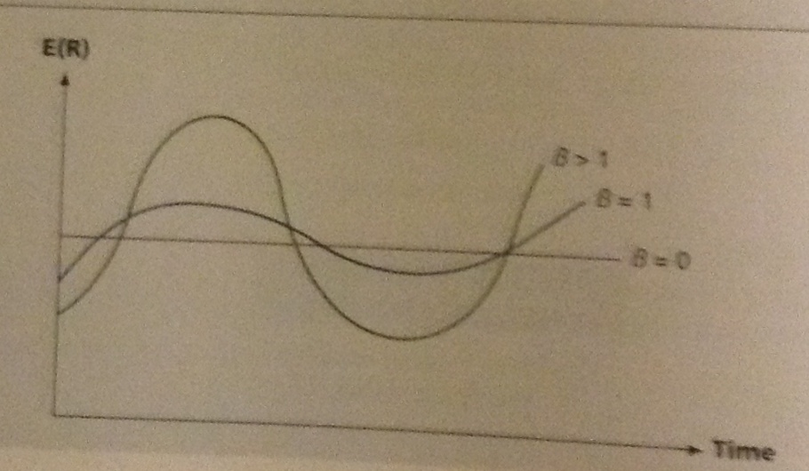

The table below contains the estimated beta coefficients for the stocks of some well-known companies ranging from 0.51 to 3.31

Company | Beta Coefficient
Bank of Nova Scotia | 0.78
Investors Group | 0.76
Talisman Energy | 1.43
Manulife Financial Corp. | 1.39
Rogers Communications | 0.51
Teck Resources Ltd. | 3.31

Remember that the expected return and the risk premium on as asset depend on its systematic risk. Because assets with larger betas have greater systematic risks, they have greater expected returns.

In the table above, an investor who buys stock in the Bank of Nova Scotia with a beta of 0.78 should expect to earn less, on average, than an investor who buys stock in Teck Resources Ltd., with a beta of 3.31

Ex.:
Which of the following 2 securities has greater total risk?
Which has greater systematic risk?
Which one has greater unsystematic risk?
Which asset has a higher risk premium?

 | Standard Deviation | Beta
Security A | 40% | 0.50
Security B | 20% | 1.50

Security A has greater total risk, but it has substantially less systematic risk.

Total risk is the sum of systematic and unsystematic risk, Security A must have greater unsystematic risk, Security B has a higher risk premium and a greater expected return despite that it has less total risk.

PORTFOLIO BETAS
The riskiness of a portfolio doesn’t have any simple relationship to the risks of the assets in the portfolio. A portfolio beta, however, can be calculated just like a portfolio expected return.

As an example, looking again at the following table:

Company | Beta Coefficient
Bank of Nova Scotia | 0.78
Investors Group | 0.76
Talisman Energy | 1.43
Manulife Financial Corp. | 1.39
Rogers Communications | 0.51
Teck Resources Ltd. | 3.31

Suppose you put half your money in the Bank of Nova Scotia and half in Teck Resources Ltd. What would the beta of this combination be?

Since bank of Nova Scotia (BNS) has a beta of 0.78 and Teck Resources Ltd (TRL) has a beta of 3.31, the portfolio’s beta, $(β_{P})$ would be:

$$β_{P}=0.50*β_{BNS}+0.50*β_{TRL}$$
=
$$0.50*0.78+0.50*3.31$$
=
2.05

Generally, if we had a large number of assets in a portfolio, we’d multiply each asset’s beta by its portfolio weight and then add the results to get the portfolio’s beta.

Ex.:
Suppose we have the following investments:

Security | Amount Invested | Expected Return | Beta
Stock A | $1000 | 8% | 0.80
Stock B | $2000 | 12% | 0.95
Stock C | $3000 | 15% | 1.10
Stock D | $4000 | 18% | 1.40

What’s the expected return on this portfolio?
What’s the beta of this portfolio?
Does this portfolio have more or less systematic risk that an average asset?

To answer, we have to first calculate the portfolio weights.
Notice that the total amount invested is $10,000. From this, we see that the portfolio weights are:

Stock A = $1000/$10,000 = 10%
Stock B = $2000/$10,000 = 20%
Stock C = $3000/$10,000 = 30%
Stock D = $4000/$10,000 = 40%

The expected return $E(R_{P})$ is thus:

$$E\left(R_{P}\right)=0.10*E\left(R_{A}\right)+0.20*E\left(R_{B}\right)+0.30*E\left(R_{C}\right)+0.40*E\left(R_{D}\right)$$
=
0.10 * 8% + 0.20 * 12% + 0.30 * 15% + 0.40 * 18%
=
14.9%
Similarly, the portfolio beta $β_{P}$ is:

$$β_{P}=0.10*β_{A}+0.20*β_{B}+0.30*β_{C}+0.40*β_{D}$$
=
0.10 * 0.80 + 0.20 * 0.95 + 0.30 * 1.10 + 0.40 * 1.40
=
1.16

So this portfolio has an expected return of 14.9% and a beta of 1.16. Since the beta is larger than 1.0, this portfolio has greater systematic risk that an average asset.

THE SECURITY MARKET LINE
We’re now in a position to see how risk is rewarded in the marketplace.

To start, suppose Asset A has an expected return of $E\left(R_{A}\right)=20\%$ and a beta of $β_{A}=1.6$. Furthermore, the risk-free rate is $R_{f}=8\%$ (the return on 3-month T-bills). We choose this measure because it matches the investor’s horizon for measuring performance.

Notice that a risk-free asset, by definition, has no systematic risk (or unsystematic risk), so a risk-free asset has a beta of 0.

BETA & RISK PREMIUM
Consider a portfolio made up of Asset A and a risk-free asset. We can calculate some different possible portfolio expected returns and betas by varying the percentages invested in these 2 assets.

Ex.:
If 25% of the portfolio is invested in Asset A, the expected return is:

$$E\left(R_{P}\right)=0.25*E\left(R_{A}\right)+\left(1-0.25\right)*R_{f}$$
=
0.25 * 20% + 0.75 * 8%
=
11.0%

Similarly, the beta on the portfolio $β_{P}$ would be:

$$β_{P}=0.25*β_{A}+\left(1-0.25\right)*0$$
=
0.25 * 1.6
=
0.40

Notice that since the weights have to add up to 1, the percentage invested in the risk-free asset is equal to 1 minus the percentage invested in Asset A.

Is it possible for the percentage in Asset A to exceed 100%? Yes this can happen is the investor borrows at the risk-free rate.

Ex.:
Suppose an investor has $100 and borrows $50 at 8%, the risk-free rate. The total investment in Asset A would be $150, or 150% of the investor’s wealth. The expected return in this case would be:

$$E\left(R_{P}\right)=1.50*E\left(R_{A}\right)+\left(1-1.50\right)*R_{f}$$
=
1.50 * 20% - 0.50 * 8%
=
26%
The beta on the portfolio would be:

$$β_{P}=1.50*β_{A}+\left(1-1.50\right)*0$$
=
1.50 * 1.6
=
2.4

We can calculate some other possibilities as follows:

Percentage of Portfolio in Asset A | Portfolio Expected Return | Portfolio Beta
0% | 8% | 0.0
25% | 11% | 0.4
50% | 14% | 0.8
75% | 17% | 1.2
100% | 20% | 1.6
125% | 23% | 2.0
150% | 26% | 2.4

In the figure below, the portfolio expected returns are plotted against the portfolio betas. Notice that all the combinations fall on a straight line.

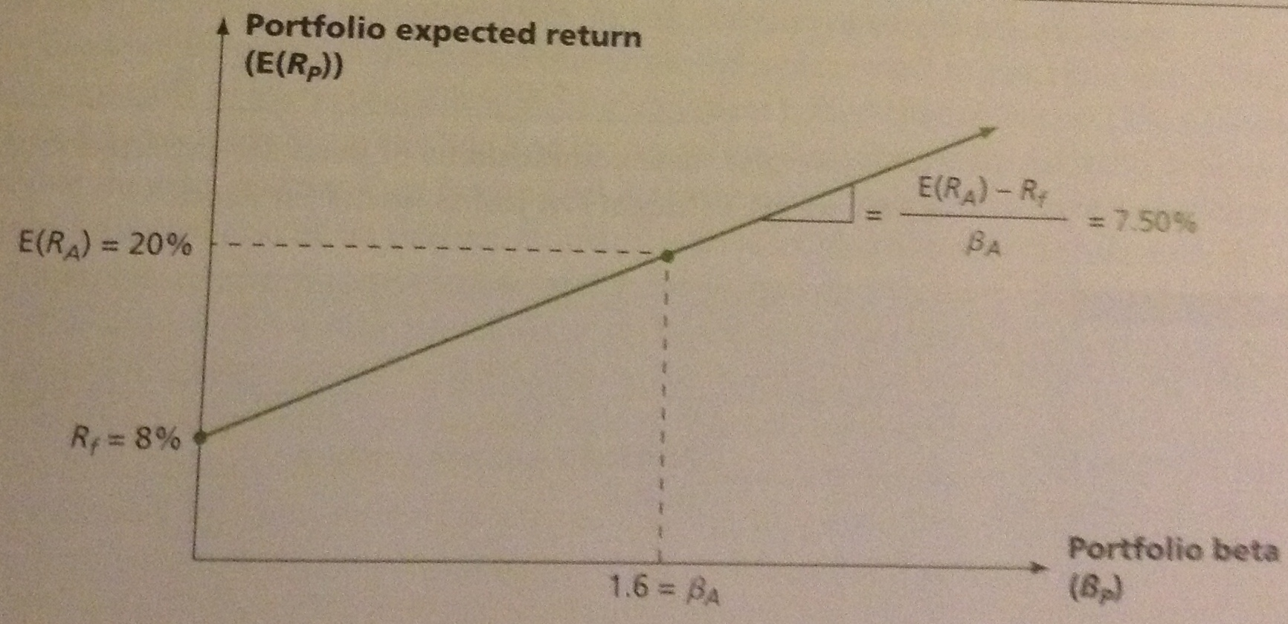

THE REWARD-TO-RISK RATIO
What’s the slope of the straight line in the figure above? As always, the slope of a straight line is equal to the “rise over run”.

As we move out of the risk-free asset into Asset A, the beta increase from 0 to 1.6 (a “run” of 1.6). At the same time, the expected return goes from 8 to 20%, a “rise” of 12%

The slope of the line is thus 12%/1.6 = 7.5%

Notice that the slope of our line is just the risk premium on Asset A, $E\left(R_{A}\right)-R_{f}$ divided by Asset A’s beta, $β_{A}$:

$$Slope=\frac{\left[E\left(R_{A}\right)-R_{f}\right]}{β_{A}}=\frac{\left[20\%-8\%\right]}{1.6}=7.50\%$$

This tells us that Asset A offers a reward-to-risk ratio of 7.5% - in other words, Asset A has a risk premium of 7.5% per unit of systematic risk.

THE BASIC ARGUMENT
Let’s consider a second asset, Asset B. This asset has a beta of 1.2 and an expected return of 16%.
Which investment is better, A or B? You might think it has to do with preference, but not in this case!

A is better because as we demonstrate, B offers inadequate compensation for its level of systematic risk, at least relative to A.

Start by calculating different combinations of expected returns and beta for portfolios of Asset B and a risk-free asset just as we did for Asset A.

Ex.:
If we put 25% in Asset B and the remaining 75% in the risk-free asset, the portfolio’s expected return would be:

$$E\left(R_{P}\right)=0.25*E\left(R_{B}\right)+\left(1-0.25\right)*R_{f}$$
=
0.25 * 16% + 0.75 * 8%
=
10%

The beta on the portfolio would be:

$$β_{P}=0.25*β_{B}+\left(1-0.25\right)*0$$
=
0.25 * 1.2
=
0.30

Some other possibilities are:

% of Portfolio in Asset B | Portfolio Expected Return | Portfolio Beta
0% | 8% | 0.0
25% | 10% | 0.3
50% | 12% | 0.6
75% | 14% | 0.9
100% | 16% | 1.2
125% | 18% | 1.5
150% | 20% | 1.8
We can plot these combination of portfolio expected returns and portfolio betas in the figure below; we get a straight line just as we did for Asset A:

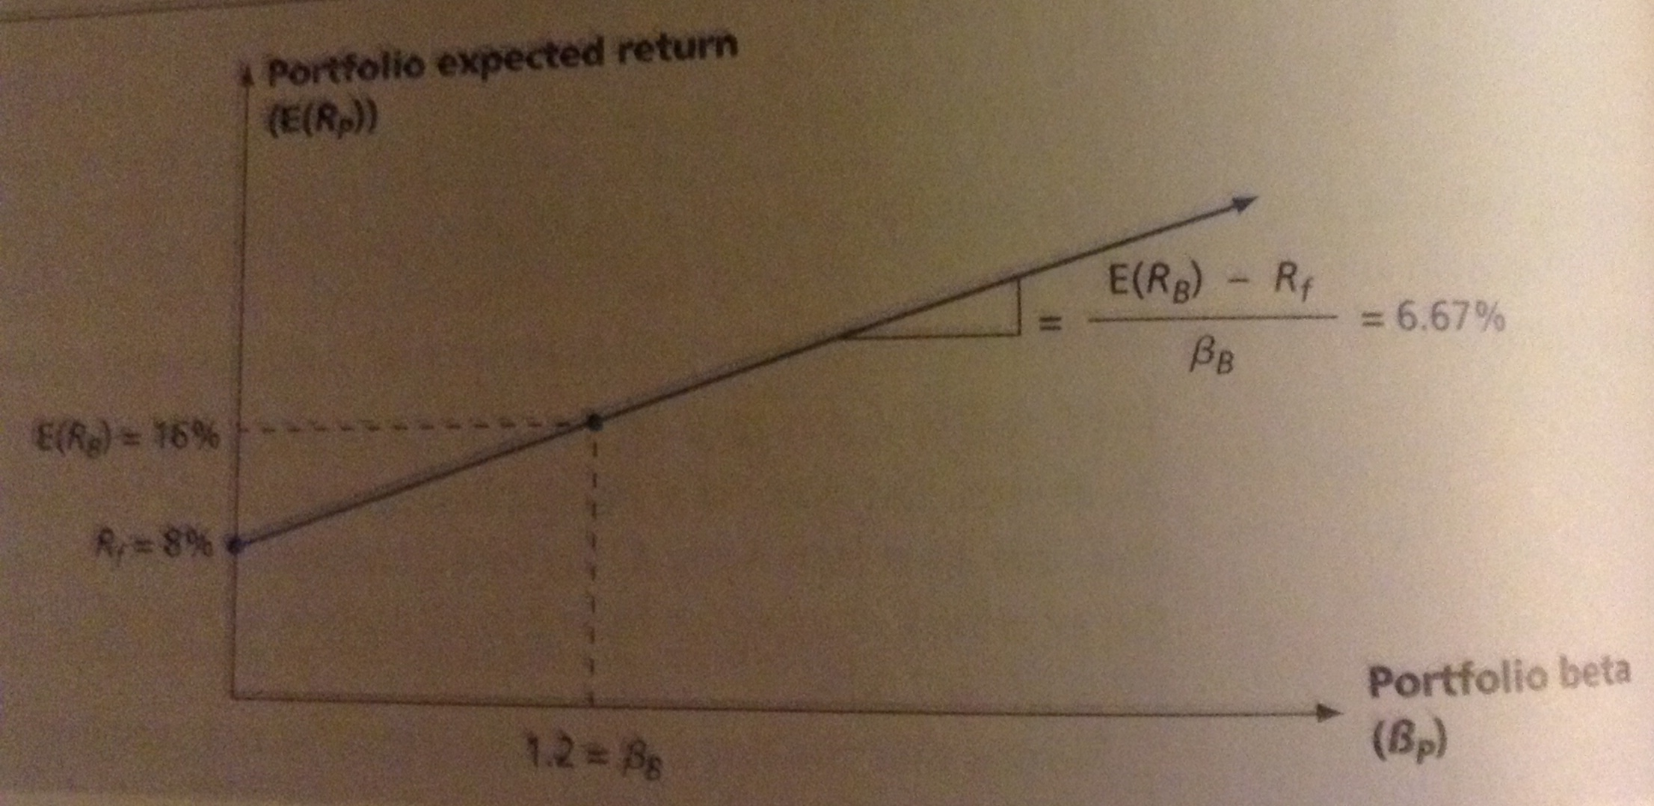

The key thing to notice when comparing the results for Assets A & B in the figure below is that the line describing the combination of expected returns and beta for Asset A if higher than the one for Asset B.

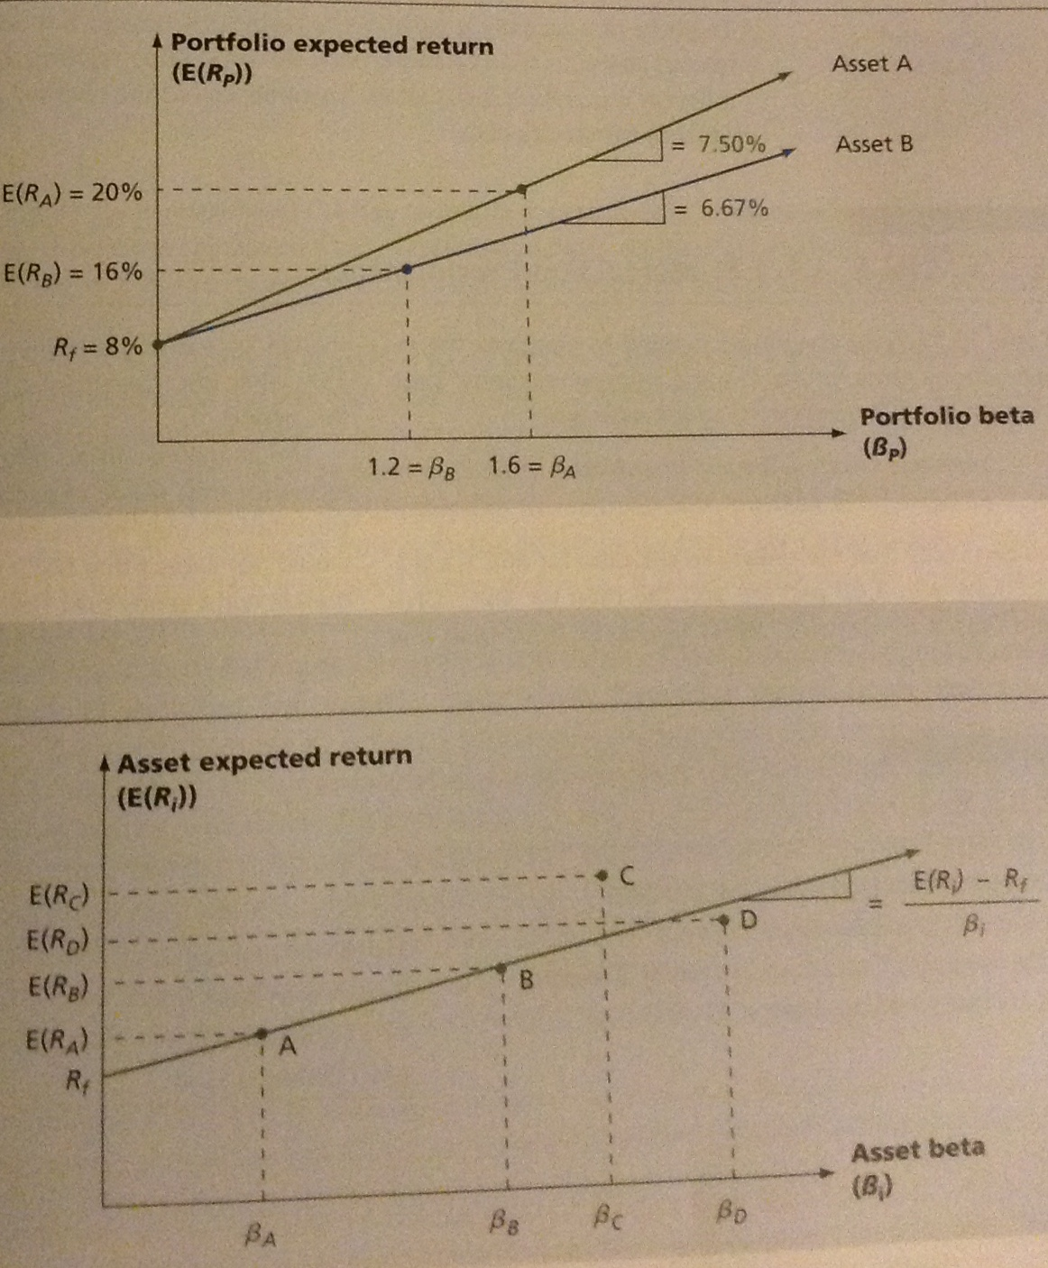

This tells us that for any given level of systematic risk (as measure by β), some combination of Asset A and the risk-free asset always offers a larger reward – this is why we can say that Asset A is a better investment than Asset B.

Another way to see that A offers a superior return for its level of risk is to note that the slope of our line for Asset B is:

$$Slope=\frac{\left[E\left(R_{B}\right)-R_{f}\right]}{β_{B}}=\frac{\left[16\%-8\%\right]}{1.2}=6.67\%$$

So Asset B has a reward-to-risk ratio of 6.67% which is less than the 7.5% offered by Asset A.

FUNDAMENTAL RESULT
In an organized, active market, the situation with Asset A & B we described can’t exist because investors would be attracted to A and away from B – as a result, Asset A’s price would rise and Asset B’s would fall.

Since prices and returns move in opposite directions, the result is that A’s expected return would decline and B’s would rise.

This buying and selling would continue until the 2 assets plotted on exactly the same line – meaning they’d offer the same reward for bearing risk.

So in an active, competitive market, we have to have:

$$\frac{\left[E\left(R_{A}\right)-R_{f}\right]}{β_{A}}=\frac{[E\left(R_{B}\right)-R_{f}]}{β_{B}}$$

This is the fundamental relationship between risk & return.
Our basic argument can be extended to more than just 2 assets – no matter how many assets we had, we’d always reach the same conclusion:

The reward-to-risk ratio must be the same for all the assets in the market

What it says, for example, is that, if one asset has twice as much systematic risk as another asset, its risk premium is simply twice as large.

Since all assets in the market must have the same reward-to-risk ratio, they all must plot on the same line in market equilibrium. This argument is shown in the figure below.

As shown, assets A & B plot directly on the line so they have the same reward-to-risk ratio. If an asset plotted above the line, like at point C, its price would rise and its expected return would fall until it plotted exactly on the line.

Similarly, if an asset plotted below the line, like point D, its expected return would rise until it also plotted directly on the line.

These arguments apply to active, competitive, well-functioning markets like the TSX and NYSE. That’s why these concepts are useful when looking at financial markets.

Ex.:
An asset is said to be overvalued if its price it too high given its experiences return and risk. Suppose you observe the following situation:

Security | Beta | Expected Return
SWMS Company | 1.3 | 14%
Insec Company | 0.8 | 10%

The risk-free rate is 6%. Is one of the 2 securities overvalued to the other?
To answer, we have to calculate the reward-to-risk ratio for.

For SWMS, this ratio is: $\frac{\left[14\%-6\%\right]}{1.3}=6.15\%$

For Insec, this ratio is: $\frac{\left[10\%-6\%\right]}{0.8}=5\%$

What we can conclude is that Insec offers an insufficient expected return for its level of risk, at least relative to SWMS. Since its expected return is too low, its price it too high.

To see why this is true, remember that the dividend valuation model treats price as the PV of future dividends:
$$P_{0}=\frac{D_{1}}{r-g}$$

Projecting the dividend stream gives us $D_{1}$ and g. If the required rate of return is too low, the stock price will be too high.

For example, suppose that $D_{1}=\$2.00$ and g = 7%
If the expected rate of return on the stock in wrongly under-estimated at 10%, the stock price estimate is $66.67.

The price is too high if the expected rate of return is 14% - at this higher rate of return, the stock price should fall to $28.57.

In other words, Insec is overvalued relative to SWMS and we’d expect to see its price fall relative to SWMS’s.

Ex.: Mutual Fund Performance
The table below gives the inputs needed to compute the reward-to-risk ratios for the TSX and 2 mutual funds.

Fund | Annual Return (%) | Beta
S&P/TSX Composite | 7.37 | 1
3-month Treasury Bills | 3.07 | 0
RBC Canadian Equity | 6.80 | 1.01
BMO Dividend Fund | 9.35 | 0.74

Starting with the TSX, the reward-to-risk ratio was:

$$\frac{Average return-Riskless Rate}{Beta}$$
=
$$\frac{7.37-3.07}{1.00}=4.3\%$$

The reward-to-risk ratio for RBC = 3.69%
The reward-to-risk ratio for BMO = 8.49%

BMO beat the market by earning a higher reward-to-risk ratio than the TSX, while RBC underperformed over this period.

Unfortunately, in an efficient market, while past performance may guide expectations of future returns, these expectations may not be realized in actual returns.

So we wouldn’t expect that BMO beat the market consistently over time.

CALCULATING BETA
The beta of a security measures its responsiveness of that security’s return to the return on the market as a whole.

To calculate beta, we draw a line relating the expected return on the security to different returns on the market. This line, called the characteristic line of the security, has a slope equal to the stock’s beta.

The figure below displays returns for both a hypothetical company and the market as a whole. Each point represents a pair of returns over a particular month.

The vertical dimension measures the return on the stock over the month and the horizontal dimension that of the S&P/TSX Composite.

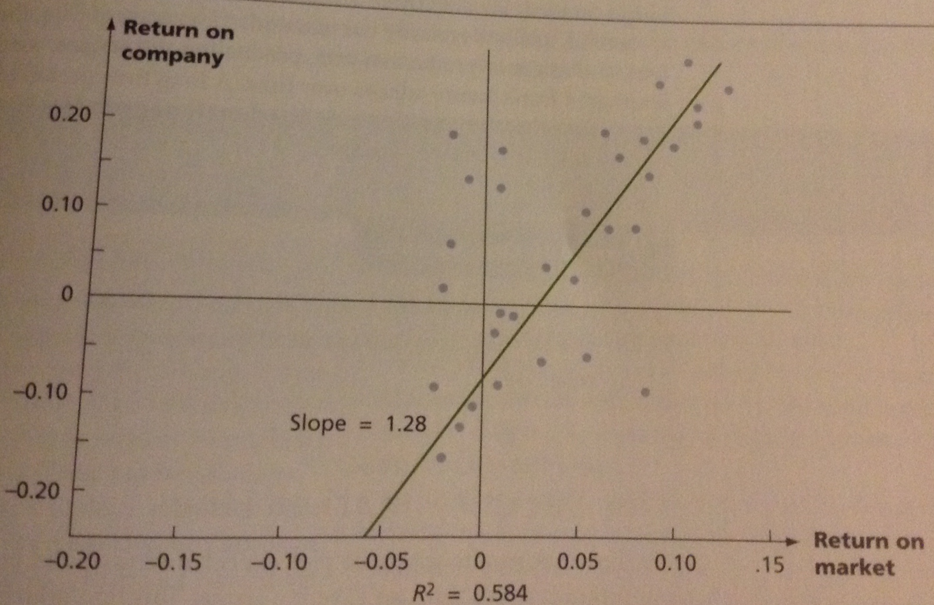

The figure also shows the line of best fit superimposed on these points. Practically, this line is calculated from regression analysis.

As you can see from the graph, the slope is 1.28. Because the average beta is 1.0, this indicates the stock’s beta of 1.28 is higher than that for the average stock.

The goal of a financial analyst is to determine the beta that a stock will have in the future – this is when the proceeds of an investment are received. But past data has to be used in regression analysis. So it’s incorrect to think of 1.28 as the beta of our example company – rather it’s our estimate of the firm’s beta from the past.

The bottom of the figure above indicates that the company’s $R_{2}$ over the time period is 0.584 – what does this mean?

$R_{2}$ measures how close the points in the figure are to the characteristic line. The highest value for $R_{2}$ is 1 – a situation that would occur if all points lay exactly on the characteristic line. This would be the case where the security’s return is determined only by the market’s return without the security having any independent variation.

The $R_{2}$ is likely to approach 1 for a large portfolio of securities.

For example, many widely diversified mutual funds have $R_{2}$s of 0.80 or more. The lowest possible $R_{2}$ is 0 – a situation occurring when 2 variables are entirely unrelated to each other. Companies whose returns are pretty much independent of returns on the stock market would have $R_{2}$s near 0.

The risk of security can be broken down into unsystematic and systematic risk. Beta measures the amount of systematic risk, $R_{2}$ measures the proportion of total risk that is systematic. So a low $R_{2}$ indicates that most of the risk of a firm is unsystematic.

In calculating beta, analysts make assumptions consistent with Canadian research on the capital asset pricing model:

- They generally choose monthly data, as do many financial economists. On the other hand, statistical problems usually come up when time intervals shorter than a month are used – but important information is lost when longer intervals are used. Choosing monthly data can be seen as a compromise.

- Analysts usually use just under 5 years of data, the result of another compromise. Because of changes in production mix, production techniques, management style and/or financial leverage, a firm’s nature adjusts over time. A long time period for calculating beta implies many out-of-date observations. On the other hand, a short time period leads to statistical imprecision because few monthly observations are used.

THE SECURITY MARKET LINE

The line that we get when we plot expected return and beta coefficients is important – this line is used to describe the relationship between systematic risk and expected return in financial markets. This line is usually called the security market line (SML).

After the NPV, the SML is the most important concepts in modern finance.

Security Market Line (SML) – Positively sloped straight line displaying the relationship between expected return and beta.

MARKET PORTFOLIOS
It’s useful to know the equation of the SML. There are many different ways to write it, but there’s one that’s most common.

Let’s consider a portfolio made up of all of the assets in the market – this type of portfolio is called a market portfolio and we write the expected return on this market portfolio as $E\left(R_{M}\right)$

Since all assets in the market must plot on the SML, so must a market portfolio made of those assets. To figure out where it plots on the SML, we need to know the beta of the market portfolio, $β_{M}$

Because this portfolio represents all the assets in the market, it has to have average systematic risk – in other words, a beta of 1.0

So, we could therefore write the slope of the SML as:

SML Slope

$$\frac{\left[E\left(R_{M}\right)-R_{f}\right]}{β_{M}}=\frac{\left[E\left(R_{M}\right)-R_{f}\right]}{1}=E\left(R_{M}\right)-R_{f}$$

The term $E\left(R_{M}\right)-R_{f}$ is often called the market risk premium since it’s the risk premium on a market portfolio.

Market Risk Premium – Slope of the SML, the difference between expected return on a market portfolio and the risk-free rate

THE CAPITAL ASSET PRICING MODEL
If we let $E\left(R_{i}\right) and β_{i}$ stand for the expected return and beta, respectively, on any asset in the market, we know it must plot on the SML.

As a result, we know that its reward-to-risk ratio is the same as the overall market’s:

$$\frac{\left[E\left(R_{i}\right)-R_{f}\right]}{β_{i}}=E\left(R_{M}\right)-R_{f}$$
If we re-arrange this, we can write the equation for the SML as:

SML Equation

$$E\left(R_{i}\right)=R_{f}+\left[E\left(R_{M}\right)-R_{f}\right]*β_{i}$$

This result is identical to the famous capital asset pricing model (CAPM).

Capital Asset Pricing Model (CAPM) – Equation of the SML showing the relationship between expected return and beta

What the CAPM shows is that the expected return for a particular asset depends on 3 things:

- The pure time value of money. As measured by the risk-free rate, $R_{f}$, this is the reward for merely waiting for your money, without taking any risk

- The reward for bearing systematic risk. As measured by the market risk premium $[E\left(R_{M}\right)-R_{f}]$, this component is the reward the market offers for bearing an average amount of systematic risk in addition to waiting

- The amount of systematic risk. As measured by $β_{i}$, this is the amount of systematic risk present in a particular asset, relative to an average asset.

The CAPM works for portfolios of assets just as it works for individual assets. Earlier we saw how to calculate a portfolio’s β – we just use this β in the CAPM equation to find the expected return on a portfolio.

The figure below summarizes our discussion of the SML and the CAPM. We plot the expected return against – but, now we recognize that based on the CAPM, the slope of the SML is equal to the market risk premium $[E\left(R_{M}\right)-R_{f}]$

- 13.11

SUMMARY OF RISK & RETURN
Total Risk
The total risk of an investment is measured by the variance, or, more commonly, the standard deviation of its return.
Total Return
The total return on an investment has 2 components:
- The expected return
- The unexpected return

The unexpected return comes from unanticipated events. The risk from investing comes from the possibility of unanticipated events.
Systematic & Unsystematic Risks
Systematic Risks – Also called market risks; these are unanticipated events that affect almost all assets to some degree because they’re economy wide.

Unsystematic Risks – Unanticipated events that affect single assets or small groups of assets. They’re also called unique or asset-specific risks.
The Effect of Diversification
Some – but not all – of the risk associated with a risky investment can be eliminated by diversification. The reason is that unsystematic risks, which are unique to individual assets, tend to wash out in a large portfolio; systematic risks, which affect all of the assets in a portfolio to some extent, don’t.
The Systematic Risk Principle & Beta
Because unsystematic risk can be freely eliminated by diversification, the systematic risk principle states that the reward for bearing risk depends only on the level of systematic risk.

The level of systematic risk in a particular asset, relative to average, is given by the beta of that asset.
The Reward-to-Risk Ratio & the Security Market Line
The reward-to-risk ratio for asset i is the ratio of its risk premium $E\left(R_{i}\right)-R_{f}$ to its beta $β_{i}$:
$$\frac{\left[E\left(R_{i}\right)-R_{f}\right]}{β_{i}}$$
In a well-functioning market, this ratio is the same for every asset. As a result, when asset expected returns are plotted against asset beta, all assets plot on the same straight line, called the security market line (SML)

The Capital Asset Pricing Model
From the SML, the expected return on asset i can be written:

$$E\left(R_{i}\right)=R_{f}+\left[E\left(R_{M}\right)-R_{f}\right]*β_{i}$$

This is the capital asset pricing model (CAPM). The expected return on a risky asset thus has 3 components:
- The time value of money, $R_{i}$
- The market risk premium, $\left[E\left(R_{M}\right)-R_{f}\right]$
- The beta for the asset, $β_{i}$

