Assessment for Learning: Teacher evaluation

Lesson 2: Limits
Tasks

Rates of change and limits
Welcome to the first Assessment activity of this course. This is an Assessment for Learning, which is used to determine where you are in your learning, where you need to go, and how best to get there. Your teacher will provide you with feedback on your work, but not marks. This is to prepare you for your first marked Assessment. When you have completed this Assessment for Learning, submit it to your teacher using the online submission tool.
As you are submitting material for a Math course, please see the Mathematics Course Communication Requirements document in your Locker before you start your work.
There are four Tasks in this Assessment for Learning.

Task 1: Knowledge and Understanding questions
- Determine the limit of the function $f\left(x\right)=\frac{x^{2}+3x-10}{x-2}$ approaches 2.
Answer:
$$\lim_{x→2}{f\left(x\right)=\lim_{x→2}\frac{x^{2}+3x-10}{x-2}}=\lim_{x→2}\frac{(x+5)(x-2)}{x-2}=\lim_{x→2}\left(x+5\right)=7$$

- Evaluate the following limit: $\lim_{x→4}{\frac{4x^{2}-7}{x-3}}$
Answer:
$$\lim_{x→4}{\frac{4x^{2}-7}{x-3}}=\frac{4×4^{2}-7}{4-3}=57$$
- Determine the limit of the function $f\left(h\right)=\frac{\sqrt{h+9}-3}{h}$ approaches 0.
Answer:
$\lim_{h→0}{\frac{\sqrt{h+9}-3}{h}=\lim_{h→0}}\frac{\left(\sqrt{h+9}-3\right)\left(\sqrt{h+9}+3\right)}{h\left(\sqrt{h+9}+3\right)}=\lim_{h→0}{\frac{h}{h\left(\sqrt{h+9}+3\right)} }$
$=\lim_{h→0}{\frac{1}{\sqrt{h+9}+3}=\frac{1}{\sqrt{0+9}+3}}=\frac{1}{6}$
- What is the average rate of change for the function $g\left(x\right)=2{\left(x-4\right)}^{2}+12$ between $x=6$ and $x=8$?
Answer:
$$\frac{g\left(8\right)-g\left(6\right)}{8-6}=\frac{44-20}{2}=12$$
Average rate of change is 12
- Estimate the instantaneous rate of change of the function $f\left(x\right)=x^{3}-2x+5$ at $x=1$, using the secant method. Round your answer to two decimal places.
Answer:
$$\frac{f\left(1.01\right)-f\left(0.99\right)}{1.01-0.99}=\frac{\left({1.01}^{3}-2.02+5\right)-\left({0.99}^{3}-1.98+5\right)}{0.02}=\frac{0.020002}{0.02}=1$$
Instantaneous rate of change is 1.
- Use limit notation to find the instantaneous rate of change of the function $f\left(x\right)=-4x^{2}+11x+3$ at $x=5$.
Answer:
$$\lim_{h→0}{\frac{f\left(5+h\right)-f\left(5\right)}{h}}=\lim_{h→0}{\frac{\left[-4{\left(5+h\right)}^{2}+11\left(5+h\right)+3\right]-\left[-4×5^{2}+11×5+3\right]}{h}}$$
$=\lim_{h→0}{\frac{-4\left(10h+h^{2}\right)+11h}{h}=\lim_{h→0}\left(-4h-29\right)=-29}$

Task 2: Thinking questions
- What does $\lim_{h→0}{\frac{f\left(4+h\right)-f\left(4\right)}{h}=8}$ indicate about the graph of the function $f\left(x\right)=x^{2}$?
Answer: The graph of the function $f(x)$ has a tangent line at $x=4$ with a slope of 8
- Determine whether the following functions are equivalent. Justify your answer.
$f\left(x\right)=\frac{x^{2}+4x-32}{x-4}$ and $g\left(x\right)=x\left(2x-5\right)-2(x^{2}-3x-4)$
Answer: They are not equivalent. Because $f(x)$ has a domain of $x∈R,x≠4$, while $g(x)$ has a domain of $x∈R$
- Determine the equation of the tangent line to the graph of $f\left(x\right)=-4x^{2}+11x-2$ at $x=2$ that is parallel to the line $y=-5x-1$.
Answer:
$$f\left(2\right)=-16+22-2=4$$
Therefore, the tangent line is: $y=-5\left(x-2\right)+4, y=-5x+14$
- For the function $y=-2x^{2}+24x-63$:
  - Find the vertex of the graph by completing the square.
Answer:
$$y=-2\left(x^{2}-12x+36\right)+9$$
$$y=-2{\left(x-6\right)}^{2}+9$$
Therefore, the vertex is $\left(6, 9\right).$
  - What are the roots of the function? Round your answers to two decimal places.
Answer:
$$-2{\left(x-6\right)}^{2}+9=0$$
$$x=6±\frac{3\sqrt{2}}{2}$$
  - Which way does the parabola open? Explain your answer.
Answer: Since coefficient for $x^{2}$is negative, the parabola open downwards.

Task 3: Communication questions
- In your own words, describe how limits can be used to find the instantaneous rate of change of a function.
Answer: Instantaneous rate of change for function $f(x)$ at point $x=x_{0}$ is defined by
$$\lim_{h→0}{\frac{f\left(x_{0}+h\right)-f\left(x_{0}\right)}{h}}$$
- Explain the difference between a secant line and a tangent line. How do they relate to the rate of change of a function? Include a sketch of each type of line in your solution.
Answer:
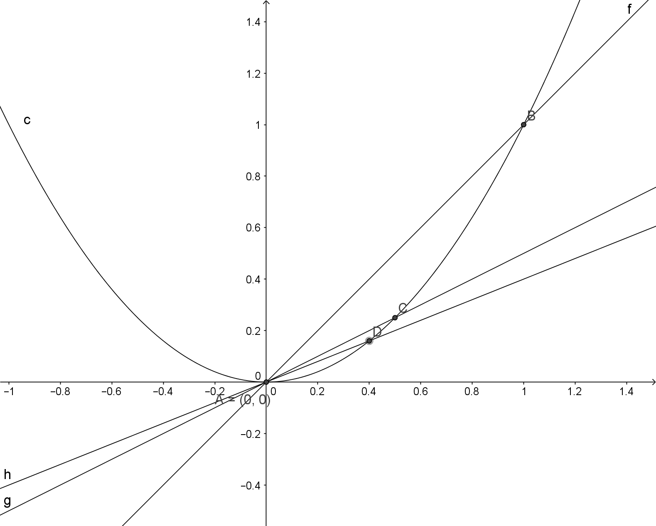
Line AB is a secant line that has two intersections with the curve $y=x^{2}$. When point B approaches point A along the curve, the secant line approaches to y-axis that is a tangent line at point A(0, 0). The rate of change from A to B approaches the rate of change at point B when point B approaches point A along the curve.
- Define the following mathematical terms:
  - Conjugates
Answer: The conjugate of x + y is x – y
  - secant method
Answer: $\frac{f\left(x+h\right)-f\left(x\right)}{h}$ is used as a slope for a secant line
  - limit
Answer: a number that can be approach infinitely but never equal to
  - completing the square
Answer: to change a quadratic form into a complete square term plus a constant
- What is the difference between the secant method and the limit formula for calculating instantaneous rate of change?
Answer: No difference

Task 4: Application questions
- The path of a baseball relative to the ground can be modelled by the function $d\left(t\right)=-t^{2}+8t+1$, where $d(t)$ represents the height of the ball in metres, and $t$ represents time in seconds.
  - Sketch a graph of the function between 0 and 9 seconds.
Answer:
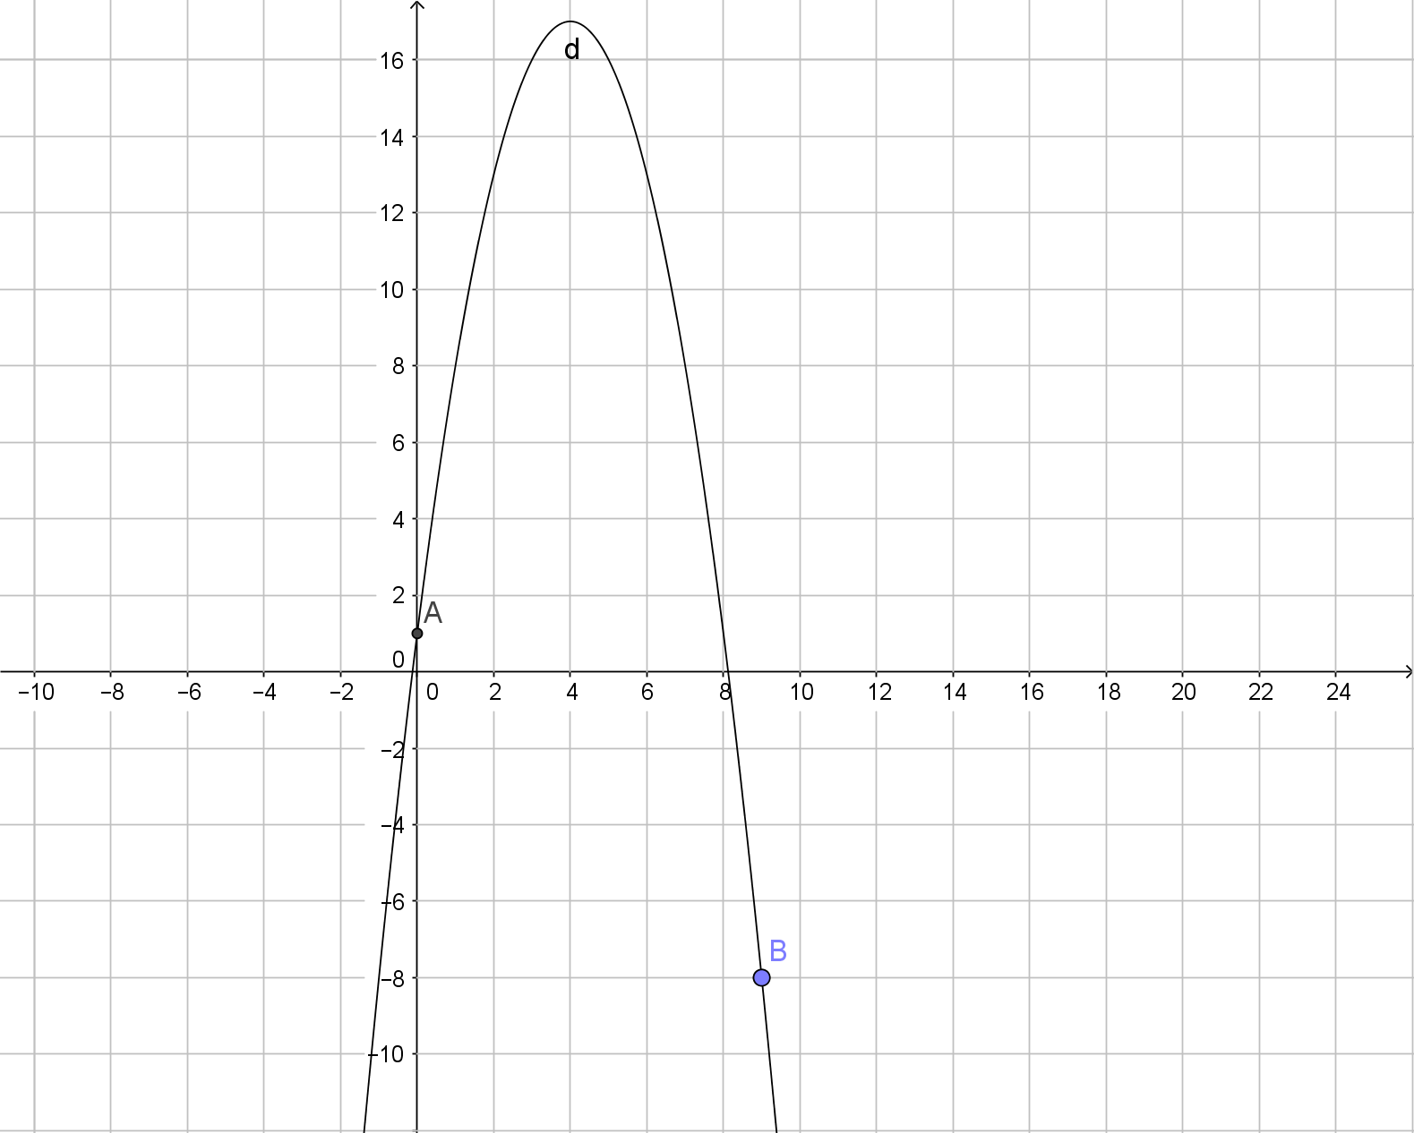
  - What is the speed of the ball when it hits the ground?
Answer:
$$d\left(t\right)=0, -t^{2}+8t+1=0, t=\frac{8±\sqrt{8^{2}+4}}{2}$$
Only take positive value of $t:t=8.12$. Then
speed$=\frac{d\left(8.12+0.01\right)-d\left(8.12-0.01\right)}{0.02}=\frac{-0.0569-0.1079}{0.02}=-8.24$
Therefore, the speed is 8.24m/s when it hits the ground.
- For the function $f\left(x\right)=2x^{3}+10x^{2}-28x$:
  - Use the secant method to estimate the instantaneous rate of change at $x=-3$, when $b=-3.001$. Round all non-terminating decimals to four decimal places.
Answer:
Instantaneous rate of change $=\frac{f\left(-3\right)-f\left(-3.001\right)}{-3-\left(-3.001\right)}=\frac{120-120.034}{0.001}=-34$
  - Determine the equation of the tangent line at $x=-3$.
Answer:
$$y=-34\left(x+3\right)+f\left(-3\right)$$
$$y=-34x+18$$
  - The tangent line intersects the graph of $f\left(x\right)=2x^{3}+10x^{2}-28x$ at another point. Determine the other point of intersection.
Answer:
$$\left\{\begin{aligned}y=-34x+18 \\ y=2x^{3}+10x^{2}-28x\end{aligned}\right.$$
$$2x^{3}+10x^{2}+6x-18=0$$
$$2\left(x+3\right)\left(x^{2}+2x+3\right)=0$$
$${\left(x+3\right)}^{2}\left(x-1\right)=0$$
Therefore, $x=1, y=-16$, the other point is $(1,-16)$

