Biology 121 – PRACTICE Midterm 1

*Please note: The questions will be similar in format, but could test different concepts or be different kinds of questions or have different lengths or have a different mark break-down. You will really need to know the material well to solve all of the questions in under 50 minutes.

The answer key is provided in a separate file. It is STRONGLY recommended that you try and solve ALL of the problems on your own before the answers are provided.

You will be allowed to bring with you to the exam: one sheet of paper, with your Concept Map on one side(if required) and hand-written notes on the other. One mark on the exam will be for the Concept Map, please check the Connect site for the specific instructions on how to make one. You will not need a calculator, they will not be allowed. No cell-phones or devices with cameras or internet access will be allowed.

-Biology 121 Teaching Team

Biology 121
Practice Midterm 1
January, 2017

Name :
 | FAMILY NAME |  | FIRST NAME

Student Number : _______________________________

Instructions:

1. Answer all questions in the space provided.
2. Answers may be in sentences or point form. Illustrations are acceptable but must be annotated. If you write in pencil or erasable ink, your exam will not be eligible for a remark.
3. Students suspected of any dishonest practices will be immediately dismissed from the examination and will be subject to disciplinary action.
4. Other than one side of one page for summary notes and one side of the same page for concept maps, no other memory devices are permitted.
5. Students may not speak or in any other way communicate with other students while in the examination room.
6. Students may not expose their written paper to other students. The excuse of accidental exposure, forgetfulness, or ignorance will not be accepted.
7. Make sure you have 5 pages including this cover page.

I have read and fully understand these instructions.
Student signature _________________________

Mark allocation:
 |  |  |  | Question | Marks possible | Your mark
 |  |  |  | 1. | 16
 |  |  |  | 2. | 10
 |  |  |  | 3. | 8
 |  |  |  | 4. | 6
 |  |  |  | 5. | 9
 |  |  |  | Concept map | 1
 |  |  |  | Total | 50
1. For this pedigree, determine the mode of inheritance and the possible genotypes for each individual. Assume the alleles B and b control the expression of the trait. (16 marks total)
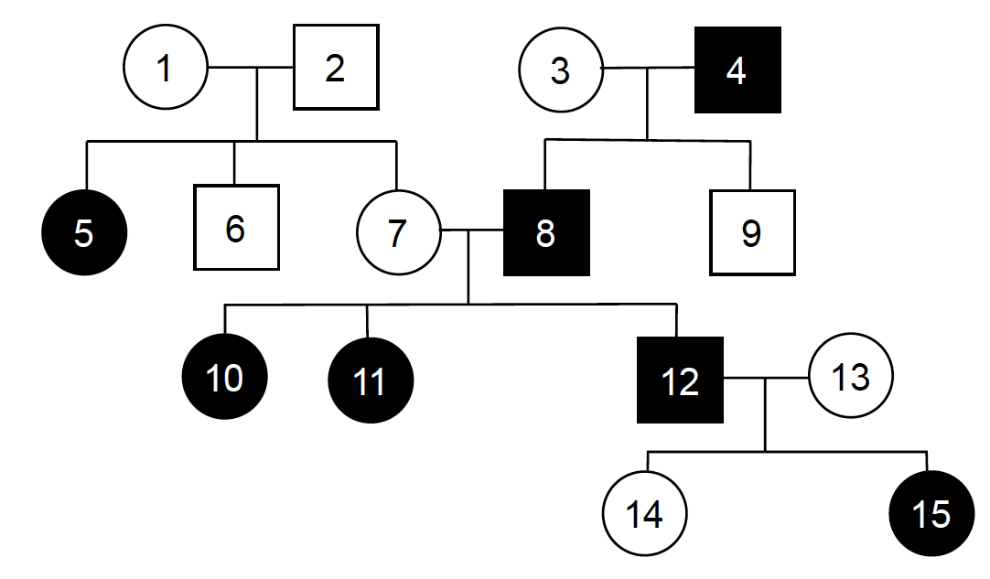
 | Possible or impossible? | If impossible, please provide support for your answer by making specific reference to relevant individuals in the pedigree.
Autosomal dominant | impossible | Impossible b/c generation of parent 1 and parent 2 are not affected. And all affected parents can have unaffected children (children 9 and 14).
Autosomal recessive | possible
X-linked dominant | impossible
X-linked recessive | impossible

2. A geneticist is studying genetic variation in three butterfly traits:
- The stripes gene has two alleles, A1 and A2
- The spots gene has two alleles, B1 and B2
- The colour gene has two alleles, C1 and C2
These three genes are on three different chromosomes. (10 marks total)

A) A butterfly has the genotype A1/A2; B1/B2; C1/C2, as shown in the diagram below.

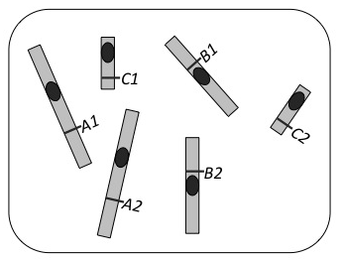 | The maximum number of different types of gametes (i.e., with different genotypes) this butterfly is capable of producing by meiosis is: (1 mark)  The maximum number of different gametes that can be produced when a single sex cell from this butterfly undergoes meiosis is: (1 mark)

B) A sex cell from this butterfly undergoes meiosis and produces four gametes. Two of these four gametes are represented in the diagrams below:
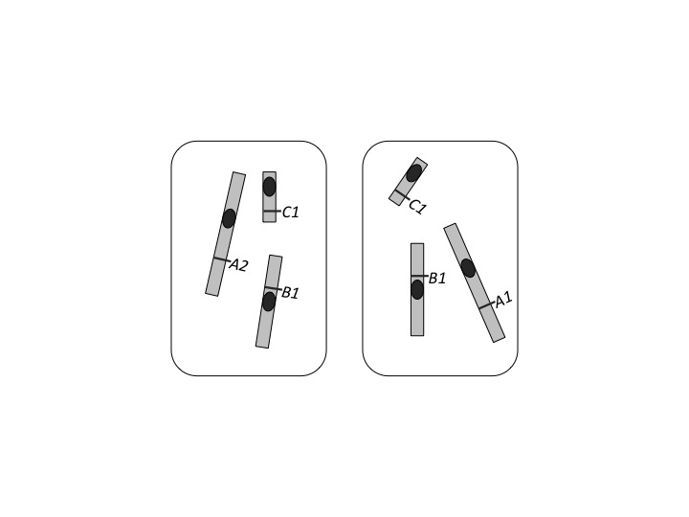
Based on the gametes shown above, draw clear diagrams showing the chromosomes of the original butterfly sex cell that produced these two gametes:

- at G2 (after DNA replication, before the start of meiosis): (4 marks)

- at metaphase of meiosis I, clearly indicating the direction in which the chromosomes will segregate/move: (4 marks)

3a. In a certain breed of dog long hair is dominant over short hair; the gene involved is autosomal. Another gene, B controls hair colour, which is X-linked, one allele B1 produces gray coloured hair; the other allele B2 produces red coloured hair; and the heterozygous combination B1B2 produces brindle coloured hair (a mix with patches of both gray and red coloured hairs).

If a red male homozygous for long hair is mated with a brindle short-haired female, what kind of puppies could be produced in the F1? (for each possible kind of puppy, state the length of their hair, their colour and their sex) (4 marks)

3b. A dominant gene, A, causes yellow color in rats. The dominant allele of another independent gene, R, produces black coat color. When the two dominants occur together (A_R_), they interact to produce gray. Rats of the genotype aarr are cream-colored. If a gray male and yellow female produce approximately 3/8 yellow, 3/8 gray, 1/8 cream, and 1/8 black offspring, what are the genotypes of the two parents? (4 marks)

4. (6 marks) A true-breeding Drosophila with red eyes and small body size was crossed with a true-breeding Drosophila with scarlet eyes and normal body size. The F1 all had red eyes and normal body size. The F1 were crossed with Drosophila with scarlet eyes and small bodies. The progeny were as follows:
red eyes and normal body size 56
red eyes and small body size 218
scarlet eyes and normal body size 182
scarlet eyes and small body size 44

Explain why you suspect these genes are on the same chromosome.

5. Squash fruits come in three distinct shapes: round, long, and disk. A squash farmer set up as series of crosses between the three varieties of squash and obtained the following results: (9 marks)

Cross Parents Offspring
1 round x round 13 round, 6 long, 5 disk
2 long x long 21 long
3 disk x disk 18 disk
4 round x long 13 round, 11 long
5 round x disk 12 round, 10 disk
6 long x disk 19 round

a) Define the letters or symbols you will use for the alleles. (1 mark)

b) What are the genotypes of the parents and offspring in cross #1? (4 marks)

c) What are the genotypes of the parents and offspring in cross #4? (4 marks)

