Sense and Perception

Our senses encode the information our brains perceive.
Sensation and perception are related but separate events
- Sensation: Simple stimulation of a sense organ
- Perception: Organization, identification, and interpretation of a sensation in order to form a mental representation
- Transduction: What takes place when many sensors in the body convert physical signals from the environment into encoded neural signals sent to the central nervous system

Sense | Sensory Input
Vision | Light reflected from surfaces provides the eyes with information about the shape, color, and positions of objects
Audition | Vibrations cause changes in air pressure that move through space to the listener’s ears
Touch | Pressure of a surface against the skin signals its shape, texture, and temperature
Taste and smell | Molecules dispersed in the air or dissolved by saliva reveal the identity of substances that we may or may not want to eat

Perceptions differ between people.
Psychophysics: Methods that measure the strength of a stimulus and the observer’s sensitivity to that stimulus
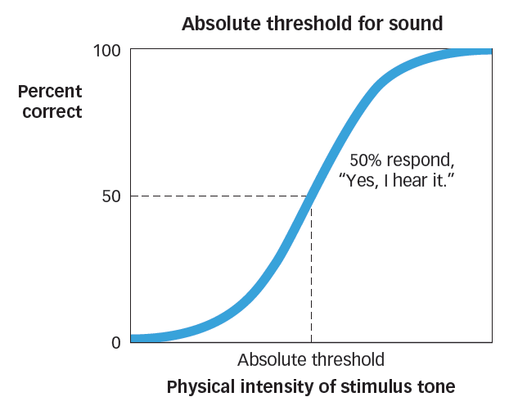
Measuring the threshold (boundary):
Absolute threshold: Minimal intensity needed to just barely detect a stimulus (usually identification on 50% of trials)

Absolute threshold is graphed here as the
point where the increasing intensity of
the stimulus enables an observer to detect
it on 50% of the trials. As its intensity
gradually increases, we detect the stimulation more frequently.

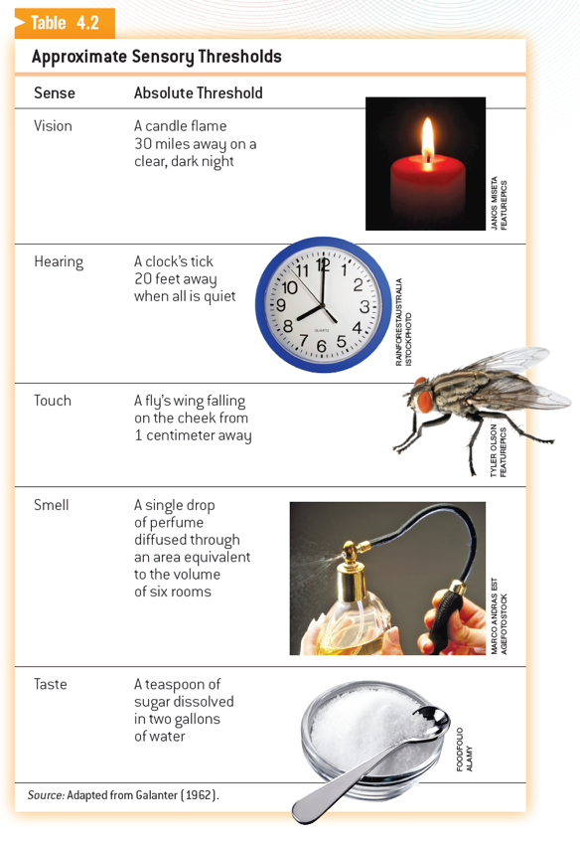
Type of threshold:
Just Noticeable Difference (JND):
Minimal change in a stimulus that can just barely be detected
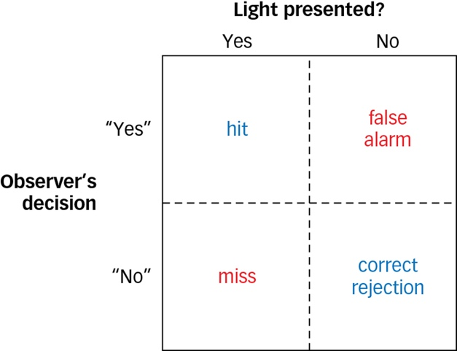
Signal detection theory:
    - Presence of noise
    - Individual perceptual sensitivity

Sensory adaptation:
- Sensitivity to prolonged stimulation declines over time as an organism adapts to current conditions

Vision:

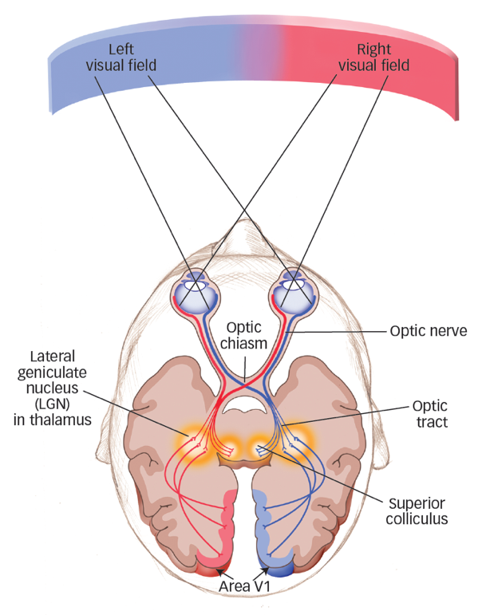
Vision I: How the Eyes and the Brain Convert Light Waves to Neural Signals
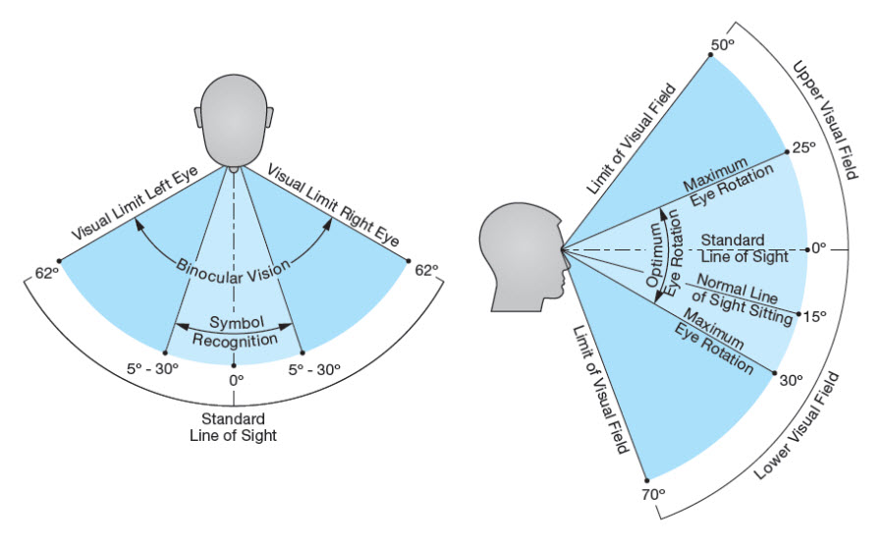

Visual acuity: Ability to see fine details

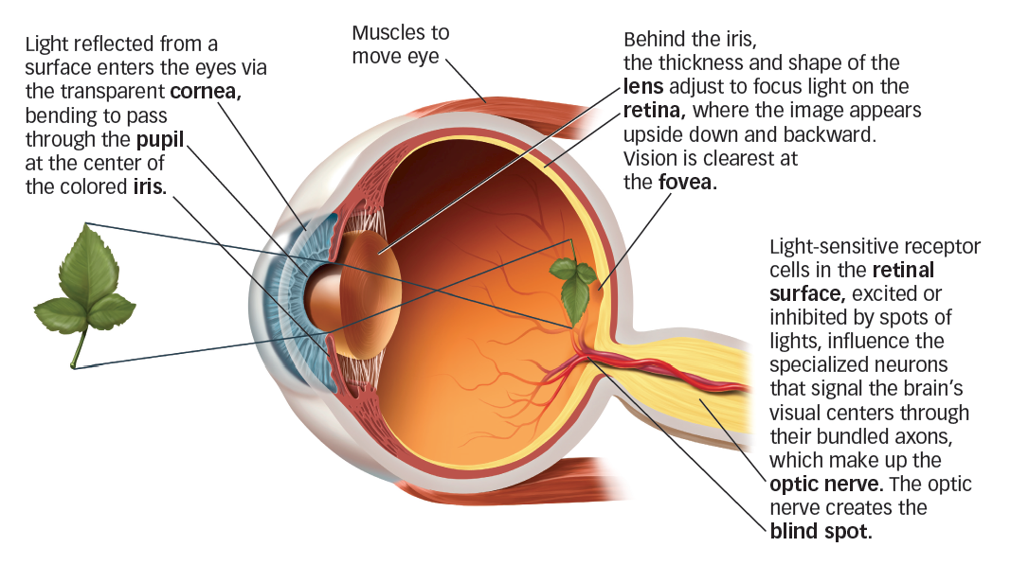
Anatomy of the human eye:

Close-up of the Retina
- The surface of the retina is composed of photoreceptor cells, the rods and cones, beneath a layer of transparent neurons, the bipolar and retinal ganglion cells (RGCs), connected in sequence.

A given RGC will respond to light falling anywhere within a small patch (receptive field).
Receptive field: Region of the sensory surface that, when stimulated, causes a change in the firing rate of that neuron.
- On-center cells, off-center cells

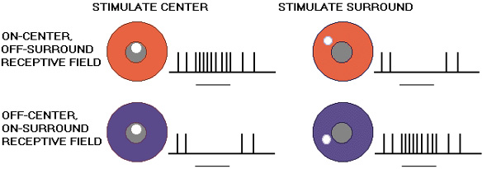

Objects selectively absorb some wavelengths of light and reflect others.
Color perception corresponds to the summed activity of the three types of cones.

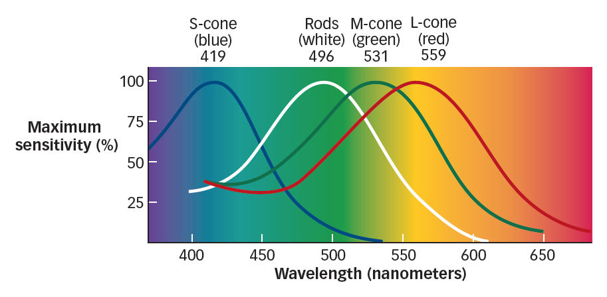

Properties of light waves:
- Length: Determines color
- Intensity: Determines brightness
- Purity: Corresponds saturation or richness of color

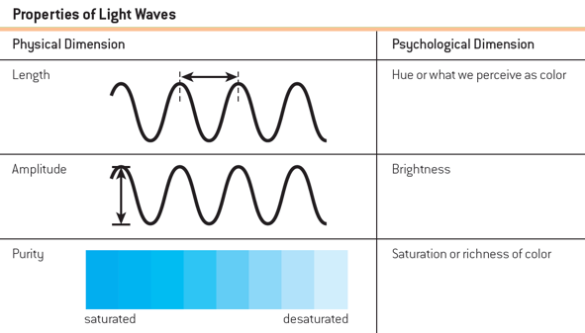

- Streams of action potentials containing information encoded by the retina travel to the brain (along the optic nerve) for further processing

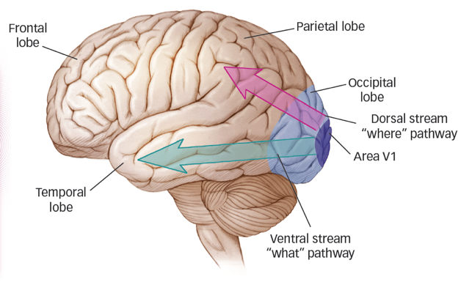
There are two distinct pathways, or visual streams, project from the occipital cortex to visual areas in other parts of the brain:
- Ventral stream (“what”) to temporal lobe
- Dorsal stream (“where”) to the parietal lobe
Evidence of two distinct streams comes from brain damage cases.
- Visual-form agnosia: The inability to recognize objects by sight

- Binding process: Utilizes structures in the ventral and especially the dorsal stream (parietal lobe)
- Binding problem: How features are linked together so that we see unified objects in our visual world rather than free-floating or mis-combined features

Errors in binding occur:
  - Illusory conjunction: Perceptual mistake where features from multiple objects are incorrectly combined
  - Feature integration theory: Idea that focused attention is not required to detect the individual features that comprise a stimulus, but is required to bind those individual features together

Illusory Conjunction example:

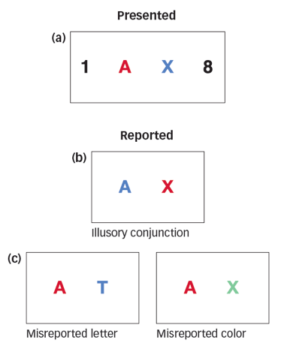

when participants are shown a red A sometimes report seeing a blue A and red X.

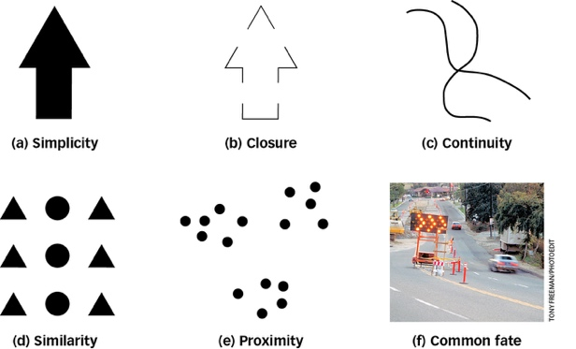
Perceptual constancy: Even as aspects of sensory signals change, perception remains consistent.
Gestalt perceptual grouping rules:
- Simplicity
- Closure
- Continuity
- Similarity
- Proximity
- Common fate

Grouping: Involves separating a figure from its (back)ground.

Theories of Object Recognition:
Image-based object recognition theory states that objects are stored as templates.
Template: Mental representation that can be directly compared to a viewed shape in the retinal image

Parts-based object recognition theory states that the brain deconstructs viewed objects into a collection of parts.

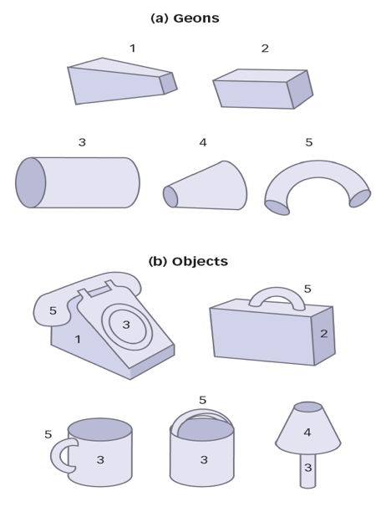
Parts-based theory holds that objects such as those shown in (b) are made up of simpler 3-D components called geons, shown in (a), such as letters combined to form different words.

Geons: Geometric elements combined to make objects
Perceiving Depth and Size:

Monocular depth cues: Aspects of a scene that yield information about depth when viewed with only one eye
  - Relative size
  - Familiar size
  - Linear perspective
  - Texture gradient
  - Interposition
  - Relative height

Familiar Size and Relative Size:
With a little image manipulation, you can see in the right-hand photo that the relative difference projected on your retinas is far greater than you perceive.
The image of the person in the dark blue vest is exactly the same size in both photos.

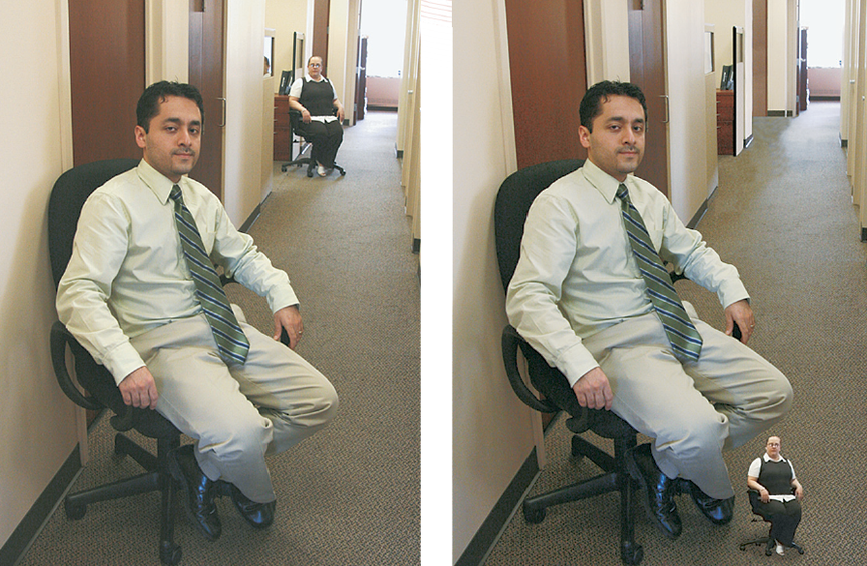

Binocular disparity (depth cues): Difference in the retinal images of the two eyes that provides information about depth

Perceiving Motion and Change:
To sense motion, the visual system must encode information about both space and time.

Illusions in motion:
- Waterfall illusion (opponent process), apparent motion: The perception of movement as a result of alternating signals appearing in rapid succession in different locations (phi phenomenon)

Color Perception and Motion Perception:
Both rely partially on opponent processing, which is why we fall prey to illusions such as color aftereffects and the waterfall illusion.

Sometimes we fail to focus attention on a changed object
Change blindness: When people fail to detect changes to the visual details of a scene
In-attentional blindness: Failure to perceive objects that are not the focus of attention

Audition:
Hearing involves the detection of sound waves, or changes in air pressure unfolding over time
Sound waves involve qualities of:
- Frequency (pitch: how high or low a sound is)
- Amplitude (loudness: a sound’s intensity)
- Timbre: A listener’s experience of sound quality or resonance

The Human Ear:
The ear is divided into three distinct parts:
- The outer ear (collects sounds waves)
- The middle ear (transmits vibrations)
- The inner ear (transduction into neural impulses)

Transduction in the inner ear involves several structures:
  - Cochlea: Fluid-filled tube that is the organ of auditory transduction
  - Basilar membrane: Structure in the inner ear that undulates when vibrations from the ossicles reach the cochlear fluid
  - Hair cells: Specialized auditory receptor neurons embedded in the basilar membrane

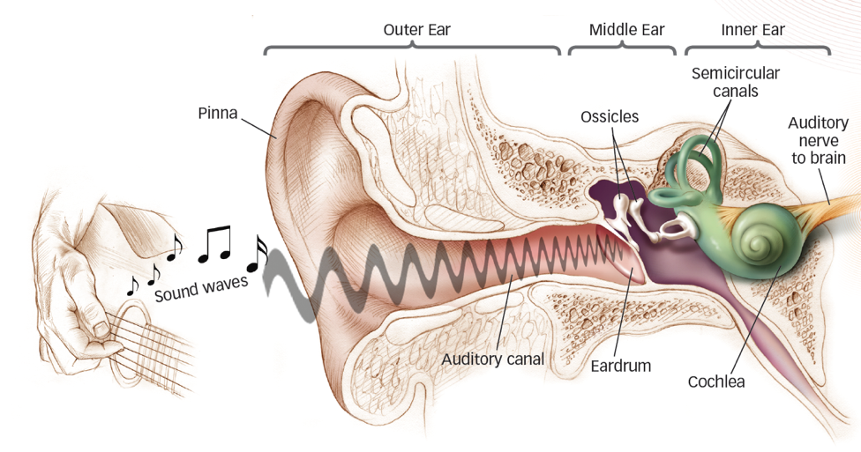

Auditory Transduction:
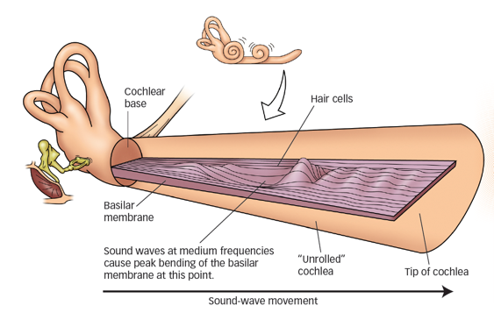

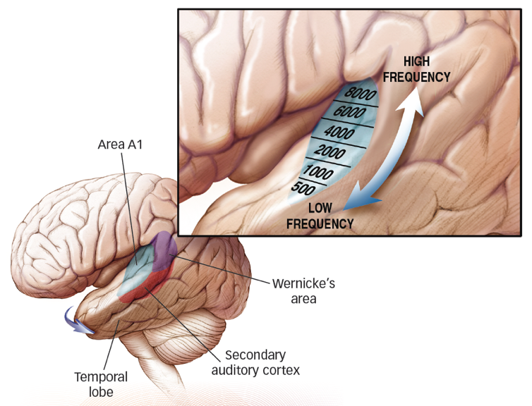

Area A1: a portion of the temporal lobe that contains the primary auditory cortex
The auditory cortex is composed of two distinct streams:
Spatial (“where”) auditory features locate the source of a sound (back/caudal auditory cortex).
Non-spatial (“what”) auditory features locate temporal aspects of a sound (lower/ventral auditory cortex).

Encoding of sound occurs in two ways:
- Place code: Cochlea encodes different frequencies at different locations along the basilar membrane (Low frequencies fire at apex, high frequencies fire at base)
- Temporal code: Cochlea registers low frequencies via the firing rate of action potentials entering the auditory nerve

Hearing loss:
Two main causes:
- Conductive hearing loss: Damage to eardrum or ossicles
- Sensorineural hearing loss: Damage to the cochlea, hair cells, or auditory nerve
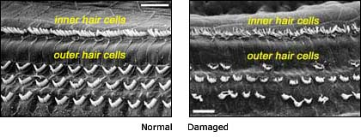

Cochlear implant: Electronic device that replaces the function of hair cells
May help sensorineural hearing loss
May assist in normal language development

Somatosenses:
The body senses are referred to as the somatosenses.
Haptic perception:
Active exploration of the environment by touching and grasping objects with our hands
- Tactile perception
- Thermoreception
- Pain
- Proprioception

- Tactile Perception:
- Pressure, texture, pattern, and vibration
- Touch receptors respond to stimulation within their receptive fields, and their long axons enter the brain via the spinal or cranial nerves.
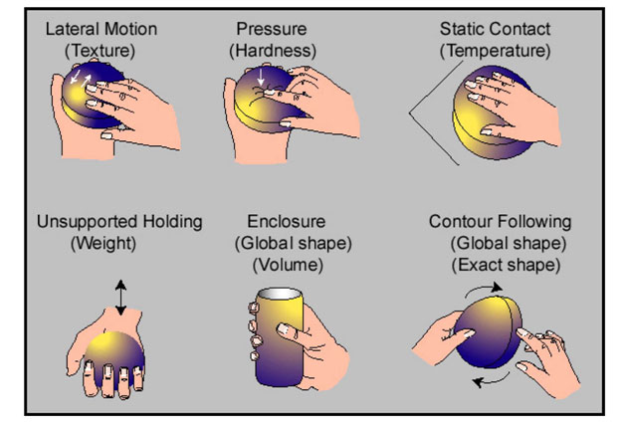

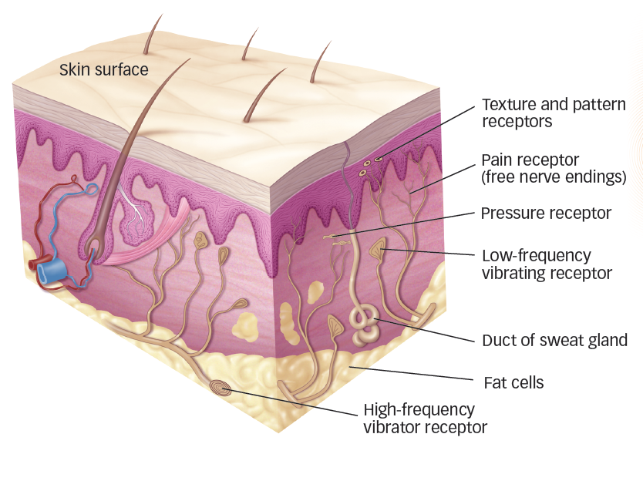

- Pain

Pain receptors populate all body tissues that feel pain; they are distributed around bones and within muscles and internal organs as well as under the skin surface.
Indicates damage or potential damage to the body; tissue damage transduced by pain receptors
  - A-delta fibers: Quick, sharp pain
  - C fibers: Long, dull pain

Two pain pathways
- One sends “where” information to somatosensory cortex
- Another sends motivational and emotional information to the hypothalamus, amygdala, and frontal lobe

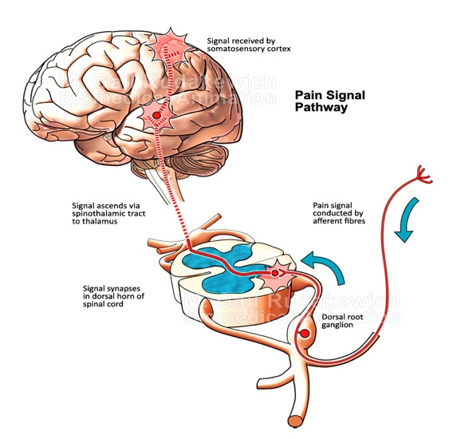

Referred pain: Feeling of pain when sensory information from internal and external areas touches on the same nerve cells in the spinal cord
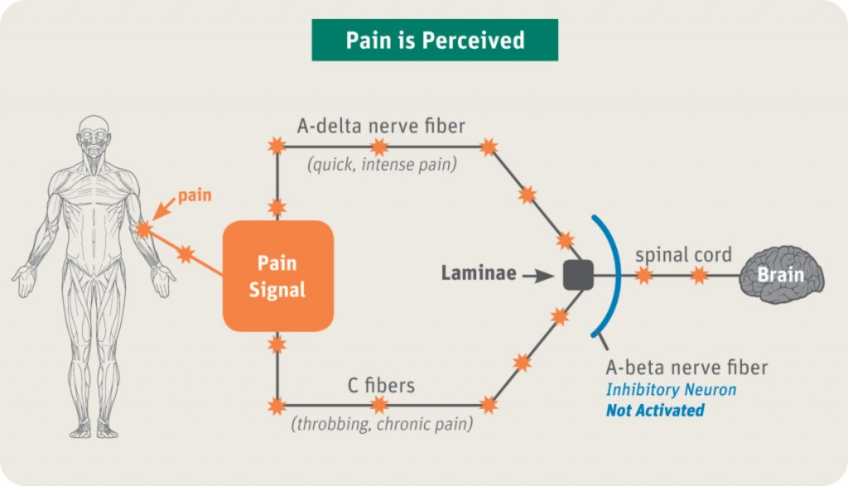
Pain intensity is subjective.
  - Gate-control theory: Signals arriving from pain receptors in the body can be stopped or gated by interneurons in the spinal cord via feedback (PAG) from two directions
  - Some recent evidence indicates ethnic differences in subjective pain intensity

Proprioception: Body Position, Movement, and Balance
- Sensory receptors provide information we need to perceive the position and movement of our limbs, head, and body.
- Vestibular system: Three fluid-filled semicircular canals and adjacent organs located next to the cochlea in each inner ear; used with visual feedback to maintain balance

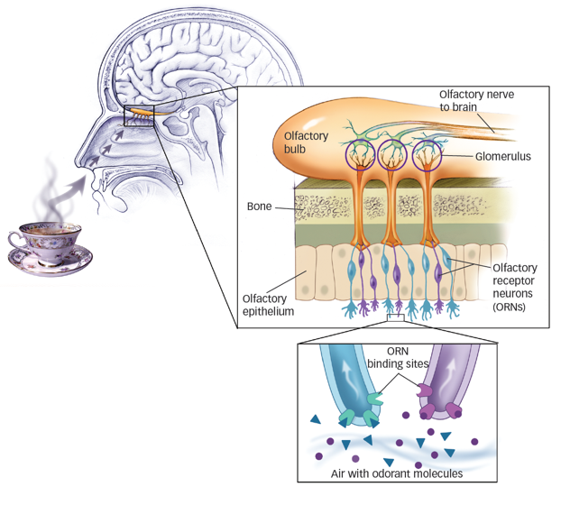
Smell and taste receptors respond to chemical molecules inhaled or dissolved in saliva.
- Odorant molecules travel through the nose to the olfactory epithelium, where they bind to receptors.
- Olfactory receptor neurons (ORNs): Receptor cells that initiate the sense of smell
- Groups of ORNs send their axons to the olfactory bulb and converge there on glomeruli.
  - Olfactory bulb: Rain structure located above the nasal cavity beneath the frontal lobes

Smell:
Smell is intimately related to emotional and social behaviour.
- Object-centered approach: Information about identity of odor object is quickly accessed from memory and then triggers an emotional response
- Valence-centered approach: Emotional response comes first and provides basis for determining the identity of the odor

Chemical odors may affect sexual behaviour:
- Pheromones: Biochemical odorants emitted by other members of its species that can affect an animal’s behaviour or physiology

A Taste Bud:
- Taste buds stud the bumps (papillae) on the tongue, shown here, as well as the back, sides, and roof of the mouth (a). Each taste bud contains a range of receptor cells that respond to varying chemical components of foods called tastants (b).
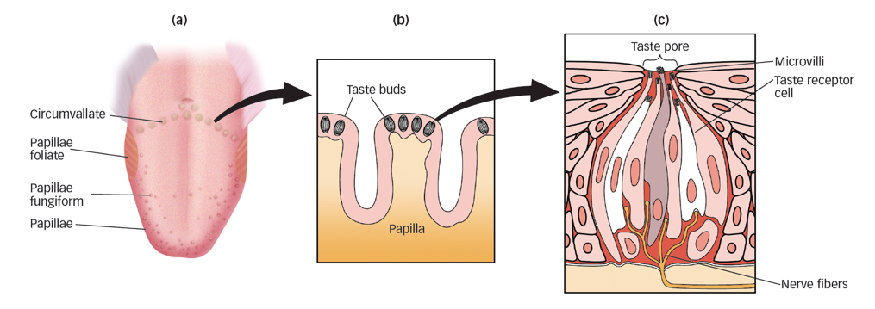
- Tastant molecules dissolve in saliva and stimulate microvilli that form the tips of taste receptor cells (c). Each taste bud contacts the branch of a cranial nerve at its base.

