2017
Jérome Lévesque
Concordia University – INTE 290
15/05/2017
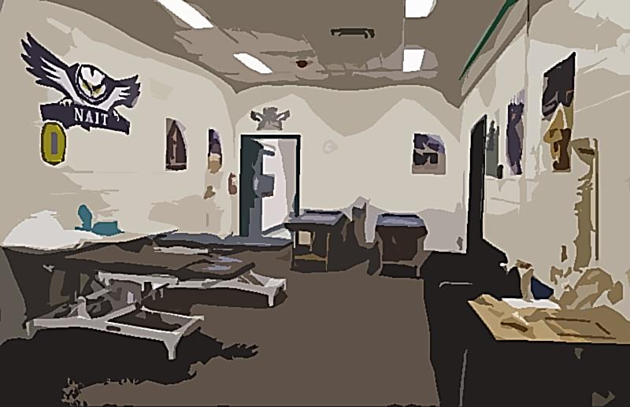
Bringing Athletic Therapy in Cegeps and High Schools
Table of contents
Project Description 2
Mission Statement 2
Services 3
Strategy 4
Budget 5
Timeline 6
Bibliography 7
© Jerome Levesque 2017

PROJECT DESCRIPTION

J
erLev Sports Therapy is a multidisciplinary agency in the field of sports medicine, destined mostly to young student athletes from various Cegeps and High Schools in Quebec City. The agency will be effective at the beginning of the 2017-2018 school year.
Mission Statement

Our mission is to provide year-long health coverage to young student athletes so they can perform at their best on the field and in the classroom.
WE ARE ALSO LOOKING TO FULFILL A NEED THAT IS PRESENT IN QUEBEC CITY’S SCHOOLS.

SERVICES

AND SO MUCH MORE!!


- Osteopathy
  - Acupuncture
    - Physical Therapy
- Kinesiology
  - Nutrionist
    - Strength and Conditioning

STRATEGY

JerLev Sports Therapy will provide a vast amount of young professionals in order to help the young student athletes to get back to 100% in the fastest possible way.

To assure the best follow-up with the athletes, each school will have its own team of ATs, Physiotherapists, Strength and Conditioning specialist and Tutors. Other resources, such as Sports Medicine, Chiropractic and others, will be offered indirectly to all schools.
This is an example of how JerLev Sports Therapy could intervene with an athlete:
- Athlete participates in a wrestling event and suffers a concussion. | On-field Athletic Therapist intervenes and safely removes the athlete from play.
- Athlete has his symptoms evaluated weekly. | Physiotherapist monitors the athlete’s concussion symptoms.
- Athlete is symptom-free for a week. | Sport Doctor clears the athlete to participate in physical activity and school-related work.
- Athlete is back to full class participation. | Academic Tutor works with the athlete to compensate for the lost time in class.
- Athlete is back to full physical activity. | Strength and Conditioning specialist, along with Kinesiologists, make sure the athlete gets back its fitness.

Budget

JerLev Sports Therapy will reduce the costs of the schools and athletes by hiring mostly students looking to acquire experience through internships in different fields. That way, the young professionals get the opportunity to work and gain experience while growing the field of Sports Medicine. We expect the schools to contribute by letting us use one or more rooms as a clinic.

The budget for a specific year will be determined by a simple equation:
$$Money available=Incomes-Expenses$$

1
‘’ JerLev Sports Therapy is good for everyone, whether you are an elite or a recreative athlete’’
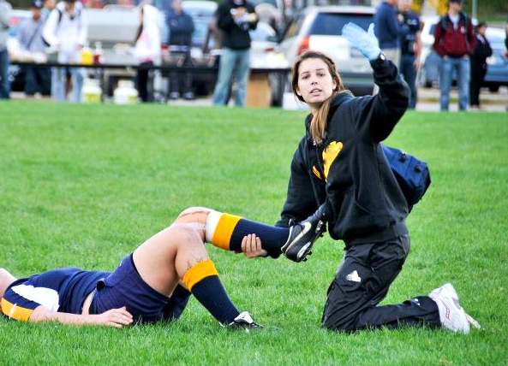
Figure 1 – One of our future Athletic Therapist in action
TIMELINE

BIBLIOGRAPHY
Figure 1 – One of our future Athletic Therapist in action - 2 -

Jerome Levesque, Personal Communication, 2017

