Chapter 42 – Circulation & Gas Exchange
- Resources that an animal acquire (nutrients, O2) enter cytoplasm by crossing pm; metabolic by-products (CO2) exit cell by crossing the same memb
- Unicell org: exchange occurs directly w/ ext env
- Multicell org: can’t, rely on specialized systems that carry out exchange w/ the env & that transport materials btw sites of exchange & the rest of the body
42.1 Circulatory systems link exchange surfaces w/ cells throughout the body
- Mol trade animal carries out w/ env (O2 & nutrient gain + CO2 & waste products loss) involves every cell in the body
- How does each cell of an animal exchange mol w/ the env? 2 solutions:
- body size & shape keeping many or all cells in direct contact w/ env (can exchange directly w/ surr); body plan only found in certain invertebrates
- circulatory system that moves fluid btw each cell’s immediate surr & the tissues where exchange w/ env occurs; found in all other animals
Gastrovascular cavities:
- Some animals (cnidarians) lack circulatory system but have instead a central gastrovascular cavity functioning in the disrt of sub through body & digestion; opening at 1 end connects the cavity to surr water
- Fluid bathes both inner & outer tissue layers, facilitating exchange of gases & wastes
- Only cells living the cavity have direct access to nutrients release by digestion but bc the body wall is only 2-cell thick, nutrients diffuse to reach cells of outer tissue layer
- Planarians (most flatworms) also survive w/out circulatory system; combination of gastrovascular cavity & flat body – optimizes diffusional exchange by increasing surface A & minimizing diffusion distances – well suited for exchange w/ env
Evolutionary variation in circulatory systems:
- For animals w/ many cell layers, diffusion distances are too large for adequate exchange of nutrients & wastes by gastrovascular cavity; thus circulatory system minimizes the distances that sub must diffuse to enter or leave cell
General properties of circulatory system (CS):
- Has 3 basic components: circulatory fluid, set of interconnecting vessels & muscular pump – the heart (powers circulation by using metabolic E to elevate hydrostatic pressure of the circulatory fluid, which then flows through vessels & back to heart)
- By transporting fluid throughout body, CS connects aq env of the cells to the organs that exchange gases, abs nutrients & dispose of wastes
- Ex inhaled O2 from air diffuses across 2 layers of cells in the lungs before reaching blood; CS powered by heart then carries O2-rich blood to all parts of body; as blood streams throughout body tissues in tiny blood vessels, it diffuses only a short distance before entering the fluid that directly bathes the cells
Open & closed circulatory systems:
- Open CS: circulatory fluid – hemolymph – bathes organs & tissues directly; no distinction btw circulating fluid & interstitial fluid; contraction of heart pumps the hemolymph through circulatory vessels into interconnected sinuses – spaces surr organs, w/in sinuses exchange occurs btw hemolymph & body cells
Ex arthropods & most molluscs
Adv: low hydrostatic pressure thus less costly in E expenditure than closed CS

- Closed CS: CS in which blood is confined to vessels & is kept separated from the interstitial fluid (fluid filling spaces btw cells in animals); heart pumps blood into large vessels that branch into smaller ones that infiltrate the organs; chem exchange occurs btw interstitial fluid & blood as well as btw interstitial fluid & body cells
Ex annelids (earthworms), cephalopods (squids, octopuses) & all vertebrates
Adv: high blood pressures which enable effective delivery of O2 & nutreitns to the cells of larger & > active animals; well suited for distr of blood to diff organs
Organization of vertebrate circulatory systems:
- Closed CS of vertebrates often called cardiovascular system – blood circulated to & from the heart through network of vessels
- 3 main types of blood vessels in which blood flows only in 1 direction:
- Arteries: vessels that carry blood away from heart to organs through body
w/in organs arteries branch into smaller arteries – arterioles – that convey blood to capillaries (carry blood from heart to capillaries)
- Capillaries: microscopic blood vessel that penetrates tissues & consists of a 1x layer of endothelial cells that allows exchange by diffusion btw blood & interstitial fluid; have very thin & porous walls; at the end, converge into venules
Capillary beds: networks of capillaries in tissues or organs
- Veins: vessel that carries blood twds heart (return blood to heart from capillaries)
Venules – small veins that converge into veins
- Portal veins carry blood btw pairs of capillary beds (ex hepatic portal vein carries blood from capillary bed in digestive system to capillary beds in the liver)
- Heart of all vertebrates contain 2 or > muscular chambers:
  - Atria: chambers that receive blood entering the heart
  - Ventricles: chambers resp for pumping blood out of the heart
Single circulation in fishes:
- Heart consists of 2 chambers – an atrium & a ventricle
- Single circulation: blood passes through the heart once in each complete circuit
- Blood collects in atrium then enters ventricle; contraction of ventricle pump bloods to the arteries that lead to gills; in capillaries of the gills O2 diffuses into the blood as CO2 leaves the blood
- 2 disadv: (1) By passing through the gill capillaries blood pressure drops as it is delivered to the rest of the body (body capillaries); thus reducing efficiency of circulation (2) heart forced to rely on deoxygenated blood for its own metabolic needs
- Other vertebrates evolved a double circulation – blood moving btw heart & rest of body (systematic circuit) is separated from the blood moving btw heart & respiratory surface (pulmonary circuit)
Incomplete separation of systemic & pulmonary circuits in amphibians & reptiles:
- Amphibians (frogs) gave 3 chambers: 2 atria & 1 ventricle
- Right atrium (RA) collects blood from body & left (LA) from respiratory surfaces; both atria empty in ventricle (contains a ridge that separates blood arrive from both atria)
- Pulmocutaneous circuit: supply lungs & skin, bc amphibians respire through lungs & skin
- When ventricle contracts, the O-rich blood from LA is sent via the systemic circuit to the rest of the body (systemic capillaries) + O-depleted blood from RA is sent to respiratory surfaces (ling & skin capillaries) via pulmonary circuit
- Amphibians have ridge to guide blood flows but reptiles evolved a wall – septum – w/in ventricle to better separate pulmonary & system blood (complete or incompl)
Four-chambered hearts of mammals & birds:
- 4 chambers: 2 atria & 2 ventricles
- Left side of heart receives & pumps only O-rich blood
- Right side receives & pumps only O-poor blood
- Complete separation of systemic & pulmonary circuits permits the independent regulation of blood pressure in to 2 circuits
- Evolved by convergent evolution for mammals & birds
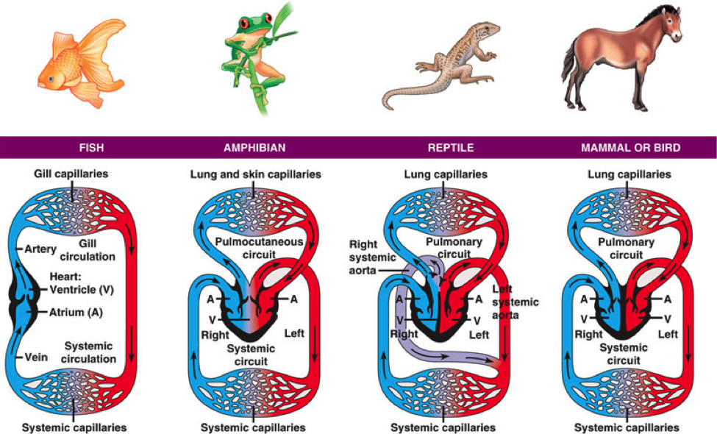
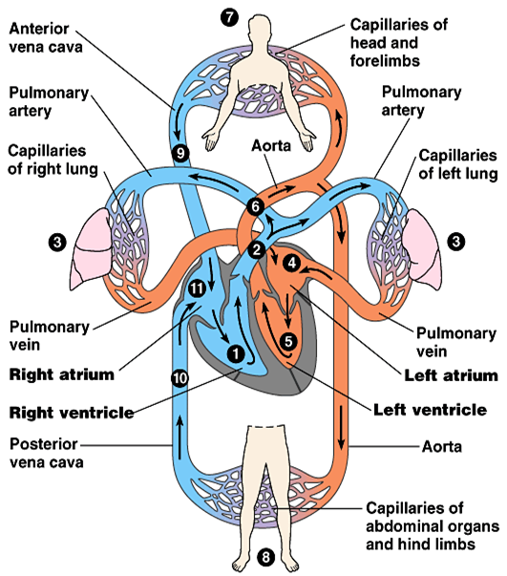
42.2 Coordinated cycles of heart contraction drive double circulation in mammals
Mammalian circulation:
(1) pulmonary circuit:
- Contraction of RV pumps blood into lungs via the pulmonary arteries
- As blood flow through capillary beds in L & R lungs, it loads O2 & unloads CO2
- O-rich blood returns from the lungs via the pulmonary veins to the LA of the heart
- O-rich blood flows into LV which pumps the O-rich blood out to body tissues through the systemic circuit
- Blood leaves LV via aorta which conveys blood to arteries leading throughout body
- 1st branches leading from the aorta are the coronary arteries which supply blood to heart muscle itself
- Then branches lead to capillary beds in head & arms (forelimbs)
- Aorta then descend into the abdomen, supplying O-rich blood to arteries leading to capillary beds in the abdominal organs & legs (hind limbs)
- W/in capillaries there is a net diffusion of O2 from blood to tissues & of CO2 (produced by CR) into the blood
- Capillaries rejoin forming venules which convey blood to veins
- O-poor blood from head, neck & forelimbs is channeled into a larger vein – the superior vena cava
- O-poor blood from trunk & hind limbs is channeled into a larger vein – the inferior vena cava
- The 2 vena cavae empty their blood into the RA from which O-poor blood flows into the RV
The mammalian heart: A closer look:
- Heart is behind sternum & consists mostly of cardiac muscle
- 2 atria have thin walls & serve as collection chambers for blood returning to the heart from the lungs or other body tissues
- Much of the blood inside atria flows into ventricles while heart chambers are relaxed; the remainder is transferred by contraction of the atria before V begin to contract
- Ventricles have thick walls & contract > forcelly than A; especially the LV which pumps w/ greater force than RV blood to the rest of body via the systemic circuit
- Heart contracts (pumps blood) & relaxes (chambers fill in) in a rhythmic cycle
- Cardiac cycle: one complete sequ of pumping & filling
- Systole – contraction phase of cycle & diastole – relaxation phase
- Cardiac output: vol of blood each V pumps /min, determined by 2 factors: (1) rate of contraction – heart rate (bpm) & stroke volume – amt of blood pumped by each V in a single contraction (ave 70 mL)
- 4 valves, made of flaps of connective tissue, in the heart prevent blood backflow & keep it moving in the right direction; open when pushes from 1 side & close if pushed from the other
- Atrioventricular valve (AVV) lies btw each atrium & ventricle
- Semilunar valves located at the 2 exits of the heart (where A leave LV + where pulmonary artery leaves the RV)
- Heart murmur: if blood squirts backward through a defective valve, abnormal sound
Maintaining the heart’s rhythmic beat:
- Some cardiac muscle cells are autorhythmic they contract w/out any signal from NS
- How are these contraction & relaxations coordinated?
- Sinoatrial node (SA) – cluster of autorhythmic cells located in the walls of the RA acting as a pacemaker, sets the rate & timing at which all cardiac muscle cells contract; produces electrical impulses like nerve cells
- Atrioventricular node – other cluster of autorhythmic cells located in the wall btw LA & RA; form a relay point where impulses are delayed by 0.1 sec before spreading

- 3 factors affecting pacemaker: (1) physiological cues (get up sympathetic division speeds up pacemaker & parasympathetic slows it down if you relax) (2) hormones secreted in the blood (epinephrine increases heart rate) (3) body T (increases w/ T)
42.3 Patterns of blood pressure & flow reflect the structure & arrangement of blood vessels:
- Vertebrate CS enables blood to deliver O2 & nutrients & remove wastes; to do so, relies on a network of vessels
Blood vessels structure & function:
- Blood vessels contain a central lumen (cavity) lined w/ an endothelium – single layer of flattened epithelial cells; smooth surface of endothelium minimizes resistance to blood flow; surr endothelium are layers of tissues that differ in capillaries, arteries & veins reflecting the specialized functions of these vessels
- Capillaries smallest blood vessels, thin walls (only endothelium + basal lamina); this structure facilitates exchange of sub btw blood in capillaries & interstitial fluid
- Arteries & veins have 2 layers of tissue surr their endothelium – outer layer of connective tissue containing elastic fibers (allow vessel to stretch) & middle layer containing smooth muscle & > elastic fibers
- Walls of arteries are thick & strong, accommodating blood pumped at high pressure by the heart
- Veins have no thick walls bc they convey blood back to heart at a lower pressure
Blood flow velocity:
- How blood vessel diameter influences blood flow
- Decrease in velocity from arteries to capillaries (bc capillaries have large cross-sectional As than arteries bc there are so many); slow flow in capillaries is crucial to allow time to exchange w/ interstitial fluid to occur (diffusion not instantaneous)
- Blood flow speeds up as it passed from capillaries to venules & veins (smaller cross-sectional As than capillaries)
Blood pressure:
- Blood flows from As of high to low pressure
- Heart = site of highest pressure
Changes in blood pressure during the cardiac cycle:
- Arterial pressure greatest when heart contracts during the ventricular systole – systolic pressure
- Pulse: rhythmic bulging of the artery walls w/ each heartbeat bc when heart contracts, blood enters arteries faster than it leaves & vessels stretch from rise in pressure
- During diastole, the elastic walls of arteries snap back thus lower blood pressure when ventricles are relaxed – diastolic pressure
Regulation of blood pressure:
- Blood pressure not only influenced by oscillations during the cardiac cycle but also by physical/emotional stress that can trigger nervous & hormone resp
- Vasocontraction: decrease in diameter of vessels caused by contraction of smooth muscles in the vessel walls; increases blood pressure
- Vasodilation: increase in diameter of vessels caused by relaxation of smooth muscles in the vessel walls; decreases blood pressure in the arteries
Blood pressure & gravity:
- Gravity can affect blood pressure; when you are standing your arterial blood pressure in your brain is less than near your heart
- If pressure in your brain is too low, you faint to place brain & heart at the same level
Capillary function:
- Capillaries in brain, heart, kidneys & liver are filled to capacity but at many other sites the blood supply varies over time as blood is diverted from 1 destination to another
- How is blood flow in capillaries altered (no smooth muscle)? 2 mech:
(1) contraction of smooth muscle in the wall of an arteriole which reduces the vessel’s diameter & decreases blood flow to the adjoining capillary beds
(2) action of precapillary sphincters – rings of smooth muscles located at the entrance of capillary beds
DIAGRAM
- Exchange btw blood & interstitial fluid done across endothelial walls of capillaries some sub are carried across endothelium in vesicles that form on 1 side by endocytosis & release their contents of the opposite side by exocytosis
small mol (O2, CO2) diffuse acroos endothelial cells or through microscopic pores in the capillary wall
- 2 Fs control the mvt of fluid btw capillaries & surr tissues:
(1) blood pressure drive fluid out of capillaries
(2) presence of blood proteins tends to pull fluid back (too large to pass through endothelium & so remain in capillaries)
Generally, blood pressure is greater than opposing Fs & result is net loss of fluid
Fluid return by the lymphatic system:
- Lymphatic system: includes network of tiny vessels intermingled among capillaries of the cardiovascular system; system that returns lost fluid & proteins to the blood
- Lymph: fluid lost by capillaries that entered the lymphatic system; same composition as interstitial fluid
- Lymph vessels also have valves preventing backflow of fluid, vessels walls have rhythmic contractions helping draw fluid into small lymphatic vessels; skeletal muscle contractions help move lymph
- Lymph nodes: organs along a lymph vessel; * role in body defence; filter lymph & contain cells that attack viruses & bacteria; contain connective tissue w/ spaces filled w/ white blood cells
42.4 Blood components function in exchange, transport & defense
- Recap: fluid transported by open CS is continuous w/ interstitial fluid (surr all body cells) & has same composition, but in closed CS the fluid is specialized like blood
Blood composition & function:
- vertebrate blood is a tissue consisting of cells suspended in liquid – plasma; dissolved in plasma are ions & proteins that, w/ the blood cells, function in osmotic regulation, transport & defence
Plasma:
- blood electrolytes – inorg salts in the form of dissolved ions in plasma, essential components of blood (buffer the blood, maintain osmotic balance, kept in range [C])
- plasma proteins act as buffers against pH changes, help maintain osmotic balance btw blood & interstitial fluid & contribute to blood viscosity (thickness)
- other proteins, immunoglobins (antibodies) combat viruses & foreign invading agents
- others are escort for lipids (insol in water & travel in blood only when bound to protei)
- 3rd gr of plasma proteins are clotting factors that help plug leaks when blood vessels are injured
- Plasma has > [proteins] than interstitial fluid but otherwise similar fluids
Cellular elements:
- Blood contains 2 classes of cells (1) red–O₂ transport (2) white blood cells–defence
- Platelets are also suspended in blood plasma, fragments of cells involved in clotting
- Erythrocytes (red blood cells): must numerous, main function = transport O2, biconcave cells, shape that increases surface A enhancing the rate of O2 diffusion across the pm; mature erythrocytes lack nuclei (also mitoch thus generate their ATP only by anaerobic metabolism) which leaves > space for hemoglobin (iron-containing protein that transports O2); more efficient than aerobic metabolism
O2 diffuses into erythrocytes & bind to hemoglobin
Sickle-cell disease: hemoglobin polymerizes into aggregates; distorts shape of erythrocytes; prevents delivery of O2 & nutrients & removal of CO2 & wastes

- Leukocytes (white blood cells): blood contains 5 major types of leukocytes; function to fight infections; some are phagocytic (engulfing & digesting microorg & debris), others called lymphocytes involved in immune resp against foreign sub; # increases when body is fighting an infection; also found outside CS (interstitial & lymphatic syst)

- Platelets: cytoplasmic fragments of specialized bone marrow cells; have no nuclei; serve both structural & molecular functions in blood clotting

Blood clotting:
- A break (cut) in a blood vessel wall exposes proteins that attract platelets & initiate coagulation – conversion of liquid components of blood to a solid clot
- coagulant circulates in vessel in an inactive form– fibrinogen; in resp to broken vessel, platelets release clotting factors that trigger Rx leading to the formation of thrombin – Z that convers fibrinogen to fibrin + catalyzes formation of > thrombin
- fibrin aggregates into threads that form the framework of the clot
- hemophilia: genetic mutation leading to xs bleeding & bruising for minor cuts
- anticlotting factors prevent clotting in the absence of injury; however smt clots – thrombus form w/in blood vessel blocking the flow of blood
Stem cells & the replacement of cellular elements:
- erythrocytes, leukocytes & platelets all dev from same source – multipotent stem cells (dedicated to replenish the body’s blood cell pop)
- stem cells that produce blood cells are located in the red marrow of bones (in the ribs, vertebrae, sternum & pelvis)
- multipotent bc they can form multiple types of cells; when stem cells divide one daughter cells remain a stem cell & the other takes on a specialized function
- production of erythrocytes negative-feedback mech sensitive to amount of O2 reaching body tissues via the blood; if tissues don’t receive enough O2, the kidney syn & secrete hormone erythropoietin (EPO) that stimulates erythrocyte prod; if blood is deleviring > O2 than the tissues can use EPO falls & prod slows
Cardiovascular disease:
- diseases of heart & blood vessels
- cholesterol – steroid in animal’s cell memb resp for its fluidity; travels in plasma
- atherosclerosis
- heart attack
- hypertension
42.5 Gas exchange occurs across specialized respiratory surfaces
- gas exchange: uptake of mol O2 from the env & discharge of CO2 to the env
partial pressure gradients in gas exchange:
- partial pressure (pp): pressure exerted by a particular gas in a mixture of gases; to calculate it need to know pressure the mixture exerts & the fraction of the mixture represented by particular gas
- pps also apply to gases dissolved in liquid (water); when water exposed to air an equilibrium is reaches in which the pp of each gas in the water = pp of that gas in air
respiratory media:
- gas exchange w/ water as the resp medium is > demanding than in air
- water’s lower O2 content, geater density & greater viscosity mean that aquatic animals must expend E to carry out gas exchange (adaptations evolved)
respiratory surfaces (RS):
- part of body where gas exchange occurs; must have pm in contact w/ aqueous sol; thus always moist
- mvt of O2 & CO2 across moist RS occurs by diffusion; rate of diffusion proportional to surface A & inversely prop to square of the distance through which mol must move
- gas exchange fast when A is large & path of diffusion is short (large & thin)
- for simple animals: every cell in body is close enough to ext env & gas can diffuse
- in more complex animals: bulk of body cells lack immediate contact w/ env; RS is thin, moist epithelium that constitutes a respiratory organ
- skin serves as resp organ (earthworms & amphibians); live in damp places
- general body surface A of most animals lacks sufficient A to ecxchange gases for the whole org (evol limitation); resp organ highly folded or branched enlarges A for gas exchange; for ex gills, trachea & lungs are such organs
Gills in aquatic animals:
- gills are outfoldings of the body surface that are suspended in the water; have total surface A much greater than that of the rest of the body’s exterior
- ventilation – mvt of resp medium oer the RS; maintains pp gradients of O2 & CO2 across the gill that are necessary for gas exchange
- to promote ventilation animals move their gills through water or move water over their gills; current of water enters mouth, passes through slits of pharynx, flows over the gills & then exits the body
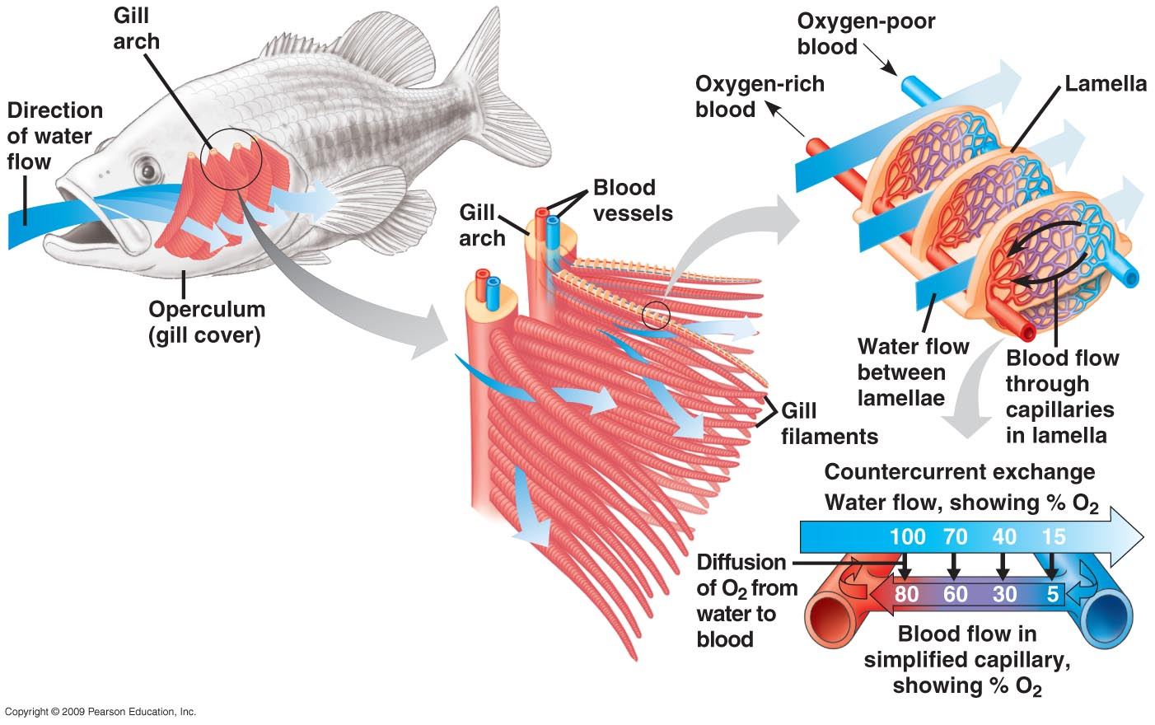
- arrangement of capillaries in a fish gill allows for countercurrent exchange – exchange of sub or heat btw 2 fluid flowing in opp directions; maximizes gas exchange efficiency
- bc blood flows in the dir opp of that of water passing over gills, at each point in its travel blood is < saturated w/ O2 than water it meets
- a pp gradient favouring diffusion of O2 from water to blood exists along the capillary
Tracheal systems in insects:
- tracheal system – in insects, a system of branched, air-filled tubes that extends throughout the body & carries O2 directly to cells
- largest tubes, trachea, open to the outside; finest branches extend close to the surface of nearly every cell, where gas is exchanged by diffusion across moist epithelium that line tips of tracheal branches
- tracheal system brings air w/in a very short distance of body cells, it can transport O2 & CO2 (support CR) w/out the participation of the animal’s open CS
Lungs:
- lungs – localized resp organs; infolded resp surface of a terrestrial vertebrate, land snail or spider, that connects to the atm by narrow tubes; subdivided into numerous pockets
- RS of lungs not in direct contact w/ rest of the body so gap bridged by CS which transports gases btw lungs & body
Mammalian respiratory system:
- Lungs located in thoracic cavity
- Air enters through nostrils & is then filtered by hairs, warmed, humidified & sampled for odours as it flows through a maze of spaces in the nasal cavity
- Nasal cavity leads to pharynx – intersection where paths for air & food cross
- When food is swallowed the larynx (upper part of resp tract) moves upward & tips the epiglottis over the glottis (opening of trachea); this allows food to go down the esophagus to stomach
- The rest of the time the glottis is open allowing us to breath
- BREATHING
- From larynx, air passes into the trachea; cartilages both inforcing the walls of larynx & trachea keeps this part of the airway open
- w/in larynx, exhaled air rushes by a pair of elastic bands of muscle called vocal cords (sounds are produced when muscles in the larynx are tensed, stretching the cords so they vibrate)
- trachea branches into 2 bronchi (one leading to each lung)
- w/in the lung the bronchus branches into finer tubes – bronchioles
- epithelium lining the major branches is covered by cilia (move mucus upward to the pharynx, where it can be swallowed into esophagus, cleanses resp system) & thin film of mucus (traps dust, pollen & other contaminants)
- gas exchange in mammals occur in alveoli – air sacs clustered at the tips of the tiniest bronchioles; O2 in the air entering the alveoli dissolved in the moist film lining their inner surfaces & diffuses across epithelium into a web of capillaries surr each alveolus
- net diffusion of CO2 occurs in the opp way, from capillaries across epithelium of the alveolus into the air space
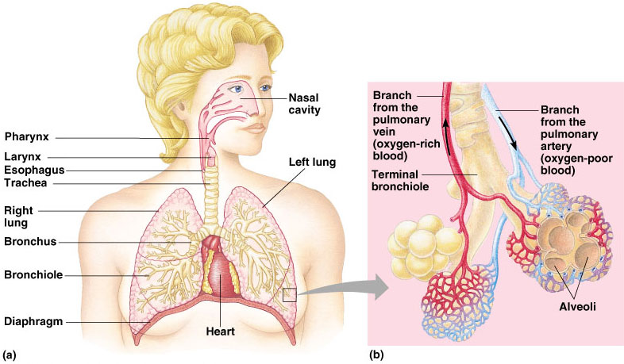
42.6 Breathing ventilates the lungs:
- like fishes, terr animals rely on ventilation to maintain high [O2] & low [CO2] at the gas exchange surface
- process that ventilates lungs is breathing (alternating inhalation & exhalation of air)
How an amphibian breathes:
- positive pressure breathing – inflating the lungs w/ forced airflow
- inhalation muscles lowers the floor of oral cavity, drawing in air through nostrils
- nostrils & mouth close, floor of oral cavity rises, forcing air down trachea
- exhalation air forced back out by elastic recoil of lungs & compression of muscular body wall
How a bid breathes:
- 2 features of ventilation making it efficient:
- 1. when birds breathe, they pass air over the gas exchange surface only in 1 dir
- 2. incoming fresh air doesn’t mix w/ air that has already carried out gas exchange
- To bring fresh air in lungs, use 8-9 air sacs situated on either side of lungs, keep air flowing through the lungs
- Site of gas exchange – parabronchi – tiny channels
- Passage of air through entire system – lungs & air sacs – require 2 cycles of inhalation & exhalation
How a mammal breathes:
- Negative pressure breathing – pulling rather then pushing air into the lungs
- Using muscle contraction to actively expand thoracic cavity, mammals lower air pressure in their lungs below that of the air outside their body
- Bc air flows from region of high to low pressure, air rushes through nostrils & mouth & down the breathing tubes to the alveoli
- During exhalation muscles controlling thoracic cavity relax & vol of cavity is reduced; increase air pressure in the alveoli forces air up the breathing tubes & out of body (always passive where as inhalation is always active & requires work)
- Expanding thoracic cavity (during inhalation) rib muscles contract pulling ribs upwards & sternum outwards & diaphragm (sheet of skeletal muscle that forms bottom wall of cavity) contracts expanding thoracic cavity downwards
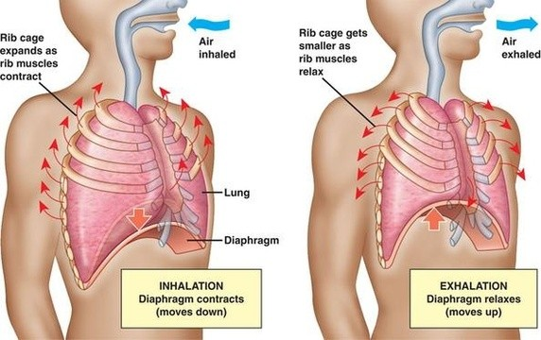
- w/in thoracic cavity a 2x memb surr the lungs; inner layer adheres to lungs & outer layer adheres to the wall of thoracic cavity; 2 layers separated by thing space filled w/ fluid causing the 2 layers to stick together bc of surface T; can slide smoothly but never separate making the vol of thoracic cavity & lungs change in unison
- for animal at rest, rib muscles & diaphragm are sufficient to change lung vol
- during exercice, other muscles of neck, back & chest increase the vol of thoracic cavity by raising the rib cage; create pumping motion pushing & pulling on lungs
- tidal vol: vol of air inhaled & exhaled w/ each breath (500 ml)
- vital capacity: tidal vol during maximal inhalation & exhalation (3.4 L F & 4.8 L M)
- residual vol: the air that remains after forced exhalation, increases w/ age
- bc lungs don’t empty completely & that inhalation & exhalation occur through same airways, fresh air is mixed w/ O-depleted residual air thus P_{O2} in alveoli is always < than in atm
- max P_{O2} in lungs of animals is also < than that in birds (bc renew air w/ each exhala)
control for breathing in humans:
- often regulated by involuntary mech that ensure that has exchange is coordinated w/ blood circulation & w/ metabolic demand
- neurons resp for regulating breathing are in medulla oblongata (bear base of brain)
- neural circuits in medulla oblongata form a breathing control center that establishes breathing rhythm (prevents lungs from over expanding or inhibits inhalation)
- to regulate breathing, medulla uses pH of surr tissue fluid as an indicator of blood [CO2]; increased metabolic activity lowers pH by increasing [CO2] in blood; sensors in blood vessels & medulla resp in increasing depth & rate of breathing until xs CO2 is eliminated and pH returns to normal value
42.7 Adaptations for gas exchange include pigments that bind & transport gases
- blood mol, called respiratory pigments, facilitate CO2 & O2 exchange
Coordination of circulation & gas exchange:
- partial p of O2 or CO2 vary in blood at diff pts in circulatory system
- blood flowing through alveolar capillaries (high P_{CO2}, low P_{O2}) thus CO2 diffuses down its gradient from blood to air in alveoli & O2 dissolves in fluid & diffuses into blood
- when blood leaves pulmonary veins, its P_{O2} has been raised & Pc_{O2} lowered, this blood after being returned to the heart is pumped through systemic system
- in tissue capillaries (systemic), partial pressure gradients favour diffusion of O2 out of blood & CO2 in (P_{O2} high, Pc_{O2} low); gradient exist bc mitoch in cells near each capillary removes O2 from & adds CO2 to surr interstitial fluid; blood is then returned to heart & pumped to lungs again
Respiratory pigments:
- prob: bc low solubility of O2 in water (thus in blood), prob when it comes to bringing O2 from lungs to active tissues
- animals transport O2 bound to proteins – respiratory pigments – circulate w/ the blood or hemolymph & are contained in specialized cells, increase the amt of O2 that can be carried in circulatory fluid
- have distinctive color (pigment) & consist of protein bound to a metal
- ex) blue pigment hemocyanin, has copper, found in mollusc & arthropods
Hemoglobin:
- respiratory pigment found in almost all vertebrates & many invertebrates
- vertebrate hemoglobin consists of 4 subunits (polypep chains) each w/ a cofactor called a heme group that has an iron atom in its center (each iron binds 1 mol of O2); 1 hemoglobin mol can carry thus 4 O2 mol
- binds O2 reversibly – loads O2 in lungs or gills & unloads in other parts of body; this is done by change in shape (O2 binding to 1 subunit increases the affinity to bind other O2 mol & if 1 unloads the 3 other subunits are > readily unloading their O2)
- production of CO2 during CR promotes unloading of O2 by hemoglobin in active tissues
- bohr shift: low pH decreases affinity of hemoglobin for O2; thus when CR is high (large CO2 prod), hemoglobin unloads > O2 to support > CR
- high T also reduces the affinity for O2, favouring unloading (useful during exercise)
Carbon dioxide transport:
- hemoglobin also helps transport CO2 & assist in buffering the blood (preventing harmful changes in pH)
- CO2 from respiring cells diffuses into blood plasma & then into erythrocytes; there CO2 reacts w/ water & forms H₂CO₃ (which dissociates into H⁺ & HCO₃⁻); most H⁺ bind to hemoglobin & proteins (min changes in blood pH), HCO₃- diffuses into plasma
- 7% of CO2 is transported in blood plasma. 23% binds to aa ends of hemoglobin & 70% transported in blood plasna as bicarbonate ions
Respiratory adaptations of diving animals:
- 1 adaptation for prolonged stays under water = ability to store large amts of O2
- 2nd = high [C] of O-storing protein – myoglobin in their muscles
- 3rd = adaptations to conserve O2, swim w/ little muscular effort, glide passively, thus heart rate & O2 consumption decrease during dive, blood supply to muscles during dive is restricted smt shut off

