sease spread by aquatic invertebrates can be classified as:
- Water-borne diseases
- Water- carried diseases
- Water- washed diseases
- Water- based diseases
- Vector- based water- related diseases
IS THE ANSWER CORRECT FOR THIS ONE???????????? Yes confirmed from answer key
10. How are Beluga whales most negatively affected by St. Lawrence River pollution
- the pollution is absorbed through their skin
- they eat eels from the river which leads to high cancer rates FUCK THIS SHIT I GOT IT WRONG….why?
- the sediment load decreases their ability to hunt/acquire food
- There is not enough oxygen in the water to allow them to breathe
Typhus is a:
- Water Borne Disease
- Water Carried Disease
- Water Washed Disease right - typhus is caused by poor hygiene
- Water Based Disease wrong
- Vector based water Related Disease

Is typhus different than typhoid?? Yes they are two different diseases, typhoid is caused by salmonella i believe and thyphus is two other bacteria types. Thyphus is due to poor hygiene and typhoid is due to contaminated food especially water - for this course lol

What characteristics is most influential in making water an effective greenhouse gas?
a) Water has high specific heat and latent heat of evapotranspiration
b) Water is good at absorbing infrared radiation
c) Water has great surface tension
d) Water has a smaller density for the solid form compared to the liquid phase
e) Penguins like water and fish

Which of the following is sometimes estimated by models?
a) The white water footprint
b) the blue water footprint
c) the green water footprint is it this ? I think so yes it is
d) The grey water footprint

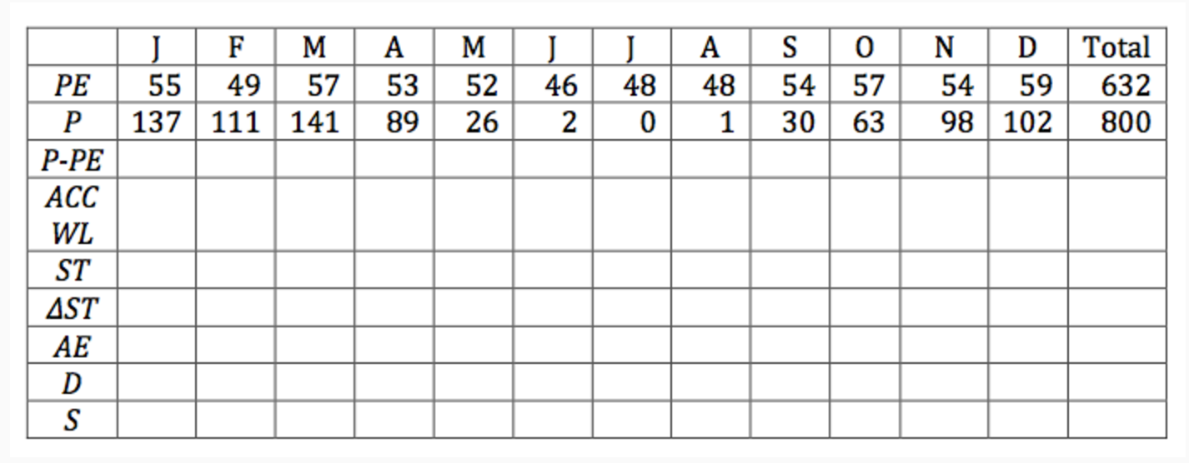
CAN SOMEONE EXPLAIN THIS TO ME OMG PLEASE . no .
For the water balance table: How many months will undergo soil moisture recharge? → anyone care to explain the process of getting the answer as well?-Number of months in the storage column to get from minimum value back to 300
I am still confused can someone pls re explain this

deficit when PE>P
surplus (if st =300 and P>PE)
Soil moisture recharge
And how to know if you’re in north/south hemisphere and growing season (PE>0)
Tables r given so u just have to read it
Youre the best omg thank u so much ily - whats soil moisture recharge tho OH WAIT thats the ST thing yeahhhhh if the months r 300 300 300 200 250 260 245 and said 200,250, 260 are PE>P months .. so 245 and 300 = 2 months to get back to 300 = 2 months soil moisture recharge. Hope that makes sense take a look at his slides they’re filled in easier to follow ok i shall check em out again thank u for ur help ur rly nice no worries bye
GUYS WHAT IF SURPLUS IS 0 FOR ONE OF THE MONTHS, DO WE STILL COUNT IT AS A SURPLUS? No.
How do u tell what hemisphere the place is in?
PE>P in june july august = northern hemisphere , PE>P in december, jan, feb = southern hem - thanks again :D

(put questions from quiz 1 and 2 and 3) QUIZ 4

Ephemeral streams in arid climates more often lose water to groundwater and may be the main source of groundwater recharge in some areas.
- True
- False

According to the 1912 Royal Commission on sewage disposal in the UK, how many times greater should river flow be compared to the volume of pollutant discharge?
- 2 isnt this the answer?-No its not, the answer is 8. Was 8 in a quiz??
- 4
- 8
- 10

Catchment ponds in ajax (east of toronto) are being tested as a means of partially treating stormwater runoff. Which of the following treatments does not occur?
- Sedimentation
- Photochemical breakdown
- Chlorination
- Biological activity
- Both (a) and (b)

The treatment of groundwater requires the process of removing larger physical contaminants?
- True
- False - THIS IS THE RIGHT ANSWER , agreed triple agree

For the water balance table: How many months will undergo soil moisture recharge? → anyone care to explain the process of getting the answer as well?-Number of months in the storage column to get from minimum value back to 300
I am still confused can someone pls re explain this …. Your essentially looking at how many months it takes to get to 300 for the storage value (ST) following rainfall (negative P-PE period). For this table ST for O = 164, N=205, D=248 and J=300. Therefore the answer is it takes 4 months to recharge the water.

- 2 months
- 3 months
- Eas 4 months
- 5 months
- 6months

What was the cause of increased contamination in the tap water in Flint Michigan?
- The decomposition of an ageing water delivery infrastructure
- High lead levels in the water from the Flint River
- High lead levels from the water from Detroit
- Poor water treatment techniques

What is the first step in the holistic management of water resources?
- Determination of inputs and outputs I THINK ITS THIS ONE THOU
- Evaluation of water balance
- Definition of catchments
- Construction of groundwater abstraction wells
- Prediction of impact of change

Within a lake the majority of life (think biomass, not species diversity) can be found in the:
- Hypolimnion
- Turnover
- Epilimnion
- Thermocline

Which of the following pH values would indicate the occurrence of acid rain?
- 6.5
- 5.0 definitely this manyyynnnnnnnnn how on earth did you pass first year
- 7.0
- 6.0

Why do the eggs of aquatic birds often have high concentrations of toxic chemicals
- The yolk is rich in fatty acids
- Biomagnification causes higher levels in their parents, and therefore the eggs
- They are at the end of a long food chain
- A and B
- All of the above

The lag to peak flow within a river system is shorter in a urban area than in a rural area (assume identical rainfall)
- True
- False

Water will have the slowest rate of movement through which type of soil/sediment?
- Gravel
- Clay
- Sand
- Loam

The market valuation approach that measures the expenditure incurred in order to avert damage to the natural environment, human infrastructure, or human health is:
- The replacement/restoration technique
- The production factor method
- The dose-response technique
- The preventative-expenditure technique

What is the compound annual growth rate by which the global water demand is increasing?
- 2%
- 4%
- 6%
- 8%

What source accounts for greater than 50% of the world’s potable water?
- Rivers
- Groundwater
- Estuaries
- Lakes
- Ponds

The process of sludge treatment and handling accounts for up to what percentage of the total costs of treatment?
- 50%
- 60%
- 70%
- 80%

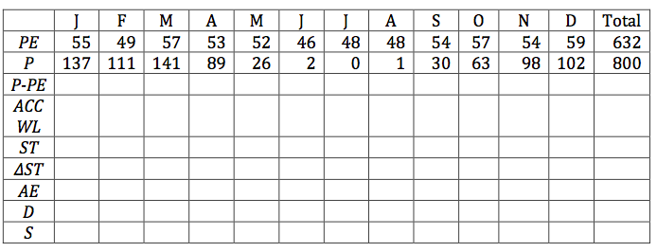
For the water balance table: How many months will have a water deficit?
- 3 months
- 5 months
- 7 months
- 1 month
- Not enough information

Which of the following are biases in domestic consumption monitors?
- Self-selection
- The Exclusion
- Financial advantage
- The Hawthorne effect
- All of the above

What is the sinuosity ratio (SR) and the type of channel found in a valley that is 150 m long with a stream that is 205 m long residing within it (rounded to the nearest 10th).
- SR = 1.8, meandering channel
- SR = 1.4, straight channel
- SR = 0.7, straight channel
- SR = 1.5, meandering channel

Riparian vegetation
- Occurs in areas of inconsistent and highly variable subsurface moisture
- Occurs on ridges and hilltops
- Occurs on steep slopes
- Occurs alongside streams

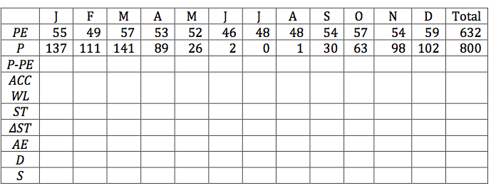
For the water balance table: How many months is the growing season?
- 3 months
- 6 months
- 9 months
- 12 months (PE>0)
- Not enough information

For the water balance table: How many months will have water surplus?
a) 2 months
b) 4 months
c) 6 months
d) 8 months
e) not enough informationj

An artesian well is one:
- That flows to the surface naturally without the need for pumping
- Forms naturally directly beside a freshly drilled water well
- Only occurs only in areas with a high sand content
- Where the water well is developed in an aquitard

Choose the most correct definition of potable water.
- Wastewater that has been treated to make usable for animal consumption
- Water soiled by the use of washing machines, tubs, showers, and bathroom sinks
- Water containing high concentrations of fluorine and is not recommended for drinking purposes
- Water that is safe for humans to drink

A river’s velocity is most likely to be faster ______.
- At the water’s surface, in contact with the atmosphere
- Along the outside of a meander loop near the cut bank <<< confirmed
- Along the channel bed at the very deepest part of the channel
- Along the inside of a meander loop near the point bar
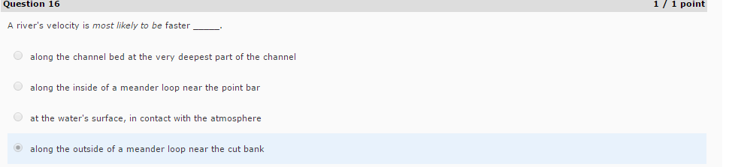

What year was the Great Lakes Water Quality Agreement originally signed?
- 1978
- 1972
- 1987
- 1974
- 1968

Of the developed aquifers in the world most are:
- Igneous rock aquifers
- Sedimentary rock aquifers
- Unconsolidated aquifers
- Metamorphic rock aquifers

The dead storage in a dam refers to:
- Point of flooding in a dam when dam is about to collapse
- Saved for irrigation in times of severe drought
- Space in reservoir …
- The water stored below the principal outlet

Which of the following statements/questions would best be considered related to Environmental Justice?
- There simply not enough fresh water for the population
- Stop or I’ll shoot
- The Love Canal trail in the US
- Does pollution come to those of lesser means or do those of lesser means come to pollution
- Hundreds of thousands of people were told to stop using water from the Yellow River

If the piezometric surface is 5m higher than a well, it is an artesian well.
- True
- False

Wetlands provide the service of nutrient cycling ,which according to the millennium ecosystem assessment (MEA) is categorized as:
- Provisioning service
- Regulating service
- Cultural service
- Supporting service

In Water treatment processes, activated carbon is used to remove?
- Microbial materials
- Inorganic materials
- Organic materials
- All of the above
The amount of infiltration during a precipitation event is dependent upon:
- Existing moisture conditions
- Substrate
- Slope
- Type of vegetation
- All of the above
- None of the above

Two most widely measured climatic variables on earth are:
D. Precipitation and Temperature

Catchment ponds in Ajax are being tested as a means of partially treating stormwater runoff. Which of the following treatments does not occur?
- sedimentation
- photochemical breakdown
- chlorination
- Biological activity
- Both A & B

Which of these is the most accepted negative aspect of privatization of water supplies?
- Low efficiency
- lack of expertise
- lack of money
- cuts to well paying jobs
- poorly maintained infrastructure
- Dragons

Within the aquatic ecosystem which area is most likely relatively shallow open water?
Littoral Zone
Profundal Photic Zone
Benthic Zone
Pelagic Photic Zone

Why do zebra mussels promote algal growth in the Great Lakes?
- The shells release nutrients as they break down
- They prey upon the predators of algal growth
- The prey of the algae eat the zebra mussels
- They filter the water decreasing the turbidity -- why is this not B yo --- BECAUSE THE QUIZ ANSWERS MARKED D AS CORRECT. Because decreasing turbidity increases the amount of UV light entering the lake, promoting algal growth and later, eutrophication
- None of the above are correct

Which of the following is used in the first stage of the water treatment process?
- Primary settlement tank
- Screen
- Biofilm
- All of the above

What was the first recognized water treatment system ?
- Biological Treatment
- Slow sand, filter bed
- Rapid sand filter bed
- Antibiotics (LOL)

A river valley just experienced a 25 year flood event in 2013, what probability of 25 year old flood will occur in 2014 ?
1/25 x 100 = 4%

It seems as though for a certain population in the ‘chemical valley’ area there are almost twice as many girls being born than boys. What is it though to be the culprit by many in the area ?
- DDT build up
- Endocrine disruption
- The diet of the local people
- Phosphorus poisoning
- Simple statistical improbability
A rapid gravity filter can treat flow velocities between:
- 1 and 10 m/hr
- 4 and 21m/hr
- 5 and 15 m/hr
- 6 and 22m/hr

In what season is thermal stratification of the lakes most distinct?
- Winter
- Summer
- Spring
- Autumn

African trypanosomiasis is a protozoan disease spread by:
A) mosquitos
b) assassin bugs
c) snails
d) flies

What are the most important contaminants removed by water treatment?
- Organic contaminants
- Inorganic contaminants
- Microbial contaminants
- All of the above
- None of the above

The process by which water moves through small pore spaces within soil is known as:
- Baseflow
- Micropore flow
- Matrix flow
- Macropore flow

Water moving as overland flow generally tends to enter rivers more slowly than water moving below the ground surface.
- True
- False

Horse Cave, Kentucky is home to “Hidden River Cave” which during a period in the 1960s had a horrible stench due to mis-handled water practices. When taking into account the townspeople relied on the underground rivers for drinking water it is best described in what way?
- Unplanned indirect potable reuse
- Direct potable reuse
- Planned potable reuse
- Unplanned potable reuse
- Planned indirect potable reuse

In areas with karst landscapes, what can easily be found?
- Pumice
- Marble
- Carbonate rocks
- Topaz

According to a 1998 Environmental Protection Agency Report what percentage of lakes in the United States are considered polluted?
- 10%
- 15%
- 25%
- 35%
- 45%
- 55%

By most accounts the production of two hundred tonnes of cement would result in the emission of approximately?
- 200 tonnes of CO2
- 2000 tonnes of CO2
- 50 tonnes of CO2
- 20 tonnes
- 1 ton

Which of the following aquifer properties is not true?
- Aquifers can be categorized as either confined or unconfined
- Groundwater is able to be extracted
- Aquifers are made up of silts and clays
- Aquifers are typically recharged by rainfall in high topographic areas

What was the main natural cause of the drought in europe in 2010?
- El nino event
- The jet stream
- Reversal of air currents
- Sudden change in ocean currents
- Air movement from the gulf of mexico

In urban areas, floods often become more frequent because:
- Storm sewers conduct runoff more efficiently into streams
- Extensive pavement limits water infiltration into soil
- Extensive pavement increases runoff to streams
- All of the above are correct

What classification/type of river would be found in a glacial meltwater area in a mountainous region with variable water discharge
- Englacial
- Straight
- Braided
- Meandering
- anastamosing

You realize there has been a massive spill of an organic compound onto a groundwater recharge area. All other information being equal would you rather it be a:
A) NAPL
B) LNAPL

To reduce the impact of mine pollution, biological systems are a good choice however they cannot be applied to every case why?
- It is expensive to construct
- It is expensive to run
- It requires the availability of suitable land areas close to the source of pollution
- It is not a sustainable solution to mine pollution

Which of the following countries has the highest water demand? (average use of water per day per person)
- USA
- Australia
- Italy
- Japan

On a global scale what percentage of developed aquifers are in unconsolidated materials?
- 25%
- 50%
- 80%
- 90%

What is the Thalweg?
- Line connecting the deepest portions of the stream
- Sequence of alternating deeper and shallower sections
- Area of slowest velocity in a river system
- A and C
- A and B

QUIZ 3
Fog Harvesters in Chile are becoming quite efficient. How many litres of water are estimated to be collected in ideal conditions per 1m² of fabric?
a. 3 litres
b. 6 litres
c. 9 litres
d. 12 litres

source : http://www.asce.org/cemagazine/Article.aspx?id=23622328090#.UyyzPRZgPzI

Which country does not experience water scarcity
- Egypt
- Libya
- Chile-
- Saudi Arabia

Why did the Aral Sea Dry up?
- The water was diverted for irrigation
- Climate change
- Damming caused reduced flow to the area
- Isostatic rebound caused change in local topography
- All of the above

the following statement(s) about Arch Dams is/are true:
- The utilize the strength of an arch to displace the load of water behind it onto the rock walls that the arch is built into
- They are able to build in a wide variety of locations
- The hoover dam is an Arch Dam
- Both A and C
- Both A and B
- All of the above

In which area does the most primary production take place?
- The profundal zone
- The benthic zone
- The pelagic photic zone
- The littoral zone

Which of the is the most likely physical impact of water body created by a dam ?
- Decreased nutrient content
- Decreased Oxygen Content
- Decreased sediment load in reservoir *
- All of the above are equally possible
,

Which of the is the least likely physical impact of water body created by a dam?
- Increased nutrient content
- Increased oxygen content
- INcreased sediment load on reservoir side of dam

In general, the head waters of river systems:
- Are steep
- Are deep
- Have coarse bed sediments
- Have slow velocities
- A and C
- All of the above

What factors need to be considered when setting a price for water?
- Costs for transmission
- Costs for treatment
- Costs for maintenance
- Costs for distribution
- All of the above

______________ is a water borne disease that comes from snails that breed on the upstream side of dams.
a.Fasciolopasis
b.Schistosomiasis
c.Shirtoshpera
d.Malaria

What statement was most likely generated from a conservationist when discussing the building of a dam? (hint: you need to think this one through. It is not in the notes)
- ‘Switch to solar, wind, and geothermal (700 MW potential in great rift valley) and other energy sources’
- ‘Foreign aid accounts for 90% of Ethiopia’s national budget - reason enough to develop economy’
- ‘Firewood contributes to more emissions, hydropower cleaner and reduces emissions’
- ‘Urban-industrial development and food self sufficiency in Africa requires large dams’

Which of the following is often used as a chemical disinfectant to treat potable water?
- Chlorine??
- UV0.71
- Chlorine dioxide
- A and C

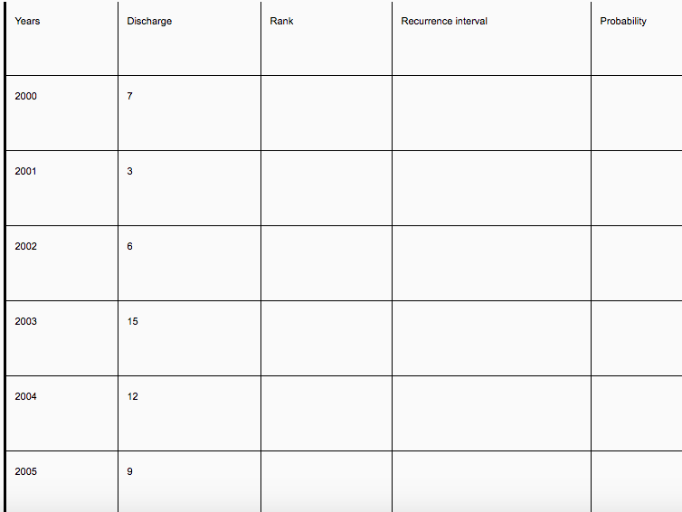
What is the probability of the year 2004 discharge? Anyone know the answer??
- 0.71
- 0.14?? << I got this -- you rank largest to smallest
- 0.33
- 0.65 dont have to do this for the exam
- 0.22
DID ANYONE FIGURE OUT THE CORRECT ANS?
What is the right answer???^^^^^^^^^^^^^

Answers for this may not work probably best to ask him but looking at this (http://www.uh.edu/~jbutler/physical/flooding/floodingprediction.html) it should be
RI = (6+1)/2 = 3.5, P = (1/3.5)(100) but none of those answers work = 0.2857…. If you rank them the other way (i.e., smallest to largest) you end up with 0.71 - can someone confirm if this is correct?
^ where you getting 6 from? - 6 is from the amount of years and you add 1
If you check the example for yourself take the rank 1 answers - 15 years total + 1 = xf → RI = 16/1, P = 1/16 0.0625
DID ANYONE GET THSI ONE???/
RI = (# of entries + 1)/rank = 7/5 = 1.4 -- probability = 1/1.4 = 0.71

In 1922 the Supreme Court instructed Colorado, New Mexico, Utah and Wyoming as to what percentage of the Colorado River they could use. Who was allocated the least among them?
- Colorado
- New Mexico
- Utah
- Wyoming

The germ theory of disease linked foul smells and stagnant air with the cause of disease.
- True
- False

The indirect use value:
- Is the value related to the present or future by individuals
- Is the value attributed by individual who have knowledge that a resource will be available for future use
- Is the value associated with the benefits derived from the knowledge of how a natural resource is maintained
- Refers to the benefits derived from ecosystem functions

APL
- Biological treatment
- Slow sand filter-bed
- Rapid sand filer-bed
- Antibiotic treatment

Which of the following makes up the majority of aquatic algae?
- Bacillariophyta
- Chlorophytes
- Chryophytes
- Cyanobacteria
- Rhodophyta

What is regarded as being the most important nutrient driving eutrophication in lake ecosystems?
- Phosphorous
- Nitrogen
- Oxygen
- Sulfur

Which are considered issues with the desalinization process?
- Expensive
- Create high saline byproducts
- High energy use
- Both A and B
- All of the above

Reservoir induced seismicity is a result of:
- Increased boat traffic
- Creating large scale dams
- Removal of naturally occurring dams (such as beaver dams)
- Naturally occur without human interaction
- Diverting water for irrigation

Which membranes have the largest pore size?
- Reverse osmosis
- Ultrafiltration
- Microfiltration
- Nanofiltration

What percentage of houses in the UK have water meters?
- 70
- 80
- 40
- 60
Which of the following is a symptom of the urban stream syndrome? - maybe
- Altered ecosystem functioning
- Modified thermal regimes
- Transformed channel morphology
- Reduction of biodiversity
- All of the above

If a dam is built, sediment will be on the upstream side of a dam and sediment will be _______ on the downstream side of the dam.
- Accumulated, accumulated
- Accumulated, eroded
- eroded , accumulated
- Eroded, eroded

How do parasites cause changes in the productivity and community of an aquatic ecosystem host?
- They break coarse material of the hosts into fine particulate organic matter
- They reduce host population density
- They change the behaviour of the host
- All of the above
- B and C

What is the world’s biggest public health concern according to WHO 2010b?
- Dengue fever
- Yellow fever
- Malaria
- Cholera
- Onchocerciasis

In developing countries, which has the largest demand on water?
- Agriculture
- Industry
- Domestic use
- Commercial use

What affects groundwater chemistry?
- The chemistry of rainwater
- The soils in the catchment
- The rocks through which the water has passed
- The residence time of in the aquifer
- All of the above

Which is true of a Eutrophic lake?
- High dissolved oxygen
- Low in nutrients
- Turbid water
- All of the above

Which First Nation Community lives along the St. Clair River?
- Onayotekaono
- Semiahmoo
- Huronian
- Aamjiwnaang
- Okanagan

To prevent toxicity, the concentration of ammonia-N in treated water should be kept below:
- 1-4 mg L-1
- 5-6 mg L-1
- 7-8 mg L-1
- 7-10 mg L-1

In which area does the most primary production take place?
- The profundal zone
- The benthic zone
- The pelagic photic zone
- The littoral zone

What is the WHO (2008) guideline value of nitrate in drinking water?
- 40 ppm
- 50 ppm
- 10 ppm
- 20 ppm

A Moraine is a deposit of glacial sediments used often used as ground water recharge zones. North of Toronto in southern Ontario is an important recharge moraine named the:
Peterborough Moraine
Pine Ridges Moraine
Oak Ridges Moraine
Pine Valley Moraine
Tim Horton Moraine

What percentage of U.S.A surface water bodies are contaminated by pesticides?
- 60
- 70
- 80
- 90

What statement was most likely generated from a conservationist when discussing building a dam?
- Urban-industrial development and food self sufficiency in Africa large dams
- Firewood contributes to more emissions, hydropower cleaner and reduce emissions
- Foreign aid accounts for 90% of Ethiopia's national budget- reason enough to develop economy
- Switch to solar, wind and geothermal (700MW potential in great rift valley) and other energy sources
b) or d)

The intrinsic groundwater water vulnerability is a function of which:
- Nature of any overlying confining layer
- Depth of groundwater
- Thickness of any overlying confining layer
- Characteristic of the aquifer materials
- All of the above

What is the Reynolds Number of a stream given the following information?
Reynolds Number (Re = VRq/u) Re = V R
Stream depth = 2m
Stream width = 5m
Discharge = 5m³/s
Choices:
- 3140
- 556
- 5491
- 1015Ï
R = (5*2)/(2+2+5)
= 1.1111

V= Q/A
V= 5/ 2*5
V = 0.5

Re= (0.5m/s) * (1.1111) * (1000)
=555.6
=556 → THANKS
nice

What is the probability of the year 2004 discharge?
- 0.71
- 0.14
- 0.33
- 0.65
- 0.22
How do u even do this??????^^^^^^^^^^

Which of the following lakes is the most likely to undergo eutrophication?
- Lake Baikal
- Lake Ontario
- Lake Erie
- Lake Superior
- Lake Huron

In water treatment processes, activated carbon is used to remove:
a) microbial materials
b) inorganic materials
c) organic material
d) all of the above

Which of the following is true when considering hydrographs?
The peak precipitation rate coincides with peak discharge
The discharge graph will be sharper (meaning have a higher peak) in a rural as opposed to an urban area
The majority of the water entering the stream is from directly atmospheric water
All of the above are true
None of the above are true ****
Of the developed aquifers in the world most are :
- Igneous rock
- Unconsolidated
- Metamorphic
- Sedimentary
https://www.coursehero.com/file/p7pgutk/Growing-Season-o-What-months-Magnitude-of-SD-o-Just-a-qualitaTve-quesTon-iming/

What was the first recognized water treatment system
a)biological treatment
b) slow sand filter bed
c) rapid sand filter bed
d) antibiotic treatment

