New Media: CMN2170

New Media:
- Innovations related to technology and the social effects these new technologies pose to daily life

Media:
- Extension of the self-Marshall Mclueon
- Mass messaging

New:
- New vs traditional
- Fb is new
- Old is newspaper printed
- Digital vs analig- helps determine old vs new
- New media can be determined by interactivity
- Traditional media: Radio-sends out info but it won’t impact

September 12: Lecture 2
Recap:
- Space vs time media
- Letters and write word: time and space
- Interactive: Core component of being new
- New Media offers us a sense of interactivity unlike older forms

New Media: Textbook says if it’s new it is
- 2 way
- Interactive
- Digital

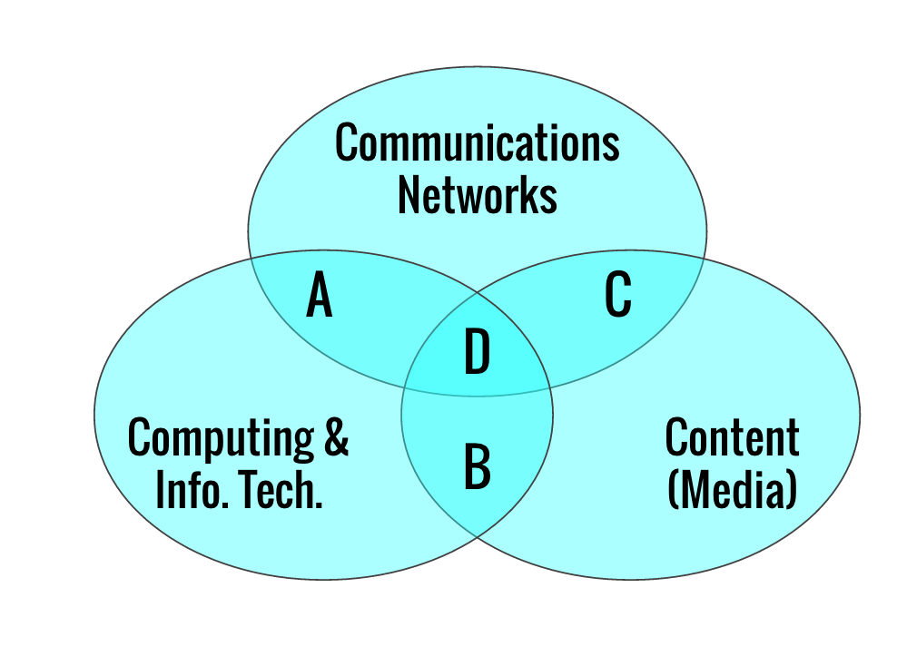
Convergence:

- More innovation b/w these sections
- New techs develop within the technologies
- ICT’s

Go to textbook for examples

D:
- Internet
- Convergence of all these things into 1

Netflix could fit in C or D

Convergence:
- Connects service, industry and technology
- Pre order drinks on starbucks apps
- Air bnb
- Yelp
- Online shopping- floats across a few industries
- Online gaming
- Youtube-convergent (link things seen with social network with tv, Service delivering content and letting you interact with it. Multiple different industries making content available on YT

Reddit:
- Took the idea of being the news of the day and using the internet to do it
- New service that is enabled because of new tech and convergence
- Multiple comm techs used: Reddit, fb…
- Traditional media commenting on this stuff

Three Elements:
- Artifacts that extend ability to communicate
- Comm. activities and practices we develop to use devices
- Social arrangements and organizations that form around these devices-subreddit

Characteristics of digital- 5 different ones (go over that)

Hybrid Media System: Andrew Chadwick
- His definition of hybrid is power relations
- New becomes old: Email was new but becomes old
- Complex and evolving power relations, First email account vs now
- Adaptation and interdependence

What do we need to consider when deciding if a media is new or not:
Year cut off? Before 1995?

September 15, 2016: Comparing Media Systems
Mass Media System:
- One to many communication
- Few media (limited channels of it)
- Concentrated ownership of the channels
- Expensive to own media
- Source is the creator of content and channel is the conduit

Channels:
- Radio
- Television
- Newspapers
- Podcast

Sources:
- Owners of printing press
- Journalists
- Photographers
- Radio or tv broadcasters (CBC, TV)

Hybrid Media System:
- “whats new becomes old”
- One to many, many to many, many to one communication
- Many and changing media (proliferation of channels)
- Ownership does not limit content creation
- Crucial difference between channel and source

Channels?
- Some channels may disappear but they aren’t necessarily excluded
- Create info about ourselves
- CBC is still posting articles

Adaption and Interdependence:
- When Facebook bought instagram- make use of different social networks
- Being able to post things to multiple social networks
- Facebook has instant articles feature

Introducing Technology:
- Introducing laptops
- Netflix
- VCR-DVD

Telegraph:
- Move info with signals (not things)
- Morse code
- Innovations: Scanning line by line and paper tape (recording/ storing)

Metcalf’s Law:
- Value of the network increases at the square of the number of connections

Monopolies:
1850’s: Over 100 telegraph companies in the US
1870’s: Western Union one of only major companies

Pair with other industries:
- Railways
- Associated press
- Newspapers

Telephone:
- 1891: Automated telephone switch
- Switchboards with women answering the calls and transferring to other people

Radio:
- Immediately valuable
- Cheap to buy/ use
- 1920’s: Becomes a broadcast medium
- Commercial value (2 types)
- Miliatry use was one of the biggest original uses
- Advertising also became prevalent and ha remained so

Television:
- 1932: First broadcast tests in Canada (montreal)
- 1950’s Widespread adoption
- After WW2, there was more interest, time and money to do so
- Seen as a risk to other media
- Maybe tv will save society and make people more educated?

Media Habits:
- Everyday approaches we have to making use and consuming media content
- Develop media habitually

Activity:
Take phone with me for a day. Every time you come into contact with ICT, take note
Every time come in contact with news, take note

September 19, 2016:

Who Invented Internet:
Packet Switching: Cutting data into smaller packets, to avoid congestion of information
- Cyclades (France) how to create key components for internet, NPL, different networks can’t talk to each other
- World Wide Web, CERN
- Meant to withstand things and add communication value

History of the Internet:
- JCR Lig…
- Advanced Research Project Agency (Arpanet)
- Ray Tomlinson-Electronic mail (email)
- Vinton Cerf-Transmission control protocol (TCP) Often credited with inventing Internet
- Tim Berners Lee-WWW
- Internet is foundation layer, World Wide web is the layer on top, connection of links
- World Wide web lets us interact with internet and do things
Mainframes: Large computers that originated. Can timeshare-divide power to other smaller computers
Personal computers: Laptops and what not
WWW: Composed to html and http (lets us link urls)

Physical Side of the Internet:
- TED talk
- Dependent on low tech systems

Webs: 1.0 vs 2.0
- Web 1.0-Read only web that is all yours
- Web 2.0-Read,write web that lets you interact and have a 2 sided dialogue with others
- You have a say in things in 2.0
- Web 2.0 is more current and what we are seeing currently

Core Principles of Web 2.0:
- Decentralized control
- Many to many interaction
- User focused
- Open (tech standards and API)
- Simple and lightweight in design
- Expected to evolve over time

API:
- Programers door into data that company like twitter has

Semantic Web:
- Everything hyperlinked
- Tom Burners Lee
- Machine readable
- All the metadata, links everything together and gives you all the info
- Extra info you can pile on top
- Metadata should be standardized

Internet of things:
- Global infrastructure for the information society (ITU
- Devices collecting and exchanging data
- Have physical internet
- Less tangible, requires us to put chips in various devices

September 22, 2016:
Regulating Cyberspace:
Is behaviour controlled?
- Instagram reserves right to get rid of things they don’t accept
- Youtube changing their policies right now
- Facebook may own some content that you post and use it for their own purposes

Declaration of Ind. of Cyberspace:
- You have no sovereignty where we gather
- No control over cyberspace by govt because it doesn’t exist in only one place as a whole
- “How cyberspace is, is not how cyberspace is meant to be”

Regulation:
- Laws
- Norms
- Markers
- Architecture

Regulability:
- Capacity of govt to regulate behaviour within proper reach
- To regulate u need to know who they are, what they’re doing, and where they are

Who are you on Internet:
- Assigned IP address on WWW
- Degree of anonymity for people
- No real rules on who can use internet

Where are you on internet:
- Packets assigned logical addresses
- ISP’s don’t always keep physical addresses linked to IP’s

What are you doing on Internet:
- Packets labelled for delivery
- No information, no content
- No required standards

End to End Principle:
- Design principle
- Lessig book (page 44)
- Architecture as way to regulate things
- Simplicity at core, complexity at the edge
- Allows for innovation
- Info is simple at the main bit but then becomes more complicated

Cookies:
Trace movement across the web j
Base for online commerce
Build profile of you baed on what you look at and buy

Single Sign-On:
- Authentication
- One password to connect to a network
- university sign on

- Packet Inspection and filtering:
Software or applications at either end of transmission
- On top of network, there are watches

IP Mapping:
- Companies and software
- Numerically close IP’s are not necessarily geo. close

- Every time you go on internet it’s like you have virtual wallet
- You decide when people see things/what they see
- Code is architecture
- Code decides what is accepted and what isn’t
- Google gets more information every time you search
- Architecture is always changing, code is always changing
- Code is law

Twitter: 3 times
Facebook: 6 times
English article research: Library and other news outlets
Facetime: Once

September 26, 2016: Mobile, Rules of Cyberspace

Mobile:
Portable devices can be mobile
Cars, mobile devices, blenders

Evolution of Texting:
- Provider to user
- User to user is an afterthought
- Popular because it is cheap and there is competition
- Phones as a platform for other things
- New level of competition \

Add ons:
- Reasons to always have your phone
- Games and add ons became a revenue source
- Games, ringtones, tv voting….
- Marketability of these new elements

Twitter:
- SMS
- 140 characters
- You can have a post pic with more characters
- SMS services have effect on tech

Apple:
- 3G phone, app store
- App for that
- Everyone can make apps
- Possibility of free apps

SMS shorthand
- wtf, why the face
- Text messaging made u be brief when u had 140 characters
- Acronyms help this
- Young people being independent of their parents

Second Screen:
- Sit and watch tv but also have my phone
- Using multiple screens at a time
- Live tweeting

New Media:

Midterm:
- 8 short answer (you answer 4)
- 30 MC
- Dates: when technology was introduced and when things changed

Short Answer:
1-2 paragraphs each

Convergence can be seen on 3 levels: (service, tech, industry)
Tech convergence because combines various technologies into one

Introduction:
- Defining new and defining media

Comparing Media Systems:
- Mass media system vs hybrid media system
- Channel and source
- Novelties and importance of technologies

Internet: A technical guide
- Web 2.0
- Semantic web
- internet of things
- Idea that we are creating network of objects because computer chips are everywhere
- Network of objects- like car, blender, phone can all send and receive things

Internet vs WWW:
- Internet is infastructure
- Internet is network of networks
- WWW is a collection of websites, mass of information
- Access WWW through internet.

WWW and Web 2.0:
- When did we move from web 1.0 to 2
- Some people don’t think that web 2.0 is very useful
- What are the principles of the technology
- Principles of web 2.0 are what make it more user focused

What regulation requires
law, architecture, norms, market

- Mobile is something you bring with you, somethings are more mobile than others
- Difference between mobile and portable
- How frequently people access social media sites
- 1999 statement

October 17, 2016: Media and Networks

Facebook as social network or not- from video and article

Organizing ourselves:
- Networks vs groups
- Barry Wellman, Canadian Sociologist
- Network capital
- Talks about how we form groups
- Cyberspace compliments physical space
- Pull from people you know that make up your network
- Network of people you know, some in both physical and cyberspace or only one

Social Capital:

Bonding
- Strong ties
- Dense
- Family, local community

Bridging
- Weak tie
- Sparse
- Cross-cutting
- Colleagues

Linking
- Ties across status
- Political elite and average citizens
- Linking capital-tweeting to JT?
- Networked capital

Social Network Analysis:
- Online and offline
- Started with sociogram
- Trace data is the breadcrumbs we leave through the internet (cookies, tweets)
- Views on a youtube page is considered trace data
- Graphs and sociogram lets us determine all the relationships that exist
- Network graph

Node and Edge:
- Created different group when blue group starts interacting with the red group
- Stronger ties lie within where red and blue are connected to each other
- Linking relationship if main one from blue is connected to red
- Outliers of CDNpoli that interact with it, but aren’t relevant
- Colour based on modularity, how they are connected and their influence
- Size represents influence

October 20, 2016:

History of Games:

- 1970’s:
Arcade style games
- Pacman and bumper games
- Coin operated
- Going into space with lots of games
- People you would play with and take turns with others

1980’s:
- Nintendo learned from Atari
- They produced quality not just volume
- Had spinoffs, cartoons, lunch boxes, comic books
- Difference b/w high quality and just creating games

1990’s:
- Personal computing and internet rise
- Sega: Attract developers
- Gameboy: Handheld and portable
- Playstation: Shift to CD roms from cartridges
- Computers were dedicated to graphics processing unity
- More computers in the home at this point

2000’s:
- Media content platforms at centre of home entertainment
- Massive multiplayer online games
- New demographics emerged
- Can connect to any screen you already have
- Leads to development in how games are produced and distributed
- Crowd funding campaigns

Choices Now:
- Console
- Computer games
- Web
- Mobile
- Social
- First Person Shooter (COD)
- Driving and racing
- Social
- Educational

Tamagotchi doesn’t fit in to one thing perfectly

Free to Play:
- Advertising to free games
- What is the cost of our time to give up

Who is Involved in Gaming Industry:
Making of a game:
- Capital and publishing
- Product and talent
- Production and tools
- Distribution
- Hardware
- End-User

Modding:
- Modification of content by end users
- Modifying the interface of the game
- Usually has the tacit approval of the game designers

Analytics and Experiments:
- Track use when specific elements are manipulated
- Active experiements
- Drive in game purchases
- What the next versions of the games will look like
- Trying to get people to buy more stuff like an extra set of turns on a game
- Changes what these turns look like

What is impact on Games:
- Increases violence and kids are desensitized

October 31, 2016: Pokemon Go

Using Wikipedia:
- Pokemon Go is a new topic
- Not enough scholarly articles on, since it is so new and evolving
- Gives stats about the app and its popularity
- Doesn’t do great job at being updated and giving it a current picture of the game’s popularity
- Sometimes need to rely on grey literature to understand more evolving and modern phonemes

Augmented Reality:
- Use of networks, databases, to overlay location….
- Influence on Pokemon Go on Physical Act: Stuy and Implications
- Tim Althoff article

Technical Issues:
- Update history A and B
- These games are in constant beta phase
- Google Access, privacy
- Too easy or too hard to get certain Pokemon
- There are safety issues
- Google information released
- Adding pokemon go support

Pokemon Go Plus:
- Wearbles trend
- Trend is emerging
- Pokemon and Google Maps drop symbol

Twitch TV:
- Live stream
- 2011 started, bought by Amazon in 2014
- News media is the highest form for Wikipedia editors
- For us it is not always best to have these news sources

Nodes
Edges (also called ties)
Strong ties
Weak ties

November 21, 2016:

November 21, 2016: Internet Law

Cyber-libertarianism:
- Technologies are going to be able to self govern
- We want libertarian view of internet ind. of governing bodies
- This is an ideal, not what we actually have
- Simplicity at core, regulation is at edges because that where it gets complicated and complex
- Corporate entities
- Cyber libertarians did not really know what they wanted in terms of corporations
- Risk is that markets become main regulatory board
- Equity issues come up here
- 4 types of regulation are balance to each other
- Central to the way we self govern

ICANN:
- Internet corporation of assigned names and numbers
- Not for profit
- IP Addresses for websites and servers
- Phonebook of the internet
- Make sure there are enough domain names for everyone to go around

Canadian New Media Policy:
- public inquiries
- public consultations
- investment and regulation of infastructure
- privacy law
- investment in underlying technologies
- subsidies and tax incentives
- declining to regulate (forbearance)

Copyright:
- Material is created and can have private benefit
- Whole idea of creating things and producing knowledge is building stronger system
- Short term boundaries-that way time restricted
- Moral right and economic right-2 different rights
- Economic right-benefit in material ways for creation
- Moral right: subjects have say in things as well as creator

What is copyrightable:
- Original forms of creative expression
- Facts cannot be copyrighted

Alternatives to Copyright:
- Insubstantial use
- Public domain- books written long ago (author dead 50 years)
- Open access
- Creative commons
- Links

Why Copyright Matters Now:
- Reproduction is faster now as well as easier
- Rise of knowledge economy
- Copyrighted products part of global popular culture
- Globalized copyright law

Intellectual Property:
- Information as public resource: Copyright laws need to be less strict here, we want materials to be as accessible as possible
- Info as private property

5 Questions to ask:
- Is the material you wish to copy still protected by copyright
- Is the proposed use still substantial
- Does permission exist in form of a license
- Is use allowed under copyright law exception
- Do you need to secure copyright licence

December 1, 2016: Civic Tech in Ottawa/ The World

James Chan:
- Impact Hub idk man
- Digital transformation are some of the biggest chages in society
- These drives are happening in private sector
- 2 biggest layers for improving people’s lives at scale are tech and government
- Meaningfully engage in public sphere
- Digital tech, when used correctly can improve governance
- Open civic level, grassroots organizations where people self organize
- Not just for techies, tech doesn’t need to be derogatory
- Hackathons

Where do we Need Civic Tech:
- Limited resources in public and nonprofit sector
- Government may be less agile
- Talent and perspectives
- Changing needs of citizens
- Increases public participation
- Opportunities to leverage data and tech
- Empowering citizens through learning, teaching and, collaborating

Definition:
- Average people or government/ professionals empowering or having impact on governance
- Beneficial to everyone
- Citizens to collaborate to make tech
- Civic tech describes meet ups
- Exist all over the world

Types of Civic Tech:
- Gets better with people
- As civic engagement
- Who/ what is involved

Who/What:
- Bring people from different backgrounds together
- Voluntary not paid
- Building networks and building skills
- Technology for public good that enables citizenship
- Vote savvy example

Vote Savvy:
- Survey on political ideals
- Hackathon
- Voter information tool
- Civic tech that bring together users
- How this relationship between acaedimia and citizens works

Wikiedits Bots:
- Anonymous edits for Gov Canada wiki edits
- GCCA edits
- Self identifies as bot
- Civic implications come
- Edits over time going down
- More transparency= knowing how govt edits knowledge

Chilling Effect:
Good or bad
Good edits aren't happening anymore, or bad edits still happen and are harder to find over time for the citizens using them

December 5, 2016: Networked Life

- Most of value from computer comes from network connection
- How this connects to past classes and social networks and social media
- How computer value comes from a network??? Good exam question
- Values of these connections
- Metcalf’s law
- Globalization
- Affordances
- Social networks

Solange’s Class:
- If you do not have internet, you cannot be a democratic member really
- Freedom of speech and association

Amazon and Networked Bookstore:
- Needs you to have network and computer
- Realistic to have one internet bookstore instead of small stores in every community

Always on:
1. Rise of mobile computing
2. Increasing access to high speed broadband
3. Diminishing costs of internet access

- People always have notifications on
- Have everything with you at all times
- Internet is cost effective, cheaper than it once was
- Freely available in a lot of circumstances

Are you compelled to be on?
- Costs in the US
- Different applications
- Social obligation
- Do not disturb

Tech Determinism:
- Approach to tech that posits unmediated outcomes
- Kind of self-determinism and internal logic to evolution of technology

Wikipedia on Tech Determinism:
- Tech development follows predictable path
- Beyond cultural or political influence
- Tech in turn has effects on societies that are inherent
- Fact that we are always on is a repercussion of mobile phones and computers

Technology determines behaviour

Tristan Harris: Time well spent
- You can make a choice, not just off or on
- 23 minutes to refocus after being interrupted by something from someone
- Self interrupt about every 3.5 minutes
- Goals of chat shouldn’t be just quick and easy messages being sent
- Should be about choice and creating this option of the interruption is inherently important
- Know if this person is busy and don't have to interrupt their own sense of focus

Affordances:
- Possible uses of specific technologies
- Affordance of a thing as simple as number ways thing can be used
- Frame but do not determine possibilities for action
- Go into silent mode or off?

mobile phone:
- Email Text
- Calling someone
- Connecting with friends
- Facebook other social media
- Music
- Clocks
- Internet
- Alarms
- Telling time
- Games
- Can act as tv
- Special ringtones for people
- Caller ID
- Utilities (calculators, flashlight)
- Books
- Calandar- be connected to other devices
- Maps
- Food delivery

Set of possible uses of a technology. Set of possible uses frames the uses of the technology. People use tech in different ways

- Engagement and involvement as affordance
- Engage in your community through twitter
- Generational gap and how people of different ages use technology in different ways

December 7, 2016: Privacy Law

Lawful Access:

Edward Snowden:
- Do we need privacy?
- What he did
- Nobody needs to justify why they need a right. Burden falls on those trying to infringe on the right
- Arguing you have nothing to hide is an invalid argument

Nothing to Hide?:
- Privacy is fundamental to human life
- Fundamental human rights don't need to be defunded, infringement needs to be justified

5. Vulnerable populations are at risk even when they don't do illegal things
6. Not just you, who you associate with as well

John Oliver:
- 2015, Patriot act
- Piece of legislation, permitted NSA to collect data about citizens

