Constructivism: Piaget and Vygotsky

Constructivism: It is an epistemology, a meta-theory, a theory of knowledge, the generic definitions of which are centered on the active participation of the subject in construing/building reality. Thus objective reality is unknowable. What we know is framed within our already existing subjective reality. Additionally, the acquisition of knowledge is not passive, it must be actively pursued or at least acted upon.

Dr. Farmer’s story: A ten year old experience of “moved with”.
(eg. Farmhouse vs. apartment)

In this class I will present three views on constructivism:

- Jean Piaget, who is known as a neural constructivist.
- Albert Bandura, a social constructivist who specializes in Social Modeling.
- Lev Vygotsky, who is a social constructivist, but his focus is on the use of language.

Neuro-Constructivism: It is a theoretical framework focusing on the construction of representations in the developing brain. Cognitive development is explained as emerging from the experience-dependent development of neural structures supporting mental representations. Neural development occurs in the context of multiple interacting constraints acting on different levels, from the individual cell to the external environment of the developing child. Cognitive development can thus be understood as a trajectory originating from the constraints on the underlying neural structures. This perspective offers an integrated view of normal and abnormal development as well as of development and adult processing, and it stands apart from traditional cognitive approaches in taking seriously the constraints on cognition inherent to the substrate that delivers it.

Social Constructivism: It is oriented toward the concept of constructing knowledge within the social domain of public discourse. Concerning himself with the concept of how we come to know, Gergen (1995) stresses sociality which is to be constructed through observation, and discourse (language). Language is used here in the broadest sense of the word (verbal, non-verbal, symbolic). This exchange as is, knowledge is not constructed autonomously but socio-culturally through the interrelationships among people within a particular community, and with the use of language as a medium.
In the case of Bandura, one would have to include that reality is also constructed through social modeling ie: observation.

Piaget’s Theory of Cognitive Development: Neuro-cognitive constructivist: Jean Piaget
- Jean Piaget (1896-1980) was a biologist who originally studied molluscs, publishing twenty scientific papers on them by the time he was 21 (Piaget’s first publication was at the age of 10 about an albino sparrow he saw in the park).
- One of his first jobs was in the Binet Laboratory in Paris.
- He moved into the study of the development of children's understanding, through observing them, talking and listening to them while they worked on exercises he set.
- Children cannot undertake certain tasks until they are psychologically/neurologically mature enough to do so.
- He proposed that children's thinking does not develop entirely smoothly: instead, there are certain points at which it "takes off" and moves into completely new areas and capabilities.

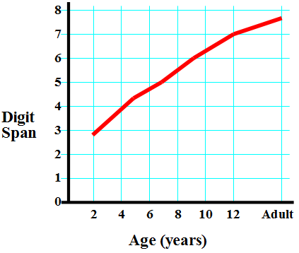Developmental Changes in Memory Span
In one study: memory span increased from 3 digits at age 2, to 5 digits at age 7, to 7 digits at age 12.

Biological influences in Piaget’s Theory
- Specific heredity – hereditary transmission of physical structures
  - Inherited physical structures set broad limits on intellectual functioning
  - Inherited behavioral reactions have an influence during the first few days of the human life but afterward are extensively modified as the infant interacts with his environment
  - The maturation of physical structures may have psychological correlates.

- General heredity – all living organisms attempt to adapt to the environment ( Dr. Farmer’s story of the flatworm):
  - Organization – the tendency for all species to systematize or organize their processes into coherent systems which may be either physical or psychological.
  - Adaptation - adapting our knowledge/understanding of the world through the act of assimilation and accommodation:
    - Assimilation – In the act of assimilation, we use present structures/thinking patterns to bring in new information. In this way, we are not changing our structures, only adding information to them.
    - Accommodation – Once we have brought new information in, it may in fact, alter the various structures or ways we organize our thinking. Accommodation is a re-organization of existing thinking patterns. (Dr. Farmer’s story of girl throwing snowball / cat and dog story).

Piaget's Key Ideas
Classification - The ability to group objects together on the basis of common features.
Class Inclusion - The understanding, more advanced than simple classification, that some classes or sets of objects are also sub-sets of a larger class. (E.g. there is a class of objects called dogs. There is also a class called animals. But all dogs are also animals, so the class of animals includes that of dogs).
Conservation - The realisation that objects or sets of objects stay the same even when they are changed about or made to look different.
Decentration - The ability to move away from one system of classification to another one as appropriate.
- Egocentrism- The belief that you are the centre of the universe and everything revolves around you: the corresponding inability to see the world as someone else does and adapt to it. Not moral "selfishness", just an early stage of psychological development.
- Operation - The process of working something out in your head. Young children (in the sensorimotor and pre-operational stages) have to act, and try things out in the real world, to work things out (like count on fingers): older children and adults can do more in their heads.
- Schema (or scheme) - The representation in the mind of a set of perceptions, ideas, and/or actions, which go together. A way of organizing thinking by way of some attributed value or classification.
- Stage - A period in a child's development in which he or she is capable of understanding some things but not others.
- Abstraction - The ability to use symbolic representation or logic. (Dr. Farmer’s stories on Einstein)

Piaget’s Four Stages of Cognitive Development
- The Sensorimotor Stage
- The Preoperational Stage
- The Concrete Operational Stage
- The Formal Operational Stage

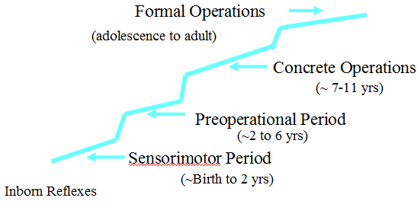Piaget’s Stages of Cognitive Development

The sensory motor stage
- Birth to 2 Years of Age

  - The infant constructs an understanding of the world by coordinating sensory experiences with physical actions. An infant progresses from reflexive, instinctual action at birth to the beginning of symbolic thought toward the end of the stage. For example, they learn what dogs look like and what petting them feels like.
  - Object permanence: understanding that objects exist independently
Dr. Farmer’s story: “Man with binocular” and “Dr. Farmer’s sense of touch”

Sensory motor substages
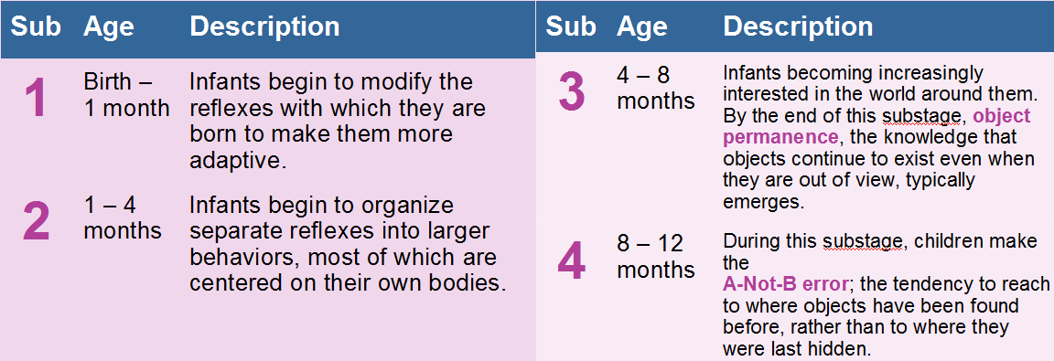

------------------------------------------------------------------------------------------------------------------------------------------
Structures and functions of the Brain

As we all know, the human brain is a very complex system. These notes are meant as an introduction to broad concepts on how the human brain works.

A first concept to remember is that the human brain has developed over millions and millions of years. More and more parts of the brain have been added through human evolution. The more complex and sophisticated the brain has become the more parts there are to integrate and coordinate, thought, feeling, and action. At the same time, new functions must coordinate with existing structures.

- The major parts of the brain

The major divisions of the brain are the hindbrain, the midbrain, and the forebrain.
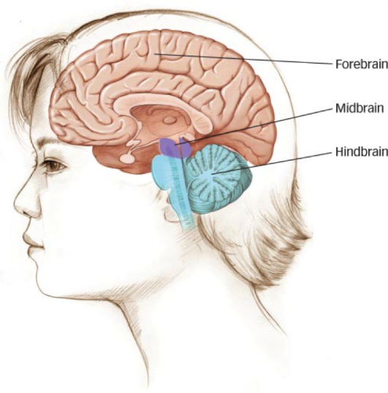
  - The hindbrain
It is located on top of the spinal cord and is responsible for basic autonomic body function (heart rate, breathing, blood pressure, etc.).
One part of the hindbrain is the cerebellum. It is the part of the brain that helps with coordination, balance, motor control, and movement to some degree. An interesting recent understanding of the function of the cerebellum is its function in language. Language has often been considered (and it still is) part of the higher cognitive functions. However, a study from the late 1990’s found that when words relate to action, such as in response to questions like “What does a hammer do?” the cerebellum is engaged to assist in the understanding and finding of the word “hit-pound-nail-strike”, etc.

  - The midbrain
The mid brain is relatively small in humans but play an important role in the functioning of the brain. Structures in the midbrain help orient us in time and space towards incoming stimuli. They also help us identify pleasurable stimuli, go away from threatening stimuli, foster arousal, attention and focus. It also helps the overall brain function, since it is the location of various neurotransmitters.

  - The forebrain and the limbic system
The forebrain is the highest level of the brain and is critical for complex cognitive, emotional, sensitive and motor functions. The forebrain is divided into two parts: the underlying subcortical structures and the cerebral cortex.
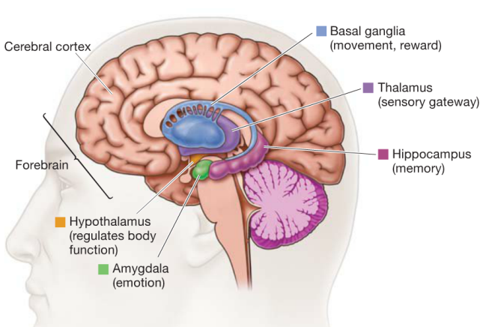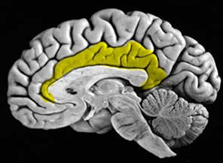
Cingulate Gyrus

    - Subcortical structures:
The subcortical structures play an important role in relaying information throughout the brain; interact closely with several other brain structures: They relay signals to and from these structures and also help to regulate them. The Subcortical structures include the thalamus, hypothalamus, and pituitary gland.

      - Hypothalamus – regulates body temperature, hunger, thirst, and sexual behavior
      - Thalamus – relays and filters information from the senses and transmits the information to the cerebral cortex.
      - Pituitary gland – Also known as the “Master Gland” of the body’s hormone-producing system, which releases hormones that direct the functions of many other glands in the body.

    - Limbic system
The limbic system is recognized as a major site of human emotions. It lies on top of the hindbrain and midbrain. Here we will look at specific structures:
      - Hippocampus – a structure critical for creating new memories and integrating them into a network of knowledge so that they can be stored indefinitely in other parts of the cerebral cortex. **(processes information to other parts of the brain - more efficient when an emotional connection is present)**
      - Amygdala – A part of the limbic system that plays an important role in many emotional processes, particularly the formation of emotional memories.
      - Basal Ganglia – A set of subcortical structures that directs intentional movements.
      - Cingulate Gyrus – The Cingulate (to surround) Gyrus (fold), is part of the cerebrum gray matter surrounding and directly connected to the parts of the inner Limbic System. The cingulate gyrus serves as a conduit of messages to and from the inner Limbic System. An important part of the limbic system, the cingulate gyrus helps regulate emotions and pain. The cingulate gyrus is thought to directly drive the body's conscious response to unpleasant experiences. In addition, it is involved in fear and the prediction (and avoidance) of negative consequences and can help orient the body away from negative stimuli. Learning to avoid negative consequences is an important feature of memory.

    - The cerebral cortex
The cortex is the highest level of the brain, and it is responsible for the most complex aspects of perception, emotion, movement and thought. It sits over the rest of the brain, like a mushroom cap shielding the underside and stem, and it is the wrinkled surface you see when looking at the brain with the naked eye.
The folds of the brain are known as the Gyri (Gyrus if you are talking about just one) and the indentations or fissures are called Sulci (Sulcus if you are talking about just one).
The functions of the cerebral cortex can be understood at three levels: the separation of the cortex into two hemispheres, the functions of each hemisphere, and the role of specific cortical areas.

      - Separation of the hemispheres (organization across hemispheres)
Each hemisphere performs generally similar functions of the opposite hemisphere. We will speak of this in more detail later. Interestingly, the right hemisphere receives stimulation/input from the left eye, left ear, and controls motor function of the left side of the body. The left hemisphere performs the same function with the right side of the body.
The corpus callosum is the primary set of neurons that connect and coordinate the functions between the two hemispheres.
Corpus callosum
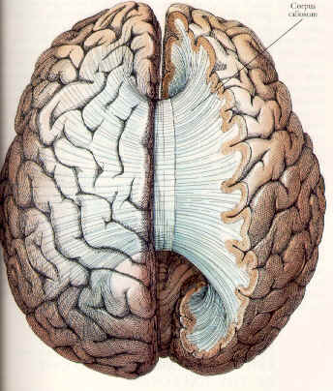

      - Organization within specific lobes
Each hemisphere of the cerebral cortex is distinguished by different functions in different regions/lobes. They are the occipital lobe, the temporal lobe, the parietal lobe and the frontal lobe:
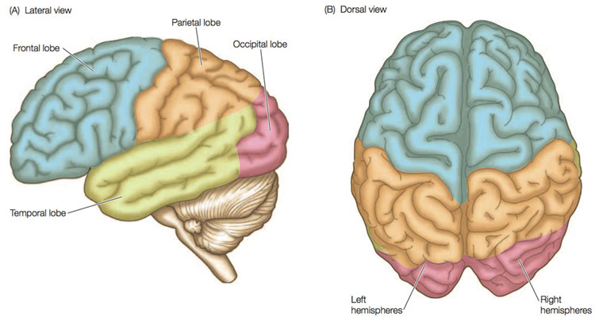
Motor cortex
        - Occipital lobe: a region of the cerebral cortex that process visual information and are located in the back of the brain. It is a primary processor of vision and they are located in the back of the brain. The association areas of the occipital lobe interpret the information extracted by the primary areas – shape, motion, human and nonhuman forms and three-dimensional vision – and the associated areas help make sense of what is being perceived.

        - Temporal lobe: is a major processor of sound and language. Primary areas within the temporal identify specific sounds and register them as relevant. The association areas of the temporal lobe translate it into meaningful constructs (I.E. language.) The speech centre is also located within the temporal lobe.

        - Parietal lobe: located in front of the occipital and above the temporal lobe. It is a region of the cerebral cortex whose functions include processing information about touch. It contains the somatosensory cortex which is bilateral. Once again, the right parietal lobe receives and processes sensory information from the skin in the right side, and the left parietal lobe does the same for the left side. Some other major functions of the parietal are mathematical calculation and integration of various inputs of information coming from the visual temporal and frontal lobes. The parietal lobe also contains a section of memory; particularly generalized information.

        - Frontal lobe: a region of the cerebral cortex that has specialized areas for movement, abstract thinking, planning, memory, and judgement. Other areas of the frontal lobe coordinate thought processes. That helps us manipulate information and retrieve memories, which we can use to plan our behaviors and interact socially with others. In short, the frontal cortex allows us to do the kind of thinking, imagining, planning, and anticipating that sets us apart from most of the other species.

        - Motor cortex: The motor cortex is located and the back of the frontal lobe. It works in connection with various parts of the brain including these two lobes and the cerebellum. The motor cortex helps to initiate movement within the body.

- Hemispheric dominance:
Each hemisphere of the brain, right and left, tend to specialize in different types of processing:

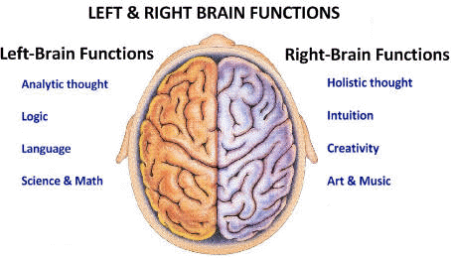

  - Right hemisphere
For example: for a young baby, visual recognition of their mother’s face is of primary importance. Research suggests that facial recognition is primarily right hemisphere occipital lobe task. Further, although an infant cannot understand language as such they do interpret sounds. Therefore, when their mother coos and speaks softly and gently to the baby, although the baby does not understand the words, they do understand the sounds. This is also considered right hemisphere, but now temporal lobe activity.
The right hemisphere has a better connection to the limbic system and gives us a global understanding. It stores/understands language in terms of emotion or topic. It allows us to make generalizations. It is often associated with creativity, imagination and even magical thinking.

  - Left hemisphere
The left hemisphere tends to me more linear sequential thinking, attending to details, and using specific language to identify and express information. It is likely that the left parietal lobe is involved in basic mathematics while the right parietal lobe would be involve in more 3-dimensional constructs such as geometry.

- Summary
All thinking involves all parts of the brain. Each subcortical structure and cerebral lobes contribute to our thinking and reasoning. While trying to think of a forest, we might envision it in some generalized dark shape and may in fact add an emotional component such as excitement, fear, adventure; all right hemisphere constructs. We may then start counting trees… 550 oak, 2000 maple, and 3500 pine as such now we have a different view of the forest. At the same time, this will give us a new overall or pictorial representation how sunny, how dark, etc.
The more we exchange ideas between lobes and hemispheres the richer our thinking will be. This type of thinking helps with memory as it touches various memory resources in parts of the brain; each one reinforces and aids the other.

