Chapter 4 – Stakeholder Relations and Analysis
- Reviews relationships between corporations and stakeholders, which ranges from the basic listing and mapping to stakeholder collaboration and social capital.
- “Stakeholder management” represent how managers perceived stakeholders; suggests that stakeholders can be manipulated or controlled.
Stakeholder engagement: efforts by a corporation to understand and involve relevant individuals, groups, or organizations by considering their moral concerns in strategic and operational initiatives.
Basic Stakeholder Analysis
- Corporations can increase their understanding of stakeholders by asking the following questions: Who are our stakeholders? What are their stakes? What opportunities and challenges are presented to our firm? What responsibilities does our firm have to stakeholders? What strategies or actions should our firm take to best deal with stakeholder challenges and opportunities.
- Similar approach is a stakeholder analysis worksheet for each stakeholder.
- Basic analysis includes a map or diagram of stakeholders arrayed. Lines connecting indicate the direction of influence and thickness indicates influence; gains appreciation for number of stakeholders and understanding of the possible influences.
Freeman’s Stakeholder Management Capability
- Process an organization uses to manage relationships with its stakeholder groups on 3 levels. (1) identifying the stakeholders and perceive their stakes (2) determine how you manage relationships with the stakeholders and fit it into the stakeholder map (3) understand bargains/transactions with stakeholders and if these negotiations fit the map.
Stakeholder management capability: ability of managers to identify stakeholders and their influence, to develop the organizational practices to understand stakeholders, and to undertake direct contact with stakeholders.
- Rational level involves preparing stakeholder map, second level identifies the procedures used to assess stakeholders, and the “transaction” level deals with actual interaction with stakeholders.
Stakeholder Matrix Mapping
Matrix mapping: a technique of categorizing an organization’s stakeholders by their according to two variables; usually involves plotting them on a two-by-two matrix; methodology for assessing the importance or power of stakeholders.
- Four categories of stakeholders:
(1) Problematic: oppose organization and are unimportant.
(2) Antagonistic: oppose organization but are very important.
(3) Low priority: support organization but low importance
(4) Supporter: support organization and of high importance.
- Strategies to deal with stakeholders – Problematic: educational programs, adjust corporate plans to accommodate, and defensive plans if coalitions; Antagonistic: prepare for undermining supporters, anticipate and develop counter-arguments, engage stakeholders in bargaining, make plan changes; Low priority: educational programs and involvement; Supporter: information to reinforce position, influence indifferent people.
The Diagnostic Typology of Organizational Stakeholders
- Stakeholder influence depends on the situation and issues involved; use appropriate methods to deal with each.
- 2 assessments considered: assessment of stakeholder’s potential to threaten organization, and their potential to cooperate.
- Potential for threat is using power to disrupt the organization’s accomplishment; potential for cooperation allows the organization to move beyond and accomplish objectives.
- Stakeholders classified as supportive, marginal, nonsupportive, and mixed blessing.
(1) Supportive: low threat and high potential for cooperation; encourage the cooperation potential, don’t ignore or take for granted.
(2) Marginal: neither threatening nor cooperative, have a potential stake issue-pending; monitor them closely and know their interests are narrow.
(3) Nonsupportive: high threat, low cooperation; be defensive and reduce dependence on stakeholder.
(4) Mixed blessing: high threat and high cooperation; collaborate.
Stakeholder Identification and Salience
- Agle and Wood developed theory of stakeholder identification based upon possession of one or more of 3 attributes: power, legitimacy, and urgency.
Salience: degree of which managers give priority to competing stakeholder claims.
Power: relationship among social actors in which one social actor, A, can get another social actor, B, to do something B wouldn’t usually do.
Legitimacy: generalized perception or assumption that the action of entity are desirable, proper, or appropriate within some socially constructed system of norms, values, beliefs, and definition that is based on the individual, the organization and society.
Urgency: degree to which the stakeholder’s claim or relationship calls for immediate attention; exists when a claim or relationship is of a time-sensitive nature and when that claim or relationship is important or critical to the stakeholder.
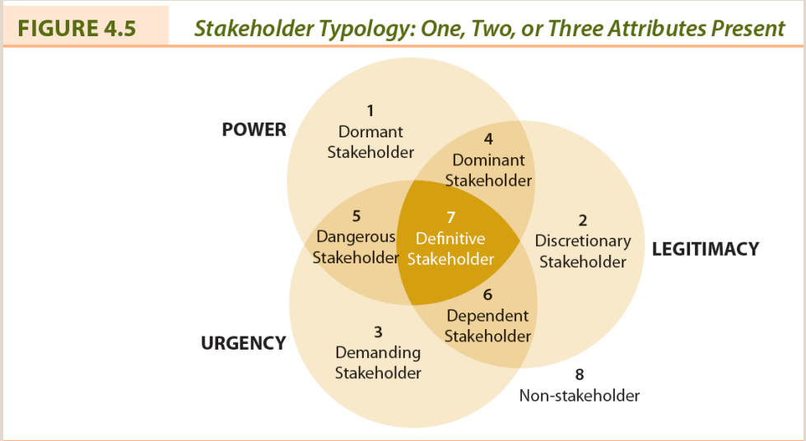
- Those with one attribute are latent or warrant low salience. Two attributes are expectant or moderately salient. Three attributes are definitive or highly salient. None of the attributes are non or potential stakeholders.
Stakeholder Influences Strategies
- For developing responses to stakeholders three general questions must be answered: who are they, what do they want and how are they going to try and get it?
Resource dependence: exists whena stakeholder is supplying a resource and can exert some form of control over it.
- Two general means of control over an organization: withholding strategies and usage strategies.
Withholding strategies: approach where stakeholder discontinues providing a resource to an organization with the intention of changing a certain behaviour.
Usage strategies: approach in which the stakeholder continues to supply a resource but specifies how it will be used.
- Second source of power is resource dependence that arises from relationships with stakeholders.
Influence pathway: occurs where withholding and usage strategies could be performed by an ally of the stakeholder with whom the organization has a resource dependence.
- Direct – stakeholder manipulates flow of resources by withholding or through usage conditions. Indirect – having the ally manipulate the flow of resources; this way requires communication and cooperation.
- Indirect/usage represents no difficulties.
- Indirect/withholding exists where stakeholders encourages customers of the corporation to withhold its business.
- Direct/withholding is illustrated by consumer boycott; stakeholder has the power.
- Direct/usage is more complicated.
Stakeholder Collaboration
- Changing the relationship between the corporation and its stakeholder from “management” to “collaboration”; mechanisms include issue analysis, consultation, strategic communication, and formal contacts.
Collaboration: a metacapability to establish and maintain relationships and allows the organization to tap into a powerful source of creative energy, a large pool of innovative ideas, and a wider network.
- Guide for organizations that wish to develop collaborative stakeholder relations: creating a foundation – relationship building by incorporating it into mission, values and ethics; organizational alignment – internal systems and structure need to be aligned, dialogue with stakeholders obtain clear understanding of perception; strategy development – forge new stakeholder relationships; trust building – promotes cooperation and understanding; evaluation – relationship-building effort and improvements identified; repeat the process – further improve social performance.
Stakeholders and Social Capital
Social Capital: any aspect of a corporation’s organizational arrangements that creates value and facilitates the actions of stakeholders within and external to the corporation.
- Corporations benefit because it facilitates cooperation and coordination, effective and efficient relations with stakeholders and provide a competitive edge.
- 3 levels of organizational culture explain how they orient themselves toward stakeholders. Level 1 – compliance culture preserves value of relationships that are established by laws/norms and seek to avoid destruction of value. Level 2 – relationship management culture where value is created, often traded off after demands of shareholders are satisfied. Level 3 – sustainable organizational which maximizes the creation of value in economic, ethical, and environmental terms.
- Source of social capital as three dimensions: structural – the networks in which the relations are embedded; relational – trust and reciprocity; cognitive – mutual understanding.
- Three benefits are willingness to share info, exert influence to benefit the other, and solidarity adherence referring to group cohesiveness.
- Potential business value created by the benefits of social capital: info allows employees access to new external ideas, enables employees to share info, establish strong emotional connection between corporation and customers, make valuable contributions to community, and allows corporation and union to have reciprocal debts that merge interests.

