Chapter 9- Attention and Awareness

Dichotic listening: listening to one message in the left ear and the other in the right

Filter theory of attention: only some of the physical signals are interpreted for meaning, the rest is filtered out (Ex. listening to only your friend’s conversation at a party and not everybody else)
however high priority sensory events (ex. your name) can capture attention even when attention is focused elsewhere.

Inattentional Blindness: the failure to perceive a fully visible but unattended visual object – even if you are looking directly at something you are likely not going to see it if you are not paying attention to it.

Change Blindness: inability to quickly detect changes in complex scenes (Ex. the map experiment with changing the person. Ex. find the differences images)

Overt attention selectively attending information with movement of eyes
Covert attention selectively attending information without movement of eyes

The Binding Problem: visual system has trouble identifying which visual feature belongs to the same object. To solve this problem Treisman developed the feature integration theory (FIT) which proposes that visual scene happens in two stages:
-the preattentive stage: visual system senses all the basic visual features (edges, shapes, colors) but are not yet bounded together
- the focused stage: attention is directed to the objects, features of each object are bounded together
- The feature integration theory proposes that the brain resolves the binding problem by attending to one object at a time

Competition for neural response objects with features that match the neuron’s preference will produce a strong response and those objects with features that don’t match the neurons preference will evoke a weak response
Biased Competition theory: proposes that the brain uses selective attention to resolve the competition for neural representation by attending one object at a time and ignoring the rest.

Where do the control attention signals come from? The posterior parietal cortex (PPC) and an area in the frontal cortex (frontal eye field)
Unilateral Visual Neglect: stroke damage to the right posterior parietal cortex – difficulty attending to objects in the left visual field

Perceptual bistability- switching be-tween two or more interpretations of an image under continuous viewing (ex. the cube)
-retinal image remains constant, but conscious experience changes
Binocular Rivalry two different images presented to the two eyes results in perceptual bistability (ex. the house and the face)
-the two images are not blended, instead the images alternate every few seconds

Damage to V1 = blind
-do respond to presence of light
Blindsight ability to correctly localize be aware of visual stimuli without any conscious awareness of them

Chapter 10: Sound and the Ears

Sound – movement that disturbs air molecules causing them to collide with other air molecules – most important physical dimensions: amplitude, frequency and wavelength
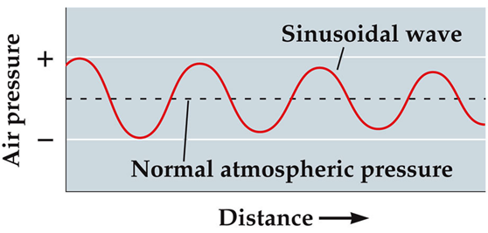
Sound waves: waves of pressure changes in air caused by vibrations of a source

simplest sound wave is pure tone – sound wave in which air pressure changes over time

Amplitude: difference between maximum and minimum sound pressure in a sound wave

Timbre: difference in sound quality between two sounds with the same pitch and loudness

The ear – divided into three parts:
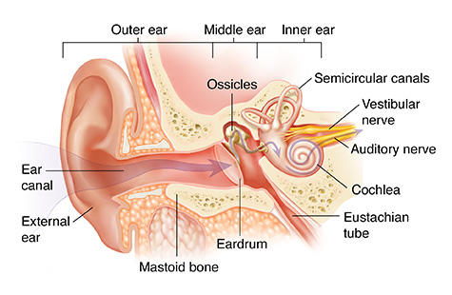
- outer ear – the pinna, the auditory canal and outer surface of the tympanic membrane funnels sound from the environment into the tympanic membrane, which vibrates in response to sound waves. These vibrations are transmitted into the middle ear
- Pinna: modifies incoming sound in a way that contributes to sound localization
- Auditory canal: funnels sounds waves gathered by the pinna onto the tympanic membrane and amplifies frequencies
- Tympanic membrane (eardrum): vibrates in response to the sound waves that strike it, forms an air tight seal between outer and middle ear
- middle ear – contains the three smallest bones in the human body (ossicles) – ossicles pick up and amplify these vibrations and transmit them into the inner ear (the cochlea)
- ossicles: transmit sound energy from the tympanic membrane to the inner ear – the malleus (hammer), the incus (anvil) and the stapes (stirrup) are connected to each other and the malleus is connected to the tympanic membrane
- when the tympanic membrane vibrates, the vibrations are transmitted and amplified by the ossicles
- transmits the vibrations to the oval window – membrane covered opening at the base of the cochlea
- oval window conveys the vibrations into the fluid filled cochlea
- inner ear – contains the cochlea which transduces these vibrations into neural signals that are sent to the brain via the auditory nerve

Eustachian tube: connects middle ear and the top of part of throat, normally closed but can be briefly opened to equalize air pressure in the middle ear with the pressure outside

Cochlea: fluid filled compartment
three chambers:
- vestibular canal
- cochlear duct
- tympanic canal
Basilar membrane – thin strip between the walls of the cochlea

Organ of Corti –responsible for auditory conduction
- inner hair cells – pear shaped and responsible for transducing sound into neural signals
- outer hair cells – cylindrical shapes and serve to amplify and sharpen the responses of the inner hair cells
- tectorial membrane
sterocilia – small hair that sit on top of the inner and outer hair cells

Auditory nerve – conveys signals from hair cells to the brain
• inner hair cells connected to Type I auditory nerve fibers – thick and myelinated which promotes rapid conduction of action potentials
•outer hair cells connected to Type II auditory nerve fibers – thinner and unmyelinated which results in slower conduction
(95% are type I and only 5% are type II)

•auditory transduction (conversion of sound waves into neural signals) occur when inner hair cells release neurotransmitters because of depolarization of the cell membrane.
initiates action potentials in Type I auditory nerve fibers – carry information about frequencies and amplitudes in incoming sound waves

•

Chapter 11: The auditory brain – localization

Ascending pathways: from ear to brain
Type I auditory nerve fibers – carry signals from inner hair cells in the cochlea
Cochlear nucleus superior olivary complex lateral lemniscus inferior colliculus medial geniculate body auditory cortex

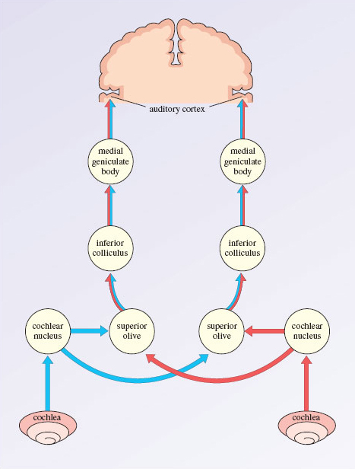
What and Where pathways:
“what” – represents the identity of sound sources
“where” – represents the location of sound sources

Localizing sounds –
Azimuth: side to side
Elevation: up and down
Distance: how far a sound source is

•Acoustic shadow – loudness of the sound is reduces because the sound waves are partially blocked by the head

•Interaural level difference – difference in the sound level at the two ears
•Interaural time difference – difference in arrival time of the same sound at the two ears

