MACRO Final Review
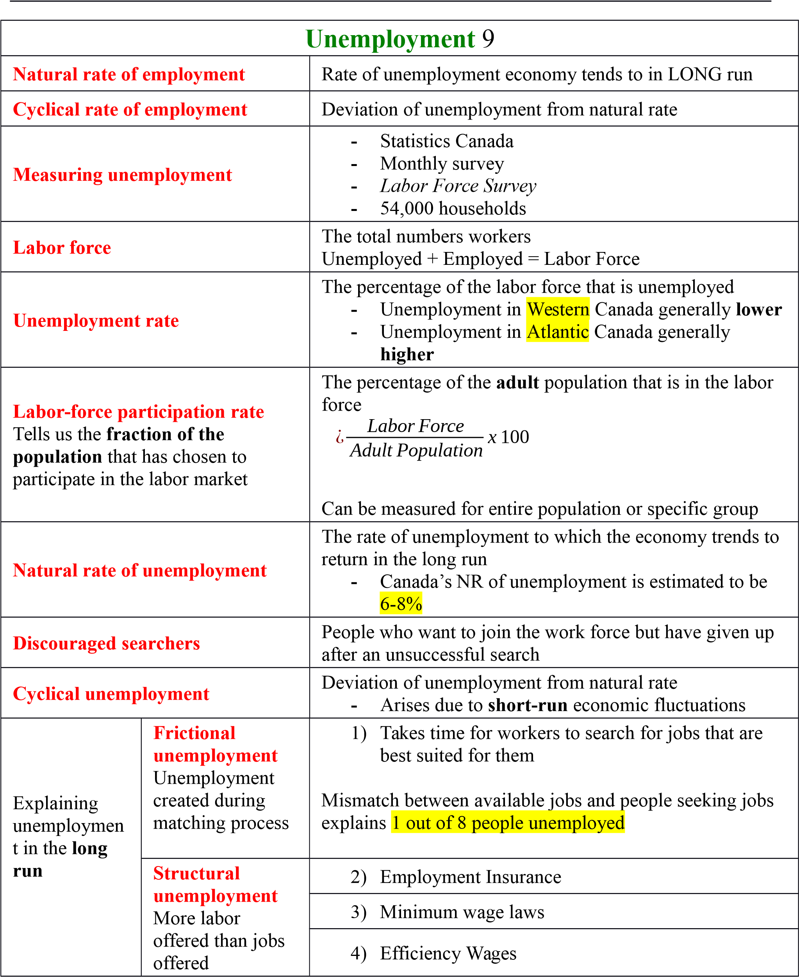
Public Policy & Job Search
-
Policy can reduce time it takes workers to find job
-
Policy can
reduce natural rate
of unemployment
Government programs
-
Give info about job openings
-
Federally run training programs
o
Funds going from aiding unemployed to
training programs
Employment Insurance
Program that partially protect
worker’s income when they become
unemployed
It is believed that
ending EI
program
would
reduce
unemployment

Changes made in 1990s
lowered
CA’s unemployment rate
Determinants:
Unemployment exceeds 16%
:
Worker must work 420 hours for 37 weeks’ worth of
benefits
Unemployment less than 6%
:
Workers must work 700 hours for 19 weeks’ worth of
benefits
Union
insiders
-
Benefit
-
Wage increases with union
Union
outsiders
-
Do not get union jobs
-
Wage decreases with union
In in union wages → Increase in supply of → Reduces wages in industries
labor other parts of economy NOT unionized
Collective bargaining
Process by which unions and firms agree on terms of
employment
Strike
Organized withdrawal of labor from firm
Efficiency wages
Worker Health
Worker Turnover
Efficiency wages REDUCE turnover
Worker Effect
Worker Quality

Canada post-WWII Labor
Force Participation Rate
:
Women RISING , Men FALLING
3
5

of unemployed Canadians are unemployed for
LESS than
3
months
If wages were always at
competitive equilibrium
due to frictional
unemployment would still exist
unemployment
2008-2009
recession affected unemployment of
males MORE than females
Measured unemployment
understates
TRUE unemployment
Companies that are expanding increase employment 10% annually
Monetary System
10
Medium of exchange
An item that buyers give to sellers when they want to
purchase goods or services
Unit of account
For economic value,
money
is the unit of
account
The type of measurement used to quantify/post/record
prices and debts
Store value
Example: Money
An item that people can use to transfer purchasing
power from the present to the future
Wealth
Total of all stores of value, including monetary and
nonmonetary assets
Liquidity
The ease with which assets can be converted in a
medium of exchange (often money)
Commodity money
Example: Gold, cigarettes
Money that takes the form of a commodity with value
even if it was not used as money
Fiat money
Money only has value because the government has
decreed its worth
Money stock
Quantity of money circulating in the economy
Currency
Paper bills & coins in the hands of the public
Not
-
only asset used to buy goods
-
Stores accept checks and debit cards
Demand deposits
Used to measure
money stock
The balance in your checking account
Measures of money stock
M1+
Checkable deposits + Currency
M2
Non-personal demand & notice deposits
+
Everything in M1+
Money supply
Quantity of money available in economy
Central Bank
Institution designed to control the quantity of money in
economy

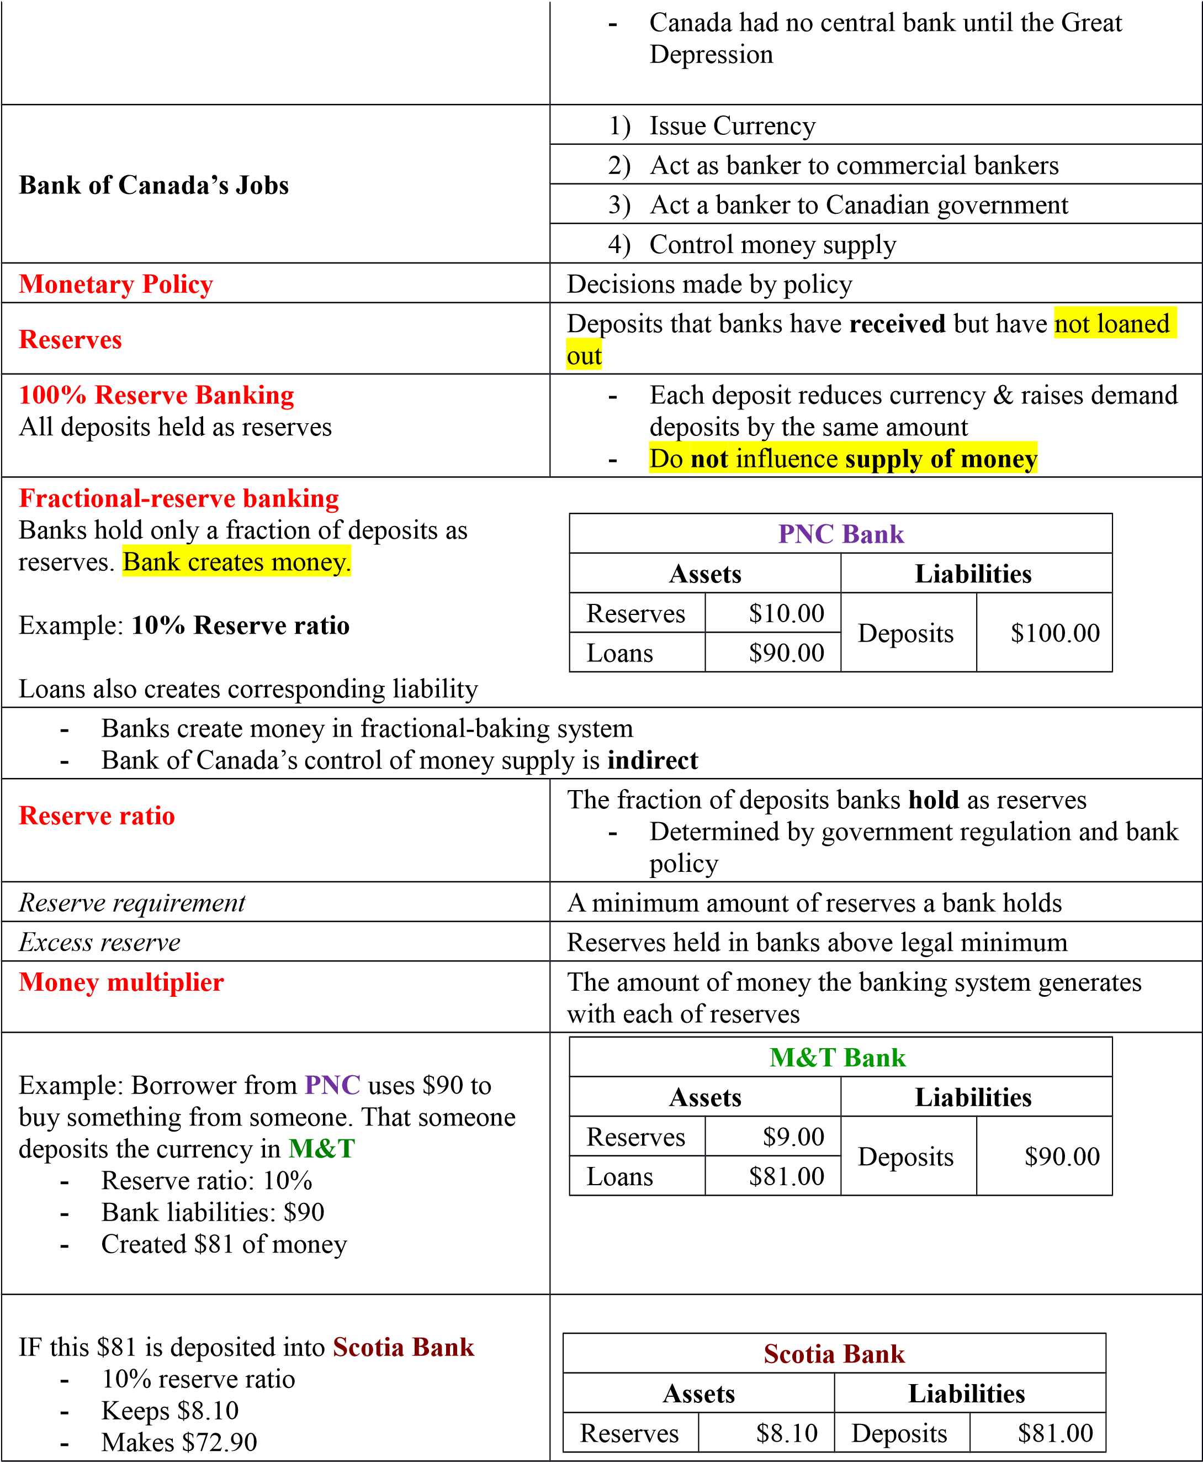
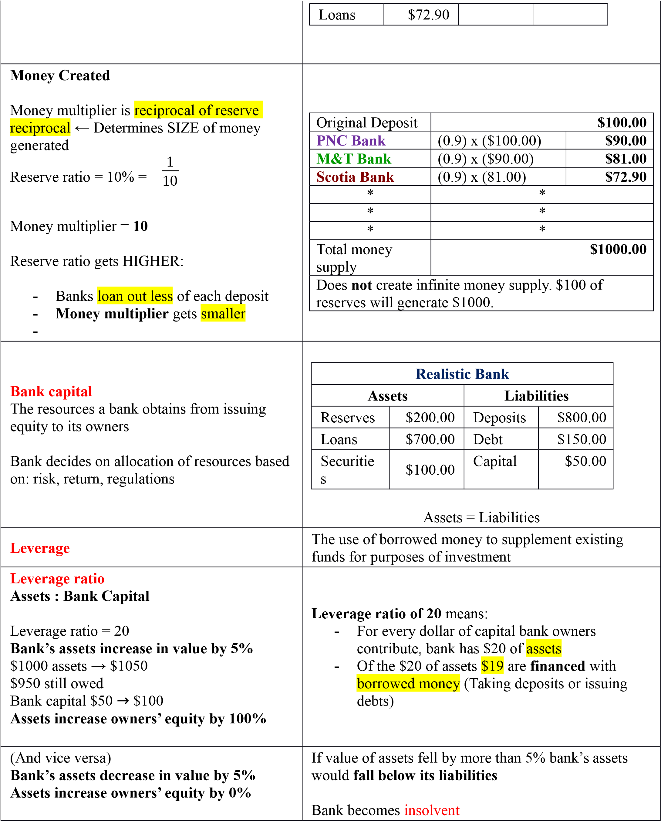

Capital requirement
Bank rate Interest rate charged by Bank of Canada on loans to
Discount rate commercial banks
Bank of Canada & Commercial Banks
Example: Commercial banks borrow at bank rates
Bank rate = 5% Bank of Canada paying on their deposits :
- PNC borrows from Bank of Canada (Bank rate) – (0.5%)
- PNC must pay back 5% interest
- Bank of Canada would pay 4.5% Example: 5% → 4.5% interest IF PNC had positive balance Operating band
in demand deposit at Bank of Canada Sets pattern for all short-term interest rates

Overnight rate
Interest rate on very short-term loans between - Bank of CA alters money supply by changing
commercial banks bank rate
- Bank of CA uses them as an indicator - Causes EQUAL change in overnight rate of certain types of policy needed
- Discourages banks from borrowing from Bank of CA
High overnight rate
- Reduces quantity of reserves
- Reduces money supply
The purchase or sale of government bonds by Bank of

Open-market operations
CA
Treasury Bills Bank of CA buys these when they want to increase
Short-term government bond money supply
Bank of CA does this when they want to decrease
Selling government bonds to public money supply
Open-market operations that involve nongovernment

Quantitative easing
securities or treasury bills with long terms to maturity Foreign exchange market operations Purchase/sale of foreign money by bank of CA
Bank of CA goal: Support CA $ exchange rate

Sterilization
- CA dollars acquired in foreign market are used
Offsetting foreign exchange market operations to buy CA government bonds
with open-market operations, so that the effect
Bank of CA sterilizes foreign exchange market
on the money supply is cancelled out
operations

Reserve requirements
- Influence how much money the banking system
Regulations on minimum amount of reserves can create with each dollar of reserves
banks must hold against deposits

Increase in Reserve requirements

- Hold more
- Loan less
- Raises reserve ratio
- Lowers money multiplier
- Decrease money supply

Money Growth & Inflation 11
Quantity of money available determines the price level
Growth rate in the quantity of money available determines inflation

Quantity theory of money rate
Increase in money supply → Increases real output proportionately
Increase in money supply → Increases prices proportionately
Classical dichotomy Separation of variables into real and nominal variables
Variables measured in monetary units

Nominal variables $$$
- Corn farmer’s income
Variables measured in physical units

Real variables
- Quantity of corn
Classical dichotomy Theoretical separation of nominal and real
Monetary neutrality Proposes that changes in money supply do NOT affect real variables
Velocity of money Rate at which money changes hands
Increase in money supply → Effects real variables NOT nominal
LONG RUN
Demand for money most dependent on : Level of prices

Quantity equation

M xV=P xY Assumptions of Quantity Theory of Money
M = Quantity of money 1) Velocity of money stable over time
V = Velocity of money 2) Because V is stable, when central bank changes M there is a
P = Price of output proportionate change in nominal value of output (P x Y)
Y = Amount of output 3) Y is determined by factor supplies
Money is neutral – does not affect output
4) Because Y is determined by factor supplies, changes in M induce proportional changes in (P x Y) that are reflected in price level Velocity (V) = Annual rate of 5) When central bank rapidly increases money supply, inflation turnover of the money supply results
Increase in price level = Decrease in value of money
Price level doubles → Quantity of money demanded doubles Price level doubles → Value of money has been cut in half
Deflation has costs similar to inflation costs: corruption, human rights violation, poverty
Bank of CA inflation target = 2%
Inflation causes a
reduction
in the relative price of goods who’s prices have been held
constant
to avoid menu costs
Actual
inflation GREATER than
expected
inflation = Wealth redistribution
Borrowers
→
Lenders

Inflation Tax
A tax on people who hold
money
“Paid” by those that hold money because inflation reduces the value of
their money holdings
Combined reasoning for implementing an inflation tax:
-
Government:
o
Spending is high
o
Inadequate tax collection
o
Difficulty borrowing
Hyperinflation
Prices rising at an extraordinarily high rate
Fisher effect
Long-run perspective
Nominal interest rate
adjusts to
expected

inflation
One-for-one adjustment of nominal interest rate to inflation rate
Bank of CA increases rate of money growth:
-
Higher inflation
-
Higher nominal interest rate
Shoeleather costs
Resources wasted when
inflation encourages people
to reduce their money
holdings
-
Inflation
does not
in itself
reduce
people’s
real purchasing
power
-
Differ based on type of costs for job
-
Example: People going to bank daily to withdraw currency
Menu costs
Cost of price adjustments
Varying Real Price
Scenario
Menu Costs:
NO inflation
-
Price of meals in comparison to other meals in economy (relative
price) would be
constant
Menu Costs:
12
% inflation
-
Restaurant’s relative prices
fall by 1%

each month

Income tax treats the
nominal
interest earned on savings as
income
Inflation tends to
reduce
the
after-tax real return
to
saving

Economy A:
Price Stability
Economy B:
Inflation
Real interest rate
4
%
4
%
Inflation rate
0
8
Nominal interest rate
(
Real + Inflation
)
4
12
Reduced interest rate due to 25%
tax
(0.25
x nominal interest rate
)
1
3
After-tax nominal interest rate
(0.75
x nominal interest rate
)
3
9
After-tax real interest
(
After-tax nominal – inflation
)
3
1
Open-Economy Macroeconomics
12
Net exports
(
Trade Balance)
(
Valueof nation
'
sexports
−
Valueof nation
'
simports
)
Measure an imbalance between a country’s exports and its
imports
NetCapitalOutflow
=
Net Exports
Equation is an
accounting identity
Trade surplus
NX
>
0
NCO
>
0
Exports greater than imports
-
Buys foreign assets
-
Capital flowing
out
of country
Trade deficit
NX
<
0
NC
0
<
0
Imports greater than exports
-
Selling assets abroad
-
Capital flowing
into
the country
Balanced trade
Exports = Imports
Current account balance
Netexports
+
Netinflowof interest
+
Dividend payments

Factors influencing
expanding trade in
Canada
Improved transportation
Advances in Telecommunications
Government trade policies
Net capital outflow
(
Foreignassetsboughtbydomesticresidents
−
domesticassetsb
Net Capital Outflow
falls
when:
- German pension fund buys stock in TransCanada
Net Capital Outflow increase → Canadian domestic investment decrease
~~~~~ Negative Capital Outflow ~~~~~~~~~
To INCREASE Domestic
Investment a country must:
Increase saving OR Decrease net capital outflow
Open Economy’s Uses for 1) Domestic investment
Savings 2) Net capital outflow
Foreigners own more Canadian assets than Canadians own
Canada is a net debtor foreign assets
The rate at which a person can trade the currency of one
Nominal exchange rate country for the currency of another
Depends on : Money, money supply, money demand
Appreciation An increase in the value of a currency
Yen-per-Dollar exchange rate RISES= Dollar appreciated
Coke in Canada: $12
Coke in Japan: 1800 yen
Yen-per-Dollar exchange rate = 150 yen per dollar
Euro countries only have one monetary policy
Higher tax rates in CA → Higher CA real interest rates than U.S.
Depreciation A decrease in the value of a currency
Arbitrage Process of taking advantage of difference in prices of the Goods with high value and same good by buying it from a market where the good is
low transportation costs cheap and selling it another market where the good is
are most likely expensive
Rate at which a person can trade goods/services from one Real exchange rate country for goods/services of another
Measures the price of a Nominalexchangerate xDometicPrice
basket of goods/services ForeignPrice available domestically
relative to a basket abroad

P = Price Index of Canadian basket
Real P* = Price index for foreign basket
e = Nominal rate between CA dollar and foreign currencies
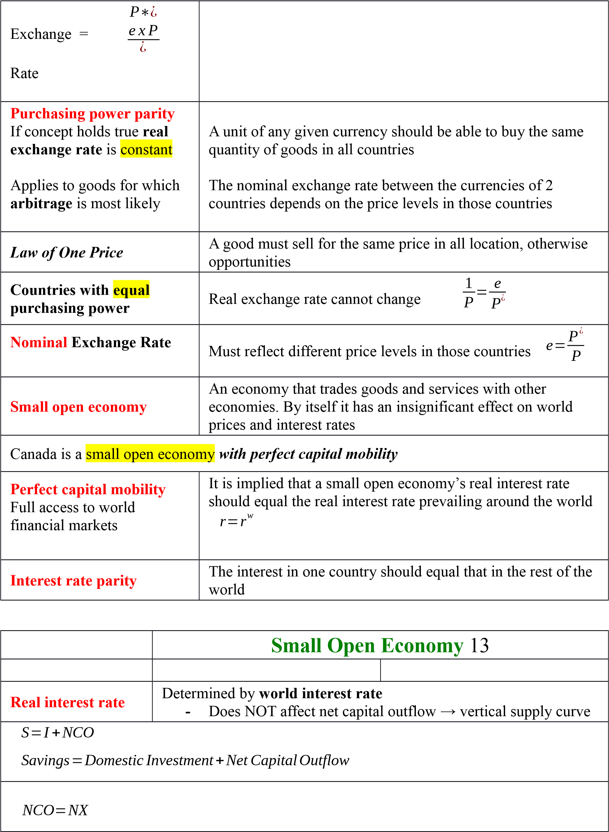
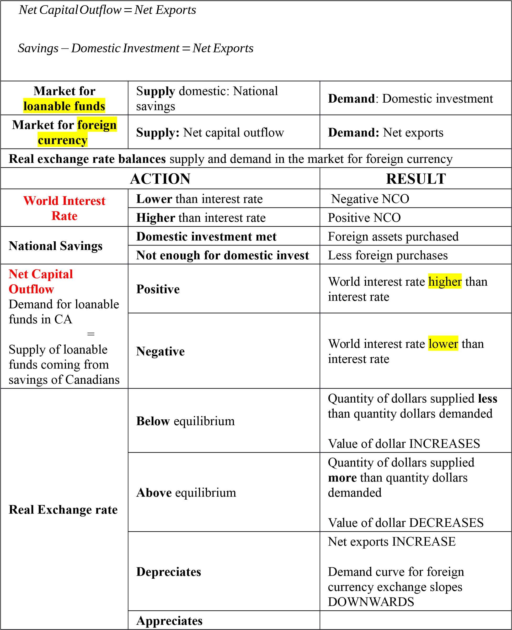
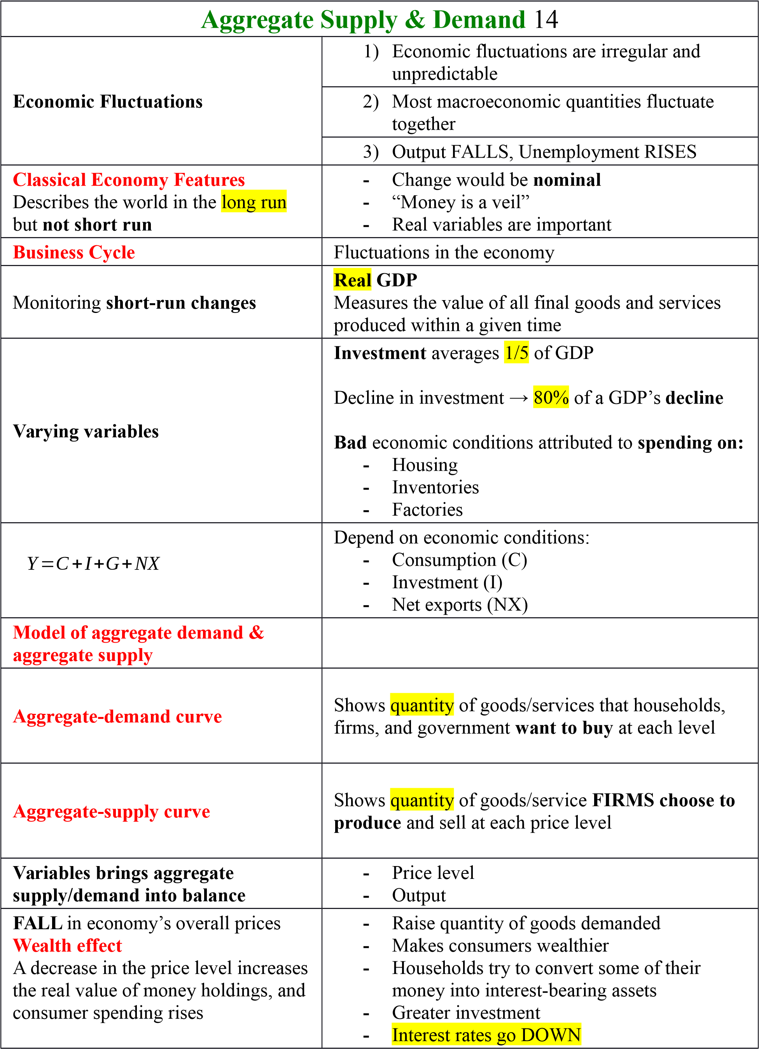

Aggregate- Demand Curve
DOWNWARD SLOPE
-
Aggregate-demand curve DOWNWARD
-
Real exchange rate depreciates
-
Demand for net exports INCREASES
RISE
in economy’s overall prices
-
Lower quantity of goods demanded
-
Reduces real value of money
-
Reduces wealth
-
Less investment
-
Interest rates go UP
Price Level & Net Exports:
Real Exchange-Rate Effect
Increase
in quantity of goods demanded
A FALL in CA → Real exchange → Net exports
price level depreciates RISE
Decrease
in quantity of goods demanded
A RISE in CA → Real exchange → Net exports
price level appreciates FALL
Investment Tax Credit
A tax rebate tied to a firm’s investment spending
Shifts in Aggregate
Demand
Curve
LONG RUN: Shifts affect overall
price level but do NOT affect output
LEFT
-
Want to save more, therefore
spend less
-
Decrease in quantity of
investment goods demanded
by firms
RIGHT
-
Want to spend more
-
Increase in quantity of
investment goods that firms
demand
Consumption
LEFT
-
Bad economy
-
Tax hikes
-
Decrease in housing prices
RIGHT
-
Good economy
-
Tax cuts
-
Increase in housing prices
Investment
LEFT
-
Decrease in money supply
RIGHT
-
Investment tax credit
-
Increase in money supply
Government purchases
LEFT
-
Spend less on highway construction
RIGHT
-
Parliament increases purchases of armed
force’s equipment
Policymakers responsible for
aggregate demand can potentially

mitigate severity of fluctuations
Can mitigate adverse effects on output BUT only at
the cost of worsening
inflation
Full employment outlook
Potential Output
Long-run
level of production

Shifts in
Aggregate
Long-Run
Supply
Curve
RIGHT
Any policy that raised real GDP
-
Growth in output
-
Growth in inflation
-
Small increases in money
supply causes smaller shifts
and little/no change in output
LEFT
Any policy that lowered real GDP
Labor
LEFT
-
Rise in unemployment
-
Raise minimum wage substantially
-
Workers leave economy

RIGHT
-
Decrease in unemployment
-
Immigration of workers
Capital
LEFT
-
Decrease in economy’s natural stock
RIGHT
-
Increase in economy’s natural stock
-
Increase in machines or universities
Natural Resources
LEFT
-
Weather making farming difficult
RIGHT
-
Discovery of new mineral
Technological Knowledge
RIGHT
-
Invention of more productive devices
LEFT
-
Government regulated production methods
Price level
rises
above expected level
Output rises above
natural rate
Price level
falls
below expected level
Output falls below
natural rate
Shifts in
Short-Run
Aggregate-
Supply
Curve
UPWARD
Slope
-
Decrease in price level
-
Decrease in level of goods
supplied
Produce less
:
Sticky-Wage Theory
Slopes upward because nominal wages are slow to
adjust to changing economic conditions

Sticky- Price Theory
Slopes upward because prices are slow to adjust
because menu costs exists
During times of operation under lagging prices there
-
Price level lower than
expected
Produce more
:
Price level higher than expected
is an overall positive association between price level
and quantity of output
Misperceptions Theory
Suppliers misled by changes in individual markets
Stagflation
Combination of recession and
inflation
FALLING output
RISING prices
Can be caused by a sharp rise the price of oil
Accommodative Policy
Accepts a
permanently higher level
of prices to
maintain a higher level of output and employment
Quantity Natural Actual Expected
of output = rate of +
a
(

price - price )
supplied output level level
Quantityof Output Supplied
=
Naturalrate of Output
-
Over the past century, CA
real GDP
per person has
GROWN

2
% per year
-
Investment is a particularly volatile component of spending across business cycle
-
As
output
FALLS
unemployment
RISES
-

In a recession
the economy adjusts to
long-run
equilibrium as wages and price
expectations fall
If
classical dichotomy
&
monetary
neutrality
hold in LONG run
LONG-run
supply curve
=
vertical

Government
cuts back spending
to
balance budget
Recession
may result in
SHORT
run
Use real GDP when comparing aggregate demand
Sale of used homes NOT in GDP
Fully anticipatated inflation has no real economic effects

Inflation reduces real value of nominal debt
Underground economy
- Legal but not reported activities
- Illegal activities
Leakage from circular flow of income = Saving
Natural rate of unemployment reached when: Cyclical unemployment = 0

Structural unemployment
- Number of jobs in a field does not meet the number of people who want a job in that field
Aggregate Demand Curve relates to:
- Composite price level to real national income

IF….
Aggregate Demand increases & Short-run Aggregate Supply decreases
THEN…
Price level increases
BUT
Change in real GDP will be indeterminate

Long-run Aggregate Supply curve shows that potential GDP has NO relationship with price level

Government Transfer Purchases
- Only payments made to households by government that are NOT made in return for the services of factors of production -
M2 does NOT change means that M1+ did NOT change
Realinterestrate=Nominalinterestrate−Inflationrate

Government Security
- Short-term government bond
- Example: Treasury Bill

GDP Deflator=NominalGDP x100
RealGDP
GDP Deflator reflects:
All goods and services produced domestically
CPI reflects:
Prices of all goods and services bought by consumers

GDP base year reflects only QUANTITES PRODUCED
Budget deficit = Negative public saving
Consumption loans DO NOT increase national saving
Accumulation of inventories = current investment
Capital stock = Total amount of capital goods in a country
Netinvestment=Grossinvestment−depreciation
Lending $$$$ to commercial bank → increase monetary aggregate of M1
Increase in real interest rate → Decrease consumption expenditures

Open-market operations
- Expansionary policy
- Decrease rate of interest
Interest rate INCREASE → Currency APPRECIATES → Net exports FALL
Nation’s standard of living measured by real GDP per person
HIGHER saving rate → HIGHER productivity
Closed economy: National saving = Investment
Persistent decline in stock prices signal a recession because low corporate profits expected
Job search NOT associated with wage rate above equilibrium
DECREASE money supply:
- Open market sales
- Raise bank rate
Real wages NOT influenced by monetary factors
Real GDP NOT influenced by monetary factors
USA buys car from German factory. Pays with USA dollars.
- German net exports DECREASE
- USA capital outflow INCREASES
CA real interest rate BELOW world interest rate → CA savers buy foreign assets
Recession → Falling employment
Recession → Falling income
Recession: Investment spending FALLS more than GDP
Aggregate demand does NOT include the purchase of stocks and bonds
Countries import to CA go into recession → CA net export FALL → Aggregate demand LEFT
INCREASE in wage → Short-run Aggregate Supply Curve LEFT
Price level does NOT shift short-run aggregate supply curve
Prices fall unexpectedly → Real wage RISES → Employment FALLS
Minimum wage NOT an automatic stabilizer
Production costs RISE → Short-run ASC shifts LEFT
GST = Consumption tax
GST → Encourages savings
HIGH real interest rate → Quantity of loanable funds GREATER
Lower taxes on interest & dividends → INCREASE rate of growth
INCREASE in price level = DECREASE value of money
Inflation GREATER than expected → Wealth redistributed from borrowers to LENDERS
Net capital outflow INCREASE = Domestic investment DECREASE
Increase saving → Increase domestic investment
Decrease net capital outflow → Increase domestic investment
Small open economy:
- World interest rate INCREASE = Net capital outflow INCREASE
Negative net capital outflow: When domestic investment is GREATER than national saving
Budget surplus INCREASE → Real exchange rate DEPRECIATES
Budget deficit INCREASE → Real exchange rate APPRECIATES
GNP (Gross national product)
- Measures all Canadian’s income earned (could be abroad)
Transfer payments NOT counted as government purchases

Core Inflation
- Does NOT include volatile components of CPI

