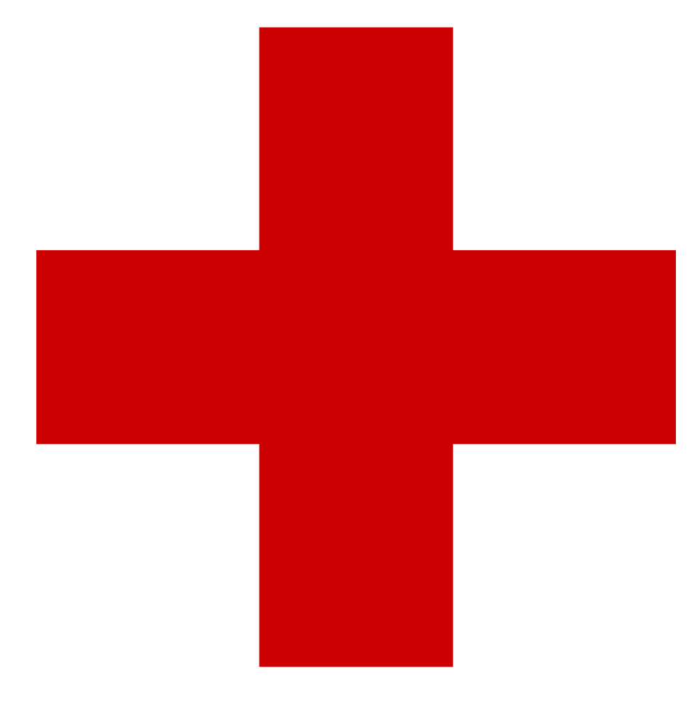
Be Safe and Vaccinate

What is a Vaccine?
- A vaccine is a product that is administrated to provide antibodies and preventions against disease.

How Does It Work?
Vaccines are used to imitate an infection. The infection though harmless, allows the immune system to create adaptive immunity towards the foreign invader. Once a vaccine is introduced, the body produces and build ups T-lymphocytes and antibodies to attack the invading antigens. The T-lymphocytes and B- lymphocytes will be maintained as a supply of memory to protect and use against the real disease in the future.
Breastfed Babies and Temporary Immunity Babies receive a type of immunity from their mothers called “passive immunity.” During pregnancy, a mother passes along their own antibodies to their unborn child. As well, once born, the mothers’ breastmilk contains a rich number of antibodies; prolonging the passive immunity in their infants. However, passive immunity will start to decline over time, which leaves a child vulnerable if not addressed.
http://www.healthexpo2015.net/wp-content/uploads/2017/01/vaccination-children.jpg
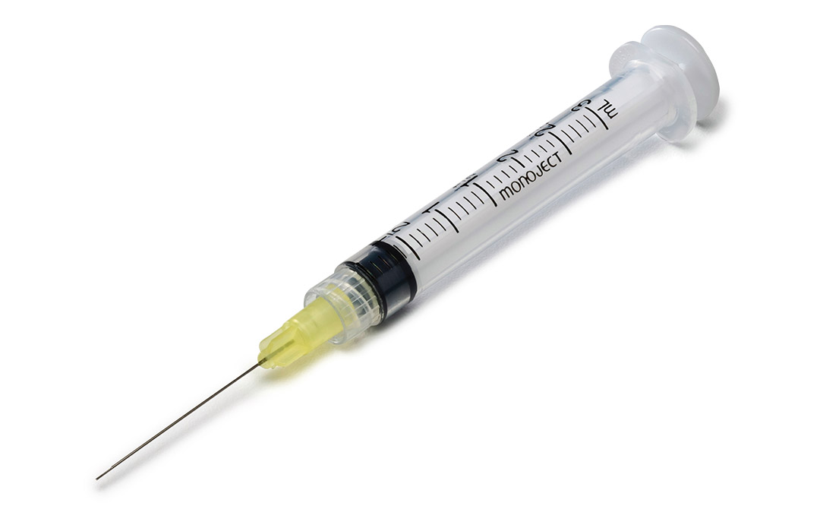
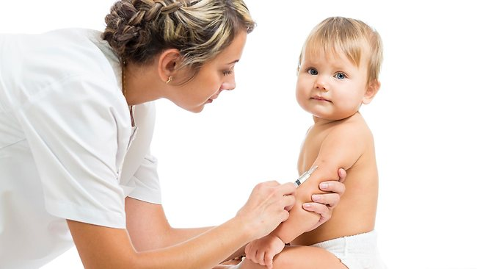
Why Vaccinate Your Child? Vaccines are safe, as they have been both studied and recommended by several medical professionals for disease prevention. Some side effects could come alongside a vaccination; however, the benefits far exceed the potential threat of these side effects.
The primary immune response occurs when a new foreign disease is introduced to the immune system. During this time, there is a lag period where the body will generate memory to fight off the specific invading antigens in future events. Secondary immunity occurs as a result from a second exposure to those certain invading antigens. At this point the body has already built an immunity to the foreign invader, allowing the body’s antibodies to react instantaneously.
As a result of vaccinating your child, the immunity process will be introduced by starting the primary immune response. Then if the child encounters the real disease, secondary immunity will be activated and destroy/prevent the disease with less lag time. This will ensure protection to your child from prolonged health issues.
http://d3n8a8pro7vhmx.cloudfront.net/seiuhealthcare/pages/735/meta_images/original/MMR_Vaccine.png?1423776765
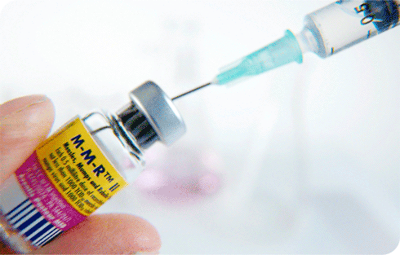
Herd Immunity When the clear majority of a community is vaccinated there is little opportunity for disease to spread. This is referred to as Herd Immunity. Herd Immunity provides protection for non-vaccinated individuals because if an outbreak occurs the infection is better controlled. Vaccinations keep everyone safe.
Common Vaccines for Children The following shows which vaccinations are suitable to protect children against which life threatening diseases:
http://www.medtronic.com/content/dam/covidien/library/global/en/product/dental/monoject-endodontic-needles-syringes-f.jpg
Vaccination | Disease
Varicella | Chickenpox
Poliomyelitis | Polio/Infantile Paralysis
MMR | Measles, Mumps and Rubella
Hepatitis B | Hep B
dTap | Diphtheria, Tetanus, and Pertussis
Human Papillomavirus Virus (HPV) | Types of HPV
Rotavirus | Rotavirus
Pneumococcal | Streptococcus Pneumoniae
Meningococcal | Meningococcus Bacteria
Haemophilus influenzae Type B (Hib) | Hib

