Organic Chemistry Laboratory #5

Preparation of Benzoic Acid Using a Grignard Reagent

Introduction

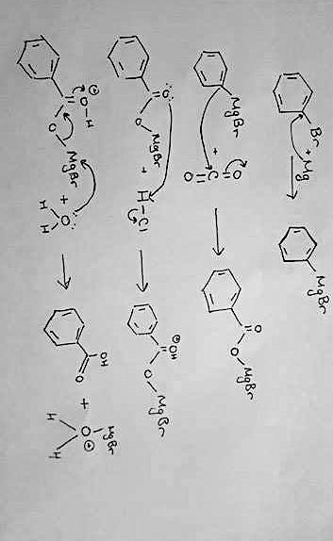
In this experiment, benzoic acid is prepared using a Grignard reagent- the process takes four steps. In the first step, iodine activated magnesium is added to bromobenzene creating a nucleophile or the Grignard reagent. The Grignard reagent formed is a benzene right with a magnesium-bromine complex. This Grignard reagent is very reactive and therefore can easily react with the electrophile dry ice, or solid CO2. The Grignard’s high reactivity is why measures must be taken to ensure there is no water in the system, since side reactions will easily occur to form benzene. Glass must be cleaned and dried in ovens to prevent water residue, and anhydrous ether is used to ensure no water enters the system. The interaction with the dry ice will create a carboxylic acid in the form of a salt, which will be protonated by the HCl, and then the extraction with the diethyl ether will form the final carboxylic acid.

Mechanism:

Procedure

The procedure for Preparation of Benzoic Acid Using a Grignard Reagent is found the in CHM 1321 Introductory Organic Chemistry Laboratory Manual 2017:

Prof. W. Oglivie and Prof. T. Durst., “CHM 1321”, Introductory Organic Chemistry Laboratory Manual, 2016, Experiment 5. p 43-47.

No modifications of this procedure were made during the experiment.

Table of Reagents

Table 1.1 Table of Reagents for the Preparation of Benzoic Acid Using a Grignard Reagent

Compound | Amount (g/ml) | Molecular Weight (g/mole) | # of Moles | Density (g/ml)
Bromobenzene | 3.0mL | 157.01 | 0.0287 | 1.474
Anhydrous Diethyl Ether | 20mL | 74.12 | 0.213 | 0.789
CaCl2 | - | 110.98 | - | -
Magnesium Turnings | 0.80g | 24.035 | 0.033 | -
Iodine Crystal | ~1 crystal | 253.81 | - | -
Dry Ice | 80mL | 44.009 | 2.908 | 1.6
Water | 20mL | 18.02 | 1.12 | 1.0
Ice | ~30g | 18.02 | 1.665 | 0.917
HCl | 5mL | 36.46 | 0.163 | 1.19
Ordinary Diethyl Ether | 15mL | 74.12 | 0.035 | 0.7134

Observations

Bromobenzene
-clear
-acetone smell
-liquid

Anhydrous ether
-clear liquid
-acetone smell
CaCl2
-small white, solid
-circular pebbles

Magnesium Turnings
-small, silvery pieces
-lustrous
-solid small strips

Iodine Crystals
-small black and silver crystals
-solid

Dry Ice
-chalky appearance
-smokes when contact with air
-cold

10% NaOH
-clear solution
-acetone smell

Conc. HCl
-clear solution
-sour smell

Solution with bromobenzene, anhydrous diethyl ether, magnesium turnings and iodine crystal:
-originally reddish-brown colour
-frothy white bubbles are present upon stirring
-flask is somewhat cloudy but darkish brown colour
-magnesium begins to disappear
-flask feels warm; small bubbles

When hot water bath added:
-still brown solution
-most of the solid has dissipated

When dry ice added:
-fizzing occurs
-a sticky mixture is created
-yellowish-brown colour

When is added:
-smoking occurs
-beaker becomes very cold: condensation is visible

When water added to the mixture, more fizzing occurs

When HCl is added:
-bubbling occurs (large bubbles)
-smoking and fizzing occurs
-yellowish solution

When ordinary diethyl ether is added:
-bubbling continues (large bubbles)
-fizzing also occurs
Product is yellow and translucent at the end of this stage of the experiment.

When poured into the seperatory funnel, the yellow solution is on the top, while the clear solution is on the bottom.

Final Product Benzoic Acid
-white, soft solid
-bubble like texture
-somewhat fluffy

TLCs

Fig. 1.1 TLC 1 Bromobenzene and Organic Layer
Solvent System: 1:9 EtOAc: Hexanes
REF
SAM
CO

a
c
REF: Bromobenzene
CO: Co spot (Bromobenzene + Organic Layer)
SAM: Organic Layer

b
d
Rf’s
REF=4.3/5 = 0.86
CO(a)= 4.3/5 = 0.86
CO(b)=1/5 = 0.2
RXN (c)= 4.3/5 = 0.86
RXN(d)=1/5 = 0.2

Fig. 1.2 TLC 2 Bromobenzene and the Final Dry product*
*a proper TLC was not obtained in the experiment; this TLC is a representation of what would occur should the reactions be done correctly (no reactant is left; excess product;; carboxylic acid is a pure solution)

REF
SAM
CO
Solvent System: 1:9 EtOAc: Hexanes

REF: Bromobenzene
CO: Co spot (Bromobenzene + Final Dry Product)
SAM: Final Dry product

Flow Chart (for extraction)

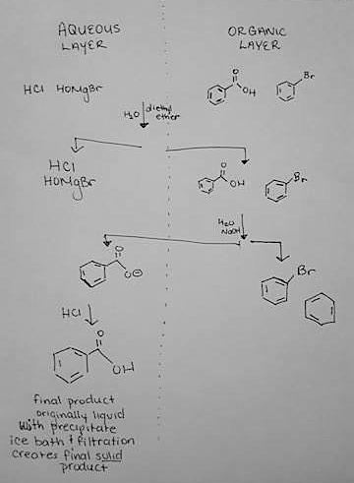

Final product is originally liquid with precipitate. When placed in an ice bath and filtered, the final, solid product is formed

Table of Results
Table 1.2 Table of Results
Compound | Amount (g/ml) | Molecular Weight (g/mole) | % Yield | Theoretical Melting Point °C | Actual Melting Point °C
Benzoic Acid | 0.43g | 122.123 | 12.3% | 121-125 | N/A*
*Due to time constraints, the actual melting point of the final product was not found

Final Product Benzoic Acid
-white, soft solid
-bubble like texture
-somewhat fluffy

Calculations:
$$3.0mL ×\frac{1.5g}{mL}×\frac{1mol}{157.01}$$
$$=0.02866 mol bromobenzene$$

$$0.43 g×\frac{1mol}{122.12}$$
$$=0.0035 mol$$
$$Percent Yield=\frac{0.0035}{0.02866}×100\%$$

$$=12.3\% yield$$

Discussion:
Justification of Procedure:
- All of the glassware had to be washed and placed in the oven because any traces of water on the glass will cause side reactions in the solutions, since the Grignard reagent is very reactive
- Iodine activated magnesium had to be used rather than just regular magnesium to ensure the magnesium-bromine complex formed on the benzene ring, creating a strong Grignard reagent
- Anhydrous ether is used because it is a dehydrated ether; should a regular ether be used, the ether would cause side reactions due to the water in the solution, allowing the Grignard reagent to form stable benzene rings
- The drying tube with the cotton and CaCl2 was used to trap water and moisture so it cannot enter the flask and the solution system; should water enter the system, side reactions can occur
- The condenser was used to keep the solvent in the container because of the reflux and exothermic reaction occurring; the condenser assists to keep the volume constant
- Need to use freshly prepared dry ice because if the dry ice (solid CO2) is left in room temperature, it will condense and water will form, potentially causing side reactions (water reacting with the Grignard rather than the CO2)
- Water and HCl are added to re-protonate the salt formed (protonate the acid form the organic phase)
- Use the diethyl to extract the product which is the organic phase
- To get rid of possible impurities that may have occurred to due traces of water, the acid is deprotonated
- The acid is deprotonated with NaOH
- Deprotonating the acid forces the product into the aqueous phase, leaving any impurities in the organic phase
- An extraction occurs separating the organic and aqueous phases
- The addition of HCl again allows the re-protonation of the acid, and causes a precipitate to form
- If too much HCl is added, this can cause the NaOH to “salt-out”, so it is important to monitor the acidity using the blue litmus strips periodically to make sure only just enough HCl is added
- The ice bath allows the rest of the precipitate to form, and filtration allows the drying of the product (in order to determine the percent yield, need a dry version of the product so it can be accurately weighed)
- The melting point is taken to determine if in fact the product is the predicted product, and if the product is pure or not

Analysis
- TLC 1 indicates that bromobenzene is found in the organic layer
- This is because the Rf’s for the reference (bromobenzene), the co-spot, made upon bromobenzene and the organic layer, and the sample made up of the organic layer all have spots that align on the TLC
- However, the co-spot and the sample sport also each have a dot that aligns with the other (same Rf’s) indicating that there is something in the organic layer that is not bromobenzene as well
- TLC 2 should indicate that after the reactions have been completed there is no bromobenzene left in the dry product
- Although a TLC was not done in the lab, a theoretical TLC has been created for the purpose of explaining this section of the reaction
- At the stage where the dry product has been created, no bromobenzene exists in the dry product: the Rf’s for the reference lane (containing bromobenzene) do not line up with the Rf for the sample lane containing only the aqueous layer precipitate (dry, and filtered precipitate)
- This TLC shows that there should only be aqueous product in the final product
- The melting point for this experiment was not found
- When analyzing the melting point, it is important to analyze how large the range is and how high the melting point is to determine if in fact the product is pure and if the product is actually the expected product
- If the product is relatively close to that of the melting point of the expected product, but the range from the start of melting point to completion is slightly longer or shorter, it is likely that the product is the expected product, however impurities do exist
- If the product’s melting point is not close to the melting point of the expected product, but the range is relatively similar/same, the product is likely not the same product as what was to be expected by the reaction
- The percent yield for the overall reaction was 12.3%
- This percentage is slightly low for the reaction because the dry ice was used in excess and should have put the reaction favoring the products more

Sources of error/ improvement
- A major source of error in this experiment was the inability, due to time constraints, to allow the product solution to continue to precipitate in the ice bath
- This lead to a low percent yield

Questions:

- Anhydrous ether is used because it is a dehydrated ether; should a regular ether be used, the ether would cause side reactions due to the water in the solution, allowing the Grignard reagent to form stable benzene rings. This would cause the Grignard reagent to form the benzene rings and would essentially halt the reaction mechanism.

- The hot water bath was used to force the reaction to the right, creating products. Since the reaction is not highly favorable, the hot water bath was used to push the reaction closer to completion. Ether has a low boiling point of 37 degrees Celsius, only slightly above room temperature. Using warm-hot water will allow the solution to boil and cause the reaction to favor the product side.

- Dry ice is solid carbon dioxide (CO2). It has a temperature of -78 degrees Celsius.

- In this experiment it is important to use freshly prepared dry ice because if the dry ice (solid CO2) is left in room temperature, it will condense and water will form, potentially causing side reactions in the mechanism system (water reacting with the Grignard rather than the CO2).

