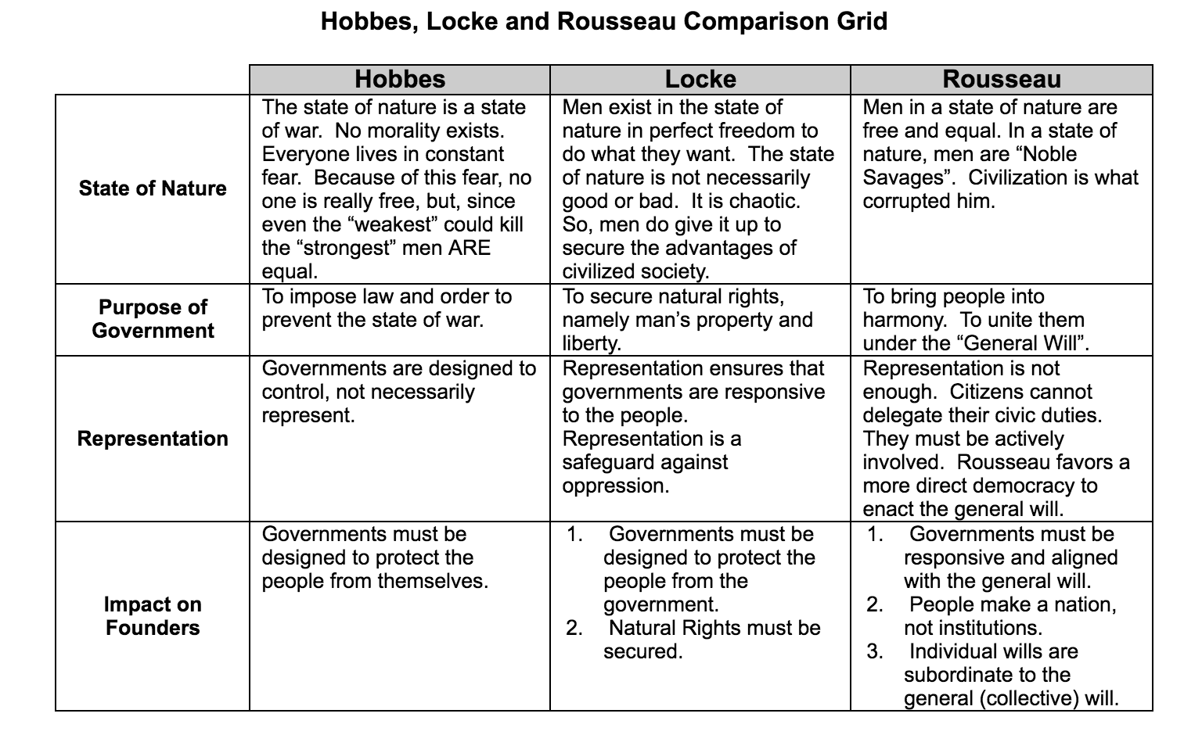

Machiavelli
Fortuna/virtu
- Virtù, which has the present meaning of manliness, is used by Machiavelli as having skills, strength, intelligence and prudence of a ruler. It is the inner ability to gain the power and not to lose it easily.
- Fortuna, with the present use, fortune is explained as the word of God and the luck and opportunity that is given to the ruler.
- A ruler by fortune is dependent to outer sources that has given him the power.
- The fortune is determined as "unreliable and capricious" (pg.21). This is why the rulers that have a good chance and do not know how to command will lose their power quickly.

The two humors
- “In every city,” Machiavelli goes on to argue, “there are two different humors, one rising from the people’s desire not to be ordered and commanded by the nobles, and the other from the desire of the nobles to command and oppress the people.”
- If nobles see they are having trouble with the people, they make one of their own a prince; he becomes their puppet, and therefore they get what they want on a larger scale.
- If the people feel that the nobles are oppressing them, they will try to make one of their own a prince; he then becomes their shield against the nobles.
- A good leader must keep the nobles and the people happy to a certain extent.

Hobbes
Collective Action Problem?
- A collective dilemma is a situation in which there is a conflict between group goals and self-interest. Thomas Hobbes argued that concentrating power in a sovereign with final authority would prevent society from becoming a "war of all against all."

The importance of fear
- The goal of the Leviathan is to eradicate fear and war
- Hobbes’s greatest fear was social and political chaos
- The state of nature is savagery. Morality is not inherent so people live in a state of fear
- People choose to form society out of fear of each other and war

Locke
Civil Society
- The governing factor in civil society must be the majority, for practical reasons.
- By entering into civil society, the individual submits him or herself to the majority, and agrees to abide by the rules and decisions of the majority.
- Nature lacks three things, that a just civil society provides:
  - “an established, settled, known law"
  - "a known and indifferent judge"
  - "power to back and support the sentence"
- In order to gain the three things above, people must relinquish their natural rights. These include the right to do as they wish within the bounds of the law of nature and the power to punish others for breaking the law (You can’t kill people!)
- Basically Locke believes that a social system relied on the existence of a law, a judge, and an executive working "to no other end, but the peace, safety, and public good of the people."

The role of money
- Locke believed that labour was the moral foundation of property
- Any land that had labour done on to It was owned by the labourer
- People could own land as long as they did not let it spoil
- People would refrain from working too much land to avoid violating the law
- Money was introduced which allowed people to sell their produce and land and introduced a form of property that could not spoil
- Money because a form of wealth that people could cultivate and hoard and lead to the creation of wealthy people

Rebellion and Tyranny
- Locke defines tyranny as "the exercise of power beyond right."
- A tyrant is a ruler who does things for himself as opposed to the people.
- People have a right to rebel against the government if the government:
  - Tries to instate absolute rule
  - Cannot protect the property of the state or the people
  - Needlessly violates legislation
- “Doctrine of Rebellion” did not believe his theory would incite riots because people are motivated by injustice not theory

Rousseau
Perfectibility
- Man's inexhaustible ability to improve himself, to shape and to be shaped by his environment. It is the chief characteristic that distinguishes him from other animals. The development of reason and language are both functions of perfectibility. For man to "perfect himself" is not necessarily for him to become perfect, but rather for his physical and mental capacities to be remolded, time and time again.
- Perfectibility draws man out of his original condition, and is responsible for his extraordinary adaptability, but it is also the source of all his miseries. It creates enlightenment and man's virtues, but also all of his vices.

Physical Inequality (Inequality in nature)
- Physical inequality results from natural differences in physical and mental abilities and is established by Nature. Differences in age, health, strength and intelligence are all physical inequalities.
- Rousseau refuses to enquire into the origins of this first inequality: it simply "is," and has been ordained by Nature.

Moral inequality (Inequality in society)
- Also called political inequality, moral inequality is based upon unnatural foundations.
- It is created not by Nature but by a convention or agreement between consenting men.
- Differences in wealth, power, status or class are moral inequalities; they involve one person benefiting at the expense of another.
- Rousseau insists that this type of inequality is a recent creation.

General Will
- Believed that society should be subjected to an aggregate of wills from the people; the general will
- The general will is more important that individual freedoms
- Rousseau’s General will makes no sense -> How are people free if they’re subjected to the general will? How do you determine the general will?
- There is a danger of totalitarianism
- Collective will or individual will

Comparisons
The Nature of Liberty
Hobbes
- Hobbes considers the nature of liberty under sovereign power and says that liberty means the ability to act according to one's will without being physically hindered from performing that act.
- Only chains or imprisonment can prevent one from acting, so all subjects have “absolute liberty” under sovereignty.
- Although the contract and the civil laws mandated by the sovereign are "artificial chains"
- People are NOT ALLOWED to take up arms unless its to protect themselves
- In the state of nature, liberty did not exist, because actions were hindered by fear of death and fear of the power of others.

Locke
- natural liberty as a person's right to be ruled solely by the laws of nature
- social liberty as the right to be under no legislative power other than that founded by the consent of the commonwealth, functioning for the commonwealth's benefit.

Is the social contract a real historical event or a thought?

The role of Religion
Machiavelli
- Religion is a great and powerful force in governance
- While a ruler may die, if he intertwines his governance with religion then his power will exist long after his reign
- Religion must be kept pure and divine
- Religion keeps people obedient to the ruler and allows the state to mobilize people “It’s the will of God.”

Rousseau
- Rousseau believed that religion was okay but that it distracted people from worshipping the state (religion of man)
- However, he believed that equating the state with God was deplorable and would breed contempt (religion of state)
- He proposed a compromise where people worshipped whoever in private but everyone publicly abided by a civil religion

Cause of Corruption
Locke
- Lustful greed of selfish men is the cause of corruption aka the greed of princes who want the goods of their subjects
- Men in positions of power are most susceptible to corruption because they can make arbitrary laws or laws that don’t apply to them

Rousseau
- People are born as ‘noble savages’ in the state of nature when they’re corrupted by civilization (He formed this opinion after seeing the immorality in Paris, often missed Geneva his home)
- Society corrupts the pure man

Beyond the Big 4
Burke
- Abstract rights – you have the right to be yourself (personality)

Mills
- “The Racial Social Contract”
- The Social Contract is an explicit agreement amongst European countries to oppress non-European countries and POC
- The Social Contract was never meant to include women and POC

Wollstonecraft
- Women are socialized since birth to appear beautiful to attract the attention and protection of a man
- They are taught that obedience, beauty, and docility are the key to getting a man
- Women are confined to home as young and are given nothing of importance to do, their education is poor and fragmented
- Their confinement in childhood and their poor education makes them look for paternalistic figures because they never have power over their own lives
- Education is the direct cause of the subjugation of women. Women’s education is poor and not about anything important.
- Women are kept inside, they are not able to grow strong
- While men and women are different physically, they have the same strength of soul and virtue
- Because of this, men and women should be educated and nurtured in the same way

