Lesson 1 – Real Estate Investment

Purpose of Real Estate Investment (REI): buy land and all physical properties attached to it in order to generate income by selling or renting it.
REI Cycle:
  - Risk and return dependent on the market`s cycle.
  - Experiences excess when the supply of property is high; this results in a decrease in property values and indicates a good time to purchase and not to sell.
Factors that affect Real Estate Market
- Interest rates
- Taxes
- Legal restrictions
- Local or provincial economy
- Population
- Mobility
- Vacancy
- Property location
- Public opinion of the property
Advantages of REI
- Risk in REI is low- stable and secure
- Appreciation of real estate increases annually- real estate is increasing in value an average of 5% annually
- Down payment is accessible- given that property is used as security, financing can cover up to 90% of the amount needed to purchase a property.
- Net return will most likely be high- values increase over time, therefore by the time you sell, the value of the property will be high than the price at which was purchased.
- Tax rates are beneficial to REI- Canadian laws allow contributors several advantageous that form tax-free to tax-savings on capital gains.
- REI build up on equity- payments on mortgage mean acquiring equity (that part that is clear of debt)

Disadvantages of REI
- Basic knowledge is essential to make sound decisions- expertise not required, but time needs to be invested on research and planning to reduce investment risks and ensure the expected outcomes
- Cash in not available immediately- must find a buyer or borrower to turn the investment into cash, which could take some time.
- REI is a long-term investment- might have to wait 5 to 10 years before selling the property to see the expected return.
- Advice from the experts is necessary- suggestions from legal, accounting, insurance and real estate experts will help plan to reach the REI objective and avoid any potential problem that any investment might involve.

The Major participants in the REI Process
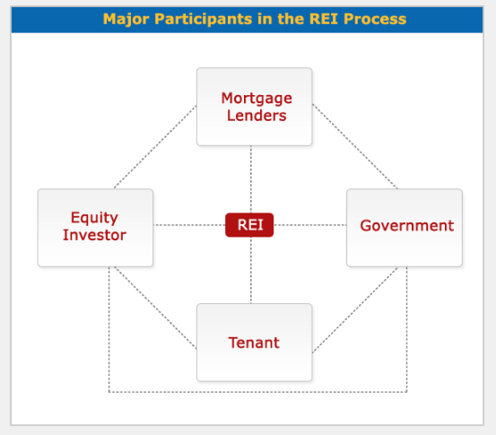
    - Government- objective is taxes on the capital gain and profits
      - Regulates the relationship between participants, and restricts participants with the imposition of taxes.
      - Different levels of participation: federal, provincial and municipal
    - Equity Investor (landlord)- have a tenant to make cash flow and to get capital gain in the future
      - Person or entity that acquires the real estate investment
      - Assess how the REI will be taken, as an individual or as an organization
      - Take make decision the investor will analyse questions such as how the organization will be created, how marketable is it, who the partners will be, how each partner will share liabilities, what the taxation opportunities and constraints for the specific organizations are
      - Common investors: individual, corporation, partnership and real estate investment trust (REIT)
    - Mortgage Lenders- make money on the interest and their security is the property
      - The entity that lends the money that the equity investor needs to start the REI
      - Common mortgage lenders: another individual, insurance companies, banks, REIT
    - Tenant- the one who buys right of possession and use of property from the equity investor.
      - Used for different purposes: residential, commercial, industrial, special purpose (theater, sports, reception halls, etc)
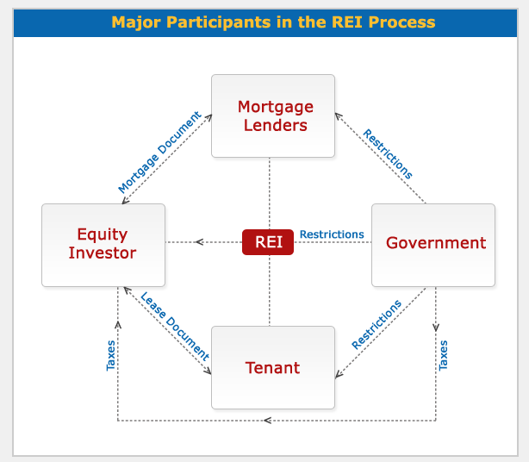
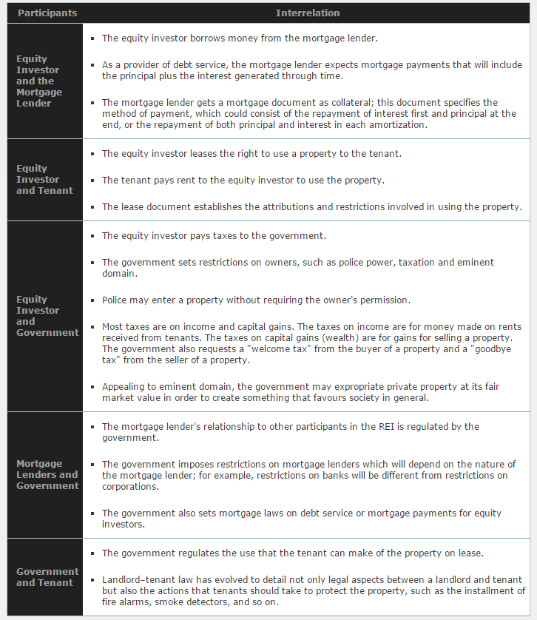

Real Estate Investment Process
- Step 1: Identify the investor's objectives, goals and constraints
  - The equity investor is interested in the cash flow that will generate the REI
  - The mortgage lender's goal is to obtain a rate of return from the money lent to the equity investor
  - The tenant does not receive an immediate income, but will be concerned with the legal rights to use the property
  - The government is responsible for regulating the relationship between the other major participants in the REI process, and it also places restrictions on real estate.
- Step 2: analyze investment climate and market conditions
  - The market environment- identifies the supply and demand in the real estate market at local, provincial, and state levels and how they affect the REI
  - The legal environment- complex legal system regulates the REI and the relationships between its participants. Analysing the legal opportunities and limitations that a REI may also entail will play an important role in the acquisition decision and also in the rest of the REI process.
  - The financing environment- the analysis of cost of debt or interest rate, and the cost of equity or rate of return, shows how feasible the REI is and how profitable it might be.
  - The tax environment- taxes decrease the REI income, knowing the taxation system and the impact that it will have on the expected income will help in making the right investment decision to save money or to increase gains.
- Step 3: develop financial analysis
  - Must be able to answer such questions as:
    - How much profit per year?
    - How much is the mortgage payment?
    - How must is the capital gain when I sell?
    - How much will taxes diminish my profit?
    - How much will taxes decrease my capital gains?
    - What strategies should I use to reduce taxes on profits and capital gains?
- Step 4: apply decision-making criteria
  - Rules of thumb techniques: measure the payback period necessary to regain what was invested to acquire property, and the methods needed to achieve the highest rate of return.
    - Techniques are: payback method, return on investment (ROI), return in equity (ROE), return on asset (ROA), gross income multiplier (GIM), net operating multiplier (NIM), overall capitalization method (OCR)
  - Discounted cash flow techniques: calculate the value today of the REI future cash flow- take time value of money into consideration and include discounted payback period method, net present value method, internal rate of return and profitability index method.
  - Traditional valuation techniques- eliminate the value of the property that will be used in the REI
    - Cost approach, net income approach and market (sales) comparable approach
- Step 5: investment decision
  - If the result of the analysis is not what you expected, then repeat the process assessing another REI until you find what meets your financial goals
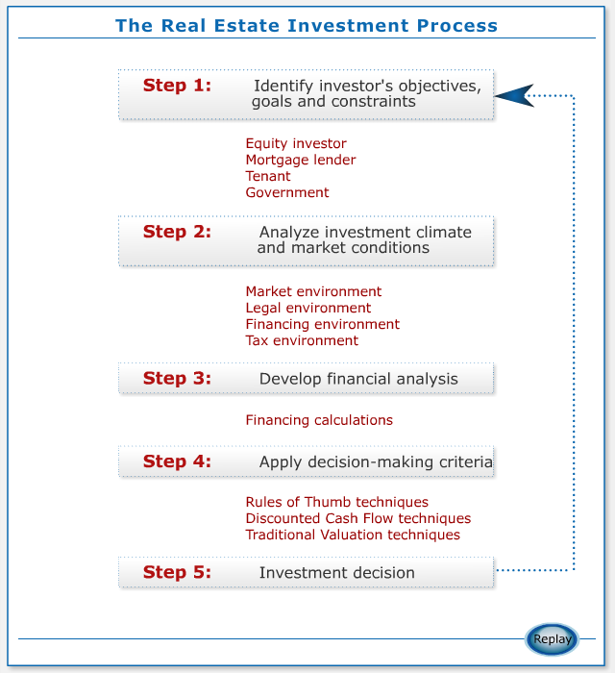

Practice questions:

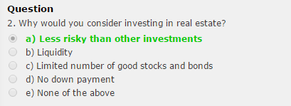

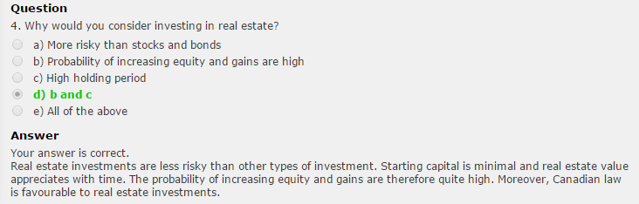









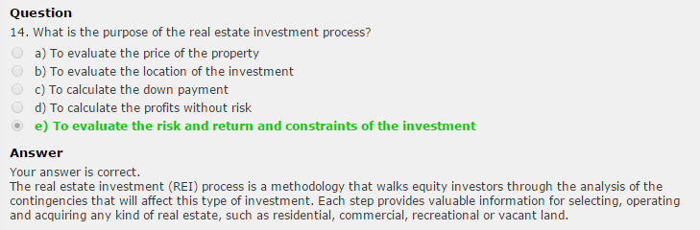

Lesson 2: The time value of money

Time Value of Money: enables us to compare dollars received or paid out in different time periods.
- Important in making smart decisions in budgeting, investment, debt management, tax and retirement planning
- Everything else being equal, today's dollar can be invested to earn interest and grow to a larger sum in the future- value of money increases as time moves forward
- Timeline (5 variables)
  - Payment (P)
  - Future Value (FV)
  - Present Value (PV)
  - Interest Rate (% per period) (r)
  - Period (t)
  - Number of Periods (n)
Rate of Return:

Nominal Rate: the nominal rate is also known as "in name only" because it has not been adjusted for inflation. Other sources might also call it Quoted Rate, Stated Rate, Observed Rate, or Annual Percentage Rate (APR). In a given problem, when we talk about the interest rate we are talking about the nominal rate, always written on a per annum basis.

Effective Annual Rate (EAR): the interest rate compounded once per year.

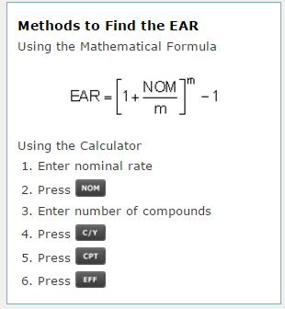
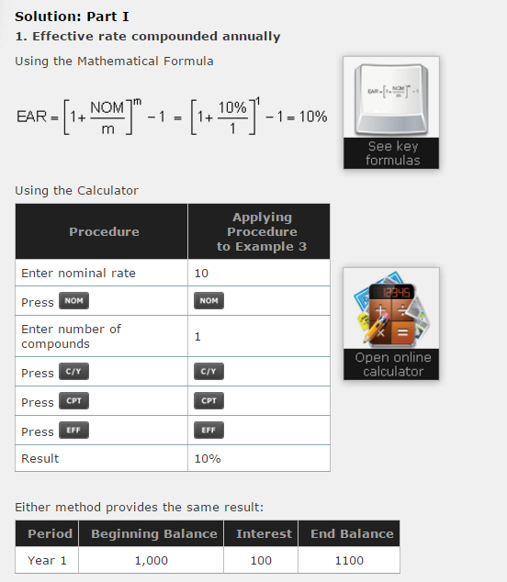
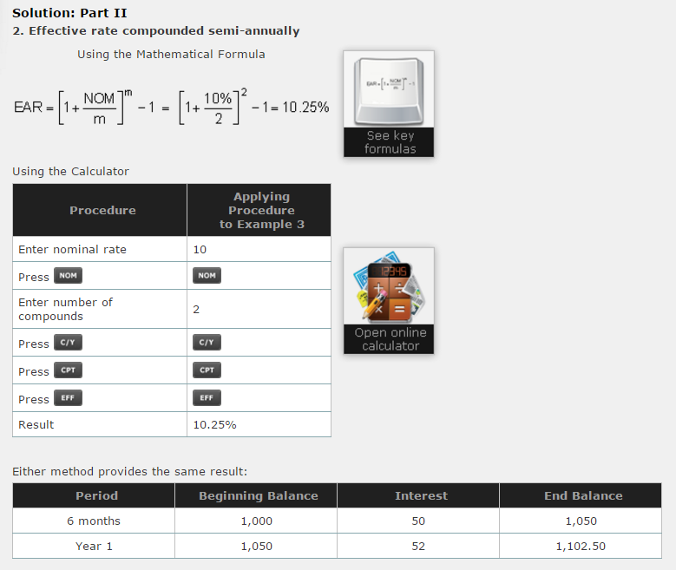

The Five Variables and the Timeline
- Payment (P)
- Future Value (FV)
  - The future value is the value that a current amount of money will have at a specific date in the future. This value is calculated using four variables: interest rate, number of periods or compounds, present value and payment.
  - FV of an ordinary annuity: receiving a fix amount at equal intervals at the end of each year- always greater than the PV.
  - FV of an annuity- Due: receiving a fix amount at equal intervals at the beginning of each year – the FV of annuity due is greater than the FV of an ordinary due because you are depositing the money at the beginning rather than at the end.
  - FV of a lump sum amount: one large amount deposited- FV also greater than the PV.
- Present Value (PV)
  - The present value is the current value that a future amount of money is worth. This value is calculated using four variables: interest rate, number of periods or compounds, future value, and payment.
  - Always less than the future value
  - Present Value Ordinary Annuity: $1000 at the end of each year for 5 years- at the end of each year you get the return
  - Present Value of an Annuity-Due: $1000 at the beginning of each year for 5 years (the PV is greater given that the money is being added at the beginning of each year)
  - Present Value of a lump sum amount: you will receive $5000 10 years from today- present value always less than the future value
- Interest Rate (% per period) (r)
- Period (t)
- Number of Periods (n)
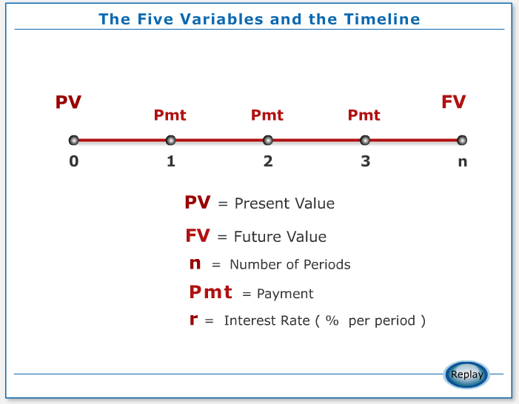
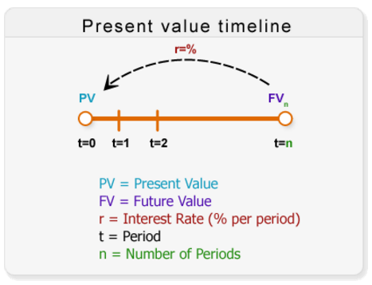

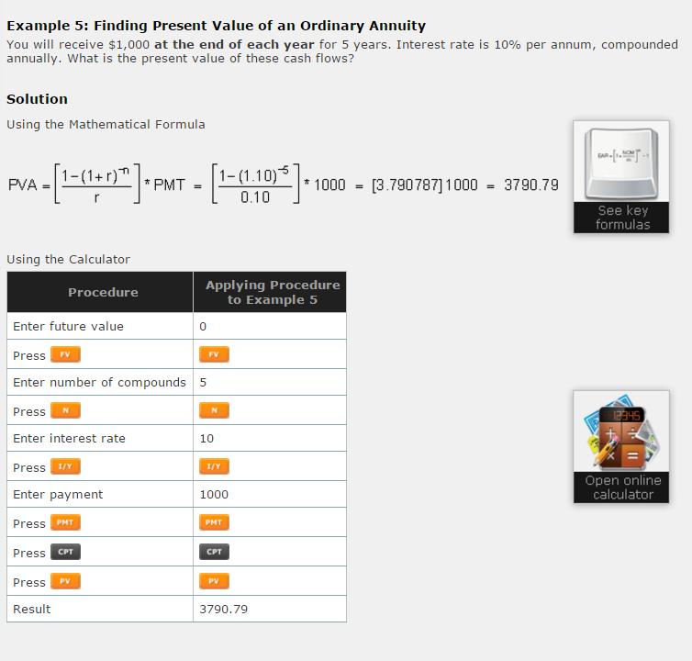

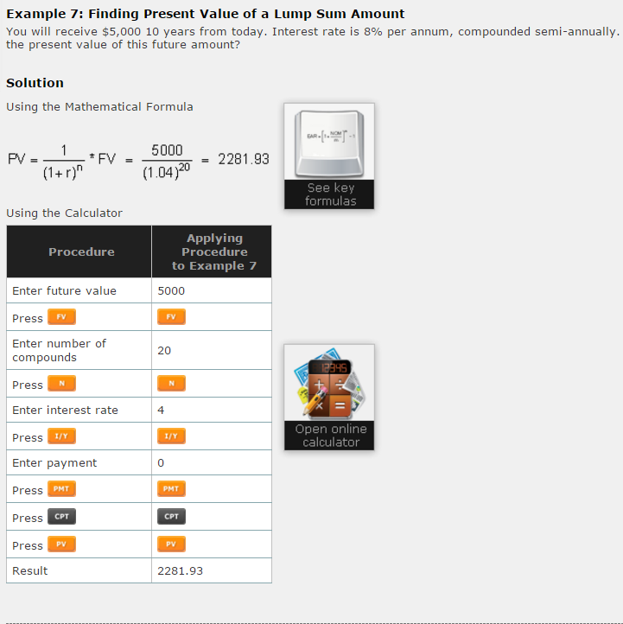
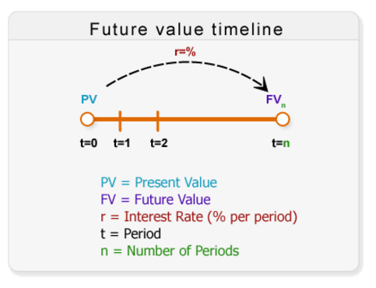
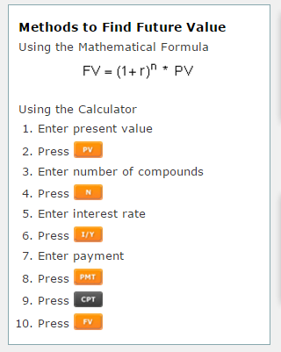

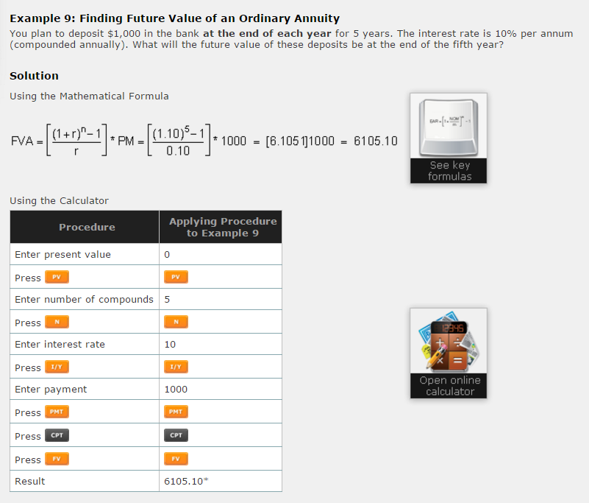
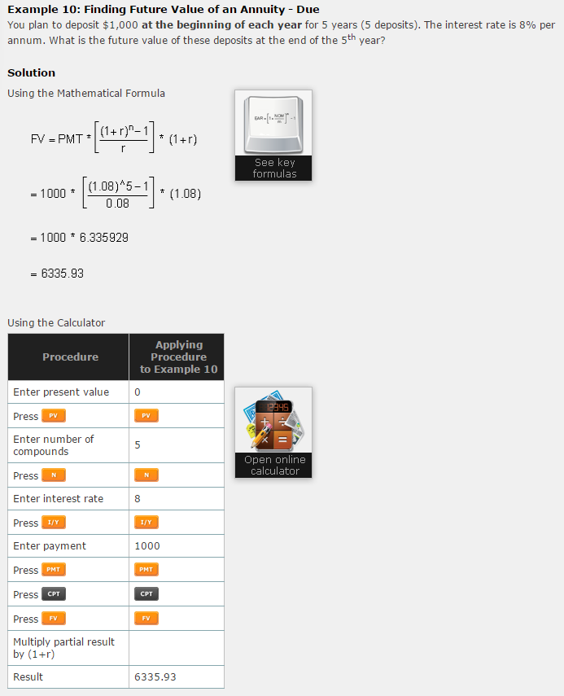


Lesson 5- The financing Environment
- Financing Environment: exists when a buyer does not have sufficient cash to purchase the property in question- resorting to obtaining a mortgage from a financial institution to cover the portion that is missing.
- Mortgage: the term used for the loan on real estate transaction (also called loan-to- value ratio)
- Mortgage payments: monthly instalments made to your bank in order to reduce your outstanding loan and eventually pay it off entirely.
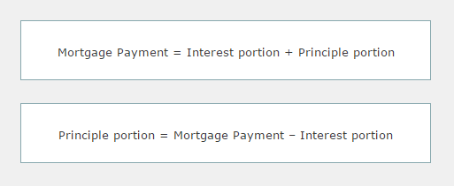

- Mortgage Loan balance: the portion of the loan that is still outstanding at any point in time.

- Loan-to-value (LVR) ratio: the loan expressed as a percentage- the mortgage value that the bank is willing to give you.

- Outstanding loan balance: refers to mortgage loan balance.

- Effective Cost of Borrowing (ECB): is a rate expressed in percentage form which takes into consideration the effects of processing fees, cancellation penalties, and so on. Processing costs are fees many banks charge in order to process your mortgage, due to the extensive paperwork and efforts in their behalf.

Lesson 6- the tax environment
Tax environment:
- Governments on all levels (municipal, provincial, federal) tax the equity owner on income and capital gains.
- Taxes on income are for money made on rents received from tenants
- Taxes on capital gains are for gains selling a property
- In addition, certain municipal governments oblige equity owners to pay taxes, the buyer pays a ``welcome tax`` and the seller pays a ``goodbye tax``
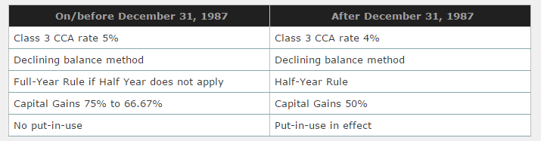
- Capital cost allowance (CCA): depreciation method under Canadian tax law which allows for the accelerated write off of property under various classifications
  - Put-in-use: all costs are capitalized to year 0 when the building is constructed and ready to be occupied.
  - The full-year rule (FYR): applies when 100% of the CCA is taken in year 1
  - The Half-year rule (HYR): applies when 50% of the CCA rate is taken in a year
  - The beginning undepreciated capital cost (BUCC): the amount prior to CCA being taken
  - The ending undepreciated capital cost (EUCC): amount after CCA is taken

Lesson 8- The investment Decision: techniques
Traditional valuation techniques: used to calculate the value of a property
- Consist of 3 approaches:
  - Cost approach
    - To value unique real estate investments
    - To value real estate projects with little or no depreciation
    - When real estate investments do not produce income- I.e when the net income approach cannot be applied
    - By municipalities or local governments to calculate property taxes
    - Advantage:
      - Easy to apply the procedures if the information is available
- Disadvantage
  - Difficult to evaluate depreciation
  - Depreciation calculation are very subjective
  - Different variables used to calculate value of new building- i.e. generates different answers
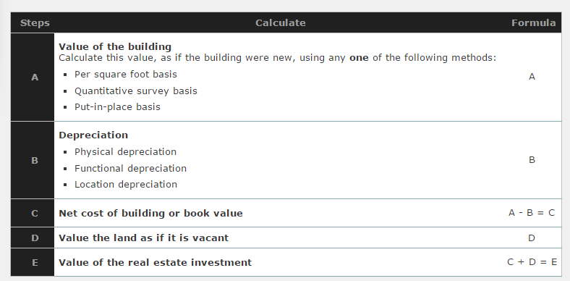

  - Net income approach
    - To value real estate investments that generate income
    - To value real estate investments when the coast approach is difficult to apply
    - To value real estate investments when there are few or no comparable on the market- i.e. when sales comparable cannot be applied
    - Advantages:
      - Do not have to calculate depreciation which is very subjective
      - Takes into account changes in the fiscal policy (supply and demand) and monetary policies (interest rates, inflations) of the economy
- Disadvantages:
      - Difficult to estimate expected vacancy and credit losses
      - Difficult to estimate expected operations expenses
      - Difficult to estimate Net Operating Income if vacancy and credit losses and operating expenses are difficult to estimate or sometimes subjective
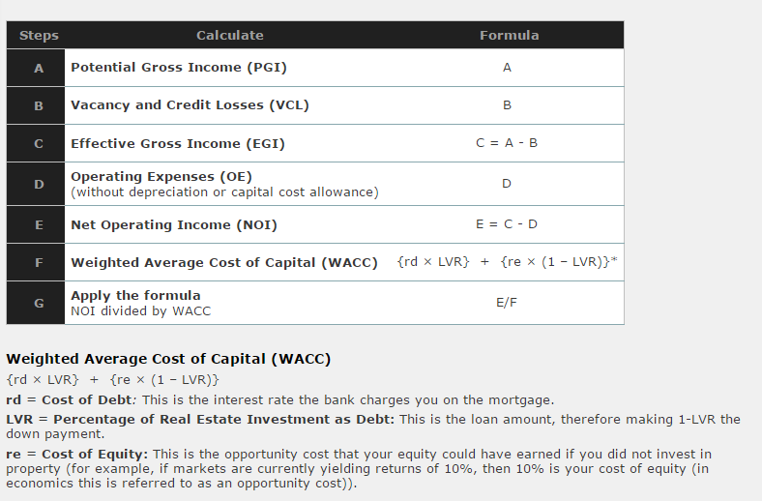
  - Sales comparable approach
    - To value real estate investments to have many comparable, such as residential properties
      - Residential properties are bought and sold every day
      - Comparable properties used for comparison have few differences for adjustments
      - Adjustments are usually required with reference to time (inflation), location (location, middle, across), size (square feet), age (number of years), garage (number of garages), types of financing used, and others (swimming pool etc.)
    - When the cost approach and net income approach are not applicable
    - Advantages:
      - Easy to find comparable
      - Comparable are bought and sold every day
      - Take into account changes in the fiscal policy (supply and demand) and monetary policies (interest rates, inflation) of the economy
    - Disadvantages
      - Difficult to find comparable with no adjustments- no two properties are the same
      - Difficult to estimate the require adjustments, very subjective depending on buyer or seller`s point of view, very biased
      - Standard estimation suggested by appraisers to make adjustments
      - Difficult to qualify or to put a dollar amount on all the differences between subject property and comparable


