Physiology of the nervous system

Biological electrical potential
- Voltage gated ion channels
  - Negative (-) on the inside and positive (+) on the outside
  - Release Na (outside) and K (inside of the cell)
  - For every 2:3 ration from K to Na
- Ohms law: current (l) = voltage (V) / Resistance (R)
- Insulators have large resistance while conductors have low resistance
  - A decrease in resistance = an increase in conduction – this permits current flow
- Na – potential of +55mV
- K – potential of -90mV
- Cl – potential of -80mV

Graded potentials
- Short lived localized changes in membrane potential
- Current flow decreases with distance
- They are graded because current flow varies with stimulus strength

Action potential (nerve impulses):
- Long distance
- Found in the membrane of excitable tissues
- Gathered by dendrites
- Charge travels down through the axon to the synapse
- Stimulates the release of neurotransmitters into a synapse
- Action occurs only when the electrical signal hits a threshold
  - All or nothing rule: the impulse will always be at the same size intensity no matter the stimulation. but it matters if it fires or not

Resting potential:
- High concentration of potassium inside the neuron
- Lower concentration of potassium outside the neuron
- Higher concentration of sodium outside the neuron
- When there is an electrical charge the potassium gates will open firing potassium outside changing the voltage to -70milivolts. The gates then close, causing the sodium channels to open and begin shooting sodium inside due to ionic attraction which causes a change in the voltage to +40milivolts. The potassium gates re-open allowing the potassium to go back inside causing the voltage to go past -70milivolts and leaving it at around -90milivotls. To reach equilibrium some sodium ions slip out through the gradient because of the charge.
  - Four events occur:
    - Resting state: All gated Na and K channels are opened
    - Depolarization: Na channels open
    - Repolarization: Na channels are inactivating, and K channels are open
    - Hyperpolarization: Some K channels remain open, and Na channels reset

Refractory period:
- This is the time after the resting potential
- Another action potential cannot fire again during this period

Axon Diameter:
- The larger the axons diameter, the faster it conducts impulses.
- Larger axons conduct more rapidly because they offer less resistance to the flow of local currents
- Threshold is achieved quicker

Degree of myelination:

Continuous conductions:
- Doesn’t contain a myelin sheath
- AP propagation involving non-myelinated axons, these channels are immediately adjacent to each other
- Continues conductions is relatively slow

Salutatory conduction:
- Contains myelin sheaths
- They act as insulators, thus preventing leakage of charge from the axon and allows the membrane voltage to change more rapidly
- The presence of myelin sheath increases the rate of speed at which the current travels at
- Nearly all voltage gates Na channels are concentrated I these gaps, also known as nodes of Ranvier
- As the current travels down the axon, there will be another AP at every node due to these gates

Bare plasma membrane:
- Voltage decays
- Without voltage-gated channels, as on dendrites, voltage decays because current leaks across the membrane

Group A fibres:
- Mostly somatic sensory and motor fibres serving the skin, skeletal muscles, and joints
- Largest diameter and thick myelin sheaths
- Conduct impulses at speeds ranging up to 150m/s

Group B fibres:
- Lightly myelinated fibres with intermediate diameter
- Transmit impulses at an average 15m/s

Group C fibres:
- These have the smallest diameter and are non-myelinated
- They are incapable of salutatory conduction and conduct at speed of 1m/s

Exocytosis (out of the cell):
- Vesicular transport processes that eject substances from the cell interior into the extracellular fluid
- Typically stimulated by the a cell surface signal such as binding of hormone to a membrane receptor or a change in membrane voltage,
- Accounts for hormone secretion neurotransmitter release, mucus secretion, and in some cases the ejection of waste.
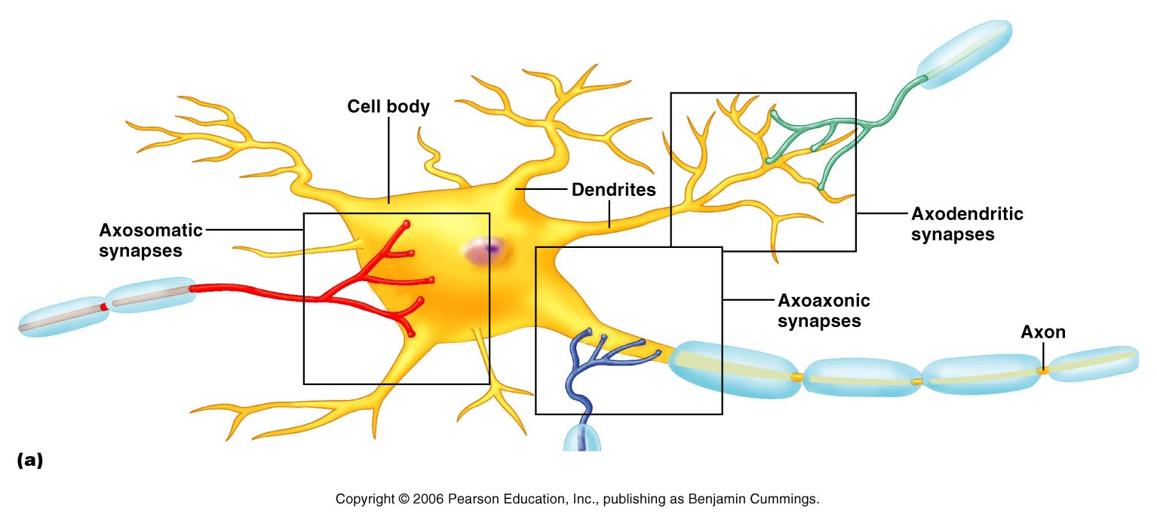
- Dendrites: ligand gated channels are activated by neurotransmitters
- Axons: voltage gated channels are activated by depolarization
- Synaptic terminals: voltage gated calcium channels open to allow neurotransmitter release

G-proteins
- 30% of the modern drugs target GPCRs
- The human genome roughly encodes 800 GPCRs
- Amino acids
  - Opens chloride channels and is inhibitory
- Glutamine
  - Opens sodium channels and is excitatory
- Acetylcholine (ACh)
  - At nicotinic receptors
    - opens channels permeable to both sodium and potassium
    - Gives a rise to the average of their two reversal potentials
    - It is excitatory
  - At G protein muscarinic receptor
    - May be either excitatory or inhibitory depending on tissue
- Endorphins
  - Inhibits pain pathways
- Tachykinins
  - The neurotransmitter in pain pathways
- Nitric oxide (NO) and Carbon monoxide (CO)
  - Non-traditional neurotransmitters

Central Nervous System
- This system consists of the brain and the spinal cord, which occupy the dorsal body cavity
- The control system of the nervous system
- It interrupts sensory input and dictates the motor output based on the reflexes, current conditions and past experiences

Peripheral Nervous System
- This is the part of the nervous system outside of the CNS
- Consists mainly of nerve bundles (bundles of axons) that extend from the brain and the spinal cord
- Spinal nerves transmit impulses to and from the spinal cord, and cranial nerves carry impulses to and from the brain
- Consists of two subsection, the sensory or afferent division and the motor or efferent division

Sensory division:
  - consist of nerve fibres (axons) that convey impulses to the central nervous system from sensory receptors located throughout the body
  - subdivided into two fibres, somatic and visceral
    - Somatic: conveys impulses from the skin, skeletal muscles, and joints (Soma= body)
    - Visceral: conveys impulses from the visceral organs (organs within the ventral body cavity)
  - Keeps the CNS constantly informed of the events occurring within and out of the body

Motor division:
  - Transmits impulses from the CNS to the effector neurons, which are muscles or glands.
  - Activate muscles to contract and glands to secrete(effect= Bring out a motor respond)
  - The motor division has two parts:
    - Somatic: it is composed of somatic motor nerve fibres that conduct impulses from the CNS to skeletal muscles. Also known as the voluntary nervous system as it consciously controls our skeletal muscles
    - Autonomic: consists of visceral moto fibres that regulate the activity of smooth muscles, cardiac muscles, and glands. Also known as involuntary nervous system as it subconsciously pumps our heart and works muscles automatically without out control. The ANS has is subdivided into two functional groups, whatever one groups stimulates the other one inhibits, meaning they work in opposition to each other.
        - Sympathetic: mobilizes body systems during activity
        - Parasympathetic: conserves energy and promotes housekeeping functions during rest
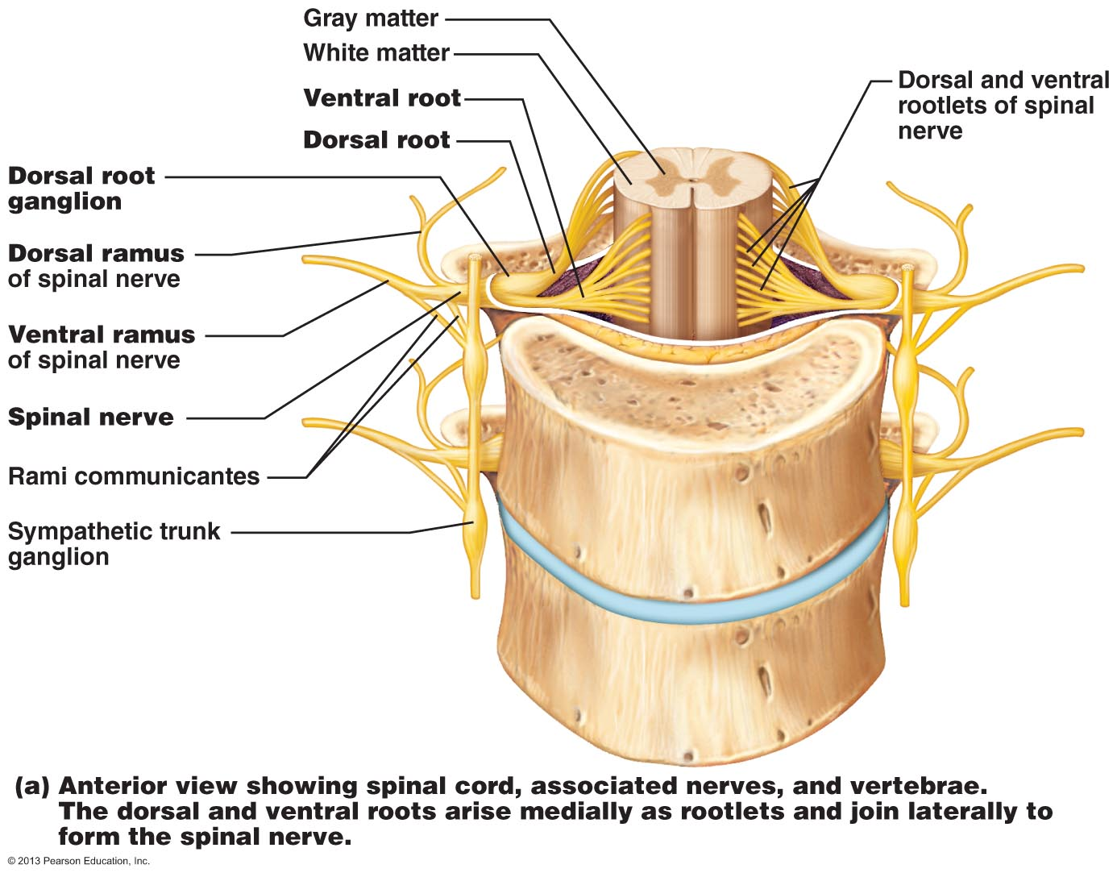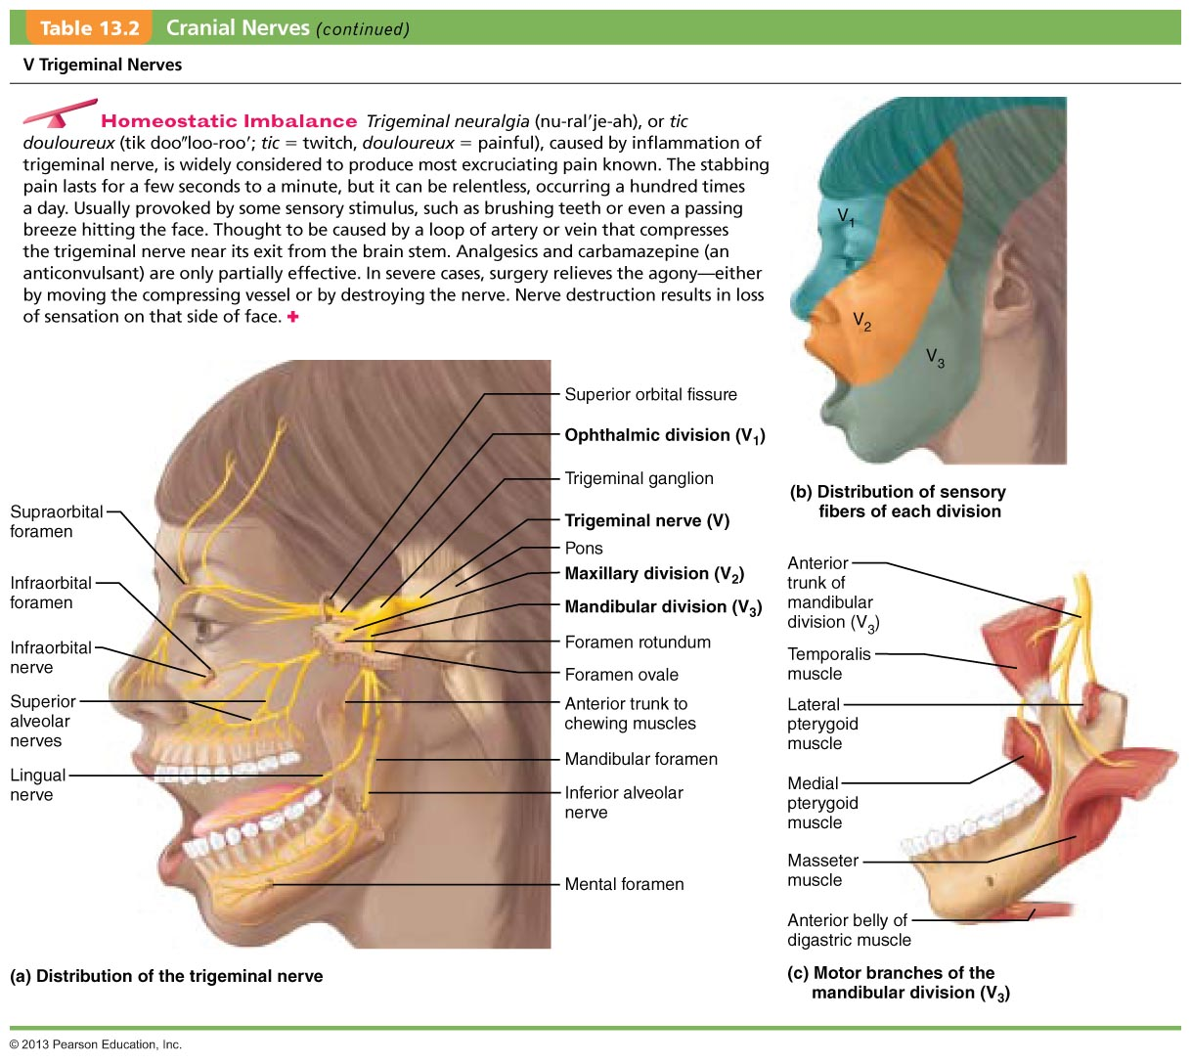

Sensory receptors

Receptor classification by stimulus type
- Mechanoreceptors : respond to touch, pressure, vibration, stretch and itch
- Thermoreceptors: sensitive to changes in temperature
  - Transient receptor potential (TRP) family of proteins
  - Free nerve endings with the membrane channels that change their permeability across specific temperature ranges
- Photoreceptors: respond to chemicals (e.g. smell, taste, change in blood chemistry)
- Nociceptors: sensitive to pain causing stimuli

Receptor class by location:

Exteroceptrors
- Respond to stimuli arising outside the body
- Found near the body surface
- Sensitive to touch, pressure, pain and temp
- Found in special sense organs

Interoceptors
- Respond to stimuli arising within the body
- Found in internal viscera and blood vessels
- Sensitive to chemical changes, stretch and temp changes

Proprioceptors
- Means ‘self-to-self”
- Respond to degree of stretch of the organs they occupy
- Found in skeletal muscles, tendons, joints, ligaments, and the CT coverings of bones and muscles
- Constantly advise the brain of ones movements
- Gives information concerning movements and position of the body
- Muscle spindles are one type of proprioceptors
  - the Golgi tendon is another – deals with muscle tension

Receptor classification by receptor structures
- receptors are structurally classified as either simple or complex
- most receptors are simple and include encapsulated and non-encapsulated varieties ( free nerve endings )
- complex receptors are special sense organs in contact with free nerving endings

Simple receptors

Non-encapsulated nerve endings
- abundant in epithelia and CT
- non-myelinated, small diameter group C fibres
- small knob like endings
- respond to temp change and painful stimuli and some respond to pressure
- Nerve endings that respond to cold (10–40°C, or 50–104°F) are located in the superficial dermis. Those responding to heat (32–48°C, or 90–120°F) are deeper in the dermis.
- Itch senses located in the dermis respond to chemicals – notably histamine – present at inflamed sits

Tactile (Merkel) discs
- Lie in the deepest layer of the epidermis
- Functions as light and touch receptors
- Certain free nerve endings associate with enlarged, disc-shaped epidermal cells to form tactile cells

Hair follicle receptors
- Wrap around hair follicle ins a basket like formation
- Light touch receptors that detect bending hairs

Encapsulated nerve endings
- Consist of one or more fiber terminals of sensory neurons enclosed in a CT capsule
- Virtually all are mechanoreceptors
- Vary in shape, size and distribution
Tactile corpuscles
- Meissner’s corpuscles are small receptors in which a few spiraling sensory terminals are surrounded by Schwann cells and then by a thin egg-shaped connective tissue capsule.
- Found just beneath the epidermis in the dermal papillae
- Numerous in sensitive and hairless skin areas such as the nipples, fingertips, and soles of the feet.
- They are receptors for discriminative touch
- play the same role in sensing light touch in hairless skin
Lamellar corpuscles
- Called Pacinian corpuscles
- Found deep in the dermis, and in subcutaneous tissue underlying the skin
- Respond only when the pressure is first applied, and thus are best suited to monitoring vibration (an “on/off” pressure stimulus)
- They are the largest corpuscular receptors.
- Some are over 3 mm long and half as wide and are visible to the naked eye as white, egg-shaped bodies.
- 60 layers of collagen fibers and flattened supporting cells.
Bulbous corpuscles
- Ruffini endings, which lie in the dermis, subcutaneous tissue, and joint capsules
- Contain a spray of receptor endings enclosed by a flattened capsule.
- Resemblance to tendon organs
- Respond to deep and continuous pressure.
Muscle spindles
- Fusiform (spindle-shaped) proprioceptors
- Found throughout the perimysium of a skeletal muscle.
- Each muscle spindle consists of a bundle of modified skeletal muscle fibers, called intrafusal fibers (in″trah-fu′zal), enclosed in a connective tissue capsule.
- Muscle spindles detect muscle stretch and initiate a reflex that resists the stretch.

Tendon organs
- Are proprioceptors located in tendons, close to the junction between the skeletal muscle and the tendon
- Small bundles of tendon (collagen) fibers enclosed in a layered capsule
  - Sensory terminals coiling between and around the fibers.
  - When muscle contraction stretches the tendon fibers, the resulting compression of the nerve fibers activates the tendon organs. This initiates a reflex that causes the contracting muscle to relax.

Joint kinesthetic receptors
- Proprioceptors that monitor stretch in the articular capsules that enclose synovial joints.
- Four receptor types:
  - Lamellar corpuscles
  - Bulbous corpuscles
  - Free nerve endings
  - Receptors resembling tendon organs
- Together these receptors provide information on joint position and motion (kines = movement), a sensation of which we are highly conscious.

Physiology of the nervous system somatosensory – higher levels
Pages 435-436, 438, 468-469, 472-474, 516-521

Cerebral hemispheres
- Form the superior part of the brain
- Accounts for 83% of the total brain mass
- Covers and obscures the diencephalon and the top of the brain stem
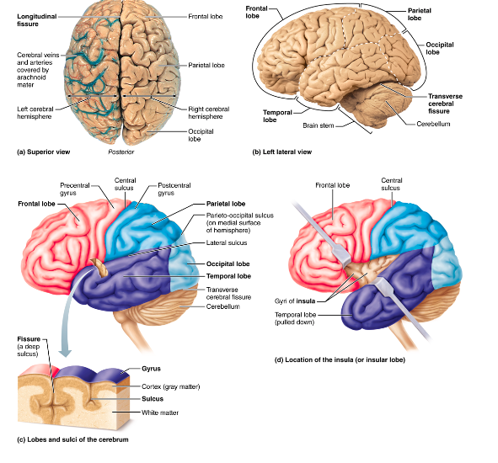

Sensory areas
- Areas concerned with conscious awareness of sensation
- Sensory areas of the cortex occur in the parietal, insular, temporal and occipital lobes

Primary somatosensory cortex
- Resides in the postcentral gyrus of the parietal lobe jus posterior to the primary motor cortex
- Neurons in this gyrus receive information from the somatic sensory recptors in the skin and form proprioceptors in skeletal muscles joints and tendons

Neuronal pathways
- All major spinal tracts are apart of the multineuron pathway
  - Connects the brain to the body periphery
  - Contains the spinal cord neuron, peripheral neurons and neurons of the brain
- Four key generalizations of the pathways
  - Decussation
    - Most pathways cord from one side of the CNS to the other (decussate) at some point along their journey
  - Relay
    - Most pathways consist of a chain of two or three neurons (a relay ) that contributes to successive tracts of the pathway
  - Somatotopy
    - Most pathways exhibit somatotopy
      - A precise spatial relationship among the tract fibres that reflects the orderly mapping of the body
  - Symmetry
    - All pathways and tracts are paired symmetrically (right and left) with a member of the pair present on each side of the spinal cord or brain

Ascending pathways to the brain
- Conduct sensory impulses upward, typically through chains of three successive neurons ( first-, second-, and third-order neurons) to various areas of the brain
- Both second and third-order neurons are interneurons

First order
- Cell bodies reside in the ganglion
- Conducts impulses from the cutaneous receptors of the skin and from proprioceptors to the spinal cord or brain stem where they synapse with the second order neurons
- Impulses from facial area are transmitted by cranial nerves
- Spinal nerves conduct somatic sensory impulses from the rest of the body to the CNS

Second order
- Reside in the dorsal horn of the spinal cord or in medullary nuclei
- Transmit impulses to the thalamus or to the cerebellum where they synapse

Third order
- Have cell bodies in thalamus
- Rely impulses to the somatosensory cortex of the cerebrum
  - Non in the cerebellum

Major ascending (sensory) pathways and spinal cord tracts

Dorsal column-medial lemniscal pathways
- Mediate precise, straight-through transmission of inputs from a single type of sensory receptor that can be localized precisely on the body surface, such as discriminative touch and vibrations
- Located on the dorsal aspect
- First order – enters the dorsal white column root of the spinal cord and branch
  - And the fasciculus cuntaenus and fasciculus gracilis and the medial lemniscus
- Medial lemniscus arise in the medulla and terminates In the thalamus
- From the thalamus, impulses are forwarded to specific areas of the somatosensory area

Spinothalamic pathways
- Receive inputs from many different types of sensory receptors and make multiple synapses to the brain stem
  - These consist of the lateral and ventral (anterior) spinothalamic tracts
  - These fibres cross over the spinal cord
- Primarily transmit impulses for pain and temperature and also for coarse touch and pressure

Spinocerebellar pathways
- The third ascending pathway
- Consists of the ventral and dorsal spinocerebellar pathways
- Convey information about muscles or tendon stretch to the cerebellum – uses this information to coordinate skeletal muscle activity
- Do not contribute to conscious sensation
- Either do not decussate or else cross over twice (thus undoing the decussation)

Processing at the circuit level
- The second level of integration
- Delivers impulses to the appropriate region of the cerebral cortex for localization and perception of the stimulus
- Axons of the first order link receptor circuit levels of processing
  - Branch diffusely when they enter the spinal cord
  - Some branches take part in local spinal cord reflexes
- Other synapses with the second order sensory neurons, synapse with the third order neurons that take messages to the cortex of the cerebrum

Processing at the perceptual level
- Sensory input interpreted at the cerebral cortex
- The ability to identify and appreciate sensations depends on the location of the target neurons in the sensory cortex
- Each sensory fibre is analogous to a labeled line that tell the brain who is calling – a taste bud or a pressure receptor – and from where

Major features of sensory perception

Perceptual detection
- Ability to detect that a stimulus has occurred
- Inputs from several receptors must be summed for perceptual detection to occur

Magnitude estimation
- The ability to detect how intense the stimulus is
- Perceived intensity increases as stimulus intensity increases because of frequency coding

Spatial discrimination
- Allows us to identify the site or pattern of stimulation
- A common tool for studying this quality in the laboratory is the two point discrimination tst
  - Determines how close two point on the skin can be and still perceived as two point rather than one
  - Allows for a crude map of the density of tactile receptors in the various regions of the skin

Feature abstraction
- The mechanism by which a neuron or circuit is tuned to one feature or property of a stimulus
- Involves interplay of several stimulus features

Quality discrimination
- The ability to differentiate the sub-modalities of a particular sensation
- Each sensory modality has several qualities or sub modalities

Pattern recognition
- The ability to take in the scene around us and recognize a familiar pattern, an unfamiliar one, or a one that has special significance for us

Physiology of smell and taste
Pages 496, 499, 501 569-574

Location and structure of olfactory receptors
- Olfactory detects chemicals in solutions
- The organ of smell is a yellow-tinged patch of pseudostratified epithelium called olfactory epithelium
  - Located in the roof of the nasal cavity
- Air entering the nasal cavity must make hairpin turns to stimulate our sense of smell
- Contains olfactory sensory neurons
  - Only type of neurons to undergo noticeable turnover through adult life
    - Life span is 30-60 days
  - Surround and cushioned by columnar supporting cells – make up the bulk of epithelial membrane
- At the base of the epithelium lies the short olfactory stem cells
- The sensory neurons are unusual bipolar neurons
  - Each has a thin apical dendrite that terminates in a knob from which several long cilia radiate
- The olfactory cilia
  - Increase the receptive surface area
  - Lie flat on the nasal epithelium and are covered by a thin coat of mucous
  - Largely non-motile
- Filaments of the olfactory nerve
  - Non-myelinated axons
  - Gathered into small fascicles
  - Cranial nerve 1
  - Project superiorly through the opening In the cribriform plate of the ethmoid bone – they synapse in the overlying olfactory bulbs

Specificity of olfactory receptors
- Humans can distinguish 10,000 or so odors
- Stimulated by different combinations of a more limited number of olfactory qualities
- About 400 “smell genes”
  - Each gene encodes a specific receptor protein
  - Each protein responds to one or more odors and each odor binds to several different receptor types
  - However each receptor cell has only one receptor protein
- Some of what we smell is pain
  - Nasal cavities contain pain and temperature receptors that respond to irritant such as the sharpness of ammonia, the hotness of chili peppers, and the chill of menthol

Physiology of smell
- Odors must be volatile – gas state
  - Must dissolve in the fluid coating of the olfactory epithelium

Activation of olfactory sensory neurons
- Dissolved odorants stimulate olfactory sensory neurons by binding to receptor proteins in the olfactory cilium membrane
  - Opens cation channels generating a receptor potential

Smell transduction
- Transduction of odorants uses a receptor G-protein
  - Begins when the odorant binds to a receptor. This activates the G-protein – this activates enzymes (adenylate cyclase) that synthesizes the cyclic AMP as a second messenger
  - Cyclic AMP act directly on a plasma membrane cation channel causing it to open allowing Na and Ca to enter
  - Na leads to depolarization and impulses transmission
  - Ca influx causes the transduction process to adapt, decreasing its response to a sustained stimulus
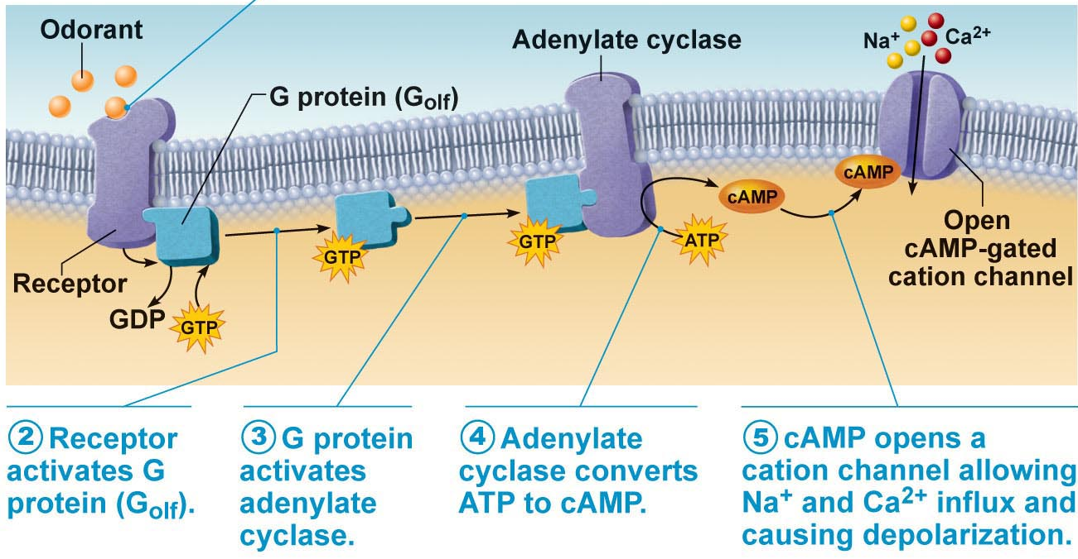

The olfactory pathway
- At the distal ends of the olfactory tracts, the filaments of the olfactory nerves synapse with mitral cells which are second order sensory neurons in complex structures called Glomeruli
- Each glomerulus represents a single aspect of an odor
- Each odor activates a unique set of glomeruli
- Mitral cells amplify and relay the signal
- The olfactory bulbs house amacrine granule cells
  - GABA releasing cells that inhibit mitral cells
  - Only highly olfactory impulses are transmitted
- Two major pathways take information to the brain
  - One pathway brings information to the frontal lobe just above the orbit
    - Where smell is consciously interpreted and identified
  - The other pathway goes to the hypothalamus , amygdala, and other regions of the limbic system
    - Dangerous scents activate the sympathetic nervous system here
    - Appetizing scents trigger the salvation reaction and the digestion tracts
    - Unpleasant odors signal sneezing and coughing

Taste buds and the sense of taste

Location and structure of taste buds
- Most taste buds are found on the tongue in papillae
  - Mainly on the fungiform papillae and found on the epithelium of the side walls of the foliate papillae and of the large round vallate papillae (largest least numerous)
- Taste buds consist of 50-100 epithelial cell – gustatory- and basal epithelial cells

Gustatory
- Receptor cells for taste
- Long microvilli called gustatory hairs project from the tips of all gustatory epithelial cell and extend through a taste pore
- Receptor membrane
- Three kinds
  - Forms Traditional synapse with sensory dendrites and release neurotransmitter serotonin
  - The other two lack synaptic vesicles, but atleast one releases ATP

Basal
- Most dynamic cells
  - Replaced every 7-10 days
  - Act as stem cells – dividing and making new gustatory cells

Basic taste sensations
- There are five basic taste sensations
  - Sweet – sugars, saccharin, alcohol, some amino acids and some lead salts
  - Salts – metal ions
  - Sour – acids, specifically due to hydrogen ions
  - Bitter – elicited alkaloids (quinine nicotine, caffeine, morphine) and non-alkaloids such as aspirin
  - Umami – amino acids and glutamine and aspartate (beef taste, aging cheese)
- For a chemical to be tasted it must be dissolved in saliva, diffuse into a taste pore, and contact the gustatory cells

Activation of taste receptors
- When food binds to a receptor it induces a dragged depolarization potential that cause neurotransmitter release
- Binding causes generator potential that elicit action potential in these fibres
- Taste receptor adapt rapidly, with partial adaptation in 3-5 seconds and complete adaptation in 1-5 seconds

Taste transduction
- Three different mechanism
  - Salty taste is due to Na influx through Na channels – depolarizes gustatory cells
  - Sour is mediated by Hydrogen ions – acts as intracellular channel openers
  - Bitter , Sweet, and Umami
    - G-proteins activation leads to the release of Ca from intracellular stores which causes cations \\ channels in the plasma membrane to open, thereby depolarizing the cells and releasing the neurotransmitter ATP

The gustatory pathway
- Two cranial nerves
  - Facial nerve (cranial VII), the chorda tympai, transmits impulses from taste receptors in the anterior two third of the tongue
  - The lingual branch of the glossopharyngeal nerve (IX) services the posterior third and the pharynx just behind
- Taste buds from the epiglottis and the lower pharynx are conducted primarily by the vagus nerve (X)
- These afferent fibres synapse in the solitary nucleus of the medulla
  - Branch to the gustatory cortex (taste)
  - The hypothalamus and the limbic system (appreciation of taste)

Physiology of vision
Pages 549-569
- Explain the concepts of refraction, image formation, accommodation
- Describe the principal refraction abnormalities
- Describe the processing of visual signals in the retina
- Describe the neural pathway for vision
- 70% of all sensory receptors are in the eye

Structure of the eyeball

Fibrous layer
- The outermost coat of the eyeball, the fibrous layers
- Composed of dense avascular CT
- Sclera
  - Posterior portion and the bulk of the fibrous layer,
  - Whites of the eye
  - Protects and shapes the eyeball
- Cornea
  - Crystal clear cornea forms a window that lets light enter the eye
  - The deep corneal endothelium is composed of simple squamous epithelium
  - Contains active sodium potassium pumps that maintain the clarity of the cornea by keeping tis water content low
  - Has no blood vessels
  - Only tissue in the body that can be transplanted form one person to another with little risk of rejection

Vascular layer
- Forms the middle coat of the eyeball
- Called the uvea
- Three layers :
  - Choroid
    - Dark brown membrane
    - Blood vessels nourish all eye layers
    - Brown pigment helps absorb light, preventing it from scattering and reflecting within the eye
    - Posterior opening where the optic nerve leaves the eye
  - Ciliary body
    - A thickened ring of tissue that encircles the lens
    - Consists chiefly of interlacing smooth muscle bundles called ciliary muscles
      - Control lens shape
  - Iris:
    - The coloured part of the eye
    - Most anterior and vascular
    - Lies between the cornea and the lens
    - In close vision and bright light the sphincter papillae contracts and the pupil constricts

Inner layer (Retina)
- The innermost layer of the eyeball
- Develops from an extension of the brain
- It contains millions of photoreceptors that transduce light energy, other neurons involved in the processing response to light and glia
- Consist of two layers
  - Pigment layer
  - Inner neural layer
    - Rods are our dim light and peripheral vision receptors
    - Cones, in contrast, are our vision receptors for bright light and provide high-resolution color vision
- Internal chamber and fluids
  - It’s the lens and its halolike ciliary zonulas divided the ye into two segments, the anterior segment in front of the lens and the larger posterior segment behind it
  - The posterior segment is filled with a clear gel called vitreous humor that binds tremendous amount of water
    - Transmits light
    - Supports the posterior surface of the lens and holds the neural layer of the retina firmly against the pigmented layer
    - Contributes to intraocular pressure, helping to counteract the pulling force of the extrinsic eye muscles

Lens
- Is biconvex, transparent, flexible structure that can change shape to precisely focus light on the retina
- It is enclosed in a thin, elastic capsule and held in place just posteriorly to the iris by ciliary zonule
- Avascular
- Lens epithelium
  - Confined to the anterior lens surface, consist of cuboidal cells that eventually differentiate into the lens fibers – these form the bulk of the lens
- Lens fibers
  - Packed tightly together like layers in an onion, contain no nuclei and a few organelles
  - Contain transparent proteins called crystallins

Accessory structures of the Eye

Eyebrows
- Short coarse hairs that overlie the supraorbital margins of the skull
- Help shade the eyes from sunlight and prevent perspiration trickling down the forehead from reaching the eyes

Eyelids
- Anteriorly, the eyes are protected by the eyelids or palpebrae
- Separated by palpebral fissures – meet at the medial and later angles of the eye (medial and lateral commissures)
- Medial commissures
  - Fleshy elevation called the lacrimal caruncle
    - Contains sebaceous and sweat glands and produces the whitish, oil secretion that collect around the edges of the eyes during sleep
- The muscles are activated reflexively to cause blinking every 3-7 seconds
- Tarsal glands
  - Embedded in the tarsal plates and their ducts open at the eyelid edge just posterior to the eyelashes
  - Lube prevents the eyelids from sticking together
  - Smaller more modified sweat glands are associated with the eyelashes
    - Ciliary glands

Eyelashes
- Projecting from the free margin of each eyelid
- Richly innervated by nerve endings (hair follicle receptors)
- Anything that touches the eyelashes (even a puff of air) triggers reflexive blinking

Conjunctiva
- A transparent mucous membrane
- Lines the eyelids as the palpebral conjunctiva and folds back over the anterior surface of the eyeball as the bulbar conjunctiva
  - Does not cover the cornea
- Conjunctival sac
  - Where contact lenses lies
  - Produces lubricating mucus that prevents the eyes from drying out

Lacrimal apparatus
- Consists of the lacrimal gland and the ducts that drain lacrimal secretions into the nasal cavity
- Lies in the orbit above the lateral end of the eye and is visible through the conjunctiva when the lid is everted
- Releases a dilute saline solutions
  - Known as tears
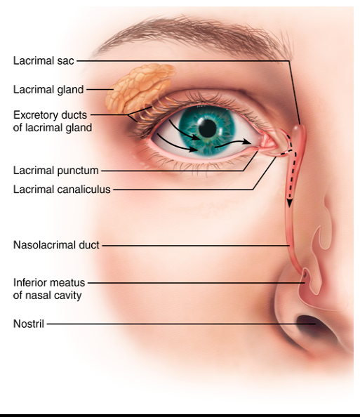
- Blinking spreads the tears downward and across the eyeball to the medial commissure, where they enter the paired lacrimal canaliculi via lacrimal puncta. This than drains to the lacrimal sac and then into the nasolacrimal duct
- Lacrimal fluid contains mucus, antibodies, and lysozymes – an enzyme that destroys bacteria.

Extrinsic eye muscles
- Lateral rectus
  - Moves the eye laterally
  - Controlled by cranial nerve VI (abducens)
- Medial rectus
  - Moves the eye medially
  - Controlled by cranial nerve III (oculomotor)
- Superior rectus
  - Elevates the eye and rotates it medially
  - Controlled by cranial nerve III (oculomotor)
- Inferior rectus
  - Depresses the eyes and rotates it medially
  - Controlled by cranial nerve III
- Inferior oblique
  - Elevates the eye and rotates it laterally
  - Controlled by cranial nerve III (oculomotor)
- Superior oblique
  - Depresses the eye and rotates it laterally
  - Controlled by cranial nerve IV (trochlear)

Refraction
- When light travels from one medium to another with different densities, the speed of the light changes. These speed changes cause refraction
- The greater the angle, the greater the bending
- The light rays bend so that they converge or intersect at a single point called the focal point
- The more convex the lens, the more the light bends and the shorter the focal distance
- Real images are inverted – upside down and reversed from left to right

Focusing light on the retina
- As light passes through air into the eye, it moves sequentially through the cornea, aqueous humor, lens, and vitreous humor, and then it passes through the entire neural layer of the retina to excite the photoreceptors that abut the pigmented layers
- Light is bent three times:
  - Entering the cornea
  - Entering the lens
  - Leaving the lens

Focusing for distant vision
- The far point of vision is that distance beyond which no change in lens shape is need for focusing
- Emmetropic = normal eye
  - Far point is 6m
- Light from an object at or beyond the far point of vision approaches the eyes as nearly parallel rays
- During distant vision, the sphincter muscles are relaxed and the tension in the ciliary zonule stretches he lens flat
- Ciliary muscles – sympathetic causes them to increase. Parasympathetic causes them to decrease

Focusing fro close vision
- To restore focus three simultaneous reactions must occur:
  - Accommodation of lens
  - Constriction of the pupils
  - Convergence of the eyeballs

Accommodation of lens
- Increase refractory power of the lens
- Ciliary muscles contract, pulling the ciliary body anteriorly toward the pupil and inward, releasing tension in the ciliary zonule
- Closest focal point = near point of vision
- Emmetropic vision is 10 cm from the eye
- Presbyopia = old persons vision

Constriction of the pupils
- Sphincter papillae muscles of the iris enhance the effect of accommodation by reducing the size of the pupil toward 2mm
- Prevents the most divergent light rays from entering the eye
  - Such rays would cause blurred vision

Convergence of the eyeballs
- The visual goal is always to keep the object being viewed focused on the retinal foveae
- When we fixate on an object, our eyes converge
- Controlled by somatic motor fibres of the oculomotor nerves

Comparing rod and cone vision
- Rods
  - Rods are very sensitive (they respond to very dim light – a single photon) making them best suited for night vison and peripheral vision
  - Rods have a single pigment
  - Rods participate in converging pathways, as many as 100 rods may feed into a single ganglion
  - Vision is fuzzy and indistinct
- Cones
  - Cones are stimulated by bright lights (they have low sensitivity), but react rapidly
  - Cones have one of three pigments
  - Each cone contains a direct pathway via its own bipolar cell to a ganglion cell

The chemistry of visual pigments
- The light absorbing molecule is known as retinal
  - It combines with proteins called opsin to form four types of visual pigments
- The cone opsin differs from both the opsin in rods and from one another
- Cone absorption spectra overlap and our perception of intermediate hues, such as yellow, orange and purple result from differential activation of one more type of cone at the same time
- Color blindness is due to a congenital lack of one or more pigments. It is an X-linked disorder
- Retinal is chemically related to vitamin A and is made from it
- Pigmented layer absorb Vitamin A from the blood
- When bound to opsins, retinal has a bent shaped
  - When pigment is struck by light and absorbs a photon, retinal twists and snaps into a new configuration – all trans retinal

Phototransduction
- Begins when a chemical captures a photon of light

Capturing light
- The visual pigment of rods is a deep purple pigment called rhodopsin
- Rhodopsin molecules are arranged in a single layer in the membranes of each of the thousands of discs in the rods outer segment
- The formation of rhodopsin
  - Pigment synthesis: rhodopsin forms and accumulates in the dark. Vitamin A is oxidized and then combined with opsin to form rhodopsin
  - Pigment bleaching: when Rhodopsin absorbs light, it allows the surrounding protein to quickly relax like an uncoiling spring into its light-activated form
    - The breakdown of rhodopsin to retinal opsin is known as the bleaching of pigment
  - Pigment regeneration: once the light-struck all-transretinal detaches from opsin, enzymes within the pigmented epithelium reconvert it to its 11-cis isomer
    - Rhodopsin is regenerated when 11-cis retinal rejoins to opsin

Light transduction reactions
- An enzyme cascade occurs that ultimately results in closing cation channels that are normally kept open in the dark
- Light activated rhodopsin activates a G protein called transduction
  - Activates PDE, the enzyme that breaks down cyclic GMP (cGMP)
    - In dark cGMP binds to cation channels in the outer segments of photoreceptors cells, holding them open. This allows Na and Ca to enter, depolarization the cell to its dark potential of about -40mV

Information processing in the retina
- Photoreceptors do not generate action potential (Aps) and neither do the bipolar cells that lie between them and the ganglion cells
- Photoreceptors and Bipolar cells only generate graded potentials – excitatory postsynaptic potentials (EPSPs) and inhibitory postsynaptic potentials (IPSPs)
- Once the signal reaches the ganglion cells it is converted into an AP
  - This AP is transmitted to the brain along the ganglion cell axons that make up the optic nerve

Light and dark adaptation
- As long as the light is low intensity, relatively little rhodopsin bleaches and the retina continues to respond to light stimuli
- In high intensity light, rhodopsin bleaches as fast as it is re-formed. At this point the rods are non-functional, but cones still respond

Light adaptation
- Occurs when we move from darkness into bright light
- Visual pigments break down almost instantaneously, producing a flood of signals that account for the glare
- Under such conditions, compensations occur. The rod systems turns off- all of the transducins “pack up and move” to the inner segment, uncoupling rhodopsin from the rest of the transduction cascade
- Within about 60 seconds, the cones, initially overexcited by the bright light, are sufficiently desensitized to take over
- Thus during light adaptation, we lose retinal sensitivity (rod function) but gain visual acuity

Dark adaptation
- Essentially the reserve of light adaptation, occurs when we go from a well-lit area into a dark one
  - Our cones stop functioning in low-intensity light
  - The bright light bleached our rod pigments, and the rods are still turned off
- Once we are in dark, rhodopsin accumulates, transducing returns to the outer segment, and retinal sensitivity increases
- There is usually enough rhodopsin within 20-30 minutes to allow adequate dim-light vision
- Bright light shining in one or both eyes constricts both pupils
- In dim light the pupils dilate allowing more light to enter

The visual pathways to the brain
- The axons of the retinal ganglion cells excite the eye in the optic nerves
- At the X-shaped optic chiasma, fibres from the medial aspect of each eye cross over to the opposite side and then continue on via the optic tracts
  - Contains fibres from the lateral (temporal) aspect of the eye on the same side and fibres from the media (nasal) aspect of the opposite eye
  - Carries all the information from the same half of the visual field
- The medial half of each retina receives light rays from the temporal (lattermost) part of the visual field (that is, from the far left or far right rather than from straight ahead) and the lateral half of each retina receives image of the nasal (central) part of the visual filed
- The paired optic tracts sweep posteriorly around the hypothalamus and send most of their axons to the synapse with neurons in the lateral geniculate nuclei of the thalamus
  - Lateral geniculate nuclei maintain the fiber separation
  - Balance and combine the retinal input for delivery to the visual cortex
- Thee fibres project to the primary visual cortex in the occipital lobes, where conscious perception of visual images occurs
- These ganglion cells respond directly to the light stimuli and their fibres project to the pretectal nuclei, which mediate pupillary light reflexes, and to the superchiasmatic nucleus of the hypothalamus
  - Functions as the timer to set our daily biorhythms

Depth perception
- Their visual field, each about 170 degrees, overlap to a considerable extent, and each eye sees a slightly different view
- Depth perception (three dimensional vision) allows for an accurate means of the location of objects in space
- Each visual cortex receives input principally from a single eye and a totally different visual field
- Depth perception depends on the two eyes working together
  - If only one eye is used, depth perception is lost

Visual processing
- Retinal cells simplify and condense the information from rods and cones, splitting into a number of different channels, each with its own type of ganglion cell
- Lateral inhibition: extracting information about edges. Contrast enhancement
- Ganglion cells pass the information to the lateral geniculate nuclei of the thalamus
  - Retinal axons from each visual field of the two eye are combines In preparation for depth perception, input from cones in emphasized and contrast is further sharpened
- Primary visual cortex
  - Also called the striate cortex, receives the thick bundle of fibres coming from the lateral geniculate nucleus
  - Contains an accurate topographical map of the retina, with the left visual cortex receiving input from the right visual field and vice versa
- Striate cortex
  - Provides form, color and motion inputs to visual association areas collectively called the pre-striate cortices
- The what processing stream extends through the ventral part of the temporal lobe and specializes in identifying objects in the visual filed
- The where processing stream takes a dorsal path through the parietal cortex all the way to the postcentral gyrus and uses information from the primary visual cortex to assess the location of objects in space

The ear: hearing and balance

Structure of the ear
- The external and middle ear structures are involved with hearing only and are rather simply engineered
- The internal ear functions in both equilibrium and hearing is extremely complex

External ear
- Consists of the auricle and the external acoustic meatus
- The auricle is what’s known as the ear or pinna
- Composed of elastic cartilage covered in thin skin
- Helix is the thicker rim
- Meant to funnel the sound into the ear
- External acoustic meatus
  - Short curved tubules that extends from the auricle to the eardrum
- Lined with skin bearing hairs, sebaceous glands and a modified apocrine sweat gland (ceruminous glands)
  - Secrete ear wax
- Jaw movements move the wax out of the ear
- Sound waves entering the external acoustic meatus eventually hits tympanic membrane (eardrum)

Middle ear
- Tympanic cavity, is a small air filled mucosa-lined cavity in the petrous portion of the temporal bone
- Two opening the superior oval window and the inferior round window
- Epitympanic recess is the roof
- The mastoid antrum, a canal in the posterior wall of the tympanic cavity, allows it to communicate with mastoid air cells housed in the mastoid process
- The anterior wall of the middle ear contains the opening of the pharyngotympanic tube
  - Links the middle ear cavity with the nasopharynx
  - Flattened and closed , but swallowing or yawning opens it briefly to equalize pressure in the middle ear cavity with external air pressure
- ossicles
  - he tympanic cavity is spanned by the three smallest bones in the body : the auditory
    - The malleus
    - The incus
    - The stapes
  - The incus articulates with the malleus laterally and the tapes medially
  - Transmit the vibratory motion of the eardrum to the oval window which in turns sets the fluids of the internal ear into motion, eventually exciting the hearing receptors
  - Two tiny skeletal muscles are associated with the ossicles
    - The tensor tympani
    - The stapedius
      - when loud muscles irritate the ears, these muscles contract to limit the ossicles vibration and minimize damage to the hearing receptors

Internal ear
- known as the labyrinth
- lies deep in the temporal bone behind the eye socket and provides a secure site for all of the delicate receptor machinery
- the bony labyrinth
  - a system of torturous channels worming through the bone
  - filled with perilymph
- membranous labyrinth
  - a continuous series of membranous sacs and ducts contained within the bony labyrinth\
  - suspended in the surrounding perilymph and its interior contains endolymph
- perilymph and endolymph conduct the sound vibrations involved in hearing and respond to the mechanical forces occurring during changes in body position and acceleration

Vestibule
- Lies posterior to the cochlea, anterior to the semicircular canals and flanks the middle ear medially. In its lateral wall is the oval window
- Suspended in the vestibular perilymph
- Two sac
- The saccule is smaller and continuous with the membranous labyrinth
- The utricle is continuous with the semicircular canals posteriorly
- These house equilibrium receptor regions called maculae that respond to the pull of gravity and report change of head position

Semicircular canals
- There is an anterior, posterior, and lateral semicircular canal in each internal ear
- The anterior and posterior canal are oriented at right angles to each other in the vertical plane whereas the lateral canal lies horizontally
- Semicircular duct communicates with the utricle anteriorly
- Each of these ducts has an enlarged swelling called an ampulla, which houses an equilibrium receptor region called a crista ampullaris
  - These receptors respond to angular (rotational) movements of the head

Cochlea
- Bony chamber
- Coils around a bony pillar called the modiolus
- Running through its center is the membranous cochlear duct
  - Houses the receptor organ of hearing, called the spiral organ or the organ of corti
- Divide the cavity of the bony cochlea into three separate chambers or scalae
- Scala vestibuli
  - Lies superior to the cochlear duct
  - The middle scala media is the cochlear duct itself
  - The scala tympani, which terminates at the membrane-covered round window, is inferior to the cochlear duct
  - Scala media is filled with endolymph
- The basilar membrane plays a role in sound reception
- the cochlear nerve, a division of the vestibulocochlear nerve (VIII), runs from the spiral organ through the modiolus on its way to the brain

Overview: properties of sound
- the speed of sounds is fastest in solids and slowest in gases, but is constant in a given medium

Sound
- Is a pressure disturbance – alternating areas of high and low pressure – produced by a vibrating object propagated by the molecules of the medium
- Energy is always transferred in the direction the sound wave is traveling
- The energy of the wave declines with time and distance, and the sound dies a natural death

Frequency
- Defined as the number of waves that pass a given point in a given time

Wavelength
- A constant for a particular tone
- The shorter the wavelength the higher the frequency of the sound
- Ears are most sensitive to frequencies between 1500 and 4000 HZ
- The higher the frequency the higher the pitch
- Quality enables us to distinguish between the same musical notes

Amplitude
- The height of the sine wave crests

Loudness
- Sound intensity
- Measured in decibels dB
- Threshold of pain is 120 dB

Transmission of sounding to the internal ear
- Sound waves vibrate the tympanic membrane
- Auditory ossicles vibrate. Pressure is amplified
- Pressure waved created by the stapes pushing on the oval window move through fluid in the Scala vestibuli
- Sounds with frequencies below hearing travel through the helicotrema and don not excite hair cells
  - Sounds In the hearing range go through the cochlear duct, vibrating the basilar membrane and deflecting hairs on inner hair cells

Resonance of the basilar membrane
- As the stapes rocks back and forth against the oval window, it sets the perilymph in the Scala vestibuli into a similar back and forth motion
- Waves travel through the perilymph
- Each time the stapes forces the fluid adjacent to the oval window medially, the membrane of the round window budges laterally into the middle ear cavity and acts as a pressure valve
- Sounds with frequencies high enough to hear create pressure waves that take a shortcut and are transmitted through the cochlear duct into the perilymph of the scala tympani

Excitation of hair cells in the spiral organ
- The hair cells are arranged functionally – specifically, one row of inner hair cells and three rows of outer hair cells
- The cochlear nerves coil about the bases of hair cells
- Hair cells are stiffened by actin filaments and linked together by fine fibres called tip links
- Bending the stereocilia toward the kinocilium puts tension on the tip links, which in turns opens cation channel in the adjacent shorter setreocilia
- Bending the cilia away from the kinocilium relaxes the tip links, closes the mechanically gated ion channels, and allows repolarization and even a graded hyperpolarization
- The outer hair cells act on the basil membrane itself
- When outer hair cells depolarize and hyperpolarize, they contract and stretch in a type of cellular boogie called fast motility
- Outer hair cells
  - Increase the responsiveness of the inner hair cells by amplifying the motion of the basilar membrane – a kind of cochlear tuning
  - It may help protect the inner hair cells from damage. Loud sounds activate a negative feedback loop from the brain stem to the outer cell via the efferent fibres, which release neurotransmitters that cause the outer hair cells to stiffen
    - This dampens the motion of the basilar membrane and spread the sound energy over a wider area

The auditory pathway to the brain
- Transmits auditory information primarily from the cochlear receptors ( the inner ear cells) to the cerebral cortex
- Impulses generated in the cochlea pass through the spiral ganglion, where the auditory bipolar cells reside, and along the afferent fibers of the cochlear nerve to the cochlear nuclei of the medulla
- Neurons project to the superior olivary nucleus
- Beyond this the axons ascend in the lateral lemniscus to the inferior colliculus , which in turn projects to the medial geniculate nucleus of the thalamus
- Axons of the thalamic neurons then project to the primary auditory cortex, which provides conscious awareness of sound
- Each auditory cortex receives impulses from both ears

Auditory processing
- Certain cortical cells depolarize at the beginning of a particular tone, and others depolarize when the tone ends

Perception of pitch
- When a sound is composed of tones of many frequencies, it activates several population of cochlear hair cells and cortical cells simultaneously, and we perceive multiple tones

Detection of loudness
- Louder sounds cause larger movements of the tympanic membrane, auditory ossicles, and oval window, and pressure waves of greater amplitude in the fluids of the cochlea
- The release of more neurotransmitters generate more frequent action potentials

Localization of sound
- Several brain stem nuclei ( most importantly the superior olivary nuclei) help us localize a sounds source I space by means of two cues:
  - The relative intensity
  - The relative timing of sounds waves reaching the two ears

Equilibrium and orientation
- This sense depends not only on inputs from the internal ear but also on vision and information from stretch receptors of muscles and tendons
- Collectively called the vestibule apparatus
- Two functional arms:
  - Static equilibrium – the receptors in the vestibule monitor linear acceleration and the position of the head with respect to gravity
  - Dynamic equilibrium – semicircular canals monitor change in head rotation

The maculae

Anatomy of a macula
- Each is a flat epithelial patch containing hair cells
- The hairs of the hair cells are embed in the overlying otolith membrane
  - A jelly like mass studded with tiny stones ( calcium, carbonate crystals)
  - Allow for resistance to change in motion
- In the utricle the macula is horizontal
  - Responding best to acceleration in the horizontal plane and tilting the head side to side
- In the saccule, the macula is nearly vertical and the hairs protrude horizontally into the otolith membrane
  - Respond best to vertical movements such as the sudden acceleration off an elevator
- The hair cells synapse with fibres of the vestibular nerve

Activating macula receptors
- Inertia causes the otolith membrane to slide backward or forward like a greased plate over hair cells
- The hair cells release neurotransmitters continuously but movement of their hairs modifies the amount they release
  - When hairs bend toward the kinocilium, the hair cell depolarize, stepping up their pace of neurotransmitter release. More impulses travel up the vestibular nerve to the brain
  - When the hairs bend away from the kinocilium, the receptors hyperpolarize and release less neurotransmitter, generate fewer impulses

The cristae ampullares
- The receptor for rotational acceleration
- Excited by head movement
- Major stimuli are rotational (angular) movements

Anatomy of a crista ampullaris
- Composed of supporting cells and hair cells
- The gelled mass is the ampullary cupula

Activating crista ampullaris receptor
- The cristae respond to changes in the velocity of rotational movements of the head
- Rotation in a given direction depolarizes the receptors in one ampulla of the pair, and hyperpolarize the receptors in the other
- Key point
  - The bony labyrinth moves with the body, while the fluids (and gels) within the membranous labyrinth are free to move at various rates, depending on the forces (such as gravity, acceleration and so on ) acting on them

Vestibular nystagmus
- Important to reflex movements of the eyes
- As you rotate your eyes slowly drift in the opposite direction as though fixed on some object in the environment
- Often accompanied by vertigo

The equilibrium pathway to the brain
- Information from equilibrium receptors foes directly to the reflex center in the brain stem, rather than to the cerebral cortex as with the other special senses
- The transmission sequence begins when the hair cells in the vestibular apparatus are activated
- Impulses travel initially to one of the destinations: the vestibular nuclei in the brain stem or the cerebellum
- The vestibular nuclei, the major integrative center for balance, also receive inputs from the visual and somatic receptors, particularly from the proprioceptors in neck muscles that report on the positions of the head
- The cerebellum also integrates inputs from the eyes somatic receptors
- It coordinates skeletal muscles activity and regulates muscle tone to maintain head position, posture, and balance, often in the face of rapidly changing inputs
- Vestibular apparatus does not automatically compensate for forces acting on the body. its job is to send warning signals

Physiology of the motor system

Levels of motor control
- The cerebral cortex is at the highest level of our conscious motor pathways but its not the ultimate planner and coordinator of complex motor activities
- The cerebellum and basal nuclei play this role and are therefore at the top of the motor control hierarchy
- Lower levels are controlled by reflex arcs

The segmental level
- the lowest level of the motor hierarchy, consists of reflexes and spinal cord circuits that control automatic movements
- circuits that control locomotion and other specific and often repeated activities are called central pattern generators

The projection level
- the spinal cord is under direct control of the projection level of motor control
  - Upper motor neurons of the motor cortex initiate the direct pathways. Axons of the direct pathway neurons produce discrete voluntary movements of the skeletal muscles
  - Brainstem motor nuclei oversee the indirect pathways. Axons of these pathways help control reflex and CPG-controlled motor actions, modifying and controlling the activity of the segmental apparatus

The precommand level
- Two other systems of the brain neuros, located in the cerebellum and basal nuclei, regulate motor activity
- Precommnad areas
  - Control the output of the cortex and brains tem motor centers and stand at the highest-level of the motor hierarchy
- Cerebellum is the key center for the “online” sensorimotor integrations and control
- The basal nuclie receive inputs from all cortical areas and send their output back mainly to premotor and prefrontal cortical areas via the thalamus
  - Involved in more complex aspects of motor control

The reflex Arc
- Reflexes which can be either inborn or learned
- Inborn reflex
  - An inborn reflex is a rapid predictable motor response to a stimulus
  - Reflex activities go one without any awareness on our part
  - Visceral reflexes, which are regulates by the subconscious lower regions of the CNS, specifically the brain stem and spinal cord
- Learned reflex
  - Results from practice and repetition
  - The withdrawal reflex is serial processing mediated by the spinal cord, and pain awareness reflects simultaneous parallel processing of the sensory input

Component of the reflex arc
- Receptor: site of stimulus
- Sensory neuron: transmits afferent impulses to the CNS
- Integration center:
  - Monosynaptic : single synapse between sensory neurons and motor neurons
  - Polysynaptic: more reflex arcs involving multiple synapses with chains of interneurons
- Motor neuron: conducts efferent impulses from the integration center to an effector organ
- Effector: muscle fiber or gland cell that responds to the efferent impulses
- Somatic reflexes activate skeletal muscles
- Autonomic (visceral) reflexes activates visceral effectors

Spinal reflexes
- Are somatic reflexes hat are mediated by the spinal cord
- Occur without the direct involvement of higher brain centers
- The brain is advised of most spinal reflex activity and can facilitate, inhibit or adapt it
- Spinal shock occurs when the spinal cord is transected, immediate depressing all functions controlled by the cord

Functional anatomy of muscle spindles
- Consists of three to ten modified skeletal muscle fibres called infrastructural muscles fibres enclosed in a connective tissue capsule
- The central regions of the intrafusal fibers lack myofilaments and are non-contractile
- Two types of afferent ending send sensory inputs to the CNS:
  - Anulospiral ending ( primary sensory endings)
    - Endings of large axons that wrap around the spindle center. They are stimulated by both the rate and degree of stretch
  - Flower spray ending (secondary sensory endings)
    - Formed of smaller axons that supply the spindle ends. They are stimulated only by degree of stretch
- The intrafusal muscle fibres have contractile regions at their ends, which are the only areas containing actin and myosin myofilaments
  - These regions are innervated by gamma Y efferent fibers that arise from small motor neurons in the ventricle horn of the spinal cord
  - These y motor fibers, which maintain spindle sensitivity, are distinct from the alpha efferent fibres of the large alpha motor neurons that stimulate the extrafusal muscle fibres to contract.
  - The muscle spindle Is stretched (and excited) in one of two ways:
    - By applying an external force that lengthens the entire muscles
    - By activating the y motor force neuron that stimulates the distal ands of the intrafusla fibres to contract. Thereby stretching the middle of the spindle

The stretch reflex
- The stretch reflex makes sure that the muscle stays at the length
- They transmit impulses at a higher frequency to the motor neurons, which rapidly excite the extrafusal muscle fibres of the stretched muscles
- Inhibition is called reciprocal inhibition
- All stretch reflexes are monosynaptic and ipsilateral. In other words they involve a single synapse and motor activity on the same side of the body

The tendon reflex
- The polysynaptic tendon reflexes, produce exactly the opposite effect of stretch reflexes:
  - Muscles relax and lengthen in response to tension
- When muscle tension increases substantially during contraction or passive stretching, high-threshold tendon organs may be activated
- Simultaneously, motor neurons in spinal cord circuits supplying the contracting muscles are inhibited and antagonist muscles are activated, a phenomenon called reciprocal activation

The flexor and crossed extensor reflexes
- A painful stimulus initiates a flexor, or withdrawal reflex, which causes automatic withdrawal of the threatened body part from the stimulus
- b/c flexor reflexes are protective and important to our survival, they override the spinal pathway and prevent any other reflexes from using them at the same time
- descending signals from the brain can override flexor reflexes
  - this happens when you are expecting a painful stimulus
- crossed-extensor reflex
  - often accompanies the flexor reflex in weight bearing limbs and is particularly important in maintaining balance
  - incoming afferent fibres synapse with the interneurons that control the flexor withdrawal response on the same side of the body and with other interneurons that control the extensor muscles on the opposite side
  - Occurs when someone is unexpectedly grabs your arm. This grasped arm is withdrawn as the opposite arm pushes you away from the attacker

Physiology of the nervous system

Comparing of the somatic and autonomic nervous system
 | Somatic | ANS
Effectors | Stimulates skeletal muscles | Innervates cardiac and smooth muscles and glands
Efferent Pathways and Ganglia | Motor cell bodies are in the CNS and their axons extend in spinal or cranial nerves all the way to the skeletal muscles they activate.  Fibres are typically thick and heavily myelinated.  Lacks ganglia entirely. The dorsal root ganglia are part of the sensory, not the motor, division of the PNS | Uses two neurons:  1) Preganglionic neurons (reside in the brain or spinal cord). Its axon, the preganglionic axon synapses with the second motor neuron  2) Postganglionic neuron is the second motor neuron. Its cell body is in an autonomic ganglion outside the CNS. Its axon, the postganglionic axon, extends to the effector organ
Neurotransmitter effects | Al fibres release Ach at their synapses with skeletal muscle fibres | Postganglionic fibres releases two:  Norepinephrine (NE) – sympathetic  Ach – parasympathetic
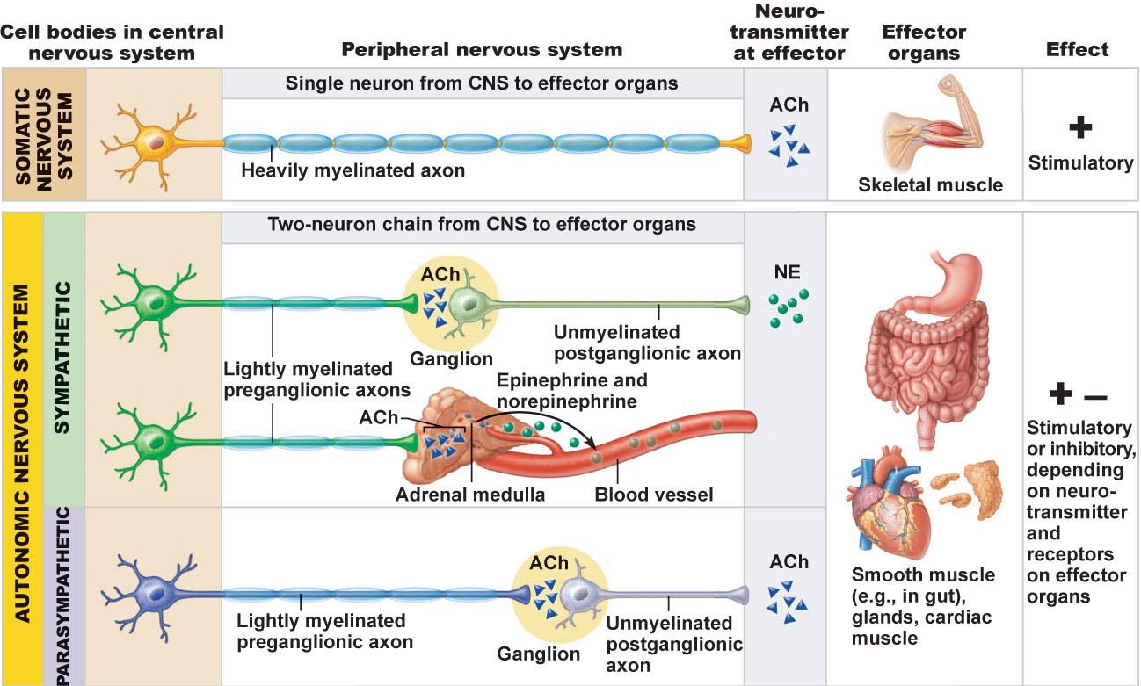

ANS division 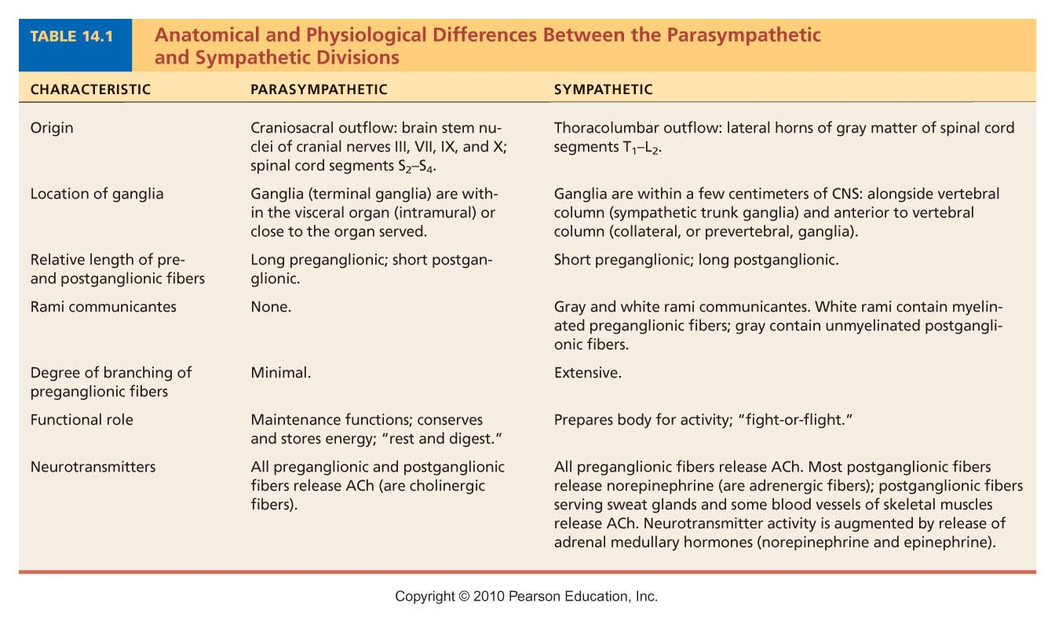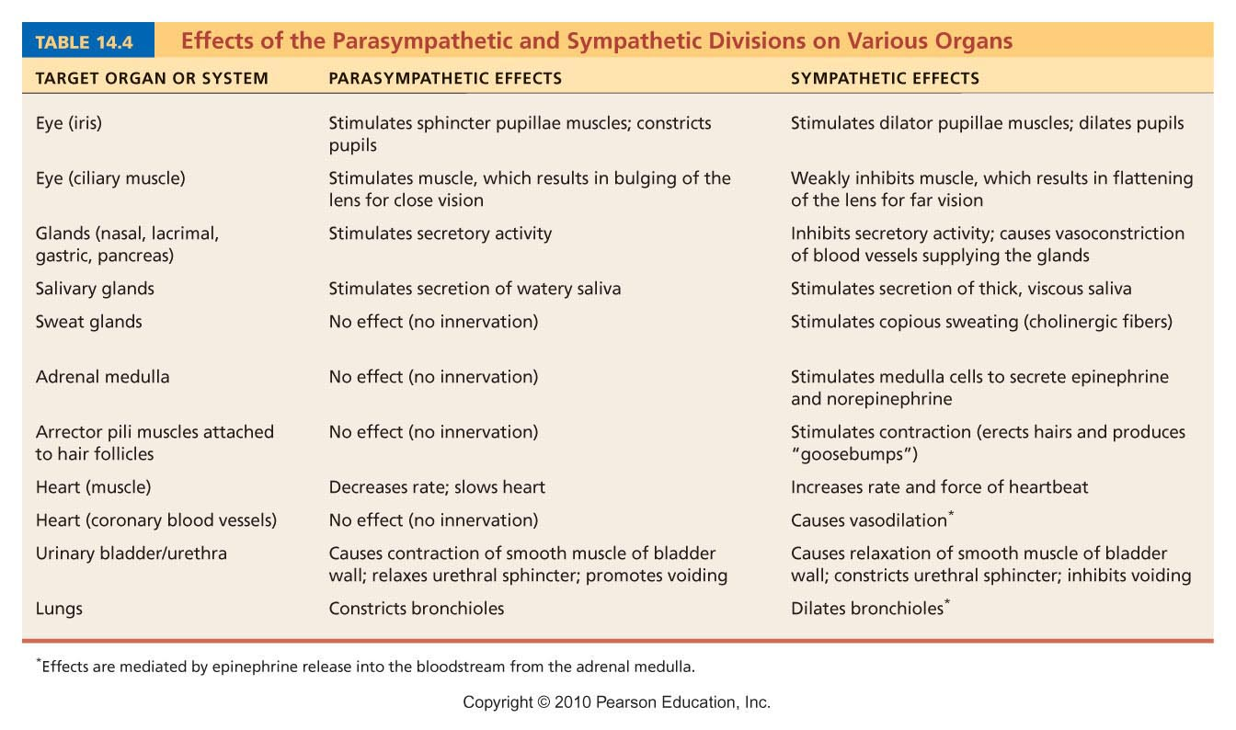
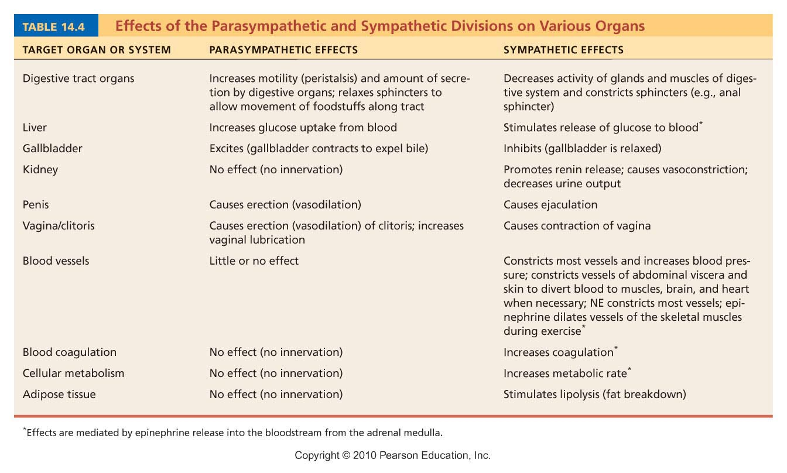

Sympathetic trunks and pathways
- Sympathetic chain is longer than T1 to L2
- A preganglionic fiber follows one of three pathways upn entering the paravertebral ganglia
  - Synapse with the ganglion neuron within the same ganglion
  - Ascend or descend the sympathetic chain to synapse in another chain ganglion
  - Pass through the chain ganglion and emerge without synapsing

Parasympathetic division outflow
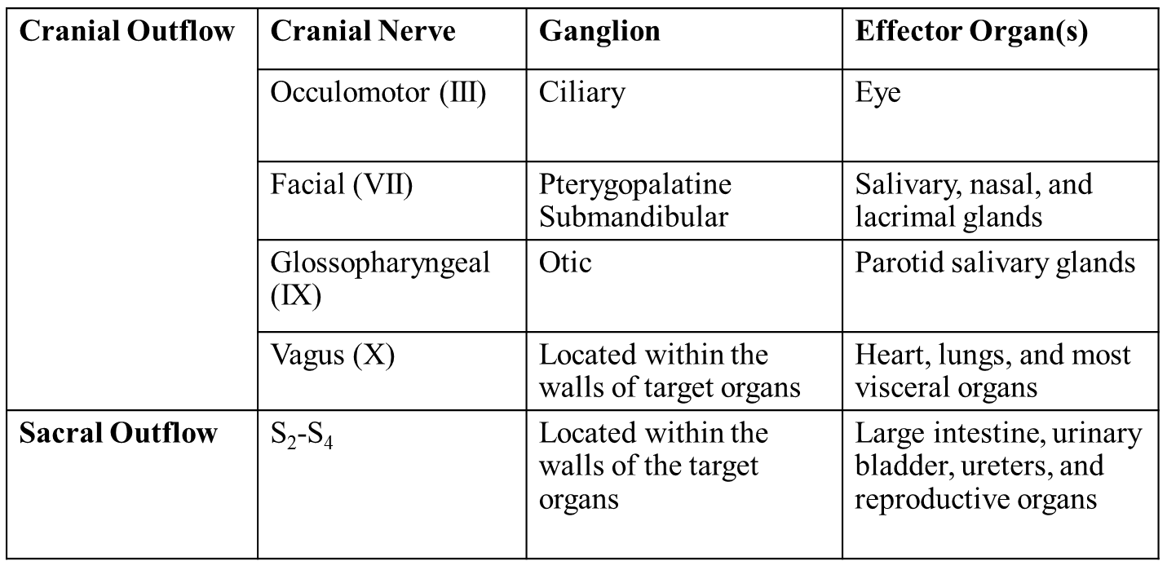

Neurotransmitter and receptors 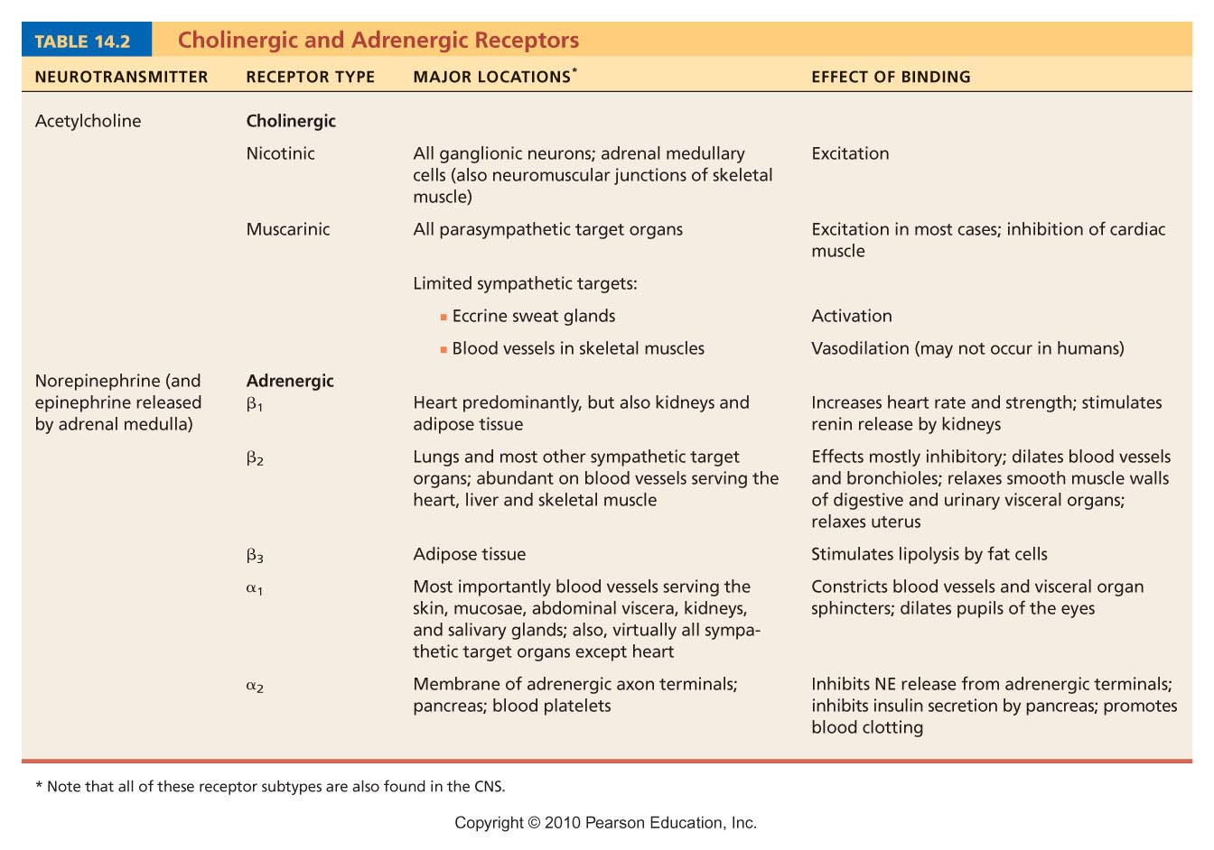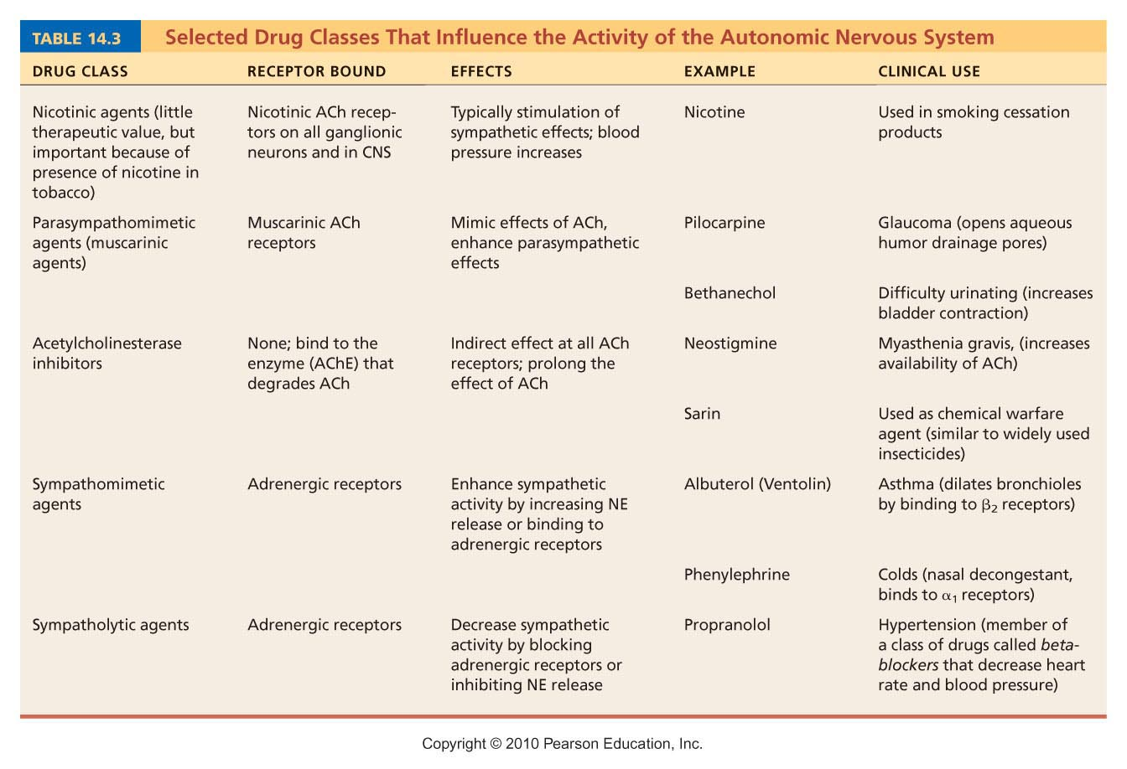

Higher mental function
Pp 452-459

Consciousness
- Encompasses perception of sensation, voluntary initiation and control of movement, and compatibilities associated with higher mental processing
- Involves simultaneous activity of large areas of the cerebral cortex
- Is superimposed on the other types of other neural activity
- Clinical consciousness is defined as a continuum that grade levels of behaviours
  - Alertness
  - Drowsiness
  - Stupor
  - Coma

Reticular formation
- Composed of three broad columns along the length of the brain
  - Raphe nuclie
  - Medial group (large)
  - Lateral (small )

Brain waves
- Normal brain functions involves continuous electrical activity
- An EEG record activity
- Patterns of neuronal electrical activities are recorded and called brain waves – these originate from cortical post-synaptic responses
- Each person’s brain waves are unique
- Continues train of peaks and troughs
- Wave frequency is measured in Hz

Types of brain waves
- Alpha waves – regular and rhythmic, low amp, slow, synchronous waves indicating an idling brain
- Beta waves- rhythmic, more irregular waves occurring during the awake and mentally alert state
- Theta waves – more irregular than alpha waves; common in children but abnormal in adults
- Delta waves – high amp waves seen in deep sleep and when reticular activating system is damped

Brain waves: state of the brain
- Change with ages, sensory stimuli, brain disease, and the chemical state of the body
- EEGs used to diagnose and localize brain lesions, tumors, infracts, infections , abscesses, and epileptic lesions
- A flat EEG is clinical evidence of death

Sleep and sleep wake cycles

Types of sleep
- Awake
- REM
  - Skeletal muscles (except ocular motor muscles and diaphragm) are actively inhibited; most dreaming occurs in this stage
- NREM stage 1
  - Relaxation begins; EEG shows alpha waves; arousal is easy
- NREM stage 2
  - Irregular EEG with sleep spindles (short high-amplitude bursts); arousal is more difficult
- NREM stage 3
  - Sleep deepens; theta and delta waves appear; vital signs decline
- NREM stage 4
  - EEG is dominated by delta waves; arousal is difficult; bed wetting, night terror, and sleepwalking may occur

Importance of sleep
- Slow wave (NREM stages 3 and 4) and REM sleep are important in different ways
  - Restorative
  - A person deprived of REM becomes moody, depressed, and exhibits various personalities’ disorders.
  - REM gives the brain an opportunity to analyze the day’s events and work through emotional problems in dream imagery
  - REM sleep is reverse learning – dream to forget
- Alcohol and barbiturates supress REM sleep but not slow-wave sleep
- Tranquilizers and diazepam reduce slow wave sleep much more than REM

Memory

Stages of memory
- Short term
  - Also called working memory
  - Limited to 7 or 8 chunks of information – that’s why it is easy to quickly remember a phone number
- Long term
  - A sensory input floods into our cerebral cortex, and is processed
  - Able to remember and transfer STM into LTM through:
    - Emotional state: we learn best when we are alert, motivated, surprised and aroused. NE is involved in memory processing of emotionally charged events
    - Rehearsal: repetition of materials enhances memory
    - Association: tying new information to old information already stored in the LTM
    - Automatic memory: not all impressions that become part of the LTM are consciously formed

Categories of memory
- Declarative (fact) memory
  - Entails learning explicit information such as names, faces , words and dates
- Non-declarative memory
  - Less conscious or even unconscious
  - Categories are:
    - Procedural (skill) memory – piano playing
    - Motor memory – riding a bike
    - Emotional memory – your pounding heart when you hear a rattle robber)
  - These are acquired through experience and usually repetition
  - Once learned, it is hard to unlearn.

Epilepsy
- A victim of epilepsy may lose consciousness, fall stiffly, and have uncontrollable jerking, characteristic of epileptic seizure
- Epilepsy is not associated with, nor does it cause, intellectual impairments
- Epilepsy occurs in 1% of the population
*No parasympathetic innervation of the kidney – only sympathetic*

