Anatomy of the muscular system

Basics
- Muscles can only pull and never push
- When a muscle shortens, its insertions (attachment of moveable bone) moves towards the origin ( its fixed or immoveable point of attachment )
- Four functional groups:
  - Prime movers
  - Antagonist
  - Synergist
  - Fixators
- Prime movers
  - Major responsibility for producing a specific movement
  - Leader of movement
- Antagonist
  - Muscles that appose, or reverse, a particular movement
  - “against the leader”
  - Help the prime mover by contracting lightly to produce some resistance
    - This prevents the muscles from overshooting and promotes for deceleration in movement
- Synergist
  - Helps the prime movers in two ways :
    - Adding a little extra force to the same movement
    - Reducing undesirable movement
- Fixator
  - Acting as a joint stabilizer
- Muscles are named according to 7 criteria
  - Location
  - Shape
  - Size
  - Direction of fibre
  - Number of origins
  - Location of attachments
  - Muscle action

Muscle fibres
- Connective tissue sheaths
  - Epimysium (SUPERFICIAL)
    - Dense, irregular fibrous CT that surround the whole muscle
  - Perimysium (MIDDLE)
    - Dense irregular CT sheet around the fascicle
  - Endomysium (DEEP)
    - The outer layer of each muscle fibre
    - Fine layer of areolar CT

Attachments
- Muscles span joints and attach to bone
- There are two points of attachments
  - Origin and insertion
- Types of attachments
  - Direct
    - Epimysium fused to periosteum of bone or pericardium of cartilage
  - Indirect
    - CT wraps beyond muscle as a rope like tendon or sheet like aponeurosis

Arrangement of muscles
- 4 patterns
- Circular
  - Connective rings that surround external openings
    - Open and close said origins
- Convergent
  - Fascicles that are converged toward a single tendon insertion
  - Muscle is a triangle or fan shaped
- Parallel
  - Fascicles are parallel to the long axis of a strap like muscle or spindle shaped muscle
- Pennate
  - Short fascicles that attach obliquely to a central tendon running the length of the muscle
  - Comes in three forms:
    - Unipennate: insert into only one side of the tendon
    - Bipennate : insert into the tendon from opposite sides of the muscle (looks like a feather )
    - Multipennate: looks like many feathers with their quills merged into one long tendon

Muscles to know

Head
- Epicranius
  - Frontal belly
  - Occipital belly
  - Epicranial aponeurosis
- Face
  - Orbicularis oculi
  - Zygomaticus
  - Orbicularis oris
  - Buccinators
  - Master
  - Platysma
  - Medial and lateral pterygoid
  - Temporalis
- Mouth
  - Genioglossus
  - Styloglossus
  - Hypoglossus
- Eye
  - Lateral rectus – lateral movement (abduction )
  - Medial rectus – medial movement (adduction)
  - Superior rectus – elevate and mover laterally
  - Inferior rectus – depress and move laterally
  - Inferior oblique – elevate and move medially
  - Superior oblique – depress and move medially

Neck
- Sternocleidomastoid
- Scalene
  - Anterior and posterior
- Splenius
  - Anterior and posterior

Respiration
- Internal/external intercostal
- diaphragm

Back
- Erector spinae
  - Illicostalis
  - Longissimus
  - Spinalis
    - Synergist
      - Semispinalis
      - Quadratis lumborum

Trunk
- Internal/external oblique
- Transverse abdominals
- Rectus abdominals

Perineum
- Pelvic diaphragm
  - Levator ani
  - Urogenital diaphragm
  - Coccygeus

Anterior thorax
- Subclavius
- Serratus anterior
- Pectoralis minor

Posterior Thorax
- Latissimus dorsi
- Trapezius
- Levator scapulae – C1 to C4
- Rhomboids
  - Major
  - Minor

Shoulder joint
- Prime movers of the arm
  - Pec major/minor
  - Deltoid
  - Lat
- Rotator cuff
  - Supraspinatus
  - Teres minor
  - Subscapularis

Know the Arm, Forearm, Hands, Legs, and feet

Anatomy of the Nervous system

Functions and divisions
3 stages of the of the nervous system
- Sensory input:
- The nervous system uses it millions of sensory receptors to monitor changes occurring both in and outside of the human body
- Integration
- The nervous system processes and interprets sensory input and decides what should be done at each moment
- Motor output
- The nervous system the responds with the efferent organ – the muscle and the glands that are effected – to cause a response.
Central Nervous System
- This system consists of the brain and the spinal cord, which occupy the dorsal body cavity
- The control system of the nervous system
- It interrupts sensory input and dictates the motor output based on the reflexes, current conditions and past experiences
Peripheral Nervous System
- This is the part of the nervous system outside of the CNS
- Consists mainly of nerve bundles (bundles of axons) that extend from the brain and the spinal cord
- Spinal nerves transmit impulses to and from the spinal cord, and cranial nerves carry impulses to and from the brain
- Consists of two subsection, the sensory or afferent division and the motor or efferent division
  - Sensory division:
    - consist of nerve fibres (axons) that convey impulses to the central nervous system from sensory receptors located throughout the body
    - subdivided into two fibres, somatic and visceral
      - Somatic: conveys impulses from the skin, skeletal muscles, and joints (Soma= body)
      - Visceral: conveys impulses from the visceral organs (organs within the ventral body cavity)
    - Keeps the CNS constantly informed of the events occurring within and out of the body
  - Motor division:
    - Transmits impulses from the CNS to the effector neurons, which are muscles or glands.
    - Activate muscles to contract and glands to secrete(effect= Bring out a motor respond)
    - The motor division has two parts:
      - Somatic: it is composed of somatic motor nerve fibres that conduct impulses from the CNS to skeletal muscles. Also known as the voluntary nervous system as it consciously controls our skeletal muscles
      - Autonomic: consists of visceral moto fibres that regulate the activity of smooth muscles, cardiac muscles, and glands. Also known as involuntary nervous system as it subconsciously pumps our heart and works muscles automatically without out control. The ANS has is subdivided into two functional groups, whatever one groups stimulates the other one inhibits, meaning they work in opposition to each other.
        - Sympathetic: mobilizes body systems during activity
        - Parasympathetic: conserves energy and promotes housekeeping functions during rest

Cell types

Neuroglia (CNS)
- Small cells that surround and wrap delicate nerurons
- Most have branching processes and a central body
- Darker stained nuclei
- Half the mass of the brain is due to these. They outnumber neurons 10 to 1
- Astrocytes
  - Most abundant in the CNS
  - Cling to neurons and cover nearby capillaries
  - Anchors neurons to nutrient support lines
  - Exchange between capillaries
  - Determines permeability
    - Potassium buffer
  - Communicates through calcium pulses
- Microglia
  - Thorny process
  - Monitors health of the neurons
  - Can transform into macrophages
  - Acts as a protector
  - Immune and inflammatory response
- Ependymal cell
  - Squamous to columnar
  - Many are ciliated
  - Lines central cavities of the brain and spinal cord
    - Forms a permeable barrier between cerebrospinal fluid (CSF) and tissue fluid bathing CNS cells
- Oligodendrocytes
  - Fewer branching processes
  - Line up against the thicker nerve fibres of the CNS
  - Wrap the nerve fibres forming insulating myelin sheaths

Neuroglia (PNS)
- Satellite cells
  - Surround neuron cell bodies located in the PNS
  - Functions similar to Astrocytes
- Schwann cells
  - Surround nerve fibres in the PNS – form Myelin sheaths in thicker nerve fibres
  - Similar to oligodendrocytes
  - Vital to regeneration of damaged peripheral nerve fibres
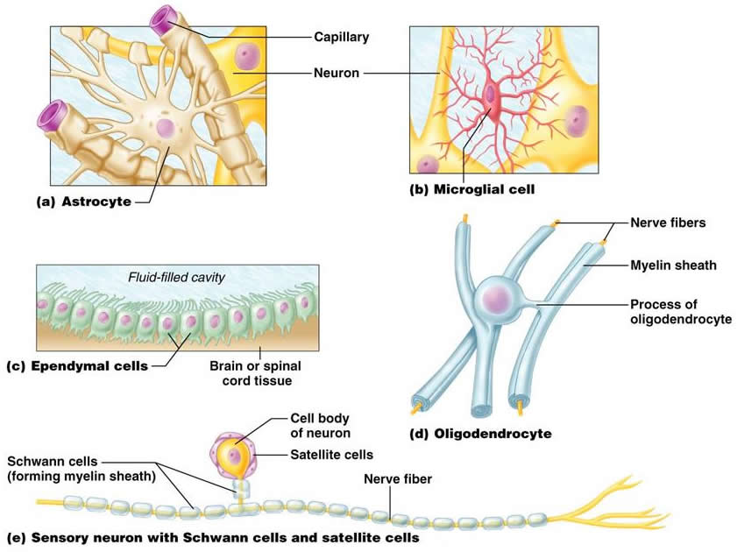

Neurons

Characteristics
- Extreme longevity
- Amitotic
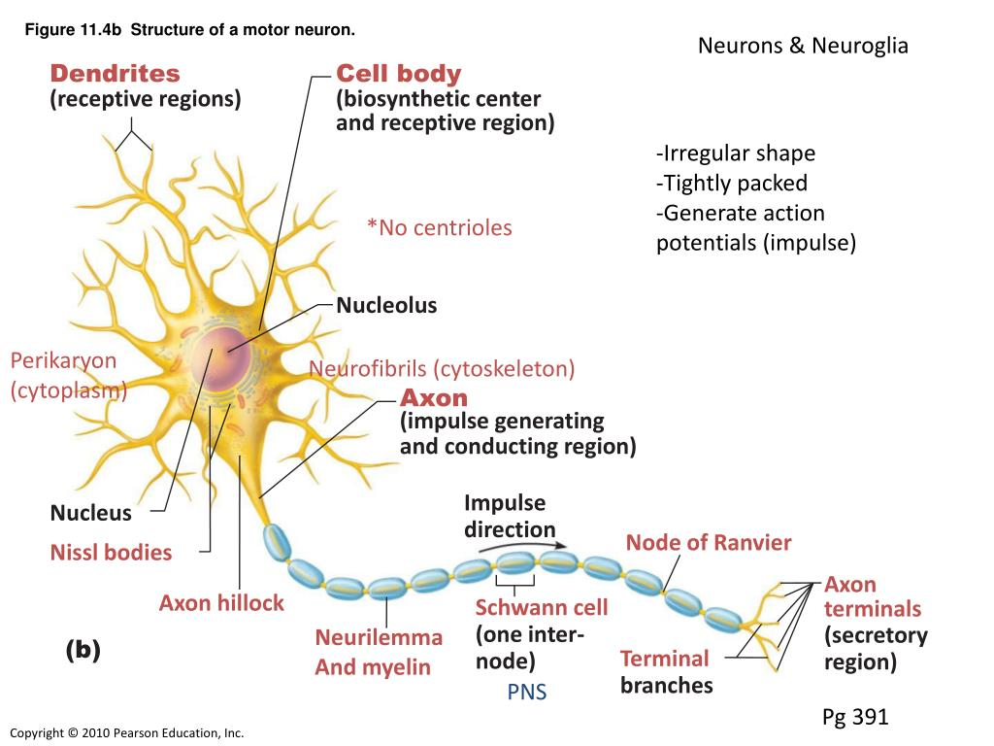
- High metabolic rate – requires a continuous supply of oxygen

- Nuclei: clusters of neuronal cell bodies in the CNS
- Ganglia: clusters of neuronal cell bodies in the PNS
- Two types of process:
  - Dendrites
    - receptive region of neuron; convey incoming messages toward the cell body
  - Axon
    - Cell arising from axon hillock
    - Long axons are called nerve fibres
    - An end called a terminals
- Tracts: bundles of neuronal processes in the CNS
- Nerves: Bundles of neuronal processes in the PNS

The synapse:
- A junction in between two neurons and mediates information transfer from one neuron to the other
- Synapses between the axon endings of one neuron and the dendrites of other neurons are axon dendritic synapses
- Those between axon endings of one neuron and cell bodies of other neurons are axon somatic synapses
- The neuron conducting impulses toward the synapse is the presynaptic neuron
- The neuron transmitting electrical signals away from the synapse is the postsynaptic neuron
- Neurotransmitters:
  - Released into the extracellular space to either excite or inhibit neaurons with which axons in close contact

Axonal transport
- Anterograde
  - Away from cell body
- Retrograde
  - Toward cell body and organelles
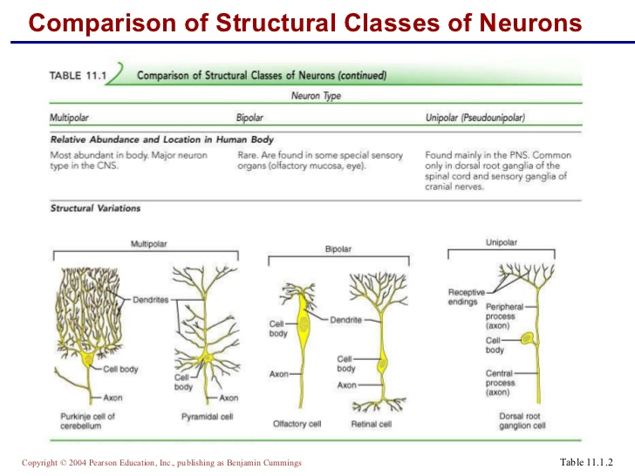

Regions and organization of the CNS
- Brain
  - Cerebral hemispheres and cerebellum
    - Outer grey matter called the cortex
    - Scattered grey matter nuclei amid white matter
- Spinal cord
  - Central cavity surrounded by grey matter
  - External white matter composed of myelinated fiber tracts

Brain regions and organizations

Subdivisions
- the four adult brain regions are the
  - cerebral hemispheres
  - diencephalon (thalamus, hypothalamus and epithalamus)
  - brain stem (Midbrain, Pons, and Medulla oblongata)
  - Cerebellum

Ventricles of the brain
- Filled with CSF and lined by ependymal cells
- Connected to one another and to the central canal of the spinal cord
- The paired lateral ventricles, one deep within each cerebral hemisphere, are large c- shaped chambers that reflect the pattern of cerebral growth
- Separated only by a thin layer called the septum pellucidum
- Each lateral third ventricle communicates with the narrow third ventricle in the diencephalon via a channel called the interventricular foramen
- The third ventricle is continuous with the fourth ventricle via the cerebral aqueduct
  - Fourth lines in the hindbrain, continuous with the central canal and the spinal cord
  - 3 apertures connect ventricles to the subarachnoid space
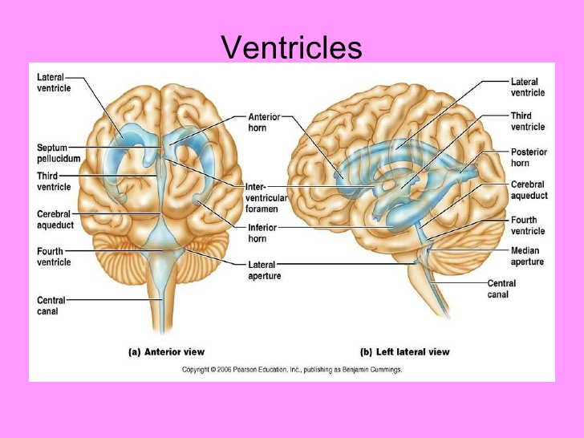

The cerebral hemispheres
- Consists of 83% of the brains total mass
- Surface markings
  - Gyri - Elevated ridges of tissue
  - Sulci – shallowed groves
  - Fissures – deep grooves
  - Longitudinal fissures – separates two hemispheres
  - Transverse cerebral fissure – separates cerebrum and cerebellum
- Central sulcus
  - Lies in the frontal plane and separates the frontal lobe from the parietal lobes
- Parieto-occipital sulcus
  - Located more posteriorly on the medial surface of the hemisphere, separates the occipital lobe from the parietal lobe
- Lateral sulcus
  - The deeps lateral sulcus outlines the flap like temporal lobe and separates it from the parietal and frontal lobe
- Insula
  - Buried deep within the lateral sulcus and forms part of its floor
- Five lobes
  - Frontal
  - Parietal
  - Temporal
  - Occipital
  - Insula
- Each hemisphere has 3 basic regions
  - Cerebral cortex of grey matter superficially
  - White matter internally
  - Basal nuclei deep within white matter
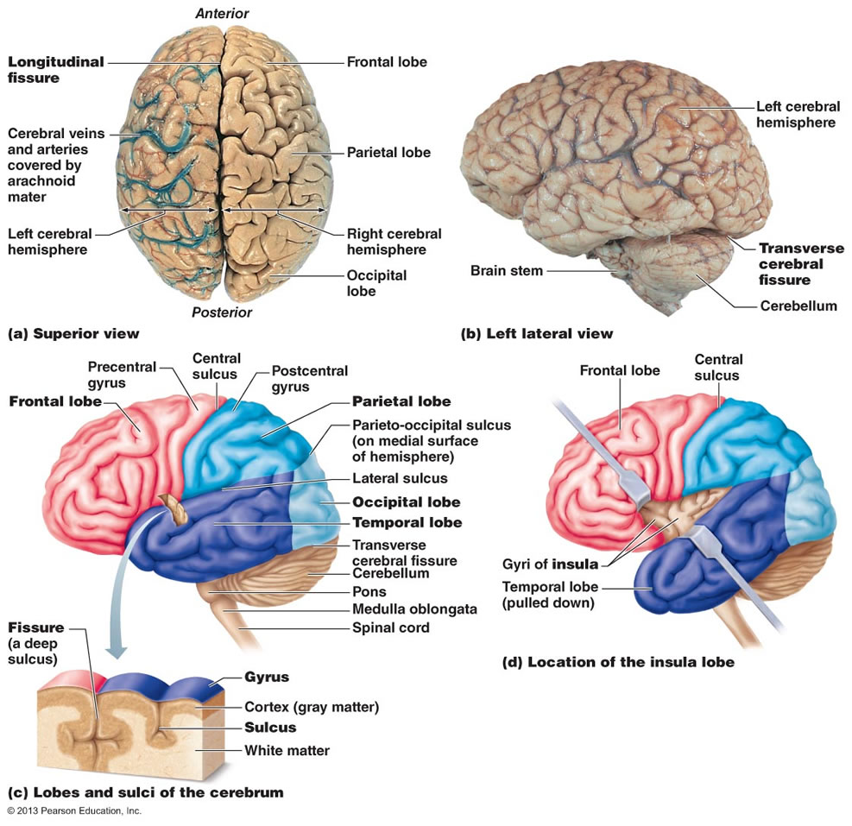

Cerebral cortex
- Executive suite of the nervous system
- This is where our conscious mind is found
- It enables us to be aware of ourselves and our sensations, to communicate, remember, understand and initiate voluntary movements
- Composed of grey matter
- No fibre tracts
- 40% of the brains mass
- 3 functional areas
  - Motor
  - Sensory
  - Association

Motor areas
  - Primary motor cortex
  - Premotor cortex
  - Brocas area
  - Frontal eye field
- Primary motor cortex
  - Located in the precentral gyrus of the frontal lobe
  - Contains large neurons called pyramidal cells
    - Allow us to consciously control precise or skilled voluntary movements of our skeletal muscles
  - Formed from long axons that project down the spinal cord
- Premotor cortex
  - Anterior to the precentral gyrus in the frontal lobe
  - Helps pan movement
  - Controls learned, repetitive, or patterned motor skills
  - Selects basic movements and converts them to more complex tasks such as playing guitar
  - Controls voluntary actions that depend on sensory feed back such as moving an arm through a maze to grasp a hidden object
- Brocas area
  - Lies anterior to the inferior region of the premotor area
  - Present in only the left hemisphere
  - A special motor speech area that directs the muscles involved in speech production
  - Active in planning speech and voluntary motor activities
- Frontal eye field
  - Located partially in and anterior to the premotor cortex and superior to the Brocas area
  - Controls voluntary movement of eyes

Sensory areas
- Primary somatosensory cortex
  - Resides in the postcentral gyrus of the parietal lobe, just posterior to the primary motor cortex
  - Neurons receive information from the general (somatic) sensory receptors in the skin
  - Capable of spatial discriminations which is the neurons ability to identify different body region
- Somatosensory association cortex
  - Lies posteriorly to the primary somatosensory cortex and has many connections with it
  - To integrate sensory input from primary somatosensory cortex for understanding of object
  - Determines size, texture and relationship of object being felt
- Visual areas
  - Primary visual (striate) cortex
    - On the posterior tip of the occipital lobe but most of it is buried deep in the calcarine sulcus in the medial aspect of the occipital lobe
    - Largest cortical sensory area
    - Receives visual information from the retinas
  - Visual association area
    - Surrounds the primary visual cortex
    - Uses past visual experiences to interpret visual stimuli ( color, form, or movement. Eg. to recognize faces )
- Auditory areas
  - Primary cortex
    - Superior margin of temporal lobes
    - Interprets information from inner ear as pitch, loudness, and location
  - Auditory association area
    - Located posterior to primary auditory cortex
    - Interpretation based on memory – speech words, music, thunder, etc.
- Vestibular cortex
  - Posterior part of insula and adjacent to the parietal cortex
  - Responsible for conscious awareness of balance (position of head in space)
- Olfactory cortex
  - Primary olfactory (smell) cortex
    - Medial aspect of temporal lobes – this is known as the uncus
    - Small in humans, most of the surround tissue now forms limbic system (emotions and memory)
    - Involved in conscious awareness of odors
- Gustatory cortex
  - In the insula, just deep to the temporal lobe
  - Involved in perception of taste
- Visceral sensory area
  - Posterior to gustatory cortex
  - Conscious perception of visceral sensations
    - Upset stomach or full bladder

Multimodal association areas
- Receives messages from multiple senses and sends out multiple responses
- Divided into three parts
  - Anterior association area
  - Posterior association area
  - Limbic association area
- Sensory receptors → Primary sensory cortex → sensory association cortex → multimodal association cortex

Anterior association area: prefrontal cortex
- Found in the frontal lobe
- Most complicated cortical region contains working memory which is necessary of abstract ideas, judgment, reasoning, persistence and planning
- Matures slowly and development depends on feedback from social environment
- Closely linked to limbic system, involved in mood
- Tumor or lesions can result in mood swings, loss of attentiveness, inhibitions

Posterior association area
- Large region in the temporal, parietal and occipital lobes
- Plays a role in recognizing patterns and faces, localizing us and our surroundings in spaceand binding different sensory inputs into coherent whole
- Wernicke’s area

Limbic associative are
- Part of the limbic system
- Provides emotional impact that makes scene important and helps establish memories

Additional language areas
- Wernicke’s area
  - Use left side : posterior temporal lobe; surrounds auditory association areas;
  - Primarily for sounding out unfamiliar words
- Comprehension
  - Prefrontal areas
- Affective language areas
  - Opposite hemisphere
  - Tone of voice to express emotion

Lateralization of cortical function
- Lateralization: division of labor between hemispheres
- Cerebral dominance: hemisphere that is dominant for language
- Left hemisphere controls language, math and logic
- Right hemisphere – visual and spatial skills, intuition, emotion, and artistic and musical skills

Basal nuclei
- A group of subcortical nuclei
- Caudate nucleus + putamen and Globus pallidus

Functions of basal nuclei
- Starting, stopping, monitoring intensity of movements executed by cortex
- If damaged there will be disturbances in posture and muscle tone
- Disorders can result in too much movement (Huntington’s disease) or too little movement (Parkinson’s disease)

Brain stem
- Three regions
  - Midbrain
  - Pons
  - Medulla oblongata
- Structure/functions
  - Deep grey matter surrounded by white matter fibre tracts
  - Brain stem has nuclei of grey matter embedded in white matter, a feature not found in the spinal cord
- Midbrain
  - Located between the diencephalon and pons
  - On its ventral aspect are two bulging cerebral peduncles which forms vertical pillars that hold up the cerebrum
  - Cerebral aqueduct is a channel running the midbrain that connects 3rd and 4th ventricles
  - Periaqueductal gray matter are nuclei that play a role in pain suppression and fight or flight response
  - Midbrain nuclei
    - Red nucleus: rich vascular supply, iron pigment in neuron cell bodies; relay nuclei for descending pathways influencing limb flexion
- Pons
  - Is the bulging brains tem region wedged between the midbrain and the medulla oblongata
  - Longitudinal fibres connect higher brain centres and spinal cord
  - Transversal/dorsal fibers relay impulses between motor cortex and cerebellum
- Medulla oblongata
  - Blends into spinal cord a foramen magnum
  - Contains fourth ventricle
    - Continuation of central canal of spinal cord
    - Medulla and pons from ventral wall
    - Contains choroid plexus: capillary-rich membrane that forms cerebral spinal fluid
  - Functions:
    - Crucial role as autonomic reflex centre for homeostasis
    - Cardiovascular centre : cardiac and vasomotor centers
    - Respiratory centers: rate and depth of breathing
    - Other centers: vomiting, hiccupping, swallowing coughing, sneezing

Protections of the brain
- Bones
- Meninges
- CSF
- Blood-brain barrier

Meninges
- Are three CT membranes that lie external to the CNS organs? They:
  - Cover and protect the CNS
  - Protect blood vessels and enclose venous system
  - Contain CSF
  - Form partitions in the skull
- Three layers
  - Dura meter
  - Arachnoid mater
  - Pi mater

Dura meter
- The leathery dura meter is the strongest meninx
- Two layers of fibrous CT that covers the brain
- Periosteum (superficial)
- Meningeal layer (deep)
- Around the brain, 2 layers are fused except where they separate to form the dural sinuses
  - These collect venous blood from the brain and direct it into the internal jugular veins of the neck
- In several areas it extends inward to form flat partitions that subdivide the cranial cavity
  - This limits excessive movement of the brain within the cranium
    - Falx cerebi
    - Falx cerebelli
    - Tentorium cerebelli
- The spinal cord has only meningeal layer

Arachnoid mater
- The middle meninx
- Forms loose brain covering
- Separated from the dura mater by subdural space
- Contains CSF and is the largest blood vessels of the brain
- Arachnoid villi protrude into superior sagittal sinus and permit CSF reabsorption

Pia mater
- Delicate CT
- Invested with tiny blood vessels
- Only meninx that clings tightly to the brain following its every convolutions
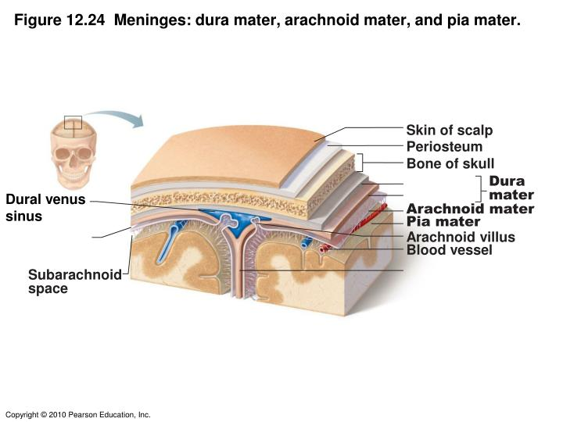

Cerebrospinal fluid (CSF)
- Composition
  - Found in and around the brain and spinal cord
  - Watery solution formed from blood plasma
  - Constant volume
  - Made from less protein that plasma and its ion concentrations are different
- Functions:
  - Reduces the brain weight by 97%
  - Protects the brain from crushing under its own weight
  - Protects the the brain and spinal cord from trauma
  - Provides nourishment for the brain and carries chemical signals

Choroid plexuses
- Hangs from the roof of each ventricle
  - Produces CSF at a constant rate to keep constant motion
- Enclosed first by pia mater and then by a layer of ependymal cells lining the ventricles
- Fairly permeable
- The ependymal cells are Joined by tight junctions and they have ion pumps that allow them to modify this filtrate by actively transporting only certain ions across their membranes into the CSF pool
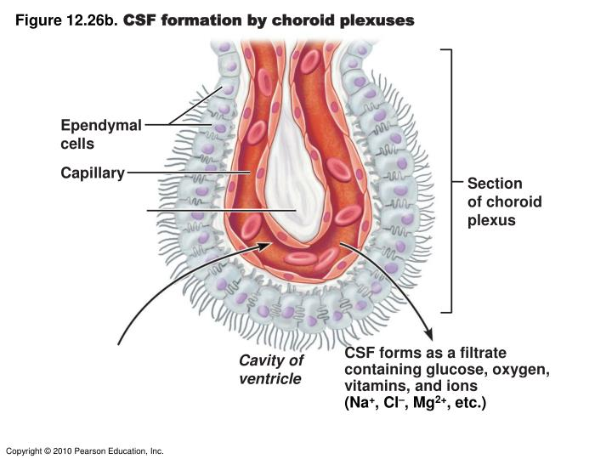

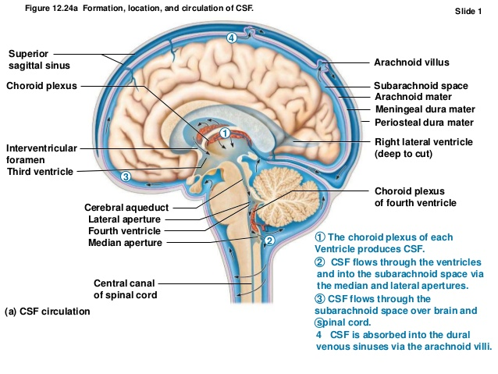

Blood brain barrier
- A protective mechanism that helps maintain a stable environment for the brain
- Chemical variations could lead to uncontrollable neuron firings
- Exceptionally impermeable tight junctions keep the brain separated from many blood born substance
- It is composed of three layers
  - Continues endothelium of capillary walls
  - Thick basal lamina around capillaries
  - Feet of astrocytes surround neurons
- Selective barrier
- Allows nutrients to move by facilitated diffusion
- Metabolic wastes, proteins, toxins, most drugs, small nonessential amino acids, K+ denied
- Allows any fat-soluble substances to pass, including alcohol, nicotine, and anesthetics
- Absent in some areas, e.g., vomiting center and hypothalamus, where necessary to monitor chemical composition of blood

Homeostatic imbalance

Traumatic brain injuries
- Concussion—temporary alteration in function
- Contusion—permanent damage
- Subdural or subarachnoid hemorrhage—may force brain stem through foramen magnum, resulting in death
- Cerebral edema—swelling of brain associated with traumatic head injury

Cerebrovascular accidents (CVAs or strokes)
- Ischemia - Tissue deprived of blood supply; brain tissue dies, e.g., blockage of cerebral artery by blood clot

Degenerative brain disorders
- Alzheimer's disease (AD): a progressive degenerative disease of brain that results in dementia
  - Memory loss, short attention span, disorientation, eventual language loss, irritable, moody, confused, hallucinations
  - Plaques of beta-amyloid peptide form in brain – Toxic effects may involve prion proteins
  - Neurofibrillary tangles inside neurons kill them
  - Brain shrinks
- Parkinson's disease
  - Degeneration of dopamine - releasing neurons of substantia nigra
  - Basal nuclei deprived of dopamine become overactive ◊ tremors at rest
- Huntington's disease
  - Fatal hereditary disorder
  - Caused by accumulation of protein huntingtin
    - Leads to degeneration of basal nuclei and cerebral cortex
  - Initial symptoms wild, jerky "flapping" movements
  - Later marked mental deterioration

Physiology of the nervous system

Biological electrical potential
- Voltage gated ion channels
  - Negative (-) on the inside and positive (+) on the outside
  - Release Na (outside) and K (inside of the cell)
  - For every 2:3 ration from K to Na
- Ohms law: current (l) = voltage (V) / Resistance (R)
- Insulators have large resistance while conductors have low resistance
  - A decrease in resistance = an increase in conduction – this permits current flow
- Na – potential of +55mV
- K – potential of -90mV
- Cl – potential of -80mV

Graded potentials
- Short lived localized changes in membrane potential
- Current flow decreases with distance
- They are graded because current flow varies with stimulus strength

Action potential (nerve impulses):
- Long distance
- Found in the membrane of excitable tissues
- Gathered by dendrites
- Charge travels down through the axon to the synapse
- Stimulates the release of neurotransmitters into a synapse
- Action occurs only when the electrical signal hits a threshold
  - All or nothing rule: the impulse will always be at the same size intensity no matter the stimulation. but it matters if it fires or not

Resting potential:
- High concentration of potassium inside the neuron
- Lower concentration of potassium outside the neuron
- Higher concentration of sodium outside the neuron
- When there is an electrical charge the potassium gates will open firing potassium outside changing the voltage to -70milivolts. The gates then close, causing the sodium channels to open and begin shooting sodium inside due to ionic attraction which causes a change in the voltage to +40milivolts. The potassium gates re-open allowing the potassium to go back inside causing the voltage to go past -70milivolts and leaving it at around -90milivotls. To reach equilibrium some sodium ions slip out through the gradient because of the charge.
  - Four events occur:
    - Resting state: All gated Na and K channels are opened
    - Depolarization: Na channels open
    - Repolarization: Na channels are inactivating, and K channels are open
    - Hyperpolarization: Some K channels remain open, and Na channels reset

Refractory period:
- This is the time after the resting potential
- Another action potential cannot fire again during this period

Axon Diameter:
- The larger the axons diameter, the faster it conducts impulses.
- Larger axons conduct more rapidly because they offer less resistance to the flow of local currents
- Threshold is achieved quicker

Degree of myelination:

Continuous conductions:
- Doesn’t contain a myelin sheath
- AP propagation involving non-myelinated axons, these channels are immediately adjacent to each other
- Continues conductions is relatively slow

Salutatory conduction:
- Contains myelin sheaths
- They act as insulators, thus preventing leakage of charge from the axon and allows the membrane voltage to change more rapidly
- The presence of myelin sheath increases the rate of speed at which the current travels at
- Nearly all voltage gates Na channels are concentrated I these gaps, also known as nodes of Ranvier
- As the current travels down the axon, there will be another AP at every node due to these gates

Bare plasma membrane:
- Voltage decays
- Without voltage-gated channels, as on dendrites, voltage decays because current leaks across the membrane

Group A fibres:
- Mostly somatic sensory and motor fibres serving the skin, skeletal muscles, and joints
- Largest diameter and thick myelin sheaths
- Conduct impulses at speeds ranging up to 150m/s

Group B fibres:
- Lightly myelinated fibres with intermediate diameter
- Transmit impulses at an average 15m/s

Group C fibres:
- These have the smallest diameter and are non-myelinated
- They are incapable of salutatory conduction and conduct at speed of 1m/s

Exocytosis (out of the cell):
- Vesicular transport processes that eject substances from the cell interior into the extracellular fluid
- Typically stimulated by the a cell surface signal such as binding of hormone to a membrane receptor or a change in membrane voltage,
- Accounts for hormone secretion neurotransmitter release, mucus secretion, and in some cases the ejection of waste.
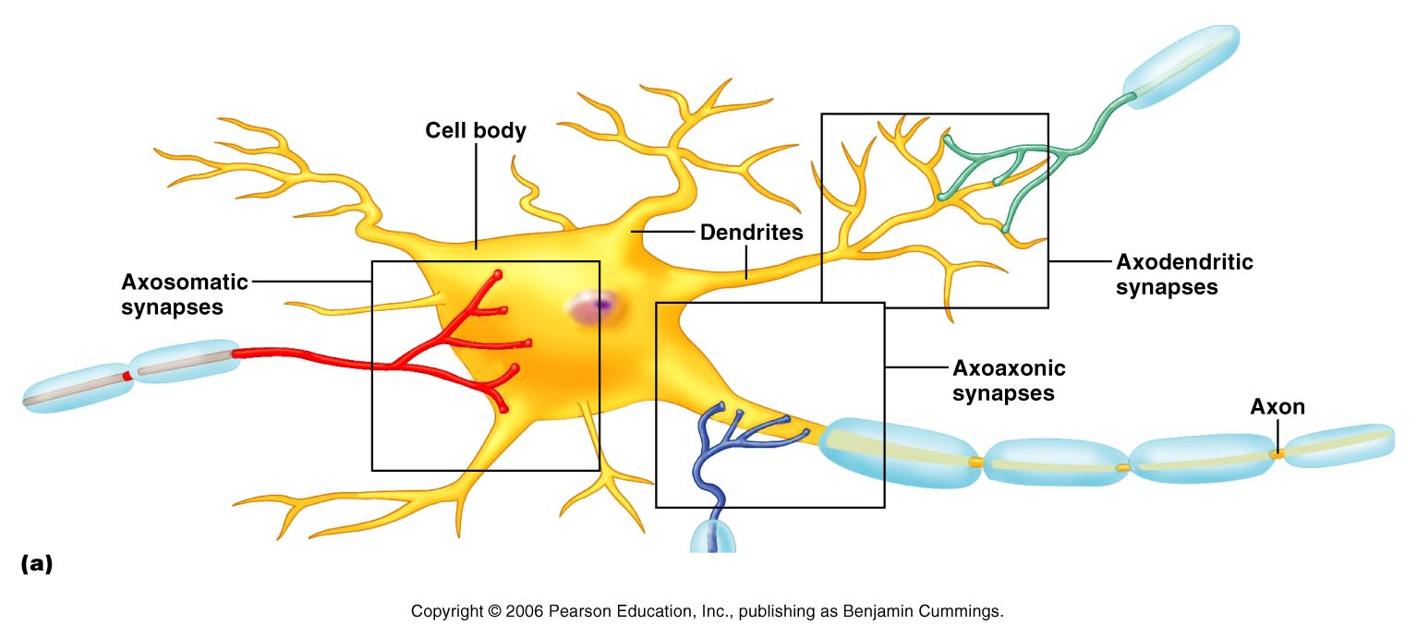
- Dendrites: ligand gated channels are activated by neurotransmitters
- Axons: voltage gated channels are activated by depolarization
- Synaptic terminals: voltage gated calcium channels open to allow neurotransmitter release

G-proteins
- 30% of the modern drugs target GPCRs
- The human genome roughly encodes 800 GPCRs
- Amino acids
  - Opens chloride channels and is inhibitory
- Glutamine
  - Opens sodium channels and is excitatory
- Acetylcholine (ACh)
  - At nicotinic receptors
    - opens channels permeable to both sodium and potassium
    - Gives a rise to the average of their two reversal potentials
    - It is excitatory
  - At G protein muscarinic receptor
    - May be either excitatory or inhibitory depending on tissue
- Endorphins
  - Inhibits pain pathways
- Tachykinins
  - The neurotransmitter in pain pathways
- Nitric oxide (NO) and Carbon monoxide (CO)
  - Non-traditional neurotransmitters

Central Nervous System
- This system consists of the brain and the spinal cord, which occupy the dorsal body cavity
- The control system of the nervous system
- It interrupts sensory input and dictates the motor output based on the reflexes, current conditions and past experiences

Peripheral Nervous System
- This is the part of the nervous system outside of the CNS
- Consists mainly of nerve bundles (bundles of axons) that extend from the brain and the spinal cord
- Spinal nerves transmit impulses to and from the spinal cord, and cranial nerves carry impulses to and from the brain
- Consists of two subsection, the sensory or afferent division and the motor or efferent division

Sensory division:
  - consist of nerve fibres (axons) that convey impulses to the central nervous system from sensory receptors located throughout the body
  - subdivided into two fibres, somatic and visceral
    - Somatic: conveys impulses from the skin, skeletal muscles, and joints (Soma= body)
    - Visceral: conveys impulses from the visceral organs (organs within the ventral body cavity)
  - Keeps the CNS constantly informed of the events occurring within and out of the body

Motor division:
  - Transmits impulses from the CNS to the effector neurons, which are muscles or glands.
  - Activate muscles to contract and glands to secrete(effect= Bring out a motor respond)
  - The motor division has two parts:
    - Somatic: it is composed of somatic motor nerve fibres that conduct impulses from the CNS to skeletal muscles. Also known as the voluntary nervous system as it consciously controls our skeletal muscles
    - Autonomic: consists of visceral moto fibres that regulate the activity of smooth muscles, cardiac muscles, and glands. Also known as involuntary nervous system as it subconsciously pumps our heart and works muscles automatically without out control. The ANS has is subdivided into two functional groups, whatever one groups stimulates the other one inhibits, meaning they work in opposition to each other.
        - Sympathetic: mobilizes body systems during activity
        - Parasympathetic: conserves energy and promotes housekeeping functions during rest
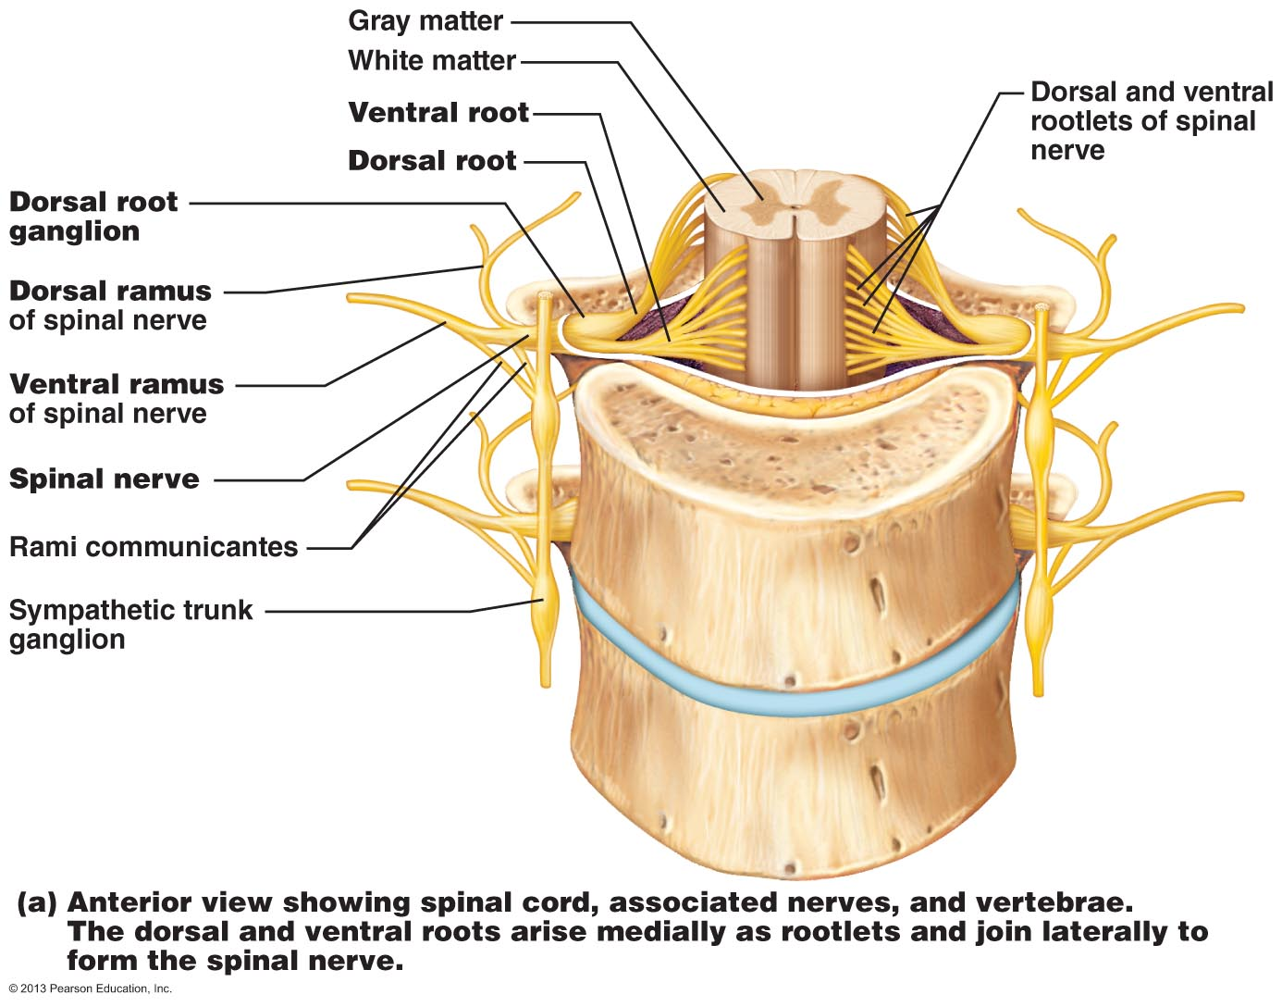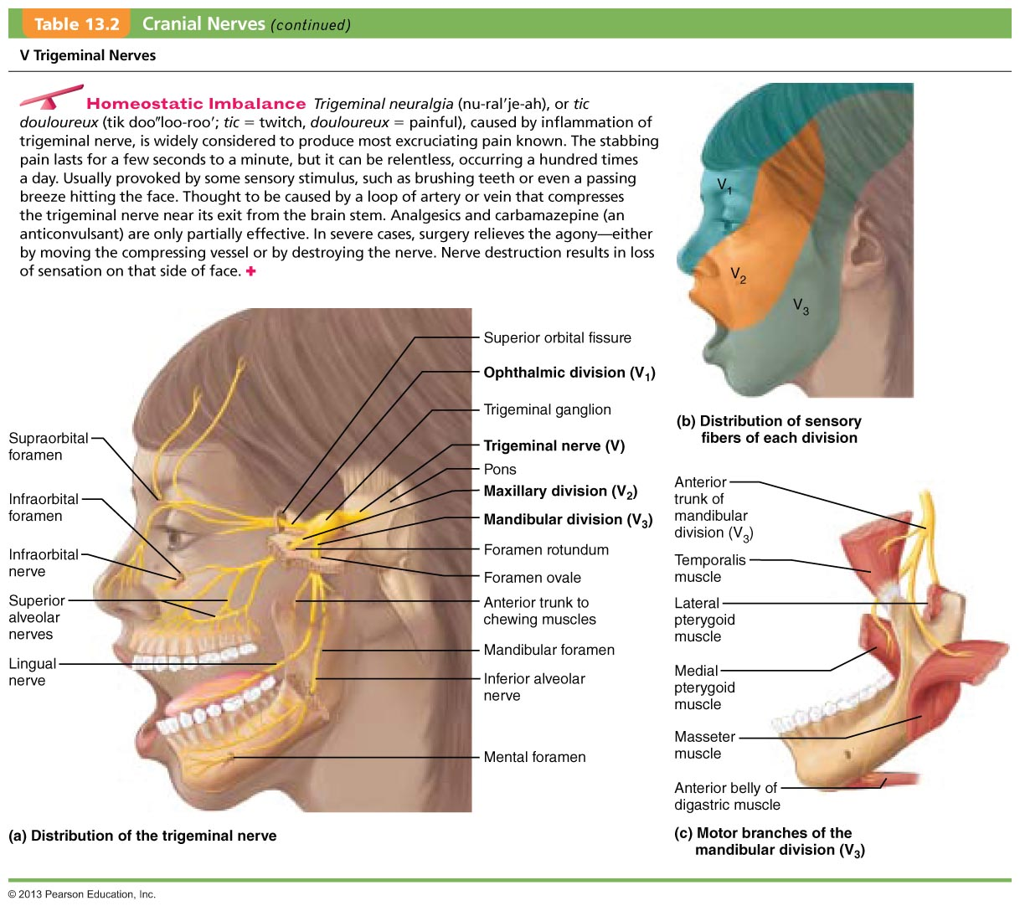

Sensory receptors

Receptor classification by stimulus type
- Mechanoreceptors : respond to touch, pressure, vibration, stretch and itch
- Thermoreceptors: sensitive to changes in temperature
  - Transient receptor potential (TRP) family of proteins
  - Free nerve endings with the membrane channels that change their permeability across specific temperature ranges
- Photoreceptors: respond to chemicals (e.g. smell, taste, change in blood chemistry)
- Nociceptors: sensitive to pain causing stimuli

Receptor class by location:

Exteroceptrors
- Respond to stimuli arising outside the body
- Found near the body surface
- Sensitive to touch, pressure, pain and temp
- Found in special sense organs

Interoceptors
- Respond to stimuli arising within the body
- Found in internal viscera and blood vessels
- Sensitive to chemical changes, stretch and temp changes

Proprioceptors
- Means ‘self-to-self”
- Respond to degree of stretch of the organs they occupy
- Found in skeletal muscles, tendons, joints, ligaments, and the CT coverings of bones and muscles
- Constantly advise the brain of ones movements
- Gives information concerning movements and position of the body
- Muscle spindles are one type of proprioceptors
  - the Golgi tendon is another – deals with muscle tension

Receptor classification by receptor structures
- receptors are structurally classified as either simple or complex
- most receptors are simple and include encapsulated and non-encapsulated varieties ( free nerve endings )
- complex receptors are special sense organs in contact with free nerving endings

Simple receptors

Non-encapsulated nerve endings
- abundant in epithelia and CT
- non-myelinated, small diameter group C fibres
- small knob like endings
- respond to temp change and painful stimuli and some respond to pressure
- Nerve endings that respond to cold (10–40°C, or 50–104°F) are located in the superficial dermis. Those responding to heat (32–48°C, or 90–120°F) are deeper in the dermis.
- Itch senses located in the dermis respond to chemicals – notably histamine – present at inflamed sits

Tactile (Merkel) discs
- Lie in the deepest layer of the epidermis
- Functions as light and touch receptors
- Certain free nerve endings associate with enlarged, disc-shaped epidermal cells to form tactile cells

Hair follicle receptors
- Wrap around hair follicle ins a basket like formation
- Light touch receptors that detect bending hairs

Encapsulated nerve endings
- Consist of one or more fiber terminals of sensory neurons enclosed in a CT capsule
- Virtually all are mechanoreceptors
- Vary in shape, size and distribution
Tactile corpuscles
- Meissner’s corpuscles are small receptors in which a few spiraling sensory terminals are surrounded by Schwann cells and then by a thin egg-shaped connective tissue capsule.
- Found just beneath the epidermis in the dermal papillae
- Numerous in sensitive and hairless skin areas such as the nipples, fingertips, and soles of the feet.
- They are receptors for discriminative touch
- play the same role in sensing light touch in hairless skin
Lamellar corpuscles
- Called Pacinian corpuscles
- Found deep in the dermis, and in subcutaneous tissue underlying the skin
- Respond only when the pressure is first applied, and thus are best suited to monitoring vibration (an “on/off” pressure stimulus)
- They are the largest corpuscular receptors.
- Some are over 3 mm long and half as wide and are visible to the naked eye as white, egg-shaped bodies.
- 60 layers of collagen fibers and flattened supporting cells.
Bulbous corpuscles
- Ruffini endings, which lie in the dermis, subcutaneous tissue, and joint capsules
- Contain a spray of receptor endings enclosed by a flattened capsule.
- Resemblance to tendon organs
- Respond to deep and continuous pressure.
Muscle spindles
- Fusiform (spindle-shaped) proprioceptors
- Found throughout the perimysium of a skeletal muscle.
- Each muscle spindle consists of a bundle of modified skeletal muscle fibers, called intrafusal fibers (in″trah-fu′zal), enclosed in a connective tissue capsule.
- Muscle spindles detect muscle stretch and initiate a reflex that resists the stretch.

Tendon organs
- Are proprioceptors located in tendons, close to the junction between the skeletal muscle and the tendon
- Small bundles of tendon (collagen) fibers enclosed in a layered capsule
  - Sensory terminals coiling between and around the fibers.
  - When muscle contraction stretches the tendon fibers, the resulting compression of the nerve fibers activates the tendon organs. This initiates a reflex that causes the contracting muscle to relax.

Joint kinesthetic receptors
- Proprioceptors that monitor stretch in the articular capsules that enclose synovial joints.
- Four receptor types:
  - Lamellar corpuscles
  - Bulbous corpuscles
  - Free nerve endings
  - Receptors resembling tendon organs
- Together these receptors provide information on joint position and motion (kines = movement), a sensation of which we are highly conscious.

Physiology of the nervous system somatosensory – higher levels
Pages 435-436, 438, 468-469, 472-474, 516-521

Cerebral hemispheres
- Form the superior part of the brain
- Accounts for 83% of the total brain mass
- Covers and obscures the diencephalon and the top of the brain stem
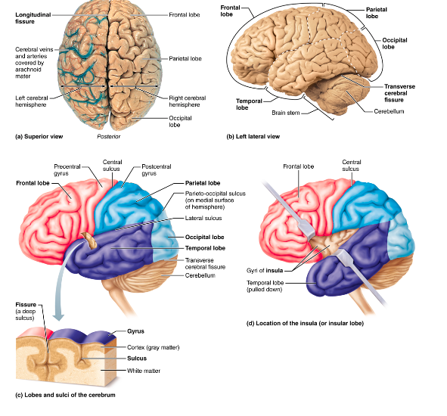

Sensory areas
- Areas concerned with conscious awareness of sensation
- Sensory areas of the cortex occur in the parietal, insular, temporal and occipital lobes

Primary somatosensory cortex
- Resides in the postcentral gyrus of the parietal lobe jus posterior to the primary motor cortex
- Neurons in this gyrus receive information from the somatic sensory recptors in the skin and form proprioceptors in skeletal muscles joints and tendons

Neuronal pathways
- All major spinal tracts are apart of the multineuron pathway
  - Connects the brain to the body periphery
  - Contains the spinal cord neuron, peripheral neurons and neurons of the brain
- Four key generalizations of the pathways
  - Decussation
    - Most pathways cord from one side of the CNS to the other (decussate) at some point along their journey
  - Relay
    - Most pathways consist of a chain of two or three neurons (a relay ) that contributes to successive tracts of the pathway
  - Somatotopy
    - Most pathways exhibit somatotopy
      - A precise spatial relationship among the tract fibres that reflects the orderly mapping of the body
  - Symmetry
    - All pathways and tracts are paired symmetrically (right and left) with a member of the pair present on each side of the spinal cord or brain

Ascending pathways to the brain
- Conduct sensory impulses upward, typically through chains of three successive neurons ( first-, second-, and third-order neurons) to various areas of the brain
- Both second and third-order neurons are interneurons

First order
- Cell bodies reside in the ganglion
- Conducts impulses from the cutaneous receptors of the skin and from proprioceptors to the spinal cord or brain stem where they synapse with the second order neurons
- Impulses from facial area are transmitted by cranial nerves
- Spinal nerves conduct somatic sensory impulses from the rest of the body to the CNS

Second order
- Reside in the dorsal horn of the spinal cord or in medullary nuclei
- Transmit impulses to the thalamus or to the cerebellum where they synapse

Third order
- Have cell bodies in thalamus
- Rely impulses to the somatosensory cortex of the cerebrum
  - Non in the cerebellum

Major ascending (sensory) pathways and spinal cord tracts

Dorsal column-medial lemniscal pathways
- Mediate precise, straight-through transmission of inputs from a single type of sensory receptor that can be localized precisely on the body surface, such as discriminative touch and vibrations
- Located on the dorsal aspect
- First order – enters the dorsal white column root of the spinal cord and branch
  - And the fasciculus cuntaenus and fasciculus gracilis and the medial lemniscus
- Medial lemniscus arise in the medulla and terminates In the thalamus
- From the thalamus, impulses are forwarded to specific areas of the somatosensory area

Spinothalamic pathways
- Receive inputs from many different types of sensory receptors and make multiple synapses to the brain stem
  - These consist of the lateral and ventral (anterior) spinothalamic tracts
  - These fibres cross over the spinal cord
- Primarily transmit impulses for pain and temperature and also for coarse touch and pressure

Spinocerebellar pathways
- The third ascending pathway
- Consists of the ventral and dorsal spinocerebellar pathways
- Convey information about muscles or tendon stretch to the cerebellum – uses this information to coordinate skeletal muscle activity
- Do not contribute to conscious sensation
- Either do not decussate or else cross over twice (thus undoing the decussation)

Processing at the circuit level
- The second level of integration
- Delivers impulses to the appropriate region of the cerebral cortex for localization and perception of the stimulus
- Axons of the first order link receptor circuit levels of processing
  - Branch diffusely when they enter the spinal cord
  - Some branches take part in local spinal cord reflexes
- Other synapses with the second order sensory neurons, synapse with the third order neurons that take messages to the cortex of the cerebrum

Processing at the perceptual level
- Sensory input interpreted at the cerebral cortex
- The ability to identify and appreciate sensations depends on the location of the target neurons in the sensory cortex
- Each sensory fibre is analogous to a labeled line that tell the brain who is calling – a taste bud or a pressure receptor – and from where

Major features of sensory perception

Perceptual detection
- Ability to detect that a stimulus has occurred
- Inputs from several receptors must be summed for perceptual detection to occur

Magnitude estimation
- The ability to detect how intense the stimulus is
- Perceived intensity increases as stimulus intensity increases because of frequency coding

Spatial discrimination
- Allows us to identify the site or pattern of stimulation
- A common tool for studying this quality in the laboratory is the two point discrimination tst
  - Determines how close two point on the skin can be and still perceived as two point rather than one
  - Allows for a crude map of the density of tactile receptors in the various regions of the skin

Feature abstraction
- The mechanism by which a neuron or circuit is tuned to one feature or property of a stimulus
- Involves interplay of several stimulus features

Quality discrimination
- The ability to differentiate the sub-modalities of a particular sensation
- Each sensory modality has several qualities or sub modalities

Pattern recognition
- The ability to take in the scene around us and recognize a familiar pattern, an unfamiliar one, or a one that has special significance for us

Physiology of smell and taste
Pages 496, 499, 501 569-574

Physiology of vision
Pages 549-569

