GEO 2010_FINAL

Chapter 1 Regional Geography

The study of Regional Geography
- Living, working in common place leads to regional identity
  - Produce of region’s physical geography, history, economy
  - Bidirectional relationship between people and landscape
Regionalism
- The division of a large area into different parts
- Some countries are more prone to regionalism
  - Canada, US, China, Russia, Australia
  - Big landmass is prone to regionalism
Region
- A distinctive area of Earth’s surface – has distinguishing human or natural characteristics that set it apart from other areas
- The boundaries of regions are related to faultlines
  - Not physical faultlines
  - Differences between two different areas – geographical, cultural, etc.
  - Metaphorical line
Approaches to Identifying Regions
- Provincially defined region
  - Choose an area of provinces
  - Describe the area
    - Analyze economy, study demographics, understand physical geography
- Categorization of land surface
  - Classify land into chunks that have similar characteristics
Types of regions
- Uniform region
  - Named after a characteristic where all location in the region have similarities in a particular characteristic
    - Grassland, desert, tundra, mountain, etc
- Functional region
  - Interactions among different areas within the region (urban core and periphery)
    - Transportation network – major roads and highways in Manitoba tend to branch out from Winnipeg
- Cultural region
  - Based on sense of belonging
  - Bond between people and the region
    - Arises from shared historical experiences, similar values, common goals
    - Francophones in Quebec
Determining regions
- How do we know how many regions to define?
  - Unlimited – subjective nature
  - Regions are human constructs
  - Textbook regions
    - Atlantic Canada
    - QB
    - ON
    - BC
    - Prairies
    - Territorial North
Faultlines within Canada
- Faultlines are economic, social, and political cracks – divide regions and threated to destabilize Canada’s integrity as a nation
- 4 faultlines
The 4 faultlines within Canada
- Centralist/Decentralist
  - Demography favours ON and QB because the majority of Canadians reside in these areas
  - People in other regions perceive the federal gov as favouring ON and QB
  - Most seats in HOC
  - Western alienation
  - Political party can’t form majority gov without support from these two regions
  - Leans most heavily on Canada’s geography and political system
  - Quarrels with Ottawa often revolve around transfer payments
  - Extensive public support/subsidies for Central Canadian industries
  - Central Canada sees the rise of western power as a threat to traditional position within Confederation
  - Physical faultlines between provinces – QB and Labrador
- English speaking/French speaking
  - Political cultural struggle in QB to maintain French as a viable language in a principally English-speaking continent
  - Proportion of French speaking Canadian has declined
  - Within QB – internal faultline between separatists and federalists
  - 1969- official languages act recognize English and French as having equal status in Canada
  - 1974 – QB made French its sole official language
- Indigenous peoples and non-indigenous majority
  - Many Indigenous communities remain dependent on the federal gov
    - Poverty, unemployment, and social issues are common in these communities
  - Modern land claim agreements have led to self-gov on reserves
    - Nunavut was created 1999 as separate territory that is predominantly populated by Inuit
    - Nunavut – our land
    - Fed gov gave land to Inuit people to govern themselves
  - Indian Act served as a means to control, dominate, and manage First Nations people and their lands
  - Residential schools
    - Designed to equip young Aboriginal students to find and accept a place on the bottom rungs of the larger society
    - resulted in the loss of their language and culture as well as the connection to the land and parents
    - created “lost generations” who fitted into neither world
- Newcomers and Old-Timers
  - Cultural friction due to immigrants and different ethnic groups
  - New immigrants concentrated in major cities
    - Network of family and friends who speak their language
    - Could create sense of isolation from other Canadians
    - Toronto, Vancouver, Quebec
  - Many immigrants left the search for belonging to the next generation who would grow up in Canada speaking either English or French

Chapter 2 Regions of Canada

The sense of place
- Involves psychological bond between people and their location
- Stem from physical landscape, human activities, institutional bodies
- Collective experiences have led to shared aspirations, concerns, goals, and values
- Strong sense of place in Canada particularly evident in Atlantic Canada and Prairies
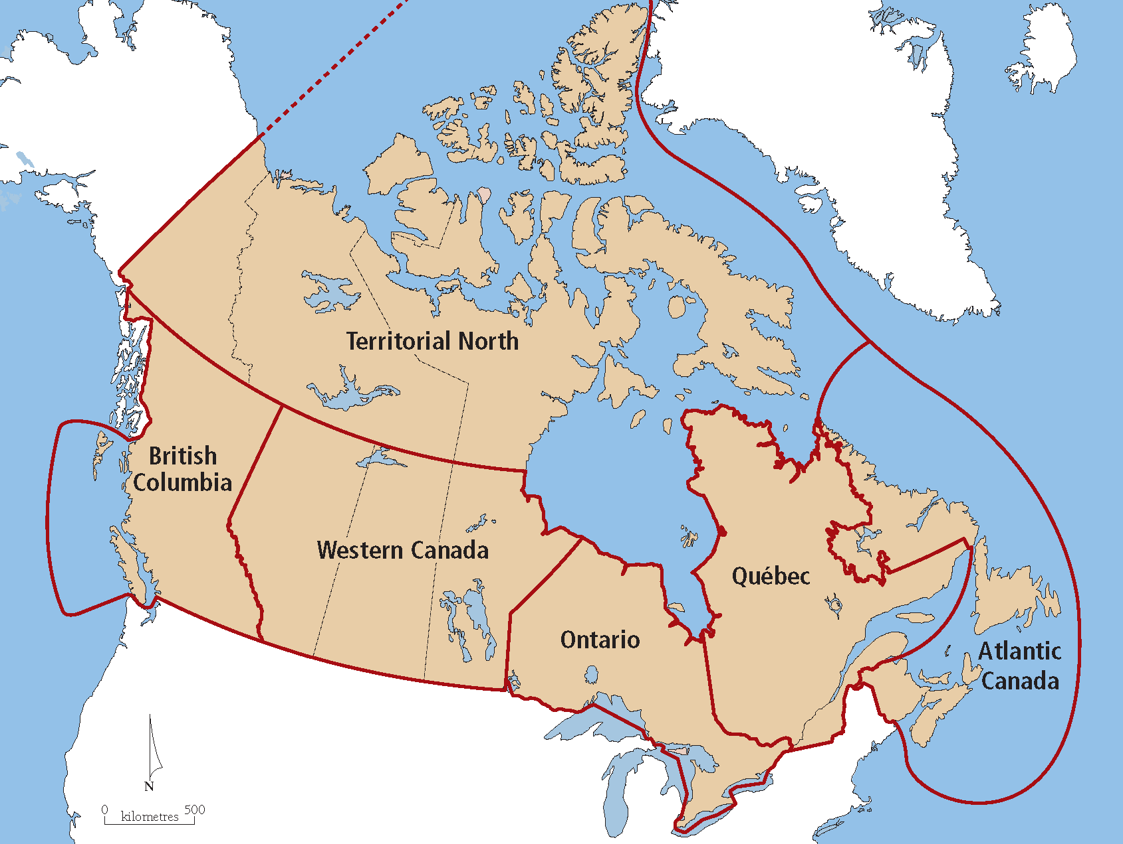
The 6 regions of Canada
- Terriotorial North
- BC
- Western Canada (Prairies)
- ON
- QB
- Atlantic Canada

- Why have these areas been defined as regions?

  - Manageable sections
  - Identifiable by a set of physical features
  - Breakdown is on a provincial basis – easy to study stats and census data
  - Commonly identified by the media
Proportion of Regional Population
- third of Canadians live in QB in 1871 – declined in 2011
- Significant drop in Atlantic Canada
- Significant growth of the Canadian West
The Core/Periphery Model
- This model describes the interaction among regions and is evident in Canada
- Heartland/hinterland model
- Based on theory that capitalist economics result in regionally uneven development
  - Some provinces grew but some didn’t
- Concept where both parts are dependent on each other but the core dominates the economic relationship with its periphery
- Core – Southern ON and southern QB
- Periphery – all other regions
- BC and Prairies are considered to be upward transitional regions – growing economy
- Atlantic Canada is a downward transitional region– economy static
- Territorial North is a resource frontier – big open area, very little pop
- In general, as one moves from core to periphery
  - Population decrease
  - Median income decrease
  - Unemployment increase
Characteristics of Cores
- Receive raw materials from the periphery
- Manufacturing is common industry
- Geographically small
- Diverse economy
- Urban and densely populated
- Home to corporate headquarters
Characteristics of peripheries
- Purchase finished goods from the core
- Resource based economy – lumber, mining, fishing, mining
- Geographically large
- Rural and sparsely populated
Theories on the Core/Periphery Model
- Regional Exploitation theory
  - Wealthy core exploits the natural wealth of the periphery leaving it impoverished
- Modernization theory
  - Core invests in the periphery and helps it to develop
    - Equalization payments – fed gov distributes wealth throughout the provinces
Sub-Cores in Canada
- Smaller scale than cores, there is evidence of sub-cores existing in Canada
  - Van city/Victoria
  - Edmonton/Calgary
- contains most of population of province
The Staples Thesis – Harold Innis
- how did Canada’s core become the core?
- ‘Staple’ product
  - Natural resource that can be exploited relatively quickly, and cheaply for profit
  - Forestry, fishing, hunting (fur), oil, agriculture
- Regional economic history of Canada was linked to the discovery, utilization, and export of staple resources
- Expected eventually economic diversification would take place
- Make peripheral regions less reliant on primary resources
- Atlantic Canada was the first region to be settled and in its early history it was periphery to England
- Over time east to west progression of staples across the country
- Four regions – one core and three periphery regions
  - Core region centered on manufacturing (ON, QB)
  - Rapidly growing region based on an expanding resource base (BC, western Canada)
  - Slow growing regions based on a declining resource base (Atlantic Canada)
  - Resource frontier region where many resources exist but few are available (Territorial North)
Progression of Canada’s Staples
- Fish (east)
- Fur (east west)
- Timber (east west)
- Agriculture (ON west)
- Oil (west)
- Major progression towards the west
Economic linkages for growth
- Three types of economic linkages are necessary for economic growth and job creation
  - Backward linkage – supplies for the staple industry
    - Saws, and tools for forest industry
  - Forward linkage – local processing before export
    - Squaring timber before shipment
  - Final demand linkage – service the needs of workers and families
    - General stores, schools, etc
The National Policy (1879)
- Contributed to the core of Canada being located where it is today
- Created a Canada-wide market for Canadian goods
- Through implementation of tariffs and restricted trade on foreign goods
Implications of the National Policy
- Prevented Canadians from purchasing cheaper goods from the US
- Favoured further economic and manufacturing growth in ON and QB – where transportation costs were minimized
- Negative impact in the west because they had to purchase expensive goods from Canada’s core
  - Were selling staple goods to the US at low prices – US had own tariffs
The Canada-US Free Trade Agreement (1988)
- Helped peripheries by providing cheaper products to purchase
- Provided larger market for their staple products
- Many companies began integrating major plants and feeder factoris in one general location
- Superseded by NAFTA (1994) when Mexico joined the agreement
The thickening Canada-US border
- Ongoing concern since Sept. 11, 2001
- Auto manufacturing assembly plants in southern ON need easy access to US market
- Citizens requires to show passports when crossing borders (land and air)
- Decline in border cities (Niagara, Windsor, Sarnia)
- US fed gov favours North American security perimeter
  - Common position on immigration, military, trade policies
  - Potentially reduce chance of terrorist attacks
Canada in the Global World
- Core/periphery on global scale
  - NA and EU – core
  - Asia – semi periphery; strong economic growth
- Diversification of trade top priority for Canada
  - Take advantage of growth in Asia
- US will always remain Canada’s principal market

Chapter 3 Physical Geography of Canada

Physiological Geography
- The study of Earth’s natural features
- 5 different geographical categories
  - Geology
  - Physiography (land surface)
  - Climate
  - Vegetation
  - Soil
Geology of Canada
- Igneous rock
  - Molten rock that emerged onto Earth’s surface and cooled
  - Hard, resists erosion, often contains minerals
- Sedimentary rock
  - Layered rock composed of materials that have been affected by wind and weathering
  - Weathering – the breakdown of the rocks
  - Erosion – the movement of the broken materials
  - Usually flat and horizontal
  - Cemented together by pressure
  - Do not contain much mineral content
  - Fossil fuels are sometimes found in these rock types
- Metamorphic rock
  - Pre-existing rocks that change form by the process of extreme heat and pressure
  - Sometimes contain minerals
  - Limestone is a sedimentary rock – metamorphic rock of limestone is marble
Major Geologic Elements of Canada
- Canadian shield
  - Composed of ancient igneous, resistant rock
  - Oldest rock in North America
  - Extends from Northwest Territories – northern Prairie provinces – northern ON, northern QB and Labrador
- Platform Rock
  - Underlay the Interior Plains of the continent
  - Northwest Territories to Texas
  - Mainly sedimentary and contain large areas of oil and natural gas
- Folded Mountains
  - Folding is caused by the movement of tectonic plates
  - Can cause sedimentary rock to change into metamorphic rock
  - 3 major mountainous areas in Canada
    - Appalachian Mountains
      - QB, Atlantic Canada (most in US)
      - Relatively old, relatively low, well eroded, covered with veg
      - 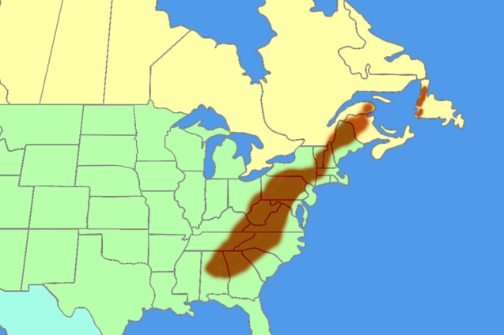
    - Innuitian Mountains
      - Northern Nunavut
      - Jagged/somewhat eroded, inaccessible mountains (waterways frozen)
      - 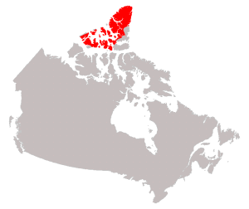
    - Cordillera
      - Major ranges include Rocky Mountains, Coast Mountains
      - Youngest mountains in Canada
      - Highest, most jagged, permanently snow-capped tops
      - 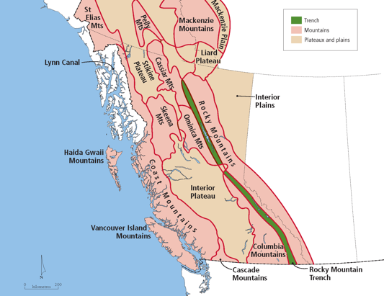
Physiographic Regions
- Large area of Earth’s crust that has common characteristics
  - Extends over large area with similar topographic features
  - Landforms shaped y common set of geologic processes
- Physiographic regions of Canada
  - Canadian Shield
  - Cordillera
  - Interior Plains
  - Hudson Bay Lowlands
  - Arctic Archipelago
  - Appalachian Uplands
  - Great Lakes – St. Lawrence Lowlands
  - 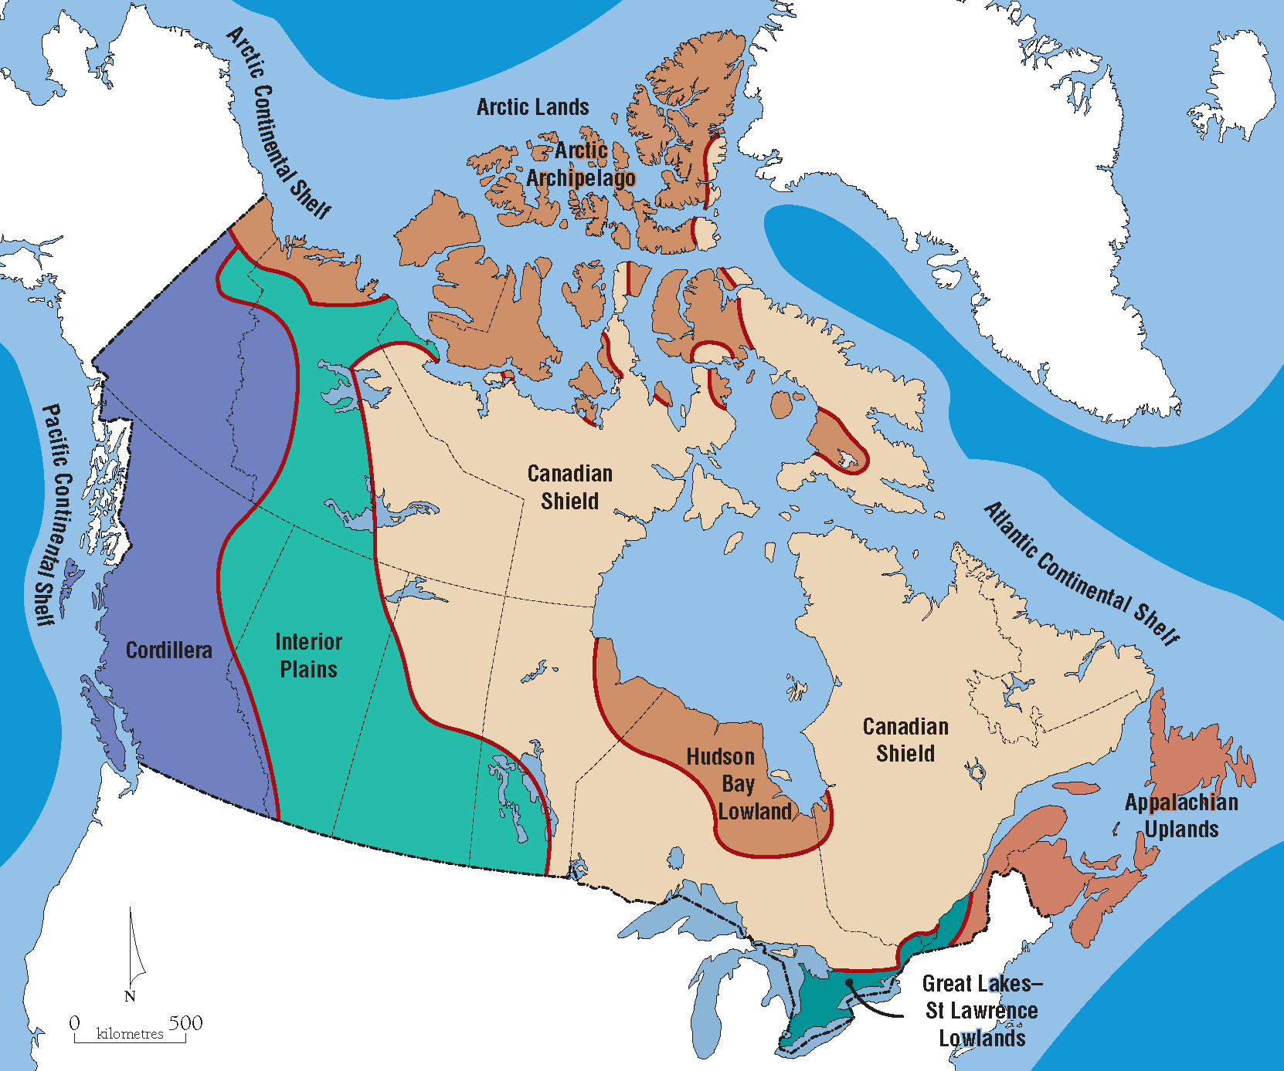
- Canadian Shield
  - Extends over half of the country’s land mass
  - Rock-like surface consists mainly of rugged land
  - During last ice advance – surfaces subjected to glacial erosion and deposition
  - Contains a wealth of varied mineral resources
- Cordillera
  - Complex region of mountains, plateaus, valleys
  - North-south alignment extends from Yukon to southern BC
  - Rocky Mountains are the best known and tallest of the mountain ranges
- Interior Plains
  - Once covered by shallow inland seas – sediments eventually formed sedimentary rock
  - Deep, wide river valleys are unique feature of region
- Hudson Bay Lowlands
  - Has many bogs and contains muskeg (poorly drained soil)
  - Permafrost is widespread
- Arctic Archipelago
  - Complex area of coastal plains, plateaus, mountains that lie north of Arctic Circle
  - Northern part of this region is permanently covered in snow and ice
  - Southern part contains tundra
  - Underlain by continuous permafrost making tree growth impossible
- Appalachian Uplands
  - Area with rugged and rocky environment (NF) and old mountains (NB)
- Great Lakes – St. Lawrence Lowlands
  - Regions is generally flat with rolling hills
  - Soil is very fertile and well suited for agriculture and variety of crops
Glaciation
- Major shaping force in Canada
- All of Canada was covered by ice sheets 18000 years ago
- 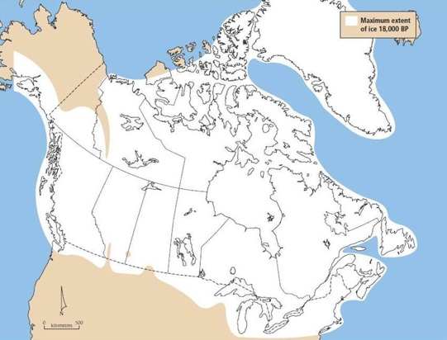
- Advance (glacier grows) and retreat (glacier melts) of ice greatly impacts the appearance of the landscapes
- Covered in thick ice (3km)
- very northern Nunavut desert land no snow, no glacier ice sheet
- Hudson Bay – ice was thickest and pushed down the crest, when it melted left a huge depression
Types of Glaciers
- Continental Glaciers
  - Thick sheets of ice that cover entire continents
  - Today, only continental glaciers on Earth are on Greenland and Antarctica
    - Ice is up to 3km thick
- Alpine Glaciers
  - Glaciers found in mountainous regions
  - Glacier can develop when slopes accumulate with snow that compacts into ice over long periods of time
  - Glaciers form on the sides of the hills, push down on the rocks, fills the valleys (v shaped valleys u shaped valleys)
  - Arete – jagged mountain side between two glaciers
  - Cirque – half circle shaped glacier on the side of the mountain
  - Postglacial landscape – big boulders, little water falls
Evolution of the Great Lakes
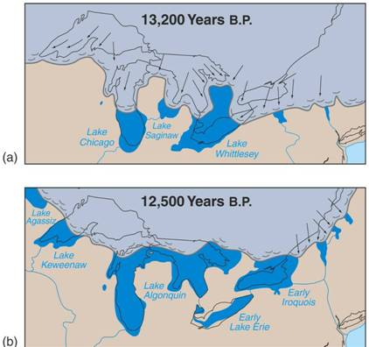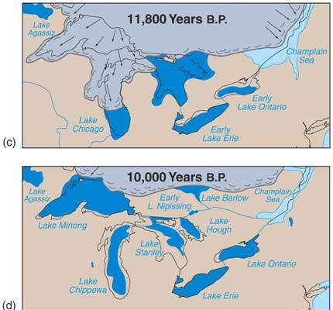
- As ice came down carved out depressions in the weaker rocks
- Ice melted filled with water
- Land that was bottom of lake – fertile and flat land
Lake Agassiz
- Large lake in what is now Manitoba and northern Ontario
- Formed from the melting of the continental ice sheets
Components of Climate
- Weather – current state of the atmosphere
- Climate – average weather conditions for a specific place over a long period of time
  - Need 30 years of data
- Two major components of climate
  - Temperature
  - Precipitation
- Components vary greatly across country
Climatic Controls
- Latitude
  - At lower latitudes, more solar radiation impacts the surface
  - The further away from the equator the cooler you are in the winter
- Altitude
  - Higher elevation experience cooler temperature
  - There are fewer air molecules at higher elevations
  - Allows heat to more easily escape into space
- Proximity to bodies of water
  - Water keeps nearby land areas warmer in Autumn and cooler in Spring
- Ocean Currents
  - Currents transport warm or cold water depending on the source of the current
- Variations in Topography
  - Cold air is dense and tends to sink into valleys
- Prevailing Wind
  - Some wind systems cause rapid temperature changes
    - Chinook wind – originates from the Rockys (southern Alberta)
    - Canada – usually comes from the west
- Locations of Pressure Systems
  - Relates to the position of warm and cold fronts
- Energy from the sun
  - Amount of solar energy absorbed by the earth and its atmosphere is converted into heat
  - Varied by latitude
  - High latitudes energy is lost through re-radiation
- Local circulation system
  - Redistributes solar energy from lower latitudes to high latitude through circulation in the atmosphere and oceans
- Global circulation system
  - Travels west to east direction in the higher latitudes of the northern hemisphere
  - Air masses develop over large water bodies to bring mild and most weather to adjacent land masses
  - Air masses from Pacific Ocean cross the Cordillera into the interior of Canada
    - Marine air masses
    - Continental air masses
Climatic Zones
- Pacific
- Cordillera
- Prairies
- Great Lakes – St. Lawrence
- Atlantic
- Subarctic
- Arctic
- Most of Canada’s land mass is located within the subarctic and arctic climatic zones (over 50%)
- 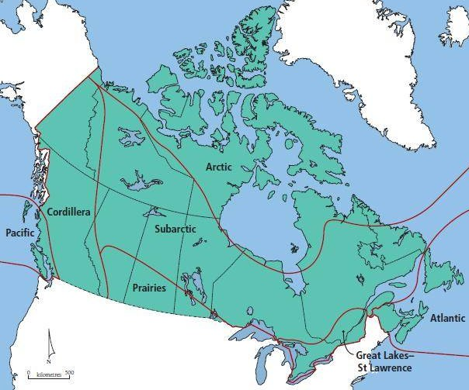
- big U-shaped pattern – climate zones dip down at Hudson Bay
- Different climate zones along the coast
Temperature Across Canada
- Temperatures in Canada are primarily controlled by latitude
- Moderation is evident along both coasts and to a lesser extent around the Great Lakes
  - Especially the Pacific coast due to prevailing westerly winds
  - 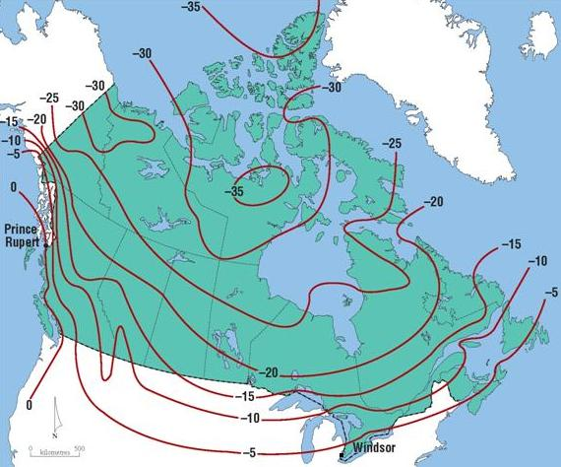 Mean January Temp
  - 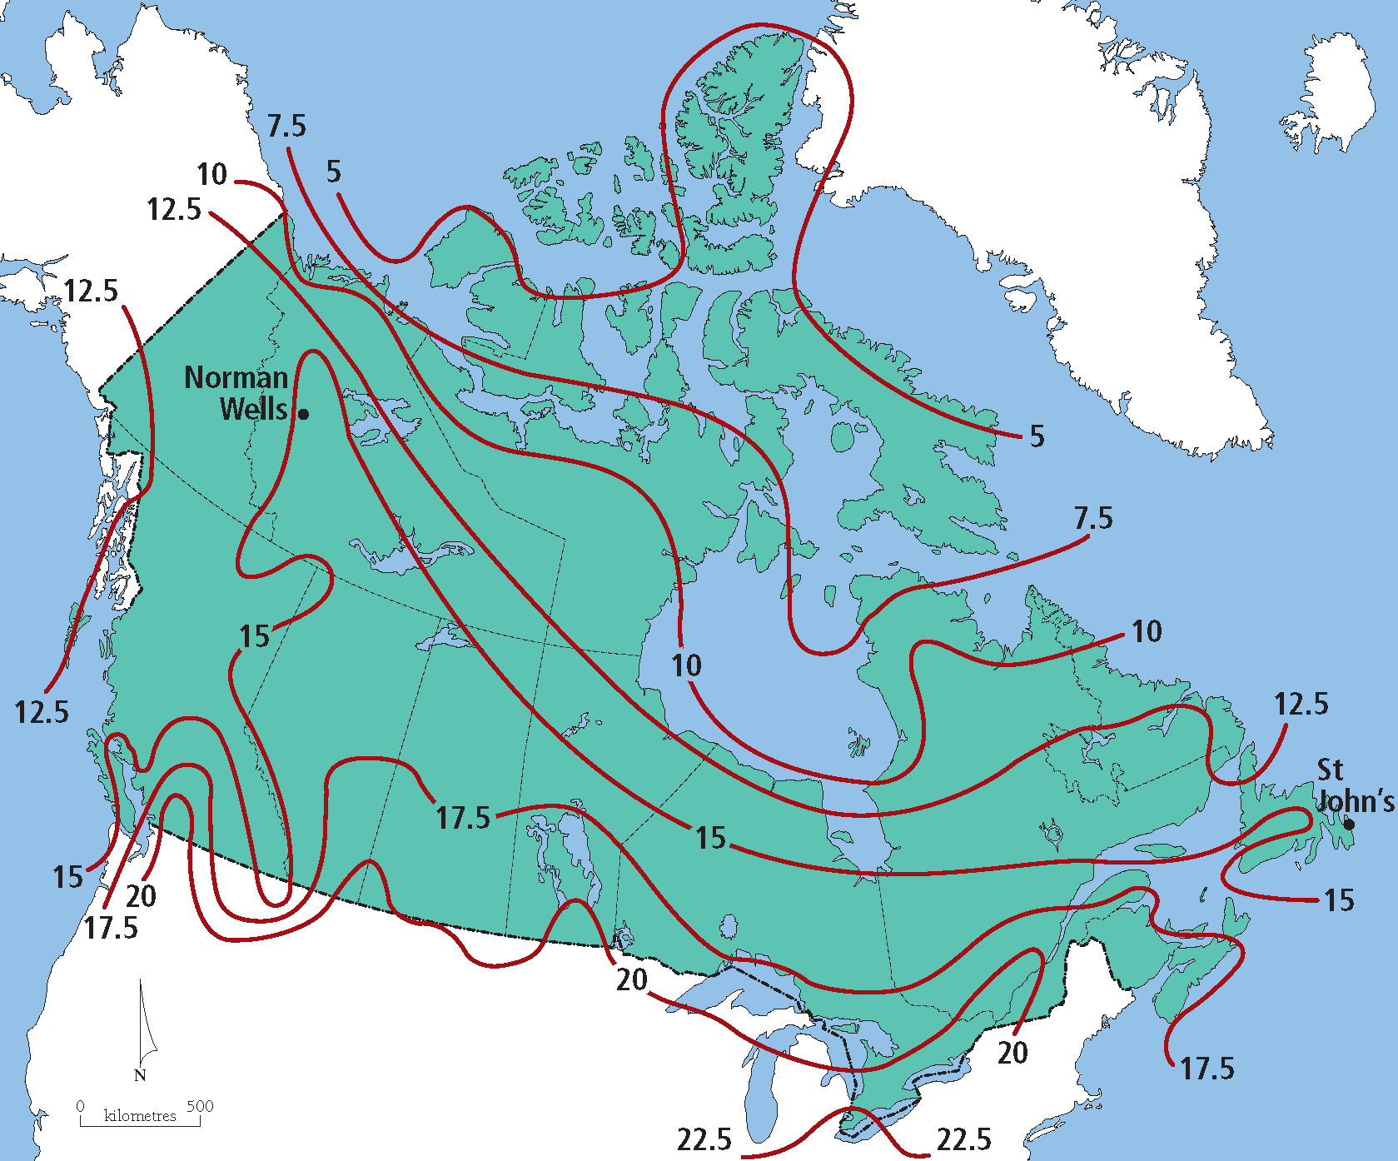 Mean July Temp
  - Effect of Hudson Bay is inexistent because it is frozen all winter
Physical Effects of Temperature
- Temperature dictates the type of predominant veg in an area
  - Deciduous – tress that lose leaves
  - Boreal – evergreens
  - 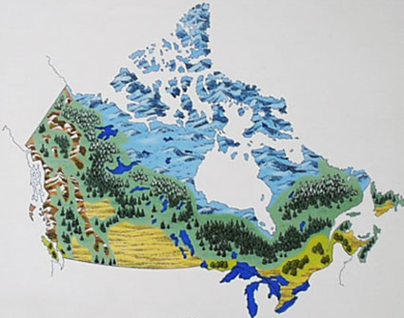
- Temperature dictates the length of the growing season in an area
- Growing season – the number of days between final frost in spring and first frost in fall
  - Victoria has the longest growing season in Canada (~200days)
  - London 5 and half months
  - 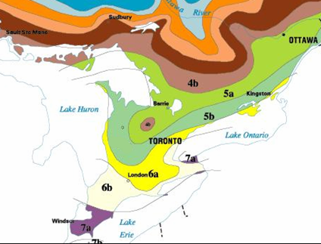
Precipitation Across Canada
- The Prairies and the North are relatively dry – especially in winter
- West coast is very wet due to orographic precipitation
  - Orographic precipitation – caused by air rising up a mountain
- Convective precipitation occurs in the prairies and Great Lakes – St. Lawrence Lowlands during summer
  - Convective precipitation – moist air is forced to rise because the ground has become particularly warm
- Precipitation is moderate and consistent in the Great Lakes – St. Lawrence Lowlands
- Lake effect snow is common
- Frontal precipitation – warm air mass is forced to rise over a colder and denser air mass
- 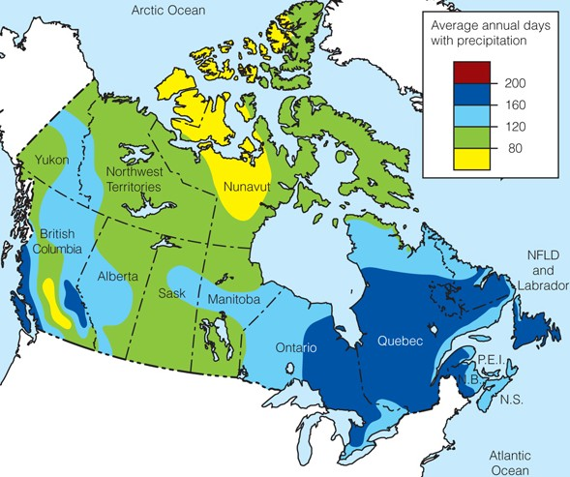
Vegetation in Canada
- Much of the veg we see today in Canada is not natural
  - Has been introduced through agriculture and human activity
- Major natural veg types in Canada
  - Forests
  - Grasslands
  - Tundra
- 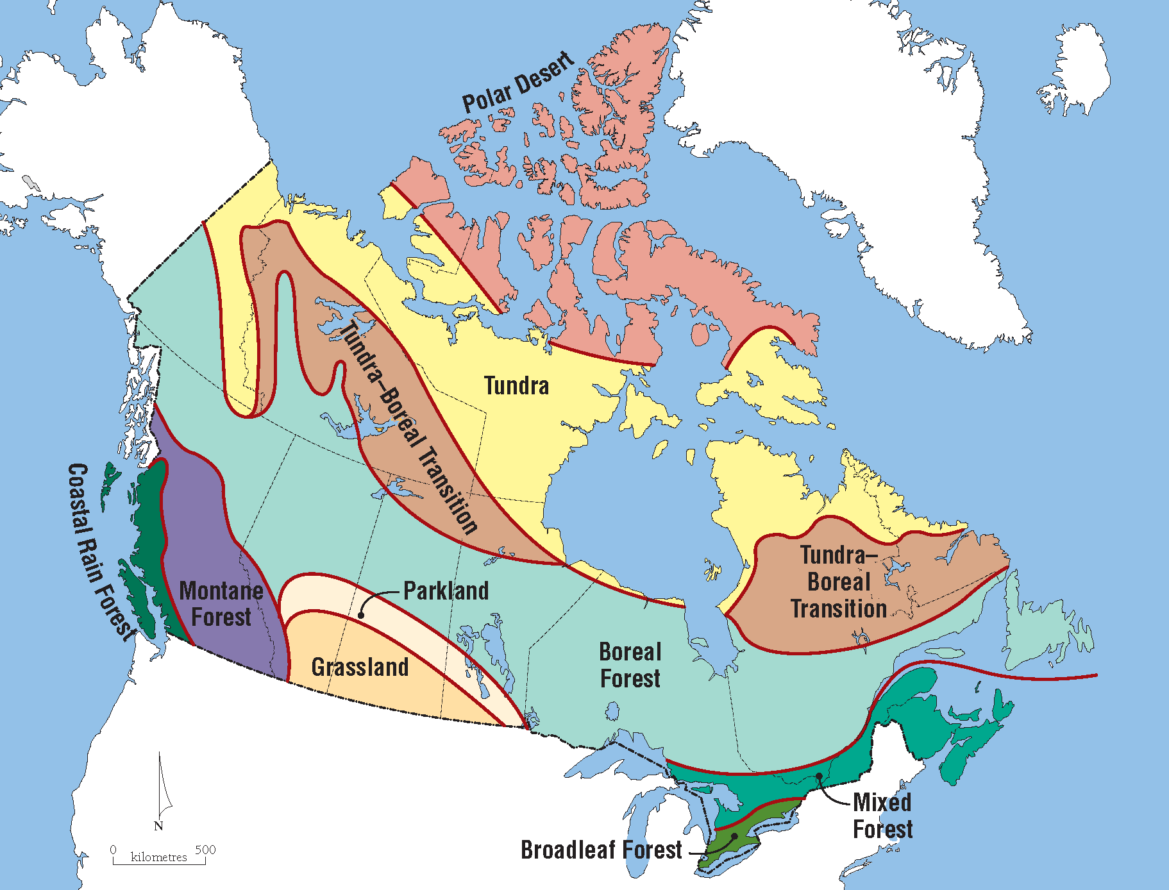
Types of Vegetation
- Forest
  - Deciduous forests are composed of trees that lose their leaves each winter
    - Broadleaf forest and Carolinian forest (Southern ON)
  - Coniferous forests are composed of evergreen trees
    - Boreal forest and Canadian shield (Northern ON)
- Grassland
  - Found in relatively dry areas
  - Size of the grass varies with moisture content
  - Prairie provinces
  - Xerophyte – a plant that has adapted to low amounts of water
    - Deep roots, waxy leaves
- Tundra
  - Small plants survive in harsh climates – produce runners
  - Runners – offshoots of the main plant
  - Permafrost under plant – can’t grow deep roots
  - Arctic and alpine areas
  - Adaptations of Tundra
    - Tundra plants have shallow root systems due to the permafrost enviro
    - Leaves of plants are waxy to reduce moisture loss
    - Krumholz - plant that grows in a sideway formation because harsh dry winds desiccate the upper part of the plant
Permafrost Zones in Canada
- Continuous permafrost – at least 80% of the ground is permanently frozen
- Discontinuous permafrost – 30-80% of the ground is permanently frozen
- Alpine permafrost – mountainous areas and takes on vertical pattern
- Sporadic permafrost – northern parts of the provinces, less than 30% of the area is permanently frozen
- 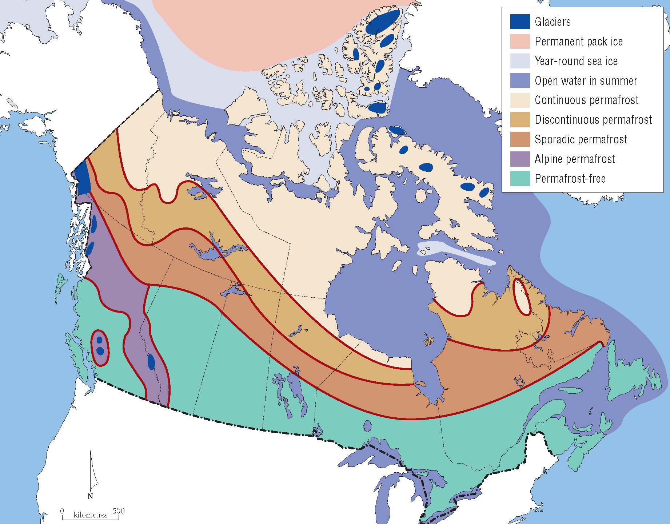
- Permafrost forms where the man annual temperature of the soil is below 0$°$C
- Discontinuous permafrost may form in areas with northerly aspect
- Aspect - the direction you are facing
  - If a slope has a northerly aspect it will never get direct sunlight
- The line marking the zone of continuous permafrost roughly follows the tree line
- The tree line has moved northward by approx. 100km over the past 50 years
- 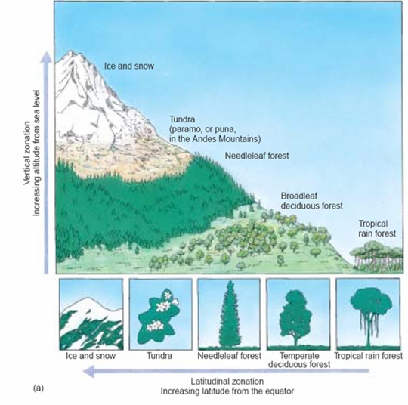
Cryosolic Soil
- Typically found north of the tree line
- Dominant soil in the Arctic Archipelago and around Hudson Bay
- Found where the mean annual temp is below 0$°$C and where continuous permafrost is common
Podzolic Soil
- Most commonly found in cool, moist climates (Canadian shield)
- Light grey in colour
- Coniferous vegetation is most commonly associated with it
- Leaching is evident (moisture easily percolates downward through this soil)
  - Good for evergreen trees
Luvisolic Soil
- Found in humid continental climates (southern ON)
- Deciduous veg is most commonly associated with it
- Organic content is most evident in this soil
  - Trees dropping leaves create thick organic layer
  - Organic – soil composed of matter from a once living organism
Chernozemic Soil
- Found in dry climates where grasslands are located
- Soil is very dark in colour with relatively high organic content
- Leaching is evident but not as much as Podzolic soil
- Prairies
Pallier’s Triangle
- Semi-arid area in western Prairies
- Name by John Palliser – leader of a survey expedition of the Canadian west for Britain (mid 1800s)
- Declared that it was an area unsuitable for agriculture
- Wheat growing and cattle grazing have become the common land uses
- Farmers here often require gov subsidies to aid in surviving through drought conditions
- 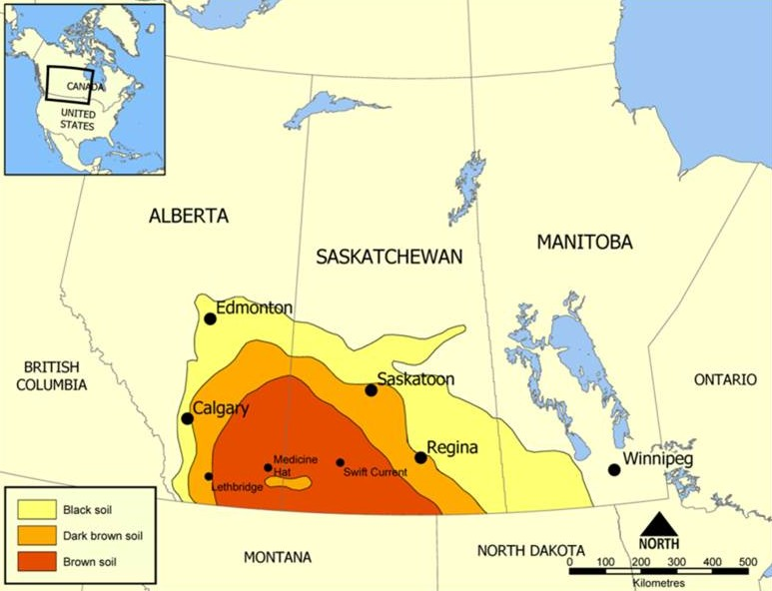
- Non of the big cities are found in Palliser’s Triangle
Drainage Basins
- Every river has a drainage basin
  - Drainage basin – area of surrounding land that is drained by that river
- Can also be defined for lakes
  - Defined as the area of land that drains into that lake
- Canada has 4 major drainage basins
  - Atlantic Basin – Atlantic Ocean
  - Hudson Bay Basin – Atlantic Ocean
  - Arctic Basin
  - Pacific Basin
- 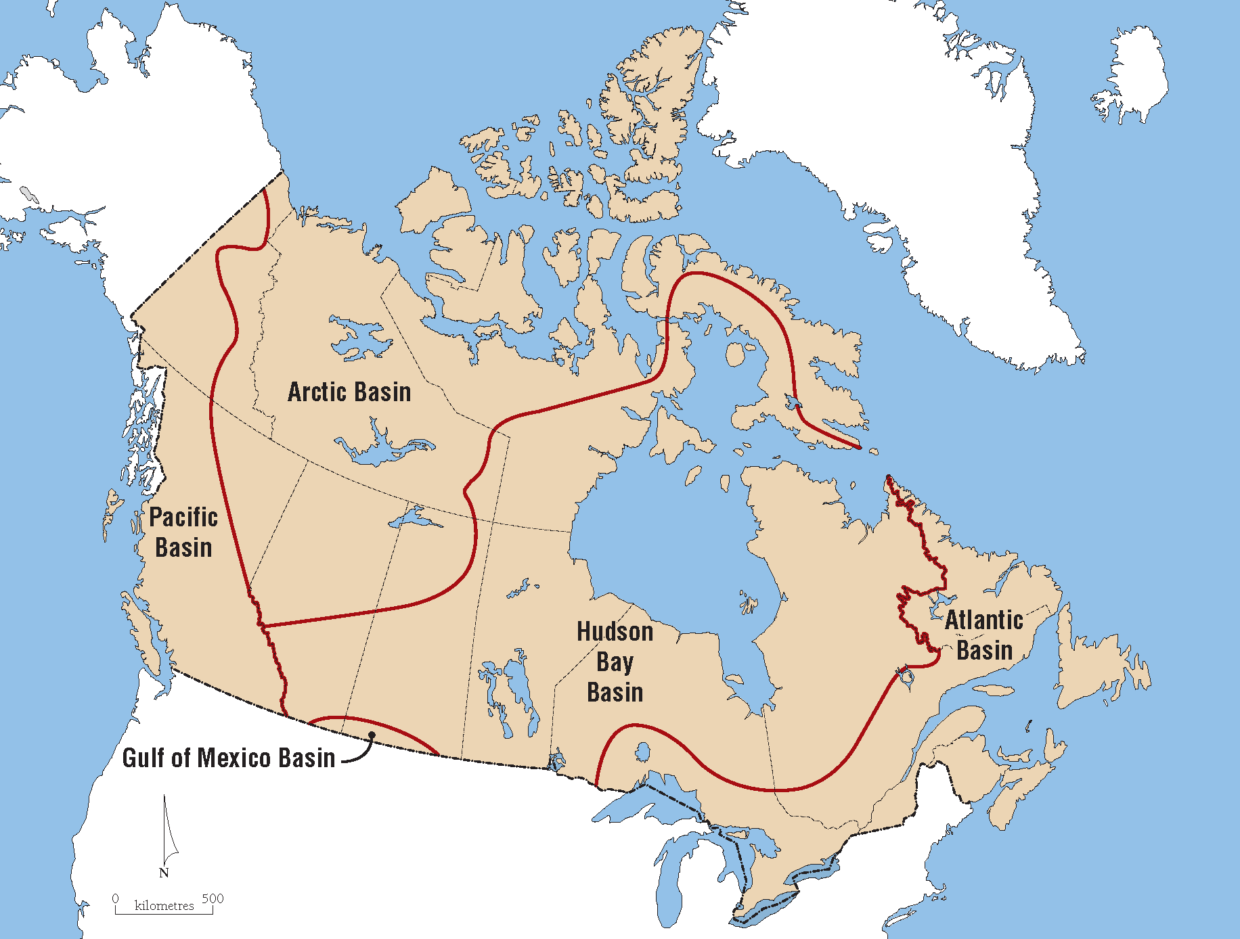
Drainage Basins as Open System
- Input – precipitation
- Output – rivers, evaporation
- Rivers are in state of dynamic equilibrium – are able to adapt to changes in amount of water in drainage basin
Divides
- Ridge of higher land that separates which way rivers flow
- Divides form boundaries for drainage basins
- Continental Divide
  - Located along the spine of the Rocky Mountains
  - Forms much of the BC-AB border
  - Separates which ocean the water will eventually drain into
Columbia Ice Field
- Last remaining ice sheet in southern Canada
- Straddles the continental divide in Jasper National Park
- Home to 8 large alpine glaciers
- North Saskatchewan River originates in the Columbia Ice Field
  - River flows through Edmonton and Saskatoon
Glacier Retreat
- Athabasca Glacier is the most well-known alpine glacier in the Columbia Ice Field
- Retreating at a rate of 2-3m per year
Changes in Arctic Sea Ice
- In coming decades – polar areas are expected to warm faster than any other areas on earth
- Ice/snow reflect sunlight
- As ice melt the resulting water absorbs sunlight
  - Heats up water and encourages nearby ice to melt
  - Positive feedback effect

Chapter 4 Historical Geography of Canada

Historical geography of Canada
- Three influential events that have shaped Canada’s history
  - Arrival of the first people in North America
  - Colonization of North America by France and England
  - Influx of people from eastern Europe
First People
- Hunters from the Old World (Eastern Hemisphere) were the first to arrive about 40000 years ago
- Corridor theory
  - Old World hunters who had been blocked from proceeding south by the ice sheet were now able to migrate south
  - Ice-free corridor appeared about 13000-14000 years ago
- Sea route theory
  - Island-hopping along the sea edge of the Cordillera Ice sheet until they reached the unglaciated US Pacific coast
- Crossed Bering Land Bridge from Siberia to Alaska then continued eastward
- Land bridge accessible at the time because sea level was much lower than it is today
- As continental ice in North America began retreating, descendants of the hunters pushed further south
- Travelled along an ice-free corridor that developed along the foothills of the Rocky Mountains
- Migration Routes
- 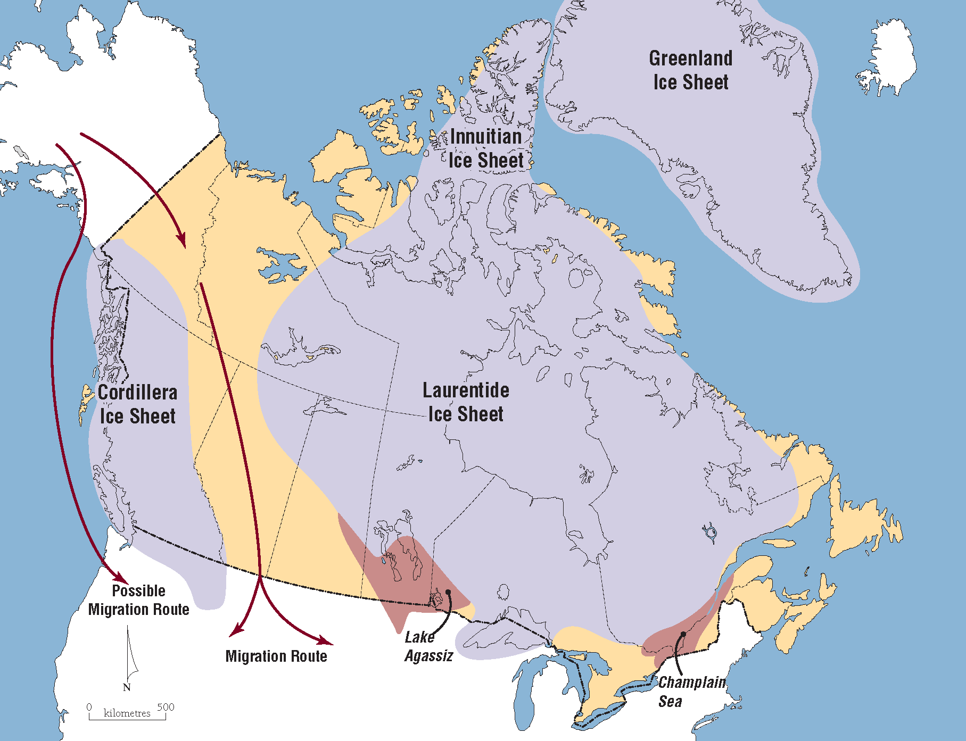
- Commonly hunted mammoths with pointed spears
  - As mammoths became extinct, the first people began shifting to a diet mixed with mean (buffalo and caribou), fish, and plants
Tribes
- Revised diet allowed the first people to remain in a specific geographic region
- Marked the beginning of more social units – became forerunners of tribes
- Trade among tribes began 10000 years ago
Arctic Migration
- The Laurentide Ice Sheet began retreating from what is now Nunavut about 5000 years ago
- Sea hunters were able to advance eastward
  - Hunted walrus, seal, etc
- The Thule people settled in this area about 1000 years ago
  - Ancestors of the current Inuit
First Contact with Europeans
- European explorers considered the New World (the Western Hemisphere) terra nullius
- Terra nullius – empty land
- First contact between Europeans and Indigenous people occurred throughout the North America from late 1400s – 1600s
- Just before first contact – may have been as many as 500000 Indigenous people living in Canada
- Indigenous population dropped by ~80% as result of battles and diseases brought be European explorers
The Second People of Canada
- French or British descent
- French explorers established a settlement at Quebec City in 1608 – New France
  - Grew to population of 60000 before arrival of British explorers in mid 1700s
- After British Conquest of New France in 1759 British immigrants began to move to the area
- Battle of Plains of Abraham
  - Reason why Canada is mostly English speaking country
  - British won battle and British took control of area and British immigrants came in
Waves of British Immigration
- First wave
  - British Loyalists living in US supported Britain during the US War of Independence (1775-1783)
  - Many British Loyalists settled in southern ON and the Maritimes soon after US became independent
- Second wave
  - During the early 1800s – 1 million people migrated from the Britain to ‘British North America’ (former name of Canada)
  - Resulted from deteriorating economy in England
  - Easily overwhelmed French speaking population
Canada at Confederation
- 1867 – population of British North America was approx. 3 million
- About 75% of population lived in the Great Lakes – St. Lawrence Lowlands
- About 20% lived in the Atlantic region
- 60% of the population of European ancestry was English speaking
- in the Red River valley, the Metis people (mix of Indigenous and European descent) were dominant population
Confederation
- Canada became a country in 1867 when four small British colonies united
  - Upper Canada (ON), Lower Canada (QB), NB, NS
  - First four provinces
- British was eager for colonies to form a union to withstand possible annexation by the US
The Third People of Canada
- 1870, Ottawa obtained control over Rupert’s Land
  - much of this land was owned by the Hudson’s Bay Company
- Fed gov felt it was important to settle this land
  - Diminish the threat of US settlers annexing the land
  - Transport of grain would provide freight for a planned cross-continent railroad
- Clifford Sifton (Minister of the Interior)
  - Assigned task of settling the prairie region of Western Canada
- Fed gov looked to attract immigrants from eastern Europe, Russia, Scandinavia, and Ukraine
- Majority of them arrived from 1895-1915
- Areas are home to dry grassland enviro similar to the Canadian Prairies
- New dimension was therefore added to Canada’s population
  - People with neither French nor British nor Indigenous background
- Majority of these new immigrants lived in homesteads
- Impact of the landscape in the prairies was enormous
- This area had previously been occupied by seminomadic Indigenous people who hunted buffalo
Evolution of Canada
- British North America Act passed on July 1st, 1867
  - ON, QB, NF, NS
- July 15, 1870
  - Land that the fed gov obtained from Hudson’s Bay Company was names North-West Territories
  - Manitoba became province
  - 5 provinces, 1 territory
- British Columbia – 1871
- Prince Edward Island – 1873
- Alberta and Saskatchewan – 1905
- Newfoundland – 1949
- Yukon – 1998
- Nunavut – 1999
- After Confederation – frequent changes in internal boundaries
- Greatest dispute between QB and NF over boundary of Labrador
  - 1927 – impartial judicial court in England settled dispute
  - All land that drained into the Atlantic Ocean was awarded to Labrador
Regional Tension
- Arise among regions or between regions and the fed gov
- Challenge for the fed gov is to seek a balance between regional needs and demands
- Effort rarely satisfy all regions of Canada
Tensions to National Unity
- Regions compete against each other for federal dollars
  - Health, education, social services are expensive provincial responsibilities
- Regions are separated by great distances making trade and commerce difficult
- Geography encourages some Canadian regions to align with nearby regions in the US
Faultlines in Canada
- Centralist/Decentralist
  - Based on Canada’s vast size
  - Linking the country has always been a challenge
    - Cross-continental railroad was funded by fed gov to encourage BC to become part of Canada
    - Fed election voting times were shifted so BC would not hear the results before the polls closed
  - Centralist
    - Ones who want to ensure there is a relatively great deal of power, strength, control in the fed gov
  - Decentralist
    - Ones who want to strengthen the powers of the provinces
  - Central Canada
    - Not true geographic centre of the country
    - Refers to the heavily populated southern ON and southern QB corridor
  - Atlantic Canada
    - Geography prevented businesses there from easily reaching markets in Central Canada or the West
    - Not able to easily sell goods to nearby New England due to US tariffs
    - Stalled economic development in the Maritimes
  - Prairie Provinces
    - Farmers had to purchase expensive machinery manufactured in Central Canada
    - Cost of transporting grain from the prairies to foreign markets very high
    - Railroad was built to Churchill (on Hudson Bay)
      - High marine insurance costs discouraged transport by boat
  - British Columbia
    - Economy driven by exports of fish, timber, minerals to Asian locations
    - Led to feelings of alienation from rest of Canada
    - BC geographically beyond economic influence of Central Canada
      - Have to high prices for goods manufactured in Central Canada
  - Territorial North
    - Area was ignored and treated as remote wilderness until valuable minerals were found
    - Fed gov subsidized the building of roads leading to resources
      - 1950s
      - Roads to Resources program
  - Dominance of the Core
    - Core exhibits political and economical dominance
    - 338 seats in HOC determined by population
    - Each seat represents electoral riding of approx. 105000 people
    - 30 more seats will likely be added to the HOC before next election (2019)
  - Rules for reshaping the HOC
    - Each province will have at least as many MPs as it has senators
      - PEI has 4 MPs even though population is 140000
    - Each province will have at least as many as MPs as it did in 1976
      - QB has 75 seats
  - Western Alienation
    - Western provinces’ lack of power to control their destiny
    - National Energy Program (1980-1984) – good example of the West’s distrust of the fed gov
  - National Energy Program
    - Energy prices rose dramatically through the 1970s
    - Mid 1970s – oil producing provinces and fed gov agreed to match the domestic oil price to the world oil price
    - Huge oil revenue for Alberta
    - 1979 – Ottawa refused to continue to match the domestic price with the world price
    - Liberal fed gov (Pierre Trudeau) formed program in 1980
    - Ensure low cost of oil in ON and QB
    - Increase the fed share of revenue from the oil industry through taxes
    - Resource development falls under provincial powers
      - However, fed gov forced this program on AB
    - As fed gov gained revenue AB lost revenue
    - Result of distrust of Liberal politicians by AB (still evident today)
    - AB didn’t elect any Liberal MPs in 1984, 1988, 2006, 2008, 2011 elections
    - 2015 4/34 AB ridings voted Liberal
  - Equalization Payments
    - Represent a sharing of fed tax revenue among provinces
    - Ensure a relatively equal standard of living among all Canadians
    - Payments only sent to provinces with fiscal capacity below national standard
    - Fiscal Capacity – ability of a province to raise its own revenue
    - Have – BC, AB, SK, NL
    - Have not – ON, QB, MB, NS, NB, PEI
    - unconditional – receiving provinces are free to spend the funds according to their own priorities
- Indigenous/Non-Indigenous
  - Fed gov responsibility for matters relating to all Indigenous people
  - Original goal was to assimilate Indigenous people
    - Attempted via Residential Schools in 1892
  - Indigenous Residential Schools
    - the federal government believe that Aboriginal children could be successful in modern society if they abandoned their culture and language and adopted Christianity, learned English, and had a basic education
    - Children were removed from families and not permitted to use their native language
    - Last school closed in 1996
    - 2008 – fed gov formally apologized for the harm done to children at these schools
  - Current policies
    - Settle outstanding land claims
    - Recognize Indigenous rights to self-gov (Nunavut)
    - Accept that the concerns of each group of Indigenous people are different (Indian, Metis, Inuit)
  - Status Indians
    - People registered as Indians under the Indian Act 1985
    - Entitled to certain rights from fed gov
  - Treaty Indians
    - Members of a band who have signed a treaty
  - Metis
    - Mixed heritage
    - French-Indigenous/English-Indigenous
  - Inuit
    - Descendants of the Thule people
  - Land rights are the most fundamental
    - Treaties negotiated with fed gov set aside reserves
    - Reserves are collectively owned by Indigenous bands
    - Many out standing land claims today
  - Bridging the Faultline
    - Indigenous economic development is a major goal
    - Continued transfer of power from fed gov to Indigenous communities
    - Economic and social well-being of reserves varies widely
    - Some reserves are wealthy due to natural resources or tourism
      - Others are trapped in poverty with little economic base
- Immigration Faultline
  - Historically used as an instrument of British colonial power
  - After British Conquest of New France in 1759 – British gov set immigration policy
    - Offset the French speaking population by encouraging large scale immigration from the British Isles
  - After Confederation – Canada remained closely tied to the British empire
    - Immigration policies continued to reflect the imperialist attitude
      - British were superior
    - Immigration from other areas were still needed due to shortage of workers
      - These immigrants often marginalized
  - Late 19th c. and early 20th c. new immigrants were expected to conform to Canadian Society
    - Poor experience for the original occupants of the Prairie provinces who were not British immigrants
  - Red River Rebellion 1869
    - Clash between fed gov and the Metis led by Louis Riel (father of MB)
    - Western land survey system ignored existing Metis landholdings
    - Posed threat to Metis hunting society
    - Metis took control of HBC headquarters – provisional gov and began to negotiate with Canada under the terms of Confederation
    - Metis wanted own province and to enter the Confederation
    - Manitoba became small province July 15, 1870
    - Metis obtained major demands
      - Use of both English and French within new provincial gov
      - Dual system of Protestant and Catholic schools
  - The Northwest Rebellion 1885
    - Metis in Saskatchewan felt threatened by advancing wave of settlers
    - Enlisted support of Riel (living in Montana)
    - Riel sent petition to Ottawa but demands were ignored
    - Uprising began – Metis soldiers ambused Northwest Mounted Police contingent
      - Killed 12 men
    - Canadian Army advanced on the area wore down Metis and Indigenous forces
    - Riel along with 8 Metis and other Indigenous leaders were hanged
    - *Railroads were built – army could be sent
  - Newcomers to MB
    - 1870-1880 Metis lost their majority due to influx of people from ON
      - ON no longer had surplus of agricultural land
      - Wheat farming in prairies became profitable
  - Doukhobors
    - Preferred to maintain their own traditions
    - Communalists – wanted little to do with the gov
    - Refused to serve in the Russian army and were persecuted by Russia
    - Granted blocks of land in Canada and freedom from military service
    - Refused to swear an oath of allegiance to England
    - 1905 – Frank Oliver enforced Dominion Lands Act
      - Fed gov cancel the Doukhonor’s right to the land
- French / English
  - Canadian unity depends on continuation of this relationship
  - Faultline dates to 1759 – Plains of Abraham
  - Treaty of Paris 1763 – France ceded New France to Britain
    - Placed French speaking people under British monarchy
  - The Quebec Act 1774
    - Provisions for French Canadians
      - Continuation of seigneurial landholding system
        - Seigneurial – land divided into long narrow strips; enabled each landholder access to river
      - Guaranteed religious freedom
      - Rights to retain native language
    - Well received by French speaking people
    - Recognized the geographic area of former French territories in North America
  - British Loyalists
    - After US revolution 40000 British Loyalists settled in Canada
    - As amount of English speaking settlers in the Great Lakes – St. Lawrence Lowlands increased, they wanted to control their own affairs
    - Led to Constitutional Act
  - The Constitutional Act 1791
    - British colony of Quebec divided into provinces of Upper Canada and Lower Canada
    - Ottawa River was dividing line
    - Upper Canada – ON
    - Lower Canada – QB
    - People became upset with small, elite groups that governed the two provinces – Chateau Clique, Family Compact
    - Rebellion broke out – led to Act of Union
  - The Act of Union 1841
    - Lord Durham investigated rebellions
    - Suggested uniting the two provinces under one large government
    - Make French minority
    - United region was referred to as province of Canada
  - Manitoba Schools
    - When MB entered confederation in 1879, did under the assurance of language rights and Protestant and Catholic schools
    - Proportion of Anglo-Protestant in MB increased steadily after it became a province
    - MB gov ended funding for Catholic Schools in 1890
    - Act contributed to the strained relationship between French and English in Canada
  - The Quiet Revolution
    - Period in 1960s characterized by rebirth of pride and confidence among French Canadians
    - Quebec nationalism gained strength
    - Hydro-Quebec was formed at this time – powerful symbol of Quebec’s revitalized economy
  - Quebec Separatism
    - Movement intensified when French president Charles de Gaulle visited Quebec in 1967
      - Vive le Quebec Libre – long live Quebec
    - Referendums were held to gauge support within QB for separation from Canada
    - 1980 – 60% voted against separation
    - 1995 – 49.5% coted against separation; 49% voted for separation
    - 2006 – Quebec was officially recognized as a nation within Canada
      - Nation – a distinct cultural group

Chapter 5 Human Geography of Canada

Canada’s Population
- 36 million
- At the tie of Confederation – approx. 3 million
- Only 20% of countries have a population higher than Canada
Current Trends in Canada’s Population
- Rate of natural increase is declining
- Population is aging
- High birth rate among the Indigenous population
- Highest growth is occurring in ON, BC, AB, SK
Population Density
- The number of people divided by the land area
- Canada 2nd largest country in the world by land area
  - Population density is one of the lowest in the world – 3.7 people/km²
- Canada’s physiological density is similar to that of the US
  - Physiological density – the amount of arable land per person
  - Arable – area where you expect to live
- 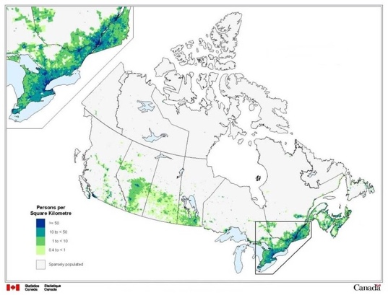
Regional Population Density
- Density varies greatly among the regions
- ON has the highest population density – 14.1 people/ km²
  - Despite the fact that northern ON is sparsely populated
- ON and QB combined are home to 62% of Canada’s population
Population Distribution
- The dispersal of people within a geographic area
- Canada’s population distribution is one of the most unevenly dispersed in the world
- 75% live within 100km of the US border
- Ecumene – the inhabited part of an area
Urban Population
- Urban – an area with population of at least 1000 and at least 400 people per km²
- Canada’s population is 82% urban
- Urban population did not increase much until 1920s
- Least urbanized region is Atlantic Canada
  - Many fishing villages have fewer than 1000 residents
The 6 Major Urban Centers
- Toronto
- Montreal
- Vancouver
- Ottawa
- Calgary
- Edmonton
- 1971 – Toronto overtook Montreal to become Canada’s largest census metropolitan area
  - Quebec’s separatism scared a lot of businesses away from Montreal to TO
Census Metropolitan Area (CMA)
- An urban core combined together with adjacent suburban areas that have a high degree of social or economic integration with the urban core of the area
- Urban core of a CMA must contain at least 100000 people
- 33 CMAs in Canada
  - 15 are in ON
CMA Growth Rates
- 2006-2011 growth rates were highest in Calgary, Edmonton, Saskatoon
  - Oil industry
Problems of Urbanization
- Urban sprawl is an environmental concern
- Causes more traffic, retail loss from downtown cores, air pollution, loss of agricultural land
- Most problematic in largest CMAs but also evident in smaller cities
4 Population Zones
- 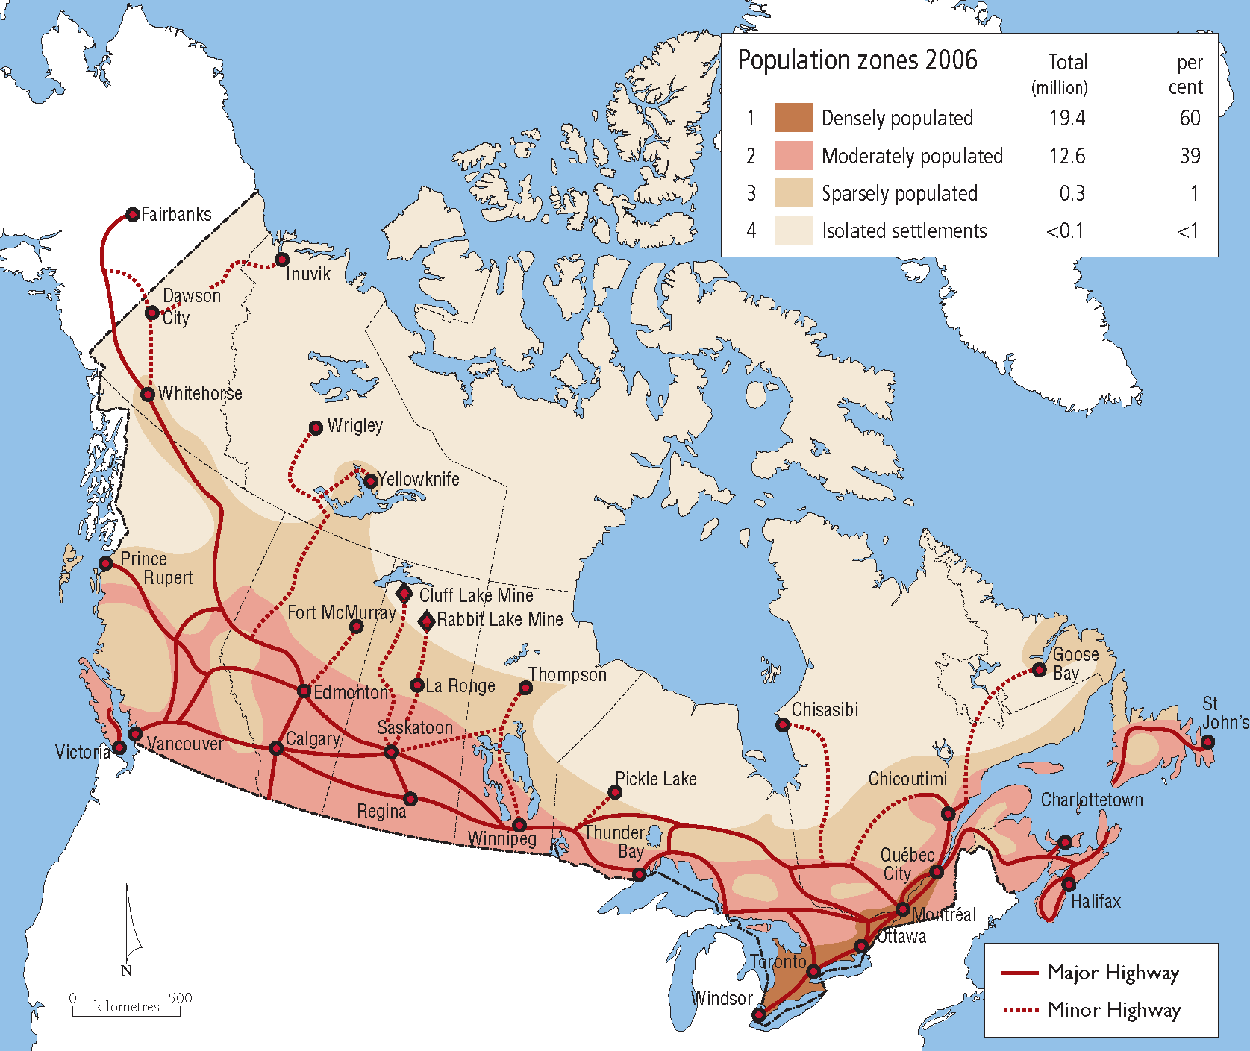
- Densely Populated Zone
  - Lies within the Great Lakes – St. Lawrence Lowlands
  - 10 largest metropolitan areas – Toronto, Montreal, Ottawa, Quebec City, Hamilton, Kitchener, London, St. Catharines, Oshawa, Windsor
  - Agricultural land in this are is the most fertile in Canada
- Moderately Populated Zone
  - Extends from coast to coast between 49th and 50th parallels of latitude
  - Major metropolitan areas – Vancouver, Calgary, Edmonton, Winnipeg, Halifax
  - Population is increasing slowly overall but unevenly
- Sparsely Populated Zone
  - Extends from coast to coast over the mid section of the country
  - Common landscape is boreal forest
  - Major population centers – Fort McMurray, Whitehorse, Yellowknife
  - < 1% of Canadians live in this zone
- Isolated Settlements zone
  - Occupies the northern part of Canada – mostly inhospitable for settlement
  - < 0.1% of Canadians live in this zone
  - Most reside in majority Indigenous settlements
  - Large population centers – Labrador City, Iqaluit, Inuvik
Population Change: Key Terms
- Crude birth rate – the number of births per 1000 people in a given year
- Crude death rate – the number of deaths per 1000 people in a given year
- Rate of natural increase - the difference between crude birth rate and crude death rate
- Net migration – the difference between in and out migration
Natural Increase
- The crude birth rate has fallen dramatically over the past 100 years
  - People moving from rural areas to cities
  - Increase in number of women in labour force
  - Widespread acceptance of fam planning (birth control)
- More of Canada’s population growth is from immigration
- Crude death rate has also fallen dramatically over the past 100 years
  - Medical advances
  - Improved nutrition
  - Better health care, reduced smoking rates
Replacement Fertility
- The level of fertility at which women have enough daughters to replace themselves
- 2.1
  - If a woman has 2.1 births in her lifetime, she will have one daughter
- Current fertility rate in Canada is 1.6
Demographic Transition Theory
- The shift of birth rates and death rates from high to low levels
- Decline in death rates precedes the decline in birth rates
- Based on the assumption that changes occur as society changes from pre-industrial to industrial
- Theory doesn’t take immigration into consideration
- 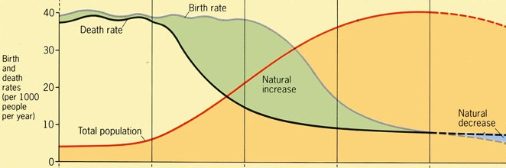
- Phase 1 Late Pre-Industrial
  - High birth rates and high death rates
  - Little to no natural increase; stable population
- Phase 2 Early Industrial
  - Falling death rates
  - Very high rates of natural increase
- Phase 3 Late Industrial
  - Falling birth rates
  - High but declining rates of natural increase
- Phase 4 Early post-industrial
  - Low birth rates and low death rates
  - Little to no natural increase; stable population
- Phase 5 Late post-industrial
  - Birth rates has fallen below death rate
  - Declining population (natural decrease)
The Baby Boom
- Time of a relatively high birth rates in North America (1946-1964)
  - After WWII soldiers came home from war and started families
- Many schools were built in the 1960s to accommodate the baby boom
- Median age in Canada rising steadily
- Almost 10 million births, created huge bulge in age structure of Canadian society
- Companies have geared their products to meet the strong demand created by baby boomers
Age Dependency Ratio
- Ratio of ‘dependent’ age groups (< 15 or > 64) to the ‘productive’ age group (15-64)
- Dependent – the government doesn’t expect to work/considered not productive
- 1961 – 70 dependents/100 working age
- 2011 – 46 dependents/100 working age
  - Decrease demonstrates affect of Baby Boom
  - As baby boomers age, the age dependency ratio will rise
- Compare the number of dependents with the number of economically productive members of society
  - Rough measure of the economic burden on those in the economically productive age group
- Canada’s population structure will change with a smaller proportion of children, smaller proportion of the population in the workforce and a much larger percentage over 64 years of age
  - Expected many Canadian seniors will remain in the workforce past the age of 64
Old Age Dependency Ratio
- Ratio of those over age 64 to the productive age group (15-64)
- 1961 – 14 elderly/100 working age
- 1991 – 18 elderly/100 working age
- 2011 – 22 elderly/100 working age
Implications of higher old age dependency
- An aging population places demands on the working-age members of the population
  - Gov health care costs will increase
  - Fewer working taxpayers to cover major costs – health care, education
Character of Canadian Society
- Population is more multicultural than most countries
- Most common locations where immigrants originated
  - Early 1800s – Britain
  - 1840s – Ireland
  - Early 1900s – Eastern EU
  - Since 1960s – East Asia, South Asia, Middle East
Immigration Today
- 60% of immigrants are from Asia and Middle East
- New immigrants tend to settle in larger cities
  - Fam contacts & employment
- 24% of population born outside of Canada
Immigration
- Has become necessary to keep population growing
- Newcomers add to Canada’s workforce
- Canada accepts refugees
- Some immigrants are more willing to do seasonal jobs
- Immigration represents 70% of Canada’s population growth
- 2030 – annual deaths are expected to outnumber annual births in Canada
  - immigration would be the only population growth factor
Implications of Increased Immigration
- Diversity of Canadian society is increasing with each census
  - Concentration of immigrants in the largest cities makes these areas culturally different than the rest of Canada
Ethnicity and Culture
- Ethnic Group – members of a population who share a culture that is distinct from other groups
  - Have common values, religions, traditions, symbols, etc
- Culture – the learned collective behaviour of a groups of people
Ethnic Groups in Canada
- > 200 ethnic groups in Canada
- Leading ethnic group in the latest census was Canadian
- 50% of population has ethnic origin from British Isles
- 16% are French origin
- Geographic notion of place overrides the concept of ethnicity
- Loyalty to the “old country” fades with each generation
Ethnicity in Quebec
- Strong sense of cultural identity exists among Quebecois
- Fear of assimilation is a basis of nationalism
- Many Quebecois believe that they will only be fully protected through independence
  - Looks more to provincial gov to protect their interests rather than the fed gov
Language
- Best tool for maintaining a culture
- Canada’s two official language is English and French
  - Only official bilingual province is NB
- Increasing immigration 20% of Canada’s population is identified as allophone
  - Allophone – a person whose mother tongue is not English, French or one of the Indigenous languages
- Language among Indigenous People
  - Maintaining Indigenous language is a key to maintaining their culture
  - Economic viability requires finding a place within Canadian society
  - English is slowly becoming the language of choice among Indigenous people
  - 50 Indigenous languages in Canada
    - Only Cree and Inuktitut are experiencing growth
Religion in Canada
- Canada is primarily a Christian country
  - Most immigrants come from non-Christian countries
- 1961 – 89% Christian
- 2011 – 67% Christian
- Most common 5 responses to religion
  - Catholic, Protestant, Non-Religious, Islam, Hinduism
Catholicism in Quebec
- Catholic Church has been instrumental in sustaining French language and culture in QB
- Sponsored group immigration to encourage settlement of rural areas
- Influenced the development of the curriculum in Catholic schools
- Recent years, overall role of the Church has diminished
Religious Freedom
- Fundamental right of all Canadians as stated in the British North America Act 1867
- Has attracted immigrants to Canada
Hutterites
- Similar to Amish and Mennonites – strongly believe in pacifism
- Pacifism – the opposition to all war and violence
- First immigrated to Canada in 1918 – US refused to exempt them from military service
- Colonies established throughout prairie provinces
- Today, 30000 Hutterites in Canada
Multiculturalism in Canada
- 1971 – fed gov made multiculturalism an official policy
- allowed funding for ethnic organizations and multicultural educational programs
  - Also involved promoting cultures of Canada’s Indigenous people
- Canada – cultural mosaic; US – melting pot
  - Cultural mosaic – a mix of ethnic groups that coexist in an area but remain distinct
  - Melting pot – a heterogeneous culture that becomes more homogeneous
- Acceptance of varied cultures is a cornerstone of Canadian history
  - French and English had to become partners
  - Compromise has become national trait
- In some countries, ethnocentricity is more common than multiculturalism
  - Ethnocentricity – the belief that certain ethnic groups are superior than others
Canadian Values
- Government is based on British system of parliamentary institutions
- Two official languages ensure a place for French but no official standing for other languages
- Indigenous people have special rights from treaties and land claim agreements
- National identity is based on Constitution (1867) and the Charter of Rights and Freedoms (1982)
Potential Concerns with Multiculturalism
- May encourage minorities to retreat into ethnic enclaves
- Social and economic barriers may confine people to certain neighbourhoods
- Cycle of poverty remains an issue in some immigrant communities
- Education provides upward mobility
Recent trends in Population
- AB – fastest growing province when oil prices were highest
- SK – experienced economic boom over past decade
  - Strong resource base (oil, natural gas, potash, agriculture)
  - Growth in knowledge-based industries (alternative fuels, bio-agriculture)
  - Construction industry in Saskatoon and Regina
Newcomers and Old-Timers
- Percentage of foreign0born people in Canada dramatically increased during the early 1900s
- Low immigration levels lowered the percentage during the Great Depression and WWII
- Children of newcomers become old-timers
Regional Patterns of Immigration
- 70% settle in either Toronto, Montreal, Vancouver
- Pattern of immigration has taken on a remarkable urban/rural dichotomy
  - Dichotomy – big difference between two areas
- Proposals have been developed to encourage immigrants to settle elsewhere in the country
  - None have passed as regulation
Indigenous Population Growth
- Indigenous population is growing rapidly – natural increase
  - Currently growing 6 times faster than Canada’s overall population
- Population of reserves is increasing but some residents are moving from them to cities
- Western Canadian cities have experience most of the growth in Canadians of Indigenous ancestry
- Indigenous people represent 4% of Canada’s population
  - First Nations – 62%
  - Metis – 34%
  - Inuit – 4%
- Phases of Indigenous growth in Canada
  - Pre-Contact
    - Population size varied depending on availability of food, weather, and animal migrations
  - Early Contact (1500-1940)
    - Exposure to new diseases and loss of hunting lands caused a decrease in population – 80% drop
  - Late Contact (1940-1960)
    - Rising fertility rates and high mortality rates resulted in population stabilization
  - Post-Contact (1960-present)
    - High fertility rates and low mortality rates result in population growth
    - Overall population is now over 1.8 million
Demands of a Growing Indigenous Population
- Growing need for Indigenous people to facilitate their participation in the economy
  - Become representative in government
- Many Indigenous people are eligible for social, health, education, and training benefits
- Demand along with increased housing demands are currently facing the MB and SK governments
The Canadian Economy
- Over the last 10 years manufacturing base in Canada has contracted
- Offshore relocation continues due to wage differences
- Unemployment peaked in 2009
- Canada has heavy dependency on US – strength of Canadian economy mirrors the US economy
Economy Sectors
- Primary
  - Activities concerned with extraction of natural resources
  - Fishing, farming, forestry, mining
- Secondary
  - Activities that process or assemble raw materials
  - Auto manufacturing, meat packing, paper making
- Tertiary
  - Activities involving sale of exchange of goods or services
  - Retail, health care, education, law
- Quaternary
  - Activities involving the processing of knowledge that leads to decision making by companies and gov
  - Research centers
Economic Structure
- Canada’s economy has evolved over time from agricultural to post-industrial
- Manufacturing industry in Canada is reliant on research and innovation
- Hoped that newly emerging knowledge-based economy will offset manufacturing losses
Knowledge-based economy
- Large portion of highly educated citizens
- Highly urbanized population
- Priority on scientific research – gov financial support

Chapter 6 Ontario

Ontario
- Has the largest population of Canada’s regions
- Economic engine of the country
  - 2009 – received equalization payments from fed gov for the first time
- Larger than most countries - > 1million sq. km
- 7% of population lives in northern ON
- Niagara Escarpment contains the most variable topography in southern ON
- Summers – hot and humid
- Winters – invasion of Arctic air masses bring cold temperatures and bitter wind chills
- Southern ON has over half of the highest-quality agricultural land in Canada
Historical Settlement
- French founded the first settlement in ON in 1749 across the river from Detroit
  - Named Petite Cote – Windsor
- Late 1700s British Loyalists from US began settling throughout southern ON
- Tension between Britain and US resulted in several battles in southern ON (War of 1812)
  - Ended the influx of US settlers
- Ontario – Iroquoian word “Beautiful Water” given in 1867
War of 1812
- Several battles took place between US forces and British forces in Upper Canada (ON)
- Key objective of US was to annex the region
- Indigenous people led by Chief Tecumseh joined the British to fight US
- Dozens were killed, including Tecumseh at the Battle of the Thames near Moraviantown
The Great Lakes
- The 5 Great Lakes make up the largest body of fresh water in the world
- Between each lake are connecting straits – referred to as rivers
- Management and care of the lakes is shared by Canada and US
- Major ports in Great Lakes system
  - Chicago, Toronto, Detroit, Cleveland, Buffalo, Milwaukee, Hamilton, Toledo, Windsor, Thunder Bay
- Evolution of the Great Lakes
  - The Laurentide ice sheet covered most of Canada 18000 years ago
  - As ice sheet melted altered the landscape, created waterways and formed Great Lakes
- By volume – Lake Superior is the largest and Lake Erie is the smallest
- Welland Canal opened in 1830 to allow ships to bypass Niagara Falls
- Great Lakes are important to ON’s economy – tourism, recreation, fishing, St. Lawrence Seaway)
- St. Lawrence Seaway connects Great Lakes with the Atlantic Ocean
Lake Effect Snow
- Snowbelts are found downwind of the lakes – in winter, winds are often from the northwest
- Caused by cold air moving over relatively warm water
- Heaving snow falls downwind of lakes
- Lake Effect Snow in Southern ON
  - London and Kitchener frequently receive lake effect snow from Lake Huron causing high annual snowfall
  - Windsor occasionally receives lake effect snow from Lake Michigan
- Lake Effect Clouds
  - All of southern ON frequently experiences lake effect clouds in winter
  - Both effects diminish when lakes freeze (February)
Tornadoes
- Can occur when a southwesterly wind brings warm, moist air from the Gulf of Mexico
- Warm moist air often interacts with cooler lake breezes
Concerns with Great Lakes
- Health of lakes
  - Eutrophication
    - The addition of phosphate to lakes from fertilizers and chemicals that runoff from agricultural areas
  - Water pollution from urban runoff
- Toxic contamination
  - Contaminated sediment
  - Beach closures due to high bacteria count
- Exotic species
  - Due to lack of natural predators
  - Sea lamprey, goby
The ON economy
- Despite recent downturns, centre of Canada’s economy remains anchored in ON
- Sheer size of population
- Median personal income is well above the national average
- Greatest cluster of cities, universities, technological/research centers
- Central location within North America with several high traffic border crossing to US
The regions of ON
- Most diverse province in Canada – physical geography and human geography
- Each region of the province is very different and its recognized as such by prov gov
- Northern ON
  - Major industries – forestry, mining
  - Population density is very low
  - Largest cities – Sudbury, Thunder Bay, Sault Ste. Marie
  - Suffers disconnection from rest of the province
  - Have been several secession movements
- Eastern ON
  - Major industries – involved with fed gov
  - Largest cities – Ottawa, Kingston, Cornwall
  - Many lakes, rivers, hills, waterfalls
  - Relatively high Francophone population in region – proximity to QB
- Central ON
  - Major industries – related to tourism and recreation
  - Largest cities – Barrie, Peterborough, Orillia
  - Cottage country – Muskoka
- Golden Horseshoe
  - Major industries – finance, insurance, health care, education
  - Largest CMAs – Toronto, Hamilton, St. Catharine’s
  - Highly urbanized, attracts many immigrants, dense diverse population
- Southwestern ON
  - Major industries – manufacturing, agriculture
  - Largest CMAs – Kitchener, London, Windsor
  - Much in common with US Midwest
  - Several auto assembly plants and feeder factories drive the economy
  - Southernmost portion is culturally influenced by the close proximity of Detroit
Forestry in Northern ON
- Demand for lumber is gradually diminishing due to technology lowering the demand for paper
- Internet is replacing newspapers and magazines
- Billing, accounting, and banking transactions are all using less paper
- Softwood lumber is the main export – evergreen trees
- Majority of land in northern ON is Crown land – owned by provincial government
- Scattered pulp and paper mills are located in small towns throughout the region
- Provincial gov signs contracts with logging companies where strict regulations are in place – AAC – annual allowable cut
  - Major challenge in forest industry is to maintain balance between cutting and regeneration of forest
- 90% of forest land owned by provincial gov, private forestry companies much obtain leases
  - Logging companies are responsible for restoring trees
Mining in Northern ON
- Canadian Shield contain gold, nickel, silver, copper
- Metallic mineral production in ON leads that of all other provinces and territories
- Minerals are non-renewable resource that deplete over time
- Mining communities can have a short lifespan – 30-50 years
Human Geography of Northern ON
- Aging population
- Net emigration of younger people
- Very few immigrants
- Small but increasing Indigenous population
- Rocky terrain of Northern ON makes it difficult to traverse and discourages settlement
- Vast majority of population located along two corridors
  - Northern branch of the Trans-Canada Highway & Canadian National railroad line
  - Southern branch of the Trans-Canada Highway & Canadian National railroad line
Agriculture in Southern ON
- Most suitable land for agriculture in Canada
- Due to temperatures moderated by the Great Lakes – moderate and consistent precipitation, ferile soil
- Cropland is dominant in southwestern ON – livestock farms more common in eastern ON
- Tomatoes and grapes – vineyards and greenhouses are common in extreme southwestern ON
- Corn – most common crop – grown throughout southwestern ON
- Tobacco – grown on sand plain north of Lake Erie near Tilsonburg; land poor for growing other crops
- Fruit – peaches, cherries, plums grown in the Niagara area
Niagara Fruit Belt
- Small area located between Lake ON and Lake Erie contains microclimate
- Advantages
  - Lacustrine soil
  - Moderate climate from two nearby lakes
    - Longer frost free season in Fall
    - Cooler temperatures in Spring – prevent early budding
  - Nearby Niagara Escarpment protects the area from harsh winds
Manufacturing in Southern ON
- Reasons for development of manufacturing in region
  - Geographic advantage – proximity to US
  - Trade restriction – National Policy
  - Size of domestic market – work force
Auto Industry
- Major, well-paying employer in Southern ON for over 100 years
- First plants were built in Detroit and Windsor
  - Then expanded through out the lower Great Lakes area on both sides of the border
- 15% of vehicles made in North America are made in Southern ON (104000 workers)
- Wages received by autoworkers help to drive the retail and service sectors of ON economy
- 5 parts to the industry
  - Suppliers of material
  - Parts production in small factories
  - Vehicle assembly in massive plants
  - Service firms
  - Corporate
- Just-in-Time Principle
  - Used by industry to take advantage of savings in inventories, warehousing, labour, etc
- Auto Pact
  - Developed by Canada and US in 1965 to integrate the industry
  - Benefits for Canadians
    - Guaranteed Canadian plants would not close
    - Allowed Canadian plants to specialize in certain models
    - Reduce the price of vehicles
  - Both countries would eliminate the 15% tariff on cars and parts
  - Canada guaranteed minimum level of car production
  - Precursor to NAFTA
- Automobile Manufacturing
  - ON passed Michigan
  - Recession of 2008-2009 – drop in production
  - Demand for new cars increased – replace aging fleet
- Automobile Assembly Plants
  - Where a vehicle is produced
  - All assembly plants are in Canada are located in southern ON
  - Transportation links to the major markets in Canada and US available and short
  - GM, Chrysler, Ford, Toyota, Honda all operate assembly plants in southern ON
- The Big Three
  - GM, Ford, Chrysler
  - Currently dominate in sale of pick-up trucks, minivans, SUVs
  - 1990 – 90% of vehicles produced in North America were from one of the Big Three
- Asian Presence
  - 2010 – 60% of vehicles produced in North America from Big Three
  - ON attracted plants owned by Japanese-based companies (Toyota, Honda)
    - ON has highly skilled automotive workforce
    - Publicly funded health care available – auto company does not need to pay for medical insurance for employees
- 2008 Recession
  - Finances of GM and Chrysler collapsed during recession – companies unable to pay workers
  - Caused by economic and mortgage crisis in US – sharp drop in vehicle sales
  - Exports of automobiles to US fell dramatically
  - Caused ripple effect throughout the manufacturing sector
    - Thousands of layoffs in ON
- Government Response
  - Canada, US, ON government kept GM and Chrysler afloat in 2008 and 2009 by providing billions of dollars in loans
  - Since 2011 – both companies seen dramatic increase in sales
  - Both companies repaid the government loans
  - Governments were credited with saving thousands of well-paying jobs in ON
Air Pollution
- Dense population and cluster of cities in Southern ON and US results in air pollution
- Smog results when sunlight reacts with pollutants emitted by industry and vehicle exhaust
  - Lead to respiratory problems – especially among elderly and very young
- Tackling air pollution
  - ON gov recently closed all of the coal power plants in the province
  - Natural gas and nuclear plants have replaced the decommissioned coal plants
  - Thousands of wind turbines have been erected in southwestern ON since 2000
Wind Energy in Southern ON
- Provincial gov created a wind atlas
- Best location for wind turbines are in flat landscapes that are relatively close to lake shorelines
Trade with US
- Over 80% of ON’s exports go to US
- Production in primary sector industries in Northern ON (forestry, minerals) is greater than what the Canadian market can absorb - most exported to US
- Automobile trade accounts for 30% of all of Canada’s trade with US
- Majority of ON’s exports cross over the Detroit river or St. Clair River
High Technology
- Innovative tech research is seen as the future of ON’s economy
- “Technology Triangle of Canada” – Kitchener, Waterloo, Cambridge
- Software companies and tech manufacturers are headquartered in this region
Urbanization in ON
- > 80% population live in urban areas
- Neighbouring US cities
  - two large US cities that border ON have strong relationships with the province both economically and culturally
- Impacts of Urbanization
  - GTA rapidly urbanized over the past 50 years
  - Geographic impact of urbanization
    - Farms are subdivided into smaller units – less production
    - Reluctance to plant new trees
    - Greater demand for services – infrastructure, schools, health care, etc
    - Speculation – holding land in anticipation of future development
    - Lack of confidence in farming – not considered good investment
Growth in ON
- Highest growth rates are found in the Golden Horseshoe region
- Areas on ON within 100km of Tdot have much higher growth rates than elsewhere in ON
- Partly influenced by public transit connections – GO bus (gov ON bus)
Political Voting Patterns
- Fast-growing areas tended to vote differently than slow-growing areas in the 2014 provincial election
- Noticeable urban/rural dichotomy developed in southern ON voting patterns
- 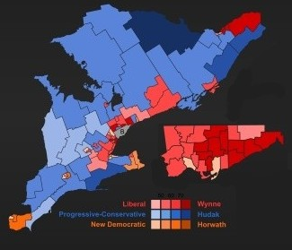
The Golden Horseshoe
- name derives from horseshoe-like shape of the land around western end of Lake ON
- most densely populated are in Canada
- > 7.5 million people live in this area
- Toronto
  - Most populous city in Canada
  - Financial capital
  - Home to main offices of national banks and investment firms
  - Immigration is major driving force of its population growth
  - Hub for entertainment industry
  - Visible minorities make up 37% of the population
- Ottawa
  - Second largest city in ON
  - Located on Ottawa River across from Gatineau, QB
  - Both official languages are used throughout Ottawa – fed gov operations on both sides of the river
  - Fed gov major employer
Other Large Urban Areas of Southern ON
- Hamilton – steel production, health care
- Kitchener-Waterloo – technology and research
- London – insurance, education, regional service center
- St. Catharines-Niagara Falls – tourism
- Windsor – manufacturing
Urban Areas of Northern ON
- Sudbury – nickel and copper mining
- Thunder Bay – trans-shipment point on the Great Lakes
  - Trans-shipment – goods from the ships are loaded on to trains, vice versa
- Sault Ste. Marie – steel production
- North Bay – regional service center
- Timmins – gold mining
The GTA greenbelt
- Effort by the provincial government to slow urban sprawl
- Prohibits urban development in a large designate zone surrounding the GTA
Chapter 7 Quebec

Quebec
- Ranks second among the six regions in terms of economic output and population
- Largest province in area
- St. Lawrence River figures prominently in QB’s history and economy
- Culture derives from historical experience of Francophones living in the area for over 400 yrs
- Approx. 80% of residents declare French as mother tongue
  - Historically been known as Quebecois
  - Quebecois – has evolved to include all residents
- Non-Francophone residents tend to be clustered in specific parts of the province
Language Laws in QB
- Provincial laws require businesses to use French
  - Laws have helped maintain French as the primary language in the region
- Most immigrants to QB choose to learn French (75%)
Non-Francophones in QB
- Anglophones
  - Generally concentrated in Montreal, the Eastern Townships, and Ottawa River valley
- Allophones
  - Non Anglophone, non Francophone
  - Concentrated in Montreal
- Indigenous Peoples
  - Inuit and Cree form the majority of the population of northern QB
The St. Lawrence River
- Essential part of North America’s transportation system
  - Connects the Great Lakes to Atlantic Ocean
- Dredging was required to prevent large freighters from running around
  - Dredging – making the river wide and deeper
- Canals were constructed to allow ships to pass around rapids or waterfalls
  - Became part of the St. Lawrence Seaway (opened in 1959)
Population Growth in QB
- Growing at a slower rate than the rest of Canada
- Birth rate is low in all areas and immigration rate is low in all areas except for Montreal
- 1871 – Quebec represented 32% of population
- 2011 – represents 23%
Decline in Canada’s Population Share
- Expansion and growth of the Canadian West
- Relocation of businesses and corporate headquarters from QB to ON
  - As separatism movements gained momentum during 1970s, Anglophone businesses and corporations left the province
  - Feared an independent QB would lead to an unattractive business climate
Physical Geography of QB
- The Canadian Shield extends over 90% of QB
- Best agricultural land is along the St. Lawrence River between Montreal and Quebec City
- Gaspé Peninsula – very rugged and confines settlements to its coastline
- Precipitation in the province is relatively high due to proximity of the Atlantic Ocean
- In small towns the tallest building is the Catholic Church
Environmental Issues
- Mining wastes are evident within the Canadian Shield
- Parts of the St. Lawrence River still contain high levels of toxic chemicals, lead, and mercury from older industrial processes
- Zebra mussel – negatively impacted aquatic ecosystems
  - Foreign species attach themselves to the bottom of ships
  - Small mollusk that was introduced to the St. Lawrence River by ships from EU
  - Blocked hundreds of pipelines and water intakes (problems for infrastructure)
Improving the Environment
- All of the energy in QB is generated from hydroelectric sources
- QB is the lowest per capita emitter of greenhouse gases of any province (along with PEI)
  - Greenhouse gas – gas that allows solar radiation to pass through but absorbs infrared radiation from earth
  - Major contributors to climate change
  - Carbon dioxide, methane
- Motorists are charged an extra 0.8 cents/litre on gas – beyond provincial tax
  - Revenue from this is used to fund maintenance of hydroelectric energy system
Historic Geography of QB – Timeline
- Area originally known as New France
- Je me souvien – I remember
  - Battle of Plains of Abraham
  - General history
- 1534
  - Cartier sailed into Chaleur Bay and claimed the land for France
  - Discovered the mouth of the St. Lawrence River the following year
- 1608
  - Champlain founded a fur trading post at the current site of Quebec City
  - Champlain – Father of New France
- 1642
  - Maisonneuve established Ville-Marie – located at the confluence of the Ottawa and St. Lawrence Rivers
  - Ville-Marie was later renamed Montreal
- 1759
  - British defeated the French Army on the Plains of Abraham
  - After this defeat British ruled Quebec for over 100 years
- 1763
  - The Treaty of Paris was formally awarded New France to Britain
- 1774
  - Britain passed the Quebec Act recognizing that citizens have special rights
  - Use of French, Catholic religion, French civil law
  - British motive for the Quebec Act was immigration
- Confederation 1867
  - Benefits of Confederation for QB
    - Union with the three other colonies would strengthen the overall economy
    - Catholicism and the French language were guaranteed protection by the fed gov
    - Provinces were given control over education and language laws
    - Working with ON, QB could influence fed politics and shape the future of Canada
- 1898
  - The fed gov extends Quebec’s northern boundary into the Canadian Shield
- 1912
  - QB nearly doubled in size when the boundary was expanded to include the Inuit lands of Nunavik
- 1927
  - Court declared the boundary between QB and Labrador should follow the drainage basin divide
  - QB does not agree with this decision to this day
The Quebec Economy
- Geographic aspects of the economy are similar to those in ON – can be divided into 2
  - Industrial and agricultural core – south
  - Resource-based periphery – north
- Differences compared to ON
  - Growing season in QB is relatively short
  - QB much better natural conditions for hydroelectricity development
- Manufacturing in QB declined during the past 10 years – remains viable industry
- 20 firms in Montreal that produce automobile parts
  - Parts are shipped to assembly plants in ON and US
- Research and technology industries have fared well with support of Montreal’s universities (McGill)
Hydro-Quebec
- Sense of pride among QB residents
- Become a symbol of its economic prominence
- Created in 1944 but was a minor force until Premier Jean Lesage came to power in 1960
  - QB announced it would purchase all private electrical utilities in the province
  - Created monopoly to generate and distribute electricity within the province and export
- Objectives of Hydro-Quebec
  - Stimulate economic growth through gov intervention
  - Undertake construction of massive hydroelectric projects in the Canadian Shield
  - Build high-voltage transmission lines to transport electricity
  - Sell power to northeastern states of the US
- Possible Expansion of Hydro-Quebec
  - Taking over the electrical utilities in NB and NS is a long-term goal
  - Gain control of the power grid in these provinces to achieve complete dominance of the area as well as a share of the market in NY state and 6 New England states
Hydroelectricity
- Developments depend on 3 factors
  - Precipitation, varying topography, access to markets
- Precipitation is abundant in QB
- Variable topography with entrenched river valleys ensure a steady flow for the power plants
- High-voltage transmission lines connect the plants in the north to the populated markets in the south
Advantages of Hydroelectric Developments
- Renewable energy
- Long life for the facilities
- Relatively low operating costs
  - Huge capital costs
- Job creation during construction
- No greenhouse gas emissions
Attracting Large-Scale Industry
- Hydro-Quebec has indirectly improved QB’s economy by attracting large-scale industrial development
  - Able to offer power to these industrial firms at a low cost
    - Northern QB can produce vast amounts of power – much more than the province needs
    - Hydro-Quebec has a long-term contract to buy power from Churchill Falls in Labrador at 1969 prices
    - As a monopoly, Hydro-Quebec is free to control its own price structures
The James Bay Project
- Involved the production of hydroelectricity from all 20 rivers that flow into James Bay from QB
- The first phase (La Grande) began in 1972 – completed 10 years later at $15 billion
- Construction required new highway to northern QB and creation of new community (Radisson)
- Controversy
  - Indigenous peoples and environmental organizations were the most outspoken against the project
  - Problems associated with James Bay project
    - Flooding caused by dams
    - Loss of habitat
    - Loss of timber
    - Chemicals in reservoirs affected fish eaten by Indigenous people
    - Impact on Indigenous hunting grounds
  - Response
    - Opposition from the Cree and Sierra Club influenced public opinion in US
    - Settlement was reached between Indigenous people and Hydro-Quebec
    - James Bay and Northern Quebec Agreement
Geography of Northern Quebec
- Occupies the Canadian Shield and the Hudson Bay Lowlands
- Economy is based on mining and forestry
- Few roads and area is too remote to attract tourists
- Political opportunities are growing for the norther Quebec regions of Nunavik
Demographics of Northern QB
- Aging population
- Net emigration – especially of younger people
- Few immigrants
- Growing Inuit and Cree population
Nunavik
- >90% population in this are is Inuit
- all residents live in one of the 15 settlements along the coast
- negotiations ae ongoing to establish a regional government
  - Would be an elected parliamentary-style cabinet and council
  - Public service would be responsible for delivering health care and education
  - Gov center would be in Kuujuaq
  - QB would maintain jurisdiction over the area and provide funding
Forestry in QB
- QB is Canada’s leading producer of paper and newsprint – much of it exported to US
- Demand for QB’s softwood lumber has been consistently higher than US softwood lumber
  - Softwood lumber – lumber that comes from evergreen trees
  - QB’s cold climate results in slower tree growth – increases the strength of the wood
Mining in QB
- Key component of the economy in northern QB
- Annual value of mineral production in northern QN is over $4 billion
- Iron ore is the most common type of mine followed by copper and gold
Tourism in QB
- Attracts tourists for its natural beauty, historic past, francophone culture
- Within a days drive of tens of millions of people
- Threats to tourism
  - Canadian dollar fluctuation
  - Global economic uncertainty
  - Thickening of US border
Urbanization in QB
- > 80% of population lives in urban area
- > 70% of population live in one of 6 cities
  - Montreal, Quebec City, Gatineau, Sherbrooke, Saguenay, Troi-Rivieres
  - Saguenay is the name of two cities that merged together in 2002 – Chicoutimi and Jonquiere
Montreal (Royal Mountain)
- Commercial, cultural, industrial centre of QB
- Located on an island
- Serves as a major port and trans-shipment point between Great Lakes and Atlantic Ocean
Quebec City
- Provincial capital and is the oldest city in Canada
- Only walled city in North America
- Features building over 300 years old
- Economy dependent on provincial gov jobs and tourism
Eastern Townships (Estrie)
- Scenic area east of Montreal abutting the Appalachian Mountains
- Sherbrooke is the largest city in this area

Chapter 8 British Columbia

British Columbia
- Mainly located in the Cordillera region
- Northeastern part of the province is located in the Interior Plains region
- Mountain ranges in BC are aligned on a northwest to southeast axis
- Central plateau lands are found between mountain ranges
- Insular Mountains are located just off the coast of BC
  - Form backbone of Haida Gwaii and Vancouver Island
- Temperate rainforests are found along the coast
- Semi-arid conditions in parts of the interior
- Tundra at high elevations
- BC is divded into 7 regions
- 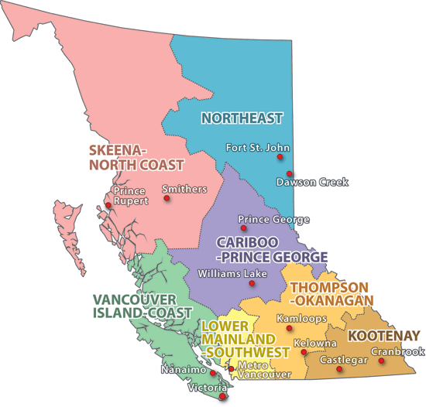
- Vancouver Island-Coast
  - Coat mountain range is the most prominent physical feature
  - Fjords are commonly found along the coast
    - Fjords – canyon filled in with water
  - Area has the mildest winters in Canada due to the moderation caused by Pacific Ocean
  - Major Industries include forestry, fishing, gov services (Victoria)
- Lower Mainland-Southwest
  - Contains alluvial soil with high nutrient content
    - Alluvial soil – deposited by water
  - Major agricultural area of the province
  - Majority of population in BC live in this region as it is home to the Vancouver CMA
- Thompson-Okanagan
  - Kamloops and Kelowna are located in this region in BC interior
  - Relatively dry area with sunny, warm summers
  - Land is a mix of open range, cattle grazing, forest and some cropland
  - Tourism is an important industry in the area around Lake Okanagan
  - Transportation corridors pass through this region
    - Roads and rails follow along the Thompson River
- Kootenay
  - Rocky Mountains are found in this region as well as Nelson, Cranbrook, and Fernie
  - Continental divide forms the border between this region and AB
  - Economy is driven by tourism, and hydroelectric power
- Cariboo-Prince George
  - Prince George is a regional service centre for the surrounding are
  - Forestry, mining, ranching, pulp and paper mill – important industries in this region
  - University of Northern British Columbia was established in Prince George in 1990
- Skeena-North Coast
  - Isolated area bordering Alaska
  - Economy is driven by fishing, mining, aluminum smelters, hydroelectric power
  - Prince Rupert is the second busiest port in BC
- Northeast
  - Only highway connecting Yukon and Alaska to southern Canada passes through
  - Small towns service traffic and truck transport along this corridor
Economy of British Columbia
- Population in BC is relatively fast growing
  - Many immigrants arrive to Vancouver CMA from Asia
- BC has 4 main exports
  - Lumber, pulp, natural gas, coal
- Vancouver has become a popular location for filming Hollywood movies
- Imports from China, Japan, South Korea flow through Vancouver to markets across Canada
Western Alienation
- Rocky Mountain act as more than just physical divide
  - Only 4 highways connect between BC and AB – too difficult to build through mountains
- Many residents of BC felt a disconnection from rest of Canada
- Cascadia
  - Name proposed for an independent country uniting BC and the states of Washington and Oregon
Physical Geography of BC
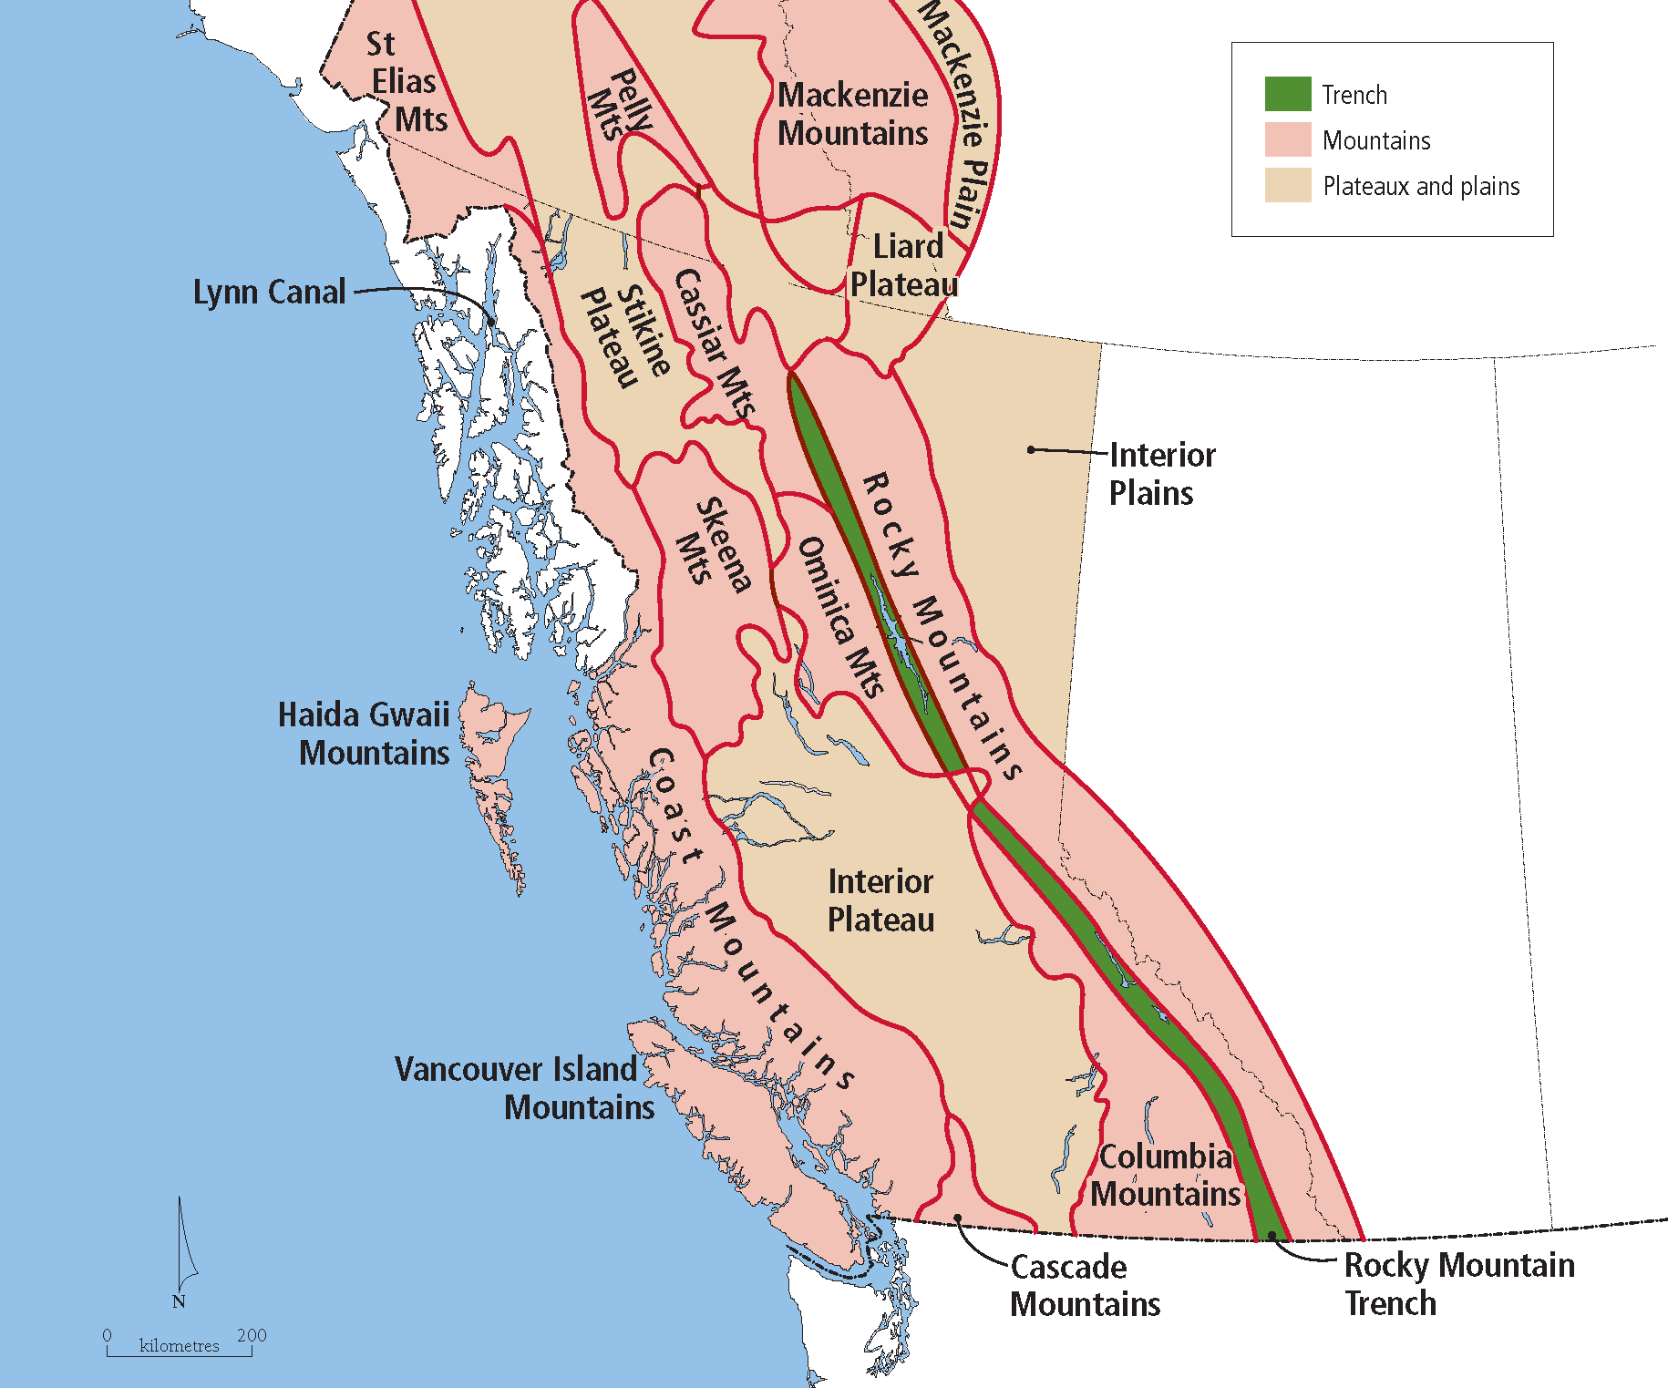
Climate Zones of BC
- Varied topography creates many microclimates
- Victoria is in the rainshadow of the Insular Mountains – receives 40% less precipitation than Vancity
- Pineapple Express is a flow of warm air in winter originating in Hawaii that keeps BC mild and wet
- Summers in Vancity and Victoria are mild and relatively dry
Environmental Issues
- BC forest industry – negatively impacted by large forest fires and mountain pine beetle
  - The beetle has destroyed vast areas of forest in the BC interior
  - Warmer winters due to climate change are allowing beetles to spread at rapid rate
  - Beetles are size of grain of rice and bore into the bark of several different species of pine trees
- Okanagan Valley is prone to dry summers, high winds, occasional lightning
  - All ingredients for forest fires
Historical Geography of BC
- Early exploration of land was by Spanish, Russians, and British
- Spain surrendered its claim to the Pacific coast north of 42$°$N
- Britain concerned about Americans arriving on the coast along the Oregon Trail
- US/Britain boundary was drawn at 49$°$N
  - Line of latitude then became the US/Canada border from MB to BC coast
- Mid 1800s – influx of Americans during gold rushes
- Britain established colony of BC in 1858 to ensure British rule over the land
- After Confederation, Ottawa aimed to lure BC into Canada
  - Promising to build railroad to the Pacific Ocean within 10 years of BC joining
  - 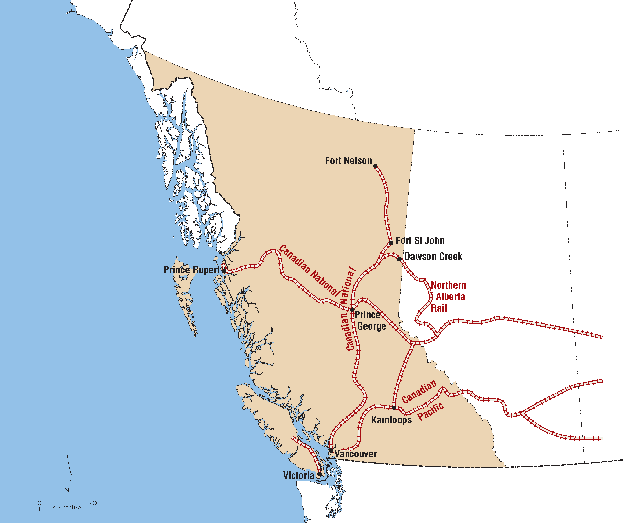
- Became 6th Canadian province in 1871
- After completion of Canadian Pacific Railway, towns and cities developed along it
- Vancity grew as trans-shipment point for lumber and coal (BC) and grain (AB)
- Immigration increased after mid 1900s
- 2010 Winter Olympics put BC on world stage – high point in its history
Core or Periphery
- BC no longer has resource-based economy
- Economy is growing and diversifying – has very small manufacturing base
  - Not considered core region
- Economic advancement in knowledge-based economy has resulted in BC becoming and upward transitional region
Pacific Rim Trade
- Exports to China, Japan, S Korea make up 25% of products passing through BC ports
- Trade is rapidly accelerating with China as their economy continues to develop
- Fed gov has invested in the Asia Pacific Gateway and Corridor
  - Program that improves infrastructure leading to BC ports
Fishing
- > 80 species of fish and marine animals are harvested from Pacific Ocean
  - Salmon, herring, shellfish
- Overexploitation of salmon stock has plagued the BC fishing industry
- Salmon Industry
  - Regulating salmon fishing is challenging – migratory fish
    - May spawn in Canadian waters but migrate to American waters
    - Example of “tragedy of the commons”
      - Destruction of renewable resources that are not privately owned
  - The main BC salmon spawning rivers are the Fraser and the Skeena
  - Fed gov responsible for managing salmon stock – four issues
    - Salmon spawn in rivers but migrate to oceans then return to ricers to spawn (5 year cycle)
    - Forestry and hydroelectric industries have negatively impacted salmon spawning grounds
    - Indigenous people are permitted to catch salmon for subsistence
    - Harvesting of Canadian salmon by Americans in international waters
  - Size of catch is highly variable from year to year – overall trend downward
    - Pollution of fish habitat
    - Warming ocean temperature
    - Overfishing
    - High fish quotas
    - Indigenous fishery
Mining in BC
- Exporting mineral deposits from BC is a challenge
  - Mines located far from ocean ports
- Shale deposit in northeastern BC contains vast quantity of natural gas
- Infrastructure improvements and pipelines are needed to export it more efficiently to growing Asian markets
Hydroelectric Power in BC
- BC has variety of energy sources including hydroelectric plants
- Ideal conditions for hydroelectric dams in Cordillera
  - High elevation, steep-sided valleys, large fast flowing rivers
- Large aluminum production plants have located in BC as result of low cost for electrical power
Tourism in BC
- Attracted to both the natural beauty and wilderness of BC and cosmopolitan urban centers
- Whistler ski resort benefited from hosting events of 2010 Winter Olympics
- Cruise ships bound for Alaska often stop along the BC coast
- Expanding the Sea-to-Sky highway to meet tourism needs was a controversial issue
Forestry in BC
- BC contains half of Canada’s softwood lumber and leads the nation in the export of forest products
- 1960 – forestry accounted for 50% of employment in BC – now accounts for 12%
  - Major factor for decline is reduction of softwood lumber exports to the US
- BC forests are divided into two major regions
  - Coast forest
    - Mild temperatures and abundant rainfall
    - Low risk of forest fires – massive trees over 200 years
    - Fir, cedar, hemlock
  - Interior boreal forest
    - Precipitation is less abundant
    - Prone to drought and forest fires in late summer
    - Trees are smaller and have shorter lifespan
    - Lodgepole pine, Ponderosa pine
- Softwood lumber dispute with US
  - US lumber producers complained to US gov about losing market share to Canadian producers who were selling lumber at lower prices
  - Lobbyists encouraged US gov to impose duties on Canadian lumber
  - Despite NAFTA this was allowable
    - US companies can claim lower prices are form of unfair trade
- Softwood lumber Trade Agreement 2006
  - US had to return $4 billion of duty it charged on Canadian lumber companies since 2002
  - US could not launch trade actions against Canadian lumber producers
  - If lumber prices fell below a certain value, Canada had to impose tax on its lumber exports – protects US lumber companies
Urbanization of BC
- > 60% of BC residents live in the Lower Mainland-Southwest region
- Urban centers – Vancouver, Abbotsford
- Second most populated are is found on southeastern Vancouver Island
  - Victoria, Nanaimo
- Third population cluster located in interior
  - Kelowna, Kamloops, Penticton
Vancouver
- Largest port in Canada and 3rd largest CMA
- 20% of CMA is Chinese ethnic origin – highest percentage in Canada
- Approx. 1/3 people do not identify with any religion – highest amount in Canada

Chapter 9 Prairie Provinces

Prairie Provinces
- Region is home to provinces of AB, MB, SK
- Commonly referred to as Prairies – northern portions of each province have a landscape dominated by boreal forest
- The southern half of the region is heavily agricultural
- Topography is relatively flat
- Climate is dry with extreme temperature difference between summer and winter
- Oil is the most important natural resource – found in western part
- Tourism is highest in Rocky Mountain foothills
- High Indigenous population and relatively high eastern EU population
Name Origins
- Alberta
  - Princess Louise Caroline Alberta was the 4th daughter of Queen Victoria and Prince Albert
- Saskatchewan
  - Derived from Cree word – swift flowing river
- Manitoba
  - Derived from Cree word – lake of the prairies
Land Settlement
- Before 1869
  - Land division was based on Metis settlement patterns
  - Lots were narrow and provided frontage along rivers
- From 1869 onward
  - Based on grids and square lots ¼ of a square mild in size
  - Square pattern preceded EU settlement and was superimposed over physical obstacles and the preceding Metis settlement pattern
Early Settlement Patterns
- Villages and towns were arranged in a linear pattern linked to pathways
- These settlements provided basic services for nearby farmers
- Larger towns developed around grain elevators
  - Roughly every third settlement along a railway was larger and provided more diverse services than villages – school, medical services
- Each village was home to frequently used services – general store
Rural population decline
- Since 1940 the rural population in the Prairies has steadily declined
  - Farms became larger and more mechanized leading to lower population density
  - Grain farms became more common
    - No livestock on these types of farms – minimal staffing is necessary
- Changes in farming
  - Decline in number of farms – every individual farm is larger
    - Not changing land of farming
- Decline in villages
  - Since 1940 the population of many villages has declined while larger towns and cities have grown
    - Lower rural population density of rural areas leads to less business for villages
    - Increased use of trucks and cars as opposed to railways
      - New roads and highways were built they tended to bypass small villages
    - Rationalization of road and rail systems
      - Infrequent used transportation corridors were shut down
  - Fewer villages resulted in reduced need to maintain a dense local road network – leading to cycle of change
    - Decline in villages closing local rail lines decline in village
Sites of Growth
- Several examples of exceptions to the pattern of decline
  - Dormitory towns – people live in town but work in a nearby city (Winnipeg/Edmonton)
  - Sites of government services
  - Resource towns – highly dependent on one specific resource
Gateway cities
- Some cities in central Prairies act as collection and distribution points between city and nearby hinterland to their north
- Size of gateway city often reflect the economic strength and extent of hinterland
  - Edmonton Northern Alberta hinterland
  - Prince Albert Northern Saskatchewan hinterland
  - Thompson Northern Manitoba hinterland
  - Smaller size of Prince Albert and Thompson reflects the few economic activities in their hinterlands
Organizing the land
- As land surveyors for fed gov continues progressing westward, they advanced on land occupied by Indigenous peoples
- 12000 Metis in region responded with organized rebellion
- Other more nomadic Indigenous tribes felt little choice but to sign treaties
- Surveyors were deployed to organize the land into townships which were each dived into 36 sections
- Each newcomer from Eastern EU was given quarter of a section
- Given land to build a homestead – no access to electricity or plumbing
  - Challenges facing Homesteaders
    - Grid and square based survey system encouraged a highly dispersed rural population – sense of isolation
    - Many settlers were not prepared for the climate and the far distance to large population centers
    - Were forced to be innovative in order for their crops to succeed
      - Summer Fallow – the practice of leaving land idle for a year or more; so land can accumulate moisture
Canadian Pacific Railway
- Sir John A. Macdonald’s vision of Canada included railway extending from Atlantic to the Pacific
- US already completed three transcontinental railways by 1870s
- Hudson Bay Company owned much of the land in the west
  - Fed gov paid company in exchange for allowing the construction of the railway
- CPR completed in 1885
Political Movements in the Prairies
- Several new parties developed in this region as a result of dissatisfaction with fed gov
- CCF (Co-operative Commonwealth Federation
  - Socialist philosophy – currently known as the New Democratic Party
- Social Credit Party (1935-1993)
  - Strict religions philosophy – popularity maximized in 1940s and 1950s
- Reform Party (1987-2000)
  - Founded by Preston Manning in Alberta (only person to lead party)
  - Strong conservative philosophy
  - Official opposition in Ottawa and changed its name to Canadian Alliance
- Canadian Alliance (2000-2003)
  - Led by Preston Manning and then Stephen Harper
  - Merged with Progressive Conservative Party in 2003 – current Conservative Party
Economy of the Prairies
- 2006-2015, the Prairies had the lowest unemployment rate in Canada
- Even during global economic crisis, unemployment rates remained well below the national average
- Majority of the population lives in one of the 5 CMAs
  - Edmonton, Calgary, Saskatoon, Regina, Winnipeg
- Most people living in the hinterland live in resource towns
  - Fort McMurray, Thompson
Shift to Natural Resources
- Price of oil increased significantly in the 1970s
- US demand for oil and gas from AB increased at this time
- Technological advancements created a method to separate oil from sand – allowing output to increase
- Increased demand for potash provided boost to the economy in SK
  - Potash – very few places around the world where you can easily extract it
  - Fertilizer for farming
Agriculture
- Was the driving force behind the settlement and development of the Prairies
- During early settlement wheat was the common crop
  - Canola has become increasingly common
- Higher prices for canola triggered by expanding demand for ethanol as alternative fuel for vehicles
- 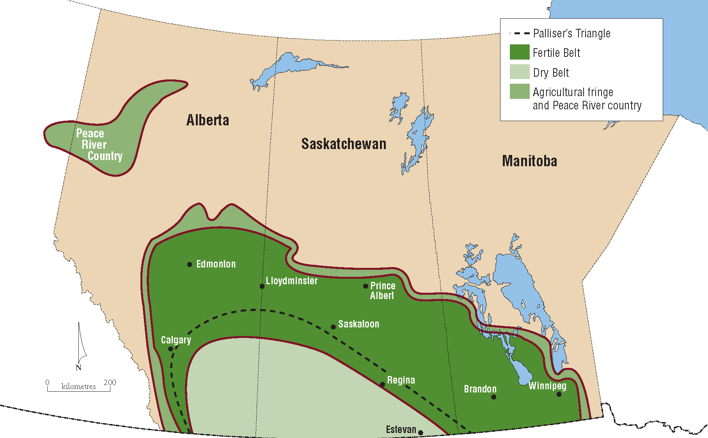
- Agricultural Belts
  - Agricultural land in the Prairies can be divided into 3 distinct regions
    - Fertile belt, dry belt, agricultural fringe
  - Major differences among these areas are the length of growing season and soil moisture
  - In agricultural fringe, the grain grown is for lower quality and is used primarily to raise livestock
  - Fertile Belt
    - Has relatively high levels of soil moisture and an adequate frost-free period
    - Wheat, canola, beans, peas, sunflowers
    - Mixed farming is common – grain & beef/pork production
  - Dry Belt
    - Cattle ranching is most common
    - Wheat is the only crop that can grow in this area
    - Practicing continuous cropping is a growing trend
      - Continuous cropping – a practice where the stubble left after harvest is not tilled
      - Aids in controlling weeds and reduces soil erosion
    - Irrigation is necessary
The Great Sand Hills
- Isolated area is located in southwestern SK
- Unique landscape formed from wind that has caused the beach deposits from former glacial lakes to form into dunes
- Dunes have stabilized as grasslands have encroached around them
Livestock Industry
- Livestock processing important secondary sector industry
- Large hog-slaughtering plants are currently located in Brandon, Red Deer, Lethbridge
- Larger plants are ideal because they achieve economies of scale
  - Economies of scale – a reduction per unit cost that results from an increase in output
  - Cost to run a factory is usually fixed
  - If you maximize the output you get greater profit
Oil Industry
- Sedimentary rock underlying the region contains valuable deposits of fossil fuels
- Vast amounts of oil are contained in the tar sands (oil mixed with sand) – bitumen
- Oil production is centered in Alberta
- Edmonton is the oil production centre and Calgary is the administrative center
- Also some production activity in southeastern SK and southwestern MB
- The four leading natural resource in the region
  - Oil, natural gas, coal, potash
- Oil sands in northeastern Alberta are the largest reservoir of bitumen in the world
- Oil sands are mixed with hot water and transported to processing plants – large hydrocarbon molecules are broken into smaller ones
- Production supplied to refineries which process it into gasoline, diesel, and propane
Environmental Issues
- Oil industry faces problem of what to do with the vast quantity of non-renewable water
- Water is toxic and cannot be released into local rivers or lakes
- Amount of toxic water is increasing daily
- Leakage from the ponds can affect groundwater or nearby surface water – including Athabasca River
- New regulations are requiring oil companies to reclaim the tailing ponds (house toxic sludge)
- Pilot projects currently underway but no proven solution currently exists
  - Possible solution – bury sludge in deep pits and cover it with layers of soil
- Extraction of oil sands presents several environmental challenges
  - Release of greenhouse gases
  - Scarred landscapes
  - Toxic water deposited in sludge ponds
  - Nearly 2 billion liters are deposited into the ponds each day
Mining
- AB contains rich coal reserves along the eastern slopes of the Rocky Mountains
- Potash and uranium are mined in SK
- Copper (Flin Flon) and nickel (Thompson) mined in Canadian Shield regions of MB
- The mining facility, rail link, town of Thompson were all developed in 1957
Forestry
- Nearly 75% of lumber production in the Prairies is located in AB
- MB the Pas is a resource town with large pulp and paper mill
Urbanization in the Prairies
- Population has undergone dramatic rural to urban shift over the past 100 years
- Top tier cities
  - Calgary, Edmonton, Winnipeg, Saskatoon, Regina
- Second order cities
  - Lethbridge, Red Deer, Medicine Hat, Brandon, Prince Albert, Moose Jaw
Southern Alberta
- Corridor from Edmonton to Calgary has become one of the more densely populated areas in Canada
- High growth rates are evident – 20% in 10 years
- Red Deer is located in the center of the corridor
Calgary
- BP, Imperial Oil (Esso), Shell each have headquarter operations in Calgary
- The proximity to the Rocky Mountains and Banff supports a tourist industry
- The economy is greatly dependent on oil
  - Unemployment rates in Calgary correlated to oil prices
Edmonton
- Known as the Gateway to the North
- Aurora borealis are frequently visible
- Along with being an oil production center, important government center – capital of AB
- Retail sector is driven by West Edmonton Mall – largest mall in North America
Winnipeg
- Historic gateway to the west
- All goods that were shipped to Prairies from manufacturing core of Canada passed through Winnipeg
- 1900 – Winnipeg largest city in the Prairies
- Major center for grain processing and administrative and financial hub of region
- Grain shipment decreased steadily as the port of Vancouver grew larger
- Winnipeg remained the largest CMA in the Prairies until the 1970s
- North end of the city has a high Indigenous population and many poverty-driven social problems
Historical Geography of the Red River Valley
- Beginning in 1670 HBC administered much of the land
- Land was mainly used for fur trading at the time
- 1810 – Lord Selkirk from Scotland acquired land in Red River Valley from HBC
- Scottish settlers arrived to form agricultural settlement – Red River Settlement
The Red River and Flooding
- Red River flows from south to north through very flat land with relatively impermeable soil
  - Snow melting as lower latitudes
  - Still cold in the north causes flooding
- In Spring, a melting snowpack at the head of the river (in the south) adds to the discharge
- Impermeable chernozemic soil causes excess water to accumulate on the land surface instead of filtering
- Land in the north has been slowly rising since the disappearance of the ice sheet 5000 years ago
  - Results in a very slow river current due to decreasing elevation difference between the south and the north
- All factors contribute to consistent flooding along the Red River in North Dakota and MB
- Red River Floodway
  - MB invested in constructing Red River Floodway in 1969
  - Artificial waterway 48km long designed to divert excess water around the city
  - Estimated that the floodway has saved billions of dollars in economic losses since it opened

Chapter 10 Atlantic Canada

Atlantic Canada
- Home to New Brunswick, Nova Scotia, Prince Edward Island, and Newfoundland and Labrador
- Have the lowest populations of the Canadian provinces
Economy of Atlantic Canada
- Unemployment rates are frequently the highest in Canada – heavy dependence on the fed gov for economic support
- Division into four small provinces discourages an integrated economy
- Some natural resources have been exhausted (coal, iron) or overexploited (cod)
- The population is widely dispersed and consists of small cities and towns
- Long distance to major cities has suppressed any type of manufacturing base
- Recent boosts to the economy especially in Newfoundland
  - Offshore petroleum deposits
  - Commuters from NL working in AB’s oil sands
Physical Geography of Atlantic Canada
- Consists of two physiographic regions
  - Appalachian Uplands, Canadian Shield
  - The Maritimes and the island of Newfoundland are located in the Appalachian Uplands
  - Labrador located in Canadian Shield
- Appalachian Uplands – ancient, eroded mountain chain
- Over millions of years, streams have cut deeply into the land resulting in hilly terrain and rugged areas
- Labrador located in the Canadian Shield
- Most prominent features are the Torngat Mountains formed 750 million years ago
Labrador
- Geography resulted in Labrador being drawn into the orbit of QB – forced to work with
  - Hydroelectricity produced in Labrador is transmitted by lines through QB
  - Iron ore mined in Labrador is shipped to the port of Sept-Isles, QB
  - The Labrador-QB highway connects Labrador’s largest city (Happy Valley-Goose Bay) to Quebec’s provincial highway system
Climate of Atlantic Canada
- Proximity to the Atlantic Ocean results in high amounts of cloud cover, fog, precipitation
- Cold Labrador current keeps winters cold enough for heavy snowfall
- Winter storms that move across North America gain moisture from Atlantic Ocean – intensify as they move over the region
- Storms that rapidly gain intensity in this way – nor’easters
Climate of Newfoundland
- Known for having the least desirable climate of any province
- Gulf Stream is warm ocean current originating off the east coast of Florida
  - Meets the cold Labrador Current off the east coast of NL
  - Mix of warm and cold currents cause frequent fog and mist
Labrador Current
- Presence of current is evident by flow of icebergs that originate in Greenland
- Labrador Current is responsible for carrying the iceberg that led to Titanic sinking in 1912
Environmental Issues
- Cape Breton Island formerly a major iron and steel center in Canada
- Waste products from Sydney Steel Company housed in Sydney tar ponds
- Toxic chemical began leaking into nearby creek and seeping into basements
- Research indicated that those in the vicinity had the highest cancer rates in Canada
- Sydney tar ponds are the site of biggest environmental clean up project in Canada
- 1998-2012 federal and NS government spend $400M cleaning the area
- Contaminated sediment was incinerated and hydrocarbon eating bacteria was used to reclaim some soil – ponds were then buried
Historical Geography of Atlantic Canada
- First part of North America to be discovered by EU explorers
- Vikings established a settlement at the northernmost point of the island of NL 1000AD
- Italian explorer John Cabot reached the area in 1497 – searching for a route to Asia
- 1700s population of the area was a mix of British, French and Indigenous people
- US War of Independence (1755-1783) impacted the historical settlement of Atlantic Canada
- Following victory by the US 40000British Loyalists migrated to NS and NB
- Waves of immigrants from the British Isles continued over the next 100 years
- Scottish tended to settle on Cape Breton Island and the Irish around Saint John, NB
Early Economic Growth
- In the early 1800s, harvesting of the area’s natural wealth was rampant
- Availability of timber and the seaside location provided ideal conditions for shipbuilding
- Just before Confederation, iron replaced wood as the main resource for shipbuilding
Confederation
- NS and NB joined Canada at the time of Confederation
- PEI became the 7th province in 1873
- NL joined as the 10th province in 1949
- All were rather reluctant to join due to the far distance from major markets in the rest of Canada
- The Intercolonial Railway from Montreal to Halifax played a role in luring the Maritimes to join Confederation
- Gave access to the larger markets and allowed Maritime businesses to achieve economies of scale
- The National Policy led to the development of southern ON and southern QB core as main manufacturing area in Canada
  - Ultimately resulted in the Maritimes remaining as periphery
Steel Industry in NS
- Iron mining provided the basis for the steel industry on Cape Breton Island
- Steel was used for the construction of railroads all across Canada
- Demand for steel dropped following WWII – size of the labour force was reduced
- Steel mill closed in 2001 – left Cape Breton Island with depressed economy
Unemployment in Atlantic Canada
- Unemployment is especially high in the rural and coastal communities of Atlantic Canada
- Many of these towns and villages have their roots in the fishing industry that can no longer support them
- Many workers turned to commuting to AB (Fort McMurray)
- Workers spend 20 consecutive days in Fort McMurray and then return to Atlantic Canada for 8 years
Atlantic Continental Shelf
- Extended perimeter of a continent associated with the coastal plane
- Atlantic Canada has a vast continental shelf that extends up to 400km offshore
- Areas where the water is relatively shallow are known as banks
- Largest are the Grand Banks east of St. John’s
- Georges Bank
  - 1977 – fed gov claimed the right to manage the fisheries within a 200 nautical mile zone off Canada’s east coast
  - US fed gov did the same for the US east coast
  - Resulted in an area of dispute between the two countries
  - Decision by the International Court awarded 5/6 of George’s Bank to the US
  - 1/6 that belong to Canada is very rich in scallops and has helped the NS economy
Fishing Industry
- differences in the type of catch by location
  - NL depended mostly on cod fishing until the collapse of that industry
  - Maritime provinces harvest variety of sea life
    - Flounder, shrimp, crab, lobster, scallops
    - Lobster has become the most valued species, accounting for over 60% of the total values of the Maritime fishery
- Modernization has impacted the fishing industry
  - Fewer fishers are required since nets and gear have become more efficient
  - Larger trawlers contributed to the problem of exploitation
- The collapse of the cod industry in NL forced many fishers to turn to gov assistance
The Cod Industry
- Mismanagement of the cod fishery was based on 3 factors
  - Estimates of cod stocks by the Department of Fisheries and Oceans were too high
  - Strong pressure for high cod quotas from NL politicians
  - Canada does not have control over the outer regions of the Grand Banks
- Largest concentration of Atlantic cod was in the Grand Banks
- 1960s annual catch was 2 million tons per year
- Much of this catch was from EU trawlers
  - Ships equipped with large weighted nets that drag across the ocean floor (indiscriminate)
  - Weighted nets indiscriminately trap all types of fish regardless of age, species, value
    - Create enormous waste because non-commercial fish are discarded
    - Destroy fragile ecosystems on the ocean floor, including coral reefs and habitats for breeding
- Fed gov placed a moratorium on cod fishing in 1992
- Still not known how long it will take for the stock to fully recover
- Cod do not reproduce until the age of 7 years
Natural resources in Atlantic Canada
- Forestry
  - Majority in NB
  - Some forests in the Maritimes have been logged three times over the past 300 years
  - Industry declined with slumping newsprint industry and the slow US housing market
  - Since 2007 five pulp and paper mills have closed
- Offshore Petroleum Deposits
  - Petroleum deposits off the coast of St. John’s are a source of optimism for NL
  - 2007 – province negotiated 4.9% equity share in an offshore drilling project
  - revenue from this resulted in NL becoming a “have” province in 2009
  - Hibernia Oil Project
    - Largest of the four drilling operations in the area
    - Construction required huge capital investment to build a platform that could withstand powerful winter storms and icebergs
    - Accounts for 12% of all Canadian oil production
- Mining
  - Canadian Shield in Labrador has deposits of iron ore and nickel
  - Voisey’s Bay is a nickel mine in Labrador
    - Lucrative mine because the deposit is close to the surface and it is a short distance from the ocean (transportation)
  - Some of the sedimentary layers in the Appalachian Uplands contain coal (Cape Breton Island)
- Churchill Falls Hydroelectric Project
  - Opened in 1971 – dam was built on the Churchill River in Labrador
  - 2nd largest hydroelectric plant in North America
  - Vast reservoir created by damming the river is known as the Smallwood Reservoir (Premier Joey Smallwood)
  - Churchill Falls Power Agreement
    - In order for power to be exported from Churchill Falls to the northeastern US has to be transmitted through Quebec
    - QB refused to allow this and negotiated a deal to buy power produced from the project
    - Deal allows QB to buy power from Churchill Falls at 1969 prices until 2041
    - Resulted in resentment toward QB among residents of NL
Agriculture in Atlantic Canada
- 5% of the land is suitable for agriculture in the Maritimes
  - 0.1% in NL
- 3 major agricultural areas
  - PEI – potatoes
  - Saint John River Valley, NB – dairy
  - Annapolis Valley, NS – fruit orchards
- The Annapolis Valley
  - Low-lying area of NS near the Bay of Fundy and Minas Basin
  - Fertile, well drained soil provides the best agricultural area in Atlantic Canada
  - After glaciers retreated, sea water flooded the land depositing marine sediments
Population Trends in Atlantic Canada
- Since Confederation the population has grown at a rate well below national average
- 1996-2006 population of NL declined by 8%
- 2011-2016 population of NB declined by 0.5%
- During time of high oil prices, approx. 7% of workforce in NL lived in that province but worked in AB
- Commuting to AB
  - Peak of construction boom in Fort McMurray up to 10000 workers from NL commuted to the area
  - Air travel, food, housing all paid for at company expense
  - Salaries they retuned to their families were a boost to the economy of NL
- Rural Population in Atlantic Canada
  - This region is 46$ rural – more than twice as high as rest of Canada (20%)
  - EU settlers arrived they searched for small sheltered harbors that would provide access to cod fishing
  - Hundreds of villages developed around these harbors – many in rapid decline
  - Delivering health care, education, social services to these villages very costly
  - Many young people leave villages in favour of urban centers
  - Since 1945, over a thousand villages have disappeared
Newfoundland Resettlement Program
- Joint venture between the fed and NL gov from 1967-1975
- Residents of tiny villages were encouraged to relocated to one of 77 “growth centers”
- If at least 75% of the residents of a village agreed, they received public relocation funds
- Over 150 villages were abandoned under this program
Confederation Bridge
- Bridge spans the Northumberland Strait and links PEI to NB
- 13km long and opened in 1997
- boost to the tourism and retail sectors on PEI
Urbanization in Atlantic Canada
- of the 33 CMAs in Canada, only 5 are located in Atlantic Canada
  - Halifax is the largest
- Halifax
  - Largest city and urban focal point of the Maritimes
  - Home to a deep, ice-free harbor that makes it ideal as an international port
  - Economy based on provincial gov services, naval base, tourism
- St. Johns
  - Largest city in NL – 2nd largest in Atlantic Canada
  - City was capital of the British colony of NL until 1949
    - Architecture is of a distinct style from the rest of Canada
  - Economy today base primarily on provincial gov services

Chapter 11 The Territorial North

The Territorial North
- Largest in area but smallest in population
- One of the most sparsely populated areas on Earth
- Indigenous peoples make up the majority of the population
Economy of the Territorial North
- The economic Performance of the region is limited to non-renewable resources
- Makes regions vulnerable to sharp fluctuations in both prices and global demand for its exports
- Economy has been subject to boom-and-bust cycles
Demographics
- The Indigenous residents currently have high birth rate but low death rate – high natural increase
- Immigration to the region is minimal
- Economy in the region stalls, non-Indigenous residents are more likely to move to the provinces for job opportunities
Governing the Region
- Provinces receive their powers as outlined in the Constitution 1876
- Territories exercise delegated powers under the watch of the fed gov
  - Do not have control over their natural resources
  - Heavily dependent on fed gov for transfer payments
Physical Geography of the Territorial North
- Area extends over four of the physiographic regions
  - Canadian Shield, Interior Plains, Cordillera, Arctic Archipelago
- Vegetation mostly consists of tundra, mosses, grasses, shrubs
- Arctic Archipelago most of the land is bare
- Contains many major rivers and thousands of small lakes
Climate of Territorial North
- Much of the area is officially classified as desert because precipitation is less than 250mm per year
- Summers are short and snowfall is possible at any time of the year
- Southern more populated parts of the region daytime high temperatures often exceed 20$°$C in July and August
- Much of the region is located north of the Arctic Circle (the 66.5$°$N line of latitude)
  - Any location north of it will experience at least one day in a year when the sun does not rise and at least one day when the sun does not set
  - Aurora borealis are commonly seen at night
Climate Change
- Temperatures are expected to warm more in polar regions than any other regions on Earth
- Due to increased solar radiation absorption that will occur with the loss of ice and snow
- Summers are forecasted to be ice-free in the Arctic Ocean and Hudson Bay by 2050
- Populations of polar bears and caribou will be greatly reduced
Historical Peoples of the Territorial North
- Generally two groups of Indigenous peoples that have inhabited the North
  - Inuit and Dene
- Inuit settlements are mostly located along coasts
  - Historically hunted marine species – seals, whales, walrus, fish
  - Dene – hunted caribou with bows and arrows in the boreal forest
Europe Exploration
- 1576 – Frobisher reached Baffin Island while searching for a route to Asia
- Battle ensued between his crew and Inuit along the coast of a bay
- Many of the Inuit in the area soon after succumbed to disease
- Community of Frobisher Bay was renamed Iqaluit in 1987
The Northwest Passage
- From the time of Frobisher’s expedition – many European explorers continued searching for continuous passage to Asia through the region
- Today referred to as the Northwest Passage
Whaling
- Early 1800s – European whalers set sail for Davis Strait and Baffin Bay
- As explorers pushed farther west, became necessary to spend the winter on nearby land
  - They met Inuit and trade developed between two groups
- Inuit would hunt and provide meat for whalers in return for knives and rifles
Fur Trade
- Demand for Arctic fox pelt in EU rose in early 1900s
  - Led to establishment of trading posts in the region
- Inuit were heavily involved in the fur trade
  - By 1950s dominated the economy
- Continued arrival of Europeans brought measles, smallpox, other communicable diseases – Inuit had no immunity
  - Hundreds of Inuits died after early contact
Relocation to Settlements
- 1960s fed gov oversaw relocation of Indigenous people throughout the North to small settlements
  - Seen necessary to protect them from hardships of living on the land
  - Concentrating people in settlements allows fed gov to provide services efficiently
- Impacts
  - Positive
    - Food security
    - Access to medical services
    - Public education
  - Negative
    - Loss of the traditional culture
    - Reduction of country food in the diet
    - Social issues related to poverty and unemployment
- Life in Settlements
  - Main source of income is from gov assistance
  - Indigenous settlements in the North have the highest rates of suicide and alcoholism in Canada
  - Few Indigenous families have abandoned settlement life in favour of living off land
    - Positive impacts are seen as outweighing the negative impacts
Historical Expansion of the Territories
- Area was formerly known as Rupert’s Land
- Britain declared ownership of this land as result of early discovery and exploration
- Much of the area granted to HBC in 1670
- Until the end of WWII, fed gov ignored the North
  - Leaving Inuit and Dene to trade fur and live off the land
A Strategic Frontier
- After WWII, Canadian North served as buffer zone between the Soviet Union and rest of North America
- 1950s – series of radar stations were constructed along the 70$°$N line of latitude
  - Designed to detect potential Soviet bombers
  - Allow sufficient response time for US fighter planes to destroy them
Arctic Sovereignty
- National boundaries have yet to be determined in much of the Arctic Ocean basin
- Increased urgency to acquire territory and declare sovereignty
  - Pressure from Russia staking claim of Arctic areas
  - Vast quantities of oil lie beneath the Arctic sea floor
  - Climate change may turn the area into a commercial shipping route
- Agreed in the international community that Canada owns the islands of Arctic Archipelago
  - Ownership of the waterways between the islands is in dispute
- US considered the Northwest Passage an international sea route
- 1988 – Canadian Prime Minister Brian Mulroney and US President Ronal Reagan singed the Arctic Cooperation Agreement
  - US is always to notify Canada before sending ships through the northwest passage
  - Canada is always to give consent
- Canada is concerned about the impacts of oil spills from tankers traversing the Northwest Passage
- 1985 – Arctic Waters Pollution Prevention Act
  - Passed by Canada’s parliament
  - Gives Canada the right to control navigation in its sector of the Arctic Ocean
- 2003 – UN Convention of the Law of the Sea
  - Coastal countries have the right to control access to their coast within 12 nautical miles
- Some of the islands in the archipelago are separated by more than 50 nautical miles of water
Population in Territorial North
- Almost all residents live in settlement, town, city
- Mining sites are not associated with resource towns
  - Workers are flown to the mines from Yellowknife
- Most settlements do not classify as urban because their population is below 1000
- Approx. 50% of the population lives in an urban area
  - Most of the urban population resides in one of the three capitals
Economy of the Territorial North
- Energy and mining are the main commercial elements of the economy
  - Diamonds, zinc, copper, iron ore
- Primary sector industries comprise 15% of all jobs
  - Compared to 4% in the rest of Canada
- Economy is based on two major components
  - Extraction of natural resources
  - Fed transfer payments – Territorial Formula Financing
Indigenous Values
- Strong attachment to land, country food, and the ethic of sharing
- Country food - food that is obtained directly from the land or water by means of hunting or fishing
- Hunting is natural to the Inuit but the European Union has banned the import of their seal pelts
  - What they believe is inhumane killing
  - Negatively affected Inuit economy
Nunavut
- Means “Our Land” in Inuktitut
- Established in 1999 out of a land settlement agreement between Canada and Inuit of the eastern Arctic
- Inuit established a public form of gov
  - Both Indigenous and non-Indigenous residents have equal political rights
  - Goal is to promote Inuit culture and the Inuktitut language
Transportation
- Few transportation routes in the region
  - High cost of construction and sparse population
- Nunavut does not have highways
- Mining companies have lobbied the fed gov to build raods to their sites
- Number of winter roads connect some mining sites with year-round highways
  - Winter roads – temporary roads over frozen lakes and rivers during the winter to provide ground transportation for freight
- Air Commuting
  - Proven to be an effective way to attract skilled workers from provinces to work for resource projects in the North
  - Does not strongly impact the economy of the North
    - Workers spend their wages in their home communities in the provinces
    - Workers pay income tax to provincial rather than territorial gov
Megaprojects in the North
- Resource development projects that are controlled by large multinational corp.
- Often have capital cost more than $1 billion
  - Require several years to complete the construction stage
- All megaprojects in the North are based on non-renewable resources
  - Developments have a limited life span
- Impacts
  - Create development in the region
  - Not necessarily beneficial to the specific region in which they are located
    - Construction equipment and supplies are manufactured outside the region
    - Have negative impact on landscape
    - Many workers are from outside the region
- Risks
  - Due to high capital cost – projects have risk
  - How do companies reduce risk?
    - Arranged for long-term sales of the product at a fixed price before proceeding with construction
    - Get gov assistance in the form of low-interest loans, subsidies, tax concessions
- Examples of Megaprojects in the North
  - Mackenzie Valley Pipeline Project
    - 1970s – pipeline to transport natural gas from northern Alaska through the Mackenzie River Valley
    - pipeline was rejected due to unresolved Dene land claims in the area, enviro concerns, dropping natural gas prices
    - higher demand for natural gas in US led to recent discussions of constructing the pipeline
  - Normal Wells Oil Fields Project
    - Pipeline extends from Norman Wells, NT to northern AB and was complete in 1985
    - Output of the Norman Wells oil fields has approached 2M cubic meters annually
    - Project has been successful in meeting its objective – shipping oil to southern markets
    - Warming climate could present challenges as permafrost melts causing ground subsidence
  - Northwest Territories Diamond Project
    - Canada is the third largest producer of diamonds in the world due to 2 mines in NT
    - Diamonds discovered in the area in 1991
    - Workers commute to the mines on by air on a 14 day in 14 day out rotation
    - Diamond production is the backbone of the mining industry in the North
      - Production at $2.1B annually

Overview

A Sense of Place
- It is not culture, religion, language, ethnicity or race that is the dominant feature of civilization – it is place
A Nation of Regions
- Sheer size of Canada requires us to divide it into manageable regions
- Not the case for many countries – presents added challenge for governance
- Political decisions that address regional differences are necessary
- Negotiation and compromise are hallmarks of these decisions
- Canada’s strength lies in its ability to reconcile cultural and regional disputes
- Equalization payments have been designed to ensure consistent standard of living across Canada
  - Future of payments heavily dependent on presumed improvement of the ON economy
  - For many years, fed gov depended on tax revenue from ON to help fun equalization payments
Ontario
- Strength
  - Most favourable conditions for economic growth, industrialization, agriculture, trade with US
- Weakness
  - Manufacturing economy has an uncertain future due to continued globalization
Quebec
- Strength
  - Home to extensive hydroelectric resources and has access to the St. Lawrence River shipping route
- Weakness
  - Consistent recipient of large equalization payments
  - Struggle to maintain its culture and language in an English dominated continent
British Columbia
- Strength
  - Culture centered around ecotopia and growing population with expanding links to the Pacific Rim
  - Ecotopia – focus on green living with emphasis on quality of the life and sustainability
- Weakness
  - Forestry industry has stalled because of the US housing market
Prairie Provinces
- Strength
  - Contains a wealth of natural resources (oil, potash) and abundant fertile soil
- Weakness
  - Sense of alienation from the core has developed partly due to the actions of past fed gov
Atlantic Canada
- Strength
  - Offshore petroleum deposits have provided wealth
  - Fishing industry will likely improve in time
- Weakness
  - Stagnant population due to lack of employment opportunities
The Territorial North
- Strength
  - Rich in natural resources
  - Rapidly growing population from natural increase
- Weakness
  - Climate change will dramatically impact the region
  - Social problems continue in the settlements
Spatial Framework
- Spatial framework of Canada’s regions consists of
  - Core regions – ON, QB
  - Upward transitional – BC, Prairie provinces
  - Downward transitional – Atlantic Canada
  - Resource frontier – Territorial North
- Frameworks are not rigid – can always be adjusted
Canada’s Faultlines
- Centralist/Decentralist
  - Has its roots in the struggle for power
- Indigenous/Non-Indigenous
  - Struggles over land, rights, enviro concerns
- English/French
  - Consistent faultline spanning a time from the very first settlers to QB separatist movements
- Newcomers/Old-timers
  - Immigration is changing the face of Canada’s major cities
- Emerging Faultlines
  - Regional faultline has erupted in recent years – need to reduce the nationwide carbon footprint
  - Fed gov introduced a policy that requires all provinces to have some form of carbon pricing by 2018
    - Pitted oil-rich provinces against ON and QB
Canada and Global Economy
- Entry of China into the World Trade Organization in 2001 impacted Canadian economy
  - Manufacturing sectors slowly eroded
    - Low-cost Chinese goods have become more common
  - Resource industries expanded to meet unprecedented demand from China
The Future
- Most oil and natural gas exports will continue to flow to the US – with increasing amounts flowing to Asia
- BC and ON will gain more seats in the HOW for the next fed election
- Uncertainties relate to oil prices, manufacturing industry in ON, impacts of climate change on the territories
National Goals for the Future
- Greener, urban country where creative class in encouraged and flourishes
  - Creative class – people who are attracted to cities that have a progressive and diverse culture
- Indigenous residents become more involved in Canada’s prosperity and move toward self-government in Nunavik and other areas
- Even more pluralistic society where any tensions that arise quickly subside
  - Pluralistic – society that values multiculturalism
- Stronger relationship with US that involves more open border for trade relations to grow and expand
- Regional growth driven by knowledge-based economy
- Strengthened sense of national identity and unity among all regions

