Bio Lab Exam Review

The 7 golden rules of the lab:
- Lab coats are obligatory and must be worn at all times in the laboratory
- Safety glasses must be brought to each lab period and worn during any potentially hazardous procedures
- No cell phones must be used during the lab, nor kept on lab benches
- No eating or drinking in the lab, this includes chewing gum
- No rowdiness. We work with expensive, sometimes dangerous equipment, as well as poisonous substances
- Discussion is encouraged, but general noise is disruptive
- Cleanliness: you must keep your own equipment and notes in order. Clean up your equipment and your bench at the end of each lab
Safety Instructions:
- You break some glassware or a thermometer:
  - Notify your TA, who will place the broken glassware in the broken glass container. If a mercury thermometer is broken, a technician (trained in hazardous waste clean-up) will come deal with the situation
- You cut yourself or have any other medical problems:
  - Notify your TA, who will use the contents of a small First Aid Kit located in the labeled drawer. Emergency telephones are available on the podium for medical emergencies. In addition, in the hallway outside each lab room you will find emergency eyewash stations, safety showers and a red button on the wall that will trigger an alarm to campus security. If necessary, the student may then be escorted by a demonstrator to Health services.
- Your clothes catch fire:
  - Notify your TA, who will bring you to the safety shower located in the hallway to extinguish the flames. The fire extinguishers located beside the doors may also be used for this purpose
- You hear the fire alarm:
  - Do not panic. You should leave your lab, in an orderly manner to the primary fire exit for your room. Once you have descended to the main floor, exit the building, moving about 30 meters away from the door.
- You accidently spray some toxic liquid into your eyes:
  - Rinse eyes for 15 minutes

Lab #1: Intro to Microscopy
- Biolabo website
  - Contains many useful resources relevant to the biology teaching labs.
- Infinity Capture:
  - Connects to the microscope to capture images of your observed specimen
- The Compound Microscope:
  - Olympus CX41 compound microscope
  - Consists of a system of lenses, a light source, and a geared mechanism for adjusting the distance between the lens system and the object being observed.
- Parts of the compound microscope:
  - Revolving nosepiece:
    - supports the various objectives (4X, 10X, 40X, and 100X)
    - and as it rotates they are brought into the light path of the microscope
  - Stage:
    - The slide is placed here.
    - Has an opening so that light can pass from the condenser underneath, through the specimen and into the objective above
    - A system of knobs on the side of the stage allows you to move the specimen under the objective on the X and Y axes.
  - Coarse Focus Knob:
    - Permits rapid change in distance between the specimen and the objective thereby allowing for rough focusing
    - Do not use when focusing with the 40X objective
  - Fine Focus Knob:
    - Is used after the coarse knob
    - Turning it brings the specimen into full focus
    - Switching between objectives, you should only have to use this knob to get a clear image of your specimen
    - Permits small changes in distance between the specimen and the objective.
  - Oculars (eyepieces):
    - A magnifying element in the microscope, usually 10X.
    - This is where you actually look at your specimen
    - All the microscopes are parfocal, so that when an object is in focus with one objective, the focus will not be completely lost when changing to the next objective
  - Objectives:
    - The magnifying element which is closest to the specimen.
    - Determine the visual magnification of the specimen
    - There is a series of numbers on the objective.
    - The numerical aperture is a number that is used to set the aperture iris diaphragm. This calibrates the microscope
  - Condenser:
    - Focuses light from the lamp into a tightly focused cone passing through the specimen on the stage and the objective lenses above.
    - Its position focuses the light path between the condenser, through the specimen, and on to the objectives
    - System of lenses that concentrates the light furnished by the illuminator.
    - It does not magnify the object
  - Condenser height adjustment knob:
    - Allows one to focus the concentrated light onto the specimen
    - Aligns the condenser to have light come through
  - Aperture Iris Diaphragm:
    - Used to reduce the glare from unwanted light by adjusting the angle of the cone that comes from the condenser
    - Set the aperture iris diaphragm to match the numeric aperture value of the objective you are using.
    - Each time you switch objectives, you’ll have to reset this control
  - Field Iris Diaphragm:
    - Determines the diameter of the cone of light that enters to condenser
    - Its position is adjusted with the condenser adjustment knobs
    - The diameter is set using the ring. Twist it until it is just a bit larger than the field of view
    - You need to change this each time you change between objectives
  - Y-axis knob:
    - The knob that moves the specimen on the stage forwards and backwards-towards and away from you (top knob)
  - X-axis knob:
    - This knob moves the specimen on the stage to the left and the right (bottom knob)
- Production of an Image by a Compound Microscope:
  - The most important part of the microscope is the objective.
  - All the other parts of the instrument are designed to help the objective produce the best possible image
  - The best image is not the largest; it is the clearest
- Using the compound microscope:
  - Always handle it GENTLY!
  - Carry it with both hands, one hand on the arm and the other hand under the base
  - If the ocular or objective are dirty, ONLY use Kimwipes (anything else may scratch it)
- Orientation and working distance:
  - Everything you see is flipped backwards and upside down
  - Working distance: distance between the objective and the slide
    - As magnification increases, the working distance decreases
  - Depth of Field:
    - Microscopes can only focus on one depth of field. Surfaces lower or higher on the microscope will be out of focus
      - Depth of field decreases as you increase magnification
- Magnification:
  - Calculating Magnification: Formula
Magnification Factor= measured size of object/ real size of object

- Specimen Size and Magnification of the picture:
  - Formula:
    - Real size of object A = on-screen size of object A
    - Real size of object B = on screen size of object B
  - First Method: Measuring an object using scale bar
    - $\frac{On screen length of object}{on screen length of scale bar}$ * real size of scale bar
    - Ex: Larva is 60mm on screen. The scale bar on screen is 30mm, but represents 0.2 m. What’s the real size of the larva?
    - Larva= (60/30) * 0.2
= 0.4 mm
  - Second Method: Measuring an object using the field of view
    - (real size of FOV/ On screen size of FOV) * on screen size of the object
    - **** on screen size FOV = measure FOV with a ruler on computer screen
- Stereoscopic (dissecting) Microscope:
  - This microscope is used to view objects that are too large or too thick to observe under the compound microscope
  - Always equipped with two oculars producing a 3D image
  - The image is not inverted
  - Provides magnification in the range of 6.7X-45X using a zoom-type lens system
  - Can be used with reflected light or transmitted light.
    - Reflected light: directed unto opaque specimens from above and is reflected to the viewer
    - Transmitted light: used with translucent specimens and passes through the specimen from beneath the stage and into the viewer’s eyes.
- Prokaryotic and Eukaryotic Cells:
  - Prokaryotic:
    - Belong to two big groups: archaea and eubacteria
    - Usually smaller than eukaryotes
    - Unicellular organisms
    - Characterized by the absence of nuclear membrane and membrane bound organelles
    - Most genetic material consists of circular DNA
    - Cyanobacteria: looked at in the lab
    - 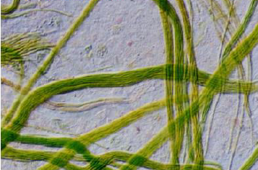
    - The filaments were moving around under the microscope
    - Light green stringy appearance
  - Eukaryotic:
    - Much larger
    - Possess a membrane bound nucleus and membrane bound organelles
    - Organelles are more complex and numerous
    - Genome is larger
    - Plant and animal cells
    - Elodea cells: looked at in the lab
    - 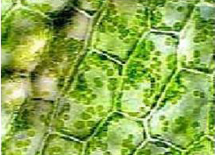
    - chloroplasts= photosynthesis
    - chlorophyll responsible for the green pigment
    - Plasmolysis: Contraction of protoplast of a plant cell resulting in water loss. (shrinkage). This is accomplished by exposing cells to a 5% NaCl solution.
    - Cyclosis: The streaming rotary motion of protoplasm within certain cells and one-celled organisms. Cytoplasmic streaming is the directed flow of cytosol (liquid component of the cytoplasm) and organelles around large fungal and plant cells. This movements aids in the delivery of nutrients, metabolites, genetic information, and other materials to all parts of the cell.
    - Plasma membrane cannot be seen in plant cells because it is too thin to see under microscopes. In order to see the true limiting boundary of the cytoplasm you need to put cells in a strong salt solution in order to withdraw the PM away from the cell wall. This will cause water to defuse out of the cell by osmosis, thereby decreasing the cell volume.

Lab #2- Permeability of the Red Blood Cell:

- Erythrocyte offers numerous advantages for the study of cell membrane permeability:
  - One can contain large quantities of homogenous cells
  - Can keep them in an isolated state for a long time (3 or 4 days in NaCl solution)
  - Contains large quantities of pigment hemoglobin. When volume of cell exceeds a critical volume, the cell ruptures and pigment is released to the external environment. This is known as hemolysis.
- Tonicity: relative concentrations of solute in the fluid inside and outside the cell
- Osmosis: the spontaneous movement of water molecules across a semi-permeable membrane. Water can freely cross the PM, mostly thanks to specialized proteins called aquaporins that form can canals through the membrane. Water movements are mostly driven by tonicity adjustment: water will move from the compartment with a lower solute concentration to the compartment with a higher solute concentration.
  - In this experiment we examine the changes in tonicity in erythrocytes
  - Hypotonic environment (solute greater outside the cell) = water enters the cell and volume increases
  - Eventually the cell will reach a critical volume and undergo hemolysis
  - Isosmotic Solution: same osmotic pressure inside and outside the cell.
    - Isosmotic solution can induce hemolysis if the solution is a penetrating substance (ex. Ethylene glycol)
    - This penetrating substance will enter the erythrocyte and change the tonicity and osmotic pressure
    - The external environment becomes more hypotonic as the osmotic pressure inside the cell increases
    - Water enters the cell and eventually undergoes hemolysis
  - Time of hemolysis depends of the permeability of the membrane to the substrate present
  - When 75% of the erythrocytes have hemolysized, the colour of the red blood appears to be transparent. This is what will be used to measure the time of hemolysis with erythrocytes in different substances.
  - Lab results:
  - 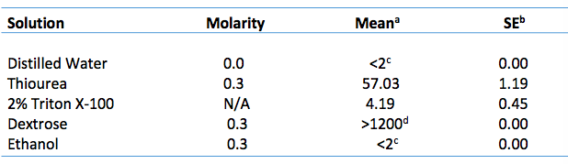
  - 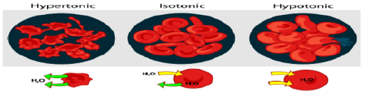
  - Isotonic: cell shape remains the same
  - Hypotonic: Cell swells
  - Hypertonic: Cell shrinks
- Factors that affect hemolysis:
  - When a molecule is highly polar, the rate of hemolysis is longer because it requires the aid of trans port proteins, which take part in facilitated diffusion
  - Essentially, the bigger the molecule is, the harder it is for it to penetrate the cell membrane of the red blood cell and the smaller the molecule, the easier it will be for it to penetrate the cell membrane.

Lab #3- Cellular Processes in Amoeba proteus:
- Commonly found on the bottom of fresh water lakes and ponds
- Single celled eukaryotic organism, protest, part of the amoebozoa group
- Uses membrane protrusions called pseudopodia for moving and eating- food vacuoles digest food
- Sensitive to light and heat under a microscope
- Due to the fact that it lives in water, amoebas must constantly fight excess water entry by osmosis. They release this water thanks to a contractile vacuole
- Principal regions of cell (BE ABLE TO IDENTITFY)
  - Hyaline ectoplasm
  - Granular endoplasm (fluid or gelatinous)
  - Uroid
  - Hyaline Cap
  - 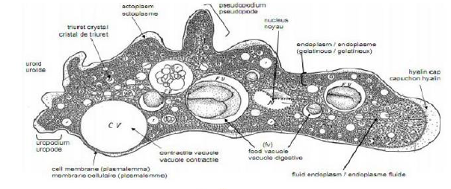
- Contractile vacuole expands and shrinks in a cycle
  - Diastole: is the coalescence (merging or smaller CV’s) and continual growth
  - Systole: is the release of CV contents to exterior
  - Approx. cycle is 4-6 minutes
- Endocytosis: Process of cells absorbing/ engulfing other molecules such as proteins, often cations
- Pinocytosis: Cell drinking, also known as fluid endocytosis
- 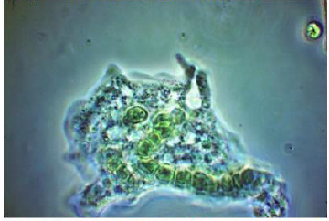
- Phagocytosis: engulfing solid matter such as bacteria or other organisms
- 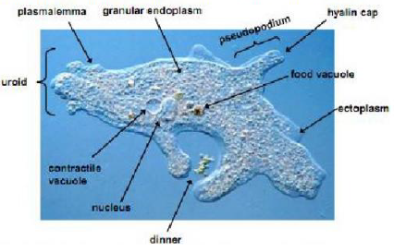

Lab #4- Mitosis:
- The cell is the basic functional structure that defines living creatures.
- All cells have in common the fact that they will have to, at one point during their life, reproduce.
- Necessary for the continuity of life, and allows organisms to reproduce
- The process that permits one cell to divide into two is called cellular division.
- Prokaryotes and unicellular eukaryotes rely on cell division to produce new individuals
- In multicellular organisms, cell division allows the development of an embryo
- In eukaryotes there’s two types of cell division:
  - Cell division that will give rise to two daughter cells identical to the original mother cell (Mitosis). Even separation into 2
  - Cell division that will produce gametes (Meiosis). Cells produced by meiosis are different from the original cell and contain a different genetic content. These cells will be used for sexual reproduction. (lab 5)
- The Cell cycle:
  - A eukaryotic cell goes through a series of events called the cell cycle.
  - May last for a few minutes or hours in actively dividing diving cells.
  - The cell cycle can be broken down into different phases:
    - Cell cycle= M phase (mitosis + cytokinesis) + Interphase (G1 +/- G0 + S + G2)
  - Cell division (or M phase) is composed of both nuclear and cytoplasmic divisions
- Interphase:
  - is the phase separating the two cell divisions
  - in which a cell enters a period of growth and preparation for the next M phase
  - cell spends most of its time in interphase
  - it’s during this time that most cellular processes are carried out
  - can be further divided into sub-stages:
    - First Gap (G1):
      - Period of growth and activate synthesis of all groups of macromolecules (RNA’s and proteins)
      - Cytoplasmic organelles (mitochondria, ribosomes, etc…) are duplicated
      - Length of this stage varies depending on the physiological condition of the cell.
      - May last from 0.5 hours, to months or even years
    - Synthesis Phase (S):
      - Precise replication of all DNA and synthesis of DNA associated proteins (ex. Histones) or microtubule-associated proteins (ex. Centrioles)
      - At the end of the S phase, each duplicated chromosome consists of two chromatids joined together by protein complexes called cohesins
      - The connections between chromatids are tighter in the centromere region where the duplicated chromosome look narrower.
      - Centromere: region that joins chromatids
      - Kinetochore: button like structure which links chromosomes to the mitotic spindle.
      - Mitotic Spindle: lines chromosomes in middle of cell (metaphase) and pulls chromosomes apart (anaphase)
      - Not as variable in length (4.5 to 22 hours)
    - Second Gap (G2):
      - Protein synthesis
      - Production of structures needed for mitosis (ex. Spindle fibers)
      - Shortest stage in Interphase (less than 4 hours)
      - Period after DNA replicates; cell prepares for division
      - Interphase ends in the parent cell
    - G0:
      - Some cells may leave the cell cycle entirely
      - Enter this phase
      - Cell cycle arrest
      - May be permanent or temporary (eventually returns to G1) withdrawal from cell cycle
    - Most cells that stop dividing arrest in G1, instead of entering G0
    - Good example of cells that stop during interphase are: cells of the central nervous system and muscle tissues in mammals
    - Cells stop dividing completely when their completely grown and differentiation is finished

- M Phase (Mitosis + Cytokinesis):
  - Part of cell division which refers specifically to the process of nuclear division where the chromosomes are equally distributed between two daughter nuclei
  - Both daughter cells are identical to the parental cell
  - 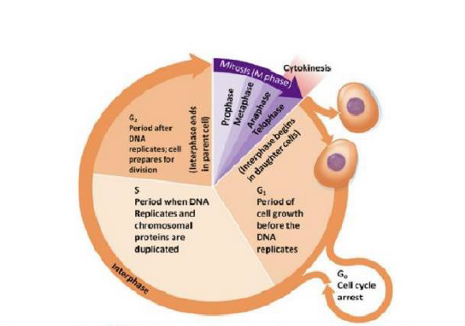
  - After mitosis and cytokinesis, both daughter cells are identical to each other and to the parental cell
  - After these two processes, three principal cell types may be found:
    - Cells that divide continually (cells of the gut epithelium)
    - Cells that leave the cell cycle (G0) and do not divide again during the life of the organism (ex: nerve cells)
    - Cells that enter a resting state (any of the G phases) but after some stimulus return to the cell cycle and divide (ex: liver cells after partial removal of the liver)
  - Involves a dynamic series of events with often rapid physiological and morphological changes.
  - Its divided into 5 main stages: prophase, prometaphase, metaphase, anaphase, and telophase
  - Closely associated (but not always) associated with nuclear division is the division of the cytoplasm known as cytokinesis.
    - It begins in late anaphase and continues throughout telophase.
    - It is seen as a cleavage furrow which forms in the middle of animal cells or a cell plate

- Summary of cell cycle phase in plants:
- 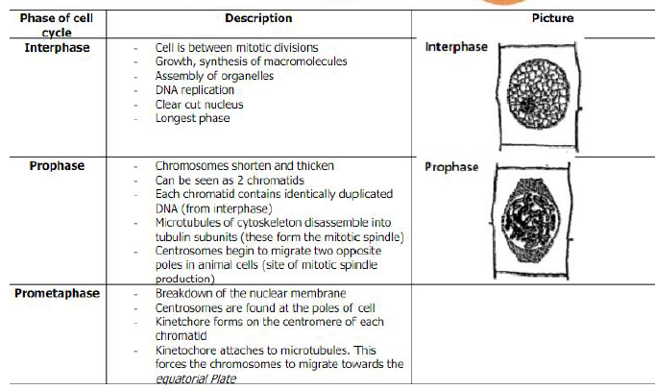
- 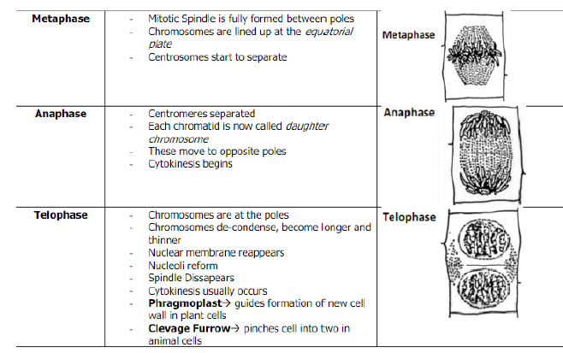

Microscopic observation of mitosis:
- Mitotic division is more clearly seen in plants as chromosomes stand out more clearly
- Additionally, plants have growth confined to certain areas and mitotic cells are usually abundant there
- These growth centers occur principally in root tips and in stem tips (apical meristems)
- Mitosis in Plants:
  - Feulgen Stain:
    - Specifically, colours DNA in magenta red
    - This substance is a “Schiff base” which will react with aldehyde groups to form a coloured reaction product.
    - Intact DNA does not contain free aldehyde groups and will not react directly with the stain.
    - However, DNA does contain deoxyribose sugars molecules chemically linked through aldehyde groups to purine and pyramidal bases.
    - To form free aldehyde groups in DNA, it’s first hydrolyzed with hot HCl which removes the purine bases and frees the aldehyde groups of the deoxyribose sugar.
  - How root growth is accomplished:
    - Root Tip:
      - Many cells in the root tip are undergoing mitosis.
      - Square cells of root tip are undergoing mitosis
    - Root cap:
      - Around the end of the root tip is a mass of irregular dead cells with thicker walls. These are root caps
      - Protects the apical meristem of the root tip as it is pushed into the soil.
      - Detects gravity and controls the direction of root growth
    - Region of Apical Meristem:
      - Immediately above the root cap
      - Zone of cell division or the site of apical growth of the root
    - Quiescent Center:
      - At the base off the apical meristem
      - Relatively inactive region where the cells are arrested in G1 of interphase
    - Region of Elongation:
      - Above the region of cell division, but not sharply delimited
      - The elongation of cells in this region result in most of the increase in length of the root
    - Region of maturation:
      - Follows the region of elongation
      - Site in which most of the cell of the primary tissues mature
      - Root hairs are also produced in the region
    - Xylem Cells:
      - These vascular bundles transport water and salts from the soil to the rest of the plant
    - Phloem Cells:
      - Transport carbohydrate from the photosynthetic portions of the plant to the roots
    - *****THE ROOTS DO NOT HAVE CHLOROPLASTS AND CANNOT MAKE THEIR OWN FOOD******

Root Tip Diagram:
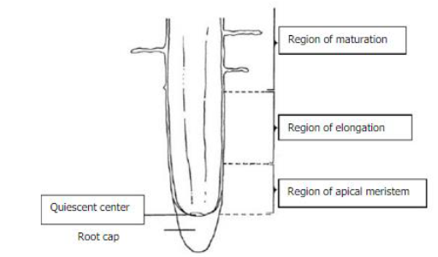
Samples that were viewed in the lab:
Broad Bean Squash, Onion Root, and whitefish blastula embryo
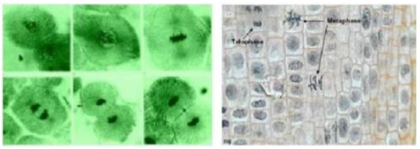

- Animal Mitosis:
  - Similar to plant cells but there is no cell wall around the membrane and no cell plate is formed during telophase. At the end of each nuclear division, the nuclear membrane simply pinches together and the cells divide
  - There is an aster, which is a semi-circle of fibrils around each end of the spindles (none in plant cells)
  - Animal cells such as muscle, nerve and red blood cells do not divide; they lose their ability to divide during their differentiation and development.
  - Embryo cells, however, divide rapidly
Whitefish= Coregonus clupeaformis
Onion Root= Allium cepa
Broad Bean= Vicia faba

Lab #5- Meiosis:
- Process of nuclear reduction division
- Is a duplication of DNA, followed by 2 divisions.
- The net result of meiosis is 4 cells, not 2.
- The 4 daughter cells are not identical to each other nor to the mother cell due to events that occur in meiosis.
- Each daughter cell contains only “n” chromosomes, half the number in the mother cell.
- Upon fertilization, the 2n number of chromosomes is restored.
- Meiosis assures:
  - That the chromosome number will be stale from generation to generation
  - That each offspring resulting from sexual reproduction will receive two entire sets of genetic instructions
  - That genetic diversity is promoted among the products
- Plant life cycles are characterized by an alternation of generations between Diploid and Haploid stages
  - The diploid (2n) generation/ sporophyte undergoes meiosis to form haploid spores.
  - These spores divide mitotically to become multicellular haploid individuals or gametophytes
  - They eventually divide mitotically, developing and differentiating into a multicellular diploid organism, the sporophyte.
  - This type of meiosis is called sporic meiosis
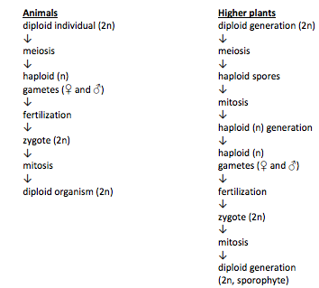
Differences between animal and plant meiosis:

- In most animals, an alternation of ploidy level occurs.
- The diploid individual produces haploid gametes by meiosis (gametogenesis)
- Male and female gametes fuse to form a diploid zygote
- The zygote then divides to become a multicellular diploid organism
- This type of meiosis is called gametic meiosis

Stages of Meiosis 1:
- Few differences between premeiotic Interphase and mitotic interphase
  - Premeiotic S may be up to 20 times longer than premitotic S in the same species
  - Sex chromosomes are replicated at the beginning of S-instead of DNA at the end of S in premitotic interphase
  - About 0.1% to 0.2% of DNA is not replicated until meiotic prophase
  - Nucleus grows to a greater volume than in mitotic interphase
    - Results in identical sister chromatids attached to the centromere
- Prophase 1:
  - Homologous chromosomes pair up
  - Recombination occurs
  - Large amounts of RNA and proteins are synthesized
  - One of the longest stages in meiosis
  - Lasting anywhere from weeks to years
  - Can be divided into 5 sub stages:
    - Leptotene:
      - Initial condensation of chromosomes occurs so they appear as fine single threads
      - Tips of chromosomes (Telomers) are attached to the nuclear membrane
    - Zygotene:
      - The maternally and paternally derived copies of each homologous pair of chromosomes line up along their length in a process known as synapsis
      - As the chromatids between homologous chromosomes intertwine, a synaptonemal complex is formed
      - May last several hours to three days
    - Pachytene:
      - Recombination occurs as adjacent chromatids break and join in a process called crossing over.
      - Fully paired homologues are called tetrads (four chromatids)
      - Genetic material is exchanged between homologous chromosomes
      - Key event in creating genetic diversity
    - Diplotene:
      - Separation between homologues increases so that 4 chromatids are visible
      - Chiasmata (regions of crossing over) become visible
      - The synaptonemal complex disappears and chromosomes detach from the nuclear membrane.
      - Extensive RNA transcription occurs in some species
      - Can be up to 12 years
    - Diakinesis:
      - Condensation of chromosomes finishes and final modifications occur, ensuring that the chromosomes are ready for division.
      - RNA Transcription stops and the nucleoli disappear
- Metaphase 1:
  - Nuclear membrane breaks down at the beginning
  - The paired homologues line up on the equator of the divisional spindle
  - The ordering of maternal and paternal homologues occurs at random
  - Two sister chromatids of one homologue attach their kinetochores via microtubules to the same spindle pole while sister chromatids of the other homologue use microtubules to attach to the other pole
- Anaphase 1:
  - The centromeres of the doubled chromosomes do not split as in mitosis, but the complete homologues are pulled away from each other towards opposite poles.
  - This is a key difference in separating meiosis and mitosis that contributes to creating genetic diversity
- Telophase 1:
  - Chromosomes decondense, the spindle breaks down and the nuclear membrane reforms.
  - Cytokinesis continues, resulting in two daughter cells, each with half the number of chromosomes, but with each chromosome containing two chromatids
- Interkinesis:
  - Between meiosis 1 and meiosis 2
  - No DNA replication occurs
  - Centrioles divide but don’t duplicate
Stages of Meiosis 2:
- Prophase 2:
  - Nuclear envelope breaks down and chromosomes recondense during this stage.
  - Spindle forms with kinetochores attached to spindle microtubules in mitotic fashion
  - Chromosomes begin to move to equator
- Metaphase 2:
  - The chromosomes (each consisting of two chromatids) line up at the metaphase plate (equator of the cell)
- Anaphase 2:
  - Sister chromatids separate and move to opposite spindle poles. Cytokinesis begins late in this stage
- Telophase 2:
  - Chromosomes decondense, nuclear membranes form around each product, nucleoli reform and cytokinesis finishes
  - After cytokinesis, 4 haploid cells are present.
  - There are four potentially genetically different gametes that may contain all maternal, all paternal, or a mix or maternal and paternal chromosomes
Meiosis in Plants:
- In angiosperms (flowering plants), meiosis is involved in the formation of both male and female spores (microspores and megaspores, respectively)
- Male gametophyte formation in Lilium, occurs in structures called anthers
- Microspores are produced by a reduction division within the four microsporangia (pollen sacs) of anthers
- Early in differentiation on the anther, four fertile groups of cells (sporogenous cells) may be observed
  - Surrounded by several layers of sterile cells
    - The innermost layers (tapetum) will provide nutrition to the developing microspores
    - The outermost layers will form the wall of the microsporangium
  - The sporogenous cells develop into microsporocytes.
    - These diploid cells divide by meiosis to produce four haploid, single-celled microspores
- After meiosis, the microspores divide by mitosis to form a tube cell and a generative cell, the macrogametophyte.
  - These two cells, together with the spore wall, constitute a pollen grain
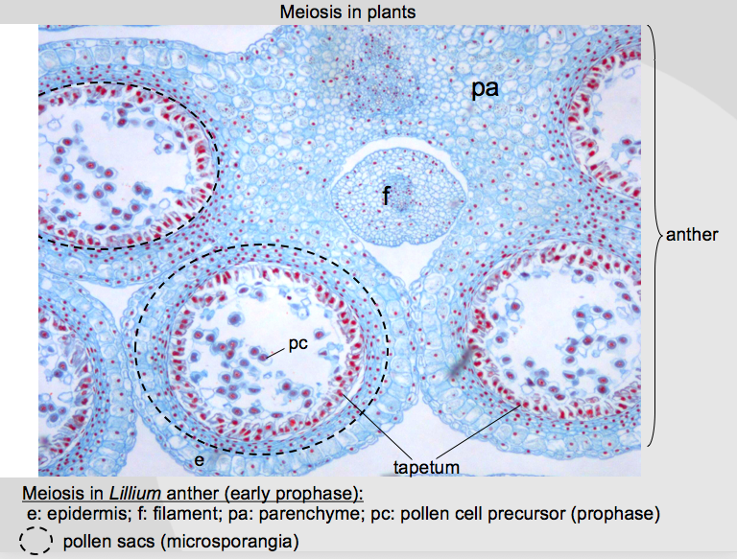

Meiosis in Animals:
- In the formation of male gametes (spermatogenesis), four viable sperm are produced from each pair of meiotic divisions.
- In the female (oogenesis), the whole cytoplasm and stored food must be retained in the egg for the use of the developing embryo.
  - Here, one of the products of the first division of meiosis is pushed out of the surface of the other as simply a nucleus without its cytoplasm.
  - The large cell is the egg; the small one is called a polar body
  - In the second division, the same thing happens
  - This leaves one large egg and two small polar bodies, which do not survive any further.
Observational of meiosis in Ascaris:
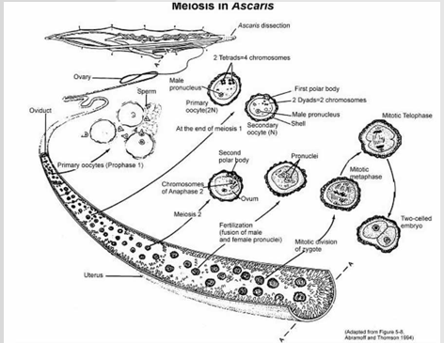
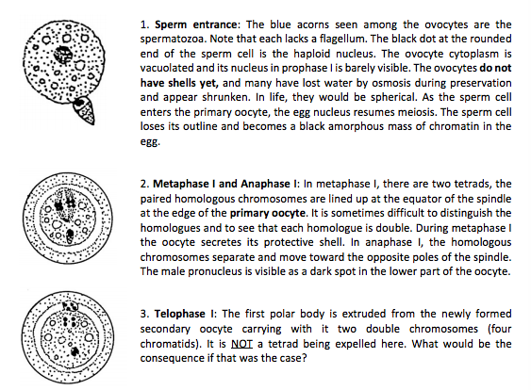

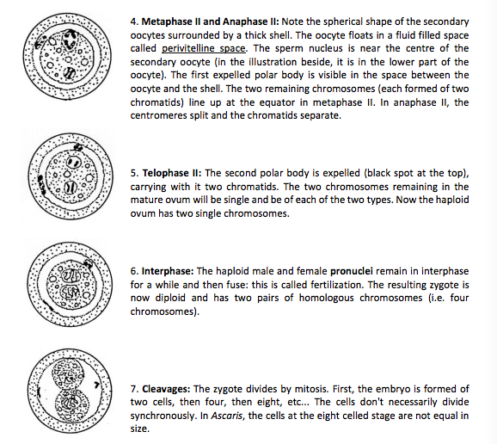

Gametogenesis in mammals:

- Spermatogenesis:
  - Is a continuous process
  - Occurs in an orderly fashion from the outside of the tubule to the lumen
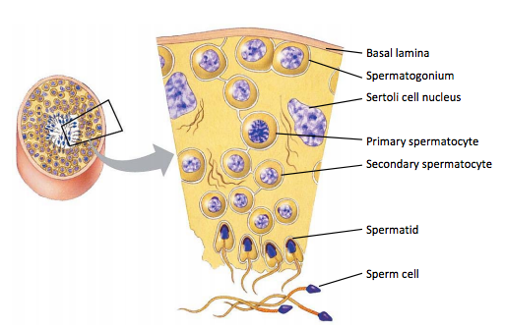
- Spermatogonia (2n): these are the large darkly stained outer cells with well-defined nuclei. They divide by mitosis to produce more Spermatogonia. About half of the Spermatogonia produced undergo meiosis to become sperm cells while the other half divided again by mitosis to replenish the Spermatogonia population.
- Primary Spermatocytes (2n): Located just below the Spermatogonia and not as darkly stained, the primary spermatocytes are larger cells undergoing the first meiotic division.
- Secondary spermatocytes (n): These slightly smaller cells are further toward the lumen of the tubule. They are the product of the first meiotic division. The secondary spermatocytes are difficult to observe because they rapidly undergo meiosis 2 to produce spermatids
- Spermatids (n): These very small circular cells will differentiate into functional spermatozoa.
- Spermatozoa (n): Upon maturity these are easily recognizable by their very long thin flagellum bordering the lumen
- Nurse cells (or Sertoli cells): the large nurse cells are also found in the walls of the seminiferous tubules. These cells feed and regulate the differentiation of spermatids into mature spermatozoa.
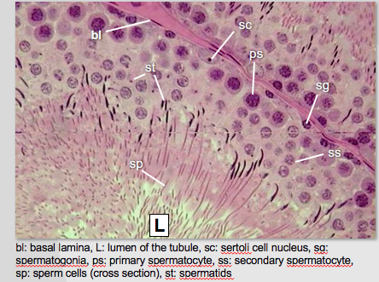

Oogenesis:
- Mammalian ovaries are solid structures in which egg-forming cells grow in small cell-lined cavities known as follicles.
- Ovaries of a newborn mammalian female already contain all the ovocytes she will ever need during her reproductive years.
  - Each ovocyte is then surrounded by a layer of follicular cells and together they constitute a primary follicle.
  - At the onset of meiosis 1, the ovocyte enlarges to become a primary oocyte.
  - The follicular cells surrounding it proliferate and together with the primary oocyte form a growing follicle.
  - Cytokinesis of the primary oocyte at the end of the first meiotic division produces a large secondary oocyte and a small first polar body.
  - Meiosis 2 of the secondary oocyte is initiated, goes as far as metaphase 2 and then stops.
  - The growing follicle containing a secondary oocyte then awaits the stimulation of female hormones to develop further
  - In response to hormonal influences that growing follicle will enlarge and form a mature follicle (Graafian follicle).
  - At that stage, the secondary oocyte is called a mature oocyte
  - After a short while, the mature follicle ruptures at the surface of the ovary by a process called ovulation and release the mature oocyte
  - The mature oocyte will only resume and finish meiosis 2 if it penetrated by a spermatozoon
- Primary Follicles: these are the numerous small round structures at the periphery of the ovary. Each primary follicle contains one ovocyte (2n) filling most of the space within one layer of follicular cells
- Growing follicles: these are larger follicles with a few layers of follicular cells. Each growing follicle contains a primary oocyte (2n) or a newly formed secondary oocyte (n)in its small fluid filled cavity.
- Graafian follicles: most of the space of these very large follicles is occupied by a large clear fluid-filled cavity.



