Midterm review #2

Anatomy of the Nervous System
Part A:

- Connected as a single unit, but anatomically divided into 2 parts:

The central nervous system – brain and spinal cord; integrating and command centre

The peripheral Nervous system- cranial and spinal nerves; communication between CNS and all parts of body

Sensory division: somatic and visceral fibers; from receptors to CNS

Motor division: motor nerve fibers from CNS to effectors
Two divisions:
- somatic NS: voluntary; from CNS to skeletal muscle

- Autonomic NS: involuntary; (visceral motor); from CNS to cardiac muscle, smooth muscle, glands:

Sympathetic division: “fight or flight”

Parasympathetic division: conserve energy at rest

Histology of Nervous Tissue

- Very cellular; minimal extracellular matrix
- 2 principle types of cells: Neurons and supporting cells.

6 types of supporting cells:

CNS:

- astrocytes: star-shaped, most abundant; anchor neurons close to capillaries
- roles in nutrient exchange, antigen presentation, control of environment

- microglia: Protective; touch neurons to monitor well-being; can transform into macrophages

- Ependymal Cells: Line cavities of brain and spinal cord as barrier between CSF and fluid bathing cells of CNS; cilia circulate CSF

- Oligodendrocytes: “few branches”; provide myelin sheaths to CNS neurons
PNS:

- Satellite cells: surround neuron cell bodies in ganglia – influence chemical environment of these neurons

- Schwann cells: form myelin sheaths around larger neurons in PNS; vital to peripheral nerve cell regeneration

Neurons:

- Extreme longevity, amitotic, high MR
- Know: cell body, dendrites, axon, axon hillock, myelin sheath, node of Ranvier, terminal branches, axonal terminals 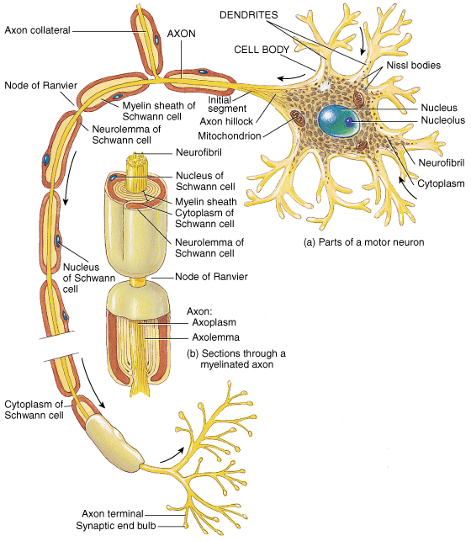

Functional classifications of Neurons

- according to direction nerve impulse travels wrt CNS
- sensory, motor and association neurons

Sensory: Toward CNS; primary, secondary, tertiary
- except bipolar neurons in some special sense organs, virt all primary sensory neurons are unipolar and cell bodies located in ganglia outside CNS
- higher order sensory neurons all multipolar and reside entirely within CNS – conduction to higher brain centres for interpretation.

Motor: away from CNS to effector organs like muscle and glands; multipolar; most cells bodies reside in CNS

Association (interneurons): Between sensory and motor neurons – integration of info; multipolar; most entirely within CNS; 99% of neurons of the body

The Brain:

- complexity of wiring rather than size is what matters

Subdivisions:

cerebral hemispheres
diencephalon (thalamus, hypothalamus, epithalamus)
brain stem (midbrain, pons, medulla)
cerebellum

- Spinal cord has central cavity surrounded by gray matter () & white matter ()

- Brain has same design, but with additional regions of gray matter; cerebral hemispheres & cerebellum have outer “bark” of gray matter
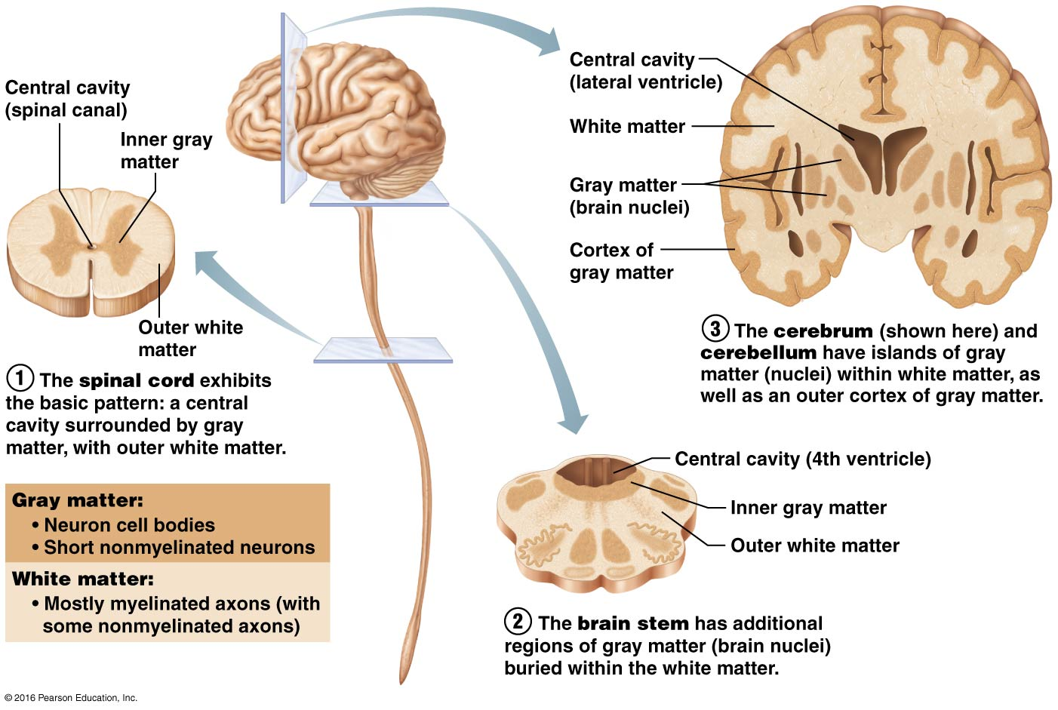

Ventricles of the Brain:
- Continuous with one another and with central cavity of spinal cord; filled with CSF and lined by Ependymal cells

- Paired lateral ventricles separated by narrow septum pellucidum
- Each communicates with narrow 3rd ventricle in diencephalon via interventricular foramen
- 3rd ventricle to 4th ventricle (dorsal to pons) via cerebral aqueduct
- 4th ventricle continuous with central canal
- 3 apertures (paired lateral apertures & median aperture) connect ventricles to subarachnoid space (surrounds brain)
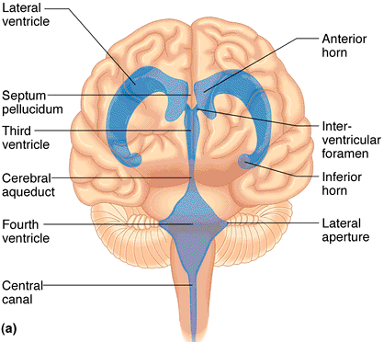

The cerebral hemispheres:

- superior; ~ 83% of brain mass
- gyri separated by sulci; anatomical landmarks
- longitudinal fissure; transverse cerebral fissure
- Lobes: frontal, parietal, occipital, temporal, insular
central sulcus: precentral/postcentral gyrus parieto-occipital sulcus, lateral sulcus
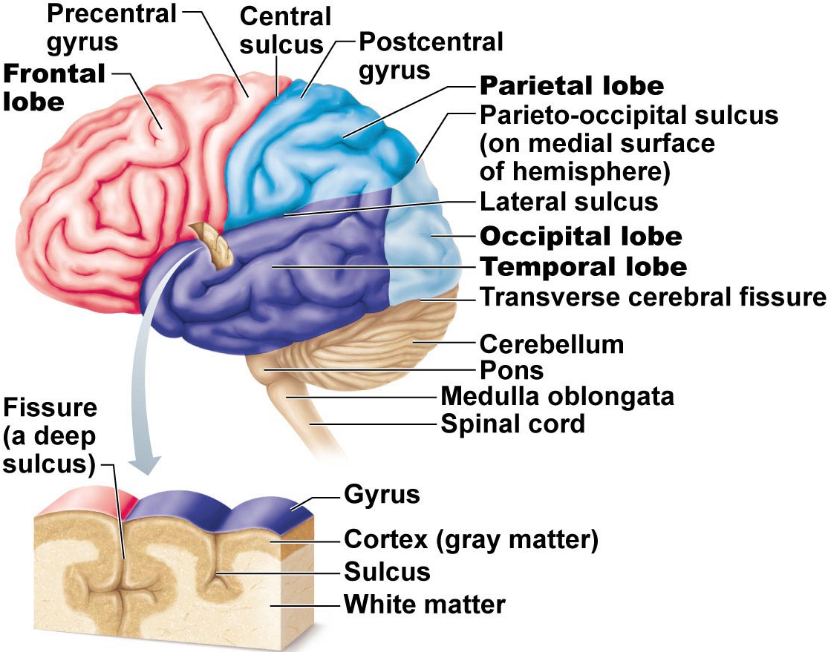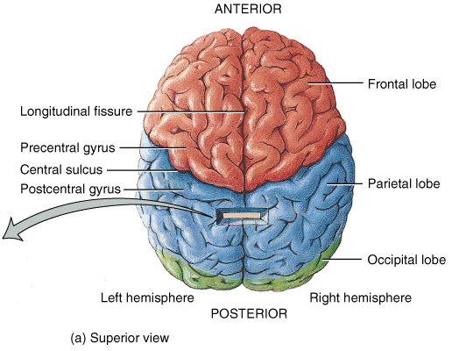
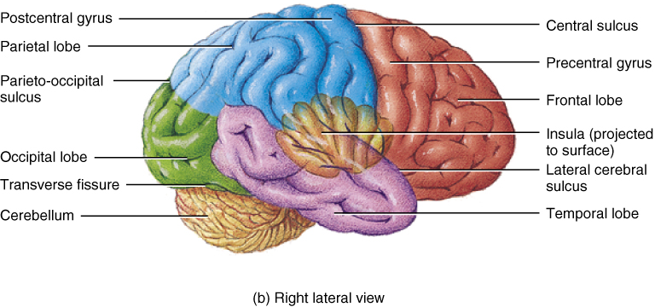

Cerebral Cortex:

- Allows us to perceive, communicate, remember, understand, appreciate, initiate voluntary movements – Conscious behaviour
- Cell bodies, dendrites and unmyelinated axons; only 2-4 mm thick, but many convolutions triple surface area
- Brodmann areas: numbered according to subtle differences in thickness, structure of contained neurons; some areas link with particular functions; other functions) memory and language) have overlapping domains; more diffusely organized

(i) 3 functional areas: motor, sensory & association
- each hemisphere handles sensory & motor functions of opposite side of body
- largely symmetrical, but not 100% equal in function (lateralization)
- no functional area of cortex acts alone; all conscious behaviour involves entire cortex in some way

Motor Areas:

- posterior part of frontal lobes: primary motor cortex, premotor cortex, Broca’s area and frontal eye field

1) Primary motor cortex: - precentral gyrus of frontal lobe of each hemisphere; pyramidal cells allow control of skeletal muscles; axons project to spinal cord as pyramidal/corticospinal tracts

- entire body represented spatially in primary motor cortex of each hemisphere – somatotopy
- which areas require most precise motor control?
- motor innervation is contralateral
- control not as simple as in diagram – some neurons send impulses to more than one muscle – think about coordinated movement of arm
- no overlap between muscles involved in unrelated movements

stroke: damage to area of right hemisphere paralyzes body muscles on left – only voluntary movement lost; reflex contraction still possible
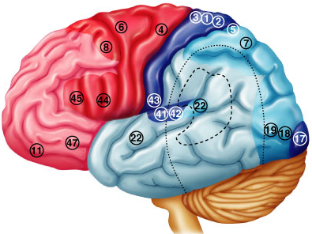17, 41,42,43
2) Premotor cortex:

- anterior to precentral gyrus
- helps plan movements by selecting and sequencing basic motor movements into more complex tasks (e.g. playing musical instrument, keyboarding)
- coordinates movement of several muscle groups simultaneously/sequentially by activating motor cortex
- can control voluntary actions that depend on sensory feedback – e.g. feeling for light switch in a dark room

what if there is damage to the area of premotor cortex regulating keyboarding?

3) Broca’s area:

- overlaps Brodmann areas 44 & 45
- present in one hemisphere only – usually the left
- originally thought to be only a motor speech area
- newer studies: Broca’s area is active when we prepare to speak and plan voluntary activities other than speech

3)Frontal eye field:

- Brodmann area 8; controls voluntary movements of the eyes

Sensory Areas:

- Primary somatosensory cortex:

- in postcentral gyrus of parietal lobe (Brodmann areas (BA) 1-3)
- receives info from somatic sensory receptors (skin) & proprioreceptors (skeletal muscle)
- spatial discrimination

- Somatosensory association cortex:
  - posterior to PSC (BA 5-7) - many connections with it
  - integrate/analyze somatic inputs (temp, pressure, ..) – interpret wrt size, texture, relationship of parts based on prior experience
- Visual areas:
    - primary visual cortex posterior tip occipital lobe
      - largest cortical area; contains map of visual space on retina (opposite sides)
    - visual association area surrounds PVC
      - interprets visual image based on prior experience – eg: recognition of a face, letter (also movement!)

What is the result of damage to the primary visual cortex? To the visual association area?

- Auditory areas:

- primary auditory cortex (~ BA 42) sound evaluated wrt pitch, rhythm, loudness
- auditory association area (~ BA 22) interpretation based on memory – speech, words, music, thunder, etc.
- Vestibular (equilibrium) cortex:

- awareness of balance – posterior part of insula & adjacent parietal cortex
- Olfactory cortex:

- medial aspects of temporal lobes = uncus
- small in humans; most of surrounding tissue now forms limbic system (emotions, memory)
- conscious awareness of different odors

- Gustatory cortex:
  - insula; ~ BA 43 and a bit anterior

- Visceral sensory area:

- posterior to gustatory cortex
- what sort of information?

Visual Agnosia: the inability to recognize/understand things that you see

Multimodal Association Areas:

- Anterior Association Area (Prefrontal Cortex):

- intellect, complex learning (cognition) & personality (working memory is here)
- abstract ideas, judgment, reasoning, persistence, planning, concern, conscience
- matures slowly; dependent on feedback from social environment
- losely linked to limbic system; involved in mood

- Posterior Association area: parts of temporal, parietal & occipital lobes

- input from all sensory association areas – storage of complex memories linked to sensation – put info together to understand what see, feel etc
- localization of self and surroundings in space
- recognition of patterns, faces
- some parts for understanding written & spoken language (Wernicke’s area)

- Limbic Association area:

- provides emotional impact – e.g. be aware of the danger associated with a particular situation and to remember it, etc.
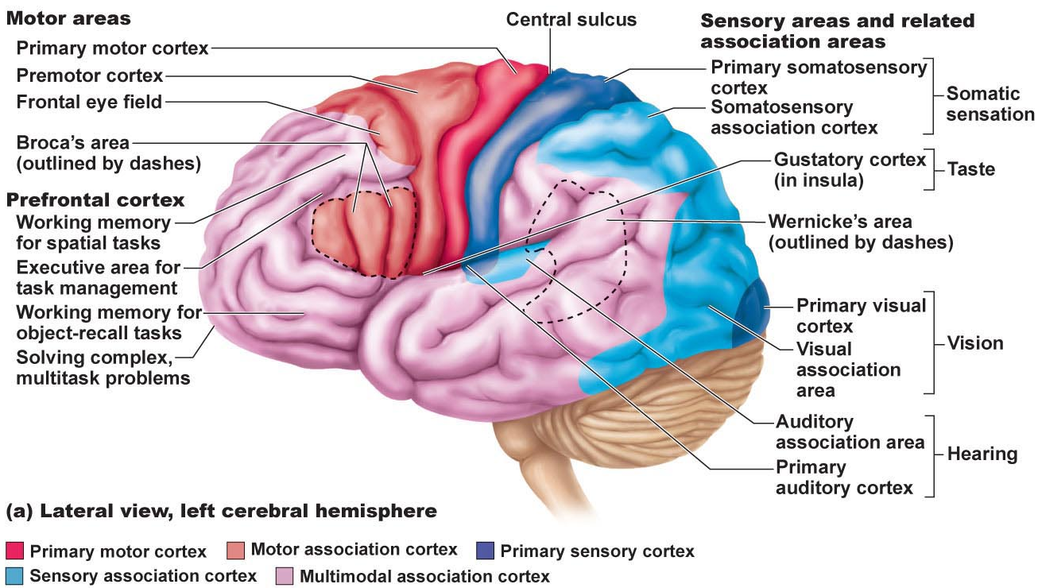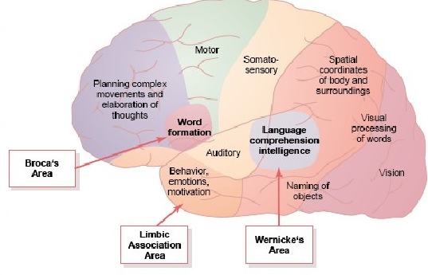

Lateralization of Cortical Functioning
- each cerebral hemisphere has some abilities not completely shared by other hemisphere
- cerebral dominance = hemisphere that is dominant for language
- 90% of people: left hemisphere dominant for language, math, logic
- other hemisphere dominates for visual-spatial skills, intuition, emotion, appreciation of art & music – creative side, better at recognizing faces
- most individuals with left cerebral dominance are right-handed
- in remaining 10%, roles reversed or shared equally

Cerebral white matter:

- communication between cerebral areas, between cortex & lower CNS centres
- commissural fibers: connect corresponding areas between the 2 hemispheres – largest is corpus callosum
- association fibers: connections within a hemisphere (connect gyri, lobes)
- projection fibers: to or from cortex and rest of nervous system; these ones run vertically

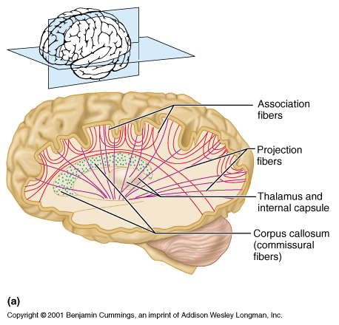
Basal Nuclei:

- caudate nucleus +[putamen & globus pallidus = lentiform nucleus]
- inputs from entire cerebral cortex, other subcortical nuclei & each other
- project to premotor & prefrontal cortices to influence muscle movements directed by primary motor cortex – have no direct access to motor pathways
- precise roles elusive (difficult to access; some roles overlap with cerebellum) – roles in starting, stopping, monitoring intensity of movements executed by cortex, especially if slow, sustained, stereotyped; also inhibit antagonistic and/or unnecessary actions
- disorders can result in too much movement (e.g. Huntington’s disease) or too little movement (Parkinson’s disease)
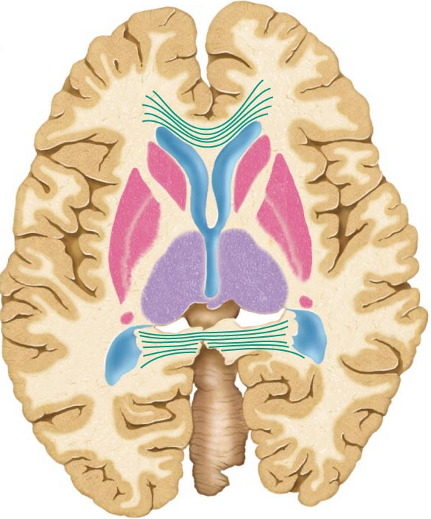

Huntington’s Disease:

- hereditary disorder in which mutant huntingtin protein accumulates in brain cells → degeneration of the basal nuclei and eventually of the cortex
- as caudate deteriorates, connections to frontal lobe become lost so that the affected individual in unable to control feelings, thoughts or movements

Parkinson’s disease:

- degeneration of dopamine-releasing neurons of substantia nigra (midbrain)
- causes basal nuclei usually targeted by substantia nigra to become overactive → persistent tremor at rest; muscles become rigid leading to difficulty walking, loss of facial expression, difficulty writing, etc.

The Diencephalon:

- thalamus, hypothalamus, epithalamus – enclose the 3rd ventricle
Thalamus: 80%; bilateral masses of gray matter held together by midline commissure called the intermediate mass
- consists of many different nuclei, named for their position in thalamus – afferent impulses from all senses & all parts of body converge on thalamus
- sorting & editing of information; group like impulses to send to appropriate region of cortex – crude awareness of sensation at level of thalamus
- also input pertaining to emotions & viscera from hypothalamus
- key roles in mediating sensation, motor activities, cortical arousal, learning, memory = “gateway to cerebral cortex”

Hypothalamus: “below” thalamus
- Autonomic control centre: centres for bp, heart, GI, respiration, etc
- Centre for emotional response & behaviour: heart of limbic system
- Body temperature regulation:
- Regulation of food intake: hunger, satiety
- Regulation of water balance & thirst: release of ADH; thirst centre
- Regulation of sleep-awake cycles: suprachiasmatic nucleus
- Control of endocrine system: releasing factors plus 2 nuclei (supraoptic & paraventricular) produce ADH & oxytocin

Hypothalamic disturbances: cause disorders in body homeostasis such as body wasting, obesity, sleep disturbances, dehydration, emotional imbalances

Epithalamus: most dorsal part of diencephalon & forms roof of 3rd ventricle; pineal gland (melatonin) extends from its dorsal border
- choroid plexus (CSF-forming structure) also part of epithalamus

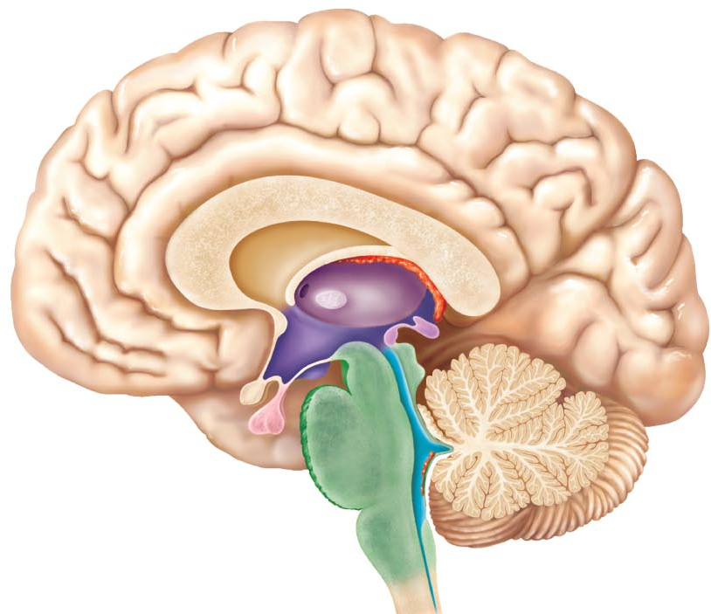
The brain Stem:

- consists of midbrain, pons, medulla oblongata
(i) rigidly programmed, automatic behaviours necessary to survival
(ii) pathway between higher & lower neural centres
(iii) associated with 10 pairs of cranial nerves

Midbrain:
- 2 cerebral peduncles that contain large pyramidal (corticospinal) motor tracts
- hollow cerebral aqueduct runs through midbrain
- periaqueductal gray matter involved in pain suppression
- Corpora quadrigemina: superior colliculi are visual reflex centres; inferior colliculi are part of auditory relay (also startle reflex)
- substantia nigra: band-like nucleus; high melanin content (precursor dopamine); linked to basal nuclei of cerebral hemispheres (Parkinson’s disease)
- red nucleus: rich vascular supply, iron pigment in neuron cell bodies; relay nuclei for descending pathways influencing limb flexion
- also some nuclei associated with reticular formation
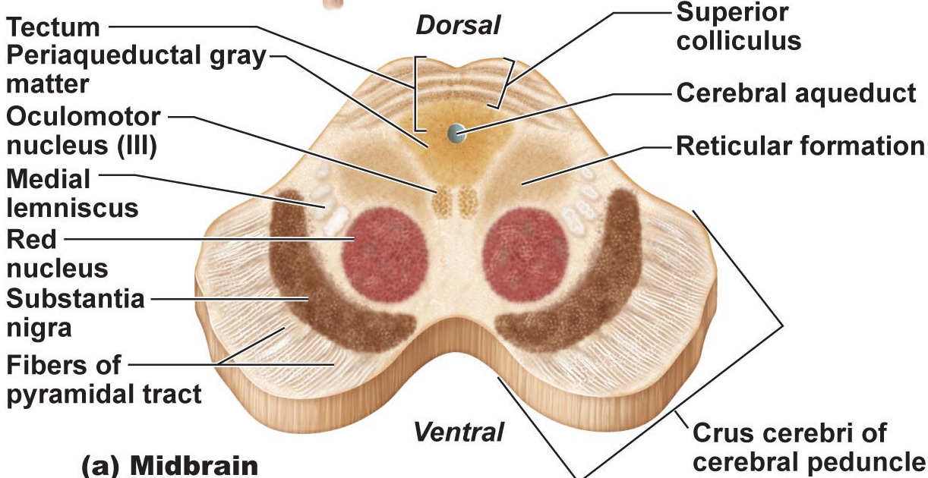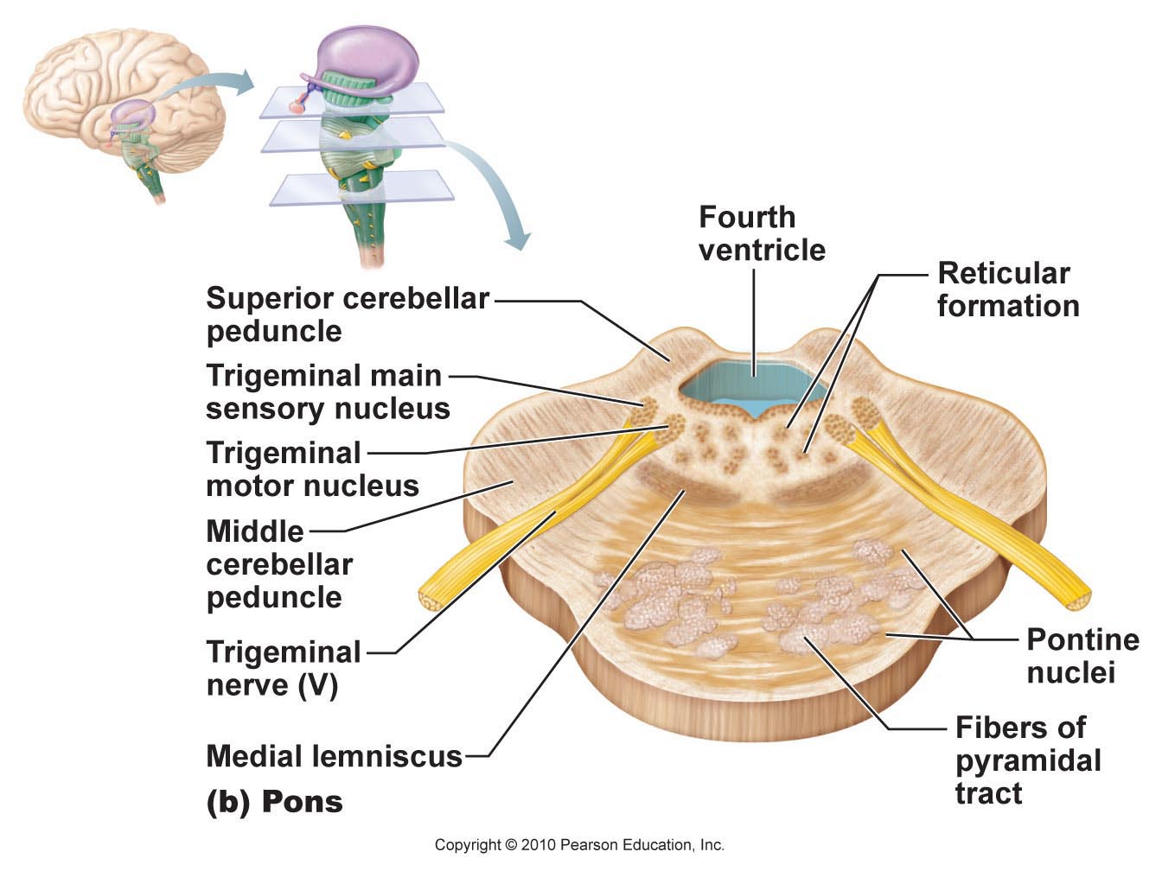

Pons: dorsally, forms part of anterior wall of 4th ventricle
- primarily conduction tracts (“bridge”); some run longitudinally; others oriented transversely to communicate with cerebellum
- cranial nerves V (trigeminal), VI (abducens) & VII facial; other pons nuclei are part of reticular formation and others are involved in respiration)
- Medulla oblongata: from pons to spinal cord
pyramids, decussation (significance of this?)
- inferior olivary nuclei: relay sensory info re muscles & joints to cerebellum
- cranial nerves XII (hypoglossal), IX (glossopharyngeal), X (vagus), XI (accessory)
- vestibulocochlear nerve fibers (VIII) synapse with cochlear nuclei (functions?)
Medulla oblongata: crucial role as autonomic reflex centre for homeostasis
- Cardiovascular centre: cardiac & vasomotor centres
- Respiratory centres: rate & depth of breathing
- Other centres: eg: vomiting, hiccupping, swallowing coughing, sneezing
- overlap with hypothalamus: hypothalamus controls most visceral functions by relaying instructions through medullary centres which carry them out

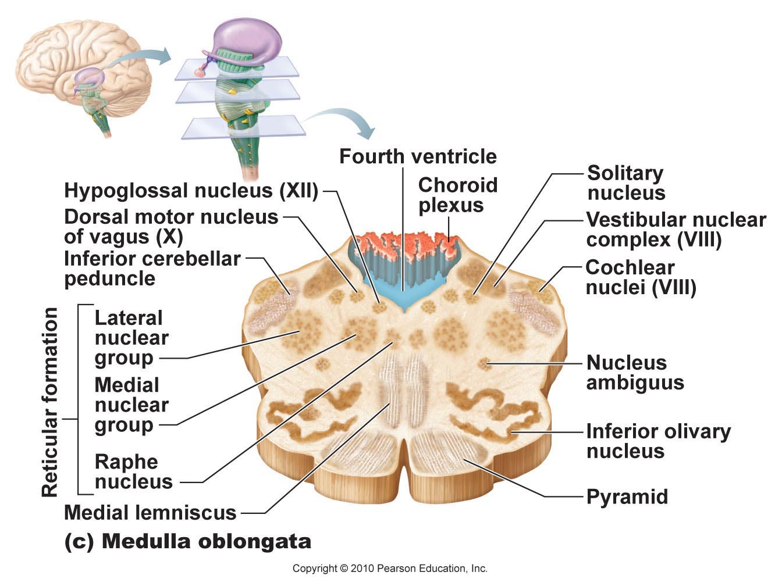
The cerebellum:

- processes inputs from cerebral motor cortex, brainstem nuclei & sensory receptors timing & patterns of skeletal muscle contraction for smooth, daily movements – eg: driving, typing, playing a musical instrument, etc (not under conscious control)
- bilaterally symmetrical; connected by vermis; fine transverse fissures called folia; each hemisphere divided into 3 lobes: anterior, posterior, flocculonodular
- anterior & posterior lobes have overlapping sensory & motor maps of body
(medial: trunk & girdle
intermediate: distal limbs, skilled movements
lateral: input from association areas of cortex (esp. planning movements))
- flocculonodular lobes – input from equilibrium sensors: balance, some eye movements

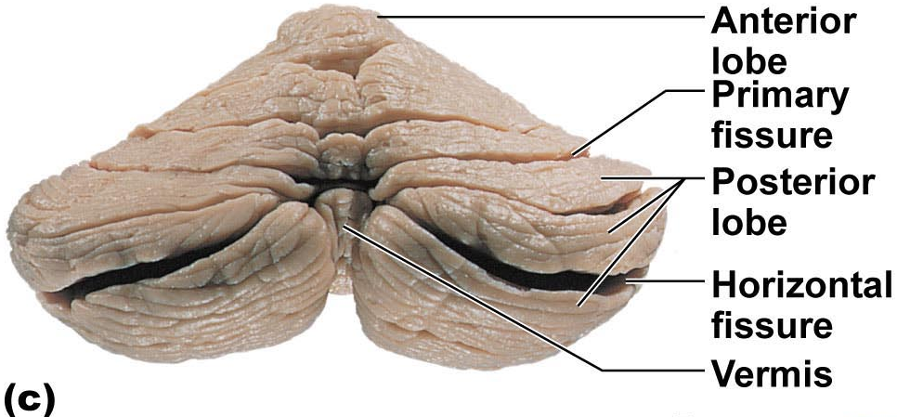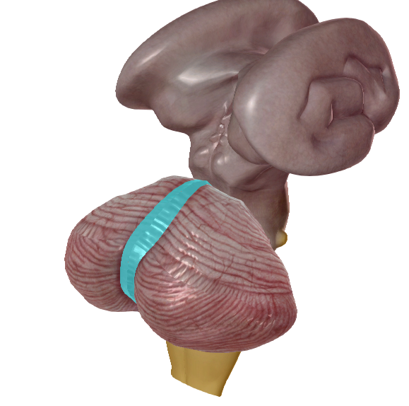
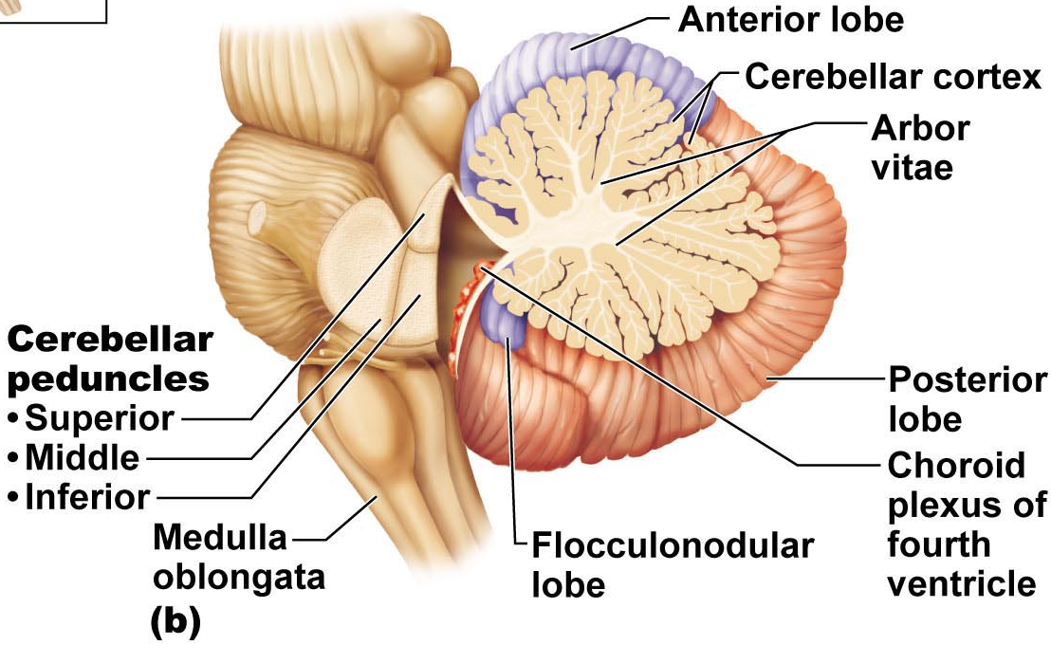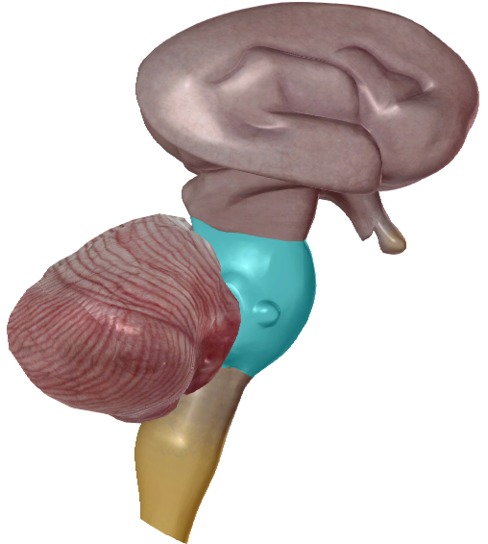

Cerebellar Peduncles

  - connect cerebellum to brain stem
  - virtually all fibers entering & leaving cerebellum are ipsilateral (unlike cerebral cortex)
Superior: connect cerebellum & midbrain; fibers originate from neurons in deep cerebellar nuclei & project to cerebral motor cortex via thalamus
Middle: connect pons & cerebellum; one-way communication from pons to cerebellar neurons (informs cerebellum of voluntary motor activities initiated by motor cortex)
Inferior: connect cerebellum & medulla; afferent tracts - sensory info to cerebellum from muscle proprioceptors & vestibular nuclei of brain stem (equilibrium & balance

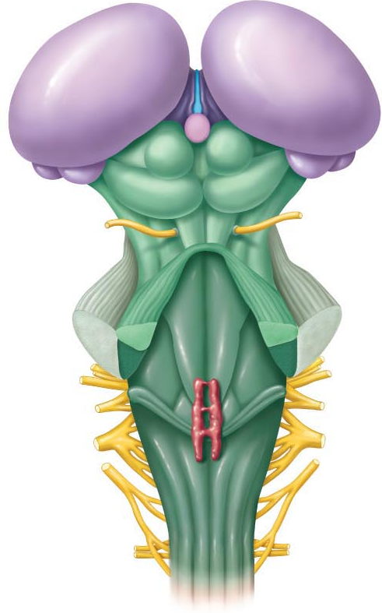

Functional Brain Systems:
- networks of neurons that work together but span large distances within brain

Limbic system: (limbus = ring)
- • medial aspect of each cerebral hemisphere & diencephalon
- • emotional-visceral brain – esp: amygdala (anger, fear, assess danger), hippocampus (emotions & memory), anterior cingulate gyrus (gestures, resolve conflicts when frustrated)
- • link between odours, memories & emotions
- • link for psychosomatic illnesses: stress & effects on bp, GI tract, heart
- • links with cortex:(i) aware of emotions, (ii) react emotionally if consciously understand; also: emotions can override logic; reason can stop us from expressing emotions
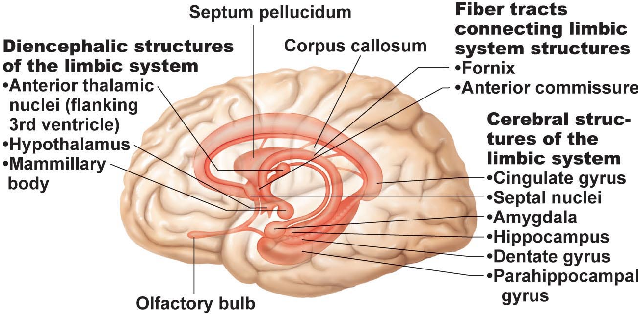

- Reticular formation:
- • central core of medulla oblongata, pons, midbrain; neurons project to hypothalamus, thalamus, cortex, cerebellum, spinal cord
- • reticular activating system (RAS):
- (i) maintains arousal of brain;
- (ii) filter for incoming signals (RAS & cerebral cortex disregard ~99% of all sensory stimuli)

Part B:

The Spinal Cord:

  - from foramen magnum to 1st/2nd lumbar vertebra; below this is ideal spot for lumbar puncture
(i) 2-way conduction system
(ii) major reflex centre
(iii) initiates complex patterns of motor activity
- 31 pairs of spinal nerves exit via???
- cervical & lumbar enlargements for ???
- spinal cord held in place by:
(i) denticulate ligaments: pia mater shelving
(ii) filium terminale: pia mater-covered conus extension

What is the cauda equina?
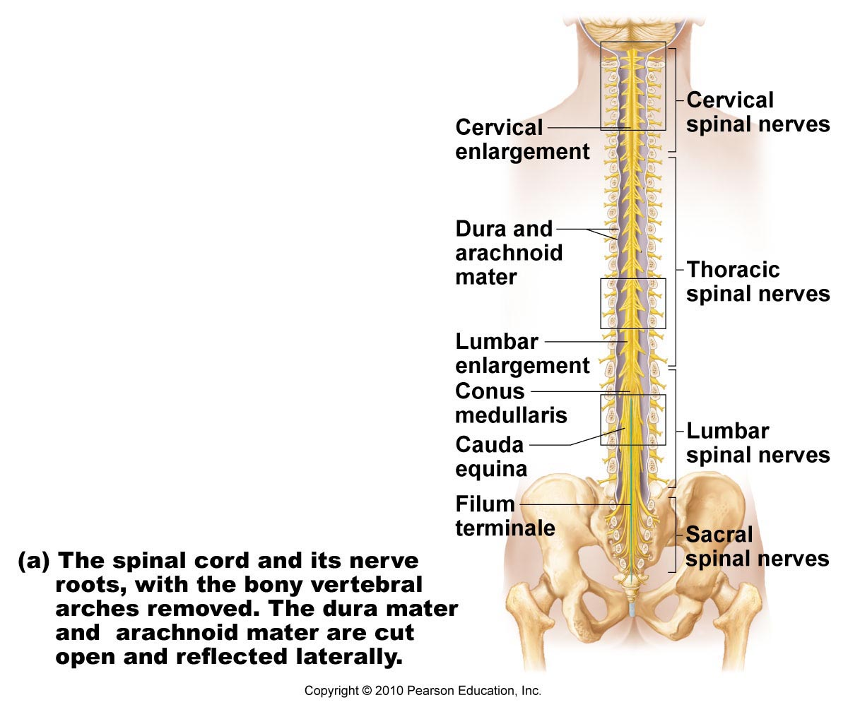

Gray Matter & Spinal Roots:
- gray matter as for other regions of CNS – but all neurons multipolar
- organized like butterfly wings: paired anterior (ventral) & posterior (dorsal) horns connected by gray commissure (where is the central canal?)
- small lateral horns associated with thoracic & superior lumbar regions of cord(lacks myelin)
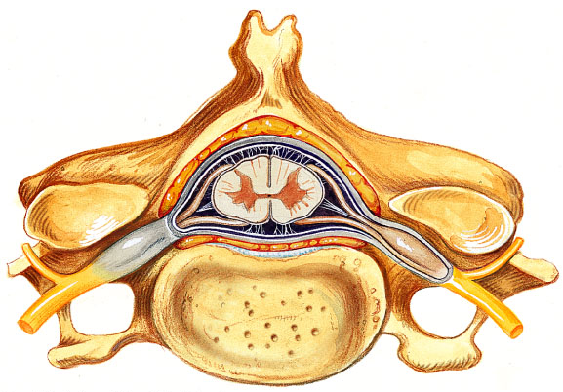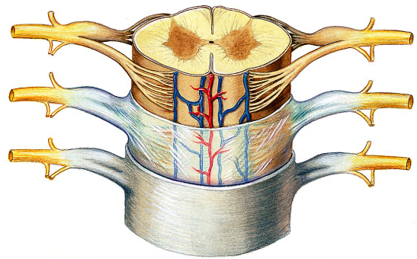

Anterior horns:
- nerve cell bodies of somatic motor neurons – axons exit via ventral roots
- largest at levels of cervical & lumbar enlargements – why??
Lateral horns:
- parasympathetic motor neurons to visceral organs; also exit via ventral roots

Dorsal root ganglion:
- afferent fibers from peripheral sensory receptors form dorsal roots; dorsal root ganglia house cell bodies of associated sensory neurons – their axons enter cord to:
(i) travel to higher cord/brain centres
(ii) synapse with interneurons in posterior horns at level they enter
- spinal nerve = fused dorsal & ventral roots
What is poliomyelitis??

White Matter:
- myelinated & unmyelinated fibers – communication between different parts of cord & between cord & brain
- scending, descending & transverse (commissural) tracts – direction of fibers

Some general properties of spinal tracts:
- Most pathways cross over from one side of CNS to other (decussate)
- Most consist of a chain of 2 or 3 neurons
- Most exhibit somatotopy:
- All pathways & tracts are paired

Protection of the CNS
- Bones
- Meninges
- Cerebrospinal fluid
- Blood-brain barrier

Meninges (meninx)
• 3 CT membranes that: (a) cover & protect CNS
(b) protect blood vessels & enclose venous sinuses
(c) contain cerebrospinal fluid
(d) form partitions within skull
Dura mater:
  - tough; 2 layers around brain: outer periosteal layer & inner meningeal layer
  - spinal cord has only meningeal layer
  - around brain, 2 layers fused except where enclose dural sinuses
  - dural septa to partition and anchor: falx cerebri, falx cerebelli, tentorium cerebelli

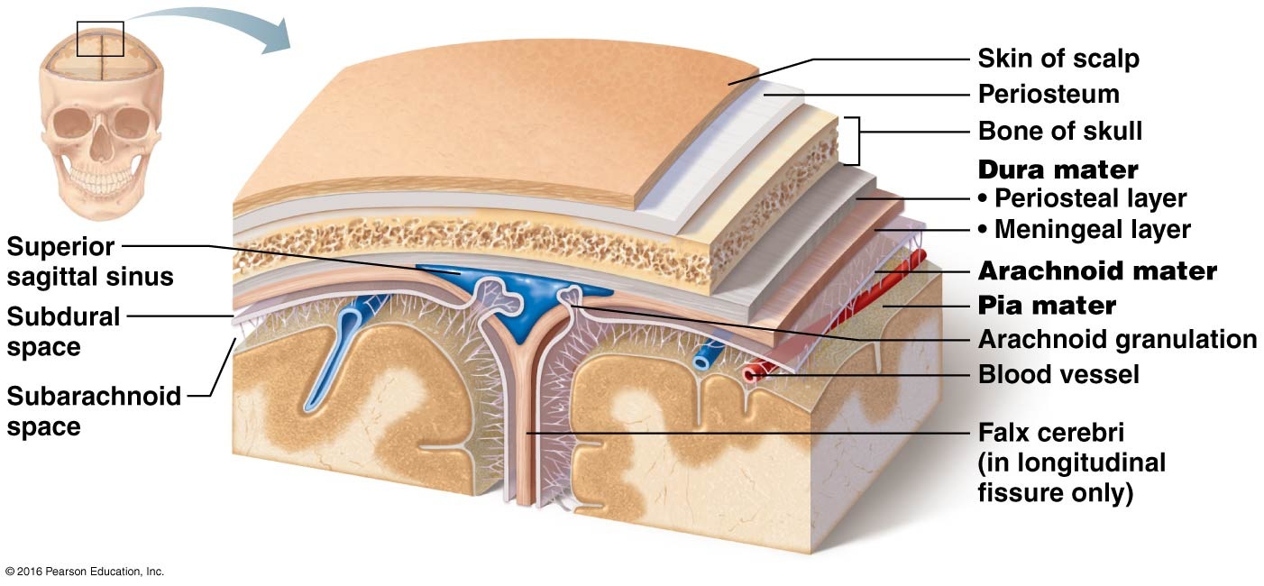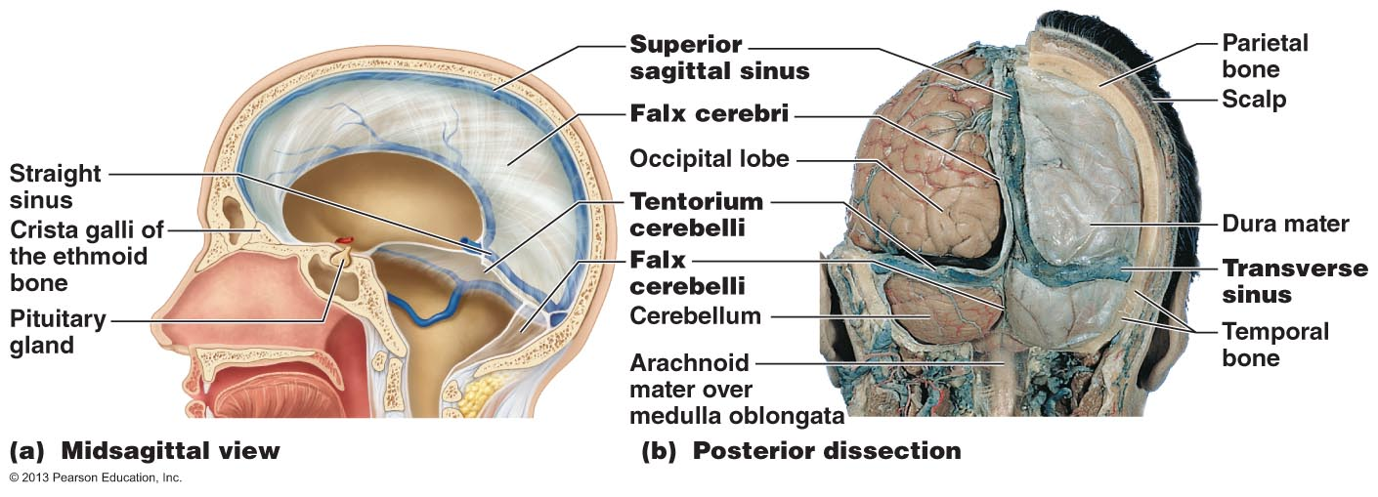

Arachnoid mater:
- loose covering separated from dura mater by subdural space
- subarachnoid space between arachnoid mater & pia mater – filled with CSF & contains largest blood vessels serving brain
- role of arachnoid villi (granulations) in accumulation of CSF

Pia mater:
• delicate CT + tiny blood vessels – clings tightly to brain, follows convolutions
What is meningitis? What is encephalitis?

Cerebrospinal Fluid
- liquid cushion to give buoyancy to CNS tissue; also protective, nutritive roles
- similar to plasma but less ptn, more vit C, Na⁺, Cl⁻, Mg⁺⁺ & H⁺, less Ca⁺⁺, K⁺
- choroid plexuses in roof of ventricles form CSF: clusters of permeable capillaries enclosed by layer of ependymal cells (role of these cells?)
- total CSF = 150 ml; replaced ~ every 8 hours; choroid plexuses also clean CSF
What is hydrocephalus?

Blood-Brain Barrier
- why?? some hormones also act at NTs; ions can increase rate of neuronal firing
- composed of 3 layers:
(i) continuous epithelium of capillary wall (sealed by tight junctions)
(ii) thick basal lamina surrounding external face of capillary
(iii) bulbous feet of astrocytes
- what gets in? glucose, essential amino acids, some electrolytes; also fats, fatty acids, oxygen, carbon dioxide, any other fat-soluble molecules
  - not completely uniform:
(i) capillaries of choroid plexuses porous but ependymal cells linked by tight junctions
(ii) very permeable near vomiting centre, hypothalamus; incomplete in newborns

Macroscopic Anatomy of the PNS
- 12 pairs of cranial nerves pass through various foramina of the skull
- first two pairs attach to forebrain; rest originate from brain stem
- all except vagus nerve serve only head & neck structures
- except those for special sense organs, most cranial nerves are mixed nerves
- “On occasion, our trusty truck acts funny – very good vehicle anyhow”

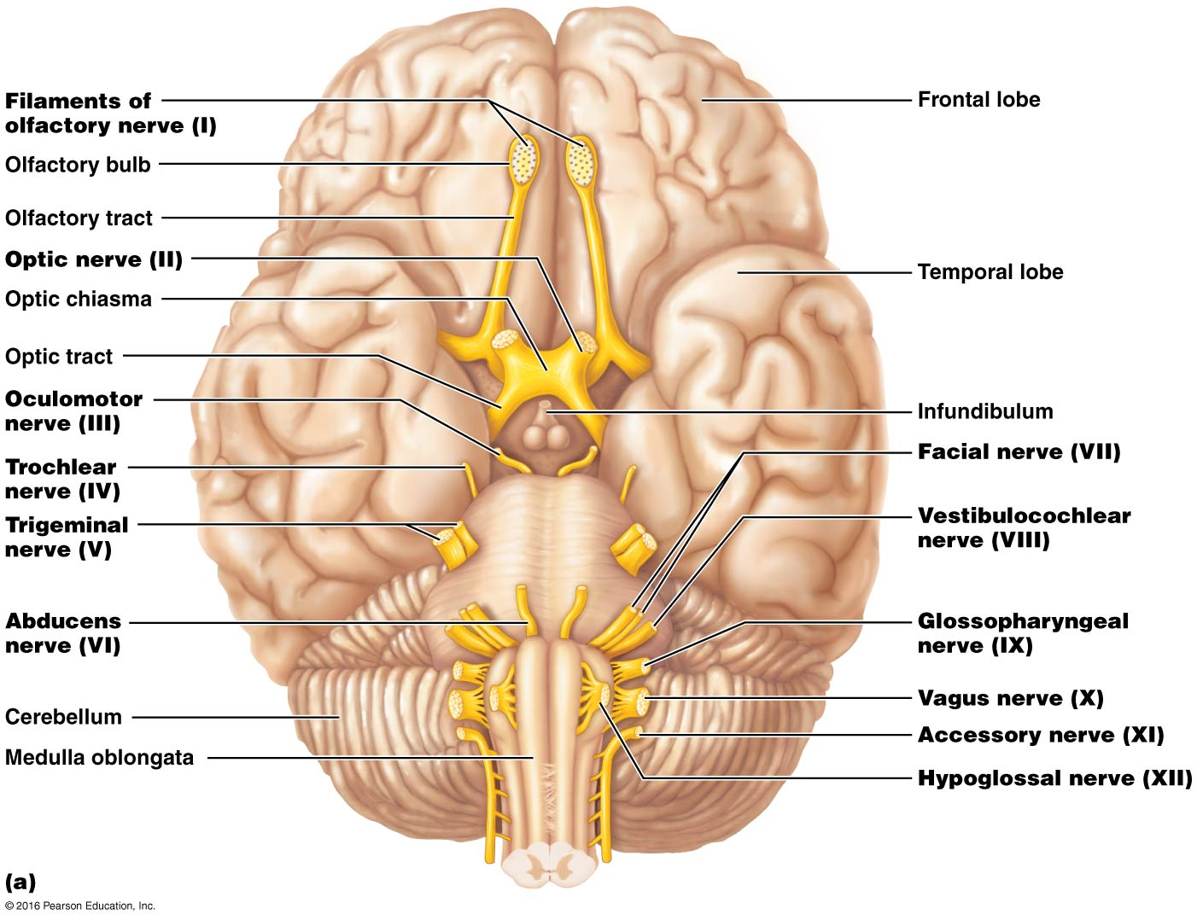

Olfactory Nerves:
  - from nasal mucosa to olfactory bulbs
  - fibers of olfactory bulb neurons extend as olfactory tract to primary olfactory cortex
  - afferent sensory fibers for smell

. Olfactory Nerves:
  - from nasal mucosa to olfactory bulbs
  - fibers of olfactory bulb neurons extend as olfactory tract to primary olfactory cortex
  - afferent sensory fibers for smell
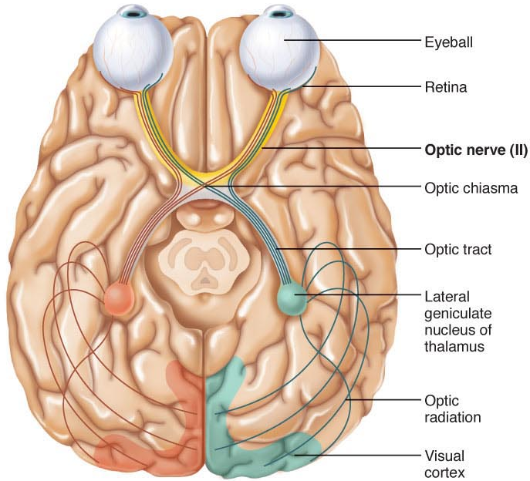
- Oculomotor Nerves:
- “eye mover”; supplies 4/6 extrinsic muscles of eyeball
- fibers from ventral midbrain (near pons) through bony orbit to eye
- mixed motor nerves to extrinsic eye muscles, but also paraymp fibers to iris, lens & (sensory afferents from extrinsic eye muscles to midbrain)
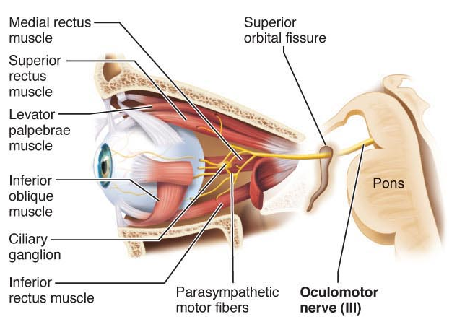
- Trochlear Nerves (pulley):
  - innervates ext eye muscle that loops through pulley-shaped ligament in orbit
  - motor fibers from dorsal midbrain to superior oblique eye muscle
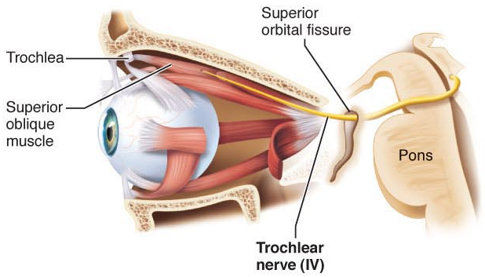
- Trigeminal Nerves:
  - largest of cranial nerves; 3 branches: sensory fibers to face & motor fibers for chewing (mandibular division)
Opthalmic division
Maxillary division
Mandibular division
  - what nerves are useful to the dentist??
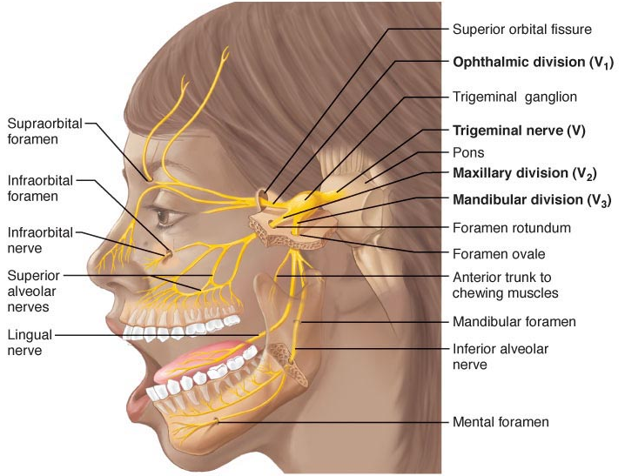
- Abducens Nerves:
- controls extrinsic eye muscle that abducts eyeball
- mixed nerve; primarily motor to lateral rectus muscle 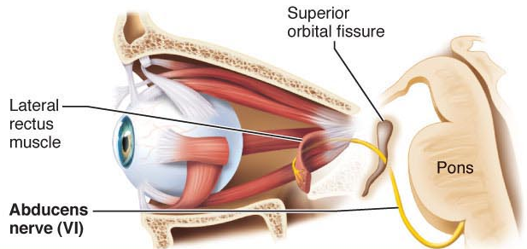
Vestibulocochlear Nerves:
- sensory nerve for hearing & balance
- cochlear (hearing) & vestibular (balance) branches that fuse
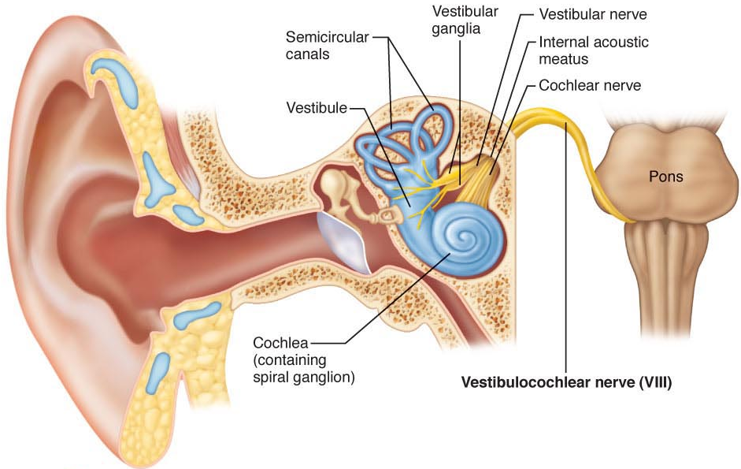
- Facial Nerves:
- large nerve; facial expression
- from pons to lateral face
- mixed nerve (primarily motor):
- also parasympathetic to lacrimal glands & sensory from anterior 2/3 of tongue

IX. Glossopharyngeal Nerves
- “tongue & pharynx”; mixed nerves to & from medulla
  - swallowing & gag reflex; also parasympathetic fibers to parotid glands
  - sensory (taste, touch, pressure, pain) from pharynx, posterior tongue
  - sensory from carotid sinus (chemo, bp)
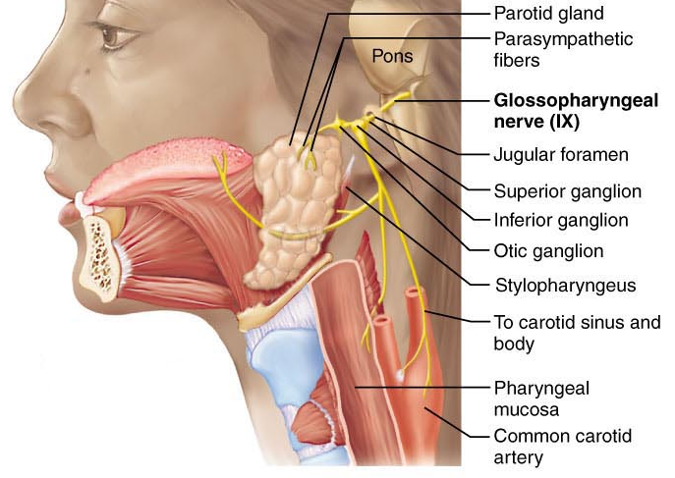
- Vagus Nerve
  - “wanderer”; only cranial nerve to extend beyond head-neck region
  - mixed nerves; to & from medulla
  - parasympathetic motor to heart, lungs, abdominal viscera; also somatic to pharynx & larynx
  - sensory from carotid sinus; also for taste, from proprioceptors in muscles of pharynx, larynx

- Accessory Nerves:
- accessory part of vagus nerve; formed by junction of a cranial root with a spinal root
- mixed nerves, but mostly motor to pharynx, larynx, soft palate; spinal root supplies motor fibers to trapezium & sternocleidomastoid muscles (head & neck movement)
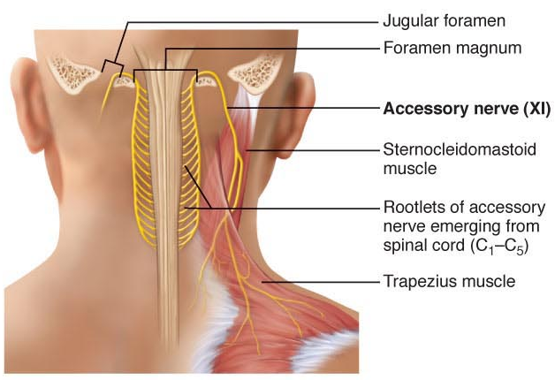
- Hypoglossal Nerves:
“beneath tongue”; mixed, primarily motor
to tongue for mixing, swallowing and speech
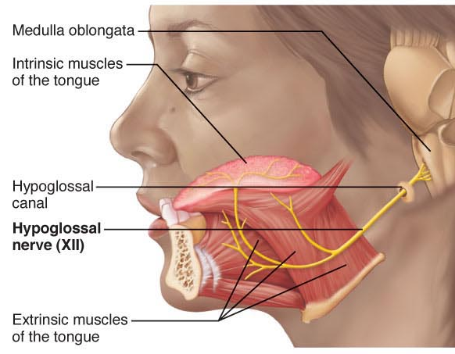
Spinal Nerves:
- 31 pairs, all are mixed nerves; named according to point of issue
- C₁-C₈; T₁-T₁₂; L₁-L₅; S₁-S₅; C₀
- almost immediately after exit from foramen, each spinal nerve branches into a dorsal ramus & a ventral ramus
- rami carry both sensory & motor fibers

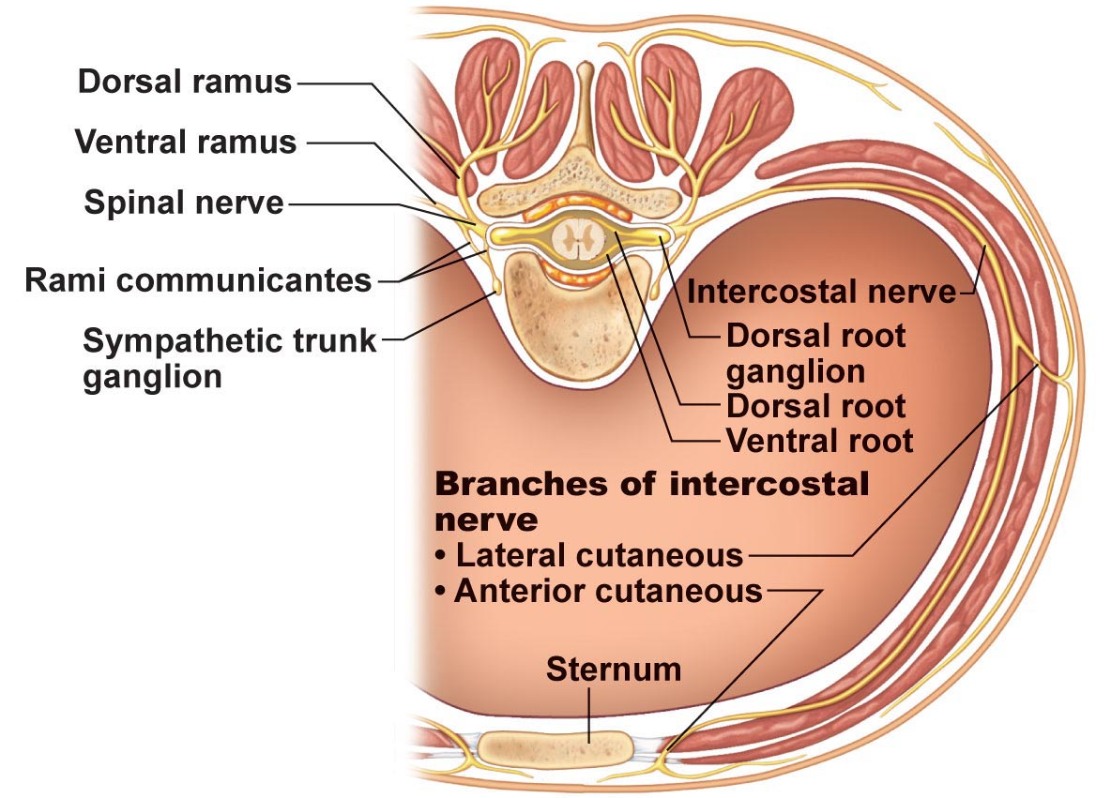
  - except for T₂-T₁₂, all ventral rami branch & make lateral connections just outside spinal cord nerve plexuses
  - fibers from different rami criss-cross in plexuses:
- Each branch of a plexus contains fibers from several different spinal nerves
- Fibers from each ventral ramus travel to body periphery via several different routes
Result: each muscle in a limb receives nerve supply from more than one spinal nerve damage to one spinal segment or root cannot completely paralyze any limb muscle

- Cervical Plexus & the Neck:
  - C₁-C₄; deep in neck under sternocleidomastoid muscle
  - most branches are cutaneous nerves
  - single most important nerve is phrenic nerve: both motor & sensory fibers to diaphragm

- Brachial Plexus & Upper Limb:
  - C₅-C₈ & most of T₁; partly neck, partly axilla – nerves supplying upper limbs
- Axillary nerve to shoulder (esp. deltoid muscle)
- Musculocutaneous nerve – to biceps brachii & brachialis to flex arm
(ii) Median nerve – flexor muscles in anterior forearm & into palm pronate forearm, flex wrist/fingers, oppose thumb
iv) Ulnar nerve – medial to elbow (“funny bone”) & follows ulna along medial forearm wrist & finger flexion and adduction & abduction of medial fingers
(v) Radial nerve – largest – to humerus & dorsal part of hand elbow extension, supination of forearm, extension of wrist & fingers, abduction of thumb

- The Back:
  - dorsal rami; follows segmented plan

- Anterolateral Thorax:
  - T₁-T₁₂; simple & segmented as for innervation of back
  - intercostal nerves: to intercostal muscles; anterolateral thorax

E Lumbar Plexus:
  - L₁-L₄; branches to abdominal wall muscles, also anterior & medial thigh
- Femoral nerve: anterior thigh muscles thigh flexors & knee extensors
- Obturator nerve: medial thigh adductor muscles

- Sacral Plexus:
  - L₄-S₄; immediately caudal to lumbar plexus – branches to buttocks, lower limbs, pelvis
- Sciatic nerve: posterior thigh – then diverges into (ii) & (iii):
- Tibial nerve: behind knee joint to posterior calf & sole of foot
- Common fibular nerve: to knee joint, calf (anterolateral) & dorsum of foot
- Superior & inferior gluteal nerves: to buttocks
- Pudendal nerve: muscles & skin of perineum (e.g. erection, voluntary urination)

Dermatome: area of skin innervated by cutaneous branches of a single spinal nerve

Endoneurium: loose CT that encloses nerve fiber + associated myelin or neurilemma sheath
Perineurium: coarser CT wrapping around a group of fibers (fascicle)
Epineurium: tough fibrous sheath around all the fascicles to make a nerve

What do I mean when I say that most nerves are mixed nerves?
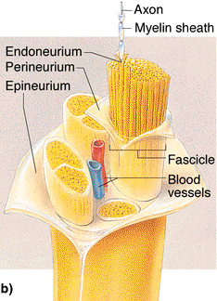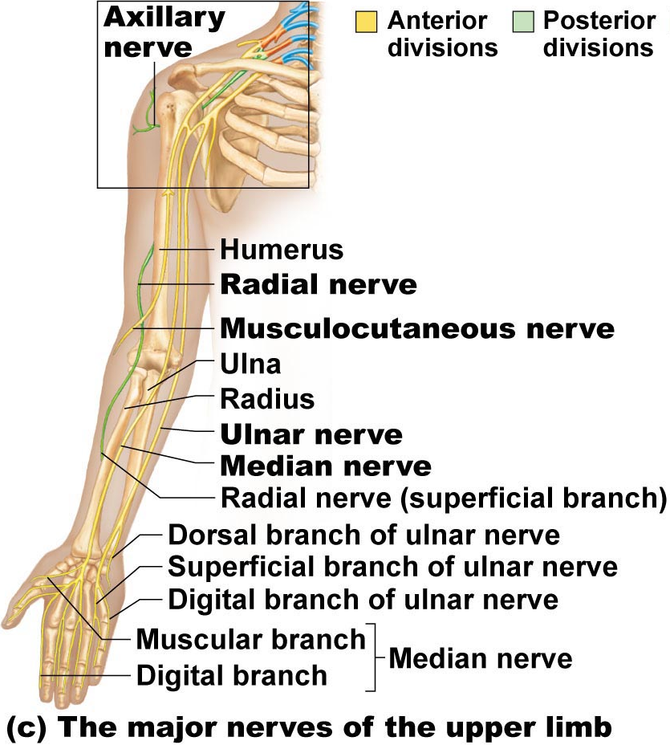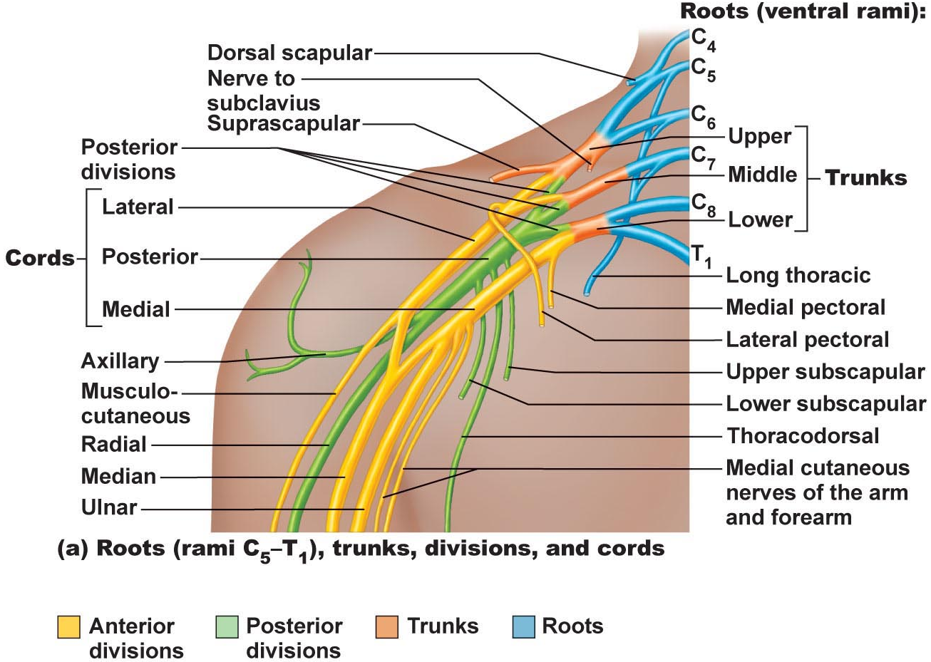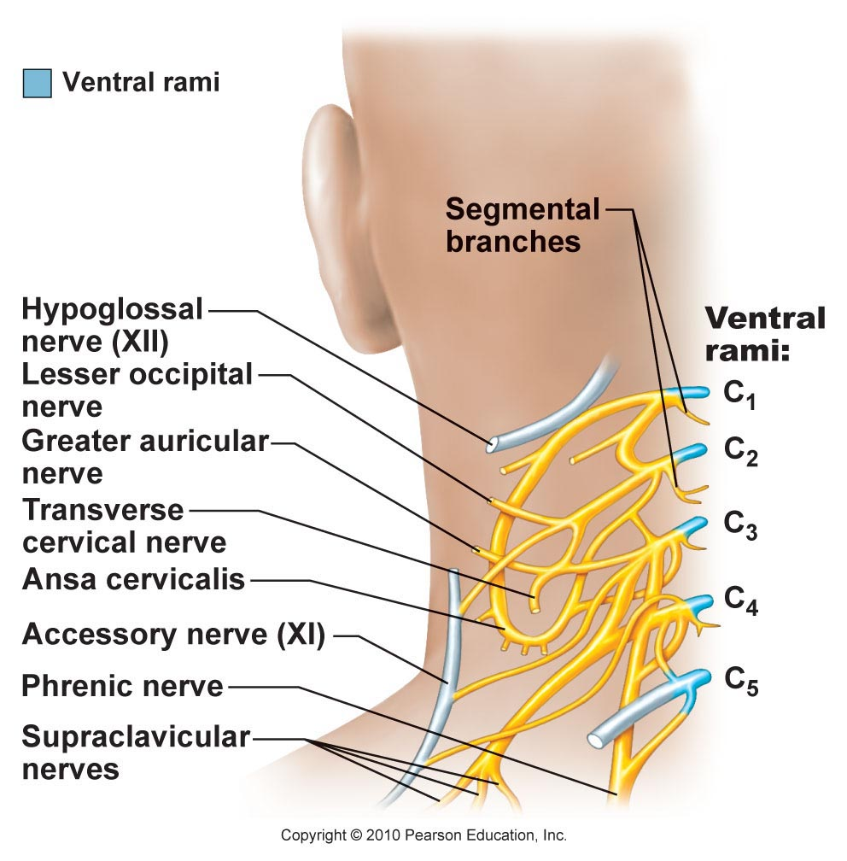

Anatomy of the Muscle System
Part A:

