Anatomy1107 Midterm 2 Review:
The immune system:

Leukocytes:

- only formed elements that are complete cells
- <1% total blood volume
- protection against bacteria, viruses, parasites, toxins, tumor cells
- can leave bloodstream (diapedesis) to mount immune and/or inflammatory response
- leukocytosis: body’s response to bacterial or viral invasion - # can double within hrs

Two types:

B1. Granulocytes:
- neutrophils, basophils, eosinophils
- spherical, larger than RBCs, lobed nuclei, cytoplasmic granules, Wright’s stain

(i) Neutrophils:
- 50% leukocytes; cytoplasm contains 2 types of granules that take up both acidic & basic dyes - granules contain hydrolytic enzymes & some antibiotic-like proteins (defensins) = polymorphic leukocytes
- phagocytes: ingest & destroy bacteria; (eg: meningitis, appendicitis)

ii) Eosinophils:
- 2-4% all leukocytes; blue-red nucleus (telephone receiver) + coarse, red granules
- > parasitic worms; cannot be phagocytized, but surround & release digestive enzymes
- modulate immune response → allergies, asthma

(iii) Basophils:
- rarest WBCs (0.5% of leukocytes); cytoplasmic granules contain histamine (vasodilator, makes blood vessels leaky & attracts other WBCs); S- or U-shaped dark purple nucleus

B2. Agranulocytes:
- includes lymphocytes, monocytes
- no visible granules; nuclei spherical or kidney-shaped

(i) Lymphocytes:
- 2nd most common leukocyte; large, dark purple nucleus + rim of pale blue cytoplasm; classified by size ; some in bloodstream, but most in lymphoid tissue (lymph nodes, spleen, etc)
- T lymphocytes (T cells): act directly against virus-infected cells, tumor cells
- B lymphocytes (B cells): give rise to plasma cells that produce antibodies

- Monocytes:
- largest leukocytes; gray-blue cytoplasm + U- or
- kidney-shaped nucleus; in tissue, differentiate into macrophages
- phagocytic in chronic infections (eg: TB)
- also against viruses, some bacteria

The main steps of leukopoiesis:
- leukopoiesis is hormonally regulated according to body’s situation:
- • interleukins and colony-stimulating factors: hormones that regulate production of leukocytes, as needed
- bone marrow stores mature granulocytes (not erythrocytes); usu contains 10- 20X more granulocytes than in blood
- lifespan of granulocytes = 0.5-9.0 days (most die in line of duty)

Leukocyte disorders:
- Leukemias: cancer of WBCs - usu descendents of a single cell remain unspecialized & mitotic
- acute if derives from blast-type cell; chronic if from cells at later stages
- bone marrow taken over by cancerous cells severe anemia, clotting problems (also fever, weight loss, bone pain)
- NB: WBCs numerous but non-functional - death usu from internal bleeding & overwhelming infections
- Treatment: irradiation & admin of anti-leukemic drugs; bone marrow transplant

- Infectious mononucleosis: caused by Epstein-Barr virus; excessive numbers of enlarged and abnormally-shaped lymphocytes (initially mistaken as monocytes), many abnormal (tired, achy, chronic sore throat, low-grade fever)

- Leukopenia: abnormally low WBC count - usu due to drugs, esp glucocorticoids & anticancer agents

The Immune system:

Innate (nonspecific) defenses: protect against foreign substances/abnormal cells without having to specifically identify them (generalized carbohydrate/lipid cell surface markers)

Adaptive (specific) defenses: (acquired immunity) – subpopulations of lymphocytes recognize the specific target (usually specific cell surface proteins) and attack the target
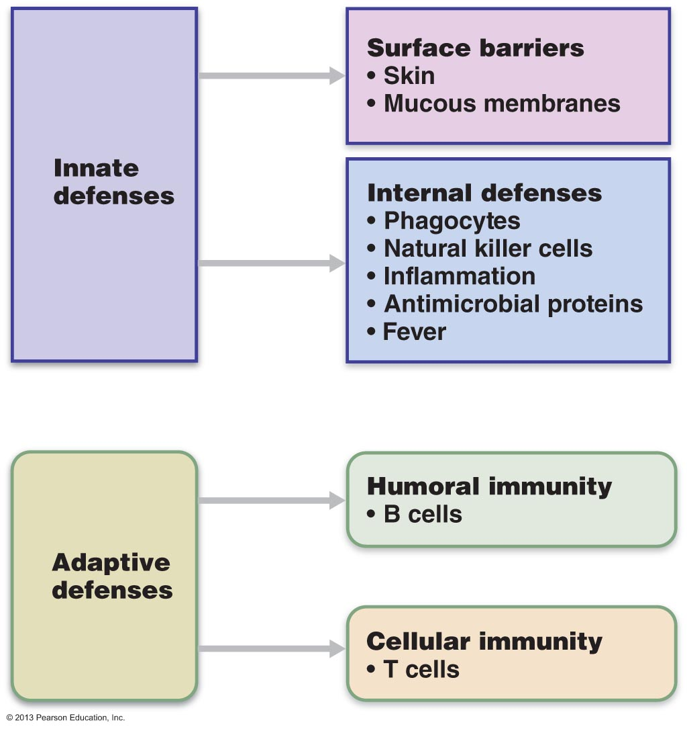

Innate defenses:

Skin & Mucous Membranes:
- effective, but can be breached
- ACID: acidity of skin, vaginal and stomach secretions deters growth of bacteria
- ENZYMES: lysozyme in saliva, respiratory mucus, lacrimal fluid; also protein-digesting enzymes in stomach
- MUCIN: digestive and respiratory passageways – sticky, traps microorganisms
- EFENSINS: broad-spectrum anti-microbial peptides secreted by mucous membranes and skin
- OTHER CHEMICALS: some lipids in sebum and dermicidin in eccrine sweat are toxic to bacteria

Natural Killer Cells:
- police blood and lymph; part of innate immune system
- can kill virus-infected cells or cancer cells even before adaptive immune system activated
- don’t identify invaders; just recognize abnormalities on surface of body cells such as loss of self-antigens – recognize cells that are “stressed”
- contact target and inject toxins inducing it to undergo apoptosis
- NK population greatly reduced in people with AIDS

Inflammation:
- a response to any type of injury – eg:
- 4 key signs: redness, heat, swelling, pain
(i) prevents spread of damaging agents to nearby tissues
(ii) disposes of cell debris & pathogens
(iii) sets the stage for repair processes
(iv) alerts the adaptive immune system
- inflammation occurs as part of nonspecific defenses and can be amplified by specific immune system responses
- inflammatory chemicals (e.g. histamine, kinins, prostaglandins, complement) released by injured cells, macrophages, lymphocytes

What causes pain during inflammation?
Why is inflammation a helpful response to tissue injury?
Define: margination, diapedesis, chemotaxis

The body’s Antimicrobial Proteins:

Interferon:
- secreted by virus-infected cells – diffuse to nearby non-infected cells & block protein synthesis, also degrade viral RNA
- NOT virus-specific
- interferons also activate macrophages & mobilize natural killer cells, allowing for some anti-cancer effects as well

Complement:
- refers to a group of at least 20 plasma proteins circulating in an inactive state
- once activated, various components amplify all aspects of inflammatory process

Fever:
- body’s thermostat normally set at …………
- reset by pyrogens released by leukocytes & macrophages exposed to bacteria & other foreign substances
- high fever is dangerous – why??
- moderate fever is helpful:
(i)
(ii)

Adaptive Mechanisms:

3 crucial cell types involved in body immunity are:
1) B lymphocytes (humeral immunity)
2) T lymphocytes (cell-mediated immunity)
3) macrophages (antigen-presenting cells)

Lymphocytes:
- originate in red bone marrow from hemocytoblasts
- initially, all lymphocytes identical - whether becomes B- or T-lymphocyte depends on where in body acquires immunocompetence (what is this??)

What is an antigen??

What is the major histocompatibility complex?

T-cells: migrate to thymus where undergo maturation (2-3 d) under direction of thymic hormones

B-cells: immature lymphocytes undergo maturation in bone marrow; self reactive ones again weeded out
- once immunocompetent, display unique receptor on cell surface which makes them able to react to one & only one foreign antigen
- lymphocytes become immunocompetent before meeting antigens they may later attack

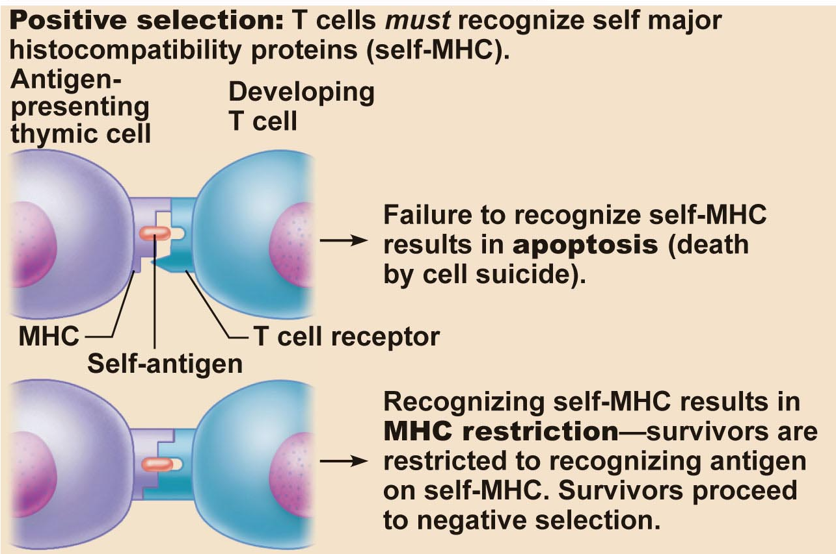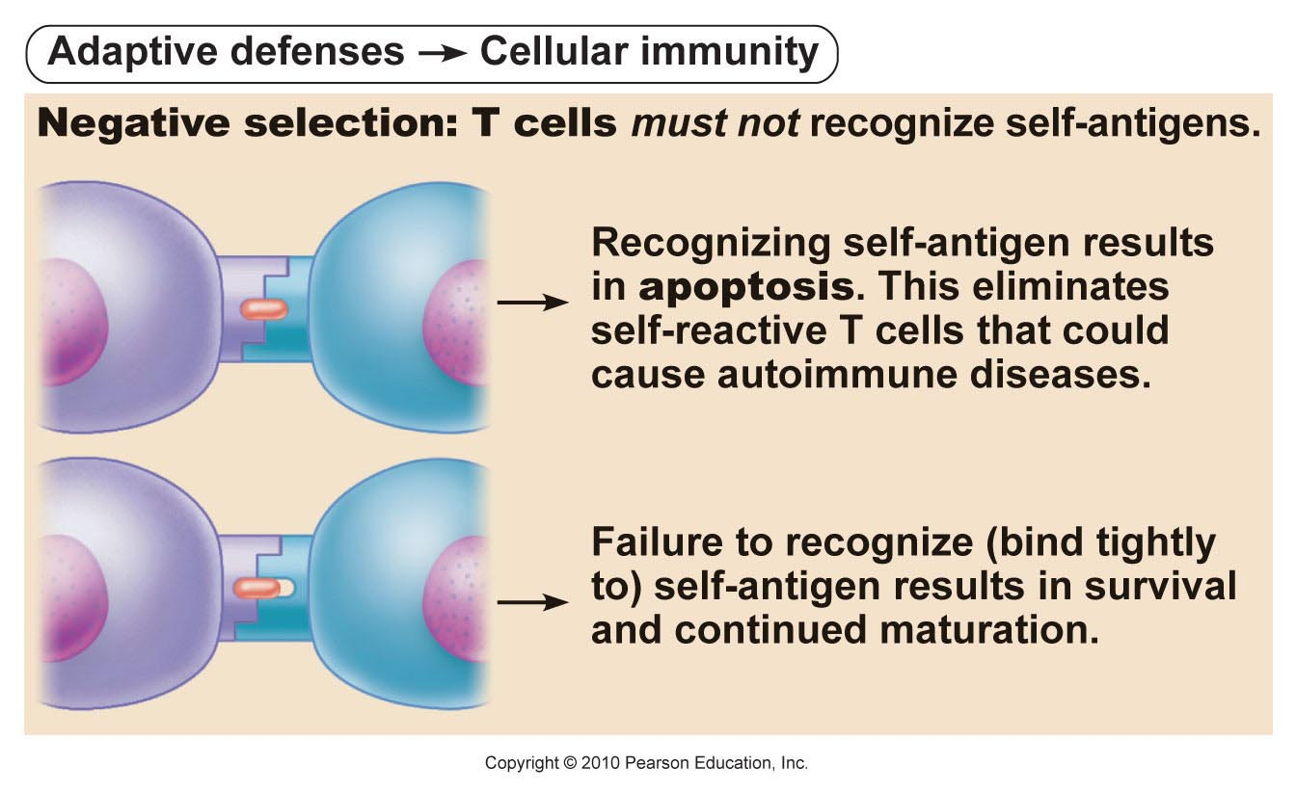

Humoral Immune Response:

- antigen challenge usually in spleen or lymph node
- if lymphocyte is a B-cell humoral immune response is evoked
(i) plasma cells turn out specific antibodies at a terrific rate; last 4-5 days
(ii) antibodies circulate & bind to free antigen destruction
(iii) clone cells that don’t become plasma cells remain as memory cells; can be called upon years later
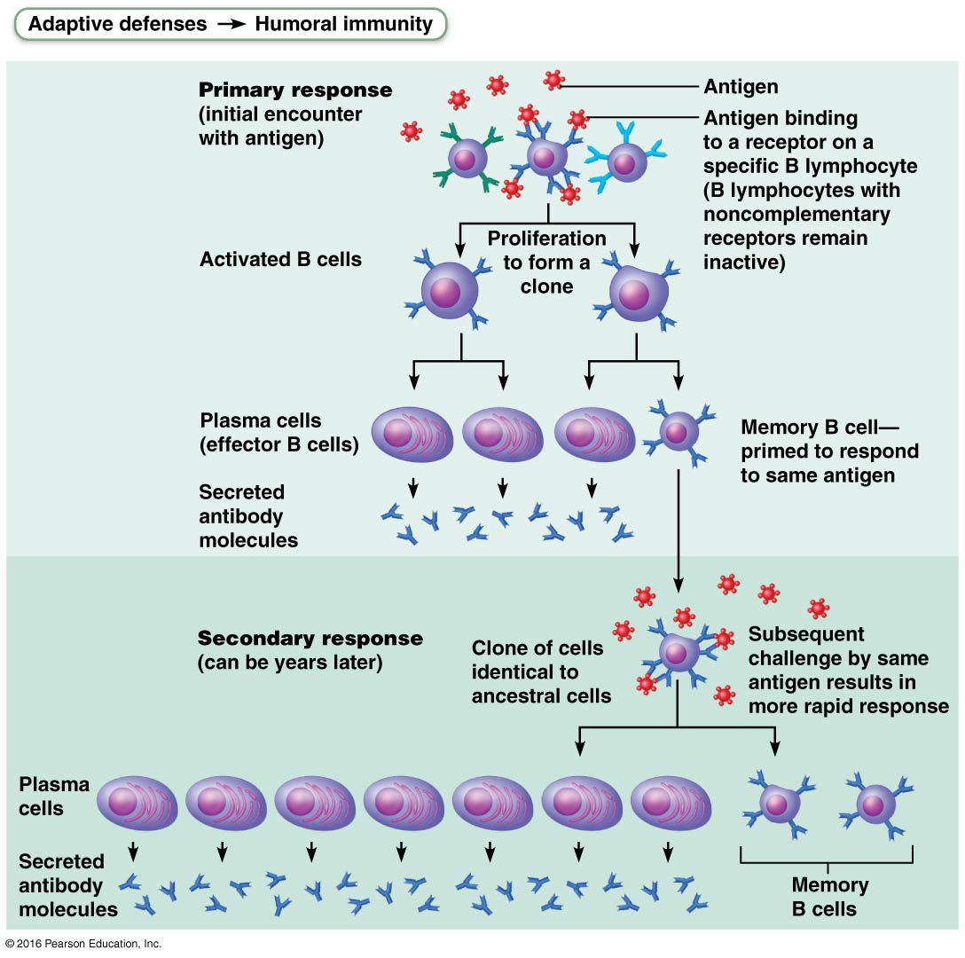

Where do vaccines fit into this?

Understand the concept of immunological memory.

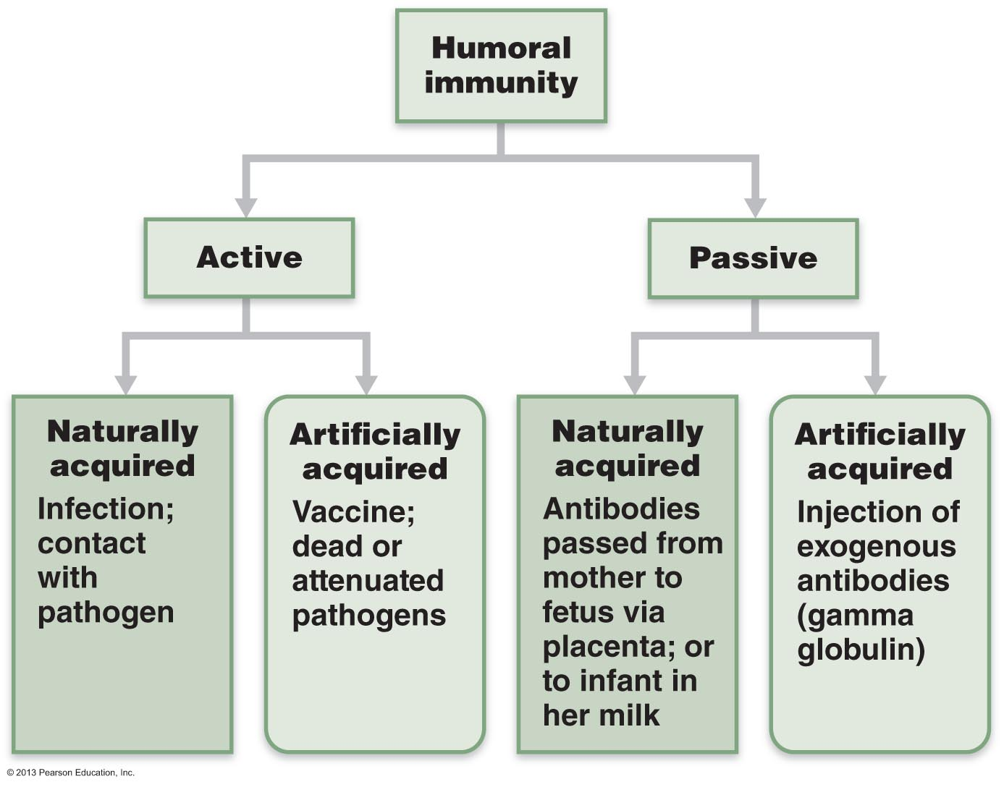

Only active immunity is able to establish immunological memory!
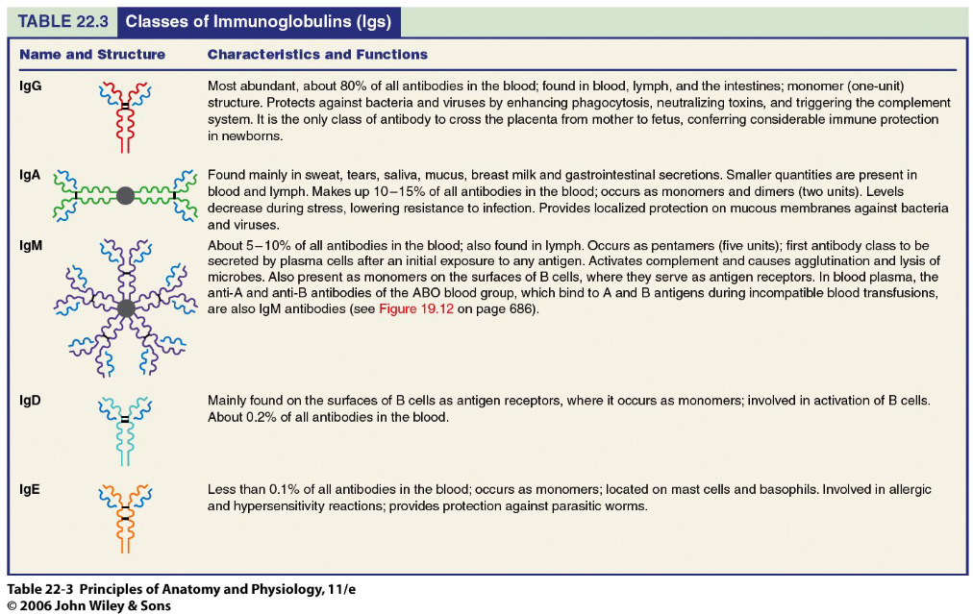

Cell-Mediated Immune Response (T-Cells):
- antibodies can handle only obvious antigens (outside cells) - cannot, eg, fight TB bacillus or viruses that multiply inside cells
- involves various types of T-cells - don’t respond to free antigens; « see » only processed antigen fragments displayed on body’s own cells
- direct attack against body cells infected by viruses, bacteria; also abnormal or cancerous cells, cells of infused/transplanted foreign tissues

There are three main subpopulations of T-cells:
- CD8 cells = Cytotoxic T cells: killer T cells - attack & kill other cells using perforin
- CD4 = Helper T cells: stimulate proliferation & activity of other lymphocyte subpopulations (including plasma cells) – most prevalent type of T-cell
- Regulatory T cells: wind down/stop immune response – a small subset of CD4 cells

Macrophages
- arise from monocytes formed in bone marrow
  - major role is to engulf foreign particles & present fragments of these antigens on own surfaces so can be recognized by T-cells (antigen presenters)
  - also secrete soluble proteins that activate T cells → activated T cells then secrete factors that activate macrophages
- macrophages tend to remain in lymphoid organs waiting for antigens to come to them; T-cells circulate freely, increases chances of contact with foreign antigens
- lymph capillaries pick up proteins & pathogens from nearly all body tissues; eg: source of microorganisms for tonsils??? for spleen???
- effectiveness of immune system in fighting disease depends on:
(i) ability to recognize foreign antigens by binding to them
(ii) ability to communicate with one another so whole organism mounts a specific immune response to those antigens

Cytotoxic T Cells recognize antigens presented via class 1 MHC [expressed by almost all cell types]

Regulation of metabolism and body temperature:

Diabetes Mellitus:

- insulin activity deficient or absent; insulin has no “back-up” hormone
- blood glucose is high, but it is unable to get into most cell types - cells are unable to utilize glucose for energy production: “starving in the land of plenty”

- In the absence of an insulin signal, glucose cannot enter cells.
- The body responds by mobilizing fats. FFA cannot make glucose, and cannot enter the Krebs cycle when carbohydrate sources are low, due to loss of the acetyl-CoA “acceptor” molecule oxaloacetate (which is scavenged). This can lead to build-up of ketone bodies in the blood;
- The accumulation of ketone bodies leads to ketoacidosis (pH of blood is lowered). If this becomes too severe it can disrupt processes including CNS, heart activity and O2 transport, leading to coma and death.
- The body thinks it needs more glucose, so it scavenges things.
- we need a pick up molecule but it’s not there so we can’t pick up acetyl-CoA, so we don’t burn the Krebs cycle

3 key signs of diabetes mellitus:
- polyuria: excess glucose in urine leads to inhibition of water resorption by the kidney, resulting in decreased blood volume and dehydration. Also have severe electrolyte imbalance due to excretion of ketone bodies (negatively charged; carry positive ions such as Na and K from body)

- polydipsia: dehydration stimulates hypothalamic thirst centers

- polyphagia: excessive hunger: diabetic person is actually starving due to inability to use ingested carbs

Two Main Types of Diabetes Mellitus:

Type 1 (Juvenile Diabetes, Insulin-Dependent Diabetes): Less common of the two forms. Loss of β cells & therefore no insulin production whatsoever. May be due to an autoimmune reaction resulting in destruction of β cells (perhaps viral-induced through “molecular mimicry”). Must take exogenous insulin for survival – long term vascular (atherosclerosis, stroke, heart attack, gangrene) and neurological (loss of sensation, impaired bladder function, impotence) complications.
(because its hard to keep the blood sugar where its meant to be).
- Type 1 is more severve but less common compared to type 2.
- complications even if you take insulin

Type 2 Diabetes (Non-insulin-Dependent; Adult-Onset Diabetes): More common form. Reduction in insulin secretion &/or target cell sensitivity. Risk increases with age, lifestyle (typically T2 are overweight and sedentary), strong genetic component in many cases. Insulin often produced, but target cell receptor or post-receptor defects.Ketoacidosis typically not a major problem with type two diabetics, but they are at risk for most other complications associated with type I; heart disease, impaired circulation, etc. Type 2 diabetes can often be managed by diet, weight loss and exercise…eventually may need exogenous insulin.
- Blunting of an insulin symbol (inhibiting )

List the various hepatic functions associated with metabolism:

- the liver one of the most biochemically complex organs in body – conducts over 500 metabolic functions.
- processes nearly every class of nutrients & plays a major role in regulation of plasma cholesterol levels

General Metabolic Functions:

Carbohydrate Metabolism:
- isomerizes monosaccharides to glucose“packages” glucose as glycogen and fats – serves as a glucose store
- glycogenolysis – to release glucose
- gluconeogenesis – converts amino acids or glycerol to glucose when needed.
Fat Metabolism:
- Primary site for b-oxidation
- Generates ketone bodies from Acetyl-CoA
- Generates lipoproteins for triglyceride transport
- Metabolizes cholesterol, bile salts

Protein Metabolism:
- Principal site of amino acid deamination -forms urea for removal of ammonia
- Generates most plasma proteins
- Major site of generation of non-essential amino acids (by transamination)

Storage:
- Stores 1-2 years worth of Vitamin A, 1-4 month supply of vitamin D and vitamin B12
- Stores iron (as ferritin) from degraded rbc for release when needed

Biotransformation:
- “Inactivates” compounds such as ethanol, drugs
- Will also activate a number of drugs
- Processes bilirubin from heme – bile pigment
- Catabolizes many hormones for excretion

List and describe the 4 major types of lipoproteins:

- Triglycerides & cholesterol are insoluble in an aqueous environment, and therefore cannot circulate freely in the blood – are transported as lipoproteins.
- All lipoproteins are composed of varying proportions of triglycerides, phospholipids and cholesterol, in addition to protein. Protein important for regulating entry into specific target cells.
- In general, the higher the % lipid in a lipoprotein, the lower its density.
- Four principal lipoproteins are: chylomicrons, VLDL, LDL and HDL. Each carries out a specific role.

Chylomicrons: lowest density; transport newly adsorbed lipids from GI tract\

VLDL: Primarily made in liver, transports triglycerides to peripheral tissues (mostly adipose tissue). At target cells, the triglycerides are “unloaded’, VLDLs become LDL

LDL: primary role is deliver cholesterol to peripheral tissues. Recall cholesterol is needed for many functions – steroid hormones, bile salts, membranes, signaling molecules in development, etc. Not all “bad”.

HDL: Protein component of HDL made in liver and secreted in a “collapsed” (lipid-poor) form. Primary purpose is to transport excess cholesterol from peripheral tissues to the liver, where it is broken down - bile. Will also deliver cholesterol to some tissues (e.g. ovaries and adrenals) for use in steroid hormone synthesis.

- Excess blood cholesterol (> 200 mg/dl) is linked to an elevated risk of atherosclerosis and associated stroke and heart attack.
- The form of cholesterol is important in this consideration:
- HDL are believed to be “good” because the cholesterol associated with HDL is mainly destined for degradation.
- LDL are believed to be “bad” because excessive LDL can lead to deposition of cholesterol in blood vessel walls (esp. lipoprotein (a) - a high risk form of LDL associated with plaque formation in blood vessels)
- Relative cholesterol levels are influenced by a number of factors:
  - saturated fatty acids simulate liver synthesis of cholesterol (liver is most important source of cholesterol) and inhibits cholesterol excretion.
  - Unsaturated fatty acids promote catabolism and excretion of cholesterol
  - However, Trans fats, even though they are unsaturated, stimulate an even greater increase in LDL compared to saturated fatty acids and decrease HDL.
Is this a good thing?

Describe the synthesis of the thyroid hormones and its regulation:

The thyroid: a butterfly-shaped organ located on trachea just inferior to larynx
- Consists of two bilateral lobes connected by an isthmus
- The thyroid is the largest “pure” endocrine gland in the body; it is supplied by a very rich blood supply through the superior and inferior thyroid arteries from the carotid artery.
- The thyroid gland is composed of hollow spherical “follicles” surrounded by cuboidal or squamous epithelial cells called follicle cells; produce thyroglobulin(a glycoprotein).
- Follicles are filled with a colloid consisting of iodinated thyroglobulin which serves
- as the precursor for thyroid hormone. Parafollicular cells, interspersed between
- the follicles, produce calcitonin.
- Thyroid gland is the source of the body’s major metabolic hormone, thyroid hormone. Actually comprised of two highly related molecules derived from two iodinated tyrosine amino acids.

(1) thyroxine = T₄; is the principal secretory product of the thyroid follicles – contains 4 iodine molecules
(2) triiodothyronine = T₃; is the more active thyroid hormone, and is derived largely from T4 at target cells.

- With few exceptions (e.g. adult brain, spleen) thyroid hormone affects essentially every cell in the body.

Transport & Regulation of Thyroid Hormone:
- Secreted T₄ & T₃ (mostly T4) are transported in blood bound to thyroxine binding globulin (TBG) which transports them throughout the body.
Why do we need a transport protein for T3 or T4?

- At target cells much of the T₄ will be converted to T₃ (most target cells have the enzymes necessary for this conversion).
- Within the nucleus of target cells T₃ (and T₄) bind to the Thryoid Hormone Receptor (TR), which results in the increased expression of target genes - T₃ is approximately 10x more active than T₄
Why is T3 so much more potent?

Transport & Regulation of Thyroid Hormone:
- Falling thyroid hormone levels lead to secretion of TSH (thyroid stimulating hormone) by the anterior pituitary; this elicits two general responses in the thyroid gland. The initial response of the thyroid gland to TSH is to secrete stored thyroid hormone. The second response it to resynthesize thyroglobulin and to replenish the colloid; there is typically enough hormone in colloid to support secretion for several months.
- What is unique about the storage and release mechanism of the thyroid gland?
- Regulation of the secretion of thyroid hormone shows the classical negative feedback system. In this scenario, thyroid hormone production initially rises following stimulation by TSH (thyroid stimulating hormone) secreted from the anterior pituitary. Thyroid hormones then feed- back inhibit at two levels: (i) They inhibit TSH secretion by the anterior pituitary and; (ii) they inhibit secretion of thyrotropin releasing hormone (TRH) by the hypothalamus.
- Some conditions, such as pregnancy, prolonged cold, etc. will override this inhibitory feedback at the level of the hypothalamus, leading to secretion of TRH and subsequent increase in the levels of thryoid hormones to increase metabolism and heat production.

List the metabolic processes regulated by thyroid hormones:

- TH affects essentially every cell of the body except adult brain, spleen, testes, uterus and thyroid gland.
- A major function is to regulate the basal metabolic rate/body heat production: calorigenic effect. TH does this in part through stimulating enzymes involved in glucose oxidation.
- Also play key roles in maintaining blood pressure through regulation of adrenergic receptor number.
- Regulates tissue growth and development, especially skeletal and nervous system development, maturation and reproduction.

Disorders involving the thyroid hormones:

Hypothyroidism:
- Myxedema (“mucous swelling”) in adults
- Can occur through inadequate TSH or TRH release, removal of thyroid gland or inadequate dietary iodine. Results in lethargy, low metabolic rate, “chills”, dry skin, edema, mental sluggishness.
- In the case of inadequate dietary iodine, the follicle cells try to make colloid, but cannot iodinate it. TSH increases in order to try to induce secretion of T3/T4, resulting in more accumulation of inert colloid. Leads to an enlarged and protruding thyroid gland termed an endemic goiter.
- Severe hypothyroidism in infants is termed cretinism due to a critical need for T3/T4 in CNS development. Mental retardation, thick tongue/neck, disproportionate body size. Preventable by replacement therapy but only if diagnosed early, not reversible once overt signs are present.

Hyperthyroidism:
- most common & puzzling form is Grave’s Disease
- autoimmune: e.g. patient has developed antibodies that mimic TSH - bind to follicle cells & continuously stimulate output of thyroid hormones
- symptoms include: elevated BMR, sweating, rapid & irregular heartbeat, nervousness, weight loss, exophthalmos
- treatments: removal of thyroid or ingestion of radioactive iodine (why the latter?)

A (very) few words about Calcitonin:
- polypeptide hormone produced by parafollicular cells or C cells of thyroid gland
- lowers blood calcium
(1) inhibits bone resorption
(2) stimulates Ca⁺⁺ uptake & incorporation into bone
- calcitonin secreted in response to an increase in blood levels of calcium; declining blood calcium inhibits calcitonin release
- calcitonin most important during childhood (skeleton); minimal role in adults

Define basal metabolism and total metabolism and identify the factors that influence them:

- Metabolic Rate; Basal Metabolic Rate (BMR):
- Metabolic rate is defined as body’s rate of energy expenditure per hour = total heat produced by all of the chemical reactions and mechanical work of the body
- BMR: “rate at which energy is expended (heat produced) by the body per unit time under controlled (basal) conditions: 12 hours after a meal, at rest” Can be measured by oxygen consumption (indirect) or by a calorimeter (to measure heat production by the body).
- BMR is a measure of the energy used to maintain only the essential activities when awake (breathing, resting levels of organ function) = “energy cost of living”.
Is this really the lowest point of metabolism?

- BMR is reported as kcal/m²/hr.
- BMR is influenced by: body surface area, age, gender, stress, hormones
(1) major determining factor is body surface area (why?)
(2) BMR inversely proportional to age; need energy for growth
(3) BMR higher in males than females; males have more muscle, less fat

Regulation of Metabolic Rate:
- Stress: (physical or emotional) - can increase metabolic rate
- norepinephrine & epinephrine from adrenal medulla increase metabolic rate primarily by increasing fat catabolism, resulting in heat generation as a by-product
- Body temperature and BMR are tightly associated; fever is associated with markedly higher metabolic rates.
- Most important hormonal factor in regulating BMR is thryoid hormone, hence the term “metabolic hormone”
- Recall that, in essentially all cells, TH increases oxygen consumption by accelerating metabolism. One means by which it does this is by increasing use of ATP for operation of Na/K pump; ATP reserves decline, cellular respiration increases, resulting in more ATP and generation of heat as a by-product.
- hyperthyroidism: high MR; weight loss, poor heat tolerance, muscle atrophy
- hypothyroidism: low MR; slowed metabolism, obesity, poor cold tolerance

Total Metabolic Rate (TMR:)
- total rate of kcal consumption to fuel all ongoing activities (sum of BMR-related calorie consumption plus voluntary activities)
- usually BMR accounts for most of TMR: eg: a woman may expend 2000 kcal energy in a day, of this ~1400 kcal is to maintain BMR
- work done by skeletal muscle (can be nearly half of body mass) produce largest increases in TMR. When exercising, an athlete can increase metabolic rate by 15-20 fold and this can remain elevated for hours after completion of activity

ingestion also impacts on TMR:
- food-induced thermogenesis: energy consumed to digest food results in rapid increase in TMR (especially when a meal is high in protein). This effect is primarily due to increased metabolic activity of the liver
- fasting or low caloric intake: decreases metabolic rate & results in slower breakdown of food reserves

Describe and explain the mechanisms of heat exchange:

Body temperature is a balance between heat production and heat loss.
• vigorous exercise: heat prod by skeletal muscle can be 30-40X that of rest of body
• change in physical activity a key way of modifying body temp
• average body temp ~ 37⁰C (maintained range = 35.8-38.2⁰C)
• body temp fluctuates ~1⁰C over 24-h [low early AM; higher in PM]
• for every 1⁰ C rise in temp, rate of catalytic reactions increases by ~10%
temp too high: neurons depressed & proteins start to be denatured
• adults: convulsions @ 41⁰C; limit for life ~ 43⁰ C
• body cooling tolerated better

Four Mechanisms of Heat Exchange:
Remember that heat always flows down its “concentration” gradient.

1. Radiation:
• defined as loss of heat by infrared waves (thermal energy)
• usually ~50% of body heat loss is by radiation (therefore body surface area is a major determinant of BMR)
• eg: cool room warming when filled with people
• movement of heat from warmer to colder by waves
2. Conduction:
• defined as the transfer of heat between objects in direct physical contact with one another (eg. heat to body from a warm tub; heat from warm buttocks to the seat of a chair); the thermal energy moves through a material medium
3. Convection:
• warm air (less dense) rises and is replaced by (denser) cool air
• cool air absorbs heat more rapidly than warm air
• convection is enhanced by any process which moves air more rapidly across the body surface (wind or fan = forced convection) – enhances the process of conduction.
4. Evaporation:
• water molecules that absorb enough heat can obtain enough energy to escape as gas. This heat is called heat of vaporization
• water absorbs a lot of heat energy before vaporizing - for every 1 gm water vaporized, ~0.58 kcal heat energy removed from body
• There is a “basal” heat loss due to continuous evaporation of water from lungs, mouth, skin; Called insensible water loss, while the heat is called the insensible heat loss. It accounts for approximately 10% of basal heat production, is constant and is not subject to body temperature controls
• evaporative heat loss becomes an active (sensible) process when body temperature rises – leads to activation of sweating to increase heat loss. For example, during vigorous exercise, the body temp can rise 2-3⁰C. This can evoke evaporation of 1-2L perspiration/hr, or a heat loss of 600-1200 kcal/hr.
- Extreme emotional states (sympathetic ns) can cause a body temp increase of ~1⁰C, and increased perspiration used to shed heat.

Explain the mechanisms for the control of body temperature:

Role of the Hypothalamus:
- major integrating centre for thermoregulation (principally the preoptic region of the hypothalamus)
- Comprised of two thermoregulatory centers:
- heat-loss centre
- heat-promoting centre
- Hypothalamus receives afferent input from
- peripheral thermoreceptors (located in the shell)
- central thermoreceptors (located in the core – sensitive to blood temperature)
- The hypothalamus receives input from these thermoreceptors and initiates appropriate heat-loss or heat-promoting reflex mechanisms much like a thermostat.
- input from central thermoreceptors more important than from peripheral ones, but lowering of shell temp may alert hypothalamus to initiate anticipatory measures to preserve core temp

Heat-Promoting (Conservation) Mechanisms
(a) Vasoconstriction of cutaneous blood vessels:
• Activation of sympathetic vasoconstrictor fibers serving skin results in decreased blood flow, restricting blood to deep body areas, largely bypassing skin – skin is “insulated” from the core by fatty subcutaneous tissue, resulting in a sharp drop in shell temperature and conservation of core temperature.
• OK for a brief period but if extended during, for e.g. very cold weather, skin will be deprived of O₂/nutrients for a prolonged period and will die = frostbite.

(b) Shivering:
• brain centers alternately stimulate stretch receptors in antagonistic muscles resulting in involuntary shuddering
• shivering is very effective as muscle activity generates lots of heat

Heat-Promoting (Conservation) Mechanisms (continued)
(c) Increase in metabolic rate:
cold stimulates release of epinepherine and norepinepherine by adrenal medulla in response to sympathetic stimuli. This results in an increased metabolic rate and more heat production.
Termed chemical or nonshivering thermogenesis – well documented to occur in infants but controversial in adults.

(d) Enhanced thyroxine release:
Gradual lowering of external temperature (eg: fall to winter) leads to an increased secretion of TRH by the hypothalamus, causing TSH secretion by the anterior pituitary which, in turn, increases secretion of thyroid hormones (T3 & T4)
increases metabolic rate & body heat production and improves the ability to maintain constant body temp as environment cools. Again, not seen in adults.

Heat-Promoting (Conservation) Mechanisms (continued)
(e) Behavioural modifications:
• putting on warmer clothing, ingesting warm fluids
• changing posture to reduce exposed body surface area; increasing physical activity

Heat-Loss Mechanisms:
• most heat-loss mechanisms occur through the skin
• when core body temp increases, the hypothalamic heat-promoting centre is inhibited & the heat-loss centre activated.

(a) Vasodilation of cutaneous blood vessels:
• turn off sympathetic vasoconstriction, resulting in increased blood flow to the skin and increasing heat loss by radiation, conduction, convection

(b) Enhanced sweating:
• if body is very overheated or the environment is hot (>33⁰) such that vasodilation alone is not sufficient, sweating is activated. Sweat glands are strongly activated by sympathetic nervous system, increasing perspiration.
• effective mechanism for heat loss if surrounding air is dry; if very humid, evaporation occurs much more slowly
(c) Behavioural modifications:
• reducing level of activity, seeking cooler environment (shade) or increasing convection (fan)
• wearing light-coloured, loosely-fitting clothing - reflects radiant energy & reduces heat gain

Hyperthermia:
• occurs when normal heat loss processes become ineffective
• elevated body temperature depresses hypothalamus. At around 41ºC this causes a suspension of heat-control mechanisms resulting in a vicious positive feedback cycle:
increased temp leads to an increased metabolic rate leading to increased heat production
This causes temperature continues to spiral up; skin becomes hot & dry, multiple organ (including brain) damage becomes possible. Condition termed heat stroke and can be fatal if not corrected.

Fever:
- Controlled” hyperthermia – usually due to infection
- Pyrogens (cytokine signaling molecules) released by macrophages cause a “reset” of hypothalamic thermoregulatory centers.
- Vasoconstriction (dry skin), shivering (core temp. too low)

Discuss the mechanisms od appetite regulation:

- Energy Intake = Total Energy Output (heat + work + Energy Storage)
- Energy Intake = energy provided by food oxidation (energy released when the bonds linking the subunits of complex food molecules are broken)
- Energy Output = energy lost as heat (~60% of total) + work (ATP)
- Energy Storage = excess of energy intake that is stored as fat or glycogen
• the majority of energy output is in the form of heat - even when muscles do work, much of this energy from food breakdown is lost in the form of heat

Heat: (1) warms tissues & blood (comfortable temperature)
(2) allows metabolic reactions to occur at efficient levels

B. Regulation of Food Intake:
• when energy intake = energy output in the form of heat + work, body weight remains stable
• in most people, body weight remains fairly stable, suggesting that physiological mechanisms must exist to control food intake, or heat production, or both
• no single signal or receptor type identified to date which balances food intake with energy output - but there are some pathways that are clearly involved

Appetite & Appetite Control:
appetite: desire for specific types of food - dependent on memory & associations; doesn’t necessarily reflect body’s caloric needs
hunger: a physiological need to eat
satiety: satisfaction of hunger

- The arcuate nucleus (with the lateral hypothalamic area and the ventromedial nucleus) in the hypothalamus and the solitary nucleus in the brainstemnare key centers in appetite regulation.
- Arcuate nucleus: two important groups of neurons: stimulation of Neuropeptide Y/agouti-related Peptide (NPY/AGRP) secretion stimulates appetite via the LHA. Proopiomelanocortin/cocaine and amphetamine-regulated transcript (POMC/CART) neurons release melanocortins - suppress appetite via corticotropin releasing hormone by the VMH.

Short-term and long-term regulation of appetite :

Short term:

Neural signals (vagal stimulation):
- stretch receptors in GI tract inhibits appetite. Protein and carbohydrates stimulate vagal afferents to inhibit appetite: protein stimulates longer response

Nutrients: Plasma levels of glucose, amino acids, FFA, & glycerol signal to brain:
- during eating, plasma glucose levels rise, activate glucose receptors in brain & ultimately eating is depressed
- elevated plasma amino acids depress & low plasma amino acids stimulate eating
- blood concentrations of FFA & glycerol play a similar role

Hormones:
• insulin - released in response to food intake, known to depress hunger, presumed to be important an satiety signal
• cholecystokinin - released by small intestine during food digestion; depresses hunger
• glucagon levels rise during fasting and stimulates hunger
• Ghrelin released from stomach; potent stimulator of hunger

Body Temperature:
• suggested that increased body temp, due to increased MR during food processing, may depress hunger
• thermal signal would also explain increased eating behaviour in cold climates

Psychological Factors:
• concept of a “higher set point” in the obese (maintains a higher total energy content)

Long-term regulation of appetite :

Leptin:
- Peptide hormone secreted by adipose tissue
- More adipose tissue, more leptin.

Serves as a sensor for adipose stores:
    - Binds to receptors in the ACR nucleus
      - Inhibits NPY secretion
      - Increases CART expression
      - Leads to inhibition of appetite until adipose stores (and leptin secretion) decrease

The Renal System:

Describe the anatomy of the male and female Urinary System:

- bean-shaped; retroperitoneal
- superior lumbar region: from thoracic vertebra to lumbar vertebra
- some protection from ; rt kidney pushed lower by liver
- adrenal glands sit on top of kidneys

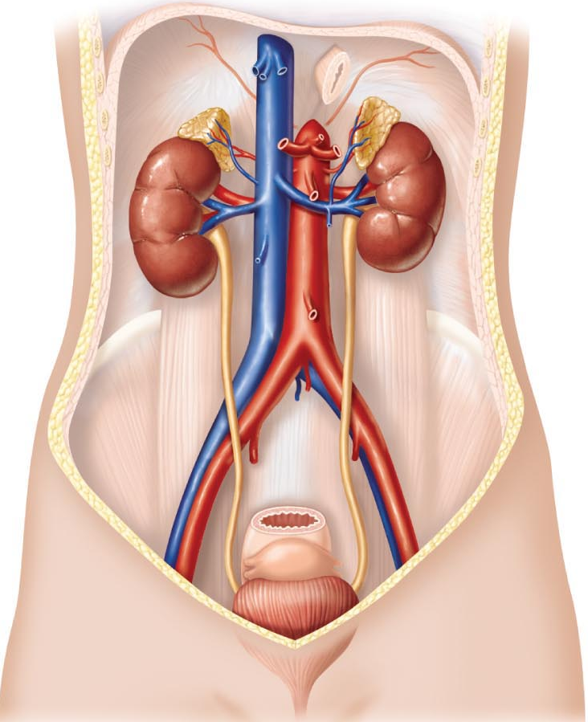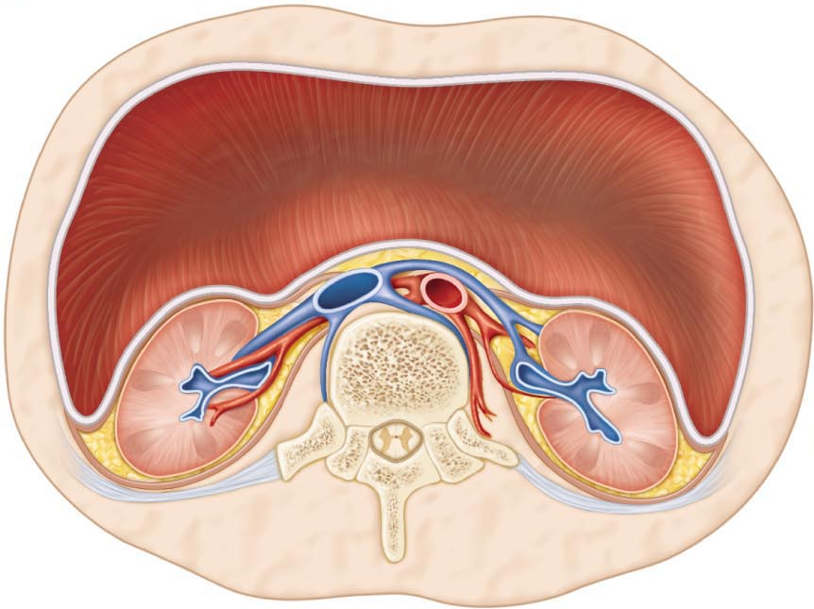

- concave medially: renal hilus to renal sinus

3 layers of supportive tissue:
- renal capsule: fibrous, adheres directly to kidney surface, strong barrier to ?
- perirenal fat capsule: cushions, helps hold kidney in place
- renal fascia: dense CT surrounds adrenal gland & kidney; anchoring role
- Right kidney, surrounded by adipose capsule of brown fat, covered by the peritoneum (it is a retroperitoneal organ).

What is renal ptosis?

INTERNAL ANATOMY:

- cortex: What process occurs here?

- medulla: darker colour; medullary or renal pyramids; Why do they appear striped ? separated by renal columns (cortical tissue); each medullary unit = ~1/8 of kidney
- pelvis: flat, funnel-shaped tube continuous with ureter; major & minor calices; minor calices enclose papillae of pyramids; calices collect urine
walls of calyces, pelvis, ureter contain smooth muscle; propel urine by peristalsis
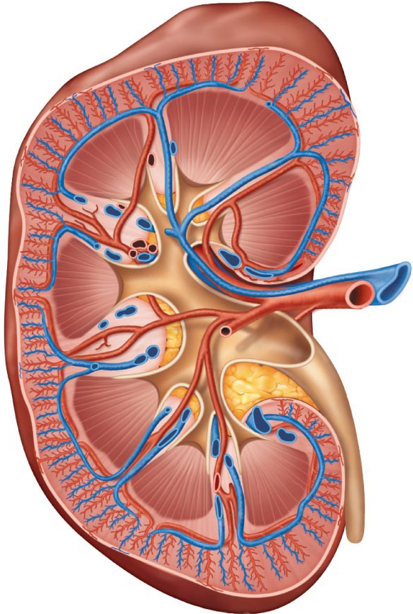

BLOOD & NERVE SUPPLY:
- renal arteries: ~1/4 total systemic CO (~1.2 L) to kidneys/min
- arterial branches pass up between medullary pyramids to reach cortex; venous branches drain back via same route
- nerve supply provided by renal plexus of primarily sympathetic fibers regulate renal blood flow by adjusting diameters of renal arterioles

4.1.2 describe the structure of a nephron; differentiate between cortical & juxtamedullary nephrons:

~10⁶ nephrons & thousands of collecting ducts/kidney

collecting duct has:

- principal cells (lack microvilli; salt & H₂O balance)
- intercalated cells (microvilli; acid-base balance)

2 types of nephrons:

- cortical (85%)
- juxtamedullary (15%)

Roles??

Microcirculation of the Nephron
glomerulus: specialized for filtration both fed & drained by arterioles
√ arterioles are high resistance vessels
√ afferent arteriole has larger diameter

Peritubular Capillaries:
arise from efferent arterioles – these drain into renal venules

What is the vasa recta and where is it found??

4.1.3 describe the structural organization of the juxtaglomerular apparatus
at junction of early DCT and afferent/efferent arterioles; regulate renal function:

- arteriole walls: JG cells (granular cells) enlarged smooth muscle cells – mechanoreceptors; secrete renin
- tubule wall: macula densa cells chemo- or osmoreceptors – monitor filtrate & adjust GFR accordingly

JGA regulates:
a) filtrate formation
b) systemic bp
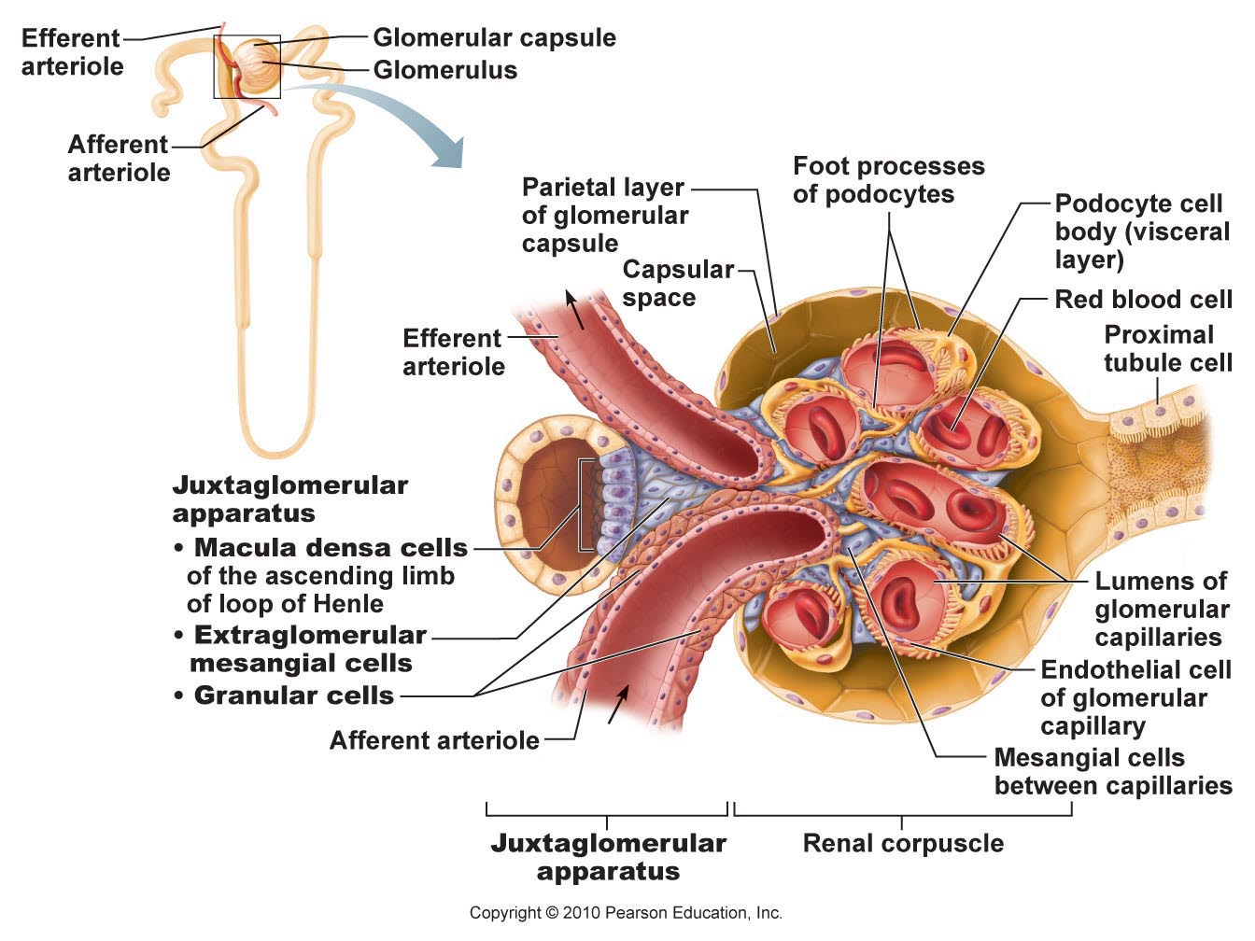
What is the trigone & why is it important clinically?

moderately full bladder (500 ml) ~12.5 cm long
can hold up to about double that volume

What forms the internal urethral sphincter?

What forms the external urethral sphincter?

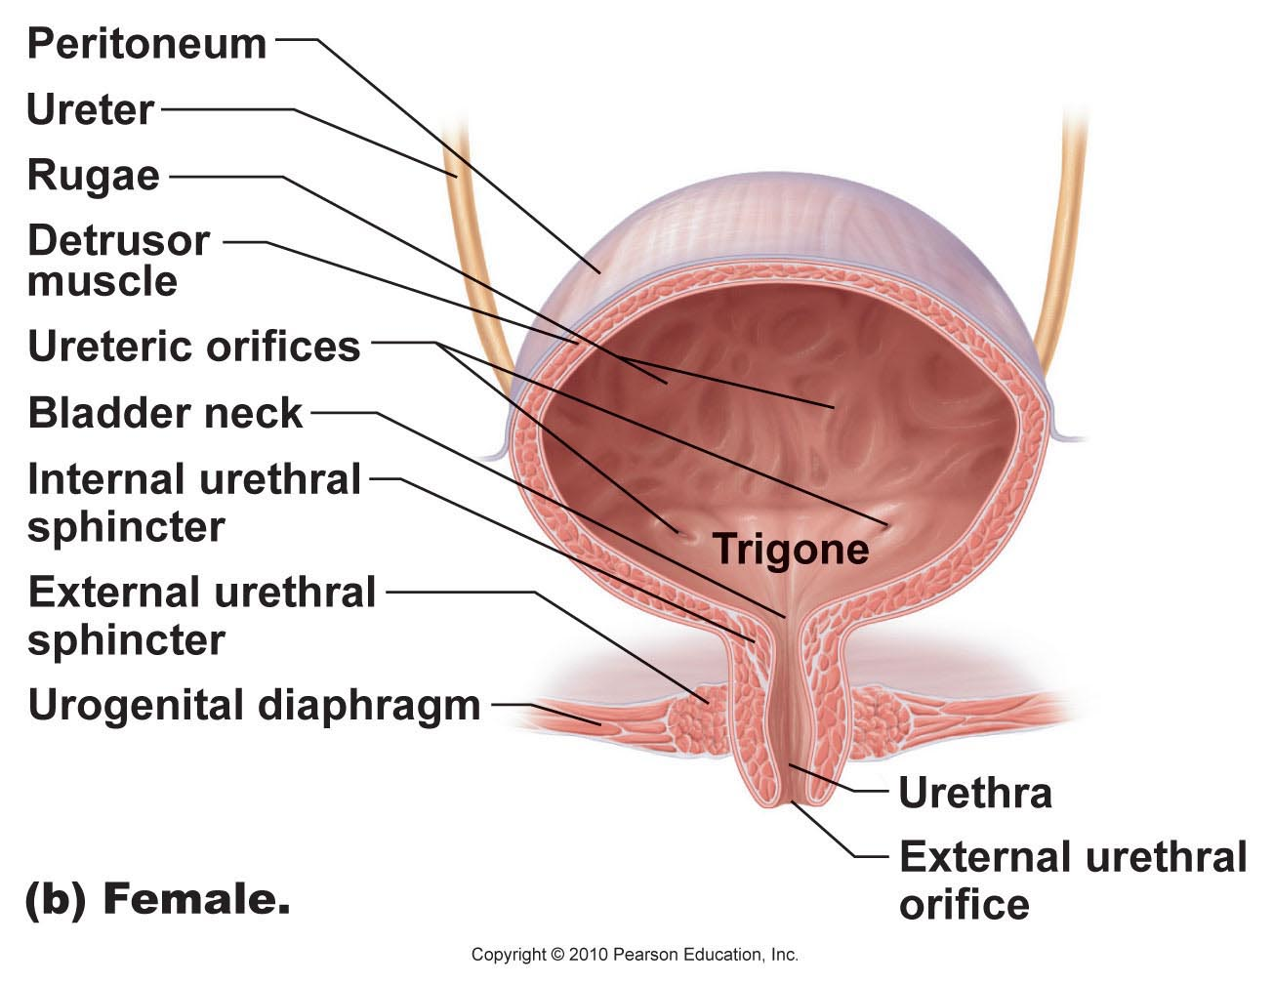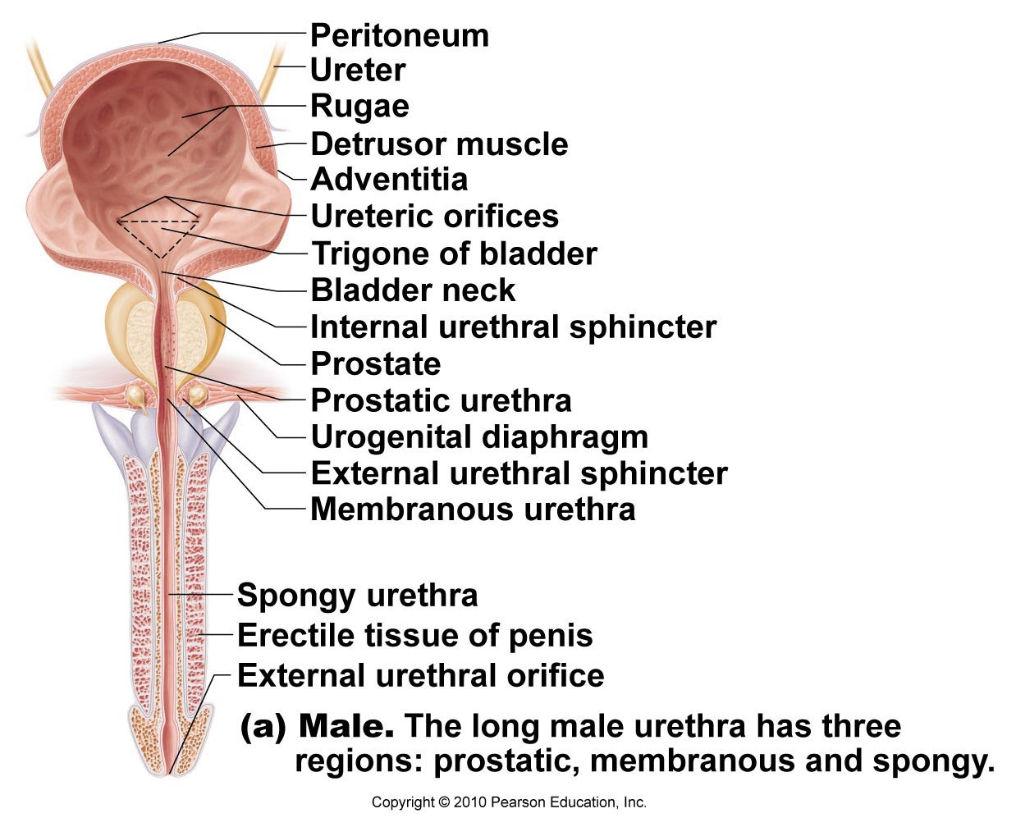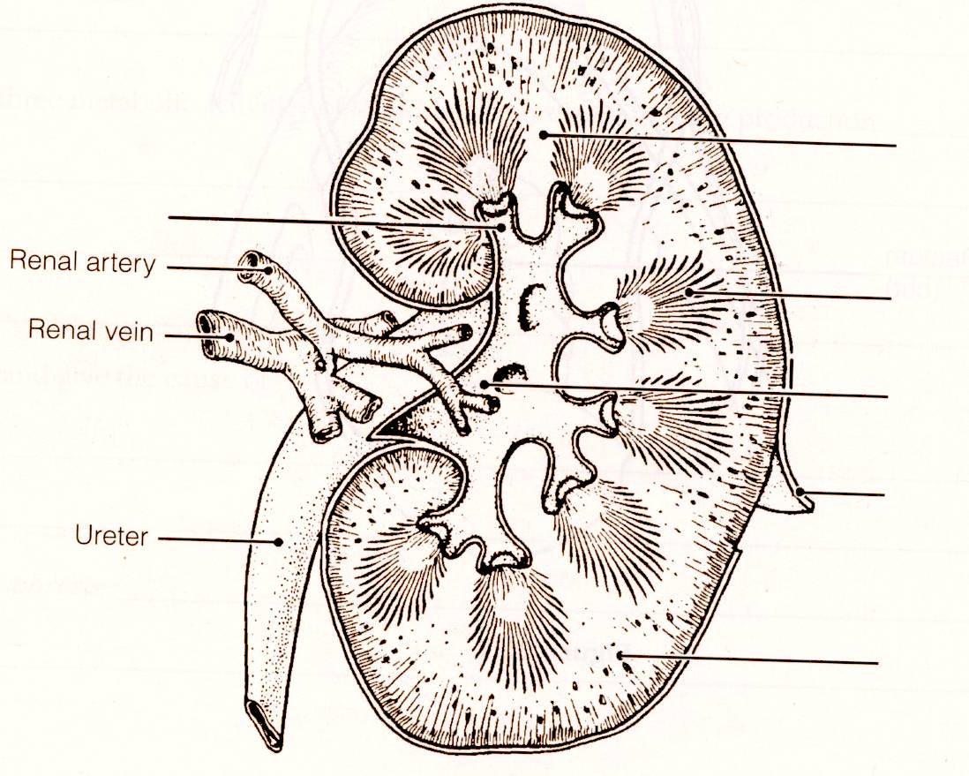

renal physiology

4.2.1 list the 2 primary & 4 additional functions carried out by the kidneys

• major excretory organs: perfect examples of homeostatic organs

Main function: filter several litres of fluid from bloodstream daily
(i) toxins, metabolic wastes, excess ions leave body in urine
(ii) materials still needed by body returned to bloodstream

Additional functions:
- regulate blood volume & composition (eg ……………& ……………)
- produce enzyme renin helps regulate bp & kidney function
- produce hormone erythropoietin
- metabolize vitamin D to its active form

4.2.2 define glomerular filtration, tubular reabsorption, tubular secretion; differentiate between filtrate & urine:

- 1000-1200 ml of blood pass through gomeruli each minute; (~650 ml plasma; of this 120-125 ml plasma forced into renal tubules every minute!)
- equiv to filtering entire plasma volume >60 times/day

filtrate = plasma minus proteins
urine = filtrate minus nutrients, essential ions, most H₂O
kidneys process ~180 L fluid/day; ~1% is urine (~1.5 L)
(i) glomerular filtration
(ii) tubular reabsorption
(iii) tubular secretion

Glomerular Filtration
• passive, nonselective fluids & solutes forced thru by hydrostatic pressure
• glomerulus very efficient filter because:
(i) filtration membrane 1000sX more permeable than other cap membranes
(ii) glomerular bp higher than in other cap beds (55 mm Hg vs < 18 mm Hg) –

what allows this bp to be maintained at such a high level??

180 L filtrate formed by kidney caps vs 3-4 L by all other cap beds combined!

4.2.3 describe the functional anatomy of the filtration membrane:

• between blood & interior of glomerular capsule - 3 layers
(i) fenestrated capillary endothelium
(ii) basement membrane
(iii) visceral membrane of glomerular capsule = podocytes

In summary:
- molecules < 3 nm (water, glucose, amino acids, N-wastes) pass easily
- molecules 3-6 nm pass, but with greater difficulty (meaning??)
- molecules > 7 nm are not filtered

• bm restricts passage of most larger ptns; aided by negative charges on most bm proteins (how does this help??)
• retention of plasma ptns maintains colloid osmotic pressure, blood flow
• presence of proteins or RBCs in urine suggests filtration membrane damage

4.2.4 define net filtration pressure:

pressure responsible for filtrate formation

NFP = HPg – (OPg + HPc)
NFP = 55 – (30 + 15)
NFP = 10 mm Hg

HPg – pushes out of blood
OPg – pulls back into blood
HPc – pushes back into blood
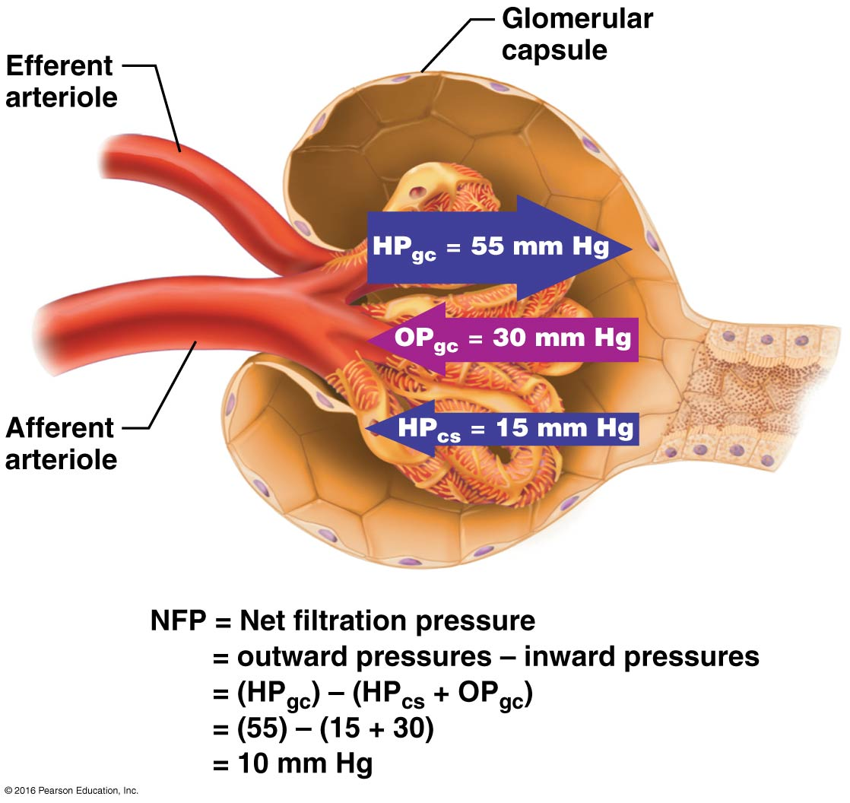

4.2.5 define glomerular filtration rate; be aware of normal value

= total amount of filtrate formed per minute (120-125 ml/min)
• depends on: (i) total SA for filtration
(ii) filtration membrane permeability
(iii) net filtration pressure (usu ?? mm Hg)
• glomerular caps have huge SA (= SA of skin); even though NFP only 10 mm Hg, get large amts of filtrate
• decrease in glomerular bp of only ~15% completely stops filtration!
• GFR is directly proportional to NFP
What happens to GFR with an increase in bp? In case of dehydration?

4.2.6 list & describe the 3 regulatory influences on GFR:

Why is this important?
• 3 regulatory influences allow for an optimal rate of flow:
- renal autoregulation (intrinsic)
- neural controls
- renin-angiotensin system

1. Intrinsic Mechanisms: Renal Autoregulation:
kidney keeps GFR ~constant by determining own rate of flow & adjusting nephron blood flow
regulates diameter of afferent (primarily) and efferent arterioles

2 types of controls:
(i) myogenic mechanism
(ii) tubuloglomerular feedback mechanism

1a) myogenic mechanism:
• responds to bp in renal blood vessels
• vascular smooth muscle tends to contract when stretched – so what happens when systemic bp increases?? decreases??

1b) tubuloglomerular feedback mechanism:
• directed by macula densa cells of JGA located in walls of distal tubules
- slow filtrate/low osmolarity: vasodilation of afferent arteriole ??
- fast filtrate/high osmolarity: vasoconstriction of afferent arteriole (via macula densa cells of JGA) ??

- renal autoregulation can maintain ~constant GFR with 80-180 mm Hg systemic bp
- systemic bp< 70mm Hg (hypovolemic shock) renal autoregulation & filtrate formation shut down

.

Extrinsic Mechanisms:

2a. Neural Controls
• sympathetic ns comes into play during times of extreme stress overrides renal autoregulation & shunts blood to heart, brain, skeletal muscles at expense of kidneys
(i) direct sympathetic-induced vasoconstriction of afferent arterioles
(ii) activation of renin-angiotensin system (how??)
JG cells: smooth muscle cells in afferent arterioles = mechanoreceptors
macula densa cells: tubule cells = chemoreceptors

2b. Renin-angiotensin mechanism:
• angiotensin II: potent vasoconstrictor ………………………..
Other effects:
- Angiotensin II stimulates release of aldosterone (by ); stimulates reabsorption of Na⁺, water follows end effect on bp??
- Afferent arterioles have fewer angiotensin receptors than efferent –effect on glomerular bp, filtration rate, etc???

What can trigger release of renin?

- bp < 80 mm Hg decreased stretch of JG cells
- direct stimulation of JG cells by macula densa cells
- direct stimulation of JG cells by renal symp. nerves
- direct stimulation of JG cells by angiotensin II

- Renin-angiotensin system is involved in renal regulation, but main purpose is to stabilize systemic bp & ECF volume

4.2.7 indicate the importance of tubular reabsorption:

• 45 min: total blood volume filtered by kidney; most does not become urine
• most material moves through rather than between cells – Why?

Reabsorption: general principles
• organic nutrients (glucose, amino acids) ~100% reabsorbed
• reabsorption can be active or passive
• rate/degree of reabsorption of H₂O /ions hormonally adjusted

4.2.7 (cont) distinguish between active and passive tubular reabsorption; list 3 substances that are not reabsorbed & indicate why

Active tubular reabsorption
• usu substances being moved against electrical and/or chemical gradient
• active process at level of basolateral membrane: substance moves passively into tubule cell, but must be actively moved into interstitial space
How does material move into adjacent peritubular capillaries?

• actively reabsorbed: glucose, amino acids, lactate, vitamins, most ions
• transport usu linked to that of Na⁺ (secondary active transport)
• transport systems (carriers) fairly specific transport maximum (T_{m})
when carriers saturated, excess of substance appears in urine (eg:???)
• plasma proteins: if squeeze through, taken up by tubule cells; hydrolyzed & amino acids to blood

Passive tubular reabsorption
• diffusion, facilitated diffusion, osmosis
• along electrochemical gradient no ATP required
- active reabsorption of Na⁺ pulls anions
- obligatory water reabsorption due to Na⁺ transport (aquaporins)
- solvent drag creates gradient for solute reabsorption

Non-reabsorbed substances
• either no carriers, not lipid soluble or too large; primarily nitrogenous end products of protein & nucleic acid metabolism
- urea: main nitrogen-containing end product of metabolism; small enough to diffuse through membrane pores; 50-60% reclaimed
- creatinine: large, lipid-insoluble nitrogenous waste molecule; not reabsorbed by kidney useful for measuring GFR
- uric acid: end product of purine metabolism; some excreted & some reabsorbed; too much uric acid can lead to

    - link tubular reabsorption with different regions of the renal tubules:

- PCT: all glucose & amino acids
65% of Na⁺
65% of H₂O
90% of bicarbonate
50% of Cl⁻ and K⁺

(2)Loop of Henle (Nephron Loop):
ascending & descending limbs different
- water (not NaCl) leaves descending limb
- NaCl (not water) leaves ascending limb

(3) DCT + collecting duct:
• here only 10% NaCl & 20% of water remain (still too much)
• from here on hormonally regulated
ADH:
aldosterone & renin-angiotensin:
ANF:

    - list (giving examples) 4 functions associated with tubular secretion:

• kidneys get rid of unwanted substances by either:
(i) not reabsorbing them
(ii) secreting them into the urine
H⁺, K⁺, creatinine, NH₄⁺, uric acid, urea
• late DCT & early collecting ducts

• 4 important functions:
(i) dispose of substances not in original filtrate
(eg: primarily drugs )
(ii) dispose of substances that underwent passive reabsorption
(eg: urea and uric acid )
(iii) dispose of excess K⁺ ions
(iv) maintenance of blood pH

    - describe the role of the countercurrent mechanism in the regulation of urine concentration & volume; define osmolality; define osmosis:

Countercurrent mechanism & medullary osmotic gradient
• much absorption of water & salt in PCT;filtrate at top of loop still at 300 mOsm
• differing permeabilities of loops allow water, then salt to be reabsorbed

- Descending limb is relatively impermeable to solutes & freely permeable to H₂O:

• as filtrate moves down descending limb, water moves freely out by osmosis – Why?

• filtrate osmolarity can reach 1200 mOsm by “elbow” of loop of Henle (in which nephrons??)

- Ascending limb impermeable to water & actively moves NaCl out

• Na⁺-K⁺-2Cl⁻ cotransporter moves solute ions out; water can’t follow – why?
• positive feedback filtrate ~200 mOsm more concentrated at each level of descending limb
• net effect is to: …………….....

- Collecting ducts in deep medullary regions permeable to urea
cortical region of CD impermeable to urea urea stays in filtrate
medullary region: highly permeable to urea what happens??

