In General:

- Ancestor was thought to sit and wait for food to phagocytise if there was no food the organism would die, then developed cellular creeping in which the microtubules produces by the centriole would extend on one side of the cell and push on the membrane and contract on the other side
- The formation of the nuclear membrane and endosymbiosis give us the basis for this group
- Centriole
  - Produces microtubules that become spindle fibres to move chromosomes apart in mitosis
  - Program the molecular motors to bring things to the right part of the cell (Dyenin, Kinesin and Myosin)
  - Kinesin/Dyenin have arms at the top to hold vesicles carrying things and then “walk” along the microtubules to the different parts of the cell
  - Myosin: no polarity like the other two, can move anywhere it wants to around the cell
- Small cells have a large SA:V ratio to supply its nutrients
  - The larger the cell the smaller the SA:V ratio so the more adaptions there needs to be
- Nitrogenous wastes are generated in the cells via metabolism
  - Ammonia: used by animals living in an aqueous environment, highly toxic, the usual end product
  - Urea: less toxic than ammonia, 2 N/molecule, need ATP to synthesize, no water to dilute the end product
  - Uric Acid:4 N/ molecule, least toxic end product, need ATP to synthesize, used by offspring that develop in a cleidoic egg
- Flagella beat: 2 types planar and helicoid
  - Planar: power and recovery stroke in the same plane, full stroke forward for the power and drag on the recovery stroke to minimize backwards motion
  - Helicoid: flagellum spins in a circle to propel the organism through the water
- Spiral cleavage: cells divide and when they do the new cells layer in the gap between the cells
- Radial cleavage: cells divide and when they do the new cells just stack on top of the old cells
- Protostomy:
  - Enterocoeley: invagination of the gut and then pinches off at the base and the mesoderm pinches off and divides to fill the space in the middle 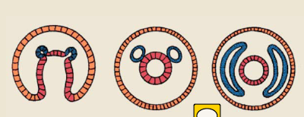
  - Schizocoeley: invagination of the gut and then pinches off at the base but there were already a mass of mesoderm cells that split open and form the cavity between them 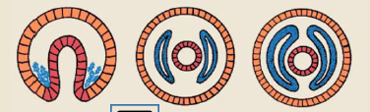
  - Advantages include having a space for organ systems to enlarge or shrink, fluid that can be used for transport, a hydrostatic skeleton (muscles that can contract to change shape) and a gut that can move independently of the body wall

Protozoans:

- Protists
- Move with cilia (9+2 microtubules), flagella or amoeboid movement
- Supergroups:
  - Unikonts: opisthokonta (animalia and fungi---think sperm= 1 tail to propel body heat) and amebozoa (have a flagella for a short period of their lifecycle=the flagella pulls their body along)
    - Characterized by 1 flagella in a groove, creates a water current to wash across surface to engulf any food contained in water
  - Bikonts: Chromalveolata (chiliophora and apicomplexa), archaeplastida (plantae), excavate (euglenozoa) and rhizaria
    - Characterized by 2 flagella, the first flagella propels forwards and the second sticks up into the substrate and allows it to move into the water column and swim
- Phagocytosis: nutrients are particulate in the water
  - Pinocytosis: nutrients are dissolved in the water
  - Both end up with a food vacuole for digestive enzymes to attack and fuse to break down
  - pH starts acidic and then becomes more alkali
  - Undigested food is removed by exocytosis
- Movement types: pseudopods (used by amebozoids), undulipods (cilia or flagella made up of 9+2 arrangement, will only have 1 of the 2) or no movement for parasitic protists
  - Undulipodia: 2 microtubules in a doublet, 9 around the periphery and a pair in the middle, has a dynein motor (1 part holds onto the microtubule and walks and the other that holds the vesicle)-as it walks the 2 doublets slide past each other which twists the shape to one side and then the other side of the cell slides back to normal==how the cilia or flagella move
- Reproduction: sexual or asexual
  - Sexual: syngamy (formation of 1 egg and 1 sperm from 2 different protists that will morph into each of the 2) and conjugation (forms a cytoplasmic bridge to pass genes without fusing cells)
  - Asexual: binary fission (everything is a clone to allow for quick reproduction) and multiple fission (divides more than once to increase numbers rapidly)
- Opisthokonta (CHOANOZOA)
  - Sit on the substrate and beat flagella and then have microvilli surrounding the top of their protoplasmic collar which trap food
  - Found in colonies when in water because its hard for the flagellas to move that much water by themselves but in groups it is easier
  - Line the insides of sponges
  - First animal cells
  - Posterior flagellum with two centrioles and flattened cristae
- Ameobozoa (AMEOBA)
  - 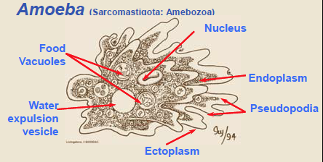
  - Endoplasm: fluid cytoplasm in which the protein molecules (actin) have not yet polymerized, flows within the ectoplasm
  - Ectoplasm: rigid protein molecules (actin) in the cytoplasm have polymerized and been stuck together, forms the outer surface of the cell and pseudopods
  - Hyaline Cap: where the endoplasm interacts and is deflected back, triggers the polymerization of actin fibres for the myosin motors to jump onto, endoplasm gets transformed into ectoplasm, found at the anterior end with regards to how the cell is moving, causes a contraction to send more fluid cytoplasm forward
    - At the other end the actin molecules depolymerize and get pulled to the front
- No flagellum/ flagellum only present in the early stages of their life
- Eat using cytoplasmic tentacles and ingesting using phagocytosis
- Move via cytoplasmic flow (see above) and by forming pseudopods with actin filaments and myosin motors
- Cilliophora
  - Can coordinate cilia to do the metachromal wave
  - Part of the Chromalveolata
  - Cilia can be morphed into different structures and specialized for certain activities
  - Have a macro and micronucleus
    - Macro: where genetic material is transcribed/translated for day to day needs
    - Micro: pristine diploid copy of the genome set aside specifically for reproduction
    - Allows for multiple copies of the genome, faster protein synthesis, no mutated DNA to be passed on to the next generation
  - Reproduce by binary fission
- Apicomplexa
  - Loss of movement= parasitic and immobile for the most part
  - Part of the chromalveolata
  - Presence of vesicles below the cell surface
  - Flagella becomes the apical complex (used to help the protist enter its host)
  - Mostly reproduce sexually (haploid gametes) via SYNGAMY
    - Zygote then undergoes meiosis and is haploid for the rest of its life
- EX/ MALARIA LIFE CYCLE
- Mosquito feeds on human, once gametocytes are in the stomach lining they differentiate into male or female gametes
- Gametes fuse and get embedded, zygote divides via MEIOSIS (GAMETOGONY), forms a cyst that grows and grows until it bursts and then the spores swim to the salivary glands
- When the mosquito bites the human the salivary solution gets inputted right next to the food tube which places spores into the human (SPOROGONY)
- Liver cells erupt, the merozoites swim into the blood in search of RBCs, once inside an RBC it morphs into a trophozoite and reproduces via multiple fission
- Blood now filled with trophozoites instead of RBCs, trophozoites burst from RBCs once the conc gets too high (SCHIZOGONY)
- Body responds by changing CO2, temperature and humidity levels to attract a mosquito to be able to continue its lifecycle
- Euglenozoa
  - Have some sort of groove, slot or indentation that the flagella is placed into
  - Have a big long flagella and a smaller one fused to the side of the bigger one inside the apical pocket
  - Have photosensitive pigments in the groove so when light hits them they change the way their flagella beat (due to the positioning of the paraflagellar body)
  - Lack mitochondria
- Rhizaria
  - Have cytoplasmic structures that are supported by a microtubules to form a cytoskeleton
  - Famous for building shells (test) out of calcium or silica (silica ones look like glass and are only made if the water pressure is too high)
  - Live in the shells and stick out pseudopods to trap food
  - Rely on cytoplasmic streaming for locomotion and feeding
  - Use pseudopods to anchor to substrate
  - In pseudopods the cytoplasmic streaming from the endo and ectoplasm becomes the intra and extracapsulum
    - Intracapsulum: bulk of the cell, contains most organelles
    - Extracapsulum: contains digestive vacuoles and lipids to make them buoyant
- Trap food on the surface of the axopod which collapses to allow phagocytosis and then cytoplasmic streaming carries food vacuole to the extracapsulum
Porifera
- Are all parazoans (without true tissues)
- Are all asymmetric because they don’t have an oral opening
- Cells are held together with collagen: no cell to cell communication
- Totipotent cells: most cells are differentiated but all can at any time can get a signal to become amoeboid cells (stem cells) to redifferentiate
- Cell layers:
  - Pinacoderm: outside cell layer (think epidermis), has pinocytes (tightly glued together with collagen, impenetrable surface) and porocytes (hollow in the middle to regulate water flow in the organism, run from the inside of the sponge to the outside)
  - Mesophyll: jelly like matrix between the inner and outer cell layers, has archaeocytes (ameobocytes: can turn into any type of cell, wanders around jelly matrix to transport food to other cells), sclerocytes (made up of needle like structures to hold the cells up from minerals and lignin=make the spicules)
  - Spongeocoel: inner cell layer, lined with choanocytes (used in food capture flagella=water current=trapped=vacuole=used/passed to ameobocyte, gas transfer, metabolic waste removal and reproduction)
  - Porocytes: control the movement of water into the spongeocoel
- Have spicules: the structure layer made up of sponging (forms a fibrous mesh that supports the sponge), calcium carbonate and silica
- 3 types of body plans:
  - Asconoid: in through porocytes, pass through choanocytes, through the spongeocoel, out the single ostulum= least efficient because possibility of water leaving without passing the choanocytes
  - 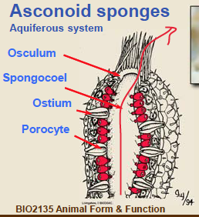
  - Syconoid: no porocyte, choanocytes now line the incurrent canals rather than the spongeocoel which leads to an increase in water hitting the canal, water leaves through a single osculum out the top 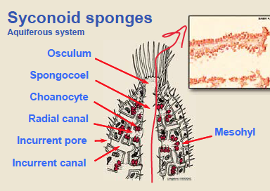
  - Leuconoid: most efficient, multiple osculum, many pores leading to the choanocytes which are located in a chamber rather than a canal to slow down water movement, water heads through multiple chambers before water leaves 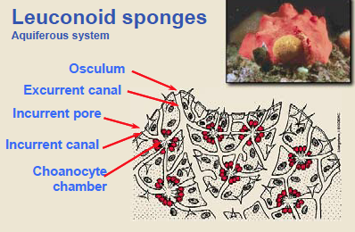
  - NOTE: more ostulums the more exit points for the water so the more efficient
- Choanocytes become the sperm because they are the only ones that are flagellated, rest of cells make a water current to push the sperm out of the cell, archeocytes become eggs waiting in the mesocyte
- Reproduce sexually and asexually
  - Asexual: budding ( a piece falls off) or fragmentation (something else ripped a piece off), cells are able to differentiate so they can mate with themselves
  - Organism lives in a seasonal environment so to adjust this they produce dormant sessile bodies consisting of masses or ameobocytes surrounded by schlerocyte cells to chill in over the winter===called gemmules, once it warms up the ameobocytes climb out of the micropile and differentiate
    - 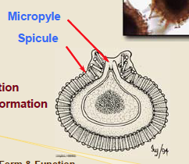

Platyhelmenthes
- Triploblastic
- Have mesodermal musculature
- Acoelomates: loss of anal opening
- Bilaterally symmetric
- Sephilization: a posterior end and an anterior end that is primarily sensory
- Protostomes: blastopore is their mouth, have a paired ventral nerve cord that runs along the underside of their body and then connectors lead up to their apical brain
- Incomplete gut: loss of coelom and the anus never developed
- Complex reproductive system as a result of hermaphrodism (IN ALL ORGANISMS IN THE PHYLUM)
- Can be free living or parasitic
- Movements of the body wall and cilia lining the gut ensure mixing of nutrients
- Have ciliated tropophore larvae
- Planaria:
  - Free living
  - Monoecious
  - Pharynx with a tube that goes to the back and another that goes to the front to distribute energy
  - No circulatory system because all are super flat so all cells are either digestive, epithelial or sitting next to the other two
  - Has a separate seminal vesicle to make sure the sperm and eggs from the same animal don’t fuse so that when it meets another worm the seminal vesicle releases the sperm
  - Body wall consists of rhabdites (crystals that can be shot out and hydrate to become goo, a predation mechanism), gland cells (which help it stick to the substrate) and cilia (to help it glide along the substrate)
  - Dorsoventral muscles help keep the organism flat
  - Within the gland cells there are adhesive glands for sticking and releaser glands to dissolve the glue
  - Have a lateral nerve cord that runs along both sides of the body rather than down the middle, and connections that pass signals to either side
  - Brain and eyespots on the top of its head at the front
    - Eyespots have pigment filled cups that can determine where the light is based off how many pigments are targeted
  - Auricles: located on either side of the eye spots and are used to pick up chemical signals in the water to decide the taste
  - Metabolic waste is diffused across the membrane as is CO2 and O2
- Fasciola
  - Parasitic (lives in sheep)
  - No cell membrane between the cells or the nucleus
  - The cells nucleus is hidden in the bottom of the cell so it can monitor the layers above it but in case of predation will not be destroyed
  - To reproduce puts eggs, sperm and yolk into a shell and then moves to uterus to be excreted with the bile
  - Invades a snail before it can invade the sheeps liver
  - 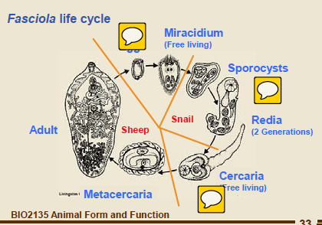
    - Uses water for the miracidium to burst out and swim to where it burrows in the body cavity of the snail to morph into a sporocyst
    - Germ cells from the miracidium morph into redia which fill the body cavity
    - Larval stages burst from the snail (cercaria) and swim to get to the grass that the sheep will eat
    - Burrows from digestive track of sheep into the venous system to get to the liver
- Tapeworm
  - Has a series of repeating units called proglottids
  - Head looks like this 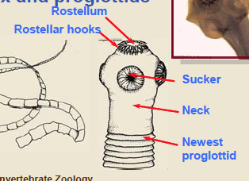
  - Literally sits in the digestive track and absorbs the nutrients to be able to reproduce
  - Reproduces in the same way as the fasciola
    - Doesn’t lay eggs the ovary ruptures instead
    - Can mate with itself
    - Every proglottid has the reproductive system and the excretory system
Cnidaria
- Gap junctions leading to cell to cell communication= TRUE TISSUES, regulated by connexion proteins
- Loss of choanocytes (can see the remnant in microvillar structures)
- Diploblastic- tissues derived from endo and ectoderm formed during grastrulation
- Biradially Symmetric
  - No cephalization (head with sensory structures)
- No mesoderm but the epithelial layer can contract via myonemes aligned in the same direction
- Have rhopalia
- Metabolic waste and gas exchange occurs via diffusion
- No complex organ systems, no circulatory system
- Internal digestive epithelium
- Dioecious- goands from male or female medusa released into the water
- Have cnidocytes: stinger surfaces contatining a nematocyst which can spring out from the operculum to do the actual stinging when triggered, used to catch food, pierces the skin or exoskeleton and releases toxins to immobilize prey, embedded in the epidermis around the mouth and in the tenticles
- Dimorphic lifecycle
- Polyp body plan
  - No anal opening=incomplete gut
  - Has an endo and ectoderm with a set of tenticles surrounding the mouth
  - In colonial polyps the gastrovascular cavities are connected
  - Epidermis followed by mesoglea (NOT MESODERM= just a jelly matrix to connect endo to ectoderm) followed by the gastrodermis (cells involved in secreting digestive enzymes (GLAND CELLS) or absorptive cells to absorb nutrients, lots of cilia to mix around food) followed by the coelenteron (the incomplete gut in the middle where digestion occurs)
  - In the epidermis there are epitheliomuscular cells with longitudinal muscles, and in the mesoglea there are nutritive muscle cells that contract circularly ==hydrostatic skeleton
  - 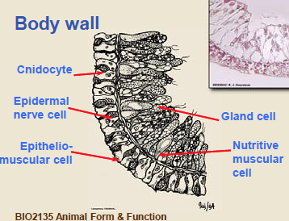
- Planula larva
  - When the egg gets fertilized it crawls across the substrate and then randomly anchors itself down and becomes a polyp
- All are predatory
- Nerve net over the entire organism to send signals provided by the sensory cells derived from the ectoderm
- Anthozoa:
  - Muscular septa
  - Hexaradially symmetric
  - NO MEDUSA
  - Tenticles around the centre of the oral disk
  - Mouth is connected to a pharynx formed by an invagination of the outer body wall that extends into a coelentron divided by septa
    - Complete septa: connect the body wall to the pharynx and have retractor muscles to change the shape of the polyp
    - Incomplete septa: attached to the body wall but have a loose end with cnidocytes to immobilize prey and help with digestion
    - Mouth looks like a slit with siphonoglyphs on the sides that use cilia to pump food into the gastrovascular cavity
  - Gonads in the gastrodermis
  - 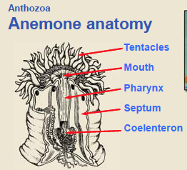
  - 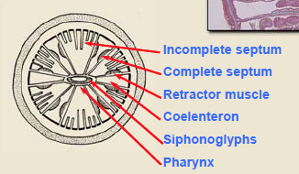
  - spend their whole lives as polyps
  - coelenteron form a hydrostatic skeleton
  - sexes are different, gametes form from the gastrodermis
  - sperm released into the coelenteron and out through the mouth or pores in the body wall as can eggs
  - asexual reproduction can also cause a disk to tear off and form new anenomes
- Schyphozoa, Cubozoa and Hydrozoa all have a dimorphic lifecycle, medusas formed by strobilization (swimming medusa), tetraradial symmetry and nematocysts covered by a protective operculum
- Dimorphic lifecycle:
  - Medusa is basically an upside down and floating polyp with a large mesoglea
  - Only has circular muscles
  - 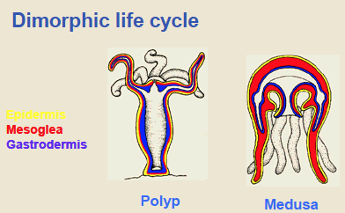
- Strobilization: lateral buds (strobili) form and grow into medusas which get pushed up the to the top and then get released to swim away
- Schyphozoa:
  - Have rhopalia on the medusa bell margin which senses light and gravity found on the outside
    - Compsed of the pigment cups (able to detect light or not depending on orientation) and statocysts (calcium minerals that sit inside the cavity that roll around when the animal moves to orient it)
  - Eggs and sperm are released into the water, zygot forms, planula crawls around, forms polyp, strobilization occurs, medusa formed
  - Are a series of canals (the digestive track) running through the medusa= unidirectional nutrient path
  - Gonads are situated on the canals to ensure they get sufficient nutrients
  - Spend most of their lifecycle as medusa
  - Have an enlarged mesoglea
  - Mouth hangs from the inside of the bell and leads to a stomach, four gastric pouches and canals, surrounded by oral arms with cnidocytes
  - Gonads formed in gastrodermal pouches derived from the endoderm
  - Triradially symmetric

- In the Cubozoa and Hydrozoa the polyp morphs into a medusa youre no longer making multiple medusa from a single polyp
- Cubozoan:
  - Polyp undergoes metamorphisis to the medusa
  - Unique eye (each eye focuses and produces an image, contains statocysts found on the rhopalium)==well developed nervous system but no brain
  - Pedalia (used to help tentacles move food to mouth easier)
  - No nervous system
  - Quadradially symmetric
  - Tenticles attached to the bell of the medusa by pedalia at the four corners with mouth at the center
  - Separate sexes
- Hydrozoa
  - Medusa form from lateral buds
  - Medusa with a velum (allows it to squeeze more forcefully to go up and down with less drag)
  - Live in colonies in which there are polyps specialized in feeding (gastrozooids), defense (dactylzooids) and ones for reproduction (gonozooids)
  - Outer epidermis secretes a protective coating made out of chitin called the perisarc that the branches grow on
  - Grows by asexual budding
  - Sexes are separated: gonads form and gametes are released into the water
  - Medusa break off from the gonozooid to continue the lifecycle
  - 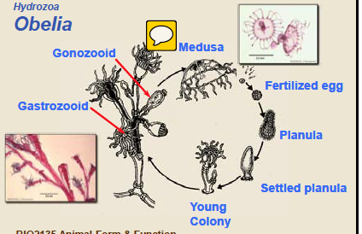
  - 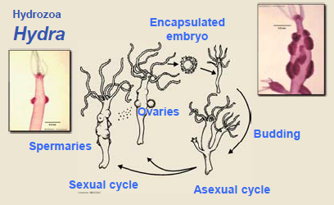polyp sits there, eggs and sperm form in the body wall and get fertilized, embryo breaks off and falls to the ground, regrows
  - digestion in the stomach surrounded by canals throughout the bell
  - nerve net and concentration around the mouth of the polyp and the margin

Bryozoa (LOPHOTROCOPHORES)
- Lophotrochozoa: presence of a u shaped gut and a lophopore OR trocophore larval stage
- Tripartite coelom: coelem modified into 3 spaces
  - Protocoel: anterior, attaches to the mouth, small flap beside the mouth that encloses the brain
  - Metacoel: posterior, attaches to the anus, rest of the body cavity, where the cystid is secreted
  - Mesocoel: middle, the body cavity that forms the lophophore-can retract into the body cavity to protect itself
  - Forms via enterocoely
- Bryozoa:
  - Body formed from polypid and cystid
  - Introvert locophore
  - Colonies grow by budding
    - Monomorphic: 1 type of zooid- all autozooids and specialized for feeding
    - Polymorphic: different types of zooids- autozooids and heterozooids (not for feeding but EX/ defense or colony attachment)
  - Funicular system
  - Freshwater organisms
  - Terms:
    - Zoarium: all the individuals in the colony
    - Zooecium: the polyp that becomes the colon, can be flexible or rigid depending on what it is made up of
    - Ancestrula: the casing the colony sits in
    - Polypid: part two of two for the polyp, extends out and is used to trap food, can be pulled back in for protection, holds the lophophore, housed inside the cystid, holds all organs, digestive tract, funiculus
    - Cystid: part one of two for the polyp, the living tissue that makes up the casing
- Lophophore: a ciliated tentacle surrounding a mouth arranged in a horseshoe shape, use the cilia to trap food and pass it towards the digestive system, hollow and can move wherever it wants/orient the polyp to where the food is
- 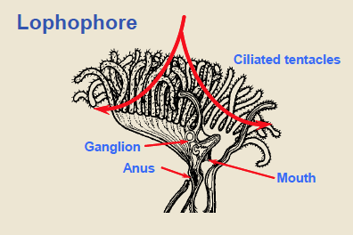
- U shaped gut: group folds body into a u shape so the anal opening is on the outside of the lophophore, the water current from the lophophore passes by the anus and flushes waste away
- Cecum: where nutrients are absorbed, when they folded it became like a side pouch
- Cardiac stomach: part of the stomach closest to mouth
- Pyloric stomach: after the cecum for last minute absorption before waste goes to the anus
- 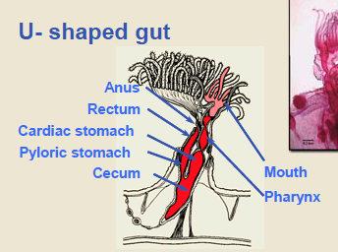
- Funiculus: strand of tissue from the base of the cecum to connect each individual in the colony together- acts as a nutrient exchange system, often where gonads form because of the nutrients, connects the stomach to the pores in the body wall
- Sperm are released from the body wall and trapped by the lophophore of another organism then brought to the eggs
- Statoblast: loaded with nutrient, covered by a water protective casing, goes dormant over winter, gets released into water and then waits for spring to come along to break open and have ancestral cells form by budding
- 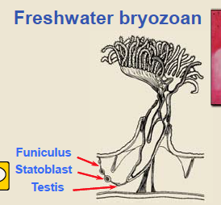
- Colony grows by budding mostly but there is some sexual reproduction for genetic variability
- Only an epithelial layer without underlying musculature
- Lophophore used un gas exchange and metabolic waste removal
- Most monoecious
- Deuterostomes: tripartite coelom, radial cleavage, and a mouth that doesn’t form from the blastopore
- Metasomal sac: appears in the developing embryo, swimming larvae’s mouth opposite and linear the anus, invaginates to form the u shaped gut (mesoderm connects the sac to the digestive tract

