CIVL 215
Pipeline Design Project
Gráinne Maguire Conneely
71183162

Introduction
The following report covers the design of a pipeline system to deliver water from one reservoir at an elevation of 300m to another, at an elevation of 500m. The report includes a couple of different design solutions, a discussion about them and a comparison between the designs.

Background Information
There are various parameters that must be followed and assumptions to be made for this project. The following is all the information considered:
- A flow rate of one cubic meter per second is delivered through the pipe
- Commercial steel piping with a roughness, e, of 0.05 cm.
- Atmospheric pressure is 98,000 Pa
- A maximum negative pressure is allowed, at 70% of atmospheric pressure
- The maximum pressure in the pipe is 150 m head
- Each pump can deliver one cubic meter per second at 100 m head
- Each pump costs $10,000,000

Table One: Estimates cost of installed pipe per km of pipe.
Pipe Diameter (m) | Total Cost ($/km)
0.7 | 38000
0.8 | 44000
0.9 | 50000
1.0 | 80000
1.1 | 120000
1.2 | 150000
1.4 | 180000

Basic Computation
We can calculate the variation in elevation between the two resevoirs using this following general equation:
𝑧* = 𝑎 + 𝑏𝑥* + 𝑐$x^{*2}$
In this equation
- a, b, and c are constants that will need to be calculated
- z* = z/Δz, where z is the elevation of the pipe and Δz is the difference in height between reservoir B and A. (Δz = 0.2 km)
- x* = x/L, where L is the length of the pipe and x is the horizontal distance between reservoir B and A

There are parameters and assumptions to be made for the calculations, as follows:
- Maximum elevation is Z_{max} = 0.66 km
- The surface discharge of the reservoirs at the depth of 20 m is insignificant, and the initial hydraulic head value of 0.3 m is used
- Minor losses are small and therefore, neglected in the calculations
- The total length of pipe assumes the horizontal distance
Initial Calculations
The first thing to be calculated are the constants from the equation above. Once these are calculated it will be possible to determine any point between the two reservoirs.
Solve a by setting x* = 0, which gives us:
$$a= \frac{Z}{∆Z}=1.5$$
With this known constant, a, and at x* = 1, we have:
$$z^{*}=a+b+c$$
Substituting these values, we get our first equation:
$$1=b+c (1)$$
The maximum elevation is Z_{max} = 0.66 km, as stated above. Using this information, it is known that x* = 0.6 and from that we know the derivative of z* = 0.
$$\frac{dz^{*}}{dx^{*}}=0=b+2cx^{*}$$
We can get our second equation from the above:
$$b= -1.2 \left(2\right)$$
We can now solve for constants b and c by substituting equation (2) into equation (1):
$$a=1.5 \\ b=6 \\ c= -5$$
As mentioned earlier, the maximum negative hydraulic head of the pipeline is 70% of atmospheric pressure, which is shown in the following equation:
$$h_{\max{head}}= \frac{P_{atmospher}}{γ}*0.7$$
In this equation, $γ=$ specific weight of water.
Using the general equation and the calculations above we can locate the initial and final position of the pipeline as shown in the equation below. The equation shows x in terms of the other variables:

There are various formulas need to throughout the project for calculations and they are listed below:
- The relative pipe roughness is:
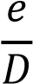 Where: e is the pipe roughness
D is the pipe diameter
- The friction factor is:
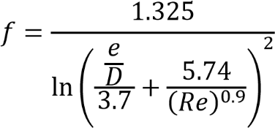

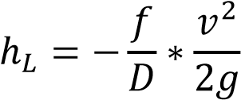
- The head loss is:
Where: g is acceleration due to gravity

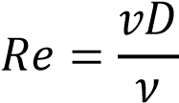
- Reynold’s number is:
Where: v is the kinematic viscosity of water

- The velocity of the water in pipe is:
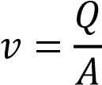

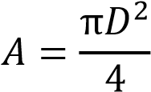
- The area of the pipe is:

Standard Solution
With the information we are given and the information we have calculated, a standard solution to pump water from reservoir A to reservoir B can be found. The simplest solutio is to use a constant pipe diameter through the whole system using the the general equation as we stated in the above sections:
𝑧∗ = 𝑎 + 𝑏𝑥∗ + 𝑐𝑥^{∗2}
The Hydraulic Grade Line (HGL) throughout the whole distance of the pipeline system must be considered. It is known that the pump will raise the HGL a total of 0.1km of head, and will drop linearly with respect to the horizontal distance due to friction loss. The horizontal position of the pump can be found using the slope of the HGL and the vertical position can be found using the following formula:
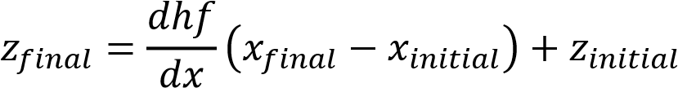

It must be noted that the final position z, is not the full 0.1 km since the HGL drops below the pipeline to a maximum, h_{max}, before it is pumped up again. Therefore, the change in position, Δz is h_{pump} – h_{max}.
From the two equations in this section, we can find the location of horizontal position of each pump using the following equation:
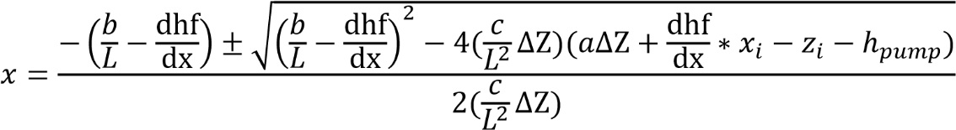

In the above equation, the variables correspond to the position of the initial pump and calculates the horizontal position of the next pump. The location of the first pump is found be replacing h_{pump} with h_{max} because this is the first maximum negative hydraulic head where the water enters the pipe from the reservoir. Z_{i} will be the initial height of reservoir A, 200m.
A summary table can be made showing the various pipe diameters and the information regarding that. From this information, we can calculate an overall cost and select what diameter pipe we will use for our initial, standard design.
Pipe Diameter (m) | Cost  ($/km) | Area of Pipe (m²) | Reynold's no.  (Re) | Friction Factor  (f) | Actual # pumps  (N) | Total Cost  ($)
0.7 | 38000 | 0.3848451 | 1818913.635 | 0.013288954 | 33 | 357018000
0.8 | 44000 | 0.502654825 | 1591549.431 | 0.01326678 | 18 | 211284000
0.9 | 50000 | 0.636172512 | 1414710.605 | 0.013257043 | 12 | 155550000
1 | 80000 | 0.785398163 | 1273239.545 | 0.013183782 | 9 | 146880000
1.1 | 120000 | 0.950331778 | 1157490.495 | 0.01314132 | 7 | 155320000
1.2 | 150000 | 1.130973355 | 1061032.954 | 0.013122435 | 6 | 166650000
1.4 | 180000 | 1.5393804 | 909456.8177 | 0.013101256 | 5 | 177980000

The HGL can be graphed using the data calculated and using the formula above. This graph is shown below:

The graph above shows that the initial standard design is not satisfactory because the HGL falls below the h_{max} of 0.007km. In the following optimised solution a design will be found that satisfies the criteria.
Optimised Solution
In the standard solution, the HGL drops past the requires value. There are several solutions to optimise the standard solution. The initial plan was to change the pipe diameter past the peak of the hill to bring the HGL close to the desired point. However, to do this the diameter would have to be larger and hence increase the cost. After calculations and graphical data, we find that increasing to the next diameter up (1.1m) cause there to be excess head. This is shown in the graph below:

An alternative solution is to the initial standard design until the HGL falls below the pipeline. At this point a larger diameter can be used, or multiple if necessary, to bring the HGL closer to the required point. To calculate the location of the change of pipes we must find the point where the pipeline’s slope is the same as the slope of the HGL. The slope of the HGL is the change in head loss over a unit distance (dh_{f} / dx). The horizontal position will then be as shown below:
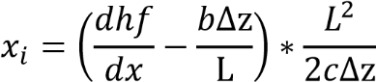

The vertical location of the point can be found by using the general equation and subtracting h_{max}.
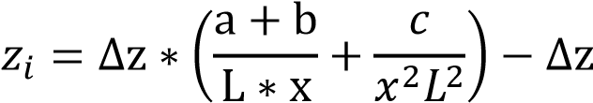

The point of intersection must now be found and this can be done with reference to the final pump. This location of the pump can be calculated using the formula from the standard solution, as the equation below shows:
$$x=\frac{{\frac{dhf}{dx}}_{1.1}* x_{i}-{\frac{dhf}{dx}}_{1.0}* x_{final pump}+(z_{pump}+h_{pump}-z_{i})}{{\frac{dhf}{dx}}_{1.1}- {\frac{dhf}{dx}}_{1.0}}$$
Once the intersection point is reached the diameter is changed to 1.1m and this change is enough to bring HGL close to the required point. This can be seen in the following graph:

