1. The lease documents will deal with which of the following?

- Loan
- Mode of Payment
- Selling Price
- Term and the Interest rate
- None of the above

2. The mortgage documents has nothing to do with:
A) Equity Investor
B) The real estate property
C) Bank
D) Government
E) None of the above

3. Mortage laws are there to protect the bank, landlord and government.
a) True
b) False

4. Which of the following does not consider the time value of money, when applying the decision-making criteria in the real estate investment process?
A) Rules of thumb techniques
B) Cost Approach
C) Net Income Approach
D) Sales Comparable Approach
E) All of the Above

5. Which of the following four environments deals with the ownership and loan to value of the project?
A) legal & Marketing
B) Legal and Financing
C) Financing and Taxation
D) Market & Taxation
E) None of the above

6.
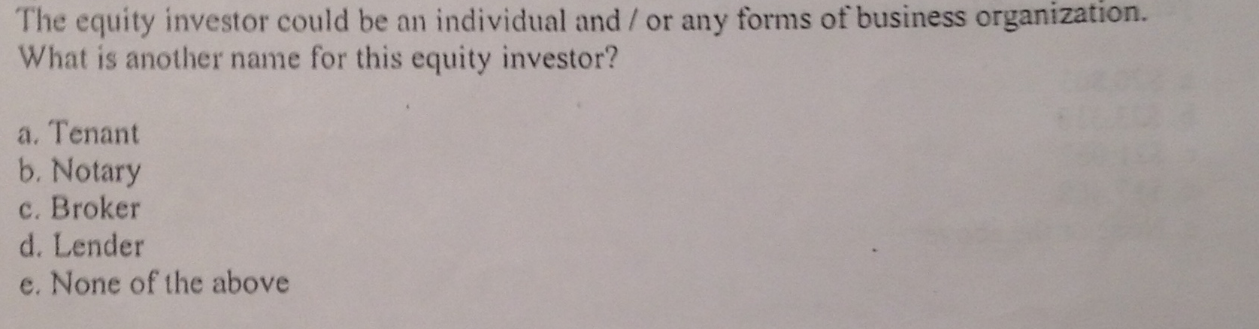
Ans: E
7.
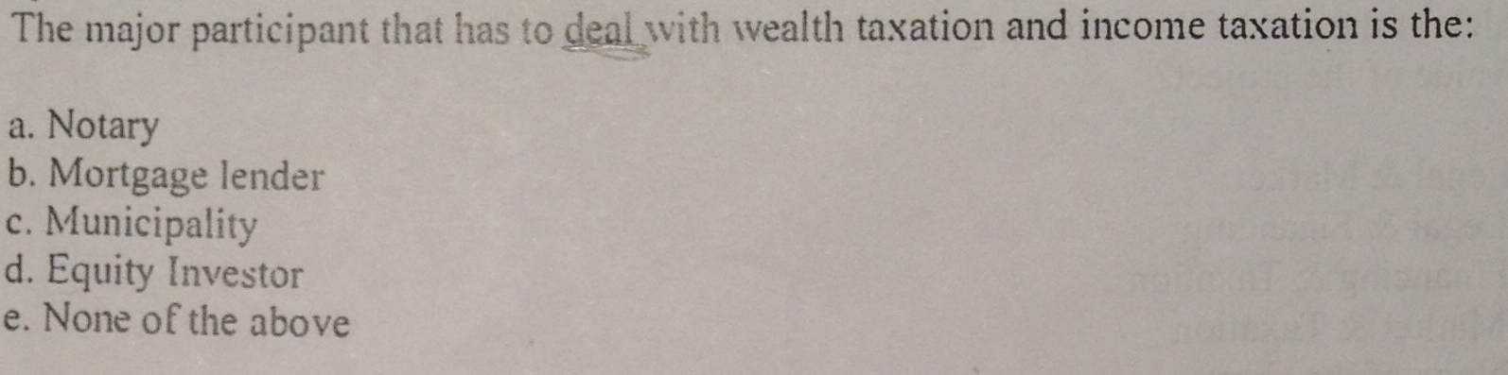
Ans: D

8.
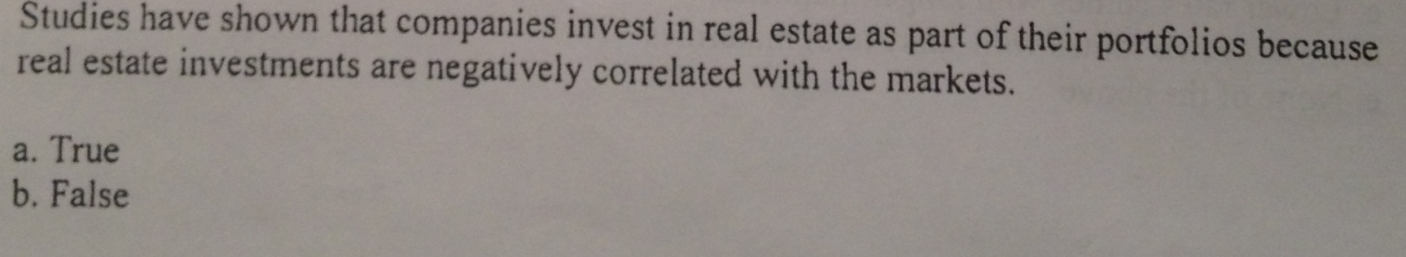
Ans: A

9.
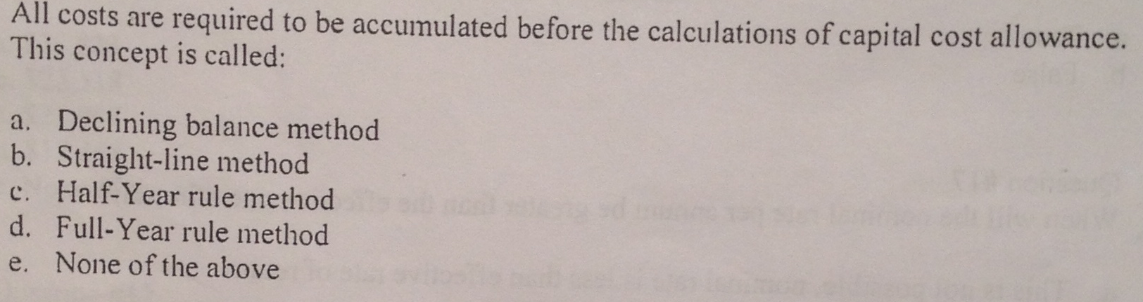
Ans: E

10. 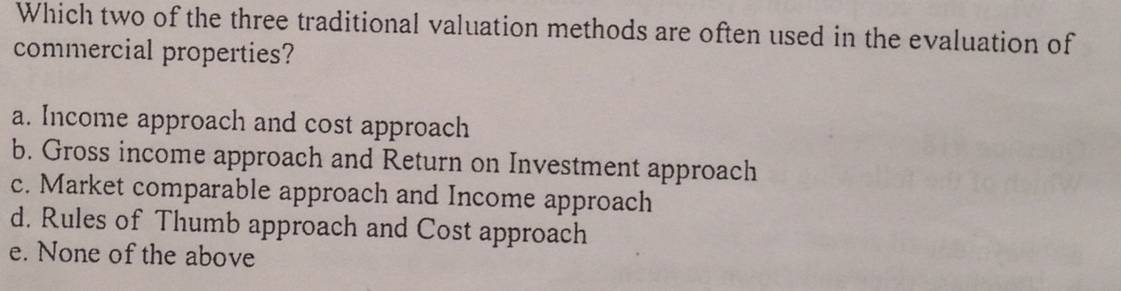
Ans: A

