LESSON 2
- Steps of the Scientific Method (Slide 4)
- Step 1: Performing Experiments
- Step 2: Making Observations
- Step 3: Proposing a Hypothesis
- Step 4: Confirming the Hypothesis
- Step 5: Proposing a Scientific Law
- Step 1: Performing Experiments (Slide 4)
An experiment is a set of steps that are performed under controlled conditions to propose or test hypothesis.
- Step 2: Making Observations
It is a key factor in scientific studies as well as in everyday life, can be classified as
- Qualitative:
The flower is purple.
Bubbles are produced when lemon juice is added to baking soda.
- Quantitative: Observation is a measurement. It has two components, a measured quantity with an appropriate unit.
For example, observed temperature for the liquid was found to be 35-degree Celsius. The quantity measured is temperature and the appropriate unit is degree Celsius.
- Step 3: Proposing a Hypothesis:
A hypothesis is a tentative explanation to account for the observations of an experiment. A hypothesis is valid provided that one’s assumptions to explain the observations of an experiment can be tested.
- Step 4: Confirming the Hypothesis
- The validity of the hypothesis needs to be confirmed via repeated and controlled experiments.
- In order to accept a hypothesis, there must be no inconsistencies between the hypothesis and the experimental observations.
- In the event of any inconsistencies, steps 1 through 4 must be repeated.
- Step 5: Proposing a Scientific Law
By repeatedly performing experiments and modifying the hypothesis to account for the observations from these experiments, one is able to propose a scientific law.
- Numerical Values (Slide 5)
- Expression of Numerical Value:
Scientific Notation
Significant Figures
SI system of units
- The Scientific Notation (Slide 6)
In the scientific notation we use powers of 10, meaning the number 10 raised to a certain power. In this format$, N*{10}^{±n}$, N can be any number other than zero, and can only have one digit before the decimal. So N can be 4.56, but can’t be 78.59 or 0.764. As for “n” it represents how many times you are multiplying N by 10, or how many times you move the decimal one place.
Example: 598.46 N would be 5.9846 and n would be 2, hence the scientific notation$5.9846*{10}^{2}$
- Significant Figures (Slide 7)
The concept of Significant Figures is:
- Used to indicate the precision of a measurements or that of a calculated result using such measurements;
- Does not apply to counted items such as exact numbers, and defined conversion factors.
- Rules of Significant Figures (Slide 7)
- Rule #1: All nonzero digits are significant figures
Examples:
Measurement: 135.62g/# of significant figures: 5
Measurement: 23.6cm/# of significant figures: 3
Measurement: 17.9871Kg/# of significant figures: 6

- Rule #2: Counting begins from the left with the first nonzero number
Example:
Measurement: 0.056mL/# of significant figures: 2
Measurement: 0.000356 L/# of significant figures: 3
Measurement: 0.0225 Kg/# of significant figures: 3
- Rule #3: Zeros between nonzero digits are counted as significant figures
Examples:
Measurement: 1.056g/# of significant figures: 4
Measurement: 30.78cm/# of significant figures: 4
Measurement: 300.5mL/# of significant figures: 4
- Rule #4: Terminal zeros (Zeros to the right of number)
Examples:
Measurement: 2.3700g/# of significant figures: 5
Measurement: 17.50mL/# of significant figures: 4
Measurement: 200.cm/# of significant figures: 3
Measurement: 2.00*10^2cm/# of significant figures: 3
Measurement: 2.0*10^2cm/# of significant figures: 2
Measurement: 2*10^2cm/# of significant figures: 1
- Chemical Calculations
- Rule #1: In addition and subtraction of measured quantities, the final answer contains the same number of decimal places as are in the measurements with least number of decimal places.
Example:
- 25.0 g + 22.41 g + 1.234 g = 48.6g, 25.0 has the least number of decimal places, therefore the answer has one decimal place.
- 4.85 mL – 0.02 mL = 4.83 mL, both measurements have two decimal places; therefore the answer has two decimal places.

- Rule #2: In multiplication and division of measured quantities, the final answer contains the same number of significant figures as are in the measurement with the least number of significant figures.
Examples:
- 9.20 g * 2.450 = 22.5 g, 9.20 has the least number of significant figures; therefore the answer has three significant figures.
- 2.35 cm / 1.456 = 1.61 cm, 2.35 has the least number of significant figures; therefore the answer has three significant figures.
- Rule #3: In the final answer of a calculation involving exact numbers, unit conversion factors and constants, the number of significant figures is dictated by the measured quantity involved.
Examples:
- If the mass of a steel ball is 2.35g (Measured quantity), what will be the total mass of 8 (exact number) identical steel balls? Answer: The total mass of 8 identical steel balls is: 2.35 g * 8 =18.8 g.
- How many centimeters are there in 31.10 inches (measured quantity)? Answer: The unit conversion factor is 1.0 in = 2.54 cm. 31.10 in * 2.54 = 78.99 inches.
- Using the formula c = a*b, calculate the value of b when a=22.65cm (measured) and c=1.2cm/s (Constant). Answer: Substituting values for a, b and c: 1.2 cm/s = 22.65cm * b. The value of b is: b = 1.2/22.65 s^(-1) = 0.05298 s^(-1)
- Rounding off Digits
- Rule #1: For multi-step calculations, all numbers are carried to the final result, which is then rounded off to give the correct number of significant figures.
- Rule #2: If the digit being rounded off is >5, you round the digit up by one.
Example: In 8.379 g, when rounded to three significant figures, the digit 7 is rounded up to 8 because 9>5. Therefore the final answer is 8.38 g.

- Rule #3: If the digit being rounded off is <5, the preceding remains the same. 6.371=6.37.
- Rule #4: If the digit is being rounded off is equal to 5, the preceding digit is rounded up if it’s off and remains the same if it’s even. Ex. 16.75 is 16.8, and 16.65 is 16.6.
- SI System of Units (Slide 10)
- Length
- Volume
- Mass
- Density
- Examples
- Dimensional Analysis (Slide 11)
- Step 1:
To convert a mass from grams to milligrams, the equation must show the relationship between one gram and the number of milligrams in one gram. (1.0 g = 10^3 mg)
To convert a volume from liters to microliters, the equation shows the relationship between one liter and the number of microliters in one liter. (1.0 L = 10^6 microliters)
- Step 2: State the relationship as a fraction
- Step 3: Multiply the measured quantity by the conversion factor that cancels unwanted units and gives the final answer in the required unit. A conversion factor changes the units of the measured quantity, but the actual quantity does not change.
- What is Matter? (Slide 14)
- The term “matter” is used to describe things which:
Occupy space,
Are perceivable by our senses

- Matter can be Classified in terms of its:
Physical state: solid, liquid, or gas
Chemical composition: element, compound, or mixture.
- Chemical Composition (Slide 15)
- Element: Composed of one type of atom, classified as metal, nonmetal, or metalloid “semi-metal”.
- Compound: Combination of elements in a definite proportion. A chemical change can break a compound into its individual elements.
- Mixture: A non-pure substance made of two or more elements or compounds that can be separated by physical, as opposed to chemical, procedures.
- What are Atoms? (Slide 16)
Atoms are composed of electrons, protons and neutrons; the center of the atom (nucleus) contains the neutrons and protons. The electrons surround the nucleus and are equal to the number of protons
- Protons: +ve charges (p+)
- Neutrons: No charge (n0)
- Electrons: -ve charges (e-)
- Atomic & Mass Numbers (Slide 17)
- Atomic Number: Z
- Mass Number: A
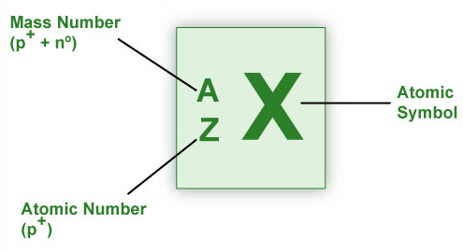
- Atomic Symbol: X

- Molecules and Ions (Slide 18)
- Molecules
- Ions
- Cation: lost an electron (positively charged)
- Anion: gained an electron (negatively charged)

LESSON 3

- The Periodic Table (Slide 4)
- Groups
- Families
- Physical State (Metals are solid at 25-degree, except Hg Mercury ewhich is a liquid at 25-degree. Metals lose electron(s) to form cations and the nonmetals gain electron(s) to become anions)
- Metals/ Non-Metals/ Metalloids
- Essential Elements
- Elements and Groups (Slide 5)
- Elements:
Arranged into vertical columns called groups (or families) and horizontal rows called periods.
- Groups:
- Traditional Group Names:
Group 1A elements are called alkali metals
Group 2A elements are called alkaline earth metals
Group 7A elements are called halogens
Group 8A elements are called noble (rare, or inert) gases.
- Classifying Compounds (Slide 9)
- Organic: Compounds that contain at least one carbon atom.
- Inorganic: Compounds that contain atoms other than carbon. Exceptions are inorganic compounds such as carbon monoxide (CO), carbon dioxide (CO2), etc.
- For the purpose of Nomenclature (systematic Naming), compounds are classified as those:
Containing a metal and a nonmetal (ionic compounds)
Containing two nonmetals (covalent compounds)
- More about Ionic Compounds…

- Rules for compounds (Slide 10)
- Rule #1: For metals of Groups 1A, 2A, and 3A of the Periodic Table, the charge on the formed monatomic cation is equal to the group number.
*The cation has the same name as the metal and is always named first*
Example:
Element Symbol: Li
Cation: Li+
Cation Name: Lithium
- Rule #2: For nonmetals of Groups 5A, 6A, and 7A of the Periodic Table, the charge on the formed monatomic anion is equal to the group number minus 8.
**The anion is comprised of the root of the nonmetal name and ends with the suffix –ide**
Example:
Element Symbol: N
Anion: N^(3-)
Anion Name: Nitrite
- Rule #3: Many metals (particularly transition metals) form more than one cation, thus forming more than one ionic compound with a particular anion. To indicate which ionic compound is formed, using Roman numerals within parentheses following the name of the metal ion specifies the charge on the metal ion.
Example:
Iron forms Fe^2+ and Fe^3+ ions. Thus, Iron can form two different ionic compounds with chlorine: feCl2 [iron(II)chloride] and FeCl3 [Iron(III)chloride]

- Rule #4: Ions that consist of two or more atoms bonded covalently possessing a net positive or negative charge are referred to as polyatomic ions.
Ammonium ion (NH4+) is an example of a polyatomic cation.
Carbon ion (CO3^2-) is an example of a polyatomic anion.
For more than one polyatomic ion, the ion is written in parentheses with a subscript indicating how many there are of the same polyatomic ion:
Calcium nitrate contains Ca^(2+) and two NO3^(-) ions.
Thus the formula is Ca(NO3)2
- Rule #5: The name, formula and the charge for a number of commonly encountered polyatomic anions can be derived from common acids (H+ donors) and bases (producing OH^(-)). When an acid dissociates it produces H+ ions and a counter ion of equal but opposite charge.
In case of sulfuric acid (H2SO4), it can do so in two ways:
(1) Lose one H+ ion leaving HSO4^(-) ion
(2) Lose two H+ ions leaving the SO4^(2-) ion
(Two positive charges and two negative charges cancel out)
Prefixes used in Naming Compounds
Prefix | Number Indicated
Mono- | 1
Di- | 2
Tri- | 3
Tetra- | 4
Penta- | 5
Hexa- | 6
- Covalent Compounds (Slide 12)
- Rule 1: Name the first element in the formula
- Rule 2: Name the second element as an anion
- Rule 3: Use prefixes to indicate the number of atoms of each element
- Rule 4: Do not use the prefix mono- for the first element

- Balancing (Slide 13)
- Writing
Coefficients: before element and indicate the moles,
Subscripts: after and underneath element, representing the number of each atom present.
- Chemical Calculations (Slide 15)
??Answering questions such as (If under a set of optimum conditions??
- A mole always equals: 6.022 x 10^23
- Mole=Mass in grams/Molar mass

Module 4
- Types of Hazards (Slide 3)
In the workplace, the worker may be exposed to:
Safety hazards | Health hazards
Based on the nature of the work, safety hazards are due to material handling, machines, energy, work practices, and confined spaces.  - Material handling hazards: These can lead to muscle strains due to lifting and carrying materials. The use of devices such as forklifts, cranes, etc. exposes the worker to accidental contact with the moving equipment.  - Machine hazards: Rotating shafts, moving belts, presses, etc. can cause very serious injuries.  - Energy hazards: All energy sources such as electricity, steam, hydraulic pressure, etc. can lead to serious injury.  - Work practice hazards: Failure to follow safe operating procedures may lead to serious injuries.  - Confined space hazards: In such spaces (for example, silos, storage tanks, pipelines etc.) hazards arise due to difficulty of entry and exit, build-up of hazardous materials and oxygen deficiency. | The extent of occupational health hazards varies with the type of activity. However, such hazards may have the potential to cause severe discomfort, illness, and lack of efficiency among workers. Based on the nature of the causative agent (or factor), occupational health hazards can be classified as physical, chemical, biological and ergonomic.  - Physical hazards are due to the presence of physical agents such as pressure and temperature extremes, excessive noise and vibration, and exposure to radiation.  - Chemical hazards are due to the presence of chemical agents such as dust, fume, gas, mist, smoke and vapor.  - Biological hazards are due to the presence of biological agents such as bacteria, moulds and viruses.  - Ergonomic hazards are due to ergonomic stresses such as fatigue and repetitious work.

- Physical and Chemical (Slide 4)
Workers have the right to:
- Work in a safe and healthy environment
- Know the processes and substances they are working with
- Know potential hazards from these processes and substances
- Hazard Assessment (Slide 5)
Walk through surveys: Recognize and assess the potential impact of occupational hazards.
Processes, operations and related activities
- Generally various emissions are evaluated because the emission of any physical, chemical or biological agents has the potential to be health hazard.
Equipment
- Equipment is generally assessed in terms of mechanical and electrical safety and the potential to create excessive noise and vibration.
Properties of substances used and produced
- These include an evaluation of raw materials and finished products in terms of their physical, chemical and toxic properties and effects.
Control measures
- All engineers controls in place for proper materials handling, storage, etc. are evaluated. Also considered are the ventilation system and the availability of personal protective equipment.
- Physical Agents (Slide 6)
Commonly encountered physical conditions with a potential to cause adverse health effects include:
- Pressure and temperature extremes
- Excessive noise and vibration
- Radiation
The action of physical agents consists of transfer of residual energy through the surrounding air or the equipment the worker is in contact with. Except for radiation, our senses can detect all other physical agents.
- Pressure & Temperature (Slide 7)
Pressure Extremes
- Hyperbaric: Pressure higher than normal atmospheric pressure. (Underwater & Mining)
- Hypobaric: Lower than normal atmospheric pressure. (Working in high elevations such as ski instructors and airline pilots).
Temperature Extremes
- Hot or cold depends on various factors: Air movement, Hot or cold objects in the vicinity, and Relative humidity.
- Heat stress and Cold stress: Excessive exposure to very hot or cold work environments.
Heat | Cold
Some of the adverse effects in very hot work environments (depending upon the individual worker and the heat intensity) include:  - Heat exhaustion  - Fainting  - Heat stroke  Heat-related problems may arise for:  - Outdoor workers (working in construction)  - Industrial workers (working near furnaces) | In very cold work environments (depending upon the individual worker and intensity of cold), the adverse effects include:  - Frostbite  - Hypothermia  Workers at risk include:  - Outdoor workers (divers)  - Meat packers and handlers (working in refrigerated warehouses)

- Excessive Noise & Vibration (Slide 8)
- Whole-body vibration: Transmitted through the supporting surface (Mining equipment)
- Hand-arm vibration: Transmitted through the hands and arms (Hand-held power tools)
- Radiation (Slide 9)
Ionizing radiation:
The energy associated with it is high and thus strong enough to damage cells and DNA. Some examples and sources of ionizing radiation include:
- X-rays (from x-ray machines)
- Alpha, beta, and gamma rays (from radioactive materials)
- High-energy ultraviolet (from germicidal lamps)
Non-ionizing radiation:
It is not as strong as ionizing radiation. However, prolonged exposure to some types of non-ionizing radiation can still cause harm. Some examples and sources of non-ionizing radiation include:
- Visible light, microwaves (from telecommunications and microwave ovens)
- Infrared (from infrared heat lamps)
- Radio waves (from broadcasting)
- Low-energy ultraviolet (tanning lamps)
Radiation Applications:
Some applications of radiation include:
- Industrial: Quality control, non-destructive testing using radiography
- Household: Television, smoke detectors
- Medical: Imaging, treatment
- Science: Material analysis, sterilization.
- Chemical Agents (Slide 10)
- A potential Risk
Where do chemical hazards come from?
Chemical hazards may arise in operations involving:
- Compressed gases
- Flammable and Combustible Materials
- Oxidizing Materials
- Poisonous & Infectious Materials
- Corrosive Materials
- Dangerously Reactive Materials
Chemical agents may be present in the air as:
- Fine particles
- Gases and vapors
- Both as particles and vapors at the same time
- Adsorbed or absorbed gases and/or vapors on particles
The problem with fine particles (slide 10)
The problem with gases and vapors (Slide 10)
- Biological Agents (Slide 11)
- Bacteria
- Fungi
- Viruses
- Micro-organisms and their associated toxins
Workplace Exposure
- Reproduce rapidly
- Survive with minimum resources
- Ergonomic Stresses (Slide 12)
Ergonomics is the science or study of work. It is a way of designing a work environment to fit people.
- Reduces workplace injuries and illnesses; particularly back injuries and cumulative trauma disorder (CTD) affecting, joints, muscles, nerves and tendons that can cause pain and swelling
- Improves productivity and quality of work
- Increases job satisfaction
- Satisfies government regulations.
- Toxicology (Slide 15)
- Toxicology: is the science that involves the study of the properties and interactions of physical, chemical or biological agents
- Toxicity: It is the degree of danger of a material to injure a living organism by other than mechanical means.
Toxic Hazards (toxicity)
- Physical Properties
- Chemical properties
- Intensity of exposure (exposure dose) [concentration x duration of exposure]
- Mode of handling
- Routes of entry
- Susceptibility of the worker
Most common natural routes of entry of chemical agents into the body include:
- Respiratory tract (by inhalation)
- Digestive tract (by ingestion)
- Cutaneous – skin and eyes (by absorption)
In occupational settings, inhalation is the most important route followed by absorption through skin and eyes.
- Dose and Exposure (Slide 16)
Dose: It is defined as the amount of toxicant actually delivered to the target organ. The units used to express dose are mg/kg (mass toxicant/body mass).
Exposure: It is the total amount of the toxicant present in the workplace. However, exposure does provide an indication of the dose. Higher the exposure, greater the probability of larger amounts being delivered to the target organ and hence higher the dose.
Units used to express exposure are:
- Threshold limit values (Slide 17)
The lower the TLV the more potentially dangerous the substance is.
- The Effects of Toxicants (Slide 18)
- Duration of the effect
- Organs affected and physiological action
- Duration of the effect (Slide 19)
- Acute: Observed effect of a toxicant is considered acute if it appears soon after exposure. The effect generally results from brief exposure to a high concentration of the contaminant. The effect is also easy to observe and relate.
- Chronic: It is considered chronic if it is observed much later after exposure. Chronic effects result from low and repeated exposure over a long period of time; they may have latency periods. Chronic effects are more difficult to study and are vey important to consider when dealing with hazardous wastes and pollution.
- Physiological Effects (Slide 20)
- Hepatotoxins (e.g. carbon tetrachloride) affect the liver; whereas immunotoxins (e.g. vinyl chloride) act upon the immune system.
Based upon the observed physiological effects, the chemicals are classified as and described below:
- Asphyxiants: asphyxia (suffocation due to lack of oxygen)
- Irritants: eye, skin, mucous membrane irritation
- Anasthetics: depressnants.
- Narcotics: Habit forming depressants.
- Systemics: Organ(s) or system(s) damage
- Lung scarring agents: Lung damage
- Carcinogens: cause cancer
- Mutagens: Changes in DNA
- Teratogens: Malformations in newborns
- Workplace Hazards (Slide 23)
Hazardous Materials Information System (WHMIS)
It consists of three key elements:
- Cautionary labeling of containers of hazardous materials.
- Provision of Material Safety Data Sheet (MSDS), which provides more detailed information on the hazardous nature of the material.
- Provision of worker education program

- Hazard Symbols (Slide 24)
Class A: Compressed Gas (Symbol is a bottle)
- Contents under high pressure
- Cylinder may explode or burst when heated, dropped or damaged
Class B: Flammable and Combustible Material (Symbol Fire)
- May catch fire when exposed to heat, spark or flame
- May burst into flames.
Class C: Oxidizing Material (Symbol is a circle on fire)
- May cause fire or explosion when in contact with wood, fuels or other combustible material.
Class D (1): Division 1: Poisonous and Infectious Material; Immediate and serious toxic effect (Symbol Skull)
- Poisonous substance
- A single exposure may be fatal or cause serious or permanent damage to health.
Class D (2): Division 2: Poisonous and Infectious Material; Other toxic effects (Symbol is A T exclamation Mark)
- Poisonous substance
- May cause irritation
- Repeated exposure may cause cancer, birth defects, or other permanent damages
Class D (3): Poisonous and Infectious Material; Bio-hazardous infectious materials (Symbol Blade with circle in the middle)
- May cause disease or serious illness
- Drastic exposures may result in death.
Class E: Corrosive Material (Symbol Chemicals fallen on hand)
- Can cause burns to eyes, skin or respiratory system.
Class F: Dangerously Reactive Material (Symbol Flask in a capital R)
- May react violently causing explosion, fire or release of toxic gases, when exposed to light, heat, vibration or extreme temperatures.

- Container Labels (Slide 25)
- Product Identifier
- Risk Phrases
- First Aid Measures
- References to MSDS for further information
- Supplier Identifier
- Safety Data Sheet (Slide 26)
MSDS provides basic information on a chemical product.
It contains information regarding its:
- Properties
- Potential hazards
- Safe use
- Emergency procedures
- Implementation (Slide 27)
Worker Education
Workers handling hazardous products must be instructed in:
- The information on labels and MSDSs as it applies to their work
- Safe use, handling, storage and disposal of hazardous materials.
- Emergency procedures to be used in case of a spill or overexposure
Successful Implementations Requirements
Successful implementation of WHMIS in the workplace requires cooperation of all parties involved. WHMIS sets the responsibilities of the parties involved:
- Suppliers: Provide hazard information through labels and MSDS on all controlled product/containers of controlled products.
- Employers (Supervisors): Ensure WHMIS labels, identifiers and MSDSs for all containers of controlled products. Employers also ensure availability and accessibility of MSDS information to employees and provide effective worker training to ensure understanding among employees of the labels, MSDSs, and precautionary measures for hazardous materials in their workplace
- Employees: Handle controlled products safely and inform supervisors of damaged/missing labels and missing MSDS information
- Regulators: Develop and administer WHMIS legislation.
- GHS (Slide 28)
The Globally Harmonized System for hazard Classification and labeling
Some of the anticipated changes are:
- Inclusion of consumer, transport and workplace sectors rather than workplace only.
- Inclusion of all chemicals except pharmaceuticals and cosmetic products intended for consumer use.
- Hazard classification format in the MSDSs
- Hazard communication format in the labels

Module 5: Air and Water
- The Air We Breathe (Slide 3)
Air (which all of us must breathe) composes the atmosphere and is a complex mixture of gases surrounding the Earth. The atmosphere is a layered structure divided into layers according to a variety of criteria such as gradually changing:  The Atmosphere  According to altitude, the atmosphere is divided into layers: | 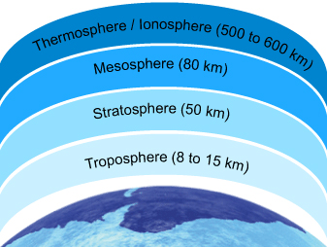
  - Altitude  - Pressure  - Temperature | - Electrical nature  - Chemical composition and concentration
  - Troposphere  - Stratosphere  - Mesosphere  - Ionosphere/Thermosphere | - Mesosphere  - Ionosphere/Thermosphere
Right: Space Shuttle Endeavour straddling the stratosphere and mesosphere. The orange layer is the troposphere, where all of the weather and clouds which we typically watch and experience are generated and contained. This orange layer gives way to the whitish Stratosphere and then into the Mesosphere (Source: NASA/Crew of Expedition 22, Wikimedia)

- The Composition of Air (Slide 4)
The air we breathe is a mixture of several gases, fine particles and vapors. Dry air consists of 21% oxygen and 78% nitrogen plus traces of other substances that are both natural and human-made.

Major components of air:
- Nitrogen (N₂)
- Oxygen (O₂)
- Water (H₂O)
- Carbon dioxide (CO₂)
Some minor components of air:
- Carbon monoxide (CO)
- Ozone (O₃)
- Oxides of Sulfur (SO_{x})
- Oxides of Nitrogen (NO_{x})

- The Air Pollutants (Slide 5)
Whereas major components are essential for life, the minor components are pollutants, which under certain conditions may produce adverse environmental and health effects. These air pollutants are emitted directly into the atmosphere during combustion and production processes, changing the composition of atmosphere and causing poor air quality.
The burning of fossil fuels (i.e., petroleum, natural gas and coal) can be used:
- To generate energy (electricity, gas and steam)
- In transportation (combustion engines)
- In industrial processes that use a great deal of energy sources (i.e., pulp and paper mills, ore smelters, petroleum refineries, power generating stations and incinerators)
These elements are mainly responsible for the presence of minor components. That is, they are the major sources of human-created air pollution.

- Minor Components (Slide 6)
- What is Carbon Monoxide? Consequences
- What is Ground-level Ozone? Consequences
- What are Oxides of Sulfur? Consequences
- What are Oxides of Nitrogen? Consequences
- Assessing Health Risks (Slide 7)
Entry into the Body
The air we breathe (inhalation) is handled by the lungs, which provide an extremely efficient method of getting oxygen (required for metabolic processes) into and carbon dioxide (waste product of metabolic processes) out of the body.
Unfortunately, the lungs also provide an excellent opportunity for minor components (pollutants) to diffuse into the blood stream via gas exchange in the alveoli.
As breathing is a continuous process, considerable amounts of a pollutant (even if present as a minor component) can be inhaled and efficiently transported into the body. Once in the body, they may manifest adverse health effects.
Risk Assessment
In order to assess the health risks due to air pollutants, we require exposure and effects assessment.
- Exposure assessment: estimates concentrations using chemical measurements.
- Effects assessment: relies on toxicity testing (estimates of exposure toxicity) and computer models to extrapolate data from human population, animal, and bacterial toxicity studies. Quantitative analysis of epidemiological, toxicological and exposure data that are based on the accurate scientific evidence estimates exposure toxicity and risk.
Risk characterization integrates the exposure and effects components to estimate the risk.
- Exposure Measurement (Slide 8)
Exposure is measured by determining the pollutant concentration in air. Monitoring methods include:
- Air sampling followed by laboratory analysis of the pollutant(s) using established procedures.
- Real time monitoring using direct reading pollutant-specific monitors.
Commonly used concentration units
For gases and vapors: | For particles:
- Parts per million (ppm)  - Parts per billion (ppb)  - Percent (%) | - Milligrams per cubic meter (mg/m³)  - Micrograms per cubic meter (µg/m³)
- Threshold Limit Values (Slide 9)
Thus, for pollutants, Threshold Limit Values (TLVs) have been developed and issued by the American Conference of Governmental Industrial Hygienists (ACGIH) to assist in the control of workplace health hazards.

According to ACGIH, Threshold Limit Value-Time-Weighted Average (TLV-TWA), is defined as the time-weighted average concentration for a normal 8-hour workday and a 40-hour workweek, to which nearly all workers may be repeatedly exposed, day after day, without adverse effect.
Review:  Dimensional Analysis in Module 2: The Scientific Method and Matter | Keep in mind these useful conversion factors:  - 1% = 10^4 ppm  - 1 ppm = 10^3 ppb

Substance | TLV-TWA
CO | 25 ppm
NO₂ | 3 ppm
O₃ | 0.1 ppm
SO₂ | 2 ppm

- Air Quality (Slide 10)
- Overview
- Asbestos Fibers (building construction materials for insulating and fire proofing)
- Biological Contaminants (bacteria)
- Combustion by-products (Incomplete burning of fuels creating gases and small particles)
- Formaldehyde (Pressed wood products (inddors)
- Pesticides (
- Radon gas (Slowly released from the ground, water, and some building materials that contain very small amounts of uraniu, such as concrete brick, tiles, etc.) Can enter a house through cracks.
- Respirable particles
- Volatile Organic Compounds (VOCs): fresheners, aerosol sprays, and disinfectants.
- Control Strategies (Slide 11)
Over the past two decades, stricter environmental emission control regulations and pollutant(s) mitigation (reduction) technologies have led to considerable reduction in the concentration of many pollutants.
The North American Free Trade Agreement (NAFTA) obliges all the three signatories to enforce environmental laws. There is a move in all the three nations toward tougher and thorough reporting of releases of pollutants to the environment. In Canada, National Pollutant Release Inventory (NPRI) is a publicly-accessible database of pollutants released to the Canadian environment.

Among the global initiatives is the establishment of the International Register of Potentially Toxic Chemicals (IRPTC). It is a computer based database. One of the objectives of the register is to identify the potential hazards of using chemicals and to make people aware of them. The database provides access to information regarding production, distribution, release and disposal of hazardous chemicals. The database also includes information on environmental and health effects of such chemicals.
- The Water Molecule (Slide 14)
Water (H2O) consists of two nonmetals hydrogen and oxygen. The covalent bonding of two hydrogen atoms to an oxygen atom forms the water molecule. Water is a unique substance that is literally everywhere. A vital substance to our well being and very existence, water is intimately linked to our daily life.
Unique properties of water
The polar nature and the capability to form hydrogen bonds are responsible for many of the unique properties of water. Such properties play an important role in making water essential for life and in determining its chemical behavior in the environment.
We use water for various purposes, such as:
- Cooking and Drinking  - Personal hygiene  - Recreation | - Agriculture  - Transportation  - Energy generation

- Polarity of Water (Slide 15)
The polar nature of the water molecule is due to its:
- Polar covalent bonds: The electron pair forming the covalent bond (between the oxygen atom and each of the two hydrogen atoms) is more strongly attracted by the oxygen atom due to its higher electronegativity (the ability of an atom in a molecule to attract shared electrons over another atom in the molecule).

- This leads to a partial positive charge on each of the two hydrogen atoms (represented as symbol+ ) and a partial negative charge on the central oxygen atom (represented as symbol- ) making the water molecule behave like a dipole.

- Molecular shape: A water molecule has a bent (V-shape) shape (H-O-H bond angle of 104.5°). This, in combination with the polar covalent bonds, leads to a resultant dipole and hence the polarity of the water molecule.

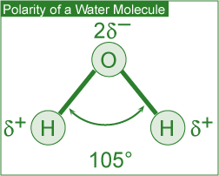

- Hydrogen Bonding (Slide 16)
The partial charges present lead to intermolecular attraction between water molecules. A single water molecule can thus attract four other water molecules.
These intermolecular attractive forces are called hydrogen bonds. These are much weaker than the forces holding the atoms in the covalent O-H bond.
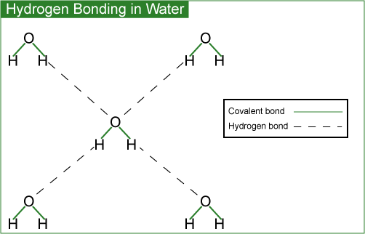
- Solvent Properties (Slide 17)

Water is a powerful solvent due to its high polarity and hydrogen bonding ability.

It is an excellent solvent for ionic (e.g., table salt), polar covalent (e.g., sugar) and non-polar (e.g., oxygen) compounds. In the case of ionic compounds, the ions are separated from the solid and caged (solvated) by polar water molecules, thus keeping them in solution.

Polar covalent compounds (i.e., ethanol and glucose) dissolve in water by the formation of hydrogen bonds.

Water therefore plays an important role in the transportation of nutrients and waste products in biological processes. Aquatic life and plants survive due to dissolved oxygen and carbon dioxide.
- Thermal Properties (Slide 18)
The presence of hydrogen bonds in water accounts for its exceptionally high boiling point, specific heat and heat of vaporization. A portion of the heat supplied is used up in breaking the hydrogen bonds.
- Specific heat is defined as the amount of heat energy required to increase the temperature of 1 g of a substance by 1°C.
High specific heat of water regulates and stabilizes the temperatures of geographical regions and organisms within a narrow range. This in turn allows our planet to support life.
- Heat of vaporization is defined as the quantity of heat required for the conversion of 1 g of a liquid entirely into its vapor at a constant temperature. High heat of vaporization of water helps in regulating the temperature of our body. It is also responsible for powering the winds and storms of our planet.
- Water Density (Slide 19)
Density of Solid and Liquid Water
Ice has a hexagonal open structure due to the presence of hydrogen bonds. When ice melts, the open spaces are filled with liquid water, causing the crystal structure to break down.

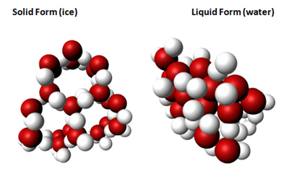
This leads to a reduction in volume for the same mass and hence an increase in density (density = mass/volume). The higher density (thus expansion and contraction of volume due to the freeze-thaw cycle) of liquid water than that of ice accounts for phenomena such as:
- Floating of ice on water
- Survival of aquatic life during winter
- Nutrient turnover in bodies of water
- Formation of pebbles, soil and sand
- Bursting of frozen water pipes

- Surface Properties (Slide 20)
The high surface tension and capillarity of water is due to the presence of hydrogen bonds. Water is the liquid with the highest surface tension. Plant debris rests (rather than sinks) on the surface of water bodies due to its high surface tension. This provides aquatic life with much-needed shelter and nutrients. Capillary action (also due to high surface tension) makes water in soil available to plants.

MODULE 6: HOUSEHOLD PRODUCTS
- Surfactants (Slide 3)
- Soaps and detergents are composed of surfactants.
- Surfactants are water-soluble and surface-active agents.
Surfactants are composed of a hydrophilic (water-soluble) head and a hydrophobic (fat-soluble, water-hating) tail. The hydrophilic end is stable when solubilized in water and the hydrophobic end consists of a long chain hydrocarbon that is more stable when surrounded by other organic groups.
Classes of Surfactants
There are different classes of surfactants categorized by the charge of the hydrophilic component of the surfactant molecule after dissociation in water:
- Anionic surfactants have a negative charge.
- Cationic surfactants have a positive charge.
- Non-ionic surfactants have no charge.
- Amphoteric surfactants have both positive and negative charges.
- All About Soap (Slide 4)
Composition and Limitations of Soap
Soaps (anionic surfactants) consist of the long hydrocarbon tails of fatty acids and the polar heads of sodium or potassium salts of fatty acids (found in fats and oils of animals and plants).
Traditionally, soap was made from animal fat and wood ash (composed of potassium hydroxide and potassium carbonate).
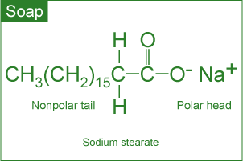
Advantages
- Soaps are manufactured from combinations of natural and renewable resources.
- Soaps are biodegradable and thus do not pollute bodies of water.
Disadvantages
- Formation of soap film (or scum) in water containing Ca²⁺ and Mg²⁺ ions (hard water). The calcium and magnesium ions react with soap molecules to produce calcium and magnesium salts of fatty acids. These salts are insoluble in water and impair the surfactant properties of soap because the amount of soap available for cleaning is reduced. Soap scum is difficult to rinse away and can be visible, i.e., on fabrics, bathtubs and sinks.
- Poor adaptability to diversity of fibers, washing temperatures and water conditions.
- Tendency to clog sewage systems due to their gelling properties.

- All About Detergent (Slide 5)
Composition and Limitations of Detergents
Detergents (containing a variety of engineered anionic or non-ionic surfactants) are made from petrochemicals.
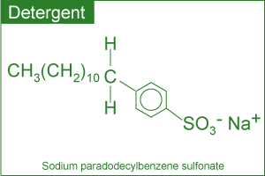

Advantages
- Detergents are less affected by calcium and magnesium ions in water, thus acting as better cleaning agents and almost eliminating the film formation.
- Detergents perform well under diverse conditions such as adaptability to diversity of fibers, washing temperatures and water conditions.
Disadvantages
- Detergents are made from non-renewable petroleum-based oils.
- Majority of detergents are not biodegradable.

- The Cleaning Process (Slide 6)
- Introduction: In the cleaning process, the polar end of the surfactant molecule interacts with water (a polar molecule) and the non-polar end is attracted to oil or grease (non-polar molecules).
- Step 1: Chemical Interaction (With soap or detergent) traps the oily and greasy oil molecules. In aqueous solution, surfactants cluster near the surface.
- Step 2: The hydrophobic tails are attracted to grease and the hydrophilic heads to the water, thereby forcing the grease away from the soiled surface.
- The grease is then surrounded by the individual surfactant molecules and removed from the soiled surface.
- Final step: Thermal Interaction (with hot water) helps dissolve oil and grease molecules. Mechanical Interaction (machine agitation or hand rubbing) releases oily and greasy soil from the fabric.

- Classifications (Slide 7)
Depending upon the function, household soaps and detergents can be classified as those used for:
 |  |  | 
Personal hygiene | Laundry | Dishwashing | Household cleaning

It is important to note that in view of the functional diversity, these products are usually formulated by mixing many ingredients. For example, laundry detergents are formulated from the following groups of chemicals:
- Surfactants to bind and suspend grease and dirt in the washing water
- Builders to remove Ca²⁺ and Mg²⁺ from hard water and soil
- Bleaching agents to remove stains and kill bacteria
- Enzymes to catalyze the degradation and elimination of some stains
- Miscellaneous chemicals such as foam stabilizers, fabric brighteners, fragrances, corrosion inhibitors etc. are added in small quantities.
- Environmental Impact (Slide 8)
Developing Products that are Safe for all of Us
As cleaning products are an integral part of our lives, it is very important to be aware of their impact on our health as well as the impact on the environment once discharged.
Health risks are very real, particularly in the case of some specialty household cleaners. Drain openers, oven cleaners and toilet bowl cleaners may contain reactive and/or corrosive chemicals. It is imperative that adequate safety precautions are taken while using such products.
The manufacturers are obliged by law to evaluate the environmental safety of the ingredients. Most of these products are formulated to work with water and end up in wastewater treatment plants, thus impact on the environment is minimized
The Safer Detergent Stewardship Initiative (SDSI) program of the U.S. Environmental Protection Agency (EPA) recognizes corporate environmental leaders using safer surfactants which break down quickly into non-polluting chemicals and thus protect aquatic life.
In an effort to handle these products in an environmentally wise way, we as consumers should buy them in usable amounts and dispose of them (if required) properly.
- Recent Trends (Slide 9)
In keeping with consumer demand for more efficient and environmentally friendly products, the present trend is to develop home and fabric care products that:
- Contain surface protectors or modifiers that repel soil and stains more effectively.
- Deliver active ingredients in a controlled way.
- Are effective in cold water.
- Contain natural or naturally derived ingredient(s).
- Do not contain chemicals of concern with respect to toxicity.
- Generate less carbon dioxide during production (smaller environmental footprint).
- Influencing Factors (Personal Care Products) (Slide 12)
Nearly all of us use personal care products for one or more reasons: to make our hair clean and colorful, skin free of wrinkles or to delight the senses. This is an expanding and dynamic field primarily because such products must be developed to take care of the changing needs of society.
Some influencing factors include:
- Aging population  - Changing attitudes of men | - More women in the workplace  - Concerns about exposure to ultraviolet radiation

The chemical ingredients in these products are thus changing at a remarkably fast pace. The availability of biotech products and processes to produce new ingredients is going to revolutionize the development of personal care products in the future.

In addition to rapidly changing chemical ingredients, more efficient delivery systems are being introduced. These include a variety of encapsulation systems to deliver the active ingredients in cosmetics.

Many shampoos, lipsticks, face creams and toothpastes contain these microcapsules. The active ingredient is delivered when the microcapsules rupture on the applied surface (e.g., skin) due to rubbing, presence of moisture, change in pH or the presence of naturally occurring bacteria.
- Hair Care Products (Slide 13)
Overview: These products are used for a variety of purposes such as to wash, condition, color or curl hair.
Thus the products used include:
- Shampoos: Anionic Surfactant. Shampoos are cleansing agents containing anionic surfactants to remove oil and dirt from the hair and scalp. Surfactants produce foam, lifting the oil and dirt from the hair. In addition, fragrances, thickeners, foam boosters and other agents may also be added.
- Conditioners: Cationic Surfactants. Help in rinsing out any residual shampoo and at the same time provide softer and easy-to-manage hair.
- Styling Agents:
The curling of hair is carried out in three steps
-Treatment of hair with a reducing agent (an electron donor) that breaks certain covalent bonds;
-Setting hair in the desired shape;
-Treating hair with an oxidizing agent (an electron acceptor) such as dilute solution of hydrogen peroxide to reform the previously broken covalent bonds in the new shape.
- Colorants:
Hair coloring is a two-step process involving:
-Oxidation of natural hair pigments to colorless products using a bleaching agent;
-Application of an organic, synthetic dye to obtain the desired color.

In addition to the dye (or its precursor), the formulations contain ammonia, hydrogen peroxide and a surfactant. In order to reduce the damage to hair during the coloring process and reduce the smell of ammonia, replacing ammonia with ammonium carbonate has modified the chemistry.
Major developments in the field of hair coloring include the availability of:
- A large variety of colors
- Improved delivery systems to enhance the adhesion of colors to the hair
- More effective conditioners to neutralize the harsh effects of dye chemicals.
- Skin Care Products (Slide 14)
- Moisturizers: How it works?
Moisturizers are used to increase the water content of the skin. They perform a number of functions such as:
-Prevent and treat dry skin
-Protect the skin and make it appear smooth by encouraging an orderly shedding process.
-Improve skin tone and texture.
-Protect sensitive skin and mask imperfections.
- Moisturizers: Active Ingredients
-Humectants: Absorb moisture and hold it in the skin. Examples: Glycerin, Urea.
-Emollients: Lubricate and smooth the skin. Examples: Lanolin, mineral oil.
-Miscellaneous: Antioxidants, fragrances, minerals, plant extracts, vitamins
Skin care products (creams, lotions, shampoos and sun care products) containing plant-derived chemicals are being developed at a very fast rate.
- Sunscreen: How do they work?
Sunscreen products are used to protect the skin against the harmful effects of ultraviolet (UV) radiation. Ultraviolet radiation emitted by the sun consists of UV-A and UV-B.
Although stratospheric ozone layer destroys most of this radiation, the UV light that gets through can cause problems. In addition, the depletion of ozone layer to a variety of natural and human made chemicals may increase the amount of UV radiation can cause painful sunburn, damage the skin, and lead to skin cancer.
Sunscreen products (sold as lotions, ointments, creams and gels) are formulated with additional chemical ingredients that absorb UV radiation.
- Sunscreens: Active Ingredients
Two types of active ingredients commonly used in sunscreens can be classified as:
-Inorganic: Approved for use are titanium dioxide and zinc oxide. These work primarily by reflecting and scattering UV light.
-Organic: Wide varieties are approved for use. These work primarily by absorbing UV light and dissipating it as heat.
The effectiveness of a sunscreen in a formulation is rated by its ability to block the UV-B rays that cause skin burns. It is called Sunburn Protection Factor (SRF). The higher the SRF, the better is the protection against UV-B rays.
- Sunscreens: Some Misconceptions
There is a misconception that a user can determine the duration of effectiveness of a sunscreen by multiplying the SRF by the time it takes for him or her to suffer a burn without sunscreen. For example, someone who would sunburn after 15 minutes (without any sunscreen protection) in the sun would expect to burn after 150 minutes if protected by a sunscreen with SRF 10.
- Sunscreens: Protection Factors
In practice, however, the protection from a particular sunscreen depends on the following factors:
-Activities (e.g., swimming leads to a loss of sunscreen from the body)
-Amount applied and frequency of re-application
-Solar intensity
-Type of skin
-Amount of sunscreen absorbed by the skin
In order to achieve a high SRF, formulations generally contain a combination of inorganic and organic ingredients.

- Safety in the Sun (Slide 15)
In an attempt to inform the consumers the level of UV-A protection in sunscreens, the US Food and Drug Administration (US FDA) is proposing a four star rating system to be displayed near the SPF rating on the label. According to this system, one star will represent low UV-A protection and four stars the highest UV-A protection.
- Cosmeceuticals (Slide 16)
Whereas pharmaceuticals are defined as products that may affect the structure or any function of the body, cosmetics are something superficial to cover a deficiency or defect.
The term cosmeceuticals is used to describe cosmetics containing ingredients which may affect the structure or any function of the body like pharmaceutical ingredients.
During the late 1980s, alpha hydroxy acids (AHAs) became important ingredients in many cosmetic formulations claiming to reduce signs of aging, sun-damaged skin and wrinkles. These work by breaking down and lifting off part of the top layer of dead skin cells in order to get rid of some surface damage and accelerate growth of living cells. The cosmetic industry believed the ingredients to be more than simple cosmetics and hence called them cosmeceuticals.
Some of these products are only available with a doctor's prescription and supervision. They include, among others, Botox (for a more youthful look), Vaniqa (to eliminate unwanted facial hair) and Propecia (for bald men).
- Perfumes (Slide 17)
Perfumes are alcoholic solutions of organic compounds with pleasant odours (fragrant compounds). Today, a large variety of natural and synthetic compounds are available to create fragrances for perfumes. In creating perfumes, the ingredients are blended based on their molecular size and volatility.

For this reason, the fragrances in perfumes are generally experienced in three different stages referred to as top, middle and base notes. The top notes are the most volatile components and hence experienced immediately after the opening of the package. The middle notes are experienced next followed by the base notes which last longest.

A recent trend has been to develop more intense and long-lasting alternatives to the known fragrant compounds. Such low-volume production means less impact on energy, health and the environment.

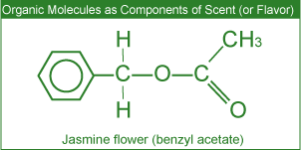
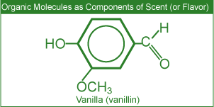
- Miscellaneous Products (Slide 18)
Deodorants
Body odors are reduced or masked by the use of deodorants. Such odors may originate from the conversion of certain compounds (present in the perspiration) to unpleasant odors by bacteria. Thus the effective chemical ingredients in such products are antibacterial agents and perfumes.
Cosmetics
Facial cosmetics such as lipstick and mascara generally contain oils, waxes, pigments and perfumes. Lipstick manufacturers blend various proportions of oils, waxes and emollients (to soothe the skin) to formulate the base for their unique brand. Fragrances, pigments, preservatives, antioxidants and a variety of other ingredients are then added.
In recent years there has been a concern regarding the presence of low levels of lead in certain cosmetics. A recent testing of a number of brands of lipstick by the US FDA (United States Food and Drug Administration) has shown the presence of low levels of lead. According to the US FDA, the levels observed do not pose a safety concern.

Lesson 7 – Drugs and Medication
ORGANIC CHEMISTRY
- Overview (Slide 3):
Organic chemistry deals with the study of carbon containing compounds and their reactions. Organic molecules are present in living organisms and in many products used in our everyday lives such as foods, household cleaning products, personal care products etc.
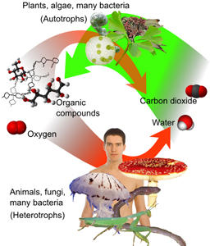
As the element carbon is present in the majority of drugs used today, some basic principles of organic chemistry (the study of carbon compounds) are discussed in this section.
- The Element Carbon (Slide 4)
The main characteristics of carbon that lead to the formation of such a large number of organic compounds (over 10 million known) with dramatically different physical and chemical properties include the ability to form:
- Covalent single, double and triple bonds with some other elements, including carbon.
- Covalent bonds with other carbon atoms to build chains and cyclic structures.
- Covalent bonds with elements such as hydrogen, nitrogen, oxygen and halogens.
- In the structures shown below, each line (bond) represents a pair of electrons.
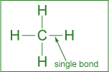 | 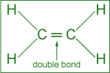 | 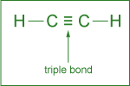
Single bond: formed by the sharing of one pair of electrons. | Double bond: formed by the sharing of two pairs of electrons. | Triple bond: formed by the sharing of three pairs of electrons.

- Arrangements of Atoms (Slide 5):
- Among the cyclic structures, the arrangement of carbon atoms in 5- or 6-membered rings is quite common. The hexagonal (6-membered) ring with three single and three double bonds is called a benzene ring.
Various Ways to Represent Benzene (C₆H₆) Ring  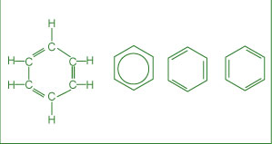 | Other Rings  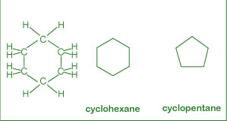

- Functional Groups (Slide 6)
A functional group can be visualized as a small structural unit or arrangement of atoms in a molecule that is the chemically functioning part of the molecule.
In the case of drugs, the functional group(s) are responsible for their action. In addition, the functional group(s) may also determine important parameters such as the rate of uptake and reaction as well as the time of residence of the drug in the body.
- Alcohol:
Functional Group: -OH
General Formula: R-OH
Example:
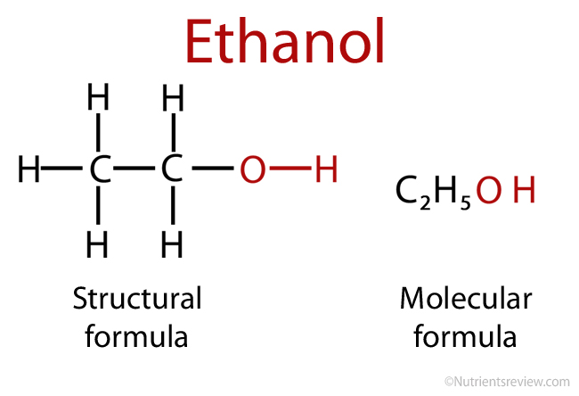
- Aldehyde:
Functional Group:

General Formula:
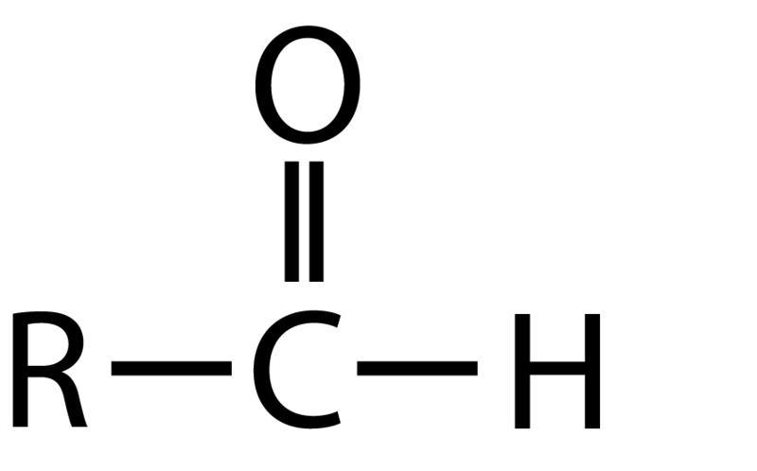
Example: (Formaldehyde)
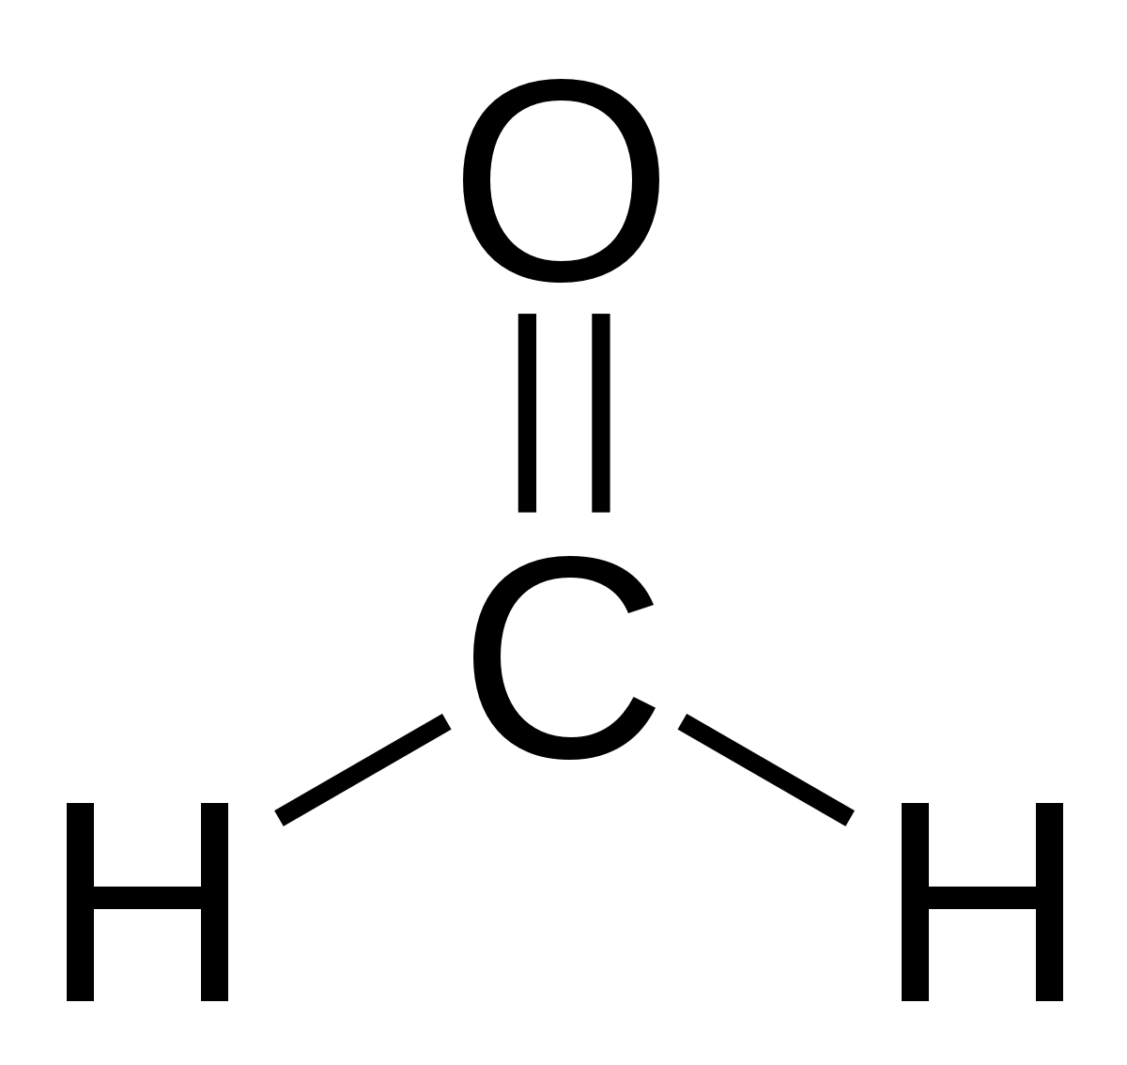

*R and R^1 represent hydrocarbon fragments which can be the same or different.
- Amine:
Functional Group: -NH₂
General Formula: R-NH₂
Example: (Methyl Amine)
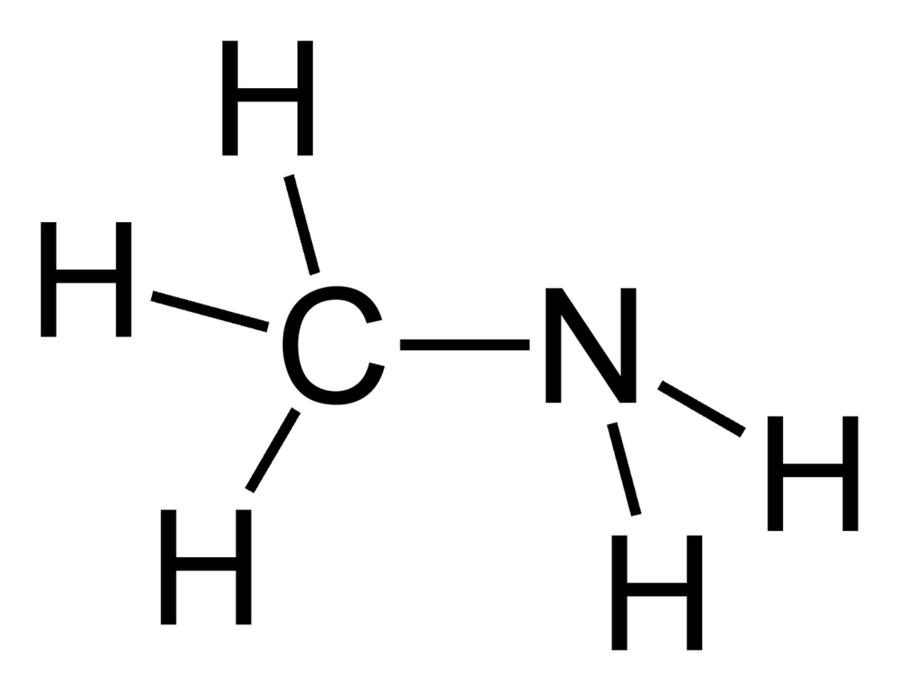
- Carboxylic Acid:
Functional group:
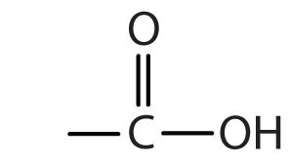
General Formula:
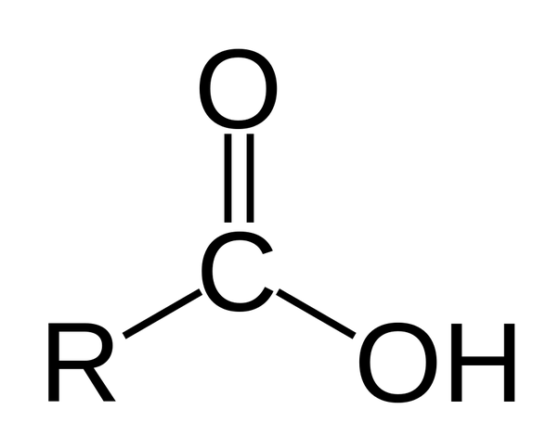
Example: (Acetic Acid)
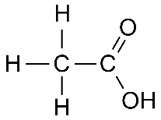

- Ester:
Functional Group:
Oxygen”O” (Double Bond) Carbon “C” (Single Bond) one side OR’/ Other side R
General Formula:
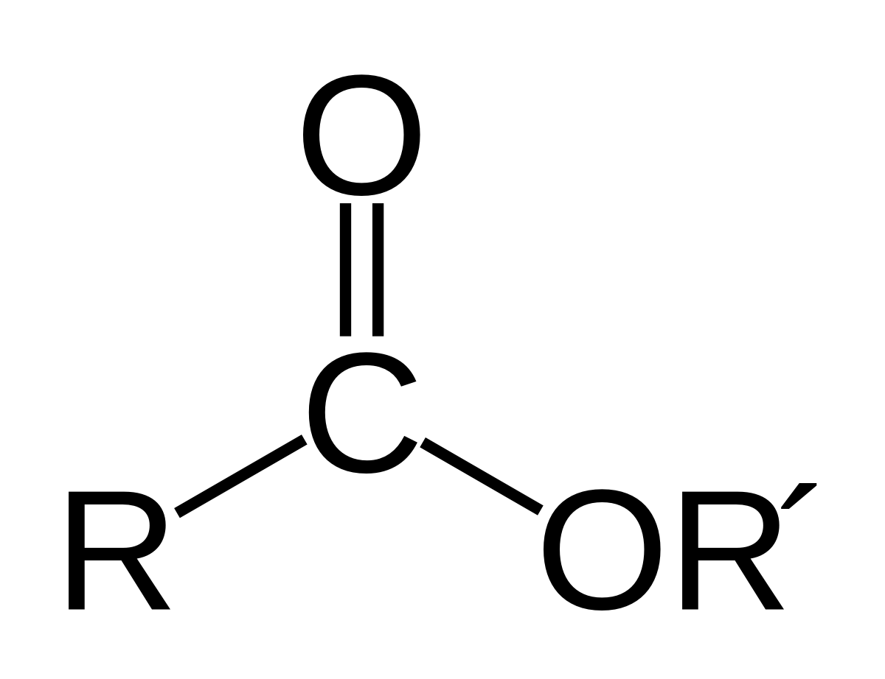
Example: (Ethyl Acetate)
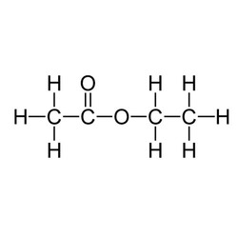

- Ether:
Functional Group: -O-
General Formula: R-O-R’
Example (Dimethyl Ether):
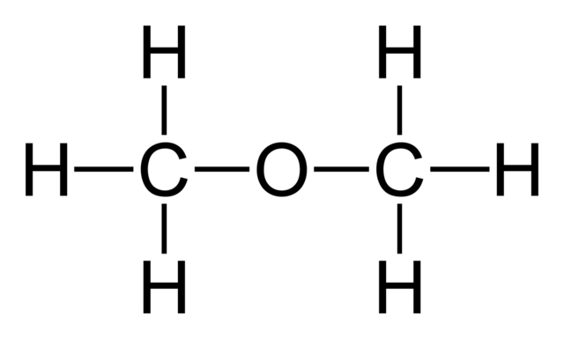

- Ketone:
Functional Group:
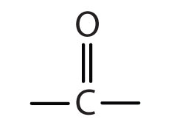
General Formula:
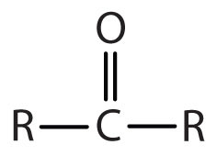
Example (Acetone):
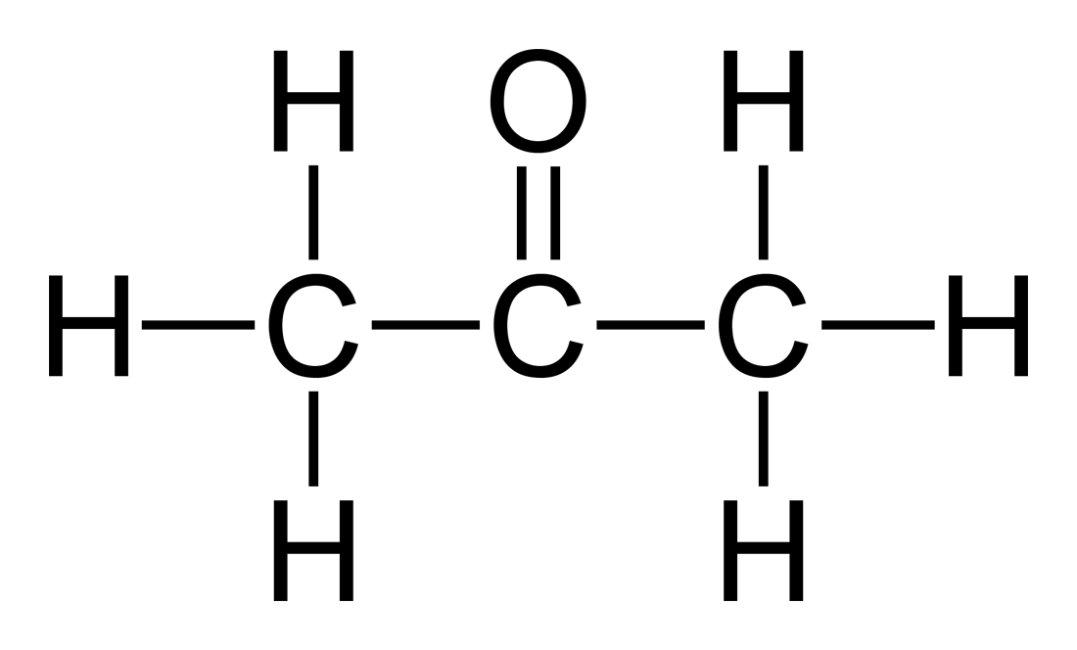
More Examples:
- CH₃CH₂CH₃: Propane: Fuel in gas barbecue.
- CH₃CH₂OH: Ethyl alcohol: Present in alcoholic beverages.
- CH₃(CH₂)₂CHO: Butyraldehyde: Responsible for the unpleasant odor of rancid butter
- CH₃COCH₃: Acetone: Component of nail polish remover
- CH₃COOH: Acetic acid: Vinegar is 5% aqueous solution of acetic acid.
- CH₃(CH₂)₂COOCH₂CH₃: Ethyl butyrate: Responsible for the sweet aroma of pineapple.

- Treatment of Infections and Diseases/Overview (Slide 9):
From the Sumerians (2200 BC) to the present, the discovery and usage of drugs has gone through a number of phases such as:
- Medicinal preparations and concoctions from plants, minerals and animal sources.
- Isolation and the use of plant ingredients as medications.
- Synthesis and testing of a variety of chemicals as potential cures for ailments.
- New areas of research into marine plants and organisms as potential drugs.
- Molecular modeling in designing drugs.
Extensive research with the available sophistication in the field of medicine has led us to engineer molecules that can be used to improve the quality of life by preventing, moderating or curing illnesses.
- Antibiotics (Slide 10):
Antibiotics drugs are used to fight bacteria that cause infectious diseases such as meningitis, pneumonia, and tuberculosis.
Several different categories of antibiotics include:
- Penicillin
- Cephalosporin
- Tetracycline
The discovery of a large number of chemically modified derivatives of these antibiotics led to the control of a large variety of bacterial infections. Antibiotics are isolated from bacterial sources, but can also be human-made. Antibiotics act directly on bacteria and destroy them or inhibit their growth. Antibiotics will not kill viruses.

HOW ANTIBIOTICS WORK???
The actual mechanism of antibacterial drugs is to alter or inhibit one of the following cellular structures/processes:
- Cell wall synthesis – prevents new bacterial cells from forming by preventing formation of the cell wall.
- Cell membrane permeability – kills bacteria cells by causing breakdown of the outer cell membrane.
- Protein synthesis – prevents the bacteria from converting proteins to energy, causing starvation and ultimate cell death.
- Nucleic acid synthesis – keeps bacteria cells from growing by interrupting DNA synthesis.
- Competitive inhibitor – mimics bacteria’s growth factors, thus preventing spreading of the bacteria.
Penicillin:
- Treat infections caused by bacteria.
- Do not fight infections caused by viruses.
- Mode of action: affect the development (damaging) of bacterial cell walls.
Cephalosporin:
- Cephalosporin has the structure similar to that of penicillin.
- Treat a much broader range of infections compared to penicillin.
- Mode of action: affect the development of bacterial cell walls.
Tetracycline:
- Chemical structure consisting of four rings.
- Used to treat penicillin-resistant infections.
- Mode of action: inhibit the synthesis of required bacterial proteins.
Antibiotics VS Superbugs
The emerging concern in the use of antibiotics is the resistance many of the so – called superbugs have shown towards the known antibiotics. The suggested ways to decrease antibiotic resistance include:
- More cautious use of antibiotics
- Monitoring outbreaks of antibiotic resistances
- Developing new antibiotics

- Antiviral Drugs (Slide 11)
Antiviral drugs are used to treat (cure or control) viral infections such as flu, polio, herpes and AIDS (Acquired Immune Deficiency Syndrome). A different strategy has to be used to combat viruses, as these do not respond to antibiotics. Two commonly used strategies to fight viral infections include:
Prevention through vaccination
When a vaccine (consisting of inactivated virus) is injected, antibodies to fight off a virus are developed and stored in the body. The stored antibodies become available to fight future infection.
Use of antiviral drugs
Commonly used antiviral drugs (particularly for the treatment of the AIDS virus) fall into three classes:
- Nucleoside derivatives inhibit the synthesis of viral DNA, thus preventing the virus from spreading.
- Protease inhibitors, on the other hand, interfere with the viral protein formation, thus preventing their reproduction.
- A three-drug cocktail consisting of different nucleoside derivatives and protease inhibitors has shown considerable promise in the treatment of AIDS. This triple cocktail treatment is also known as Highly Active Antiretroviral Therapy (HAART). The success of the therapy is probably due to the cocktail's ability to disrupt the viral replication at different stages. It is important to note that the therapy is very expensive and patients must adhere to their dosing schedule.
Some major problems associated with multiple drug therapy are: Moderate effectiveness, lack of response in some cases, serious to severe side effects and drug resistance by the virus. Recent efforts in the fight against AIDS have been directed towards the development of: Viral entry inhibitors (i.e., the drugs that will prevent HIV from attaching and consequently entering into the cell) and Vaccines.
- Anticancer Drugs (Slide 12)
Chemotherapeutic Agents
Cancer involves an uncontrolled division of some cells of the body due to mutation of DNA within the healthy cells. These cells invade nearby tissue and spread throughout the body via the bloodstream or lymphatic system. Thus the chemical treatment of cancer (chemotherapy) involves drugs targeting rapidly dividing cells to kill the cancerous cells.
Some chemotherapeutic agents include:
Alkylating agents:
- Mode of action: due to their high reactivity, alkylating agents introduce defects in the DNA, thus killing the rapidly growing cells by preventing cell growing cells by preventing cell growth and multiplication.
- Alkylating agent drugs also affect the growth of normal cells and cause mutations.
Antimetabolites
- Metabolite is a general term for the organic compounds that are synthesized, recycled, or broken down in cells.
- Antimetabolites inhibit DNA synthesis, thus stopping cell replication.
- Mode of action: compete for binding sites on enzymes and are incorporated into nucleic acids.
Topoisomerase Inhibitors
- Topoisomerase inhibitors damage DNA, which causes cell death.
- Mode of action: act against the topoisomerase enzymes to prevent cancer cell growth.
Hormone Therapy
- Hormone therapy is used against certain cancers that depend on hormones for their growth. This therapy is used primarily for the treatment of breast cancer and that of the sexual organs. As these tissues require hormones for their growth, the chemotherapeutic agent acts by inhibiting the hormone supply thus stopping the tissue growth.
- Mode of action: stop the production of certain hormones or change their mode of functions.

- Antidepressants (Slide 13)
A deficiency of certain neurotransmitters (any chemical that carries impulses between nerve cells), particularly serotonin in the brain, seems to be partly responsible for causing clinical depression. Neurotransmitters are needed for normal brain function and mood control, in addition to other functions.
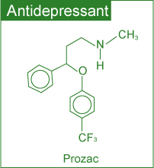
Although the effects of antidepressants are not fully understood, there is substantial evidence to show that antidepressants help to restore the brain’s chemical balance.
Commonly used antidepressants include:
- Selective Serotonin Reuptake Inhibitors (SSRIs) (e.g. Prozac, Paxil and Zoloft)
- Monoamine Oxidase Inhibitors (MAOIs) (e.g. Nardil, Marplan and Parnate)
- Serotonin and Norepinephrine Reuptake Inhibitors (e.g. Effexor)
- Norepinephrine and Dopamine Reuptake Inhibitors (e.g. Welbutrin)
- Tricyclics (e.g. Norpramine, Pamelor and Tofranil)
Whereas SSRIs target the serotonin levels only, tricyclics affect the brain levels of other neurotransmitters (including serotonin) as well.
- Anti-Inflammatory Drugs (Slide 14)
Inflammation is the first response of the immune system to infection or irritation characterized by pain, swelling, redness and heat. An inflammation results from the rapid transport of blood proteins and other substances to a damaged tissue site or an area under attack by a foreign organism.
Certain steroids are used as potent anti-inflammatory drugs. These suppress the inflammatory responses of the body, thus reducing inflammation.
- Over the counter drugs “OTC” (Slide 15):
Whereas all types of drugs discussed earlier require a prescription, a considerable number of drugs are sold Over The Counter (OTC) without a prescription.
According to the Non Prescription Drug Manufacturers Association, in the US alone there are more than six hundred OTC drugs.
OTC Drug Criteria:
The criteria generally used by the regulatory agencies to designate a drug with OTC status or switch its status from (Prescription R_{x} to OTC) involves a benefit-risk comparison and making sure that patients alone can achieve the desired medical result without endangering their safety.
Although OTC drugs allow patients to participate in their own health care, experts emphasize that labels must be followed closely because OTC drugs are not without risks.

Aspirin – The Best Known OTC Drug
Aspirin was introduced more than a century ago. It has long been as an:
- Analgesic (relieving minor pain)
- Antipyretic (lowering fever)
- Anti-inflammatory (reducing swelling) drug
Recent studies have shown its usefulness in treating heart attack and stroke.
Aspirin – Effectiveness and Side Effects
It is believed that Aspirin’s effectiveness as an analgesic, anti-inflammatory agent and its protective effects against heart attacks and strokes are due to its ability to reduce the production of prostaglandins (a hormone-like substance that promotes inflammation, fever and pain) and thromboxane (responsible for platelet aggregation in the formation of blood clots) in the body.

Some possible side effects of Aspirin include:
- Stomach irritation
- Ringing in the ears
- Allergy
- Reye syndrome (brain disorder) in children.
- Drug Delivery Systems (Slide 16):
Active pharmaceutical ingredient (API) in a medicine is delivered to the body in many forms, such as tablets, gelcaps, liquids and so on. Some newer alternate methods for drug delivery have been developed with three major advantages:
- User convenience
- Improved drug performance
- Better patient compliance
Some of these methods include:
- Pulmonary delivery: The system is noninvasive and facilitates the rapid absorption of the drug on the large surface area of the lungs followed by rapid desorption into the bloodstream.
- Skin absorption: Skin patches are being used to deliver the medication via skin absorption.
- Nanocrystals: This method reduces the drug particle size to nanoscale (<400 nm) making it more soluble in body fluids.
- Effects & Trends (Slide 17):
Environmental Effects of Pharmaceuticals
Recent research has led scientists to be concerned about the environmental impact of old and/or expired medications that are discarded. The pharmaceuticals enter the environment mostly through raw or treated sewage.
Some of the effects observed include:
- Feminization of male fish due to estrogenic compounds: The signs of feminization in male fish have been concluded as a response to estrogen (in birth control pills) exposure.
- Slow development of fish and frogs due to certain antidepressants: Profound effects on spawning and other behaviours in shellfish can occur with antidepressants such as Selective Serotonin Reuptake Inhibitors (SSRIs).
Recent Trends in Pharmaceutical Development
In the field of pharmaceutical development the present trends include:
- A shift from blockbuster drugs (drugs that work for a large number of patients) to personalized medicine: In personalized medicine, therapies are catered towards genetic profiles of patients and their diseased cells.
- Exploring marine organisms in an attempt to obtain new compounds with therapeutic potential: Several of these compounds are being investigated as potential anticancer agents, analgesics and anti-inflammatory drugs.
- Medication & Health (Slide 18)
Drugs should not be considered risk-free chemical substances. It is strongly recommended by health professionals that patients should always bear in mind the fact that medications have side effects and may have serious interactions with other medications, dietary supplements, food and beverages consumed.

In order to reduce risks, it is strongly recommended that all individuals:
- Read drug labels carefully.
- Learn about the warnings of all drugs taken.
- Inform health care providers of all prescription and OTC drugs and dietary supplements taken.
- Keep a record of all medications taken.

LESSON 8 – SOME ENVIRONMENTAL CONCERN
- Acid and Rain (How does it happen? slide 3)
When atmospheric carbon dioxide dissolves in water it forms carbonic acid.
CO₂ (g) + H₂O (ℓ) H₂CO₃ (aq)
The acid formed dissociates partially generating small amounts of hydrogen ions.
H₂CO₃ (aq) H⁺ (aq) + HCO₃⁻ (aq)
The hydrogen ions formed are responsible for the weakly acidic nature of rain.
- The pH Scale (Slide 4)
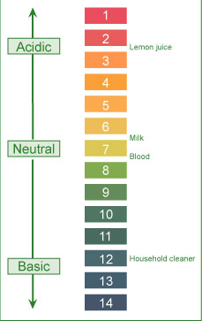
The acidity (a measure of hydrogen ion concentration) of a solution is conveniently described in terms of pH scale.
According to this scale, if:
pH < 7: solution is acidic
pH > 7: solution is basic
pH = 7: solution is neutral

- pH Laboratory (Slide 5)
- Acid Rain (Slide 6):
↑ Acidity = ↓ pH
Based on the concentration of carbonic acid and small amounts of other natural acids, the estimated pH of rain (as well as fog, dew and snow) under normal atmospheric conditions should be around 5.3.
Field measurements in many areas, on the other hand, show much lower pH values (4.1- 4.5).
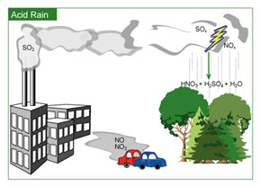
Click on image to enlarge.
Higher acidity (lower pH) is due to the reactions of
NO_{x} and SO_{x} present in the atmosphere.
Various reactions of these oxides lead to the formation of acids. The dissociation of formed acids generates hydrogen ions and hence higher acidity (or lower pH).
2 SO₂ (g) + O₂ (g) + 2 H₂O (ℓ) 2 H₂SO₄ (aq)
H₂SO₄ (aq) H⁺ (aq) + HSO₄⁻ (aq)
HSO₄⁻ (aq) H⁺ (aq) + SO₄²⁻ (aq)
4 NO₂ (g) + O₂ (g) + 2 H₂O (ℓ) 4 HNO₃ (aq)
HNO₃ (aq) H⁺ (aq) + NO₃⁻ (aq)

- Environmental Effect of Acid Rain (Slide 7):
- Material Damage:
Marble and limestone (CaCO₃) used in many historic and irreplaceable statues and buildings (e.g., the Parthenon in Greece, the Taj Mahal in India) react with acid in the rain.
The reaction leads the formation of calcium salts. The solubility of these salts in water is much greater than that of marble in water. The dissolution of formed calcium salts leads to roughened surfaces, removal of material and loss of carved details from the buildings and statues.
CaCO₃ (s) + 2 H⁺ (aq) $→$ Ca²⁺ (aq) + CO₂ (g) + H2O (l)
- Corrosion of Metals:
The corrosion process is accelerated in the presence of acid. Thus, iron structures, bridges, railroads, etc. show a faster rate of corrosion (rusting) in acid rain predominant areas. Studies indicate that even painted or plated iron corrodes more rapidly in such areas.
The reaction occurs in two steps with hydrogen ions (formed from the dissociation of acid) being involved in the first step of the reaction. The overall reaction, conversion of iron to its oxide (rust), can be represented as follows:
4 Fe (s) + 3 O₂ (g) $→$ 2 Fe₂O₃ (s)
- Forest Damage:
Considerable damage to trees has been reported in various parts of North America and Europe. Acid rain has been implicated with slower growth, injury and destruction of forests and has been attributed to be a contributing factor to the declining health of trees by damaging their leaves, limiting the nutrients available to them or exposing them to toxic substances released from the soil due to the change in pH.
Acid rain is implicated in depleting the nutrient supply to the trees by:
-Attacking the leaves whose protective coating has already been destroyed due to attack by other atmospheric pollutants such as O₃ and NO_{x}.
-Mobilizing various metals (Al, Pb, etc.) in the soil that attack the roots.
Inadequate nutrient supply increases the possibility of destruction due to disease, drought, insects or high winds.
- Aquatic Life:
Aquatic life is quite susceptible to changes in pH. Reduced pH has led to lakes with no fish or other living beings. Acid rain has been shown to reduce fish population, kill individual fish and in some cases eliminate fish species entirely from a body of water.
Adverse effects of acid rain on aquatic life are due to:
-Lowering of pH well below the required value of about 6.5 for healthy aquatic life.
-Increasing aqueous concentration of metals (Al, Pb, etc.) due to their higher solubility at lowered pH.
Both low pH and increased aluminum levels are directly toxic to fish. In addition, low pH and increased aluminum levels cause chronic stress leading to smaller size and lower body weight. These factors in turn make the fish less able to compete for food and habitat.
- Control Strategies Acid Rain (Slide 8)
Reduction of SOx emissions by using emission control technologies:
Over the years, progress has been made in reducing the emissions of sulfur dioxide. The major strategies under consideration include:
- Using coal with low sulfur content
- Removing sulfur from the coal before using
- Using chemicals to neutralize acidic sulfur dioxide
In view of the substantial cost involved in using any of the above strategies individually or in combination, the progress in this direction has been rather slow in North America. In Japan, using the above technologies in particular the use of scrubbers (for the neutralization of acidic sulfur dioxide) has led to considerable decrease in sulfur dioxide emissions.

Reduction of NOx emissions by using emission control technologies:
Catalytic converters are now in use in automobiles to reduce the emission of oxides of nitrogen.
Using cleaner energy sources (such as alcohol and hydrogen) in transportation:
These cleaner energy sources are being explored. A number of projects all over the globe are in progress. In some parts of the US there is limited use of alcohol to replace gasoline in cars. There are considerable numbers of investigations in progress pertaining to the use of hydrogen as a fuel.
Developing and/or using alternate energy (i.e. hydroelectric, nuclear, or wind) sources:
Hydroelectric, nuclear and wind power are being used in many parts of the world. However, the progress in their development is very slow primarily due to high initial costs and environmental issues.
- Global Warming (How does this happen? Slide 11)
How does this happen?
Global warming refers to an increase in the Earth’s average temperature. This warming is the result of increased absorption by the atmosphere of infrared (IR), a major source of heat, radiated back from Earth's surface. This is due to an increase in concentration of gases that trap heat in the atmosphere. These gases are often called greenhouse gases.

The principal greenhouse gases that enter the atmosphere due to human activities include:
Carbon dioxide (CO₂) | Methane (CH₄) | Nitrous oxide (N₂O) | Fluorinated gases
It enters the atmosphere due to the burning of fossil fuels (oil, natural gas, and coal), waste materials, and as a result of other chemical reactions. | Main sources of emission are the production and transport of fossil fuels, livestock, agricultural practices and organic waste decay. | It is emitted during agricultural and industrial activities as well as during the combustion of fossil fuels and waste materials. | These fluorine containing compounds are emitted from a variety of industrial processes and are sometimes called High Global Warming Potential (GWP) gases.
Based on measured concentrations of various greenhouse gases, computer models have been developed to predict the extent of global warming. It is estimated that the temperature of the atmosphere may increase anywhere from 1.5 ºC to 3.5 ºC during the next fifty years.
- Environmental Effects of Global Warming (Slide 12)
Climatic Changes:
Human activities such as burning of fossil fuels, deforestation, industrial processes and some agricultural practices release greenhouse gases.
These gases trap energy in the atmosphere causing it to warm.
Changes in sea level due to melting of polar ice caps:
The North Pole is warming up faster than the rest of the world.
The Arctic sea ice is in a state of ongoing decline as shown by the data from the national Snow and Ice Data Center (NSIDC) in the US.

Possibility of droughts and increased frequency of heat waves due to warming:
Based upon detailed analysis using computer climate models and other relevant data, it is concluded that in the next few decades increasingly dry conditions may be encountered across much of the globe.
Changes in ecosystem:
As many animals and plants survive within a narrow range of climatic conditions, some animal species are shifting towards higher elevations.
Many species even face extinction. As ocean temperatures rise, the coral reefs will continue to decline.
Effects on Human Health:
Global warming may lead to increased temperature-related illnesses, air pollution due to higher temperatures, and possible spread of some infectious diseases.
- Control Strategies Global Warming(slide 13)
Some of the suggested control strategies include:
Reduction in CO₂ emissions: The governments all over the globe are working to reduce their country's carbon dioxide emissions by:
- Promoting that alternate non-fossil sources such as hydroelectric, solar, nuclear and wind are developed and used
- Capturing the carbon dioxide generated by burning fossil fuels
- Supporting new fuels and technologies (like electric cars) to reduce carbon dioxide emissions from transport
- Setting 'carbon budgets' to cap overall carbon dioxide emissions.
Encouraging energy conservation: This will lead to lesser energy consumption and hence lower production and reduced emissions.
Using carbon dioxide sinks: A carbon dioxide sink is any resource (natural or artificial) that captures and stores atmospheric carbon dioxide. Natural carbon dioxide sinks include forests, oceans and soil. Thus replanting forests is being encouraged globally.
Some of the artificial carbon dioxide sinks being studied involve removing carbon dioxide from the atmosphere and storing it in rocks, injecting it deep into the oceans or trapping it via chemical reactions.
- Present Situation (Slide 14)
- 1988 – Intergovernmental Panel on Climate Change, United Nations Environmental Program (UNEP), Intergovernmental Panel on Climate Change (IPCC)
- 2007 – Intergovernmental Panel on Climate Change
- 1997 – Kyoto protocol
- Today – Kyoto protocol
- Ozone Depletion (How Does it Happen? Slide 18)
Ozone plays a double role in our environment:
- In our immediate atmosphere, it acts as an air pollutant contributing to photochemical smog
- In the stratosphere (in conjunction with oxygen), it filters the solar ultraviolet (UV) radiation, thus protecting us against its harmful effects
In our immediate atmosphere exposure to ozone may occur in operations involving:
- High-intensity UV light such as mercury vapor lamps, plasma torches, glass blowing, etc.
- High-voltage electrical equipment
- Welding
In all the above operations, the interaction of high energy with oxygen in the surrounding atmosphere leads to the formation of O₃:
3 O₂ (g) + Energy 2 O₃ (g)
- Ozone Formation (Slide 19)
In the stratosphere, oxygen and ozone interact with energy (ultraviolet radiation) from solar radiation to form a dynamic system involving the following reactions:
When ultraviolet light strikes oxygen molecule, individual oxygen atoms are produced. | O₂ + Energy 2 O
The combination of atomic oxygen with oxygen molecule leads to the formation of ozone. | O₂ + O O₃
The interaction of ozone molecule with ultraviolet light splits it into a molecule of oxygen and an atom of oxygen. | O₃ + Energy O₂ + O
Recombination of ozone molecule with an oxygen atom leads to the formation of oxygen molecule. | O₃ + O 2 O₂

- Environmental Concern (Slide 20)
The environmental concern in the case of ozone is its stratospheric depletion, which leads to less efficient filtration of harmful solar UV rays. The depletion is caused by both natural (water vapour, nitric oxide) as well as human-made (chlorofluorocarbons, halons) sources.
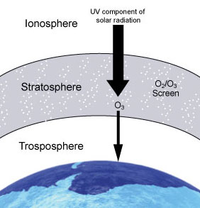
These manufactured chemicals, containing chlorine and/or bromine are called "ozone-depleting substances" (ODS). The use and popularity of these chemicals is due to their stability and low toxicity.
Chloroflurocarbons (CFCs) and halons
have been used as:
- Foam-blowing agents  - Solvents | - Fire-extinguishing agents  - Refrigerants
However, their stability and long lifetime (up to several centuries) allows them to reach the stratosphere. The interaction of these molecules with ultraviolet light in

the stratosphere leads to the generation of chlorine and bromine which in turn destroy stratospheric ozone.
- Effects of Depletion (Slide 21)
Introduction:
Stratospheric ozone depletion leading to less efficient filtration of the ultraviolet radiation from the sun, will increase the intensity of ground-level UV radiation. This increased intensity may have adverse effects on:
- Humans
- Agriculture and Forestry
- Materials
- Marine ecosystems
Humans:
Such adverse effects include:
- Higher probability of sunburns, skin cancer and premature aging of skin.
- More cataracts, eye diseases and blindness
- Immunosuppression (weakening of the human immune system)
Agriculture and Forestry:
Physiological and developmental processes of major crop species (such as barley, rice and wheat) may be affected. The data available on the effect of more intense ultraviolet radiation on commercially important trees shows that plant growth is harmed.
Materials:
Increased intensity of UV radiation may accelerate the degradation of materials such as fabrics, plastics, rubber, and wood.
Marine Ecosystems:
Increased intensity of ultraviolet radiation may:
- Damage marine life by decreasing the plankton. Such a decrease in plankton could disrupt the food chains leading to a shift in marine species in global waters.
- Lead to decreased reproductive capacity reducing fish yields.
- Control Strategies Ozone Depletion (Slide 22)
In North America, the use of chlorofluorocarbons (as propellants in spray cans) was banned in 1978 in response to the threat of ozone depletion. The global response to the threat of ozone depletion came with the signing of the Montreal Protocol (in 1987). It set out to reduce and ultimately ban the manufacture and use of CFCs and other ozone depleting substances.
The international agreement has been effective in reducing risks in the long term; ultraviolet radiation remains a health hazard. In view of this, we as individuals should protect ourselves against it.
NASA projections of stratospheric ozone concentrations from 1974 to 2060 if chlorofluorocarbons (CFCs) had not been banned (Source: Earth Observatory, NASA, Wikimedia)  Click on image to enlarge. | 

