Deciding which Company Vehicle to Buy
Josh Thiopoulos
Consulting division
ENG 1131C
Prof: Jeanie Warnock
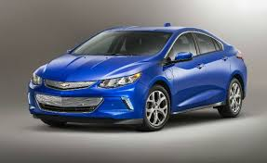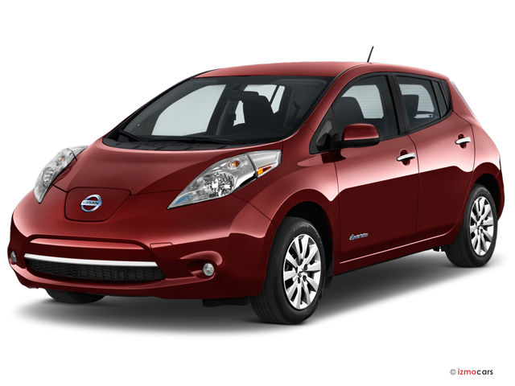
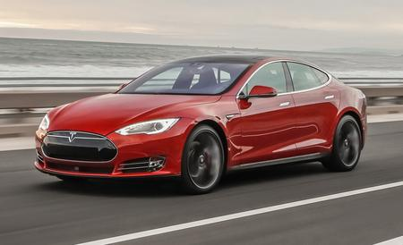

Letter of Transmittal

This report contains a comparison between 3 electric and hybrid-electric vehicles that Green Consulting Firm is interested in buying. The goal of this report is to identify categories of strength and/or weakness in each car by comparing them to each other. A recommendation will be made based off of the information found in the comparison. The company has narrowed their choices down to 3 electric cars which are: the Nissan leaf, Chevrolet Volt, and the Tesla model S.

Table of Contents
Letter of Transmittal ii
Executive Summary iv
Deciding which Company Vehicle to Buy 1
Introduction 1
Basic Overview of Each Vehicle 1
Nissan Leaf 1
The Chevrolet Volt 2
Tesla model S 2
Efficiency 2
Nissan Leaf 2
Chevrolet Volt 3
Tesla Model S 3
Driving Experience and Features 4
Nissan Leaf 4
Chevrolet Volt 5
Tesla Model S 5
Aesthetic 6
Nissan Leaf 6
Chevrolet Volt 6
Tesla Model S 6
Findings 7
Conclusion 7
Appendix 9
Tables 10
10
References 12

Executive Summary
The report will compare the Chevrolet Volt, Nissan Leaf and Tesla Model S on: Efficiency, Driving Experience /features and aesthetics. Each vehicle is scored on how well they do in each section. At the end of the comparison, the recommendation will be based of which car scores the best in the most categories. Based off of the results, the Tesla Model S is the best option to not only serve as a company vehicle, but to represent the green image of this firm.

Deciding which Company Vehicle to Buy

Introduction
Image and status are inescapable aspects of business. Any piece of capital that a company owns contributes to its image. That’s why it is important to for the CEO of Green Consulting Firm to own a car that represents the firm well. The car must reflect the company’s commitment to eco-friendly activity and responsibility to environmental sustainability. It is important to preface this report by mentioning that the three cars up for consideration are of different price ranges and have very different features so we will only talk about the standard features that are on the base models and by grand coincidence, they are all eligible for the same $14,000 Government of Ontario rebate as seen in tables 1-3.
This report will help compare important aspects of each vehicle so that you may make an informed decision on which one to buy. A recommendation will be made based off of the information found in the comparison. The company has narrowed their choices down to 3 electric cars which are: the Nissan leaf, Chevrolet Volt, and Tesla model S.
I will start by providing a detailed look at each vehicle and then I will compare them based on 3 metrics: Efficiency, Driving Experience/Features and Aesthetics.

Basic Overview of Each Vehicle

Nissan Leaf
The Nissan Leaf is a 4-door compact electric vehicle that has a base price of $33,998 and uses a 30 kWh battery to power its 80 kW electric motor. It weighs around 1480 kilograms and produces 187 pound/foot of torque.

The Chevrolet Volt
The Chevy volt is a hybrid electric vehicle that has an 18.4 kWh battery and a 4-cylinder gas powered engine. Its base price is $34 005 and is a 4-door midsize vehicle that only has 4 seats. It produces a combined total of 194 horsepower and weighs in at 1721 kg.

Tesla model S
The Tesla is a 4-door full-sized sedan with an all-electric powertrain Making the car weigh 1961 kilograms. It has a 60 kWh battery that produces a little over 400 horsepower and comes in at an MSRP of $72,500. However, the availability of the Tesla is quite scare so buyers will usually have to fork out much more than that. The Model S is in a different car segment than the other vehicles which is why its; heavier, longer and wider than the Leaf or the Volt. It is also branded as a luxury sedan rather than an all-electric compact vehicle.

Efficiency

Nissan Leaf
The leaf is a fully electric car that produces zero carbon emissions and boasts an effective range of 172 km on a single full charge. According to Frank Serzano, a salesman at the Plaza Nissan dealership, the leaf takes an average of 10-12 hours to fully charge with the regular charger which is way too long of a charge time. While the 172km range is impressive, it is not the best out of the other 2 cars. In fact, it has the lowest range among the 3 vehicles. This means that you will need to charge the car nearly every night if you intend to use it regularly. There is a misconception that the more you need to charge your car, the more energy it uses and thusly; it is not an efficient user of energy. However, this dependence on charging time is based on the fact that the actual capacity of the battery is much lower than any of the other cars. The Leaf only has a 30 kWh capacity battery which is 2 times smaller than that of the Tesla Model S. Efficiency is measured using the rate at which energy form the battery is consumed by the motor The actual efficiency of the motor is 5.73km/kWh which is to say that 1kWh of energy from the battery gets you 5.73km in driving range.

Chevrolet Volt
The Chevy volt uses hybrid technology so the electric motor can get you a little over 85 km on its own but with the gasoline engine, you can get a total of 676 km with a full tank. This car is different form the other 2 cars in the comparison in that, it is not fully electric and in doing so, does not have zero emissions. But this car gives you the option to use the electric motor separately from the gasoline engine. With the electric motor alone, the Volt achieves an efficiency level of 4.62km/kWh.
Even though the car has been called the “the plug-in hybrid to beat” by PCworld’s Melissa Riofrio, the problem is that it has a gasoline engine which produces carbon emissions that contribute to global warming and pollution of the air. Therefore; this vehicle is not the best option to represent a company that emphasizes Eco friendliness because it contributes to the problem of global warming albeit a small amount.

Tesla Model S
The base Model S achieves a 351km range using only electric power and makes use of regenerative braking to help conserve some of the energy. Regenerative braking is a feature that is exclusive to electric vehicles where the car can actually regenerate energy from the friction of the brakes and restore it to the power supply.
Tesla’s success with developing new technology lead them to switch from a the standard EV motor type to a reinvented motor type that produces more power (in the form of torque) from the motor given the same amount of electric charge. Tesla explains in-depth how their motor is more efficient than the standard motor designs. The standard motor type that is found on the Leaf and the Volt is called the DC Brushless motor whereas the Model S has a 3-phase induction motor (AC). The 3-phase induction motor has less moving parts than the DC motor and generates power by sending an electric current into a magnetic field where it can continuously fuel the motor making better use of the electricity form the battery cells. The reason most electric vehicles use the DC motor is because hydro companies have converted their electricity current into DC. Tesla had to create a module that converts DC current to AC current in order to make their motor work properly.
All of this contributes to the Tesla’s efficiency ratio of 5.85km/kWh.

Driving Experience and Features

Nissan Leaf
The Leaf is not a very powerful car and it really shows when you push the car to high speeds. In Merek Wieruszewshi’s review of the car, he described feeling the power declines as you push it to high speeds. This leads to the car having a 0-60 time of 10.4 seconds which is relatively normal for any other car but not impressive to say the least. The leaf has great standard features such as heated front seats, regenerative breaking and a free 2-year warranty.

Chevrolet Volt
The actual ride quality of the car is can only be described as adequate. In fact, Kim Reynolds from Motor Trend describes the steering as being light and precise. From my experience driving the car, I found it to be quite fast and has no trouble keeping up on the highway when it’s in electric mode. When the Volt is in sport mode, it’s fun to drive and very nimble. This allows the Volt to have a 0-60 time of 7.1 seconds.
The base model Volt doesn’t have regenerative breaking but includes an awesome Bose sound system. On top of that, it’s unique drive train is very smart. For example, the Volt’s heated seats and power options are normally powered by the electric battery cells but when you switch into the electric-only mode, the gas engine can lend energy to heat the seats.

Tesla Model S
The Tesla model S is a ludicrously fast car in a straight line. It has a 0-60 time as fast as 2.4 seconds (with the speed package). The overall ride is very comfortable and has optional air ride suspension. It drives like a normal luxury sedan until you want it to go insanely fast; then it becomes a whole different car. Evidentially, the acceleration of the Model S rivals that of most supercars and hypercars. The one nitpicky criticism the car gets for its performance is that most of the driving sensations are artificial. For example, the car plays artificial exhaust notes in the cabin so the driver can feel how fast they’re going and also the steering is heavily assisted by the car’s computer. Besides that, the model S is powerhouse in performance.
Tesla is famous for providing insane additional features in their cars that nobody really need but are awesome to have. For example, it has a built-in bioweapon air filtration system for the inside of the car and the car can be switched into autonomous driving mode for when you’re on the highway.

Aesthetic

Nissan Leaf
Even though aesthetic is largely subjective and varies from person to person, the consensus is that this car looks strange. The exterior of this car is shaped awkwardly with bodylines seemingly going in every direction. It would not be the kind of car you would want to represent your company solely based on looks. The overall form of the car is very dainty and puny. The interior of the Leaf is functional but does not feel up to par for a car that starts at $34 000. It makes heavy use of cheap looking plastics along the interior that is not very appealing.

Chevrolet Volt
This is a small vehicle like the Nissan leaf but it only has 4 seats which is unusual. However, Chevrolet has put a lot of work into making the car look good and it shows. Compared to the Leaf, it looks much sharper and angular. The inside of the car is also nice. Chevrolet also makes use of cheap materials but from my experience sitting in one, they find a way to make it look good. The interior design of the Volt is slightly nicer than the Nissan Leaf’s design.

Tesla Model S
The Model S is Tesla’s flagship vehicle and it certainly shows. The exterior of the car is what most people like about the design of the car. An editor for Car and Driver magazine named Csaba Csere gave a first impression of the vehicle and said: “It’s very sleek but subtle too. Tesla really got the proportions right when you look at it from different angles.” The exterior of the car looks like how a proper luxury vehicle should; long and sleek without being too aggressive. However, the interior of the car is not as satisfying as the outside. The interior features a very large touchscreen in the console and has no physical buttons or knobs which looks very futuristic but that’s it. In fact, the Model S has received criticism on its lack of luxury “It’s almost like the interior isn’t finished” and “Not feeling special enough for a luxury sedan” (Jonny Lieberman, Motor Trend).

Findings
In terms of efficiency, the Tesla’s motor had the highest efficiency rating of 5.85km/kWh. An added bonus is that the Model S also has the second highest battery range of the 3 cars. So the tesla makes the most out of its battery cells.
If we look at how each car performs in driving experience, there are only 2 good options. The leaf is not well suited for driving on high speed areas like highways and is really only useful for inner city living because of its slow charging time and short range. For that reason, the Chevy Volt and the tesla are winners for this category: they’re both sporty and have great ride quality. If anything, the Model S pushes ahead of the Volt in performance just because of its ludicrous acceleration.
The nicest looking vehicle in this group is either the Chevy or the Tesla. They are on opposite sides of the spectrum in terms of design style. The Chevy has an aggressive sporty exterior with a plush traditional interior. Comparatively, the Tesla has a subtle but sleek exterior design and the interior is very futuristic with nothing but a 17-inch touchscreen that controls everything in the car.

Conclusion
The clear winner here is the Tesla model S. It’s well-engineered from top to bottom and doesn’t cut corners in any department. It has ranks in the top tier for all 3 categories. The Model S is the frontrunner for efficient electric cars and would serve as a great company vehicle for this firm since its very ecofriendly. It’s even got the most usable space within the car to transport multiple clients comfortably. The only tradeoff of the model S is that it costs more than the other options but it’s still a very affordable car. The extra money you would pay for this vehicle is well worth it. I recommend the Tesla Model S for Green Consulting Firm to buy a company car.

Appendix
Primary Sources
Frank Serazano. 905 389 3588 sales representative Plaza Nissan Hamilton, Ontario
Merek Wieruszewshi. YouTube: Merek Drives Instagram: merek_drives
Jonny Lieberman. Email: jonny.lieberman@motortrend.com
Josh Thiopoulos. Email: jthio030@uOttawa.ca

Tables
Table 1
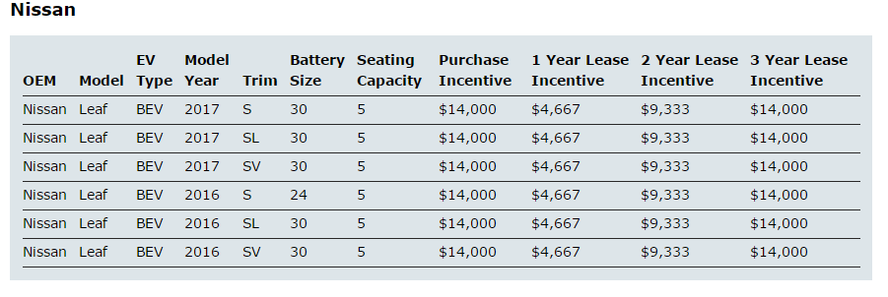

Table 2
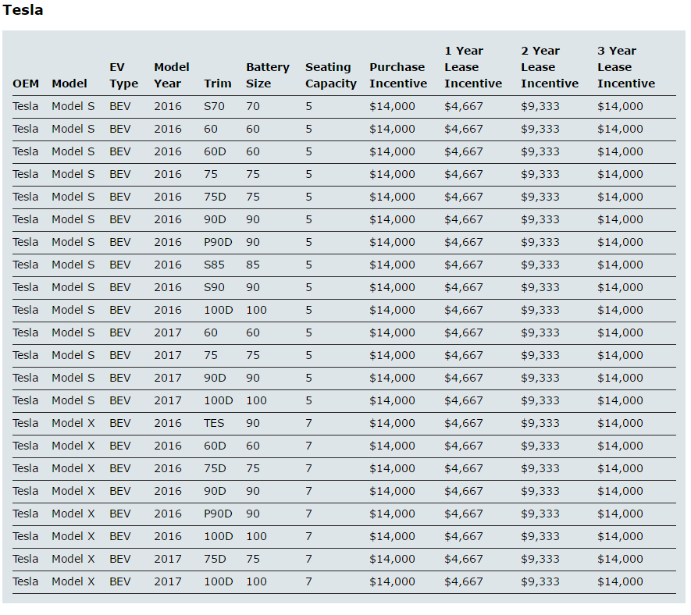

Table 3
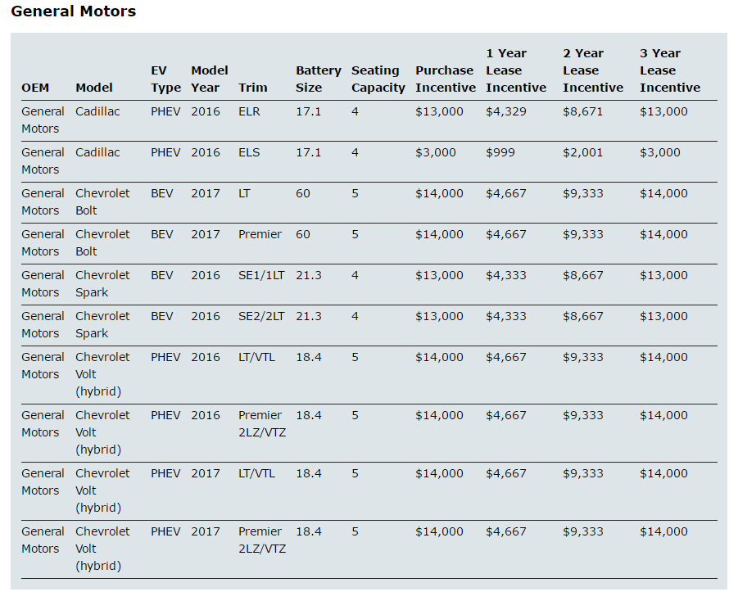

Tables 1-3 were screenshots of tables from the Ontario Ministry of Transportation webpage on Eligible vehicles for the Electric Vehicle Incentive Program and can be found in the link below:
http://www.mto.gov.on.ca/english/vehicles/electric/electric-vehicle-rebate.shtml

References
C. (2012, October 04). Retrieved April 04, 2017, from https://www.youtube.com/watch?v=1kCG-WqpVnI

M. (2014, May 14). Retrieved April 04, 2017, from https://www.youtube.com/watch?v=z87U8qVxNio&t=2s

Fletcher, G. (2015, December 04). Car Review: 2016 Chevrolet Volt. Retrieved April 04, 2017, from http://driving.ca/chevrolet/volt/reviews/road-test/car-review-2016-chevrolet-volt

Rippel, W. (2010, June 30). Induction Versus DC Brushless Motors. Retrieved April 04, 2017, from https://www.tesla.com/en_CA/blog/induction-versus-dc-brushless-motors?redirect=no

Government of Ontario, Ministry of Transportation. (2013, October 25). Eligible Electric Vehicles. Retrieved April 04, 2017, from http://www.mto.gov.on.ca/english/vehicles/electric/electric-vehicle-rebate.shtml

