LECTURE 1 : Chapter 1
The Purpose and Use of Financial Statements
Uses and Users of Accounting
- accounting identifies and records the economic events of an organization and communicates to interested users
- there are two broad categories of user: (1) internal users, (2) external users
- INTERNAL USERS : work for the company, include managers, employees, and others who plan, organize, and run the company QUESTIONS = do we have enough cash for (i.e. expansion, investment, payment etc.), what products are making us the most amount of money?, what products are making us the least amount of money?
- EXTERNAL USERS : (don’t make decisions for the company) : do not work for the company, include investors, lenders, and other creditors, customers, employees, labour unions, taxing authorities and regulators QUESTIONS = should we invest?, should we lend money to this company?

Ethical Behaviour
- for accounting information to have value, preparers must have high ethical standards
      - actions are legal and responsible
      - consider organization’s interests
Why is ethics as important to accountants as it is to the decision makers who rely on financial information?
      - accountants, other professionals, and most companies have rules or codes of conduct to guide ethical behaviour
      - companies have codes of conduct
Forms of Business Ownership
PROPRIETORSHIP :
- owned by one person (proprietor)
- simple to set up … requires little seed capital
- owner has control over business
- limited life
- unlimited liability
- income tax paid by owner
PARTNERSHIP :
- similar to proprietorship except owned by more than one person
- formalized in a written agreement (EX. dissolution)
- limited life
- each partner has unlimited liability … both liable for the same thing (joint/several liability)
- income tax paid by individual partners
CORPORATIONS :
- separate legal entity owned by shareholders (owners of shares) … compares to its own “person”
- indefinite life; ease of raising capital
- shareholders enjoy limited liability
- corporation pays income tax … they are taxed twice
- bigger businesses get favourable tax credits / taxation rates … government favours big businesses because bigger businesses provide jobs to many and incomes that they can then tax
- may be public or private … PUBLIC if shares are publicly traded, PRIVATE if shares are not available to the general public
Generally Accepted Accounting Principles (GAAP)
- rules and practices for the preparation of financial statements
- different for publicly-traded and private corporations
      - publicly-traded corporations use International Financial Reporting Standards (IFRS)
      - private corporations may use IFRS or Accounting Standards for Private Enterprises (ASPE)
- proprietorships and partnerships generally follow ASPE for external reporting
      - not required to follow any particular standards for internal use
Types of Business Activities
- the three types of business activities that companies are involved in include : financing, investing and operating
FINANCING ACTIVITIES
- obtaining (and repaying) funds to finance the operations of the business
- borrowing money or repaying loans (debt)
- selling or repurchasing shares (equity)
- forms of debt : bank indebtedness, bank loans, concurrent debt such as mortgages/bonds/leases
INVESTING ACTIVITIES
- purchase or sale of long-lived assets needed to operate the company
- EX. purchase or sale of investments not held for trading, purchase or sale of long-lived assets such as property, plant and equipment and intangible assets
OPERATING ACTIVITIES
- operating activities are the main day-to-day activities of the business
- examples = revenues, expenses, related accounts such as accounts receivable and accounts payable
Financial Statements
- INCOME STATEMENT = reports revenues and expenses for a specific period of time … revenues - expenses = net income
- STATEMENT OF CHANGES IN EQUITY = reports the changes in each component of shareholders’ equity during a period of time
- STATEMENT OF FINANCIAL POSITION (BALANCE SHEET) = show the assets, liabilities and shareholders’ equity at a specific point in time ‘snapshot’… determines a company’s net worth
- STATEMENT OF CASH FLOWS = shows, for a specific period of time, how companies obtained cash and how that cash was used
The order of preparation of statements is …
- income statement (2) statement of changes in equity (3) statement of financial position (4) statement of cashflows
1. Income Statement
- REVENUES … arise from sales of a product or service, result in an inflow of assets
- EXPENSES … costs of assets consumed or services used to generate revenues
- profit = revenues - expenses
2. Statement of Changes in Equity
- shows the changes in each component of shareholders’ equity for the period
- share capital : amounts contributed by shareholders, may include common and preferred classes
- retained earnings / deficit (more expenses than revenues) : cumulative profit retained in the company, less dividends paid to shareholders
- other shareholders’ accounts
- changes in shares … common shares at beginning of period + common shares issued (sold) - common shares repurchased = common shares, end of period
- changes in retained earnings … revenues - expenses = retained earnings, beginning of period + profit (or - loss) - dividends = retained earnings, end of period
3. Statement of Financial Position
- ASSETS = resources owned by a business
- LIABILITIES = claims of lenders and other creditors
- SHAREHOLDERS EQUITY = claims of shareholders
- ACCOUNTING EQUATION … assets = liabilities + shareholders’ equity
4. Statement of Cash Flows
- the purpose of this statement is to report the effect on cash of the company’s … operating activities, investing activities and financing activities
- shows net increase or decrease in cash for the period
Relationships Between Statements
- statements are interrelated : results from some statements are used as data in other statements
- EXAMPLES … profit from income statement is reported in statement of changes in equity, ending balances of each shareholders’ equity account is reported in both statements of financial position and changes in equity, statement of cash flows is related to statement of financial position
- 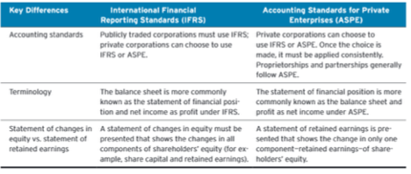
LECTURE 2 : Chapter 2
Further Look At Financial Statements

Classified Statement of Financial Position
- a classified statement of financial position generally contains the following standard classifications …

ASSETS
- current assets
- investments
- property, plant & equipment
- intangible assets
- goodwill

Current Assets
- assets expected to be converted to cash or used in the business within one year or one operating cycle, whichever is longer
      - operating cycle is the average time it takes to go from cash to cash in producing revenue
- usually listed in order of liquidity : reverse order also possible
- examples include cash, short term (trading) investments, accounts receivable. merchandise inventory and prepaid expenses

Non-Current Assets
- assets NOT expected to be converted into cash or used in the business within one year or one operating cycle
- all assets are not considered current
- examples include investments, property/plant and equipment, intangible assets and goodwill, other assets

Long-Term Investments
- multi-year investments in debt securities (loans, notes, bonds, mortgages) and equity securities (shares of other companies)
- these assets are normally not intended to be sold and converted to cash within one year

Property, Plant and Equipment
- tangible assets with relatively long useful lives
- used in operating the business
- examples include : land, buildings, equipment and furniture
- usually listed in order of permanency

Depreciation
- allocation of the cost of property, plant and equipment over their estimated useful lives
- companies systematically assign a portion of the cost of an asset to expense each year
- under IFRS, this allocation is referred to as depreciation for property, plant, and equipment, and amortization for intangible assets
- under ASPE, amortization is often used instead of depreciation
- the cost of long-lived assets with indefinite lives is not depreciated (e.g. land)
- accumulated depreciation account shows the total amount of depreciation taken to date
- the difference between the cost of the asset and its accumulated depreciation is referred to as the carrying amount of the asset

Intangible Assets
- non-current assets that do not have physical substance and represent a privilege or a right held by the company
- Examples: patents, copyrights, trademarks, licenses, goodwill: excess price paid on acquisition of another company
- generate a future value to the company
- amortized if they do not have an indefinite life

Current Liabilities
- obligations that are to be paid within the (longer of the) coming year or one operating cycle
- Examples: bank indebtedness, accounts payable, unearned revenue, bank loan/notes payable, current maturities of long-term debt

Non-Current Liabilities
- debts expected to be paid or settled after one year
- examples : bank loan / notes payable, lease obligations, pension and benefit obligations, deferred income tax liabilities
- usually accompanied by extensive notes to the financial statements

Shareholder’s Equity
- Share Capital: investment of cash (or other assets) in the company by shareholders in exchange for preferred or common shares
- Retained Earnings: cumulative profits kept for use in the company

Using the Financial Statements
- specific tools can be used to analyze the financial statements
- ratio analysis expresses the relationships between selected financial statement data
- use comparisons to aid in analyses:
Intracompany comparisons cover two or more years for the same company
Intercompany comparisons between the company and a competitor
Industry average comparison based on averages for particular industries

Liquidity Ratios
- measure a company’s short-term ability of to pay its maturing obligations and to meet its unexpected needs for cash
working capital = current assets - current liabilities

current ratio = current assets / current liabilities
*higher is generally better*

Solvency Ratios
- measure a company’s ability to survive over a long period of time:
*The higher the percentage of debt to total assets, the greater the risk that debts cannot be repaid when they are due*

debt to total assets = total liabilities / total assets
*lower is generally better*

Profitability Ratios
- measure a company’s operating success for a given period of time

earnings per share = profit available to common shareholders /
weighted average number of common shares

price earnings ratio = market price per share / earnings per share
*higher is generally better*

Conceptual Framework of Accounting
- guides decisions about:
    - what to present in financial statements
    - alternative ways of reporting economic events
    - appropriate ways of communicating this information

Conceptual Framework for Financial Reporting
- five main sections:
    - objective of financial reporting
    - qualitative characteristics of useful financial information
    - underlying assumptions
    - elements of financial statements
    - measurement of the elements of financial statements

Objective of Financial Reporting
- to provide financial information that is useful to existing and potential investors, lenders and other creditors
- who are making decisions about providing resources to a company:
    - Buying, selling, holding equity and debt
    - Providing or settling loans or other credit
- financial information is provided by general purpose financial statements

Qualitative Characteristics of Accounting Information
1. Relevance:
- information has relevance if it makes a difference in users’ decisions
- may have predictive value and/or confirmatory value
- materiality is important: will information influence the decisions of users?
2. Faithful representation:
- information should reflect economic reality
- it must be complete, verifiable and free from material error

Enhancing Qualities of Useful Information
- Comparability: users can identify and understand similarities and differences among items
- Verifiability: independent consensus that information is faithfully represented
- Timeliness: available before it loses its usefulness in decision-making
- Understandability: classified, characterized and presented clearly and concisely

Going Concern Assumption
- The business will continue operating in the foreseeable future
- The key assumption – provides a foundation for accounting
- Provides justification for using cost as the value of certain assets

Elements of Financial Statements
Assets, Liabilities, Equity, Revenues and Expenses

Measurement of the Elements
- accountants have developed principles that describe when and how the elements of financial statements should be:
                - Recognized
                - Measured
                - Reported
                - 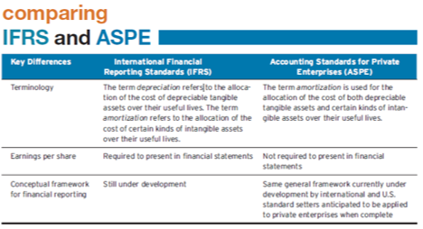
- known as generally accepted accounting principles

Generally Accepted Accounting Principles
1. Historical Cost:
- assets and liabilities should be recorded at their cost when acquired
- not only at time of purchase, but throughout the life of each asset and liability
2. Fair Value:
- certain assets and liabilities should be recorded and reported at fair value
In choosin g between these two, apply the concepts of relevance and representational faithfulness

LECTURE 3 : Chapter 3
Accounting Transactions
- What is an accounting information system? Describe some of the factors that may impact the design of a company’s information system.
- accounting information system:
    - The system of collecting and processing transaction data and communicating financial information
- can vary widely based on factors such as:
- 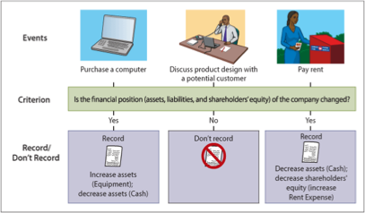
    - type of business and its transactions
    - size of company
    - amount of data
    - information requirements
- transactions are economic events that must be recorded in the financial statements

2. Why are some events recorded as accounting transactions but others are not?
- not all events are recorded and reported as accounting transactions:
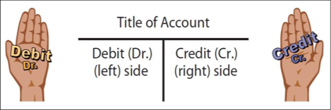
    - only those that change assets, liabilitie s, or shareholders’ equity

Analyzing Transactions
- transaction analysis determines impact on the accounting equation
Assets = Liabilities + Shareholders’ Equity
- the accounting equation must always balance
- therefore, each transaction has a dual (double-sided) effect on the equation

The T Account
Account
- an individual accounting record of increases and decreases in a specific asset, liability, or shareholders’ equity item
- three parts: (1) the title of the account (2) a left or debit side (3) a right or credit side

Debits and Credits
- Describe where entries are made in the accounts:
1. Debiting: entering an amount on the left side
2. Crediting: entering an amount on the right side
- If debit amounts exceed credit amounts, account has a debit balance
- If credit amounts exceed debit amounts, account has a credit balance

The T Account - Debit Balance
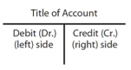
-Total the entries to each side. If the greater sum is on the left, the account has a debit balance

The T Account - Credit Balance

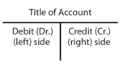

-Total the entries to each side. If the greater sum is on the right, the account has a credit balance

Normal Balances
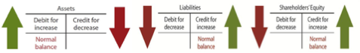
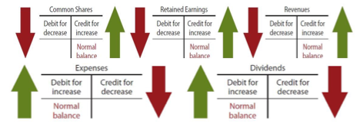
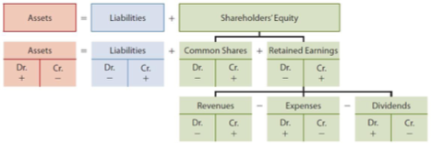

Expanded Accounting Equation
Accounting Cycle
Steps in the Recording Process
STEP 1 : Analyze each transaction to determine its eff ect on accounts (if any). Evidence comes from a source document
STEP 2 : Record transaction as a journal entry in the general journal
STEP 3: Transfer information to appropriate accounts in the general ledger
STEP 4: Prepare a trial balance
General Journal (STEP 2)
- accounting record where the transactions are recorded in chronological order
- general journal is most common
11. What is a general journal? How does the journal facilitate the recording process?
- other journals can include: cash receipts, cash disbursements, sales, purchases
- entering transaction data is known as journalizing
General Journal (STEP 3)
- entire group of accounts maintained by a company : list of accounts is called a chart of accounts
- contains all the asset, liability, and shareholders’ equity accounts
- posting is the process of transferring information from the general journal to the general ledger accounts
Trial Balance (STEP 4)
- list of all the accounts and their balances at a specific time
- serves to prove the mathematical equality of debits and credits after posting (sum of debits = sum of credits)
- aids in the preparation of financial statements
- subject to limitations (does not prove that the general ledger is correct)

LECTURE 4 : Chapter 4
Timing Issues
- companies need immediate feedback on how well they are doing
- accounting divides the economic life of a business into artificial time periods
          - month, quarter (three months), year
          - one-year period is known as the fiscal year
          - shorter periods are known as interim periods
          - many transactions affect more than one time period
Revenue Recognition
- revenue is earned (recognized) when …
          - sales or performance effort is substantially complete
          - amount is determinable (measurable)
          - collection is reasonably assured
- in merchandising companies when merchandise is sold (point of sale)
- in a service company when the service is performed
Expense Recognition
- expenses are recognized when …
      - due to ordinary activity, a decrease in economic benefit occurs (a decrease in an asset or an increase in a liability)
      - can be measured reliably
- tied to changes in assets and liabilities
- often (but not always) coincides with revenue recognition … known as matching
Accrual Basis Accounting
- transactions affecting a company’s financial statements are recorded in the period the events occur, rather than when cash is received or paid … DO NOT NEED TO RECEIVE CASH
      - revenue is recorded when earned, rather than when cash is received
      - expenses are recorded when goods or services are consumed or used, rather than when cash is paid
Cash Basis Accounting
- revenue is recorded only when cash is received
- expenses are recorded only when cash is paid
- can lead to misleading information for decision-making …
      - revenue and expenses can be manipulated by timing the receipt and payment of cash
      - can increase or decrease profit
Adjusting Entries
- entries made to adjust or update accounts at the end of the accounting period
- required because the trial balance may not contain complete and up-to-date data
      - some items are not recorded daily
      - some costs are not recorded during the accounting period, as they expire due to the passage of time
      - some items may be unrecorded
Types of Adjusting Entries
- prepayments
    - prepaid expenses (supplies, depreciation, insurance)
    - unearned revenues
- accruals accrued revenues
      - accrued expenses
Prepaid Expenses
- expenses paid in cash and recorded as assets before they are used
      - when the cost is incurred, an asset (prepaid) is increased (debited) to show the future service or benefit, and cash is decreased
- expire with the passage of time or through use
      - not practical to record this expiration on a daily basis, so done when statements are prepared
- adjusting entry increases an expense account and decreases the asset (prepaid) account
- 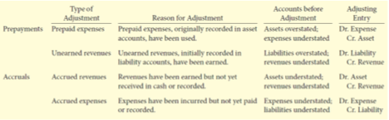
Unearned Revenue
- cash received and recorded as liabilities before revenue is earned
      - when the cash is received, cash is increased (debited), and a liability account (unearned revenue) is increased (credited)
- the opposite of prepaid expenses
- adjusting entry decreases the liability (unearned revenue) account and increases a revenue account
      - reflects amount of revenue earned in the period and the remaining liability at the end of the period
Accruals
- accruals have not been recognized at all until an adjustment is made
- revenues that have been earned, but not received in cash (accrued revenues)
      - adjusting entry results in an increase to both an asset and a revenue account
- expenses that have been incurred, but not yet paid or recorded (accrued expenses)
      - adjusting entry results in an increase to both an expense and a liability account
      - 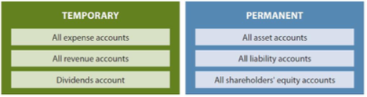
Adjusted Trial Balance
- prepared after all adjusting entries have been journalized and posted
- shows the balances of all accounts at the end of the accounting period
      - including those accounts that have been adjusted
- proves total debit balances and total credit balances are equal after the adjusting entries have been made
- the main source for preparation of financial statements

Closing the Books
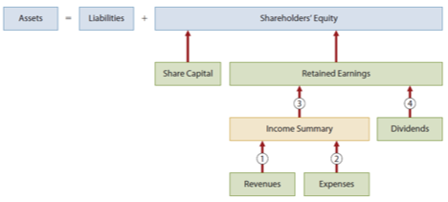
- revenue and expense accounts are subdivisions of retained earnings
            - considered to be temporary accounts
- statement of financial position accounts carry forward into the future
            - considered to be pe rmanent accounts
- closing entries … (A) temporary account balances are transferred to Retained Earnings (B) produce a zero balance in the temporary accounts to prepare them for the next period’s activity
Temporary and Permanent Accounts
The Closing Process
1. close revenue accounts: debit each revenue account for its balance and credit Income Summary
2. close expense accounts: debit Income Summary and credit each expense account for its balance
3. close Income Summary: debit (or credit) Income Summary for the balance in the account and credit (debit) Retained Earnings
4. close Dividends account: debit Retained Earnings and credit Dividends account for the balance

Post-Closing Trial Balance
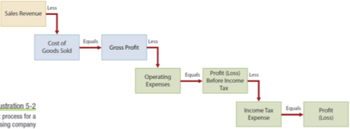
- lists all permanent accounts and their balances after all closing entries are journalized and posted
- proves that total debit balances and total credit balances are equal after the closing entries have been made
LECTURE 5 : Chapter 5
Merchandising Operations
Differences Between Service and Merchandising Companies
- service companies perform services as their primary source of revenue
- merchandising companies buy and sell inventory (e.g. Loblaws):
    - retailers sell to consumers
    - wholesalers sell to retailers
    - manufacturers produce goods for sale

Operating Cycle
- the time it takes to go from cash to cash in producing revenues
- longer for a merchandising company that for a service company:
- merchandise must first be purchased before it can be sold
- adds an additional step to the cycle

Income Measurement Process
- Revenue -
- sales revenue (from the sale of merchandise): the ma in source
- Expenses are divided into two categories -
      - (1) cost of goods sold: total cost of merchandise sold in a period
      - (2) operating expenses: incurred in the process of earning sales revenue
- Gross profit -
= sales revenue less cost of goods sold

Income Measurement Process for Merchandiser
Inventory Systems

- flow of costs for a merchandising company:
  - beginning inventory + purchases = cost of goods available for sale
  - once sold, these costs are assigned to cost of goods sold
  - goods left over are ending inventory
- one of two systems is used to account for inventory and cost of goods sold:
  - perpetual inventory system
  - periodic inventory system
- 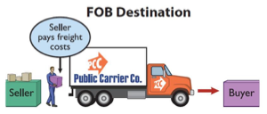

Perpetual System
- detailed records are kept for the cost of each product purchased and sold
- these records are updated continuously (perpetually) for purchases and sales
- a physical count is done at least once a year to adjust perpetual records to actual
- this system enables the effective control of inventory which is an important asset
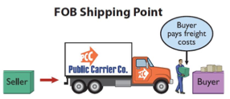

Periodic System
- detailed records of merchandise are not kept throughout the period
- cost of goods sold is only determined at the end of the accounting period:
    - once inventory is counted …
    - cost of goods sold = beginning inventory + cost of purchases less ending inventory

Purchases of Merchandise
- purchases are recorded in the Merchandise Inventory account
- includes all costs to get merchandise to place of business and ready for resale:
    - includes freigh t and applicable taxes
    - less purchase returns, allowances, discounts
    - credit purchases are supported by a purchase invoice
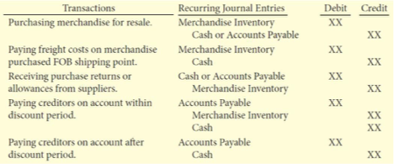

Sales Taxes and Freight
- GST and HST paid does not form part of cost of goods (refunded)
- generally no PST on goods purchased for resale
- FOB (Free on Board) – refers to where title or ownership of goods transfers:
    - FOB destination: buyer’s place of business
    - 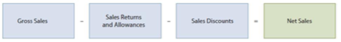
    - FOB shipping point: seller’s place of business
- freight paid by buyer (FOB shipping point) is part of the cost of merchandise purchased

FOB Destination
- ownership of the goods does not pass from the seller to the buyer until the goods are received by the buyer (i.e. destination point) 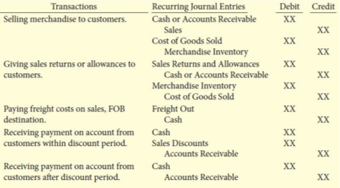
FOB Shipping Point
- ownership of the goods passes from the seller to the buyer as soon as the goods are shipped
Purchase Returns and Allowances
- a purchaser returns the goods to the seller and receives a cash refund or credit
- the buyer may choose to keep the merchandise if the seller is willing to give an allowance (deduction) from the purchase price
- in both cases, the result is a decrease to the cost of goods purchased

Discounts
- a quantity discount gives a price reduction according to the volume of the purchase:
      - not recorded separately – discounted price is recorded as cost of purchase
- a purchase discount is offered to encourage early payment of a balance d ue. Example: 2/10, n/30:
      - recorded separately when payment made. Results in a decrease to Merchandise Inventory account

Summary of Purchase Transactions
Sales of Merchandise
- recording of sales: two entries required: (1) to record sales price and (2) to record cost of sale
- sales taxes are not recorded as revenue
- when freight is FOB destination, seller records cost of freight as an expense
- sales returns and allowances are a contra revenue account to Sales
- sales discounts are also a contra revenue account to Sales

Summary of Sales Transactions

Recording Inventory Sales
Income Statement Presentation
- two different forms of income statement:
1. Single-Step
          - all data classified into two categories: revenues and expenses
2. M
          - 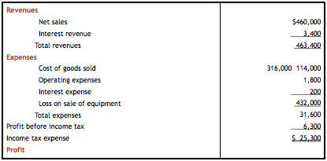ultiple-Stepshows several steps in determining profit or loss
            - Net sales
            - Gross profit
            - Profit from operations
            - Non operating revenues and expenses
            - Profit

Single-Step Income Statement Multiple-Step Income Statement
Evaluating Profitability : Gross Profit Margin
- measures the gross profit expressed as a percentage of net sales
gross profit margin = gross profit / net sales
- higher is generally better

Evaluating Profitability : Profit Margin

- 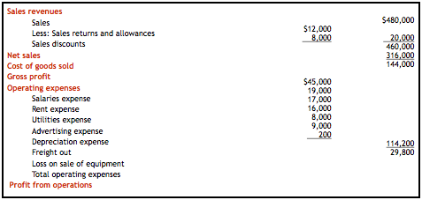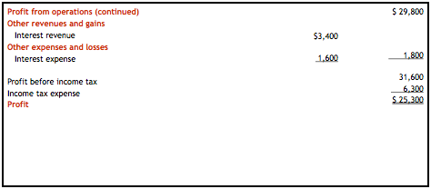 measures the percentage of each dollar of sales that results in profit
profit margin = profit / net sales
- higher is generally better

Calculating the Cost of Goods Sold
- three steps are required:
- Calculate cost of goods purchased
- Determine ending inventory
- Calculate the cost of goods sold

LECTURE 6 : Chapter 6
The Purpose and Use of Financial Statements
Determining Inventory Quantities
- whether companies use a periodic or perpetual system, physical inventory must still be counted at the end of the period:
      - To check the accuracy of the perpetual inventory records
      - To determine the amount of inventory lost to shrinkage or theft
      - 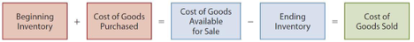

Taking Inventory
- to ensure inventory is properly counted, companies must have a good system of internal control:
      - employees who perform the count should not have responsibility for custody or record-keeping
      - counter establishes validity of item:
        - item exists
        - quantity of each item
        - condition of each item
      - second count by another employee or auditor

Determining Ownership
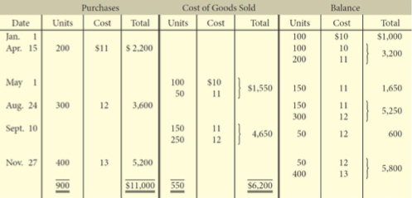
- need to consider ownership of goods when taking inventory
- goods in transit at the end of the period make the determination of ownership more complicated:
      - determine who has legal title to goods in transit
      - include in inventory if company has legal title
- apply freight/shipping concepts from chapter 5
      - FOB shipping point versus FOB destination
- ownership of consigned goods remains with the owner (the consignor), not the holder of the goods (the consignee)
- goods taken home “on approval” by a customer are still owned by the company

Inventory Cost Determination Methods
- once inventory quantities are counted, must apply unit costs to determine total cost of inventory
- units of the same inventory can be purchased at different prices
- which costs should be used?

Specific Identification
- tracks physical flow of goods
- used in perpetual system only
- can only be used where
        - actual costs of each item can be determined
        - goods are easily distinguishable (not easily interchangeable)
        - for goods produced and segregated for specific projects

Cost Methods
- cost methods assume a flow of costs that may not be the same as the actual flow of goods
- FIFO (First-in, first-out)
      - cost of first item purchased is cost of first item sold
- average
      - cost is determined using a moving (weighted) average of the cost of the items purchased

First-in, First-out (FIFO)
- merchandise inventory is recorded at most recent (current) cost in the current assets section o f statement of financial position
- cost of goods sold is recorded as an expense at oldest inventory cost on income statement
- ending inventory and cost of goods sold under FIFO are the same for periodic and perpetual inventory systems

Perpetual System Inventory Costing - FIFO
Average Cost
- used when physical flow of inventory cannot specifically be measured
- under a perpetual inventory system, a new weighted (called moving) average is calculated after each purchase
      - used to record cost of goods sold and ending inventory

Perpetual System Inventory Costing - Average

Choice of Cost Determination Method
- Q8 choose a method that best
        - represents physical flow of goods
        - reports ending inven tory at recent cost
- use the same method for inventories of similar nature and usage

Advantages of Cost Determination Methods

Summary of Financial Statement Effects
Inventory Errors
- errors can occur in accounting for inventory
            - incorrect counting or costing
            - transfer of title not recognized
- errors affect both
            - statement of financial position : through merchandise inventory

Effects of Inventory Errors on Income Statement
Summary of Effects of Errors
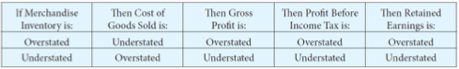
- an error in ending inventory of the current period will have a reverse effect on profit in the next accounting period
- an error in ending inventory affects retained earnings of the same period
        - but not the next period, as the error reverses

Valuing Inventory at the Lower of Cost and Net Realizable Value
- when the net realizable (fair) value is less than cost, the value is written down
- the lower of cost and net realizable value (LCNRV) rule
- net realizable value is selling price less any costs to make ready for sale

LCNRV Rule - Application
- apply rule to individual inventory items
- reduce inventory by crediting it for the amount of write-down, debit is to cost of goods sold
- reverse write-down if value subsequently recovers
        - when conditions that caused the write-down have changed

Reporting Inventory
- in the statement of financial position
          - at the lower cost and NRV
- in the notes to the statements
          - total amount of inventory
          - cost of goods sold
          - cost determination method
          - amount of write-downs or reversals
- no significant differences between IFRS and ASPE

Inventory Turnover
- how much inventory should a company have?
- two ratios to help manage :

            - inventory turnover ratio – measures the number of times inventory is sold in a period
            - days in inventory ratio – converts inventory turnover ratio into number of days inventory is held

Inventory Ratios
- in general, the higher the inventory turnover and the lower the days in invento
 ry ratios, the better
Appendix 6A - Periodic Inventory Systems
- both inventory cost formulas (FIFO and average) can also be used in periodic systems
- allocation is made at the end of the period

Appendix 6A - Periodic System Under FIFO

Appendix 6A - Periodic System Under Average
LECTURE 7 : Chapter 8
Tools for Business Decision-Making
Types of Receivables
- amounts due to a business from its customers or other entities expected to be collected in cash
- 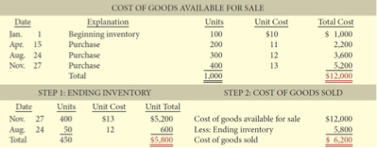
- frequently classified as …
      - (regular) amounts receivable - amounts owed by customers due to the sale of goods and services
      - 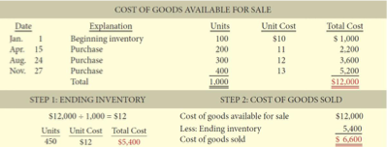
      - notes receivable - a more formal mechanism / credit instrument (written promise to pay)
      - others receivables - interest receivable, loans and advances to employees, recoverable sales tax, income tax receivable

Why would you sell an account receivable ?
- liquidate … want cash now (improve cash flow)
- not sure if customer will pay

ACCOUNTS RECIEVABLE
- a receivable is recorded when service is provided on account or at point of sale of merchandise on account (believed that revenue is earned)
- a receivable is reduced when cash is collected, a sales discount is taken, or the merchandise is returned by the customer

NONBANK CREDIT CARD RECIEVABLES
- bank credit card and debit card transactions recorded as Cash
- nonbank (company) credit cards recorded as Accounts Receivable
      - collections usually outsourced and sent to a credit card company for reimbursement

Accounts Receivable Subsidiary Ledger
- subsidiary ledger is a group of accounts that share a common characteristic (i.e. they are all receivable accounts)
- the subsidiary ledger for accounts receivable provides the details that support the total balance for accounts receivable in the general ledger
- the single accounts receivable account in the general ledger is the control account

Interest Revenue
- if a customer does not pay in full within a specified period of time (usually 30 days), an interest (financing) charge may be added to the balance due
        - seller recognizes interest revenue and increases the account receivable balance owed by the customer

Recording Estimated Uncollectible Accounts
- some accounts receivable become uncollectible
- we need to match unpaid funds that become an expense because of the accrual method
- losses from these uncollectible accounts are debited to an account called Bad Debts Expense
- bad debts expense is recognized in the same period that the related sales revenue is generated

Allowance Method
- this method estimates the uncollectible accounts at the end of each period
- the amount estimated is shown in the Allowance for Doubtful Accounts
        - a contra asset account that is shown below Accounts Receivable
        - note that the allowance is an estimate – it does not show specific customer accounts

Estimating the Allowance
- most companies use the percentage of receivables basis to determine the allowance
        - estimate what percentage of receivables are likely to be uncollectible
        - apply this percentage to total receivables, or
        - apply this percentage to receivables classified according to the length of time they have been out standing (called aging the accounts receivable)
- once the appropriate estimate for uncollectible accounts is determined, an adjusting entry can be recorded
- the amount of the adjusting entry is the difference between the required balance and the existing balance in the allowance account

Recording and Reporting Estimated Uncollectible Accounts
The balance in the Allowance for Doubtful Accounts is deducted from Accounts Receivable in the current assets section of the statement of financial position:
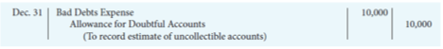
Recording the Write-Off of an Uncollectible Account
The vice president of finance authorizes a write-off of $2,500 owed by T. Ebbet:
Recording the Recovery of an Uncollectible Account
Summary of the Allowance Method
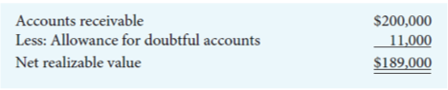
1. Recording estimated uncollectible accounts
- any increase to the allowance is recorded as bad debts expense
2. Recording the write-off of an uncollectible account
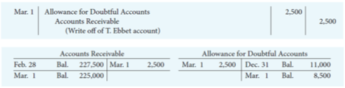
- actual accounts are written off when they are determined to be uncollectible
- this write-off reduces the allowance
3. Recording the recovery of an uncollectible account
if a written-off account is later collected, the write-off is reversed and the collection recorded

Notes Receivable
- stronger legal claim to assets than accounts receivable; written promise (promissory note) to repay
- a credit instrument that normally
      - requires the payment of interest
      - extends for time periods greater than 30 days
- often accepted from
      - customers who need to extend payment of an account receivable
      - high-risk customers

Formula for Calculating Interest
- the basic formula for calculating interest on an interest-bearing note is

FACE VALUE OF NOTE X ANNUAL INTEREST RATE X TIME IN TERMS OF ONE YEAR = INTEREST

- the interest rate specified on the note is an annual rate of interest

Derecognizing Notes Receivable
HONOURED
- paid in full at maturity date
- collection recorded
DISHONOURED
- not paid at maturity date; note no longer negotiable
- balance transferred to Accounts Receivable if eventual collection expected
- balance transferred to Allowance for Doubtful Notes if eventual collection not expected

Statement Presentation
1. Statement of Financial Position
- receivables reported in the current assets section
- following cash and short-term investments
- only required to disclose net realizable value, but helpful to disclose gross receivables and the allowance for doubtful accounts
2. Income Statement
- bad debts expense is reported as an operating expense
- interest revenue is non-operating

Managing Receivables
- determine to whom to extend credit
- establish a payment period
- monitor collections
      - prepare and update an accounts receivable aging schedule
- evaluate the liquidity of receivables

Evaluating the Liquidity of Receivables
- liquidity is measured by how quickly certain assets can be converted into cash
      - receivables turnover
      - average collection period

Receivables Turnover
- is a measure of the liquidity of receivables
receivables turnover = net credit sales (sales on account) / average gross receivables
- HIGHER is better

Average Collection Period
- is the average amount of time that a receivable is outstanding
average collection period = 365 days / receivables turnover
- LOWER is better

LECTURE 8 : Chapter 9
Long Lived Assets
Property, Plant and Equipment
- long-lived resources that
      - are controlled by the company
      - have physical substance
      - are used in the operation of a business
      - are not intended for sale to customers
- provide benefits over many years

Determining the Cost of Property, Plant and Equipment
- recorded at cost, which includes
      - purchase price, including non-refundable taxes and duties, less discounts or rebates
      - expenditures necessary to bring asset to its intended location and make it ready for its intended use
      - estimated cost of future obligations to dismantle, remove or restore the asset at the end of its useful life

Types of Expenditures
- operating expenditures
- benefit ONLY the current period
- immediately charged as an expense
- capital expenditures
- capitalized as an asset
- benefits future periods
- increases a company’s investment in productive activity

Land
- cost of land includes
        - purchase price
        - closing costs such as title and legal fees
        - additional costs to prepare land for its intended use (less any proceeds from salvage)
- land has an unlimited life, therefore it is not depreciated \

Land Improvements
- the costs of structural additions made to land (such as paving, fencing, and sidewalks)
- these decline in service potential over time
      - they are recorded separately from land
      - depreciated over their useful lives
- not one-time costs of getting the land ready to use

Buildings
- all expenditures related to the purchase or construction of a building
- when a building is purchased such costs include
      - purchase price
      - closing costs (legal fees)
      - costs required to make building ready for its intended use
- when a building is constructed, its cost consists of
      - contract price
      - architect's fees
      - building permits
      - excavation cost
      - interest costs during construction

Equipment
- costs include …
        - purchase price
        - freight charges and insurance during transit paid by the purchaser
        - assembling
        - installing and testing

Depreciation
- systematic allocation of the cost of property, plant and equipment over the asset’s useful life
- a process of cost allocation, not determining an asset’s fair value
- does not use or provide cash to replace the asset

Factors in Calculating Depreciation
1. Cost
- purchase price plus costs required to get the asset ready for use plus estimated asset retirement costs
2. Useful Life
- the period of time that the asset is expected to be availabl e for use, or
- the number of units that the asset is expected to produce
3. Residual Value
- how much you will receive for the item once sold
- estimated amount to be received at the end of the asset’s useful life
- if they don’t give one, assume 0$

Depreciation Methods
1. Straight-Line
- used by the majority of Canadian publicly-traded companies
2. Diminishing-Balance
3. Units-of-Production
- management chooses the method that best reflects the pattern of use of the economic benefits from that asset
- 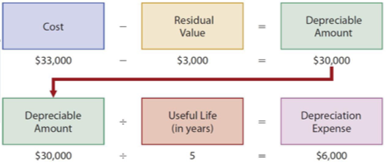

Straight-Line Method
- depreciation is constant for each year of the asset's useful life
Diminishing-Balance Method
- produces a decreasing annual depreciation expense over an asset’s useful life
    - depreciation is calculated based on the asset’s carrying amount, which diminishes each year as accumulated depreciation increases
- annual depreciation expense is calculated by multiplying the carrying amount by the depreciation rate
    - residual value is not included in the calculation ****
- can be applied using different rates
depreciation rate = straight-line rate x multiplier
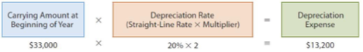

Units of Production Method
- useful life is expressed in terms of total units of production or activity expected from the asset
    - such as units produced or machine-hours worked
- useful for factory machinery, vehicles, airplanes
- 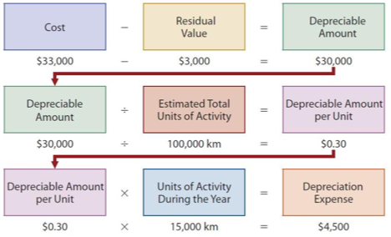

Other Depreciation Issues
IMPAIRMENTS
- impairment loss occurs when carrying amount of asset exceeds its recoverable amount (how much you could sell the asset for in a ‘distressed scenario’)
Revising Periodic Depreciation
- revisions needed if …
        - capital expenditures during useful life
        - impairment losses
        - change in estimated useful life or residual value
        - change in the pattern in which the asset’s economic benefits are consumed
- accounted for as change in estimate
        - change made in current and future years, but not to prior periods (prospectively)

Derecognition of Property, Plant and Equipment
- update depreciation
- depreciation for the fraction of the year to the date of disposal must be recorded
- calculate carrying amount
- carrying amount = cost - accumulated depreciation
- calculate gain or loss
- proceeds - carrying amount = gain/loss
proceeds > carrying amount … = a GAIN (cr.) because it is REVENUE
proceeds < carrying amount … = a LOSS (dr.) because it is an EXPEN
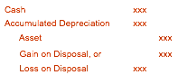SE4. record disposal
- remove cost of asset and accumulated depreciation. Record proceeds (if any) and gain or loss on disposition (if any)
Presentation of Long-Lived Assets
1. Statement of Financial Position
- reported as
        - Property, Plant and Equipment
        - Intangible Assets
        - Goodwill
- disclose cost and accumulated depreciation (amortization) of each major class of assets
        - either in statement or in notes
- disclose depreciation/amortization methods and useful lives or rates
- IFRS also requires additional disclosures
2. Income Statement
- depreciation expense, gains and losses on disposal and impairment losses are included in the operating section
3. Statement of Cash Flows
- cash flows from the purchase and sale of long-lived assets are reported in the investing section
Return on Assets
- measures overall profitability
- average total assets = all of assets at beginning of period + all of assets at end of period / 2
Asset Turnover
- measures how efficiently a company uses its assets
Profit Margin Revisited
- together, profit margin and asset turnover explain the return on assets ratio
LECTURE 9 : Chapter 10
Reporting and Analyzing Liabilities
Liabilities
- obligations resulting from past transactions
- classified as current and non-current
      - liabilities must be settl
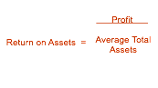 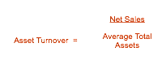 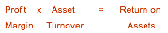ed in the future by transfer of assets or services
Current Liabilities
- expected to be paid:
      - from existing current assets or through the creation of other current liabilities
      - within one year of the date on the statement of financial position
- debts that do not meet both criteria are classified as non-current (or long-term) liabilities
- types of current liabilities include:
      - bank indebtedness from operating lines of credit
      - accounts payable and accrued liabilities
      - unearned revenue
      - notes and loans payable
      - sales taxes
      - property taxes
      - payroll
      - current maturities of non-current debt
      - provisions and contingent liabilities

Operating Line of Credit
- pre-arranged agreement between a company and a lender to allow the company to borrow up to an agreed-upon amount:
      - to help manage temporary cash shortfalls
- interest is charged using a floating (or variable) interest rate
- security (collateral) may be required by bank
- when used, results in bank indebtedness

Sales Taxes
- Federal Goods and Services Tax (GST)
- Provincial Sales Tax (PST or QST)
- Combined into one harmonized sales tax (HST) in some provinces

Sales Tax Payable
- may or may not be included in sale price
- must be remitt ed periodically to respective governments:
      - when paid, debit Sales Tax Payable account and credit Cash

Property Taxes
- businesses that own property pay property taxes for each calendar year to municipal or provincial governments
- property taxes are calculated at a specified rate for every $100 of the assessed value of the property

Property Taxes Payable
- upon receipt of the property tax bill (assume in March), an expense is recorded for the months that have passed (assume in January and February)
- when paid (assume in May), expense is recorded for additional months that have passed, and prepaid is set up for remaining months

- prepaid is cleared to expense at the end of year

Payroll
- three types of liabilities related to employee salaries and wages:
- salary and wages owed to employees (known as gross pay)
- payroll deductions required to be withheld from employees’ gross pay
        - employees’ gross pay less payroll deductions is known as net pay (or take home pay)
    - employer payroll obligations
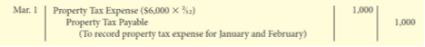
3. employer payroll obligations

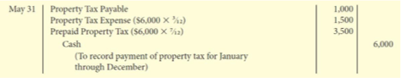

Employee Payroll Deductions
- mandatory payroll deductions:
      - Canada pension plan (CPP) employment insurance (EI)federal and provincial income taxes
- voluntary payroll deductions:
      - benefits such as health and pension
      - union dues
      - charitable contributions
      - 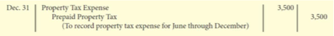

Employer Payroll Obligation s
- employer’s share of CPP and EI
- workers’ compensation
- employee benefits:
      - compensated absences (vacation, statutory holidays)
      - employer-sponsored health plans and pensions

Short-Term Notes Payable
- a promise to pay a specified amount either at a future date or on demand
- often used instead of accounts payable
- provide written documentation, if needed, for legal remedies
- normally has interest attached (at a fixed annual rate)
- issued for varying periods:
      - if due within one year of financial statement date, they are classified as current liabilities

Current Maturities of Non-Current Debt
- the portion of non-current (long-term) debt that is due within the current year or operating cycle should be classified as a current liability

Uncertain Liabilities
- events with uncertain outcomes:
    - who is owed
    - when it is owed, and/or
    - how much is owed
- provisions are uncertain as to timing or amount
- contingent liabilities are possible obligations that are dependent upon some future event:
    - should be recognized if more likely than not (IFRS)
    - should be recognized if likely (ASPE)

Non-Current Liabilities
- obligations to be paid after one year or longer
- also known as financial liabilities (a type of financial instrument):
    - a contractual obligation to pay cash in the future
- includes long-term notes, bonds, and lease obligations
- may be secured or unsecured:
    - secured notes ar e also known as mortgages

Instalment Notes Payable
- normally repayable in a series of periodic payments called instalments
- instalment payments usually take one of two forms:
    - fixed principal payments plus interest (fixed or floating interest)
    - blended principal and interest payments

Instalment Payment Schedule - Fixed Principal Payments
- loan is repayable in equal periodic amounts plus interest
- to illustrate, assume that Belanger Ltée borrows $120,000 for five years at 7%:
    - terms provide for monthly instalment payments of $2,000 ($120,000 ÷ 60 months)
- monthly interest expense is calculated by multiplying the outstanding principal balance by the interest rate
Instalment Payment Schedule - Blended Payments
- loan is repayable in equal periodic amounts including interest
- to illustrate, assume that instead of fixed principal payments, Belanger Ltée repays its $120,000, 7%, 5-year loan payable in equal monthly installments of $2,376
- monthly interest expense is still calculated by multiplying the outstanding principal balance by the interest rate

Statement Presentation
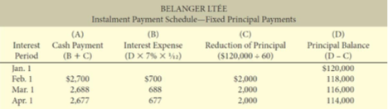
- current liabilities
      - reported as the first category of liabilities
      - can be listed separately on statement of financial position or detailed in the notes
      - normally listed in order of liquidity
- non-current liabilities
- 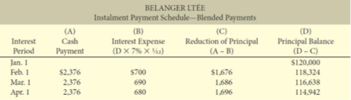

      -  report separately in statement of financial position and detail in notesmeasured and reported at amortized cost

Analysis of Debt Obligations
- liquidity – measure short-term ability to pay maturing obligations and meet cash needs:
      - current ratio
      - inventory turnover ratio
      - receivables turnover ratio
- solvency – measure ability to meet long-term obligations:
      - debt to total assets
      - times interest earned

Debt to Total Assets
- indicates the extent to which a company’s assets are financed by debt

Times Interest Earned
- provides an indication of a company’s ability to meet interest payments as they come due

LECTURE 10 : Chapter 11
Reporting and Analyzing Shareholders’ Equity

The Corporate Form of Organization
- a separate legal entity
      - separate and distinct from its owners
- has most of the rights and privileges of a person
- may be public or private
      - PUBLIC : many shareholders, shares are publicly traded and held
      - PRIVATE : few shareholders, shares are closely held and not traded

Characteristics of a Corporation
- separate legal existe
- ncelimited liability of shareholders
- transferable ownership rights
- ability to acquire capital
- continuous life
- corporation management
- government regulations
- income tax

Advantages and Disadvantages of a Corporation
ADVANTAGES
- separate management and ownership
- separate legal entity
- limited liability of shareholders
- potential for reduced income tax
- ease of transferring ownership rights
- ability to acquire capital
- continuous life

Share Issue Considerations
- to raise capital, the corporation sells ownership rights as shares
- shares can be divided into different classes
        - usually referred to as common shares and preferred shares
- ownership rights are specified in articles of incorporation or in by-laws
        - rights in voting, dividends, liquidation
- authorized shares =
        - maximum amount of shares allowed to sell
        - may be limited or unlimited
        - not recorded; disclosed only
- issued shares =
        - number of shares sold
- legal capital =
        - share capital cannot be distributed to shareholders - unlike retained earnings, which can be distributed as dividends

Issuing Shares
- first issue normally through initial public offering (IPO)
      - share price is set by the company
- once issued, shares of publicly held companies trade on organized exchanges
      - at prices per share established between buyers and sellers (no direct impact on company)
      - fair value of shares – share price - is determined by market forces

Issuing Common Shares
- contributed capital
      - the amount that shareholders have paid to the corporation for their shares
- shares are usually issued for cash
Dr. Cash Cr. Common Shares
- shares can be issued in exchange for services or noncash assets
      - IFRS: Record at cash equivalent price (ideally the fair value of consideration received)

Preferred Shares
- share capital can consist of preferred and common shares
- preferred shares have contractual provisions that give them priority over common shares
- usually do not have voting rights
- accounting for preferred shares similar to common shares

Preferred Share Preferences
- dividend preference
      - cumulative (dividends in arrears)
- liquidation preference
- other preference
      - convertible
      - redeemable / callable (company option)
      - retractable (shareholder option)

Dividends
- a pro rata (equal) distribution of a portion of a corporation’s retained earnings to its shareholders
- cash dividends are most common
        - a distribution of cash to shareholders
- stock dividends may also be issued

Cash Dividends
- for a cash dividend to occur, a corporation must:
    - Meet a two-part solvency test (CBCA), and
    - Effect a formal declaration of dividends by board of directors
- three important dates in connection with dividends:
    - Declaration date
    - Record date
    - Payment date

Declaration Date
- date the Board of Directors authorizes the cash dividend
- commits the corporation to a binding legal obligation
- example: declaration on December 1 of a $0.50 per share cash dividend on 100,000 common shares (100,000 x $0.50 = $50,000)
Record Date
- date ownership of shares is determined for dividend purposes

Payment Date
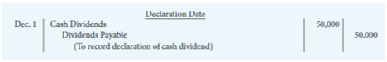
- date dividend cheques are mailed
- example: payment date is January 20
Stock Dividends
- cash dividend: paid in cash
- stock dividend: distributed (paid) in shares
        - fair value (on date of declaration) is assigned to the stock dividend shares
        - same three dates (declaration date, record date, distribution date) as cash dividends
        - 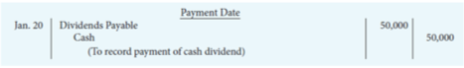
Purposes and Benefits of Stock Dividends
- satisfy shareholders' dividend expectations without spending cash
- increase marketability of the shares
        - increases number of shares and decreases market price per share
- reinvest and restrict a portion of shareholders' equity
        - unavailable for future cash dividends

Stock Dividends - EXAMPLE
- assume 50,000 common shares
        - balance of $500,000 in Common Shares accou
- 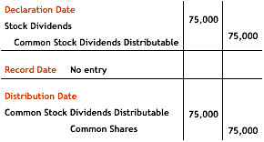 nt and $300,000 in Retained Earningsin a 10% stock dividend, 5,000 common shares (50,000 x 10%) would be issued
- amount debited to Stock Dividends account is $75,000 (5,000 shares x $15*)
- *$15 is the market price of the shares on the date of the stock dividend declaration

Effects of Stock Dividends
- decreases retained earnings
- increases common shares
- total shareholder’s equity remains the same
Stock Splits
- a stock split involves the issue of additional shares to shareholders according to their percentage ownership (like a stock dividend but much larger)
- a stock split has no effect on total share capital, retained earnings, or total shareholders’ equity
- market value of the shares will decrease roughly proportionately to the split
Comparison of Dividends and Stock Splits
Presentation of Shareholders’ Equity
- contributed capital
        - share capital: preferred and common shares
        - additional contributed capital: amounts contributed from acquiring and retiring shares
- retained earnings
        - cumulative profits (losses) since incorporation
        - annual profit is added; losses and dividends declared are deducted
        - a portion may be restricted and therefore unavailable for dividends
- Accumulated Other Comprehensive Income (IFRS)
        - other comprehensive income reported only under IFRS; not required under ASPE
        - other comprehensive income (OCI) includes certain gains and losses that bypass profit (such as revaluation gains and losses of property, plant, and equipment using the revaluation model)
        - accumulated other comprehensive income is the cumulative change in shareholders equity
            - starts with opening balance and is increased (decreased) by other comprehensive income (loss) each period
            - 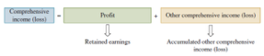

Accumulated Other Comprehensive
- total comprehensive income (loss) includes profit and other comprehensive income (OCI)
Statement of Changes in Equity (IFRS)
- discloses changes in total shareholders’ equity for the period including …
          - contributed capital
          - retained earnings
          - accumulated other comprehensive income
- required under IFRS

Measuring Corporate Performance
- dividend record
          - payout ratio
          - dividend yield
- earnings performance
          - earnings per
          - share return on common shareholders’ equity

Payout Ratio
- measures the percentage of profit distributed in the form of cash dividends to common shareholders

Dividend Yield
- measures the profit generated by each share, based on the market price of the shares
Earnings Per Share
- measures the profit earned by each common share
- profit available to common shareholders
= profit – preferred dividends
- weighted average number of common shares
          - shares issued during the year x the fraction of the year they are outstanding
          - example: April 1 = 3/12 months if calendar year used

Returns on Common Shareholders’ Equity
- measures the company’s profitability from the shareholders’ viewpoint
- common shareholders’ equity
= total shareholders’ equity – legal capital of preferred shares

LECTURE 11 : Chapter 13 20% of FINAL
Cash Flow Statement
- important to know both methods of operating activities

Purpose of the Statement of Cash Flows
- helps users assess :
      - a company’s ability to generate cash
      - what the company did with the cash
- this is useful in determining :
      - company’s ability to generate future cash flows
      - investing and financing transactions during the period, and effect upon capital structure
      - making comparisons with other companies

Definition of Cash Classification of Cash Flows
- cash may include cash equivalents
      - short-term, highly liquid trading investments that are readily converted to cash within a short period of time (usually within three months)
- cash receipts and payments are classified into three categories
      - operating activities
      - investing activities
      - financing activities

Operating Activities
- cash effects of transactions that create revenues and expenses that enter into determination of profit
- includes relevant non-cash current assets and current liabilities on the statement of financial position
        - where the related account is an income statement account
        - anything that contributes to profit it operating
        - EX. research, development
        - think of profits + adjustments + current assets + current liabilities

Investing Activities
- purchasing and disposing of : 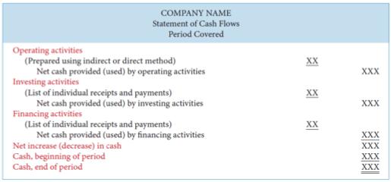
        - long-term investments not held for trading
        - long-lived assets
- lending money and collecting the loans
- generally includes non-current asset items (ex. long-lived investments, property, plant and equipment) on the statement of financial position

Financing Activities
- obtaining cash from issuing debt and repaying the amounts borrowed
- obtaining cash from selling common and preferred shares and paying dividends
- generally includes non-current liabilities, and shareholders’ equity items

Significant Non-Cash Activities
- if it does not affect cash, do NOT report in statement of cash flows
- report in separate note to the financial statements
- examples:
        - issue of debt to purchase assets
        - issue of shares to purchase assets
        - conversion of debt into equity
        - exchange of property, plant, and equipment

Format of Cash Flow Statement
Preparing the Statement of Cash Flows
STEP 1: Prepare operating activities section
STEP 2: Prepare investing activities section
STEP 3: Prepare financing activities section
STEP 4: Complete the statement of cash flows
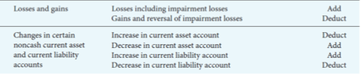
STEP 1 : Operating Activities
- determine the net cash provided (used) by operating activities by converting profit from an accrual basis to a cash basis
- indirect method … PROFIT + DEPRECIATION + LOSSES - GAINS = profit reported on OA section of Statement of Cash Flows
- 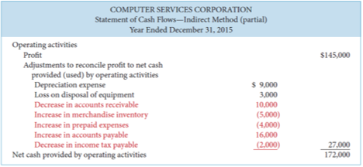
- indirect method … CURRENT ASSETS = if INCREASED from year to year (-) THE INCREASE, if DECREASED from year to year (+) THE INCREASE
- conversion may be done either by the indirect method or the direct method
      - both methods arrive at the same a mount of net cash provided (used) by operating activities
- most companies favour the indirect method for the following reasons
      - easier to prepare
      - reveals less information to competitors

Convert Profit to Net Cash Provided (used) by Operating Activities - INDIRECT METHOD
- start with profit and add or deduct items not affecting cash to arrive at net cash provided (used) by operating activities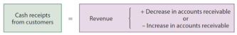
      - (+) non-cash expenses such as depreciation / amortization
      - (—) non-cash revenues and gains
      - (+) non-cash losses and expenses
      - (+) decreases in non-cash current asset accounts and increases in non-cash current liability accounts 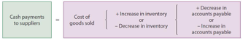
      - (—) increases in non-cash current asset accounts and decreases in non-cash current liability accounts
      - 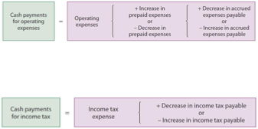

Net Cash Provided (used) by Operating Activities - INDIRECT METHOD
Direct Method
- standard setters prefer the direct method but allow the use of either method
- 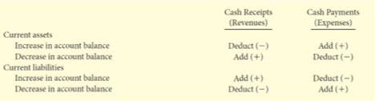
- details cash receipts and payments
- 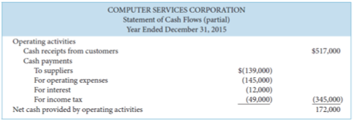
- similar to indirect method :
        - adjusts income statement from accrual basis to cash basis in order to arrive at net cash provided (used) by operating activities
        - however, whereas indirect method adjusts total profit, direct method adjusts each individu al revenue and expense account

Cash Receipts from Customers
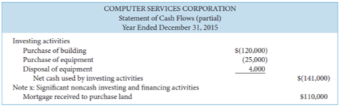
- the relationship among cash receipts from customers, revenues from sales, and changes in accounts receivable is:
- If other cash receipts (such as interest), these must be adjusted for any receivable amounts as was done above

Cash Payments to Suppliers 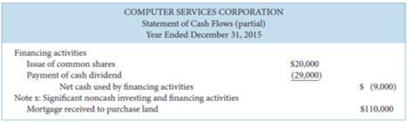
- the relationship among cash payments to suppliers, cost of goods sold, changes in inventory, and changes in accounts payable is:
Cash Payments for Operating Expenses
- the relationship among cash payments for operating expenses, changes in prepaid expenses, and changes in accrued expenses payable is:
Cash Payments for Income Tax
- the relationship among cash payments for income ta x, income tax expense, and changes in income tax payable is: 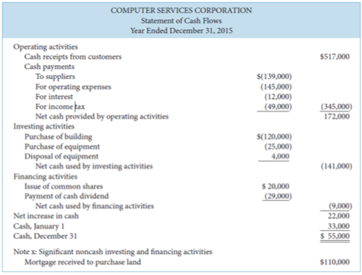
- a similar calculation would be made for cash payments for interest

Summary of Conversion of Net Cash - DIRECT METHOD
Net Cash Provided (used) - DIRECT METHOD
STEP 2 : Investing Activities
- measure cash flows relating to non-current asset accounts; long-term investments; property, plant and equipment; intangible assets
- reported the same under both direct and indirect methods
- asset acquisitions are uses of cash; disposals are sources of cash (for the proceeds of disposition)
        - depreciation expense is a non-cash charge

Net Cash Provided (used)
STEP 3 : Financing Activities Section
- determine the net cash provided (used) by financing activities by analyzing changes in non-current liability and sha reholders’ equity accounts
- changes to notes, loans, and bonds payable are analyzed to determine cause of change
- analyze share capital and retained earnings accounts for changes and their cause
          - profit is reported in the operating activities section

Net Cash Provided (used)
STEP 4 : Complete Statement of Cash Flows
- complete the statement of cash flows
- determine increase (decrease) in cash
- ensure ending cash balance agrees to that reported on statement of financial position
- identify any non-cash disclosures

Statement of Cash Flows
Using Cash Flows to Evaluate a Company
- liquidity
          - cash current debt coverage ratio
- solvency
          - cash total debt coverage ratio
          - free cash flow

Cash Current Debt Coverage Ratio
- measures ability of company to repay obligations coming due within the next year
- if the cash you earned from current operating activities/cur rent assets is able to satisfy your current liabilities
Net cash provided (used) by operating activities / Average current liabilities
*higher is better*

Cash Total Debt Coverage Ratio
- measures ability of company to repay its liabilities from operating activities
Net cash provided (used) by operating activities / Average total liabilities
*higher is better*

Free Cash Flow
- measures discretionary cash flow remaining from operating activities available to use to expand operations, reduce debt, go after new opportunities, or pay additional dividends, among other alternatives
net cash provided (used) by operating activities – net capital expenditures – dividends paid
*higher is better*

LECTURE 12 : Chapter 14
Performance Measurement

Sustainable Income
- the level of profit that is likely to be obtained in the future
- differs from actual profit due to irregular revenues, expenses, gains and losses that are included in profit
- most common irregular item is discontinued operations

Discontinued Operations
- disposal, or availability for sale, of a component of an entity
          - separate major line of business or major geographical area of operations that has been disposed of or is for sale
          - must be clearly distinguishable operationally and financially
          - 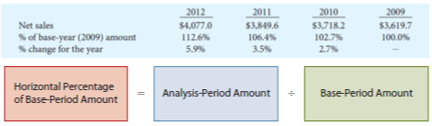
          - 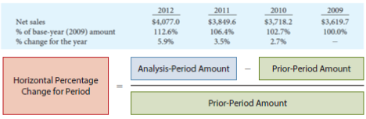
          - 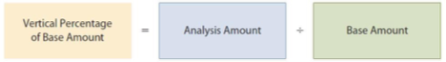

Discontinued Operations : Statement of Financial Position
- assets and liabilities are reported separately
- valued and reported at lower of carrying amount and fair value, less any anticipated costs of selling
          - reported as current or non-current assets or liabilities

Discontinued Operations : Income Statement
- segregated from continuing operations and reported separately on the income statement
          - shown immediately following profit/loss from continuing operations
- consists of two parts
          - profit (loss) from discontinued operations
          - gain (loss) on disposal of the segment
          - both components are reported net of applicable taxes

Comparative Analysis : TWO Tools
- horizontal analysis (trend analysis)
- a technique to determine change over time
- look for the base period
          - percentage of base-period amount
          - percentage change for the period
- vertical analysis (common size analysis)
- important to review non-financial information as well
        - mission, strategy, goals and objectives, management discussion and analysis

Horizontal Percentage of a Base-Period Amount
Horizontal Percentage Change for the Period
Vertical Analysis
- expresses each item in a financial statement as a percent of a base amount (total assets or net sales)
Comparative Analysis
Three types of comparisons …
- intracompany basis = comparisons within a company
- intercompany basis – comparisons between one or more competitor companies
- industry averages

Ratio Analysis
Liquidity Ratios: measure short-term ability of the company to pay its maturing obligations and to meet unexpected needs for cash
Solvency Ratios: Measure the ability of the company to survive over a long period of time
Profitability Ratios: Measure the earnings or operating success of a company for a given period of time

Liquidity Ratios
- working capital = measures short-term debt paying ability (higher is better)
Working Capital = Current Assets – Current Liabilities
- current ratio = measures short-term debt paying ability (higher is normally (but not always) better. Be cautious about influences of slow moving inventory and receivables on this ratio.)
Current Ratio = Current Assets / Current Liabilities
- cash current debt coverage = measures short-term debt-paying ability (higher is better)
Cash Current Debt Coverage = Net Cash Provided (used) by Operating Activities / Average Current Liabilities
- receivables turnover = measures liquidity of receivables (higher is better)
Receivables Turnover = Net Credit Sales / Average Gross Receivables
- average collection period = measures number of days receivables are outstanding (lower is better)
Average Collection Period = 365 days / Receivables Turnover
- inventory turnover = measures liquidity of inventory (higher is better)
Inventory Turnover = Cost of Goods Sold / Average Inventory
- days in inventory = measures number of days inventory is on hand (lower is better)
Days in Inventory = 365 days / Inventory Turnover

Solvency Ratios
- debt to total assets = measures % of total assets provided by creditors (lower is better)
Debt to Total Assets = Total Liabilities / Total Assets
- times interest earned = measures ability to meet interest payments as they come due (higher is better)
Times Interest Earned = (Profit + Interest Expense + Income Tax Expense) / Interest Expense
- cash total debt coverage = measures long-term debt-paying ability from cash provided by operations (higher is better)
Cash Total Debt Coverage = Net Cash Provided (used) by Operating Activities / Average Total Liabilities
- free cash flow = measures cash available for paying dividends or expanding operations (higher is better)
Net Cash Provided (used) by Operating Activities - Net Capital Expenditures - Dividends Paid = Free Cash Flow

Profitability Ratios
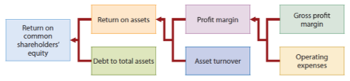
- gross profit margin = measures margin between selling price and cost of goods sold (higher is better)
Gross Profit Margin = Gross Profit / Net Sales
- profit margin = measures the percentage of profit generated by each dollar of sales (higher is better)
Profit Margin = Profit / Net Sales
- asset turnover =measures how efficiently assets are used to generate sales (higher is better)
Asset Turnover = Net Sales / Average Total Assets
- return on assets = measures overall profitability of assets, how much is earned on each dollar invested in assets (higher is better)
Return on Assets = Profit / Average Total Assets
- return on common shareholders’ equity = measures overall profitability of shareholders’ investment (higher is better)
Return on Common Shareholders’ Equity = (Profit - Preferred Dividends) / Average Common Shareholders’
- earnings per share (EPS) = measures profit earned on each common share (not comparable between companies)
Earnings Per Share = (Profit - Preferred Dividends) / Weighted Average Number of Common Shares
- price-earnings (P-E) ratio = measures relationship between market price per share and earnings per share (higher indicates investors expect favourable profitability in future)
Price-Earnings Ratio = Market Price per Share / Earnings per Share
- payout ratio = measures % of profit distributed in the form of cash dividends (higher is better for investors seeking income)
Payout Ratio = Cash Dividends / Profit
- dividend yield = measures rate of return earned from dividends during the year (higher is better for investors seeking income)
Dividend Yield = Dividend per Share / Market Price per Share

Relationship Amongst Profitability Ratios
Limitations of Financial Analysis
Can be impacted by …
      - -alternative accounting principles
      - -professional judgement
      - -comprehensive income
      - -diversification
      - -inflation
-economic factors

